Tertiary student transitions: sectors, fields, impacts of and reasons for study — support document
SUPPORT DOCUMENT

Nick Fredman,
University of Melbourne

This document was produced by the author(s) based on their research for the report Missing links: the fragmented relation between tertiary education and jobs, and is an added resource for further information. The report is available on NCVER’s website: <http://www.ncver.edu.au>.

The views and opinions expressed in this document are those of the author(s) and do not necessarily reflect the views of the Australian Government, state and territory governments or NCVER. Any errors and omissions are the responsibility of the author(s).

© Commonwealth of Australia, 2012
With the exception of the Commonwealth Coat of Arms, the Department’s logo, any material protected by a trade mark and where otherwise noted all material presented in this document is provided under a Creative Commons Attribution 3.0 Australia <http://creativecommons.org/licenses/by/3.0/au> licence.
The details of the relevant licence conditions are available on the Creative Commons website (accessible using the links provided) as is the full legal code for the CC BY 3.0 AU licence <http://creativecommons.org/licenses/by/3.0/legalcode>.
The Creative Commons licence conditions do not apply to all logos, graphic design, artwork and photographs. Requests and enquiries concerning other reproduction and rights should be directed to the National Centre for Vocational Education Research (NCVER).
This document should be attributed as Fredman, N 2012, Tertiary student transitions: sectors, fields, impacts of and reasons for study — support document, NCVER, Adelaide.
This work has been produced by NCVER on behalf of the Australian Government and state and territory governments, with funding provided through the Department of Industry, Innovation, Science, Research and Tertiary Education.
The views and opinions expressed in this document are those of NCVER and do not necessarily reflect the views of the Australian Government or state and territory governments.

Contents
Tables and figures 4
Introduction 6
Tertiary pathways, fields of education and policy contexts 6
Previous work in this project and past research on tertiary student flows 7
Findings from the survey of education and training from the project 9
Change in patterns of post-school study over time 11
Reported impacts of and reasons for study 18
Relative weight of impacts, reasons and fields in field changing 23
Conclusions 24
References 25
Appendix: Additional tables 27

Tables and figures

Tables
1 Percentage stating impact of first completed qualification on working
life by those with one qualification in VET or HE, those with
two qualifications in VET or HE, and those with one qualification
in each sector (respondents permitted to cite one impact on
working life) 19
2 Percentage citing selected reasons (multiple choices) for undertaking
their first qualification, by pathway and whether field had
changed or not between qualifications 20
3 Percentage citing selected reasons (multiple choices) for undertaking
their second qualification, by pathway and whether field had changed
or not between qualifications 21
4 Numbers who have commenced in each field of education and
proportions of these who by age group who have gone to a second qualification 27
5 Those citing each impact of first qualification on working life in first
6 months after completion (single choice), by pathway and whether
field had changed or not, per cent 29
6 Percentage citing each reason for undertaking their first qualification (multiple choices), by pathway and whether field had changed or not between qualifications 30
7 Percentage citing each reason for undertaking their second
qualification (multiple choices), by pathway and whether field had changed or not between qualifications 32
8 Odds ratios for significant items in regression models for changing
field of education between two qualifications, run for all and
separately for each pathway 34

Figures
1 Those in workforce with one, two or three or more qualifications in
2001, 2005 and 2009, per cent 11
2 Those within broad age groups that have completed each post-school educational pathway up to two completed qualifications, per cent 12
3 For agriculture and environment in VET as first qualification, per cent undertaking each second qualification pathway 13
4 For agriculture and environment in higher education as first
qualification, per cent undertaking each second qualification pathway 13

5 For management and commerce in VET as first qualification, per cent undertaking each second qualification pathway 14
6 For management and commerce in higher education as first
qualification, per cent undertaking each second qualification pathway 14
7 For health in VET as first qualification, per cent undertaking each
second qualification pathway 15
8 For health in higher education as first qualification, per cent
undertaking each second qualification pathway 15
9 For engineering in VET as first qualification, per cent undertaking
each second qualification pathway 16
10 For engineering in higher education as first qualification, per cent undertaking each second qualification pathway 16

Introduction
This support document is part of broad project examining the connections between education and work entitled ‘Vocations: post-compulsory education and the labour market’. The project consists of three strands:
- Strand 1: entry to vocations. This strand is examining how to improve occupational and further study outcomes for entry level vocational education and training (VET) including VET in schools and certificates I and II;
- Strand 2: the role of educational institutions in fostering vocations. This strand is examining how to improve occupational outcomes and educational pathways within VET, and between VET and higher education.
- Strand 3: the nature of vocations today. This strand is examining how to improve the development and use of skills within core sectors of the labour market, how to improve vocational pathways and the changes that are needed to the institutional arrangements that mediate vocational pathways.
The work of the project so far has assessed how educational progression in Australia is fragmented and how there is relatively little mobility in work life. The project has put forward broad notions of human capability and of vocational streams to both better understand current flows in education and work and to conceptualise how these might be improved (Wheelahan et al., 2012b, pp. 17—26). One of the goals set for strand two of the vocations project, in investigating the role of educational institutions in fostering vocations, was to undertake a detailed quantitative investigation of student flows in tertiary education. The aim was to assess, in combination with qualitative work consisting of interviews with students, graduates, teachers and managers, how well current policy settings and their conceptual bases fitted the empirical picture of student flows. Part of the report on the first stage of the second strand of the project presented and analysed data on student flows (Wheelahan et al., 2012a, p. 17—23). The present paper is an expanded version of that part of the report, presenting more background and data. The paper builds on the work undertaken thus far within the project on such student flows, particularly in the discussion paper for strand two and the paper synthesising the discussion papers for each strand. The paper looks at both what students actually do and also how they conceive study and its relation to work and other aspects of life. The particularly under-researched (and difficult to research) area of the role of fields of education in student movement is a focus. Fields of education are related to the sector studied in, the impacts of study and the reasons for study. The paper principally consists of analysis of data from the Australian Bureau of Statistics’ Survey of Education and Training and a discussion of these findings in light of the project’s aims and overall approach, and in light of previous research.

Tertiary pathways, fields of education and policy contexts
In 2009, the Australian government announced ambitious targets for increased tertiary education participation as a central means to improve economic productivity and social inclusion. The targets, to be achieved by 2020, included: that the proportion of 25 to 35 year olds holding a bachelor level qualification or above would increase from 32% to 40%; that the proportion of Australians aged 20 to 64 years without a certificate level III qualification would be halved; and that the number of higher diploma and advanced diploma completions would be doubled (DEEWR, 2009). A key means of achieving such increases in participation rates was declared to be improving the interconnections within tertiary education, to allow broader groups of people to develop the skills and knowledge needed to achieve higher-level qualifications:
To enhance this interconnection we need an education system that is less fragmented and easier for students to navigate. It should be straight forward for students to enter post-school education and move between vocational and higher education as appropriate to enhance their skills and qualifications. (DEEWR, 2009, p. 43)
The implication of this policy focus is that the norm in student transfer is a move towards higher qualifications, particularly across sectors, in the same or a very similar field of study. This is shown by the emphasis Australia’s council of federal and state education ministers places on credit transfer and articulation from VET to higher education, with a general assumption that this will be within the same fields, as elaborated in reports published between 2005 and 2007 collated at MCEECDYA (2009).
One area of policy that is meant to facilitate student movement is the development of a national qualifications framework. In the wake of the initial development of an Australian Qualifications Framework from 1995, and particularly since the post-2007 Labor government moved to strengthen this framework, state governments have sought to facilitate smoother pathways between VET and higher education through arrangements for credit transfer between TAFE and universities and through publicity about pathways. However, while the new AQF does not differentiate between VET and higher education qualifications, each sector still accredits its own qualifications in ways that continue to do so.
Curtis (2009, p. 2) has noted that the working of student transfers is an important question of efficiency at both an individual and a system level: ‘To maximise efficiency, individuals should be able to negotiate the skills development they require without duplicating previous study, saving their own time and provider resources’. This implies that transfers work best in the same or similar fields so that prior learning can be recognised. This might be true from a fairly narrow perspective of maximising the utility gained per unit of effort but it also makes sense from the broader perspectives of capabilities and vocations underpinning this project as referred to above: The accumulation of knowledge and skills in an area or range of similar areas is most likely to build capabilities to participate in creative labour and social life generally. The questions remain how well student flows work in these regards and how much can this be changed within tertiary education itself.
The purpose of this paper is to consider how well current policy settings, focusing on the internal mechanics of tertiary education as such, fit the current picture of student flows and the factors shaping student flows. The paper also considers how well such settings are likely to fulfil the stated aims of improving connections within tertiary education and economic performance and social inclusion. Initially, we will consider what we know from previous work, before the presentation and analysis of new data.

Previous work in this project and past research on tertiary student flows
This project is researching how to improve the interconnections between education and work. Within this focus various aspects of the project relate to tertiary student flows. Strand one of the project is examining vocational education and training in schools (VETiS). This part of the project is relevant to flows within tertiary education because qualifications gained at school can be building blocks for further qualifications, as the working paper for strand one demonstrated. However, most VETiS consists of certificate I and II programs that do not provide strong pathways to work or further study (Clarke and Volkoff, 2012). Strand three of the project is examining occupational mobility. This section of the research is also relevant to student flows because the attainment of more skills or higher education can enable workers to move into higher skilled roles within an occupation or to change occupations or careers. In the working paper for this strand Yu and colleagues (2012) found occupational stasis the norm in the Australian labour force, with the exceptions of: movement from higher education to professional and then managerial roles; churn within low skilled areas; and marginal attachment, consisting of repeated movements into low-skilled areas and out of the work force. Patterns of student movement discussed in this paper will be related to these broader findings.
Past research on student transfers have generally placed the question within the structures of education systems without an examination of broader structures and have grappled with a range of limitations and inadequacies of the available data, not least in examining patterns of fields in successive programs. Some efforts have concentrated on institutional data, including Moodie (2010) discussing upward transfer from VET to higher education and Guthrie et al. (2011) examining upward, horizontal (within a sector) and reverse transfers. Both of these papers point to an apparently upward trend in transfers and a strong differentiation by field of study entered into but also stress the inconsistencies and inadequacies of institutional data — particularly that institutional data records the level of only the highest level of previous study and does not record its field of education. Moodie (2004a) has examined reverse transfer via ABS surveys as well as institutional data, stressing that the extent of transfer depends upon concepts and measures applied and that available data (including ABS surveys up to that point) did not allow an examination of multiple or “swirling” enrolments, however this paper did not examine fields of education. Curtis (2006) has examined student transfers using the Longitudinal Surveys of Australian Youth and argues that the extent of transfer from VET to higher education is considerably higher than the extent of reverse transfer but also that the extent of transfer within sectors is considerably higher than the extent of transfer either way between sectors. This study is limited in age range and while fields of education for successive programs are available in this survey series, these have not been examined in any previous research based on this series. The only research that has examined fields of education in successive enrolments in tertiary education consists of the examination of useful but limited surveys. Harris and colleagues (2005) examined national and South Australian institutional data in terms of student transfers. They also conducted a sample survey of South Australian students commencing in 2003 who had either commenced in VET with previous experience in higher education or commenced in higher education with previous experience in VET, to garner insights into how fields of study and reasons for study were associated with transfers. Werner (1998) also considered how fields of education changed in a survey of students in South Australian TAFE who held a higher education qualification. The results of our study can be usefully compared to these two earlier state-based efforts in regard to how fields of education change between qualification. However, this needs to be done with caution, as not only have categorisations of fields changed since the earlier study, but Moodie (2004b) has also shown from tertiary admission centre data from Queensland and Victoria that patterns of transfer, at least from VET to higher education in regard to admission and acceptance rates, vary considerably between states, and so patterns of field changing based on a study of a single state may not reflect patterns nationally.
The working paper for strand two of the vocations project reviewed the institutional data on student participation in tertiary education in regard to prior tertiary study and sought to place it in the broad context of the project (Moodie, 2012, pp. 9—15). It was found that most students undertake further qualifications within their original sector (VET or higher education) rather than move between sectors and that pathways between sectors vary by field of education being entered into (past fields not being recorded in institutional data). The latter finding was related to occupational structures: for example, the highly regulated pathways within nursing underpin considerable transfer between VET and higher educationa; and the strongly differentiated skills and knowledge requirements within engineering industries lead to weak links between VET and higher education in engineering education. A lack of coherence between education and work was also pointed to in this paper. Most VET graduates do not work in areas related to their studies (Karmel et al. 2008), there are considerable mismatches between education, skill levels and work requirements (Mavromaras et al. 2010) and such mismatches lead to considerable job dissatisfaction (Mavromaras et al. 2011). This paper helps to fill a gap in the research around patterns of student flows and how these relate to a lack of coherence between education and work.
An appendix to the working paper for strand two of the vocations project outlines the problems and limitations of the different possible data sources on student transfers. These include the census, institutional data from both higher education and VET, tertiary admission centres data, several Australian Bureau of Statistics (ABS) surveys and other surveys such as the Household, Income and Labour Dynamics in Australia survey and the Longitudinal Surveys of Australian Youth (LSAY) (Moodie, 2012, pp. 34—53). Institutional data from VET and higher education was found to be incompatible in a number of areas and inconsistently recorded between institutions. Further, the only data sources which record the field of education for any study apart from study at the time the data was recorded (vital information if patterns of movement between fields are to be studied) are the LSAY and the ABS Survey of Education and Training (SET). The LSAY has the advantage of following cohorts through time but only up to the age of 24 which is too limiting for our study. The SET, while cross-sectional, represents all those aged 15—74. As well as recording details of all current and past qualifications, it also (uniquely for a regular large scale survey in Australia) contains very relevant questions relating to the labour market impact of respondents’ first qualification and their stated reasons for undertaking each qualification (labour market-related, educational and otherwise). Hence the SET for 2009 (it has been undertaken every four years) was selected as the main source of data for the quantitative part of the second strand of the project.

Findings from the survey of education and training from the project
We began the presentation of new analyses about student flows in the vocation project’s synthesis discussion paper, in which we examined field to field flows for each of the four possible sectoral (VET and higher education) pathways for people with at least two qualifications (Wheelahan et al., 2012b, pp. 32—35). Overall we found that less than half, 48%, studied a second qualification in the same field as their first. In terms of sectoral pathways, the proportion was around half for those who had undertaken two qualifications within VET or two within higher education and those who had transferred from VET to higher education. Of those who had trod the path of ‘reverse articulation’ from higher education to VET, 71% undertook VET study in the same field as their degree. Examining the extent that field of education changed for each initial field (regardless of sector), we found the smallest extent among those commencing in management and commerce, of whom 38% had done their second qualification in the same field. The percentage changing fields is also relatively low within regulated occupations — such as in health and education — with 42% and 47% respectively changing fields. However, for those commencing in the natural sciences only 32% undertook a second qualification in the same field and for those who begin in information technology the figure is 39% (pp. 32—33).
We also examined proportions transferring from each first field of education to each second field of education for each pathway. As many such field-to-field pathways consisted of quite small respondent numbers and hence were unreliably representative of the population, we presented data on the most popular and next most popular second field for each first field. The summary of the patterns evident in these tables and charts was: ‘Overall these figures show that only a minority of graduates get a second qualification in the same broad field as their first qualification and this varies markedly by broad field of education and sector’ (p. 36).
Two possible interpretations were then put forward:
- ‘One possibility is that pathways within vocational and higher education and from vocational to higher education are under developed and more work is needed to strengthen these pathways within tertiary education. On this interpretation the somewhat stronger pathways in higher education seem to reflect higher education’s greater emphasis on preparing students for further education’.
- ‘Another possible interpretation is that pathways within tertiary education aren’t particularly strong not because the links within tertiary education are under developed but because graduates’ decisions on undertaking a second tertiary qualification are heavily influenced by their perception of whether this may improve their job or career prospects’ (pp. 36—7).
The remainder of the paper uses data and analyses from the SET to continue an overall examination of student flows in terms of sectoral pathways and fields and to specifically examine the above two possibilities. We do this in three ways. First we examine changes in flows over time. This is done using the 2001, 2005 and 2009 SETs, while an examination of how flows vary by age groups uses the 2009 SET. Second, we examine how students following different paths respond to questions in the SET about the impact undertaking their first qualification had on the kind of job they got or on the job they were in, and we explore their reasons for undertaking a first and second qualification. Third, we use a logistic regression to examine the relative weight of factors that may affect decisions to change fields of education.

Change in patterns of post-school study over time
We can infer changes in the patterns of qualifications in the workforce from the Survey of Education and Training in two ways. Firstly we can examine total patterns in successive editions of the survey, and secondly we can examine differences between age groups within a single, cross-sectional edition of the survey. Figure 1 shows the change in proportions of the workforce with one, two or three or more qualifications evident from the 2001, 2005 and 2009 SET. We can see from Figure 1 that the proportion of those with no qualifications has fallen from 49% in 2001 to 43% in 2009 and that the proportion of those in the workforce with three or more qualifications has increased from 6% in 2001 to 9% in 2009. Between 2001 and 2009 there were also marginal increases in the proportion with one qualification and in the proportion with two qualifications from 33% to 34% and 12% to 14% respectively (these are all statistically significant differences at the 95% level). There is a clear trend evident towards a more highly qualified workforce including the holding of multiple qualifications.
Figure 1 Those in workforce with one, two or three or more qualifications in 2001, 2005 and 2009, per cent
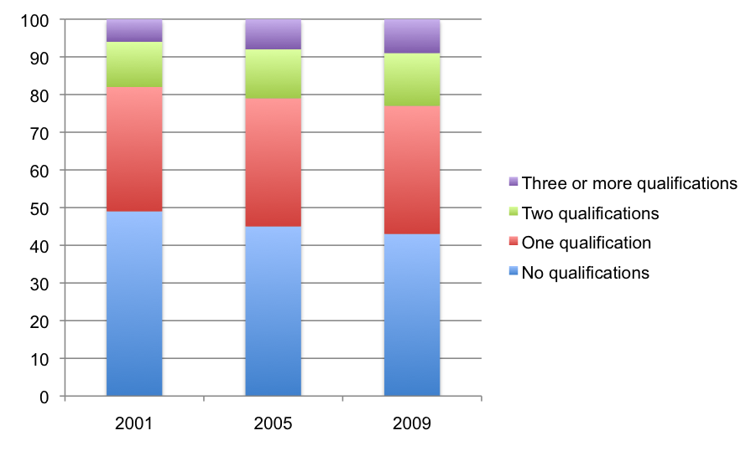
Source: ABS Survey of Education and Training, 2001, 2005 and 2009.
We cannot examine patterns of successive qualification paths between editions of the SET because the 2009 SET was the first in the series to record the order in which all qualifications were completed. We can however infer something about this change by examining how patterns of post-school educational paths, up to two qualifications, have varied between broad age groups in the 2009 SET. Figure 2 shows the proportions within each age group that have followed each possible post-school educational path by sector for up to two completed qualifications. Comparing those aged 25—44 years and those aged over 44 years should tell us about changes in flows over time. Figure 2 shows that those in the 25—44 years age group compared with the older group has: a higher proportion with any qualification (66% versus 55%); a higher proportion with a single higher education qualification (15% versus 11%); and a higher proportion with two higher education qualifications (16% versus 12%). Figure 2 also shows that the two age groups have a similar proportion with a single VET qualification (24% versus 25%) and that there is not much difference between each group for those who completed a higher education qualification first followed by a VET qualification (4% versus 3%). Overall, these results, in combination with those shown in Figure 1, suggest an increasing trend towards post-school qualifications and for multiple qualifications, with additional qualifications often taken after the age of 24, and an increasing proportion of qualifications in higher education. It seems from the figures here that the increased prevalence of tertiary education study since the 1990s is engaging people across age groups.
Figure 2 Those within broad age groups that have completed each post-school educational pathway up to two completed qualifications, per cent
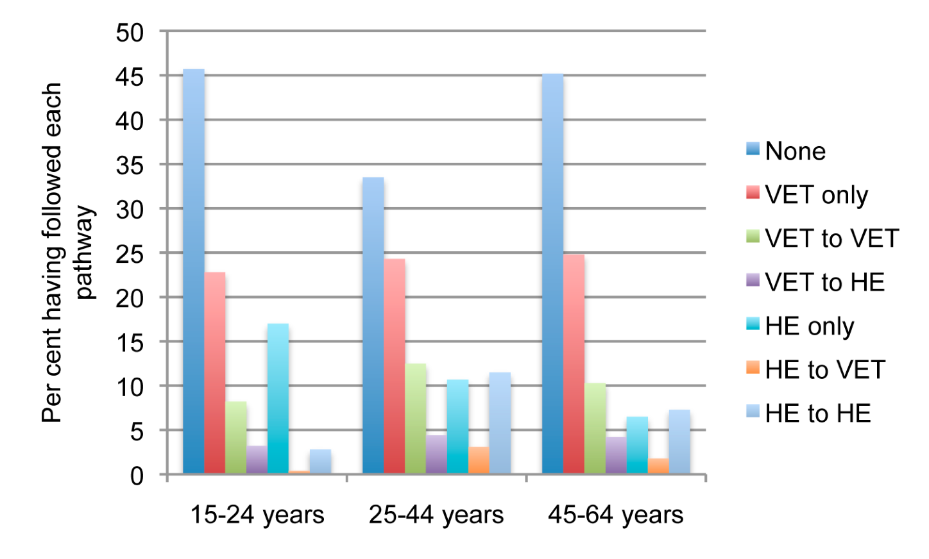
Source: ABS Survey of Education and Training, 2009.
We also examined how flows vary with the broad field of education and the sector in which students commenced, and how such flows may have varied for different age groups. We used the two age ranges of 15—39 and 40—64 years, as it was found that any finer splitting resulted in considerable errors in the figures particularly among the smaller fields. We indicate below the estimated total numbers commencing study in each field in both sectors for each age group, and the proportions of these totals who have no further qualification, have a second VET qualification, have a second higher education qualification or a have a second qualification in an undetermined sector. The results for each field are shown in Table 4 in the Appendix. We also show and particularly discuss the results for each of the four broad fields of education examined in this study: the results for agriculture and environment are shown in Figures 3 and 4; the results for commerce and management are shown in Figures 5 and 6; the results for health are shown in Figures 7 and 8; and the results for engineering are shown in Figures 9 and 10.
In regard to those commencing study in the broad field of agriculture and environment, the results shown in Table 4 and Figures 3 and 4 follow the general patterns evident in Figures 1 and 2: trends towards multiple qualifications and towards a greater proportion of qualifications in higher education. Comparing the estimated total population numbers commencing study in this field for our two broad age groups, we find the number in the younger group commencing in VET, 89,000, a little less than the 101 000 in the older group who commenced in VET, and the proportions undertaking further study are similar except that 8% of the younger group have undertaken further higher education qualifications compared with 4% of the older group. In contrast to the overall similarities among VET commencers there were 42 000 in the younger group who commenced study in higher education in this field compared with 24 000 in the older group. Among the higher education commencers in this field, interestingly 13% of the younger group have gone on to a second qualification in VET compared with 5% of the older group, whereas 37% of younger group have gone on to a second qualification in higher education compared with 50% of the older group. Perhaps in this field there are tendencies for younger people with degrees to obtain VET qualifications in fields such as management and for people to undertake higher degrees at a mature age. While further education among those commencing in VET may appear limited the proportions are, for example, greater than for those commencing in a VET engineering program. In work for the third strand of this project Yu and colleagues (2012, pp. 21—24) indicate that in primary industries there is a stratum of medium skilled and high skilled workers who can develop in a vocational area often with the help of formal education — despite a prevalence in this industry of low skilled labourers who face formidable barriers to advancement.
Figure 3 For agriculture and environment in VET as first qualification, per cent undertaking each second qualification pathway
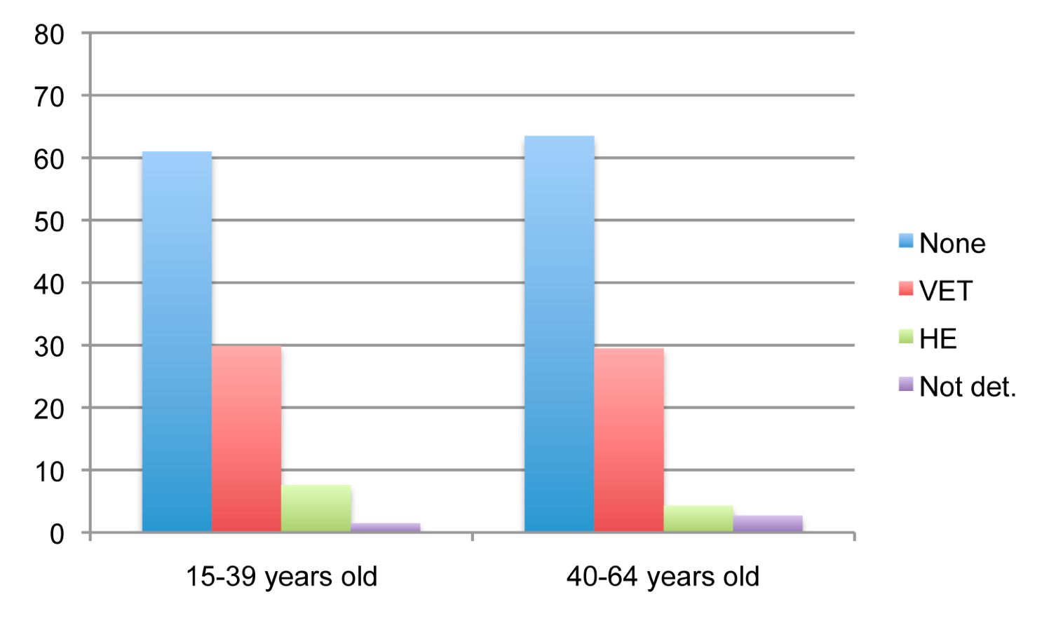
Source: ABS Survey of Education and Training, 2009.
Figure 4 For agriculture and environment in higher education as first qualification, per cent undertaking each second qualification pathway
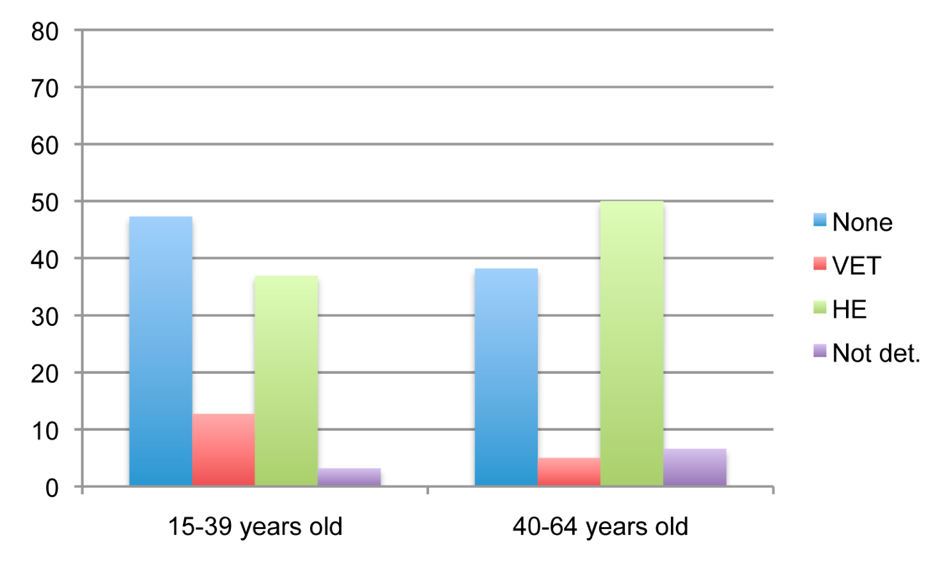
Source: ABS Survey of Education and Training, 2009.
Among those who have commenced study in commerce and management we see similar but more marked patterns to those observed among individuals commencing in agriculture and environment, as we can see from Table 4 and Figures 5 and 6. Among VET commencers in this field there are somewhat more in the younger group than the older group, 804 000 compared with 707 000, but among higher education commencers there are well over twice as many, 413 000 compared with 174 000. A higher proportion of the younger VET commencers have gone on to a further qualification and, in particular, 13% have gone on to a higher education qualification compared to 6% of the older VET commencers. As with the findings for agriculture and environment a lower proportion of the younger higher education commencers have gone to a further higher education award, although this difference is somewhat less for the field of education of commerce and management than for agriculture and environment: for the former it is 32% of the younger group compared with 40% of the older group. This suggests again a tendency for people with a first qualification in higher education in this field to undertake further higher education study over the age of 40, alongside a substantial shift in qualification attainment in management and commerce study towards higher education and towards multiple qualifications in recent decades. Yu and colleagues (2012, pp. 26—31) report that demands towards higher qualifications in the financial services area have been driven by tighter licensing in some areas and by increased use of such qualifications to screen entry-level job applicants.
Figure 5 For management and commerce in VET as first qualification, per cent undertaking each second qualification pathway
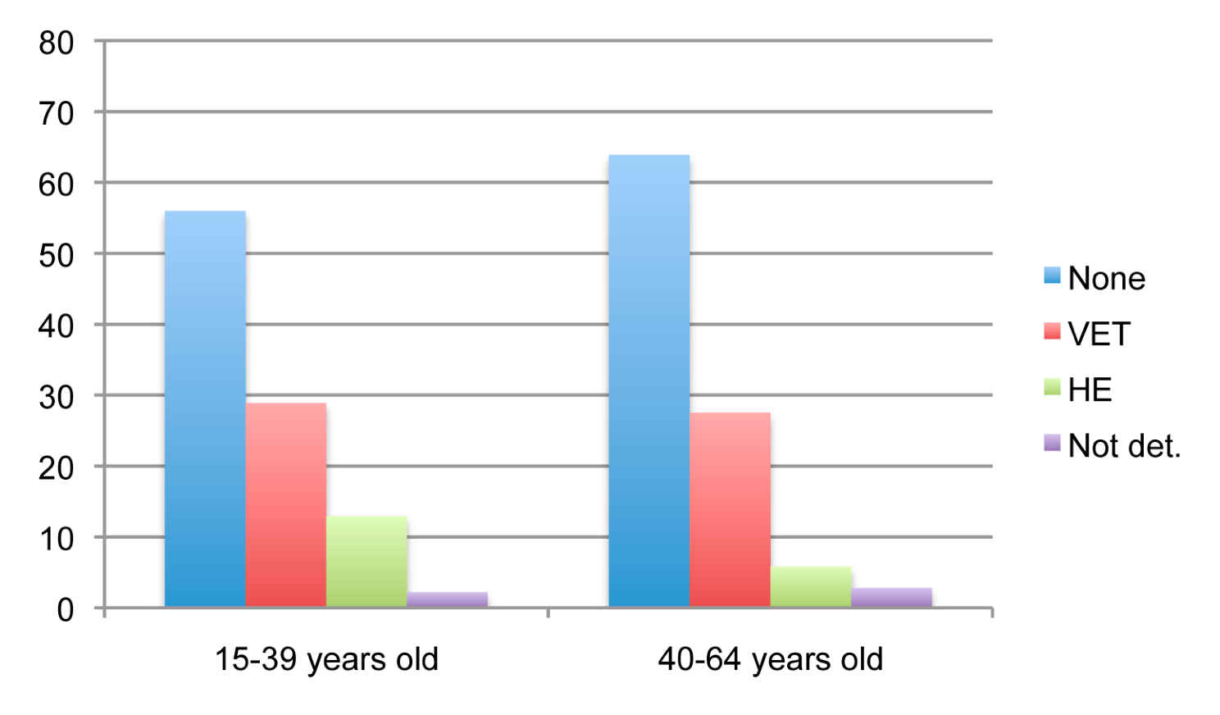
Source: ABS Survey of Education and Training, 2009.
Figure 6 For management and commerce in higher education as first qualification, per cent undertaking each second qualification pathway
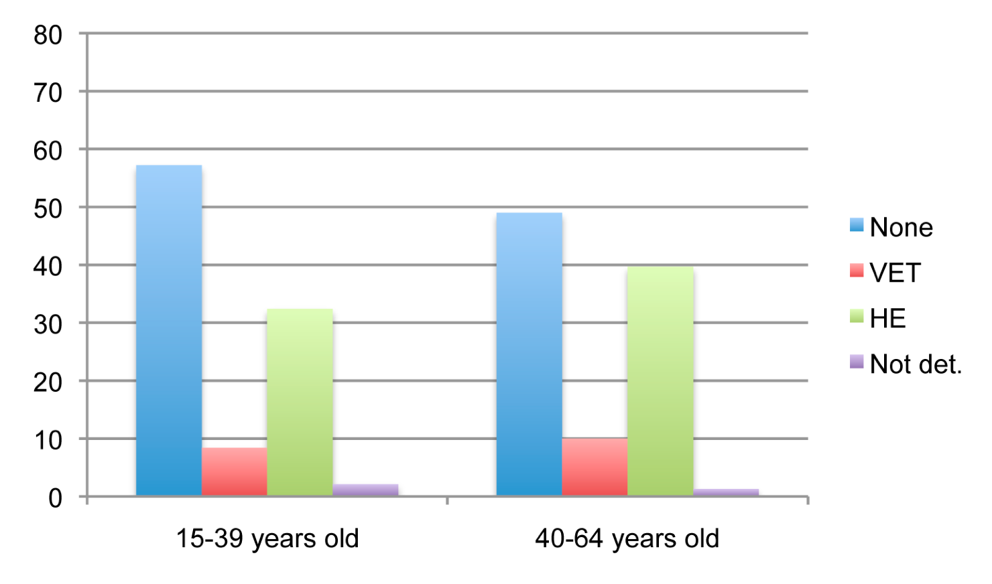
Source: ABS Survey of Education and Training, 2009.
For those with a first qualification in health, there also seems to be a considerable shift in educational requirements, as can be seen from Table 4 and Figures 7 and 8, but with a somewhat different pattern to that in management and commerce. Among those commencing in VET, the younger group is less than half the size of the older group, that is 114 000 compared to 256 000. Among the higher education commencers the younger group is around a third larger than the older group, 235 000 compared to 179 000. Further, a notable pattern among health graduates is that a considerably larger proportion of the older group who commenced in VET went on to a second higher education qualification, this being 30% compared with 17% for the younger group. From Table 4 we can see a pattern for education that is similar, although with an even greater variation between older and younger VET commencers who then went on to higher education (46% compared with 22%). Francis and Humphreys (1999) discuss how both in Australia and the UK nursing education was restructured in the 1980s towards what was seen as a higher status education within higher educational institutions for registered nurses, but in different ways. In the UK the enrolled nursing position was absorbed into the registered nurse position, which from then on required a higher education diploma for entry. In Australia enrolled nursing was retained and upgraded to a diploma level. At the same time, registered nursing entry requirements were upgraded to a degree level. The figures here indicate that although the enrolled nursing position has been retained and upgraded there is substantial demand by students who commence in health in VET, who are principally moving into nursing, to upgrade to a degree. Further, the greater extent of this pathway among the older group probably reflects a considerable amount of ‘up-qualifying’ among nurses who were working as VET-qualified nurses before the registered nursing requirements changed. By contrast, in the field of education of commerce and management, the more notable pattern is the greater proportion of first qualifications in higher education among younger people. We can see that in the less regulated field of financial services the less formal raising of entry requirements has mainly affected new entrants while in the highly regulated field of nursing (and education) both new entrants and established workers have been encouraged to undertake higher education after formal job requirements changed.
Figure 7 For health in VET as first qualification, per cent undertaking each second qualification pathway
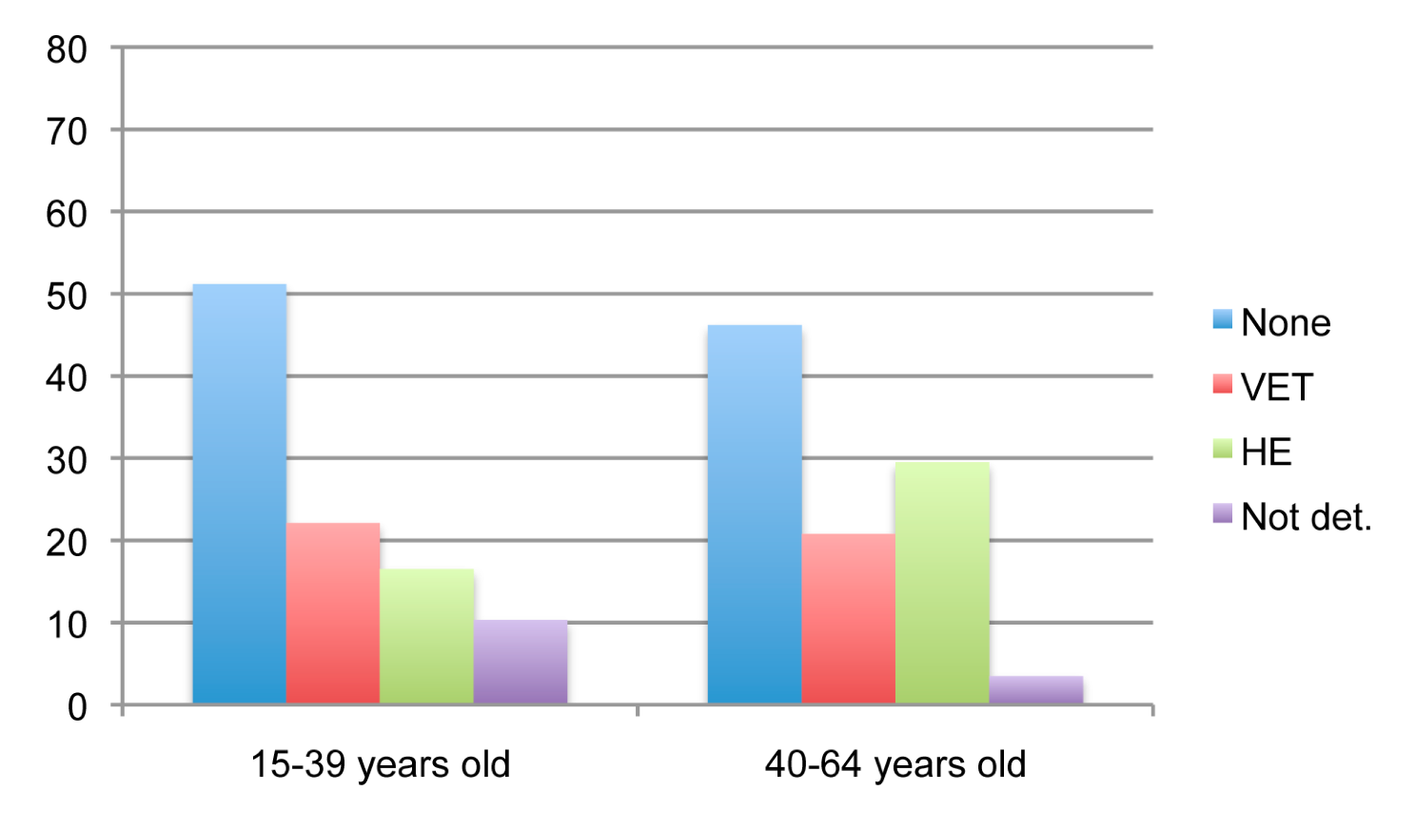
Source: ABS Survey of Education and Training, 2009.
Figure 8 For health in higher education as first qualification, per cent undertaking each second qualification pathway
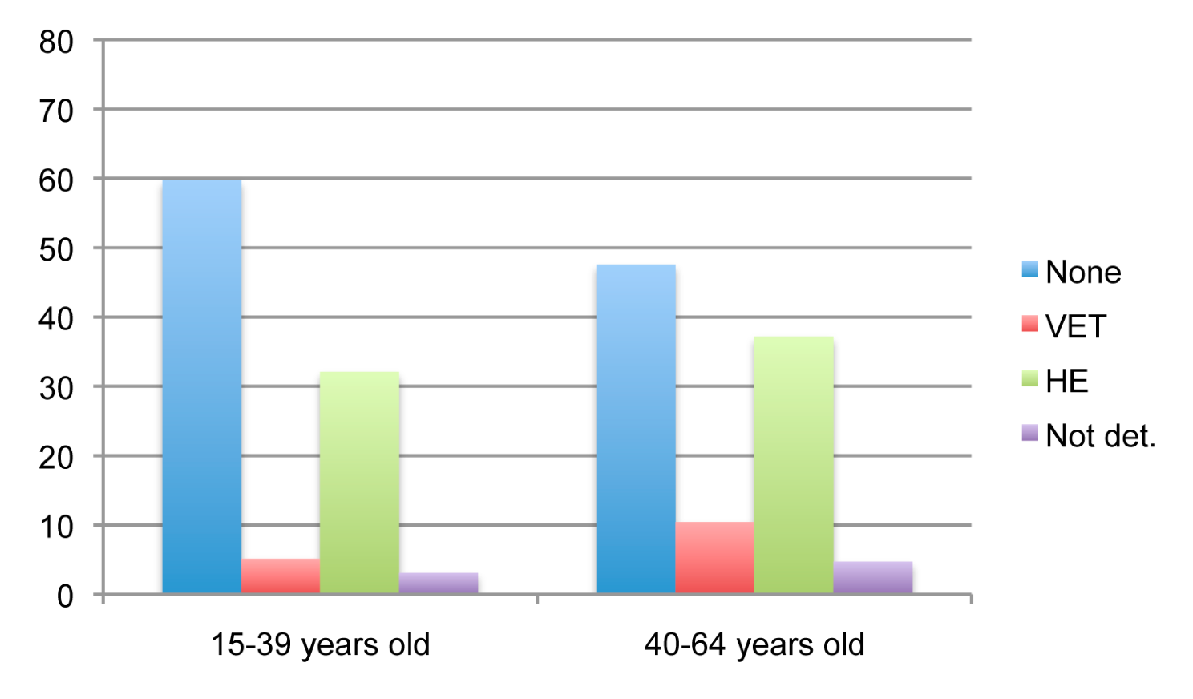
Source: ABS Survey of Education and Training, 2009.
Patterns among those with a first qualification in engineering, shown in Table 4 and Figures 9 and 10, illustrate, as we saw with regard to those with a first qualification in health, a decline by age group in those who commenced in VET (828,000 older people compared to 588 000 younger people) that has been less than matched by an increase by age group commencing in higher education (112 000 older people compared with 138 000 younger people). As in the field of agriculture and environment, there is little articulation between VET and HE, but without, in this case, an increase between the older and the younger group (at 4% of the younger and 5% of the older group). King and colleagues (2011) also note that the pathway from VET is under-represented in engineering degrees and argue this is problematic in terms of the Australian economy’s future needs for professional engineers. They point to mismatches and gaps between VET and higher education engineering programs as barriers to articulation. Also notable among those with a first qualification in engineering commencers is that while 29% of older people who have undertaken a first VET qualification go on to another VET qualification, only 21% of younger people have done so, and while 37% of older people who have undertaken a first higher education qualification go on to another higher education qualification, only 21% of younger people have done so. This could reflect both shifts towards requirements for higher education in the field and a tendency among those in engineering who gain additional qualification to do so later in life more so than in other fields.
Figure 9 For engineering in VET as first qualification, per cent undertaking each second qualification pathway
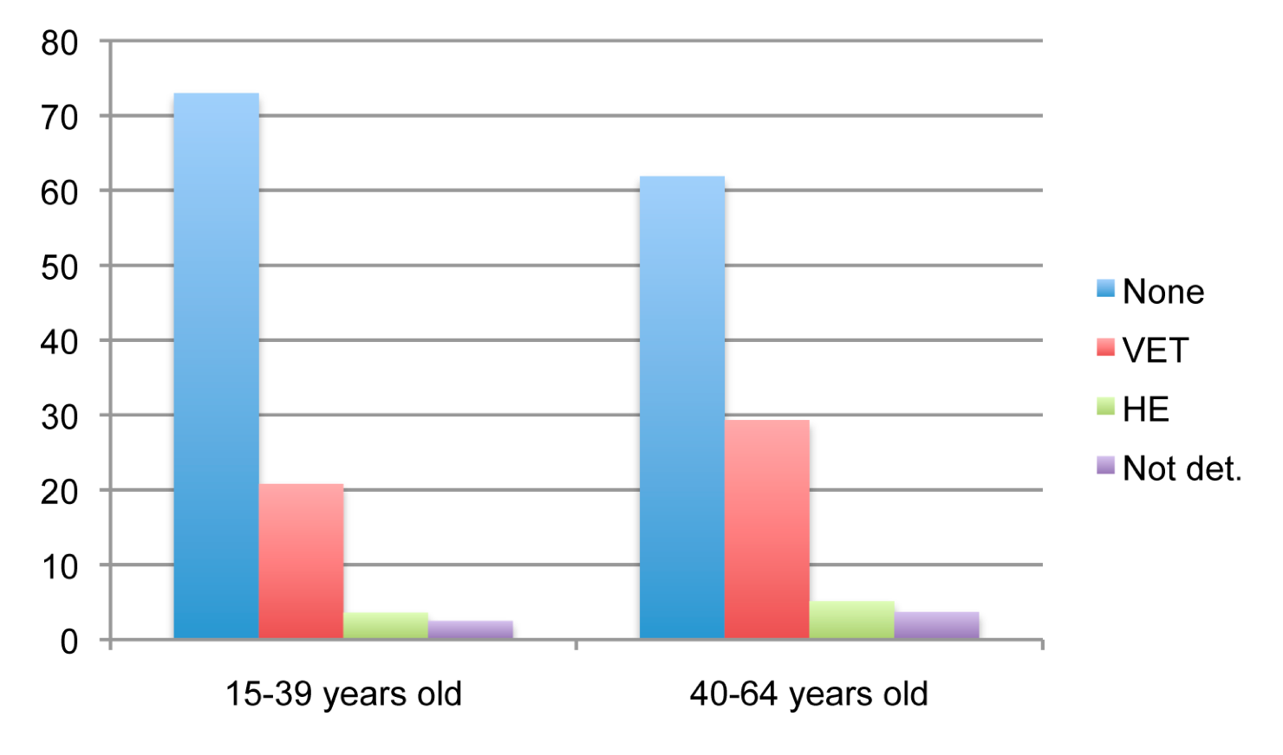
Source: ABS Survey of Education and Training, 2009.
Figure 10 For engineering in higher education as first qualification, per cent undertaking each second qualification pathway
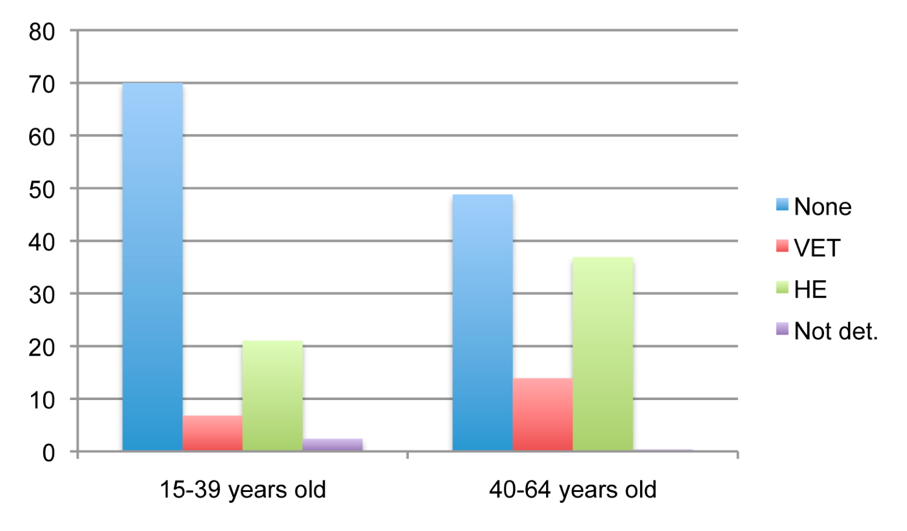
Source: ABS Survey of Education and Training, 2009.
We can also see the dependence of pathway patterns by field upon labour market structures by comparing engineering with natural and physical sciences. The natural and physical sciences field is rather different from other fields. It is by far the smallest field in vocational education (44 000 students) but the fourth biggest field in higher education (320 000). An unusually high proportion of VET science graduates get a second qualification (80% of 15-39 year olds) and an unusually high 28.7% get a second qualification in higher education. Higher proportions of higher education science graduates get a second qualification (58% of 15-39 year olds, although this isn’t markedly higher than the 51% for society and culture graduates) and a high 50% get a second qualification in higher education.
In contrast, engineering is the second biggest field in vocational education (1 416 000 students) but the median sized field in higher education (250 000). An unusually low proportion of engineering graduates in vocational and higher education get a second qualification (27% of vocational 15-39 year olds and 30% of higher education 15—39 year olds) and an unusually low 4% of VET engineering graduates get a second qualification in higher education.
Both the sciences and engineering are empirical and quantitative disciplines. Yet within sciences, VET and higher education have markedly different student enrolments and flows. VET students’ enrolments and flows in science are rather different from vocational students’ enrolments and flows in engineering. These can hardly be due to differences in the disciplines; they surely reflect differences in the labour market for vocational and higher education graduates in these fields. In contrast, there are much less marked differences between the sectors in management and commerce, which is the biggest field in VET and the second biggest in higher education.
Karmel (2011) found that the skill level of jobs held by holders of VET diplomas decreased between 1996 and 2006 and concluded that the diploma was losing its value as an entry-level qualification in favour of degrees. Consistent with this finding, we have found a general trend towards higher education and multiple qualifications, but also that these patterns have played out differently for different fields of education in ways that appear related to changing labour market conditions and regulatory structures.

Reported impacts of and reasons for study
The second method used in this chapter is a descriptive examination of respondents’ answers to questions about the impact of a first qualification on getting a job or on the job they already have, and their reasons for undertaking their first and any second qualification. These responses were split both by the type of educational pathway they undertook, and for those who had completed at least two qualifications, by whether they changed field of education between qualifications.
Survey respondents were asked to nominate one from a list of impacts on work of a first qualification. Table 1 summarises the responses for impacts that were most notable. The full results are shown in Table 5 in the Appendix. From Table 1 we can see that results for the response category on higher standards or additional duties within a job suggest the relatively greater ‘skills deepening’ effects of VET courses. Proportions of those reporting this response ranged from 26.9% to 27.6% for those with initial VET programs compared with 7.2% to 10.8% for initial higher education students, and there appears to be some association between having this impact from a first qualification and studying the same field in a second qualification. For example, of those studying higher education and then VET in the same field, 13.0% reported this impact compared with 9.9% of those studying higher education and then VET in a different field. Also notable is that initial higher education study is considerably more associated with beginning a new career, with this impact being reported by between 36.3% and 50.3% of the groups with initial higher education study compared with between 20.7% and 33.0% for groups with initial VET study. Those who found the impact of an initial VET course to be the start of a new career and who then studied a higher education program were somewhat more likely to do so in the same field, 34.1% of this group experiencing this impact compared with 31.7% of those studying VET and then higher education in a different field. Perhaps unsurprisingly, an initial program having no impact on working life is associated with further study overall and further study in higher education: 19.7% of those with only a single VET qualification reported no impact on working life compared with 27.2% of graduates of two VET programs and 30.9% of graduates of a VET and a higher education program. Similarly, 15.1% of those with only a single higher education qualification reported no impact compared with 27.1% of those completing a higher education and then a VET program and 34.2% of those with two higher education qualifications. There appears to be some association between lack of an impact of a first qualification on working life and changing fields for a second qualification, with 31.1% of those changing fields, across pathways, nominating a lack of impact, compared with 29.2% of those sticking to the same field.

Table 1 Percentage stating impact of first completed qualification on working life by those with one qualification in VET or HE, those with two qualifications in VET or HE, and those with one qualification in each sector (respondents permitted to cite one impact on working life)
Impact | VET only | VET to VET | VET to HE | HE only | HE to VET | HE to HE | Total*
Assisted respondent to perform same job to a higher standard or undertake additional duties | 26.9 | 27.6 | 20.1 | 7.6 | 10.8 | 7.2 | 20.0
Same field | NA | 28.4 | 20.8 | NA | 13.0 | 7.2 | 19.2
Changed field | NA | 26.9 | 19.4 | NA | 9.9 | 7.1 | 17.9
Assisted respondent to begin a new career (i.e. get a different job in a different field) | 20.7 | 24.2 | 33.0 | 36.3 | 50.3 | 46.3 | 28.9
Same field | NA | 23.7 | 34.1 | NA | 50.3 | 46.5 | 33.9
Changed field | NA | 24.7 | 31.7 | NA | 50.4 | 46.1 | 34.3
Qualification had no impact on working life including permanently unable or not intending to work | 19.7 | 27.2 | 30.9 | 15.1 | 27.1 | 34.2 | 23.6
Same field | NA | 25.9 | 31.2 | NA | 26.4 | 32.4 | 29.2
Changed field | NA | 28.4 | 30.5 | NA | 27.4 | 36.2 | 31.1
Source: ABS Survey of Education and Training, 2009.
Notes: * Includes those in pathway “not determined” category not otherwise shown.
Survey respondents were asked to nominate their reasons for studying each qualification that they had completed, with multiple responses allowed. Table 2 summarises the most notable results for the stated reasons for a first qualification with the full results given in Table 6 in the Appendix. Given the policy prominence on VET to higher education pathways, it is noteworthy that the highest proportion of those nominating a study pre-requisite as a reason was among those having undertaken the VET to higher education pathway. However, this was only 13.0%, suggesting that there is a low level of pre-meditation in regard to pathways generally. The first qualification reason ‘to get a job’ is associated with initial higher education study, with single rather than multiple qualifications, and with later study of VET in a different field to an initial, job-related VET program (48.2% studying VET to VET in different fields nominating this reason compared with 43.2% undertaking such a pathway within the same field). Higher proportions of VET initial students than higher education initial students nominated the job requirement and extra skills reasons, and the highest extra skills response occurs in the VET to VET, same field category, all suggesting the skills deepening role of VET. The different career reason for a first qualification appears associated with changing fields in all pathways. Educational skills as a reason is associated with higher education. Interest and enjoyment as a reason was also associated with higher education and also with changing fields later on.

Table 2 Percentage citing selected reasons (multiple choices) for undertaking their first qualification, by pathway and whether field had changed or not between qualifications
 | VET only | VET to VET | VET to HE | HE only | HE to VET | HE to HE | Total*
To get into another course of study | 4.1 | 6.6 | 13.0 | 4.8 | 6.3 | 8.7 | 5.9
Same field | NA | 7.8 | 14.0 | NA | 2.0 | 9.6 | 9.6
Changed field | NA | 5.3 | 12.0 | NA | 8.1 | 7.8 | 6.8
To get a job | 54.1 | 45.8 | 53.1 | 74.6 | 69.5 | 66.4 | 57.4
Same field | NA | 43.2 | 55.6 | NA | 70.1 | 67.6 | 54.1
Changed field | NA | 48.2 | 50.3 | NA | 69.2 | 65.0 | 55.9
Was a requirement of job | 20.2 | 22.4 | 15.1 | 7.3 | 7.1 | 7.0 | 16.1
Same field | NA | 22.5 | 14.1 | NA | 5.5 | 6.6 | 15.2
Changed field | NA | 22.3 | 16.3 | NA | 7.8 | 7.6 | 15.3
Wanted extra skills for job | 20.3 | 19.5 | 13.2 | 9.3 | 9.1 | 7.9 | 15.8
Same field | NA | 21.9 | 13.5 | NA | 11.2 | 7.4 | 15.1
Changed field | NA | 17.2 | 12.9 | NA | 8.2 | 8.5 | 13.3
To try for a different career | 9.1 | 9.0 | 8.7 | 9.1 | 6.4 | 5.4 | 8.6
Same field | NA | 8.1 | 8.1 | NA | 2.8 | 4.2 | 6.6
Changed field | NA | 9.9 | 9.4 | NA | 7.8 | 6.6 | 9.0
To improve general educational skills | 18.6 | 21.9 | 23.7 | 32.1 | 33.6 | 34.4 | 24.2
Same field | NA | 23.6 | 20.1 | NA | 39.1 | 33.4 | 26.6
Changed field | NA | 20.3 | 27.6 | NA | 31.3 | 35.4 | 26.6
For personal interest/enjoyment | 21.8 | 23.1 | 24.4 | 37.7 | 31.8 | 33.7 | 26.7
Same field | NA | 21.9 | 24.5 | NA | 25.4 | 30.1 | 25.6
Changed field | NA | 24.3 | 24.2 | NA | 34.4 | 37.5 | 29.2
Source: ABS Survey of Education and Training, 2009.
Notes: * Includes those in pathway “not determined” category not otherwise shown.
Table 3 summarises the most notable results for the stated reasons for a second qualification with the full results given in Table 7 in the Appendix. We can see a number of differences with the results for first qualifications shown in Table 2. Getting a job as a reason is associated with changing fields except in the higher education to VET group. There appears to be a greater difference in Table 3 compared with Table 2 between the job requirements reason and both the extra skills reason and the general educational reason, particularly in the VET to higher education category. Interestingly this suggests the impetus for further education and training (particularly in higher education) comes from workers rather than employers. The different career reason is strongly associated with changing fields (chosen by 21.6% of field changers compared with 11.3% of same fielders across pathways), whereas general education as a reason shows association with staying in the same field, particularly in the higher education to higher education path (with 37.9% of same fielders compared with 31.1% of field changers). It is also noteworthy that there appears to be somewhat less of a gap between VET and higher education in regard to reasons of gaining educational skills and interest and enjoyment for a second qualifications than there is for a first. As calculated separately from the tables, 33.2% of those graduating from VET as their first qualification gave either educational skills and/or interest and enjoyment as reasons, compared with 52.2% of those graduating from higher education as their first qualification, a difference of 19.0%. By contrast, educational skills or interest or enjoyment was cited by 49.0% of graduates of two successive higher education qualifications and by 39.6% of VET graduates who got a second vocational qualification, a difference of 9.4%.
Table 3 Percentage citing selected reasons (multiple choices) for undertaking their second qualification, by pathway and whether field had changed or not between qualifications
 | VET to VET | VET to HE | HE to VET | HE to HE | Total
To get into another course of study | 6.9 | 7.7 | 5.3 | 6.1 | 6.6
Same field | 7.8 | 5.2 | 3.4 | 6.6 | 6.6
Changed field | 6.2 | 10.4 | 6.0 | 5.5 | 6.5
To get a job | 23.5 | 34.4 | 22.5 | 38.6 | 29.0
Same field | 23.8 | 29.8 | 26.4 | 33.7 | 27.4
Changed field | 23.1 | 39.5 | 21.0 | 43.6 | 30.4
Was a requirement of job | 22.3 | 9.5 | 21.3 | 14.1 | 17.7
Same field | 21.6 | 10.3 | 19.8 | 15.9 | 18.0
Changed field | 22.9 | 8.7 | 21.9 | 12.2 | 17.5
Wanted extra skills for job | 34.4 | 30.3 | 31.0 | 30.8 | 32.6
Same field | 38.0 | 36.0 | 37.7 | 34.4 | 36.9
Changed field | 30.9 | 24.1 | 28.3 | 27.1 | 28.7
To try for a different career | 16.2 | 21.4 | 18.4 | 14.9 | 16.7
Same field | 12.2 | 11.2 | 14.8 | 9.5 | 11.3
Changed field | 20.0 | 32.7 | 19.9 | 20.5 | 21.6
To improve general educational skills | 26.3 | 34.9 | 22.7 | 34.6 | 29.7
Same field | 27.2 | 33.2 | 30.5 | 37.9 | 31.8
Changed field | 25.5 | 36.7 | 19.5 | 31.1 | 27.7
For personal interest/enjoyment | 24.0 | 36.5 | 26.3 | 31.8 | 28.7
Same field | 20.7 | 32.5 | 21.4 | 31.0 | 26.7
Changed field | 27.3 | 40.9 | 28.3 | 32.7 | 30.5
Source: ABS Survey of Education and Training, 2009.
Harris and colleagues (2005) found similar results from questions on reasons for study in their survey of South Australian tertiary students commencing in 2003 who had either commenced in VET with previous experience in higher education or commenced in higher education with previous experience in VET. This study found that considerably more VET commencers than higher education commencers were studying due to employer requirements; that re-training for a different career was somewhat associated with moving into higher education study; that gaining of skills and improving prospects in a current career was somewhat associated with moving into VET study; and that educational and interest reasons were prevalent among both groups, but more widely expressed by those moving into higher education. Our results as well as those of Harris and colleagues (2005) suggest that motivations for further study are somewhat different among those entering higher education and VET but not absolutely so, and less so for further study in tertiary education. In regard to the specific question posed in this chapter our results suggest an intertwining of labour market and educational factors even if the latter may be dominant and overarching.

Relative weight of impacts, reasons and fields in field changing
The above results suggest a complex interplay of fields of education, educational pathways, impacts on work and reasons for undertaking qualifications. Binary logistic regression was used to examine this interplay further; it is a technique for modelling the probability of one event occurring with respect to another, and gives the relative weight of factors associated with such an occurrence. For the purposes of this chapter we modelled whether or not people with at least two qualifications changed fields of education when they moved from their first to second qualification. We examined the effects of whether or not students were aged 25 years and over, the impact on work of a first qualification, the reasons given for undertaking each qualification and the fields of education of each qualification. Regressions were performed for all those undertaking two qualifications overall, and for each pathway separately. The results, given in Table 8 in the Appendix, give the odds ratio for each regression for each factor that proved significant. The odds ratio indicates the extent by which the odds of changing fields of education are increased if the factor is ‘true’ (all factors in this case being dichotomous variables), controlling for other variables (for example, how much such odds increase if a respondent indicated the ‘to get a job’ reason for their first qualification, regardless of other responses). The notes to this table give details on the significance and fit of the regressions and why it was necessary to give results for each field of education measured against a reference field (which was commerce and management, chosen because it had the least field-changing in all pathways).
The logistic regression indicated that the impact of the first qualification on work did not have a significant effect on changing fields of education. Nor did the reasons students gave for undertaking a first qualification, with one exception. Undertaking the first qualification to get into another program did have a significant effect on changing field of education (and this effect was not significant when the analysis was split into different types of educational pathway). Labour market related reasons for undertaking a second qualification had effects on changing field of education that were statistically significant but relatively small. The labour market reason for a second qualification with the biggest effect was that of attempting to start a different career, which increased the odds of changing field of education by 2.0 times overall, and 3.0 times for those undertaking the VET to higher education pathway. By contrast, the regressions confirmed that students were more likely to change field of education if they started in some fields compared to others. Overall, the effect of studying a first qualification in the society and culture field of education increased the odds that students would change fields 1.6 times, whereas it increased by 6.6 times for those studying in food and hospitality. The effect of the second field of education in which students studied was also marked: those studying engineering as their second qualification were less likely to have changed fields of education than those studying management in their second qualification. However, those studying in the management field of education as their second qualification were less likely to have changed fields of education compared to those studying in education. VET engineering graduates who later undertook a second VET qualification didn’t change fields of education very much, and nor did VET health and education graduates who later undertook a second qualification in higher education, which probably reflects the particularly well defined pathways in the regulated professions and trades. However, those VET graduates who undertook a second VET qualification in education were quite likely to move field of education, which may reflect a move into VET teaching from initial VET study in another area.

Conclusions
This paper has examined the relationships between post-school educational fields and sectors and labour market considerations that appear to shape students’ study decisions. It was found that pathways taken vary considerably by age, suggesting changes over time to patterns in tertiary education towards greater participation overall, a greater extent of multiple qualifications and a larger proportion of higher education programs as distinct from VET programs. It was also found that pathway use varied considerably by field and by age group in ways related to labour market conditions. A regression model of whether students changed field of education between first and second qualifications found that the field of education in which students undertook their first qualification had the biggest effect on whether they changed field of education for their second qualification. Tabulations of responses regarding the impact of a first qualification, reasons for undertaking first and second qualifications and whether or not students changed fields between qualifications, for each distinct pathway, revealed a number of associations that suggested both distinctions and overlaps between VET and higher education and an intertwining of labour market and educational factors, even if the former may be dominant and overarching. From the descriptive tables it can be noted that many of the responses varied considerably across pathways: for example, the impact of performing a job to a higher standard was nominated by 28% of those in the VET to VET category and only 7% in the higher education to higher education category, and job requirement as a reason for a first qualification was nominated by 22% in the VET to VET category and only 7% in the higher education to higher education category. It may be the case that overall that labour market impacts and considerations shape choices about pathways in terms of sectors and additional qualifications, while the field initially chosen within a pathway shapes the probability of whether or not the field will change with any succeeding qualification. A multinomial logistic regression modelling of pathway choice might be a useful way for the project to investigate this idea further.

References
Clarke, K & Volkoff, V 2012, Entry to vocations: a discussion paper on current policy structures of VET in Schools, Adelaide, forthcoming.
Curtis, D 2006, ‘Inter-sectoral transfers: sense, status, prevalence and purpose’, paper to Australian Vocational Education and Training Research Association 15th annual conference 12—14 June, Mooloolaba, Queensland, <http://www.voced.edu.au/content/ngv42529>.
Curtis, D 2009, Student transfer: At a glance, NCVER, Adelaide, viewed 10 March, 2011, <http://www.ncver.edu.au/publications/2144.html>.
Department of Education, Employment and Workplace Relations 2009, Transforming Australia's Higher Education System, Commonwealth of Australia, viewed 5 December 2011, <http://www.deewr.gov.au/HigherEducation/Documents/TransformingAusHigherED.pdf>.
Francis, B & Humphreys, J 1999, ‘Enrolled nurses and the professionalisation of nursing: a comparison of nurse education and skill-mix in Australia and the UK’, International Journal of Nursing Studies, vol.36, no.2, pp.127—35, <http://www.sciencedirect.com/science/article/pii/S0020748999000061>.
Guthrie, H, Stanwick, J & Karmel, T 2011, Pathways: developing the skills of Australia's workforce, NCVER, Adelaide, viewed 5 June 2011, <http://www.ncver.edu.au/publications/2376.html>.
Harris, R, Sumner, R & Rainey, L 2005, Student traffic: Two-way movement between vocational education and training and higher education, NCVER, Adelaide, viewed 1 March, 2011, <http://www.ncver.edu.au/publications/1549.html>.
- Karmel, T, Mlotkowski, P & Awodeyi, T 2008, Is VET vocational? The relevance of training to the occupations of vocational education and training graduates, National Centre for Vocational Education Research, Adelaide, viewed 5 August 2009, <http://www.ncver.edu.au/publications/2013.html>.
Karmel, T 2011, ‘The implications of skills deepening for vocational education and training in Australia’, International Journal of Training Research, vol.9, no.1—2, pp.72—94.
King, R, Dowling, D & Godfrey, E 2011, Pathways from VET awards to engineering degrees: a higher education perspective, Australian National Engineering Taskforce, Epping, <http://www.anet.org.au/wp-content/uploads/2011/06/ANET-Higher-Ed-pathways1.pdf>.
Mavromaras, K, McGuinness, S & Fok, YK 2010, The incidence and wage effects of overskilling among employed VET graduate, National Centre for Vocational Education Research, Adelaide, viewed 21 January 2011, <http://www.ncver.edu.au/publications/2231.html>.
- Mavromaras, K, McGuinness, S, Richardson, S, Sloane, P & Wei, Z 2011, Over-skilling and job satisfaction in the Australian labour force, National Centre for Vocational Education Research, Adelaide, viewed 21 June 2011, <http://www.ncver.edu.au/publications/2365.html>.
Ministerial Council on Education, Employment, Training and Youth Affairs 2009, ‘Higher Education: Good Practice Principles for Credit Transfer and Articulation’, viewed 20 December, 2011, <http://www.mceecdya.edu.au/mceecdya/report_of_the_national_study_on_credit_transfer,11910.html>.
Moodie, G 2004a, ‘Reverse transfer in Australia’, The International Journal of Training Research, vol.2, no.2, pp.24—48.
Moodie, G 2004b, ‘Transfer of roles and students between VET and higher education’, in J Searle, C McKavanagh & D Roebuck, eds, 12th Annual International Conference on Post-Compulsory Education and Training, Gold Coast: Australian Academic Press, pp.50—57, <http://www.voced.edu.au/content/ngv17925>.
Moodie, G 2010, ‘Change and transformation in student transfer from Australian vocational to higher education’, paper to National Vocational Education and Training Research 15th annual conference 8—9 April, Surfers Paradise viewed 5 May 2011, <http://www.voced.edu.au/content/ngv43977>.
Moodie, G 2012, The role of educational institutions in fostering vocations, National Centre for Vocational Education Research, Adelaide, forthcoming.
Werner, M 1998, Issues regarding higher education graduates in vocational education and training, NCVER, Adelaide, viewed November 5, 2011, <http://www.ncver.edu.au/publications/266.html>.
Wheelahan, L 2011, ‘From old to new: the Australian qualifications framework’, Journal of Education and Work, vol.24, no.3—4, pp.323—42 viewed 8 January 2012, <http://dx.doi.org/10.1080/13639080.2011.584689>.
Wheelahan, L, Leahy, M, Fredman, N, Moodie, G, Arkoudis, S & Bexley, E 2012a, Missing Links: The fragmented relation between tertiary education and work, National Centre for Vocational Education Research, Adelaide, forthcoming.
Wheelahan, L, Moodie, G & Buchanan, J 2012b, Revitalising the vocational in flows of learning and labour, National Centre for Vocational Education Research, Adelaide, forthcoming.
Yu, S, Bretherton, T & Schultz, H 2012, Modern vocations and labour market pathways, NCVER, Adelaide, forthcoming.

Appendix: Additional tables
Table 4 Numbers who have commenced in each field of education and proportions of these who by age group who have gone to a second qualification
First qualification field | First qual. sector | Age group | Total no. | Subsequent qualification, %
 |  |  |  | None | VET | HE | Not det. | Total
Natural and physical sciences | VET | 15–39 | 15 000 | 20.0 | 42.6 | 28.7 | 2.0 | 100.0
 |  | 40–64 | 29 000 | 30.6 | 44.7 | 24.4 | 0.2 | 100.0
 | HE | 15–39 | 172 000 | 42.0 | 8.2 | 49.8 | 0.1 | 100.0
 |  | 40–64 | 148 000 | 28.7 | 10.4 | 57.5 | 3.4 | 100.0
Information technology | VET | 15–39 | 120 000 | 46.6 | 35.5 | 14.1 | 3.8 | 100.0
 |  | 40–64 | 51 000 | 54.3 | 36.7 | 4.8 | 4.2 | 100.0
 | HE | 15–39 | 94 000 | 53.5 | 9.7 | 34.0 | 2.8 | 100.0
 |  | 40–64 | 27 000 | 67.3 | 10.8 | 21.3 | 0.6 | 100.0
Engineering | VET | 15–39 | 588 000 | 73.0 | 20.8 | 3.6 | 2.6 | 100.0
 |  | 40–64 | 828 000 | 61.9 | 29.3 | 5.1 | 3.7 | 100.0
 | HE | 15–39 | 138 000 | 69.8 | 6.8 | 21.0 | 2.4 | 100.0
 |  | 40–64 | 112 000 | 48.8 | 13.9 | 36.9 | 0.4 | 100.0
Architecture and building | VET | 15–39 | 224 000 | 77.9 | 15.4 | 3.7 | 3.7 | 100.0
 |  | 40–64 | 237 000 | 72.0 | 21.3 | 4.0 | 2.8 | 100.0
 | HE | 15–39 | 32 000 | 65.0 | 8.6 | 22.6 | 3.8 | 100.0
 |  | 40–64 | 17 000 | 45.0 | 16.9 | 38.1 | 0.0 | 100.0
Agriculture and environment | VET | 15–39 | 101 000 | 61.0 | 29.9 | 7.6 | 1.5 | 100.0
 |  | 40–64 | 89 000 | 63.5 | 29.5 | 4.3 | 2.7 | 100.0
 | HE | 15–39 | 42 000 | 47.3 | 12.7 | 36.9 | 3.2 | 100.0
 |  | 40–64 | 24 000 | 38.2 | 5.0 | 50.2 | 6.6 | 100.0
Health | VET | 15–39 | 114 000 | 51.2 | 22.1 | 16.5 | 10.3 | 100.0
 |  | 40–64 | 256 000 | 46.2 | 20.8 | 29.5 | 3.5 | 100.0
 | HE | 15–39 | 235 000 | 59.8 | 5.1 | 32.0 | 3.1 | 100.0
 |  | 40–64 | 179 000 | 47.6 | 10.4 | 37.2 | 4.7 | 100.0
Education | VET | 15–39 | 37 000 | 52.6 | 21.0 | 22.2 | 4.2 | 100.0
 |  | 40–64 | 176 000 | 37.6 | 15.2 | 46.1 | 1.1 | 100.0
 | HE | 15–39 | 154 000 | 66.8 | 7.8 | 24.1 | 1.2 | 100.0
 |  | 40–64 | 157 000 | 40.8 | 11.6 | 46.1 | 1.4 | 100.0

Table 4 (continued)
First qualification field | First qual. sector | Age group | Total no. | Subsequent qualification, %
 |  |  |  | None | VET | HE | Not det. | Total
Management and commerce | VET | 15–39 | 804 000 | 56.0 | 28.9 | 12.9 | 2.1 | 100.0
 |  | 40–64 | 707 000 | 63.9 | 27.5 | 5.8 | 2.8 | 100.0
 | HE | 15–39 | 413 000 | 57.2 | 8.4 | 32.4 | 2.1 | 100.0
 |  | 40–64 | 174 000 | 49.0 | 10.0 | 39.7 | 1.3 | 100.0
Society and culture | VET | 15–39 | 342 000 | 51.4 | 32.6 | 12.3 | 3.7 | 100.0
 |  | 40–64 | 245 000 | 58.4 | 30.4 | 7.5 | 3.8 | 100.0
 | HE | 15–39 | 381 000 | 49.0 | 9.5 | 38.3 | 3.2 | 100.0
 |  | 40–64 | 276 000 | 27.9 | 9.2 | 59.6 | 3.3 | 100.0
Creative arts | VET | 15–39 | 165 000 | 53.3 | 25.6 | 17.1 | 4.1 | 100.0
 |  | 40–64 | 95 000 | 56.6 | 26.7 | 15.3 | 1.5 | 100.0
 | HE | 15–39 | 145 000 | 59.2 | 11.3 | 27.0 | 2.5 | 100.0
 |  | 40–64 | 50 000 | 35.7 | 24.7 | 37.2 | 2.4 | 100.0
Food and hospitality | VET | 15–39 | 396 000 | 61.8 | 29.5 | 7.6 | 1.1 | 100.0
 |  | 40–64 | 213 000 | 68.8 | 25.1 | 3.2 | 2.9 | 100.0
 | HE | 15–39 | 5127 | 67.9 | 10.4 | 21.7 | 0.0 | 100.0
 |  | 40–64 | 1422 | 5.9 | 94.2 | 0.0 | 0.0 | 100.0
Source: ABS Survey of Education and Training, 2009.

Table 5 Those citing each impact of first qualification on working life in first 6 months after completion (single choice), by pathway and whether field had changed or not, per cent
Impact | VET only | VET to VET | VET to HE | HE only | HE to VET | HE to HE | Total*
Not applicable | 19.1 | 2.9 | 2.5 | 32.7 | 0.1 | 1.1 | 14.1
Same field | NA | 3.9 | 1.3 | NA | 0.1 | 1.2 | 2.5
Changed field | NA | 1.9 | 3.8 | NA | 0.0 | 1.0 | 1.6
Assisted respondent to perform same job to a higher standard or undertake additional duties | 26.9 | 27.6 | 20.1 | 7.6 | 10.8 | 7.2 | 20.0
Same field | NA | 28.4 | 20.8 | NA | 13.0 | 7.2 | 19.2
Changed field | NA | 26.9 | 19.4 | NA | 9.9 | 7.1 | 17.9
Assisted respondent to get a different job or promotion in the same field | 5.7 | 8.4 | 7.0 | 3.5 | 2.9 | 3.6 | 5.7
Same field | NA | 8.7 | 7.9 | NA | 2.6 | 5.2 | 7.1
Changed field | NA | 8.1 | 5.9 | NA | 3.0 | 1.9 | 5.8
Assisted respondent to begin a new career (i.e. get a different job in a different field) | 20.7 | 24.2 | 33.0 | 36.3 | 50.3 | 46.3 | 28.9
Same field | NA | 23.7 | 34.1 | NA | 50.3 | 46.5 | 33.9
Changed field | NA | 24.7 | 31.7 | NA | 50.4 | 46.1 | 34.3
Assisted respondent to find a job | 2.7 | 3.4 | 1.8 | 2.1 | 2.9 | 2.5 | 2.7
Same field | NA | 3.4 | 1.0 | NA | 4.7 | 2.4 | 2.6
Changed field | NA | 3.3 | 2.7 | NA | 2.1 | 2.6 | 3.1
Assisted respondent to start or expand own business | 2.0 | 2.2 | 0.5 | 0.9 | 1.4 | 0.8 | 1.6
Same field | NA | 1.7 | 0.0 | NA | 0 | 0.6 | 1.3
Changed field | NA | 2.8 | 1.0 | NA | 2.0 | 0.9 | 1.9
Qualification had other impact on working life | 3.3 | 4.1 | 4.2 | 1.8 | 4.5 | 4.4 | 3.5
Same field | NA | 4.4 | 3.6 | NA | 2.8 | 4.5 | 4.2
Changed field | NA | 3.9 | 5.0 | NA | 5.2 | 4.2 | 4.4
Qualification had no impact on working life including permanently unable or not intending to work | 19.7 | 27.2 | 30.9 | 15.1 | 27.1 | 34.2 | 23.6
Same field | NA | 25.9 | 31.2 | NA | 26.4 | 32.4 | 29.2
Changed field | NA | 28.4 | 30.5 | NA | 27.4 | 36.2 | 31.1
Total | 100.0 | 100.0 | 100.0 | 100.0 | 100.0 | 100.0 | 100.0
Same field | NA | 100.0 | 100.0 | NA | 100.0 | 100.0 | 100.0
Changed field | NA | 100.0 | 100.0 | NA | 100.0 | 100.0 | 100.0
Source: ABS Survey of Education and Training, 2009.
Notes: * Includes those in pathway “not determined” category not otherwise shown.
Table 6 Percentage citing each reason for undertaking their first qualification (multiple choices), by pathway and whether field had changed or not between qualifications
 | VET only | VET to VET | VET to HE | HE only | HE to VET | HE to HE | Total*
To get into another course of study | 4.1 | 6.6 | 13.0 | 4.8 | 6.3 | 8.7 | 5.9
Same field | NA | 7.8 | 14.0 | NA | 2.0 | 9.6 | 9.6
Changed field | NA | 5.3 | 12.0 | NA | 8.1 | 7.8 | 6.8
To get a job | 54.1 | 45.8 | 53.1 | 74.6 | 69.5 | 66.4 | 57.4
Same field | NA | 43.2 | 55.6 | NA | 70.1 | 67.6 | 54.1
Changed field | NA | 48.2 | 50.3 | NA | 69.2 | 65.0 | 55.9
To get a different job or promotion | 10.0 | 9.9 | 10.1 | 7.5 | 6.7 | 6.5 | 9.0
Same field | NA | 11.1 | 9.4 | NA | 7.8 | 6.8 | 9.3
Changed field | NA | 8.8 | 10.9 | NA | 6.2 | 6.1 | 8.0
Was a requirement of job | 20.2 | 22.4 | 15.1 | 7.3 | 7.1 | 7.0 | 16.1
Same field | NA | 22.5 | 14.1 | NA | 5.5 | 6.6 | 15.2
Changed field | NA | 22.3 | 16.3 | NA | 7.8 | 7.6 | 15.3
Wanted extra skills for job | 20.3 | 19.5 | 13.2 | 9.3 | 9.1 | 7.9 | 15.8
Same field | NA | 21.9 | 13.5 | NA | 11.2 | 7.4 | 15.1
Changed field | NA | 17.2 | 12.9 | NA | 8.2 | 8.5 | 13.3
To start own business | 6.4 | 5.3 | 1.9 | 7.1 | 4.9 | 1.5 | 5.3
Same field | NA | 4.8 | 1.3 | NA | 3.9 | 2.3 | 3.6
Changed field | NA | 5.9 | 2.5 | NA | 5.2 | 0.7 | 3.9
To develop existing business | 1.5 | 1.2 | 0.6 | 0.2 | 0.3 | 0.7 | 1.1
Same field | NA | 1.2 | 0.4 | NA | 0.4 | 0.9 | 1.0
Changed field | NA | 1.1 | 0.8 | NA | 0.3 | 0.5 | 1.0
To try for a different career | 9.1 | 9.0 | 8.7 | 9.1 | 6.4 | 5.4 | 8.6
Same field | NA | 8.1 | 8.1 | NA | 2.8 | 4.2 | 6.6
Changed field | NA | 9.9 | 9.4 | NA | 7.8 | 6.6 | 9.0
To improve general educational skills | 18.6 | 21.9 | 23.7 | 32.1 | 33.6 | 34.4 | 24.2
Same field | NA | 23.6 | 20.1 | NA | 39.1 | 33.4 | 26.6
Changed field | NA | 20.3 | 27.6 | NA | 31.3 | 35.4 | 26.6
To get skills for community/voluntary work | 2.3 | 2.8 | 1.7 | 5.3 | 3.9 | 2.2 | 3.0
Same field | NA | 2.5 | 2.0 | NA | 4.9 | 1.9 | 2.5
Changed field | NA | 3.0 | 1.3 | NA | 3.5 | 2.5 | 2.9
Table 6 (continued)
To increase confidence/self-esteem | 7.5 | 7.2 | 6.5 | 11.4 | 7.5 | 7.3 | 8.0
Same field | NA | 6.9 | 6.1 | NA | 5.2 | 8.2 | 7.3
Changed field | NA | 7.5 | 7.0 | NA | 8.5 | 6.5 | 7.3
For personal interest/enjoyment | 21.8 | 23.1 | 24.4 | 37.7 | 31.8 | 33.7 | 26.7
Same field | NA | 21.9 | 24.5 | NA | 25.4 | 30.1 | 25.6
Changed field | NA | 24.3 | 24.2 | NA | 34.4 | 37.5 | 29.2
Source: ABS Survey of Education and Training, 2009.
Notes: * Includes those in pathway “not determined” category not otherwise shown.
Table 7 Percentage citing each reason for undertaking their second qualification (multiple choices), by pathway and whether field had changed or not between qualifications
 | VET to VET | VET to HE | HE to VET | HE to HE | Total
To get into another course of study | 6.9 | 7.7 | 5.3 | 6.1 | 6.6
Same field | 7.8 | 5.2 | 3.4 | 6.6 | 6.6
Changed field | 6.2 | 10.4 | 6.0 | 5.5 | 6.5
To get a job | 23.5 | 34.4 | 22.5 | 38.6 | 29.0
Same field | 23.8 | 29.8 | 26.4 | 33.7 | 27.4
Changed field | 23.1 | 39.5 | 21.0 | 43.6 | 30.4
To get a different job or promotion | 20.9 | 24.5 | 22.2 | 23.8 | 22.3
Same field | 19.8 | 25.7 | 21.3 | 23.0 | 21.9
Changed field | 22.0 | 23.1 | 22.5 | 24.7 | 22.6
Was a requirement of job | 22.3 | 9.5 | 21.3 | 14.1 | 17.7
Same field | 21.6 | 10.3 | 19.8 | 15.9 | 18.0
Changed field | 22.9 | 8.7 | 21.9 | 12.2 | 17.5
Wanted extra skills for job | 34.4 | 30.3 | 31.0 | 30.8 | 32.6
Same field | 38.0 | 36.0 | 37.7 | 34.4 | 36.9
Changed field | 30.9 | 24.1 | 28.3 | 27.1 | 28.7
To start own business | 8.8 | 4.7 | 7.2 | 3.5 | 6.4
Same field | 8.6 | 4.1 | 6.3 | 3.3 | 6.2
Changed field | 9.0 | 5.4 | 7.5 | 3.6 | 6.7
To develop existing business | 2.6 | 1.5 | 4.0 | 2.2 | 2.6
Same field | 2.7 | 1.4 | 2.2 | 2.6 | 2.7
Changed field | 2.5 | 1.7 | 4.8 | 1.9 | 2.6
To try for a different career | 16.2 | 21.4 | 18.4 | 14.9 | 16.7
30% nominate Same field | 12.2 | 11.2 | 14.8 | 9.5 | 11.3
Changed field | 20.0 | 32.7 | 19.9 | 20.5 | 21.6
To improve general educational skills | 26.3 | 34.9 | 22.7 | 34.6 | 29.7
Same field | 27.2 | 33.2 | 30.5 | 37.9 | 31.8
Changed field | 25.5 | 36.7 | 19.5 | 31.1 | 27.7
To get skills for community/voluntary work | 4.2 | 3.6 | 4.9 | 3.2 | 3.8
Same field | 2.8 | 3.1 | 2.9 | 2.3 | 2.6
Changed field | 5.5 | 4.2 | 5.7 | 4.1 | 4.8
Table 7 (continued)
To increase confidence/self-esteem | 9.5 | 12.0 | 9.1 | 10.1 | 9.9
Same field | 8.8 | 10.4 | 7.1 | 11.3 | 9.7
Changed field | 10.2 | 13.8 | 9.9 | 8.9 | 10.1
For personal interest/enjoyment | 24.0 | 36.5 | 26.3 | 31.8 | 28.7
Same field | 20.7 | 32.5 | 21.4 | 31.0 | 26.7
Changed field | 27.3 | 40.9 | 28.3 | 32.7 | 30.5
Source: ABS Survey of Education and Training, 2009.

Table 8 Odds ratios for significant items in regression models for changing field of education between two qualifications, run for all and separately for each pathway
 | VET to VET | VET to HE | HE to VET | HE to HE | All pathways
Age 25 and over | 1.5 |  |  |  | 1.3
1st qualification reason: to get into another course |  |  |  |  | 0.6
2nd qualification reason: to get a job |  | 1.7 |  | 1.6
2nd qualification reason: job requirement |  |  |  | 0.7
2nd qualification reason: extra skills for job | 0.7 |  |  |  | 0.7
2nd qualification reason: different career | 1.6 | 3.0 |  | 2.5 | 2.0
2nd qualification reason: general educational skills |  |  |  |  | 0.7
2nd qualification reason: community/volunteer skills |  |  |  |  | 1.7
2nd qualification reason: increase confidence/self-esteem |  |  |  | 0.6
2nd qualification reason: general interest/enjoyment | 1.5 |  |  | 1.4 | 1.2
1st qualification physical sciences  vs. 1st qualification management and commerce | 3.3 |  |  | 25.9 | 5.3
1st qualification information technology  vs. 1st qualification management and commerce |  |  |  | 4.2 | 2.9
1st qualification engineering  vs. 1st qualification management and commerce | 2.7 | 10.8 | 6.8 | 9.3 | 3.8
1st qualification architecture and building  vs. 1st qualification management and commerce | 2.1 |  |  |  | 2.2
1st qualification agriculture and environment  vs. 1st qualification management and commerce | 2.4 |  |  | 17.0 | 3.4
1st qualification health  vs. 1st qualification management and commerce | 1.7 | 0.3 | 12.5
1st qualification: education  vs. 1st qualification management and commerce | 2.7 | 0.2 | 21.5
1st qualification society and culture  vs. 1st qualification management and commerce |  |  | 8.7 | 7.4 | 1.6
1st qualification creative arts  vs. 1st qualification management and commerce |  |  | 19.3 | 22.3 | 2.8
1st qualification food and hospitality  vs. 1st qualification management and commerce | 5.0 |  |  |  | 6.6
2nd qualification field natural and physical sciences  vs. 2nd qualification management and commerce |  |  |  | 0.1 | 0.4
Second qualification field is engineering  vs. 2nd qualification management and commerce | 0.2 | 0.1 |  | 0.2 | 0.2
Second qualification field is architecture and building  vs. 2nd qualification management and commerce |  |  |  |  | 0.6
Second qualification field is agriculture and environment  vs. 2nd qualification management and commerce |  |  |  | 0.1
Table 8 (continued)
Second qualification field is health  vs. 2nd qualification management and commerce | 1.8 | 3.7 | 0.1 |  | 0.6
Second qualification field is education  vs. 2nd qualification management and commerce | 5.5 | 9.0 |  |  | 2.0
Second qualification field is society and culture  vs. 2nd qualification management and commerce | 1.6 | 20.0 | 0.1 | 0.2
Second qualification field is creative arts  vs. 2nd qualification management and commerce |  | 5.3

Notes: All the regressions were significant overall with p < 0.001. The models seemed relatively good fits, with concordant percentages ranging from 73 per cent for the overall model to 84 per cent for the VET to HE model, and Somers’ D and Gamma scores ranging from 0.5 for the overall model to 0.7 for the VET to HE model.
It was initially considered that the results be simplest to interpret simpler with dichotomous variables for each of first and second qualification fields. However, a check for collinearity with a linear regression (with age as an arbitrary dependent) showed tolerance for many of these field variables being less than 0.3, indicating a linear relationship and hence unsuitability for logistic regression. Hence categorical variables for fields were used with was management and commerce taken as the reference category, this being the field with the lowest level of field changing associated with it.

