

**occasional paper**

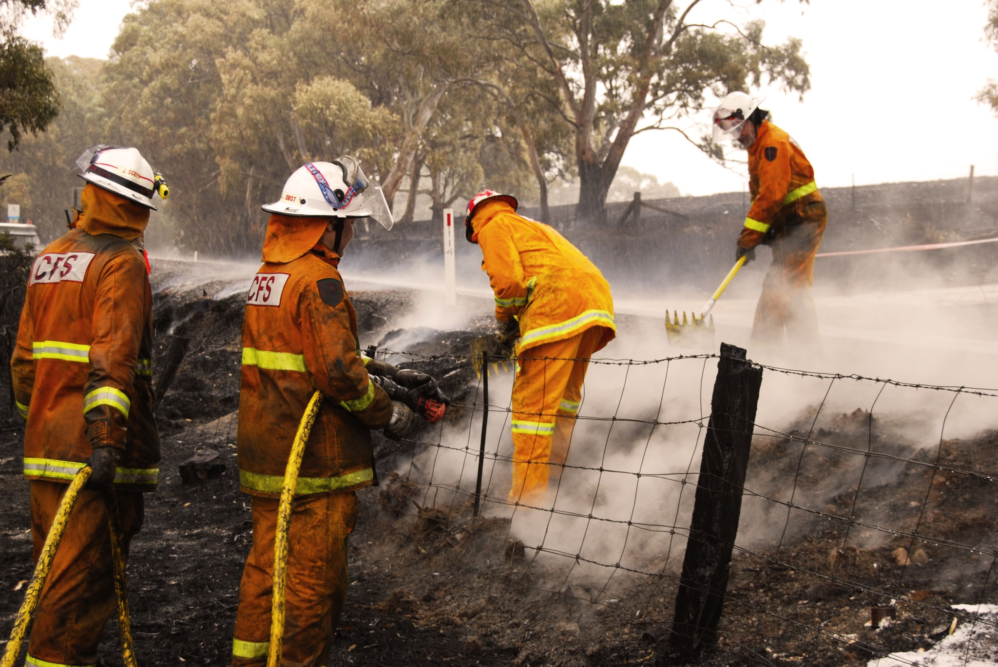

**From volunteering to paid employment: skills transfer in   
the South Australian Country   
Fire Service**

**Dr Mark Keough**

Meechi Road Consulting

### Publisher’s note

The views and opinions expressed in this document are those of the author/project team and do not necessarily reflect the views of the Australian Government, or state and territory governments or NCVER. Any interpretation of data is the responsibility of the author/project team.

P:\PublicationComponents\logos\Social Media\InBug-16px_0.pngP:\PublicationComponents\logos\Social Media\Twitter_blackbox.png

**© National Centre for Vocational Education Research, 2015**

G:\pub_prod\PublicationComponents\logos\Creativecommons\CC BY logo.eps

With the exception of cover design, artwork, photographs, all logos, and any other material where copyright is owned by a third party, all material presented in this document is provided under a Creative Commons Attribution 3.0 Australia <http://creativecommons.org/licenses/by/3.0/au>.

This document should be attributed as Keough, M 2015, *From volunteering to paid employment: skills transfer in the SA Country Fire Service*, NCVER, Adelaide.

The National Centre for Vocational Education Research (NCVER) is an independent body responsible for collecting, managing and analysing, evaluating and communicating research and statistics about vocational education and training (VET).

NCVER’s in-house research and evaluation program undertakes projects which are strategic to the VET sector. These projects are developed and conducted by NCVER’s research staff and are funded by NCVER. This research aims to improve policy and practice in the VET sector.

The views and opinions expressed in this document are those of NCVER and do not necessarily reflect the views of the Australian Government or state and territory governments.

COVER IMAGE: South Australian Country Fire Service

ISBN 978 1 925173 28 4

TD/TNC 121.11

Published by NCVER, ABN 87 007 967 311

Level 11, 33 King William Street, Adelaide, SA 5000  
PO Box 8288 Station Arcade, Adelaide SA 5000, Australia

**Phone** +61 8 8230 8400 **Fax** +61 8 8212 3436

**Email** [ncver@ncver.edu.au](mailto:ncver@ncver.edu.au) **Web** <http://www.ncver.edu.au> <<http://www.lsay.edu.au>>

**Follow us:** <http://twitter.com/ncver> <http://www.linkedin.com/company/ncver>

# About the research

From volunteering to paid employment: skills transfer in the South Australian Country Fire Service

### Dr Mark Keough, Meechi Road Consulting

This report is an outcome of research collaboration between the South Australian Country Fire Service (SA CFS), Government Skills Australia (GSA) and the National Centre for Vocational Education Research (NCVER). The project looked at the extent to which skills obtained in the voluntary sector are used and applied in the formal employment sector.

Key messages

* It is useful to have a local study to add to knowledge about volunteer recruitment, retention and training across Australia. The challenges are not uniform across the country. SA CFS brigades promote a strong sense of working together which, combined with opportunities for training and an interesting variety of work, have improved the climate for recruitment and retention in recent years.
* This research has shown that volunteers use skills gained through formal and informal vocational education and training in the public safety sector in other parts of their working life. This transfer is recognised most strongly by the volunteers/employees themselves. It also reveals that resources for training are limited and therefore focused quite rightly on operational skills, with formal recognition of more generic, albeit valuable, skills such as leadership, management and team work not possible.
* Volunteering provides career development opportunities for SA CFS volunteers, especially younger ones. The latter often choose to participate in community emergency services groups as a pathway to gaining employment, as well as to contribute to their community and build personal skills and self-esteem.
* Recognition systems that support local learning outcomes in semi-formal, peer and informal settings would bring many benefits, in terms of recruitment and retention of volunteers but also in revealing skills such as leadership and management that reside in a local community.
* There are clear linkages between public safety programs and other industry qualifications pertinent to, for example, skills needed in Agriculture; Food and Forestry; Mining; Public Administration and Safety industries. Greater effort to identify the synergies could provide a wider funding base for public safety volunteer training. Enhanced training opportunities would further strengthen retention and participation incentives, particularly in communities further away from the main population centres.

Dr Craig Fowler  
Managing Director, NCVER

# Acknowledgments

**The author would like to acknowledge the following people:**

*Steering Committee members*

**Ann De Piaz (SA CFS)**

**Brendon Eden (SA CFS)**

**Serena Eales (SA CFS)**

**Lee Watson (SA CFS)**

**Janine Fletcher (SA CFS)**

**Karen Taylor (GSA)**

**Sandra Lunardi (AFAC)**

**Judy Gouldburn (AFAC)**

**Phil Loveder (NCVER)**

*Research assistance*

**Kim Arnott (GSA)**

**Bethany Keough**

**Emily Bird**

**Kristen Lawler**

P:\PublicationComponents\Icons\PaperClip_CorpBlue.emfP:\PublicationComponents\Icons\References_LightBlue.emfP:\PublicationComponents\Icons\2-way-arrows-people_purple.emfP:\PublicationComponents\Icons\Cogs_Green.emfP:\PublicationComponents\Icons\SummaryOfTheResearch_corpblue.emfP:\PublicationComponents\Icons\Book_Lightblue.emfP:\PublicationComponents\Icons\PencilPurple.emfP:\PublicationComponents\Icons\Intro_Green.emfP:\PublicationComponents\Icons\ExecutiveSummary.emfContents

Tables and figures 7

Executive summary 8

Introduction 10

Overview of training provided by the SA CFS 10

Research methodology 14

Research design 14

Data collection methods 14

The state of volunteering in Australia: what the literature is saying 16

Emergency service volunteers 17

Reform of the sector 18

Findings 21

Findings from industry consultation 21

Findings from the employer interviews 26

Findings from the volunteer survey 27

Analysis 30

Informal learning is highly valued but under recognised 30

Recruitment and retention is a focus of policy makers but funding   
training is the challenge on the ground 30

Accredited training and compliance courses add to job readiness 31

Volunteers bring diverse skills and qualifications to their volunteer service 31

Looking forward 32

References 34

Appendices

A Survey questions 36

B Employer telephone interview survey 38

# Tables and figures

## Tables

1 Percentage of employment in South Australia by ANZSIC code 23

## Figures

1 Common Competency Alignment of SA CFS course content to all nationally endorsed training packages 12

2 Alignment of CFS training to national endorsed training packages 13

3 Alignment of SA CFS course content to ANZSIC codes (division level) 22

4 Alignment of CFS nationally endorsed training to potential employment areas 23

# Executive summary

P:\PublicationComponents\Icons\ExecutiveSummary.emfVolunteers are an invaluable asset to Australian society. This report shows that the skills obtained by South Australian Country Fire Service (SA CFS) volunteers also contribute to the vitality of businesses and communities.

The SA CFS provides pathways for young people through its programs for cadets.

Put simply: a common complaint from business and industry is that employees entering the workforce are not ‘job ready’. They often lack the practical skills, maturity and workplace experience to perform well in their roles, leaving employers to fill the gap by providing training either at their own expense or with public funding.

In contrast, a new employee with previous experience as a volunteer in an emergency services organisation comes into the workplace with an understanding of teamwork, a demonstrated sense of community and responsibility, and an appreciation of the role of organisational culture, thus accelerating their emergence as an asset to their employer.

This case study of the SA CFS examined key factors in the resourcing and efficacy of training for volunteers. It was undertaken as a joint initiative of Government Skills Australia (GSA), the SA CFS and the National Centre for Vocational Education Research (NCVER).

The SA CFS delivers nationally endorsed and non-endorsed training to their volunteers, all funded from the annual operational budget it receives from the South Australian Government. It maintains a training centre at Brukunga in the Adelaide Hills and several regional training resources across the state. The SA CFS is a registered training organisation.

The research sought views through qualitative and quantitative sources, interviewing brigades, employers and key industry stakeholders – 242 volunteers responded to the quantitative survey.

The core hypothesis for this research was that SA CFS volunteers who trained under the Australian Qualifications Framework’s (AQF) Public Safety Training Package are taking skills and knowledge gained in roles as firefighters, trainers and incident managers into their paid employment. Formal transferrable skills revealed in the case study included safety and first aid, truck driving, equipment use (e.g. using a chainsaw), training and assessment. Such skills have valuable alignment with jobs in Agriculture; Food and Forestry; Mining; Public Administration and Safety; and Health Care and Social Assistance industry areas. Other generic skills acquired informally are in management, leadership, communication and logistics. The SA CFS training model is not funded to recognise these latter skills.

The data gathered also show that the SA CFS provides pathways for young people through its programs for cadets; the inclusion of SA CFS volunteering in the South Australian Certificate of Education for Years 11 and 12; and the provision of nationally accredited units in operational training. This is important given the need to recruit and retain new, younger volunteers in the emergency service sector.

The findings indicate that volunteers are more strongly aware of the benefits of SA CFS training to the workplace than their employers. Their skills acquisition and transfer have multifaceted, multi-directional benefits: volunteers who are drawn from a broad range of industries bring professional skills to the brigade and transfer knowledge among the volunteer cohort; they also take skills imparted during their volunteer experience back to the workplace and to their communities. Greater recognition of this process is warranted, especially in order to elucidate the overall gains for both employers and the community from the activities of the SA CFS as a learning organisation.

While volunteer recruitment and retention are major preoccupations within the Australian volunteer sector, these are not challenges for the SA CFS. Rather, it has constant difficulty in funding the operational training of new volunteers. Given evidence of mutual benefits for employers, employees, the SA CFS and local communities from volunteer training, this paper argues there is a need for greater policy consideration of how to create a wider funding base for public safety volunteer training by finding synergies with vocational training supported through the national training system.

# P:\PublicationComponents\Icons\Intro_Green.emfIntroduction

SA CFS volunteers are highly motivated, with waiting lists to join brigades in the populous and high fire risk areas on the metropolitan fringe around Adelaide.

This project examined the transferability of skills between emergency services volunteers in the South Australian Country Fire Service (SA CFS) and their employed workplace.

The hypothesis tested was that emergency services volunteers who undertake training under the Australian Qualifications Framework’s (AQF) Public Safety Training Package for their volunteer roles are using those skills and knowledge in their paid jobs or when seeking employment.

The literature indicates that with an ageing population and a difficult economic climate recruiting and retaining volunteers is becoming increasingly difficult. The offer of training and personal development has thus become not only an important recruitment and retention strategy for volunteers, but also a way to foster a culture of individual and community value in the volunteer position.

The importance of training as an incentive to volunteers is borne out in the case of the SA CFS, which does not have difficulty recruiting or retaining volunteers. It does, however, have trouble funding the operational training of new volunteers. That remains a constant challenge.

Much of the literature in the emergency services volunteering sector emphasises the need for retention strategies. This study indicates that SA CFS volunteers are highly motivated, with waiting lists to join brigades in the populous and high fire risk areas on the metropolitan fringe around Adelaide, and most rural SA CFS brigades remaining viable despite some towns losing population.

## Overview of training provided by the SA CFS

The SA CFS provides and funds nationally endorsed and non-endorsed training to their volunteers. It maintains a training centre at Brukunga in the Adelaide Hills and several regional training centres across the state. The SA CFS is a registered training organisation and also outsources some of its training to external registered training organisations.

The SA CFS training model has been developed on a risk-management approach. Appropriate levels of training are provided to individuals and brigades within regions based on considerations about the roles required within the teams and about the hazards facing each region. This approach ensures a more effective use of resources by maximising the return on the investment in training and enabling the best response to the risk for the communities.

Training is aligned to five families of job roles within the organisation:

* Firefighter
* Specialist
* Incident Management Team
* Operational Leadership
* Organisational Trainer

Nationally accredited units of study are organised into operational courses that deliver the skills and knowledge required by volunteers to undertake these roles. The courses consist of a combination of nationally endorsed units of competency or non-endorsed material needed to satisfy the requirements of the volunteer role within the SA CFS. The following nationally endorsed training packages are used:

* 22202VIC Course in Australasian Inter-service Incident Management System (AIIMS)
* AHC10 Agriculture, Horticulture and Conservation and Land Management
* BSB07 Business Services Training Package
* HLT Health Training Package
* PUA12 Public Safety Training Package
* TAE Training and Education Training Package

The courses listed below also accord with the national Standards for Fire and Emergency Cover (SFEC):

### Firefighter courses

* Basic firefighting
* Defensive fire suppression
* Rural fire suppression
* Provide first aid
* Operate and maintain chainsaws
* Navigate in urban and rural environments
* Frontline leadership
* Drive vehicles under operational conditions

### Specialist courses

* Operate breathing apparatus open circuit
* Hazmat combatant
* Road crash rescue
* Check installed fire safety systems
* Apply advanced resuscitation

### Incident Management team courses

* Australasian Inter-service Incident Management System (AIIMS)
* AIIMS Incident Management Exercise Program
* Incident Controller
* Planning Officer
* Operations Officer
* Logistics Officer

### Operational leadership

* Tactical command and leadership
* AIIMS Strike Team Leader and Sector Commander

### Trainer and assessor skill sets

* Enterprise trainer-presenting skill set
* Assessor skill set

Alignment since 2001 of these training courses with the VET Quality Framework (formerly the Australian Quality Training Framework) mean that participants are part of the national training system and have the capacity to align their skills to the relevant qualifications through credit transfer and recognition of prior learning (RPL). In addition to the training package in which the units of competency originate, these units are imported into and used by other training packages as depicted in the figures below. For example, the units of competency acquired by those becoming volunteer trainers appear in 31 training packages, while the unit of competency *Provide first aid* appears in another nine training packages, across a total of 116 different qualifications. This is not surprising given that first aid and workplace training are competencies required across a broad range of industries.

First aid and workplace training are competencies required across a broad range of industries.

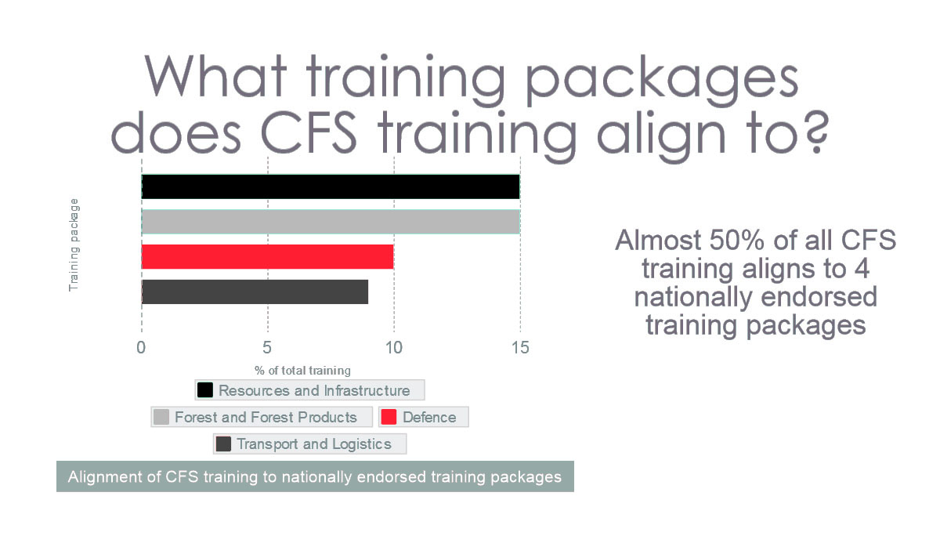Figure 1 Common competency alignment of SA CFS course content to all nationally endorsed training packages

Figure 2 Alignment of CFS training to national endorsed training packages

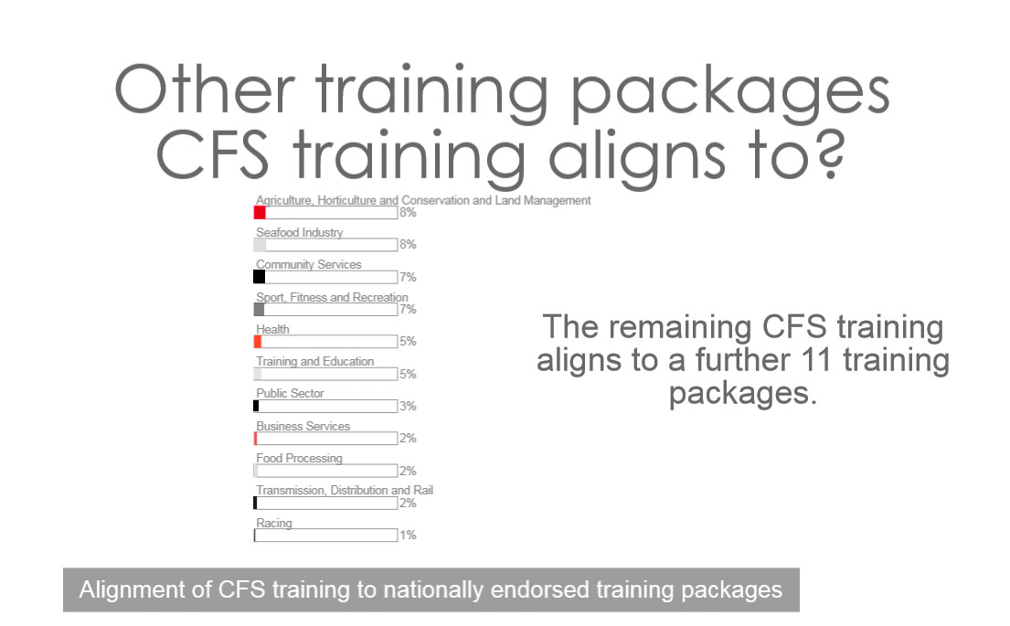

# P:\PublicationComponents\Icons\PencilPurple.emfResearch methodology

AFAC was able to provide invaluable insights from recent internal projects looking at Emergency Services, youth recruitment and development.

This research used a mixed-method approach to gather qualitative and quantitative data from a case study of the SA CFS. Its objective was to discover the types of knowledge and skills gained by SA CFS volunteers, and the extent to which these skills were transferred to a job or whether the skills and knowledge acquired as a volunteer enhanced a job seeker’s ability to gain employment.

The project was governed by a steering committee chaired by the SA CFS with representation from the SA CFS, NCVER and GSA as well as the Australasian Fire and Emergency Service Authorities Council (AFAC).

## Research design

The research combined quantitative and qualitative methods with a view to triangulating the data and enhancing the rigour of the research outcomes (Matthews and Ross 2010). Quantitative data collection methods are those that collect primarily structured data that can be represented in a numerical format (Matthews and Ross 2010). Qualitative data includes descriptive data represented through stories and anecdotal accounts that enable the analysis of opinions, feelings and beliefs.

## Data collection methods

### Industry consultation

The project partners formed a steering group to provide guidance and access to current industry thinking. The researcher was in regular contact with members of the steering group and key relevant staff at the SA CFS, GSA and AFAC. Formal consultations were held with AFAC and SA CFS senior training management staff.

AFAC is an industry peak body representing the emergency services sector. It develops and provides training materials for the Public Safety Training Packages and continuously evaluates volunteer training, recruitment and retention. AFAC was therefore able to provide invaluable insights from recent internal projects looking at Emergency Services training as a whole, as well as at youth recruitment and development. The key staff at AFAC also made observations about leadership and management development in the sector.

SA CFS key staff participated in a number of discussions out of which several of the key themes in this report emerged. They also provided valuable support by distributing the survey and by facilitating discussions with local brigades, all of which assisted in gathering a comprehensive picture of current circumstances.

GSA staff also provided valuable information and assisted with explaining the direct relationship between elements of the Public Safety Training Package and other training packages relevant to employers.

### Survey of SA CFS volunteers

The survey data was collected using an online survey tool. It was sent by email to 1600 SA CFS volunteers, all of whom had participated in public safety training and who were identified through contacts within the SA CFS. The survey was concise so as not to deter any time-poor potential participants. The response rate was 15% and the questions were based on the NCVER Annual Student Outcomes Survey for the VET sector relating to industry and occupation types in accordance with Australian and New Zealand Standard Industrial Classification (ANZSIC). See appendix A for a copy of the SA CFS volunteer survey questions.

### Semi-structured interviews with employers

Matthews and Ross (2010) define semi-structured interviews as a collection of interview question themes that may vary in length and wording to enable respondents to use their own words to answer a topic and discuss the elements of a topic that are most relevant to them (Matthews and Ross 2010, p.221). It allows for detailed anecdotal discussion that may lead to interesting and unexpected findings in a variety of settings.

To validate the findings of the survey, semi-structured interviews were undertaken with employers who have SA CFS volunteers working in their organisation and are aware of the training and skills they have accumulated throughout their volunteer experience. Participants were recruited by contacting employer organisations based on nominations made in the volunteer questionnaire. The interviews took no longer than 30 minutes. Ten completed the telephone interview. The interview questions were designed to evaluate how the volunteers’ skills have impacted their paid employment and if they had enhanced their employing organisation’s culture and productive output.

### Document analysis

The secondary research involved a review of information about the relevant training packages, and the relevant training population as a whole. This involved collecting, comparing and evaluating training programs, material and policy positions within the stakeholder organisations.

### Data analysis techniques

The survey question and style was a customised version of the NCVER annual training effectiveness survey. This survey conducted in May each year is designed to measure the transfer of vocational education training outcomes into the workplace. The quantitative data collected for this research was analysed using statistical software such as Statistical Package for the Social Sciences and Excel. Data was aggregated and interesting themes summarised.

The qualitative data was analysed using a thematic approach identifying common narratives obtained from differing perspectives.

The document analysis was undertaken in a thematic way, similar to the semi-structured interview approach, whereby documents were themed and sections compared using cross tabulation.

# P:\PublicationComponents\Icons\Book_Lightblue.emfThe state of volunteering in Australia: what the literature is saying

The most significant long-term threats to Australia’s volunteering sectors are economic and demographic.

Volunteering is ingrained in Australian culture; in 2010 our nation was ranked number three in the World Giving Index (Volunteering Australia 2012). While volunteers are an invaluable asset to Australian society and our economy, it is difficult to comprehensively measure total volunteer contributions, particularly those that occur informally. Volunteering Australia (2012) quantifies formal volunteering by means of time, skills or services willingly contributed by an individual through an organisation (Volunteering Australia 2012, p.8). Informal volunteering is the help provided through personal networks and family. Recent Australian Bureau of Statistics (ABS) data (2011), reported that 36% of Australian adults volunteered at home and abroad (ABS 2011).

In 2012 the State Government of Victoria, through the Department of Planning and Community Development, commissioned a report on the economic value of volunteering in Victoria (Ironmonger 2012a). This research suggested that the value of formal volunteers in Victoria in 2006 was $4.9 billion (excluding travel costs), an amount that had risen by over 50% from the 15 years prior. The report also suggested that men volunteered less than women, but men on average offered more of their time per annum than women. Informal volunteering reportedly offered even more value. In 2006, the value of informal volunteering in Victoria was estimated at $9 billion, a substantial increase from the 1992 value of $4 billion (Ironmonger 2012a, pp.4–5).

A similar study was commissioned by the Office for Volunteers, Government of South Australia (Ironmonger 2012b). It showed that from 1992 to 2012 the total contribution by volunteers, both formal and informal, to the South Australian economy had grown from $2.4 billion in 1992 to $4.9 billion in 2006. For the state, the contribution from volunteering to the gross product was 7.7% in 2006, comparably higher than that for Queensland and Western Australia (Ironmonger 2012b, p.3).

The most significant long-term threats to Australia’s volunteering sectors are economic and demographic. Declines in income security in light of recent global economic developments mean that there is less job and income security in Australia. This affects how much time and resources individuals are able to contribute to volunteering, and also managers’ inclination to allow workers time away from work to engage in volunteer activities, a requirement for emergency service volunteers. The ageing population, the increase in single parent families and the immigration of younger skilled workers from countries where formal volunteering is not traditional are all demographic factors which do not serve volunteer recruitment or retention well (McLennan 2004, pp.8–9).

In rural areas volunteer rates are much higher than in metropolitan areas ― some rural towns in Australia have reported rates of volunteering of up to 50% of the population. Salt (2012) suggests the reasons for this are twofold: because decreasing populations in many rural areas cause services to decline, the only way for these services to continue is through community-driven contributions; and secondly, because in a small town anonymity is almost impossible there is a greater sense of social obligation to volunteer (Salt, 2012).

Other demographic factors that influence an individual’s likelihood to volunteer are:

* Age – with older people, particularly those who are retired, offering the greatest number of hours to volunteer initiatives (Volunteering Australia 2012, p.7) and younger (18-32 year olds) people’s contribution increasing from 16% in 1995 to 27% in 2010 (Productivity Commission, 2010)
* Job status – with professionals and managers typically volunteering more than labourers
* Socio-economic status, educational level and other factors – with households receiving government pensions, people without a tertiary education, individuals with a disability and those who speak a language other than English at home being less likely to volunteer (Volunteering Australia 2012, p.7).

The ageing population will affect the retention of emergency service volunteers who have to undertake physically demanding tasks in some roles, such as that of the firefighter.

With the ageing population growing, and expected to almost double in coming decades, the volunteer sector will be heavily impacted. There is the potential for growth in volunteer contributions, which will come with a new set of challenges for volunteer management and recruitment, including the need for more flexible volunteering roles as well as for adaptation to the preferences and needs of older people, both as volunteers and as clients (Warburton and Paynter 2006, p.4).

Emergency service volunteers

Australia’s emergency services depend on volunteers a great deal. Any decline in their numbers could have negative economic and social impacts. A recent report by the Audit Office of New South Wales (2014) found gaps in the number of volunteers and of services needed by the state emergency service (SES) in many regions of the state. The report proposed a reform of recruitment and training priorities to address the decline in the number of SES volunteers in recent years. Similarly, in Victoria a 2014 audit of both the Country Fire Authority (CFA) and SES sector suggested that current emergency response capabilities were typically over-estimated and that there was a lack of clarity about how many volunteers were needed. One reason for this was the decentralisation of training management in Victoria, which meant that the training status and therefore current capability and capacity of volunteers were not fully visible on a state-wide basis (Victorian Auditor General 2014). In the case of South Australia, the SA CFS training is centralised and the systems convey close to real-time data. This allows the training gap in South Australia to be understood with greater clarity.

The ageing population will affect the retention of emergency service volunteers who have to undertake physically demanding tasks in some roles, such as that of the firefighter. This poses a problem given that in the past decade volunteer firefighters in Australia were already predominantly older, Caucasian males. There is potential to address this by attracting more females and people from culturally and linguistically diverse communities into this sector (McLennan and Birch 2006, pp.47–48) and more young people.

To recruit younger groups into the volunteer sector many organisations have been ‘selling’ volunteering as a means to engage with the community and make new friends; it is promoted as a way to develop skills to prepare for the workforce; it is seen to offer challenging and unique experiences, and travel opportunities; it also draws on the altruistic appeal of contributing to the community (Burns 2012). Flexibility is a key factor that appeals to youth who are often experiencing a busy period in their life, already full with study, change and decision making.

These selling points do not just appeal to the young – most people who become volunteer firefighters in Australia want to contribute to their community and society as a whole, and enjoy feeling like a valued member of the community. They also use volunteering as a mechanism for self-development and career enhancement, or to make friends and keep active, or to contribute previously acquired skills (McLennan 2008, p.9; Francis and Jones 2012, p.27). This suggests that skills learned in the formal workforce that can benefit the volunteer sector, and on the flip side, skills learned in the volunteer sector can be transferred back to paid employment and enhance career development. A 2006 study into the experiences of women in the SA CFS, for example, showed that a strong positive experience from training as well as satisfaction with the ability to learn new skills and foster personal growth assisted in retaining females (McLennan and Birch 2006, pp.15–16).

Climate change and increased occurrences of natural disaster, along with economic uncertainty, are affecting the demands on volunteers.

Pleffer (2010), writing about the service sector, suggests another retention strategy, namely integrating volunteers into the workforce of the organisation rather than segregating them from the paid employees. This would address people’s desire for recognition of their efforts:

The culture of managing volunteers needs to change significantly and reflect more of the practices and behaviours that are commonplace in the commercial working environment. (Pleffer 2010, p.8)

This points to the need for better management training and practice in volunteering programs. Another Service Skills Australia report on workforce development for volunteers in the services sector suggested that leadership development would have a flow-on effect on improving the volunteer sector by further mirroring the paid sector (Service Skills Australia 2010). This is echoed in research undertaken by the Bushfire Cooperative Research Centre (2008, p.2), which indicated that good leadership in brigades was one very significant factor in retaining volunteers.

Reform of the sector

In 2001 during the International Year of Volunteers the National Agenda for Volunteering initiated core objectives for guiding growth within the volunteer sector and enhancing its strengths. These objectives included making it easier for those who wanted to volunteer in less traditional ways.

One of the eleven objectives outlined in this agenda, ‘Excelling in Volunteering’, addressed learning and development opportunities for volunteers (Volunteering Australia 2012, p.3). This led to increased investment in leadership and management roles for volunteers, including funding for and access to training programs offered by external organisations.

The result has seen considerable change in volunteer management since 2001. A decade later, the *State of volunteering in Australia* report recognised the impact changing social and physical environment and rapid development of technology are having on the way that volunteering is defined and the platforms that engage volunteers (Volunteering Australia 2012, p.27). The report also acknowledged that climate change and increased occurrences of natural disaster, along with economic uncertainty, are affecting the demands on volunteers. The report calls for governments, corporations and education systems to engage further with the volunteering sector to mitigate the effects of these major shifts. Similarly, the increased scale and frequency of severe weather events has been highlighted as a key challenge to boosting volunteer retention (Office of the Emergency Services Commissioner 2008).

Even before this call, in 2009 the Ministerial Council for Police and Emergency Management endorsed the *National Action plan for the Attraction, Support and Retention of Emergency Management Volunteers* (Volunteer Action Plan Reference Group 2009). This document outlined the struggle to retain volunteers in light of socio-economic and demographic shifts. These challenges included pressures on people’s time; the availability and cost of training; and inadequate recognition of volunteers’ contribution, pointing to the need for improved leadership (Volunteer Action Plan Reference Group 2009; Esmond 2009). The action plan outlined ways to address these challenges and enhance the retention of volunteers. The plan proposed 11 core actions divided into three groups identified as top, medium and low priority.

The three top priority actions all related to management-oriented training and learning:

* Action 1: Enhance subsidies for volunteer training, activities and equipment
* Action 2: Enhance leadership training to support emergency management volunteers
* Action 3: Develop alternative learning approaches for emergency management volunteers.

In 2011, the National Emergency Management Volunteer Summit again underlined the importance of training. The summit included initiatives to streamline training and make it more accessible and flexible to volunteers, to incorporate e-learning that complements on-the-job and face-to-face training, and recommended that ‘leadership programs be increased and accessible to all emergency management volunteers’ and that ‘emergency management volunteer organisations be provided with necessary support to meet training compliance requirements’ (Commonwealth of Australia 2011, p.7).

In 2012, the federal Attorney-General’s Department undertook a stocktake of actions taken by jurisdictions to implement the 2009 plan. It found that at a national level a three-day leadership program had been developed for a broad range of volunteer leaders. This is now held twice a year in Victoria, with a supplementary remote leadership development program also now in place.

The stocktake also shows that the SA CFS responded to the leadership recommendations by developing a new leadership and training module, providing support and subsidies to encourage volunteers to attend the leadership training, and through the continuation of cadet training programs on leadership and life skills (Commonwealth of Australia 2012, p.14).

With regard to ‘Action 2’, on a federal level an off-campus leadership program was developed through the ‘Regional and Remote Volunteer Leadership Development Program’ to improve accessibility to training. With regard to ‘Action 3’, in South Australia the Training Management and E-Learning Project was developed under the E-mergency Connect program to support emergency services expand their models for learning and development. The project was linked to other programs aimed at improving email and internet access for volunteers. These enhancements are in addition to the simulated recovery training programs that have been offered in the state since 2003. These programs assist in the retention of volunteers who are enthused by experiencing real life simulation in addition to theoretical training (Commonwealth of Australia 2012, pp.19-20).

# P:\PublicationComponents\Icons\SummaryOfTheResearch_corpblue.emfFindings

Many young volunteers were considered to have strong community values and encouraged others   
to be community minded.

## Findings from industry consultation

### Benefits for younger people

During the consultation phases of this project, interviews with the key staff at AFAC and people in the two SA CFS brigades revealed that volunteering provided career development for all volunteers, especially younger ones. The latter often chose to participate in community emergency services groups as a pathway to gaining employment.

Those consulted also said the benefits of emergency service volunteering were articulated in the Youth Forum conducted by AFAC in March 2014, held with the assistance of National Emergency Management Project (federal) funding. The forum canvassed the views of a broad range of young people drawn from emergency services volunteers nationwide and found clear benefits in terms of career development and increasing community mindedness through comradeship, team forming, team building and skills development. The forum affirmed the varying attitudes of employers – some employers love having volunteers on their staff, some don’t. Several sources of anecdotal evidence reported during consultation with the key stakeholders suggest the ratio is about 50:50.

The positive narrative of emergency services volunteering for young and old people emerged clearly in respect to the way in which those consulted saw social fabric being formed and maintained. Those with the motivation to volunteer do so for altruistic reasons, especially when they live in high-risk areas where the direct benefit to them is clear and their volunteering has the practical benefit of maintaining the safety and integrity of their own families and assets.

Many young volunteers were considered to have strong community values and encouraged others to be community minded. Most were not primarily motivated by employment options that may arise from SA CFS volunteering, although many could articulate how their volunteer work had enhanced their career prospects. For many, there was the importance of being recognised in the community with SA CFS volunteering offering many opportunities to build and maintain self-esteem, and develop a sense of pride in the community.

Consultations with SA CFS staff, SA CFS volunteers and AFAC leaders consistently reported the benefits of the cadet volunteering program for future career paths and in the community. This program provides a range of introduction and orientation programs for young people in the latter years of their high school education. SA CFS cadets are able to include volunteering as a South Australian Certificate of Education (SACE) subject during Year 11 and 12. It was said that many young leaders including brigade captains had become long-term SA CFS volunteers through this path. For young people entering the workforce, SA CFS volunteering was seen to be a positive in their résumés. This was especially true for jobs in regional areas such as the forestry and freight industries. The skills and experience valued by employers included teamwork, job mastery (e.g. truck driving), understanding of organisational structures and cultures, workplace health and safety procedures, and first aid training.

To help address the problem of an ageing volunteer cohort, AFAC has produced a promotional video encouraging young volunteers to join the emergency services. The video promotes benefits to the next generation of volunteers, and particularly emphasises skills development and training. Young volunteers tend to place a greater value on formal recognition of skills and experience gained. Recognition in the community and an increased sense of self-worth and self-esteem can go hand in hand with the achievement of earning nationally recognised training. Consultations with AFAC representatives observed, however, that retention of younger volunteers became more challenging once these young people moved into the workforce.

Young volunteers tend to place a greater value on formal recognition of skills and experience gained.

### Transferability of CFS volunteers training to other industries

Consultation with GSA indicated that 88% of the training content the SA CFS used from nationally endorsed training packages had relevance to the following industries:

* Agriculture, Forestry and Fishing
* Mining
* Public Administration and Safety
* Health care and social assistance
* Transport, Postal and Warehousing
* 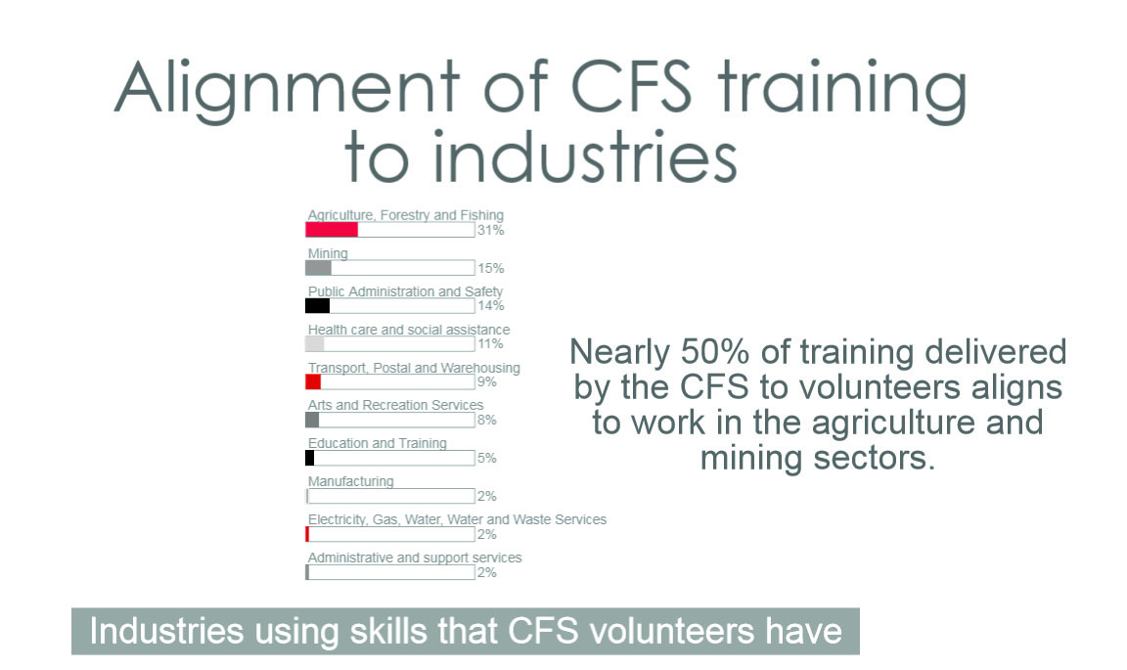Arts and Recreation Services.

Figure 3 Alignment of SA CFS training to industries

These industries account for 50% of total employment in South Australia summarised in table 1.

Table 1 Percentage of employment in South Australia by ANZSIC code

|  |  |
| --- | --- |
| ANZSIC Division | % of total employment in SA in 2012-13 |
| Health care and social assistance | 11 |
| Manufacturing | 10 |
| Administrative and support services | 8 |
| Agriculture, Forestry and Fishing | 8 |
| Education and Training | 4 |
| Transport, Postal and Warehousing | 4 |
| Arts and Recreation Services | 2 |
| Electricity, Gas, Water, Water and Waste Services | 1 |
| Public Administration and Safety | 1 |
| Mining | 1 |

Source: Australian Bureau of Statistics 2012-13.

This analysis supports the hypothesis that SA CFS volunteers who undertake training in their SA CFS role should be able to transfer those skills into a range of other industry sectors.

### Alignment of CFS volunteers’ training to other job roles

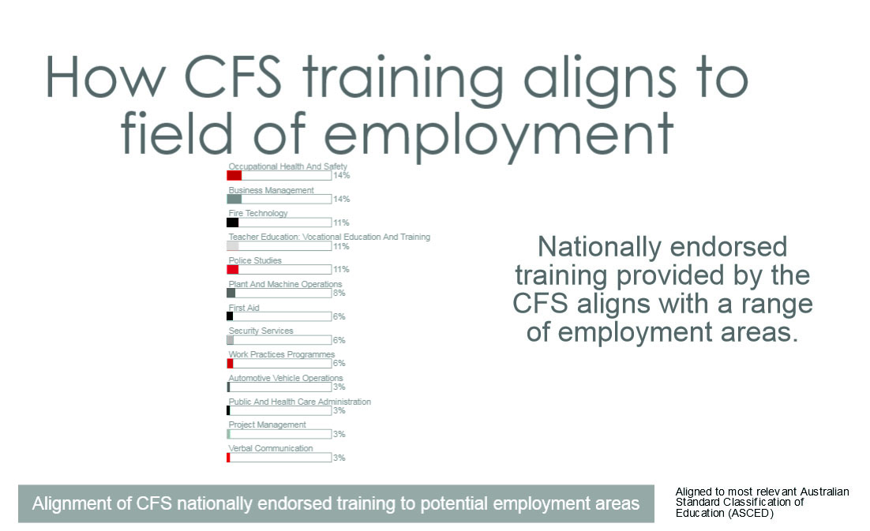As discussed earlier in the overview of training provided by SA CFS, their volunteers are trained to undertake roles within five different job families. Figure 4 illustrates the alignment of job roles to training packages.

Figure 4 Alignment of CFS nationally endorsed training to potential employment areas

This alignment indicates the capacity of the AQF to support formal transferability of skills. In this way SA CFS volunteers who acquire skills under the Public Safety Training Package are well placed to transfer that attainment to other industries, laying the groundwork for potential employment.

While the SA CFS does not offer frontline management qualifications, many SA CFS courses did contribute to frontline management skills development.

### Vocational benefits for volunteers

A primary challenge in retaining SA CFS volunteers who are also employed is the heavy time commitment and the degree of support or flexibility offered by the employer. All participants in the consultation phase mentioned the importance of having active support from employers, family or community to encourage volunteers to develop their skills. This includes pointing to the added benefits for their career trajectories.

It was reported that some volunteers felt that they could not disclose their volunteering activities to their employer because the employer might see SA CFS volunteering as disruptive to the productivity of the workplace.

On the other hand, it was noted that many employers had entirely the opposite view, and actively valued employees who demonstrated community mindedness and leadership skills. These employers saw the benefit to the community and were supportive of skills development in their workforce more generally. Anecdotal evidence was offered that in the mining industry SA CFS volunteers were particularly valued for their skills in safety and good communication in dangerous settings.

Those consulted were in no doubt that skills learnt as a SA CFS volunteer were transferable to the employment environment and had benefitted many employees in their business and/or working lives, whether they were employed full time, part time, self-employed or looking for work. Almost by definition, SA CFS volunteers demonstrated a high-level of commitment and responsibility. They needed to have the ability to work under pressure and remain calm in emergencies. Their work could be physically and psychologically challenging, especially for those in active firefighting roles. They often gained additional training in areas such as leadership, teamwork, communication, emergency management, first aid, cultural sensitivity and equal opportunity through accredited and non-accredited programs, as well as through brigade-based weekly meetings and field experience. It was acknowledged that recognition for informal training sessions was patchy at best, and further effort in recognising brigade-based learning would quantify even higher levels of community and economic benefit.

The consultation revealed that SA CFS volunteers were exposed to a variety of different team leadership and operational leadership situations. While the SA CFS does not offer frontline management qualifications, many SA CFS courses did contribute to frontline management skills development.

At an elite level, SA CFS leaders developed increased assertiveness and radio communication skills. They were able to take command and give instructions in high-pressure situations. For example, someone who had the role of SA CFS captain tended to have more credibility and authority in other work environments. More intangibly, volunteering could result in improved interpersonal relationships and a greater connection with community.

One of the main issues surrounding the formal recognition of SA CFS volunteer training mentioned was lack of consistency. The nationally endorsed Public Safety Training Package was released for the first time in 2000. Prior to 2000 training was non-accredited, with much variation in the content and quality of training provided. Training did align with AFAC National Fire Modules (the predecessor to the Public Safety Training Package) and was appropriate for its time. However, with no formal recognition against the National Training Framework, localised sign-off on skills gained and subject matter covered led to potential inconsistencies in education standards. In response to the findings of the State Coroner on the Wangary (Eyre Peninsula) bushfire in 2005, training of volunteers became more standardised. To enhance safety, consistency in evidence-based assessment of capabilities and risk profiles was introduced. Today the Public Safety Training Package (driven by industry) facilitates collaboration between jurisdictions ensuring a national approach is continuously improved.

Firefighters cross jurisdictions regularly. To do this they must meet minimum national training standards. One person described this nationally accredited training, based on the national Australasian Inter-service Incident Management System (AIIMS) standard for incident management, as a national passport.

Brigade members observed that skills gained through the SA CFS such as first aid, chainsaw use and truck driving contributed to safe and productive working lives in other employment.

Professional certification for continuing development in leadership and communication was also considered desirable, but it is currently beyond the scope of the SA CFS training resources. The priority focus was to have enough volunteers trained in operational skills to allow them to respond to incidents. Volunteers were encouraged to take up opportunities for broader development and, where more opportunities available, it was thought there would be flow-on benefits to volunteers in their employment context.

The consultations with SA CFS brigades revealed that a blend of formal and informal training was used to ensure skills gaps were filled in situational priority areas. Recognition systems for skills already acquired and informal training were limited. For example, only 20% of the members at the two brigades visited had their chainsaw qualification. Brigade stakeholders delivered a strong message that further training and refresher courses were needed to maintain the essential skills required in firefighting (at the Gumeracha brigade only four volunteers had up-to-date first aid certificates). Furthermore, the brigade members observed that skills gained through the SA CFS such as first aid, chainsaw use and truck driving contributed to safe and productive working lives in other employment. Certification of these skills would therefore be useful to people’s efforts in the CFS and in their day-to-day employment.

The brigades saw social capital and direct economic benefit as tangible benefits that volunteers bring to the community. An example given was SA CFS volunteers assisting at Adelaide’s Clipsal 500 motor race, which relies on 80 to 100 Fire and Rescue Marshals for the safe conduct of this important contributor to the South Australian tourist economy.

During brigade visits many members described how SA CFS training and their role as volunteers contributed to their workplace careers. They cited pertinent qualifications such as the Certificate IV in Training and Assessment and the Assessor Skill Sets, which had direct applicability across a broad range of industry settings.

### Training trainers and assessors

The SA CFS provides training for a significant number of formal assessors and trainers in three tiers:

1. Instructors and subject-matter experts for non-accredited training, who require no formal qualifications.

Brigade members reported that the time commitment for training was significant, especially training that involved a full weekend.

1. Enterprise trainers/assessors, who undertake five units of the Certificate IV in Training and Assessment. This skillset is recognised as the minimum required to assess competence under the relevant training packages.
2. Lead assessors, who require a Certificate IV in Training and Assessment and who provide a supervisory role for enterprise trainers/assessors. Enterprise trainer/assessors or lead assessors undertake all accredited training.

All stakeholders consulted through qualitative interviews indicated that brigade members in the course of their paid employment regularly use these qualifications.

### The climate for training

Organisational stakeholders reported significant unmet demand for training to keep up with operational requirements. This unmet demand was caused by lack of funding and volunteers to participate.

Brigade members reported that the time commitment for training was significant, especially training that involved a full weekend. Most volunteers were willing to undertake weekend training, particularly if they could see a benefit not only for their SA CFS role but also for their working lives and the communities in which they live.

Capability gained through SA CFS participation and acquisition of accredited and informal skill sets in leadership and communication were recognised as contributing significantly to working life and the pursuit of career goals, as well as in community leadership. The benefits were, however, often intangible and as diverse as the employment circumstances from which volunteers were drawn. Volunteers spoken to included academics, teachers, small business operators and workers, tradespeople, mining contractors, defence workers and people not in the workforce for a variety of reasons. This narrative from the consultation is borne out in the survey data presented later in this report.

## Findings from the employer interviews

The researchers conducted telephone interviews with 10 employers of the SA CFS volunteers. The employers were identified from the 242 respondents to the online survey, 50 of whom indicated that their employer would be willing to undertake a telephone interview. From 20 phone calls initiated,10 employers gave their time for a short interview. The employer interview questions are detailed in the appendices.

The interviewees ranged from a large mining company to a large government agency to a rural food production enterprise, rural service providers and small businesses.

Two respondents indicated that SA CFS skills were directly responsible for employment and promotion opportunities for their staff. A further two respondents said that training undertaken at the SA CFS assisted in the day-to-day operations of their enterprise. Half of the respondents were positively disposed to the influence that involvement with the SA CFS had on their business.

Only one respondent expressed concern about the time away from the job required to respond to incidents, although like all the interviewees, they acknowledged the important role the SA CFS plays in the community and did support the involvement of their staff.

## Findings from the volunteer survey

The ‘Volunteer Skill Transfer to Employment’ survey was undertaken over three months in late 2014. The criteria for recruitment of survey participants included volunteers who had regular and ongoing volunteering hours with the SA CFS, and had participated in formal SA CFS training. Of the 1600 volunteers invited to participate, 242 CFS volunteers were recruited.

The survey’s objective was to improve understanding of the binary impact that paid employment has on the recruitment and retention of SA CFS volunteers and that SA CFS training in turn has on volunteers’ paid employment opportunities. The survey had 13 questions, with the first eight focused on the nature of participants’ paid employment.

One of the survey questions asked ‘Do you have a job of any kind?’ to which:

* 85.1% of the survey participants responded ‘yes work for payment or profit.’
* Further to that, 3.7% indicated that they worked in a family business for no pay, 1.24% indicated that they also worked in another volunteer role, 6.6% indicated that they were unemployed and not seeking work, and 2.5% indicated that they were unemployed but actively seeking work
* 77.7% of the survey respondents who indicated they were employed said they were a wage or salary earner, 7.1% indicated that they were self-employed with other employees working for them, 10.7% indicated that they were self-employed without any other employees and 4.5% indicated that they were not receiving wages for their work.

The focus of the fourth survey question was to determine where this employment was based. Of the 234 responses (some unemployed participants answered this question in regard to their volunteer employment), 44.5% indicated that their work was based in a metropolitan area and 55.6% said their work was based in a regional area.

The fifth question asked respondents to indicate which ANZSIC description best fit their employment. 234 participants answered this question (again, some respondents may have applied this question to their volunteer roles). Those industries with a response rate of greater than 5% were:

* Agriculture, Forestry and Fishing – 15.8%
* Tradesperson – 13%
* Public administration and safety – 10.7%
* These top three responses provide an insight into the industries that are compatible with SA CFS volunteering, or at least the demographic qualities of workers attracted to SA CFS volunteer work.
* Other services – 8.5%
* Professional, Scientific and technical services – 7.7%
* Education and Training – 7.7%
* Information, media and telecommunications – 6.8%
* Construction – 5.6%
* Retail Trade – 5.6%

The high percentage of full time workers underscores the challenges that volunteers confront in finding time for training.

Question six asked respondents to describe which out of eleven labels best described their position or role in their paid employment. 216 answered this question:

* 20.1% of respondents said ‘Manager/Team Leader’
* 18% of the respondents chose ‘Professional (e.g. Doctor, Lawyer, Teacher, Nurse)’
* 10% of the respondents said ‘Tradesperson’
* 10% said ‘Business Owner’
* 10% chose ‘Administration Worker (e.g. Clerical, Project Administrator, Finance, Call Centre)’.

Question seven asked for an indication of the specific employment role held by the employee. From the 239 responses received, textual analysis revealed over 27 common themes and phrases, indicating significant diversity. The most common employment themes were:

* Services – 14.6%
* Government – 7.5%
* Education – 5.9%

The remainder of the survey questions focused specifically on the relationship between paid employment and SA CFS volunteering roles. Question nine asked the respondents if they believed their employer or manager in their paid employment role would be willing to discuss skills transferred from volunteer experience and training, 30.5% answered yes to this question. Those who responded ‘yes’ were then asked to provide their contact details; 51 respondents provided contact details.

With a view to improving the understanding of the relationship between time and volunteer engagement or retention, question 11 asked how many hours each week they worked. Of the 218 respondents that answered:

* 76% indicated they worked more than 35 hours a week
* The high percentage of full time workers underscores the challenges that volunteers confront in finding time for training.
* 17.5% indicated that they worked between one and 35 hours a week
* 6.5% indicated that they were not currently working.

Question 12 delved further into the benefits sought through volunteer work, again with a view to gaining insight into the motivation to join and remain in volunteer roles. When asked what job-related benefits respondents felt they had received as a result of undertaking training at the SA CFS, a total of 138 respondents replied:

* 58% selected ‘other benefit’ and went on to describe this individually
* 24% of respondents felt SA CFS training had assisted them in gaining a promotion in their paid employment
* 19.6% of the respondents said they had gained employment as a result of their SA CFS training
* 17.4% indicated that they had an increase in earnings, likely due to a promotion of some kind
* 15.2% indicated that they had changed their job as a result of their SA CFS training
* close to 6% of respondents reported that they felt their SA CFS training had benefited, or enabled the set-up of, their own business.

The final survey question asked participants to indicate what qualifications they had attained, aside from their CFS training. A total of 204 participants responded to this question:

* 55% said ‘other compliance certificate (e.g. first aid, crane operator, forklift operator)’
* 34% selected certificate IV
* 32% said they had completed Year 12
* 30% said they had a university bachelor’s degree or higher
* 25.5% indicated that they had completed a certificate III
* 24% chose advanced diploma or diploma
* 18% said they had completed a certificate II
* 6% indicated they had completed a certificate I.

# P:\PublicationComponents\Icons\Cogs_Green.emfAnalysis

Recognition of prior learning and current competencies is a clear gap in the SA CFS, which has to give priority to formal training in essential operational skills.

The results of the research support the hypothesis that SA CFS volunteers who undertake training in their SA CFS role are able to transfer those skills into a range of other industry sectors. Analysis of the findings identified the following themes.

## Informal learning is highly valued but under recognised

From the survey data and the interviews with brigade members it is clear that informal learning is acknowledged and valued by volunteers, their peers and their employers because it enhances the volunteers’ participation in the workplace and community activities.

The common narrative from brigade interviews was that they undertake a lot of development in leadership, management, communications and logistics. This occurred on a weekly basis in semi-formal and informal settings including on-the-job peer training and support but was rarely formally recognised or indeed fully understood, given the diversity of skills acquired informally. The type of learning that took place included on-the-job leadership training where newer volunteers were partnered with experienced volunteers, and developed skills to communicate with the community through door knocking regarding an incident or making presentations to community groups and at community events.

Recognition of prior learning and current competencies is a clear gap in the SA CFS, which has to give priority to formal training in essential operational skills. Recognition systems that support local learning outcomes in semi-formal, peer and informal settings would bring many benefits in terms of recruitment and retention of volunteers but also in revealing skills such as leadership and management that reside in a local community.

## Recruitment and retention is a focus of policy makers but funding training is the challenge on the ground

Across Australia, considerable effort goes into engaging young people and encouraging their involvement in lifelong volunteering. In the SA CFS, some brigade members first become engaged through the recognition of SA CFS Volunteering as a SACE senior school subject. Youth programs are critical given the ageing volunteer force and competition for time from other influences. Those consulted in this project considered the maintenance of career relevance within volunteering was a key point of engagement for young people. Significant effort has already gone into youth engagement, though stakeholders report that links to other career paths could be stronger.

This could be achieved through the SA CFS training program, although brigade members indicated that the time commitment to training is a challenge, which calls for innovation in the way the training is delivered so that it fits with volunteers’ availability. Furthermore, current funding gaps mean there is a significant unmet demand for formal operational training. State-based funding is used to address gaps in essential operational training. Further funding for formal training in leadership, management and communications, which would appeal to volunteers at the brigade level, is not readily available.

While recruitment and retention has been a focus of policy makers, in the SA CFS most brigades reported an adequate flow of new recruits. The problem, according to the SA CFS, is less about overall numbers and more about trained volunteers who can undertake critical firefighting and rescue roles. The SA CFS’s challenge has been to resource the required training to maintain their operational requirement for trained volunteers and to formally recognise the other skills volunteers acquire. This suggests that the pattern of volunteer engagement is not the same across Australia, and that we need to identify the requisite retention, recruitment and training resource mix on a more local and situational basis. At the policy-making level this calls for a flexible approach which allows training providers to tailor their offerings to suit local circumstances.

## Accredited training and compliance courses add to job readiness

The volunteer profile is diverse in terms of employment types and prior education.

Employees who gained skills such as first aid training, truck driving or chainsaw use reported a very direct benefit in the day-to-day requirements of their job. Others reported that understanding workplace health and safety principles and having communication skills were generally beneficial, while others saw less tangible links to benefits from leadership development, general communication and team skills. Overall, around half of all employees saw direct links between volunteering and gaining a job or promotion.

Most employers saw the direct and indirect benefits of a commitment to SA CFS volunteering, for their business and their community. Two of the 10 employers mentioned SA CFS training had helped people gain a job or promotion and several said SA CFS training enhanced their day-to-day operations.

Employers interviewed consistently suggested that they saw the positive benefit being about their good corporate citizenship. Few saw the connection between volunteering, training and employment skills without first being prompted to do so. This suggests that more needs to be done within the volunteer sector itself to promote volunteers as ‘job ready’ to employers, and to better articulate the benefits of both hiring a volunteer and supporting their volunteering efforts.

## Volunteers bring diverse skills and qualifications to their volunteer service

The volunteer profile is diverse in terms of employment types and prior education. Many have university qualifications and a wide range of professions is represented in the employment profile.

In this context, skills transfer becomes a multi-faceted multi-directional benefit with volunteers bringing professional skills to the brigade setting, as well as transferring knowledge among the volunteer cohort. Greater recognition of this process is warranted within the National Training System, the primary funder of employment-related training, especially in establishing the overall gain in skills for both employers and the community through SA CFS as a learning organisation.

# P:\PublicationComponents\Icons\2-way-arrows-people_purple.emfLooking forward

The main reason community members join the SA CFS is to provide services to their community in times of emergency. In order to do that safely and successfully they must be well trained in operational skills, management, communication and leadership. Many volunteers become trainers and educators of others. Peer-based and on-the-job training is a core part of the SA CFS brigade culture. This volunteer workforce is not only a critical part of the public safety community infrastructure in South Australia but also a well-trained and skilled contributor to the economic and social fabric. When not responding to emergencies, the SA CFS is essentially a learning organisation.

While recruitment and retention are often identified as a challenge, the reality is that the SA CFS is able to attract sufficient volunteers.

A key motivator for volunteers is the way in which they work together with their communities. They value the comradeship that comes from volunteering with a diverse range of people. SA CFS brigades promote a strong sense of working together which, combined with opportunities for training and an interesting variety of work, have improved the climate for recruitment and retention in recent years.

Participation in the national qualifications framework is an essential means for maintaining the quality of all formal SA CFS training. Without this framework, standardised skill development and national co-operation would be very difficult. The framework also provides the basis for transfer of skills gained while volunteering into paid employment. Given the SA CFS is part of the national training system, it would seem prudent to look for opportunities to increase employers’ understanding of the value of this training to their industry. There are clear linkages between public safety programs and other industry qualifications but greater effort to identify the synergies could provide a wider funding base for public safety volunteer training. Enhanced training opportunities would further strengthen retention and participation incentives, particularly in communities further away from the main population centres.

This research has shown that volunteers use skills gained through formal and informal vocational education in the Public Safety sector in other parts of their working life. The evidence presented here indicates that this transfer is recognised most strongly by the volunteers/employees themselves. It also reveals that resources for training are limited and therefore focused quite rightly on operational skills with formal recognition of more generic, albeit valuable, skills such as leadership, management and team work not possible.

While recruitment and retention are often identified as a challenge, especially in the context of an ageing volunteer cohort, the reality is that the SA CFS is able to attract sufficient volunteers. What is missing is adequate funding for operational training and for training in broader skills, and for recognition services of non-operational training. The latter would be of benefit for people aged between 18 and 40 and career changers, who participate in the SA CFS as part of their post-secondary or post-graduate career plans. Such recognition would also make clear to employers the type of sought-after generic skills such as leadership and management that volunteers acquire. This could in turn encourage cooperative efforts in training.

However, such benefit would only accrue were there staff available to deliver the training. Under South Australian Government rules fulltime equivalent (FTE) staff numbers in the CFS are strictly controlled, meaning that many trainers are volunteers so there is not always a ready pool of qualified or available part-time and sessional trainers.

This case study had its focus on South Australian rural and outer metropolitan communities and employers. To gain a more comprehensive view of the factors affecting the volunteering sector and its links to paid employment would require investigations in other jurisdictions, and in both metropolitan communities as well as remote communities.

The findings from this study should encourage policy consideration of how formal transferability of training between the volunteers of organisations such as the SA CFS and employers of volunteers might be achieved. Transfer of skills of a technical and vocational nature, especially in safety and health, in vocational training and assessment, and rural industry skills, as well as in leadership and management, does take place. Further understanding of how and where these skills are best learned and where the benefits accrue could allow for a consolidation of the training and funding effort.

# P:\PublicationComponents\Icons\References_LightBlue.emfReferences

ABS (Australian Bureau of Statistics) 2011, *Voluntary work, Australia, 2010*, cat.no.4441.0, ABS, Canberra, viewed 4 August 2015, <http://www.abs.gov.au/ausstats/abs@.nsf/mf/4441.0>.

——2012—13, *Australian Industry 2012—13*, cat.no.8155.0, ABS, Canberra, viewed 28 October 2014, <<http://www.abs.gov.au/ausstats/abs@.nsf/mf/8155.0>>.

Auditor General Victoria 2014, *Managing emergency services volunteers*, Victorian Auditor General’s Report, Victorian Auditor General’s Office, Melbourne.

Audit Office of New South Wales 2014, *Management of volunteers*, NSW State Emergency Service, Sydney.

Burns, T 2012, ‘Future boosting: attracting, engaging, retaining and developing young volunteers’*,* paper presented at the AFAC & Bushfire CRC Conference 2012 Perth, Western Australia, 28—31 August.

Bushfire CRC 2008, ‘Keeping your recruits: boosting volunteer retention’, *Fire Note,* issue 22, September*,* Australian Fire and Emergency Service Authorities Council, viewed 30 October 2014, <<http://www.bushfirecrc.com/resources/firenote/keeping-your-recruits-boosting-volunteer-retention>>.

Commonwealth of Australia 2011, *National Emergency Management Volunteers Summit 30—31 May 2011 — Summit report*, Attorney-General’s Department, Canberra.

——2012, *Summary of achievements: stocktake against priority actions identified for the attraction, support and retention of emergency management volunteers (NEMVAP, 2009),* Attorney-General’s Department, Canberra.

Esmond, J 2009, *Report on the attraction, support and retention of emergency management volunteers*, Emergency Management Australia, Canberra.

Francis, J & Jones, M 2012, ‘Emergency service volunteers: a comparison of age, motives and values’, *Australian Journal of Emergency Management,* vol.27, no.4, October.

Ironmonger, D 2012a, *The economic value of volunteering in Victoria*, Households Research Unit, Department of Economics, University of Melbourne.

——2012b, *The economic value of volunteering in South Australia*, Households Research Unit, Department of Economics, University of Melbourne.

Matthews, B & Ross, L 2010, *Research methods: a practical guide for the social sciences,* Longman Press.

McLennan, J 2004, *Recruitment and retention of volunteers: rural fire services issues and initiatives*, Report 1: 2004 for the Bushfire CRC, Enhancing Volunteer Recruitment and Retention Project (D3), La Trobe University, Melbourne.

McLennan, J 2008, *Issues facing Australian volunteer-based emergency services organisations: 2008—2010*, La Trobe University, Complex Decision Research Group, Melbourne.

McLennan, J & Birch, A 2006, *Survey of South Australian Country Fire Service women volunteers,* Report 1: 2006 for the Bushfire CRC, Enhancing Volunteer Recruitment and Retention Project (D3), La Trobe University, Melbourne.

Office of the Emergency Services Commissioner 2008, *Climate change and volunteerism:* *emergency services strategy project discussion paper,* Department of Justice, Melbourne.

Pleffer, A 2010, *‘Not ‘just a volunteer’: embracing concepts and approaches from the paid sector’,* Service Skills Australia, viewed 10 October 2014, <http://www.serviceskills.com.au/sites/default/files/National\_Conference\_on\_Volunteering-Not\_Just\_a\_Volunteer.pdf>.

Productivity Commission 2010, *Contribution of the not-for-profit sector,* Australian Government, Canberra.

Salt, B 2012, ‘Connection counts for those who put up their hands to help’, *The Australian*, 9 August.

Service Skills Australia 2010, *Workforce development for volunteers in the services industries*, viewed 31 October 2014, <<http://www.serviceskills.com.au/sites/default/files/volunteer-final.pdf>>.

Volunteer Action Plan Reference Group 2009, *National Action Plan for the Attraction Support and Retention of Emergency Management Volunteers,* Ministerial Council for Police and Emergency Management, Canberra.

Volunteering Australia 2012, *State of volunteering in Australia 2012,* Volunteering Australia, Canberra.

Warburton, J & Paynter, J 2006, ‘Barriers and benefits of volunteering for seniors’, *Productive Ageing*, Research Bulletin, vol.2, no.1.

P:\PublicationComponents\Icons\PaperClip_CorpBlue.emfAppendix A

## Survey questions

### Survey of SA CFS volunteers

#### Assumptions

Following the steering group meeting it is assumed:

* this does not need to be an anonymous survey
* we could preload the competency/qualification profile for each survey recipient.

#### Questions

1. What is your full name?
2. Do you have a job of any kind?

Yes, work for payment or profit

Yes, but absent on leave, on holidays, on paid leave, on strike or temporarily stood down

Yes, unpaid work in a family business

Yes, other unpaid work

No, I do not have a job

No, but I am seeking a job

1. On what basis are you employed?

Wage or salary earner

Conducting own business with employees

Conducting own business without employees

Helper, not receiving wages

1. Do you work in a metropolitan or regional area?
2. What industry are you employed in?

Choose from list or other (which?)

1. Which label best describes your employment position or role?

Business owner

Professional (e.g. Doctor, Lawyer, Teacher, Nurse)

Executive manager

Manager/Team leader

Administration worker (e.g. Clerical, Project administrator, Finance,   
Call centre operator)

Manufacturing or transport worker

Service worker (e.g. Carer, Cleaner, Labourer, Taxi driver)

Retail employee

Tradesperson (which trade)?

Other (which)?

1. If you are a wage or salary earner who is your employer?
2. What kind of business or services was carried out by your employer or your business in your main job?
3. How many hours do you usually work each week?

35 or more

1-35 hours

1. Which of the following job-related benefits do you feel you have received as a result of undertaking training at SA CFS (more than one can be ticked)

Got a job

Was able to set up/expand my own business

Change of job

A promotion (or increased status at work)

An increase in earnings

Other

1. Do you have any of the following qualifications aside from SA CFS training?

Bachelor’s degree or higher

Advanced diploma or Diploma

Certificate IV

Certificate III

Year 12 certificate

Certificate II

Certificate I

Other compliance certificate

1. Do you believe your employer would be willing to discuss skills transferred from your volunteer experience and training?
2. Who would be the best contact:

Role: Email: Phone number:

# P:\PublicationComponents\Icons\PaperClip_Green.emfAppendix B

## Employer telephone interview survey script

*I am calling today on behalf of the CFS. We are doing some research about the training we do with our volunteers. In particular we are asking the employers of volunteers a few questions about whether the training and involvement with the CFS enhances their work and standing with their employer.*

1. Did your employee’s involvement with the CFS help them get their job or gain a promotion?
2. Is there any specific training your employee has received through the CFS that has helped with their job/role?
3. Are there any other elements of their involvement that assists in their employment with you?
4. Are there any less helpful aspects of their involvement with the CFS?
5. Do you have any other comments you would like to make?

P:\PublicationComponents\logos\Social Media\Twitter_blackbox.pngP:\PublicationComponents\logos\Social Media\InBug-16px_0.pngP:\PublicationComponents\logos\NCVER LOGOS\WMF - word\No lines\NCVER_Floating_Blue.wmf

**National Centre for Vocational Education Research**

Level 11, 33 King William Street, Adelaide, SA 5000  
PO Box 8288 Station Arcade, Adelaide SA 5000, Australia

**Phone** +61 8 8230 8400 **Fax** +61 8 8212 3436

**Email** [ncver@ncver.edu.au](mailto:ncver@ncver.edu.au) **Web** <http://www.ncver.edu.au> <<http://www.lsay.edu.au>>

**Follow us:** <<http://twitter.com/ncver>> <http://www.linkedin.com/company/ncver>