NATIONAL CENTRE FOR VOCATIONAL
EDUCATION RESEARCH

CONFERENCE PAPER

Youth transitions in Australia: lessons for
other countries?
Tom Karmel
National Centre for Vocational Education Research

Paper presented to the third International congress on Technical and Vocational Education and Training 13–16 May 2012, Shanghai

The views and opinions expressed in this document are those of the author/
project team and do not necessarily reflect the views of the Australian Government
or state and territory governments.

© National Centre for Vocational Education Research, 2012
With the exception of cover design, artwork, photographs, all logos, and any other material where copyright is owned by a third party, all material presented in this document is provided under a Creative Commons Attribution 3.0 Australia <http://creativecommons.org/licenses/by/3.0/au>.
NCVER is an independent body responsible for collecting, managing and analysing, evaluating and communicating research and statistics about vocational education and training (VET).
NCVER’s in-house research and evaluation program undertakes projects which are strategic to the VET sector. These projects are developed and conducted by NCVER’s research staff and are funded by NCVER. This research aims to improve policy and practice in the VET sector.
This document should be attributed as Karmel, T 2012, Youth transitions in Australia: lessons for other countries?, conference paper, NCVER, Adelaide.
TD/TNC 109.08
Published by NCVER, ABN 87 007 967 311
Level 11, 33 King William Street, Adelaide, SA 5000
PO Box 8288 Station Arcade, Adelaide SA 5000, Australia
P +61 8 8230 8400 F +61 8 8212 3436 E ncver@ncver.edu.au W <http://www.ncver.edu.au>
About the research
Youth transitions in Australia: lessons for other countries?

Tom Karmel
This paper was presented to the third International Congress on Technical and Vocational Education and Training 13—16 May 2012, Shanghai.
Compared with many countries, Australia has relatively few young people who are unemployed. The presentation examines the features of Australia’s education system and labour market to see the extent to which they contribute to this outcome. These features include: recent increases to the school leaving age and an emphasis on post-school education; the apprenticeship and traineeship system; the vocational stream of education within the schooling system; and the high proportion of students undertaking part-time work. It argues that there are two key factors behind Australia’s good performance in this area: high levels of post-school education with the consequence that there is not a large cohort of people in their mid-to-late teens flooding on to the labour market; and a flexible education system which gives individuals multiple choices. However, these factors are not sufficient and are unlikely to be effective without a strong economy — it is very difficult to absorb teenage and young adults’ labour in a depressed labour market.

Tom Karmel
Managing Director, NCVER

Contents
Tables and figures 6
Introduction 7
Context 7
Features of Australia’s education and training system relevant to
youth transitions 9
Final comments 14
References 15
Appendix A 16

Tables and figures

Tables
1A Education paths, males 11
1B Education paths, females 11
A1 Unemployment rate, unemployment-to-population ratio, males
aged 15—24 years, selected countries, 2010 16

Figures
1 Unemployment rate, unemployment-to-population ratio, males
aged 15—24 years, selected countries, 2010 7
2 Unemployment rates, males, 15 to 24-year-olds, Australia and selected countries, 1980—2009 8
3 The ratio of the unemployment rate of males, 15—24 years, relative
to that of males, 15—64 years 9
4 Gross enrolments rates in tertiary education, selected countries, 2008 10
5 Full-time education participation, Australia, 2009 10
6 Percentage of young people in full-time work, by age, Australia, 2009 11

Introduction
In this presentation, I first provide some context for looking at the way Australia handles youth transition, by looking at Australia’s youth labour market by comparison with other countries. I then briefly discuss the distinctive features of the Australian education and training system, as well as pertinent labour market issues. I end with some final comments.

Context
Recent data from the Organisation for Economic Co-operation and Development (OECD) indicate that Australia’s performance in managing youth transitions to the labour market is good, if we take youth unemployment as an indicator. Figure 1 takes two measures of youth unemployment for males aged 15—24 years: the standard unemployment rate (unemployed as a percentage of those in the labour force) and the unemployment to population ratio for some 35 countries).
Figure 1 Unemployment rate, unemployment-to-population ratio, males aged 15–24 years, selected countries, 2010
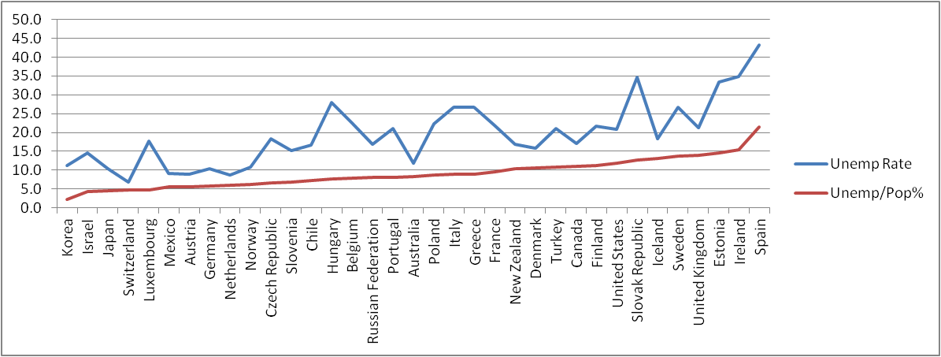
Note: Countries are sorted according to the unemployed-to-population ratio. The individual country data are shown in appendix A.
Source: <OECD.Stat>, viewed 23 April 2012.
As can be seen from figure 1, Australia by no means has the lowest youth unemployment but on both measures the level of unemployment is toward the low side. The reason for looking at the unemployment-to-population rate, rather than the more usual unemployment rate, is the confounding effect of education. If large numbers of young people are in full-time education, then the unemployment rate can give a very misleading view of the size of the problem of youth unemployment. For example, in the above figure, Hungary (point 14) has an unemployment rate of 27.9% but only 7.7% of young people are unemployed. By contrast, Sweden (point 31) has a youth unemployment rate of 26.7% but has 13.8% of young people unemployed, so is in a worse position than Hungary.
Figure 1 shows youth unemployment for 2010. However, the youth unemployment rate has changed very significantly over time, driven by both cyclical and structural economic factors. Figure 2 gives a time series view for Australia and a number of comparator groupings of countries.
Figure 2 Unemployment rates, males, 15 to 24-year-olds, Australia and selected countries,
1980–2009
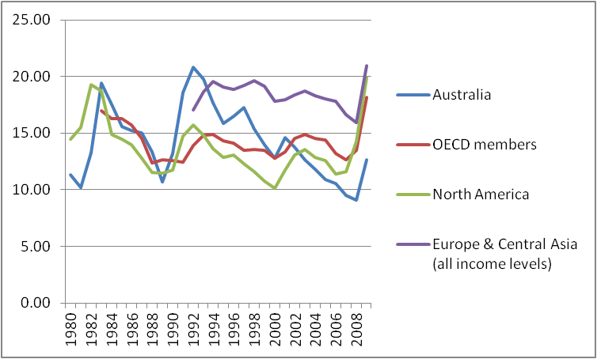
Source: World Bank, International Labour Organization, Key Indicators of the Labour Market database, <http://data.worldbank.org/indicator >, viewed March 2012.
We see that there have been points where Australia’s youth unemployment rate was high, in line with the experience of many countries. However, while Australia’s youth unemployment rate has increased over the time of the recent Global Financial Crisis, the increase has been relatively modest. Perhaps this is because of the emphasis that is being placed on education and training, particularly if a young person has not obtained a full-time job, although part of the reason may be due to Australia’s relatively good economic performance, driven by the resources sector (allied to economic growth particularly in China).
We should point out that Australia’s performance is middling in terms of the relationship between youth and total unemployment. In figure 3, we show the ratio of the unemployment rate for males,15—24 years to the corresponding rate for males 15—64 years for 2010. Interestingly, these ratios within countries are remarkably stable across time, suggesting that the rapid increase in youth unemployment rates is largely driven by macroeconomic labour market conditions.

Figure 3 The ratio of the unemployment rate of males, 15–24 years, relative to that of males,
15–64 years
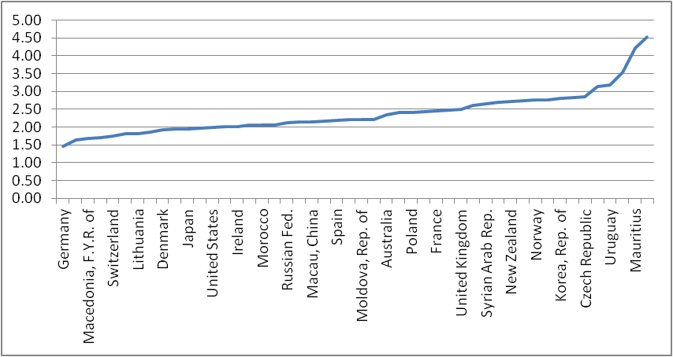
Source: Derived from International Labour Organisation 2012, Short-term indicators of the labour market, ILO, Geneva, viewed March 2012, <http://laborsta.ilo.org/sti/sti_E.html>.

Features of Australia’s education and training system relevant to
youth transitions
There are a number of features that I wish to discuss: the emphasis being placed on education and training; the apprenticeship and traineeship system; vocational education and training (VET) in schools; and the extent of part-time work among students.

Emphasis on education and training
It is an accepted fact in the Australian context that those with better educational qualifications have higher labour force participation rates and low unemployment rates than those with lower-level qualifications. This has been the fundamental underpinning of increases in the school leaving age from 15 and a push for higher-level vocational qualifications and new targets for the proportion of an age cohort with a university degree. It also has been behind the change in rhetoric from a singular focus on completion of school to a recognition that vocational pathways also have merit. So concepts such as ‘Year 12 (that is, school completion) or its vocational equivalent’ and targets incorporating Year 12 or certificate III (the vocational qualification that is the cornerstone of the vocational and education system) feature heavily in policy discussions.
Internationally, Australia now has a very high proportion of its population attending tertiary education of some description. Internationally comparable data are hard to get, but this point is made by gross enrolments rates in tertiary education compiled by UNESCO. Figure 4 shows where Australia sits internationally.
Figure 4 Gross enrolments rates in tertiary education, selected countries, 2008
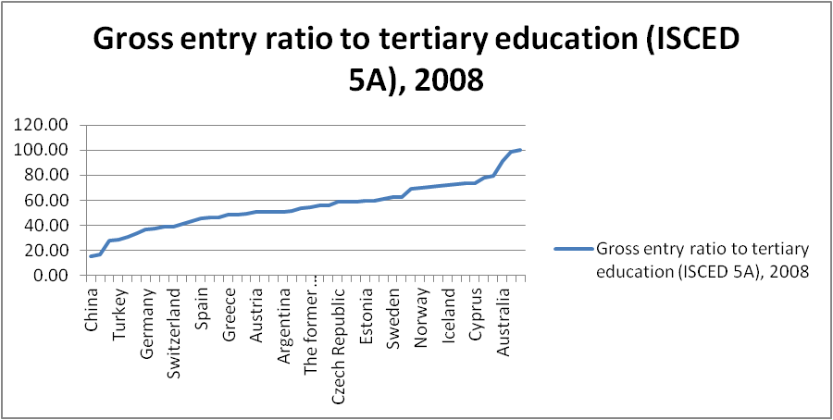
Source: <http://social.un.org/index/Youth/OurWork/Youthdevelopmentindicators.aspx>, viewed March 2012.
While one would not interpret these rates literally, they do indicate that Australia has a very high rate of tertiary education. Using more recent educational participation data (not readily available internationally), we see that the proportion of the population still in full-time education ranges from around 90% at age 16 years to around 20% at age 24 years (figure 4).
Figure 5 Full-time education participation, Australia, 2009
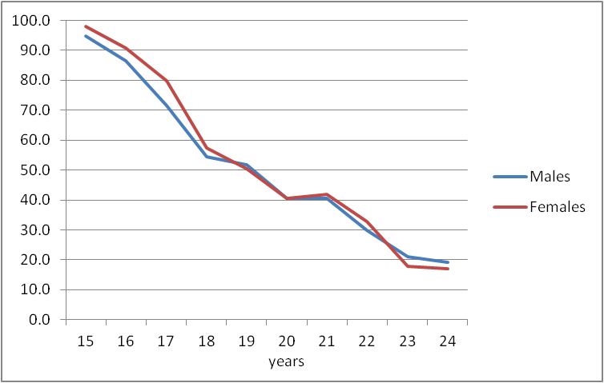
Source: Australian Bureau of Statistics 2009 Survey of Education and Training, basic confidentialised unit record file.
This high rate of educational participation has two impacts on youth transition. First, it reduces the number of young people competing for full-time jobs (taking full-time employment as the most obvious alternative to full-time study). Second, it means that the cohort of new entrants to the labour market is spread over the wider range of ages that would be the case if everyone entered the labour market immediately after reaching school leaving age, as can be seen from figure 6.

Figure 6 Percentage of young people in full-time work, by age, Australia, 2009
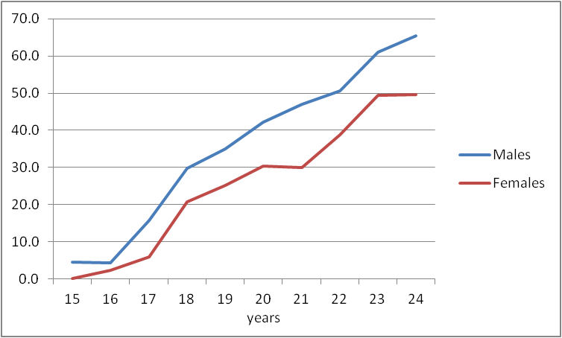
Source: Australian Bureau of Statistics 2009, Survey of Education and Training, basic confidentialised unit record file.
In fact in Australia there are a relatively large number of pathways from full-time education to the labour market. Karmel and Liu (2011) looked at the relative success of the various pathways, listed below in table 1. It is this range of pathways that creates the gradual transition to full-time employment.
Table 1A Education paths, males
Paths | Weighted % who  take each path by  age 25.5 in 2006
Early school leaver, no post-school study | 9
Early school leaver, apprenticeship | 5
Early school leaver, traineeship/other  post-school VET study | 5
Completed Year 12, no post-school study | 23
Completed Year 12, apprenticeship | 5
Completed Year 12, traineeship | 4
Completed Year 12, other post-school  VET study | 13
Completed Year 12, university study | 36
Table 1B Education paths, females
Paths | Weighted % who  take each path by  age 25.5 in 2006
Early school leaver, no post-school study | 9
Early school leaver, further post-school study | 5
Completed Year 12, no post-school study | 25
Completed Year 12, apprenticeship/ traineeship | 6
Completed Year 12, other post-school  VET study | 13
Completed Year 12, university study | 43
Source: Derived from the Longitudinal Surveys of Australian Youth; see Karmel and Liu (2011).
The point here is that Australia does not have ‘all its eggs in one basket’, although the two largest groups of new entrants are those who complete school and do not go on (at least at this stage in their life) to further study, and those who do go onto university. Apprenticeships and traineeships are also important, especially for males. While on some measures some pathways are better than others (for example, wages and occupational status at age 26), all pathways are equally effective in terms of employment at age 26. The conclusion from this is that, on the whole, Australia is relatively successful in effecting positive transitions from education to work, and there are not just one or two paths to such a successful transition.

The role of the apprenticeship and traineeship system
One of the paths available to young Australians is to undertake an apprenticeship or traineeship. In Australia these are built around a contract of training — a legal contract between an individual, an employer and a training provider. The apprenticeship or traineeship consists of on the job work experience and training, and formal off-the-job (in almost all cases) training delivered by a training provider. Apprenticeships in the trades have been part of Australia’s training system virtually forever, while traineeships were introduced in the 1980s in response to very high levels of youth unemployment (although numbers did not become significant until the mid-1990s). Apprenticeships are typically of three to four years’ duration, while traineeships are shorter, the majority less than two years’ duration. Apprentices and trainees are paid a training wage during the contract of training, and are often, but not necessarily, kept on by their employer after the contract of training has been completed. Certain subsidies are paid to employers who take on apprentices or trainees.
The most obvious benefit of apprenticeships and traineeships is the combination of training and working. The work element in effect means that the individual has made the transition into employment, while the training element is designed to provide the individual with skills that are valued in the labour market. The apprenticeship and traineeship model seems particularly good for individuals from a disadvantaged background. For example, Indigenous people are over-represented among apprentice and trainee commencements, relative to their share of employment, and outcomes for Indigenous people who complete an apprenticeship or traineeship are superior to those who complete an alternative vocational qualification (Karmel & Rice, 2010, pp.29—31).
While the model has many desirable features, it is not without issues. The first is that an apprenticeship or traineeship is dependent on an employer offering one. In times of economic downturn, employers typically take on fewer apprentices or trainees so that it is a pro-cyclical model. This implies that there is a risk of inadequately trained individuals after the economy has recovered from a recession — although it appears that this was not the case in respect of the recent downturn in Australia (see Karmel & Oliver 2011). One implication here is that it is probably useful to have more than one way of providing the skills, such as an institutionally based model. A second issue is that completion rates are not as high as are desired, especially in some occupations, raising questions about the efficacy of the model. A third issue is that the level of skills acquisition (at least as measured by the wages premium associated with completion) is variable across occupations, implying that there needs to be clarity about the objectives of the model — whether it is about skills acquisition or about getting individuals into jobs. These issues are part of the policy debate in Australia.

Vocational education and training in schools
A significant initiative is the introduction of vocational education and training in senior secondary schooling. Here, we are talking about undertaking certificates (mostly level II and some III) from the training packages designed to meet industry needs, rather than academic courses with a vocational orientation.
The motivation for this initiative is twofold. First, while the value of completion of school is generally acknowledged, there is a realisation that an academic pathway is not for everyone. A vocational stream is therefore aimed at those who are unlikely to be engaged with an academic approach. Second, the initiative is aimed at providing some familiarity with the world of work.
The numbers of students taking part in vocational education and training in school is very large, of the order 40% (NCVER 2010). However, the level of involvement by students is variable. For example, some undertake a school-based apprenticeship or traineeship, which typically would not be completed until the individual has left school (if completed at all). Others are academically oriented students who are interested in getting experience and a qualification in areas such as retail or hospitality, which will be helpful for part-time employment while at university.
As with any model, there are issues that are being grappled with. The first is the recognition of VET in schools as a legitimate form of training from the point of view of employers. In some areas, employers are unwilling to recognise training in a school environment — they argue that only training in a proper work environment is worthwhile. A second is whether VET in Schools is offering a high-level alternative to an academic stream. On this last point, I have argued that a certificate III, for example, is different from the completion of Year 12 and therefore needs to be thought of as an alternative rather than a literal equivalent (Karmel & Lim 2011).
In terms of whether the model has been a success, the outcomes typically considered are whether VET in Schools has led individuals to complete school and whether the model leads to better employment outcomes. The evidence is a little mixed. Some research I was involved with (Anlezark, Karmel & Ong 2006) suggested that the evidence that VET in Schools led to increased Year 12 completion was not compelling, while there was very strong evidence that those who had undertaken VET in Schools who left after Year 11 (the penultimate year of schooling) had far superior employment outcomes to their peers who left after Year 11, but who had not participated in VET in Schools. Presumably, the reason for this result is the work experience and contacts made during work placements as part of the vocational education at school. One of the design features of VET in Schools type programs that needs to be considered is when it is offered. It could be argued that such programs are more likely to keep students at school if they are offered during compulsory schooling. A further issue is the extent to which VET in Schools programs should be emphasising basic educational outcomes (although in a vocational context), as distinct from attempting to make students work-ready so that they can walk into a job fully trained. While the latter approach may be better in obtaining immediate employment, perhaps the former provides a better foundation for future skills acquisition.

Part-time work while in education
The final feature I wish to discuss is the prevalence of part-time work by full-time students, whether at school or attending tertiary education. It has been estimated that around 55% of school students in their latter years of schooling (Anlezark & Lim 2011, p.15) and 70% of tertiary students (ABS 2008) are undertaking part-time work. This proportion has been growing in recent years.
The benefits of part-time work are obvious. First, it provides income to help with the student’s living expenses (income support for students is means-tested for persons up to the age of 22 years). Second, it provides work experience with the positive social behaviours that go with it — punctuality, reliability, communication etc. However, there is a downside, with the research suggesting that too much part-time work has a detrimental effect on academic performance. Anlezark and Lim (2010) show that working up to ten hours a week has no impact on academic performance at school, while 20 plus hours has a clear and negative impact. Similarly, Polidano and Zakirova (2011) found that those who were working more than eight hours a week were less likely to complete their studies, with those working the most (more than 24 hours a week) being 14 percentage points less likely to complete.
Thus, for Australia at least, part-time work for full-time students can be taken to be a positive feature of the landscape, as long as the hours per week are modest.

Final comments
While one should always be prudent in assuming that what works in one country is transferable to another, the Australian education and training system and the labour market have two dominant features that appear to help youth transitions:
- high full-time participation in education, although this is only going to be effective if the labour market is demanding educated labour
- multiple pathways: apprenticeships and traineeships, and VET in Schools all offer a variety of paths to a successful transition. These, together with the high proportions of individuals going on to tertiary education, ‘spread the risk’ and also mean that young people entering the full-time labour market are spread across a range of ages. If one pathway does not work out for an individual, then there are options. (One of the very positive features of Australia’s tertiary education system is its ability to offer second chances.)
While both of these features are very important, one cannot forget the importance of the macro economy. If the labour market is buoyant, then it is relatively easy to absorb new entrants. However, if aggregate unemployment is very high, then it will be very difficult to construct models that deliver effective youth transitions.

References
ABS (Australian Bureau of Statistics) 2008, Year book of Australia, ABS, Canberra.
Anlezark, A, Karmel, T & Ong, K 2006, Have school vocational education and training programs been successful?, NCVER, Adelaide.
Anlezark, A & Lim, P 2010, Does combining school and work affect school and post-school outcomes?, NCVER, Adelaide.
International Labour Organisation 2012, Short-term indicators of the labour market, ILO, Geneva, viewed March 2012, <http://laborsta.ilo.org/sti/sti_E.html>.
Karmel, T & Liu, S 2011, Which paths work for which young people, NCVER, Adelaide.
Karmel, T & Oliver, D 2011, Effect of the downturn on apprentices and trainees, NCVER, Adelaide.
Karmel, T & Lim, P 2011, The vocational equivalent to Year 12, NCVER, Adelaide.
Karmel, T & Rice, J 2010, The economics of apprenticeships and traineeships, Commonwealth of Australia, viewed March 2012, <http://www.australianapprenticeships.gov.au/documents/ncverreport4.pdf>.
NCVER (National Centre for Vocational Education Research) 2010, Australian vocational education and training statistics: VET in Schools 2008, NCVER, Adelaide.
—— 2011, Australian vocational education and training statistics: students and courses 2010, NCVER, Adelaide.
Polidano, C & Zakirova, R 2011, Outcomes from combining work with study, NCVER, Adelaide.

Appendix A
Table A1 Unemployment rate, unemployment-to-population ratio, males
aged 15–24 years, selected countries, 2010
Country | Unemployment  rate | Unemployment/  population (%)
Korea | 11.2 | 2.3
Israel | 14.5 | 4.2
Japan | 10.4 | 4.4
Switzerland | 6.8 | 4.7
Luxembourg | 17.6 | 4.7
Mexico | 9.1 | 5.6
Austria | 8.9 | 5.7
Germany | 10.4 | 5.7
Netherlands | 8.7 | 6.0
Norway | 10.9 | 6.3
Czech Republic | 18.3 | 6.6
Slovenia | 15.2 | 6.8
Chile | 16.6 | 7.3
Hungary | 27.9 | 7.7
Belgium | 22.4 | 7.9
Russian Federation | 16.9 | 8.1
Portugal | 21.1 | 8.2
Australia | 11.9 | 8.3
Poland | 22.4 | 8.7
Italy | 26.8 | 8.9
Greece | 26.7 | 8.9
France | 21.9 | 9.5
New Zealand | 16.8 | 10.4
Denmark | 15.8 | 10.6
Turkey | 21.0 | 10.7
Canada | 17.1 | 11.0
Finland | 21.6 | 11.2
United States | 20.8 | 11.8
Slovak Republic | 34.7 | 12.6
Iceland | 18.3 | 13.1
Sweden | 26.7 | 13.8
United Kingdom | 21.2 | 13.9
Estonia | 33.5 | 14.5
Ireland | 34.8 | 15.4
Spain | 43.2 | 21.4
European Union 21 | 21.1 | 10.1
European Union 15 | 20.7 | 10.4
Europe | 20.7 | 10.1
G7 countries | 18.5 | 9.8
North America | 16.6 | 9.8
Oceania | 11.2 | 4.6
OECD countries | 17.6 | 9.1
Source: <http://stats.oecd.org>, labour force statistics, unemployment rate, males, viewed 23 April 2012.

The Council of Australian Governments agreed in April 2009 to implement a requirement which makes participation in education, training or employment compulsory for all young people until they turn 17 <http://www.coag.gov.au/ coag_meeting_outcomes/2009-04-30/index.cfm>.
It is acknowledged that this is a very crude statistic and will over-estimate the rate of educational pariticpation among young people to the extent that older persons attend tertiary education. This caveat is important for Australia, particularly in vocational education and training where over 55% of VET students are aged of 25 years or over (NCVER 2011).
The sample from the survey does suffer from attrition and most likely early school leavers are somewhat under-represented. Therefore the percentages against each path should be taken as indicative only.

