P:\PublicationComponents\logos\NCVER LOGOS\EPS - pagemaker_quark\ncver left tab_mono.eps

Understanding the nature of vocations today: exploring labour market pathways

Serena Yu  
Tanya Bretherton  
Johanna Schutz   
John Buchanan

Workplace Research Centre, University of Sydney

FOR CLARITY WITH FIGURES,  
PLEASE PRINT IN COLOUR

The views and opinions expressed in this document are those of the author/  
project team and do not necessarily reflect the views of the Australian Government,   
state and territory governments or NCVER.

Any interpretation of data is the responsibility of the author/project team.

### NATIONAL VOCATIONAL EDUCATION AND TRAINING RESEARCH PROGRAM

### **WORKING PAPER**

About the research

**© Commonwealth of Australia, 2012**

[Creative Commons License](http://creativecommons.org/licenses/by/3.0/au/)

With the exception of the Commonwealth Coat of Arms, the Department’s logo, any material protected by a trade mark and where otherwise noted all material presented in this document is provided under a Creative Commons Attribution 3.0 Australia <http://creativecommons.org/licenses/by/3.0/au> licence.

The details of the relevant licence conditions are available on the Creative Commons website (accessible using the links provided) as is the full legal code for the CC BY 3.0 AU licence <http://creativecommons.org/licenses/by/3.0/legalcode>.

The Creative Commons licence conditions do not apply to all logos, graphic design, artwork and photographs. Requests and enquiries concerning other reproduction and rights should be directed to the National Centre for Vocational Education Research (NCVER).

This document should be attributed as Yu, S, Bretherton, T, Schutz, J & Buchanan, J 2012, *Understanding the nature of vocations today: exploring labour market pathways*, NCVER, Adelaide.

ISBN 978 1 922056 23 8  
TD/TNC 109.31

Published by NCVER, ABN 87 007 967 311

Level 11, 33 King William Street, Adelaide SA 5000  
PO Box 8288 Station Arcade, Adelaide SA 5000, Australia

**P** +61 8 8230 8400 **F** +61 8 8212 3436 **E** [ncver@ncver.edu.au](mailto:ncver@ncver.edu.au) **W** <http://www.ncver.edu.au>

Understanding the nature of vocations today: exploring labour market pathways

### Serena Yu, Tanya Bretherton, Johanna Schutz and John Buchanan, Workplace Research Centre, University of Sydney

This paper is part of a wider three-year program of research, ‘Vocations: the link between post-compulsory education and the labour market’, which is investigating both the educational and occupational paths that people take and how their study relates to their work.

This paper uses data from the Household, Income and Labour Dynamics in Australia (HILDA) Survey to initially explore the movements individuals take through the labour market. The authors use the notion of ‘vocation’ — occupations with an underlying similarity of practice — as the basis of their analysis. An example of a ‘vocation’ is care work, which encompasses occupations such as nursing, aged care and childcare.

The paper focuses on four areas: financial services, primary industry, community services and healthcare, and trades and engineering.

Key messages

* Most workers spend long periods of time in one occupation. The authors call this occupational stasis, and it is particularly evident in the health sector.
* Labour market movements tend to follow three pathways:
* *High trajectory* pathways, which show upward movement through occupations and which are experienced more by those in professional roles. More defined occupational labour markets (that is, those that require registration) also have greater upward mobility
* *Low trajectory* pathways, which are characterised by high turnover and little movement into higher skilled roles. They are experienced more by sales workers and labourers
* Pathways of *marginal attachment*, which include periods in unemployment or not in the labour force. These pathways are experienced more by women moving in and out of the labour force, as well as by some older workers.
* There are entrenched social and labour market settings (that is, labour market segmentation), which make movement from low-skilled occupations to high-skilled occupations a rarity, even within a single vocational stream.

Tom Karmel  
Managing Director, NCVER

Contents

Tables and figures 6

Introduction 7

Methodology 11

Data 14

Results 16

Whole-of-sample analysis 16

Analysis of financial services 27

Analysis of primary industry 31

Analysis of healthcare and community services 35

Analysis of trades/engineering 42

Conclusion 48

References 50

Appendices

A 51

B 52

NVETR Program funding 54

# Tables and figures

## Tables

1 Characteristics of used and missing data (%) 15

2 Distribution of states, pooled waves 1—9 16

3 Prevalence of unchanging states 17

4 OMA clusters 17

5 Distribution of time by cluster (%) 21

6 Distribution of clusters by gender (%) 24

7 Distribution of clusters by age group in wave 1 (%) 26

8 Results of cluster analysis, financial services 27

9 Distribution of time by cluster, financial services (%) 29

10 Distribution of clusters by gender, financial services (%) 30

11 Results of cluster analysis, primary industry 31

12 Distribution of time by cluster, primary industry (%) 33

13 Distribution of clusters by age group in 2009, primary industry (%) 34

14 Results of cluster analysis, healthcare and community services (%) 35

15 Distribution of time by cluster, healthcare and community   
services (%) 38

16 Distribution of clusters by age group in 2009, healthcare and   
community services (%) 39

17 Results of cluster analysis, trades and engineering 42

18 Distribution of time by cluster, trades and engineering (%) 45

19 Distribution of clusters by age group in 2009, trades and   
engineering (%) 45

## Figures

1 Stylised vocational paths 13

2 Sequence plots by cluster, all sample waves 1—9 18

3 Sequence plots by gender 24

4 Sequence plots, financial services 28

5 Sequence plots, primary industries 32

6 Sequence plots, healthcare and community services 36

7 Sequence plots, engineering/trades 43

# Introduction

This working paper has been prepared as part of the National Centre for Vocational Education Research (NCVER) research program: ‘Vocations: the link between post-compulsory education and the labour market’. The research program’s central concern is to gain a more accurate understanding of the reality of vocational pathways, and in particular to understand the connections and disconnections between work and education. The concept of vocations is being used to structure the research. The question is whether a modern non-linear notion of vocations can help to provide insights into these relationships and whether it is useful in guiding the development of policies and institutional structures to strengthen occupational and educational pathways and the links between them.

A vocation emerges from fields of practice where there are commonalities; for example, the commonalities between nursing, aged care and childcare. The vocation is care work and it is located within a ‘care work’ vocational stream. Vocational streams consist of linked occupations within broad fields of practice, with the focus on the development of the person and on the the attributes they need and the knowledge and skills they require to work within a broadly defined vocation where educational and occupational progression are combined (Buchanan, Yu, Marginson & Wheelahan 2009). A vocation groups together related clusters of knowledge and skills that allow individuals to progress and/or specialise within a vocational stream, or to move laterally into linked occupations. It is based on a continuum of knowledge and skill that links work, vocational education and training and higher education and is premised on the capacity to accrue skills in a coherent, cumulative fashion (Buchanan, Yu, Marginson & Wheelahan 2009, p.29). A vocation fosters identification with the field of practice rather than with a specific employer or enterprise.

Vocations are underpinned by capabilities. The capabilities approach focuses on the conditions individuals need to make choices about their lives, engage in work and progress through a career. Capabilities link individuals, education and work by identifying the individual, social, economic and cultural resources that individuals need to develop as autonomous and innovative workers within broad vocational streams. Capabilities are differentiated from generic skills, employability skills or graduate attributes because they are not ‘general’ or ‘generic’. In the capabilities approach, the focus is on the development of the individual and on work, and consequently students need access to the knowledge, skills and capabilities for work in their vocational stream.

There are three strands in the project: the first focuses on entry to vocations and how to improve occupational and further study outcomes from entry-level vocational education and training (VET). The second focuses on the role of educational institutions in fostering vocations and how to improve occupational outcomes and educational pathways with VET and between VET and higher education. This working paper is part of Strand 3, which seeks to understand the presence of vocational pathways in core sectors of the Australian labour market, along with the institutional arrangements that support or inhibit them. The purpose of this paper is to empirically identify patterns of vocational mobility. Specifically, we ask the questions:

* How do individuals move into and through the labour market? Can these movements be characterised as vocational pathways?
* What are the commonalities in the trajectories of workers in the labour market?

Recent educational policy reforms in Australia emphasise improved linkages in the tertiary education sector, and between the education sector and the labour market. These have included:

* participation and attainment targets for post-compulsory education: these targets have been established to help improve the skills of Australia’s workforce and to support social inclusion. The sectors will need to work together to achieve these targets; fulfilling the targets for higher-level qualifications presupposes filling the targets for lower-level qualifications, as there will need to be a bigger pool of eligible entrants for the higher-level qualifications
* the implementation of student demand-driven funding models in VET and income-contingent loans in VET similar to those in higher education
* an overhaul of the Australian Qualifications Framework (AQF), including new requirements for credit and articulation arrangements
* the establishment of Skills Australia in 2008 as the organisation responsible for advising on Australia’s skills and workforce development needs and the implications for VET and higher education. Skills Australia’s role has been expanded and it will form the basis of the new National Workforce and Productivity Agency with a broader role in advising government, developing policy, and administering funding for industry-based training programs.

These reforms are all underpinned by the assumption that higher levels of education and training will both strengthen the Australian economy and deliver benefits to the individual worker. Improved pathways within the education system are said to support pathways into and upwards within the labour market. While much policy reform has been premised on the implicit assumption that education and training will provide greater mobility within the labour market, the nature of educational and labour market mobility and the connections between them are not well understood in the existing literature. Research in the area focuses on the nature of one particular event or transition (for example, from one level of education to another, school to employment, or employment to unemployment), but is relatively mute when considering a trajectory holistically. Other research in this field accepts a notional or hypothetical ‘availability’ of career pathways, but it is limited in its ability to test these pathways in relation to actual worker experience. For example, policy reforms designed to lift participation in higher education rates in areas of occupational demand (for example, nursing) are often assumed to produce changed outcomes in terms of labour supply (greater nurse availability and career mobility for graduates). Whether these outcomes eventuate however, has been difficult to test.

This working paper therefore contributes to the body of knowledge in a number of ways. It considers the way people actually use vocational pathways. There are no preconceived assumptions regarding groups of workers, their mobility or the availability of pathways. We argue that this approach offers unique insights because it asks whether common patterns in labour market participation and education can be observed between individual workers who each experience and make decisions about transitions in their employment and education life course. Finally, our analysis considers whether these longer-term patterns in labour market participation exhibit features which could be recognised as ‘vocational’ in nature.

This paper involves analysis of the work and study histories, spanning a period of nine years, of over 6000 individuals. The research used Optimal Matching Analysis (OMA) to examine data from nine waves of the longitudinal Household, Income and Labour Dynamics in Australia (HILDA) Survey   
(2001—09). The research was framed around pathways through four vocational streams: financial services, primary industries, community services and healthcare, and trades and engineering. The sectors have been chosen to represent a diverse cross-section of working life.

From the standpoint of the broader labour market and each sectoral case study, a number of interesting and common patterns emerged. Sequence analysis allowed clusters of activity to be revealed across and within these occupational groupings. We identified first and foremost that worker histories did not tend to be characterised by a sequence of occupational transitions moving from lower- into higher-skilled roles. The overarching theme of worker experience could be described as occupational segmentation. We have characterised this as occupational stasis, which we have described as:

* *Occupational stasis*: many individuals spend long episodes in the one occupation. This suggests they are unlikely to enter increasingly skilled roles, or engage in further formal study.

Despite some data limitations, the analysis shows clear limitations of flows between occupational segments. This is a key finding of this research strand thus far.

Further, we distinguished three broad pathways within each of the case studies:

* *High trajectory pathways*: these were characterised by access to high-skill work. Where upward occupational mobility is observable, this tended to occur in the higher-skill occupations, with clearer pathways from higher education studies to professional work, and from professional to managerial roles. These pathways are readily identifiable as vocational in nature and are evident across the different vocations, for example, amongst financial services professionals, health professionals and engineers.
* *Low trajectory pathways*:these were defined by entrenchment in low-skill work. ‘Mobility’ for those working in low- to semi-skilled roles such as labourers and clerical workers is characterised by significant turnover, with little movement into higher-skilled roles. These workers are likely to move frequently between these jobs, with little evidence of sustained career progression and with some spells in unemployment or outside the labour force. This was the case across the four vocations, affecting, for example, labourers on farms and those linked to the trades, as well as hospital cleaners and sales workers in financial services.
* *Pathways of marginal attachment*:this third pathway is characterised by time outside paid employment. This includes periods of unemployment, or not in the labour force. The term ‘marginal attachment’ is used to describe these pathways because they can incorporate periods of paid employment, but these episodes appear to occur on the ‘outskirts’ of the labour market — in low-skill, marginal positions, which appeared to offer no inroads to more stable or career-based work. Pathways of marginal attachment often affect women moving in and out of the labour force, as well as older workers with decreasing attachment to the labour market.

These different pathways point to some clearly different destination points for the workers identified in these clusters of activity. Greater upward mobility is apparent where occupational labour markets (and vocational pathways) are more clearly defined. Examples of more defined occupational labour markets may include registered or licensed professional and trades roles. A key explanation for this is that these occupations tend to be comprised of more highly skilled roles and are characterised by clear barriers to entry in terms of qualifications and training, with strong relationships between occupational/professional bodies and education and training institutions. By contrast, there is evidence that the lower reaches of the labour market are more fluid and directionless and are likely to be characterised by more fragmented institutional arrangements within the occupation itself, and between the occupation and education and training institutions.

While common themes arose across the different vocational streams, a high level of heterogeneity exists within the educational and labour market arrangements which underpin them. The results of this paper are therefore exploratory and will inform the next phase of our research. Phase two is comprised of qualitative research involving interviews with employees in each of the vocational streams. A qualitative method has been selected for the next phase to yield rich information about the mobility of individuals and the social and institutional factors which shape these labour flows.

# Methodology

This paper considers recent research into work and career histories, which has seen the growing popularity of sequence analysis. Sequence analysis seeks to empirically derive typologies of these career patterns for a more holistic investigation. This has included studies of class mobility (Halpin & Chan 1998), early-career patterns (Scherer 2001; Brzinsky-Fay 2007) and changes in labour force status (Pollock, Antcliff & Ralphs 2001). Even so, the potential individual narratives remain complex and are shaped by disparate institutional arrangements within the tertiary education system (for example, multiple curriculum models), within the labour market (for example, divergent forms of employment and wage setting) and within society more broadly (for example, changes in the participation of women in the workforce).

The research uses a technique called Optimal Matching Analysis (OMA), which was originally used in molecular biology and applied to DNA sequences. OMA is effective in the context of labour market and career research for a number of reasons. First, OMA allows some tracking of flows in and out of the labour market and between different occupational streams within the labour market. Second, the technique offers the ability to observe multiple transitions over the course of many years (rather than single events) and looks for patterns across these transitions. Third, it offers a more dynamic way to explore or present labour market experience which steps beyond static labels of worker experience (such as unemployed, or occupational group) or a survey, which can only reflect a ‘point in time’ observation of worker experience.

OMA was first used in the social sciences by Abbott and Hrycak (1990), who modelled the careers of German musicians. The methodology has the advantage of considering a sequence of transitions through a life course and is most suitable for a large number of sequences and a complex structure and ordering of states (Brzinsky-Fay 2007), as is typical of longitudinal datasets. While it is not a parametric statistical technique and does not produce predictive statements, it can be usefully applied to generate typologies of sequences (Halpin & Chan 1998). In reviews of the careers literature, Abbott and colleagues illustrate the usefulness of OMA in avoiding the difficulties (and assumptions) of traditional models in modelling a sequence of events, including multiple and/or repeated transitions, and the independence of a series of events (Abbott & Hrycak 1990; Abbott & Tsay 2000).

The methodology seeks resemblance in pairs of sequences, by calculating the minimum ‘elementary operations’ (or steps) to transform one sequence into another. For example, in the box below two individuals move between full-time work (F) and not in the labour force (N). An elementary operation involves inserting a different status, deleting a status, or substituting one for another. By a series of elementary operations, sequence 2 is transformed into sequence 1. The ‘distance’ between the two individuals is 4, the total insertions and deletions. Performing this process on every pair of individuals generates a distance, or similarity, between each pair. These steps are then weighted by a subjective cost[[1]](#footnote-1) and standardised, generating a distance matrix which measures similarity between every pair of sequences.

|  |  |  |  |  |  |  |  |
| --- | --- | --- | --- | --- | --- | --- | --- |
| Box 1 OMA elementary operations example | | | | | | | |
| Sequence |  |  |  |  |  |  |  |
| Individual 1 | N | F | F | F | F |  |  |
| Individual 2 | N | N | N | F | F |  |  |
| Conversion of 2 to 1 |  |  |  |  |  |  |  |
| Individual 1 | N | N | F | F | F |  |  |
| Individual 2 | N | N(del) | N(del) | F(ins) | F(ins) | F | F |

Cluster analysis is then performed on this matrix to classify the data into groups that minimise the smallest within-cluster variation while maximising between-cluster variation. Following previous studies, we have used Ward’s clustering algorithm. A detailed discussion of this and alternative techniques is provided by Abbott and Hrycak (1990), Pollock, Antcliff and Ralphs (2001) and Brzinsky-Fay (2007). We have implemented the methodology in STATA, using the *sq* package created by Brzinsky-Fay, Kohler and Luniak (2006).

For each individual, we have nine observations (one per wave in HILDA). We have defined the state space available to each observation as:

1. Studying at school
2. Studying for a VET qualification[[2]](#footnote-2)
3. Studying for a higher education qualification
4. Employed as a manager
5. Employed as a professional
6. Employed as a technician/trades worker
7. Employed as a community/personal services worker
8. Employed as a clerical/administrative worker
9. Employed as a sales worker
10. Employed as a machinery operator
11. Employed as a labourer
12. Unemployed (and not studying)
13. Not in the labour force (and not studying).

These states are assigned to each individual, in each year, based on their student status, labour force status and occupational status in each wave of the HILDA Survey.

The paper is set out as follows. Using OMA our initial focus was on deriving empirically meaningful patterns of individuals. These groups are characterised by distinctive trajectories through different states, such as movement from higher education study to professional occupations. It was instructive then to consider how these clusters spent their time in study and work, in relation to other variables such as gender and age. We then investigated in greater detail the trajectories experienced in a diverse set of vocations, namely, financial services, primary industry, trades/engineering and community services/healthcare. As a platform for our investigations, notional pathways were developed, against a null hypothesis that such progressions are accessible. These notional pathways are presented in figure 1. The null hypothesis was formed against a policy backdrop that prioritises an increasingly qualified workforce, the aim being a more internationally competitive and productive Australian economy. It asks two questions (by way of example). The first is: is it possible for an electrician to become an electrical engineer? And second: why or why not do electricians become electrical engineers? Some of these paths from low- to high-skill roles are more intuitive than others, and in some cases there is a well-known level of articulation between the occupational categories (for example, from enrolled nurse to registered nurse). In other cases, there is likely to be little occupational movement from one category to another.

The goal of the research is to empirically validate or invalidate these notional paths, and to thereby shed some light on the institutional arrangements (in both educational sectors and the labour market) which facilitate or inhibit such progressions. Despite the neat representation given in figure 1, it is not anticipated that these linear progressions characterise the lived experience of Australian workers, or that each transition is equally easy to achieve.

Figure 1 Stylised vocational paths

The quantitative analysis of this paper underpins the next stage of research — in-depth qualitative interviews with individuals in these vocational streams. This second stage of research will seek to find out the social and institutional factors which come to bear on the presence or absence of educational and labour market pathways.

# Data

This research has used data from waves 1 to 9 (2001—09) from the Household, Income and Labour Dynamics in Australia (HILDA) Survey, an Australian panel study which collects information about economic and subjective wellbeing, labour market dynamics and family dynamics. The survey commenced in 2001 with 19 914 individuals and 7682 households.

The key variables used were related to educational participation and attainment and occupational and industrial classification. A list of the variables used is provided in appendix A. The relevant classifications of these variables are provided by the Australian Standard Classification of Education (ASCED), the Australian and New Zealand Standard Classification of Occupations (ANZSCO) and the Australian and New Zealand Standard Industrial Classification (ANZSIC). The scope of a vocational stream is broader than occupational definitions and, as such, our samples were determined with breadth and simplicity in mind. This resulted in analysis mostly dominated by one-digit ANZSCO codes. A detailed description of this classification scheme and sample construction is provided in appendix B.

The OMA methodology requires complete sequences of work/study histories (Halpin & Chan 1998). Of the 11 260 in-scope individuals in wave 1 (under 65 years old and of working age), a total of 5234 (44%) were excluded due to attrition or incomplete sequences. This produced a sample of 6726 valid sequences for analysis. Studies in this area typically number only dozens, or hundreds of observations. One of the largest (Brzinsky-Fay 2007) analysed 3089 individuals across ten European countries. Since our focus is exclusively on sequences of categorical data, and the methodology does not involve the use of inferential statistics, we have used unweighted, unimputed data. This is strongly in accord with existing studies using OMA (Abbott & Hrycak 1990; Halpin & Chan 1998; Pollock, Antcliff & Ralphs 2002; Scherer 1999).

The advantage of OMA lies in its ability to identify typologies and patterns of career paths without prior knowledge or assumptions regarding what produces such patterns. Our treatment of partial responses (to remove the individual from the sample) is standard within the literature, but produces biased characteristics within the remaining sample. Table 1 details the characteristics of the data used and the missing data.

As we can see, key biases arise due to certain groups of individuals being more likely to be excluded from the sample. This includes males, those living in major cities, the young, and those with lower educational attainment. This treatment of missing data and attrition currently stands as a limitation to the OMA methodology *if* we seek to generalise our analysis to those of a representative population. Indeed, OMA is sensitive to sample variability and, as such, should be applied to as large a sample as possible. However, given the large sample size (particularly compared with existing studies using OMA), the analysis provides substantial insight into the movements of individuals into and through the labour market.

Table 1 Characteristics of used and missing data (%)

|  |  |  |
| --- | --- | --- |
|  | Used data | Missing data |
|  | N = 6726 | N = 5234 |
| **Gender** |  |  |
| Female | 54.1 | 49.4 |
| Male | 45.9 | 50.6 |
| **Location** |  |  |
| Major city | 61.5 | 65.0 |
| Regional Australia | 36.5 | 32.3 |
| Remote Australia | 2.1 | 2.7 |
| **Age** |  |  |
| Less than 25 years | 13.6 | 25.6 |
| 25–34 years | 21.4 | 22.5 |
| 35–44 years | 27.0 | 22.8 |
| 45–54 years | 22.2 | 17.4 |
| 55–64 years | 15.8 | 11.6 |
| **Educational attainment** |  |  |
| Bachelor or higher | 21.9 | 15.6 |
| Diploma/adv. diploma | 9.4 | 7.0 |
| Cert. III/IV | 17.9 | 17.6 |
| Cert. I/II or not defined | 1.6 | 2.1 |
| Year 12 | 14.6 | 17.8 |
| Year 11 and below | 34.6 | 39.9 |

In our review of the literature, we did not find any use of imputation models or more sophisticated treatment of partial responses (such as weighting). Studies have invariably drawn conclusions based on the profile of the sample, not the population. A further limitation with respect to the use of cluster analysis is that it tends to produce groupings even when meaningful structures do not exist (Halpin & Chan 1998). However, OMA is intended to be exploratory, producing analytically meaningful patterns without a suite of statistical tests or a prior hypothesis of any generating mechanism. Most critically, it allows for analysis of a series of transitions without the traditional statistical limitations associated with multiple and/or repeated events, or limited prior knowledge. It can therefore be used to enhance our understanding of the question at hand, while respecting the limitations of the sample.

It should be noted that missing data *were* included (but not imputed) for analysis of the four distinct vocational streams due to much smaller sample sizes (see page 27 onwards). In these analyses, a ‘black gap’ represents the missing data, and individuals have been included on the basis that available data (for example, 7 out of 9 years) are similar enough to other, complete sequences in its cluster. This is not the ideal use of OMA, which routinely demands complete sequences, and we have therefore not included missing data within the larger aggregate sample. However, the analysis was conducted both with and without these incomplete sequences, and it was found that the typologies derived in each instance were very similar. As the results for the vocational streams show, individuals with missing data often only have one or two observations missing within trajectories very similar to their cluster counterparts. Where sample sizes were much smaller we therefore resolved to present the data inclusive of this missing data.

# Results

## Whole-of-sample analysis

We begin with an overview of the sample based on individuals’ flows through the labour market and education. Table 2 gives an initial overview of the distribution of individuals (aged 18—64 years) across the 13 states in the dataset, pooled across all nine waves.

We observe that those not in the labour force (and not studying) and who are employed as professionals comprise the most dominant categories (24.5% and 17.6% respectively). The data show that only a small percentage of individuals in the sample were engaged in study, with less than 1% of the nine-wave sample being engaged in studying a vocational education and training (VET) qualification. Fewer than 3% reported studying a higher education qualification.

Table 2 Distribution of states, pooled waves 1–9

|  |  |  |  |  |
| --- | --- | --- | --- | --- |
| State | Description | Frequency | % | Cumulative % |
| 1 | Studying secondary qualification | 8 | 0.0 | 0.0 |
| 2 | Studying VET qualification | 401 | 0.7 | 0.7 |
| 3 | Studying higher education qualification | 1 756 | 2.9 | 3.6 |
| 4 | Employed as manager | 6 216 | 10.3 | 13.9 |
| 5 | Employed as professional | 10 638 | 17.6 | 31.4 |
| 6 | Employed as a technician/ trades worker | 5 316 | 8.8 | 40.2 |
| 7 | Employed as a community/personal services worker | 3 809 | 6.3 | 46.5 |
| 8 | Employed as a clerical/administrative worker | 6 837 | 11.3 | 57.8 |
| 9 | Employed as a sales worker | 2 812 | 4.7 | 62.4 |
| 10 | Employed as a machinery operator | 2 655 | 4.4 | 66.8 |
| 11 | Employed as a labourer | 3 737 | 6.2 | 73.0 |
| 12 | Unemployed (and not studying) | 1 498 | 2.5 | 75.5 |
| 13 | Not in the labour force (and not studying) | 14 851 | 24.5 | 100.0 |
|  | **Total** | **60 534** | **100** |  |

### The presence of occupational stasis

Our initial analysis considered broad study and labour force indicators and occupational categories   
(1-digit ANZSCO units). While we are interested in the nature of change and mobility, it is essential to note that the most commonly observed sequences saw individuals attached to a single state across all nine waves. Almost a third (27.4%) of the 6726 individuals sampled did not make a transition between study, employment, unemployment or occupational groups. One important caveat here, however, is that the data do not tell us if an individual changed employers, or moved from a junior to a more senior position within their occupational group, and therefore may understate labour market mobility.[[3]](#footnote-3) Nonetheless, table 3 is indicative of these prevalent sequences.

Table 3 Prevalence of unchanging states

|  |  |  |  |
| --- | --- | --- | --- |
| Sequence pattern | Frequency | % of total | Cumulative total % |
| Not in the labour force (and not studying) – all 9 waves | 749 | 11.1 | 11.1 |
| Employed as professional – all 9 waves | 400 | 5.9 | 17.0 |
| Employed as a clerical/administrative worker – all 9 waves | 188 | 2.8 | 19.8 |
| Employed as a technician/ trades worker – all 9 waves | 174 | 2.6 | 22.4 |
| Employed as manager – all 9 waves | 112 | 1.7 | 24.1 |
| Employed as a community/personal services worker – all 9 waves | 84 | 1.2 | 25.3 |
| Employed as a machinery operator – all 9 waves | 67 | 1.0 | 26.3 |
| Employed as a labourer – all 9 waves | 45 | 0.7 | 27.0 |
| Employed as a sales worker – all 9 waves | 30 | 0.4 | 27.4 |

The OMA analysis identified ten clusters. While the technique is most useful for deriving patterns of movement, it was in fact the stability of occupational segments which identified the clusters. The clusters were identified as per table 4.

Table 4 OMA clusters

|  |  |  |
| --- | --- | --- |
| Cluster | Description | N |
| 1 | Professionals | 1066 |
| 2 | Labourers | 356 |
| 3 | Machinery operators | 306 |
| 4 | Technician/ trades workers | 548 |
| 5 | Clerical/ administrative workers | 761 |
| 6 | Higher education study 🡪 professional | 367 |
| 7 | Sales workers | 364 |
| 8 | Community/ personal services workers | 471 |
| 9 | Managers | 786 |
| 10 | Not in the labour force | 1701 |
|  | **Total** | **6726** |

The trajectory of each of these clusters is shown visually in the set of sequence plots in figure 2. Each horizontal line represents the trajectory of one individual. We can see that, for most of these clusters, the similarity in trajectories was characterised by long episodes in the original state, or occupational group. Table 5 details how each cluster’s time was spent over nine years. Together the sequence plots and distribution table allow us to describe the trajectory of similar groups of individuals through occupational labour markets.

An inspection of these sequence plots shows that the experience of some clusters is much more heterogeneous than others, as individuals move from study to work, or between occupational groups.

Figure 2 Sequence plots by cluster, all sample waves 1–9

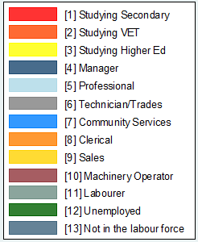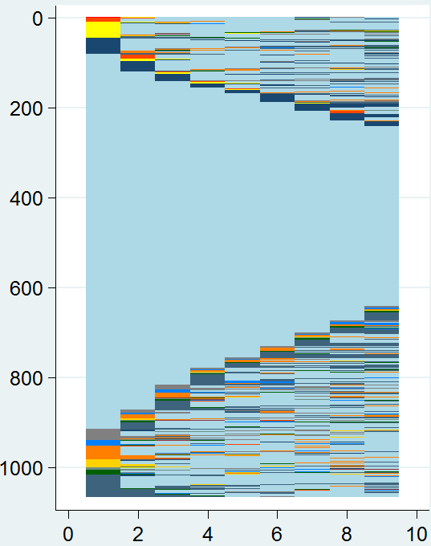 Cluster 1: Professionals

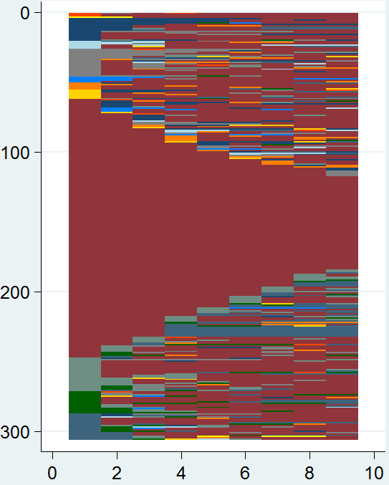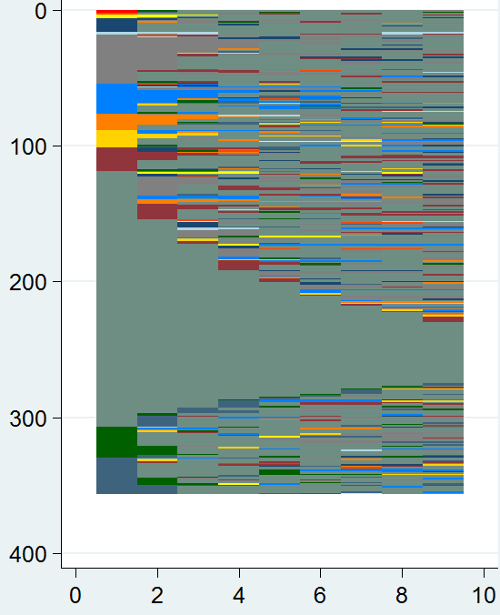Cluster 2: Cluster 3: Machinery operators

Figure 2 (continued)

Cluster 4: Trades workers Cluster 5: Clerical workers

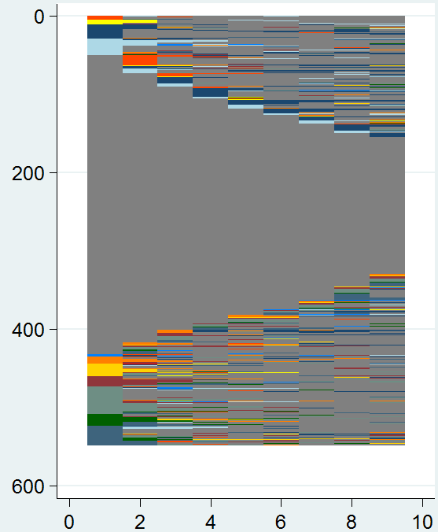 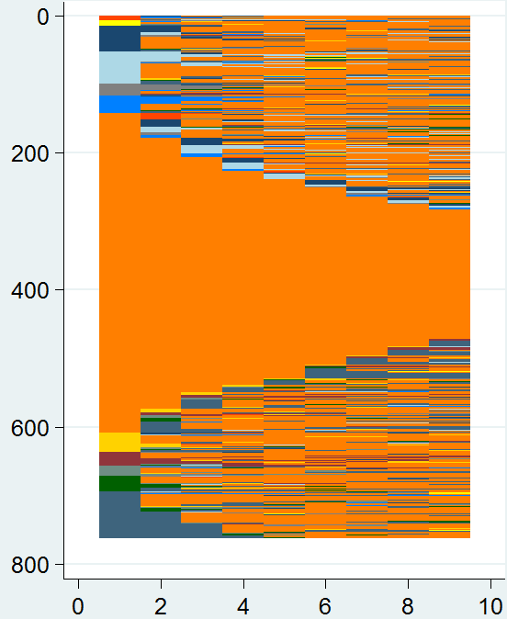

Cluster 6: HE🡪 Professional Cluster 7: Sales workers

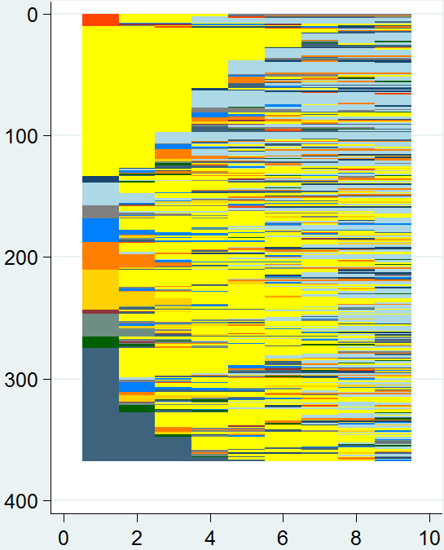 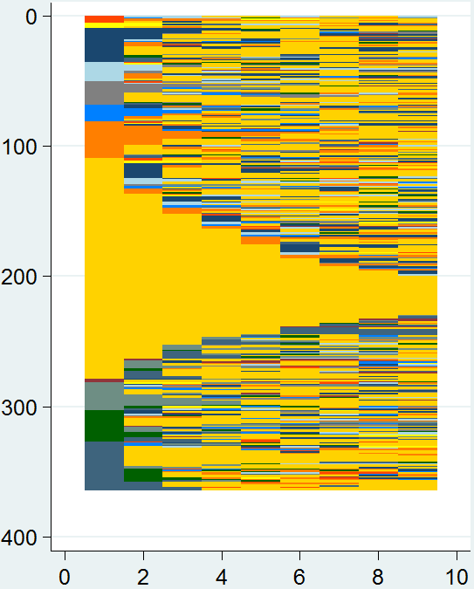

Cluster 8: Community service workers Cluster 9: Managers

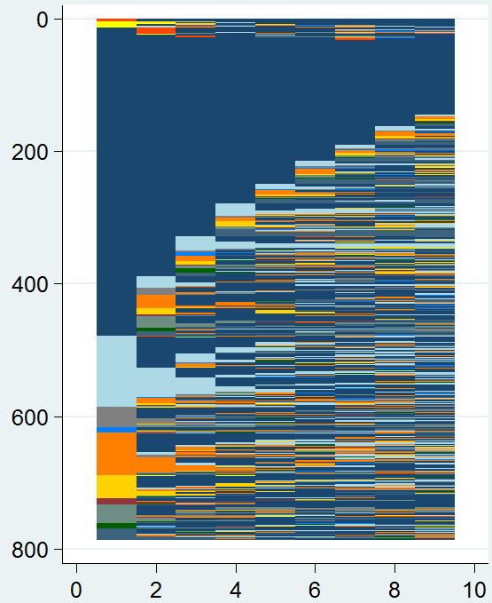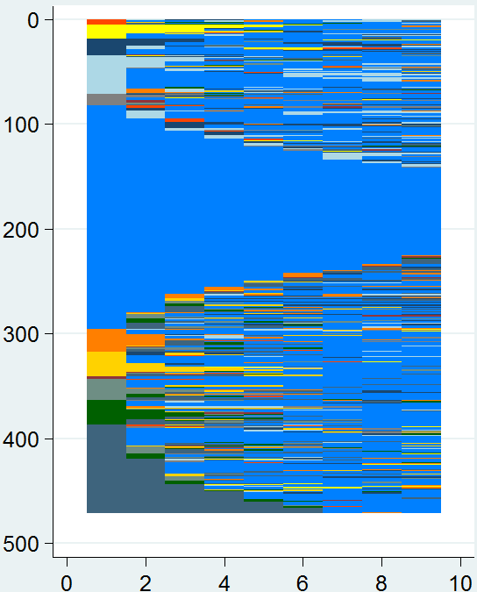

Figure 2 (continued)

Cluster 10: Not in the labour force

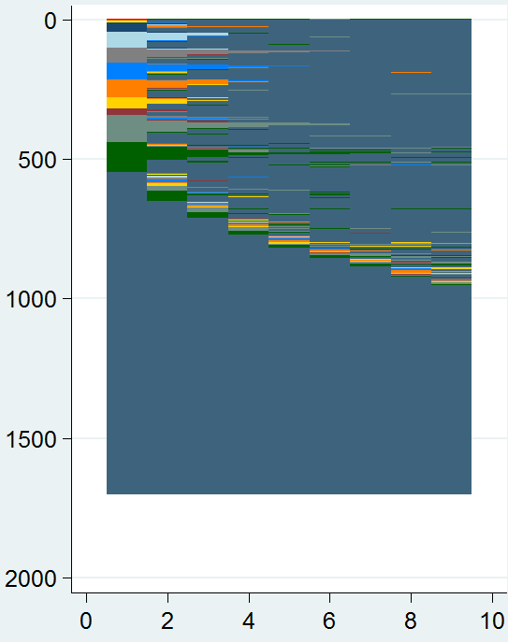

As an indicator of this mobility, table 5 provides the distribution of time for each cluster, across the available 13 states. For each cluster, dominant cells have been highlighted.

Table 5 Distribution of time by cluster (%)

|  |  |  |  |  |  |  |  |  |  |  |  |  |  |  |  |
| --- | --- | --- | --- | --- | --- | --- | --- | --- | --- | --- | --- | --- | --- | --- | --- |
| Cluster | N | Proportion of time in … | | | | | | | | | | | | | |
| School | VET  study | Higher education study | Manager | Professional | Technician/ trades | Community services | Admin. worker | Sales  worker | Machinery operator | Labourer | U/E | NILF | Total |
| 1 Professionals | 1066 | 0.0 | 0.6 | 0.8 | 3.6 | **83.1** | 1.9 | 0.9 | 2.0 | 0.6 | 0.1 | 0.4 | 0.8 | **4.9** | 100 |
| 2 Labourers | 356 | 0.1 | 0.5 | 0.6 | 2.2 | 0.8 | **10.0** | 4.7 | 2.2 | 1.6 | 5.3 | **65.2** | 2.9 | 3.8 | 100 |
| 3 Machinery operators | 306 | 0.0 | 0.5 | 0.2 | 4.4 | 1.2 | 4.1 | 1.0 | 2.2 | 0.9 | **71.3** | 5.0 | 2.8 | **6.4** | 100 |
| 4 Technician/trades workers | 548 | 0.0 | 1.1 | 0.4 | **5.0** | 2.5 | **78.5** | 0.5 | 1.5 | 1.1 | 2.1 | 3.2 | 1.3 | 2.6 | 100 |
| 5 Clerical/administrative workers | 761 | 0.0 | 0.5 | 0.4 | 3.2 | 4.6 | 1.5 | 2.0 | **73.1** | 1.8 | 2.1 | 1.1 | 1.5 | **8.1** | 100 |
| 6 Higher education professional | 367 | 0.0 | 0.8 | **43.2** | 2.9 | **22.0** | 2.6 | 3.8 | 6.4 | 4.1 | 0.5 | 2.3 | 1.8 | 9.5 | 100 |
| 7 Sales workers | 364 | 0.0 | 1.3 | 1.1 | 8.6 | 4.4 | 2.9 | 3.1 | **8.5** | **54.7** | 1.5 | 4.4 | 3.4 | 6.0 | 100 |
| 8 Community/personal services workers | 471 | 0.0 | 0.8 | 1.6 | 4.5 | 5.2 | 1.4 | **65.7** | 2.9 | 2.5 | 0.6 | 2.3 | 2.6 | **9.8** | 100 |
| 9 Managers | 786 | 0.0 | 0.6 | 0.5 | **64.0** | **11.5** | 2.3 | 1.0 | 6.8 | 2.6 | 0.7 | 3.2 | 0.9 | 5.9 | 100 |
| 10 Not in the labour force | 1701 | 0.0 | 0.5 | 0.2 | 0.7 | 1.7 | 2.1 | 1.9 | 2.2 | 1.8 | 0.8 | 4.6 | 4.8 | **78.7** | 100 |

These figures provide an insight into the nature of mobility across a heterogeneous set of individuals, organised according to clusters of similar nine-year sequences. While table 5 does not give information on the direction of movement, this can be broadly determined upon closer inspection of the sequence plots.

### Low trajectory patterns

The experience of those in cluster 2 and 7 (labourers and sales workers) were the most heterogeneous and were more likely to see spells of unemployment. Where transitions occur for labourers, they tend to be short episodes as machinery operators and trades workers with little evidence of sustained direction. Similarly, sales workers are likely to move between sales and administrative roles. Mobility for these lower-skill workers is characterised by many short episodes in various states, and does not present pathways into further study or more highly skilled work.

Cluster 3 (machinery operators) spent long periods within its occupational group, with some spells as labourers, or outside the labour force.

Clusters 5 and 8 (clerical workers and community services workers) were dominated by time spent (at least 65%) in their respective occupational groups, with some movement into and out of professional roles. Closer inspection of these clusters showed that movement between administrative work and professional roles in business, human resources and marketing was most likely, but that the movement was far from one-directional. Similarly, transitions from community services into professional roles were dominated by the health, education and legal/social/welfare professions. However, professionals were just as likely to have spells as community service workers, often in health/welfare support roles. These two clusters were dominated by women and were more likely to spend time out of the labour force.

### High trajectory patterns

Cluster 6 (higher ed>> professional) was characterised by a significant proportion of time spent undertaking higher education studies (43.2%,and an average period of 3.24 years) before entering professional occupations (22% of their time). This reflects the high-entry barriers required by many professional roles, and was the only significant transition identified in the analysis.

Clusters 1 and 9 were dominated by the managerial and professional states, and frequent movement between the two. We hypothesise that structured occupational labour markets for many professions is conducive to mobility, as career progression may be occupationally defined (for example, by professional associations).

Cluster 4 was characterised by trade workers and shows a very high stability within the occupational group. However, as the sequence plot shows, movement does occur into professional and into managerial roles. This progression may again reflect the impact of clearly defined occupational labour markets and will be explored further in the next section.

### Marginal attachment patterns

Finally, we can see that cluster 10 (not in the labour force) spent almost 80% of their time over the eight waves absorbed in the not in the labour force category. For those who did make transitions, they were likely to be into unemployment or labourer roles.

### Discussion

Overall, vocational pathways were not evident for large segments of the sample. Where upward mobility appears to exist, it is within the more highly skilled occupations and particularly where clearly defined occupational labour markets may exist. In other segments of the market (labourers, administrative, community services and sales roles), there appears to be either limited mobility, high turnover, characterised by frequent short spells in various occupations, or ambiguous mobility, characterised by movement to and from professional roles. In the next section, we investigate these flows at a more detailed level, looking at movements within particular vocational streams.

Note that our findings are constrained by the limitations of the data, which are likely to be underestimating mobility because they do not provide detail on changes in employer. In addition, for simplicity within the thousands of permutations of occupational classifications, we have not yet considered occupational changes finer than 1-digit ANZSCO units. (For example, an accountant becoming an equities analyst would be lost in our analysis.) In the following analysis of four different vocational streams, we relax this constraint. Finally, the transition from study to employment is difficult to comment on in this paper, as the sample of people engaged in study was quite low.

The distribution of these clusters in relation to other variables was highly distinctive and instructive for the next phase of our research. Labour market segmentation along gender lines is well established, for example, and there is a significant gender dimension to almost every cluster, as shown in table 6 and in figure 3. Membership in the clusters dominated by sales, community services and clerical workers (clusters 5, 7 and 8) was much more likely for women, with proportions of 61%, 70% and 81% respectively. Those most likely to be out of the labour force, ending up on marginal attachment pathways, are also likely to be women (68%).

Interestingly, cluster 6, characterised by a long spell in higher education before progressing to professional work, is also dominated by women (61%). Moreover, the professionals cluster (cluster 5) is the only cluster approaching equal representation, with just over a half (57%) being women. Given the over-representation of women amongst university-educated Australians, the balanced representation of women in the professions was not unexpected.

The clusters that are largely characterised by the presence of managers, labourers, machinery operators and trades workers are male-dominated, with men comprising around 90% of the latter two categories.

Finally, we also present two sequence plots in figure 3, which show male and female employment and occupational mobility over nine years along the themes discussed above. Males formed 45.9% of the sample (3087), while females formed 54.1% (3639).

The data do not conclude that high trajectory pathways are the domain of males or females in particular; rather, labour market segmentation lends itself to entrenching individuals within occupational boundaries. These boundaries do tend to capture distinctive gender characteristics, such as the dominance of women in clerical roles. Yet, as we will see with the analysis of specific vocational streams, both males and females are present in both high and low trajectory paths. Women are more likely to follow marginal attachment pathways, exiting the labour force for varying periods of time and often not returning.

Table 6 Distribution of clusters by gender (%)

|  |  |  |  |  |  |  |  |  |  |  |  |
| --- | --- | --- | --- | --- | --- | --- | --- | --- | --- | --- | --- |
| Gender | N | Cluster | | | | | | | | | |
| Professionals | Labourers | Machinery operators | Technician/ trades  workers | Clerical/ administrative workers | Higher education professional | Sales workers | Community/ personal services workers | Managers | Not in the labour force |
| Male | 3087 | 43.4 | **61.0** | **94.1** | **87.8** | 19.1 | 39.2 | 39.0 | 30.1 | **65.4** | 32.4 |
| Female | 3639 | 56.6 | 39.0 | 5.9 | 12.2 | **80.9** | **60.8** | **61.0** | **69.9** | 34.6 | **67.6** |
| **Total** | **6726** | **100** | **100** | **100** | **100** | **100** | **100** | **100** | **100** | **100** | **100** |

Figure 3 Sequence plots by gender

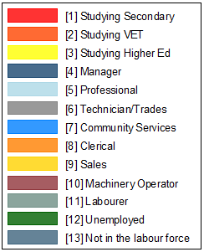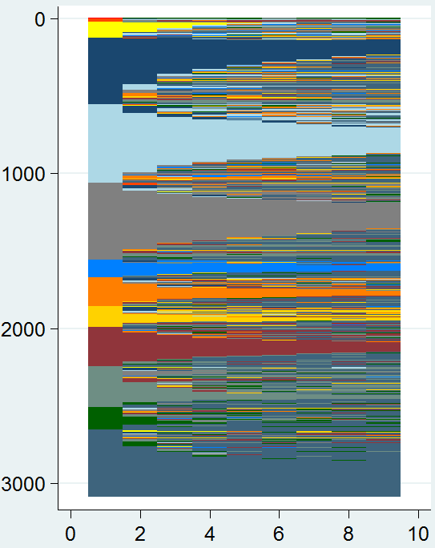 Male Female

**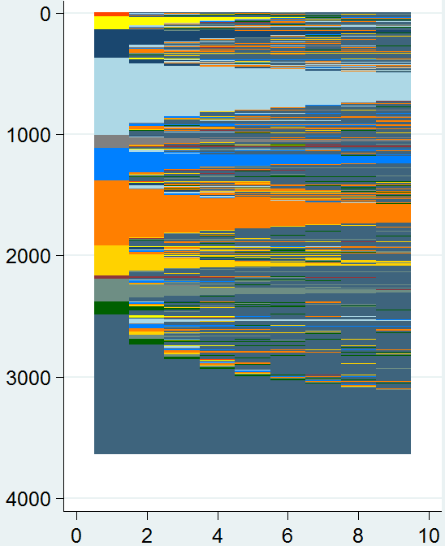**

When we consider these patterns by age group (in wave 1), there are a number of interesting results. First, while the group characterised by a transition from higher education to the professions (cluster 6) is dominated by those under the age of 24 years (42%), there is a significant proportion of prime working-age individuals entering higher education studies and likely to transition to professional roles. This is shown in table 7.

Most of the occupational clusters are distributed quite consistently within the prime working-age groups (25 to 55 years). Workers in the sales and community service clusters are slightly younger at the start of their trajectories, with at least one in four under the age of 34. Compared with the other clusters, those over the age of 55 are more strongly represented within Managers (cluster 9), reflecting the accumulation of skills and expertise over their careers.

Over half of those in cluster 10 (not in the labour force) are over the age of 55, representing those moving into retirement.

Table 7 Distribution of clusters by age group in wave 1 (%)

|  |  |  |  |  |  |  |  |  |  |  |  |
| --- | --- | --- | --- | --- | --- | --- | --- | --- | --- | --- | --- |
| Age group  Wave 1 | N | Cluster | | | | | | | | | |
| Professionals | Labourers | Machinery operators | Technician/ trades  workers | Clerical/ administrative workers | Higher  education professional | Sales  workers | Community/ personal services workers | Managers | Not in the labour force |
| Less than 24 years | 914 | 2.2 | 6.5 | 2.1 | 7.7 | 3.5 | 42.0 | 8.5 | 6.4 | 1.3 | 2.1 |
| 25–34 years | 1438 | 17.5 | 16.4 | 15.8 | 17.8 | 15.4 | 20.5 | 21.9 | 19.3 | 15.2 | 7.0 |
| 35–45 years | 1816 | 34.1 | 35.9 | 31.0 | 38.3 | 32.1 | 25.5 | 29.4 | 36.8 | 28.9 | 12.7 |
| 45–55 years | 1492 | 31.9 | 29.4 | 34.2 | 28.6 | 36.3 | 11.1 | 29.0 | 29.1 | 35.9 | 23.3 |
| 55 years and over | 1066 | 14.3 | 11.8 | 16.9 | 7.6 | 12.8 | 0.9 | 11.2 | 8.3 | 18.7 | 54.9 |
| **Total** | **6726** | **100.0** | **100.0** | **100.0** | **100.0** | **100.0** | **100.0** | **100.0** | **100.0** | **100.0** | **100.0** |

## Analysis of financial services

The financial services sector is characterised by fluid occupational labour markets, with high general education entry requirements (typically a university degree). The sector consists of substantially unlicensed and broad groupings of occupations, often at the higher end of the skills spectrum. Critically, qualifications rarely align with job descriptions, and qualifications are typically used as an entry screening process, with graduates from a wide range of disciplines being accepted and then trained on the job in specialised skills (Buchanan, Yu et al. 2010). This might suggest favourable implications for occupational mobility, particularly where strong internal labour markets exist.

Workers in the financial services industry were dominated by administrative workers, business professionals and managers. Our sample of individuals who had worked in the financial services industry at any point during the nine-wave period provided 632 observations. In order to improve sample size, we have included respondents with some missing data within their sequence. We initially used more detailed occupational data, for example, separating professionals into those working in ICT, human resources, marketing roles etc. However, we found that the themes were very similar across these disaggregated groups to those presented below. Our results for financial services therefore remain aggregated at the 1-digit ANZSCO occupational level. Table 8 describes the cluster analysis results.

Table 8 Results of cluster analysis, financial services

|  |  |  |  |
| --- | --- | --- | --- |
| Cluster | Description | N | % |
| 1 | HE🡪professional+clerical | 51 | 8.1 |
| 2 | Clerical/administrative workers | 144 | 22.8 |
| 3 | Professionals | 152 | 24.1 |
| 4 | Managers | 92 | 14.6 |
| 5 | High turnover in low-skill roles | 193 | 30.5 |
|  | **Total** | **632** | **100.0** |

Figure 4 presents the sequence plots for five financial services clusters. Together with table 9, which provides the distribution of time within each of these clusters, we can make quite useful insights into the trajectory of these groups of individuals.

Figure 4 Sequence plots, financial services

Cluster 1: HE🡪 professional/clerical

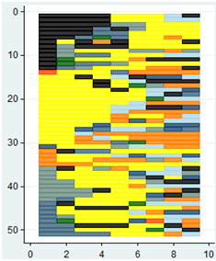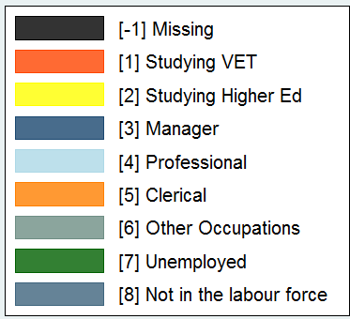

Cluster 2: Clerical Cluster 3: Professionals

*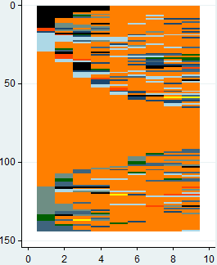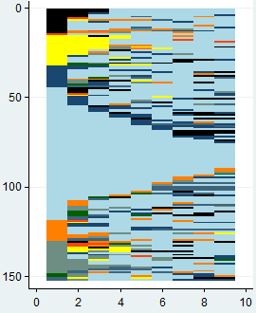*

*Cluster 4: Managers*

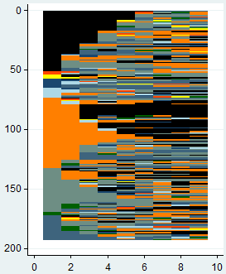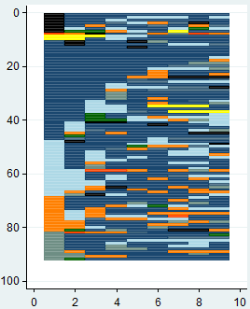Cluster 4: Managers Cluster 5: High turnover, low-skill roles

Table 9 Distribution of time by cluster, financial services (%)

|  |  |  |  |  |  |  |  |  |  |  |
| --- | --- | --- | --- | --- | --- | --- | --- | --- | --- | --- |
| Cluster | N | Proportion of time in | | | | | | | | |
| VET study | Higher education study | Manager | Professional | Clerical/ administrative workers | Other occupations | U/E | NILF | Total |
| 1 HE🡪professional+clerical | 51 | 0.5 | **48.1** | 4.9 | **11.5** | **15.6** | 9.2 | 2.3 | 7.9 | 100 |
| 2 Clerical/administrative workers | 144 | 1.3 | 0.3 | 3.7 | 7.3 | **74.9** | 4.8 | 1.9 | 6.0 | 100 |
| 3 Professionals | 152 | 0.9 | 4.5 | **8.3** | **70.0** | 5.3 | 5.2 | 1.2 | 4.6 | 100 |
| 4 Managers | 92 | 0.8 | 1.5 | **59.9** | **16.9** | 10.0 | 4.9 | 1.6 | 4.5 | 100 |
| 5 High turnover, low-skill | 193 | 1.5 | 1.6 | 4.3 | 5.1 | **31.3** | **32.6** | 3.0 | **20.8** | 100 |

Our examination of the financial services sector found evidence of all three patterns of activity (trajectories) identified by the aggregated labour market analysis. High trajectory patterns were evident, with pathways between managerial and professional roles appearing quite common, as seen in clusters 3 (professionals) and 4 (managers). While both clusters had a stable cohort of long-tenured workers, there also appeared to be a distinctive group of professionals moving into managerial roles across both clusters (and vice versa). Also, as cluster 1 and 3 show (HE🡪professional+clerical, and professionals), pathways into professional roles are most common from higher education studies.

Low trajectory patterns were also present. First, while cluster 1 (HE🡪professional+clerical) was dominated by those in higher education studies, they were just as likely to progress to clerical roles as to professional ones. In many cases, higher education studies may not surmount the high entry barriers into professional roles in financial services. This corroborates broader findings in the Graduate Pathways Survey, which showed that numerical and general clerks, clerical and office support workers, inquiry clerks and receptionists, sales assistants, and personal assistants and secretaries were amongst the top 20 occupations for graduates five years after degree completion (Coates & Edwards 2009, p.76). Cluster 2 is a large group of clerical workers whose low trajectory is characterised by occupational stasis.

Evidence of marginal attachment pathways in financial services was also present. Cluster 5 (high turnover, low-skill) represents those trapped in largely low- and semi-skilled roles. The category other occupations was dominated by sales workers, and to a lesser degree, labourers and community service workers. Cluster 5 was characterised by those moving quite frequently between clerical work, other low-skill jobs, and also out of the labour force. While the analysis has captured this pattern of transitions, there is little evidence that sustained career progression is taking place with these movements. There was a strong gender dimension to these financial services clusters, as shown in table 9. Cluster 1 (HE🡪professional+clerical) was dominated by women, who comprised almost 70% of those likely to move from higher education studies into financial services roles, mostly professional. However, the cluster characterised mostly by established professionals (cluster 3) was strongly dominated by males, suggesting that women are likely to leave their professional roles for family or other reasons. This will be explored further in the next stage of research. Subsequently, cluster 5 (managers) is similarly dominated by males.

The low-to-medium skill clusters (clusters 2 and 5) were dominated by women, with very low proportions of men in clerical work in particular. This is shown in table 10.

Table 10 Distribution of clusters by gender, financial services (%)

|  |  |  |  |  |  |  |
| --- | --- | --- | --- | --- | --- | --- |
| Gender | N | Cluster | | | | |
| HE🡪 professional | Clerical/ administrative workers | Professionals | Managers | High turnover, low-skill |
| Male | 347 | 31.4 | 16.0 | 67.1 | 66.3 | 33.7 |
| Female | 447 | 68.6 | 84.0 | 32.9 | 33.7 | 66.3 |
| **Total** | **794** | **100.0** | **100.0** | **100.0** | **100.0** | **100.0** |

## Analysis of primary industry

The primary industries are broadly characterised by ageing workforces with relatively low levels of educational attainment. Evesson, Jakubauskas and Buchanan (2009) highlighted a number of workforce and skill development challenges, particularly key barriers to educational and career pathways. High external pressures and capital costs, breakdowns in succession planning and poor working conditions have led to a migration of workers away from farming localities and intensified the workloads for remaining workers. The sector has the highest levels of non-standard employment, including casual, contract and labour hire work, and provides amongst the lowest wages. These two factors have strong implications on both opportunities and incentives to train (Evesson, Jakubauskas & Buchanan 2009).

Our sample of workers passing through the agriculture, forestry and fishing industries was 691, which was subsequently clustered into six groups, described in table 11. We have classified clerical, community service, sales and non-farm labourer roles as other low and semi-skilled.

Table 11 Results of cluster analysis, primary industry

|  |  |  |  |
| --- | --- | --- | --- |
| Cluster | Description | N | % |
| 1 | Farm managers | 249 | 36.0 |
| 2 | Professionals | 62 | 9.0 |
| 3 | Trades workers | 63 | 9.1 |
| 4 | High turnover manual roles | 182 | 26.3 |
| 5 | Other low/semi-skill roles | 79 | 11.4 |
| 6 | NILF | 56 | 8.1 |
|  | **Total** | **691** | **100.0** |

The sample was dominated by cluster 1, representing farm managers with typically long tenure. Sequence plots of the six clusters and a description of their time spent is provided in figure 5 and table 12, respectively.

Figure 5 Sequence plots, primary industry

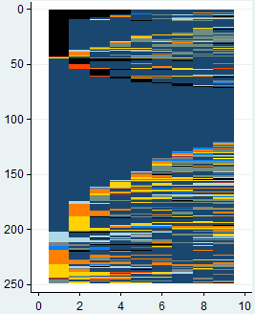 Cluster 1: Farm managers

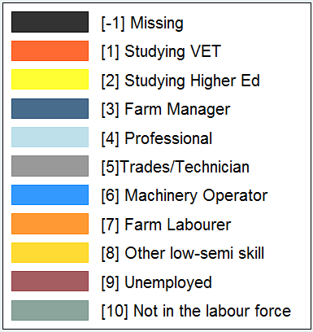Cluster 2: Professionals Cluster 3: Trades workers

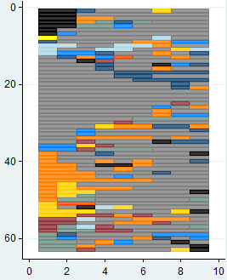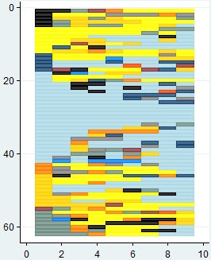

Cluster 4: High turnover, manual roles Cluster 5: Other low/semi-skill roles

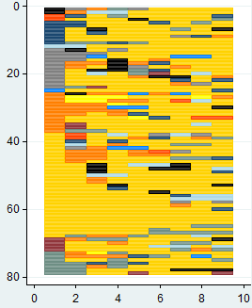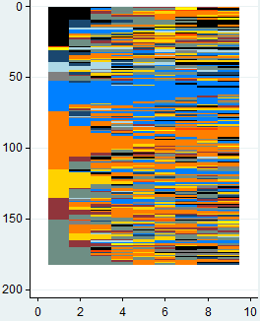

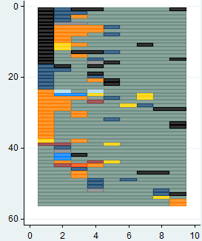Cluster 6: Not in the labour force

Table 12 Distribution of time by cluster, primary industry (%)

|  |  |  |  |  |  |  |  |  |  |  |  |
| --- | --- | --- | --- | --- | --- | --- | --- | --- | --- | --- | --- |
| Cluster | N | Proportion of time in | | | | | | | | | |
| VET  study | Higher education study | Farm  manager | Professional | Technician/ trades  workers | Machinery operators | Farm  labourer | Other low/ semi-skill | U/E | NILF |
| Farm manager | 249 | 0.5 | *0.1* | ***72.6*** | 3.5 | 1.7 | 1.8 | 5.8 | 6.2 | 0.3 | 7.4 |
| Professional | 62 | 0.6 | ***22.6*** | *5.1* | **43.8** | 4.2 | 1.3 | 4.9 | 9.6 | 1.7 | 6.2 |
| Technician/trades | 63 | 0.6 | *0.2* | *5.9* | 2.4 | **63.0** | 4.4 | **11.4** | 3.5 | 3.7 | 5.0 |
| High turnover manual | 182 | 1.1 | *0.6* | 5.6 | 3.4 | 3.6 | **19.5** | **26.1** | **12.5** | 7.9 | **19.7** |
| Other low-skill | 79 | 1.2 | *1.3* | 4.8 | 3.7 | 4.1 | 1.6 | **9.7** | **64.9** | 1.5 | 7.3 |
| NILF | 56 | 0.2 | *0.0* | 6.2 | 0.4 | 1.1 | 0.9 | **9.0** | 2.1 | 1.1 | **79.0** |

The primary industry sector is often an ‘exception to the rule’ in labour market analysis because it has a unique occupational and skill profile, workplace profile and sectoral composition. Nevertheless, our analysis identified the presence of the three generic pathways or trajectories associated with clusters of occupational activity. Due to the strong seasonal dimension of primary industry activity, the marginal attachment trajectory featured strongly in the sectoral profile. Individuals in cluster 6 (NILF) were likely to spend long spells outside the labour force and appeared most likely to be working as labourers while employed.

However, high trajectory pathways also appeared to be present in this sector. The sequence plots show that the medium- to high-skill occupational clusters (clusters 1, 2 and 3) are quite segmented, characterised by long spells within each stream. Entry into cluster 2 (professionals) was likely to be preceded by higher education studies and is dominated by science professionals. Entry into roles such as animal and science technicians, as well as trades workers, was more likely to feature an episode in labour roles.

The low trajectory pathways also appeared to be a feature of multiple roles within the sector. Resemblance between individuals in cluster 4 (high turnover manual role) was marked by movement between low-skill roles, and out of the labour force. While the sequence plot shows some individuals in stable roles as labourers or machinery operators, the cluster is dominated by those experiencing short episodes in a number of low-skill roles, as shown in table 12. Cluster 4 was also the most likely to experience spells of unemployment.

The nature of cluster 5 (other low-skill) may be masked by the aggregation of other low-skill (mostly clerical) roles. Closer inspection of the occupational frequencies suggested that movement within this group was significant, with transitions between clerical, community service and sales roles. There may therefore be some commonality between clusters 4 (high turnover manual role) and 5 (other low-skill) with regards to mobility within the low to semi-skilled streams. Due to the relatively low numbers of these non-manual workers, however, we have left the results aggregated.

There was a significant age dimension to many of these clusters in primary industry. Most notably, farm managers (cluster 1) are strongly over-represented amongst the older age groups, with one in two aged 55 years and over in 2009. In cluster 6 (NILF), individuals are likely to be approaching retirement, and three-quarters of cluster members are over the age of 55.

Professionals were on average a younger cluster, with almost one in two under the age of 35. The other occupational clusters were more evenly distributed across the working age spectrum.

Table 13 Distribution of clusters by age group in 2009, primary industries (%)

|  |  |  |  |  |  |  |  |
| --- | --- | --- | --- | --- | --- | --- | --- |
| Age group | N | Cluster | | | | | |
| Farm manager | Professional | Technician/ trades | High turnover, manual | Other  low-skill | NILF |
| Less than 24 years | 56 | 0.4 | 19.4 | 19.0 | 14.3 | 6.3 | 0.0 |
| 25–34 years | 116 | 9.6 | 29.0 | 17.5 | 19.2 | 30.4 | 7.1 |
| 35–45 years | 122 | 14.5 | 21.0 | 14.3 | 21.4 | 24.1 | 10.7 |
| 45–55 years | 156 | 24.1 | 22.6 | 31.7 | 23.1 | 21.5 | 5.4 |
| 55 years and over | 241 | 51.4 | 8.1 | 17.5 | 22.0 | 17.7 | 76.8 |
| **Total** | **691** | **100.0** | **100.0** | **100.0** | **100.0** | **100.0** | **100.0** |

## Analysis of healthcare and community services

There is evidence to suggest that, in the lower reaches of the health and community services industries (for example, care attendants), there is a relative absence of both labour market and educational pathways. The relative absence of educational pathways, fragmentation of institutions and the tradition of care work being undervalued as ‘intuitive’ women’s work has slowed the codification of knowledge and skills. Available qualifications are generally delivered by VET providers. On the labour market side, the prevalence of low-cost funding models and subsequent pressures on staff retention, wages and access to training have stunted the development of career pathways for workers in these sectors (Romeyn, Buchanan & Fattore 2010).

Almost a third of community services workers have no post-school qualifications, with greater training uptake in aged and child care due to licensing and accreditation requirements (Romeyn, Buchanan & Fattore 2010). In the middle of the skill spectrum, registered nurses and psychologists require a degree and registration, while social workers require a degree but no regulatory requirement for registration. (The professional body does however accredit all social work degrees in universities.) In the highly skilled areas of healthcare (for example, medical specialists) the medical professions have traditionally controlled boundaries to entry and standards of practice, as well as regulated the body of knowledge, assessment and career progression. Occupational pathways are clearly defined and are explicitly tied to educational pathways by way of training, assessment and registration criteria.

Given such divergent institutional arrangements, it would appear unlikely that workers would be able to access ever-higher levels of further study and labour market positioning. Our analysis of 1657 individuals shows high segmentation of healthcare and community services workers, represented by the nine clusters given in table 14 and the sequence plots in figure 6.

Table 14 Results of cluster analysis, healthcare and community services (%)

|  |  |  |  |
| --- | --- | --- | --- |
| Cluster | Description | N | % |
| 1 | Nurses | 213 | 12.9 |
| 2 | HE🡪 health specialist/other professional | 159 | 9.6 |
| 3 | Managers | 77 | 4.6 |
| 4 | Health/welfare support (including enrolled nurses) | 76 | 4.6 |
| 5 | Health professionals | 268 | 16.2 |
| 6 | Transitions between low-skill non-manual work and NILF | 215 | 13.0 |
| 7 | Manual workers | 158 | 9.5 |
| 8 | Carers | 215 | 13.0 |
| 9 | Clerical+sales | 276 | 16.7 |
|  | **Total** | **1657** | **100.0** |

Figure 6 Sequence plots, healthcare and community services

**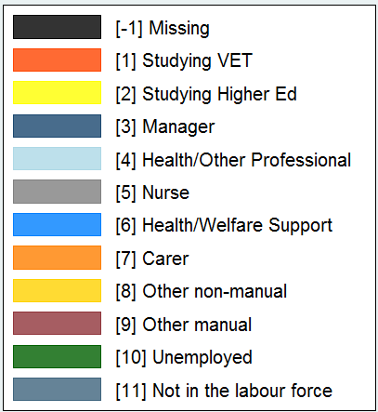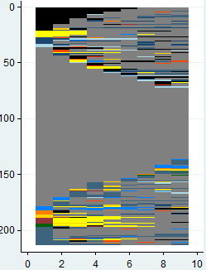** Cluster 1: Nurses

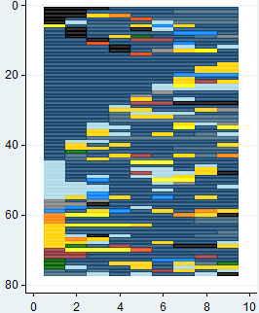Cluster 2: HE🡪Health professional Cluster 3: Managers

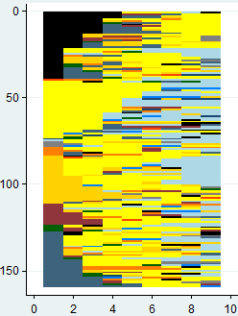

Cluster 4: Health/welfare support Cluster 5: Health professionals

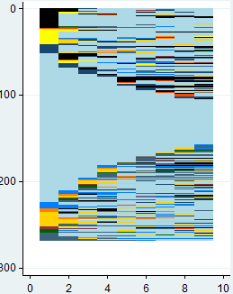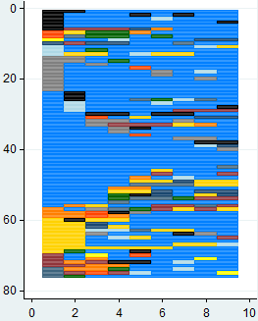

Figure 6 (continued)

Cluster 6: Low-skill non-manual 🡨🡪NILF Cluster 7: Manual workers

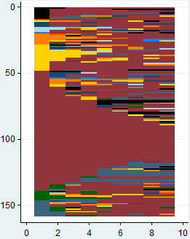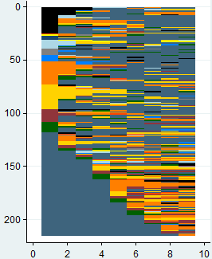

Cluster 8: Carers Cluster 9: Clerical/sales workers

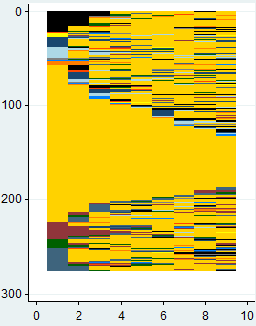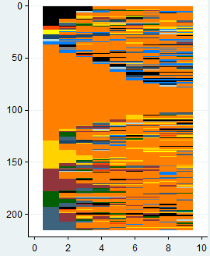

Table 15 Distribution of time by cluster, healthcare and community services (%)

|  |  |  |  |  |  |  |  |  |  |  |  |  |
| --- | --- | --- | --- | --- | --- | --- | --- | --- | --- | --- | --- | --- |
| Cluster | N | Proportion of time in | | | | | | | | | | |
| VET  study | Higher education study | Managers | Health specialist/ other professional | Nurses | Health/ welfare support  role | Carer/  aide | Other  non-manual role | Other manual  role | U/E | NILF |
| 1 Nurses | 213 | 0.9 | 3.9 | 2.4 | 1.9 | **78.9** | 2.0 | 0.6 | 1.4 | 0.6 | 0.3 | 7.1 |
| 2 HE🡪 health specialist | 159 | 0.5 | **42.5** | 0.8 | **19.1** | 2.0 | 2.0 | 4.1 | 12.6 | 4.2 | 1.9 | 10.3 |
| 3 Managers | 77 | 0.6 | 2.5 | **61.6** | 9.6 | 1.8 | 2.4 | 1.2 | 9.0 | 2.2 | 1.0 | 7.9 |
| 4 Health/welfare support workers | 76 | 1.4 | 0.6 | 2.6 | 3.4 | 4.4 | **67.8** | 2.9 | 7.8 | 4.3 | 2.3 | 2.6 |
| 5 Health specialists/professionals | 268 | 0.7 | 1.4 | 3.8 | **75.2** | 0.2 | 4.4 | 1.3 | 5.0 | 0.7 | 1.3 | 6.1 |
| 6 Transitions from low-skill non-manual work to NILF | 215 | 0.9 | 0.6 | 0.8 | 2.5 | 0.9 | 1.6 | **12.8** | **12.0** | 5.5 | 5.1 | **57.4** |
| 7 Manual workers | 158 | 0.6 | 0.3 | 2.7 | 1.5 | 0.4 | 0.6 | 4.9 | 5.9 | **70.6** | 2.9 | **9.6** |
| 8 Carers | 215 | 0.9 | 0.6 | 3.1 | 1.4 | 1.5 | 4.1 | **65.5** | 7.8 | 5.7 | 3.4 | 6.0 |
| 9 Low-skill non-manual workers | 276 | 0.7 | 0.5 | 4.0 | 3.3 | 1.0 | 1.1 | 1.7 | **76.2** | 4.0 | 2.9 | 4.5 |

Table 16 Distribution of clusters by age group in 2009, healthcare and community services (%)

|  |  |  |  |  |  |  |  |  |  |  |
| --- | --- | --- | --- | --- | --- | --- | --- | --- | --- | --- |
| Age group | N | Cluster | | | | | | | | |
| Nurses | HE🡪health specialist | Managers | Health/welfare support  workers | Health specialists/ professionals | Transitions  from low-skill non-manual work to NILF | Labourers | Carers | Low-skill  non-manual workers |
| Less than 24 years | 112 | 2.3 | 36.5 | 2.6 | 1.3 | 0.0 | 7.4 | 3.2 | 5.6 | 4.7 |
| 25–34 years | 277 | 16.0 | 35.8 | 6.5 | 10.5 | 16.4 | 13.5 | 8.9 | 19.5 | 15.9 |
| 35–45 years | 390 | 23.5 | 15.7 | 29.9 | 35.5 | 26.1 | 22.8 | 22.2 | 22.3 | 22.8 |
| 45–55 years | 466 | 32.9 | 8.2 | 31.2 | 32.9 | 29.9 | 21.9 | 31.0 | 33.0 | 31.5 |
| 55 years and over | 412 | 25.4 | 3.8 | 29.9 | 19.7 | 27.6 | 34.4 | 34.8 | 19.5 | 25.0 |
| **Total** | **1657** | **100.0** | **100.0** | **100.0** | **100.0** | **100.0** | **100.0** | **100.0** | **100.0** | **100.0** |

The health sector showed the greatest evidence of occupational stasis across all the case studies in our analysis. This is not surprising, given the high level of specialisation associated with health care delivery and the immense diversity of service settings. In other words, once a practitioner builds skill capacity within a certain field (for example, mental health nursing or dementia treatment), they tend to remain within that area of care delivery. Overall, the health and community services workforce is characterised by large groups of stable segments, from health/welfare professionals and nurses, down to kitchen hands, cleaners and clerical workers. Very few clusters were identified by transitions over the nine years, except for health professionals from higher education studies, and for carers and clerical workers moving out of the labour force. Despite the obvious (and in some cases formally established) linkages between care work, welfare support work and nursing, the analysis showed that articulation between these vocational segments was far from the norm.

For the purposes of this analysis, we argue that high trajectory pathways were reflected in clusters 1—3 (nurses, HE🡪health specialists, and managers) and cluster 5 (health specialists/professionals). Cluster 1 includes long-tenured nurses, with a small proportion entering the vocation through health/welfare support roles (most commonly enrolled nurses). While our sample shows a very stable segment, most of these nurses would have entered the profession via higher education studies at some point. Cluster 2 includes those moving from higher education studies to professional roles. While these roles appear dominated by health and welfare professionals, around 20% actually ended up as education professionals. High trajectory patterns were present among managers (cluster 3), with some transitioning into and out of professional roles. Cluster 5 (health professionals) represented quite a stable segment of the health workforce, dominated by health and welfare professionals. Similar to the nurses, this cluster is likely to have completed higher education studies and practical training prior to entering their professions. A small percentage of the cluster enters through welfare support and clerical/sales roles, largely into social/welfare professional roles such as counsellors and psychologists.

Low trajectory pathways were strongly present in clusters 7—9 (manual workers, carers, and low-skill non-manual workers). Cluster 7 was dominated by cleaners and kitchen hands, but also includes some skilled manual workers. Like nurses and other professionals, this low-skill segment sees relatively little movement, with around 10% of time spent outside the labour force. Cluster 8 was a large cluster of carers, dominated by personal care attendants, aged/disabled carers and child carers. As the sequence plot shows, while care work is the predominant vocation for most, some individuals do transition into welfare support roles. Just as likely, however, are spells in clerical work with little apparent career progression. Cluster 9 represented a large number of clerical workers showing little career movement.

Cluster 4 (health/welfare support workers) could also be argued to be a low trajectory pathway. This cluster was dominated by enrolled nurses and welfare support workers. In 2006, the National Review of Nursing Education found that, while qualification linkages existed between the VET and higher education sectors, heterogeneity in the treatment of credit transfer and experience affected the availability of articulation pathways (National Nursing and Nursing Education Taskforce 2006). Our sequence plot does show some articulation between enrolled nurses and registered nurses, but equally in and out of other non-manual work, mostly in clerical or sales roles. Uptake of available articulation pathways appears to be minimal.

Marginal attachment pathways are most evident in cluster 6 (transitions from low-skill non-manual work to NILF), which is characterised by long spells outside the labour force. Transitions into employment were dominated by low-valued work as carers or in clerical roles; this was also the most likely group to experience periods of unemployment. Unlike other vocational streams where the NILF cluster was characterised by those moving into retirement, this cluster was dominated by females of prime working age.

It was observed that over half the members of all but one of these clusters was over the age of 45 in 2009, as shown in table 16. This probably reflects both the ageing workforce in those working in health services (from registered nurses to hospital cleaners), as well as the higher attrition of younger respondents in the HILDA Survey. Overall, labour flows in healthcare and community services are highly delineated along occupational lines, with limited transitions upwards through the skills spectrum. This is despite efforts to open up educational pathways for nurses moving between VET and higher education, and despite the improved codification of skills in care work. As mentioned earlier, there remain highly disparate institutional arrangements in healthcare and community services, which continue to impede skill formation in these occupational segments.

## Analysis of trades/engineering

Trades and engineering are examples of relatively stable occupational markets, tied quite explicitly to standards of entry and practice governed by occupational bodies. In the trades, long-standing apprenticeship, training and licensing requirements provide these connections. Despite there being clear educational pathways, for example, from trades assistant to licensed electrician, and strong demand for electrical tradespeople arising from the resources sector, there are severe shortages of electrical apprentices due to the realities of the labour market — trades assistants are able to access higher earnings in other low-skilled jobs, and there is limited employer investment in training.

In engineering, professional designations are tightly regulated by Engineers Australia to adhere to international standards of competence and ethics. Career progression is tied to formal education and training and there are low levels of articulation between VET and higher education students, due to differences in learning models (Buchanan et al. 2010). Currently only 6% of commencing students in engineering undergraduate degrees are admitted on the basis of completing a VET qualification, which is lower than the average of 10% for all higher education courses (King, Dowling & Godfrey 2011).

It was difficult to construct possible vocational pathways for this stream, since these workers work across a range of industries, and because quite a broad catchment of skills might feed into trades and engineering roles. Our screening ultimately consisted of individuals who were classified as automotive/ construction/electrotechnology trades workers, engineering technicians or professionals at any point during the nine waves. This produced a sample of 1145 observations, clustered into eight groups. These clusters are detailed in table 17, and in the sequence plots in figure 7.

Table 17 Results of cluster analysis, trades and engineering

|  |  |  |  |
| --- | --- | --- | --- |
| Cluster | Description | N | % |
| 1 | HE🡪engineers | 96 | 8.4 |
| 2 | Managers | 77 | 6.7 |
| 3 | Other professionals | 55 | 4.8 |
| 4 | Low-skill non-manual | 93 | 8.1 |
| 5 | NILF | 62 | 5.4 |
| 6 | Low-skill manual🡪trades | 93 | 8.1 |
| 7 | Movement out of trades | 324 | 28.3 |
| 8 | Trades | 345 | 30.1 |
|  | **Total** | **1145** | **100.0** |

Overall, this was the most difficult vocational stream for analysis. While trades workers formed the largest cluster of stable occupational segmentation (cluster 8), there also appeared to be those on the fringe of this segment, transitioning into low-skill manual (clusters 6 and 7) and even non-manual work (cluster 4). Pathways into professional work were available, but seemingly limited to those with experience as engineering technicians or electronics trades, or had come via extensive higher education studies.

Figure 7 Sequence plots, engineering/trades

**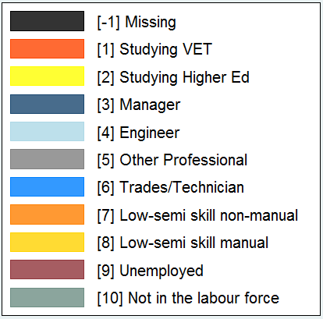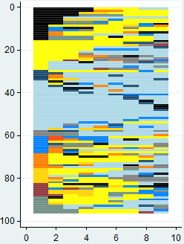** Cluster 1: HE🡪 engineer

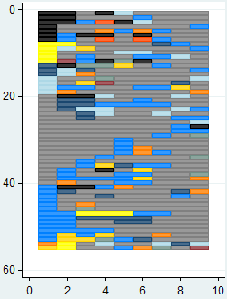Cluster 2: Managers Cluster 3: Other professional

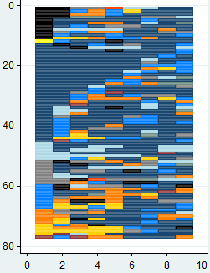

Cluster 4: Low-skill non-manual Cluster 5: Not in the labour force

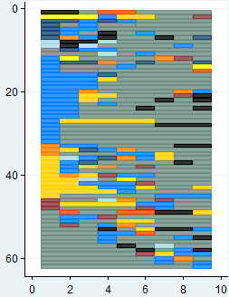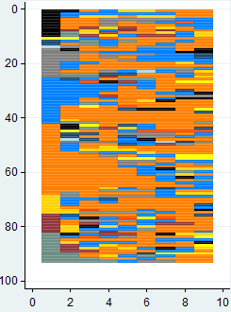

Figure 7 (continued)

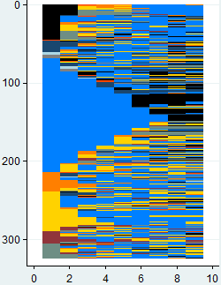Cluster 6: Low-skill manual🡪 trades Cluster 7: Transition out of trades

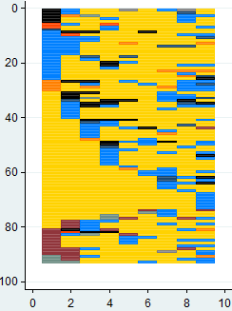

Cluster 8: Trades workers

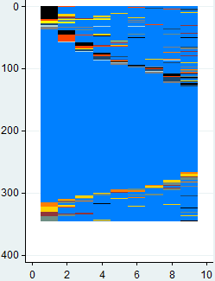

Table 18 Distribution of time by cluster, trades and engineering (%)

|  |  |  |  |  |  |  |  |  |  |  |  |  |
| --- | --- | --- | --- | --- | --- | --- | --- | --- | --- | --- | --- | --- |
| Cluster | N | Proportion of time in | | | | | | | | | | |
| VET  study | Higher education study | Managers | Engineers | Other professional | Trades/ technician | Low-semi skill non-manual | Low-semi skill  manual | U/E | NILF | Total |
| 1 HE🡪engineers | 96 | 0.2 | **26.8** | 3.9 | **40.6** | 5.8 | 7.3 | 4.3 | 4.1 | 1.5 | 5.3 | 100 |
| 2 Managers | 77 | 0.3 | 0.2 | **54.5** | **9.0** | 7.7 | **11.7** | 9.0 | 4.9 | 1.2 | 1.7 | 100 |
| 3 Other professionals | 55 | 0.6 | 2.3 | 5.3 | 5.1 | **61.4** | **16.8** | 3.2 | 2.5 | 0.6 | 2.1 | 100 |
| 4 Low-skill non-manual | 93 | 1.5 | 2.5 | 3.1 | 0.5 | 7.8 | **21.4** | **46.5** | 6.6 | 3.9 | 6.2 | 100 |
| 5 NILF | 62 | 1.3 | 1.1 | 3.2 | 1.7 | 2.8 | **17.5** | 2.8 | 8.3 | 2.6 | **58.5** | 100 |
| 6 Low-skill manual🡪trades | 93 | 0.6 | 0.0 | 2.1 | 0.0 | 0.4 | **18.6** | 2.3 | **71.5** | 3.3 | 1.3 | 100 |
| 7 Transitions out of trades | 324 | 1.1 | 0.5 | 8.8 | 0.3 | 1.3 | **54.5** | 5.2 | **17.2** | 4.0 | 7.1 | 100 |
| 8 Trades | 345 | 1.3 | 0.4 | 1.6 | 0.5 | 1.0 | **90.4** | 0.8 | 1.8 | 0.9 | 1.4 | 100 |

Table 19 Distribution of clusters by age group in 2009, trades and engineering (%)

|  |  |  |  |  |  |  |  |  |  |
| --- | --- | --- | --- | --- | --- | --- | --- | --- | --- |
| Age group | N | Cluster | | | | | | | |
| HE🡪 Engineers | Managers | Other professionals | Low-skill  non-manual | NILF | Low-skill manual🡪 trades | Transitions out of trades | Trades |
| Less than 24 years | 100 | 16.7 | 1.3 | 0.0 | 12.9 | 3.2 | 2.2 | 15.7 | 4.6 |
| 25–34 years | 250 | 36.5 | 13.0 | 32.7 | 25.8 | 9.7 | 24.7 | 18.2 | 21.7 |
| 35–45 years | 270 | 15.6 | 19.5 | 27.3 | 20.4 | 12.9 | 26.9 | 25.9 | 25.8 |
| 45–55 years | 289 | 16.7 | 37.7 | 12.7 | 24.7 | 19.4 | 32.3 | 23.1 | 28.1 |
| 55 years and over | 236 | 14.6 | 28.6 | 27.3 | 16.1 | 54.8 | 14.0 | 17.0 | 19.7 |
| **Total** | **1145** | **100.0** | **100.0** | **100.0** | **100.0** | **100.0** | **100.0** | **100.0** | **100.0** |

Again, our analysis of trade and engineering work found clusters of activity consistent with our categorisation of high, low and marginal attachment pathways. High trajectory pathways were present in clusters 1—3 and cluster 8. Cluster 1 comprised engineers, including those graduating from higher education studies. The group also includes a small number of engineering technicians or draughtspersons (but generally not trade workers) who moved into the engineering stream. Cluster 2 was dominated by managers, but showed some flow between trades workers as well as engineers. A significant proportion of time (12%) was spent as trade workers, typically in automotive/engineering and construction trades roles such as metal fitters, carpenters and joiners, before moving into roles as construction or production managers.

Cluster 3 (other professionals) was a small, heterogeneous group, characterised by those working in non-engineering professions, with movement to and from technician/trades roles. There appeared to be distinctive ‘mini-streams’ within this group, one comprising individuals moving from electronics/ telecommunications trades to ICT/network professionals, as well as a second architectural stream which captured those moving through civil engineering draughtsperson or building/surveying technicians roles.

Finally, cluster 8 (trades) represented one of the most stable labour market segments seen in this study, drawing a large sample of long-tenured trade workers. The group was dominated by electricians, metal trade workers (fitters and welders) and construction trade workers (carpenters and plumbers). There was difficulty in classifying this group, as it was characterised, on the one hand, by very limited occupational mobility and transition into higher-status roles such as management; on the other hand, the extended training and qualifications required for entry to the trades suggests at least one significant career transition, from apprentice to skilled qualified tradesperson. For this latter reason, we have included it amongst the high trajectory paths. Low trajectory paths were present in cluster 4, 6 and 7. Cluster 4 comprised those who had the common experience of non-manual work, including community services, administrative and sales roles. Surprisingly, this cluster’s attachment to the sample is through episodes in trades/technician roles, which ranged from engineering draughtspersons to motor mechanics, welders and fitters, and comprised 21.4% of the group’s time. There was very little logic to the transitions made within this group, with pathways into and out of trades work passing through sales roles, clerical roles, and occasionally into higher education studies.

Cluster 6 (low-skill manual 🡪 trades) was an interesting case, representing those making unsuccessful transitions from low-skill manual work into trades/technician roles. Most of these brief episodes were in the metal and construction trades, with time spent as welders, fitters and carpenters, before returning to labourer work. Cluster 7 (movement from trades) was characterised by a different kind of transition, out of trades work, and most likely into low-skill manual work. The cluster was also dominated by carpenters, metal fitters, motor mechanics and the engineering/construction trades more broadly. Both clusters 6 and 7 were quite evenly distributed across the age spectrum (table 19), such that we could not clearly attribute the exit from trades to either young apprentices or those approaching retirement.

Cluster 5 (NILF) represents an archetypal example of a marginal attachment pathway. Over half the members in cluster 5 were over the age of 55, and likely moving into retirement; see table 19. This explains the high proportion (59%) of time spent out of the labour force. Apart from clusters 2 and 5 (managers and NILF), the sample of trades and engineering workers are quite evenly distributed

across the age spectrum. Professionals (including those completing studies) are more likely to be younger. This sample is significantly younger than those found in the primary industry and healthcare/ community services analyses.

# Conclusion

Our analysis has shown great diversity in labour market trajectories across a number of vocational streams. Using Optimal Matching Analysis as an exploratory tool, we have been able to empirically derive patterns of labour flows using a large sample of Australians. The advantage of this technique is that it draws out commonalities between groups of workers as they move through employment; as we saw at the outset, the greatest commonality was one of *occupational segmentation and inertia*. This analysis will be further enriched by qualitative interviews.

The most distinctive exception to this occupational stasis was the transition between higher education and professional roles, which was observed for each of the financial services, engineering, healthcare and even science professionals in primary industry. These transitions characterised distinctive *high trajectory pathways*. The cohorts of professionals and trades workers were characterised by long-tenured individuals likely to access these high trajectory pathways and accumulate skills and expertise. These groups also tend to be linked to organised professional and occupational associations, who have varying controls over entry, training and standards of practice.

We saw that transitions were also common for those in low-skill sales and labourer roles. These transitions showed little semblance of sustained career progression and were more aptly described as *low trajectory pathways*. Low trajectory pathways are characterised by high turnover and little evidence of accumulation of skill and knowledge.

Finally, *marginal attachment pathways* were evident in the analyses, and captured those with a marginal attachment to the labour market, likely due to the presence of care responsibilities, or movement into retirement. Episodes outside paid employment were often connected to low-skill roles in the labour market.

Pathways in the financial services industry were somewhat fluid, with movement from higher education into professional roles, and between professional and managerial roles, but without clearly defined occupational labour markets. Clerical work however appeared to be a state with little movement for many in that segment. Where transitions occurred, they tended to be choppy episodes to other low-skill occupations (particularly sales). Moreover, the gender dimension in financial services was stark: despite a dominance of females transitioning from higher education to professional roles, they were highly under-represented in the clusters of professionals and managers.

The agricultural industries were dominated by two clusters: farm managers and those moving between low- to semi-skilled roles. Over half the farm managers were over 55 years old and were a very stable segment of the primary industries labour market. This contrasted with the other large group — those moving frequently between labourer, machinery operator and other low-skill roles. This group was a distinctive example of low trajectory pathways.

In healthcare and community services, we saw very disparate experiences along quite distinct occupational lines. From kitchen hands and cleaners, carers, and enrolled nurses and welfare workers, to nurses and medical specialists, the analysis showed strong labour market segmentation, despite efforts to support vocational pathways in nursing. Those working as carers were as likely to spend time working in clerical jobs, or out of the labour force, as moving into welfare support or enrolled nursing roles. There was limited evidence of articulation within this vocational stream.

In trades and engineering, the analysis highlighted many engineering and construction trades as very stable segments of the labour market. Interestingly, however, these same trade occupations, particularly metal fitters, welders and carpenters, were often points of transition for movements to and from labourer jobs, characterised often by a return to low-skill manual jobs.

Ultimately, this first stage of analysis has explored what in many cases may have been expected — that often electricians don’t go on to become engineers and carers don’t become nurses, despite efforts to streamline institutional arrangements to support such pathways. In other ways, this paper has firmly highlighted what might have been emerging concerns, that there are entrenched social and labour market settings which affect those working in low- to semi-skilled jobs. These settings have produced a commonality in experience, characterised by high job turnover and little opportunity for the accumulation of skill and access to career pathways. To some extent, these entrenched settings may be attenuated by policy agendas such as social inclusion and educational participation (and articulation) initiatives. However, it is just as likely that divergences in business settings (and their effects on how labour is engaged and developed) will affect the reality and realisation of these pathways.

The results of this paper will be used to underpin the qualitative stage of the research to follow. The overarching research question for this strand of research is: what is the nature of vocational development in Australia today and how might it be improved? By identifying that vocational ‘movements’ are defined by some distinguishable and distinct features, the sequence analysis provides a first step in our analysis of this question. For the purposes of this research, we have classified these movements into three pathways — high trajectory, low trajectory and marginal attachment. This paper is a clear step in recognising that vocational pathways must be identified and understood in a dynamic way, one which extends beyond the prism of occupational status. Movements in and out of the labour market, in and out of education, and between jobs can all exert influence over the trajectory of a vocational pathway.

The next phase of research will consider what factors influence the formation of these pathways and the events which ultimately accelerate or decelerate individual workers along these pathways. Workers identified as belonging to each of these pathways, in each of the four vocational sectors of interest — health, trades and engineering, primary industry and financial services — will be interviewed with a view to identifying: the nature of occupational segmentation from one vocational stream to the next (the importance of skill accumulation in distinguishing between these streams); the availability and provision of training and education (the relevance of current training offerings to the emergence and progress of vocational streams); the influence of the workplace and working conditions in pathway formation and resilience; how vocational streams might impede or support career formation; and, if and how the individual narrative identities of workers influence, or do not influence, the nature and form of career outcomes for individual workers. The experience of the interviewees will add rich insight into what we have developed in this first paper.

# References

Abbott, A & Hrycak, A 1990, ‘Measuring resemblance in sequence data: an optimal matching analysis of musicians' careers’, *American Journal of Sociology*, vol.96, no.1, pp.144—85.

Abbott, A & Tsay, A 2000, ‘Sequence analysis and optimal matching methods in sociology: review and prospect’, *Sociological Methods and Research*, vol.29, no.3, pp.3—33.

Billari, FC & Piccarreta, R 2005, ‘Analyzing demographic life courses through sequence analysis’, *Mathematical Population Studies*, vol.12, no.2, pp.81—106.

Brzinsky-Fay, C 2007, ‘Lost in transition? Labour market entry sequences of school leavers in Europe’, *European Sociological Review*, vol.23, no.4, pp.409—22.

Brzinsky-Fay, C, Kohler, U & Luniak, M 2006, ‘Sequence analysis using Stata’, *The Stata Journal*, vol.6, no.4, pp.435—60.

Buchanan, J, Yu, S, Marginson, S & Wheelahan, L 2009, *Education, work and economic renewal: an issues paper prepared for the Australian Education Union,* Workplace Research Centre, University of Sydney, viewed 26 August 2009, <<http://www.aeufederal.org.au/Publications/2009/JBuchananreport2009.pdf>>.

Buchanan, J, Yu, S, Wheelahan, L, Keating, J & Marginson, S 2010, *Impact analysis of the proposed strengthened Australian Qualifications Framework*, report prepared by the Workplace Research Centre, University of Sydney for the Australian Qualifications Framework Council (AQFC).

Coates, H & Edwards, D 2009, *The 2008 Graduate Pathways Survey: graduates’ education and employment outcomes five years after completion of a bachelor degree at an Australian university*, report prepared by the Australian Council for Educational Research for the Department of Education, Employment and Workplace Relations, Canberra.

Evesson, J, Jakubauskas, M & Buchanan, J 2009, *Choosing a sustainable future: workforce development in Victorian primary industries*, report prepared by the Workplace Research Centre, University of Sydney for the Victorian Department of Innovation, Industry and Regional Development.

Halpin, B & Chan, TW 1998, ‘Class careers as sequences: an optimal matching analysis of work-life histories’, *European Sociological Review,* vol.14, no.2, pp.111—30.

King, R, Dowling, D & Godfrey, E 2011, ‘Pathways from VET awards to engineering degrees: a higher education perspective’, Australian National Engineering Taskforce, March 2011.

National Nursing and Nursing Education Taskforce 2006, *National Nursing and Nursing Education Taskforce: final report*, Australian Health Ministers’ Advisory Council, Melbourne.

Pollock, G, Antcliff, V & Ralphs, R 2002, ‘Work orders: analysing employment histories using sequence data,’ *International Journal of Social Research Methodology*, vol.5, no.2, pp.90—105.

Romeyn, J, Buchanan, J & Fattore, T 2010, *Health and community services: the role of wages policy in the evolution of work and skill in the care work sector*, report prepared by the Workplace Research Centre, University of Sydney, for the Application by the Australian Municipal, Administrative, Clerical and Services Union and Others for an Equal Remuneration Order in The Social and Community Services Industry, Fair Work Australia No. C2010/3131

Scherer, S 2001, ‘Early career patterns: a comparison of Great Britain and West Germany’, *European Sociological Review*, vol.17, no.2, pp.119—44.

# Appendix A

| HILDA variable name | Description | Categories derived from HILDA |
| --- | --- | --- |
| xwaveid | Cross wave person identifier |  |
| \_hgage | Age in years as at prior June 30 | Age in years |
| \_hgsex | Sex | 1 = male  2 = female |
| \_esbrd | Labour force status | 1 = employed  2 = unemployed  3 = not in the labour force |
| \_anengf | English as first language | Yes/No |
| \_ hhtype | Household type | 1–3, 10–12 = couple without children or dependants  4–9 = couple with children <15 or dependants  13–18 = lone parent with children <15 or dependants  19–21, 24 = lone parent without dependants, and lone persons  22–23, 25–26, 99 = other |
| \_hhra | Geographical location | 0 = major city  1 = inner regional  2–5 = other (includes outer regional, remote, and migratory) |
| \_edcq100  \_edcq200  \_edcq310  \_edcq311  \_edcq312 | Currently studying bachelor and higher qualifications (including graduate certificate/diploma) | 0 = not studying  1 = studying |
| \_edcq400  \_edcq413  \_edcq500 | Currently studying vocational qualifications (including associate degree, advanced diploma/diploma) | 0 = not studying  1 = studying |
| \_edcq600 | Currently studying secondary education | 0 = not studying  1 = studying |
| aedcqfpt (Wave 1 only) | Student status | 1 = not studying  2 = studying full time  3 = studying part time |
| \_edcqtyp | Student status | -1 = not applicable  1 = studying full- time  2 = studying part- time |
| \_jbmo61 | 1-digit occupation codes | 1 = managers  2 = professionals  3 = technicians and trades workers  4 = community and personal service workers  5 = clerical and administrative workers  6 = sales workers  7 = machinery operators and drivers  8 = labourers |
| \_ jbmo62 | 2-digit occupation codes | See ANZSCO sub-major groups |
| \_ jbmo06 | 4-digit occupation codes | See ANZSCO unit groups |
| \_jbmi61 | 1-digit industry codes | See ANZSIC divisions |
| \_jbcasab | Casual worker status | 1 = casual  2 = permanent |
| \_ jbocct | Tenure in current occupation | Years |
| \_jbempt | Tenure with current employer | Years |

# Appendix B

## Occupational classifications

ANZSCO identifies the set of occupations in the Australian and New Zealand labour markets and classifies them according to their attributes and similarities in terms of skill level and skill specialisation. They are grouped into five hierarchical levels, each progressively broader for various types of analysis.

The key classification unit which arose from the analysis was the ‘major groups’. These are given as (in decreasing skill levels) managers; professionals; technicians/trades workers; community/personal services workers; clerical/administrative workers; sales workers; machinery operators/drivers; and labourers. More detail can be found at the ABS website.[[4]](#footnote-4)

This broad result differed slightly within the four vocational streams. Here we present how the final samples were constructed.

### Primary industry sample (N = 691)

The sample was first restricted to those who had worked in agriculture (ANZSIC Division A) at any time during the first nine waves of HILDA. Individuals were classified according to the occupational groups below, with the balance of occupations grouped as ‘low/semi-skill role’. Further categories were designated according to labour force (unemployed or NILF) or student status.

|  |  |  |
| --- | --- | --- |
| Occupational group | ANZSCO classification | Link to ABS description |
| Farm labourers | ANZSCO 83  ANZSCO 84 | [Sub-major group 83 Factory process workers](http://www.abs.gov.au/ausstats/abs@.nsf/Latestproducts/E7E5A4A324E7CB50CA2575DF002DA5CE?opendocument)  [Sub-major group 84 Farm, Forestry and garden workers](http://www.abs.gov.au/AUSSTATS/abs@.nsf/Latestproducts/BBF202C37EF29E5BCA2575DF002DA663?opendocument) |
| Machinery operators | ANZSCO 7 | [Major group 7 Machinery operators and drivers](http://www.abs.gov.au/ausstats/abs@.nsf/Latestproducts/0C5E275A8A8DA737CA2575DF002DA5FA?opendocument) |
| Agricultural technicians | ANZSCO 3 | [Major group 3 Technicians and trades workers](http://www.abs.gov.au/ausstats/abs@.nsf/Latestproducts/9762670788E261B3CA2575DF002DA5B8?opendocument) |
| Farm managers | ANZSCO 1 | [Major Group 1 Managers](http://www.abs.gov.au/ausstats/abs@.nsf/Latestproducts/89B83875FDFC4781CA2575DF002DA5FD?opendocument) |

### Financial services (N = 632)

The sample was first restricted to those who had worked in financial services (ANZSIC Division K) at any time during the first nine waves of HILDA. Individuals were classified according to the occupational groups below, with the balance of occupations grouped as ‘other’. While we initially separated types of both administrative worker and professional, we found that the trajectories within these finer categories were not dissimilar to the broader category. We have hence retained analysis at the 1-digit ANZSCO category for simplicity. Further categories were designated according to labour force (unemployed or NILF) or student status.

|  |  |  |
| --- | --- | --- |
| Occupational group | ANZSCO classification | Link to ABS description |
| Clerical workers | ANZSCO 5 | [Major group 5 Clerical and administrative workers](http://www.abs.gov.au/ausstats/abs@.nsf/Latestproducts/85BB0D1A45628535CA2575DF002DA5E3?opendocument) |
| Professionals | ANZSCO 2 | [Major group 2 Professionals](http://www.abs.gov.au/ausstats/abs@.nsf/Latestproducts/71200051AA046C37CA2575DF002DA5C3?opendocument) |
| Managers | ANZSCO 1 | [Major group 1 Managers](http://www.abs.gov.au/ausstats/abs@.nsf/Latestproducts/89B83875FDFC4781CA2575DF002DA5FD?opendocument) |

### Healthcare and community services (N = 1657)

The sample was first restricted to those who had worked in healthcare and social assistance (ANZSIC Division Q) at any time during the first nine waves of HILDA. Individuals were classified according to the occupational groups below, with the balance of occupations grouped as other manual and non-manual roles. Further categories were designated according to labour force (unemployed or NILF) or student status.

|  |  |  |
| --- | --- | --- |
| Occupational group | ANZSCO classification | Link to ABS description |
| Carer | ANZSCO 42 | [Sub-major group 42 Carers and aides](http://www.abs.gov.au/ausstats/abs@.nsf/Latestproducts/8202D8D47B816971CA2575DF002DA5B0?opendocument) |
| Health/welfare support worker1 | ANZSCO 41 | [Sub-major group 41 Health and welfare support workers](http://www.abs.gov.au/ausstats/abs@.nsf/Latestproducts/F1612813BC6B9B4ECA2575DF002DA610?opendocument) |
| Nurse | ANZSCO 254 | [Minor group 254 Midwifery and nursing professionals](http://www.abs.gov.au/ausstats/abs@.nsf/Latestproducts/3D4FCD9FE858DC9BCA2575DF002DA61E?opendocument) |
| Other health professional | ANZSCO 2 | [Major group 2 Professionals](http://www.abs.gov.au/ausstats/abs@.nsf/Latestproducts/71200051AA046C37CA2575DF002DA5C3?opendocument) |
| Manager | ANZSCO 1 | [Major group 1 Managers](http://www.abs.gov.au/ausstats/abs@.nsf/Latestproducts/89B83875FDFC4781CA2575DF002DA5FD?opendocument) |

Note: 1 Includes enrolled nurses and health technicians.

### Trades/engineering (N = 1145)

The sample was restricted to those classified within the occupational groups below, at any time during the first nine waves of HILDA. Their pathways from/into other occupations were classified as low/semi-skill manual or non-manual roles, other professional, and manager. Further categories were designated according to labour force (unemployed or NILF) or student status.

|  |  |  |
| --- | --- | --- |
| Occupational group | ANZSCO classification | Link to ABS description |
| Trades workers/ technicians | ANZSCO 312  ANZSCO 32  ANZSCO 33  ANZSCO 34 | [Minor group 312 Building and engineering technicians](http://www.abs.gov.au/ausstats/abs@.nsf/Latestproducts/39D53FC6385D8659CA2575DF002DA638?opendocument)  [Sub-major group 32 Automotive and engineering trades workers](http://www.abs.gov.au/ausstats/abs@.nsf/Latestproducts/FEEC97FECC5AB135CA2575DF002DA5B9?opendocument)  [Sub-major group 33 Construction trades workers](http://www.abs.gov.au/ausstats/abs@.nsf/Latestproducts/056BBD91C7AF5109CA2575DF002DA5FF?opendocument)  [Sub-major group 34 Electrotechnology and telecommunications trades workers](http://www.abs.gov.au/ausstats/abs@.nsf/Latestproducts/4FE4151647D54B1ACA2575DF002DA626?opendocument) |
| Engineer | ANZSCO 233 | [Minor group 233 Engineering professionals](http://www.abs.gov.au/ausstats/abs@.nsf/Latestproducts/4BBEAD7D65D34C7FCA2575DF002DA5E9?opendocument) |

# NVETR Program funding

This work has been produced by NCVER under the National Vocational Education and Training Research (NVETR) Program, which is coordinated and managed by NCVER on behalf of the Australian Government and state and territory governments. Funding is provided through the Department of Industry, Innovation, Science, Research and Tertiary Education.

The NVETR Program is based on priorities approved by ministers with responsibility for vocational education and training (VET). This research aims to improve policy and practice in the VET sector. For further information about the program go to the NCVER website <http://www.ncver.edu.au>.

The author/project team was funded to undertake this research via a grant under the NVETR Program. These grants are awarded to organisations through a competitive process, in which NCVER does not participate.

1. The OMA technique can be sensitive to the costs associated with insertions, deletions (indels) and substitutions. These costs reflect, for example, the effort to move from an administrative role into a professional role. In view of existing studies (for example, Brzinsky-Fay 2007) and our intuitive results, we have set indel costs = 1 and substitution costs = 2. [↑](#footnote-ref-1)
2. Those who were simultaneously employed and studying have been classified as studying. [↑](#footnote-ref-2)
3. It is important to note that ‘stasis’ does not mean workers did not change jobs, or achieve promotion. Rather, the occupational stasis reflects that workers tend to remain within a bounded stream of activity or occupational area of work. [↑](#footnote-ref-3)
4. See <[http://www.abs.gov.au/ausstats/abs@.nsf/Latestproducts/1220.0Contents0First%20Edition,%20Revision% 201?opendocument&tabname=Summary&prodno=1220.0&issue=First%20Edition,%20Revision%201&num=&view](http://www.abs.gov.au/ausstats/abs@.nsf/Latestproducts/1220.0Contents0First%20Edition,%20Revision%25%20201?opendocument&tabname=Summary&prodno=1220.0&issue=First%20Edition,%20Revision%201&num=&view)=> [↑](#footnote-ref-4)