VOCATIONAL TRAINING AND SOCIAL INCLUSION

key messages
- Overall, the data from 2006 to 2010 indicate an increase in the proportion of students from disadvantaged groups participating in and completing their training.
- There is evidence that the training experience can be a useful stepping stone towards participation in the community and labour market.
- The problems facing the disadvantaged learner are often entrenched; training is not the sole answer. Some interventions intensify or entrench disadvantage when they don’t result in real opportunities, while others widen participation and improve outcomes. The research consistently points to the following three areas as effective in leading to a positive outcome:
- an integrated partnerships approach, with advice linked to other services beyond the remit of the VET system, especially to identify work opportunities and to overcome the structural and personal barriers affecting both training and labour market participation
- career guidance, with the ambitions of the individual supported and the development of ‘life skills’ encouraged, so that the individual can manage educational and occupational pathways
- retention strategies that assist with overcoming barriers to completion, such as extensive student support services and flexible approaches to training delivery.

AUTHOR: jo hargreaves

introduction
Social inclusion has become a key focus for public policy in Australia, with governments supporting interventions that aim to improve the lives of those who are disengaged or disadvantaged. One of the key areas of concern is raising the educational levels of individuals.
Vocational education and training (VET) has long played an important role in the provision of pathways to further learning or employment, as well as providing ‘second chance’ learning opportunities for people from disadvantaged backgrounds.
VET is seen as one way to facilitate inclusion, as it seeks to provide individuals with skills that are directly applicable to the workplace and to getting a job. For others a VET pathway may be required to help remove barriers to participation in further learning and to meet a wide range of needs, in which case the training intervention may not necessarily lead to a stable job in the first instance.
Indeed, an important means by which education facilitates social inclusion is through ‘socialisation’ (Nilsson 2010), and some criticise the broad concept of social inclusion for having a paid-employment focus (Buckmaster & Thomas 2009; Preston & Green 2008; Giddens 2007 cited in CEDEFOP 2009). Socialisation can range from gaining confidence, self-respect, life skills and interpersonal skills, to engagement in the community (Considine, Watson & Hall 2005; Wheelahan 2009a; National VET Equity Advisory Council 2009).
VET cannot be considered a panacea in combating social exclusion. What matters is that social inclusion as an overarching concept ‘offers an opportunity to do things differently, based on new insights arising from a more complete picture of the issues that affect education participation and attainment and the nature of the individual student’s education experience’ (North & Ferrier 2009).
This At a Glance explores the current picture of disadvantaged learners in VET — those who are or could be at risk of being socially excluded. Starting from the premise that having a job is one of the most direct ways to encourage social inclusion, the key messages from this paper indicate there remain some entrenched problems to overcome in achieving an inclusive Australia, and considers some of the challenges and successful practices.
The whole area of equity is essential to the whole notion of VET. It provides opportunities for a very broad slice of our society and provides another chance for many who have really been failed by the other education sectors, whether it’s the school sector or the higher education sector. (Karmel 2010a)

AUSTRALIAN GOVERNMENT PRINCIPLES OF SOCIAL INCLUSION
Being socially included means that people have the resources (skills and assets, including good health), opportunities and capabilities they need to:
- Learn: participate in education and training
- Work: participate in employment, unpaid or voluntary work including family and career responsibilities
- Engage: connect with people, use local services and participate in local, cultural, civic and recreational activities)
- Have a voice: influence decisions that affect them.
Resources help to support capabilities and opportunities, enabling people to make choices about how they wish to participate in society. In turn, participation, such as in work, training or connecting with friends, can help to build people’s resources such as work experience, qualifications or support networks, which assists further participation and opportunities (Australian Social Inclusion Board 2010a).

How is success measured?
Overall, the data from 2006 to 2010 indicate an increase in the proportion of students from disadvantaged groups participating in and completing their training.
– There is evidence that the training experience can be a useful stepping stone towards participation in the community and labour market.

AUSTRALIA’S FOCUS ON PRODUCTIVITY
There is a divide emerging within the working-age population: while a growing number of Australians have a bachelor degree, a significant number of others lack any non-school qualification. In 2009, of the 7.8 million people aged 15—64 years with a non-school qualification, 83% were employed, compared with 64% without a non-school qualification (ABS 2009). By comparison with Organisation for Economic Co-operation and Development (OECD) and European Union countries, Australia has a greater proportion of adults with only very basic education, as well as a greater proportion with a tertiary level of education (Brotherhood of St Laurence 2007; Australian Social Inclusion Board 2010b). The OECD advocates that changes to patterns of participation in education will boost the productivity of a country’s economy (Machin 2006). With this in mind, the Australian Government suggests that an additional year of education may raise productivity by 3—6% (Commonwealth of Australia 2009).
While the VET system can justifiably claim that a number of disadvantaged groups are well catered for, the available data mask a complex story. It is one thing to talk about participation and another to talk about outcomes and achievement.
The data in this section focus on the following six disadvantaged groups:
- Indigenous students
- students with a disability
- students who speak a language other than English at home
- students from the most socioeconomically disadvantaged backgrounds (SEIFA quintile 1)
- students with the highest level of prior educational attainment of less than Year 12 (less than Year 12 includes students with educational attainment of less than Year 10, Year 11 or certificates I and II)
- students who are the most geographically disadvantaged (ABS Remoteness Index — remote/very remote areas).
Exploring notions of equity through these broad groups may provide a focus for analysis at an aggregate level but the data are not refined enough to capture the characteristics of individuals or to understand the effects of multiple disadvantage. Being disadvantaged in more than one life aspect compounds the difficulties that individuals face. For example, when it comes to extending VET programs to homeless young people, providers must take account of the patterns of cumulative disadvantage stemming from histories of family breakdown and behavioural or health problems, as well as educational problems such as low levels of literacy and numeracy and limited engagement with educational institutions (Considine, Watson & Hall 2005; North, Ferrier & Long 2010).
Targeting VET on the basis of client class, race, family type or disability creates deadweight losses (some who are not really the victims of exclusion will benefit), whereas people who do not fit the profile but are victims of exclusion are not targeted by such learning opportunities. Tailoring by skills, learning needs and learning capacities is substantially different from targeting by social characteristics and probably more appropriate in modernising VET. Even apparently homogenous groups of socially excluded are heterogeneous in terms of skill and qualification needs. (CEDEFOP 2009)
Another difficulty in analysis is the lack of precise data. Reliance on self-identification of disadvantage through enrolment processes is recognised as a major weakness in the system. Although 90% of TAFE institutes express concern about this information gap, the research indicates that only 19% have dedicated data-gathering processes relating to disadvantage and education barriers (Volkoff, Clarke & Walstab 2008).

KEY TARGETS
Skills Australia has set ambitious workforce participation targets, suggesting that a 69% workforce participation rate is needed by 2025 to lift productivity and improve social inclusion (Skills Australia 2009).
The Commonwealth Government and the Council of Australian Governments (COAG) have agreed that they will monitor progress towards achieving specific targets for attainment and participation, including:
- Halve the proportion of Australians aged 20 to 64 years without qualifications at certificate II and above by 2020.
- Double the number of higher qualification completions (diploma and advanced diplomas).
- 20% of higher education enrolments at the undergraduate level will be of people from low-SES background by 2020.
- Raise the proportion of young people achieving Year 12 or equivalent qualification to 90% by 2015.
- 40% of all 25 to 34-year-olds will hold a qualification at bachelor level or above by 2025.

PARTICIPATION AND ACHIEVEMENT
From 2006 to 2010 the proportion of students studying a VET course across all disadvantaged groups increased, except for students with a disability (no change) and students from remote or very remote areas (-0.1 percentage points). The largest increases were for students who speak a language other than English at home (2 percentage points) and students with less than Year 12 prior educational attainment (1.8 percentage points). The largest proportion of students participating in VET comprises those with a highest level of prior educational attainment of less than Year 12 (figure 1). In relation to achievement, the Load Pass Rate is the proportion of subjects passed. Between 2006 and 2010 this increased for each of the student groups (figure 2).

EMPLOYMENT OUTCOMES
The proportion of graduates who improved their employment circumstances after training has decreased by 4.4 percentage points from 2006 to 2010 and by 3.8 percentage points for students from most disadvantaged backgrounds from 2007 to 2010 (figure 3).

MOVING TOWARDS HIGHER-LEVEL TRAINING OUTCOMES
The Council of Australian Governments is focusing on increasing the proportion of individuals with higher-level qualifications — certificates III—V, diplomas and advanced diplomas.
This policy approach is supported by the data, which indicate that higher-level VET qualifications result in positive economic returns, while the benefit for an individual completing a lower-level qualification is less certain. For example, various studies confirm that graduates at or above certificate III level have far better employment outcomes after training (Long & Shah 2008; Leigh 2008; Karmel & Nguyen 2007; Wheelahan 2009a; NCVER 2010). Stanwick (2005) found that, for the minority who complete a lower-level qualification, just over a third reported no job-related benefit from the course and only 28% of certificate I and 40% of certificate II holders under 25 went on to complete a further qualification at the same or higher level.
Typically, these studies have been careful in their conclusions not to completely dismiss the value of completing a lower-level certificate. They note that those may act as a stepping stone to further study (Long & Shah 2008), or may offer other less tangible benefits, such as improved self-esteem or foundation skills like literacy and numeracy (Dawe 2004). As lower-level training is a critical entry point for disadvantaged learners, the importance of bridging and prevocational pathways should not be lost in the focus to achieve stronger participation in higher-level qualifications (National VET Equity Advisory Council 2010).
All this suggests that we still need to know more about the strategies which will provide the disadvantaged learner with access to and completion of higher-level VET qualifications and, where appropriate, through these qualifications, access to higher education opportunities (Karmel 2008; Wheelahan 2009a). The caveat is of course that outcomes need to be worthwhile.
During the economic downturn, young people with low levels of education were hard hit, with unemployment rates for those who had not completed high school rising by almost five percentage points in OECD countries between 2008 and 2009. For people with tertiary degrees, by contrast, the increase in unemployment levels during the same period was below two percentage points. (OECD 2010)
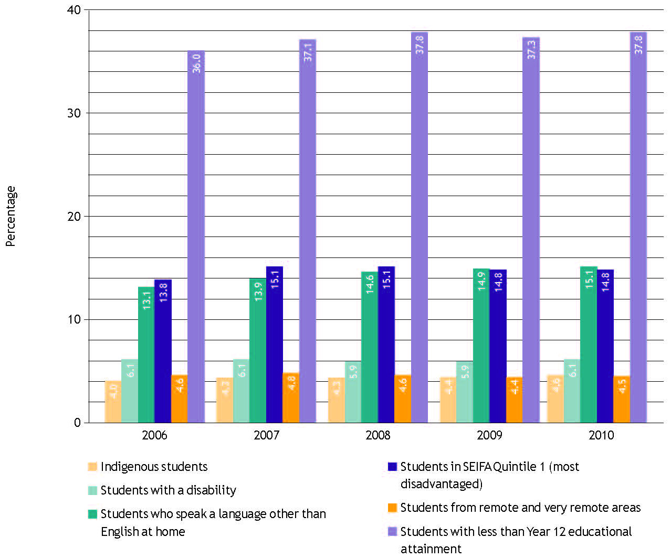
Figure 1 Students in disadvantaged groups as a proportion of all VET students, 2006–10
Notes: The VET Provider Collection contains data on publicly funded training programs delivered by government-funded and privately operated training providers.
For SEIFA population, the categories of ‘No SEIFA’ and ‘No usual residence’ have been excluded.
Less than Year 12 includes students with educational attainment of less than Year 10, Year 11 or certificates I and II.
Source: NCVER, VET Provider Collection, 2006–10.

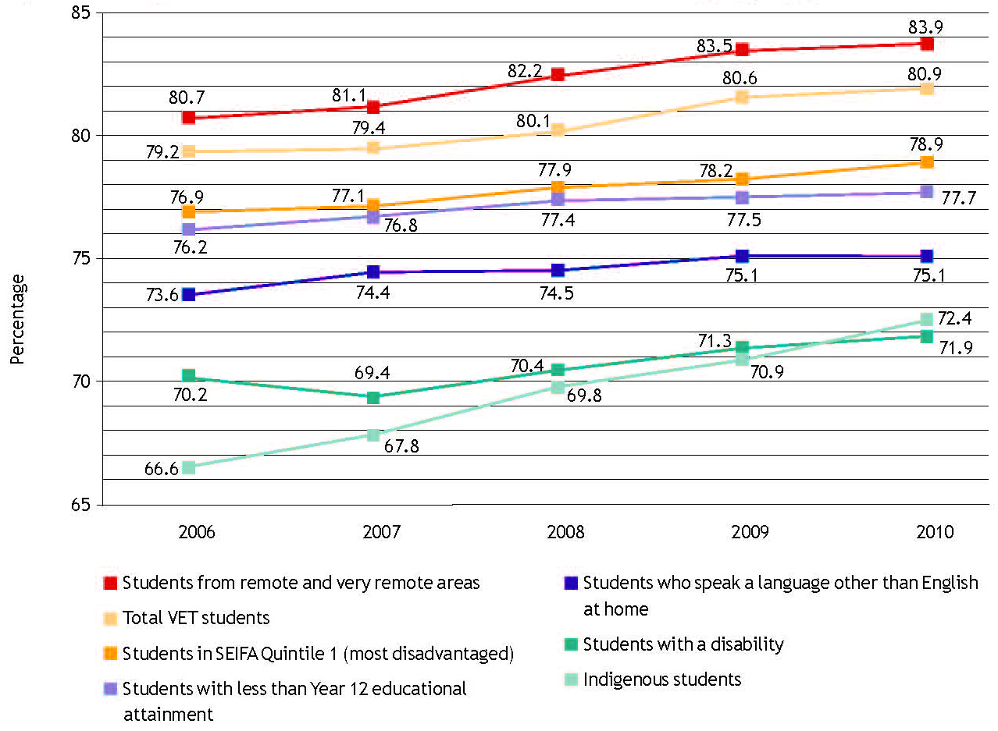
Figure 2 Load pass rate for all VET students and students in disadvantaged groups, 2006–10
Notes: The VET Provider Collection contains data on publicly funded training programs delivered by government-funded and privately operated training providers.
For SEIFA population, the categories of ‘No SEIFA’ and ‘No usual residence’ have been excluded.
Less than Year 12 includes students with educational attainment of less than Year 10, Year 11 or certificates I and II.
Source: NCVER, VET Provider Collection, 2006–10.

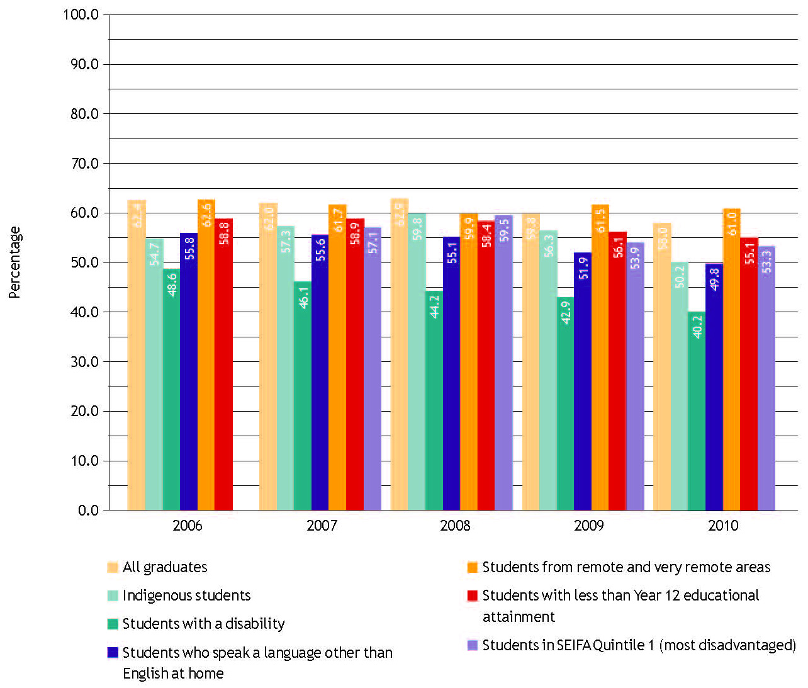
Figure 3 Proportion of all VET graduates and graduates in disadvantaged groups who improved their employment circumstances after training, 2006–10
Note: 2006 data not available for students in SEIFA Q1. Less than Year 12 includes students with educational attainment of less than Year 10, Year 11 or certificates I and II.
Source: NCVER Student Outcomes Survey 2006–10.

The challenges and opportunities to foster success
The problems facing the disadvantaged learner are often entrenched: training is not the sole answer. Some interventions intensify or entrench disadvantage when they don’t result in real opportunities, while others widen participation and improve outcomes. The research consistently points to the following three areas as effective in leading to a positive outcome:
— an integrated partnerships approach with advice linked to other services beyond the remit of the VET system, especially to identify work opportunities and to overcome the structural and personal barriers affecting both training and labour market participation
— career guidance, with the ambitions of the individual supported and the development of ‘life skills’ encouraged so that the individual can manage educational and occupational pathways
— retention strategies that assist with overcoming barriers to completion — not only barriers to participation — such as extensive student support services and flexible approaches to training delivery

INTEGRATED PARTNERSHIPS
The research highlights several barriers preventing meaningful engagement in both training and the labour market. These can be grouped as:
- individual: related to human capital, such as skills, education and work experience
- structural: such as child care, transport and labour market conditions, such as availability of jobs and quality employment
- personal: such as disabilities, health and mental health problems, substance abuse, children with health or behavioural issues, and housing instability.
When more immediate needs such as housing, health and finances have to be addressed, attending a training course is not a priority. Pocock (2009) suggests — in relation to low-paid workers, although this is applicable broadly — that the situation needs more than ‘adding vocational training and stirring’. Research from the Brotherhood of St Laurence shows that, where individuals had strong social networks and resources, training and formal credentials assisted them to secure employment. However, for many other students training is only part of the solution. Without support or mentoring, a certificate or qualification is not sufficient to enable them to acquire and keep a job (Bowman & Souery 2010).
Unemployment or disengagement from the labour market impedes the benefits to be gained from skills development. Support mechanisms beyond the classroom are required to ensure a successful transition to the workforce. Even short-term work or training opportunities can increase engagement with others, improve self-esteem and dignity and provide work experience and skills which enhance future employment prospects. As the Australian Social Inclusion Board (2011) notes: ‘Obtaining meaningful and satisfactory employment had the most dramatic positive impact on people’s lives but obtaining some form of employment (even if less than satisfying) could have strong and positive impact’.
For the long-term unemployed, the situation is difficult. A recent evaluation of Australia’s Employment Services cites a stark reality: around half of those participating in programs aimed at the long-term unemployed will not gain work at all (Fowkes 2011). ‘Their sense of exclusion, of helplessness and of shame is reinforced by the way that labour market assistance operates and the public discourse around unemployment.’ Fowkes calls for a major overhaul of labour market programs, so that the focus is on building individual capabilities, not just in terms of vocational skills, but in the ability to make effective decisions. Breaking down employment and industrial structures that impede access to work and developing new types of learning/work experience pathways to bridge the gap are needed (Fowkes 2011).
Ultimately, good results will depend on support from other parts of the system outside the boundaries of VET. Reform in terms of making the system more equitable requires an integrated approach, with advice and advocacy linked to other services (Wheelahan 2009a; Nechvoglod & Beddie 2010; North, Ferrier & Long 2010; National VET Equity Advisory Council 2009; Pocock 2009). Since effort needs to be put into developing relationships between stakeholders, strong institute leadership and enthusiasm are crucial. Inclusiveness strategies must be embraced by mainstream staff to ensure that the social outcomes approach is not marginalised (Volkoff, Clarke & Walstab 2008).

WORK THE PROBLEM AND THE ANSWER
The Brotherhood of St Laurence has collected evidence highlighting where the big employment hurdles lie for the disadvantaged. They suggest that Australia as a nation has to invest more in getting people back to work. The five top-ranked countries in the OECD spend more than 1.15% of GDP on labour market programs compared with 0.32% in Australia. But it is how the additional investment is made that is critical. The Brotherhood’s research suggests that success for highly disadvantaged job seekers lies in their participation in an integrated package of training, work experience and health and welfare support over a period of nine to 18 months — all tied to a job offer from an employer. The package provides people with the foundation skills, work experience, accredited training and flexible help that allows them to look after children, deal with health problems, get adequate housing and develop personal resilience (Nicholson 2010).

CAREER GUIDANCE
Research using data from the Longitudinal Surveys of Australian Youth (LSAY), a survey which tracks young people, highlights both the need for young people to have a plan for their lives and the importance of aspirations. This may sound obvious, but the quality and value of career guidance will affect the pathways taken. A persistent challenge is the tendency of school teachers to encourage students towards VET in Schools subjects when they ‘don’t know what else to do with them or they can’t do anything else with them’ (Gale 2010).
The research indicates that only a small proportion of eligible TAFE and university students are gaining access to available career services (Harris, Rainey & Sumner 2006). A key issue is whether the advice being offered is actually tailored to the aspirations, achievements and abilities of the individual, or whether the advice is restricted to the range of pathways the advisor is familiar with or which may serve the interests of others (Guthrie, Stanwick & Karmel 2011).
Career advisors need to pay special attention to helping individuals to take the steps necessary to meeting their goals. This is especially the case for students from low socioeconomic backgrounds, who may not have support or role models outside school or VET that encourage their career aspirations. The advice provided needs to take into account up-to-date information on courses, job outcomes and the scope of opportunities afforded by the range of pathways on offer (Sikora & Saha 2011; Hillman & McMillan 2005; National VET Equity Advisory Council 2010).

RETENTION STRATEGIES
Initiatives to address disadvantage have generally sought to increase participation and attainment through a mixture of encouragement or outreach programs, special arrangements for entry, participation and assessment, and by providing various financial, academic, personal and social supports (North & Ferrier 2009).
It is important to understand a learner’s motivation as well as their social disadvantage when considering a training intervention.
Persistence is retention turned inside out, putting learners, rather than providers, at the heart of the equation. Success through learning — skilfully supported by practitioners, who invest time and sensitivity in discovering learners’ reasons and motivations for learning — can create learners’ confidence, thereby reinforcing learner motivation and persistence.
(National Research and Development Centre for Adult Literacy and Numeracy 2008)
There are many reasons why an individual may disengage from learning, including competing priorities at work or at home, bad prior experiences of education, lack of knowledge about courses and career paths, low aspirations, low literacy and numeracy and poor self-esteem. While there is no simple answer to why some adult learners persist with their studies and others do not, there is a growing appreciation of the deeply entrenched and complex nature of disadvantage and the difficulties associated with engaging and keeping individuals in skill development opportunities.
In a study of what works in reaching and keeping hard-to-engage learners, Nechvoglod and Beddie (2010) emphasise the importance of putting the learner at the centre of the process. Determining the needs and desires of learners and being able to meet these will encourage them to be lifelong learners, not just learners for a specific end.
Research consistently mentions the importance of wide-ranging and adaptable learning support initiatives and programs for disengaged learners. They are generally characterised by more student autonomy, small classes, less regimentation, applied learning principles and close collaboration between educators to ensure effective pastoral care and guidance (Myconos & Duizend 2010).
In summary, the practices that foster persistence and improve skills and employment outcomes for the disadvantaged learner include:
- building a student’s self-worth; for example, helping students to recognise that they are capable of attaining learning goals
- establishing goals, which should regularly be revisited and reassessed
- offering extensive student support services, with access to pastoral care and mentoring; these may need to extend beyond the classroom into the workplace
- nurturing close relationships with committed teaching and support staff
- involving excluded or ‘at-risk’ individuals in the identification of their own needs, thus encouraging autonomy; for example, a personalised approach to the design, delivery and assessment of training (within agreed parameters)
- ensuring training delivery that features small classes, less regimentation, flexibility in content and delivery
- ensuring non-formal and embedded learning approaches to the teaching of generic, literacy and numeracy skills
- maintaining respect for the learning needs and skill capacities of the individual.
It is important to acknowledge the extensive range of programs available and the variety of providers — VET, ACE (adult and community education), welfare-to-work, third sector and community organisations — who are working successfully with socially excluded groups. It is also important to recognise that the diversity of students and programs across and within states with their differing barriers and support requirements complicates the task of identifying which specific practices are beneficial. Support can take many forms but needs to cater for learners whose life experiences, capacities, motivations, resources and needs are complex. This can be expensive (Nechvoglod & Beddie 2010; National Quality Council 2009).

IMPACT OF HIGH-LEVEL POLICY, MARKET AND FUNDING FRAMEWORKS
The reform of educational institutions and the way they are positioned in the market is creating opportunities for individuals of all social backgrounds. While some people caution that increased marketisation and demand-driven funding will compel providers to ‘ditch’ their equity programs because they are expensive (Wheelahan 2009b), current policy settings indicate that the role of vocational providers could become even more important. Karmel (2010b) argues that ‘second-chance education’ could be offered by many different types of institutions, with funding and regulatory models as the key driver. He also suggests that policies to expand higher education via demand funding and to encourage individuals from low socioeconomic backgrounds to participate will have small impact on the VET sector (Productivity Commission 2010; CEDEFOP 2009; Karmel & Lim 2010).

FINAL COMMENTS
When it comes to the social inclusion approach, whether its purpose is to impart skills to get a job, to improve self-esteem, to break down barriers to further learning, to assist with a career change or to build or rebuild social capital, then there is still plenty for VET to do.
One challenge to be addressed is the state of our data. Disadvantage is tricky to identify and measure. The lack of a complete collection of data for all VET students — private as well as publicly funded — hampers our understanding of how well VET is meeting the challenge of social inclusion. While improvements to data will not solve disadvantage, good data are needed to underpin understanding and sensible policy initiatives.

USEFUL RESOURCES
NCVER resources:
- Disability and VET statistical compendium <http://www.disabilityandvet.edu.au/>
- Indigenous students statistical compendium <http://www.indigenousvet.edu.au/>
- Research related to access and equity groups: <http://www.ncver.edu.au/students/31002.html>
Framework for the development of an ACE social inclusion strategy by Kaye Bowman (January 2011): <https://ala.asn.au/wp-content/uploads/2011/02/Framework-for-the-Development-of-an-ACE-Social-Inclusion-Strategy.pdf>
NVEAC research papers <http://www.nveac.tvetaustralia.com.au/nveac_research_papers>
Australian Government social inclusion website <http://www.socialinclusion.gov.au/>
(all accessed July 2011)

REFERENCES
ABS (Australian Bureau of Statistics) 2009, Education and Work Australia, cat.no.6227-0, ABS, Canberra.
Australian Social Inclusion Board 2010a, ‘Australian Government Social Inclusion Principles for Australia’, viewed March 2010, <http://www.socialinclusion.gov.au/SIAgenda/Principles/Pages/default.aspx>.
——2010b, Social inclusion in Australia — how Australia is faring, Commonwealth of Australia, Canberra.
——2011, Breaking cycles of disadvantage, Commonwealth of Australia, Canberra.
Bowman, D & Souery, N 2010, Training for work — insights from students and trainees at the Brotherhood of St Laurence, Brotherhood of St Laurence, Melbourne.
Brotherhood of St Laurence 2007, The Brotherhood’s social barometer — the working years, Brotherhood of St Laurence, Melbourne.
Buckmaster, L & Thomas, M 2009, Social inclusion and social citizenship —towards a truly inclusive society, Parliamentary Library, viewed September 2010, <http://www.aph.gov.au/library/pubs/rp/2009-10/10rp08.htm#_Toc244315389>.
CEDEFOP 2009, Modernising vocational education and training: fourth report on vocational education and training research in Europe — synthesis report, Greece.
Commonwealth of Australia 2009, Budget 2009—10 Ministerial statement on education, employment and workplace relations jobs, productivity and fairness — a foundation for recovery.
Considine, G, Watson, I & Hall, R 2005, Who’s missing out? Access and equity in vocational education and training, NCVER, Adelaide.
Dawe, S 2004, Moving on from enabling courses: why do some students remain in enabling courses?, NCVER, Adelaide.
Fowkes, L 2011, Rethinking Australia’s employment services, Whitlam Institute, University of Western Sydney.
Gale, T 2010, ‘Has VET’s time for equity come?’, Campus Review, 12 July.
Guthrie, H, Stanwick, J & Karmel, T 2011, Pathways: developing the skills of Australia’s workforce, NCVER, Adelaide.
Harris, R, Rainey, L & Sumner, R 2006, Crazy paving or stepping stones? Learning pathways within and between vocational education and training and higher education, NCVER, Adelaide.
Hillman, K & McMillan, J 2005, Life satisfaction of young Australians: relationships between further education, training and employment and general and career satisfaction, ACER, Melbourne, LSAY research report no.43, viewed March 2010, <http://www.lsay.edu.au/publications/1845.html>.
Karmel, T 2008, ‘What has been happening to vocational education and training diplomas and advanced diplomas?’, conference paper, NCVER, Adelaide, viewed March 2010, <http://www.ncver.edu.au/publications/2090.htm>.
——2010a, ‘On measuring SES and the VET sector’, paper for the Socioeconomic Status and Australian Higher Education Student Symposium.
——2010b, ‘The future of VET: or, Allen Ginsberg revisited’, in The future of VET: a medley of views’, eds F Beddie & P Curtin, NCVER, Adelaide.
Karmel, T & Lim, P 2010, ‘Socio-economic disadvantage and participation in tertiary education: some preliminary thoughts’, unpublished, NCVER, Adelaide.
Karmel, T & Nguyen, N 2007, The value of completing a vocational education and training qualification, NCVER, Adelaide.
Leigh, A 2008, ‘Returns to education in Australia’, Economic Papers, vol.27, no.3, pp.233—49.
Long, M & Shah, C 2008, Private returns to vocational education and training qualifications, NCVER, Adelaide.
Machin, S 2006, Social disadvantage and education experiences, OECD social, employment and migration working papers no.32, viewed March 2010, <http://www.oecd.org/dataoecd/13/60/36165298.pdf>.
Myconos, G & Duizend, E 2010, ‘Shaping future education and youth transitions to work’, in Brotherhood Comment, Brotherhood of St Laurence, Melbourne.
National Quality Council 2009, VET products for 21st century: final report of the Joint Steering Committee of the NQC and the COAG Skills and Workforce Development Subgroup, TVET Australia, Melbourne.
National Research and Development Centre for Adult Literacy and Numeracy 2008, Persistence research briefing, UK, viewed July 2011, <http://www.nrdc.org.uk/publications_details.asp?ID=134#>.
National VET Equity Advisory Council 2009, Summary of equity stakeholder messages: October—November 2009, NVEAC, Melbourne.
——2010, Equity blueprint creating futures: achieving potential through, VET NVEAC, Melbourne.
NCVER (National Centre for Vocational Education Research) 2010, Student Outcomes Survey 2009, NCVER, Adelaide.
Nechvoglod, L & Beddie, F 2010, Hard to reach learners: what works in reaching and keeping them?, Adult, Community and Further Education Board, Melbourne.
Nicholson, T 2010, Work the problem: Tony Nicholson opinion piece, Brotherhood of St Laurence, Melbourne, viewed March 2010, <http://www.bsl.org.au/pdfs/Nicholson_Age_Work_the_problem_30-08-2010.pdf>.
Nilsson, A 2010, ‘Vocational education and training — an engine for economic growth and a vehicle for social inclusion?’, International Journal of Training and Development, vol.14, no.4, pp.251—323.
North, S & Ferrier, F 2009, ‘Social inclusion and tertiary education’, presentation to the 13th Annual CEET Conference, Melbourne, 30 October 2009.
North, S, Ferrier, F & Long, M 2010, Equitable and inclusive VET, NVEAC, Melbourne.
OECD (Organisation for Economic Co-operation and Development) 2010, Education at a glance: OECD indicators, OECD, Paris.
Pocock, B 2009, Low-paid workers, changing patterns of work and life, and participation in vocational education and training: a discussion starter, NCVER, Adelaide.
Preston, J & Green, A 2008, ‘The role of vocational education and training in enhancing social inclusion and cohesion’, in CEDEFOP, Modernising vocational education and training: fourth report on vocational training research in Europe — background report, volume one, Greece.
Productivity Commission 2010, Issues paper — vocational education and training workforce, viewed March 2010, <http://www.pc.gov.au/projects/study/education-workforce/vocational/issues>.
Sikora, J & Saha, LJ 2011, Lost talent? The occupational ambitions and attainments of young Australians, NCVER, Adelaide.
Skills Australia 2009, Workforce futures: papers to promote discussion towards and Australian workforce development strategy: overview paper, Canberra.
Stanwick, J 2005, Australian Qualifications Framework lower-level qualifications: pathways to where for young people, NCVER, Adelaide.
Volkoff, V, Clarke, K & Walstab, A 2008, Impact of TAFE inclusiveness strategies, NCVER, Adelaide.
Wheelahan, L 2009a, ‘What kind of access does VET provide to higher education for low SES students? Not a lot’, paper presented to Student equity in higher education: what we know: what we need to know, National Centre for Student Equity in Higher Education Launch & Forum, University of South Australia, 25—26 February.
——2009b, ‘Market design and contestable funding’, paper to AEU National TAFE conference, Melbourne, 14 January.

With the exception of the Commonwealth Coat of Arms, the Department’s logo, any material protected by a trade mark and where otherwise noted all material presented in this document is provided under a Creative Commons Attribution 3.0 Australia <http://creativecommons.org/licenses/by/3.0/au> licence.
The details of the relevant licence conditions are available on the Creative Commons website (accessible using the links provided) as is the full legal code for the CC BY 3.0 AU licence <http://creativecommons.org/licenses/by/3.0/legalcode>.
The Creative Commons licence conditions do not apply to all logos, graphic design, artwork and photographs. Requests and enquiries concerning other reproduction and rights should be directed to the National Centre for Vocational Education Research (NCVER).
This document should be attributed as Hargreaves, J 2011, Vocational training and social inclusion: at a glance, NCVER.
This work has been produced by NCVER under the National Vocational Education and Training Research and Evaluation (NVETRE) Program, which is coordinated and managed by NCVER on behalf of the Australian Government and state and territory governments. Funding is provided through the Department of Education, Employment and Workplace Relations.
The NVETRE program is based upon priorities approved by ministers with responsibility for vocational education and training (VET). This research aims to improve policy and practice in the VET sector. For further information about the program go to the NCVER website <http://www.ncver.edu.au>.
The views and opinions expressed in this document are those of the author and do not necessarily reflect the views of the Australian Government or state and territory governments.
An at a glance is a synthesis of research focused on a particular topic of interest, drawing on information from various sources.
ISBN 978 1 921955 35 8 web edition ISBN 978 1 921955 36 5 print edition TD/TNC 104.20

