Embedding learning
from formal training into sustained behavioural change in the workplace
Cheryle Barker
Bendigo Regional Institute of TAFE

Participant in the NCVER Building Research Capacity Community
of Practice Scholarship Program 2009

The views and opinions expressed in this document are those of the author/project
team and do not necessarily reflect the views of the Australian Government,
state and territory governments or NCVER.
Any interpretation of data is the responsibility of the author/project team.

As part of the National Centre for Vocational Education Research (NCVER) Building Researcher Capacity Scheme, a Community of Practice Scholarship Program has been created to encourage a culture of research in vocational education and training (VET) organisations. With the guidance of an experienced mentor, VET practitioners without any formal research experience undertake their own work-based research project. The scholarship also provides participants with an opportunity to have their research peer-reviewed and published by NCVER.
For more information see:
http://www.ncver.edu.au/research/opportunities.html#Community_of_practice_scholarships_for_VET_practitioners
About the research
© Commonwealth of Australia, 2011
This work has been produced by the National Centre for Vocational Education Research (NCVER) under the National Vocational Education and Training Research and Evaluation (NVETRE) Program, which is coordinated and managed by NCVER on behalf of the Australian Government and state and territory governments. Funding is provided through the Department of Education, Employment and Workplace Relations. Apart from any use permitted under the Copyright Act 1968, no part of this publication may be reproduced by any process without written permission. Requests should be made to NCVER.
The views and opinions expressed in this document are those of the author/project team and do not necessarily reflect the views of the Australian Government, state and territory governments or NCVER.
ISBN 978 1 921955 25 9 web edition
ISBN 978 1 921955 26 6 print edition
TD/TNC 104.16
Published by NCVER
ABN 87 007 967 311
Level 11, 33 King William Street, Adelaide, SA 5000
PO Box 8288 Station Arcade, Adelaide SA 5000, Australia
ph +61 8 8230 8400 fax +61 8 8212 3436
email ncver@ncver.edu.au
<http://www.ncver.edu.au>
http://www.ncver.edu.au/publications/2405.html
Embedding learning from formal training into sustained behavioural change in the workplace

Cheryle Barker, Bendigo Regional Institute of TAFE
Building the research capacity of the vocational education and training (VET) sector is a key concern for the National Centre for Vocational Education Research (NCVER). To assist with this objective, NCVER supports a community of practice scholarship program, whereby VET practitioners without research experience are given the opportunity to undertake their own research to address a workplace problem. Scholarship recipients are supported by a mentor, and NCVER publishes their research results.
Cheryle Barker participated in the 2009 community of practice program. Cheryle is an Education Research Officer at Bendigo Regional Institute of TAFE. With a focus on the health industry, Cheryle’s research explores which workplace practices help individuals to embed learning from training programs into their work practice.
Through a literature review and interviews with industry and trainers, the study identified a range of potential strategies to assist learners to integrate learning into the workplace. A pilot training program was conducted to test the effectiveness of these strategies. Learners’ pre-training benchmarks were established and feedback was sought immediately after the conclusion of training and again two months later.
Key messages
- The delivery model, including the use of practical and interactive workshops, maximised students’ capacity to transfer their learning into their workplace.
- Transference could be enhanced by focusing attention on self-directed learning for students and ensuring that adequate support was provided to their trainers and workplace supervisors/coaches to carry out their roles in supporting sustained behavioural change.
- A clear understanding of the purpose, outcomes and model of delivery was vital for students. Understanding the purpose of the training program prior to beginning influenced learner motivation to participate and their openness to the learning experience.
- Coaching and mentoring have been strongly promoted as useful adjuncts to training but this research shows more work is needed to get people to engage in these activities.
Tom Karmel
Managing Director

Acknowledgments
In 2009, the National Centre for Vocational Education Research (NCVER) took on its second group of new researchers as part of a three-year building researcher capacity in the VET sector scheme. Through the initiative ten new VET researchers received an NCVER scholarship and were supported to undertake work-based research projects.
I was awarded one of these scholarships to complete this research project. A significant feature of the NCVER scheme is the mentoring component, by which new researchers are matched with experienced and senior researchers from the Australian Vocational Education and Training Research Association (AVETRA). I was mentored by Dr Peter Smith from Deakin University. He provided support and expertise in the planning, implementation and review of the research. Dr Smith’s ideas, feedback and encouragement were particularly appreciated, as were the support provided by Berwyn Clayton, Llandis Barratt-Pugh, Geri Pancini and Bendigo TAFE.
I also wish to express my gratitude to the participants and their organisations for their support and willingness to provide feedback on the pilot training program.

Contents
Introduction 7
The research project 8
Relevant literature 8
Methodology 13
Delivery model 13
Findings 16
Motivational factors for engaging in the learning process 16
Learning 16
Behavioural change and the impact of training 17
Feedback on what factors contributed to embedding learning
in the workplace 20
Summary 24
Conclusions 25
Key features supporting sustained change workplace
practice convert 25
Summary 27
References 28

Figures
Figure 1
Training participants’ pre- and immediately post-formal training
self-rating against nine key learning outcomes 16
Figure 2
Interviewees’ rating of the impact of participating in the training
program and their confidence to apply new skills in the workplace 17
Figure 3
Interviewees’ rating of how eager they were to change their
behaviour on the job once training had completed 18
Figure 4
Interviewees’ rating of the impact of participating in the training
program and their overall performance in the workplace in relation
to planning, implementing and evaluating group activities 18
Figure 5
Training participants’ pre- and post-formal training self-rating against
nine key learning outcomes 19
Figure 6
Interviewees’ expectations of doing things differently in the future 20

Introduction
The health workforce currently receives significant scrutiny from governments, the media, health services and the general community about its size, distribution and effectiveness. In particular there has been a focus on skill shortages such as those reported by the Productivity Commission (2005), which also found that demand for health services will increase with an aging population and growing community expectations, while the available labour pool will shrink.
The industry is actively working through workforce development issues related to meeting increasing service provision demand within the context of an aging workforce, low uptake of health careers by young people and skill shortages. Plans to address these concerns include responding to the ever-changing training needs of staff as a consequence of new service delivery approaches, the realignment of health care roles and the development of new roles. Significant funds have been spent on the training and retraining of staff. Anecdotal evidence suggests that the industry is beginning to question the value of current delivery models and their effectiveness in meeting future workforce requirements, given the difficulty some training participants have in integrating learning from formal training into their current workplace and day-to-day practice. Consequently, further investigation is warranted to identify learning practices that assist the integration of formal learning into work practice.
This paper is concerned with investigating learning approaches that embed learning from training programs into workplace practice for individuals in the health industry. The project aimed to identify:
- learning practices that maximise the transfer of learning from formal training to work practice
- factors that inhibit the transfer of learning from formal training to work practice.
A pilot training program was initiated in collaboration with a local health organisation. What this research was really interested in was examining how learning was transferred from this program into the workplace. The purpose of the program was to deliver innovative training for ‘planned activity groups’. Planned activity groups aim to provide the social, intellectual, physical and emotional stimulation which helps maintain living and social skills for older people who are physically independent, people with moderate to severe dementia, frail older people and people with disabilities. Planned activity groups focus on providing healthy living programs to maintain healthy lifestyles, while facilitating social support and interaction. These activities provide an opportunity for support and social interaction and are usually run by local government or non-profit community-based organisations.
The training program used a model of delivery based on an acknowledgment that participants should be provided with the opportunity to develop new skills and knowledge (learning) and be supported to embed and sustain this learning in their current workplace (behavioural change).
The expected outcomes of the pilot were:
- the achievement by the learner group of three nationally accredited units of competency, covering programming and group facilitation skills and knowledge
- the development, implementation and evaluation of an innovative project conducted by participants.
The research project focused on evaluating the pilot program in relation to its effectiveness in supporting the integration of learning into workplace practice.

The research project
The first phase of the project was to identify a range of potential strategies for assisting learners to integrate learning into their day-to-day practice. This was achieved by both undertaking a literature review and discussions with industry and trainers. The effectiveness of these strategies was evaluated by establishing pre-training benchmarks and seeking feedback from learners immediately after the conclusion of the pilot training program and again two months later. The methodology adopted for the pilot program is described in the next chapter.

Relevant literature

Linking workplace pedagogy and formal training
Although it is relatively old, a significant amount of research has been undertaken to determine how learning takes place in the workplace. Workplace learning can be defined as learning usually undertaken on the job, including on-the-job training under ‘normal’ operational conditions and on-site training, which is conducted away from the work process, for example, in a training room (Australian National Training Authority 2003). Research focusing on workplace learning tends to highlight the type of workplace learning and the organisational factors conducive to workplace learning and not necessarily the teaching methods that support integration of formal learning into workplace practice.
Brown, Collins and Duguid (1989) identify the following components essential to the design of a learning program aimed at supporting the integration of learning into day-to-day work practice.
- Authenticity: knowledge and learning are a product of the situation and activity within which it is produced. Learning needs to be embedded in everyday activities or set in the real world (rather than being independent of the situations in which learning will be used).
- Spiral process: learning is a progressive process involving multiple practices, reflection and feedback.
- Articulation: learning involves conscious articulation of knowledge and learning.
- Social interaction: learning occurs through social interaction and collaboration. This includes modelling, coaching and support from others, as well as comparing performance with others.
Further insight into the rationale and benefits associated with authentic activities is provided by Billett (1993, 1998). Billett suggests that an understanding of workplace learning can be enhanced by considering the sociocultural constructivist literature. A sociocultural perspective emphasises the influence of social and cultural factors on an individual’s construction of knowledge, in that knowledge is developed and influenced by interaction and relationships with other individuals in the workplace and the social/cultural practices within each. One of the key premises of this perspective is that the construction of knowledge in the workplace will be influenced by the specific workplace.
Billet suggests that a precondition for learning is access by learners to authentic activity, defined as that based in the settings in which that knowledge and learning will be applied, that is, specific workplaces. For example, consider a student learning how to undertake intravenous therapy. An authentic activity would be where the learner observes and/or practises intravenous therapy within a health service with ‘real’ patients. In these circumstances the learner is guided by an expert and exposed to both the professional and organisational values associated with the learning task.
Non-authentic activities, such as classroom-based activities or simulated work environments, are suggested to be limited because of the different sociocultural factors that influence the development of knowledge. Even in a simulated work environment based in an educational setting, the goals may be sufficiently different to undermine the embedding or transference of learning into work practice. In an educational setting the goals may ultimately focus on passing assessments or demonstrating competency against learning elements in nationally accredited units of competency.
On the other side of the ledger, the limitations of learning based on authentic activities are:
- the ability of the learner to develop conceptual understanding about their work practice
- the necessary learning resources not always being available in work situations.
The development of conceptual understanding is necessary for applying learning into new situations. Furthermore, knowledge developed in, or appropriate to, one setting or workplace may not be transferrable to other settings. This can also be a limitation in any learning program that involves the development of knowledge in only one context (such as the classroom). Other concerns relate to limited access in the workplace to authentic activities that take the learner from routine to more complex tasks, the reluctance of experts to give or share knowledge and limited access to expertise, and guidance being based on a process, whereby one person is describing rather than modelling or supporting the deliberate development of knowledge.
Billet (1993) suggests that guided learning by experts or mentors promotes conceptual knowledge development through reflection and dialogue, which makes the reasons for actions explicit. In addition to guided learning, practical experiences, relevance to work activities and ‘hands-on’ experience were key determinants in the acquisition and application of skills.
Billett (1993) also notes that this type of learning places greater responsibility on the learner to demonstrate initiative, seek feedback and regulate their own behaviour or knowledge development. Self-motivation is a key part of ensuring that learners demonstrate self-initiative, particularly in higher-order activity or more complex tasks.
Self-direction in learning is defined by Brockett and Hiemstra (1991) as the process by which a learner assumes primary responsibility for planning, implementing and evaluating the learning process. In this scenario the trainer or teacher plays a facilitator role. Brockett and Hiemstra also suggest that the second key component of this process is the learner’s preference or willingness to assume responsibility for learning. Learners, they argue, possess different degrees of preparedness to accept responsibility for their own learning. Brockett and Hiemstra’s (1991) Personal Responsibility Orientation Model also suggests that the optimal conditions for learning result from congruence between the learner’s level of self-direction and the requirements of the external learning process. For example, if a learner is predisposed towards a high level of self-directedness and the learning process actively facilitates self-direction, then there is a greater likelihood that learning will take place. Similarly, if a learner is predisposed to a low level of self-directedness, then success is more likely if the trainer assumes a more directive role. This model supports both greater attention to supporting learners to be self-directed and to setting up a learning situation that is congruent with both types of learner expectations. Consideration may need to be given to learning processes that support learners to be self-directed and demonstrate initiative, as well as those that embed learning from formal training programs into day-to-day work practice.
Billett (2000) proposes a model of workplace learning in which two of the key features are the ability to access more complex tasks and support and guidance from experts and other workers in the workplace itself. One of the concerns with workplace learning is the unintended learning that can sometimes occur in the workplace because of the workplace culture and organisational factors. This may result in learning that does not necessarily encompass best practice. However, it is suggested that the quality of the knowledge gained is influenced by the quality of guidance received. The guidance offered needs to encourage the learner to explore options, to question and to build scenarios — as opposed to merely taking direction. This type of guidance is considered to overcome some of the shortcomings of workplace learning and assist in both reinforcing existing knowledge and constructing the new knowledge required in solving problems. The incorporation of this type of guidance and reflective practice is believed to also assist in transferring knowledge to new situations.
Ultimately Billett (2000) is arguing that individuals need access to work activities that display increasing levels of complexity and accountability, with guidance from experienced workers in the form of coaching and modelling and including assistance that focuses on transferring knowledge to new situations through reflective practice.
In the context of mentoring, Billett (1999) also suggests that providing an opportunity for the learner to appoint the mentor or person who will guide them will also have a positive influence on their learning, as the ability to influence the choice of mentor directly impacts upon the learner’s perception of the credibility of the expert.
Similar approaches to workplace learning are supported by the work of Fuller and Unwin (2003). These include involving the participant in a range of activities outside their normal work practices, such as secondment to other workplaces, with the learner being exposed to new challenges and perspectives. Secondly, they support the need to provide opportunities to reflect on practice. This can include one-to-one approaches and/or multiple communities of practice.
Although there are a range of significant differences between countries, such as culture, organisational structures, job roles and levels of education, there still appear to be some commonalities on what promotes learning and behaviour change in the workplace. A Norwegian study (Skule & Reichborn 2002) investigated the conditions characteristic of learning-conducive workplaces. The authors identify seven different factors that promote learning through work:
- high degree of exposure to demands from customers, management, colleagues and owners
- high degree of exposure to changes in technology, organisation and work methods
- managerial responsibility
- a significant amount of external professional contact
- good opportunities for feedback from work
- support and encouragement for learning from management
- high probability that skills are rewarded through interesting tasks, better career possibilities or better pay (Skule & Reichborn 2002, p.10).
These factors also have the potential to inform strategies that may be useful in a learning program that supports the integration and sustainability of learning from formal training into day-to-day work practices.
Chappell and Hawke (2008) undertook a literature review designed to assist the VET system to understand how learning in the workplace can be encouraged and supported.
One of the more important challenges in this area is for organisations to understand the significant conceptual gap that separates learning that takes place in the classroom/training room contexts and learning that occurs at work. (Chappell & Hawke 2008, p.4)
From the review four key factors were identified as influencing organisations’ learning environments, including:
- job structure (amount of change staff are exposed to and feedback received)
- work process (understanding an organisation’s strategic direction and exposure to different sections of the business)
- social interaction (exposure to different work groups both within and outside the organisation)
- managerial (support and feedback from management, rewards).

Effective teaching practice
A significant amount of research has also been undertaken in an attempt to define ‘effective’ teaching practice. In general, studies support a shift in teaching practice, whereby ‘good teaching is now understood to involve a process of facilitating learning rather than being the simple transmission of knowledge from teacher to learner’ (Smith & Blake 2005, p.2). The roles that teachers take to facilitate learning include:
- placing a strong emphasis on the workplace to provide a meaningful context for learning where problems are framed by the context of the workplace
- encouraging ‘hands-on’ and interactive approaches to learning activities to allow learners to apply and interact equally with the thinking and performing aspects of learning
- establishing learning outcomes that are clear in their intent to achieve ‘work-readiness’ for learners
- giving learners the opportunity to collaborate and negotiate in determining their learning and assessment processes
- understanding learners as ‘co-producers’ of new knowledge and skills
- recognising that the prior learning and life experiences of learners are valuable foundations for constructing new knowledge and skill sets (although they can also impose limitations)
- using flexible teaching approaches that address the different learning styles of students
- valuing the social interactions involved with learning in groups (Smith & Blake 2005, p.3).
Many of the characteristics of facilitative teaching may assist in the integration of learning into learners’ daily work practice, such as examining real issues that arise in the work contexts of training participants and encouraging self-reflection of current practice.

Summary
The focus of this research was on investigating different learning strategies for formal training that facilitate the integration of learning into the current workplaces of participants. In summary, a review of related research identified the key learning strategies that maximise the transference of knowledge and skills from the formal training to a work context. These include:

- engagement in authentic activities
- guided learning by experts (such as mentors, workplace coaches), particularly in terms of providing feedback on performance
- strategies that support self-initiation, conscious thinking and reflection on practice by learners (rather than being told what to do, the learner is asked what they think and is guided by the expert; the guidance provided makes explicit the learning process and why things are done in a certain way)
- movement from simple to more complex tasks
- support and encouragement from management (including access to opportunities for learning).

Measuring behaviour change in the workplace
Kirkpatrick and Kirkpatrick (2007) suggest four levels of evaluation as critical to determining the effectiveness of training programs. The four levels of the evaluation model essentially measure:
- reaction of student: what they thought and felt about the training
- learning: the resulting increase in knowledge, skills or learning
- behaviour: the extent of behaviour change/improvement and application of learning to practice
- results: the effects on the business or environment resulting from the trainee’s performance.
It is the third level that appears relevant to the research topic — measuring the extent of applied learning. In this instance the data being sought will focus not only on whether applied learning on the job has occurred, but also on the factors or learning strategies that were viewed by the learners to assist this process. The third level of evaluation requires obtaining feedback from participants both immediately and between three and six months after the completion of formal training.
The key questions suggested by Kirkpatrick and Kirkpatrick for the third level — behavioural change evaluation — are:
- Did the participants put their learning into effect when back on the job?
- Were the relevant skills and knowledge used?
- Was there noticeable and measurable behaviour change in participants when back in their workplace?
- Were the changes in behaviour and the new level of knowledge sustained?
- Is the participant aware of their change in behaviour, knowledge, skill level?
- Would the participant be able to transfer their learning to another person?
- If behaviour change did occur, what factors in the learning strategy assisted?
- If the change did not occur, was it related to the delivery or workplace factors?
Kirkpatrick and Kirkpatrick (2007) suggest that it is important to undertake first and second level evaluations to a build a clear ‘chain of evidence’. That is to say, it is important to clarify whether the learners were engaged in the training program and if they developed the relevant skills and knowledge prior to assessing whether an increase in capability was followed by behaviour change in the workplace.

Methodology

Delivery model
The approach adopted in the pilot training model was informed by the literature review and consultations with local industry.
The core aim of the pilot training model was for participants to learn about developing innovative activities by undertaking a project themselves. Basically a learning-from-action approach, the heart of the training program was the participants’ project activity, as opposed to the final product. The assumption underlying this learning program was that individuals continually learn from their experiences through reflection on their actions, which themselves have been informed by theory and prior learning. Consequently, it was important that numerous opportunities were provided in the pilot program that enabled participants to reflect on their practice. Processes that encourage reflection, for example, support from a mentor, are also key components of an approach that supports the integration of learning into work practice.
New skills and knowledge were introduced via workshops and self-paced workbooks. Participants attended four workshops led by two facilitators, with a view to embedding person-centred practices. The workshops were held three to four weeks apart to provide an opportunity to implement learning. Self-paced workbooks were provided to support learning, as was industry material designed to provide resources already familiar to training participants.
A range of strategies was utilised to support the process of embedding learning and sustaining participant behaviour change in their current workplace. These included the requirement for participants to develop, implement and evaluate an innovative activity/program. In addition, the participant’s line manager or another appropriate staff member would act as a workplace coach, who would support and encourage the participant in their project. It was envisaged they would also, in collaboration with the participant, provide progress reports to the training provider. The training provider was responsible for providing support to workplace coaches to ensure clarification of their role, tips for assisting learners to integrate learning into practice and strategies for supporting change in work practice. Key to the success of the model was the support and commitment of employers, since the central component of the training program involved participants developing and implementing a new activity in the workplace and being linked to an appropriate staff member.
Another key strategy for embedding learning in workplace practice was the role of the facilitator as a mentor. Given that each participant may have different needs, the mentoring role would include being a teacher, guide, motivator, coach, advisor, sponsor, role model, referral agent and door opener. The mentoring relationship may have included:
- planning activity: guidance, goal setting
- supporting reflection about project experiences: sounding board
- reviewing project progress: critical friend
- offering alternative solutions to issues encountered: options for problem-solving
- responding to questions about project activity: knowledge development
- offering advice on key resources: expand network and open doors.
Participants were also required to keep a self-reflective journal, which it was expected would be encouraged and supported by supervisors and management. The journal entries provided participants with the opportunity to reflect on and improve their current work practices.
Critical reflection would focus on what had been learned from implementing a project and offer the opportunity to reflect upon the changes participants would continue to make in the workplace in relation to:
- group facilitation
- person-centred approaches
- innovative ideas for programs based on health promotion philosophy
- individual outcomes.
A buddy system was also to be established between learners to encourage further collaboration, cross-fertilisation of ideas and team learning. Contact between learners and each of their supports (workplace coaches, buddies and facilitators) was expected to occur at least once between workshops.
Nineteen planned activity group staff participated in the pilot training program. The training program was mapped to the following national accredited units from the Community Services Training Package (CHC08):
- CHCGROUP403D: Plan and conduct group activities
- CHCICS405C: Facilitate groups for individual outcomes
- CHCRH402A: Undertake leisure and health programming.
The group consisted of 17 females and two males between the ages of 20 and 61 years. The length of employment with their current employer was greatly varied. Six participants had been working in their current occupation for less than 12 months, seven between one and ten years and five staff for ten years or more. The remaining participant worked in the home and in the community services area but was interested in, and being encouraged by their manager, to consider employment in the near future in planned activity groups.
Pre- and immediate post-training self-assessments were undertaken by training participants, with all participants completing the pre-training self-assessment ratings. Thirteen participants completed the post-training self-assessments conducted immediately after the conclusion of training. The self-assessment process involved participants rating their performance against key learning areas on a scale of one to ten, where one equals low levels of performance and ten equals outstanding levels of performance. The following are the nine key learning areas, based on learning outcomes in the three nationally accredited units of competency:
Identify leisure and health needs of clients/groups
- Facilitate a group planning process
- Prepare an activity/program plan
- Resource issues for activity/programs
- Deliver activity/program
- Facilitate and manage group process
- Manage conflict within groups
- Evaluate activity/program
- Involve clients in the planning, implementation and evaluation of activity/program.
Self-assessment ratings were also conducted two months after the formal training program had been completed against the same nine key learning areas. In addition to the subsequent self-assessment rating, training participants were interviewed face to face for feedback on the different components of the training program, at a time and location of their choice. This feedback was used to provide evidence of the effectiveness of the different strategies for assisting the integration of learning into the participants’ workplace. Thirteen participants participated in the follow-up interviews and a transcript of the interview was returned to participants for validation. Four of the training participants chose not to participate in the interviews and two were on leave at the time interviews were conducted. As the post-training ratings collected immediately upon the completion of training were returned anonymously, the 13 remaining training participants who agreed to being interviewed may or may not have completed the previous ratings.

Ethical considerations
It was important to note the reluctance of some training participants to admit that they had not implemented the learning from training programs. This may be due to their not wanting to ‘look bad’ or to suggest that their employer’s investment in their training was not of significant value. To counteract this factor, it was important to stress to participants that the evaluation was measuring the effectiveness of the program and not their individual performance. Ensuring and reassuring the participants in the interviews that their responses would remain anonymous was also critical.
As such the researcher attended the first workshop to both introduce herself and reinforce the purpose of the evaluation project. Participants were provided with relevant written information, including the purpose of the study, the voluntary nature of the study and how anonymity would be maintained. They were also informed that they could withdraw from the research process at any time. This decision would remain confidential to the interviewer.
The researcher also attended the final workshop to reintroduce the purpose of the evaluation and the post-training evaluation interviews. Prior to the post-training interview, participants were again provided with written details of the purpose of the evaluation and the voluntary nature of participation, and anonymity was again confirmed. In the follow-up interview the researcher left the interview room while the participant completed the self-assessment rating form.
The employers of learning participants were also contacted and asked to provide permission for staff to participate in post-training interviews.

Findings

Motivational factors for engaging in the learning process
Kirkpatrick and Kirkpatrick (2006) suggest that one of the conditions necessary for behavioural change is a motivation to change. Learning participants stated that their main motivation for attending training was because their supervisor or manager encouraged them to do so (nine out of the 13 interviewees). The second most significant reason offered was to improve work performance by being exposed to different planned activity group activities and being able to network with other planned activity group workers. Four interviewees were new to the role and thought it would be beneficial to learn more about the types of activities delivered in other planned activity groups. Although a few interviewees were reluctant at first, comments like ‘Always keen to be involved in further training’, ‘Enriches what we do with our clients’ and ‘Great networking opportunities’ highlight the positive attitude that a vast majority approached the training with.

Learning
According to the Kirkpatrick evaluation model, learning needs to occur before behavioural change is likely (Kirkpatrick & Kirkpatrick 2006). Learning is assessed by measuring skills and knowledge levels prior to and immediately after the completion of training. Figure 1 provides an indication from a participant’s perspective of the increase in knowledge and skills or learning as a result of participating in the pilot training program.
Figure 1 Training participants’ pre- and immediately post-formal training self-rating against nine key learning outcomes 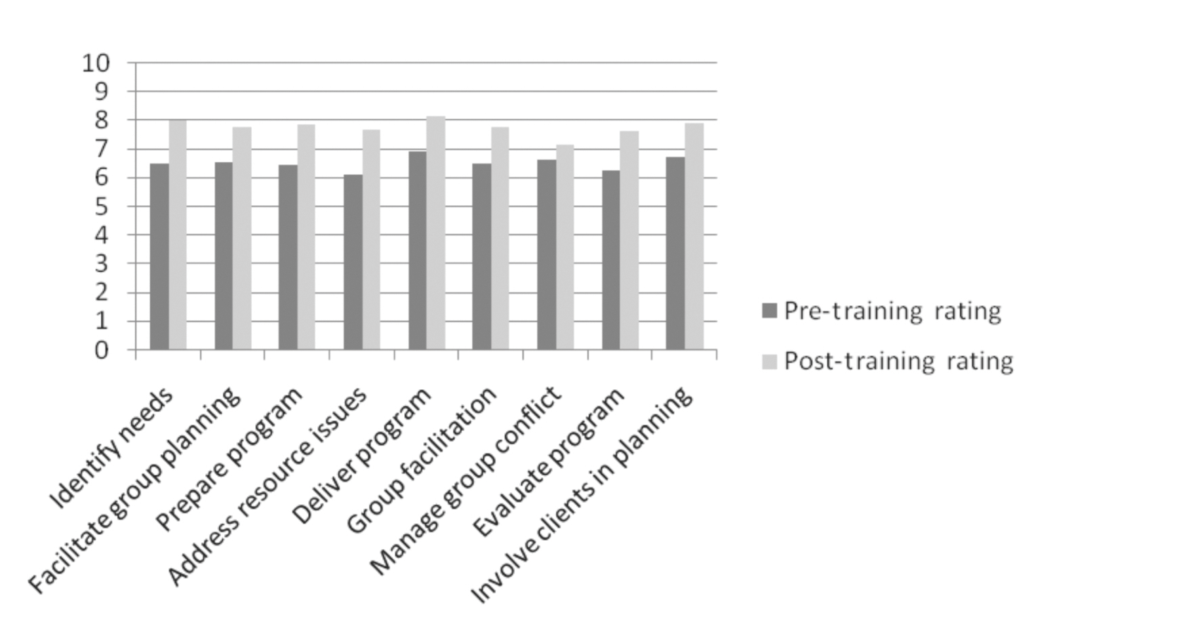

The data indicate that training participants assessed their level of skills as between the sixth and seventh categories (just above average) prior to participating in the training program. Based on training participants’ self-assessment, learning was achieved against all of the nine key learning areas. The learning area with only minimal change was the ability to manage conflict within groups. Furthermore, 18 of the 19 learners were assessed as competent against the three nationally recognised units of competency that training was mapped to.
In addition to the acquisition of knowledge and skills, learning includes the confidence and commitment or willingness to apply the new skills and knowledge in the workplace.
Figure 2 Interviewees’ rating of the impact of participating in the training program and their confidence to apply new skills in the workplace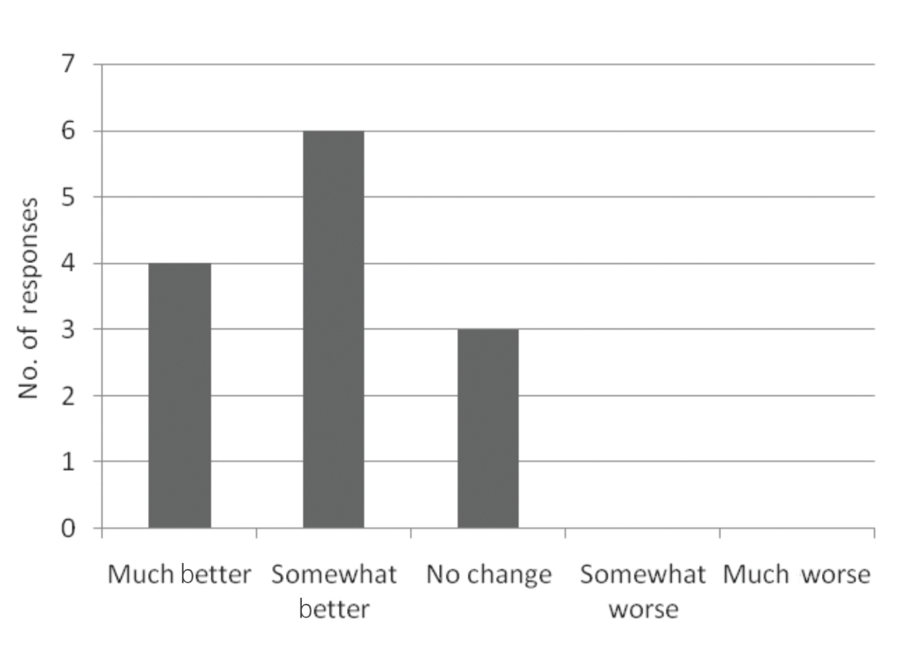
Ten of the 13 respondents indicated a positive change in their level of confidence to apply new skills in their workplace. Two interviewees stated that their no change rating was based on having recently completed accredited training or an accreditation/compliance audit, which meant their confidence and skill levels had already improved and had resulted in change in their behaviour in the workplace. Another interviewee who stated there was no change was a team leader who suggested she had the skills and knowledge prior to undertaking this training and therefore her behaviour had not changed. However, she had observed an increase in the confidence levels of the staff she supervised who had attended the training.
Data indicate that training participants were eager to implement some change within the workplace upon completing the formal training. This is an important consideration in measuring the impact of personal motivation and preparedness to integrate learning into day-to-day practice.

Behavioural change and the impact of training
The data suggest that the impact of the training program on interviewees’ performance in the workplace was less by comparison with the increase in their confidence to apply new skills and knowledge. Again, similar comments were made by those staff who recorded a rating of no change as for figure 2 data. Another interviewee stated there was currently no change as the current planned activity group program had already been determined. They did envisage significant change in how activities were planned in the future, in terms of greater consultation and planning with clients.
Figure 3 Interviewees’ rating of how eager they were to change their behaviour on the job once training had completed
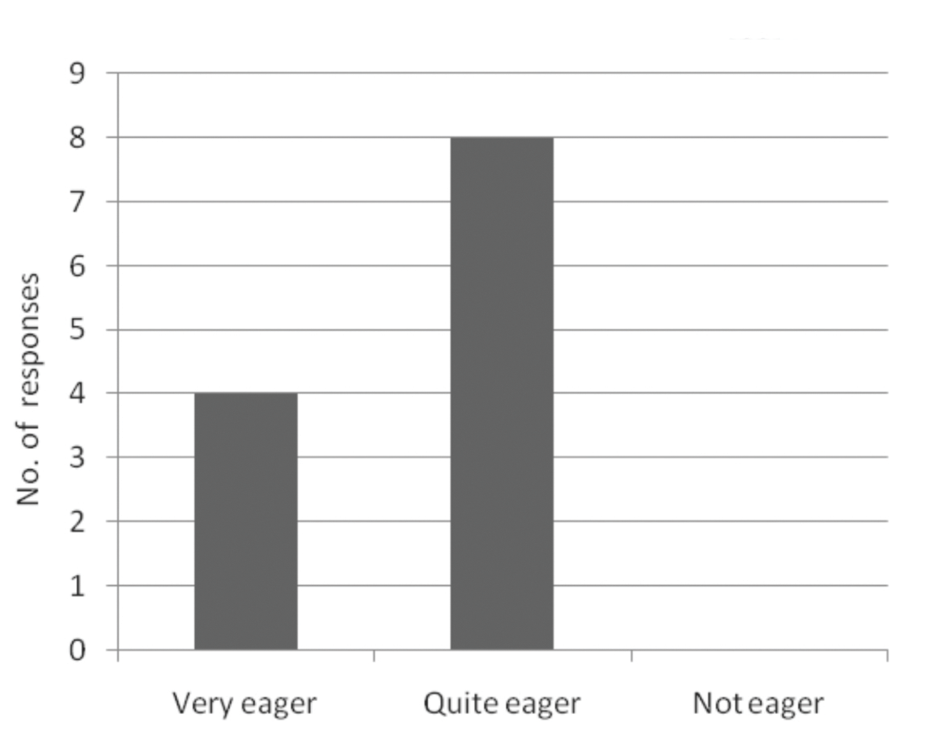
For these data there was only one participant who did not respond.
Figure 4 Interviewees’ rating of the impact of participating in the training program and their overall performance in the workplace in relation to planning, implementing and evaluating group activities
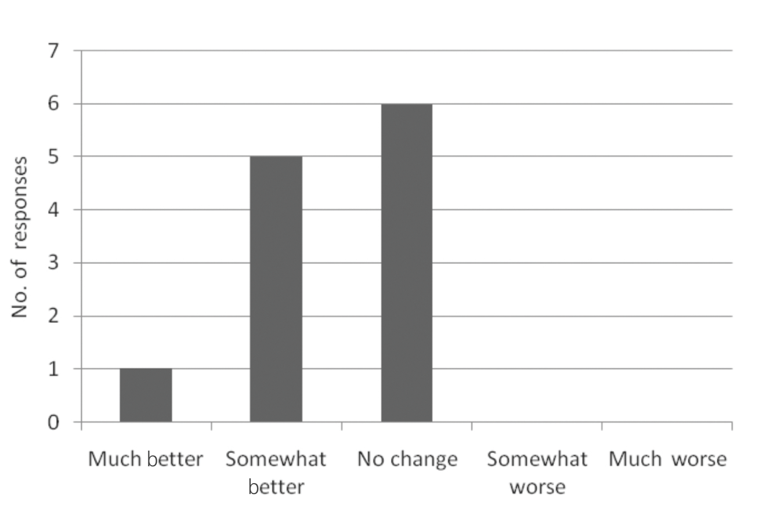
For these data there was only one participant who did not respond.
Figure 5 provides, from a training participant’s perspective, a measure of the transfer of knowledge and skills to the training participant’s job.
According to the training participants, behavioural change in the workplace was achieved in all nine key skill and knowledge areas. The most significant change occurred in the ability to involve clients in the planning, implementation and evaluation of activity/program (key learning area 9), followed by the ability to facilitate a group planning process (key learning area 6) and the ability to evaluate activity/program (key learning area 8).
Figure 5 Training participants’ pre- and post-formal training self-rating against nine key learning outcomes
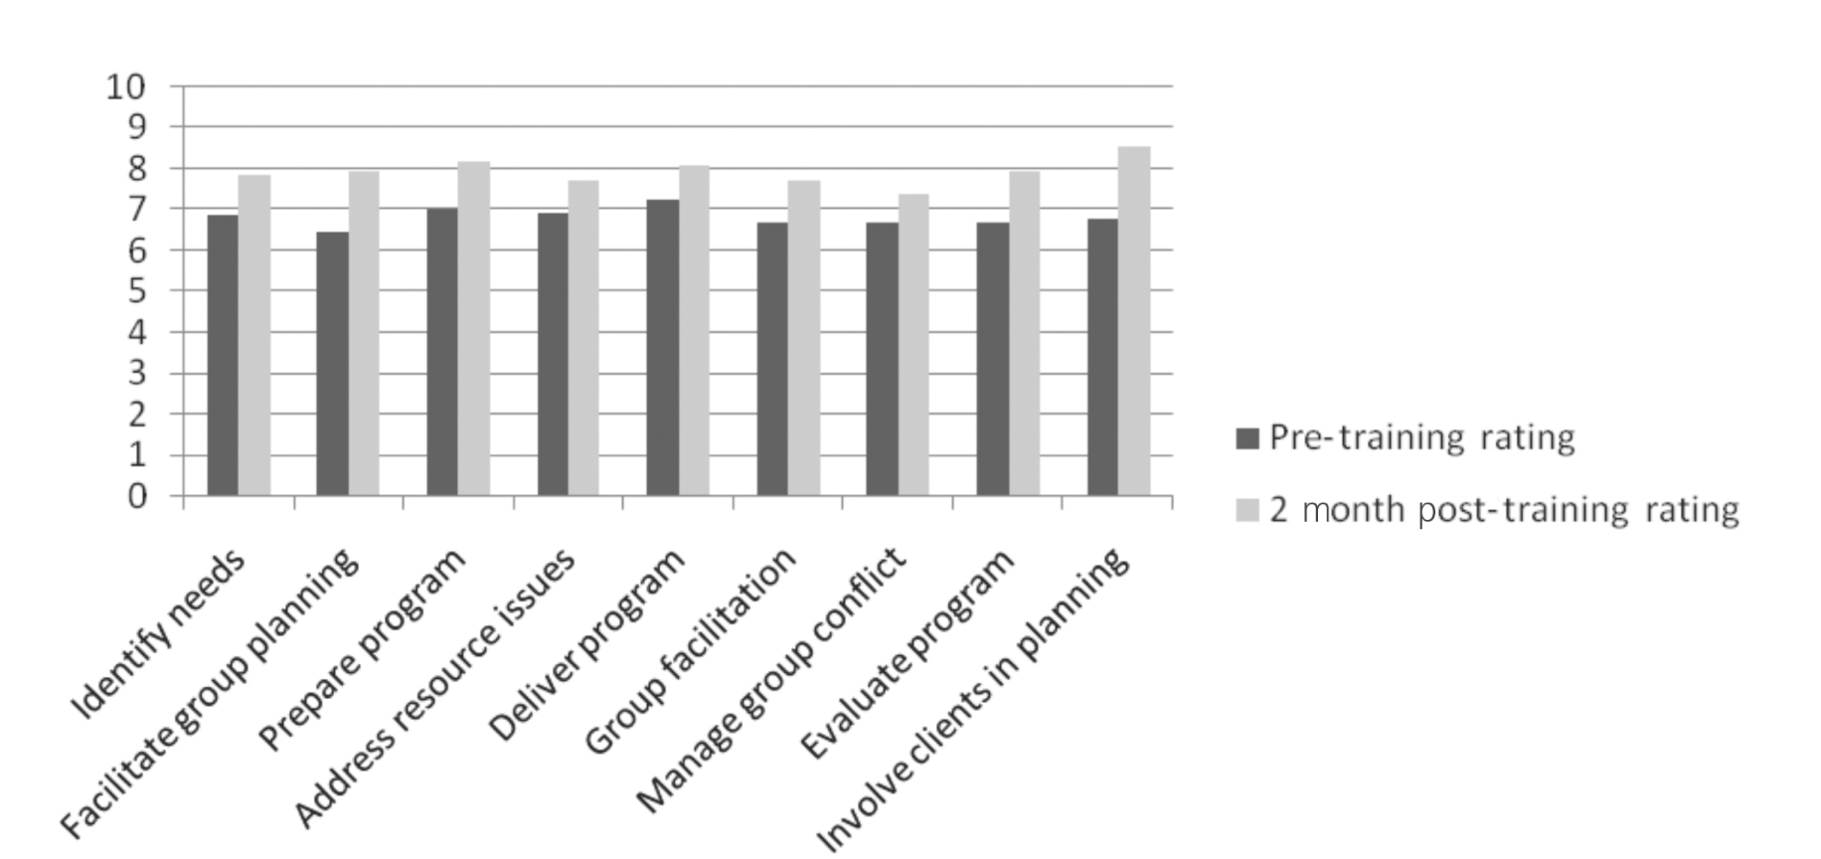

Examples of integrating learning into practice
A vast majority of the examples of integrating learning into practice provided by learners related to involving clients in the planning of activities and promoting more choice and independence for clients. In addition, six of the examples provided were the new activities staff were required to implement as part of the assessment task/project.
Two interviewees expressed some difficulty in integrating learning into work practice because of timing or because of not currently working in a planned activity group program, while a third stated that the: ‘PAG has been running for a long time and they [the clients] are all happy with what they are doing so why change it’.

Areas not implemented in current workplace
Ten of the interviewees stated that they could not think of any examples of areas of learning they were not implementing in the workplace. Comments from the remaining three participants indicated that the reasons for not implementing new ideas or learning from the training program were generally related to limited resources, workloads and different agency policies and procedures, particularly in relation to client care plans, which acted as a barrier to initiating change.
Two interviewees stated that this question was not applicable to them, either because they did not currently work in a planned activity group or they were a team leader who had recently been employed to instigate change prior to participating in the training program.
The vast majority of participants (ten of the 11) who responded expected to do ‘things’ differently in the future. This is an important consideration in assessing personal motivational factors supporting sustained behavioural change. Comments from participants including ‘Now will try new and bolder activities and try to think outside the box’, ‘Always have to improve’ and ‘I think things have to change’ highlight the general theme of wanting to continue to perform differently.
One interviewee from a rural planned activity group stated that access to opportunities and budget limitations impacted upon their ability to apply learning. Another interviewee stated that there would be no change because they believed the clients were ‘happy’ with how the program was currently running.
Figure 6 Interviewees’ expectations of doing things differently in the future
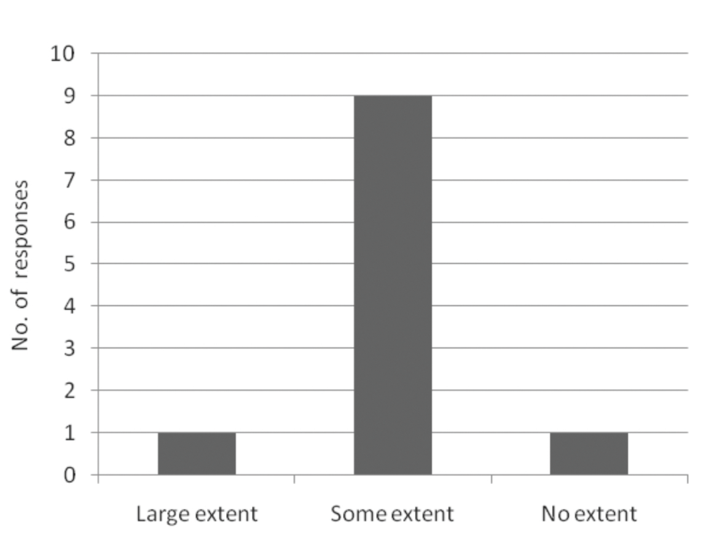

Feedback on what factors contributed to embedding learning in the workplace
As previously explained, one condition for behaviour change is a desire to change. The second condition is that the person needs to know what to do and how to do it (Kirkpatrick & Kirkpatrick 2006). The training program can influence this by creating a positive and well-constructed learning environment.

Content and facilitation
One of the most significant themes emerging from participant feedback was related to the opportunity to exchange ideas, share resources and network (nine of 13 interviewees commented on the value of this process). One interviewee stated that the sharing of ideas and hearing about other workers’ approaches had motivated them to try different ways of working in their own workplace. The following comment by one participant highlights the thoughts of a majority of interviewees:
The larger groups have many varied resources — close to different activities and venues. Then I realised the wonderful resources that we have at ... [their PAG] ... Our own transport and facility; great volunteers; terrific clients ... I have learnt that we must make the most of the resources we have, to ensure the wellbeing of everyone who comes to PAG, whether client, volunteer or staff member by talking with, listening to and getting to know each other. Ultimately whether your PAG is large or small we are all wanting the same safe, happy, active environment for our members, volunteers and staff.
The value of sharing ideas and resources was further supported by the feedback on the requirement in the last workshop for participants to present the projects they had implemented in their workplace. The focus on providing positive feedback to each other and suggesting improvements or different ways of doing things enhanced participant learning, generated further ‘possibilities’ for new approaches in their own planned activity groups and further contributed to embedding learning in workplace practice.
Another significant theme (highlighted by six of 13 interviewees) was the influence of the first workshop, in terms of learning and behavioural change. During this session a simulated work environment was set up. Training participants became the planned activity group clients, with trainers playing the role of PAG staff. In this scenario the staff did everything for the clients, such as making decisions about what activities the clients wanted to engage in and even making morning tea for them. This session simulated a common approach in planned activity groups, one which promotes dependence in clients. A second simulated work environment was set up in a later session; in this session clients were offered a range of choices and were actively involved in making decisions about activities. They were also encouraged to take responsibility for themselves (even to the extent of making their own morning tea). The second session highlighted a culture of promoting the independence and involvement of clients, which, it was believed, would result in a more positive and healthy approach to their lifestyles. Many interviewees stated that immediately after the first training session they had sought to change their practice in the workplace to reflect this more strength-focused and empowering philosophy. Only one participant stated that the first workshop was a ‘total waste of time’ and they did not learn anything from attending the session. The following comment by one interviewee highlights the feedback from a majority of interviewees:
That’s what stuck with me all the way through, the involvement and keeping clients informed.
Confusion and a lack of understanding about the aim of the overall training program was also a significant theme and commented on by seven participants. The following two comments, ‘I didn’t know what we were in for’ and ‘Flying by the seat of your pants’, highlight the general theme that many of the interviewees were provided with limited information about the nature and content of the program and felt confused or lost.
Participants stated this was a barrier to learning and applying new knowledge and skills to their current work practice. The confusion for some resulted in negative feelings and a lack of confidence about what was expected of them. Some participants stated that it was not until the final workshop that they felt they fully understood the overall purpose of the training. Other interviewees who missed a session stated it was hard to catch up because people were unsure about what was going on or how each workshop fitted into the overall program. There was a strong message that ‘setting the scene’ earlier in the program would have established a more positive and less confusing learning environment. This would have supported an understanding of what each workshop was building towards.
This lack of understanding about the overall purpose and nature of the training program appeared also to have had an impact upon the participants’ understanding of the requirements of certain activities (and in particular what was expected in relation to the assessment task or implementing activities in the workplace). Many participants stated that more detailed explanation of the specific activities they were required to undertake, or the distribution of participant workbooks at the start as opposed to the end of the training program, would have assisted in their learning (particularly those who had not attended training in recent years).

Workplace coach
Because of the difficulties in accessing appropriate workplace coaches (in-house), external workplace coaches were arranged. In some instances, the workplace supervisor was not appropriate as they had limited experience in planned activity group programs. In other instances workloads and leave being taken during the implementation of the training program resulted in a lack of access to in-house workplace coaches. Coaches from a similar planned activity group program were linked to students wherever possible (such as rural with rural). Learning participants were provided with the contact details for their coach and asked to make the initial contact to discuss suitable times and methods of communication. The induction of coaches by the training provider was via a brief verbal and email explanation. Phone or email contact was suggested as the type of contact that might suit the different parties. Students were responsible for negotiating how often contact would be made.
The majority of learning participants did not contact the allocated workplace coach (11 of the 13 respondents). However, a majority perceived the idea as potentially valuable, particularly for support and in being able to tap into someone else’s ideas, knowledge and experience. The two most significant barriers cited were a lack of understanding about the purpose of the coach and the practical issues in contacting them. Practical issues related to both workload issues for learners and difficulty in contacting the workplace coach due to their availability. One interviewee stated that she did not contact her workplace coach because ‘sometimes I do not feel comfortable ringing up a stranger’. Another interviewee stated that when they contacted the coach, the coach asked them, ‘can you tell me what you are ringing about?’ For another learner there was a potential conflict of interest, given the pre-existing working relationship with the allocated coach. This was viewed as a potential barrier to establishing an open, honest and productive coaching relationship.
Interviewees nevertheless acknowledged the value of this strategy for both supporting learning and implementing workplace projects/activities. The following suggestions for improving the implementation of the workplace coach approach were provided by participants:
- greater clarity in relation to the purpose of the workplace coaching learning strategy
- more structure to support conversations and reflection on practice
- the opportunity for learning participants to be involved in the selection of coaches, including ensuring their appropriateness
- the opportunity for training participants to be introduced to the coach rather than having to ring up ‘cold’.

Facilitator mentoring
The contact by trainers between workshops was variable, ranging from no contact, one or two contacts and regular contact. It was acknowledged that there were some practical difficulties associated with facilitators being able to contact training participants, given the nature of the planned activity group programs and staff availability. A recurring negative theme related to being contacted by trainers during the evening. This was viewed as inappropriate and an intrusion in training participants’ personal lives, as highlighted by the following comment: ‘I just wanted to get off the phone as I was tired ... had already had a busy day ... just dishing up dinner’.
Some participants stated they were only contacted briefly to check how they were going. For others who were contacted more regularly, there was much more positive feedback about the value of facilitator mentoring. Generally the usefulness of mentoring was related to the mentor clarifying any difficulties the participant was having, being supported and encouraged to keep on track. In particular, feedback indicated that the mentoring by facilitators encouraged or motivated participants to apply their learning in the workplace, as they were asked to reflect on their progress and learning in relation to implementing a new activity at work. One learner indicated that they felt it was positive to touch base in between workshops, as they often left the workshops feeling passionate, but this would begin to drop off. Contact with the trainers assisted in maintaining the momentum.
Feedback from participants who were either not contacted or who only had brief contact further confirmed the value of facilitator mentoring in supporting learning and the integration of learning into work practice. Respondents suggested it would have been useful as they needed more support, particularly in terms of clarifying what was required for the assessment task (which was planning, implementing and evaluating a new activity at work). It might also have assisted them to be better prepared for each workshop and encouraged them to think about the content or learning in between workshops.

Buddy system
The buddy system was proposed as a strategy for supporting the integration of learning into day-to-day work practice by exposing individuals to others outside their organisation. Ten of the 13 respondents stated that they did not make contact with their ‘buddy’ outside the workshop. Three of this cohort stated they were not aware of the buddy system or having been allocated a ‘buddy’. The two most significant reasons for not contacting a buddy were a lack of clarity of the purpose and work demands. As one participant stated: ‘I never contacted the other [buddy] because we didn’t know what direction we were heading in’.
For the three participants who did contact their buddy, there was a positive impact upon their learning. This process was viewed as having provided an opportunity to find out more about the different roles of planned activity group staff and share ideas.

Project/assessment
All training participants interviewed stated that the requirement to plan, implement and evaluate a new activity in their planned activity group had had a positive impact on embedding learning into their work practice, even though for many there was a lack of clarity about the specific requirements of the task. Several participants stated that it provided them with the opportunity and motivation to pilot an idea they had previously considered but not acted upon. Interviewees claimed that these activities were easy to implement as they were related to their core job responsibilities. However, it was also suggested that implementing a new project in the workplace also required people to ‘think outside the square’ and ‘made you think and reflect on what you were doing’. Participants suggested that greater clarity and more specific examples of assessment requirements would have assisted in their implementing a new project in their workplace. Many of the participants stated that the project they had planned, implemented and evaluated would also be used on an ongoing basis (supporting sustained behavioural change in the workplace).

Workplace factors
The third condition for behaviour change is that the person must work in the right climate (Kirkpatrick & Kirkpatrick 2006). This condition refers to the level of encouragement and support for change by the learner’s immediate supervisor and within the general workplace. All but one interviewee had the opportunity within their workplace to apply new skills and knowledge (via the implementation of a project) and the additional resources required to undertake the new project. The learner who did not work in a planned activity group was unable to implement an activity at the time of interview. For the majority of interviewees the nature of the project or new planned activity group activity meant resource requirements were within the normal budget limits. In two instances additional resources were necessary and supported by management.
Nine of the 13 interviewees stated that both their immediate supervisors and management were supportive and encouraging in relation to implementing a new activity in their work group. As one interviewee stated, the support from their immediate supervisor, management and colleagues was very encouraging and ‘makes a huge difference’. The difference related to their motivation and ability to try new and different approaches in the workplace, based on promoting greater choice for the wellbeing of clients.
One respondent claimed that the lack of support from colleagues initially inhibited the implementation of learning in the workplace. ‘Some staff have the attitude of why change something if it works rather than doing it for better outcomes.’ The interviewee explained that their colleagues may not have fully understood what was required until the project was actually implemented. ‘Changing their [staff] mindset was difficult ... It has taken a few months to gain support or for them to understand and apply the new way of doing things with confidence.’
Three interviewees stated there was no or minimal interaction with their supervisors or management in relation to the project. Management was not aware of their project nor did the training participant request any additional resources for implementing an activity. In two instances the project implemented was not a new activity but one that had previously been planned and thus did not result in significant change.
Overall, having the support and access to opportunities within the workplace to implement the project was important and assisted the application of new skills and knowledge. As one interviewee stated, the project had ‘given us a little push to do it’ and changes would continue to occur in the future. The following comment by another participant also highlights the increase in confidence and the desire expressed by many to continue to implement change in their workplace:
I seem to have a bit more confidence ... I seem to speak up for myself a bit more ... I would not have dreamt of doing anything like that in the past [ask for more resources and apply for additional funding] ... We would never think of doing something out of the ordinary ... More confident with working with other workers and volunteers and talking to them about how they work with clients ... More confident about putting submissions together ... I really got a lot out of it and it was really worth going to.

Summary
The two most common suggestions from participants for facilitating and sustaining behavioural change in the workplace were:
- greater clarity about the overall training program, what was happening week by week and the assessment task/work project requirements
- provision of more detailed information about the purpose of the workplace coach strategy, to facilitate a greater confidence in learning participants for making contact with their coach, and the development of proformas to provide a structure to the focus of discussions between learners and workplace coaches.

Conclusions
Findings from this study are congruent with the literature review. Feedback from learners support that the experience of undertaking a project, complemented by being exposed to theory, having an opportunity to receive feedback, and reflecting on the outcomes of the work are necessary conditions for learning and integrating that learning into work practice.
The comments and opinions of the interviewees support the following key findings:
- Learning occurred across all nine key learning outcomes.
- Integration of learning into behavioural change in the workplace occurred across all nine key learning outcomes.
- The most significant areas of learning and behavioural change related to promoting client choice, group facilitation and evaluation.
- Feedback from a majority of interviewees suggested support for the model of delivery. However, the establishment of the workplace coach and buddy system appeared to have been presented as ‘optional extras’ rather than core components of the training program.

Key features supporting sustained change workplace practice convert
Findings from this study validated the following key features of a good-practice approach to supporting sustained change in work practice:

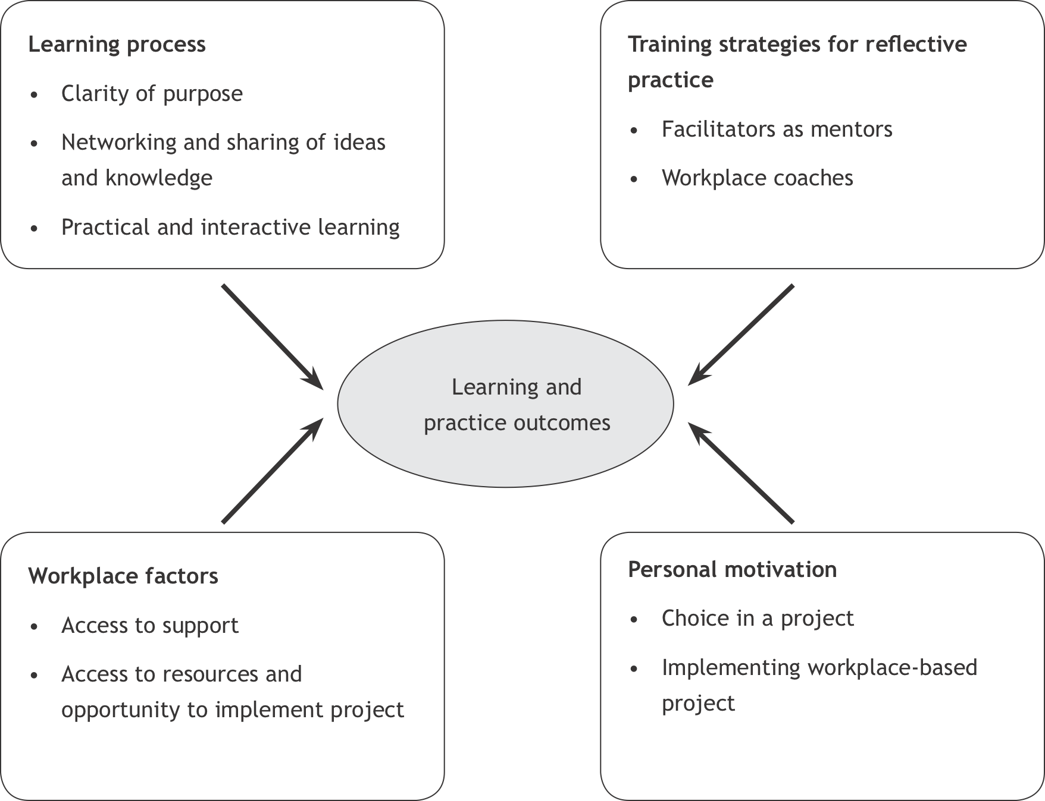

Learning process
In terms of the learning process, the factors identified by learners as supporting their learning and the integration of their learning into work practice was the opportunity to network and share knowledge and ideas and the practical and interactive focus of learning. It is also clear that more information about the purpose, outcomes and model of delivery needed to be provided to participants at the outset of the training program. This is consistent with one of the principles of adult learning developed by Malcolm Knowles. He suggests that adults need to know why they should learn or how it will benefit them before investing time in a learning process or training program. The responsibility lies with the trainer to ensure that learners know the purpose of training as early as possible (Atherton 2009). Understanding the purpose of the training program will also impact upon a learner’s motivation to participate in and be open to the learning experience.

Training strategies for reflective practice
Billett (2000) identified a range of strategies for supporting the integration of learning into work practice, including those that provide learners with guidance and promote reflective practice. These included linking workers to a workplace coach, mentor and/or other experienced colleagues. Workplace coaches and facilitators as mentors were supported by learners as valuable in assisting to embed learning into day-to-day practice. Feedback in relation to the usefulness of the buddy system was less conclusive.
Findings indicate that the workplace coach, facilitators as mentors and buddy system were not fully implemented by the training team or embraced by the learners. This leads us to consider what factors led to key components of the model being presented as optional as opposed to a core part of the delivery approach. The competing demands of training staff and workload issues and/or the lack of attention to the understanding and skill level of trainers required to deliver the training effectively may have been contributing factors. Smith, Wakefield and Robertson (2002) suggest there has been limited attention given to the skill levels required of training staff to support flexible workplace learning and behavioural change in the workplace. This may have been the case in this pilot, where support for the implementation of the model might have been greater had more attention been directed to supporting training staff to focus on self-directed learning, mentoring and coaching skills, and the other skills necessary for implementing flexible workplace delivery training programs. If this component of the model had been stronger, it is possible that the integration of learning into work practice would have been more robustly supported, ultimately providing a better return on investment.
It is acknowledged that learners identified competing demands of workloads and the lack of clarity of purpose as impinging upon their ability to access workplace coaches as a key learning strategy. The effectiveness of workplace coaching would have been enhanced if training participants had been provided with clearer details of the purpose and the expected outcomes of the workplace coaching learning strategy. Workplace coaching also needs to be presented as a core part of the training program. More structure in the form of guidelines and proformas to assist the focus of discussions would also facilitate increased use of this learning strategy and promote greater reflection and integration of learning into practice. Proformas should include a list of questions that focus on the topics covered in each of the workshops and key areas of critical reflection.
In addition to the external factors identified above, the difficulties or reluctance of some learners to access the range of strategies that supported reflective practice may be attributed to their reluctance to be self-directed in the learning process. This is particularly relevant in relation to workplace coach support, where the learner was required to initiate and manage the contact. Greater attention may have been necessary to assist learners (particularly in the earlier stages of the training program) to develop their ability and motivation to be self-directed and to develop instructional processes that were more congruent with individual preferences to be self-directed.

Workplace factors
Access to support, resources and the opportunity to implement projects in the learning participants’ workplaces were critical to facilitating behavioural change in the workplace. Smith, Wakefield and Robertson (2002, p.8) suggest that one of the essential components of a flexible, workplace-based training program is a workplace characterised by skilled staff who can support the development and management of self-directed learning (associated with this type of delivery model). This pilot could have been strengthened by greater attention being given to the partnership arrangement between the training provider and the employer. The involvement of employers prior to and during a training program is likely to facilitate a consistently supportive learning environment and greater commitment from the employer. Workplace support and preparedness may have been enhanced by refining the skills of staff within the organisation to support the development and management of self-directed learning.

Personal motivation
The opportunity to choose a project to plan, implement and evaluate in the work environments of learners was consistently viewed as a positive component of the training program. Learners identified as being important to both maintaining their motivation and integrating learning into practice the need for more information, with specific examples and templates on the requirements of the workplace project/assessment task. These should be provided at the beginning of the training program

Summary
In conclusion, the research was able to clearly identify a range of potential strategies for supporting the integration of learning into the workplace that were consistent with previous research. Feedback from training participants supported the key components of this delivery model, including practical and interactive workshops, and strategies for interaction and reflective practice (facilitators as mentors, workplace coaches and discussions with colleagues in similar roles). However, the effectiveness of the delivery model in supporting learning and behavioural change in the workplace could have been enhanced if greater attention had been given to learners’ capacity to be engaged in self-directed learning, the skills of trainers to implement flexible workplace delivery training programs and the engagement of and support for workplace supervisors/workplace coaches to carry out their role in supporting sustained behavioural change.

References
Australian National Training Authority 2003, What makes for good workplace learning? NCVER, Adelaide.
Atherton, J S 2009, Learning and teaching; Knowles’ andragogy: an angle on adult learning, UK, viewed 5
April 2010, <http://www.learningandteaching.info/learning/knowlesa.htm>.
Billett, S 1993, ‘Authenticity and a culture of practice within modes of skills development’, Australian and
New Zealand Journal of Vocational Education Research, no. 2, pp.1—28.
—— 1998, ‘Understanding workplace learning: cognitive and sociocultural perspectives’, in Current issues and new agendas in workplace learning, ed. D Boud, NCVER, Adelaide.
—— 1999, ‘Guided learning in the workplace’, in Understanding learning at work, eds D Boud & J Garrick, Routledge, London.
—— 2000, ‘Guidance, activities and participation: towards a workplace pedagogy’, paper presented to the 8th Annual International Conference on Post Compulsory Education and Training: Learning together, working together, 4—6 December 2000, Gold Coast, vol .1, pp.216—23, viewed May 2009, <http://www98.griffith.edu.au/dspace/bitstream/10072/1114/1/clwr00_2.pdf>.
Brockett, RG & Hiemstra, R 1991, Self direction in adult learning: perspectives on theory, research and practice, Routledge, London.
Brown, JS, Collins, A & Duguid, P 1989, ‘Situated cognition and the culture of learning’, Educational Researcher, vol.18, no.1, January—February, pp.32—42.
Chappell, C & Hawke, G 2008, ‘Investigating learning through work: what the literature says’, support document, NCVER, Adelaide, viewed 19 May 2009, <http://www.ncver.edu.au/research/proj/nr04025pra5s1.pdf>
Fuller, A & Unwin, L 2003, ‘Learning as apprentices in the contemporary UK workplace: creating and managing expansive and restrictive participation’, Journal of Education and Work, December, vol.16, no.4, pp.407—26.
Kirkpatrick, DL & Kirkpatrick, JD 2006, Evaluating training programs, 3rd edn, Berrett-Koehler, San Francisco.
—— 2007, Implementing the four levels: a practical guide for effective evaluation of training programs, Berrett-Koehler, San Francisco.
Productivity Commission 2005, Australia’s health workforce: research report, AGPS, Canberra.
Skule, S & Reichborn, AN 2002, Learning-conducive work: a survey of learning conditions in Norwegian workplaces, European Centre for the Development of Vocational Training, Belgium.
Smith, P & Blake, D 2005, Facilitating learning through effective teaching, NCVER, Adelaide.
Smith, P, Wakefield, L & Robertson, I 2002, Preparing for flexible delivery: learners and their workplaces, NCVER, Adelaide.

Anonymity was reinforced by informing participants that, apart from the researcher, no other individual, including their employer, would be informed of who did or did not participate in the research interviews or have access to their individual information.

