The shifting demographics and lifelong learning
CONFERENCE PAPER
TOM KARMEL
National Centre for
vocational Education Research

Paper presented to the International Symposium on Lifelong
Learning for Poverty Alleviation and Sustainable Development:
Developing a Research Agenda for the Asia-Pacific
The views and opinions expressed in this document are those of the author and do not
necessarily reflect the views of the Australian Government or state and territory governments
FOR CLARITY WITH FIGURES, PLEASE PRINT IN COLOUR

© National Centre for Vocational Education Research, 2011
With the exception of the cover design, artwork, all logos, and any other material where copyright is owned by a third party, all material presented in this document is provided under a Creative Commons Attribution 3.0 Australia <http://creativecommons.org/licenses/by/3.0/au/>.
This document should be attributed as Karmel, T 2011, The shifting demographics and lifelong learning.
The National Centre for Vocational Education Research (NCVER) is an independent body responsible for collecting, managing and analysing, evaluating and communicating research and statistics about vocational education and training (VET).
NCVER’s inhouse research and evaluation program undertakes projects which are strategic to the VET sector. These projects are developed and conducted by the NCVER’s research staff and are funded by NCVER. This research aims to improve policy and practice in the VET sector.
TD/TNC 103.20
Published by NCVER
ABN 87 007 967 311
Level 11, 33 King William Street, Adelaide, SA 5000
PO Box 8288 Station Arcade, Adelaide SA 5000, Australia
ph +61 8 8230 8400 fax +61 8 8212 3436
email ncver@ncver.edu.au
<http://www.ncver.edu.au>
<http://www.ncver.edu.au/publications/2358.html>

About the research
The shifting demographics and lifelong learning
Tom Karmel
Demographic change in the modern world is synonymous with an ageing population. Karmel suggests that there are four implications of an ageing population for lifelong learning that are worth exploring. The first is the need to improve labour force participation and productivity, and education is a key driver of this. The second is that the ageing population will provide a ‘demographic dividend’ because there will be fewer young people who need to be schooled (relative to the working population). The third is that increasing life expectancy changes the arithmetic of the return to investments in human capital, and makes investment in the education and training of the middle-aged more attractive. The final implication is that ageing of populations in developed countries provides a golden opportunity for developing countries through the export of labour services.

Contents
Tables and figures 3
Introduction 3
Demographic change 3
Increasing labour force participation and productivity 3
The ‘demographic dividend’ 3
Increasing life expectancy and the arithmetic of investment
in human capital 3
The export of labour services 3
Final comments 3
References 3

Tables and figures

Tables
1 Decomposition of changes in the average number of hours
per head of population, 1993–2003 (people 15–64 years) 3
2 Average weekly wage by highest post-school qualification
and sex, Australia, 2009 3
3 The ‘demographic dividend’ for selected countries, 2010–50 3
4 Life expectancy at 40 years, selected countries, 1990 and 2008 3

Figures
1 Population pyramids: age and sex distribution, 2000 and 2050 3
2 Impact of educational level on employment of older people,
2001: educational attainment of postgraduate degree or
graduate diploma or certificate and Year 9 or less 3
3 Impact of timing of qualifications on employment rates of
older workers 3
4a Educational participation by age, males, Australia, 2009 3
4b Educational participation by age, females, Australia, 2009 3
5 Net present value of $100 per annum against years since
investment 3
6 Asia: remittances in $US and as a share of GDP by country,
2004 3

Introduction
When I began to think about the topic it was not clear to me that there was an obvious link between demographic change and lifelong learning. There is no doubt that demographic change is one of the big structural changes facing our economics and labour markets. Many policy-makers emphasise the importance of lifelong learning. But what is the link between demographic change and lifelong learning?
In this presentation, I first make the point that demographic change in the modern world is synonymous with an ageing population. I suggest that there are four implications of an ageing population that are worth exploring. The first is that inevitably an ageing population will mean that, if we are to maintain increases in living standards, we need to improve labour force participation and productivity, and education is a key driver of this. The second is that the ageing population will provide a ‘demographic dividend’ because there will be fewer young people who need to be schooled (relative to the working population). The third is that increasing life expectancy changes the arithmetic of the return to investments in human capital. The final implication is that ageing populations in developed countries will increase the return to labour (that is, the ageing of the population will increase wages relative to returns on investments) and this provides a golden opportunity for developing countries to export labour.
I will address each of these in turn, but first I provide a very quick picture of the demographic change over the next 40 years. I end with a few final comments.

Demographic change
The way that demographic change is usually portrayed is through population pyramids showing how the proportion of the population by age changes (figure 1). The first point to be taken from the figure is that, while ageing of the population is more pronounced in developed countries and certainly has received more attention, it is also occurring in developing countries. Maclean and Pavlova (2007) point out that ageing poses a serious set of issues for developing countries:
the tempo of ageing in developing countries is more rapid than in developed countries, thus developing countries are likely to have less time than the developed countries to adapt to the consequences of population ageing.
They argue that the ageing of the population in developing countries will have very direct economic consequences. The employable population will shrink in relative terms and older people living at subsistence levels will be particularly vulnerable because of insufficient numbers of young people to support them. Maclean and Pavlova suggest two major objectives to be pursued: training the workforce for self-employment; and raising the productivity of the informal sector.
Even in India ageing is an issue. In the 100 years to 2016 it is expected that India’s population will have increased five times, but the aged population by 13 times. While issues relating to ageing are important, Rajput (2007) argues that, in an Indian context, they are not necessarily the most pressing. Rather, the critical priorities are unemployment among youth and adults, the universalisation of elementary education, and the need to put more emphasis on technical and vocational education and training (TVET) rather than on more academic education.
However, the major point remains—the ageing of the population is an international phenomenon.

Figure 1 Population pyramids: age and sex distribution, 2000 and 2050
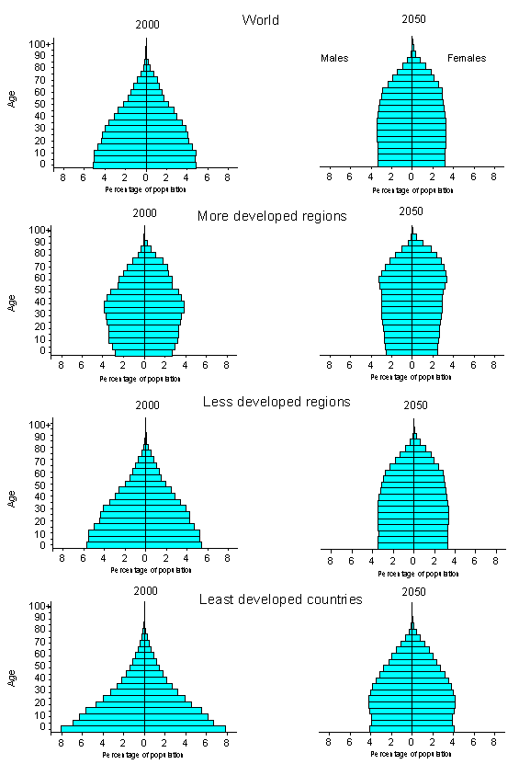Source: United Nations Secretariat (1998, cited in Karmel & Maclean 2007).
Percentage of population
Percentage of population
Percentage of population
Percentage of population
Percentage of population
Percentage of population
Percentage of population
Percentage of population
Percentage of population
Percentage of population
Percentage of population
Percentage of population
Percentage of population
Percentage of population

Increasing labour force participation and productivity
The ageing of the population has caused consternation in many countries, including Australia. Governments see budgetary problems occurring because dependency ratios (that is, the ratio of persons who are dependent on persons who are contributing economically) are projected to decline. In Australia, the mantra to address this has been the three Ps: population, participation and productivity. An increase in population will certainly promote economic growth but whether it will increase economic growth per capita will depend on whether there are increasing or decreasing returns to the size of the population. In many parts of the world there may well be decreasing returns, particularly when population growth puts too much pressure on the natural environment. However, the second and third of the three Ps—participation and productivity-—are less controversial, and are the ones to which education and training are relevant.
The simple argument is that those with higher levels of education tend to be more engaged with the labour market and are more productive than those with lower levels of education. I will use Australian data to illustrate this point.
Figure 2 shows employment-to-population ratios for people at the two extremes of educational attainment (postgraduate degree and Year 9 or less) for persons aged 40–65 years. These polar cases are chosen to illustrate that employment is very much related to educational attainment.

Figure 2 Impact of educational level on employment of older people, 2001: educational attainment of postgraduate degree or graduate diploma or certificate and Year 9 or less
Source: Karmel and Woods (2004).
From these graphs it is clear that those with high educational attainment tend to retire later as well as being more engaged with the labour market at earlier ages.
Karmel and Woods (2004) show that increasing levels of education are significant in explaining changes in overall participation. Table 1 looks at the decade 1993–2003 and shows that, for Australia, increasing education levels explained 2.4 % points (males) and 7.6% points (females) of the changes in hours of work per head. These are very significant contributions.
Table 1 Decomposition of changes in the average number of hours per head of population, 1993–2003 (people 15–64 years)
 | Males | Females
1993 hours per head of population | 31.0 | 17.0
2003 hours per head of population | 33.0 | 18.8
Education effect (percentage points) | 2.4 | 7.6
Employment effect (percentage points) | 3.9 | 6.5
Hours effect | 2.8 | -3.7
Demographic effect and interactions (percentage points) | -2.8 | 0.1
Total change in hours per head (percentage) | 6.3 | 10.5
Source: Karmel and Woods (2004).
Karmel and Woods also looked forward and showed that increasing education levels will continue to make a significant contribution to available labour supply, based on current patterns of skills acquisition. The point is that participation will naturally increase as more educated cohorts move through the workforce. In addition, they were also interested to see whether education acquired later in life had the same effect as education obtained at younger ages, and found that indeed it did. Figure 3 shows the employment rates of older workers, depending on the age at which they obtained their qualifications. The graphs show the predicted probability of being employed for those with a diploma-level qualification or higher, those with an Australian Qualifications Framework certificate III or IV, and those with an Australian Qualifications Framework certificate I or II.

Figure 3 Impact of timing of qualifications on employment rates of older workers
Source: Karmel and Woods (2004).

As can be seen, the more recently acquired qualifications are associated with a higher probability of employment, a result very supportive of the concept of lifelong learning.
So far I have focused on the participation part of the equation. The effects of education on productivity are also important, and are well known. It is not the place to go into the vast literature on the returns from education, but, to illustrate the point, I present some recent Australian data showing average weekly wages by post-school qualification.
Table 2 Average weekly wage by highest post-school qualification and sex, Australia, 2009
 | Male | Female
 | $ | $
Postgraduate degree, graduate diploma/graduate certificate | 1376.8 | 1116.6
Bachelor degree | 1238.4 | 967.0
Advanced diploma/diploma | 1108.7 | 777.7
Certificate III/IV | 1059.0 | 640.4
Certificate I/II | 782.5 | 589.5
Certificate not further defined | 956.4 | 586.5
No non-school qualification | 801.1 | 513.7
Level not determined | 1017.6 | 691.4
Total | 1007.0 | 721.3
Note: Sample restricted to wage and salary earners only.
Source: Survey of Education and Training, 2009.
There is no doubt that education and training are very important elements of any increases in participation and productivity, which are needed to maintain living standards as ageing of the population occurs.

The ‘demographic dividend’
One of the characteristics of formal education and training is that it is front-end-loaded—the majority of formal education and training is undertaken when people are young. This is for very good reasons. First, in order to undertake post-school education a reasonable level of secondary schooling needs to be completed. Attendance at secondary school requires completion of primary schooling. In order to complete primary schooling one needs to be taught to read and write. And so on. Second, the ‘learning to learn’ nature of education—the better educated you are, the easier it is to acquire more education—means that lifetime learning will be maximised by investing heavily early in life. Finally, if education and training are considered in human capital terms—as an investment in future productivity—then the greatest return is obtained by investing earlier rather than later in life.
To illustrate this point, figure 4 presents educational participation by age in Australia.
Figure 4a Educational participation by age, males, Australia, 2009

Figure 4b Educational participation by age, females, Australia, 2009
Source: Survey of Education and Training, 2009.
The figures show that the bulk of educational participation occurs for people below the age of 24 years, and this is in an education system which is very open and encourages mature-age entry. It further shows that, among the young, educational participation is mostly full-time, while in older cohorts it is mostly part-time.
The implication of this is that, everything being equal, countries with ageing populations will have to spend relatively less on education. The ‘everything being equal’ assumption is of course a foolish one in the sense that all governments are attempting to increase educational participation rates. However, the point is that the ageing of the population does provide governments with some discretion with their budget.
The way we show this ‘dividend’ is to calculate the ratio of persons in education to persons not in education, where the latter is calculated for the age group 15–64 years. This ratio is projected into the future by assuming that current levels of educational participation are maintained but that the population profile changes. A ‘dividend’ is observed if that ratio declines; such a decline implies that fewer workers are required to support those in education. Table 3 shows these calculations for a number of countries.
Table 3 The ‘demographic dividend’ for selected countries, 2010–50
 | Median age |  | In education/adults not in education |  | Change
 | 2010 | 2050 | 2010 | 2050 | % pts
Australia | 37.5 | 42.7 | 0.378 | 0.353 | 2.5
India | 25.9 | 37.2 | 0.618 | 0.408 | 21.0
Indonesia | 27.9 | 40.3 | 0.522 | 0.376 | 14.6
Philippines | 22.7 | 32.6 | 0.736 | 0.486 | 25.0
Bangladesh | 22.9 | 37.7 | 0.746 | 0.41 | 33.6
Iran | 26.3 | 42.6 | 0.546 | 0.337 | 20.9
Note: The education participation rates are those of Australia, with part-time education assumed to be 1/3 of a person's time.
Source: Author’s calculations based on Australian educational participation rates (Survey of Education and Training), and US Census Bureau International Database.
An immediate difficulty is that in the time available I did not manage to locate educational participation rates for countries other than Australia. Thus these calculations are rather artificial. Nevertheless, they show the extent of demographic change and make the point that the ‘demographic dividend’ is very large for developing countries. For example, if India in 2010 were to have educational participation rates equivalent to those in Australia, then for every 100 adults who are potential full-time workers (that is, aged 15–64 years and not in full-time education) there would be 62 full-time students (aged 15–64 years). By 2050 this ratio falls to 41 students for every 100 adults who are potential full-time workers.
What this implies is that the ageing of the population provides choices to governments. Since the task of maintaining educational participation rates becomes easier, governments have the opportunity to improve levels of educational participation (or quality) or, alternatively, spend the resources on other sectors of the economy. In a sense, lifelong learning will become more affordable.

Increasing life expectancy and the arithmetic of investment in human capital
I have argued earlier that education and training is front-end-loaded and this is perfectly logical. On the assumption that there is a return from education and training, the optimal strategy must be to concentrate on foundation skills and initial entry education and training, for the simple reason that this enables the longest possible time to realise the return. However, the very fact that this conference is occurring indicates the importance attached to lifelong learning, and no one would argue that learning ends or should end once an individual has competed their initial training.
However, a model in which all education and training is applied to the young misses two simple facts. The first is that there is considerable investment in the skills of older persons which occurs through the workplace. Wages tend to increase with age because of the return from experience, reflecting increasing skill levels and productivity. This type of learning tends to be forgotten because it is funded by employers and employees and is implicit rather than explicit.
The second is that rate-of-return calculations need to take into account the value of time, so that net present value calculations need to use a discount rate (often the long-term bond rate). What this means is that it is the returns close to the time of investment that matter more than returns some years off. For example, if a particular skill leads to an increase in wages of $100 per annum, then a substantial portion of the return is obtained in the first ten years. Figure 5 illustrates this point by plotting the share of the net present value of an investment that provides an annual return of $100 against years since investment. The example assumes that the life of the investment is 40 years (representing the length of working life) and a discount rate of 6%.
Figure 5 Net present value of $100 per annum against years since investment
Source: Author’s calculations.

What this implies is that return over the first ten years is around 50% of the total return, and that the return over 20 years is 80% of the return. Thus an individual who invests in education and training at the age of 40 years can expect to harvest 80% of the return that a 20-year-old would obtain (assuming both work until they are 60 years). Therefore we see that investments in education and training have a very good return, certainly until middle age, depending on the length of an individual’s working life.
One of the features of demographic trends is that ageing of the population is occurring because of a decline in fertility but also because of increasing life expectancy. It is true that increases in life expectancy are partly due to declines in infant mortality and maternal mortality. But putting these to one side, life expectancy has been increasing steadily and therefore one would expect that working lives will begin to get longer as well. Table 4 shows current life expectancy at the age of 40 years for our selection of countries for 1990 and 2008.
Table 4 Life expectancy at 40 years, selected countries, 1990 and 2008
 | 1990 |  | 2008
 | Females | Males | Females | Males
Australia | 41.7 | 36.5 | 45.0 | 41.1
Bangladesh | 29.8 | 29.0 | 32.5 | 31.0
Indonesia | 31.2 | 28.5 | 34.1 | 31.6
India | 31.4 | 29.7 | 34.1 | 30.9
Iran | 33.1 | 29.6 | 37.9 | 34.4
Philippines | 34.8 | 31.1 | 37.5 | 32.4
Source: World Health Organisation (2010), llfe tables for WHO member states, 1990, 2000, 2010, by country and region <http://www.who.int/healthinfo/statistics/mortality_life_tables/en/>.
We see that even in poor countries such as Bangladesh the life expectancy of a 40-year-old is around 30 years, and this has increased by around two years between 1990 and 2008. I would expect these increases to continue, noting that life expectancies are significantly higher in developed countries. The point is that investments in education and training during middle age have the potential to pay off, on the assumption that people continue to work into their 60s. Whether individuals will do so is another matter and will depend on all sorts of things such as health, availability of suitable work, and alternative sources of income.

The export of labour services
The argument here is that the ageing of the populations of developed countries provides a golden opportunity for developing countries to export labour services. Sectors currently important in this regard are construction, health and community services and personal services. This export of labour is already very important for a number of countries, and my expectation is that this will continue.
Graeme Hugo (2007) notes that in 2005 there were around 14 million migrant workers from South-East Asia, 17 million from South Asia and two million from North-East Asia working in various countries around the world. The remittances from these workers are very substantial.
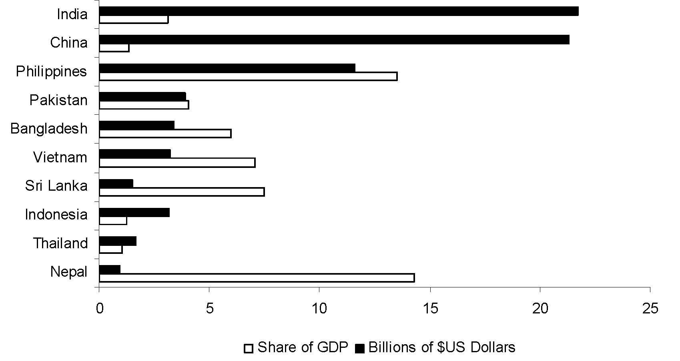
Figure 6 Asia: remittances in $US and as a share of GDP by country, 2004
Source: Hugo (2007).
The remittances of people working overseas on a temporary basis are very significant as a proportion of GDP for Nepal, Philippines, Sri Lanka, Vietnam and Bangladesh (all greater than 5% of GDP). Countries which see this as an opportunity will need to position their education and training systems to train people for occupations that are in demand overseas.

Final comments
The purpose of this paper is to act as a discussion starter. The links between lifelong learning and demographic change are by no means obvious. I have put forward for consideration four possible implications which go further than ‘people are living longer and therefore we need to provide lifelong learning for the elderly’. My interest is in the basic economic questions relating to labour markets and standards of living, and thus my focus has been economic rather than social.
In proposing these four areas I don’t pretend that I have provided a comprehensive or balanced discussion. Inevitably, I have drawn on Australian data and literature and some data available from international databases because these are what are readily to hand. However, the data are intended to illustrate the various points rather than to be definitive.
To summarise, my contention is that:
- An ageing population will mean that, if we are to maintain increases in living standards, we need to improve labour force participation and productivity, and education is a key driver of this.
- The ageing population will provide a ‘demographic dividend’ because there will be fewer young people who need to be schooled (relative to the working population).
- Increasing life expectancy changes the arithmetic of the return from investments in human capital and makes it more attractive to invest in the education and training of the middle-aged.
- The ageing of populations in developed countries provides a golden opportunity for developing countries through the export of labour services.
I trust this is helpful in starting a discussion on what changing demographics mean for lifelong learning in delegates’ countries.

References
Hugo, G 2007, ‘Demographic change in East and South East Asia and the implications for the future’, presentation to the 17th general meeting of the Pacifica Economic Cooperation Council, Sydney, viewed 10 March 2011, <http://www.pecc.org/resources/doc_view/820-demographic-change-in-east-and-southeast-asia-and-the-implications-for-the-future>.
Karmel, T & Woods, D 2004, Lifelong learning and older workers, NCVER, Adelaide.
Karmel, T & Maclean, R 2007, ‘Technical and vocational education and training in an ageing society’, Technical and vocational education and training in an ageing society, experts meeting proceedings, eds T Karmel & R Maclean, NCVER, Adelaide.
Maclean, R & Pavlova, M 2007, ‘Re-skilling for all? The changing role of TVET in ageing societies of developing countries’, Technical and vocational education and training in an ageing society, experts meeting proceedings, eds T Karmel & R Maclean, NCVER, Adelaide.
Rajput, JS 2007, ‘The changing context of TVET for the workforce in India’, Technical and vocational education and training in an ageing society, experts’ meeting proceedings, eds T Karmel & R Maclean, NCVER, Adelaide.
US Census Bureau International database, viewed 10 March 2011, <http://www.census.gov/ipc/www/idb/ groups.php>.
World Health Organisation 2010, Life tables for WHO member states, viewed 10 March 2011, <http://www.who.int/healthinfo/statistics/mortality_life_tables/en/>.

I would like to thank Josie Misko for her help in locating the international data for this paper.
Although not presented here there are also considerable differences between the wages of those who leave school early and those who complete secondary schooling.

