P:\PublicationComponents\logos\NCVER LOGOS\EPS - pagemaker_quark\ncver left tab_mono.eps

Vocational trajectories within the Australian labour market

Serena Yu

Tanya Bretherton

Hanna Schutz

Workplace Research Centre, University of Sydney

The views and opinions expressed in this document are those of the author/  
project team and do not necessarily reflect the views of the Australian Government,   
state and territory governments or NCVER.

Any interpretation of data is the responsibility of the author/project team.

### FOR CLARITY WITH FIGURES, PLEASE PRINT IN COLOUR

### NATIONAL VOCATIONAL EDUCATION AND TRAINING RESEARCH PROGRAM

### **RESEARCH REPORT**

### Publisher’s note

To find other material of interest, search VOCED (the UNESCO/NCVER international database <[http://www.voced.edu.au](http://www.voced.edu.au/)>) using the following keywords: career development; educational level; employees; employment; industry; labour market; labour mobility; qualifications; workforce development.

About the research

**© Commonwealth of Australia, 2012**

G:\pub_prod\PublicationComponents\logos\Creativecommons\CC BY logo.eps

With the exception of the Commonwealth Coat of Arms, the Department’s logo, any material protected by a trade mark and where otherwise noted all material presented in this document is provided under a Creative Commons Attribution 3.0 Australia <http://creativecommons.org/licenses/by/3.0/au> licence.

The details of the relevant licence conditions are available on the Creative Commons website (accessible using the links provided) as is the full legal code for the CC BY 3.0 AU licence <http://creativecommons.org/licenses/by/3.0/legalcode>.

The Creative Commons licence conditions do not apply to all logos, graphic design, artwork and photographs. Requests and enquiries concerning other reproduction and rights should be directed to the National Centre for Vocational Education Research (NCVER).

This document should be attributed as Yu, S, Bretherton, T & Schutz, H 2012, *Vocational trajectories within the Australian labour market*, NCVER, Adelaide.

ISBN 978 1 922056 27 6  
TD/TNC 109.33

Published by NCVER  
ABN 87 007 967 311

Level 11, 33 King William Street, Adelaide SA 5000  
PO Box 8288 Station Arcade, Adelaide SA 5000, Australia

**P** +61 8 8230 8400 **F** +61 8 8212 3436 **E** [ncver@ncver.edu.au](mailto:ncver@ncver.edu.au) **W** <http://www.ncver.edu.au>

Vocational trajectories within the Australian labour market

### Serena Yu, Tanya Bretherton and Hanna Schutz, Workplace Research Centre, University of Sydney

This report is part of a wider three-year program of research, ‘Vocations: the link between post-compulsory education and the labour market’, which is investigating the educational and occupational paths that people take and how their study relates to their work. This report is specifically interested in exploring the movements workers make in the labour market. The authors consider whether these movements can be characterised as vocational pathways, which they describe as movement between linked occupations, those which share an underlying field of practice, such as the health workforce.

The authors look at these pathways by interviewing individuals about their employment and study history, career progression and reasons for any movements. This work builds upon a previous working paper, which used quantitative data to explore these movements. The finance, primary, health and electrical trades/engineering industries were used as case studies.

In that work, three pathways were distinguished:

* high-skill trajectories: those accessing high-skill occupations, often including long tenures in the occupation
* low-skill trajectories: those characterised by entrenchment in low-skill work
* marginal attachment: clusters of activity outside the labour market, interspersed with periods of paid employment.

Key messages

* There are two ways that workers progress within medium- to high-skill roles. They either move upwards to roles with greater leadership or organisational responsibilities, or they move laterally into related roles, where they expand their technical skills and knowledge.
* Within low-skill roles, movements are associated with ensuring an ongoing livelihood rather than a career pathway. There are also fewer opportunities for skill formation than in higher-skill roles.
* The way employers recruit, develop and promote skills within different industries is diverse.

The variation across industries means that any attempts to promote vocational pathways through educational policy need to take account of labour market structures, including industrial and economic settings.

Tom Karmel  
Managing Director, NCVER

Contents

Tables and figures 6

Executive summary 7

Background 11

Method 15

Results and discussion 17

Primary industry 17

Financial services 20

Trades and engineering 25

Healthcare and community services 32

Conclusion 38

References 41

Appendices

A: Optimal Matching Analysis 44

B: Vocational cluster trajectories 46

C: Additional descriptive table 49

NVETR Program funding 51

# Tables and figures

## Tables

1 Profile of interviewees, primary industry 18

2 Profile of interviewees, financial services 21

3 Profile of interviewees, trades and engineering 26

4 Average weekly gross earnings by occupation, electrical trades   
and engineering, 2010 30

5 Profile of interviewees, healthcare and community services 33

6 Average weekly gross earnings by occupation, healthcare and   
community services, 2010 35

C1 Prevalence of unchanging states 49

C2 Distribution of clusters by gender 50

C3 Distribution of time by cluster 50

## Figures

1 Stylised vocational paths 15

2 Key clusters in primary industry 17

3 Key clusters in financial services 21

4 Key clusters, trades and engineering 26

5 Key clusters, healthcare and community services 32

A1 OMA elementary operations example 44

B1 Sequence plots, high-skill trajectories 46

B2 Sequence plots, low-skill trajectories 47

B3 Sequence plot, pathways of marginal attachment 48

# Executive summary

This is a report of the first year of a three-year project entitled ‘Vocations: the link between post-compulsory education and the labour market’. The project’s aim is to research how pathways can be improved within education, within work, and between education and work. There are three strands in the project; the first strand is researching entry-level vocational education and training (VET), particularly VET in Schools; the second is researching the role of educational institutions in tertiary education in fostering vocations; and the third is researching how to improve flows within work and how to improve occupational pathways and vocations within the labour market. This report outlines Strand 3’s initial findings.

The research seeks to understand the presence of vocational pathways in core sectors of the Australian labour market — agriculture, financial services, engineering and trades, and healthcare and community services. A vocation emerges from fields of practice where there are commonalities; for example, the commonalities between nursing, aged care and childcare. A vocation groups together related clusters of knowledge and skills that allow individuals to progress and/or specialise within a field of practice or to move laterally into linked occupations.

The nature of these vocational pathways, or the connections between educational and labour market progression, are not well understood, and the research questions were formulated as follows:

* How do individuals move into and through the labour market? Can this movement be characterised as vocational pathways?
* What are the commonalities in the trajectories of workers in the labour market?

This report follows an earlier working paper (Yu et al. 2012), which produced a quantitative analysis from the Household, Income and Labour Dynamics in Australia (HILDA) Survey dataset. The working paper sought to empirically derive patterns of movement through study, and into and upwards within the labour market. The analysis found that the overarching theme of worker experience could be described as *occupational segmentation.* We characterised this as occupational stasis, whereby individuals tended to spend long episodes in the one occupation and entrenched in either high-skill or low-skill roles. In each of the case studies we distinguished three broad pathways:

* *High-skill trajectories*: these were defined as those accessing high-skill occupations, and was often evidenced by long tenures in occupations that in all likelihood required specialised training over long periods of time (for example, farm managers and health professionals). Where upward occupational mobility was observable, this tended to occur within the higher-skill occupations only, with clearer pathways from higher education studies to professional work and from professional to managerial roles.
* *Low-skill trajectories*: these were characterised by entrenchment in low-skill work. ‘Mobility’ for those working in low- to semi-skilled roles, such as labourers and clerical workers, was defined by significant turnover, with little movement into higher-skilled roles. These workers were likely to move frequently between these jobs, with little evidence of sustained career progression and with some spells in unemployment or outside the labour force. Alternatively, these low-skill trajectories were also characterised by long tenures in low-skill roles, with little engagement with further study or access to higher skill roles.
* *Marginal attachment*: this third pathway is characterised by clusters of activity outside the labour market. The term ‘marginal attachment’ is used to describe these pathways because they can incorporate periods of paid employment, but these episodes appear to occur on the margins of the labour market. Marginal attachment includes the unemployed and also affected women moving in and out of the labour force, as well as older workers with decreasing attachment to the labour market.

These different pathways suggest distinct destination points for the workers identified in these clusters of activity and variance in how they engage with both the education system and the labour market. The analysis in this paper highlighted the way in which businesses choose to compete and how this determines the way in which they engage with their workforce. This in turn drives prevalent forms of employment, types of skill formation and job design. These elements of demand for labour and skill are critical to the availability of vocational pathways and must be engaged with as much as the supply of labour, skills and graduates in the economy. The results of this phase of research are summarised below:

*The commonalities in the experience of low-skill workers were characterised by the absence of vocational identity and pathways. Lack of employer support, resource constraints and lack of confidence were prominent barriers to career development and were exacerbated by precarious terms of employment and/or periods of unemployment.*

The research saw little evidence of vocational attachment amongst low-skill workers in primary industries, engineering and financial services. The experience of these workers (especially labourers in trade-related work or agriculture) was often characterised by high turnover between unrelated roles, with little opportunity to define or pursue career progression, and frequently interspersed with periods of unemployment. These workers were likely to be employed on precarious terms (for example, seasonal, casual or part-time), thereby reducing the incentive for employers to invest in their skills.

The one clear exception to this absence of career direction were low-qualified care workers in community services, who reported a clear vocational identity located around the notion of patient care, consistent with their counterparts in higher-skill roles. Despite these aspirations, business and institutional settings severely constrained their ability to progress along a clearly defined pathway.

*The commonalities in the experience of medium- to high-skill workers were characterised by a combination of horizontal as well as vertical career transitions, which were viewed very differently across the four sectors. In some cases, vocational pathways were characterised more by a broadening of the technical skills and knowledge bases and lateral movements into related roles; in other cases, pathways reflected vertical movements into managerial/supervisory positions. In all cases, interviewees reported autonomy and diversity in their work and the presence of learning opportunities as integral to their development and satisfaction.*

All forms of career progression reported in the study leveraged some degree of horizontal movement, characterised by a broadening of technical skills and knowledge bases, either through formal study or on-the-job learning. This form of development enabled individuals to transition laterally between roles or to widen their responsibilities, such that there appeared to be a broad sense of career and vocational identity. For example, in the engineering trades this included undertaking the various ‘tickets’ required to operate different machinery or work with hazardous substances.

Vertical career progression was available to varying degrees and was characterised by growing staff, project and organisational management responsibilities. This form of development was less concerned with the expansion of technical skills and more with leadership and management experience. While for some, such as nurses, vertical career progression was associated with high levels of stress, work intensification and detachment from clinical practice, others such as those in engineering trades engaged enthusiastically with greater supervisory and organisational responsibilities. In all cases, however, there was a strong sense of vocational attachment.

*Distinctive business and institutional settings in each sector ultimately mediate the definition and accessibility of vocational pathways.*

The relative dominance of various business and institutional settings in each vocational stream had strong implications for the nature of horizontal and/or vertical career pathways. While educational institutions have a very strong role to play in supporting these pathways, factors such as dominant models of skill formation, recognition of informal versus formal training and the level and forms of employer support are critical and vary from sector to sector. Indeed, Keep (2005) argues that certain sectors of the economy are likely to demand large and growing numbers of unskilled workers rather than more qualified workers. Keep’s study reviewed research that concluded that qualifications play very different roles across the occupational spectrum. This was certainly borne out in our research, which found that:

* Vocational pathways in *primary industries* are likely to be enhanced by informal modes of skill formation, low-entry barriers and high levels of on-the-job learning. However, they are significantly inhibited by a high prevalence of seasonal and contractor workers with little access to training and promotion opportunities and by the high financial barriers to entering farm management. Despite strong reports of broad learning opportunities and the need to be a ‘jack of all trades’, it appeared very difficult to progress vertically, as farm management has historically been attached to land ownership and family succession.
* Vocational pathways in *healthcare and community services*, as they relate to care work, are clearly defined by educational and occupational institutions, with the existence of articulation arrangements between vocational education and training and university studies and clear occupational standards of entry. Yet resource constraints in the sector manifest themselves by limiting the opportunities of lower-skilled workers for accessing training and development, while acting as broad deterrents for those interested in progressing vertically.
* Different learning models between VET and university *engineering* studies make articulation paths difficult, and there is some evidence that the wage premiums attached to professional engineering roles (relative to trades roles) are not incentive enough for undertaking this arduous path. Most importantly, clear career prospects, in terms of earnings, training and promotion opportunities for both qualified trades workers and professional engineers, enforce strong occupational segmentation between the two.
* *Financial services* is characterised by dynamic labour markets with a premium on generic skills such as problem-solving skills and the capacity to learn. Entry to a high-skill pathway is typically available to those with higher education qualifications, after which career progression is linked primarily to on-the-job learning, performance and experience. Those in low- to medium-skilled roles are constrained by these high entry barriers and are more likely to experience career progression into roles such as financial planners, mortgage/insurance brokers, middle managers and accounting bookkeepers.

The key finding from this analysis is that enabling vocational pathways is not simply about promoting articulation pathways within education and building a more highly qualified workforce. Rather, the greater issue is one of how employers recruit, develop and promote skills in their organisation and in markets. Given these diverse settings, we suggest that a uniform policy approach would not be possible for supporting vocational pathways in different areas of the economy. Moreover, any differentiated policy response would need to integrate elements of not only educational policy, but also industrial relations, industry and other economic policies, all of which have direct and indirect effects on labour market demand and supply.

# Background

In our previous working paper (Yu et al. 2012), a quantitative analysis was conducted using data from Waves 1 to 9 (2001—09) of the longitudinal Household, Income and Labour Dynamics in Australia (HILDA) Survey. The HILDA Survey is an Australian panel study which collects information about economic and subjective wellbeing and labour market and family dynamics. The survey commenced in 2001 with 19 914 individuals and 7682 households.

The analysis used a technique called Optimal Matching Analysis (OMA), which was originally used in molecular biology and applied to DNA sequences. A full description of this methodology is provided in appendix A. It is effective in our research — and in other labour market and career research —for a number of reasons. First, our use of this methodology identifies patterns of flows in and out of the labour market and between different occupational streams within the labour market. Second, OMA offers the ability to observe multiple transitions over the course of many years (rather than single events) and looks for complex patterns across these transitions.

The sequence and cluster analysis suggested ten highly segmented groups along occupational lines, with only one group characterised by a common transition — those moving from higher education studies to professional roles. The trajectories of each of these clusters were most vividly illustrated using sequence plots, and these are replicated in appendix B.

The analysis identified those on high-skill trajectories — those who are able to access upper occupational categories as defined by the ANZSCO[[1]](#footnote-1) classification. This includes professionals, higher education graduates, managers and trades workers. These trajectories are characterised by access to high-skill employment. This is defined both by relative stability within these occupational groups, which are often mediated by structured entry and training requirements (for example, health professionals, trades workers), and by some mobility between high-skill roles, such as between professionals and managers. This evidence of stability and career progression contrasts greatly with the nature of low-skill trajectories.

Low-skill trajectories, dominated by the lower ANZSCO occupational categories, include labourers, sales workers, machinery operators, clerical workers and community service workers. These trajectories are characterised by entrenchment in low-skill work. The experiences of labourers and sales workers are the most heterogeneous and are more likely to see spells of unemployment. Where transitions occur for labourers, these tend to be short episodes as machinery operators and trades workers with little evidence of sustained direction. Similarly, sales workers are likely to move between sales and administrative roles. Mobility for these lower-skill workers is characterised by many short episodes in various states and does not present pathways into further study or more highly skilled work. Other low-skill roles in clerical or community service work are dominated by women and are defined by long episodes in these roles and greater likelihood of leaving the labour force.

Finally, pathways of marginal attachment comprise those who spend long periods out of the labour force. For those who do make transitions, they are likely to be into unemployment or labourer roles.

The analysis showed that access to high-skill work and entrenchment in low-skill work are clearly visible along occupational lines and that there is limited mobility between low, medium, and   
high-skilled segments. Using this typology of occupational segmentation, high- and low-skill trajectories and marginal attachment, we developed a framework for the qualitative phase of the project. Appendix C provides additional descriptive tables relating to how time is spent in each of these clusters and their gender profiles.

The purpose of this report is to better understand the nature of labour market segmentation as identified in the first working paper. We had in mind a number of guiding questions:

* How important are skill accumulation and qualifications to the segmentation of the labour market?
* How are training and education made available within vocational streams?
* In what ways are the workplace settings important to the formation and accessibility of vocational pathways?
* How do social and individual factors (such as the decision to raise a family full-time) influence these vocational outcomes?

In questioning how individuals identify and access vocational pathways, it is important to be clear about what we mean by ‘vocation’. A vocation emerges from fields of practice where there are commonalities; for example, the commonalities between nursing, aged care and childcare. The vocation is care work and it is located within a ‘care work’ vocational stream. Vocational streams consist of linked occupations that relate to the core underpinning concept and set of practices; for example, care and care work. Vocational streams focus on the development of the person, the attributes they need and the knowledge and skills they require to work within a broadly defined vocation that combines educational and occupational progression (Buchanan, Yu et al. 2009). A vocation groups together related clusters of knowledge and skills, which allows individuals to progress and/or specialise within a vocational stream or to move laterally into linked occupations. It is based on a continuum of knowledge and skill that links work, VET and higher education and is premised on the capacity to accrue skills in a coherent, cumulative fashion (Buchanan et al. 2009, p.29). A vocation fosters identification with the field of practice rather than a specific employer or enterprise.

This paper is informed by the life course approach, which focuses on how and when people make key transitions in their lives. These include the completion of schooling, the transition to full-time work, marriage, raising children and retirement. Martin (2009) reviews the life course approach and its emphasis on institutional influences, including, for example, the articulation between different education systems and the workplace (see for example, Bosch & Charest 2008). Social norms meanwhile condition individuals’ responses to the institutional structures (for example, how women, parents or older workers experience the labour market). Evidence suggests, however, that the link between these institutional and normative circumstances and conventional life course patterns has weakened (Martin 2009), with, for example, a greater heterogeneity of labour market choices amongst women who balance childcare, childrearing and work (Apps & Rees 2009), young people moving from school to work (Dwyer et al. 2003) and those transitioning to retirement. More flexible work arrangements and a greater onus on individuals to manage and upgrade their education and training ‘investment’ as well as retirement outcomes, may have also contributed to a greater ‘choose your own’ set of possible pathways and less conventional life courses. While this paper focuses on employment and occupational changes, we emphasise the tangled nature of these transitions, amongst others, within the life course more broadly.

There is limited literature on occupational mobility in Australia. Shah (2009) used one-year labour mobility data to show that job turnover varies significantly according to a number of factors. First, younger workers are more likely to experience job separation (either voluntary or involuntary) than older workers. Low-skill workers such as labourers are also more likely to change jobs and are also more likely than high-skill workers to have lost their jobs than left their jobs. Shah’s study also found industry pockets in which the probability of job separation is low, such as females employed in education, and pockets where job security is relatively high, such as health. Higher educational attainment is linked to an occupational stasis (that is, staying or moving within the one occupation) and lower probability of unemployment or leaving the labour force. While these results are based on one year’s data, they corroborate our own findings, that mobility has different meanings in varying pockets of the skills (and vocational) distributions. In a UK survey of 1102 young adults, Bradley and Devadason (2008) also echoed the typology derived from our analysis, identifying four key groups: shifters, stickers, settlers and switchers. The careers of these four groups were characterised respectively by: high turnover and no committed pathway; an immediate and long-term career pathway; a career choice driven by desire for stability or ‘growing up’; and a major life change.

While it is difficult to isolate and attribute employment transitions to any one factor, the results of our analysis can be framed by applying the concept of skill ecosystems. Drawing on work by Finegold (1999) and Keep and Mayhew (1999), a skill ecosystem is defined as ‘clusters of high, intermediate and low level competencies in a particular region or industry, which are shaped by interlocking networks of firms, markets and institutions’ (Buchanan 2006, p.4).

Examples of well-functioning skill ecosystems include the biotechnology firms and educational institutions of Silicon Valley (Finegold 1999) and the multipartite German model of vocational and academic streaming, based around cooperation between government, employer and occupational/union groups (see, for example, Brockmann, Clarke & Winch 2008). The conditions governing such a network determine how individuals’ capabilities are developed and deployed and contribute fundamentally to pathways (or separation) between one cluster and the next. These conditions include (Buchanan, Schofield et al. 2001):

* *business settings*: the competitive structure of the product market, business organisation/networks, including the interaction with financial markets
* *institutional and policy frameworks*: educational institutions and regulators, industry and employer associations, as well unions and occupational groups. The policy framework itself is difficult to define, touching on not only educational and industry policy, but also industrial relations and social policy very broadly
* *modes of engaging labour*: the incidence of contractors, labour hire, casual and permanent workers
* *structure of jobs*: shift and seasonal work and elements of job design such as level of autonomy and task discretion.
* *level and type of skill formation*: examples include apprenticeships, structured or informal on-the-job training.

The business and institutional settings that affect vocational pathways are diverse. For example, award restructuring was in part designed to contribute to and facilitate occupational pathways. Government policies also help to shape vocational pathways, for example, the Commonwealth Government’s targets for educational participation and attainment, which it is hoped will facilitate student progression through higher qualification levels (Commonwealth of Australia 2009). In revising the Australian Qualifications Framework (AQF), the AQF Council (2011) gave strong consideration to the implementation of credit and articulation policies at tertiary education institutions. These objectives largely address the issue of ensuring the supply of skills in the economy, and indeed this is a critical objective. However as Keep and Mayhew (1999, p.122) explain:

Unless and until first-order questions, such as choice of product market and competitive strategy, and consequent second order decisions about work organisation and job design, are confronted, the underlying causes of Britain’s skills problems will continue to be ignored. The danger of policies and institutional devices … which concentrate on boosting the supply of qualifications and formalised skills and knowledge is that they appear to offer a relatively swift and simple short cut to a wide-ranging set of desired outcomes — increased economic competitiveness, greater productivity, rising GDP and greater social inclusion — without having to confront complex and difficult choices about how businesses choose to compete.

We cannot hope to capture all factors which impact on transitions through education and the labour market. These movements are embedded not only in social norms, labour market and business institutions, but also within the sheer randomness and richness of individuals’ decisions. However, with the above frameworks in mind, the research built a qualitative method around the broad research questions. The following section describes this method.

# Method

This report uses qualitative analysis to extend the concepts developed in the working paper (Yu et al. 2012). Thirty-two individuals were interviewed, with the aim of further investigating the notional pathways in figure 1. Figure 1 presents a stylised — indeed idealised — notion of vocational pathways, with the hypothesis that these pathways are both *available* and *accessible,* derived from the policy presumption that this is the case. In this context, availability refers to the *possibility* of movement and articulation, provided by educational institutions, employers and other stakeholders. It is possible, for example, for an electrician to enrol in an engineering qualification and have prior learning recognised. It is also possible for a loans officer to be promoted into the role of a financial dealer. Accessibility, however, refers to the uptake of such vocational paths and depends not just on the existence of available pathways, but on the suite of workplace, household and educational settings which need to support their uptake.

Figure 1 Stylised vocational paths

The thirty-two interviewees were drawn randomly from the Australia at Work dataset, based on the same four case studies as the quantitative analysis. The dataset is a five-year longitudinal study of individuals’ experience of working life and the labour contract. It spans the period 2007 to 2011, and began with an initial survey of 8641 individuals. In Wave 5, there were 6080 individuals.

General clerk

Loan officer general

Financial dealer

Investment manager

Registered nurse

Farm operator

Agricultural technician

Farm manager

Trades assistant

Trades worker

Engineering technician

Enrolled nurse

Engineer

Health administrator

Farm worker

Personal care worker

In our interviews, individuals were asked to discuss in detail their employment and study history, career progression and, in particular, the reasons behind their movements. Interviews were audio-recorded and confidentially transcribed. As part of the qualitative analysis, we have presented anonymous quotes throughout this paper, where appropriate.

We have framed the qualitative analysis of this paper around the four (not mutually exclusive) categories derived in the first paper:

* occupational stasis
* high-skill trajectories
* low-skill trajectories
* marginal attachment.

The interviews bore out a much more nuanced understanding of these categories.

# Results and discussion

The interviews in this section investigate, from the perspective of the worker, how businesses and institutions conduct themselves in engaging workers, developing skills and promoting career opportunities. They show clearly that, not only are complex family, workplace and economic preconditions necessary to access vocational pathways, but that these preconditions vary from stream to stream.

Given the small sample, we did not expect to fully explore the complex social issues arising from phase 1 of the research, nor make generalisations about the experiences of the workforce as a whole. This research does however add useful insights into the quantitative analysis and provide a small window into the career and life course experiences of those in the four industry case studies.

## Primary industry

Our quantitative analysis of 691 individuals working in the primary industries at some point between 2001 and 2009 found that the most dominant patterns of mobility (or lack thereof) were the occupational stability of farm managers and the high turnover of those working in manual roles (Yu et al. 2012). These patterns are replicated in figure 2, which shows sequence plots of these individuals (with respect to their occupational movement) over nine years. Here each horizontal line represents the trajectory of one individual, colour-coded to reflect different states of study, labour force status and occupation. These two groups accounted for 62% of our sample within primary industries.

Figure 2 Key clusters in primary industry

Farm managers High turnover manual roles

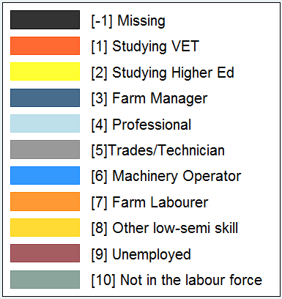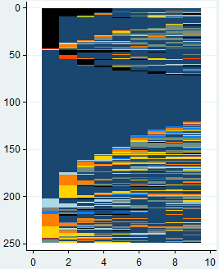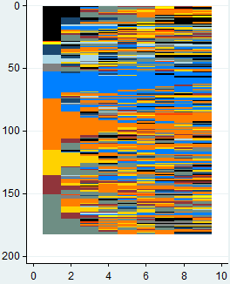

In this report, this analysis is extended through eight detailed interviews, with the purpose of better understanding the motivations or circumstances responsible for career and labour market movements. These eight individuals are currently working in the agricultural industries, ranging from labourers, to technicians and farm managers. A brief profile of the interviewees is provided in table 1.

Table 1 Profile of interviewees, primary industry

|  |  |  |  |
| --- | --- | --- | --- |
| Occupation | Age | Gender | Qualifications |
| Vineyard hand | 45 | Female | Year 9 secondary school |
| Farm hand | 52 | Male | Year 10 secondary school |
| Tractor operator | 31 | Male | Welding traineeship |
| Arboriculturist | 24 | Male | Certificate III (Horticulture) |
| Agricultural technician | 45 | Male | Electrical Distribution Powerline apprenticeship |
| Dairy farmer | 42 | Male | Fitter/turner apprenticeship; Advanced Diploma of Agriculture |
| Mixed crop/sheep farmer | 48 | Male | Year 10 secondary school plus 2 years at agricultural college |
| Mixed crop/cattle farmer | 37 | Male | Diesel mechanic apprenticeship |

The interviews cast a spotlight on several elements of the framework developed in the quantitative phase of our research and which were particularly apparent in the primary industries. These are summarised below:

*Pathways of learning and skill formation are fluid and largely informal. On-the-job learning is the most highly valued way of delivering training.*

When asked about available career paths, all interviewees noted that there are few formal barriers to learning. Most skills can be and are learnt on the job, and while the skills and knowledge can be substantial (and common to different streams of farming), they are not necessarily codified into formal education syllabi and outcomes. Indeed, 52% of the workforce does not possess post-school qualifications (Skills Australia 2010). The following excerpts were representative of this view:

It doesn’t matter whether you’re working around pigs, or working around cows, or working around sheep, your same basic stock handling, and stock monitoring principles are still the same … You do need a basic know-how of pig anatomy, of generally being able to pick up when animals are sick, when to treat them, things like that, and a lot of that you can’t learn in the classroom, you can only learn hands-on. Agricultural technician

Such comments were qualified with an understanding that formal qualifications can be indeed valuable, but are not the only way of acquiring a broad range of relevant skills and knowledge. One farm manager had completed an advanced diploma in agriculture to learn skills such as production planning, accounting and personnel management. Farm managers generally valued on-farm learning most highly, but highlighted the growing importance of business management skills as one area of recommended formal study.

While all respondents valued on-site learning most highly, farm managers pointed out that it was common for young future farmers (including themselves) to complete a trades apprenticeship, acquiring useful mechanical and/or construction skills for the farm as well as a fallback career if needed. These skills included welding and the use of heavy machinery, although the most commonly cited skill transfer was related to occupational health and safety awareness and behaviour.

There are few barriers to learning in terms of standards of entry or practice within farming: farm managers noted only that certification by way of a short course is necessary for chemicals purchasing/usage and operation of heavy machinery. Less than 10% of farm managers (7.6%) are degree-qualified, compared with a quarter (26.3%) of Australian managers overall (ABS Census 2006). Farm managers (compared with other agricultural workers) were the most likely to have completed such longer-term formal training and qualifications. Indeed, while most respondents reported they could have worked towards a course or certificate that might enhance their careers, they had instead acquired their skills through practice and on-site learning, with the addition of some targeted short courses of study.

*While pathways of learning are readily available, a number of prohibitive factors affect their accessibility and associated career progression. Key among these factors is the prevalence of family succession planning and the existence of significant financial barriers.*

These quite open flows of learning should not be confused with flows of labour. While respondents reported substantial on-the-job learning outcomes, all interviewees reported significant barriers to vertical career progression and the possibility of managing a farm. These barriers included the dominance of family succession planning — occupational stasis was particularly notable for farm managers, who were born into a farming family and whose plans for succession are family-centric. These respondents were all male and they had spent little time out of the labour force:

In my district here, pretty well all the farms are passed down until somebody decides they want to sell and then the farm is usually divided up by the remaining farmers that are in the area.  
 Farm manager

Another participant suggested that, without existing land assets, the alternative route would be likely to involve leasing land and livestock, drafting and delivering on a bank-backed business plan, and eventually moving to owner—manager status. This path is both difficult and uncommon.

*Harsh and precarious working conditions also contribute significantly to low- to medium-skill agricultural workers failing to progress along their career path, or choosing other employment opportunities.*

Relatively harsh working conditions may contribute to the phenomenon of young workers choosing other careers. All farm managers reported long working hours seven days a week, with limited opportunity to take time off. Census (2006) data show that 39.4% of farm managers work more than 55 hours per week, well in excess of Australian managers overall (25.2%) and the Australian workforce as a whole (10.2%). Indeed, no interviewees reported any significant period outside the labour force: low-skill workers reported living season to season under extremely precarious employment conditions; and farm managers reported extremely long working hours with very little time away from the farm.

The attractiveness of regional centres and industries competing for regional labour also affect the decision to pursue a career in agriculture. Evesson, Jakubauskas and Buchanan (2009) show that the migration of workers from the Victorian primary industries has drastically changed the profile of labour available for agricultural work, while Pratley (2008) finds that the rural population has fallen from half of Australians in the early 1900s to 15% in the year 2000. Feedback from interviewees indicated that income prospects were better in local mining industries, reporting, for example, that trades assistant roles in the mines paid significantly better than machinery operator roles in farming. This corroborates findings from Gelade and Fox (2005), which cite mining and construction as the greatest competing industries for local workers.

Apart from a prevalence of long-tenured, occupationally stable farm owner—managers, the other distinctive result was the precarious nature of the low-skill trajectory, as per figure 2. Those identified as agricultural labourers reported significant job turnover between low-skill roles, with very few employment entitlements as well as periods of unemployment. One labourer, for example, reported an employment history containing episodes (in order) as a grape picker, kitchen hand, noodle factory hand, retail assistant, cleaner, bottling factory hand, and seasonal vineyard work. Such a sequence of roles was typical of those working in low-skill roles and shows little skill accumulation or career progression, and indeed responses highlighted the importance of survival rather than engagement with further study or career progression.

I wouldn’t mind being a school teacher actually but the trouble with that is that being … my wife doesn’t work, she stays home and looks after the kids. But being the sole income earner … unless I’m out working we don’t make money. Tractor operator

You do whatever sort of comes up, you know what I mean? You see an opportunity come up and that’s what you want to do … if I’ve had enough or sometimes the work runs out, you just sort of try and find other people that are willing to put you on. Farmhand

The irregularity of these low-skill pathways is exacerbated by the seasonal nature of agricultural work. Lower-skill workers reported significant down time and/or unpredictable hours of work and minimal or zero leave entitlements. The pressures of providing income for themselves and their family during down time and the off season and the intensity of working during the high season combined to minimise further training opportunities that might extend or diversify their skill set. A review of research by the Industries Development Committee Workforce (2009) into the impact of seasonal work points to the low incentives for farmers to upskill existing staff and invest in training as a significant barrier to career paths. The report also claims that the industry is dominated by small enterprises, which cannot afford to provide staff with leave or support for formal training purposes. Evesson, Jakubauskas and Buchanan (2009) report that such low employment standards are not only driving labour and skill shortages, but increasing the use of contractors with specialised skills. This was, for example, the experience of one interviewee, who was contracted each season by a sugar mill to clear rail side weeds and overgrowth, using his own tractor.

The occupational stability of highly skilled farm managers and the choppy turnover of low-skill workers were the two key results for the agricultural sector, and are particularly notable, given the composition of the agricultural workforce. Data from the 2006 census report that 35.7% of the workforce are farm owner—operators, while a further 14.2% are contributing family farmers (likely to succeed the owner). Labourers constitute 22.5% of the total workforce.

Overall, the qualitative interview process showed a clear dichotomy of possible career paths in the primary industries. First, medium- to high-skill workers had autonomy over their career choices, often pursuing formal training and being occupied for long periods of time accumulating expertise in one vocation. Career change for this group was motivated by family, lifestyle and personal reasons. Second, low-skill workers were entrenched in precarious employment conditions, often episodic or seasonal, and with little sustained career development. The situation of this group is reactive, dependent on the weather, the crop or livestock, and with little scope to engage with training opportunities.

## Financial services

The financial services workforce is relatively young, with 72.4% below the age of 45, compared with 62.8% of the Australian workforce more broadly (IBSA 2010). While our research has focused on pathways into a range of high-skill roles, over half of those in financial services roles are accountants, bookkeepers, or accounting clerks (IBSA 2010). Moreover, while the industry as a whole is well represented by female workers (54%), at least 60% of those in the high-skill sectors of interest to our research (investment services and financial asset investing) are male (IBSA 2010). Beyond these characteristics, the nature of career entry and formation, training and development and workforce transitions over a career in financial services is not well understood. The financial services industry is relatively underrepresented in the careers literature and its dynamism makes any current understanding even more difficult.

This research serves to enhance our understanding of the quantitative analysis of 632 individuals in the HILDA Survey. A number of divergent themes arose in this analysis. These included evidence of high-skill trajectories for those moving from higher education studies to professional work, and from professional roles into managerial roles. There was also evidence of low-skill trajectories, as the largest group comprised those who moved mostly between clerical and sales roles and out of the labour force altogether. The overarching theme remained one of occupational segmentation, as particularly for those in clerical roles there appeared to be limited flows upwards in the labour market. Some of these patterns are shown in figure 3.

Figure 3 Key clusters in financial services

Managers Clerical workers

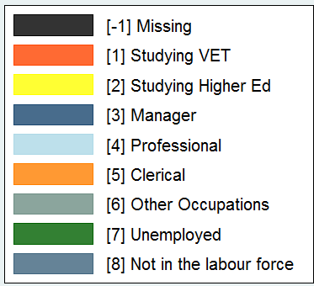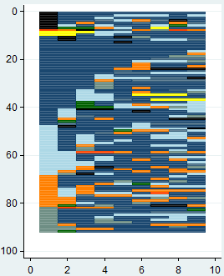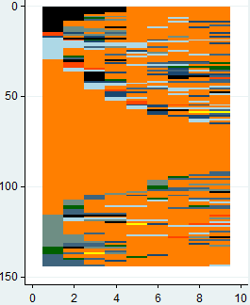

Detailed interviews were conducted with eight workers in the financial services industry to enhance our understanding of what motivates these common trajectories. A brief profile of interviewees is provided in table 2.

Table 2 Profile of interviewees, financial services

|  |  |  |  |
| --- | --- | --- | --- |
| Occupation | Age | Gender | Qualifications |
| Head of research | 45 | Female | Bachelor of Science; Masters of Commerce |
| Portfolio manager | 35 | Male | Bachelor of Science (Hons); Chartered Financial Analyst |
| Bank teller | 53 | Female | (former equivalent of) Cert. III Business Administration |
| Financial planner | 32 | Male | Diploma of Financial Services |
| Mortgage broker | 40 | Male | Bachelor of Commerce; Masters of Business Studies; Certificate IV in Mortgage Broking |
| Branch manager | 48 | Female | Cert. IV Workplace Assessor and Training; Cert. IV Mortgage Broking (enrolled) |
| Call centre operator | 55 | Female | Cert. III in Tourism |
| Chief investment officer | 54 | Male | Bachelor of Commerce |

Access to high-skill employment in financial services is mediated by high entry barriers in terms of qualifications and experience, yet not predominantly in the form of the mandated licensing or certification requirements of government or occupational groups. While there is a broad range of occupations[[2]](#footnote-2) that require an Australian Financial Services (AFS) licence from the Australian Securities and Investments Commission (ASIC), the requirements for the licence focus on broad organisational issues such as adequate resourcing, risk management and compliance systems.[[3]](#footnote-3) The Australian Financial Services licence does set out some minimum training standards for those providing financial advice to retail clients; however, these are commensurate with the certificate III and diploma levels of the Australian Qualifications Framework.[[4]](#footnote-4) Amongst some staff (responsible managers), higher standards of knowledge and skill standards exist which combine the AQF, industry and Australian Prudential Regulation Authority (APRA) standards and years of experience. These flexible standards exist alongside a highly qualified workforce, with more than 38% possessing a bachelor’s degree or higher (IBSA 2010).

With this context in mind, we summarise the key themes arising from the interviews below.

*Formal qualifications have become more important over time in two key ways. First, minimum educational standards are becoming tighter in the licensing of some occupations. Second, they are used widely to screen job applicants at many levels, particularly amongst university graduates. However, it is the capacity to learn and the analytical and problem-solving skills attached to these degrees, rather than the disciplinary knowledge, which are sought.*

All interviewees reported the increasing importance of formal qualifications over time. At the low-to-medium section of the skill spectrum, many financial services workers are now required (and supported) by their organisations to possess a minimum Certificate III in Financial Services, while numerous occupations such as financial advisers and mortgage brokers are moving towards more advanced VET qualifications for licensing and professional membership requirements. Also while the licensing conditions set out by the Australian Prudential Regulation Authority and the Australian Securities and Investments Commission are generally not prescriptive about training standards for many of those in financial services, a suite of industry standards and qualifications do apply.[[5]](#footnote-5) These are largely delivered through occupational bodies, often in collaboration with educational institutions. Such programs typically prescribe curriculum, assessment and experience requirements for completion, and many of these standards set informal benchmarks in specific occupations. All respondents emphasised a strong level of employer support for further study; however, these studies are typically undertaken while working full-time within the industry (rather than prior to entry), they are not compulsory and their attainment is often not explicitly linked to promotion or progression. The importance of these qualifications is reflected in the following comments:

As time went on, a lot of financial institutions then as a matter of course would introduce that qualification [Cert III Financial Services] to be done during work time anyway … I don’t really actually think you get a choice to be honest, I think you’ve just got to do it … Certainly they will hire people without it, on the undertaking that they will be doing that study. (Branch manager)

Buchanan et al. (2010) found that entry barriers into high-skill roles existed, not through the formal licensing requirements, but through recruitment processes, focused almost exclusively on a broad pool of degree-qualified applicants. Our interviewees valued the high level of generic skills present in university graduates and focused more on problem-solving and analytical skills, over discipline-specific knowledge:

I recruit people and we’re looking for smart people. They don’t necessarily have to have a qualification in the specific area that we work in … it’s usually to do with their degree and the levels of marks … it’s the raw material that is the key thing because if you’re smart then you can pick up anything. Research manager

I’ve been involved in the graduate recruiting roles and I think the qualifications really are an indication of — they show that someone has the capability to grasp concepts to work through problems … I think qualifications are important, not necessarily for the knowledge behind them but again for what they show about the way that person thinks, the way that person can work.  
 Portfolio manager

There’s not that many these days that don’t [have a degree]. I mean, in my day, going back to the mid-1980s, not that many people had degrees really … [Today] if you had a list of 25 applicants to choose from, you’d have to whittle it down to something that’s manageable, and obviously having a degree is an easy way out. Chief investment officer

*The business settings in financial services are extremely dynamic and consequently, for workforce entrants, skills demand is focused squarely on generic skills such as communication, problem-solving and analytical skills.*

In terms of the skills ecosystem framework, financial services offer a different context, in that the business settings, institutional and regulatory frameworks, the structure of jobs and the types of skill formation are all very dynamic. Adams, Antonacopoulou and Neely (2008) identified challenges raised by this industry, which include more liberalised, internationalised and emerging markets, changes in technology and new regulatory frameworks. Most respondents in financial services said changes in job structure and design had occurred in response to one or more of these challenges, and indeed these changes are reflected in both the composition and level of financial services employment (for example, Rae 2008). Business and regulatory responses to the global financial crisis and the ongoing recovery attest to the dynamism of the financial markets.

If the mortgage market collapses, if people stop borrowing money as they have been in places like Europe and America because of what’s happened, then my position will become redundant anyway. Mortgage broker

Under such dynamic and flexible, yet precarious, business settings, generic skills were agreed to be of paramount importance at all levels. Regardless of the complexity or seniority of the role, all participants emphasised communication skills, relationship-management skills, sales skills and a capacity to learn as being critical to both career entry and progression. Those who had experienced substantial career progression had been able to move either from lowly clerical roles to branch manager roles or from university graduate to portfolio manager roles, on the basis of experience and initiative rather than through the presence of structured educational or career pathways. Participants used words including ‘initiative’, ‘can-do attitude’, ‘commitment’ and ‘passion’ to describe the keys to successful recruitment and promotion. Similarly, the greatest barriers to progression were given as a lack of self-drive, arrogance and a lack of self-confidence. This reflects a shift towards recruitment of ‘soft skills’, such as disposition and attitude, reported by Keep (2005). These themes are represented by the comments below:

Relationship skills and communication skills are important … those are things that you can’t really formally teach people, they either develop them or they don’t. Leadership skills are very, very important [too] … If they’re young people they’re not coming in with a huge amount of experience, so they’ve got to have some core skills. Like analytical skills, or marketing skills … you have to make sure they’ve got the core competencies. Chief investment officer

*Strong internal labour markets and on-the-job learning support dynamic career paths. Possession of a university degree is a tacit barrier, but not an insurmountable one, as employers may support their employees both financially and with study leave.*

Entry to high-skill careers may thus be achieved by higher education graduates in a broad range of disciplines that exhibit highly technical and analytical skills, including engineering, business, maths and sciences, and actuarial studies. Durrani and Tariq (2008) found that numeracy skills tests are more likely to be used in banking and finance recruitment than in other industries. As Adams, Antonacopoulou and Neely (2008) report, however, career progression seeks experience and the accumulation of skills and knowledge on the job rather than formal educational achievements. All interviewees stated that educational attainment was helpful — and employer-supported — but no guarantee of progression or promotion, and that their accumulated on-the-job expertise had forged career paths.

[Success] takes a long time because a large element of it is experience and you just simply can’t get that without being there over time but there’s definitely — there are ways to actually short cut it so that you understand what you are seeing in the first place and so study is very useful for that. I didn’t study in this area initially which is why I did the CFA [Chartered Financial Analyst program], I think those kind of very broad knowledge basis qualifications are very useful early on, so getting those early is quite handy, it means you can assimilate the experience much more effectively. Portfolio manager

The career pathways described by participants in high-skill roles indicated the presence of dynamic internal labour markets, demonstrated by long tenures with one employer, while moving through increasingly challenging roles. Examples of such pathways included entry into a ‘back office’ analyst role with responsibilities for compliance and reporting, into junior research or trading roles, senior roles with mentoring responsibilities, and finally staff and investment management responsibilities. Access to this high-skill trajectory, however, is largely dependent on the point of entry of the university graduate. While it is certainly possible for those in lower-qualified roles to progress through on-the-job learning, this appears to be a less common, and much slower, route. Rather, those entering via low-skill roles such as a clerk were more likely to experience different opportunities (dependent on the institution in question), for example, progressing to lending consultant, financial planner or branch manager roles. The formal educational requirement of this second, medium-skill path is typically lower, typically a certificate or diploma-level qualification in financial services or financial planning.

The long tenures observed in figure 3 appear to be explained by a number of distinct patterns. As mentioned, those able to access high-skill roles reported significant career progression in line with experience and learning (and within the professional/managerial groupings). Those in low-skill occupations, however, cited a combination of two experiences: very long tenure and limited occupational mobility, compensated by the attractiveness of secure employment and/or many episodes in roles such as insurance sales, call centre operator and general clerk. Many interviewees cited age as the key reason for not investing in further training or career development. Other constraints included the difficulty of completing further studies while raising a family, competing with young university graduates and sacrificing pay and experience for a new career. As one interviewee’s comments reflected:

You’ve got to start at the bottom and work your way up, so you get a degree, you can get into a graduate program and then you can work your way up … I would be getting into that graduate program as a 35, 36 year old, compared to other people who are only 20, 22 … I feel like it’s a bit too much of a gamble. Financial planner

In summary, there appear to be two distinct career paths typical of financial services: the first is characterised by entry as a university graduate, whereas the second typically requires no qualifications at entry. Both paths value the presence of generic skills most highly at entry, with the capacity to learn, analytical skills and communication skills equally important in both streams. Both paths exhibit quite fluid systems of skill formation, characterised mostly by on-the-job learning, but often supported by employer-sponsored formal study. Both paths provide opportunities for career progression, but typically within quite distinct streams. The first is relatively unlimited, able to access management roles in investment management, research, risk management, ICT and so on; the second is likely to be limited to careers as medium-skill intermediaries (for example, financial planner, book keeper, mortgage or insurance broker) or middle management. Although crossover between paths is possible, it probably requires a substantial investment of time and money in university studies.

It is important to note that neither path has a greater stake over career fulfilment. Rather, the participants reporting the greatest career fulfilment cited a high level of autonomy and problem-solving responsibilities and a dynamic work environment. Career progression occurred via lateral movements between different roles, as well as vertically in taking on organisational and managerial roles. Further, despite our emphasis on university qualifications, perhaps the best interpretation of these two pathways is that careers are accelerated through the possession of a university degree and other formal study. Such is the strength of internal labour markets that career pathways from more lowly clerical roles to senior managerial roles are indeed more fluid than for, for example, health and engineering professionals. As cited by all respondents, it is the capacity to learn and a commitment to self-development which is the best predictor of success.

## Trades and engineering

There are few formal barriers to working as labourers, trades assistants and manufacturing process workers. Some roles require the equivalent of an AQF certificate I, II or even III, or a short period of on-the-job training, and in some cases jobs do not require any formal qualifications or training at all. Although there are few barriers to entering these roles, labourers are required by state safety regulations to hold certain tickets or licences for using certain types of machinery and undertaking certain building work. These tickets can be obtained through registered training organisations.

Clear educational pathways exist from lower-skilled occupations such as process and production operators or trades assistants (with the equivalent of a certificate II in engineering) to fabrication tradesperson roles (certificate III) and into higher-skilled roles such as higher engineering tradespersons or licensed electricians (certificate IV). Becoming a licensed tradesperson generally involves undertaking a three- to four-year apprenticeship, with both structured on-the-job and   
off-the-job training. From there, educational paths exist into engineering technician roles and professional engineering through the diploma of engineering and the bachelor degree respectively.[[6]](#footnote-6)

Despite these clear educational pathways, the quantitative analysis identified little occupational mobility. The working paper (Yu et al. 2012) focused on the quantitative analysis of 1145 individuals working as engineers or tradespersons at some point between 2001 and 2009. It characterised low-skill trajectories as those attempting to transition from low-skill manual roles into the skilled trades, but largely returning to labourer roles. High-skill trajectories were observed for both qualified trades workers and engineers (including those moving from higher education studies). Those working as tradespersons, predominantly electricians, metal trades workers and construction trades workers, formed the most occupationally stable segment and represented 30% of the sample. Despite the availability of educational pathways into professional engineering, there was little mobility within this group.

These key groups are illustrated in figure 4, which shows their patterns of movement over nine years.

Figure 4 Key clusters, trades and engineering

Qualified trades workers Manual labourers

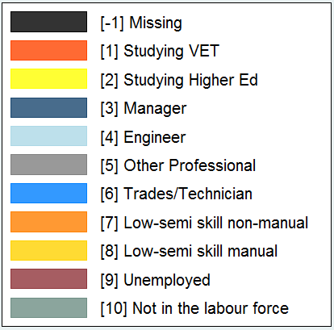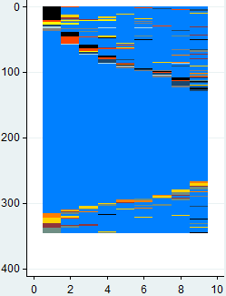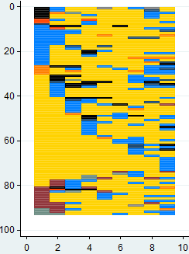

Eight interviews were conducted with manual labourers, qualified tradespersons and engineering paraprofessionals and professionals. A brief profile is given in table 3.

Table 3 Profile of interviewees, trades and engineering

|  |  |  |  |
| --- | --- | --- | --- |
| Occupation | Age | Gender | Qualifications/licences |
| Water operations officer | 45 | Male | Cert. III Automotive Mechanic; Cert. III Water Treatment Operations (enrolled) |
| Electrician | 29 | Male | Cert. II Horticulture; Cert. III Electrotechnologies |
| Labourer | 38 | Male | Forklift licence |
| Electrical engineer | 55 | Male | Bachelor of Electrical Engineering |
| Labourer | 50 | Male | Quarrying certificate (level unknown) |
| Electronics technician | 31 | Male | Diploma in Information Technology, PC and network support;  Cert. IV Electrotechnology |
| Process operator | 52 | Male | Bobcat, forklift, elevated work platform and overhead crane licences |
| Electrical engineer | 55 | Male | Bachelor of Electrical Engineering |

*The barriers to labour market mobility experienced by low-skill labourers are complex and interconnected. These included high turnover in often marginal forms of employment, which diminished access to systematic training; lack of employer support or incentive to invest in training and development; and severe difficulties arising from being income- and time-poor (both at home and in the workplace).*

Despite the existence of clear educational pathways, the experience of labourers and trades assistants in the HILDA data was characterised by minimal mobility into higher-skilled work or study. Where transitions occurred, they were characterised by high turnover and little accumulation of skills and knowledge. Such labour market churning, whereby individuals cycle between unemployment and employment and through low-paid jobs, has been widely recognised as a significant issue for lower-skilled workers (Watson 2008) and was reflected in the responses of the labourers and low-skilled manual workers in this study. Their experiences saw either long episodes in one low-skill role, or significant job turnover between low-skill roles, unemployment, and periods out of the labour force due to serious work-related injuries and family responsibilities.

While trades assistants and labourers can theoretically transition to a trade-qualified role though the completion of an apprenticeship and certificate III or IV level qualifications, few participants in our study were interested in making such a transition. Indeed, their ability to progress in their current job relied strongly on the willingness of their employer to provide training. The interviewees’ comments reflected the literature, which suggests that employees working on a part-time, casual or agency basis generally have less access to training opportunities (for example, Pocock 2009).

It is difficult to untangle the disaffected attitudes towards further study and training amongst these low-skill workers. The literature suggests that the barriers to successfully undertaking further education and training and transitioning to higher-skilled work are substantial. To start with, upskilling into the role of trade-qualified worker, for example, requires these workers to undertake further study in the form of a low-paying apprenticeship of three to four years.[[7]](#footnote-7) There is little evidence that initiatives such as adult apprentice wages or accelerated apprenticeships have become widespread.[[8]](#footnote-8) In addition, research undertaken by Harris, Rainey and Sumner (2006) identified a range of reasons why particular work and study pathways are not taken up by individuals including: financial constraints; the difficulty of juggling work and family responsibilities; the availability of transport; inflexible class schedules; and lack of confidence to take study (2006, p.10). Pocock’s (2009) research on low-paid workers’ participation in education and training also highlighted a number of impediments to training including: ‘fear of change, low confidence, high care loads, exhaustion, age, gender and churning between welfare and work’ (2009, p.7).

A number of these barriers, which act as impediments to advancing into higher-skilled pathways, resonated with interviewees from labouring and process manufacturing backgrounds. Pocock (2009) found that the combination of both income and time poverty is a barrier to low-paid/low-skilled workers’ participation in VET, and these results are reflected in the comments below:

I’ve always got friends and family digging me in the back ‘Go do a course, go do this, go do that’, but I’ve got a wife that doesn’t drive, I’ve got four kids, three go to school, one doesn’t. I just ain’t got the support to even think about it really and at the moment I just need money, I need a permanent job to get my security back up and where I am now, it’s really good … To go back into a course … yeah, you know, the money drops and then you’ve got to make up for it with a part-time job elsewhere. Labourer

Given the tight time and financial resources available, it is not surprising that undertaking a three- or four-year apprenticeship for entry to a qualified trades role is out of the question for many low-skilled workers. The exception in our study was one, notably young, electrician, who identified stronger income prospects and broke away from the cycle of low-skill work.

The workers in this research were more likely to undertake short courses or vocational certification such as tickets to comply with state safety regulations requiring such licences and tickets rather than invest in longer-term courses. Interviewees talked of holding such tickets as being an investment in one’s employment prospects and income. Holding tickets can lead to a slightly higher income return, as industrial agreements and awards usually stipulate higher rates or an allowance for undertaking work that requires these tickets.

Watson’s analysis of VET student outcomes data found that 20% of all labourers lacked the opportunity to improve their skills while at work compared with 10% of associate professionals and tradespersons (Watson 2008 cited in Pocock 2009, p.26). Our research corroborated this finding, with labouring workers given minimal time for coherent, systematic development through on-the-job learning. Previous research shows that casual workers, by virtue of their employment status, tend to experience limitations to their access to employer-provided or sponsored training, as employers are less willing to invest in training (Pocock 2009).

The experience of most low-skilled manual workers in the study showed that low-skilled work was not a stepping stone into medium- or high-skilled work due to an intimidating range of constraints. These constraints included the lack of systematic on-the-job training, time and/or income poverty and forms of engagement with the labour market (for example, casual employment, churning in and out of employment). Where labourers were employed continuously with one employer, there was little evidence of any upward trajectories of skill or career development. Rather, the interviewees reported being entrenched long term in roles which saw little task variety, changes in responsibility, or skill expansion.

*The articulation of qualified trades workers into professional engineering roles is limited by differences in learning models between engineering studies in the VET and university systems.*

Analysis of the HILDA data showed trade-qualified workers to be one of the most stable labour market groups. Trades workers are characterised by high-skill trajectories, having undertaken significant training, including the completion of a three- or four-year apprenticeship and possessing a certificate III or IV. Specialised trades workers such as electricians, automotive mechanics and plumbers are required to hold licences before they can undertake either residential or commercial work. Analysis by Karmel, Lim and Misko (2011) on attrition and mobility in the trades finds that attrition levels are broadly comparable with those in professional categories.

The linked structure of occupations and qualifications means that trade-qualified workers have the ability to transition into engineering occupations through cross-sector articulation. Entry to engineering is available through certain VET programs that qualify graduates or students for admission with credit into the university engineering schools. In some cases, universities will allow entry on the basis of trade qualifications into specific associate degree programs.[[9]](#footnote-9) Despite these articulation paths, the HILDA data showed trade-qualified workers as displaying limited upward mobility into paraprofessional or professional engineering roles. The qualitative research explored some of the reasons for career, study and occupational transitions among trade-qualified workers.

Previous research has highlighted that Australian universities currently do not have standard credit arrangements for VET graduates to enter tertiary education in the engineering field and often grant credit on a case-by-case basis (King, Dowling & Godfrey 2011). Other research has also identified the differences in learning models between vocational education and higher education, which may also be a disincentive for trades workers seeking to study at university. Buchanan et al. (2010) reported that Engineers Australia employs separate accreditation systems for VET-based advanced diplomas and for university-based associate degrees for admission to their engineering designations, citing differences in learning models.

Ideally … an Advanced Diploma would give a year’s credit into a 3 year Bachelor of [Engineering] Technology, but this is another big issue at the moment, and the universities are really wrestling with this in a big way, because they have lost faith in the Advanced Diploma [graduates] coming out of the TAFE sector … simply because of the TAFE sector having to move to this competency based framework, there has been quite a loss of academic rigour.  
 Engineers Australia, quoted in Buchanan et al. 2010

The difficulty of this pathway was illustrated by the one participant who had articulated into the engineering pathway. This interviewee has an electrical trades qualification (certificate III) and moved into an engineering role after completing university studies over a period of nine years, balancing full-time work, a family and study. Although he was successful in making the transition from trades worker to engineer, his experience illustrates the challenges posed by the strict entry requirements into engineering. His experience of nine years of university studies involved long-term part-time study and the services of a tutor to assist with the higher-order mathematical knowledge requirements. The transition was made possible due to strong financial and study leave support from his employer, who wanted to develop engineering expertise in-house. This example demonstrates the important role of strong internal labour markets and of employers in supporting workers’ opportunities to up-skill.

*More importantly, the articulation of qualified trades workers into professional engineering roles is attenuated by strong career growth within trades work itself, characterised by access to ongoing training, a broadening skills base, strong incomes and movement into supervisory/ management roles.*

The interviewees in trades roles had all considered moving into engineering but none had immediate plans or intentions to move in that direction. There was seemingly little impetus for the trade workers in our study to move into a career in engineering. Aside from the heavy burden of university study to become an engineer, experienced trade-qualified employees are likely to suffer a temporary, or even permanent, loss of pay and conditions in moving to professional engineering, as illustrated by the following comment:

But with the money, funnily enough, trades people earn more money than engineers. It’s a fact of life. Electrical engineer

Indeed, ABS data released by the Department of Education, Employment and Workplace Relations indicated some overlap between the average earnings of those in the electrical trades and engineering profession (table 4). The overlap would also be more evident if we considered interstate and inter-industry differences.

Table 4 Average weekly gross earnings by occupation, electrical trades and engineering, 2010

|  |  |
| --- | --- |
| Occupation | Average gross weekly FT earnings, $ |
| Electrician | 1200 |
| Electrical distribution trades worker | 1500 |
| Electrical engineering draftsperson | 1518 |
| Electrical engineer | 1450 |
| Mining engineer | 2108 |
| Engineering manager | 2013 |

Source: Department of Education, Employment and Workplace Relations, Job Outlook database.

An allied issue is that study participants reported having access to strong opportunities for career progression in their current workplace. This was characterised by a number of key elements: opportunities for earnings growth; horizontal career movement in the form of a growing technical skills base; and/or vertical career movement in the form of greater managerial and organisational responsibilities. In contrast to the lower-skilled manual workers, these skilled tradespeople often had access to structured on-the-job training as well as employer-supported vocational training, and this contributed to a broadening of their vocational identities. One participant, for example, was undertaking a certificate III in water operations with the support of his organisation. This qualification allowed him to broaden his skills so that he could work on both manual and automatic irrigation channels. The following excerpts indicate the broad range of career prospects open to trades workers:

Well once you start going underground, you’re still doing a similar sort of job, but you get an extra $100,000 a year so. Electrician

To summarise, the experience of most medium-skilled trade-qualified workers showed that there is little impetus for them to articulate into engineering, given that they have access to career growth and high incomes in their current roles. The one interviewee who had made such a transition did so with the strong support of his family and employer over a nine-year period of university studies.

*Professional engineers are typically highly qualified individuals with significant career opportunities in internal labour markets, as well as in external labour markets characterised by skill shortages. Moreover, these individuals possess advanced analytical and problem-solving skills, which create more diverse career paths into project management and other industries such as financial services.*

Professional engineers, like trades workers, are an example of relatively stable occupational markets, tied quite explicitly to standards of entry and practice governed by occupational bodies such as Engineers Australia. According to the 2006 census, 72% of engineers have a bachelor’s degree or higher, reflecting the high-skill trajectory of those with an engineering qualification (Wise et al. 2011). Census data show that engineers in older age cohorts are more likely to have associate degrees and diplomas as their highest level of qualification (Wise et al. 2011). This reflects previous practice, whereby engineers could be non-degree-qualified and learn the profession through traineeships. Over time engineering skills requirements have been formalised so that university degrees now represent the main route into engineering. Most engineers currently enter university on the basis of their university admissions ranking and there are low levels of articulation from VET to engineering.

Given that engineers are highly educated and have spent considerable time studying, there appears to be little impetus to gain further qualifications. Furthermore, on–the-job training and experience enable engineers to access career progression (for example, from graduate to professional engineer to principal engineer), either within internal labour markets or externally. The engineering skills shortage in Australia contributes to strong job opportunities, as reflected in the very low unemployment rates amongst qualified engineers (Wise et al. 2011). The interviewees both felt that their employer offered good career opportunities for promotion and further development.

Both engineers also noted that they had the ability to transition from engineering roles into non-engineering management roles, such as project manager. The project manager role involves the running of projects and coordinating aspects of the project and staff. It is usually more client- and contract-focused than technical engineering roles. Although the project manager role tends to be less about the ‘nuts and bolts’ of engineering design, a strong understanding of engineering principles is necessary to enable project managers to bring different aspects of projects together. The role of project manager can be a stepping stone to higher-level line-management positions.

The strong problem-solving and analytical skills possessed by engineers often make them attractive in a variety of other occupations, particularly those that involve engineering project management. Moreover, these valuable skills were sought by interviewees from financial services, such that recruitment practice focused on engineering, maths, and science as well as business school graduates. As Garner (2002) reports, ‘engineers in the financial services industry draw on their knowledge of cost management and maximisation of resources. They also draw on their problem-solving skills and analytical abilities’ (2002, p.240).

Whether engineers want to take up such career opportunities is a matter of personal preference. Census data also reflect that there is a ‘sharp fall in participation rates for qualified engineers aged 55 years or over, with only about half of this older group remaining in the labour force’ (Wise et al. 2011, p.27). For those who remain in the workforce, the data show that over 40% of engineers work extended hours, of 45 hours or more per week. Two interviewees in their mid-50s reported that they did not have the desire to progress up the career ladder, but rather they wanted to stay in their current job and retire in five to ten years.

These findings have helped to sharpen our understanding of the learning pathways and movements identified in the quantitative study. We have seen that time and money poverty and precarious attachment to the labour market entrench lower-skilled workers in the low-skilled trajectory. The difficulty of undertaking a three- or four-year low-paid apprenticeship to become trade-qualified is clearly out of the question for many labourers. In terms of trade-qualified workers, the interviews illustrated that these workers were exposed to strong career prospects, in relation to training opportunities, earnings growth and changes in responsibilities. This contributed to the strong segmentation of trades workers, with little impetus to articulate into professional engineering. While the engineers were a group of highly qualified workers with strong career opportunities in a market characterised by skill shortages, long hours of work meant that some workers preferred to work more flexibly rather than to progress up the career ladder. A major theme that cut across the sub-segments is the importance of on-the-job learning and supportive employers for the skill formation of all workers, as well as the structured nature of pathways into the trades and engineering, mediated by strict standards of entry and practice.

## Healthcare and community services

For the last decade much research has emphasised the importance of exploring and identifying the differences that separate and distinguish community service from health work (Connetica Consulting 2009; Bretherton 2008; Victorian Council of Social Service 2007; Meagher & Healy 2005). In this exploration, great emphasis has been placed on differentiating the sectors in relation to: overarching management practices; ownership and funding models; operating environments; and the distinctly different occupational profiles that drive service delivery. Implicit in these arguments is that community services and health reflect very different occupational profiles (Meagher & Healy 2005) and therefore must yield very different career opportunities and pathways for workers in these sectors. While there is value in continuing to explore diversity at the sectoral level, the workers interviewed for this study highlight that discussions of vocation and career can also be enhanced by considering the experience of these sectors together. As a first and critical point of comparison and commonality, ‘care’ roles continue to form the basis of much work in both sectors. In this discussion, worker experience and the ‘meaning’ of care are identified as important and defining issues for the vocational and career choices made by workers in both sectors.

Quantitative analysis of the healthcare and community services workforce in the first stage of this project involved 1657 individuals from the HILDA Survey. The sector showed the greatest level of occupational segmentation, consistent with the high level of specialisation in healthcare delivery. The analysis showed that high trajectory pathways were evident for those in, or entering, the health professions, such as nursing. In other low- to medium-skill occupations, however, there was limited mobility, with, for example, relatively few care workers progressing to enrolled nurse and registered nurse roles. These key clusters are illustrated in figure 5, which depicts their sequence of movement over nine years.

Figure 5 Key clusters, healthcare and community services

Nurses Carers

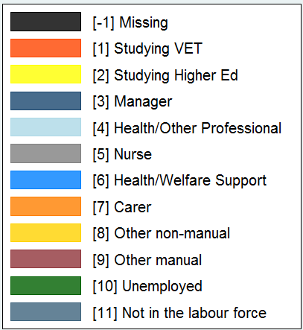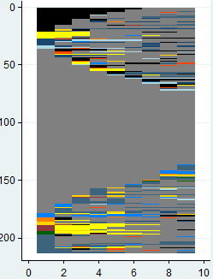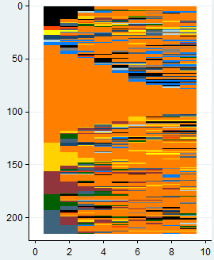

As a first step in understanding the nature of career transition, the Community Services and Health Industry Skills Council (CSHISC) has done much work in the last decade to emphasise the commonalities in ‘care work’, with a view to offering or enhancing the capacity for individual workers to develop and build career paths from diverse starting points. Yet, despite attempts to structurally expand the opportunities for career development, there remains limited evidence that this is happening. The interviews conducted for this study indicate that the ‘vocation’ of care and whether this represents a motivating and driving force within job and training transitions are issues that warrant further consideration, particularly in the context of VET, higher education transitions and career formation. The commentaries provided by workers on their experience in job and career transition, also offer insight on the barriers which work to inhibit career development and identify possible preconditions for successful career transition. Eight in-depth interviews were conducted with those currently working in the healthcare and community services industries. A brief profile of these interviewees is provided in table 5.

Table 5 Profile of interviewees, healthcare and community services

|  |  |  |  |
| --- | --- | --- | --- |
| Occupation | Age | Gender | Qualifications |
| Residential service manager | 48 | Female | Registered nurse  Endorsement in aged care practice |
| Aged care worker | 42 | Female | Undertaking community service and disability care certification |
| Nursing unit manager | 57 | Male | Division 1 registered nurse  Endorsements in midwifery, rural and remote area care and practice |
| Home care nurse | 40 | Female | Registered nurse  Diploma in Health Science |
| Domestic aide and direct care worker | 32 | Male | None, beyond mandatory OH & S, first aid and manual handling |
| Nursing unit manager | 60 | Female | Registered nurse  Masters in Management  Endorsements in child and family health, and midwifery practice |
| Patient care assistant (aide) | 23 | Female | None, discontinued (non-completed) Bachelor of Teaching |
| Aged care nurse | 48 | Female | Registered nurse  Endorsement in aged care practice  Certificate IV in Training and Assessment |

A thematic summary of the interviews identifies a number of key points, which are outlined below.

*There is strong consensus among workers that resource constraints, which are present in both sectors, serve to broadly curtail career development.*

Training, and the value of training to service delivery in community services and health, was acknowledged by all interviewees. In higher-skilled roles, the need to update skills in line with changing practice regimes is critical. In this regard, licensing and registration agencies are essential (for example, the Australian Health Practitioners Registration Agency). In the case of nurses, for example, the need to maintain and update training is present across all aspects of the practitioner role — basic and advanced life support training, medications training and, at the state level, the need for additional endorsements[[10]](#footnote-10) in order for nurses to undertake certain roles in public health service delivery (for example, child and family health, or rural and remote endorsements).

In lower-skilled or ‘unqualified’ roles, training also plays an important role by ensuring that workers engaged in direct care roles particularly understand manual handling procedures and workplace health and safety, and can give essential first aid in emergency situations. Despite the recognition of a need to update clinical skills and ensure safety amongst workers and for patients and clients, workers universally noted the absence of employer financial support for training. The following excerpts are representative of comments made on this point and demonstrate how wide the impact for staff is.

All of the training I’ve had, it’s occurred because I’ve decided I needed it, generally once I’m already in a role, and I’ve gone about getting it. Nursing unit manager

There is a strong body of work which indicates that this lack of financial support for training impacts negatively on workers in career terms. As Kubiak, Rogers and Turner (2010, p.375) notes, resource deficits ‘militate against learning opportunities’. At the higher end of the occupational hierarchy, the impact of cost-cutting on workers in health and community services is felt most directly through work intensification, which thereby reduces both formal and informal learning opportunities. Bretherton, Buchanan and Gordon (2009) note that work intensification and cost-cutting in health facilities limit the ability of staff to access supports for training because there are reduced opportunities to attend training during work time, and there is often no financial support to meet course costs. This is illustrated by the experience of a highly qualified registered nurse who had already achieved a number of endorsements to practise in family and community care, home care and aged care and yet identified a barrier to further advancement without employer support:

I’ve reached a point where I’m almost 50 and to get to the next level, I would have to do a double degree to get to the next level of management in aged care … Ideally I would love to actually teach because it would be rewarding, and I believe I have skills and experience to impart … but again, a double degree. I don’t want to take that on at my age, because it would mean trying to work at the same time. That would be hard without family, and pretty much impossible with family. Registered nurse

Lack of employer support to acquire further qualifications can inhibit the ability of workers to advance beyond the entry level in the long term. This challenge was explained by a domestic aide who had worked in aged care and disability direct care for eight years, yet remained at the entry level:

In a perfect world, I’d do my nursing degree but I’ve worked out that it will cost me twenty grand, and I’d have to fit that around work. The pay would be better, and personally you’d feel better because you’re ‘qualified’ but I’m not sure how I would make it happen because you have to keep working don’t you? You have to bring money in. Aged care worker

Care workers also noted that increased stress and pay were ‘not enough’ to justify a promotion, particularly to the management level:

The pay and responsibility are better, but it still doesn’t seem to be worth it … To be honest with you it is a very poorly paid job and you need to work two jobs just to make ends meet.  
 Care worker

The low-pay conditions in community services are well established and were the subject of the recent Fair Work Australia decision in a key Equal Remuneration case for the social, community and disability services (SACS) industry[[11]](#footnote-11) in May 2011 (Fair Work Australia 2011). Table 6 presents the relative average weekly (gross) earnings for care workers in both the community services and healthcare industries. Full-time and total earnings are given to illustrate the prevalence of part-time work particularly amongst lesser-qualified workers.

Table 6 Average weekly gross earnings by occupation, healthcare and community services, 2010

|  |  |  |
| --- | --- | --- |
| Occupation | Average weekly full-time earnings $ | Average weekly total earnings $ |
| Aged or disabled carer | 800 | 560 |
| Personal care worker | 750 | 550 |
| Enrolled nurse | 805 | 750 |
| Registered nurse | 1150 | 960 |
| Nurse manager | 1500 | 1500 |
| Average Australian employee | 1050 | 870 |

*Workers in both sectors expressed a shared ‘vocational narrative’, located around the concept of care. This appeared to offer a stabilising and directing force for workers in giving meaning and purpose to their job and career movements. The vocational narrative of ‘care’ also meant that on-the-job training was highly valued by workers in the secto****r.***

While both health and community services are defined by a high density of professional and ‘paraprofessionals’ (for example, 60% of health jobs are allied health professionals, and social work practitioners represent a comparable keystone occupational group in community services), it is possible that occupationally different roles within a sector can have common and vocational ‘shared meaning’ in the form of a commitment to client and/or patient care. This is corroborated by Tsang’s (1998, p.23) work in community services and health, which highlights that both social work and nursing are defined by self-reflection, which encourages ‘vocational’ meaning. This is particularly pertinent to discussions of community services and health work for, as Kubiak, Rogers and Turner (2010) notes, there is a strong and ‘consistent thread of a vocation devoted to working with people’ which spans core roles such as nursing and community care. This vocation serves to ‘anchor’ people and provides a way by which the meaning and value of work can be acknowledged and be made tangible for workers.

In the context of health and community services, this process of ascribing ‘meaning’ to work is an essential component in understanding vocational pathways, career development and the decisions that underpin these movements. These factors, it is argued, can help to explain why workers sustain commitment to roles which may have low status and persistently low pay. It is because workers themselves understand the significance of their contribution to patient care and this includes roles at the lower and higher ends of the occupational hierarchy. As Fejes and Nicholl (2010, p.356) note, attending to the cleaning and basic care and hygiene of a patient can be seen as ‘instrumental’ to the quality of life of patients, or could simply be perceived as ‘dirty work’.

While the pool of workers interviewed for this project is too small to make generalisations for all workers in these sectors, it is important to note that the workers in this study strongly identified with their role as ‘care’ workers. Indeed, the notion of a ‘calling’ emerged as a common thread across the interviews. The following comments are illustrative of this point.

My discovering this work was for me, kind of happened by accident. There were a few incidents at work, a lady had a heart attack and another lady had stroke, and I was in the situation and I found that I was good at it, I was confident, I was calm … it was at that point I knew I was cut out for this kind of work. Care worker

I believe this work is not for everyone. I do believe that nursing picks you, not the other way around. Registered nurse

*Career paths in both health and community services could be described as ‘non-conventional’ in the sense that satisfaction among workers is delivered by lateral (horizontal) movements, in addition to vertical (ascending) movements.*

Both health and community services are characterised by perspectives on career development in which career progression is not necessarily predicated on ‘ascending’ movements. The reasons for this approach and attitude towards career development appeared to be driven by complex and interconnected factors.

In some cases, workers transferred between sectors in order to maintain career momentum and expand their skill base, in response to job stress and to delay burnout. In other sectors, this might be described as a ‘hiatus’ in career movement. In community services and health, these movements were viewed very differently, because of the underpinning attachment to a vocational ‘care’ narrative. Worker perceptions of career experience — including their own, and their observations of colleagues and senior staff — are important in the pursuit of and decisions about vocational choice. As Gunz and Jalland (1996) describe it, the ‘observable sequence of posts’ within a sector is important in understanding how workers assess career development. Gunz and Jalland (1996, p.745) note that at the micro level, organisations experiencing resource constraints (for example, downsizing and restructuring) will often substitute progression by horizontal movements within a firm in order to maintain a ‘career stream’. In the case study reported here, these lateral movements are encouraged and directed by the executive of the organisation in order to retain committed staff. The following comments indicate that clinicians wanted to stay in ‘care’ and ‘practice’ roles, and this underpinned a motivation to transfer sideways and expand the scope of practice to new realms, rather than pursue a management role.

I made it to executive director level, and then I felt I’d really burnt out from nursing, so I went to work for Queensland Health in a role that wasn’t [a] clinical role. But after about 9 months, I felt something was missing and it was the clinical practice, I knew I had to go back to it. So, I’ve eventually ended up in aged care because it’s not the adrenalin pumping that you get in the hospital environment, but it still allows me to do the clinical work.

The wide range of specialisations available in community services, and more particularly health, offer professionals the opportunity to expand their skills base by moving laterally between highly specialised areas of care and practice (for example, midwifery, child and family health, rural and remote practice, or aged care and residential care practice). Nurses are a demonstrative case study of this process because the endorsements in each of these fields can be completed and accumulated as ‘add-ons’ to a bachelor degree.

The commitment to ‘clinical care’ is perceived to represent the heart of ‘what it is to be a nurse’ and was expressed as the main reason why workers remained satisfied with what appeared, superficially at least, to be static career progression. As Skeggs (1997) notes, attachment to vocational identity can offer its own form of career reward. This observation is certainly present in the commentaries provided by workers interviewed for this study. In this scenario, the commitment to further study and the need to acquire new skills and expand experience is present and purposeful. This is consistent with Wray and McCall’s (2007) observations on this process, in which worker-driven movements between jobs reflect wider vocational purpose rather than vertical aspiration. In this scenario, advancements to lateral, different and more unique forms of clinical practice are valued as highly as promotion. Workers acknowledge that specialisation, in which many nurses appear to accumulate endorsements in multiple fields of practice, also offered an intensely satisfying work experience. The variety and the rewards derived from the diversity of clinical practice environments was argued to substitute for conventional career promotion and the recognition of professional status that a promotion to a higher role might otherwise bring. This also applied to the unqualified and entry-level workers interviewed.

In summary, the health and community services sector was different from the other industries in our study because a strong vocational narrative, centred on the notion of care, characterised both high- and low-skilled workers. This was largely absent amongst the low-skilled workers in the other vocations. This vocational narrative appeared to drive a greater focus on horizontal career progression via the possibility of cross-specialisation or movement into different institutional settings. In terms of the overarching skills ecosystem setting, the prevalence of resource constraints meant diminished skill formation amongst lower-skilled workers and work intensification for higher-skilled workers, blunting both opportunity and aspiration for successful career paths.

# Conclusion

The analyses contributing to this report framed the notion of vocational pathways along several key dimensions. First, the dominant theme was one of *occupational segmentation*, characterised by very limited flows of workers between occupational silos. Within these occupationally segmented lines, the quantitative analysis identified two key trajectories: *high-skill trajectories* and *low-skill trajectories*.

*High-skill trajectories*were characterised by access to high-skill occupations, typically following long periods of specialised training. The delivery of this training, however, varied from setting to setting, ranging from the fluid, on-the-job training of farm managers and investment managers, to the highly structured training standards characteristic of health and engineering professionals. The research found that those engaged in these pathways enjoyed employer-supported training and development opportunities, significant diversity and autonomy in their work and strong career prospects (in terms of earnings, promotion and responsibility). Within these high-skill trajectories, two notions of vocational pathways were apparent in the research. First, *horizontal transitions*involved lateral movements into related roles and were defined by an expansion of technical skills and knowledge. Importantly, horizontal transitions typically occurred within an occupational area, leveraging existing skills and knowledge with a greater breadth and depth of training and experience. Second, *vertical transitions*occurred where individuals moved into managerial/supervisory roles, taking on greater leadership and organisational responsibilities. Horizontal and vertical transitions were valued differently in different sectors but both contributed to individuals’ notions of vocation.

*Low-skill trajectories*were defined by long-term entrenchment in low-skill occupations, either in many unrelated low-skill roles, or being stuck in a long tenured role with little opportunity for progression. Low-skill workers were most likely to face resource constraints, either through low earnings and/or low employer investment in training. Many were employed on part-time, seasonal or casual terms and had experienced periods of unemployment. Consequently, these workers’ transitions were associated with ensuring an ongoing livelihood rather than investment in career pathways. Low-skill trajectories were often associated with diminished opportunities for skill formation and little attachment to a vocational identity or pathway. The key exception was care workers in community services, who shared a similar sense of meaning in their work to their qualified nursing counterparts, although still experiencing few opportunities for career progression or training.

The stark differences seen between the four sectors highlighted the importance of institutional arrangements and business settings. Strong occupational associations, as well as labour market skill shortages, supported clear career paths and prospects for qualified workers in the healthcare and trades and engineering sectors. Dynamic business settings in financial services placed a high premium on generic skills, such as analytical and problem-solving skills, in the recruitment of (mostly university) graduates. Resource deficits in healthcare and community services prevented less qualified workers from accessing training opportunities and deterred senior nurses from taking on managerial positions. A prevalence of small rural businesses and seasonal work in the agricultural industries required farm managers to work long hours as a ‘jack of all trades’, yet prevented labourers from building a cumulative skills base.

The findings of this report highlight a number of issues for both VET policy and broader educational policy. First, it must be noted that diversity in employer, institutional and business arrangements precludes any one notion of vocation or any one set of policies supporting the application of pathways across different fields of study, workplaces and sectors of employment. Put another way, while some workers may identify with a field of knowledge and practice, the notion of vocation does not form part of the language in the industries at the heart of this study and certainly not amongst employers. This is important, because employers represent the gatekeepers for transitions between jobs, between sectors, and between different roles in a workplace.

Second, it must also be noted that a policy framework which might support or be responsive to this diversity in vocational pathways is a particularly challenging task for policy drafting. This is because market, business (organisational) and workplace settings all deeply shape the context surrounding vocational pathways, both in terms of the formation and momentum of vocational progression. In addition, the links between educational progression and labour market progression (sequential, lateral and/or ascendant shifts in a career path) are not always well defined and in many cases are not universally accepted, even within a single sector. In policy terms, this means that both VET and higher educational policy approaches that might be drafted and which are sympathetic to a vocational path would at this point in time be difficult to achieve. Indeed, given the diversity of vocational pathways present in the case studies associated with this research, it suggests that uniform policy frameworks which might support vocational pathways across different occupations and industries would not be possible. The skills ecosystem framework used in this study highlighted the divergent nature of product markets and the way businesses choose to compete. These competitive strategies appear to be the primary driving force in the demand for skills and labour, which in turn affects job design, the form of employment, and the level and type of skill formation — and ultimately the presence or absence of an identifiable vocational pathway that might exist within a sector or between sectors. For example, in financial services, employers continue to sustain strong internal labour markets, while precarious working conditions and resource constraints affect the progression of care workers and agricultural labourers. Given this fundamental link between business settings and labour/skills demand, it is impossible to isolate the notion and pursuit of vocational pathways in one policy approach. Changes in conditions as divergent as wage-setting practices, industry assistance, and investment in technology have direct bearing on the way businesses engage with their workforce. Educational policy (and institutions) is embedded in this broader context and plays a fundamental role in structuring educational pathways in such a way as to be responsive to labour market needs.

Finally, it must be acknowledged that, while the findings of this report identify ‘vocation’ as a largely worker- or employee-driven concept, engagement with employers and the conditions at the workplace level have a deep impact on whether workers ultimately realise their vocational goals and aspirations. While many interviewees who participated in this study note that they have limited employer support for the additional qualifications and training that might be needed to realise their vocational goals, employer support for training remains essential if workers are to commit, develop and acquire higher levels of proficiency in job roles and/or vocations of practice. This is where the concept of a vocation may present a useful way for considering and reflecting on some core and common challenges facing the sectors in this study. The notion of vocation and the pride of craft attached to it may be a concept through which both employer and employee commitment can be harnessed to both encourage skill development — horizontally as well as vertically — and retain workers (at least within a field of work). We suggest that vocation may present a concept through which employers and employees can share a common dialogue which need not rely on default notions of pathways. If employers can provide support for employees to undertake further training because they see the value of ‘vocation’, in terms of staff retention and the status of work, and employees see that further development might strengthen their affinity with a field of work, the concept may be beneficial for both parties. It is no easy undertaking, however, as any dialogue must involve shifts in the skills and knowledge content underpinning training, the engagement between workplaces and educational institutions, and the engagement between the learner, teacher and learning process itself (Bretherton 2011). Bretherton (2011) argues that in order to support the creation of vocations, training and work arrangements must focus more on ‘holistic competence’ rather than on disaggregated competencies. In some sectors, such as nursing and trades, successful systems of learning exist, fostered by strong relationships of trust between educational and occupational institutions. In others, such as financial services and farming, the institutional arrangements are more fragmented and dynamic, and the status of structured learning and qualifications more ambiguous. In order for vocational pathways to become more than an employee-driven notion, however, a commitment to vocations and fields of practice must extend beyond these individual and institutional settings, to the divergent work and market structures themselves. As we have emphasised, the divergent skills ecosystem profiles of the four case studies suggest that a uniform policy approach is not possible and that a differentiated response would need to engage with a diverse set of labour market institutions.

# References

Abbott, A & Hrycak, A 1990, ‘Measuring resemblance in sequence data: an optimal matching analysis of musicians’ careers’, *American Journal of Sociology*, vol.96, no.1, pp.144—85.

ABS (Australian Bureau of Statistics) Census 2006, cat.no.2064.0, Canberra.

Adams, R, Antonacopoulou, E & Neely, A 2008, ‘A scoping study of contemporary and future challenges in UK Financial Services’, Economic and Social Research Council, United Kingdom.

Apps, P & Rees, R 2009, *Public economics and the household,* Cambridge University Press, UK.

Australian Qualifications Framework Council 2011, *Australian Qualifications Framework 2011*, viewed 4 July 2011, <http://www.aqf.edu.au/Portals/0/Documents/Handbook/AustQuals%20FrmwrkFirstEdition July2011\_FINAL.pdf>.

Bosch, G & Charest, J 2008, ‘Vocational training and the labour market in liberal and coordinated economies’, *Industrial Relations Journal*, vol.39, no.5.

Bradley, H & Devadason, R 2008, ‘Fractured transitions: young adults’ pathways into contemporary labour markets’, *Sociology*, vol.42, no.1, pp.119—36.

Bretherton, T 2008, ‘Identifying paths to skill atrophy or skill recession’, Community Services and Health Industry Skills Council, Sydney.

——2011, *The role of VET in workforce development: a story of conflicting expectations,* NCVER, Adelaide.

Brockmann, M, Clarke, L & Winch, C 2008, ‘Knowledge, skills, competence: European divergences in vocational education and training (VET) — the English, German and Dutch cases’, *Oxford Review of Education*, vol.34, no.5, pp.547—67.

Brzinsky-Fay, C 2007, ‘Lost in transition? Labour market entry sequences of school leavers in Europe’, *European Sociological Review*, vol.23, no.4, pp.409—22.

Brzinsky-Fay, C & Kohler, U 2006, ‘Sequence analysis with Stata’, *The Stata Journal,* vol.6, no.4, pp.435—60.

Buchanan, J 2006, ‘From skill shortages to decent work’, NSW Board of Vocational Education and Training, Sydney.

——Schofield, K, Briggs, C, Considine, G, Hager, P, Hawke, G, Kitay, J, Macintyre, J, Meagher, G, Mounier, A & Ryan, S 2001, ‘Beyond flexibility: skills and work in the future’, NSW Board of Vocational Education and Training, Sydney.

Buchanan, J, Yu, S, Marginson, S & Wheelahan, L 2009, *Education, work and economic renewal: an issues paper prepared for the Australian Education Union,* Workplace Research Centre, University of Sydney, Sydney, viewed 26 August 2009, <<http://www.aeufederal.org.au/Publications/2009/JBuchananreport2009.pdf>>.

Buchanan, J, Yu, S, Wheelahan, L, Marginson, S 2010, *Impact analysis of the proposed strengthened Australian Qualifications Framework,* a report prepared for the Australian Qualifications Framework Council.

Commonwealth of Australia 2009, *Transforming Australia's higher education system*, Department of Education, Employment and Workplace Relations, viewed 22 May 2009, <http://www.deewr.gov.au/HigherEducation/Pages/TransformingAustraliasHESystem.aspx>.

Connetica Consulting 2009, ‘Queensland non government organisation mental health workforce training needs analysis’, report prepared for the Queensland Department of Communities, Brisbane.

Durrani, N & Tariq, V 2008 ‘Employers’ and students’ perspectives on the importance of numeracy skills in the context of graduate employability’, CETL-MSOR Conference, Lancaster University, 8—9 September 2008.

Dwyer, P, Smith, G, Tyler, D & Wyn, J 2003, ‘Life-patterns, career outcomes and adult choices’, Australian Youth Research Centre, University of Melbourne.

Evesson, J, Jakubauskas, M & Buchanan, J 2009, ‘Choosing a sustainable future: workforce development in Victorian primary industries’, report prepared by the Workplace Research Centre, University of Sydney for Skills Victoria.

Fair Work Australia 2011, ‘Decision: equal remuneration case’, application made by the Australian Municipal, Administrative, Clerical and Services Union, viewed 15 September 2011, <http://www.fwa.gov.au/decisionssigned/html/2011fwafb2700.htm>.

Fejes, A & Nicholl, C 2010, ‘Vocational calling: exploring a caring technology in elderly care’, *Pedagogy, Culture and Society*, vol.18, no.3, pp.353—70.

Finegold, D 1999, ‘Creating self-sustaining high-skill ecosystems’, *Oxford Review of Economic Policy*, vol.15, no.1.

Garner, G 2002, *Great jobs for engineering majors*, 2nd edn, McGraw Hill, New York.

Gelade, S & Fox, T 2005, *Reality check: matching training to the needs of regional Australia*, NCVER, Adelaide.

Gordon, S, Buchanan, J & Bretherton, T 2008, *Safety in numbers: nurse-to-patient ratios and the future of health care,* Cornell University Press, Ithaca. New York.

Gunz, H & Jalland, M 1996, ‘Managerial careers and business strategies’ *The Academy of Management Review*, vol.21, no.3, pp.718—56.

Halpin, B & Chan, TW 1998, ‘Class careers as sequences: an optimal matching analysis of work-life histories’, *European Sociological Review*, vol.14, no.2, pp.111—30.

Harris, R, Rainey, L & Sumner, R 2006, *Crazy paving or stepping stones? Learning pathways within and between vocational education and training and higher education*, NCVER, Adelaide.

IBSA (Innovation and Business Skills Australia) 2010, *Environment scan — 2010,* IBSA, Melbourne.

Industries Development Committee Workforce, Skills and Training Working Group 2009, *Workforce, training and skills issues in agriculture*, a report to the Primary Industries Ministerial Council, Canberra.

Karmel, T, Lim, P & Misko, J 2011, *Attrition in the trades*, NCVER, Adelaide.

Keep, E 2005, ‘Reflections on the curious absence of employers, labour market incentives and labour market regulation in English 14—19 policy: the beginnings of a change?’, *Journal of Education Policy,* vol.20, no.5, pp.533—53.

Keep, E & Mayhew, K 1999, ‘The assessment: knowledge, skills, and competitiveness’, *Oxford Review of Economic Policy*, vol.15, no.1, pp.1—15.

——2005, ‘Reflections on the curious absence of employers, labour market incentives and labour market regulation in English 14—19 policy: first signs of a change in direction?’, *Journal of Education Policy*, vol.20, no.5, pp.533—53.

King, R, Dowling, D & Godfrey, E 2011, ‘Pathways from VET awards to engineering degrees: a higher education perspective’, a commissioned report for the Australian National Engineering Taskforce by the Australian Council of Engineering Deans.

Kubiak, C, Rogers, A & Turner, A 2010, ‘The learning experiences of health and social care paraprofessionals on a foundation degree’, *International Journal of Lifelong Education*, vol.29, no.3, pp.373—86.

Meagher, G & Healy, K 2005, ‘Who cares? A profile of care workers in Australia’s community services industries’ ACOSS, paper 140, June, Sydney.

Martin, B 2009, ‘Skill acquisition and use across the life course: current trends, future prospects’, *Australian Bulletin of Labour*, vol.35, no.1.

Pocock, B 2009, *Low-paid workers, changing patterns of work and life, and participation in vocational education and training: a discussion starter*, NCVER, Adelaide.

Pollock, G, Antcliff, V & Ralphs, R 2002, ‘Work orders: Analysing employment histories using sequence data’, *International Journal of Social Research Methodology*, vol.5, no.2, pp.90—105.

Pratley, J 2008, ‘Workforce planning in agriculture: agricultural education and capacity building at the crossroad’, *Farm Policy Journal*, vol.5, no.3.

Rae, D 2008, ‘Riding out the storm: graduates, enterprise and careers in turbulent economic times’, *Education and Training*, vol.50, no.8/9, pp.748—63.

Scherer, S 2001, ‘Early career patterns: a comparison of Great Britain and West Germany’, *European Sociological Review*, vol.17, no.2, pp.119—44.

Shah, C 2009 ‘Determinants of job separation and occupational mobility in Australia’, Working paper no.66, Centre for the Economics of Education and Training, Monash University.

Skeggs, B 1997, *The formation of class and gender*, Sage Publications, London.

Skills Australia 2010, ‘Industry snapshot 2010: agriculture, forestry and fishing’, viewed 1 September 2011,   
<http://www.skillsaustralia.gov.au/IndustrySnapshots.shtml>.

Tsang, N 1998, ‘Re-examining reflection — a common issue of professional concern in social work, teacher and nursing education’, *Journal of Interprofessional Care*, vol.12, no.1, pp.21—31.

Watson, I 2008, ‘Low paid jobs and unemployment: churning in the Australian labour market, 2001 to 2006’, *Australian Journal of Labour Economics*, vol.11, no.1, pp.71—96.

Wise, S, Schutz, H, Healy, J & Fitzpatrick, J 2011, *Engineering skills capacity in road and rail*, a commissioned report for the Australian National Engineering Taskforce.

Wray, N & McCall, L 2007, ‘Plotting careers in aged care: perspectives of medical, nursing, allied health students and new graduates’, *Educational Gerontology*, vol.33, no.11, pp.939—54.

Victorian Council of Social Service 2007, ‘Recruitment and retention in the community services sector’, VCOSS, Melbourne.

Yu, S, Bretherton, T, Schutz, J & Buchanan, J 2012, *Understanding the nature of vocations today: exploring labour market pathways*, NCVER, Adelaide.

# Appendix A

## Optimal Matching Analysis

The first working paper used sequence analysis to empirically derive typologies of career patterns for a more holistic investigation. Other studies in this area have included studies of class mobility (Halpin & Chan 1998), early-career patterns (Scherer 2001; Brzinsky-Fay 2007) and changes in labour force status (Pollock, Antcliff & Ralphs 2002).

The research used a technique called Optimal Matching Analysis (OMA), which was originally used in molecular biology and applied to DNA sequences. OMA was first used in the social sciences by Abbott and Hrycak (1990), who modelled the careers of German musicians. The methodology has the advantage of considering a sequence of transitions through a life course and is most suitable for a large number of sequences and a complex structure and ordering of states (Brzinsky-Fay 2007), as is typical of longitudinal datasets. While it is not a parametric statistical technique and does not produce predictive statements, it can be usefully applied to generate typologies of sequences (Halpin & Chan 1998). In reviews of the careers literature, Abbott and colleagues illustrate the usefulness of OMA in avoiding the difficulties (and assumptions) of traditional models in modelling a sequence of events, including multiple and/or repeated transitions, and the independence of a series of events (Abbott & Hrycak 1990; Abbott & Tsay 2000).

The methodology seeks resemblances in pairs of sequences, by calculating the minimum ‘elementary operations’ (or steps) to transform one sequence into another. For example, in figure A1, two individuals move between full-time work (F) and not in the labour force (N). An elementary operation involves inserting a different status, deleting a status, or substituting one for another. By a series of elementary operations, sequence 2 is transformed into sequence 1. The ‘distance’ between the two individuals is 4, the total insertions and deletions. Performing this process on every pair of individuals generates a distance, or similarity, between each pair. These steps are then weighted by a subjective cost and standardised, generating a distance matrix which measures similarity between every pair of sequences.

Figure A1 OMA elementary operations example

|  |  |  |  |  |  |
| --- | --- | --- | --- | --- | --- |
| Sequence |  |  |  |  |  |
| Individual 1 | N | F | F | F | F |
| Individual 2 | N | N | N | F | F |

|  |  |  |  |  |  |  |  |
| --- | --- | --- | --- | --- | --- | --- | --- |
| Conversion of 2 to 1 |  |  |  |  |  |  |  |
| Individual 1 | N | F | F | F | F |  |  |
| Individual 2 | N | N(del) | N(del) | F(ins) | F(ins) | F | F |

Cluster analysis is then performed on this matrix to classify the data into groups which minimise the smallest within-cluster variation, while maximising between-cluster variation. Following previous studies, we have used Ward’s clustering algorithm. A detailed discussion of this and alternative techniques is provided by Abbott and Hrycak (1990), Pollock, Antcliff and Ralphs (2002) and Brzinsky-Fay (2007). We have implemented the methodology in STATA, using the sq package created by Brzinsky-Fay and Kohler (2006).

For each individual, we have nine observations (one per wave in HILDA). We have defined the state space available to each observation as:

1. Studying at school
2. Studying for a VET qualification
3. Studying for a higher education qualification
4. Employed as a manager
5. Employed as a professional
6. Employed as a technician/trades worker
7. Employed as a community/personal services worker
8. Employed as a clerical/administrative worker
9. Employed as a sales worker
10. Employed as a machinery operator
11. Employed as a labourer
12. Unemployed (and not studying)
13. Not in the labour force (and not studying).

These states are assigned to each individual, in each year, based on their student status, labour force status, and occupational status in each wave of the HILDA Survey.

The research used data from Waves 1 to 9 (2001—09) from the Household, Income and Labour Dynamics in Australia (HILDA) Survey. The HILDA Survey is an Australian panel study which collects information about economic and subjective wellbeing and labour market and family dynamics. The survey commenced in 2001 with 19 914 individuals and 7682 households.

The key variables used were related to educational participation and attainment and occupational and industrial classification. The relevant classifications of these variables are provided by the Australian Standard Classification of Education (ASCED), Australian and New Zealand Standard Classification of Occupations (ANZSCO) and Australian and New Zealand Standard Industrial Classification (ANZSIC).

The OMA methodology requires complete sequences of work/study histories (Halpin & Chan 1998). Of the 11 260 in-scope individuals in Wave 1 (less than 65 years old and of working age), a total of 5234 (44%) were excluded due to attrition or incomplete sequences. This produced a sample of 6726 valid sequences for analysis. Studies in this area typically use samples of only dozens, or hundreds of observations. One of the largest (Brzyinsky-Fay 2007) analysed 3089 individuals across ten European countries. Because our focus is exclusively on sequences of categorical data and the methodology does not involve the use of inferential statistics, we have used unweighted, unimputed data. This is strongly in accord with existing studies using OMA (Abbott & Hrycak 1990; Halpin & Chan 1998; Pollock, Antcliff & Ralphs 2002; Scherer 1999).

# Appendix B

## Vocational cluster trajectories

Figure B1 Sequence plots, high-skill trajectories

Cluster 1: Professionals

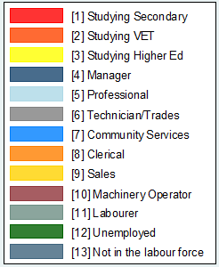 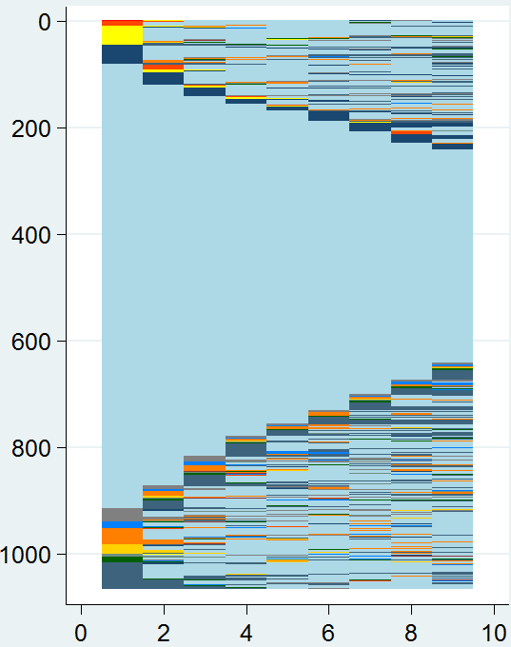

Cluster 4: Trades workers Cluster 6: Higher education graduates

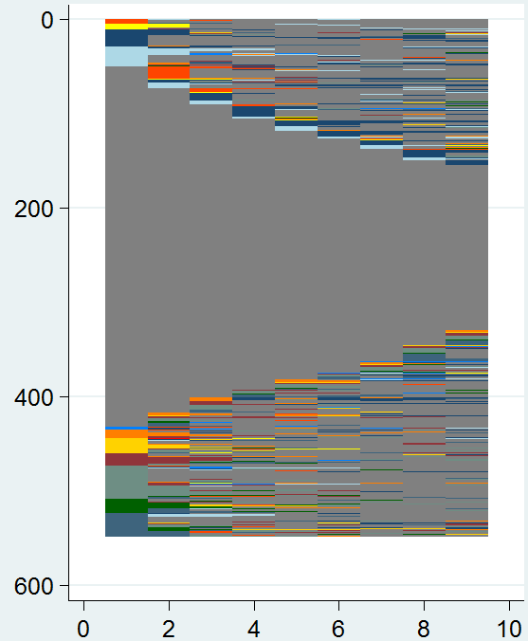 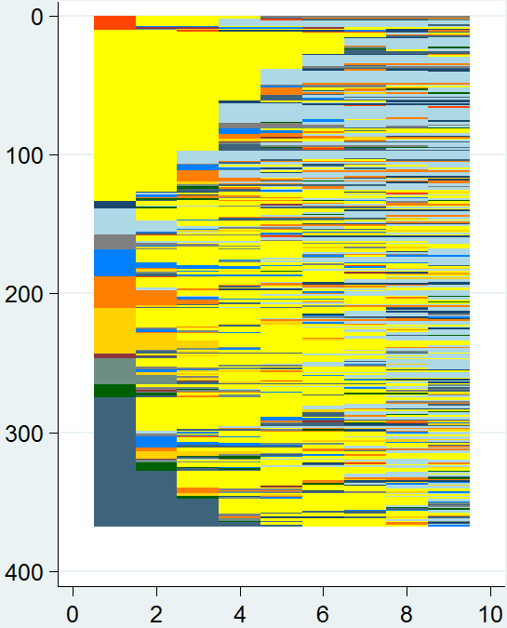

Cluster 9: Managers

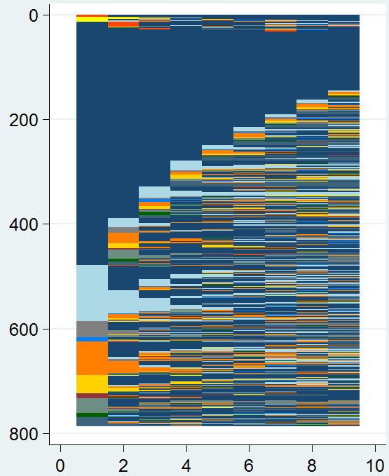

Figure B2 Sequence plots, low-skill trajectories

Cluster 2: Labourers

 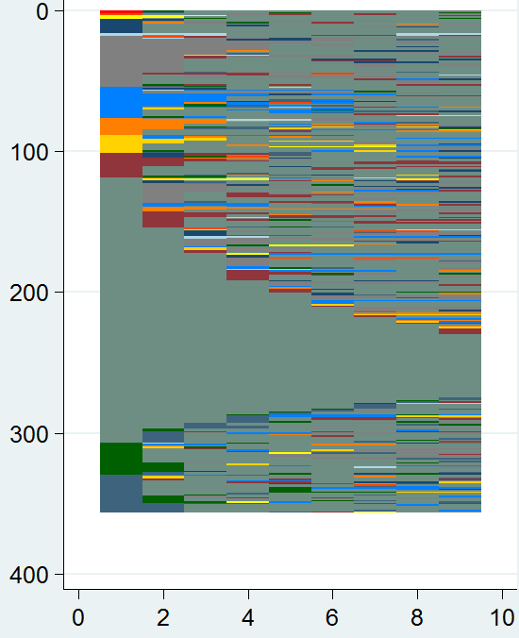

Cluster 3: Machinery operators Cluster 5: Clerical workers

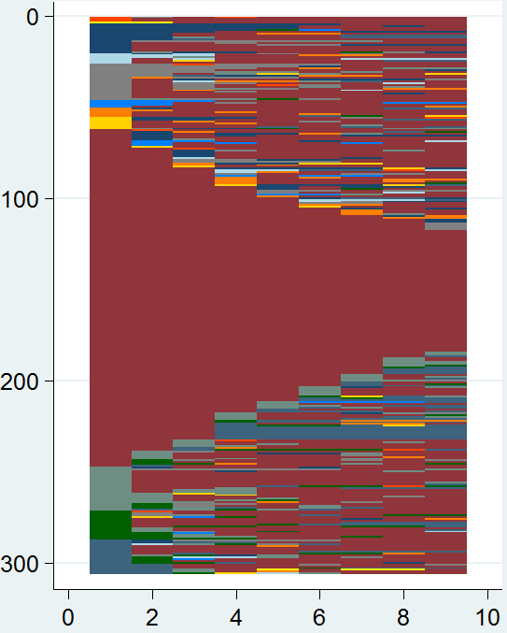 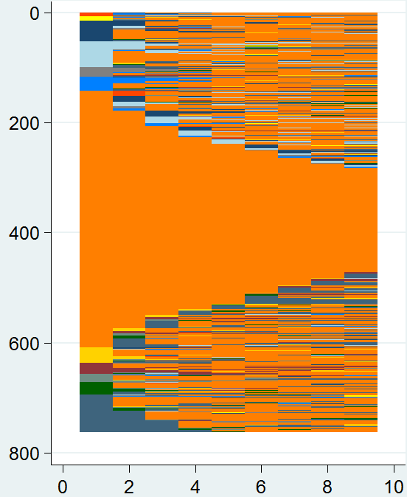

Cluster 7: Sales workers Cluster 8: Community service workers

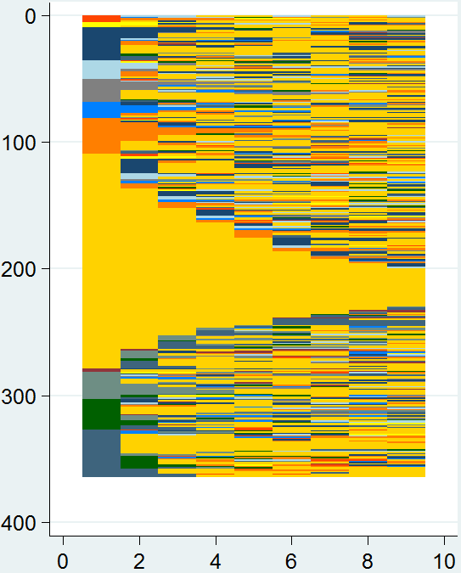 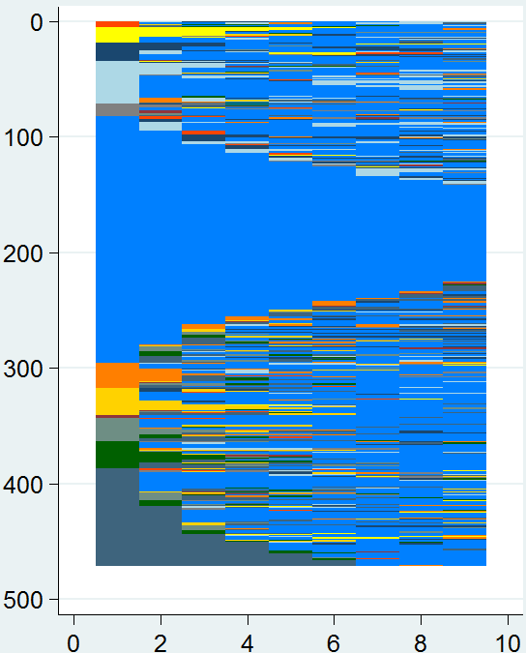

Figure B3 Sequence plot, pathways of marginal attachment

Cluster 10: Not in the labour force

 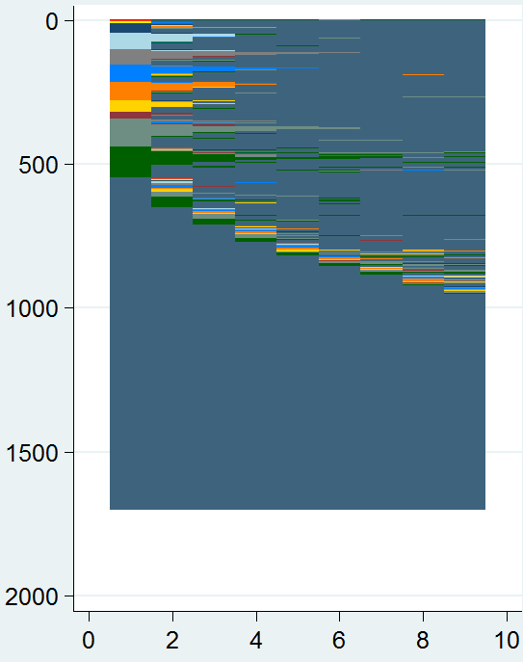

Here each horizontal line represents the trajectory of one individual, colour-coded to reflect different states of study, labour force status and occupation. We can see that, for most of these clusters, the similarity in trajectories was characterised by long episodes in the original state, or occupational group.

# Appendix C

## Additional descriptive tables

Table C1 Prevalence of unchanging states

|  |  |  |  |
| --- | --- | --- | --- |
| Sequence pattern | Frequency | Per cent | Cumulative per cent |
| Not in the labour force (and not studying) – all 9 waves | 749 | 11.1% | 11.1% |
| Employed as professional – all 9 waves | 400 | 5.9% | 17.1% |
| Employed as a clerical/administrative worker – all 9 waves | 188 | 2.8% | 19.9% |
| Employed as a technician/trades worker – all 9 waves | 174 | 2.6% | 22.5% |
| Employed as manager – all 9 waves | 112 | 1.7% | 24.1% |
| Employed as a community/personal services worker – all 9 waves | 84 | 1.2% | 25.4% |
| Employed as a machinery operator – all 9 waves | 67 | 1.0% | 26.4% |
| Employed as a labourer – all 9 waves | 45 | 0.7% | 27.0% |
| Employed as a sales worker – all 9 waves | 30 | 0.4% | 27.5% |
| **Total** | **6726** | **27.5%** |  |

Table C2 Distribution of clusters by gender

|  |  |  |  |  |  |  |  |  |  |  |  |
| --- | --- | --- | --- | --- | --- | --- | --- | --- | --- | --- | --- |
| Gender | N | Cluster | | | | | | | | | |
| Professionals | Labourers | Machinery operators | Technician/ trades  workers | Clerical/ administrative workers | Higher education 🡪 professional | Sales  workers | Community/ personal services workers | Managers | Not in the labour force |
| Male | 3087 | 43.4% | **61.0%** | **94.1%** | **87.8%** | 19.1% | 39.2% | 39.0% | 30.1% | **65.4%** | 32.4% |
| Female | 3639 | 56.6% | 39.0% | 5.9% | 12.2% | **80.9%** | **60.8%** | **61.0%** | **69.9%** | 34.6% | **67.6%** |
| Total | 6726 | 100% | 100% | 100% | 100% | 100% | 100% | 100% | 100% | 100% | 100% |

Table C3 Distribution of time by cluster

|  |  |  |  |  |  |  |  |  |  |  |  |  |  |  |  |
| --- | --- | --- | --- | --- | --- | --- | --- | --- | --- | --- | --- | --- | --- | --- | --- |
| Cluster | N | Proportion of time in … | | | | | | | | | | | | | |
| School | VET  study | Higher education study | Manager | Professional | Technician/ trades | Community services | Admin worker | Sales worker | Machinery operator | Labourer | U/E | NILF | Total |
| 1 Professionals | 1066 | 0.0% | 0.6% | 0.8% | 3.6% | **83.1%** | 1.9% | 0.9% | 2.0% | 0.6% | 0.1% | 0.4% | 0.8% | **4.9%** | 100% |
| 2 Labourers | 356 | 0.1% | 0.5% | 0.6% | 2.2% | 0.8% | **10.0%** | 4.7% | 2.2% | 1.6% | 5.3% | **65.2%** | 2.9% | 3.8% | 100% |
| 3 Machinery operators | 306 | 0.0% | 0.5% | 0.2% | 4.4% | 1.2% | 4.1% | 1.0% | 2.2% | 0.9% | **71.3%** | 5.0% | 2.8% | **6.4%** | 100% |
| 4 Technician/trades workers | 548 | 0.0% | 1.1% | 0.4% | **5.0%** | 2.5% | **78.5%** | 0.5% | 1.5% | 1.1% | 2.1% | 3.2% | 1.3% | 2.6% | 100% |
| 5 Clerical/administrative workers | 761 | 0.0% | 0.5% | 0.4% | 3.2% | 4.6% | 1.5% | 2.0% | **73.1%** | 1.8% | 2.1% | 1.1% | 1.5% | **8.1%** | 100% |
| 6 Higher education 🡪 professional | 367 | 0.0% | 0.8% | **43.2%** | 2.9% | **22.0%** | 2.6% | 3.8% | 6.4% | 4.1% | 0.5% | 2.3% | 1.8% | 9.5% | 100% |
| 7 Sales workers | 364 | 0.0% | 1.3% | 1.1% | 8.6% | 4.4% | 2.9% | 3.1% | **8.5%** | **54.7%** | 1.5% | 4.4% | 3.4% | 6.0% | 100% |
| 8 Community/personal services workers | 471 | 0.0% | 0.8% | 1.6% | 4.5% | 5.2% | 1.4% | **65.7%** | 2.9% | 2.5% | 0.6% | 2.3% | 2.6% | **9.8%** | 100% |
| 9 Managers | 786 | 0.0% | 0.6% | 0.5% | **64.0%** | **11.5%** | 2.3% | 1.0% | 6.8% | 2.6% | 0.7% | 3.2% | 0.9% | 5.9% | 100% |
| 10 Not in the labour force | 1701 | 0.0% | 0.5% | 0.2% | 0.7% | 1.7% | 2.1% | 1.9% | 2.2% | 1.8% | 0.8% | 4.6% | 4.8% | **78.7%** | 100% |

# NVETR Program funding

This work has been produced by NCVER under the National Vocational Education and Training Research (NVETR) Program, which is coordinated and managed by NCVER on behalf of the Australian Government and state and territory governments. Funding is provided through the Department of Industry, Innovation, Science, Research and Tertiary Education.

The NVETR Program is based on priorities approved by ministers with responsibility for vocational education and training. This research aims to improve policy and practice in the VET sector. For further information about the program go to the NCVER website <http://www.ncver.edu.au>. The author/project team was funded to undertake this research via a grant under the NVETR Program. These grants are awarded to organisations through a competitive process, in which NCVER does not participate.

1. ANZSCO = Australian and New Zealand Standard Classification of Occupations. [↑](#footnote-ref-1)
2. An AFS licence is required by those who provide financial product advice, deal in financial products, are market makers in financial products, operate a registered investment scheme, or provide custodial or depository services. [↑](#footnote-ref-2)
3. Other licensing requirements include the Registrable Superannuation Entity (RSE) licence for superannuation fund trustees, which is issued by the Australian Prudential Regulation Authority and focuses on the adequacy of organisational resources and planning; and the credit licence issued by the Australian Securities and Investments Commission to those engaged in credit activity. The credit licence requires credit industry qualifications to the certificate IV level. [↑](#footnote-ref-3)
4. Diploma-level qualifications are required by those who provide advice on more complex ‘Tier 1’ financial products. Certificate III level is required for those advising on the less complex ‘Tier 2’ products. [↑](#footnote-ref-4)
5. These include designations such as Chartered Accountant (CA), Fellow Chartered Financial Practitioner (FChFP), Certified Credit Adviser (CCA) and Chartered Financial Analyst (CFA). [↑](#footnote-ref-5)
6. See for example, the ‘Fabrication Career Pathways’ document produced by South Western Sydney Institute. Details can be found at <http://www.swsi.tafensw.edu.au/files/Career%20Pathway/EMES\_Fabrication%20Pathway%20Flyer.pdf>. [↑](#footnote-ref-6)
7. For example, under the Electrical, Electronic and Communications Contracting Industry Award 2010, a first year apprentice earns $255.04 per week, while a fourth year apprentice earns $522.83. [↑](#footnote-ref-7)
8. Furthermore, not all modern awards contain adult apprenticeship rates. For example, the Electrical, Electronic and Communications Contracting Industry Award 2010 does not contain adult apprenticeship rates. Under clause 12.8, however, apprentices can commence at a later wage point ‘with approval of the apprenticeship authority provided that any credits granted will be counted as part of the apprenticeship for the purpose of wage progression’. [↑](#footnote-ref-8)
9. The University of South Australia, for example, will accept students into the associate degree with at least five years work experience as technicians, or equivalent, and current employment in the industry. [↑](#footnote-ref-9)
10. Endorsements are additional qualifications within a defined field of nursing. For example, endorsements in midwifery can include additional qualifications and training in ‘scheduled medicines’ or ‘supply scheduled medicines specifically for rural and isolated practice’. [↑](#footnote-ref-10)
11. Fair Work Australia is Australia’s national workplace relations tribunal. It is an independent body whose functions include presiding over a safety net of minimum wages and employment conditions. [↑](#footnote-ref-11)