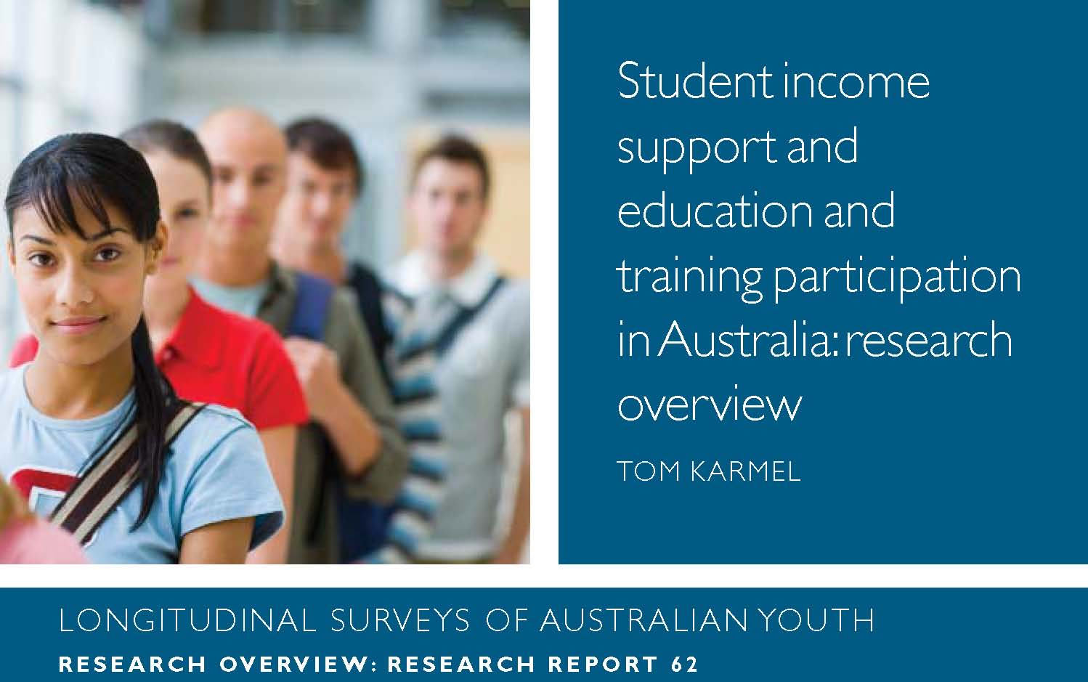

This overview is based on Ryan, C 2013, *Student income support and education and   
training participation in Australia, research report no. 62, NCVER, Adelaide.*

<www.ncver.edu.au/publications/2611.html>.



**Introduction**

Youth Allowance supports young people when they are in full-time school, completing tertiary education (university or vocational education and training [VET] study), are full-time apprentices or trainees, or are looking for work. Income support is paid either to the student’s parents or to the young person depending on their age and circumstances. Using data from the Longitudinal Surveys of Australian Youth (LSAY), Chris Ryan set out to examine the role and impact of Youth Allowance as it operated until 2010. He investigated:

* the impact of Youth Allowance on tertiary education participation
* whether Youth Allowance increases the number of students taking a ‘gap’ year
* whether Youth Allowance improves course completion rates
* the extent to which Youth Allowance alleviates financial stress.

Young people from low-income families, or those supporting themselves while studying full-time, are eligible to receive government assistance in the form of Youth Allowance. But, how does this payment affect their education and training participation? There are many complexities involved in this assessment, as we will discuss.

**Methodology**

Young people from low-income households are generally from low-socioeconomic (SES) backgrounds and broadly speaking, tend not to do as well academically. So by definition it would be expected that young people eligible for Youth Allowance would participate less in tertiary education and training and not do as well academically as their more affluent peers. Thus, to assess the impact of Youth Allowance, Ryan needed to find out how the eligible group would have behaved in its absence.

However, because being eligible for Youth Allowance requires a defining set of characteristics, Ryan struggled to find a group of young people with similar characteristics to act as the control group. Ideally the research would have looked at young people who fall either side of the threshold for Youth Allowance, but this was not possible because the criteria for Youth Allowance are mainly based on family income. Unfortunately, this information was not collected in LSAY datasets used for this analysis. The research is reliant on information provided by respondents on whether or not they receive Youth Allowance and the amount they are paid. It is not known how they qualified for this payment and so Ryan uses other demographic characteristics, such as socioeconomic status, to investigate what the main effects are in regard to the take-up of Youth Allowance.

**Results**

From the LSAY sample, around a quarter of school students and 30% of tertiary students were receiving Youth Allowance. The characteristics of Youth Allowance recipients were as expected: students were from low-socioeconomic status backgrounds. However, interestingly those who were on Youth Allowance post-school had higher SES-related characteristics and higher levels of school achievement.

This suggests that young people who qualify for Youth Allowance through independence criteria may in fact have a different set of defining characteristics, and ‘gap taking’ appears to be a means to qualify for Youth Allowance for some students. Indeed, the modelling suggests that receiving Youth Allowance while in tertiary study is associated with an increase in the probability of taking a gap year of between five and 15%.

To assess the effect of Youth Allowance on education and training participation, several analytical approaches are used. The most satisfactory involves creating a ‘propensity to get Youth Allowance’ variable and controlling for gender and the equivalent national tertiary entrance rank (ENTER).1 When the models are run for the half-sample most likely to receive Youth Allowance, no significant change in university or VET participation is observed.

By contrast, the modelling of course completion (with control variables covering gender, various socioeconomic variables, ENTER and hours worked during the course) provides a clear conclusion that the receipt of Youth Allowance increases course completion rates by between four and ten percentage points. It was also evident that combining part-time work and study decreases university course completion. Perhaps those on Youth Allowance are afforded some protection from having to combine work and study, hence increasing their chances of university course completion.

The final part of the report explores whether Youth Allowance affords some protection against financial hardship and assesses how young people on Youth Allowance view their financial situation. (Young people generally report their financial circumstances to be less favourable than older people, with students in particular falling into this category.)

The research indicates that students on Youth Allowance have a self-perception of faring poorly financially. More Youth Allowance students indicated they ‘often had to borrow money from family or friends to live on’ and rated their financial position less favourably than those not receiving Youth Allowance. These results come from a statistical technique called a fixed-effects model that takes into account individual characteristics by taking advantage of the longitudinal nature of the data and comparing changes over time. The model also controls for a range of living arrangement variables, such as whether students are living with parents and whether they are employed (both leading to less financial stress).Thus, it can be concluded that Youth Allowance is not equalising the financial position of students. Indeed, Ryan’s model suggests that Youth Allowance would have to be increased by $180 per week to remedy the financial position of those on Youth Allowance. However, a rather interesting finding was that, despite self-assessing their financial position as poor, the rating of those on Youth Allowance with regard to their general satisfaction with life was the same as those not on Youth Allowance.

**Conclusion**

One must always be modest about the conclusions that can be drawn from this type of analytical work. The biggest challenges for this study are the lack of a comparison group and the unavailability of family income data. These challenges can be addressed to some extent through sophisticated econometric modelling. The conclusions paint a mixed picture of the impact of Youth Allowance on tertiary education study. Those receiving Youth Allowance are not satisfied with their financial position. On the other hand, there is clear evidence that Youth Allowance has improved course completion rates for those receiving it. Finally, the impact of eligibility rules on the numbers taking a ‘gap’ year point to the importance of careful design — individuals do respond to incentives and will order their affairs to make best use of what is on offer.

1 Now referred to as Australian tertiary admittance rank (ATAR).



**National Centre for Vocational Education Research Ltd**  Level 11, 33 King William Street, Adelaide, SA **M** PO Box 8288,Station Arcade, SA 5000 Australia **T** +61 8 8230 8400 **F** +61 8 8212 3436 **W** www.ncver.edu.au **E** ncver@ncver.edu.au

© Commonwealth of Australia, 2013



With the exception of the Commonwealth Coat of Arms, the Department’s logo, any material protected by a trade mark and where otherwise noted all material presented in this document is provided under a Creative Commons Attribution 3.0 Australia <www.creativecommons.org/licenses/by/3.0/au> licence.

The details of the relevant licence conditions are available on the Creative Commons website (accessible using the links provided) as is the full legal code for the CC BY 3.0 AU licence <www.creativecommons.org/licenses/by/3.0/legalcode>.

The Creative Commons licence conditions do not apply to all logos, graphic design, artwork and photographs. Requests and enquiries concerning other reproduction and rights should be directed to the National Centre for Vocational Education Research (NCVER).

This document should be attributed as Karmel, T 2013, *Student income support and education and training participation in Australia: research overview*, NCVER, Adelaide.

This work has been produced by NCVER through the Longitudinal Surveys of Australian Youth (LSAY) Program on behalf of the Australian Government and state and territory governments, with funding provided through the Australian Department of Education, Employment and Workplace Relations.

COVER IMAGE: GETTY IMAGES/THINKSTOCK

TD/TNC 112.02

