


Skilled migration and the
workforce: An overview

John Saunders

Key messages
- Australia clearly beneﬁts from the movement of skilled workers in and out of the country. In 2004–05 there was a net gain of around 46 000 skilled migrants, two in three of whom were professionals.
- The number of skilled migrants has tripled in the past decade. They now account for close to half of all migrants. Skilled migrants represent a major source of supply for occupations experiencing employment growth, particularly in the professions and the trades.
- Temporary migration has grown substantially and is most evident in the rapid rise in employer-sponsored long-stay (or class 457) visas. This is in response to recent skill shortages, with most 457 visa holders employed in the professions and the trades.
- Migrants constitute 11% of employed people. They are relatively over-represented in the professions (14%) but under-represented in technical and associate professional occupations (10%) and the trades (9%).
- Many skilled migrants experience difﬁculties in ﬁnding employment in their occupational ﬁeld, representing a loss of the potential beneﬁts they bring to a job.

Introduction
Migrants have contributed to Australia’s skill base since the arrival of the First Fleet. This publication is intended to provide a brief overview of migration, with an emphasis on the contribution migration has made to the skills of the workforce.
The ﬁrst section describes the migration program, particularly as it relates to the migration of skilled people. Areas covered include:
- an historical perspective
- the skilled migration program
- temporary migration
- education as a migration mechanism.
The second section focuses on migration’s contribution to the workforce, covering:
- migrants in the workforce
- the ‘brain drain’
- occupational outcomes and the utilisation of qualiﬁcations.

The migration program

An historical perspective
Large-scale migration to Australia began in the years immediately following the Second World War, when Australia actively sought migrants from Europe. The earliest example of a targeted migration program designed to expand and enhance Australia’s skills base was that associated with the Snowy Mountains Hydro-electric Scheme. From 1949 large numbers of post-war migrants were recruited to this project, some as unskilled labour and others with specialised skills in a range of key occupations.
Since that time, but particularly in the last ten years, Australia has continued to use targeted migration programs to expand and enhance the skills base of its workforce. During 2004–05 record numbers of skilled migrants were granted visas, accounting for almost two-thirds of the non-humanitarian migration program (Department of Immigration and Multicultural and Indigenous Affairs 2005c), with Australia encouraging migration from a wide range of countries and regions, increasingly including Asia.
Among the more recent developments in Australian skilled migration policy are provisions to enable working holiday makers, occupational trainee visa holders and overseas students to apply to remain permanently in Australia as skilled migrants—subject to their meeting relevant skilled entrance criteria (Department of Parliamentary Services 2005). Overseas students studying in Australia who graduate after two or more years of full-time study with a diploma or above or a trade qualiﬁcation may also now apply to remain in Australia as skilled migrants. Such migrants are, of course, likely to have a better grasp of English and an enhanced ability to integrate into the Australian workforce.
What do we mean by ‘migrant’?
In an international context the simplest answer is someone who transfers their residence from one country to another. Often, but not always, they do this with a view to improving their quality of life. Migrants enter Australia permanently under a range of programs, the three major ones being family, skilled and humanitarian. To cater for people who are not migrating permanently, there are temporary visas, such as those covering international students and trainees, intra-company transfers and seasonal and holiday workers.
In the context of skilled migration, the subject of this publication, in most cases we will use the deﬁnition of migrant used by the Australian Bureau of Statistics (ABS), which deﬁnes ‘migrants’ as:
People who were born overseas, arrived in Australia after 1984, were aged 15 years and over on arrival, and are permanent Australian residents.
Australian residents who were born overseas but who do not satisfy these conditions are simply referred to as other overseas-born.
The number of migrants in the skilled stream has increased signiﬁcantly in recent years, growing from 34 676 in 1996–97 to 97 336 in 2005–06 (see ﬁgure 1). This represents an increase of 181% over the last decade; that is, the number of skilled migrants has nearly tripled. In the same period, the number of migrants in the Family stream rose only 22% (from 37 176 in 1996–97 to 45 291 in 2005–06) while the other streams, special eligibility (e.g. former Australian residents) and humanitarian (see graph 1: ABS 2006), remained steady.
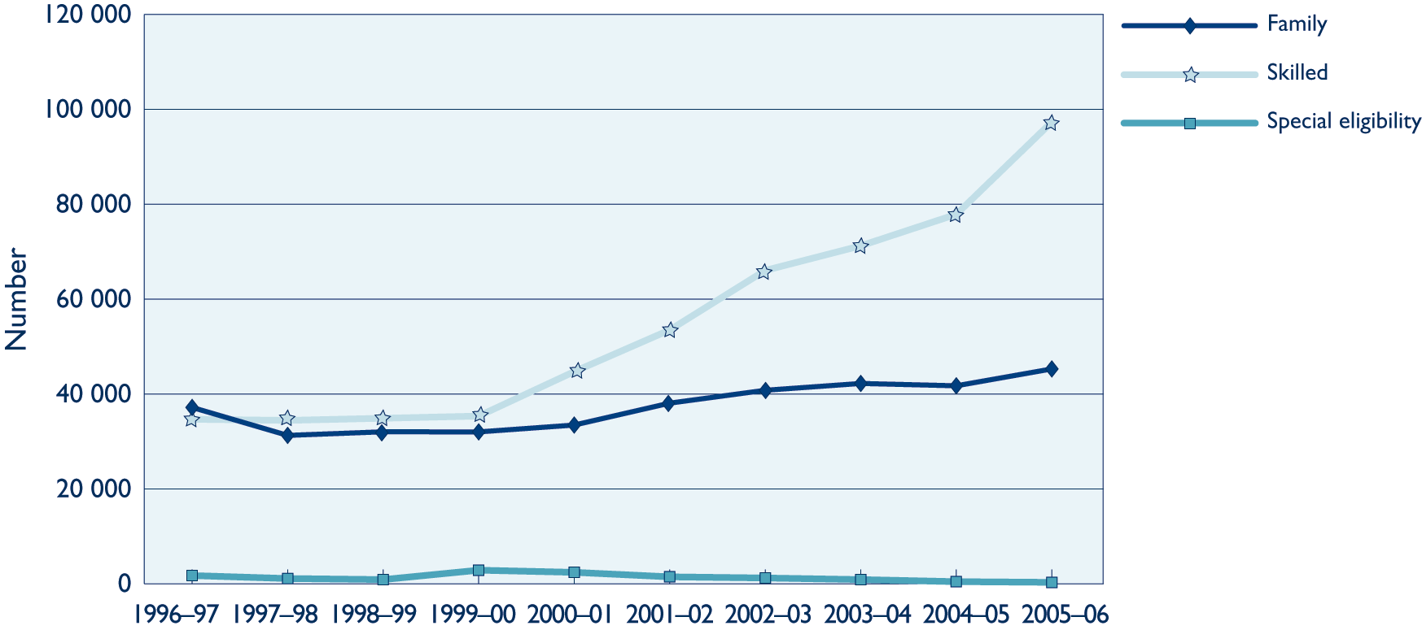
Figure 1 Migration program outcomes
Source: Derived from Department of Immigration and Citizenship (2006, table 1.5).

The skilled migration program
The skilled migration program in Australia comprises a number of component streams. Of these, the skilled—independent stream, through which people directly apply for entry as skilled migrants, has been by far the largest contributor to Australia’s skills base (54.0% of the total skilled migrant arrivals over the ﬁve years from 2001–02 to 2005–06) (Department of Immigration and Multicultural Affairs 2007). Other important contributors over the same period have been: skilled—sponsored, in which the applicant is most often assessed against the general skilled migration points test and receives additional points for sponsorship by an Australian citizen or permanent resident who is a relative (17.7%); employer-nominated, in which an employer who is unable to ﬁll a position from the local workforce nominates a worker from overseas with the requisite skills (15.8%); business-skilled, a program designed to encourage successful business people to settle in Australia and develop new business activities (8.2%); and the state/territory-sponsored migration stream through which the states and territories sponsor migrants with skills in demand (4.1%) (Department of Immigration and Multicultural Affairs 2007). Figure 2 shows the changing trends in these proportions over the period 1997–98 to 2005–06.
Skilled migrants are younger
The age of Australia’s overseas migrant intake is markedly younger than the Australian population as a whole. Of the migrants arriving in Australia between the years 2004 and 2005, nearly half (44.6%) were aged between 15 and 34 years (Department of Immigration and Multicultural and Indigenous Affairs 2005b). This ﬁgure compares with the Australian population at June 2006 where this age group comprised 28% (ABS 2006a). In fact, if we look solely at skilled migrants, the proportion is even higher (58% in 2003–04) (Shah & Burke 2005).
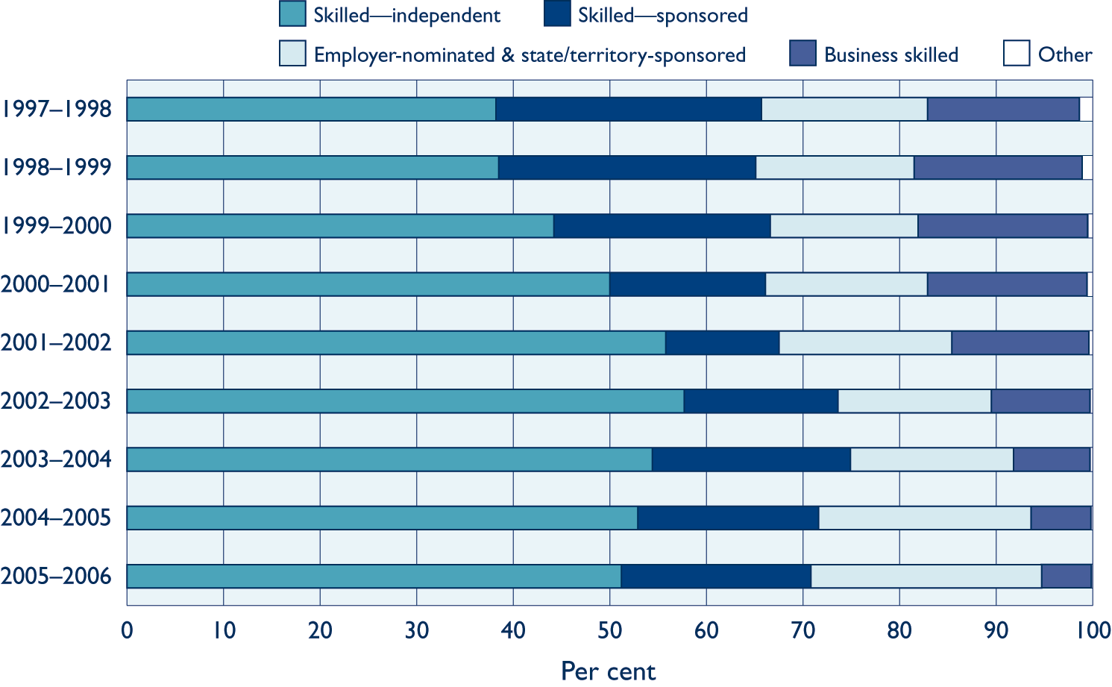
Figure 2 Arrivals by year and skilled migration stream
Source: Derived from Department of Immigration and Multicultural Affairs (2007, ﬁgure 2.3).
If we look at the occupations migrants held before settling in Australia (and therefore the occupational skills they bring into the country), we ﬁnd that, in 2004–05, 61% of people who came to Australia with major skilled occupational backgrounds (that is, managers and administrators, professionals, associate professionals and tradespersons) did so via the ‘skilled migration’ program, compared with 23% via ‘family migration’ and 1% via ‘humanitarian’ migration. A fourth group, ‘non-program plus special eligibility’, which comprised almost entirely New Zealand citizens (who do not require a migration visa), accounted for the remaining 15%. These proportions contrast with those who worked in lower-level occupations. Here family migration accounts for 36%, followed by skilled migration (22%), humanitarian (3%) and non-program plus special eligibility, the remaining 39% (Department of Immigration and Multicultural Affairs 2005b).

Rating skilled migration candidates—the points test
The points test applying to skilled migration programs (as opposed to family and humanitarian programs) is used to determine whether applicants possess the requisite skills and attributes to enable them to settle into Australian society, enter the workforce and contribute to the Australian economy. Entry is dependent on the applicant achieving a minimum points score based on a combination of criteria that may include: skilled work experience; industry demand for the applicant’s occupation; job offers (sponsorship) from employers; willingness to study and work in regional Australia or low population growth metropolitan areas; regional sponsorship offers from the states and territories; possession of Australian qualiﬁcations; age; English language ability; and family relationships. Applicants may also receive bonus points for being able to invest capital in Australia, and possession of Australian work experience and foreign language skills.
Box 1 The points system and how it works
Minimum points scores for visa eligibility
Skilled—Independent (subclasses 175, 885): 120 points | Note: Applicants may apply for visas offshore or onshore.
Skilled—Sponsored—(subclasses 176, 886): 100 points
Skilled—Regional Sponsored (subclasses 475, 487): 100 points
How the points are awarded
Points awarded for mandatory criteria
Occupational skills: (type and level of training and eligibility for any relevant registration) |  | 40, 50 or 60 points
Age: 18–29 years; 30–34 years; 35–39 years; 40–44 years (higher points for lower age) |  | 30; 25; 20; 15 points
English language: (meet threshold for type of visa and/or nominated occupation)  Vocational English, concessional competent English or competent English  Proficient English |  | 15  25 points
Points awarded for optional criteria
Australian educational qualiﬁcations  Degree/diploma/trade qualifications (minimum 2 years)  Masters/Honours with undergraduate degree (minimum 3 years)  Undergraduate degree with honours (minimum 3 years)  Doctorate (minimum 2 years) |  | 5 points  15 points  15 points  15 points
Recent Australian employment: Applicants with appropriate visas who have worked 20 hours per week in paid employment in nominated occupation or closely related skilled occupation in one of the last four years  Completion of professional year in skilled occupation or closely related skilled occupation for 12 months immediately preceding application |  | 10 points  10 points
Specific work experience: If nominated occupation is worth 40, 50 or 60 points and applicant has worked in any occupation on Skilled Occupation List (SOL) for at least three of the last four years immediately preceding application.  If occupation nominated is worth 60 points and applicant has been employed in this occupation or closely related occupation for three of the last four years. |  | 5 points  10 points
Occupation in demand: Employed in nominated or closely related skilled occupation listed on Migrant Occupations in Demand List for 12 of last 48 months and has offer of full-time employment;  Employed in nominated or closely related skilled occupation listed on Migrant Occupations in Demand List for 12 of last 48 months. |  | 20 points  15 points
Bonus points: professional fluency in a designated language other than English |  | 5 points
Regional studies: lived and studied for two years in an Australian regional or low population growth metropolitan area |  | 5 points
State/territory nomination: nominated by state or territory government agency |  | 10 points
Partner skills: if spouse or interdependent partner satisfies requirements for age, recent work experience or qualification/s, nominated occupation, suitable skill assessment and English language competency |  | 5 points
Eligible relative sponsorship: applicant, spouse or interdependent partner is related to an Australian citizen, permanent resident or eligible New Zealand citizen living in a designated area who is willing to sponsor them—only applies to Skilled—Regional Sponsored (subclasses 487 and 475 visa categories).  Applicant, spouse or interdependent partner is related to an Australian citizen, permanent resident or eligible New Zealand citizen living anywhere in Australia. |  | 25 points  No points awarded
Applicants for other visas including Skilled—Recognised Graduate visa and Skilled—Graduate visa (sub-classes 476, 485) are not points tested.  Applicants who are applying for a Skilled—Regional visa (subclass 887) or for a 12-month extension via the Skilled—Regional Sponsored (subclass 487) visa of their provisional visa and who is a holder of a Skilled—Independent Regional, Skill Designated Area—Sponsored visa, or Skilled—Regional Sponsored (subclasses 495, 496, 475, 487) visa are also not points tested. |  | Not points tested
Source: Derived from Department of Immigration and Citizenship 2007.
The points test serves as an effective means of targeting migrants with the particular skills and attributes needed in Australia. For example, points awarded for willingness to settle and work in areas of low population growth help to divert migrants from high density population areas to regional areas in need of their skills. Speciﬁc occupations may be boosted by awarding additional points for occupations listed in a biannually reviewed Migration Occupations in Demand List (MODL). However, experience has shown that care must be exercised in setting the skilled migration criteria to ensure that targeting does not lead to an over-supply of particular skills. Kinnaird (2005) highlights the example of information technology in which migrant student intake in this ﬁeld in 2004 (57% of all commencing information technology students in Australia) swamped the market to the disadvantage of Australian resident graduates—the percentage of graduates looking for full-time work increasing from 19% in 2001 to 30% in 2004. Nevertheless, it is an impressive demonstration of how powerful the application of migration criteria can be as a tool for recruitment of speciﬁc skills.
Migration occupations in demand list (MODL)
In September 2006, the MODL listed a total of 86 occupations comprising one occupation in the managers and administrators occupation group, 43 in the professionals group, one in the associate professionals group, and 41 in the tradespersons group.

Temporary migration
Temporary migration also plays a part in meeting Australia’s skills needs. There are various ways in which people entering Australia under temporary visas can work in Australia. For example, they may take jobs under a working holiday visa, be sponsored by an employer in need of their skills under a business long-stay visa (commonly referred to as a ‘457 visa’) or be granted a business skills visa, which allows them to establish and manage a business in order to qualify for permanent residence.
In 2005–06 a total of 111 973 working holiday visas were granted, a 7.3% increase over 2004–05 (Department of Immigration and Multicultural Affairs 2007). Holders of working holiday visas (subclass 417) are only permitted to work for three months of their stay but, after changes in 2006, holders of working holiday visas are now permitted to apply for a second visa if they work for three months with a primary industry employer in regional Australia. Their contribution to the labour market is less than those on 457 visas. In 2005–06 the number of 457 visas granted was 71 150, a rise of 46.4% compared with the previous year (Phillips 2007). Figure 3 shows comparative numbers of 457 visas from 1997 to 2006.
Figure 3 Number of primary and secondary 457 visas (excluding independent executives) granted, 1997–2006
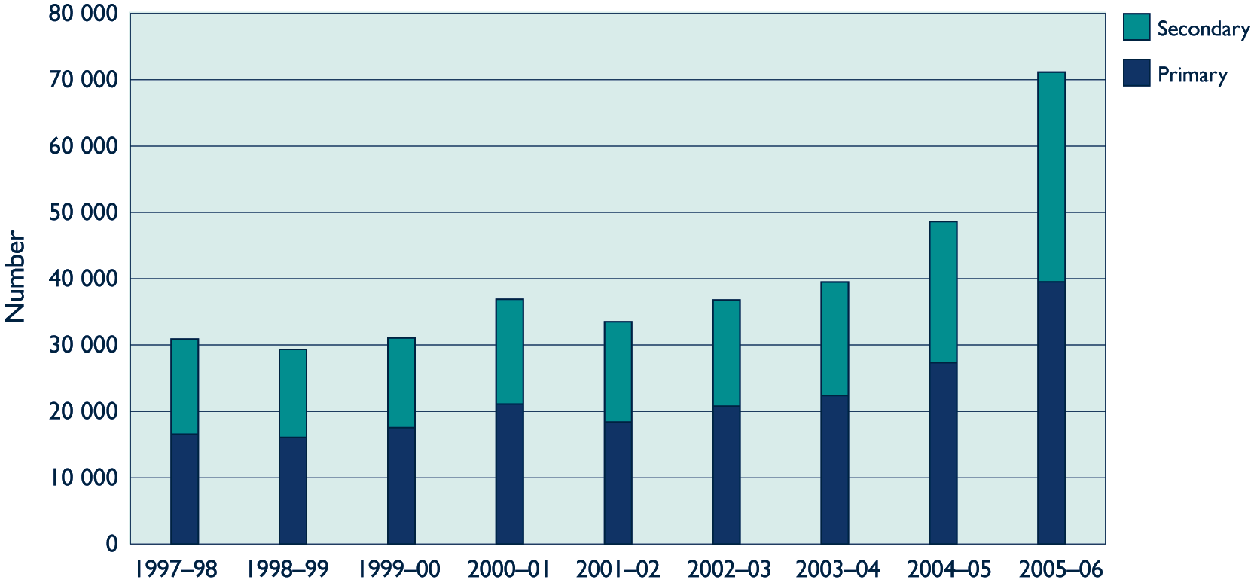
Note: A primary applicant is one who applies for a visa. A secondary applicant migrates by virtue of his/her relationship to the
primary applicant.
Source: Phillips (2007)
In terms of major occupation groups, just over half (54%) of 457 visa holders worked as professionals in 2005–06, followed by tradespersons (21%), managers and administrators (11%), associate professionals (11%) and ‘other’ (3%) (Department of Immigration and Multicultural Affairs 2007). Analysis of primary 457 visa grants by industry sector shows that the largest proportions worked in health and community services (14.4%), property and business services (12.4%), manufacturing (10.1%), construction (8.8%) and communication services (8.3%). Figure 4 shows the numbers for all sectors.
Essentially driven by employer demand, the 457 visa is the main temporary visa used for entry by employer-sponsored skilled people. There is no limit to the number of 457 visas issued each year, nor are they restricted to ﬁelds in which shortages exist—employers are free to sponsor skilled migrants in any ﬁeld they choose. Temporary 457 visas are nominally granted for a period of four years.
Figure 4 Primary grants for 457 visas by industry sector 2005–06
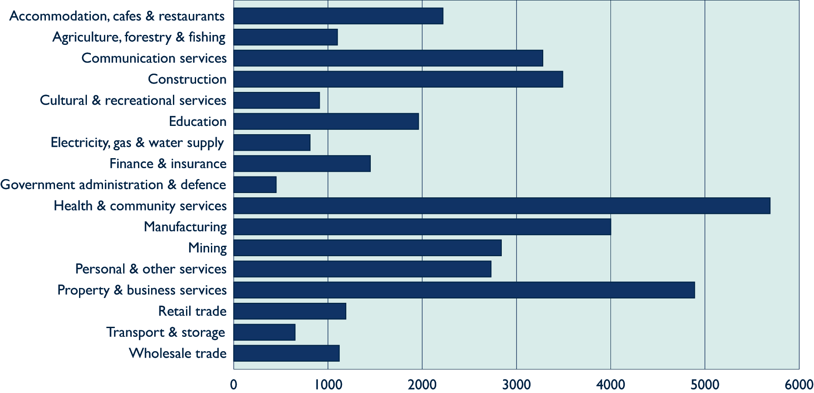
Source: Derived from Phillips (2007).

Education as a migration mechanism
In recent years Australia has taken steps to link its highly developed and comprehensive international student market to skilled migration programs to facilitate the entry of migrants who have gained Australian qualiﬁcations (either in Australia or off-shore). For example, overseas students who complete an Australian degree, diploma or trade qualiﬁcation through an Australian institution may be awarded an additional ﬁve migration eligibility points, and former full-fee-paying overseas student graduates no longer have to leave Australia before becoming eligible to apply for permanent residency (Birrell et al. 2001, cited in Ziguras & Law 2006). These strategies are helping to increase the number of migrants accepted who are already acquainted with Australia’s industry conventions and skill-formation processes—particularly important qualities for migrants from non-English speaking countries.

Migrants and the workforce

Migrants in the workforce
ABS (2006b) statistics tell us that, of the 10.4 million people in the Australian labour force in 2004–05, 2.6 million or about one-quarter were born overseas.
Looking speciﬁcally at migrants, as deﬁned by the ABS, and excluding ‘other overseas-born’ (see What do we mean by ‘migrant’?, p.2), we ﬁnd that they constituted 11% of the employed population in Australia in 2004 (unpublished ABS data prepared for NCVER). In some occupational classiﬁcations the proportion was higher than this, notably professionals (14 %), labourers and related workers (14%) and intermediate production and transport workers (12%). All of the other occupational classiﬁcations, with the exception of managers and administrators (11%), fall below the average, elementary clerical, sales and service workers and advanced clerical and service workers being especially low, at around 8%. The associate professionals and tradespersons classiﬁcations fell slightly below the average at around 10% and 9%, respectively. Figure 5 depicts these proportions in terms of numbers of people.
Figure 5 Persons in employment by occupation and migrant status, 2004 (’000)
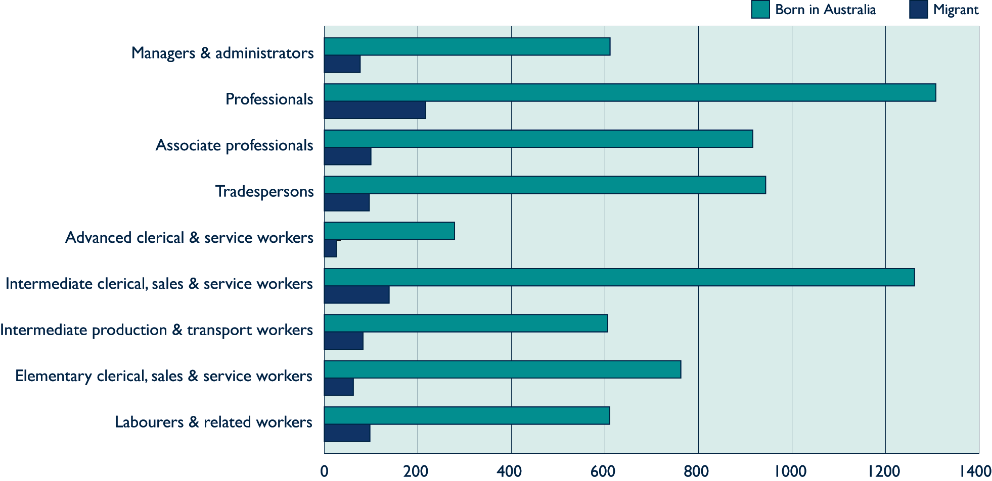
Source: Unpublished data prepared for the National Centre for Vocational Education Research (NCVER) by ABS.
Using the same data (that is, excluding other overseas-born) and looking in more detail at the proportions of migrants in the associate professionals classiﬁcation, for which the average proportion was 9.8%, we ﬁnd that there were above-average proportions of migrants in the health and welfare professions (15.0%) and managing supervisor professions (11.7%). In the case of the tradespersons classiﬁcation (for which the average proportion was 9.2%), proportions were notably higher than average in the food trades (17.5%) and lower than average in the skilled agricultural and horticultural occupations (6.8%) and automotive trades (8.0%). Figure 6 depicts these relationships in terms of numbers of people.
Figure 6 Associate professionals and tradespersons in full-time or part-time employment by migrant status (’000)
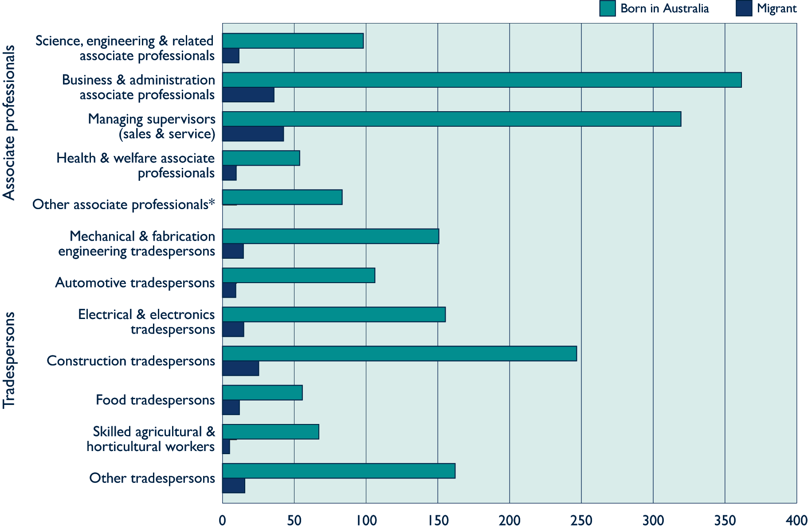
Note: * Migrant number for this category was very small.
Source: Unpublished data prepared for NCVER by ABS.
In the eight years to 2005, the number of people employed in the four major skilled occupational categories (that is, managers and administrators, professionals, associate professionals, and tradespersons) increased by more than 1.1 million. Over a similar period, the net number of migrants to Australia with occupational skills in these categories totalled just over 263 710. In relative terms therefore the net gain in skilled migrants was equivalent to nearly a quarter (24%) of the new jobs created (ABS 2007a). Clearly, skilled migrants represent a signiﬁcant source of supply for skilled labour. Breaking this ﬁgure down by occupation (ﬁgure 7) shows that for managers and administrators the proportion is 32%, for professionals 33%, for associate professionals 6%, and for tradespersons 30%. However, it should be noted that there is no guarantee that skilled migrants will necessarily be employed in their stated occupation.
Figure 7 Net migrant inﬂow by occupation as proportion of employment growth in occupation, 2000–01 to 2004–05
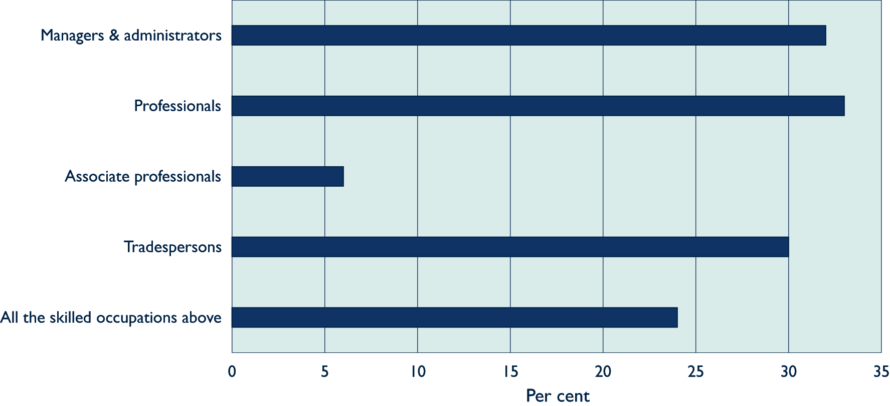
Source: Derived from ABS (2007a).

The ‘brain drain’
So far this discussion has focused on the skilled people who come to Australia as immigrants. Of course, there are also skilled people who leave Australia. The Department of Immigration and Multicultural Affairs publishes statistics that enable calculation of the net change resulting from the movement of skilled workers into and out of Australia.
Figure 8 Net inﬂow of skilled migrants, by stated occupation, 1995–96 to 2004–05
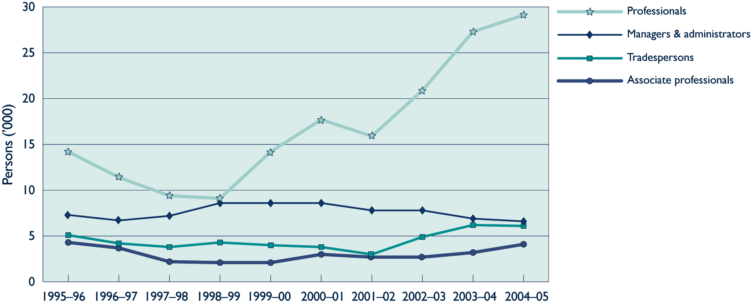
Source: Derived from Birrell, Rapson and Smith (2006, table 1).
Overall, movements of people into and out of Australia result in a net gain in people with ‘skilled’ occupations. The net gain in people with skilled occupations in 2004–05 was 45 857, a ﬁgure considerably higher than it was ﬁve to ten years earlier when it averaged around 26 500. Figure 8 shows that by far the largest contributor to these net gains over these years has been the professional group. In 2004–05 it contributed 63.4% to the net inﬂow of migrants with skilled occupations. Corresponding proportions in that year for the other skilled occupation groups were: managers and administrators 14.4%; tradespersons 13.3%; and associate professionals 8.9% (Birrell, Rapson & Smith 2006).

Occupational outcomes and utilisation of qualiﬁcations
What happens to our skilled migrants after they arrive? Firstly, we know they participate quite successfully in the Australian labour market. ABS statistics (ABS 2004) tell us that migrants, generally, have a slightly higher labour market participation rate than Australian-born people (70% compared with 67%). However, the rate for skilled migrants is considerably higher at 82%.
In a review of results from the Longitudinal Survey of Immigrants to Australia (LSIA), Shah and Burke (2005) describe the labour market experiences of migrants and highlight some of the difﬁculties migrants face in securing a job, particularly one which matches their qualiﬁcations and training. They note that, while about three-quarters of permanent migrants to Australia over a one-year period from September 1999 had a job in the 12 months prior to migration, only a little over half had found a job in Australia within six months of arrival, this proportion increasing to about 60% over a further 12 months. Analysis by occupational proﬁles before and after migration (ﬁgure 9) suggests there is also considerable downward movement in occupational status as a consequence of migration, with many higher-qualiﬁed migrants unable to ﬁnd jobs that match their skills and resulting in their having to resort to lower-level jobs. For example, while 62% of pre-migration jobs were as managers and administrators, professionals or associate professionals, only 41% of post-migration jobs were in these categories. By contrast, only 2% of pre-migration jobs were as labourers, but the post-migration proportion was 15%. Interestingly, the comparative proportions for tradespersons stayed relatively constant at around 12%.
Figure 9 Comparison of occupational distributions prior to and following migration to Australia
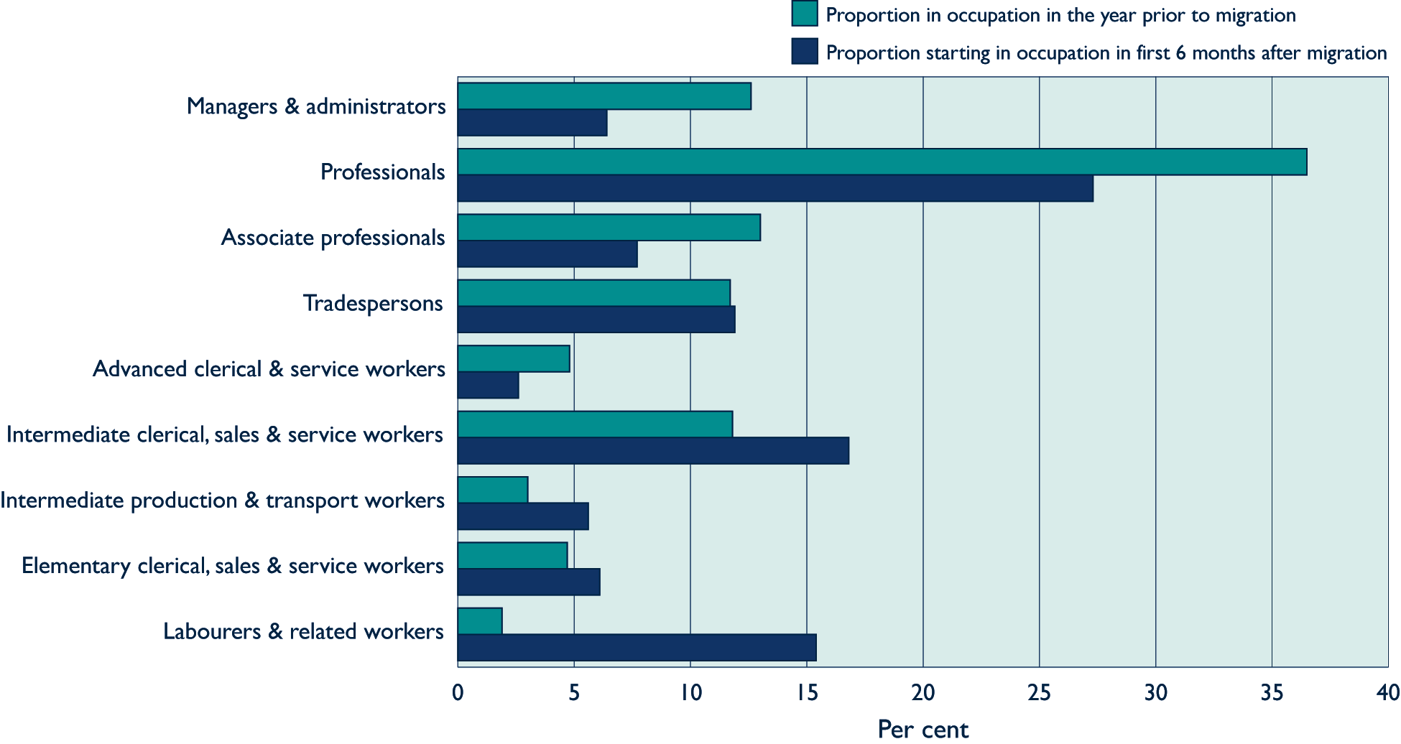
Source: Based on Shah and Burke (2005, tables 16 and 18).
The preceding discussion makes it clear that some skills beneﬁts are being lost. Why? Reasons are likely to be that some migrants lack either everyday English skills or more specialised technical English skills speciﬁc to their occupation. Furthermore, the occupational conventions and health and safety requirements of their home country may differ signiﬁcantly from those of Australia. All of these factors can contribute to making them a less attractive proposition to an employer and may impede their ability to meet registration requirements in some trades. It is recognised that some migrants do not seek to have their skills recognised in Australia. While some state they do not need to, others may be unaware of the beneﬁts of pursuing this option or lack the contacts and resources to do so. Of course, it is also likely that a few may be opting not to take equivalent jobs available to them because they have different aspirations.
English language ability clearly plays a part in the extent to which the skills of migrants are utilised. Migrants from non-English speaking countries are nearly twice as likely as those from mainly English speaking countries to be unemployed, the comparative rates being 7% and 4%, respectively (ABS 2004), highlighting the additional difﬁculty that migrants from non-English speaking countries initially experience. For more recent migrants (arriving 2001 to 2005) the differences are even more pronounced (participation rates: non-English speaking: 57%; mainly English speaking: 78%; and unemployment: non-English speaking: 12%; mainly English speaking: 6%) (ABS 2007b).
Recognition of qualiﬁcations
The ease by which migrants are absorbed into the labour market will be affected by the extent to which their qualiﬁcations are recognised. Recognition can occur at two levels—‘ofﬁcial recognition’ and ‘recognition by employers’. Ofﬁcial recognition is needed for a small number of licensed occupations, but is not needed for most occupations. Rather, the skills of migrants need to be recognised by employers by giving migrants jobs. Data from the Longitudinal Survey of Immigrants over a 12-month period from September 1999 (Shah & Burke 2005) show that only 41% of people applied for recognition of their overseas qualiﬁcations—those with trade qualiﬁcations being most likely to do so (57%)—followed by those with higher education (42%) and then diplomas/certiﬁcates (33%). Despite these variations in rates of application, the data show that more than 96% of those who do apply for recognition are successful, regardless of the level of their qualiﬁcation. A study by Richardson et al. (2004) shows that, for migrants generally, the National Ofﬁce of Overseas Skills Recognition was most often cited as the agency through which recognition was obtained and that, where migrants did not seek recognition, by far the most common reason was that assessment was not needed.
ABS data for all migrants arriving over a 20-year period from 1985 to 2004 show that, overall, 60% of migrants were successful in having their highest overseas qualiﬁcation recognised in Australia, while 28% were unsuccessful. (The remainder were unable to say, or in the case of a relatively small number, had obtained their qualiﬁcation in Australia before being granted permanent migrant status.) Not surprisingly, migrants born in non-English speaking countries were not as successful in having their qualiﬁcations recognised as those from mainly English speaking countries (non-English speaking countries: 32% unsuccessful; mainly English speaking countries: 22% unsuccessful). However, as noted earlier, ‘ofﬁcial recognition’ does not guarantee a job commensurate with the qualiﬁcation.
Other important differences have also been identiﬁed. A 2004 ABS survey (quoted in Department of Immigration and Multicultural and Indigenous Affairs 2005a) has shown that, of the migrants from mainly English speaking countries arriving between 2000 and 2004, 66% who were employed as managers and administrators, professionals and associate professionals in their former countries before arrival in Australia were employed in similar occupations in Australia in 2004. A similar situation applies to 57% of tradespersons. However, corresponding proportions for migrants from non-English-speaking countries were much lower at 40% and 26%, respectively.

References
ABS (Australian Bureau of Statistics) 2004, Labour force status and other characteristics of migrants, Australia, cat.no.6250.0, released 17 June 2005, ABS, Canberra.
——2006a, Australian Labour Market Statistics, Jan 2006, cat.no.6105.0, ABS, Canberra.
——2006b, Population projections: Australia, cat.no.3222.0, released 14 June 2006, ABS, Canberra.
——2006c, Year book Australia, cat.no.1301.0, ABS, Canberra.
ABS 2007a, Labour force, Australia, detailed, quarterly, February 2007, E07 Aug 96 (cat. no.6291.0.55.003), ABS, Canberra.
——2007b, Labour force status by sex, country of birth (main English speaking, other), year of arrival, state, cat.no. 6291.0.55.001 LM7, ABS, Canberra.
Birrell, B, Rapson, V & Smith, TF 2006, Australia’s net gains from international skilled movement, Centre for Population and Urban Research, viewed 18 September 2006, <www.immi.gov.au/media/publications/ pdf/aus_net_gais_int_kills_mnt_2004_05_.pdf>.
Department of Immigration and Citizenship 2007, Changes to the General Skilled Migration Programme, DIAC, viewed 20 February 2008, <http://www.immi.gov.au/skilled/general-skilled-migration/changes/index.htm>.
Department of Immigration and Multicultural Affairs 2007, Population ﬂows: Immigration aspects, January 2007, DIMA, Canberra, viewed 2 March 2007, <http://www.immi.gov.au/media/publications/statistics/ popﬂows2005-6/index.htm>.
Department of Immigration and Multicultural and Indigenous Affairs 2005a, Economic impacts of migration and population growth, submission to the Productivity Commission study into the impact of population growth and migration on productivity and economic growth in the Australian economy, DIMIA, Canberra, viewed 3 July 2006, <http://www.pc.gov.au/study/migrationandpopulation/subs/sub022.pdf>.
——2005b, Immigration update 2004–2005, release date: December 2005, DIMIA, Canberra, viewed 13 October 2006, <http://www.immi.gov.au/media/publications/statistics/immigration-update/ update_june05.pdf>.
——2005c, Population ﬂows: Immigration aspects 2004–05 edition, Chapter 2—The Migration and Humanitarian Programs, DIMIA, Canberra, viewed 17 July 2006, <http://www.immi.gov.au/media/publications/ statistics/popﬂows2004-5/ch2pt1.pdf>.
Department of Parliamentary Services, Australia’s migration program: Research note, 10 May 2005, no.48, 2004–05, Parliament of Australia, Canberra.
Kinnaird, R 2005, ‘The impact of the skilled migration program on domestic opportunity in information technology’, People and Place, vol.13, no.4, pp.67–79.
Phillips, J 2007, Temporary (long stay) business visas: Subclass 457: Research note no.15, 2006–07, Social Policy Section, Parliamentary Library of Australia, Canberra, viewed 6 March 2007, <http://www.aph.gov.au/ library/pubs/RN/2006-07/07rn15.htm>.
Richardson, S, Healy, J, Stack, S, Ilsey, D, Lester, L, & Horrocks, J 2004, The changing labour force experience of new migrants: Inter-wave comparisons for cohort 1 and 2 of the LSIA, National Institute of Labour Studies, Flinders University, Bedford Park, viewed 23 August 2006, <http://www.immi.gov.au/media/publications/ pdf/labour-forcev2.pdf#search=%22%20%22The%20Changing%20Labour%20Force%22%22>.
Shah, C & Burke, G 2005, Skilled migration: Australia, working paper no.63, December 2005, Centre for the Economics of Education and Training, Monash University, viewed 5 June 2006, <http://www.education.monash.edu.au/centres/ceet/docs/workingpapers/wp63dec05shah.pdf>.
Ziguras, C & Law, S-F 2006, ‘Recruiting international students as skilled migrants: The global skills race as viewed from Australia and Malaysia’, Globalisation, Societies and Education, vol.4, no.1, March 2006, pp.59–76.

© National Centre for Vocational Education Research, 2008  This work has been produced and published by the National Centre for Vocational Education Research (NCVER). Apart from any use permitted under the Copyright Act 1968, no part of this publication may be reproduced by any process without written permission. Requests should be made to NCVER.  The National Centre for Vocational Education Research is an independent body responsible for collecting, managing and analysing, evaluating and communicating research and statistics about vocational education and training (VET).  NCVER’s inhouse research and evaluation program undertakes projects which are strategic to the VET sector. These projects are developed and conducted by NCVER’s research staff and are funded by NCVER. This research aims to improve policy and practice in the VET sector. | ISBN 978 1 921170 94 2 print edition  978 1 921170 05 8 web edition  TD/TNC 91.19  Published by NCVER  ABN 87 007 967 311  Level 11, 33 King William Street, Adelaide SA 5000  PO Box 8288 Station Arcade, Adelaide SA 5000, Australia  ph +61 8 8230 8400 fax +61 8 8212 3436  email ncver@ncver.edu.au  <http://www.ncver.edu.au>

