TECHNICAL REPORT

The role of VET in alcohol and other drugs workforce development: survey technical report

Ken Pidd, Amanda Carne, Ann Roche

This document was produced by the authors based on their research for the report The role of VET in alcohol and other drugs workforce development, and is an added resource for further information. The report is available on NCVER’s website: <http://www.ncver.edu.au>

The views and opinions expressed in this document are those of the author(s) and do not necessarily reflect the views of the Australian Government, state and territory governments or NCVER. Any errors and omissions are the responsibility of the author(s).
© Commonwealth of Australia, 2010
This work has been produced by the National Centre for Vocational Education Research (NCVER) on behalf of the Australian Government and state and territory governments with funding provided through the Australian Department of Education, Science and Training. Apart from any use permitted under the Copyright Act 1968, no part of this publication may be reproduced by any process without written permission. Requests should be made to NCVER.

Contents

Survey Technical Report 3
Introduction 3
Scope 3
Survey methodology 4
Questionnaire design 7
Data quality 9
Recommendations 11
References 12
Appendix A 13
Online Survey 13
Appendix B 31
Cover letter 31
Appendix C 32
ADCA update – email letter 32
Appendix D 33
Listserver letter 33
Appendix E 34
Direct mail letter to Peak Bodies and NGOs 34
Appendix F 35
Online Survey response statistics 35

Survey technical report

Introduction

Background
To examine the effectiveness of vocational education and training qualifications as a workforce development strategy in the community services and health industries, a case study was undertaken of the alcohol and other drug sector.
The project comprised of two parts.
- An online survey to gain an understanding of employer’s perceptions of and levels of satisfaction with alcohol and other drug qualifications and training provided by the vocational education and training sector;
- Secondary analysis of National Vocational Education and Training Provider Collection Data and the Higher Education Student Statistics Collection Data to identify the demographic profile of students who have undertaken the Certificate IV in Alcohol and Other Drug Work, the Diploma in Alcohol and Other Drug Work, and other alcohol and other drug-related graduate and postgraduate studies.
This Technical Report concerns the development and conduct of the online survey only.

Scope
To determine employers’ levels of satisfaction with and opinions of vocational education and training qualifications as a workforce development strategy, an online survey was conducted of alcohol and other drug treatment agency managers. The specific research questions addressed by this online survey were:
- What are employers’ attitudes toward and levels of satisfaction with vocational education and training qualifications in alcohol and other drug work?
- What are employers’ opinions regarding vocational education and training qualifications in alcohol and other drug work as a minimum qualification for working in the alcohol and other drug sector?

Survey methodology
To examine these research questions, a specially designed online survey was undertaken. While data concerning employer satisfaction with vocational education and training and higher education training exists, national survey sample sizes are relatively small and it is unlikely that data sufficient from sufficient numbers of alcohol and other drug workforce employers would be available.
The focus of the survey questions were on employers’ satisfaction with vocational education and training for meeting alcohol and other drug workforce development needs and their perceptions of the adequacy of certificate IV level training as a minimum alcohol and other drug qualification level.
The survey was accessed, completed and submitted online via SurveyMonkey™ (http://www.surveymonkey.com/home.asp). The survey sample included alcohol and other drug specialist treatment agency managers from government, non-government, private and community owned treatment agencies from urban and rural areas in each state and territory across Australia.
The survey took no longer than 20 minutes to complete and participation was voluntary.

Survey pilot
Before commencing the survey, the survey tool was scrutinized by a panel of independent experts in the alcohol and other drug field during September-October 2009. Piloting to assess the appropriateness and suitability of the survey for the project was conducted with a sample of eight experts with agency management experience. Feedback provided by these experts was used to improve question clarity.

Sampling frame
The sampling frame of specialist alcohol and other drug treatment agencies for this project was based on the 2006 version of the Clients of Treatment Service Agencies Database (Shand & Mattick, 2001). This database is set up for the purposes of collecting information from Australian treatment service providers. Using email contact details provided by this database, agency managers were contacted and invited to participate. Additional email addresses were obtained from other National Centre for Education and Training on Addiction datasets. These were collated into one refined contact email addresses list. The survey sampling frame included alcohol and other drug specialist treatment agency managers from government, non-government, private and community agencies from urban and rural areas in each state and territory across Australia.
Further to this, direct mail to the executives of the government and non-government peak bodies supplemented the survey recruitment strategy. The direct mail asked these executives to circulate the request for participation in the survey to the relevant alcohol and other drug specialist treatment agency managers within their organisation. This contact was followed up by a phone call and an email to further explain the letter request and impress upon them the significance of participation in the research.
The survey was online and open for participation by treatment agency managers between 19th January and 31st March 2010.

Ethics approval
Permissions have been sought and granted from the funding body, the National Centre for Vocational Education Research and the Australian Bureau of Statistics Statistical Clearing House as to the survey’s content and appropriateness.
The research project was approved by the Flinders University Social and Behavioural Ethics Committee (Project number 4683), and by the Australian Government Statistical Clearing House (Approval Number 02067-01).

Sample design
To ensure that an acceptable response rate was achieved further invitations to participate were provided via email fortnightly through the Alcohol and other Drugs Council of Australia national listserve – UPDATE.
Participation was voluntary and those that elected to participate showed their consent by going online and completing the survey. Participants were able to withdraw at any time, and the survey allowed individuals the option to not answer a question or to stop at any time if desired.
Responses were not required to be weighted.

Response rates
The alcohol and other drug treatment agency databases yielded 454 email addresses. After the first recruitment email a considerable number of email addresses were invalid or not contactable and bounced-back resulting in a more refined smaller contact list in the second round of emailing (n=319). At this point, direct email and phone contact was made with 16 alcohol and other drug peak bodies to enhance participation in the survey. A follow-up phone call was made to those states/territories that were considered under-represented nearing the close of the survey period.
Two cases were deleted as they had no data, resulting in a total of 186 survey responses received resulting in a response rate of 58% (Table 1).
Table 1 Survey response rate
 | Numbers (n)
COTSA database and alcohol and other drug agency lists emails | 454
Minus non-contactable (email bounce backs) | -135
Second round of emails sent, including direct contact to alcohol and other drug peak bodies and NGOs | 319
Number of survey responses | 188
Minus 2 cases removed that held no data | -2
Total survey responses | 186
Response rate | 58%

The number of alcohol and other drug agencies by state/territory and type was established by asking two questions that could have multiple selections (Table 2).

Table 2 Agency location and type questions response rates
Question | No. of responses (n) | Response rate (%)
In what state/territory is the agency you manage? (select all that apply) | 182 | 97.8
Please indicate all the geographic locations where the agency you manage operates. (select all that apply) | 183 | 98.4
The resulting number of alcohol and other drug agencies represented by the survey by state/territory and type are listed below (Table 3).
Table 3 alcohol and other drug agency type and state/territory location
Agency location & type  n (%) | Government | Non-government (“Not for profit”) | Private | Other | Total
ACT | 2 (1.1) | 7 (3.7) | - | - | 9 (4.8)
NSW | 31 (16.5) | 19 (10.1) | 1 (0.5) | - | 51 (27.1)
NT | 6 (3.2) | 1 (0.5) | - | - | 7 (3.7)
VIC | 2 (1.1) | 27 (14.4) | 3 (1.6) | - | 32 (17.0)
QLD | 12 (6.4) | 13 (6.9) | - | - | 25 (13.3)
SA | 9 (4.8) | 25 (13.3) | 2 (1.1) | 2 (1.1)¹ | 38 (20.2)
TAS | 1 (0.5) | 8 (4.3) | - | - | 9 (4.8)
WA | 5 (2.7) | 12 (6.4) | - | - | 17 (9.0)
Total | 68 (36.2) | 112 (59.6) | 6 (3.2) | 2 (1.1) | 188 (100) ²
¹ Other = Peak bodies (n=2)
² The total number of agency types per State/Territory is greater than the number of respondents as some managers oversee more than one treatment agency.

Non-response bias
Non-response bias may be evident when:
- a substantial proportion of respondents did not answer specific questions in the survey, or
- a substantial proportion of the population of interest decline to participate in the survey.
Due to the majority of questions being forced choice and a number being opened ended, a range of questions were not answered by respondents. The most problematic of these was Question 30 which asked about satisfaction levels with vocational education and training (58.1% response rate). Non response bias cannot be ruled out for this question.
The overall response rate for the survey was 58%, thus non response bias also cannot be ruled out in general. However comparison of demographic details provided in this survey indicated similar data to previous national surveys of alcohol and other drug agency managers (Duraisingam, et al., 2007; Roche & Pidd, 2010: Wolinski, et al., 2003).

Weighting
The focus of the survey was on a census of alcohol and other drug treatment agency managers, and therefore no weighting estimates were required of the data in this project.

Questionnaire design

Survey instrument
The survey instrument comprised 33 questions (incorporating both open-ended questions and Likert-scale type questions) (Table 4) and was designed to take less than twenty (20) minutes of the managers’ time to complete.
Assurances of anonymity and confidentiality were stated in the cover letter, email, and on the introduction page of the survey. The survey did not request individual alcohol and other drug agencies to give their names or contact details that may identify them to the researchers, and there is no method to connect the initial contact email requesting participation in the project to the returned survey.
The focus of the survey questions included employers’ satisfaction with vocational education and training for meeting alcohol and other drug workforce development needs and their perceptions of the adequacy of certificate IV level training as a minimum alcohol and other drug qualification.
The survey also identified employers' views on how vocational education and training could be improved and their opinions on suitable minimum alcohol and other drug qualification levels.
Table 4 Survey questionnaire design
Theme |  | Question number | Question type | Page no.
 | Introduction page |  |  | p. 1
Demographics | Gender, age | Q1 and Q2 | Closed and numerical | p. 2
Current role of manager | Main work role, time in alcohol and other drug field, highest formal qualification, and alcohol and other drug qualification | Q3 to Q7 | Closed and open | pp. 3-4
Agency demographics | Type of agency/ies: location, type, main services, staff | Q8 to Q12 | Closed, numerical, and open | pp. 5-6
alcohol and other drug specialist workforce employed | Opinion and statistics regarding alcohol and other drug staff and qualification levels | Q13 to Q24 | Likert, numerical and open | pp. 7-10
Worker qualifications | Qualifications of alcohol and other drug workers | Q25 and Q26 | Closed and open | p. 11
Preferences | Ranking of preferred minimum alcohol and other drug qualification for alcohol and other drug workers | Q27 and Q28 | Closed and open | pp.12-13
Barriers | Barriers to employing | Q29 | Closed and open | p.14
Satisfaction | Satisfaction with quality of vocational education and training qualifications | Q30 and Q31 | Closed and open | pp. 15-16
Other skills | Other skills of alcohol and other drug workforce | Q32 | Closed and open | p. 17
 | Final comments | Q33 | Open | p. 18
A copy of the full online survey can be found in Appendix A.

Survey pilot
Before commencing the main online survey portion of the study, the survey was screened by a panel of independent experts in the alcohol and other drug field during the months of September-October 2009. Piloting the survey tested the appropriateness and suitability of the survey for the project. A sub-sample of eight experts with agency management experience was selected. These government and non-government organisations provided a professional opinion and feedback as to the survey’s suitability.
The pilot survey was a word document emailed to the panel with comments returned by email or telephone to the project manager. This feedback was collated and the survey instrument refined to manage time limitations and improve question clarity.

Relevant documentation
All relevant documentation was given ethics approval and were available to participants electronically or in hard copy.
A copy of the introduction (cover) letter can be found in Appendix B.
A copy of the Alcohol Drug Council of Australia update (email letter) can be found in Appendix C.
A copy of the Listserver Introduction letter (email) can be found in Appendix D.
A copy of the direct mail letter to peak bodies can be found in Appendix E.

Data collection
The online survey was accessed, completed and submitted online via the ‘SurveyMonkey™’ online survey tool from mid-January 2009 to the end of March 2010.
Responses were stored securely on the SurveyMonkey website and were only available to members of the research team with the NCETA username and password.
Hard copy questionnaires were available to participants on request, with a sealable, reply-paid envelope to ensure confidential return.
Both qualitative and quantitative data was collected in the survey with the data collated by the SurveyMonkey online survey tool and entered into the Statistical Package for Social Sciences (SPSS®) version 17.0 for further analysis. Frequencies and descriptive statistics were used to summarise key responses and create a demographic profile.
The qualitative data from the open questions in the survey were collated and a thematic analysis conducted.

Data quality

Quality of questionnaire completion
The online survey was considered a census of the alcohol and other drug treatment agencies. Managers could access, complete and submit their online survey via SurveyMonkey™ (http://www.surveymonkey.com/home.asp).

Closed questions
Checklists, rankings, and graded response Likert-style questions were used to produce an aggregation of answers for each question to establish a profile of views in relation to the alcohol and other drug sector.

Open-ended questions
These questions provided managers with space in which to elaborate on a personal response to a particular question where available. The open-ended questions and all ‘other, please specify’ answers were coded into common themes. Each question was thematically analysed question by question based on the most common themes for each.

Survey response and editing
A scan of the raw data found after quality checks, 2 cases had no data entered into any fields, and these were subsequently removed prior to analysis.
Full completion:
Of the 33 questions in the survey, 2 demographic questions were completed by all survey participants (N=186). These were
- Question 2: Age
- Question 6: What is the highest formal qualification that you have completed?
Non-completion:
Due to the parameters of the survey of allowing participants the ability to not answer questions and/or exit the survey at any time, a total of 31 questions were not answered by all survey participants.
The first 13 questions were each completed by over 90% of the survey participants (i.e., 91.4% to 100%), with 18 questions varying in response rates of 58.1% to 83.3%. There were two questions that were supplementary open-ended questions that did not require completion by all survey participants and their response rates were 16.1% (Question 33) and 9.1% (Question 26) respectively.
Not including two optional supplementary open-ended questions that had low response rates, the question left blank by most survey participants was Question 30: “Thinking about the alcohol and other drug specialist workers you have employed, how satisfied overall have you been with the quality of alcohol and other drug Vocational Education and Training (at the Certificate, Diploma, Advanced Diploma level) provided by Technical and Further Education Colleges, Universities that provide vocational education and training qualifications, and private training providers” (n=108; 58.1% response rate).
A full list of the response rates for each individual question can be found at Appendix F.

Significance testing
There was no requirement for between group comparisons or to test for significant differences on this occasion.

Recommendations

Recommendations for revisions to the methodology should another survey be contemplated in the future
Methodology revisions to be considered in the future include ensuring that the initial database list is as accurate as possible prior to the first contact emails. For example, the COTSA database was updated in 2006 conducted by Shand and Mattick (2001) and since then a number of agencies may have closed and many were not contactable by email as a result. Any new agencies established after the last updates are unknown and could not therefore be included in the census.
Persuasion and persistence with recruitment by directly contacting alcohol and other drug peak bodies and State alcohol and other drug managers and NGOs assisted with increasing the response rate.
The survey process gave the participants the freedom to exit the survey at any time, and contained optional questions instructing respondents that they were free to decline answering any particular question of their choice which affected the full response rate being achieved. Forced choice questions and a number being opened ended, coupled with the flexibility to exit the survey at any time, a range of questions were not answered by respondents and impinges on a 100% response rate.
Timing of the survey is for consideration. It is suggested that future surveys of this nature avoid the Xmas-New Year period where some businesses go into hiatus for the festive season, and where alcohol and other drug agency managers may choose to take extended annual leave at that time. This impacts recruitment and participation.
Recruitment issues included participant apathy, where the alcohol and other drug treatment agencies had recently participated in other like surveys from other states and may have felt they were inundated with surveys (e.g., the 2009 Victorian alcohol and other drug Census was conducted at the same time as this survey).
On-line survey tools such as ‘SurveyMonkey™’ are very useful and suitable for this intended purpose of canvassing opinions from widespread groups or organisations.

References

Duraisingam, V, Roche, AM, Pidd, K, Zoontjens, A & Pollard, Y 2007, Wellbeing, stress and burnout: A national survey of managers in alcohol and other drug treatment services, National Centre for Education and Training on Addiction (NCETA), Flinders University, Adelaide.

Roche, AM & Pidd, K 2010, Alcohol and Other Drugs Workforce Development Issues and Imperatives: Setting the Scene, National Centre for Education and Training on Addiction (NCETA), Flinders University, Adelaide.
Shand, FL & Mattick, R P 2001, Clients of Treatment Service Agencies: May 2001 Census Findings (No. 47), Australian Government Publishing Service, Canberra.
SPSS Statistics for Windows, Rel. 17.0.0 2008, SPSS Inc., Chicago.
Wolinski, K, O'Neill, M, Roche, A, Freeman, T & Donald, A 2003, Workforce issues and the treatment of alcohol problems: A survey of managers of alcohol and drug treatment agencies, Australian Government Department of Health and Ageing, Canberra.

Appendix A

Online Survey
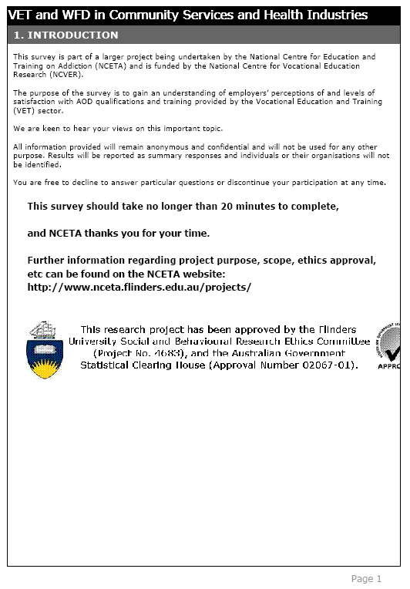
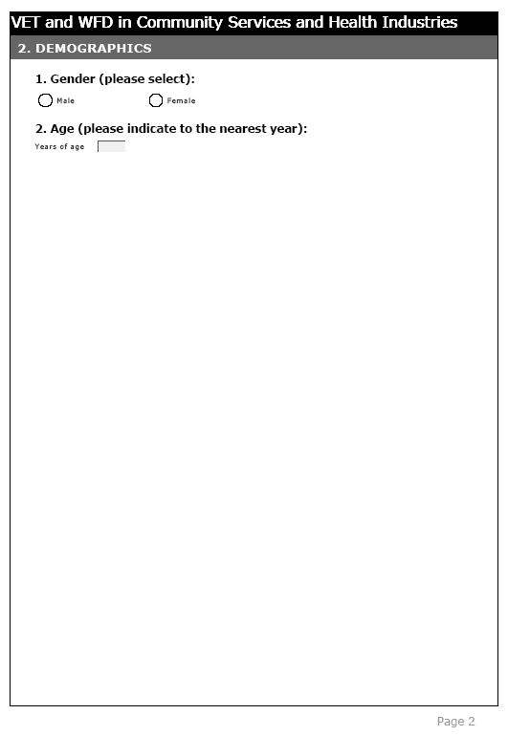
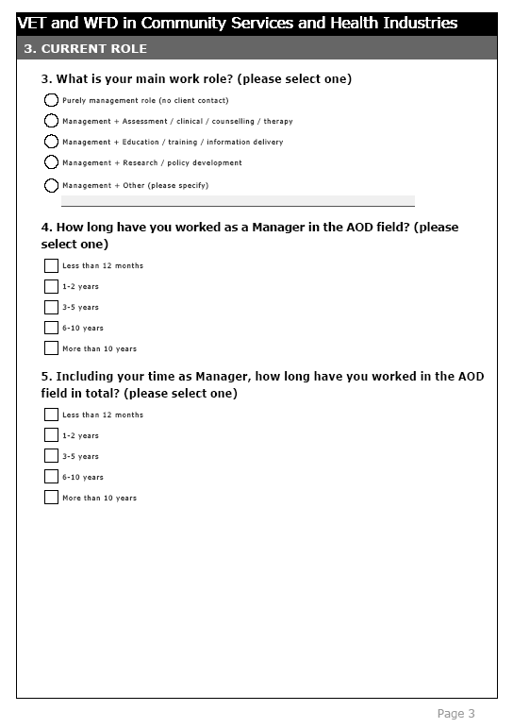

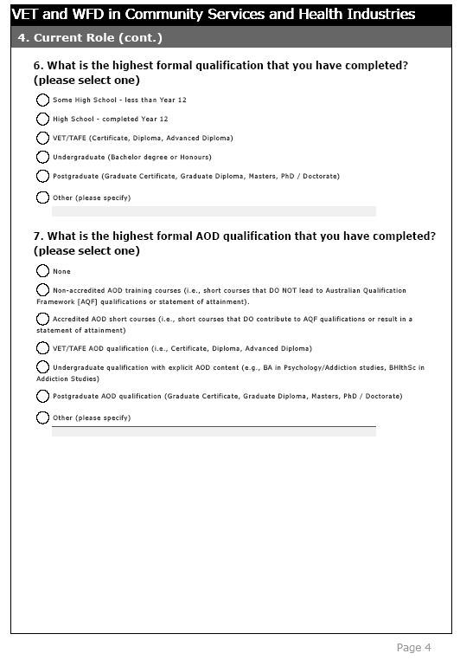
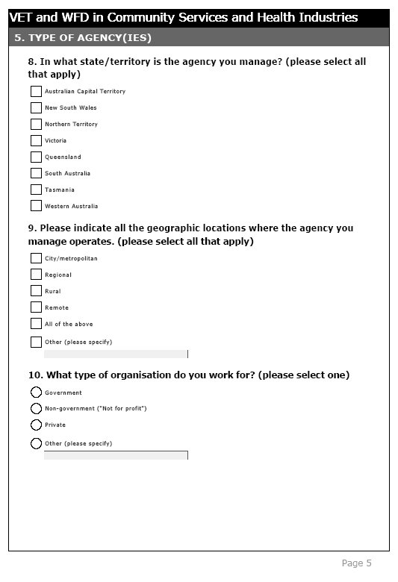
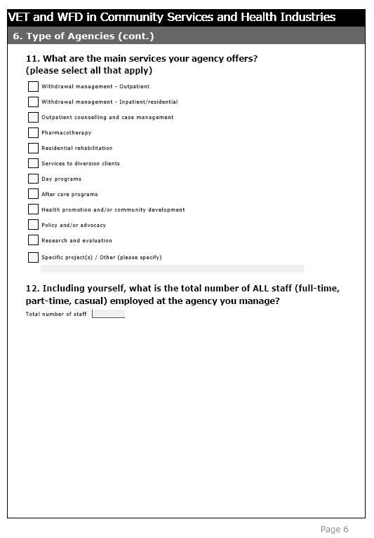
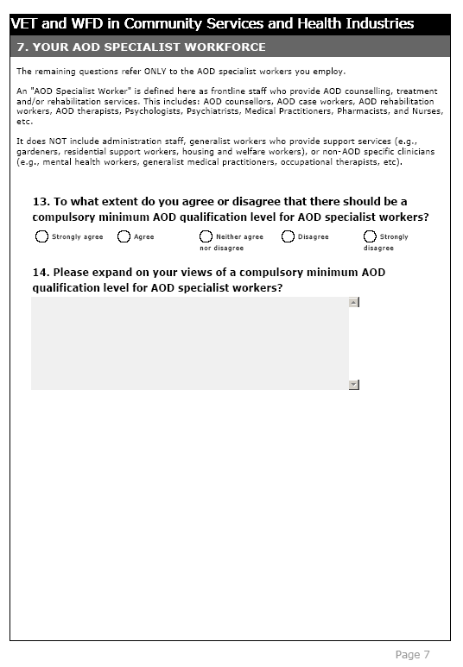

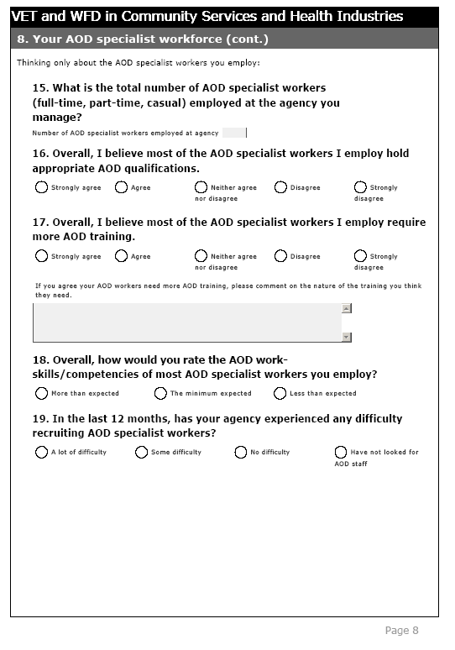

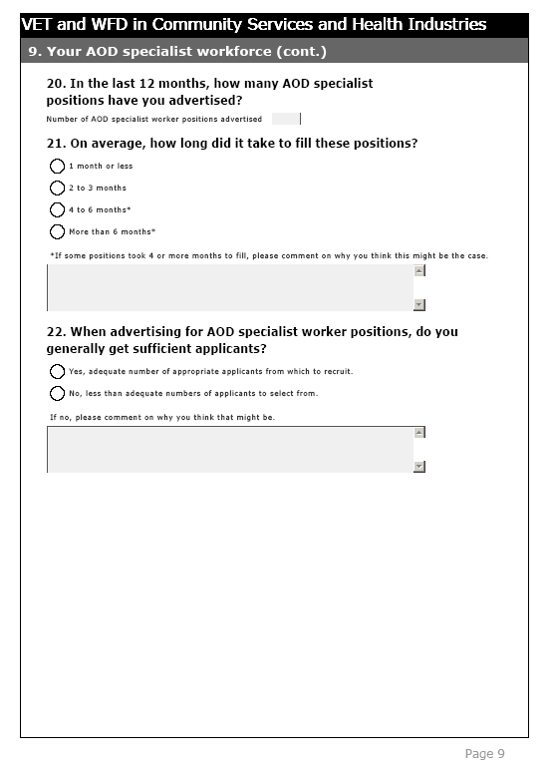
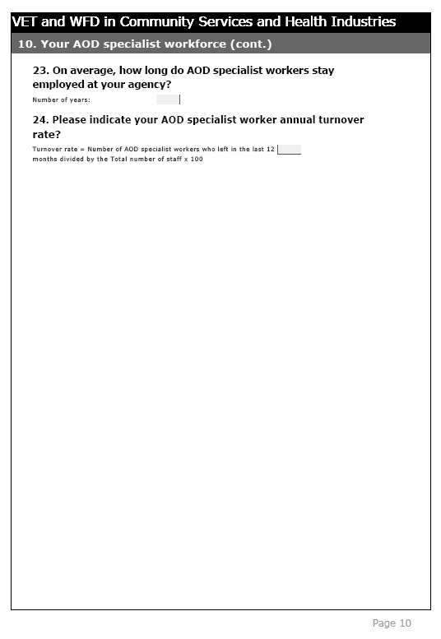
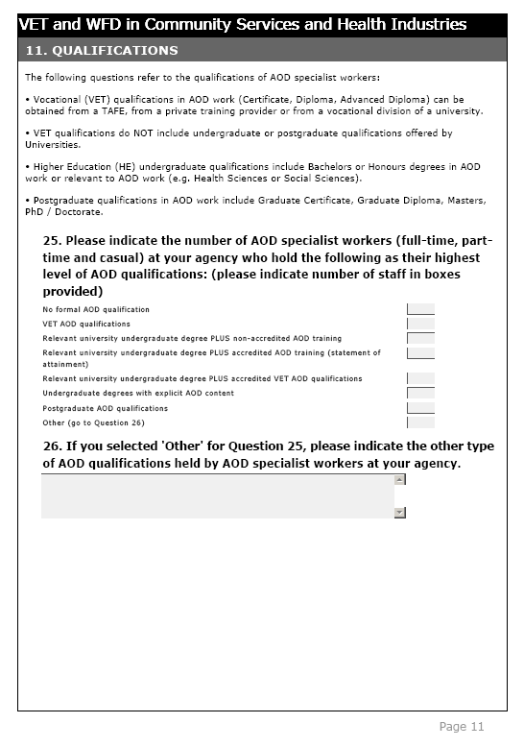
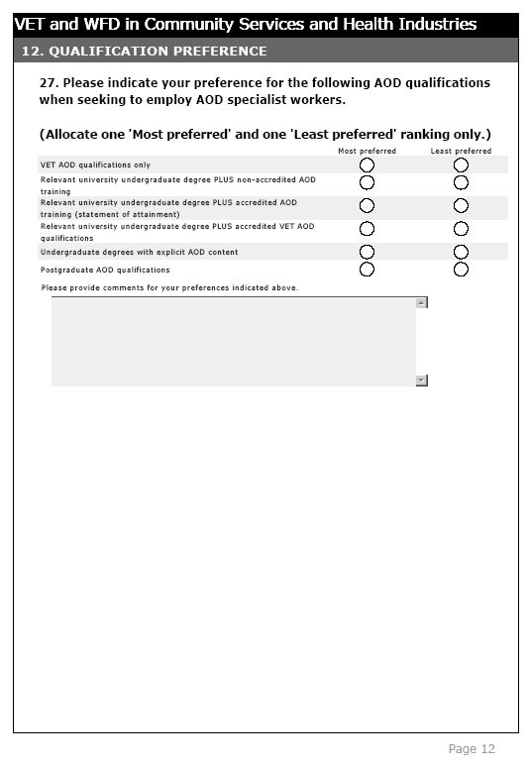

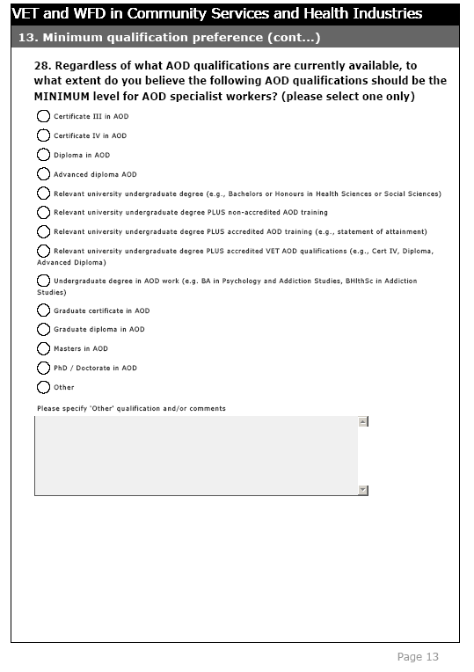
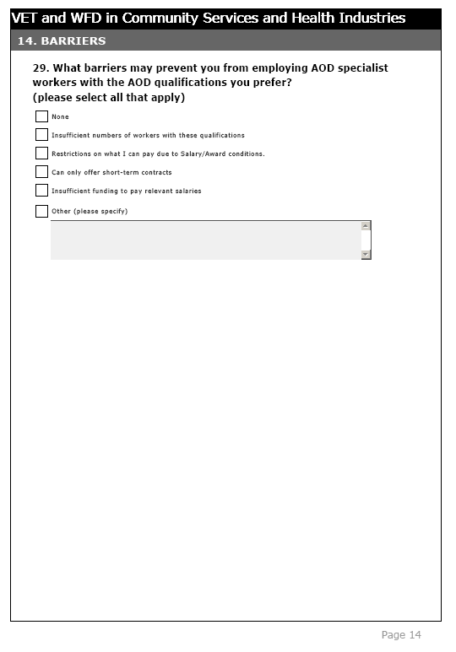

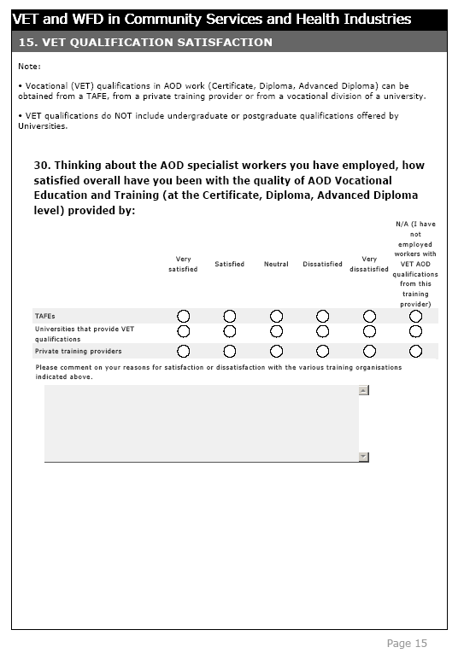
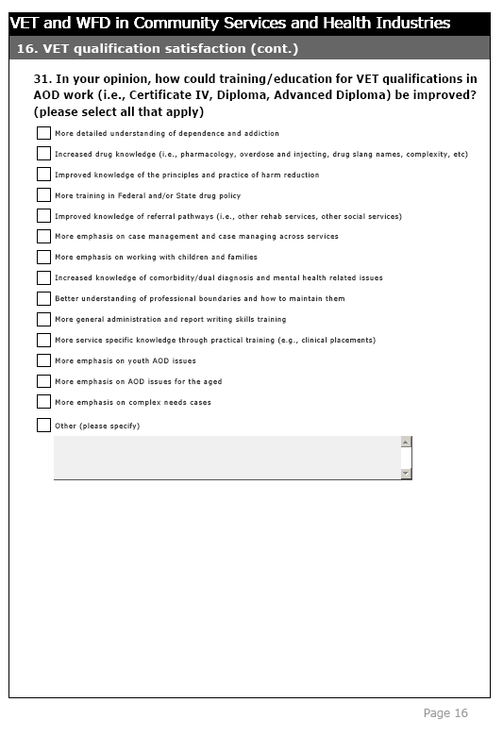
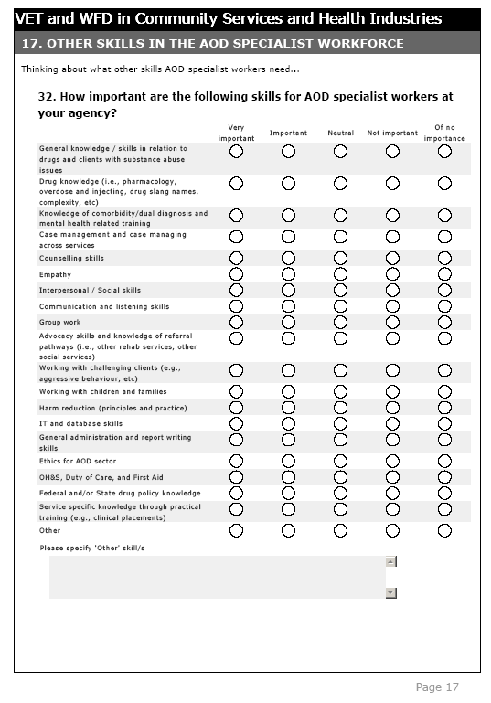
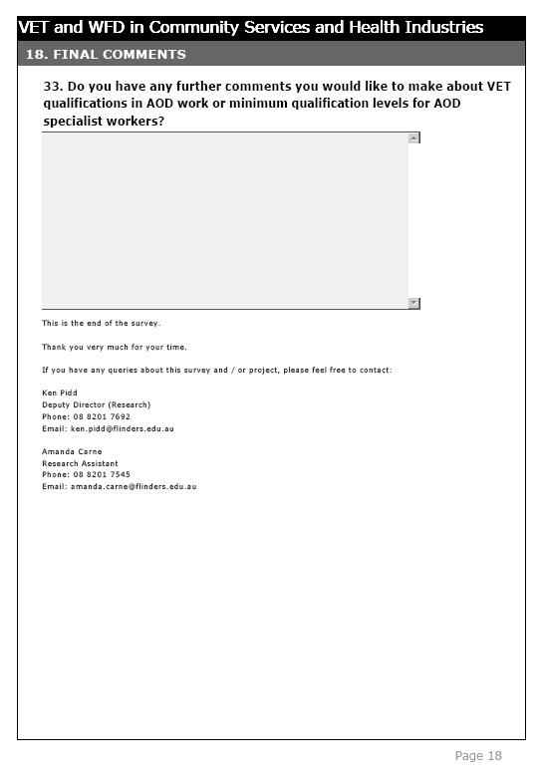

Appendix B

Cover letter
Re: Vocational Education and Training (VET) as a AOD workforce development strategy
The National Centre for Education and Training on Addiction (NCETA) is undertaking a survey on employers’ attitudes toward, and levels of satisfaction with Vocational Education and Training (VET) AOD qualifications as workforce development strategy.

The survey provides an opportunity to comment on the content and quality of vocational AOD training and to provide input relevant to the establishment of a national minimum qualification standard for AOD work.

The survey is part of a larger research project funded by the National Centre for Vocational Education Research (NCVER). NCVER is Australia's leading provider of quality, independent information relating to VET to governments, the VET sector, industry, and the community.

As the manager of an AOD treatment agency, we believe you are the most appropriate person to provide this information and we are keen to hear your views on these important topics by completing a short (20 minute) online questionnaire that can be accessed at http://www.surveymk.com/s/KQMPZR9

Any information provided will be treated in the strictest confidence and no participant or agency will be individually identified in the resulting reports or other publications. You are, of course, entirely free to discontinue your participation at any time or to decline to answer particular questions.
Any queries you may have concerning this project should be directed to me at the address given above or by telephone (08) 8201 7692, fax (08) 8201 7550 or e-mail ken.pidd@flinders.edu.au.

Thank you for your attention and assistance.

Yours sincerely,

Ken Pidd
Deputy Director (Research)
NCETA, Flinders University

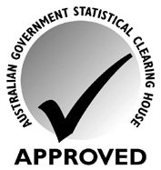
This research project has been approved by the Flinders University Social and Behavioural Research Ethics Committee (Project No. 4683), and the Australian Government Statistical Clearing House (Approval Number 02067-01).

Appendix C

ADCA update – email letter

The National Centre for Education and Training on Addiction (NCETA) at Flinders University is undertaking research on employers’ attitudes toward, and levels of satisfaction with VET AOD qualifications as workforce development strategy. The survey is part of a larger VET project that is being undertaken by NCETA and is funded by the National Centre for Vocational Education Research (NCVER).

If you are a Manager of an AOD agency, we are keen to hear your views on this important topic by completing an online questionnaire. No more than 20 minutes of your time would be required. Your responses will help facilitate the development of effective workforce development strategies in the AOD field.

The survey can be accessed online at http://www.surveymk.com/s/KQMPZR9

Any queries concerning this project should be directed to me by telephone (08) 8201 7692, fax (08) 8201 7550 or e-mail ken.pidd@flinders.edu.au.

Thank you for your attention and assistance.

Yours sincerely,

Ken Pidd
Deputy Director (Research)
National Centre for Education and Training on Addiction
Flinders University, South Australia

Appendix D

Listserver letter

Re: Vocational Education and Training (VET) as an AOD workforce development strategy

Dear Sir/Madam

The National Centre for Education and Training on Addiction (NCETA) at Flinders University is undertaking research on employers’ attitudes toward, and levels of satisfaction with VET AOD qualifications as workforce development strategy. The survey is part of a larger VET project that is being undertaken by NCETA and is funded by the National Centre for Vocational Education Research (NCVER). This national study will include AOD specialist and generic health workers across government and non-government agencies and community controlled organisations.
As the manager of an AOD treatment agency, we believe you are the most appropriate person to provide information concerning employer satisfaction levels with VET and the degree to which VET qualifications meet AOD workforce development needs. We are keen to hear your views on this important topic by completing a questionnaire. No more than 20 minutes of your time would be required.
Be assured that any information provided will be treated in the strictest confidence (i.e., all responses are confidential) and no participant or agency will be individually identified in the resulting reports or other publications (i.e., all participants are completely anonymous). You are, of course, entirely free to discontinue your participation at any time or to decline to answer particular questions.
The survey can be accessed online at http://www.surveymk.com/s/KQMPZR9
Any queries you may have concerning this project should be directed to me at the address given above or by telephone (08) 8201 7692, fax (08) 8201 7550 or e-mail ken.pidd@flinders.edu.au.

Thank you for your attention and assistance.

Yours sincerely,

Ken Pidd
Deputy Director (Research)
National Centre for Education and Training on Addiction
Flinders University, Australia
This research project has been approved by the Flinders University Social and Behavioural Research Ethics Committee (Project No. 4683), and the Australian Government Statistical Clearing House (Approval Number 02067-01).
This research project has been approved by the Flinders University Social and Behavioural Research Ethics Committee (Project Number 4683). For more information regarding ethical approval of the project the Secretary of the Committee can be contacted by telephone on 8201 3116, by fax on 8201 2035 or by email human.researchethics@flinders.edu.au.

Appendix E

Direct mail letter to Peak Bodies and NGOs
Re: Vocational Education and Training (VET) as an
AOD workforce development strategy
Dear {Name}

The purpose of this letter is to invite you to have your say regarding the content and quality of AOD Vocational Education and Training (VET) to input relevant to the establishment of a national minimum qualification standard for AOD work.

As the manager of an AOD treatment agency, we believe you are the most appropriate person to provide this information and we are keen to hear your views on these important topics by completing an online questionnaire.

The questionnaire is part of a larger VET project that is being undertaken by NCETA and is funded by the National Centre for Vocational Education Research (NCVER). NCVER is responsible for collecting, managing, analysing, evaluating and communicating research and statistics about VET and is Australia's leading provider of quality, independent information relating to VET to governments, the VET sector, industry, and the community.

We understand that surveys can be time consuming, however no more than 20 minutes of your time would be required.

Be assured that any information provided will be treated in the strictest confidence (i.e., all responses are confidential) and no participant or agency will be individually identified in the resulting reports or other publications (i.e., all participants are completely anonymous). You are, of course, entirely free to discontinue your participation at any time or to decline to answer particular questions.

The online survey can be accessed online at http://www.surveymk.com/s/KQMPZR9 until the end of March 2010.

Any queries you may have concerning this project should be directed to me at the address given above or by telephone (08) 8201 7692, fax (08) 8201 7550 or e-mail ken.pidd@flinders.edu.au.

Thank you for your attention and assistance.

Yours sincerely,

Ken Pidd
Deputy Director (Research)
National Centre for Education and Training on Addiction
Flinders University, Australia
This research project has been approved by the Flinders University Social and Behavioural Research Ethics Committee (Project No. 4683), and the Australian Government Statistical Clearing House (Approval Number 02067-01).
This research project has been approved by the Flinders University Social and Behavioural Research Ethics Committee (Project Number 4683). For more information regarding ethical approval of the project the Secretary of the Committee can be contacted by telephone on 8201 3116, by fax on 8201 2035 or by email human.researchethics@flinders.edu.au.

Appendix F

Online Survey response statistics
Online survey response statistics¹
Survey question | No. of responses  n (%) | No. not answered  n (%)
- Gender | 185 (99.5) | 1 (0.5)
- Age | 186 (100) | 0
- What is your main work role? (select one) | 183 (98.4) | 3 (1.6)
- How long have you worked as a Manager in the AOD field? (select one) | 184 (98.9) | 2 (1.1)
- Including your time as Manager, how long have you worked in the AOD field in total? (select one) | 185 (99.5) | 1 (0.5)
- What is the highest formal qualification that you have completed? (select one) | 186 (100) | 0
- What is the highest formal AOD qualification that you have completed? (select one) | 185 (99.5) | 1 (0.5)
- In what state/territory is the agency you manage? (select all that apply) | 182 (97.8) | 4 (2.2)
- Please indicate all the geographic locations where the agency you manage operates. (select all that apply) | 183 (98.4) | 3 (1.6)
- What type of organisation do you work for? (select one) | 184 (98.9) | 2 (1.1)
- What are the main services you agency offers? (select all that apply) | 183 (98.4) | 3 (1.6)
- Including yourself, what is the total number of all staff (full-time, part-time, casual) employed at the agency you manage? | 177 (95.2) | 9 (4.8)
- To what extent do you agree or disagree that there should be a compulsory minimum AOD qualification level for AOD specialist workers? | 170 (91.4) | 16 (8.6)
- Please expand on your views of a compulsory minimum AOD qualification level for AOD specialist workers? | 120 (64.5) | 66 (35.5)
- What is the total number of AOD specialist workers (full-time, part-time, casual) employed at the agency you manage? | 153 (82.3) | 33 (17.7)
- Overall, I believe most of the AOD specialist workers I employ hold appropriate AOD qualifications? | 155 (83.3) | 31 (16.7)
- Overall, I believe most of the AOD specialist workers I employ require more AOD training. | 154 (82.8) | 32 (17.2)
- Overall, how would you rate the AOD work-skills/competencies of most AOD specialist workers you employ? | 154 (82.8) | 32 (17.2)
- In the last 12 months, has your agency experienced any difficulty recruiting AOD specialist workers? | 152 (81.7) | 34 (18.3)
- In the last 12 months, how many AOD specialist positions have you advertised? | 139 (74.7) | 47 (25.3)
- On average, how long did it take to fill these positions? | 120 (64.5) | 66 (35.5)
- When advertising for AOD specialist worker positions, do you generally get sufficient applicants? | 132 (71.0) | 54 (29.0)
- On average, how long do AOD specialist workers stay employed at your agency? | 138 (74.2) | 48 (25.8)
- Please indicate your AOD specialist worker annual turnover rate? | 127 (68.3) | 59 (31.7)
- Please indicate the number of AOD specialist workers (full-time, part-time and casual) at your agency who hold the following as their highest level of AOD qualifications. | 125 (67.2) | 61 (32.8)
- If you selected ‘Other’ for Question 25, please indicate the other type of AOD qualifications held by AOD specialist workers at your agency. | 17 (9.1)² | 169 (90.9)
- Please indicate your preference for the following AOD qualifications when seeking to employ AOD specialist workers. | 127 (68.3) | 59 (31.7)
- Regardless of what AOD qualifications are currently available, to what extent do you believe the following AOD qualifications should be the minimum level for AOD specialist workers. (select one) | 127 (68.3) | 59 (31.7)
- What barriers may prevent you from employing AOD specialist workers with the AOD qualifications you prefer? (select all that apply) | 129 (69.4) | 57 (30.6)
- Thinking about the AOD specialist workers you have employed, how satisfied overall have you been with the quality of AOD Vocational Education and Training (at the Certificate, Diploma, Advanced Diploma level) provided by TAFEs, Universities that provide VET qualifications, Private training providers. | 108 (58.1) | 78 (41.9)
- In your opinion, how could training/education for VET qualifications in AOD work (i.e., Certificate IV, Diploma, Advanced Diploma) be improved? (select all) | 124 (66.7) | 62 (33.3)
- How important are the following skills for AOD specialist workers at your agency? | 127 (68.3) | 59 (31.7)
- Do you have any further comments you would like to make about VET qualifications in AOD work or minimum qualification levels for AOD specialist workers? | 30 (16.1)² | 156 (83.9)
¹ Participants were free to decline to answer any question and were able to discontinue participation in the survey at any time; therefore 100% completion was not required.
² This was an open-ended optional question and therefore not required to be answered by all respondents.

An AOD specialist worker was defined as frontline staff who provide AOD counselling, treatment and/or rehabilitation services. This includes: AOD counsellors, AOD case workers, AOD rehabilitation workers, AOD therapists, Psychologists, Psychiatrists, Medical Practitioners, Pharmacists, and Nurses, etc. It did not include administration staff, generalist workers who provide support services (e.g., gardeners, residential support workers, housing and welfare officers), or non-AOD specific clinicians (e.g., mental health workers, generalist medical practitioners, occupational therapists, etc).

