

Workforce planning for the resources
and infrastructure industry
Tom Karmel
Managing Director
National Centre for Vocational Education Research
Paper presented to Grow and maintain the workforce, the 2006 national conference of the
Resources and Infrastructure Industry Skills Council on 23 August 2006
at Swissotel Sydney

It is argued that workforce planning should be built on an understanding of how the labour market works, and the links between it and education and training. Workforce planning is particularly difficult for the resources and infrastructure industry because (1) the demand for resources is difficult to forecast and (2) the industry is made up of relatively small employers and draws workers from a wide range of occupations.

Please note:
The graphs in this document have been produced in colour.
For clarity, please print in colour.

© National Centre for Vocational Education Research Ltd 2007

ISBN 978 1 921170 99 7 web edition
TD/TNC 91.09

Workforce planning for the resources and infrastructure industry

Introduction
Workforce planning has enjoyed a renaissance in Australia in recent years. This has been driven to a large extent by skill shortages and also longer-term concerns about the ageing of the population and the difficulties this will bring in terms of a slowdown in labour force growth.
In looking at labour force planning for the resources and infrastructure industry I wish to do two things. First, I want to look at the links between the labour market and the training system in fairly general terms. The purpose of this is to begin to think about the institutional framework in which particular industries and particular firms sit, and also to consider how labour markets work. The second part of the paper will look at workforce planning in more concrete terms and the difficulties that the resources and infrastructure industry faces in implementing it.

The institutional framework
In very simple terms firms can meet the skill needs of the workforce in any of three ways: first, they can hire individuals with the requisite skills; second, they can take on an apprentice or trainee; or, third, they can train their current employees. Another way of thinking about skills acquisition is to distinguish between entry-level recruits and recruits who are already skilled and experienced in the occupation in question.
Pathways vary by occupation and industry. However, the important pathways in Australia could be characterised as:
- entry-level apprentices and trainees—virtually the only pathway in the traditional trades
- graduates of the university and vocational education and training (VET) sectors—virtually the only pathway in professions and the norm now for many industries. As an aside, the pathway of entry post-school, once the norm for the public service, banking and finance industries, is becoming rarer
- learning on the job—the traditional pathway for many jobs where qualifications are not mandatory. Traineeships for existing workers probably fit in here.
It is worth noting that there is nothing sacrosanct about entry-level pathways. They have evolved very significantly over time. For example, it used to be possible to be a lawyer by learning on the job, by becoming an articled clerk. This is now a thing of the past, and practising lawyers almost all have a law degree, followed by a year of professional practice. As noted earlier, school leaver entry was really important in many areas, and it was possible to rise from being the office boy to head of the organisation. In recent times, however, the trend has been towards formal qualifications obtained prior to employment.
The one area that has remained largely unchanged is that of apprenticeships, particularly in the regulated occupations. There is nothing in principle to prevent these occupations going the same way as many others, with the training largely undertaken before work commences. A model can easily be envisaged, by which an individual is certified as satisfying the competencies of a training package in say, automotive, prior to being employed, say, as a provisional tradesperson (if the professional model is followed).
It is worth looking at some numbers to get a feel for the importance of these pathways. Taking a cohort of school leavers I estimate that around 50% go into VET (figure 1a) and another 35% or so (around 30% for males and almost 40% for females) go to university in the years immediately following school (figure 1b). Within the VET statistics, apprenticeships and traineeships are particularly important, especially for males. As can be seen from table 1, around one-third of male school leavers undertakes an apprenticeship or traineeship. The table also shows that this pathway is particularly important for those who do not complete school.
Figure 1a Percentage of school leavers going to VET, 2001
Source: Australian Bureau Statistics (ABS) Survey of Education and Training, 2001
Figure 1b Percentage of school leavers going to university, 2001
Source: ABS Survey of Education and Training, 2001
Table 1 Apprentices and trainees, 15–19 years, not attending school, by highest school level completed, commencements, 12 months ending December 2004
 | Male | Female | Total
Year 12 | 25 470 | 19 180 | 44 660
Year 11 | 9 200 | 4 230 | 13 420
Year 10 | 17 810 | 7 630 | 25 440
Year 9 or lower | 3 660 | 1 330 | 4 990
Total | 56 140 | 32 370 | 88 510
% discount for multiple commencements | 15% | 11%
Estimate of first-time commencements | 47 546 | 28 712 | 76 259
Typical cohort size | 140 788 | 133 870 | 274 659
% of cohort | 34% | 21% | 28%
Source: NCVER National Apprentice and Trainee Collection estimates, December 2005; ABS (2004)
One issue worth highlighting here is that there is a big difference between individuals taking a particular path and their actually completing the training. While completion rates are notoriously difficult to estimate, there is considerable evidence that they are not as high as perhaps they should be. The main area of interest for the National Centre for Vocational Education (NCVER) is obviously VET, so I am in a position to give a couple of estimates for this sector.
Table 2 Projected completion rates of certificates I and II in the longer term (%)
 | 15 to 19 |  | 20 to 24 |  | 15 to 24
 | Cert. I | Cert. II | Cert. I | Cert. II | Cert. I | Cert. II
Completed a course | 34.6 | 44.2 | 23.5 | 33.5 | 32.9 | 42.6
Did not complete a course | 65.4 | 55.8 | 76.5 | 66.5 | 67.1 | 57.4
Total | 100.0 | 100.0 | 100.0 | 100.0 | 100.0 | 100.0
Source: Stanwick (2005)
Figure 2 Proportion of school leavers obtaining a VET qualification, 2001
Source: ABS Survey of Education and Training, 2001
Figure 3 Proportion of school leavers obtaining a certificate III or IV, or diploma, 2001
Source: ABS Survey of Education and Training, 2001
One of the features of the Australian education system is its openness. Unlike many countries, adult participation in VET and university is encouraged. Older people participate in VET and university for various reasons, but particularly to train for a new occupation or improve their skills in their current area. So even when you are considering entry-level training, it should not be forgotten that the immediate pathway from school is not the only story. The importance of adults in VET can be seen from table 3, which shows the distribution of qualifications by age.
Table 3 Vocational course completions by qualification level by age for Australia, 2005
 | Age 19 and under | Age 20–24 | Age 25–34 | Age 35–44 | Age 45–54 | Age 55+ | Total
Diploma or higher | 6 563 | 14 592 | 8 919 | 6 641 | 4 293 | 1 072 | 42 279
Certificate IV | 6 789 | 10 193 | 13 873 | 13 284 | 10 353 | 3 306 | 58 475
Certificate III | 22 169 | 31 453 | 21 514 | 19 018 | 13 438 | 4 483 | 112 489
Certificate II | 26 200 | 9 689 | 10 093 | 9 515 | 6 578 | 2 362 | 64 736
Certificate I | 8 194 | 2 163 | 2 980 | 3 011 | 2 295 | 1 287 | 20 063
Total | 71 043 | 68 387 | 57 466 | 51 521 | 36 982 | 12 525 | 299 652
Note: Totals include age unknown and secondary education.
Source: NCVER National VET Provider Collection, 2005
I have talked about entry-level training, but training on the job is arguably even more important. I point to two elements. First, when you look at the occupational profile of people working in the resources and infrastructure industry, one thing immediately jumps out. This is the large number of different occupations. The majority of these occupations will have their entry-level training outside the industry. The second is that the level of training after entering the industry is likely to be high.

Table 4 Employment by selected occupations, resources and infrastructure industry (’000)
Occupation
Engineering, distribution & process managers | 4.3
Natural & physical science professionals | 6.0
Building & engineering professionals | 8.4
Building & engineering associate professionals | 7.6
Mechanical engineering tradespersons | 11.7
Electrical & electronics tradespersons | 6.2
Miscellaneous tradespersons & related workers | 4.2
Mobile plant operators | 32.7
Intermediate stationary plan operators | 6.3
Road & rail transport drivers | 8.8
Intermediate mining & construction workers | 13.3
Mine, construction & related labourers | 11.8
Total selected occupations | 121.2
Source: ANTA (2005)
It is clear that many employees in the industry will have on-the-job training very specific to the industry. I know little about the resources and infrastructure industry but would guess that there is a huge amount of industry-specific and perhaps site-specific training. While we don’t know the full extent of structured training provided to the resources and infrastructure industry, we know quite precisely the amount of activity undertaken through the training packages for which the Resources and Infrastructure Industry Skills Council is responsible. It is a reasonable supposition that most of this training is provided to employees of the industry.
Table 5 Vocational students, course enrolments and course completions, by specific training package qualifications for Australia, 2005
Training package qualification | Students | Course enrolments | Course completions
Civil construction | 4 028 | 4 462 | 904
Drilling industry | 103 | 122 | 23
Black coal | 3 664 | 4 140 | 96
Metalliferous mining | 2 062 | 2 513 | 162
Extractive Industry | 792 | 974 | 190
Total | 10 649 | 12 211 | 1 375
Source: NCVER National VET Provider Collection, 2005
The other general point is that arguably the skills acquired while working are more valuable than those obtained in formal credentialled education. Sue Richardson makes this point in her work on employers’ contribution to training (Richardson 2004). She makes use of the well-known phenomenon that employers pay more for experienced workers (or, from the employee’s point of view, that wages go up with experience). In fact she estimates that the value of employment-based training is roughly $30 million per annum, reflecting the impact of experience on wages. In mining, she estimates that an extra year of experience is worth around $11 per year (1996 prices) compared with a new employee with no experience.
The point that qualifications are not the be all and end all is also brought home if you look at the distribution of qualifications across occupations. Apart from the licensed occupations, there is quite a mix of qualifications, as can be seen from table 6.
Table 6 Occupation group and highest educational qualification, 2001, Australia (%)
 | Degree & post-graduate | Diploma | Certificate III & IV | Certificate I & II | No post-school qualification | Total
Managers & administrators | 31 | 10 | 16 | 11 | 33 | 100
Professionals | 66 | 13 | 5 | 4 | 11 | 100
Associate professionals | 18 | 15 | 19 | 10 | 36 | 100
Tradespersons & related workers | 4 | 4 | 55 | 9 | 29 | 100
Advanced clerical & service workers | 13 | 9 | 8 | 25 | 46 | 100
Intermediate clerical, sales & services workers | 8 | 10 | 14 | 16 | 51 | 100
Intermediate production & transport workers | 4 | 3 | 19 | 9 | 65 | 100
Elementary clerical, sales, service workers | 6 | 4 | 8 | 13 | 69 | 100
Labourers & related workers | 3 | 4 | 13 | 11 | 70 | 100
Not applicable | 8 | 5 | 9 | 11 | 66 | 100
Source: Derived from the ABS Survey of Education and Training, 2001.
In thinking about workforce development, it is very important to understand that the labour market is very dynamic and that the education sector should not be perceived as a process that produces what the labour market requires at an occupational level. My point is that a person’s education equips them for many possible occupations and that people will change occupations over their working lifetime. Thus in matching the output of the VET sector to the labour market, we need to note that many graduates will not work in jobs they have trained for, and that attrition rates within occupations are in some cases more important than the number of qualified entrants. This observation points to two things. The first is that the general aspects of training (those aspects that are not specific to an occupation) are as important as the specific skills. The second is that conditions within occupations have arguably a larger impact on skill shortages than the number of newly qualified persons. To put some flesh on these points, we first provide some data on destinations of graduates and then look at training rates and training mobility.
Table 7 Destination occupation matches by intended occupation of training activity, 2003 (%)
Intended occupation of training activity  (major and sub-major group) | Match at  major group | Match at  sub-major group
Managers | 16.9 | na
General managers | 17.9 | 3.8
Specialist managers | 14.2 | 9.4
Farm managers | 29.6 | 27.0
Professionals | 31.2 | na
Science & engineering professionals | 20.8 | 7.4
Business & information professionals | 35.0 | 9.2
Health professionals | 28.9 | 18.4
Education professionals | 38.0 | 26.4
Social & arts professionals | 26.6 | 14.7
Associate professionals | 16.1 | na
Science & engineering associate professionals | 20.8 | 11.1
Business & administration associate professionals | 14.0 | 8.3
Managing supervisors (sales & service) | 10.4 | 5.6
Health & welfare associate professionals | 15.1 | 12.9
Tradespersons | 54.1 | na
Mechanical & fabrication trades | 65.6 | 48.9
Automotive trades | 76.4 | 66.3
Electrical & electronics trades | 68.4 | 62.9
Construction trades | 75.8 | 68.8
Food trades | 42.3 | 41.0
Skilled agricultural & horticultural trades | 25.3 | 20.6
Other trades | 47.6 | 42.0
Advanced clerical & service | 13.5 | na
Secretaries & personal assistants | 8.3 | 5.4
Other advanced clerical & service | 17.2 | 12.2
Intermediate clerical, sales & service | 42.8 | na
Intermediate clerical | 37.1 | 28.8
Intermediate sales | 13.0 | 1.5
Intermediate service | 50.8 | 44.0
Intermediate production and transport | 33.8 | na
Intermediate plant operators | 38.3 | 22.1
Intermediate machine operators | 32.6 | 25.5
Road & rail transport drivers | 39.9 | 29.3
Other intermediate production & transport | 29.7 | 15.7
Elementary clerical, sales & service | 39.0 | na
Elementary clerks | 16.7 | 0.0
Elementary sales | 30.8 | 25.8
Elementary service workers | 43.2 | 25.1
Labourers & other | 27.1 | na
Cleaners | 71.6 | 67.8
Factory labourers | 29.5 | 15.2
Other labourers & related workers | 20.2 | 14.9
Total | 31.3 | 22.8
Note: Base is those graduates employed in May 2003.
Source: Student Outcomes Survey, 2003
From table 7 it can be seen that there is a great deal of variation, and it is clear that VET is providing considerable general training. It is true that the trades tend to have a higher degree of matches, but even here there is much variation, with the food and agricultural/horticultural trades having relatively low matches.
In table 8 we look at training rates for the trades. The reason for looking at the trades is because most skilled tradespersons enter through the apprenticeship system, and so we can measure the inflow with some confidence. So these training rates give us an idea of the rate at which people are entering and leaving the occupation. As can be seen from the table, the rates vary markedly, with food tradespersons having the highest training rate. This means that there is a very high labour turnover among food tradespersons and that high training rates need to be high to maintain the trade. Thus, any imbalance between supply and demand can be partly addressed by changing working conditions in the occupation. Putting it another way, the training system cannot be expected to solve all of the skills issues of particular labour markets.
Table 8 Apprentices and trainees as a proportion of employed persons by occupation (%)
 | 1996 | 2002
Mechanical & fabrication engineering tradespersons | 10.2 | 7.9
Automotive tradespersons | 16.8 | 16.3
Electrical & electronics tradespersons | 9.1 | 9.1
Construction tradespersons | 9.2 | 11.3
Food tradespersons | 18.6 | 25.3
Skilled agricultural & horticultural workers | 4.6 | 7.5
Other tradespersons & related workers | 9.6 | 9.8
Note: The proportions have been calculated after pro-rating the number of ‘tradespersons not further defined’ amongst other trades occupations.
Source: Brooks (2004, p.26)
Finally, the labour market is very dynamic. Each year considerable numbers of people enter the labour market, retire from it, change employers within an industry, and leave an industry or occupation. As any employer can attest, it is a constant of life that workforces are constantly requiring recruitment action, even at a time when the firm’s total level of employment is static or even declining. Some feeling for this can be obtained from Shah and Burke’s (2005) work based on the survey of labour mobility conducted by the Australian Bureau of Statistics (ABS). Table 9 provides some of the elements of mobility for occupational groups.
Table 9 Gross replacement in 2003–04 and job vacancies filled in the year ending February 2004, Australia
 | Gross replacement in 2003–04 |  | Job vacancies filled in year ending February 2004
Occupation group | ’000 | % | ’000 | %
Managers & administrators | 75 | 10.7 | 126 | 18.4
Professionals | 211 | 11.7 | 515 | 29.0
Associate professionals | 150 | 12.8 | 316 | 27.0
Tradespersons | 150 | 12.3 | 347 | 28.4
Advanced clerical & service | 55 | 14.4 | 99 | 26.4
Intermediate clerical, sales & service | 305 | 18.8 | 611 | 38.6
Intermediate production & transport | 147 | 18.6 | 246 | 32.0
Elementary clerical, sales & service | 251 | 26.3 | 460 | 49.3
Labourers | 223 | 25.3 | 429 | 50.4
All | 1568 | 16.5 | 3148 | 33.6
Note: The gross replacement rate is calculated as a percentage of employment in 2003–04, while the rate for job vacancies filled is calculated as a percentage of employment at February 2004.
Source: Shah and Burke (2005)

Workforce planning
The story so far can be summarised as follows.
- There are a number of entry-level training paths.
- Post-school education has become very important, although completion rates leave something to be desired.
- On-the-job training is as important as formal qualifications.
- The labour market is very dynamic; many people end up in occupations not directly related to their training and many people move between jobs and occupations each year.
I should add to this a couple of points about the way the labour market works. First, the future is very uncertain, and it is not possible to predict with any certainty employment levels at anything except an aggregate level. We can make reasonable projections but cannot anticipate shocks or the economic cycle. The second is that one should not think of the labour market as ‘needing’ people with a specific skill. There is a supply of people with certain skills, a demand for such people, and the outcome will determine employment levels and how businesses conduct their business. Neither supply nor demand are fixed and will adjust over time.
As an example, during the recent building boom you could not get bricklayers for love or money. Well, that is not quite correct, because you could get them at a price. Several things happened. First, the price of laying bricks went up very significantly. This no doubt attracted people into the occupation, either people who already had the skills or people who were prepared to acquire the skills. It also likely that bricklayers who might have been thinking of leaving the industry put off their departure while their work was so profitable. So a simple labour market response occurred. The second thing that happened was that builders and architects started looking at alternatives to bricks. Concrete walls became more common. So how many bricklayers do we need to train?
I am not trying to argue that workforce planning is a waste of time. But there are many ways of organising production and a business’s workforce. What labour force planning can do is provide an understanding of the magnitude of various factors, and give some pointers to possible ways of addressing the issues.
I would also make the point that analysis at the micro level tends to provide better insights than macro analysis. This is because each industry, and each firm, is facing different issues.
I’ll depart from the resource and infrastructure industry for a short while to illustrate the point.
You may recall considerable publicity about nursing shortages some years ago. With one of my colleagues at the time (Karmel & Li 2003), I built a reasonably sophisticated supply model based on what we know about the training of nurses and attrition rates. Figures 4 and 5 show the building blocks. Essentially, we model employment by adjusting the number of employed nurses by both the number of graduates who feed into the new entrants and the net attrition rate. The demographics are explicitly built in through the age profile.
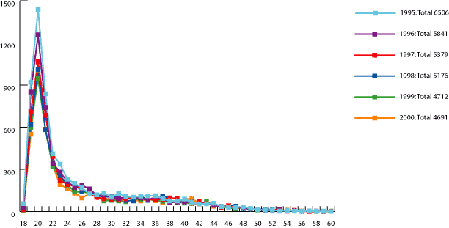
Figure 4 New nurse graduates by age, 1995–2000
Source: Karmel and Li (2000)
As can be seen from the above figure, most new entrants are young.
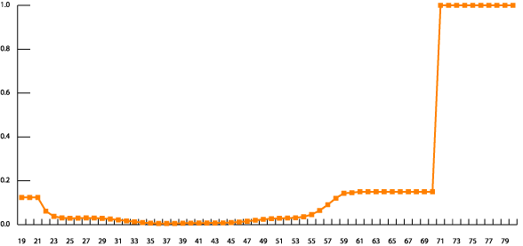
Figure 5 The smoothed and extrapolated net exit rate by age, registered nurses
Source: Karmel and Li (2000)
From these building blocks we project both the age profile and the total number of nurses (figures 6 and 7).
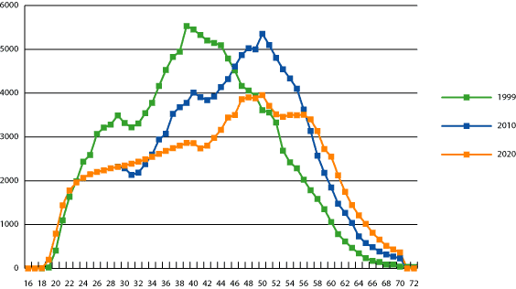
Figure 6 The projected registered nurses at 2010 and 2020, based on the supply model
Source: Karmel and Li (2000)
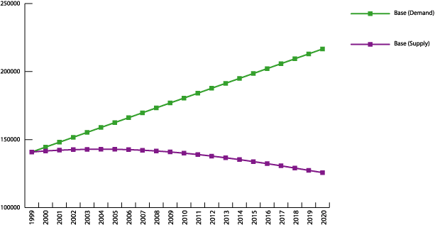
Figure 7 Projections of the number of registered nurses, 2000–20
Source: Karmel and Li (2000)
In figure 7 we have contrasted the projected supply against projected demand (based on ratios of nurses to the population). This exercise shows that a huge imbalance will eventuate. Finally, we show how large the increase in graduates would have to be to remove the gap between supply and demand.
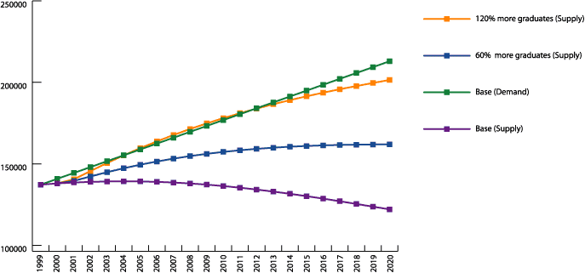
Figure 8 Projections of registered nurses, allowing for an increase in the number of new graduates, 2000–20
Source: Karmel and Li (2000)
Our conclusion was that there was no way that we could meet the gap between demand and supply. This does not imply that we are all doomed, but rather that any solution had to involve a range of factors such as:
- an expansion of nursing graduates
- an end to the decline in enrolled nurses
- a review of articulation between nurses of various skill levels and nursing assistants and personal carers
- major changes to work organisation to reflect the changing balance of the nursing workforce.
Back to the resource and infrastructure industry.
I have not attempted to build a detailed workforce model for the industry. This could be done in principle, but in my view it would not be worth doing, for a number of reasons.
First, employment demand is much harder to predict for this industry than for nurses. While demand for nurses is pretty closely tied to population movements, employment demand in the resources and infrastructure industry is dependent on global economic conditions. This is not to say that we can’t forecast demand but such forecasts are likely to be very inaccurate. In fact the Monash Centre of Policy Studies made some forecasts several years ago for the industry.
Table 10 Employment forecasts to 2011–12 for the resources and infrastructure industry
Source: Cited in ANTA (2005)
The thing that is notable about these forecasts is how flat they are. But this is at variance with historical experience, as can be seen from the following graph.
Figure 9 Total employed by mining industry subdivisions, Australia, 1995–2005 (’000)
Source: ABS (2007)
The point is that long-term economic models are good at understanding trends but are of little use in anticipating the peaks and troughs of demand. And, as is well known, the resources industry is one in which there are considerable variations in global demand (and prices) and hence activity. Figures 10 to 13 provide data on output and prices for a number of mineral commodities.
Figure 10 Bauxite, iron ore and black coal production output, 1960–2004
Source: Australian Bureau of Agricultural and Resource Economics (2005)
Figure 11 Goal and silver production output, 1960–2004
Source: Australian Bureau of Agricultural and Resource Economics (2005)

Figure 12 Unit export value for aluminium, copper and nickel, 1960–2004
Source: Australian Bureau of Agricultural and Resource Economics (2005)
Figure 13 Unit export value for alumina, iron ore, zircon and black coal, 1960–2004
Source: Australian Bureau of Agricultural and Resource Economics (2005)
The second point is that, unlike the nursing workforce, the resources and infrastructure industry is employing people from a wide range of occupations. Not only does it employ people across a very wide range of occupations, but it is a modest employer in terms of numbers.
Table 11 Employment by selected occupations, resources and infrastructure industry (’000)
Occupation | ’000 | % of employment in this occupation
Engineering, distribution & process managers | 4.3 | 4.5
Natural & physical science professionals | 6.0 | 9.0
Building & engineering professionals | 8.4 | 7.5
Building & engineering associate professionals | 7.6 | 8.9
Mechanical engineering tradespersons | 11.7 | 9.6
Electrical & electronics tradespersons | 6.2 | 3.1
Miscellaneous tradespersons & related workers | 4.2 | 6.4
Mobile plant operators | 32.7 | 26.7
Intermediate stationary plan operators | 6.3 | 8.3
Road & rail transport drivers | 8.8 | 3.0
Intermediate mining & construction workers | 13.3 | 35.1
Mine, construction & related labourers | 11.8 | 11.4
Total selected occupations | 121.2 | 8.8
Source: ANTA (2005)
The industry is not a big player in either the professional or trades areas. Only in the mobile plant operators and intermediate mining and construction worker occupations does the industry account for more than 25% of overall employment.
In addition, employment forecasts give no reason for any concern at all.
Table 12 Employment forecasts for selected occupations, 2003–04 to 2011–12
Source: Cited in ANTA (2005)
None of the forecasted growth rates are large, and some are negative. The highest is mobile plant operators, and this is an occupation where training is largely industry-specific, and is not an occupation that relies on large numbers of skilled entrants.
My point is that the industry has to be concerned with attracting individuals to the industry, and that issues relating to overall supply in most of the occupations are second-order issues. The point is that it might be critical to get sufficient electricians for the industry, but the issue is the attractiveness in working in the resources and infrastructure industry relative to other industries.
It is timely, however, to start thinking about the demographic profile of the workforce. Even without looking out over a longer period when the retirement of the baby boomers really begins to bite, the workforce is ageing, as can be seen from figure 14. Thus, the balance between recruiting young people and either recruiting or retaining older people will change. However, this will be true for all industries that are ageing. The challenge for the resources and infrastructure industry is how it maintains its attractiveness relative to other industries.
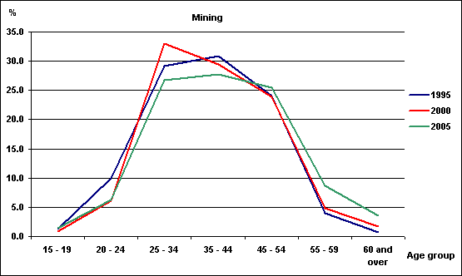
Figure 14 Age distribution of the mining workforce
Source: ABS Labour Force Survey, selected years
Another obvious comment to make is that what is happening across the industry is only background to many employers. The variation in demand and conditions is huge, and each employer, and probably each site, will have its own set of challenges.
To sum up, in thinking about workforce planning, the main points to keep in mind are the following.
- Credentials are becomingly increasingly important as an entry into many occupations.
- Many skills are learnt on the job rather than through formal credentials.
- Much entry-level training needs to have a large generic component because many graduates end up working in occupations for which they have not been trained.
- Labour markets are fluid, with high levels of job mobility.
- In thinking about the resources and infrastructure industry in particular, there are a number of elements that make it problematic to undertake high-level workforce planning for the industry. These include the following factors.
- Industry activity can be quite variable because of the influence of global factors.
- The industry draws on labour across a large number of occupations.
- It is a small employer in relative terms, and this is true for many occupations which are important to the industry; hence, it will have difficulty influencing the labour supply at an occupational level.
- Much of its training is industry-specific and occurs after people have entered the industry.

Concluding comments
If anyone were to check the conference program they would see that my talk was titled: ‘Workforce planning—How do we use demographic information to our advantage?’ My presentation has been on workforce planning, but I have managed to get to the end without any reference to demographic information. I guess this is the speaker’s prerogative. In fact, if you were being really critical you might say that I have not really talked about workforce planning in any concrete sense. The reason for this is essentially that I am very sceptical about the value of workforce planning in a general sense. Rather, what is important is to have an understanding of the way the training system works, the way the labour market works, and how the industry fits into the overall labour market. I would probably go further and say what really counts is understanding how particular employers and work sites fit into the local labour markets. It is the individual employer who is best placed to do this.

References
ABS (Australian Bureau of Statistics) 2004, Population by age and sex, June 2004, cat.no.3201.0, ABS, Canberra.
——2007, Labour force, Australia, detailed, quarterly, May 2007, cat.no.6291.0.55.003, ABS, Canberra.
Australian Bureau of Agricultural and Resource Economics 2005, Australian commodity statistics 2005, viewed 16 August 2006, <http://www.abareconomics.com/publications_html/acs/acs_05/acs_05.html>.
ANTA (Australian National Training Authority) 2005, Resource and Infrastructure Industry Skills Council report, ANTA, Brisbane.
Brooks, L 2004, Australian vocational education and training statistics: Trends in ‘traditional apprentices’, NCVER, Adelaide.
Shah, C & Burke, G 2005, ‘Job turnover and vacancies by occupation’, working paper prepared for the Department of Employment and Workplace Relations, Centre for the Economics of Education and Training, Melbourne.
Karmel, T & Li, J 2002, ‘The nursing workforce 2010’ in National Review of Nursing Education: The nursing workforce, Department of Education, Science and Training, Canberra, 2002.
Richardson, S 2004, Employers’ contribution to training, NCVER, Adelaide.
Stanwick, J 2005, Australian Qualifications Framework lower-level qualifications: Pathways to where for young people?, NCVER, Adelaide.

