

**What is STEM? The need for unpacking its definitions and applications**

Gitta Siekmann

NATIONAL CENTRE FOR VOCATIONAL EDUCATION RESEARCH

**INTRODUCTION**

There is a strong belief by most governments, enterprises and higher education providers that competence in the academic fields of science, technology, engineering and mathematics (STEM) is not developing as quickly as required in spite of the importance for innovation, productivity, prosperity and international standing. This belief is often amplified by the media. The generality of the umbrella term ‘STEM’ as a synonym for a diverse group of skills and academic fields poses various problems in terms of workforce planning and targeted interventions. This summary brings together findings from the National Centre for Vocational Education Research’s detailed exploration of STEM skills, which investigated educational and occupational concepts and their associated definitions.

For further information, see the accompanying paper *Measuring STEM in vocational education and training* and support documents *Defining STEM skills: review and synthesis of the literature* and *Identifying STEM occupations: national and international approaches,* available at [<http://ww](http://www.ncver.edu.au/publications/2889.html)w[.ncver.edu.au/publications/2889.html>.](http://www.ncver.edu.au/publications/2889.html)

**HIGHLIGHTS**

* The acronym ‘STEM’ has been used simplistically to bundle up all education and occupations in the scientific and

technical domains.

* Scientific and technical education and skill formation are not limited to schools and universities but are also intrinsic in the vocational education and training (VET) sector.
* Competency in science, technology, engineering and maths are only one asset set among other equally valuable contributions of non-technical disciplines in a holistic skills framework for education and successful employment.
* While STEM is recognised as a key enabler for national skills, its various (and occasionally conflicting) meanings and excessive use render it increasingly meaningless.

# BACKGROUND

**‘STEM’ is not straightforward**

**“The trouble with simplification is**

**that things are**

**complicated. The**

**trouble with things being complicated is that we need to simplify them.” -**

**Charles Crawford**

With our increasingly busy lives, coupled with information overload, it is easy to understand our desire to simplify complexity. However, the challenge with simplifying complex concepts is that it can lead to different meanings and interpretations. The use of the acronym ‘STEM’ is one such example.

The acronym represents a seemingly simple list of four disciplines **—** science, technology, engineering and mathematics **—** but it has come to represent

a complex concept linking education, employment and productivity (US National Science Foundation 2010).

Since the inception of the STEM concept in the late 1990s, educators, policymakers, researchers and journalists have grappled with the use and interpretation of it. The acronym STEM is used by a wide variety of interest groups with different agendas, such as governments, industry

bodies, education providers and the media. Different understandings exist in education and workforce planning, which lead to different goals and implementation methodologies. For example, where a government aims to increase a nation’s productivity by funding more ICT engineering degrees, a school may want to increase its Year 12 retention rate by making maths subjects more achievable and engaging.

Based on NCVER research exploring the definition of STEM skills (Siekmann & Korbel 2016), it is evident that the acronym can be employed as an umbrella term for a group of concepts, outcomes and derived disciplines. It does not make sense to assume or even force a unique definition at this broad level. A way forward is to identify the components within STEM that are distinct and provide a high degree of a shared interpretation or meaning. It starts with the combination of the disciplines, which can be either a list of single disciplines, S.T.E.M., or a new super-discipline ‘STEM’.

The quest of identification continues with the following questions:

● Are we talking about technical skills, higher cognitive skills or foundational skills?

● Who are the beneficiaries of STEM education: everybody, the working population in general or professionals trained for specific occupations?



To capture the concept of STEM education in relation to its intended outcomes, such as improved education, career advice, workforce capacity and a nation’s productivity (Office of the Chief Scientist 2013, Marginson et al. 2013; Australian Industry Group 2014), the following overarching definition is proposed. It expands on a version originally developed by

the US STEM Education Caucus (2015), which was reflected in the social compact described by the Chief Scientist Ian Chubb in 2013 (Office of the Chief Scientist 2013).

## 

|  |  |  |
| --- | --- | --- |
|  |  | |
|  | **Explaining the concept of ‘STEM’ education** |  |
|  | STEM is an acronym for the disciplines of science, technology, engineering and mathematics taught and applied either in a traditional and discipline-specific manner or through a multidisciplinary, interconnected and integrative approach. Both approaches are outcome-focused and aim to solve real-world challenges.  STEM education and training establishes relationships between the four disciplines with the objective of expanding people’s abilities by supporting technical and scientific education with a strong emphasis on critical and creative-thinking skills.  This approach should be implemented from primary school to tertiary education, in order to provide a nation with four kinds of intellectual and skill-based investment:  ● Teachers and educators who are able to successfully teach foundational STEM knowledge and skills in an integrated and inspirational manner.  ● Scientists, engineers and digital specialists who research and develop the technological advances required for a nation’s economic success and, ultimately, for solving global challenges.  ● Technologically proficient workers who are able to create, design, support and operate complex and evolving technological innovations.  ● Scientifically and technologically literate citizens who can critically examine, understand, respond to and improve the world around them. | |

**Existing STEM statistics – based on the same units?**

**VET’s**

**contribution to STEM is often underreported,**

**despite providing engineering,**

**technology and employability**

**skills.**

The reporting of education and workforce statistics under the STEM banner may not tell the true story. Metrics on education and occupations in science and technology related employment are highly sensitive to the selection of the level of qualification (for example, certificate, diploma, bachelor and higher) and field of education related to the STEM disciplines and its related fields (for example, architecture and construction, agriculture, economics).

Table 1 illustrates the difference these choices can make. The proportion of people in Australia with a STEM qualification in 2011 could either be reported as 4% or 15%. There is nothing right or wrong with the categories chosen

and metrics calculated but the issue is with both sources reporting ‘STEM qualification statistics’ (ABS 2013; Healy at al. 2013).

### Table 1 Contrasting number of people with STEM qualifications in 2011

|  |  |  |  |  |
| --- | --- | --- | --- | --- |
|  | **ABS field of education**  **selected** | **Level of education** | **Number of people** | **Proportion of total workforce population** |
| **ABS1** | National and physical sciences, information technology, engineering and related technologies, agricultural, environmental and related studies | AQF cert. III and higher | 2 718 300 | 15% |
| **Healy et al.2** | National and physical sciences, information technology,  engineering and related technologies | AQF bachelor and higher | 651 000 | 4% |

Source: 1 Australian Bureau of Statistics (ABS) (2013); Survey of Learning and Work 2010**–**11.

2 Healy et al. (2013); data source: ABS Census 2011.

Note: AQF = Australian Qualifications Framework

Education and workforce planning must be inclusive of all education sectors. In spite of a large provision of engineering, technology and employability skills from the VET sector, its contribution and potential for the science

and technology industries is underreported (Korbel 2016). Given these shortcomings, the term STEM may not be appropriate for statistical reports and debates.

P:\PublicationComponents\Icons\References_Purple.emf

For more about measuring STEM in vocational education and training, see the accompanying *Measuring STEM in vocational education and training* paper, available at

[<http://www.ncver.edu.au/publications/2889.html>.](http://www.ncver.edu.au/publications/2889.html)

# THE HOUSE OF STEM

To improve the understanding and application of the STEM concept we have unpacked and identified the major components within. For this purpose we will illustrate a ‘deconstruction exercise’ with the analogy of a building with different rooms (figure 1). A skill model by Cunningham and Vilasenor (2010) has been of value in sorting skills into categories that are useful for targeted intervention. The skill model describes four skill set definitions based on economics and psychology literature, and a global meta-analysis on the skills required by employers:

● socioemotional (e.g. resilience)

● basic cognitive (e.g. numeracy)

● higher-order cognitive (e.g. critical thinking)

● technical skills (e.g. coding).

Skills most demanded by employers are higher-order cognitive skills and socioemotional skills (Cunningham & Villasenor 2010).

In our analogy, STEM is the roof covering the building, which is based on a foundation of skills needed for everyday life, such as literacy and numeracy. To succeed at all levels of education and employment, a sense of agency and self-efficacy is supported by socioemotional skills, such as curiosity and resilience. Further rooms are separately occupied by advanced cognitive skills, such as critical and creative thinking and technical, occupation or discipline related skills. The Stem Shed represents the tools that can be used to help categorise and measure skills and outcomes via fields of education, occupation or industry.

### Figure 1 Deconstructing the concept of STEM

**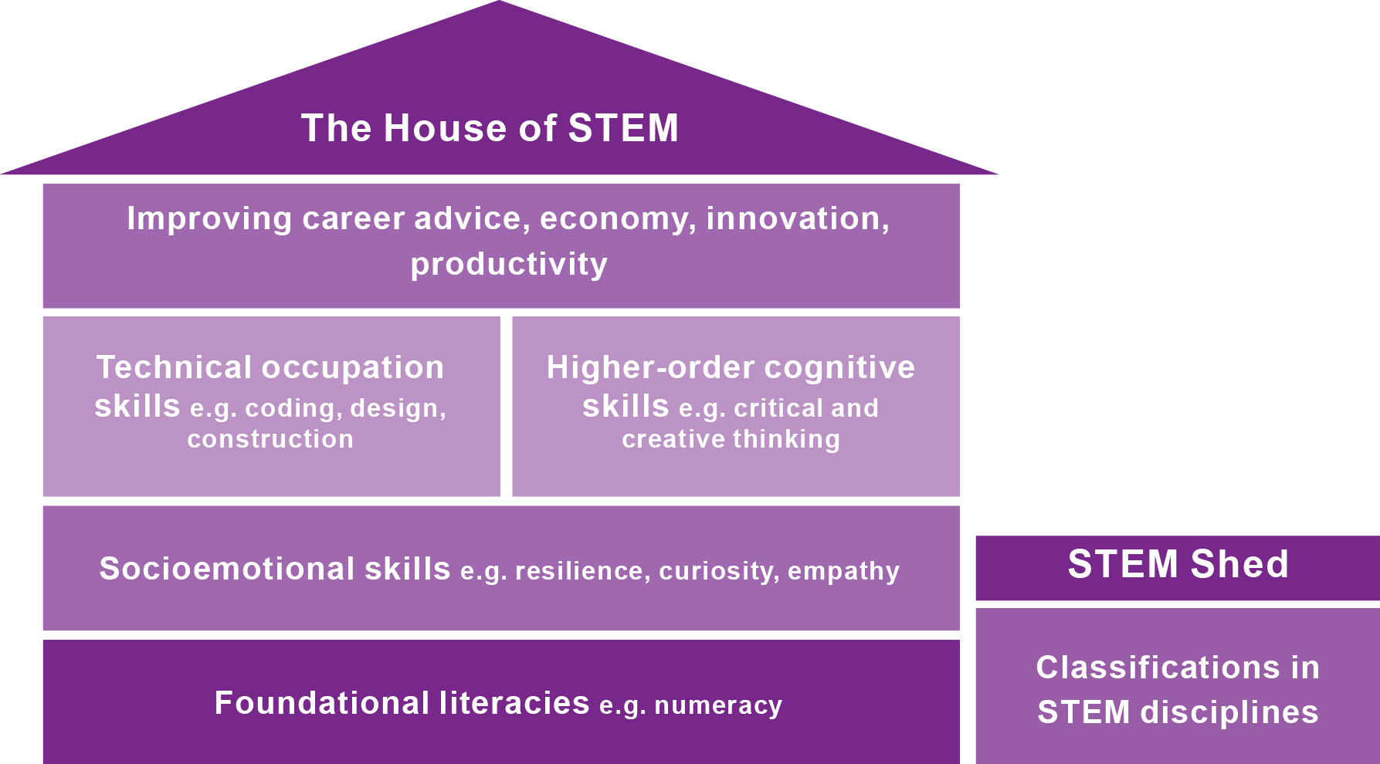**

The overlapping nature of these categories are most pronounced at this level.

**STEM education is inclusive**

**of society as a whole, not**

**only providing technical skills but improving capacity for**

**life and work in general.**

For example, scientific task work relies on analytical and logical thinking. None of these skills are exclusive to STEM but collectively they contribute to the concept of STEM. These four skill categories are targeted to satisfy the intended outcomes (for example, educational experience, equity measures, career advice and productivity) of education in the STEM disciplines.

In order to estimate the number of programs and people who are learning, training and working in the science and technology related domains, standard categories or classifications such as ASCED and ANZSCO1 are currently the best approximation tools. This corresponds to the STEM shed in our ‘House of STEM’.

As indicated earlier, STEM education is inclusive of society as a whole, not only providing technical skills for occupations in demand (for example, electricians and data scientists) but also improving foundational capacity for life and work in general. Thus, STEM education aims to improve:

● scientific and technical literacy for all

● scientific and technical work(place) capacity for all workers

● science and technology specific, occupational skills for selected

occupations.

(US National Science Foundation 2010; Office of the Chief Scientist 2013)

These outcomes can be achieved either through:

● interdisciplinary or integrated STEM education (box A in figure 2)

● ‘traditional’ single, disciplinary education (box B in figure 2).

The distinction between these groupings may appear academically similar

on paper but it has significant implications for the future development of curriculums (Blakeley & Howell 2015). This distinction is also necessary to map skills to suitable standard categories or classifications.

**Teaching STEM disciplines in different ways**

### Integrated STEM education

Interdisciplinary and integrated STEM education can be explained as a fusion of disciplines used to understand and problem-solve real-world examples. This is accomplished with an understanding of societal needs, using critical and creative thinking skills, and research and experimentation skills. The term ‘STEM’ has evolved into a foundational competency based on inter-disciplinary knowledge of its founding disciplines, with its defining characteristic being the ability to think ‘outside the box’ and being able to build or construct solutions.

This kind of education and learning is still rare and difficult to measure or monitor.

1 ASCED = Australian Standard Classification of Education, ANZCO = Australian and New Zealand Standard Classification of Occupations.

Interdisciplinary STEM can be further split up into occupation- and non- occupation-specific fields. This categorisation determines whether the mode of education is either focused on occupation-specific skills or on broader areas such as skills useful in day-to-day life or foundational skills for a variety of workplaces.

### Figure 2 STEM education classification

**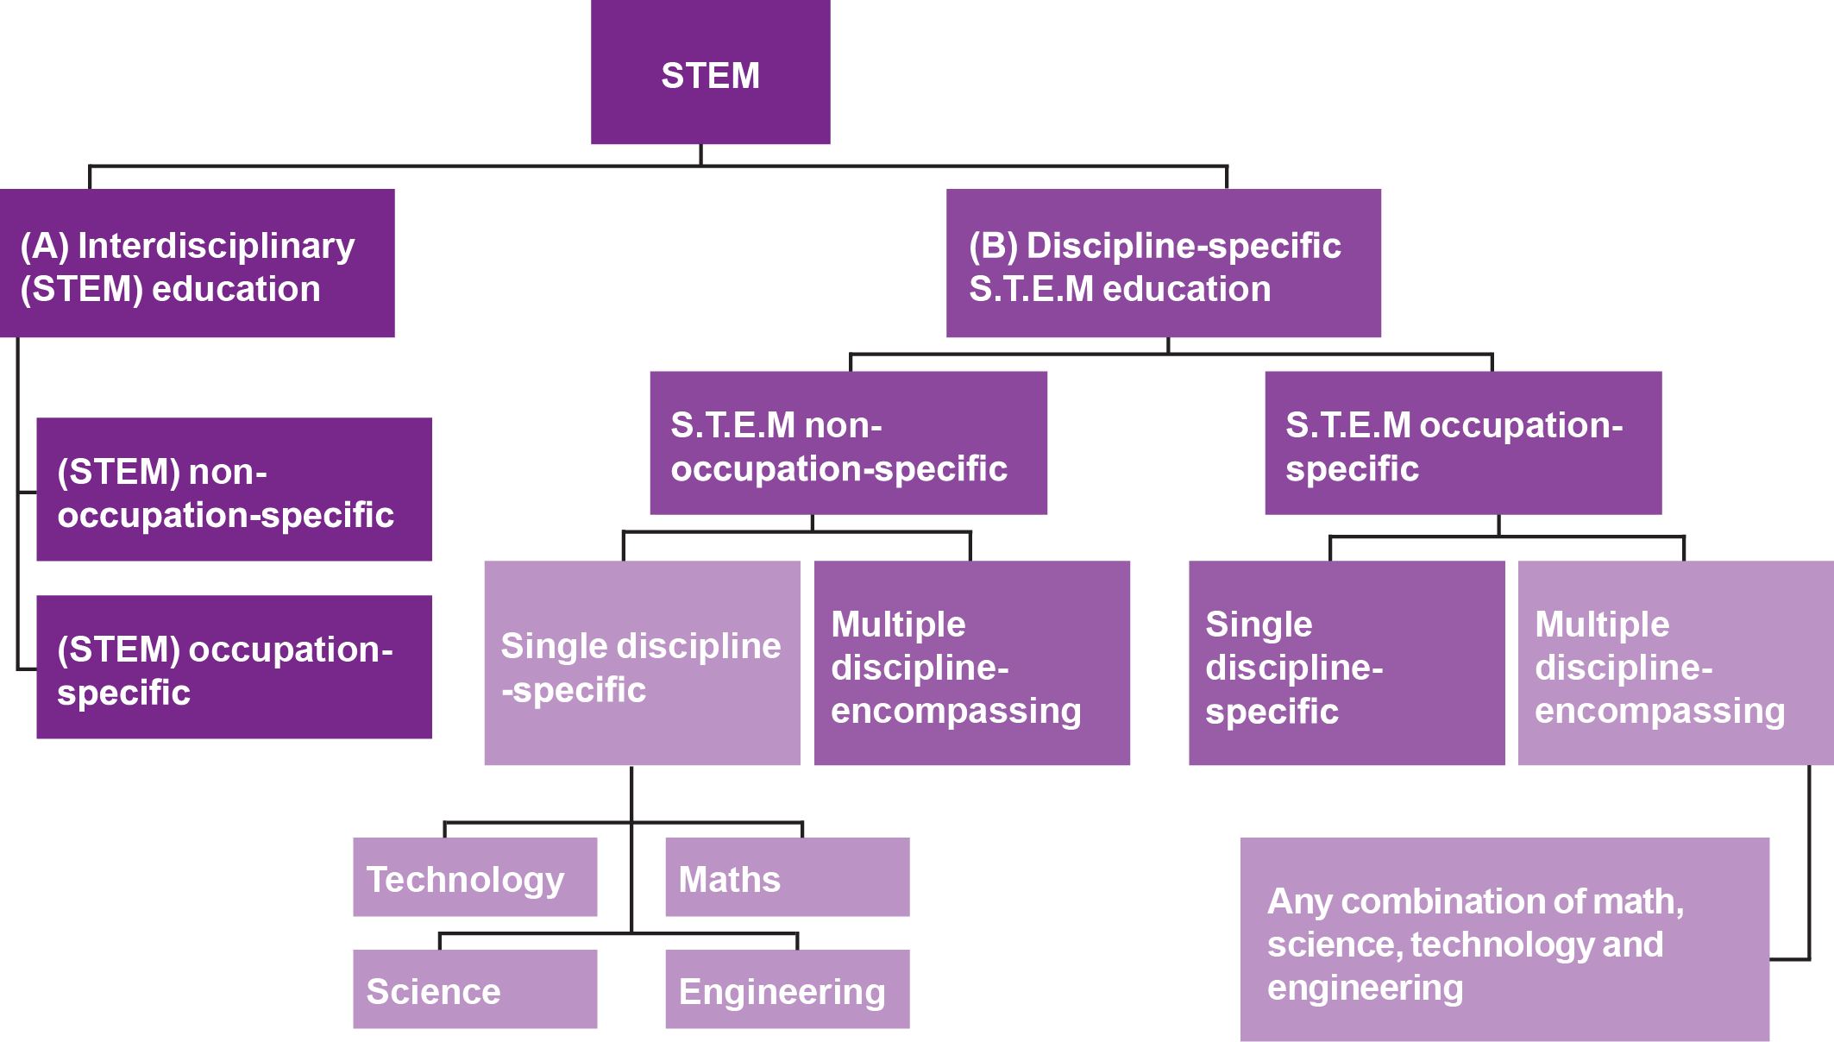**

**Traditional subject education**

When we say traditional education in the STEM-related disciplines, we mean the most usual way of teaching single STEM subjects, such as maths and science at school, or engineering in further education. The emphasis is on teaching discipline-specific knowledge and skills. Distinction by discipline allows for standardised testing, intra- and intercountry comparisons and general statistical reporting. National tests such as the National Assessment Program **—** Literacy and Numeracy (NAPLAN) and international tests such as Programme for International Student Assessment (PISA) are frequently cited in the media as indicators of a state’s or country’s STEM capacity.

The aim of these types of policy initiatives is to make these subjects more attractive and attainable and increase the number of people **—** particularly girls and women **—** in science and technology-related career paths.

# STEM SHED: CLASSIFYING AND MEASURING SKILLS

## How to measure scientific and technical skills

Discipline-specific skills can be measured or estimated in a variety of different ways. The two most commonly used measures are the qualifications that individuals have previously acquired and the occupational classification of the jobs that they do. While these can be relatively simple to measure, they are not necessarily relevant to the actual skills required by employers and used

by individuals (Korbel 2016). When using standard classifications only, such as ASCED and ANZSCO in Australia, science and technology-related discipline- specific fields of education and occupations can be identified via major groupings, titles and brief descriptions of detailed fields.

A high concentration of science and technology-related descriptors of education and occupation are found in the ASCED broad fields of education and ANZSCO occupational groups in tables 2a and 2b (Siekmann & Korbel 2016; Korbel 2016). However, they are not inclusive as a small number of subcategories related to science and technology are found in other categories and industries.

Rather than taking a quick and easy top-down approach by selecting broad categories that most closely align with the words science, technology, engineering and mathematics, a bottom-up approach needs to be adopted. This approach ensures that each detailed field of education or occupation is examined on its STEM discipline-related elements.

### Table 2a Conventional educational STEM categories

**Table 2b Conventional occupational STEM categories**

|  |
| --- |
| **ASCED field of education** |
| 01 NATURAL AND PHYSICAL SCIENCES |
| 02 INFORMATION TECHNOLOGY |
| 03 ENGINEERING AND RELATED TECHNOLOGIES |
| 04 ARCHITECTURE AND BUILDING |
| 05 AGRICULTURE, ENVIRONMENTALAND  RELATED STUDIES |
| 06 HEALTH (some sub categories) |
| 07 EDUCATION (some sub categories) |

|  |
| --- |
| **ANZSCO field of occupation** |
| 1 MANAGERS (sub-major groups: Farmers and Farm managers; Specialist managers) |
| 2 PROFESSIONALS (sub-major groups: Design, Engineering, Science and Transport professionals; Education professionals; Health professionals; ICT professionals) |
| 3 TECHNICIANS AND TRADES WORKERS |
| 8 MACHINERY OPERATORS AND DRIVERS |

Using the bottom-up approach reveals that, for example, being a photographer involves distinct technical elements, such as manipulating images using digital imaging techniques. However, this occupation sits under the occupational grouping Arts and Media Professionals, which is not included in conventional STEM reporting (ABS 2013). Similarly, economics and econometrics has strong

mathematical elements in its skill formation but this field is grouped under the educational category Society and Culture. In fact attempting to identify these fields via a ‘STEM’ keyword search algorithm was unsuccessful. This exercise revealed that the title and brief descriptions underneath are insufficient to picking all fields with scientific and technical components and the degree of these.

But there is an alternative. An exemplary method for identifying and quantifying skills for occupations exists via the survey-based occupational database, O\*NET (US Department of Labor, Employment and Training 2015; Siekmann & Korbel 2016). Every occupation is described in great detail via a set of nearly 300 standardised descriptors on knowledge, skills and abilities.

## h

|  |  |  |
| --- | --- | --- |
|  |  | |
|  | **The six domains in O\*NET Online** |  |
|  | The information contained in O\*NET Online is divided into six domains:  ● worker characteristics  ● worker requirements  ● experience requirements  ● occupational specific information  ● workforce characteristics  ● occupational requirements.  This enables identification and measurement, not only on the occurrence of details skills and knowledge - as displayed in the ‘House of STEM’ (figure 1) - but also their level of complexity as relevant to occupations and real jobs performed. | |

Information stored in the O\*NET knowledge bank could be mapped to the Australian classification system of occupations, as demonstrated by the United Kingdom (Dickerson et al. 2012; Hillage & Cross 2015). The Commonwealth Scientific and Industrial Research Organisation (CSIRO) with TAFE Queensland made a start in Australia and linked O\*NET data to a subset of ANZSCO occupations (Reeson et al. 2016). Long term, it would be beneficial to build an Australian data bank to reflect a country’s individual education and occupation systems. Being able to identify detailed skill descriptions is invaluable for any approaches addressing skills in demand.

# THINKING ABOUT OUTPUT BEFORE INPUT?

**Moving the focus from STEM skills to skills in demand**

**There are concerns that a holistic**

**education, which includes the**

**humanities and**

**social sciences, is neglected in favour of a STEM focus.**

STEM is frequently cited in the media, often dramatically foreshadowing an imminent shortage of the scientific and technical skills and knowledge vital to the Australian economy (Office of the Chief Scientist 2013; Australian Industry Group 2014). It is argued that improvements in education and training are required now to ensure an adequate supply of labour in the future (Deloitte Access Economics 2015). However, there are concerns with this rush for STEM skills, as it is difficult to make accurate labour market predictions, especially considering the changing nature of the workforce and the restructuring of labour and industries.

There is also concern that a holistic education, which includes the humanities and social sciences, is neglected in favour of a STEM focus in education (Spoehr et al. 2010; Zakaria 2015). The push for more STEM degrees has been criticised by the Grattan Institute who argue that the labour market is oversupplied with science graduates not being able to find work in their field (Norton & Cakitaki 2016). In 2015, unemployment four months after graduation was near 20%

for life scientists, mathematicians and chemists, which is above the overall graduate average for unemployment of 12.5% (Graduate Careers Australia 2016). The chief scientist responded to these concerns by pointing out that the skills and expertise of STEM graduates are highly transferable and enable them to work in a variety of jobs outside their original field of study (Finkel 2016).

The focus on STEM education, skills and occupations could be considered unbalanced in terms of its contribution to innovation, productivity and ultimately a country’s prosperity. Instead of continuing with the focus on discipline-specific skills, a shift in focus to technical or science outputs or products could allow for more inclusive skill analysis. When wanting to land on the moon, ‘rocket scientists’ were important but not exclusively so; a lot of other skills outside the science and technology domain were needed to make this grand vision in the early 1960s several years later a reality (NASA 2004).

More recently, the development and implementation of solar powered cars, for example, requires automotive-related construction and digital skills but also project management, legislative and sales skills. Defining a particular industry sector in demand (for example, advanced manufacturing and cyber security) or a defined product, such as solar cars, helps to focus on which skills and how many people are needed from a wide variety of fields and disciplines. Technological innovations such as genetic modification and nuclear energy facilities are examples where the HASS (Humanities, Arts and Social Sciences) disciplines are crucial in their discussion, evaluation and implementation (Spoehr 2010).

**CONCLUSION**

**Our preference is to use STEM only as**

**any other acronym**

**- an abbreviation of words, without**

**adding any further meaning to it.**

Current definitions of STEM skills are inconsistent and not specific enough to inform education and skill policies and initiatives, potentially leading to a number of unsubstantiated and uncoordinated actions. There is a potential risk of providing overly generic career advice for science and technical occupations in general when, in fact, only some specific occupations are in demand. The review of the reports and debate on STEM reveals two inherent key concerns.

**e**

|  |  |  |
| --- | --- | --- |
|  |  |  |
|  | **Key concerns** |
|  | 1. The dominance of university education and pathways. Education and workforce planning must be inclusive of all education   sectors. In spite of a large provision of engineering, technology and employability skills from the VET sector, its contribution and potential is underreported and underrepresented.   1. The singular view of science and technology competency in light   of a nation’s productivity and competitiveness neglecting the equally valuable contribution of non-technical disciplines. | |

To improve the understanding and application of the concept of STEM, we suggest unpacking and identifying the major components within it. These have been identified as a variety of intended outcomes and four distinct skill groupings: socio-emotional, basic cognitive, higher-order cognitive, and technical, job specific skills. Our preference is to use STEM only as any other acronym **—** an abbreviation of words: science, technology, engineering and mathematics **—** without adding any further meaning to it. This means dropping ‘STEM’ from the skill vocabulary altogether and instead referring to distinct skill groups, specific jobs and occupations relevant in the science and technology industry sector.

For clarity in analyses, debate and policy work, we would advise using skill definitions within holistic skills frameworks. The most appropriate frameworks address foundations for work, employability and the future of work. For example, the 21st Century skills framework refers to a broad set of knowledge, skills, work habits, and character traits that are critically important to success in today’s and tomorrow’s world, particularly in secondary schools, tertiary education and workplaces (Binkley et al. 2012; Great School Partnerships 2016). These skill groups can be applied in all academic subject areas, and in all educational, career, and civic settings throughout a student’s life. The ‘House of STEM’ reflects this framework.

# REFERENCES

Australian Bureau of Statistics 2001, Australian Standard Classification of Education (ASCED), cat.no.1272.0, viewed July 2015, [<http://www.abs.go](http://www.abs.gov.au/ausstats/abs%40)v[.au/ausstats/abs@.](http://www.abs.gov.au/ausstats/abs%40) nsf/mf/1272.0>.

**——** 2013, *Perspectives on education and training: Australians with qualifications in science, technology, engineering and mathematics (STEM), 2010—11*, cat.no.4250.0.55.005, viewed March 2015, [<http://www.abs.go](http://www.abs.gov.au/)v[.au/](http://www.abs.gov.au/) ausstats%5Cabs@.nsf/0/54B42BD3902EB8A2CA257C86000EA59A?Opendocument>.

Australian Industry Group 2015, *Progressing STEM skills in Australia*, viewed July 2015,

[<http://www.voced.edu.au/content/ngv%3A56724>.](http://www.voced.edu.au/content/ngv%3A56724)

Binkley, M, Erstad, O, Herman, J, Raizen, Ripley, M, Miller-Ricci, M & Rumble, M 2012, ‘Defining twenty-first century skills’, in P Griffin, B McGaw & E Care (eds), *Assessment and teaching of 21st century skills*, pp.17—66, Springer, Dordrecht.

Blackley, S & Howell, J 2015, ‘A STEM narrative: 15 years in the making’ *Australian Journal of Teacher Education,* vol.40, no.7, pp.8.

Charette, R 2013, *The STEM crisis is a myth*, viewed April 2015, [<http://spectrum.ieee.](http://spectrum.ieee/) org/at-work/education/the-stem-crisis-is-a-myth>.

Crawford, C 2004, Iraq: Mars, Venus, Extremism. Keynote address: VI Stuttgarter Schlossgespräch, Stuttgart, 17 June 2004, viewed May 2016, <http:// charlescrawford.biz>

Cunningham, W & Villasenor, P 2016, *Employer voices, employer demands, and implications for public skills development policy connecting the labor and education sectors*, World Bank policy research working paper, no.7582, Washington, DC.

Deloitte Access Economics 2014, *Australia’s STEM workforce: a survey of employers*,

Deloitte Access Economics, Canberra.

Finkel, A 2016, ‘Time to change our university graduate expectations by degrees’, *The Australian*, 29 August 2016, viewed August 2016, <http://www.chiefscientist. gov.au/2016/08/article-the-australian-time-to-change-our-university-graduate- expectations-by-degrees/>.

Graduate Careers Australia 2015, *GradStats: employment and salary outcomes of recent higher education graduates*, viewed 22 March 2016, [<http://www](http://www/). graduatecareers.com.au/research/researchreports/gradstats/>.

Great School Partnership 2015, ‘21st Century Skills’, *Glossary of education reform,*

viewed 25 February 2016, [<http://edglossar](http://edglossary.org/21st-century-skills/)y[.org/21st-century-skills/>.](http://edglossary.org/21st-century-skills/)

Healy, J, Mavromaras, K & Zhu R 2013, ‘The STEM labour market in Australia’, *A consultant report securing Australia’s future STEM: country comparisons*, Australian Council of Learned Academies, Melbourne.

Korbel, P 2016, *Measuring STEM in vocational education and training*, NCVER, Adelaide. Marginson, S, Tytler, R, Freeman, B & Roberts, K 2013, *STEM: country comparisons:*

*final report*, Australian Council of Learned Academies, Melbourne, viewed March 2015, [<http://www.acola.org.au/index.php/projects/securing-australia-s-future/](http://www.acola.org.au/index.php/projects/securing-australia-s-future/) project-2>.

NASA (National Aeronautics and Space Administration) 2004, *A president issues NASA’s first historic challenge*, viewed May 2016, [<http://www.nasa.gov/vision/space/](http://www.nasa.gov/vision/space/) features/jfk\_speech.html>.

National Science Foundation (US) 2010, *Preparing the next generation of STEM innovators: identifying and developing our nation’s human capital*, National Science Foundation, Arlington.

Norton, A & Cakitaki, B 2016, *Mapping Australian higher education 2016*, Grattan

Institute, Carlton.

Office of the Chief Scientist 2013, *Science, technology, engineering and mathematics in the national interest: a strategic approach,* Australian Government, Canberra.

Siekmann, G and Korbel, P 2016, *Defining STEM skills: a literature review and synthesis*, NCVER, Adelaide.

Reeson, A, Mason, C, Sanderson, T, Bratanova, A & Hajkowicz, S 2016, *The VET era: equipping Australia’s workforce for the future digital economy*, CSIRO, Clayton, viewed July 2016, [<http://tafeqld.edu.au/resources/pdf/about-us/research-](http://tafeqld.edu.au/resources/pdf/about-us/research-) papers/vet-era.pdf>.

Spoehr, J, Barnett, K, Molloy, S, Dev, S & Hordacre, AL 2010, *Connecting ideas: collaborative innovation for a complex world*, Australian Institute for Social Research, University of Adelaide, Adelaide.

U.S. Department of Labor, Employment & Training Administration 2015, O-NET Resource Centre, May 2016, [<https://www.onetcente](http://www.onetcenter.org/)r.org/>.

U.S. STEM Education Caucus 2015, *Why was the STEM Education Caucus created?*,

viewed July 2015, [<http://stemedcaucus2.org/>.](http://stemedcaucus2.org/)

Zakaria, F 2015, ‘Why America’s obsession with STEM education is dangerous’, *The Washington Post*, viewed March 2015, [<https://www.washingtonpost.com/](http://www.washingtonpost.com/) opinions/why-stem-wont-make-us-successful/2015/03/26/5f4604f2-d2a5-11e4- ab77-9646eea6a4c7\_story.html>.



**© Commonwealth of Australia, 2016**

With the exception of cover design, artwork, photographs all logos and any material

protected by a trade mark and where otherwise noted all material presented in this document is provided under a Creative Commons Attribution 3.0 Australia <http:// creativecommons.org/licenses/by/3.0/au> licence.

This document should be attributed as Siekmann, G 2016, *What is STEM? The*

*need for unpacking its definitions and applications,* NCVER, Adelaide.

NCVER is an independent body responsible for collecting, managing and analysing, evaluating and communicating research and statistics about vocational education and training (VET).

NCVER’s inhouse research and evaluation program undertakes projects which

are strategic to the VET sector. These projects are developed and conducted by NCVER’s research staff and are funded by NCVER. This research aims to improve policy and practice in the VET sector.

IMAGES: GETTY IMAGES/ISTOCK

ISBN

978 1 925173 66 6

TD/TNC 125.13

Published by NCVER ABN 87 007 967 311

Level 11, 33 King William Street, Adelaide SA 5000

PO Box 8288, Station Arcade, Adelaide SA 5000, Australia P +61 8 8230 8400 F +61 8 8212 3436

E [ncver@ncver.edu.au](mailto:ncver@ncver.edu.au) W [www.ncver.edu.au](http://www.ncver.edu.au/)

twitter.com/ncver [www.linkedin.com/company/ncver](http://www.linkedin.com/company/ncver)