OCCASIONAL PAPER

Apprenticeships and traineeships in the downturn

Tom Karmel
Josie Misko
NCVER



The views and opinions expressed in this document are those of the author/project team and do not necessarily reflect the views of the Australian Government or state and territory governments.

© Commonwealth of Australia, 2009
This work has been produced by the National Centre for Vocational Education Research (NCVER) on behalf of the Australian Government and state and territory governments with funding provided through the Australian Department of Education, Employment and Workplace Relations. Apart from any use permitted under the CopyrightAct 1968, no part of this publication may be reproduced by any process without written permission. Requests should be made to NCVER.
The views and opinions expressed in this document are those of the author(s) and do not necessarily reflect the views of the Australian Government or state and territory governments.
978 1 921413 48 3 web edition
TD/TNC 97.15
Published by NCVER
ABN 87 007 967 311
Level 11, 33 King William Street, Adelaide, SA 5000
PO Box 8288 Station Arcade, Adelaide SA 5000, Australia
ph +61 8 8230 8400 fax +61 8 8212 3436
email ncver@ncver.edu.au
<http://www.ncver.edu.au>
<http://www.ncver.edu.au/publications/2197.html>

About the research

Apprenticeships and traineeships in the downturn

Tom Karmel, Josie Misko, National Centre for Vocational Education Research
The purpose of this paper is to describe what we know about apprenticeships and traineeships, with a view to assessing the likely impact of the current economic downturn on them.

Key messages
- There is considerable evidence that the downturn has hit apprenticeships, although there appears to be a lesser effect on traineeships.
- In terms of what matters, we argue that it is commencements rather than completions that need attention.
- Policies need to distinguish between apprentices and trainees and take account of the very different circumstances that apply at the occupation level.
- It is important in the debate to remember the genesis of traineeships—the high levels of unemployment in the 1980s. They were primarily seen as a way of reducing unemployment, rather than a skilling strategy. This may be particularly pertinent to disadvantaged groups for which traineeships may be especially important.

Tom Karmel
NCVER

Contents
Tables and figures 6
Apprenticeships and traineeships in the downturn 7
Introduction 7
Background 8
What the research says: Impact of the downturn 9
What the research says about how to increase completion rates 15
What the latest data show 17
Concluding comments 21
References 24
Appendix 1: Apprentice and trainee commencements 26

Tables and figures

Tables
1 Apprentice and trainee commencements by 1-digit ANZSCO and selected characteristics, for the year ending 31 December 2008 9
2 Main reason for not completing an apprenticeship or
traineeship in a trade occupation 2008 12
3 Apprenticeship and traineeship commencements by
occupation (ANZSCO) group, Australia, December
quarter 2007 and December quarter 2008 19
A1 Apprentice and trainee commencements by 2-digit
ANZSCO and selected characteristics, for the year ending
31 December 2008 26

Figures
1 Apprentices and Trainees in training at 30 June, 1966–2008 (trades and non-trades) 8
2 Apprenticeship and traineeship commencements, 1995–2008 (trades and non-trades) 8
3 Apprentices in-training at June 30 by trade occupation,
1967–2006 10
4 Apprentices and trainees in-training at 30 June, and unemployment rate, 1966–2008 13
5 Impact of employment on apprentice and trainee in-training numbers, 1986–1995 ('000) 14
6 Impact of employment on apprentice and trainee in-training numbers, 1996–2008 ('000) 14
7 In-training, seasonally adjusted, 1998–2008 (’000) 18
8 Trade and non-trade commencements, seasonally adjusted,
1998–2008 (’000) 18
9 Commencements, completions and cancellations/
withdrawals, seasonally adjusted 1, 1998–2008 (’000) 20
10 Attrition rates for apprentices, 2003–2008 21
11 Attrition rates for trainees, 2003–2008 21
12 Quarterly attrition for apprentices, December quarters 2007
and 2008 21
13 Quarterly attrition for apprentices, December quarters 2007
and 2008 21

Apprenticeships and traineeships
in the downturn

Introduction
Apprenticeships have a very long history in Australia, building on the traditions of the medieval guilds. The essence of the apprenticeship is the contract of training—a legal contract between an individual, an employer and a training provider. The defining characteristic is the combination of employment and training. While the traditional apprentice was a young man working full-time in a trade, in recent decades the model has been applied to a much broader set of occupations and to a wider section of the population, beginning in the 1980s with Peter Kirby’s (Committee of Inquiry into Labour Market Programs 1985) recommendation for the introduction of traineeships, at a time of high youth unemployment.
While all facets of education and training are affected by the state of the economy, apprenticeships and traineeships are potentially very sensitive, because they involve employment. The purpose of this paper is to marshal what we know about apprenticeships and traineeships, with a view to assessing the likely impact of the current downturn on them.
We first provide some brief history and a description of apprentices and trainees. This is followed by a summary of relevant research on the likely impact of the downturn on apprenticeships and traineeships, while the following section discusses briefly what the research says about ways of increasing completion rates of apprentices and trainees. Next we present the latest data on apprenticeship and traineeship numbers. The paper ends with some concluding comments.
In brief, we argue that it is important to think about apprenticeships and traineeships at a disaggregated level. The trades are very different from other apprenticeships and traineeships, and there are differences within the trades.
Our view is that trade apprenticeships will be more seriously affected than non-trade traineeships. This view is based on historical observations and theoretical considerations (noting that traineeships have expanded over a period of solid economic growth since we have no direct evidence of what happens in a downturn). The latest data are consistent with this view. In terms of improving completion rates we suggest that rates may improve during the downturn, independent of any efforts of government, because apprenticeships and traineeships become more attractive in an unfriendly labour market. However, the latest data suggest this pattern for trainees but not for apprentices, for whom attrition rates have increased marginally.

Background
As can been seen from figure 1, apprenticeships are a very well-established plank of the vocational education and training system. Traineeships were introduced in the 1980s, but numbers did not grow significantly until the second half of the 1990s. This growth was underpinned by Commonwealth incentives and a relaxation of a number of constraints. Over a relatively short period the apprenticeship and traineeship model was expanded to cover older people (previously apprentices and trainees had to be younger than 25 years), part-time workers, existing workers and school students.
Figure 1 Apprentices and trainees in-training at 30 June, 1966–2008 (trades and non-trades)
Source: NCVER (forthcoming).
While figure 1 indicates that apprentice numbers are more or less commensurate with trainee numbers, this is due to the longer duration of apprenticeships compared with traineeships. In fact if we look at commencements, trainees dominate, as can be seen from figure 2.
Figure 2 Apprenticeship and traineeship commencements, 1995–2008 (trades and non-trades)
Source: National Apprentice and Trainee Collection, March 2009 estimates, unpublished.
The breadth of the apprenticeship and traineeship system is notable. In table 1 we show for each occupation, the number and percentage of commencements of contracts of training and the percentage of females, workers over the age of 24 years, part-time workers, and existing workers. A more detailed occupational split up is given in appendix table A1.
Table 1 Apprentice and trainee commencements by 1-digit ANZSCO and selected characteristics, for the year ending 31 December 2008
ANZSCO occupation group | Total | % | Selected characteristics (%)
ANZSCO occupation group | Total | % | Female | > 24 years | Part-time | Existing worker | AQF cert. III +
Managers | 6 064 | 2.1 | 69.6 | 53.2 | 31.8 | 45.7 | 99.8
Professionals | 5 307 | 1.8 | 28.3 | 85.3 | 10.1 | 77.5 | 95.6
Technicians and trades workers | 85 889 | 29.8 | 15.3 | 20.2 | 9.4 | 12.8 | 99.0
Community and personal service workers | 44 302 | 15.4 | 71.0 | 47.7 | 60.3 | 20.8 | 89.4
Clerical and administrative workers | 54 325 | 18.8 | 63.8 | 56.5 | 20.5 | 41.0 | 93.9
Sales workers | 41 479 | 14.4 | 64.0 | 26.6 | 58.5 | 25.1 | 59.1
Machinery operators and drivers | 25 741 | 8.9 | 11.6 | 79.8 | 8.3 | 48.9 | 91.3
Labourers | 25 264 | 8.8 | 31.2 | 56.8 | 34.5 | 21.7 | 43.2
Total | 288 370 | 100.0 | 42.4 | 42.6 | 28.9 | 27.0 | 85.2
Source: National Apprentice and Trainee Collection, March 2009 estimates.
The table shows the variety of occupations that are now included in the apprenticeship and traineeship system, with substantial numbers among community and personal service workers, clerical and administrative workers, sales workers, machinery operators and drivers, and labourers, as well as the trades. There is also some coverage of manager and professional occupations. There is also considerable variation in the characteristics of apprentices and trainees, with part-timers, older workers (as distinct from school leavers and young people) and existing workers being of considerable importance in some occupations. The trades are quite distinctive in their composition, with young, full-time, new-entrant males dominating (apart from the food trades and hairdressing).
This great variety implies that the effect of the downturn on apprentices and trainees, at least at the aggregate level, is likely to differ from previous downturns, when apprentices were concentrated in the trades.

What the research says: Impact of the downturn
It is conventional wisdom that apprenticeship numbers are linked with the economic cycle (see Kapuscinski 2001, 2004; Toner 2003, Karmel & Mlowtoski 2008). This is not surprising because apprentices are concentrated in industries in which employment itself is cyclical. It can also be explained by the observation that the provision of an apprenticeship by an employer is a substantial undertaking, with considerable costs borne by the employer. Nechvoglod, Karmel and Saunders (2009) find from a series of case studies that the costs of supervision in particular are high and not offset by low wage costs. In fact, on the basis of both employer and apprentice estimates, wages and productive output balance out remarkably well. The authors argue that the high cost of an apprenticeship to an employer is balanced by intangible benefits (such as loyalty, knowing the quality of the training and so on). It stands to reason that in an economic downturn these intangibles are likely to be less attractive and therefore it is not surprising that apprenticeship numbers go down.
However, we stress again the importance of looking at the impact of the downturn at a disaggregated level. Karmel and Mlotowksi (2008) found that metal and vehicle, electrical, building, printing and food apprenticeships were all cyclical, with the numbers dependent on the level of employment, the level of unemployment and the level of construction employment. Lags also play a role. So if we consider the downturn of 1980–83 we observed total employment down by 40 200, construction employment down by 97 800 and unemployed persons up by 292 300. Thus it is not surprising that we saw metal and vehicle apprentices down 10 400 and building down 2200 over the period 1982–85. Food apprentices bucked the trend increasing by 800 over this period, while electrical apprentices declined by 100. Printing apprenticeship numbers have been affected by longer-term structural changes and we have seen declines in recent years, despite the growth in the economy.
The numbers of apprentices 1967–2006 is shown in figure 3 for metal and vehicle, electrical, building, printing and food occupations.
Figure 3 Apprentices in-training at 30 June by trade occupation, 1967–2006
Source: Karmel & Mlotkowski (2008).
In understanding how apprentice numbers are affected, we need to understand the dynamics: the number of apprentices at a point of time is affected by the numbers commencing, the numbers withdrawing and the numbers completing. While considerable attention has been given in the press to ‘out of trade apprentices’, the impact of the downturn on commencements is likely to be more important. It is likely that employers will cut down on taking new apprentices quickly in uncertain times. While employers making apprentices redundant will impact on numbers, it is likely that completion rates will actually go up during a downturn. There is evidence for this proposition from two sources. First, Ball and John (2005), Karmel and Virk (2006) find that completion rates decreased at a time when the labour market was becoming increasingly buoyant. The obvious reason for this is that apprentices have other opportunities when times are good. So if other opportunities decline then we would expect the opposite result.
The other source of evidence is provided by the recent Apprentice and Trainee Destination Survey conducted by NCVER (2009b). From this survey we find that apprentices leaving an apprenticeship in 2007 give a whole range of reasons for not completing their apprenticeship and being put off by an employer is of little importance (see table 2).
Table 2 Main reason for not completing an apprenticeship or traineeship in a trade
occupation 2008
Main reason | Proportion
Employment related | 69.7
Left job or changed career | 9.4
Lost job or made redundant | 8.9
Got offered a better job | 3.3*
The pay was too low | 8.7
Poor working conditions | 3.1*
Did not like the type of work | 10.2
Did not get on with boss or other people at work | 16.2
Not happy with the job prospects in the industry | 3.6*
Changed to another apprenticeship/ traineeship | 3.1*
Apprenticeship/traineeship cancelled or discontinued | 3.2*
Training related | 10.1
Was not happy with the on-the-job training | 5.4*
Was not happy with the off-the-job training | 1.4*
Found the study too difficult | 1.4*
Left to study elsewhere | 1.9*
Personal reasons | 10.0
Problems with travelling/transport | 2.6*
Illness | 4.0*
Family reasons | 1.3*
Lack of time | 0.9*
Moved | 1.2*
Other reasons | 10.2
Total | 100.0
Source: NCVER (2009b, p.8).
Less than 10% of apprentices not completing their apprenticeship did so because they had lost their job or were made redundant. Thus the number of apprentices losing their jobs could go up significantly without making a huge difference to the completion rates. And any such increase is likely to be balanced by a decline in those leaving of their own volition as alternative jobs become less plentiful. Recent data, presented in a later section, suggest that attrition rates for apprentices may have increased a little, indicating that the employer effect outweighs voluntary attrition to date.
The situation with traineeships is rather different. First, we have no historical experience to say what might happen in a downturn. As can be seen from figure 4, traineeships have burgeoned at a time when the labour market was strong.
Figure 4 Apprentices and trainees in-training at 30 June, and unemployment rate, 1966–2008
Source: NCVER (forthcoming); ABS 1966–84, Labor force historical time series, cat.no.6204.0.55.001; ABS 2009, Labour force, April, cat.no.6202.0.
As for apprentices, it is possible that the completion rates will go up. The proportion of trainees not-completing their traineeship according to NCVER (2009c ) is 50%, a little smaller than the corresponding percentage for apprentices. The second point is that the occupations with traineeships tend to be less cyclical than apprentice occupations. We illustrate this point by creating a simple index, taking the latest training rates and applying them to employment data of the last 22 years. We thus create two series, which we label impact of employment on apprenticeships and traineeships—apprentice occupations and traineeship occupations, respectively. They abstract from changes in training rates and show the change in apprenticeship and traineeship numbers due to changes in the employment in relevant occupations. Figures 5 and 6 display the results. (The data are presented in two graphs because of a revision to the occupational classification in 1996.)
Figure 5 Impact of employment on apprentice and trainee in-training numbers, 1986–95
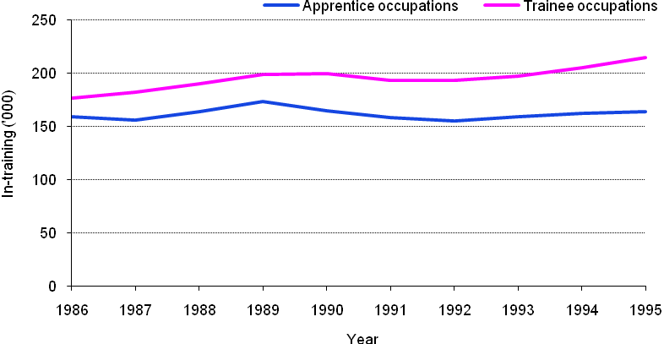

Source: NCVER, unpublished.

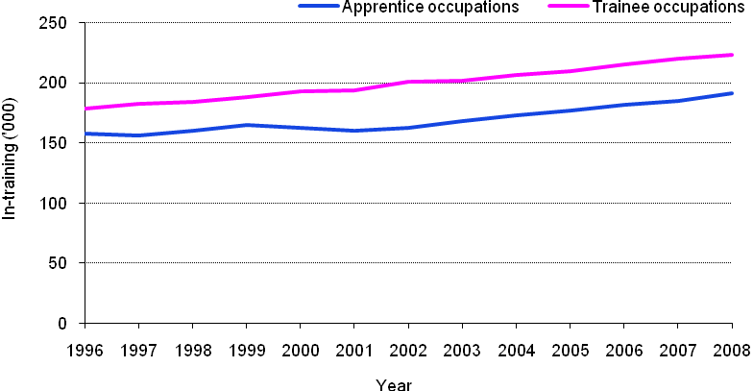
Figure 6 Impact of employment on apprentice and trainee in-training numbers, 1996–2008
Source: NCVER, unpublished.
We stress that these are artificial calculations and are designed to make the point that apprentices tend to work in more cyclical occupations than do trainees.
Finally, some theorising suggests that trainees will not be as badly off in a downturn, relative to apprentices. Cully (2009) argues that the incentives associated with trainees can be thought of as implicit wages subsidies, which in some cases are very substantial. This is because of the interaction between junior and adult wages rates, the duration of the traineeship and the wage incentives. Traineeships are relatively short in duration, which means that the incentives form a higher proportion relative to the wage than is the case for apprenticeships. Cully’s point is that employers will be attracted to trainees relative to other labour because of the high level of wage subsidy associated with them. We also argue that trainees and non-trainees are close substitutes, because trainees are typically in occupations with modest skill requirements. From this it follows that in a downturn employers may well prefer the subsidised trainees to other employees for whom they have to pay a full wage. Thus traineeship numbers may well hold up during the downturn. On the other hand, the number of traineeships did decline a little between 1990 and 1992, mirroring the decline in apprenticeships, but much more modestly. However, this was at a point when the number of traineeships was very low, before the growth that occurred in the late 1990s.

What the research says about how to increase
completion rates
The question how to help apprentices and trainees complete their training has been pertinent both in good and bad economic times. In times of recession or industry decline, governments and industry sectors search for ways to provide continued work for apprentices and trainees so that they can complete their training. When times are good, they are interested in ways to rapidly increase the pool of qualified trades to address issues of skill shortage.
Before we can effectively suggest ways to help apprentices and trainees complete their programs we need to understand why it is that they drop out of training. The reasons for leaving are varied, as we saw earlier from table 2.
The characteristics of the individual apprentice or trainee are also important, including incomplete upper secondary education, low levels of socioeconomic status, family employment status, low levels of English, and female gender (Griffin, Gillis & Coates 2000). Retention has been found to vary across occupational groups (Symonds & Simons 2004; Harris et al. 2001) and over the stage of the apprenticeship or traineeship program itself (Harris et al. 2001). Duration of contract term is also identified as a risk factor for non-completion, with longer durations generally associated with higher non-completion rates (Symonds & Simons 2004; Choy et al. 2008).
Wages are also a factor (see, for example, Bittman et al. 2007), but likely to have less importance during a downturn.
Researchers have suggested a variety of ways to address the risk factors they have identified. Some have made suggestions for improvements in recruitment processes (Cully 2001; Misko 1997) and access to training support, good-quality teachers and supportive and positive workplace environments (Harris et al. 2001, Choy et al. 2008). Others have suggested assistance for English as a Second Language (ESL) apprentices and trainees, adequate induction processes, monitoring and following-up of attendance of those at risk of dropping out, and monitoring and auditing workplace supervision (Griffin et al. 2000). In attempting to explain large differences in the completion rates between states, it was argued that the level of pastoral support was pertinent.
Various strategies have also been implemented to lift completion during economic downturns (Misko 1997) but also during times of economic health (Western Australia Skills Formation Taskforce 2006; Misko 2006; Callan 2008). A common practice relates to establishing good recruitment practices in the first place (Misko 1997; Western Australia Skills Formation Taskforce 2006).
We would think that more highly motivated individuals entering an apprenticeship are better placed to complete their programs because of their innate interest in the industry or the occupation. However, this is not always the case and persistence in the program may actually be reduced if the apprentice comes into the program with high motivation and associated high expectations. Griffin et al. (2000) have found that, although high motivation was associated with higher retention for hospitality and electro-technology apprentices, it had the opposite effect for automotive apprentices.
Noting lower completion rates for those with low levels of secondary education, there are also suggestions for ensuring that students complete Year 12 before starting an apprenticeship (Parliament of the Commonwealth of Australia 2007). The problem with suggesting these types of solutions is that they ignore the impact of personal aptitude and the motivation required for Year 12 completion in the first place.
The use of prevocational programs as methods for recruitment or pre-selection is regularly adopted by employers looking for apprentices. It is hoped that by adopting this approach employers have access to apprentices who have a clearer understanding of what the trade entails, are more motivated, and have completed some of the initial modules (Western Australia Skills Formation Taskforce 2006; Misko 1997).
Group training companies operate by placing apprentices and trainees with host employers for a charge-out fee. A reduction in these charge-out rates by group training companies (building and construction, engineering, and automotive trades) during recessions or times of industry decline is another means to help apprentices and trainees acquire the work experience they need to complete their contracts (Misko 1997). Because the charge-out rates are especially high for fourth-year apprentices, it is not uncommon to discount these so that a placement can be secured. Of course, this may put the group training companies at some financial risk.
When group training apprentices are not in work placements, another typical strategy is to involve them in ‘live work’ projects (Misko 1997) established for this task. In the mid-1990s building and construction apprentices in a number of states were put into housing projects where the group training company used government funds to build houses and sell them. Apprentices were also placed in government-funded community and public building projects where they would do maintenance work on student villages, local nursing homes and general hospitals. Projects other than building have also been used in the same way. For example, in South Australia an engineering industry initiative (supported by government funding) involved renovating a ketch bought by the South Australian Government for jubilee celebrations. To ensure that the labour hours in government-funded projects include a certain percentage done by apprentices, some governments have also made it a condition of obtaining government contracts over a certain price. Group training companies have also sent apprentices further afield (often to big cities) to find placements.
A common solution to a lack of work placements for apprentices and trainees is for group training companies to engage apprentices and trainees in any outstanding formal off-the-job training or to undertake extra training, or relevant short courses. This was the case for electrical trades (which generally did not experience much down time), automotive trades, building and construction, and food trades (Misko 1997). Registered training organisations may waive the need to be employed to complete off-the-job training if the apprentice is nearing the end of the contract.
Encouraging a day off if there is not enough work is another strategy for apprentices and trainees sometimes used by group training companies. However, this cannot last too long, and the policy for some group training companies is to suspend apprentices after ten days of down time (Misko 1997).
In recent years there has been a push to increase completion by implementing early sign-off procedures (Misko 2006). Typically these enable apprentices to have their contracts of training signed off early, if they have completed all of their off-the-job training and 75% of their contract term. In addition to this there has been a concerted effort in recent years to apply other forms of accelerated completions (see, for example, Callan 2008). Typically these accelerated apprenticeships use recognition of prior learning to recognise the practical skills of people with experience in the trades but lacking qualifications or trade certificates. In Western Australia and Queensland these processes have been used to identify any gap training required. The gap training is often undertaken via self-paced training. The problem with using self-paced learning as a mode of learning is that, in many cases, apprentices and trainees in these programs do not always have the language, literacy and numeracy skills required. This also underscores the need to select the right candidates for these accelerated programs. There have been instances where those in accelerated apprenticeships have had to drop out from these programs and return to the traditional programs (Misko 2006).
Another approach used with initial apprentices is to intensify periods of up-front training so that apprentices have undertaken some of the necessary theoretical or underpinning components before they get on the job (Callan 2008; Misko 2006). Shortening the formal term of the training contract duration is another solution to the acceleration of apprenticeship completions. Such approaches have been in place for a number of industries in Western Australia and Queensland (Misko 2006; Callan 2008).
Breaking the training employment contract is not taken lightly by employers, and when ill health or economic non-viability causes them to close down their business or retrench apprentices, they generally attempt to place their apprentices with other employers. Training consultants employed by the state training authority to monitor apprenticeships and traineeships are especially supportive of apprentices and trainees who are displaced and do their best to help apprentices find alternative employment (Misko 1997).
Apprentices, when asked to suggest ways to address the issue of completing contracts in the event of displacement, tend to suggest strategies that have already been mentioned, but do have some other suggestions. One is to have apprentices work on relevant trade jobs (say private vehicles for automotive apprentices) and have a travelling assessor assess the apprentice. Other suggestions include sharing the cost of apprentices between companies, setting up employer list centres, and increasing government subsidies. Using government workshops to complete on-the-job training is also preferred. Suggestions for apprentices to continue with off-the-job training were also supported by apprentices (Misko 1997).

What the latest data show
NCVER publishes a quarterly series on apprenticeships and traineeships. However, the administrative systems on which the publication is based have lags, and thus the latest data we have is for the December quarter 2008. At an aggregate level the numbers of apprentices and trainees appears to be holding up, with the number in training as at 31 December 2008 up 3% from the previous year (see figure 7).
Figure 7 In-training, seasonally adjusted, 1998–2008 (’000)
Source: NCVER (2009a).
However, this impression of strength is misleading, as can be seen if we disaggregate the data.
The numbers in training are derived from the numbers in training at the previous quarter plus inflows (commencements) minus outflows (completions and cancellations/withdrawals). One would expect to see the first sign of a downturn in commencements, and this is exactly what we see. Figure 8 disaggregates commencements by trade and non-trade.
Figure 8 Trade and non-trade commencements, seasonally adjusted, 1998–2008 (’000)
Source: NCVER (2009a).
As we can see, the trade commencements have declined in seasonally adjusted terms between the March and December quarters of 2008, while non-trade commencements have declined a little between September and December quarters.
The seasonally adjusted series are only available for the main aggregates. However, we can compare the December quarter data for 2008 and 2007 at a more disaggregated level. In table 3 we do this, showing individual trades and non-trades at a 1-digit ANZCO level.
Table 3 Apprenticeship and traineeship commencements by occupation (ANZSCO) group, Australia, December quarter 2007 and December quarter 2008
Occupation (ANZSCO group) | Dec. Quarter 2007 | Dec. Quarter 2008 | Absolute change from  Dec 07–Dec 08 | % change from  Dec 07– Dec 08
Managers and professionals | 2 171 | 2 422 | 251 | 11.6
Technicians and trades workers | 17 074 | 14 802 | -2 272 | -13.3
31 Engineering, ICT and science technicians | 735 | 634 | -101 | -13.7
32 Automotive and engineering trades workers | 3 918 | 3 327 | -591 | -15.1
33 Construction trades workers | 4 396 | 3 338 | -1 058 | -24.1
34 Electrotechnology and telecommunications trades workers | 2 151 | 1 783 | -368 | -17.1
35 Food trades workers | 2 409 | 2 166 | -243 | -10.1
36 Skilled animal and horticultural workers | 881 | 1 104 | 223 | 25.3
39 Other technicians and trades workers | 2 584 | 2 450 | -134 | -5.2
391 Hairdressers | 1 576 | 1 407 | -169 | -10.7
392 Printing trades workers | 124 | 142 | 18 | 14.5
393 Textile, clothing and footwear trades workers | 47 | 24 | -23 | -48.9
394 Wood trades workers | 410 | 305 | -105 | -25.6
399 Miscellaneous technicians and trades workers | 427 | 572 | 145 | 34.0
Community and personal service workers | 8 947 | 9 863 | 916 | 10.2
Clerical and administrative workers | 10 079 | 10 657 | 578 | 5.7
Sales workers | 8 403 | 8 959 | 556 | 6.6
Machinery operators and drivers | 5 990 | 5 259 | -731 | -12.2
Labourers | 5 189 | 5 940 | 751 | 14.5
Total | 57 853 | 57 900 | 47 | 0.1
Source: NCVER, unpublished data.
We see sizable declines in most of the trades. However, the March quarter data will be the more interesting because this is the quarter with the highest intakes. Very preliminary data suggest a decline of around 20% in trade commencements relative to a year earlier. It would be foolish, however, to make too much of this because of the large amount of noise associated with this figure.
Consistent with our early theorising, we find that completions are holding up and cancellations and withdrawals are going down (figure 9).
Figure 9 Commencements, completions and cancellations/withdrawals, seasonally adjusted, 1998–2008 (’000)
Source: NCVER (2009a).
It is rather difficult to translate the completions and cancellations/withdrawals into completion rates because of the complicated dynamics. NCVER has estimated completion rates but to date only for cohorts of those commencing long enough ago to negate the reporting lags. An alternative methodology, not following individuals but looking at aggregates, has been employed to provide evidence on completion and attrition rates based on the latest available data. This methodology calculates completion and attrition rates in a quarter and then constructs cumulative ‘life table’ completion and attrition rates. These reflect what completion and attrition rates would be if the patterns observed in a particular quarter remain unchanged for the life of the commencing cohort in that quarter (see Karmel & Harvey, forthcoming, for a technical explanation). Employing this methodology enables us to estimate completion and attrition rates which relate to the patterns at the end of 2007 and the end of 2008. Figures 10 and 11 show attrition and completion rates, respectively, for apprentices.
Figure 10 Cross-sectional attrition rates for apprentices, December quarter, 2007 and 2008
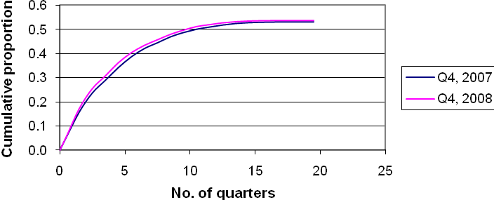

Source: NCVER calculations based on unpublished data.
Figure 11 Cross-sectional completion rates for apprentices, December quarter, 2007 and 2008
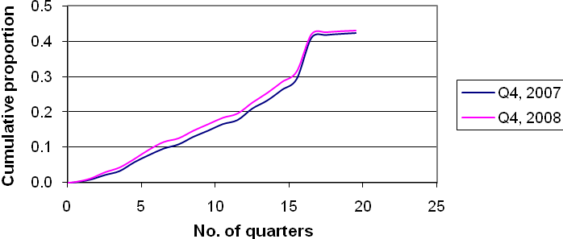

Source: NCVER calculations based on unpublished data.
The cumulative attrition rates are smooth, reflecting cancellations and withdrawals occurring at all durations but at a faster rate in early quarters. By contrast, the completion rate starts off slowly (very short apprenticeships are a rarity), kicking up after 16 quarters, which is the standard period of an apprenticeship for many apprentices. Our interest is in the difference between the patterns for 2007 and 2008. Our earlier theorising was that completion rates would possibly increase. In fact, what seems to have happened is that completions have tended to occur faster, although the overall completion rate is virtually unchanged. Attrition, however, has increased a little rather than decreased, suggesting that employer-initiated cancellations have outweighed employee-initiated withdrawals. Overall, however, the final attrition rate is also unchanged. Our reading is that employers have pushed apprentices through their training, perhaps feeling that it is better to lay off someone who has completed their training than someone who would become an out-of-trade apprentice.
Analogous graphs for trainees are presented in figures 12 and 13.
Figure 12 Cross-sectional attrition rates for trainees, December quarter, 2007 and 2008
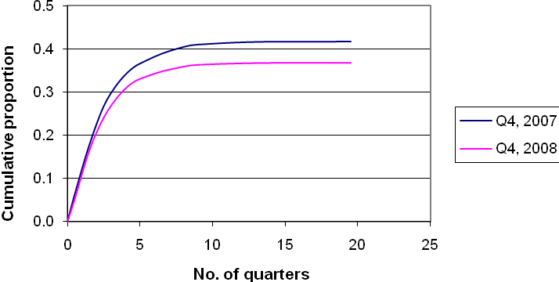

Source: NCVER calculations based on unpublished data.
Figure 13 Cross-sectional completion rates for trainees, December quarter, 2007 and 2008
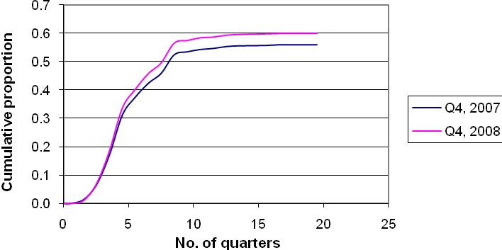

Source: NCVER calculations based on unpublished data.
For trainees, the differences in the completion and attrition rates between the end of 2007 and the end of 2008 are more dramatic, with attrition rates declining and completion rates increasing. The change in the patterns implies an overall reduction in attrition and an overall increase in completion rates. In addition, the implied completion rates for trainees are higher than the implied overall completion rates for apprentices.

Concluding comments
There is considerable evidence that the downturn has hit apprenticeships, although there appears to be a lesser effect on traineeships. Some theorising is also consistent with such a pattern. In terms of what matters, we argue that it is commencements rather than completions that need attention. Governments in the past have tended to focus on minimising the number of out-of-trade apprentices and trainees, and this makes sense in terms of the tragedy of young people being unable to complete their training. But, if anything, completion rates may rise, and the bigger issue is likely to be reductions in the number of commencements in the trades, thus sowing the seeds of future skills shortages. An alternative pathway, akin to but more substantial than pre-vocational training, may be worth considering.
One lesson that we do draw from our analysis is the need to disaggregate the data. Policies need to distinguish between apprentices and trainees and take account of the very different circumstances that apply at the occupation level. Finally, it is worth remembering the genesis of traineeship—the high levels of unemployment in the 1980s. They were seen as a way of reducing unemployment primarily, rather than a skilling strategy. This may be particularly pertinent to disadvantaged groups for which traineeships may be especially important.

References
Ball, K & John, D 2005, Apprentice and trainee completion rates, NCVER, Adelaide.
Bittman, B, Reavell, R, Smith, G & Battin, T 2007, Living standards of apprentices, report prepared for Group Training Australia, University of New England, Centre for Applied Research in Social Science, Armidale, NSW.
Callan, V 2008 Accelerated apprenticeships: Apprentice, employer and teaching staff perceptions, NCVER, Adelaide.
Choy, S, Bowman, K, Billett, S, Wignall, L & Haukka, S 2008, Effective models of employment-based training, NCVER, Adelaide.
Committee of Inquiry into Labour Market Programs 1985, Report of the Inquiry, Chair, Peter Kirby, Australian Government Publishing Service, Canberra.
Cully, M 2001, ‘New Apprenticeships: An unheralded labour market program’, Australian Bulletin of Labour, vol.27, September, pp.204–15.
——2009, Youth wages, training wages and productivity: The economic activity of traineeships, Productivity Commission, Canberra.
Griffin, P, Gillis, S & Coates, H 2000, Factors influencing completion rates of New Apprenticeships: A pilot study, Assessment Research Centre, Melbourne.
Harris, R, Simons, M, Bridge, K, Bone, J, Symons, H, Clayton, B, Pope, B, Cummins, G & Blom, K 2001, Factors that contribute to retention and completion rates for apprentices and trainees, NCVER, Adelaide.
Karmel, T & Harvey, B (forthcoming) Estimating apprentice and trainee completion and attrition rates, NCVER, Adelaide.
Karmel, T & Mlotkowski P (forthcoming), The impact of wages on the probability of completing an apprenticeship or traineeship, NCVER, Adelaide.
——2008, Modelling the trades: An empirical analysis of trade apprenticeships in Australia, 1967–2006, NCVER, Adelaide.
Karmel, T & Virk, G 2006, What is happening to traditional apprentice completions? NCVER, Adelaide.
Kapuscinski, C 2001, Apprenticeships and traineeships in Australia in the last three decades: An empirical overview of the evidence, Department of Education, Training and Youth Affairs, Canberra.
——2004, Dynamics of apprenticeship and traineeship training in Australia: An historical analysis, Research Analysis and Evaluation Group, Department of Education, Science and Training, Canberra.
Misko, J 1997, Getting qualified: Dealing with lack of access to workplace training for apprentices and trainees, NCVER, Adelaide.
——2006, ‘Addressing barriers to employment and training of traditional trade apprenticeships in the Australian mining industry’, a report to the Western Australian Chamber of Minerals and Energy, Perth, unpublished.
Misko, J & Lim, P (forthcoming) Attrition in the trades, NCVER, Adelaide.
Misko, J & Halliday-Wynes, S 2009, Tracking our success: How TAFE institutes measure their effectiveness, NCVER, Adelaide.
NCVER (National Centre for Vocational Education Research) (forthcoming), Historial time series of apprenticeships and traineeships in Australia, 1962–2009, NCVER, Adelaide.
——2009a, Australian vocational education and training statistics: Apprentices and trainees, December quarter 2008, NCVER, Adelaide.
——2009b, Australian vocational education and training statistics: Apprentice and trainee destinations 2008, NCVER, Adelaide
——2009c, Australian vocational education and training statistics: Apprentices and trainees 2008 – Annual, NCVER, Adelaide
Nechvoglod, L, Karmel, T & Saunders, J 2009, The cost of training apprentices, NCVER, Adelaide.
Parliament of the Commonwealth of Australia 2007, Social security amendment (apprenticeship wage top-up for Australian apprentices), viewed May 2009, <http://www.comlaw.gov.au/comlaw/Legislation/Bills1.nsf/0/452449AE379C2698CA2572E6000C5D5E?OpenDocument>.
Queensland initiative Train to retain, viewed May 2009, <http://www.training.qld.gov.au/client/about/programs/skillsplan/unemployed/train_to_retain/retention_practices.html>.
Toner, P 2003, ‘Supply-side and demand-side explanations of declining apprentice training rates: A critical overview’, Journal of Industrial Relations, vol.45, no.4, pp.457–84.
West Australian State Training Board, 2006, Great Southern Consultation Forum: Western Australia, viewed May 2009, <http://www.stb.wa.gov.au/docs/AlbanyForum.pdf>.
Western Australia Skills Formation Task Force 2006, Terms of reference, viewed May 2009, <http://www.det.wa.edu.au/training/training/docs/SESSION_2.pdf>.

Appendix 1: Apprentice and trainee commencements
Table A1 Apprentice and trainee commencements by 2-digit ANZSCO and selected characteristics, for the year ending 31 December 2008
ANZSCO occupation group | Total | % | Selected characteristics (%)  %
 |  |  | Female | > 24 Years | Part-time | Existing Workers
Managers | 6 064 | 2.1 | 69.6 | 53.2 | 31.8 | 45.7
11 Chief executives, general managers and legislators | 0 | 0.0 | 0.0 | 0.0 | 0.0 | 0.0
12 Farmers and farm managers | 967 | 0.3 | 31.2 | 30.7 | 19.8 | 15.0
13 Specialist managers | 4 192 | 1.5 | 84.4 | 54.4 | 39.1 | 49.4
14 Hospitality, retail and service managers | 905 | 0.3 | 41.9 | 71.9 | 10.5 | 61.4
Professionals | 5 307 | 1.8 | 28.3 | 85.3 | 10.1 | 77.5
21 Arts and media professionals | 5 | 0.0 | 60.0 | 80.0 | 20.0 | 80.0
22 Business, human resource and marketing professionals | 4 409 | 1.5 | 22.9 | 88.7 | 2.6 | 84.3
23 Design, engineering, science and transport professionals | 359 | 0.1 | 16.4 | 55.7 | 12.3 | 39.6
24 Education professionals | 482 | 0.2 | 81.5 | 80.1 | 73.9 | 47.3
25 Health professionals | 33 | 0.0 | 90.9 | 51.5 | 54.5 | 45.5
26 ICT professionals | 7 | 0.0 | 14.3 | 42.9 | 0.0 | 42.9
27 Legal, social and welfare professionals | 11 | 0.0 | 63.6 | 36.4 | 27.3 | 27.3
Technicians and trades workers | 85 889 | 29.8 | 15.3 | 20.2 | 9.4 | 12.8
31 Engineering, ICT and science technicians | 3 436 | 1.2 | 21.7 | 44.5 | 18.0 | 34.7
32 Automotive and engineering trades workers | 22 190 | 7.7 | 2.3 | 16.7 | 6.8 | 13.4
33 Construction trades workers | 21 842 | 7.6 | 1.6 | 11.6 | 6.9 | 5.4
34 Electrotechnology and telecommunications trades workers | 11 999 | 4.2 | 2.2 | 22.0 | 3.6 | 9.1
35 Food trades workers | 9 954 | 3.5 | 27.7 | 19.9 | 9.8 | 11.8
36 Skilled animal and horticultural workers | 4 687 | 1.6 | 27.8 | 37.0 | 21.4 | 21.9
39 Other technicians and trades workers | 11 781 | 4.1 | 60.9 | 27.3 | 17.1 | 19.8
391 Hairdressers | 5 738 | 2.0 | 92.1 | 7.6 | 13.1 | 2.4
392 Printing trades workers | 692 | 0.2 | 21.5 | 37.3 | 9.8 | 27.5
393 Textile, clothing and footwear trades workers | 165 | 0.1 | 30.3 | 40.0 | 10.9 | 30.3
394 Wood trades workers | 2 061 | 0.7 | 3.1 | 9.6 | 9.4 | 8.8
399 Miscellaneous technicians and trades workers | 3 126 | 1.1 | 52.3 | 72.5 | 31.3 | 56.8
Community and personal service workers | 44 302 | 15.4 | 71.0 | 47.7 | 60.3 | 20.8
41 Health and welfare support workers | 4 365 | 1.5 | 72.1 | 83.0 | 53.1 | 51.3
42 Carers and aides | 12 869 | 4.5 | 90.7 | 55.2 | 66.1 | 14.4
43 Hospitality workers | 19 207 | 6.7 | 66.1 | 36.7 | 70.7 | 22.4
44 Protective service workers | 2 993 | 1.0 | 27.2 | 73.5 | 14.9 | 16.9
45 Sports and personal service workers | 4 867 | 1.7 | 64.4 | 24.1 | 37.8 | 5.8
Clerical and administrative workers | 54 325 | 18.8 | 63.8 | 56.5 | 20.5 | 41.0
51 Office managers and program administrators | 19 765 | 6.9 | 56.2 | 80.7 | 15.0 | 75.8
52 Personal assistants and secretaries | 0 | 0.0 | 0.0 | 0.0 | 0.0 | 0.0
53 General clerical workers | 14 585 | 5.1 | 82.7 | 21.4 | 28.5 | 5.0
54 Inquiry clerks and receptionists | 10 540 | 3.7 | 55.5 | 51.2 | 23.7 | 21.1
55 Numerical clerks | 4 585 | 1.6 | 76.1 | 56.4 | 23.6 | 35.6
56 Clerical and office support workers | 0 | 0.0 | 0.0 | 0.0 | 0.0 | 0.0
59 Other clerical and administrative workers | 4 850 | 1.7 | 44.6 | 74.6 | 9.0 | 55.6
Sales workers | 41 479 | 14.4 | 64.0 | 26.6 | 58.5 | 25.1
61 Sales representatives and agents | 1 691 | 0.6 | 58.5 | 44.9 | 7.3 | 23.4
62 Sales assistants and salespersons | 39 788 | 13.8 | 64.3 | 25.8 | 60.7 | 25.2
63 Sales support workers | 0 | 0.0 | 0.0 | 0.0 | 0.0 | 0.0
Machinery operators and drivers | 25 741 | 8.9 | 11.6 | 79.8 | 8.3 | 48.9
71 Machine and stationary plant operators | 6 477 | 2.2 | 14.2 | 80.4 | 4.5 | 58.5
72 Mobile plant operators | 2 428 | 0.8 | 3.0 | 75.0 | 3.4 | 54.2
73 Road and rail drivers | 8 485 | 2.9 | 5.4 | 91.3 | 9.6 | 43.8
74 Storepersons | 8 351 | 2.9 | 18.3 | 69.1 | 11.3 | 45.1
Labourers | 25 264 | 8.8 | 31.2 | 56.8 | 34.5 | 21.7
81 Cleaners and laundry workers | 5 005 | 1.7 | 62.5 | 90.6 | 66.9 | 31.5
82 Construction and mining labourers | 1 712 | 0.6 | 7.2 | 42.6 | 24.1 | 13.7
83 Factory process workers | 10 742 | 3.7 | 29.5 | 55.2 | 20.7 | 20.4
84 Farm, forestry and garden workers | 3 069 | 1.1 | 22.0 | 31.5 | 33.9 | 7.0
85 Food preparation assistants | 424 | 0.1 | 43.9 | 21.7 | 64.6 | 1.7
89 Other labourers | 4 149 | 1.4 | 13.0 | 50.4 | 30.0 | 30.1
Total | 288 370 | 100.0 | 42.4 | 42.6 | 28.9 | 27.0
Source: National Apprentice and Trainee Collection, March 2009 estimates.

As a convenience, we label those with a contract of training in the trades (technicians and trades workers in the Australian and New Zealand Standard Classification of Occupations [ANZSCO]) as apprentices and those with a contract of training in other occupations as trainees.
The impact of a downturn on employer-initiated cancellations is purely speculative. However, we do know the impact of downturns on attrition from the trades. Misko and Lim (forthcoming) use ABS data from the survey of labour mobility and estimate that the probability of losing a job (i.e. employer-initiated) was around 6% in 1994 (when the labour market was relatively weak) and 1.4% in 2007 (when the labour market was strong).
We have applied the 2008 training rates to the annual employment data.
Work in progress (Karmel & Mlotowski (forthcoming) is looking at the impact of wages on completion, exploiting data from the NCVER survey of apprentice and trainee destinations.
A good example of an initiative to provide a high level of pastoral support is the collaboration between Regency International Centre and the Food Tourism and Hospitality Skills Council—the ‘Appetite for Success Program’. It combines a case study management approach with industry mentorship to provide apprentices with pastoral care, training advice and technical training while they are in training and when they have completed their training. The program has been successful and negotiations are underway to franchise this to New South Wales and Queensland TAFE Institutes (Misko & Sian-Halliday Wynes 2009).
The figures for the most recent quarters are estimates, and will be revised in later quarters.
The methodology that NCVER has used to calculate completion and attrition rates will be explained in Karmel and Harvey (forthcoming).

