SUPPORT DOCUMENT

Men’s sheds in Australia: Learning through community contexts – Support document
Larning
Barry Golding
Mike Brown
annette foley
Jack Harvey
Lynne gleeson
University of Ballarat

This document was produced by the author(s) based on their research for the report, Men’s sheds in Australia: Learning through community contexts, and is an added resource for further information. The report is available on NCVER’s website: <http://www.ncver.edu.au>.

The views and opinions expressed in this document are those of the author(s) and do not necessarily reflect the views of the Australian Government, state and territory governments or NCVER. Any errors and omissions are the responsibility of the author(s).
© Australian Government, 2007
This work has been produced by the National Centre for Vocational Education Research (NCVER) on behalf of the Australian Government and state and territory governments with funding provided through the Australian Department of Education, Science and Training. Apart from any use permitted under the CopyrightAct 1968, no part of this publication may be reproduced by any process without written permission. Requests should be made to NCVER.

Contents
Appendix 1 3
Survey of Men using the [CUSTOMISED MEN’S
SHED TITLE] 4
Appendix 2 10
Interview and survey protocols 11
Appendix 3 17
Location of men’s sheds in community contexts 18
Appendix 4 20
Brief insights from the interview data 21

Appendix 1

 | Survey of Men using the  [CUSTOMISED MEN’S SHED TITLE]

Thank you for agreeing to complete this survey. It is for completion by men who use ‘Men’s Sheds’- type programs in the community. The aim of the survey is to find out you and what you get from your participation in your men’s shed (Part A, Questions 1 to 6) and also your learning needs & preferences (Part B, Questions 1 to 13). Survey results will be available on request.
You do not need to tell us your name. We will not be reporting any information that can identify you. Please answer the questions by placing ticks ü in boxes or comment where appropriate.

Part A: Questions about you, your experiences and participation in the men’s shed
1. About your experiences in the men’s shed  (Tick one box in each row) | Strongly agree |  | Agree |  | Disagree |  | Strongly disagree
I enjoy being able to make what I want. |  | £ |  | £ |  | £ |  | £
I enjoy being able to come when I want to. |  | £ |  | £ |  | £ |  | £
I enjoy the social aspect. |  | £ |  | £ |  | £ |  | £
I am frustrated by the limited time the shed is open. |  | £ |  | £ |  | £ |  | £
I feel ‘at home’ in the shed. |  | £ |  | £ |  | £ |  | £
I have some say over how the shed is run. |  | £ |  | £ |  | £ |  | £
I have made good friends in the shed. |  | £ |  | £ |  | £ |  | £
I get a chance to mentor others. |  | £ |  | £ |  | £ |  | £
I enjoy the trips or outings. |  | £ |  | £ |  | £ |  | £
It is best to have programs with set times and days. |  | £ |  | £ |  | £ |  | £
The role of the shed coordinator is important. |  | £ |  | £ |  | £ |  | £
It is best to have a mix of men of different ages. |  | £ |  | £ |  | £ |  | £
I would feel comfortable if women participated. |  | £ |  | £ |  | £ |  | £
Someone has to be responsible at all times. |  | £ |  | £ |  | £ |  | £
2. As a result of participating in the men’s shed …  (Tick one box in each row) | Strongly agree |  | Agree |  | Disagree |  | Strongly disagree
… I am doing what I really enjoy. |  | £ |  | £ |  | £ |  | £
… I can give back to the community. |  | £ |  | £ |  | £ |  | £
… I have a place where I belong. |  | £ |  | £ |  | £ |  | £
… I expect to get more paid work |  | £ |  | £ |  | £ |  | £
… I get access to men’s health information. |  | £ |  | £ |  | £ |  | £
… I feel better about myself. |  | £ |  | £ |  | £ |  | £
… I feel more accepted in the community. |  | £ |  | £ |  | £ |  | £
… I feel happier at home. |  | £ |  | £ |  | £ |  | £
3. I regard the men’s shed as a place …  (Tick one box in each row) | Strongly agree |  | Agree |  | Disagree |  | Strongly disagree
… to be with other men. |  | £ |  | £ |  | £ |  | £
… to meet new friends. |  | £ |  | £ |  | £ |  | £
… to get out of the house. |  | £ |  | £ |  | £ |  | £
… to learn new skills. |  | £ |  | £ |  | £ |  | £
… to help me keep healthy. |  | £ |  | £ |  | £ |  | £
4. About your access to skills and tools  (Tick one box in each row) |  | Strongly agree |  | Agree |  | Disagree |  | Strongly disagree
I have limited access to my own tools where I live. |  | £ |  | £ |  | £ |  | £
I have limited access to my own work shed. |  | £ |  | £ |  | £ |  | £
I enjoy working with wood. |  | £ |  | £ |  | £ |  | £
I enjoy working with metals. |  | £ |  | £ |  | £ |  | £
I am frustrated by occupational health & safety (OHS) rules. |  | £ |  | £ |  | £ |  | £
I need more training on some of the equipment. |  | £ |  | £ |  | £ |  | £
5. About you Tick if any of the following apply to you

  - I am a current or former qualified tradesman.
  - I am currently in the paid workforce.
  - I currently have a car licence and drive my own car.
  - I depend on others to get to the men’s shed.
  - I had access to a work shed as a boy.
  - I heard about the men’s shed through friends.
  - I was referred to the men’s shed by a health or welfare worker.
  - I am married or have previously been married.
  - I currently live with a wife or partner.
  - I receive some type of pension.
  - I am a father.
  - I am a grandfather.
  - I speak another language other than English at home.
  - I am an Aboriginal or Torres Strait Islander.

6. About your experiences in the past five years
Tick if you have recently experienced any of the following during the past five years.
In the past five years I have experienced:

  - separation from a partner.
  - separation from the family home.
  - separation from children.
  - an inability to get paid work.
  - a significant loss in my life.
  - a major health crisis.
  - a financial crisis
  - a new impairment or disability.
  - loss of my own tools, work shed or work space.
  - retirement.

Part B About your learning in the men’s shed

1. How often, on average, do you take part in this men’s shed’s activities? (Tick one)
£ Daily £ A few times a week £ Weekly
£ Fortnightly £ Monthly £ Occasionally
£ Never

Please continue at Question 2 on Next Page …
Part B (continued)
2. What type of learning, if any, is available through this men’s shed?
(You can tick more than one answer)
- Computers or internet skills
- Land management skills
- Technical, trade or craft skills
- Team or leadership skills
- Safety or health skills
- Communication or literacy skills
- Hobby or leisure skills
- Customer service skills
- Other learning (Please specify): ________________________________________________

3. Is the learning you receive through this men’s shed useful in other aspects of your life? (Tick any which apply in each row)
Type of learning | Useful at home | Useful at work | Useful in the community | Not  useful
Learning about computers or the internet £ £ £ £
Learning about land management £ £ £ £
Learning technical skills, a trade or craft £ £ £ £
Learning team or leadership skills £ £ £ £
Learning about safety or health £ £ £ £
Learning communication or literacy skills £ £ £ £
Learning hobby or leisure skills £ £ £ £
Learning customer service skills £ £ £ £

4. Please indicate how strongly you agree or disagree with the following statements as they apply to learning in and through your men’s shed. (Tick one box in each row)

STATEMENTS | Strongly agree | Agree | Disagree | Strongly disagree
Members of this men’s shed need more opportunities to learn. | £ | £ | £ | £
There is too much emphasis on learning things I can already do. | £ | £ | £ | £
My skills are already good enough for me to be able to take an active part in this men’s shed. | £ | £ | £ | £
There is too much importance placed on formal learning. | £ | £ | £ | £
There are opportunities to improve my communication skills. | £ | £ | £ | £
Learning is more difficult because of this men’s shed’s isolation. | £ | £ | £ | £
There is not enough recognition of what I already know. | £ | £ | £ | £
I am keen to learn more. | £ | £ | £ | £
I would like to improve my skills. | £ | £ | £ | £
My skills help me learn with others in a team. | £ | £ | £ | £
Difficulties with my skills make it hard for me to learn. | £ | £ | £ | £
I actively take part in the learning opportunities that are offered. | £ | £ | £ | £
Being part of this men’s shed helps me to learn. | £ | £ | £ | £
Opportunities for learning elsewhere in this community are limited. | £ | £ | £ | £
This men’s shed’s small size makes learning easier. | £ | £ | £ | £
This men’s shed should offer more opportunities for learning. | £ | £ | £ | £
- Please indicate how strongly you agree or disagree with the following statements as you think they apply to your men’s shed.
(Tick one box in each row)

STATEMENTS | Strongly agree | Agree | Disagree | Strongly disagree
This men’s shed warmly welcomes new members. | £ | £ | £ | £
This men’s shed is equally welcoming of male & female members. | £ | £ | £ | £
This men’s shed’s resources are available for wider community use. | £ | £ | £ | £
This men’s shed only welcomes men. | £ | £ | £ | £
This men’s shed is well connected to the local community. | £ | £ | £ | £
This men’s shed has strong links outside of the town. | £ | £ | £ | £
This shed’s members are mainly men. | £ | £ | £ | £

6a. If more learning opportunities were available through this men’s shed, would you be interested in taking part?

£ Yes £ Maybe £ No (If No, go straight to question 7)

If ‘Yes’ or ‘Maybe’, which type of learning would you be interested in?
(Tick as many as you like)

A course to get a qualification £
Special interest courses £
In a small group £
Field days or demonstrations £
‘Hands on’ learning £
In a class £
Through the internet £
By taking on responsibility £
Preparation for further study £
Where I can meet other people £
Individual tuition £ Other way ____________________ £

6b. How and where would you prefer these learning opportunities be provided?
(Tick the one box in each column that you would most prefer)

BY … (tick one) |  | IN … (tick one)
- another member of your men’s shed with the appropriate skills  - bringing in a local tutor/ trainer from outside of your men’s shed  - bringing in a tutor/ trainer from outside of your town or suburb  - the internet  - a men’s shed elsewhere in a larger centre  - Other way ___________________ |  | - this men’s shed  - another local community men’s shed  - a local community learning centre or neighbourhood house  - a TAFE  - your home  - a venue outside your local area  - Other location _____________________

Information to help you answer Question 7 Most larger towns and cites have a TAFE college or campus where adults can do courses. When responding to the statements in Questions 7, think of the ‘local’ TAFE closest to where you live.
7. Please indicate how strongly you agree or disagree with the following statements as they apply to your ‘local’ TAFE. (Tick one box in each row)
Statements about your ‘local’ TAFE | Strongly agree | Agree | Disagree | Strongly disagree
I don’t feel comfortable going there. | £ | £ | £ | £
It is valuable to me as a resource. | £ | £ | £ | £
It is a useful place for me to do courses. | £ | £ | £ | £
I don’t know enough about it to use it. | £ | £ | £ | £
I would go there more if more people I knew went there. | £ | £ | £ | £
I would use it anytime if I really needed it. | £ | £ | £ | £
I would go there more often if more men I know went there. | £ | £ | £ | £
It is held in high regard by the local community. | £ | £ | £ | £
It doesn’t offer anything I need to learn. | £ | £ | £ | £
8. Your general preferences for learning (Tick one box in each row)
 | I generally enjoy to learn … | Strongly agree | Agree | Disagree | Strongly disagree
 | in a mixed group including women | £ | £ | £ | £
 | in a group with men | £ | £ | £ | £
 | in practical situations | £ | £ | £ | £
 | in a classroom | £ | £ | £ | £
 | by doing | £ | £ | £ | £
 | on my own from books and other written materials | £ | £ | £ | £
 | in outdoor settings | £ | £ | £ | £
 | via the computer or internet | £ | £ | £ | £
9. I would be more likely to be involved in learning if …  (Tick one box in each row) |  | Strongly agree | Agree | Disagree | Strongly disagree
 | I had more free time | £ | £ | £ | £
 | I had more opportunities locally | £ | £ | £ | £
 | there were more male tutors or teachers available locally | £ | £ | £ | £
 | there were sufficient learning resources locally | £ | £ | £ | £
 | there was somewhere locally I considered a good place to learn | £ | £ | £ | £
 | there was something I really wanted to learn | £ | £ | £ | £
 | I had more support from my family or partner | £ | £ | £ | £
 | I was younger | £ | £ | £ | £
 | this men’s shed was open more often | £ | £ | £ | £
 | my health allowed it | £ | £ | £ | £
 | there were more learning situations where men were encouraged | £ | £ | £ | £
 | programs or courses were available at times that suited me | £ | £ | £ | £
 | I lived closer to the men’s shed | £ | £ | £ | £
 | courses were shorter | £ | £ | £ | £
 | I was more confident | £ | £ | £ | £

OTHER THINGS ABOUT YOU

10. Please tick any statements that apply to you.
  - I am an active participant in this men’s shed.
  - I am a returned serviceman.
  - I have a leadership role within this men’s shed.
  - I began participating in this men’s shed within the past two years.
  - I have special needs (an impairment or disability).
  - I attended a formal learning program some time in the past year.
  - I really enjoyed learning at school.

  - I am retired from paid work.

11. How long (in years) have you participated in this men’s shed? _________

12. Your age:
£ Younger than 20 years  £ 20-24 years  £ 25-34 years  £ 35-44 years | £ 45-54 years  £ 55-64 years  £ 65 years or older

13. Your highest completed formal education (Tick one in each column)

AT SCHOOL …
£ Below Year 9
£ Year 9
£ Year 10
£ Year 11
£ Year 12
SINCE SCHOOL …
£ None completed since school
£ Apprenticeship or Traineeship
£ TAFE Certificate or Diploma
£ University or higher degree
£ Other (add) __________________

Thank you for taking the time to complete the survey
Please place and seal your survey in the envelope and return it to the person at the men’s shed who gave it to you, or post it back as soon as possible (the postage is pre-paid).

Any questions about the project can be directed to the Principal Researcher:
Associate Professor Barry Golding, School of Education, University of Ballarat, P.O. Box 663,
Ballarat Vic. 3353 Ph: (03) 5327 9733 b.golding@ballarat.edu.au
Should you (i.e. the participant) have any concerns about the conduct of this research project, please contact the Executive Office, Human Research Ethics Committee, Research & Graduate Studies Office, University of Ballarat, PO Box 663, Mt Helen VIC 3353. Telephone: (03) 5327 9765

Appendix 2

Interview and survey protocols

Information for the Local Person Responsible for Survey Distribution & Interviews

Advice for Distributing the Surveys
Thank you for agreeing to distribute the survey to participants in your men’s shed (or similar men’s program). You will have up to 15 surveys for completion by up to 15 men – of any age over 18 years - in your program, as well as 15 reply paid envelopes for returning them in. Several copies of more detailed descriptions of the research project for men who request them are also available on a brown sheet.
- If you have more than 15 men in your program, please give it to a sample of men that you feel represents the diversity of men using your shed.
- If you have less than 15 men available to complete the survey, please send the blank forms back (this is important to increase our response rates).
- If you are from a Victorian shed, do NOT give surveys to men who completed the Victorian Men’s Shed survey in November 2005.
A green coloured sheet is also provided to formally record your agreement to ethically distribute and collect the surveys. We invite you to carefully read, sign and return it to us. If you have any questions or concerns about what we’re asking you to do, please contact the person who is doing the site visit and interview (either Barry Golding 53279733 b.golding@ballarat.edu.au , Mike Brown 53279736 mb.brown@ballarat.edu.au or Annette Foley 53279764 a.foley@ballarat.edu.au).

Please note given the small numbers of men surveyed in each program that we will not be reporting data that identifies men in particular sheds or your organisation or program.

Reasons to encourage men to fill the survey out
Some men might wonder and ask why they should fill it out. Please emphasise:
- Very little is yet known or written about the benefits of men’s sheds or the profile or diversity of men using them.
- This is the first ever (‘world first’) national survey of participants across several sheds. It will help inform people and organisations running and funding sheds of the men using them and of the benefits (as well as difficulties) men experience in shed-type programs.
- The combined results will be fed back in a report to all the sheds involved - and be available to the men who take part (though no data will be available on particular sheds).
- The survey and results will be published as part of a national project involving sheds in all Australian States (for the National Centre for Vocational Education and Training through the University of Ballarat).

Thanks a lot: and a reminder to try and account for all 15 surveys. We need as many surveys back – completed of not - by the end of March 2006 at latest.

Details about setting up the interviews are on the other side of this sheet …

Advice for Setting up the Interviews

We want you to organise for us to be able to conduct three small interview groups of with up to four people in each. The group interviews will be recorded with a small portable tape recorder and last approximately 20 minutes each.
- Group 1 will consist of 3 to 4 key stakeholders in the program (e.g. a program and/or shed manager or coordinator, including - in some cases - a program worker or volunteer).
- Groups 2 and 3 will each consist of 3-4 current participants in your men’s shed-type program that are all aged at least 45 years.

Questions for Group: Coordinators and stakeholders:
- Why, when and how did you get started?
- How are you funded and how do you recruit participants?
- Who comes along and why? What do you think they get out of it?
- What have been the difficulties? What kinds of things have helped?
- How could the shed (and the experience of men who use) be improved?
- Any other issues or comments?

Questions for Groups 1 and: Men who participate in the shed
- How did you find out about the shed?
- What do you do at the shed?
- Why do you come along and what do you get out of it?
- What do you like (and don’t you like) about the shed? What could be done better?
- Any other issues or comments that you would like to make?

We suggest you schedule the three interviews in an order that best suits you and your staff and participants – back to back over a total of an hour and a half (i.e. half an hour for each interview) to allow for introductions and completion of consent forms.

In addition to the group interviews, you should allow approximately another hour before or afterwards for the interviewer to chat with you (or else the program coordinator) to collect other background information and take notes about your shed and its programs. Each researcher usually has two sites to visit in one day. Allowing for travel time, the total time the researcher will be with you is usually no more than three hours.

No recorded interview will start until the purpose of the interview has been explained and all participants confirm – by signing the bright blue Statement of Informed Consent – which they understand the reason for and agree to the conditions of the interview. All participants will sign and return the bright blue Statement of informed consent but keep the attached pale blue Plain Language Statement.

Any questions regarding this project can be directed to the Principal Researcher,
Associate Professor Barry Golding, of the School of Education, University of Ballarat
on telephone number (03) 5327 9733
Should you or any participants have any concerns about the conduct of this research project, please contact the Executive Office, Human Research Ethics Committee, Research & Graduate Studies Office, University of Ballarat, PO Box 663, Mt Helen VIC 3353. Telephone: (03) 5327 9765

Shed Site and Interview Details

Name of ‘Shed’ or Program: ………………………………………………………

Town or suburb ……………………………………………

Name of Responsible Organisation ………………………………………………

Name of Contact Person …………………………………………………………

Contact Person Postal Address ……………………………………………………

Phone Number ……………………………………

Email Address …………………………………….

Postal Address ……………………………………
____________________________________________________________________
SHED & PROGRAM DETAILS
Shed Origins:

1. Number of Years the shed has been operating:
………years (or fraction of years)

2. The way the shed developed was (Tick one)
Spontaneous o OR Planned o

3. The way the shed began can be described as (Tick one):
Grass-roots o OR Institutional o

Further comments about shed or program origins _____________________________________________________________________
_______________________________________________________________________________________________________________________________________________________________________________________________________________
Shed Operation:

4. The shed coordination position or facilitation is mainly (Tick one):
Volunteer o OR Paid o.

5. Tick the days the shed is open (Tick any that apply):
Mon o; Tues o; Wed o; Thurs o; Fri o; Sat o; Sun o.

6. The shed is open (Tick one):
All year round o; With shorts breaks only o; Similar to school term time o; As requiredo.

7. The purpose of the shed is (Tick any that apply):
For any men o; For a Specific Group of men o; For either men or women o; Also available for some young people o.

8. Eligibility to become a shed member is (Tick one):
Assessed against criteria o OR Not assessed o

9. Membership to the shed (Tick one): Open to the public o OR
Restricted to members of a particular group o.

10. List up to five main user groups in order from most to least
1. ____________________ 2. ___________________ 3 ___________________
4_____________________ 5. ___________________

11. Use of tools Tick one : Open to anyoneo; Partly restricted o;
Strictly limited to those who have demonstrated competency o.

12. Approximate average number of different individuals who access the shed each week _____

Further comments about the shed operation ______________________________
__________________________________________________________________________________________________________________________________________
Shed Location
13. The shed is: (Tick any that apply)
Stand alone o; Purpose built o; Adapted from an existing shed o;
Built into an existing other buildingo; In a suburban area o.

14. The shed is (Tick any that apply)
On a main street frontageo; In an out of the way area. o.

Shed Facilities and Activities
15. The shed has (Tick any that apply)
A Woodworking activity area o; A Metal working activity area o;
Another Craft Activity Area o (specify____________________)
An area for preparing food o; A shed garden o; An area for socialising outside o.

16. Activities in the shed are (Tick one): Diverse o;
Mainly Focused on one activityo Specify ________________.

17. Activities are decided on mainly by the (Tick one): Group Members o;
Shed Manager or Supervisor o; the Organisation o.

18. Activities are mainly lead by the (Tick one): Group Members o; Shed supervisor/manager o; Volunteers o.

19. ,Activities are (Tick one); o Controlled by clearly defined rules;
Without clearly defined rules o.

20. What is produced mainly (Tick one): Goes to participants o; Is sold to support the organisation o; Is donated to the community o.

Further comments about shed facilities or activities ____________________________________________________________________
__________________________________________________________________________________________________________________________________________

Funding and Resources:

21. Participants pay to attend: Yes o; No o.

22. The shed is: Mainly Funded o; Partly funded o; Unfunded o.

23. Obtaining the funding for this shed was (Tick one): Mostly sought o; Mostly donated o.

24. The main source of the funding for this shed can be considered (Tick one):
General funding (for anyone) o; Discrete funding (for men’s programs) o.

25. At present, this shed is (Tick one): Adequately funded o; Under funded o.

26. Our shed: Is o Is not o …dependent upon other resources than funding.
Explain________________________________________________.

Further comments about shed funding or resources: _____________________________________________________________________
__________________________________________________________________________________________________________________________________________

Shed Relationships:
27. Our shed is (Tick one): Embedded and located within a larger organisation or institution o; Part of a larger organisation but separately located o.
Completely stand-alone o.

28. The future of this shed: (Tick one): is Secure o; Insecure o.

29. Name the shed (if any) on which your shed is most closely modelled on OR
similar to: ______________________________________________ (Specify).

30. Are women welcome as participants? What are the policies and procedures on women’s involvement? Who decides? How were these decisions made?

………………………………………………………………………………………………………………………………………………………………………………………………………………………………………………………………………………
ATTACH ANY ADDITIONAL NOTES and any other info FROM THE SHEDS

Appendix 3

Location of men’s sheds in community contexts

Figure A1 Location of men’s sheds in community contexts in Australia
(open or planning to open, July 2006; centred on Postcodes)
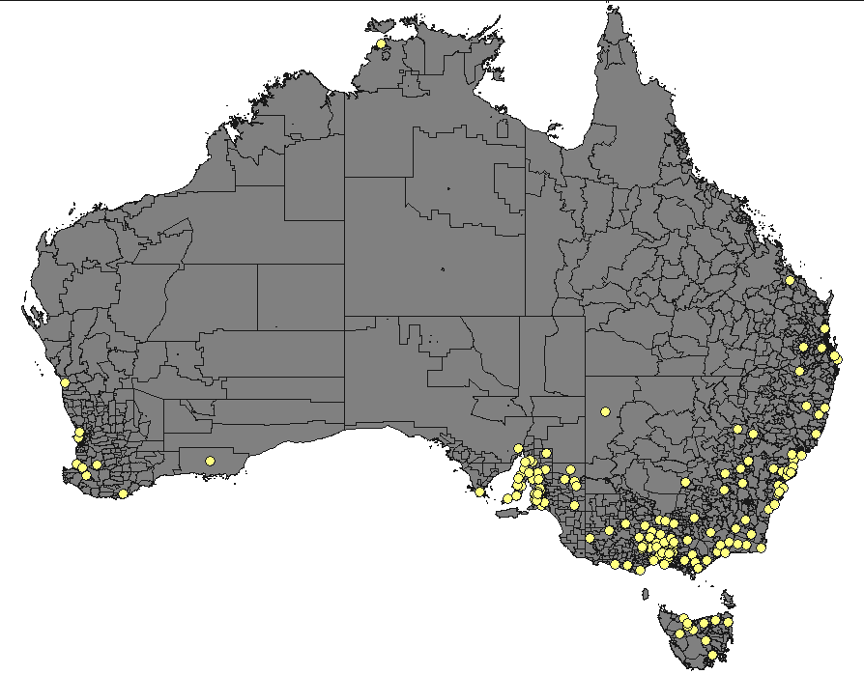

Figure A2 Location of men’s sheds in community contexts in south-eastern mainland Australia
(open or planning to open, July 2006; centred on Postcodes)

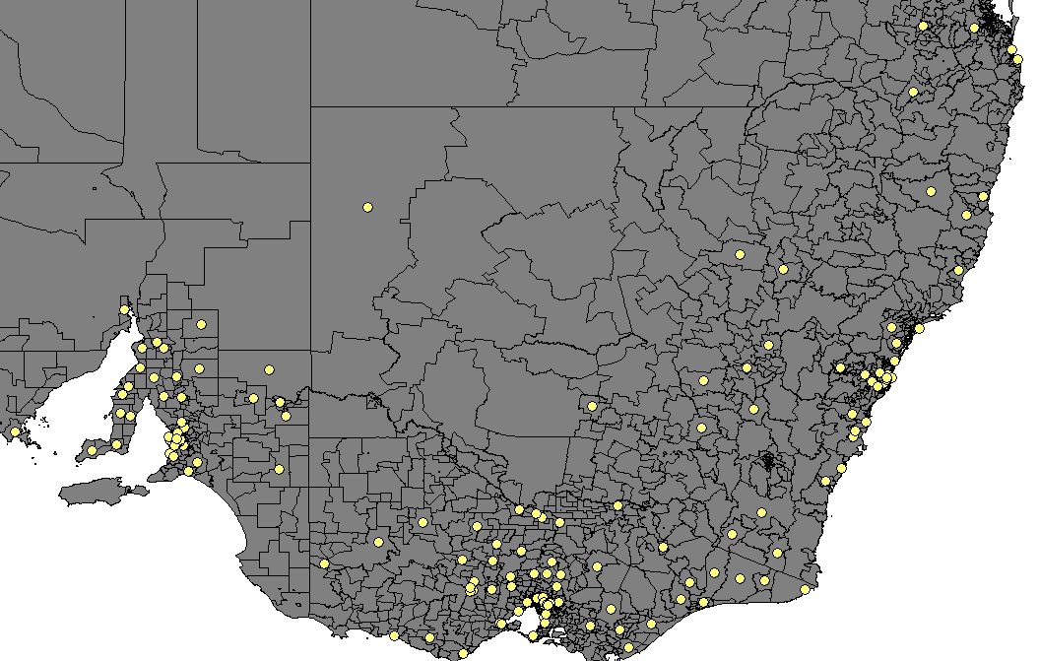

Appendix 4

Brief insights from the interview data
While the quantitative data cited in the research report derive primarily from surveys completed by male men’s shed participant, our findings and insights have also been shaped by insights from the interviews that researchers conducted on-site with participants, managers and mentors in each shed. The necessary brevity of the main report means that the use of direct quotes from the extensive qualitative interview data has not been possible. This Appendix briefly examines the experiences and attitudes of shed participants using a narrative lens. It gives the reader a brief opportunity to hear some of the rich narrative data and allow a small number of men in the study to tell their own stories. This use of direct narratives acknowledges the relationship between self and the environment through individual stories that illustrate the complex, sometimes ambiguous and shifting journeys of lived experience and self identity (see for example, Polkinghorne, 1988; Chase, 2005; Gubrium and Holstein, 2001; Clandinin and Connelly, 1994). The narrative form of inquiry can allow individuals to share personal beliefs, and transmit values through data. The brief insights from the interview data that follow illustrate only some of the many themes identified within the data.

Why men participate

The data tell us that men participating in the sheds do so for a myriad of reasons: perhaps no single reason can be identified specifically. We already know from the quantitative survey data that there are some common themes, which appear in the interview data as common stories told by the men that highlight their desire to participate. Some of these stories are associated with their desire to become involved or ‘interact’ with and connect to a place and people where they can feel comfortable and relaxed. Other stories tell about coming to the shed to ‘get away from the wife’, or as a way of managing a health issue.

- “When you retire you don’t always retire with skills and you can come down here and learn a few and it gives you something to work at, it gives you an outlet.”
- “I think it’s very important conversation-wise, some people know things you don’t know.”
- “When you retire you haven’t got anything to do so you tend to hang around the house too much.”
- “It’s an outlet for a bit of banter, a bit of shit-stirring, bit of bonding. If you come along with … a bit of affliction or a bit of a down you can switch off and just have a coffee.”
- “There’s no pressure to do any work here. If you don’t feel like doing anything and if you just want the company and you want to talk to somebody, by all means come along.”
- “It’s a good comfortable place where the guys don’t have any barriers, you can relax a little … It’s flexible, you are not bound up, you can really fit it into your time frame.”
- “You are picking up another person’s expertise and helping out and you pass on some of the stuff you have learnt. That’s a big point.”
- “I come here purely to get away from the wife at times and give her some space, because when we were together every day we were arguing, fighting, looking like having a divorce. So this gives me the opportunity of building some things, getting some satisfaction out of life instead of sitting home and vegetating.”
- “I come out here simply because if you stop at home with depression and your wife says something to you …you explode, and then you cause this conflict in the household. … I prefer to come out here than go anywhere else because it’s [an] open space and we are not locked in … the doors not closed. We can get up and go home any time we want.”

Learning

Learning and skill acquisition was identified as an important theme in the data with men referring to the sheds as being seen as ‘places of learning’. For some of the men, coming to the shed enabled them to obtain skills they had never had the opportunity to gain in the past. Others were participants for several learning-related reasons, one being able to pass on ‘traditional’ skills to others in a friendly and informal environment:

- “I didn’t know too many people when I came along and whilst I like doing things with my hands, I don’t have much expertise … but I find the learning experience fantastic because there is always someone here who knows more than yourself.”
- “I haven’t made a thing here yet, but it doesn’t matter, I just come and sweep the floor and feel good about that and it’s good having other blokes around to have a yarn with and I’m learning skills here too. My eyes are open.”
- Three things I reckon … I pass on skills, which not many people have left, traditional skills, I enjoy doing that, it gives me satisfaction. I find it helps me, particularly in the boring latter stages of my life to have at least a semi-formal environment to go to … . If I’m home I don’t stop work and I always bugger myself up and end up not being able to work for three months. … Not here, I am restricted to the times … and the other thing is being free to talk about mateship, that it does exist and it exists here and that’s important.”

Friendship

Evidence from the data fully supported the importance the sheds had in the development of men’s ‘mateship’, ‘friendships’ and ‘social enjoyment’ as also anticipated in the previous quote.
- “Men’s companionship, this is why I think personally that [I come] … it’s not that we hate you [referring to the female researcher], it’s that we need the men bonding thing and that’s what happens here and it’s great, you can come here and you can always get a coffee and someone is going to be nice to you.”
- “I get friendship and when people come to me and say, “I really enjoyed that,” that gives me satisfaction and also a lot of people have come to me and said it’s a very safe environment for them to come, and that makes them feel really good. So that’s what I get out of it. Social activity, friendship, makes friends with the guys and you get a lot of help from other people on the project and ideas. And learn new skills.”

Health and wellbeing

A key finding evident in many conversations was the overt and in some cases subtle effects that participation in the men’s sheds had on the health and well being of the men. In some cases the spill over effects of the health benefits to their families and communities are regarded as important:
- “There are a lot [of men] who haven’t got facilities for themselves or who can get out. With a space like this you can do something and have one or two others around at the same time and have a communication … [and] perhaps later on … have programs on men’s health and things like that that can bring the community together.”
- “‘Colin’ the blacksmith is 70 this year. … [His wife] gave [the shed coordinator] a letter the other day to hand on to say that she can see the improvement in Colin’s health since he started coming down to the Shed, and he comes down with tears in his eyes on a Saturday morning, he really enjoys coming … if we could be open more often.”
- “In a lot of areas of my life I feel powerless, but here at the shed I have got a chance to use my skills and do something … we are all really good at something and just to learn and to teach and to share is a great experience which really benefits my mental health.”
- “We probably become less of a burden on the health system because … the mind is active … We are taking less drugs to keep us going.”

What participants have got out of it

A wide range of key themes was identified in the data relating to what men gain from participating in the men’s sheds. Some of these include a sense of ‘enjoyment’, ‘socialising’ with ‘like minded people’, a sense of community, feelings of being ‘relaxed’, and feelings of contribution and ‘giving back’.
- “I quite enjoy sitting around with the rest of the blokes and having a bit of a yarn.”
- “I am a Vietnam Veteran and I go through a few problems and this sort of helps … It makes me feel more relaxed and it gives me something to do. I like the people I work with. We have some men who come out once a week who have recently lost a partner. They generally last about three months – after that they get assimilated back into society as such and find their way again. … In most cases it has probably been a lifetime partner of about 50 years.”
- “I remember coming here [to the shed] a couple of times and things were getting too much. I had heaps of support, people who knew where I was at and what was going on … and I wasn’t too embarrassed to bawl my bloody eyes out when things were too much.”
- “I am a morose old bastard at home and this is where I come to socialise and loosen up. It takes my mind off other things.”
- “I feel more relaxed when I go out with my people because they’re the same as me.”
- “For 36 years or so I have kept stuff that I have locked away because I was starting to break down. … I can come here and talk with people with like minds who have seen the same places and had the same problems. Things we can’t communicate even with our wives … with even our doctors and even our own psychologists. We can talk to each other about things and understand each other.”
- We took on mainly Indigenous boys - aged from 9-15 - who were at risk … who wouldn’t even go to school because school was boring. They came along to the shed, they got one-on-one [mentoring], they made lovely projects, they had a feeling of achievement, they wanted to go on to TAFE, they didn’t want to go on to school, but enjoyed what we were doing manually.”
- “The Shed gives that opportunity to have that comradeship or whatever rather than the pub or café that aren’t crash hot all the time. It’s the common sense and purpose that’s linked through machinery and tools.”
- “[My wife’s] glad to see me get out and away from under her feet ... At this stage of your life you wear each other out being around all the time. You need separate interests.”
- “I [suffer from post traumatic stress disorder and] come here to give myself a break from other people, my wife and family, to get away and get my rocks off … let off steam, anything that has been built up, I can basically do anything I want here, I’m a free agent. I think places like the Shed definitely have places in ex-military people’s lives … I fear for the more recent ex-military people of his country because I don’t think we have learnt our lesson. … We need places like this to help them come back.”

Some wider benefits

Many of the men were proud of their community contribution, which, in many cases, involved making things for the local community or repairing community assets. Other benefits were evident in the training programs for school children involving the shed, such as VCAL (Victorian Certificate of Adult Learning: an alternative Year 12 stream) and VET in schools programs.

- “We hope to be able to teach some of the high school kids a few skills, which might make up their mind what they are going to do when they grow up.”
- “We have kids from the local primary school come here … over 50 kids a week … on a weekly basis.”
- “We don’t have an extended family here so it’s really good for us [to bring our son here] to have that father, grandfather person in their lives. Our boys see a lot of inappropriate male behaviour and this kind of modelling [at the Men’s Shed that] I want my boys to [see] which is really positive. It’s one of my husband’s long requests to provide boys with the opportunity to link with men away from the influence of women and learn men’s business from men. (Female interviewee: a parent supervising her own and other children in a Men’s Shed.)
- “[My wife’s] happy, I’m happy but more to the point my whole family is happy.”
- “Well what I do mostly is I make casts and I make little gifts for people and make chairs and tables for kids. A lot of the needs are in the community … what I am working on now is two key boxes, one for the Hospital and one for the Community Centre where they can put their keys in so that they don’t lose them.”
- “[I make] letter boxes and stuff for the community hospital and chopping blocks. We go around the community and fix fences and stuff like that for old people when they need it done and whatever other little jobs come in.”

