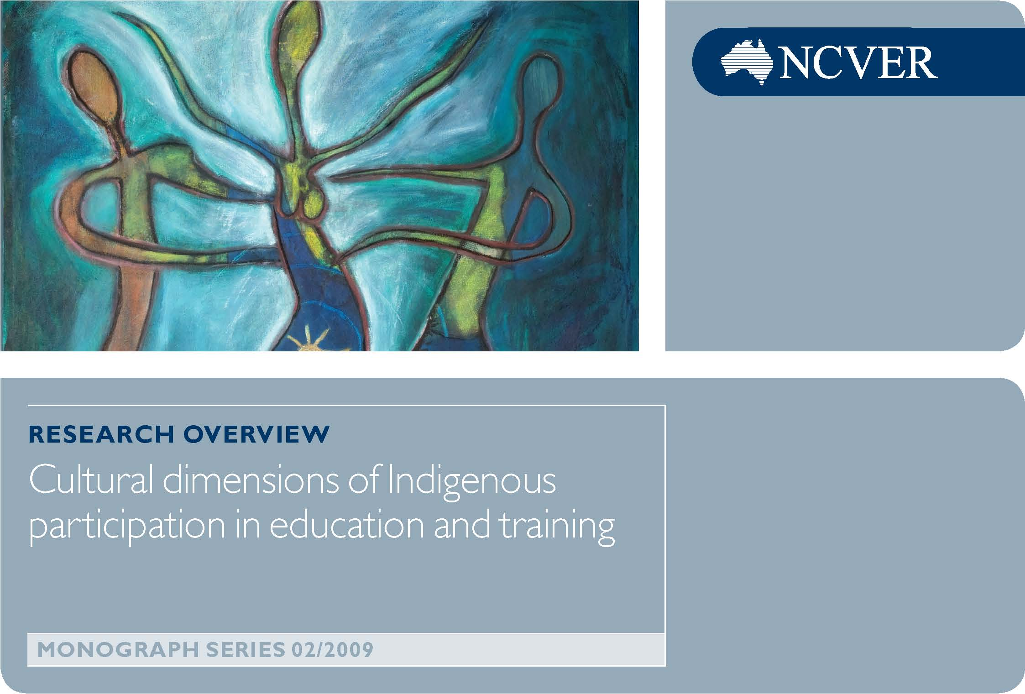

The preservation of Indigenous culture is an important issue in Australia, as is the need to ‘close the gap’ in the living standards between Indigenous and non-Indigenous people.
The report Cultural dimensions of Indigenous participation in education and training by Mike Dockery looks at the role of Indigenous culture in shaping Indigenous Australians’ participation in education and training, and improving their performance.
There have always been two main approaches to this challenge: integration of Indigenous people into ‘mainstream’ society; or maintenance by Indigenous people of a more traditional life, which has been characterised by cooperation and coexistence between members, with less emphasis on individual ownership of possessions. In the past, attachment to their culture was seen as a barrier to economic success because it limited Indigenous people’s access to the most important means of achieving that success: education and training.
Cultural attachment is a difficult concept, and one which could be interpreted in a variety of ways. In this report—which is Dockery’s first exploration of the subject—cultural attachment was gauged by each person’s sense of their own identity and their connection with, and participation in, traditional activities (such as ceremonies and dances, rituals, art, stories, and customs). Dockery measured a sense of identity by looking at whether individuals spoke their traditional language, recognised their traditional homelands, or identified with clan or language groups. He also recognised that, although the term ‘Indigenous culture’ is the one commonly used, in reality there is considerable diversity in cultures among Indigenous people from different regions.
Based on a statistical analysis of survey data, the report found that attachment to traditional culture had an ‘enabling’ effect on Indigenous people and encouraged them to take part in education and training programs. This adds strength to the view that maintenance of Indigenous culture not only has a value in its own right, but may also play an integral role in improving Indigenous people’s participation in mainstream Australian life and their wellbeing. Those who were more attached to their traditional culture had better education and training outcomes—Dockery believes this is due to a greater sense of self-esteem and personal identity, and a close network of community support.
Statistical evidence came from the 2002 National Aboriginal and Torres Strait Islander Social Survey of almost 10 000 Indigenous people aged 15 years and over. The survey looked at the highest level of education gained and whether students participated in a vocational education and training (VET) course in the 12 months leading up to the survey. Data showed that educational outcomes and attachment to culture varied and depended on an individual’s location.
The way that the data were analysed is key to the findings. When Indigenous students living in all locations were looked at as one group, then strong cultural attachment seemed to lead to poorer educational participation. However, when he looked at them as two separate groups—Indigenous people living in metropolitan areas and those living remotely—then within each group, those with stronger attachment to their culture had more success in the educational system.
Thus, in non-remote areas, Indigenous people who had a strong attachment to their culture were more likely to participate in vocational education and training than those without that attachment. Indeed, a strong sense of cultural heritage and pride was seen to go together with a drive to undertake training and achieve successful employment. Given the importance of education as a means of reducing Indigenous disadvantage, this finding goes against the assumption that there is a trade-off between preserving a sense of culture and achieving economic and social success.
There was also a link between the fields of study chosen and Indigenous culture. Students selected subjects which complemented their cultural pursuits, such as creative arts and, to a lesser extent, building and architecture. Another finding was that those who were more attached to their culture were drawn to further literacy and numeracy training, which would improve a student’s chance of achieving employment.
In remote areas the benefit of such attachment is more tenuous and difficult to prove, partly because access to education is so limited by location. However, there is a clear finding that those with strong cultural attachment are much more likely to finish high school. Dockery surmised that lower participation in education and training in remote areas may be due to a lack of incentives. The strong interdependence between the individual, their community and the place in which they live characterises traditional Indigenous groups and leads to a greater emphasis on work which contributes to the community. Higher-level certificates, in particular, don’t seem to be attractive to those in remote areas. This may be attributed to the fact there are fewer more conventional employment opportunities in remote Australia.
This study is a complex one and raises as many questions as it answers. Although it shows a positive relationship between a strong sense of culture, and educational and economic success, it also highlights the obstacles to pursuing educational opportunities for Indigenous Australians living in remote areas, particularly those difficulties relating to the cultural need to stay closely connected to the land. In addition, the most popular courses for Indigenous students are in areas where few jobs are available, such as the creative arts. This shows the huge challenge which the VET sector faces in both improving access to services for those who live remotely, and in providing Indigenous people with courses which reflect the different values and interests of their culture, and which are both relevant and meaningful to their lives.
This overview is based on the research report, Cultural dimensions of Indigenous participation in education and training by Alfred Michael Dockery. Visit <http://www.ncver.edu.au/publications/2174.html> for more information.
© Commonwealth of Australia 2009
Produced by NCVER, as a part of the NCVER monograph series, on behalf of the Australian Government and state and territory governments, with funding provided through the Australian Department of Education, Employment and Workplace Relations. The author/project team was funded to undertake this research via a grant under the National Vocational Education and Training Research and Evaluation (NVETRE) Program. These grants are awarded to organisations through a competitive process in which NCVER does not participate.

