Forecasting future demands:
What we can and cannot know

Sue Richardson

Yan Tan

National Institute of Labour Studies,
Flinders University
The views and opinions expressed in this document are those of the author/project team and do not necessarily reflect the views of the Australian Government, state and territory governments or NCVER.

Publisher’s note
Assessing the reliability of the MONASH labour market forecasts: Some comments on a report by the National Institute of Labour Studies is a response by GA Meagher to the report by Richardson and Tan. It can be accessed from NCVER’s website <http://www.ncver.edu.au>.
© Australian Government, 2007
This work has been produced by the National Centre for Vocational Education Research (NCVER) on behalf of the Australian Government and state and territory governments with funding provided through the Australian Department of Education, Science and Training. Apart from any use permitted under the Copyright Act 1968, no part of this publication may be reproduced by any process without written permission. Requests should be made to NCVER.
The views and opinions expressed in this document are those of the author/project team and do not necessarily reflect the views of the Australian Government, state and territory governments and NCVER.

The author/project team was funded to undertake this research via a grant under the National Vocational Education and Training Research and Evaluation (NVETRE) Program. These grants are awarded to organisations through a competitive process, in which NCVER does not participate.
The Consortium Research Program is part of the NVETRE program. The NVETRE program is coordinated and managed by NCVER, on behalf of the Australian Government and state and territory governments with funding provided through the Department of Education, Science and Training. This program is based upon priorities approved by ministers with responsibility for vocational education and training (VET). This research aims to improve policy and practice in the VET sector. For further information about the program go to the NCVER website <http://www.ncver.edu.au>.
ISBN 978 1 921170 68 3 web edition
TD/TNC 90.03
Amended August 2007, pp.16–17
Published by NCVER
ABN 87 007 967 311
Level 11, 33 King William Street, Adelaide, SA 5000
PO Box 8288 Station Arcade, Adelaide SA 5000, Australia
ph +61 8 8230 8400 fax +61 8 8212 3436
email ncver@ncver.edu.au
<http://www.ncver.edu.au>
<http://www.ncver.edu.au/publications/1744.html>

Foreword
In 2004 the National Centre for Vocational Education Research (NCVER) invited proposals from consortia of researchers to address questions relating to changing work skill needs and work organisation arrangements and their implications for the vocational education and training (VET) sector. NCVER subsequently contracted the National Institute of Labour Studies, Flinders University, and the Centre for Post-compulsory Education and Lifelong Learning, University of Melbourne, to undertake a body of work in this area, focusing on the relationship between the country’s future skill needs and the VET system.
This research was undertaken under the National Vocational Education and Training Research and Evaluation program, a national research program managed by NCVER and funded by the Department of Education, Science and Training on behalf of the Australian Government and state and territory governments.
This report is one of the outcomes of the research consortium and addresses the crucial issue of future labour demand, with a focus on the demand for vocational skills. As such, it will be of interest to VET policy-makers and planners and industry trainers.
In order to meet industry requirements in terms of the supply of necessary and appropriate skills, the VET sector needs to have the capacity to anticipate these requirements. This report examines how VET planners might do this in the context of an unpredictable and complex economy, noting that Australia, like other Organisation for Economic Co-operation and Development (OECD) countries, uses computer models of the economy to predict future employment patterns. The report argues that, essentially, the challenge is how best to manage the unavoidable uncertainty about the future of skills demand.
Readers interested in the topic of skill shortages are referred to other reports published through this consortium*, in particular, What is a skill shortage? by Sue Richardson.

Tom Karmel
Managing Director, NCVER

Contents
Tables and figures 6
Key messages 7
Executive summary 8
The demand for vocational skills 11
Introduction 11
Labour force ageing 12
Trends of vocational skills demand 13
Link between occupation and skill level 16
Uncertainties in demand forecasts 19
Factors impacting on skill demand 19
Review of forecasting methods in relation to skill demand 22
Comparison of outcomes with forecasts of the MONASH model 26
Other ways of looking forward 30
What is to be done? 33
References 35
Support document details 37
Appendix 1: Skills consortium publications 38

Tables and figures

Tables
1 Occupational employment, shares for males and females, 1997–2004 15
2 Major occupation groups and requirements for skill levels
or qualifications 16
3 Students enrolled for VET major qualifications, 2001 18
4 Forecasts of net replacement needs in 2002–06, Australia 31

Figures
1 Age structure of the population and labour force, 2004
and 2015 12
2 Labour force 2004–15, projected gains 13
3 Growth in employment in all jobs and in trades jobs,
1986–2005 14
4 Average annual growth rates of employment by occupation, persons, 1996–2005 15
5 Distribution of qualifications by occupation, Australia, 2004 17
6 Comparison of actual and projected growth rate of
employment for all occupations, 1993–94 to 2002–03 27
7 Comparison of predicted and actual change in employment
for selected occupations, 1996–2002 28
8 Comparison of actual and projected employment of
Electrical trades and drivers, 1996–2003 29
9 Comparison of projected and actual employment in
selected occupations, 2003 30

Key messages
The vocational education and training (VET) sector seeks to teach courses that will meet future demands from employers in terms of the quantity and types of skills required. The question is how does the VET sector anticipate what these future demands might be in the context of a rapidly evolving economy.
This report is part of the larger research program, ‘A well-skilled future: Tailoring VET to the emerging labour market’.
- The MONASH model for projecting future skills needs is of high quality by international standards, but the complexity of the economy is such that it is not possible to make accurate projections of future skill needs in any detail, or for more than a few years into the future.
- New VET graduates play only a modest part in filling expanding skilled vacancies; other sources of supply are people who learn the required skills on the job and people who already have the required skills, but who are working in other jobs, are out of the labour force or are unemployed, or are migrants.
- VET planners should not try to match training to projected skills needs in any precise way; they should instead focus on distinguishing skills that are in growing demand from those in declining demand, and on skills that take a long time to learn (and to gear up to teach).
- VET planners also need to anticipate areas where there are large numbers of people with specific skills who will leave employment in the forecast period, that is, replacement demand.

Executive summary

Introduction
This report is a component of the research program, ‘A well-skilled future: Tailoring VET to the emerging labour market’. This research program examines the evolving labour market and changing work organisation and management in the context of the vocational education and training (VET) sector and its role in the development of the appropriate levels, types and quantities of skills required to satisfy the future demands of Australian industry. The research reports have been produced by a consortium of researchers from the National Institute of Labour Studies, Flinders University, and the Centre for Post-compulsory Education and Lifelong Learning of the University of Melbourne.
The VET sector seeks to teach courses that will meet future demands from employers in terms of the quantity and types of vocational skills required. If changes in the quantity and types needed by employers can be anticipated, then we can avoid the development of redundant capacity (excess people and excess capacity in teaching institutions). We can also make it easier for employers to find the skills they need, at the time when they need them, and in the places where they need them. Computer forecasting models are often used for this purpose. However, no model, no matter how carefully and cleverly constructed, can hope to remove fully the uncertainty involved in dealing with the future. This is especially so when the forecasts need to be broken down by type of skill and by region before they become useful for planning.
This study examines how economists construct their projections of future skills demand; evaluates how successful the principal models used for skills projections are; and discusses how the VET sector should respond to the unavoidable uncertainty about the shape of future skills demand.

The demand for vocational skills
The demand for vocational skills is not observed directly, but is usually inferred from the number of people who are employed in occupations deemed to require those skills. In practice, many people in higher-level occupations do not have the level of formal education designated for such work. For example, associate professionals are deemed to require diploma or advanced diploma. In practice, only one-third of people employed as associate professionals are qualified at this level or higher. Even in instances of those working as tradespersons and related workers, one-third has no post-school qualification at all.
In general, the levels of formal education of the Australian workforce are not high by Organisation for Economic Co-operation and Development (OECD) standards, but they have been rising. Younger cohorts have more education than older cohorts. The proportion of the working-age population with post-school qualifications in Australia increased from 39% to 51% over the ten years up to 2004. The proportion of those with a bachelor degree or above rose markedly, from 12% to 19% over the same period. By contrast, the proportion of people with VET qualifications (advanced diploma/diploma or below) has only increased slightly (by three percentage points).
Most of the growth in demand for skills has been for those at higher levels (that is, university degrees or diplomas). In the 18 years since 1986, total employment grew by about 40%, while employment of tradespersons and related workers grew by only about 8%. Associate professionals and professionals have been the occupations with the fastest rates of growth.

Uncertainties in demand forecasts
It is extremely difficult, in both theory and practice, to forecast how the demand for labour is going to evolve—beyond a few years into the future. Economies are complex and dynamic and are affected by many forces that cannot be predicted with any confidence. Major influences on the economy include: new technology; the macroeconomic state of the domestic economy and of the economies of trading partners; the amount of capital investment and its distribution between industries; changes in governmental policy; and the interaction of these factors. The changes in demand for skills reflect technological innovation, the strategies that industries adopt to increase productivity, and the tastes of eventual consumers. Even the best of the forecasting models do only a moderate job of projecting total output and employment for a number of years into the future. Their accuracy falls rapidly as the projection horizon extends, as the types of skills become more disaggregated, and as projections are made by region.
Despite the difficulties, many OECD economies, including Australia, have models of their economies which they use to project employment by quite disaggregated levels of skill. These models are complex, large and dynamic. The one most widely used in Australia for skills forecasting is the MONASH model, which ranks as one of the best of its kind in the world. It is difficult to evaluate the accuracy and reliability of the forecasts of such models, because such evaluations can only occur some time after the forecasts are made. Where there have been evaluations, they generally conclude that the models are of some value, but mainly as indicators of overall trends and interdependencies. When they are used to forecast the growth in occupations in any detail, they are often out by 10 or 20% within a few years. Our own comparisons of projections with outcomes for the MONASH model confirm that, over a nine-year period, its projections diverged substantially from the actual outcomes for a number of occupations. Indeed, even at the major occupational group level, the direction of change was in some cases incorrect—projecting growth when there was decline and vice versa. This inaccuracy is a reflection of the difficulty of the task.

What is to be done?
How should the VET sector decide what to teach in the light of the virtual impossibility of reliable projections of the demand for skills at the necessary level of detail for course planning?
We emphasise that the labour market is dynamic. People are constantly changing their jobs, learning new skills from their work, moving to new locations, moving in and out of the labour force, changing the number of hours per week they work. At the same time, firms are being born, growing, dying, declining, altering the size and skill set of their workforce, recruiting strategic new skills, training some of their existing staff with the additional skills they find they need. By these means, via the continuing search of employers and workers for a good match, shortages and surpluses usually sort themselves out over time. In all of this, formal vocational education has an important, but modest role to play. It is a misunderstanding of how the labour market adjusts to think that there is a direct, one-to-one relation between an expansion in output, the associated increase in skills needed to produce that extra output, and a requirement for the VET system to provide those extra skills.
Indeed, there is only a loose match between the qualifications that people have and the jobs they do. Many people have qualifications they do not utilise in their current job. Many also work in jobs for which they have no formal qualification. So it is important to appreciate that the VET sector does not need to attempt to identify every future skill vacancy and then train someone to fill it; rather, there is much to be said for focusing on what people want to study, as well as on what future employers are anticipated to need. Individuals themselves will have a feel not only for what they like and are good at, but where the future job opportunities lie. VET planners should not try to match vocational education and training to projected skills needs in any precise way; instead, at the system-wide level, VET planners should focus on distinguishing skills that are in growing demand from those in declining demand, and on skills where replacement vacancies (for example, from retirement) are likely to be large.
There is no need to put serious effort into forecasting the demand for skills that are quite quickly and easily learned. The demand for these skills can be met at the time, if the need actually eventuates. Rather than attempting to forecast, with all the attendant errors in over- or underestimating the true outcomes, it is preferable to have effective systems for rapidly identifying emerging trends and for responding to them.
At the same time, there is value in the VET sector being able to align the broad structure of its offerings with the future needs of the economy. Here, the best strategy is likely to require a combination of steps. These include the following.
- Use the best available model of the economy to project the expected growth or decline of occupations and the volume of replacement vacancies, at a fairly broad level.
- Check these projections against other sources of information, such as those contained in the job prospects listing compiled by the Department of Employment and Workplace Relations.
- Confine these projections to around five years and update them regularly with the latest information.
- Where more detail is required, retain an Australia-wide focus and disaggregate by skill level or type.
- Where a regional labour market is important, use local information from employers’ associations, graduate destination surveys, recruitment agencies and similar sources to refine the broad projections.
- Undertake separate, bottom-up, high-quality studies of expected skills demands for those major skills that take a long time to learn and to gear up to teach—it is for these that the ability to make accurate projections is of most importance.

The demand for vocational skills

Introduction
The vocational education and training (VET) sector seeks to teach courses that will meet the future demands from employers in terms of the quantity and types of skills required. If changes in the quantity and types of vocational skills needed by employers can be anticipated, then we can avoid the development of redundant capacity (in people and in teaching institutions). We can also make it easier for employers to find the skills they need, at the time when they need them, and in the places where they need them.
Many attempts are made to forecast labour demand. These range from the most aggregate level, of forecasting total employment (for example, by the Australian Bureau of Statistics [ABS]), to forecasts of employment by types of jobs in more or less detail (for example, by the Department for Employment and Workplace Relations, the MONASH model and many recent efforts at state level). But projecting the size and shape of the future workforce is no simple task. No model, no matter how carefully and cleverly constructed, can hope to remove fully the uncertainty involved in dealing with the future. This is especially so when the forecasts need to be quite disaggregated by type of skill and by region before they can be useful for planning. This study examines how economists construct their projections of future skills demand; evaluates how successful the principal models used for skills projections are; and discusses how the VET sector should respond to the unavoidable uncertainty about the shape of future skills demand.
The study focuses on the meta-level: reviewing and identifying best practice for forecasting and planning vocational skills policy. It seeks to provide an understanding of how projections of future skills needs are made and the extent to which they may be relied on for planning the capacity of the VET sector. The study also aims to gain an understanding of what we know about the shape of future labour demand, by analysing those aspects of labour demand that can be projected with reasonable confidence. We examine the reasons why it is difficult to make reliable forecasts of future skill needs, in order to understand better how much reliance can be placed on such forecasts. We review existing international and Australian efforts to forecast the patterns of future skill demands and evaluations of their success. We present recent trends in the demand for vocational skills as one guide to how the near future is likely to evolve. We conclude with a discussion of how the VET system might manage the inevitable uncertainty about future skills requirements that even the best forecasts are unable to remove.
The study endeavours to answer questions raised by the current labour demand forecast methodologies for projecting skills demand by industry and occupation. These questions include the following.
- Why is it so hard to get robust projections of future skill needs?
- Do the best examples of model-based forecasting of the demand for skills provide an adequate basis for planning of VET capacity?
- How can policy-makers best manage the irreducible uncertainty about the shape of future skills requirements?
We start with an overview of some of the main features of demand for vocational skills. This gives a background against which we can examine in more depth the challenges of forecasting future skills needs.

Labour force ageing
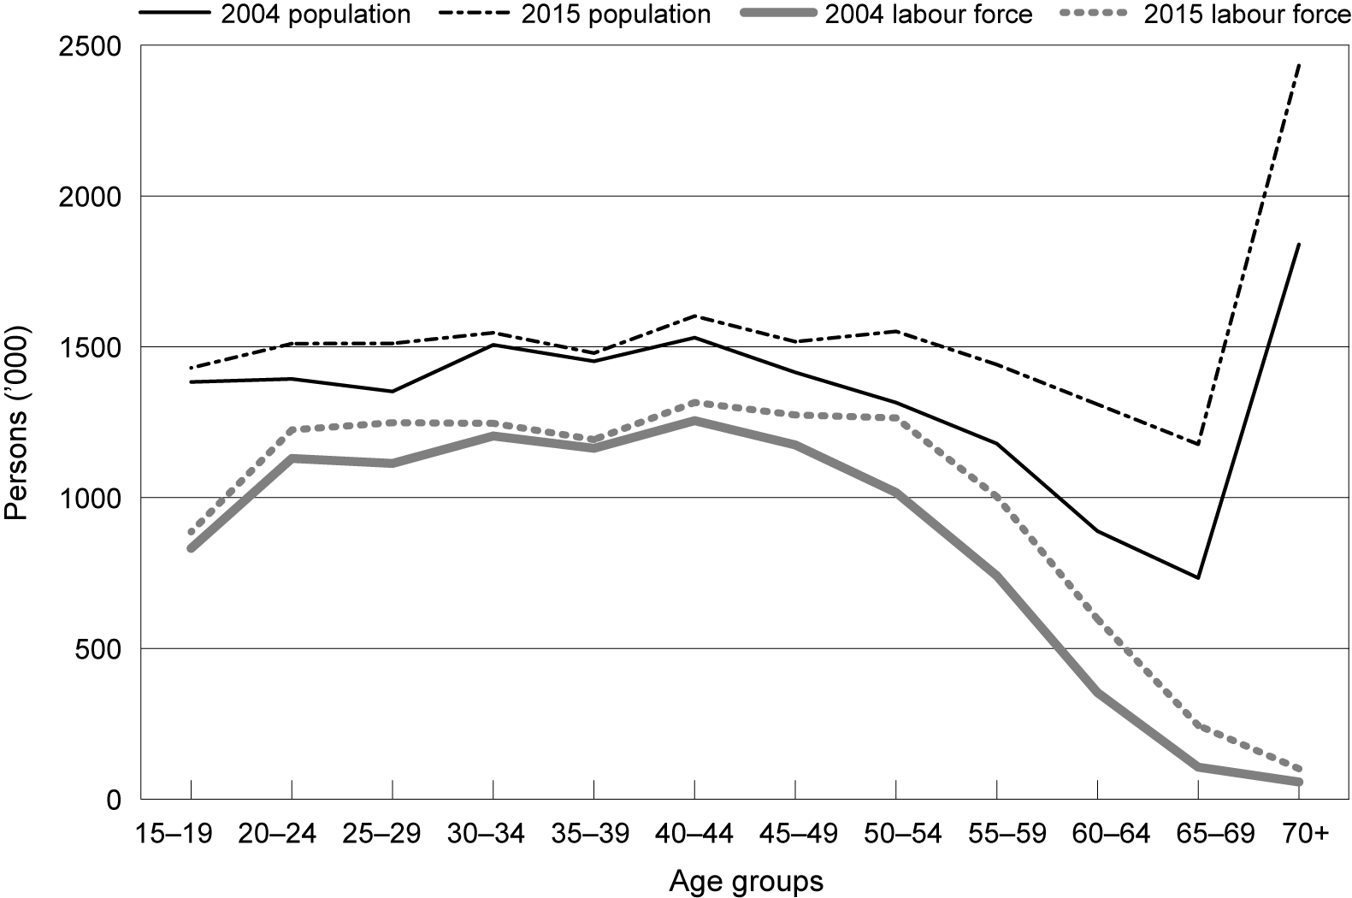
A prominent fact about the workforce as we look forward is that, as with the population more generally, it will gradually get older. More than 71% of the projected growth in the workforce between 2004 and 2015 will be in the 45 years and over age group (figure 1). In 2004, 12% of the labour force was aged 55 and over. Yet this age group is anticipated to increase to 17% in 2015, accounting for 48% of all growth in the labour force. The 55 to 59 and 60 to 64 years age groups will grow most rapidly, accounting for 11% of the labour force in 2004, but accounting for more than one-third (35%) of the total growth in the labour force from 2004 to 2015.
Figure 1 Age structure of the population and labour force, 2004 and 2015
Source: Adapted from the population and labour force projection of the Productivity Commission (2005)
While those aged 20 to 44 years made up 58% of the labour force in 2004, they are projected to contribute only 25% of the growth between 2004 and 2015. Males in this age group represented 32% of the labour force in 2004, but are projected to contribute only 7% of the growth (an additional 573 632 males) over the period 2004 to 2015.
By 2015, 15 to 19-year-olds in the labour force are projected to rise by around 7% (54 704 more than in 2004). There are significant differences between the percentages of change of each age-sex specific group, as shown in figure 2. Among these age groups, except for the groups of 30 to 34 years and 35 to 39 years, the expected percentage increase of the female labour force is greater than that of the male labour force, especially for the 55 to 69 age group. This reflects the different labour force participation trends of the sexes, with rising participation for women and falling participation for men.
The change in the age structure of the population and of the workforce will have complex consequences for the demand for skills and for training. One avenue of impact is the change it will bring in the patterns of consumption. A second, direct impact on the demand for training will be through the acceleration in the rates of retirement. This will increase the need for training to replace the exiting workers, even if there is no net growth in employment in a particular skill/occupation.
Figure 2 Labour force 2004–15, projected gains
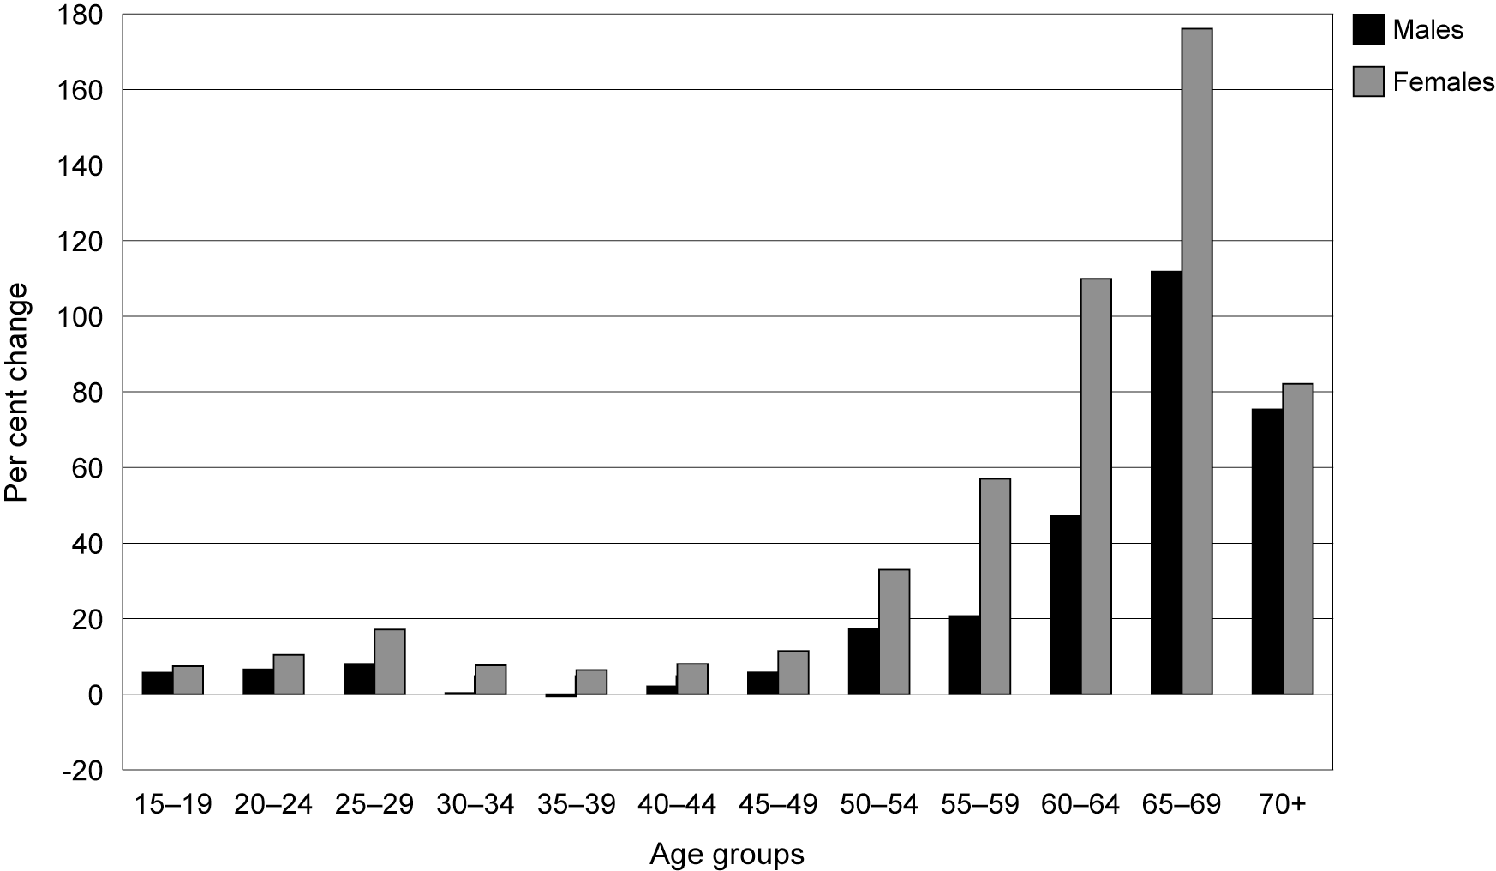
Source: Adapted from the population and labour force projection of the Productivity Commission (2005)

Trends of vocational skills demand
We use occupation as a proxy for demand for skill, because there are few sources of information that give a direct indication of the types of skills demanded. It is usual also to assume that the actual number of people employed is the same as the number demanded (that is, that employers can find all the vocationally skilled people they require). There are no direct data on demand per se. Thus, our picture of the demand for skills is based on the number of people employed in occupations that require such skills. Vocational education covers much more than just the trades occupations. But for illustration, and because the trades are a very important component of vocational skills, we begin with the story of what has happened recently to demand for tradespeople.
Figure 3 shows the growth in employment of people in trades jobs, by comparison with the growth in total employment in Australia, from 1986 to 2004. Each series is expressed as an index number, with 1986 set as the base year with a value of 100. A value of 106, for example, shows a 6% increase in employment over the base year level. The figure shows the uneven rate of growth of trades employment over time. During the late 1980s, trades employment grew at almost the same rate as total employment. But for a decade after that, it first fell, then was stagnant. In 2002, the absolute numbers employed in trades jobs was the same as a decade earlier. The past three years have seen a return to modest growth. The upturn is caused in part by the high levels of construction and mining activity since 2003. Figure 3 also helps us to understand why young people have not been eager to seek trades apprenticeships. For over a decade, the only job opportunities in the trades were coming from replacement of people who left. They did not look like the place to go for a career with good job prospects and security.
Figure 3 Growth in employment in all jobs and in trades jobs, 1986–2005
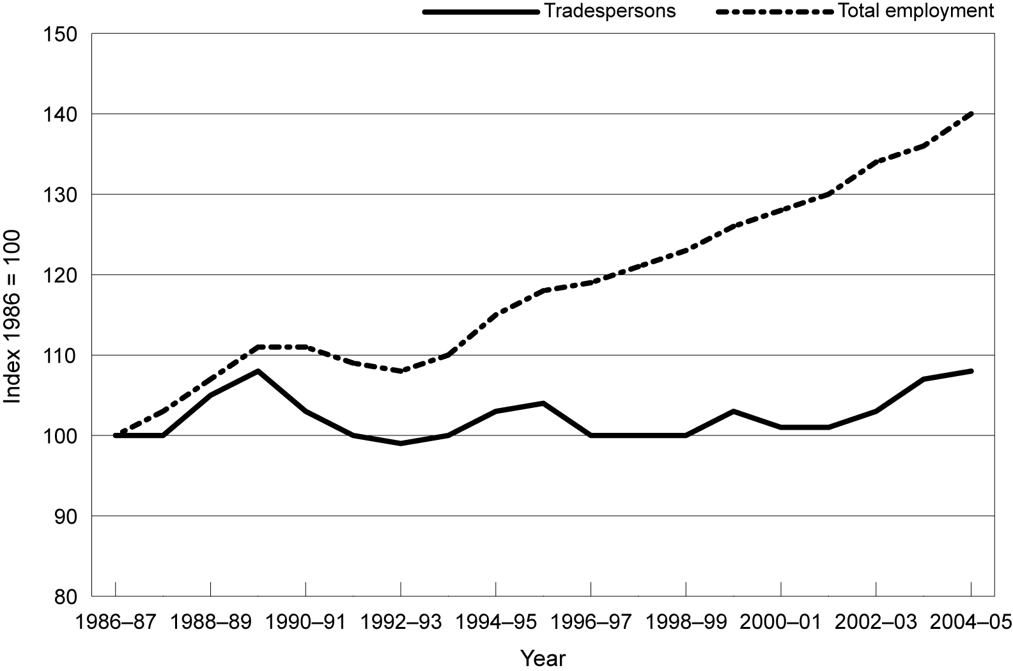
Source: ABS (2005)
Will the longer-term propensity for the demand for trades skills to stagnate reassert itself? Or does the recent kick upwards in trades employment signal a shift to a new higher-growth rate? Methods of projecting the future have particular trouble when past trends have kinks, such as that observed for the trades.
Figure 4 shows how the rates of employment growth per annum from 1997 to 2004 have varied widely for different occupational groups. The average growth rate of all occupations was 1.96% per annum. In terms of the annual average growth rates, associate professionals has the strongest growth at a rate of 4.2% annually, followed by managers and administrators (3.3%), professionals (3.2%), and intermediate clerical, sales and service workers (1.7%).
The other four occupational groups, namely, tradespersons and related workers, elementary clerical, sales and service workers, intermediate production and transport workers and labourers and related workers, have experienced growth rates substantially lower than the average total growth rate. The growth rates of the first two groups were just above 1%, at 1.1% and 1.7%, respectively. The latter two groups had less than a quarter of the total growth rate. Furthermore, there was a decline in the absolute number of advanced clerical and service workers (-0.4%). The figure shows that not only has growth been very uneven for the different occupations, but that the fastest growth has been at the high skill end. Most of the growth has been in occupations for which university rather than VET qualifications are required, or for which no formal qualifications are required.
The sex composition of employed persons in the nine major groups of occupations varies greatly (table 1). A much greater proportion of male workers are employed as managers and administrators, tradespersons and related workers, intermediate production and transport workers, and labourers and related workers. In contrast, a much higher percentage of female workers are employed as advanced and intermediate clerical, sales and service workers and elementary clerical, sales and service workers. A slightly higher percentage of females than males works in professional occupations, and this percentage is rising. It will be noted that the percentage of female workers employed as associate professionals has continued to grow, while the proportions in most occupations remain almost unchanged.
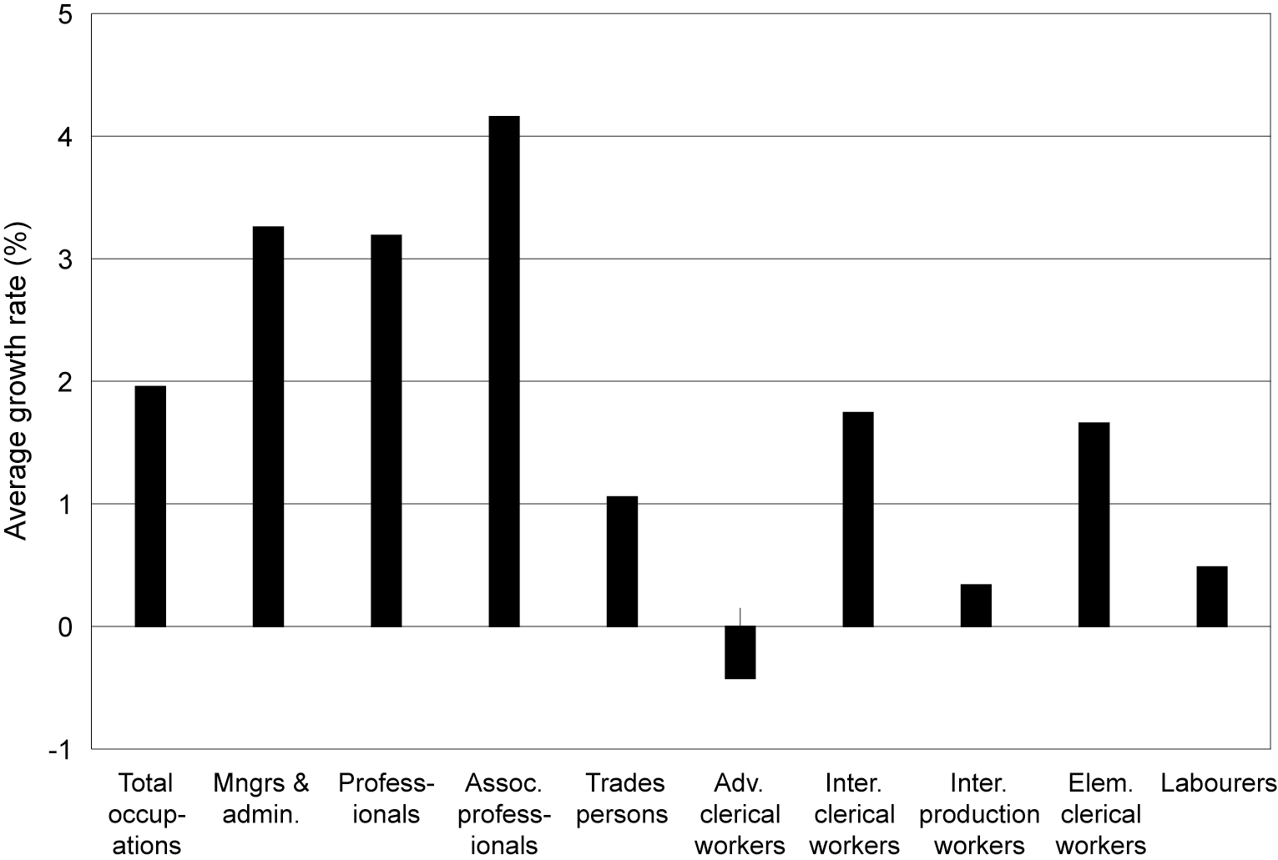
Figure 4 Average annual growth rates of employment by occupation, persons, 1996–2005
Source: ABS (various years)
Table 1 Occupational employment, shares for males and females, 1997–2004
Occupations dominated by males
ASCO code | Occupations | Share of  males | Share of females | Scale of change
1 | Managers & administrators | 73–77% | 23–27% | Moderate drop for males
4 | Tradespersons & related workers | Some 90% | Less than 10% | Almost unchanged
7 | Intermediate production & transport workers | 86–88.4% | 14–11.6% | Varying slightly
9 | Labourers & related workers | 62.5–64.5% | 37.5–35.5% | Slight rise for males
Occupations dominated by females
ASCO code | Occupation | Share of  males | Share of females | Scale of change
5 | Advanced clerical & service workers | Less than 12% | Some 88% | Almost unchanged
6 | Intermediate clerical, sales & service workers | Less than 22% | Some 78% | Almost unchanged
8 | Elementary clerical, sales & service workers | 35.2–33.2% | 64.8–66.8% | Varying slightly
Other occupations
ASCO code | Occupation | Share of  males | Share of females | Scale of change
2 | Professionals | 49.2–41.6% | 48.4–51.8% | Moderate rise for females
3 | Associate professionals | 63.2–57.6% | 36.8–42.4% | Large rise for females
Note: ASCO = Australian Standard Classification of Occupations.
Source: ABS (various years)

Link between occupation and skill level
This section looks at the relationship between major groups of occupations and the associated level of qualifications usually required to do the job. Table 2 shows the major occupational groups and corresponding skills requirements for entrance to those job tasks in each specific group.
Table 2 Major occupation groups and requirements for skill levels or qualifications
ASCO code | Major group | Skill level | Commensurate levels of qualifications
1 | Managers and administrators | 1 | Bachelor degree or higher qualification
2 | Professionals | 1 | Bachelor degree or higher qualification
3 | Associate professionals | 2 | Diploma/advanced diploma
4 | Tradespersons and related workers | 3 | Certificate III/IV
5 | Advanced clerical and service workers | 3 | Certificate III/IV
6 | Intermediate clerical, sales and service workers | 4 | Certificate II
7 | Intermediate production and transport workers | 4 | Certificate II
8 | Elementary clerical, sales and service workers | 5 | Certificate I or completion of compulsory secondary education
9 | Labourers and related workers | 5
Source: ABS (1997)
The first three groups of occupations (coded 1 to 3) have higher requirements for skill or qualification levels. These occupations include various groups of managers, financial dealers, various professionals (for example, scientists, media and arts occupations), and most technicians. This part of the workforce has the potential and capacity to interact directly or through corporations with the world’s knowledge-based economy. Competition and demand for managerial/administrative, professional/associate professional skills not only exist within the Australian labour market but also globally.
The associate professionals, trades and related workers, advanced and intermediate clerical, sales and service workers, and intermediate production and transport workers tend to have VET qualifications. Occupations in these groups are closely associated with ‘insulated occupations’ and ‘vulnerable occupations’ (see the discussion below on globalisation). Competition for insulated occupations is largely locally based. Vulnerable occupations cover a range of skill requirements, ranging from specialised trade skills to basic manual skills.
The link between occupations and qualifications in practice (as distinct from that implied in the occupational classification) is shown in figure 5. Within managers and administrators only around 32% of the employed persons had a bachelor degree or higher, the expected qualification held by people in that occupational group. This compares with some 68% of professionals. For associate professionals, the proportion of employed persons at the expected or higher qualification level was 34%. One matter of interest is the 35% of managers and administrators qualified below the expected qualification level and the 32% without any post-school qualifications. The same concern extends to the 21% of professionals qualified below the expected qualification level and some 10% without post-school qualifications. This may be partly a function of the number self-employed within these two occupational groups. It suggests that the link between occupations and qualifications is quite loose and imprecise. Many people are able to acquire the skills they need for work in high-level occupations on the job or informally: they have been able to do this without going through the formal educational system. Richardson (2004) provides evidence that the amount of this informal learning on the job exceeds the amount of learning provided through the vocational education system, in any one year. This has important implications for the way in which demand for skills (qualifications) is projected. In practice, most projections rely on forecasting the changing pattern of occupations and infer from that the change in the qualifications that will be needed.
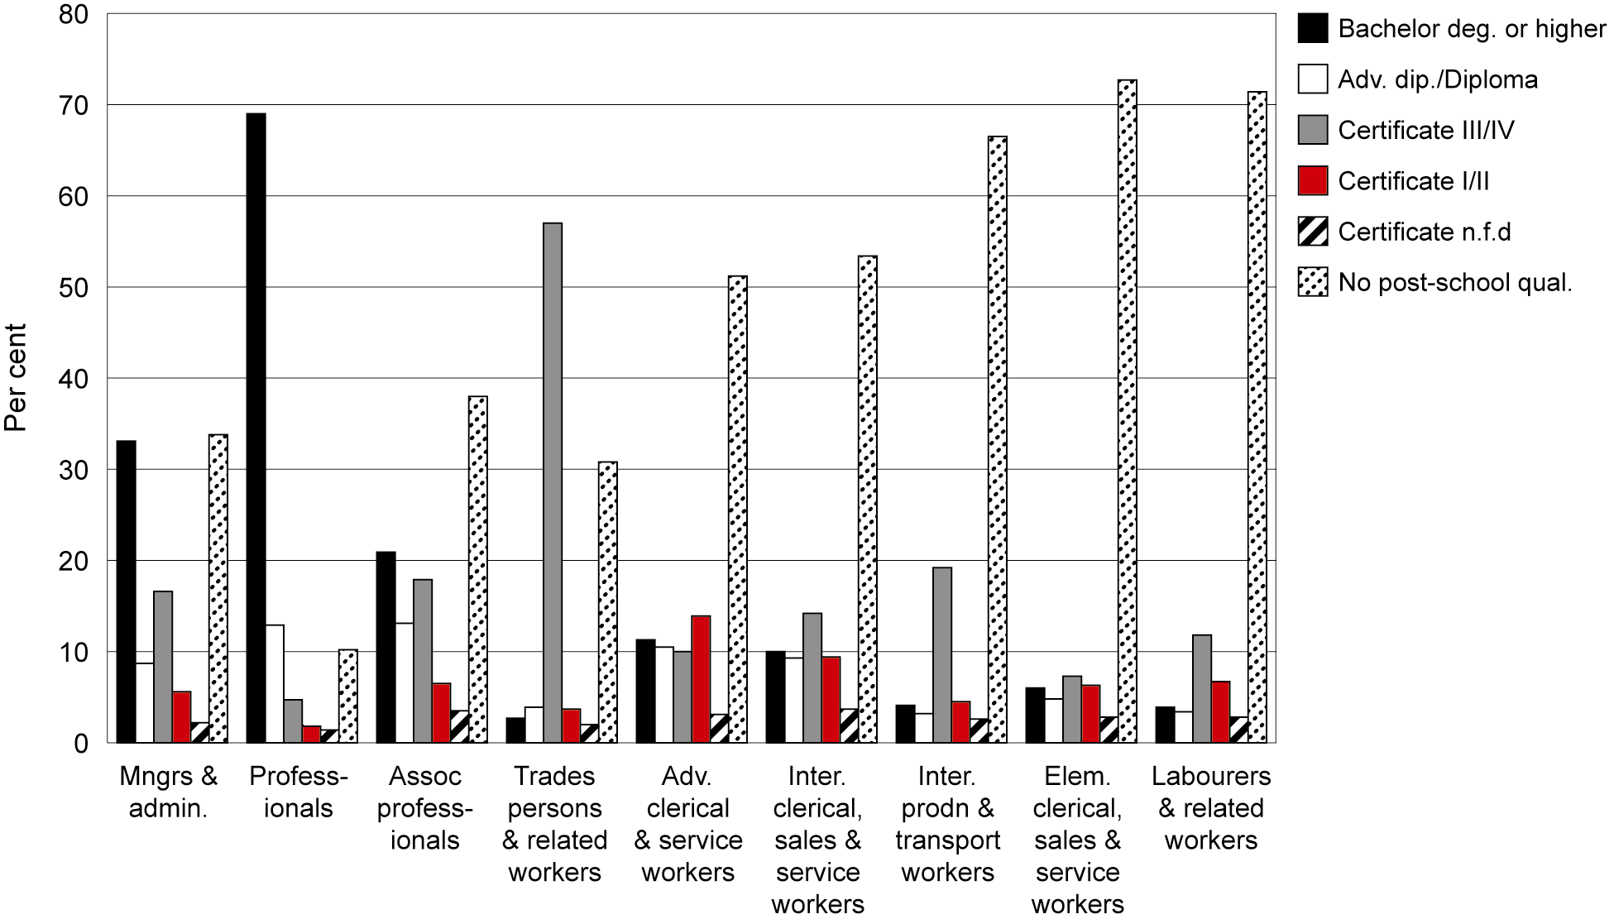
Figure 5 Distribution of qualifications by occupation, Australia, 2004
Source: Calculated from ABS (2004)
Those occupations which have high proportions of their employees with either no post-school qualifications or a certificate qualification are labourers and related workers (92%), tradespersons and related workers (92%), intermediate production and transport workers (92%), elementary clerical, sales and service workers (88%), intermediate clerical, sales and service workers (78%) and advanced clerical and service workers (74%). For tradespersons and related workers, a majority (54%) of all workers are qualified at certificate level III/IV. In terms of meeting the expected skill levels for their occupational group, professionals have the highest congruence between expected and actual qualifications (68% are qualified to bachelor degree or higher), followed by tradespersons and related workers (62% qualified to certificate level III or above), and intermediate clerical, sales and service workers (45% qualified to at least certificate II level). By sharp contrast, up to one-third of the workforce employed as managers and administrators, associate professionals, advanced clerical and service workers and intermediate production and transport workers are not qualified to the expected skill level. Those employed as elementary clerical, sales and service workers and labourers and related workers had more than one-third of employees (36% and 35% respectively) holding qualifications of certificate I or above.
In 2001, there were 1 198 400 students enrolled in VET courses (at certificate and diploma level and excluding ‘level unknown’) in Australia (table 3). The large proportion of them (40.7%) was studying for certificate II/III. Students pursuing certificate IV and diploma or higher qualifications amounted to 202 400 (11.5%) and 190 000 (10.8%), respectively. The total combined figure pursuing vocational qualifications represented 64% of overall students studying in VET programs in that year.
While those in ‘low skilled jobs’ may not necessarily require formal post-school qualifications to perform well, there is a need for their skills to be maintained and updated to keep pace with new forms of production and working practices that create demands for new skills and behaviours (Bloom et al. 2004). Some of them can be provided through the VET system and others through on-the-job training.
Table 3 Students enrolled for VET major qualifications, 2001
VET students
 | ’000 | %
AQF diploma or higher | 202.4 | 11.5
AQF certificate IV or equivalent | 190.0 | 10.8
AQF certificate III or equivalent | 374.6 | 21.3
AQF level not known | 26.5 | 1.5
AQF certificate II | 340.7 | 19.4
AQF certificate I | 90.7 | 5.2
AQF senior secondary | 2.8 | 0.2
Other recognised course | 164.6 | 9.4
Non-award course | 258.6 | 14.7
Subject only | 105.8 | 6.0
Total | 1756.8 | 100.0
Source: ABS (2001)

Uncertainties in demand forecasts
In this section, we discuss some of the changing forces in the economy that have a powerful impact on the shape of the demand for skills but are very hard to model and project. The demand for skills is determined by many factors. Major influences include: the advent of technology; the macroeconomic state of the domestic economy and of the economies of trading partners; the amount of capital investment and its distribution between industries; changes in governmental policy; and the interactions of these factors. The changes in demand for skills reflect technological innovation, the strategies that firms and employers adopt, and the tastes of eventual consumers. Were it possible for economists to forecast the dynamics of these factors, it would be a way of forecasting skill demand. But to do so is extremely difficult. An important reason is because labour demand is sensitive to non-linear trends and exogenous factors, such as technological innovation, policy intervention, and economic cycles. In this section, we also review the international and national approaches to forecasting employment and skills needs into the future.

Factors impacting on skill demand

Technological development
Changes in technology provide a particular challenge for models of the economy and for forecasting labour demand. Technological change has a profound impact on the nature of work, the way it is organised and the skills it requires. But it is very difficult to model because it involves the emergence of new ways of doing things that were not known or knowable before they happened. But we must be careful not to exaggerate the problem. Much technological change at the firm and industry level arises from the more widespread adoption of emerging technologies (such as computer-based ways of working) than from completely new and surprising techniques, equipment or products.
A sizable amount of literature has documented the changing demand for skills in many countries and has identified the key factors underlining the observed changes (for example, Autor, Levy & Murnane 2003). Researchers have addressed the role played by new technologies used in modern workplaces and how they have altered employers’ demand for skills. They reveal that the technological changes that have occurred in the past two decades are a likely major cause of the shifts in demand for skills and increases in labour market inequality observed in the labour markets of many countries (Kim 2002; OECD 2005). Machin (2001) provides strong evidence of the link between skill upgrading and increases in computer usage at work. He examined the common nature of shifts in employer demand for skills in the same industry in the United Kingdom and the United States in the 1980s and 1990s. One of the findings is that throughout the 1990s relative demand shifts in favour of skilled workers in industries where computers are becoming important. New technologies, especially the diffusion of computerisation across workplaces, are perceived to be the critical factor causing relative demand to shift in favour of the skilled. The observed wage and employment shifts to the skilled workers differ for workforces, firms and industry. Such shifts usually occur within industries, rather than between industries (Berman & Machin 2000). A disproportionately large amount of the shift away from unskilled towards skilled employment in OECD countries has taken place within industries, particularly in the manufacturing sector. The upgrading of technology and the relative demand for skilled workers have risen faster in more technologically intensive workforces, firms and industries since the early 1970s. Faster changes in skill demand are concentrated in similar industries in different countries, which reinforces the conclusion that technological change is an important cause of these changes. Workforce skills and flexibility are seen to be the crucial factors in determining the rate at which the potential of technologies can be realised (Lewis 2004).
The development of technology gives rise to apparently two directions of technical change: ‘task-intensive technical change’ and ‘task-extensive technical change’, as defined by Haskel and Holt (1999, p.21). The former type of change upgrades the skill requirements of a specific task. The latter enhances the ability of workers performing one type of job to perform another type of job or task. This, together with multiskilling or the merging of skills required by a task, makes occupational tracking and occupational forecasting less appropriate for projecting skills demand. These complications reinforce the difficulties we confront in seeking to understand and forecast the dynamics of occupational change and skills demand.

Economic growth
The effect of economic growth on labour demand is mediated by a number of factors. These factors include enhanced productivity, changes in the regulatory framework and the distribution of hours worked. Each of these factors has varied substantially in Australia, within the sorts of timeframes that are encompassed by forecasts. Economic growth will not, for example, generate more jobs if it is brought about solely by an increase in labour productivity. Output can rise because there is a shift from part-time to full-time work, rather than because more people are being employed. Boswell, Stiller and Straubhaar (2004, p.10) conclude that: ‘Altogether, forecasting the relationship between economic growth and labour demand is a highly difficult and complex issue—but it is an essential element for forecasting labour and skills demand’.
Economic growth has been quite rapid in Australia since the recession of the early 1990s. It has been accompanied by a sustained growth in the number of people employed and a fall in unemployment. But the pattern of employment growth has been very uneven across occupations and skill levels. Between 1996 and 2004, 60% of the net new jobs were for professionals and associate professionals, while a further 17% were for managers and administrators. Seventeen per cent of the extra jobs were for intermediate clerical, sales and service workers (such as receptionists, keyboard operators, more senior sales staff, carers and aides and hospitality workers—those requiring a skill level of AQF certificate II or higher, or equivalent experience). Over the same period, there was a reduction in the number of jobs for labourers, tradespersons and advanced clerical workers (ABS 1996–2004). For jobs that offered full-time permanent employment, all of the growth (for both men and women) was in associate professional, professional and managerial jobs. Lower-level jobs saw a decline in the number of full-time permanent positions. This pattern of change in the structure of employment in recent years has strong implications for the VET system.

Globalisation
There has been a large increase in the degree of interconnection of world economies (through trade and investment)—often referred to as globalisation. Over the past 50 years, the volume of world trade has multiplied sixteen-fold, while flows of direct foreign investment have increased twenty-five-fold (OECD 2005, p.24). This huge expansion has had a substantial impact on the patterns of production of all the developed economies, including Australia. The major effect has been to reduce the role of manufacturing, with a consequent expansion in the role of services in the economy. At the same time, there has been an increase in inequality in the labour market, with high-skill/pay jobs being favoured and low-skill/pay jobs being confronted by strong pressures from low-wage countries. The OECD (2005, p.31) shows that employment in manufacturing fell in at least 13 of its member countries, including Australia, over the period 1980–2000. In most cases, employment fell faster in those sectors of manufacturing that were most exposed to international competition. In these exposed sectors in Australia, employment fell by 25%. More recently, there has been a shift to importing some forms of business services, as well as to manufactured goods although, as yet, the absolute numbers of workers displaced by such imported services is not large (OECD 2005, p. 33).
These trends are likely to continue and they have important consequences for the types and levels of skills required in Australia. Specifically, they are likely (a) to reduce the demand for lower-level skills used particularly in manufacturing (especially that part of manufacturing that faces a high level of imports); and (b) increase the demand for more skilled workers (in manufacturing and elsewhere) and reduce the demand for less skilled workers. In the case of Australia, the reduced demand for lower skilled workers has shown up mainly in the form of a shift to part-time jobs. Thus, the fall in the number of hours worked in such jobs is much greater than the fall in the number of people employed in such jobs. Indeed, the number of people employed has in many cases continued to rise.
The more recent moves to use overseas workers to provide business services (such as information technology work, call centre work and data processing), while not yet large-scale, are likely to have a similar impact for service workers. That is, they will reduce the demand for lower-skilled service workers and increase the demand for higher-skilled service workers.
The following are the implications for the VET sector.
- We should expect a rise in the demand for higher-level VET qualifications, of associate diploma and diploma level.
- There will be a continuing need for VET courses that cater to people who have been displaced from their low-to-middle skill level manufacturing (and increasingly, services) jobs by competition from overseas.
Some of the latter will be able to find jobs in manufacturing, replacing people who change jobs or leave the workforce. Others will have to learn skills to equip them for employment in growth areas of the economy.
A small number of people with specialised expertise, such as consultants, academics, international sportspersons, artists and musicians, directly sell their skills to the world markets. In the context of globalisation, on the one hand, Australian labour and skills increasingly become part of the world supply of labour. On the other hand, demand for Australian labour and skills is increasingly determined, not only by national or local circumstances, but also by global factors.
One study estimates that about 4.9 million, or 56% of the Australian workforce, are employed in global labour markets (Maglen 2001). To look at the impacts of globalisation on occupations, Maglen regroups the Australian Standard Classification of Occupations categories into three major groups: ‘the positively/opportunistically engaged group’ (or ‘globally advantaged group’); ‘the vulnerable group’; and ‘the insulated group’. This grouping method was first developed by Maglen (2001) and further refined by Shah and Burke (2003). Their grouping method is based on the extent to which globalisation and technological change expose workers to international markets. A finding of the research of Maglen (2001, pp.2–4) indicates that about 60% of the Australian workforce could be said to be employed in global labour markets. The first group of occupations accounts for approximately 20% of Australian workers and the second group, around 40%. Globalisation has resulted in the emergence of more customer-focused organisations, less hierarchical divisions of labour, new occupational profiles and new skill requirements (Bartlett & Ghoshal 1993). The comprehensive nature of globalisation reinforces the complexity and uncertainty of demand for skills.

Structural change
Industrial restructuring has taken place in the developed countries over the last two decades. The occupational composition of labour demand varies significantly between industries. The employment share of the agricultural and manufacturing sectors has generally dropped, while the share of the service sectors has increased greatly. Restructuring is also taking place within industries. Structural changes have placed new demands on skills.
One form of structural change is policy-driven. We refer here to the sustained program of selling off public trading enterprises to the private sector and the pressures to behave in profit-oriented ways in the many enterprises that remain publicly owned. The sale of much of the public infrastructure led to an initial sharp fall in employment in these enterprises. Labour shedding was universal and large. Many skilled blue-collar workers, in particular, lost their jobs. At the same time, most of the newly private enterprises moved away from the earlier traditions of substantial skills development for their trades and other workers. Together, these changes have led to a fall in skilled blue-collar jobs and a fall in training for these types of skills.
Population ageing is another important factor causing structural change in Australia as well as many other developed countries. With change in the demographic structure, demand for products and services consumed by elderly people increases substantially. These include the health sector, entertainment, tourism products and care for the elderly. Conversely, demand for products and services oriented to young generations (for example, education and childcare) declines as a share of all output. In addition, due to the uneven development between urban and regional areas, people tend to migrate to metropolitan areas. The internal migration of people causes a higher density of population in the urban areas. As a result, there is an increasing demand for housing, medical and health services, schools, and transportation from the industries of construction and tertiary and service sectors.
Most lesser skilled jobs are in personal and other services (such as retail, distribution, caring and food). The United States Bureau of Labor Statistics forecasts the largest number of new jobs between 2002 and 2012 to be (in order) for nurses, tertiary education teachers, retail sales workers, food preparation and service workers, cashiers, cleaners, general managers, waiters, nurses aides, and truck drivers. That is, on the one hand, there will be a fast increase in demand for highly skilled workers (nurses, tertiary education teachers and managers). On the other hand, there will be fast growth for low-skill level jobs—cashiers, cleaners, truck drivers, food preparation and service workers. None of these projected fast-growing occupations, apart from nurses’ aides, requires substantial vocational education. These projections for the United States are likely to be relevant for Australia also, given the many parallels between the two economies. Note, however, that the relative value of low-skill wages is higher in Australia than in the United States; this is likely to lead to a somewhat lower rate of increase in low-skill jobs in Australia.

Review of forecasting methods in relation to skill demand
Forecasting the demand for skills is extraordinarily challenging. As with all models of complex economic phenomena, it is necessary to use simplified proxies for the complex reality. Models can be evaluated in terms of how skilfully they construct these approximations. Alternatively, or additionally, they can be evaluated in terms of the accuracy of their projections. The latter evaluation, of course, can only be undertaken after the projected period has passed and we are able to look back to compare outcomes with forecasts. Even then, such evaluations are rendered difficult by changes over time in the ways in which data are collected, coded and presented.

Linking forecasts of occupational change to skill demand
In Australia, as in most other countries, economists do not directly conduct quantitative forecasts of skill demand. They forecast future employment by industry and by occupation, from which information on skill demand is then derived. The main reason is that the demand for skills is derived from the demand for the goods and services that skilled people produce. Two empirical facts are important here. First, most specific skills are found widely dispersed among the different industries, so that changes in industry structure do not necessarily have a substantial impact on the pattern of demand for skills. Second, technological change, over time, alters the skill mix used to produce any given pattern of output. The extent, nature and impacts of technological change are extremely difficult to predict, although in practice what needs to be modelled is mostly diffusion of existing technologies rather than entirely new breakthroughs.

Approaches to forecasting labour demand
One of the most influential workforce forecasting models historically has been the ‘manpower requirements approach’ which was applied in the Mediterranean Regional Project. That project, initiated by OECD in the early 1960s, aimed to enhance the level of economic activity in Mediterranean countries by improving the educational capacity of the workforce (Van Eijs 1993). Parnes (1962) created a model in which a particular target growth of gross domestic product over years was used to derive the labour requirements, first by sector, then by occupation per sector, and finally by education per occupation. The labour requirements for each education program were compared with forecasts of the working-age population by education and the inflows from the various levels and types of education to the labour market. This comparison was used as a measure of the additional educational initiatives required to achieve the gross domestic product growth targets.
The manpower requirements approach has been criticised widely in regard to both the methodology and the aim behind the manpower forecasts: educational planning. Parnes (1962, pp.17–18) noted that ‘estimating future manpower requirements in the context of educational planning is not the same as forecasting future demand in the market sense’. Hollister (1967) on behalf of OECD provided a comprehensive evaluation of the manpower requirements approach in general, followed by the Mediterranean Regional Project in particular. He noted that educational requirements can differ from the forecasts of manpower requirements for three reasons. These include: the growth in the labour force; changes in the occupational structure of labour demand; and changes in the educational types needed in given occupations.
The manpower forecasting approach has evolved from a comprehensive planning orientation in the 1960s to a focus in recent decades on increasing the transparency of labour market developments for the various parties who are interested in a good match between education and the labour market. Forecasts were seen as an element of the information required for educational and vocational guidance (Heijke 1994). The manpower forecasts were then used as guidelines for active labour market policies in the field of training, job replacement and job creation (Hughes 1993; OECD 1994).

Modern forecasting models: Features and limitations

Features
Major modern labour market forecasts, differentiating by occupation and education, have been created at regular intervals in a number of countries. The methods used are generally more refined than the early manpower planning approach, but essentially there are no great differences from that approach (Heijke 1994; Neugart & Schömann 2002). The main attributes of the models in six OECD countries: Australia, Canada, Germany, The Netherlands, the United Kingdom and the United States are shown in table A.2 in appendix A in the support document.
The approaches embedded in those models are academically based, consisting of econometric simulation models using economic theory and large amounts of historical data in projecting a future picture. Some of them, for example, the Canadian Occupational Projection System (COPS) demand model and America’s Bureau of Labor Statistics, have evolved from the econometric approach, incorporating some qualitative judgements into their biannual occupational projections.
The main forecasting models focus primarily on modelling future labour demand (employment), while less attention has been paid to modelling labour supply, particularly during the 1970s and 1980s. The objective of manpower forecasting has shifted away from educational planning. One reason for the shift relates to criticism of the early manpower models. The other is due to a growing awareness that gaps between forecast demand and supply are difficult to interpret. These factors resulted in a focus on forecasts by occupational categories rather than by educational category. Modelling forecasts of trends in the employment structure by occupational group require no supply forecasts (Willems 1996, p.25).
Various forecasting models provide quantitative methods for labour market analysis and labour demand in particular. The Western European institutes mentioned in table A.2 in appendix A (see support document), except for the Netherlands model, ROA (from the Research Centre for Education and the Labour Market), focus on occupational demand forecasts as well. For instance, the United Kingdom’s Institute for Employment Research model has built a manpower forecasting model that, in its current medium term, forecasts over a timeframe to the year 2010. It provides forecasts for 50 sectors of industry. Employment by sectors is translated in several steps into demand by 22 sub-major occupational classes. It uses models that enable the production of projections which distinguish qualifications, generic and key skills (up to 12 categories), age and temporary work. Qualifications are divided into three higher levels (intermediate, first degree, and postgraduate); nine subjects/disciplines; and up to nine lower-level qualification categories. Age falls into three broad age groups (16–24, 25–55, 55+) (see Warwick Institute for Employment Research website).
In the Netherlands, the ROA forecasts cover the entire labour market and are highly differentiated. Its forecasts distinguish 13 economic sectors, 127 occupational groups and 104 types of education (including six levels). The models used for the occupational structure of economic sectors are flexible, interpreting the shifts over time and containing not only trend variables, but also explanatory variables. Its education model illustrates not only the autonomous shifts in the educational structure of occupations (skills upgrading and downgrading), but also the substitution of education programs as a result of gaps between demand and supply. It also has forecasts of future gaps between supply and demand, differentiated by education. Moreover, the quantified forecasts of the gaps are interpreted on a qualitative scale, ranging from very good, through good, reasonable, moderate, and poor to very poor (Cörvers & Heijke 2004).
Looking at these forecasting models, we identified the aspects that most of these models have in common. Three common operational steps of analysis are: the change in employment in the whole economy; changes in the relative shares of different industries within the whole economy; and changes in the relative shares of different occupations within each industry. With respect to forecasting labour demand by skills, the method of modelling economic growth via a bottom-up rather than a top-down approach is more useful. A top-down approach begins with deriving industrial employment projections, then disaggregating into occupational categories for each industry. In contrast, a bottom-up approach starts with deriving information from modelling economic development by sector and then allowing a detailed analysis of sectoral development trends. Detailed sectoral analysis provides a basis for forecasting the occupational composition of future labour demand. Therefore, the quality of labour demand projections depends on how deep the sectoral disaggregation of a forecasting model is. A good example of a bottom-up model is the INFORGE model, which includes 59 sectors, developed by the Institute for Employment Research (IAB) of Germany. Different models have different structures. The differences between countries can be attributed to the availability of data from different sources. The forecasts of the Bureau of Labor Statistics of America, for example, show that the combination of economic forecasts and complementary labour market survey data can produce highly disaggregated projections. Bureau of Labor Statistics forecasts are broken down according to 725 occupations.

Limitations
Well-designed forecasting models still have impediments to yielding accurate projections to assist in the medium-term planning of VET development. Forecasts cannot realistically cover more than a ten-year horizon. The construction of models of the economy that can be used for forecasting also faces the problem that much of the data needed are not available in a suitable form or are of dubious quality. Most forecasting models are based on extrapolation from past trends, for example, educational attainment by industry and occupation. There are problems with classification and categorisation of data, inconsistencies in data collection, and diversity of data sources. Detailed disaggregated data are often unavailable. For example, the measure by which ABS collects data on qualifications results in underestimates of persons with VET qualifications because it mostly identifies the highest level of qualification. Thus a person who has a trade qualification and an associate diploma will only be recorded as having an associate diploma. Another problem with data is that many factors influencing labour demand are qualitative and are therefore unmeasurable or can only be measured on an ordinal scale.
To assess how accurate and useful forecasts are, it is usual to compare projections with actual outcomes (possible, of course, only some time after the projections have been made). A comparison of forecasts with outcomes usually reveals many detailed and quite major discrepancies. The following commentary relating to the Institute for Employment Research model projections in the United Kingdom explains some of the limitations of forecasts, and their evaluation by this means.
Changing systems of classification for industries and occupations, major revisions of historical databases, belated publication of crucial data sets, as well as major and significant improvements to the modeling framework, all contribute to a very confusing picture if one tries to compare past projections with outcomes. A very considerable effort would be required to ensure that like is compared to like and to disentangle the various possible causes of error (data revisions, model failure, erroneous judgment, etc.). Because of this there have been few systematic attempts to undertake such an analysis. (Haskel & Holt 1999, p.19)
Borghans, van Eijs and de Grip (1994) have conducted a comprehensive assessment of a forecasting system for The Netherlands. Their evaluation revealed mixed success and was summarised by the OECD as follows.
The differences between the projections and the outcomes were assessed in terms of a standard loss function. The conclusions were that ‘the lowest average loss was for the replacement demand per type of education, and the average loss for the forecasts of replacement demand per occupational class was also quite low’. On the other hand, the forecasts for the expansion demand per occupational class had ‘by far the lowest reliability’. A comparison of the projections with a variant assuming no change in the labour market since the base year suggested that most components of the projections were ‘mediocre’. However, a qualitative indicator, designed to characterise the labour market prospects per type of education, was found to give ‘especially good results’. The general conclusion was that ‘despite the errors, the forecasts seem to be reasonably good. (1994, p.85)
When assessing a model, criteria need to be set up for evaluating the performance of a system. If a model is provided with the actual values of all the exogenous variables, like those incorporated into the MONASH model—and if all the expert opinion incorporated in the MONASH forecast is correct—does the model accurately determine the values of all the endogenous variables? Such an issue has been examined by Polo and Sancho (1993). They used an applied general equilibrium model of Spain as a case study. They found that some major indicators can be adequately captured but that some sectoral variables are accounted for less satisfactorily. There is uncertainty in determining whether the errors resulted from a misspecification of the model or from measurement errors and poor data. One possible reason for such uncertainty may come from the technical change among the exogenous variables included in the models. As technical change cannot be observed directly, it does not make sense to claim that the model can be provided with its ‘correct’ values (Meagher, Adams & Horridge 2000, p.17).

Comparison of outcomes with forecasts of the MONASH model
The most sophisticated model for projecting labour demand in Australia is the MONASH model, constructed and operated by the Centre of Policy Studies at Monash University. The MONASH model can be used by policy-makers to project demand for different types of labour at quite detailed levels. Projections can be provided by region, by detailed industry and occupation, and by each of the eight main qualification levels. Do these projections provide a robust basis on which to plan the development of VET education capacity? As we note above, there are many obstacles to making an accurate comparison of forecast demand for labour with the actual outcomes. Nonetheless, such comparisons are the best single way of judging the reliability of the forecasting process. We could find only two systematic evaluations of the accuracy of the labour market forecasts of the MONASH model (Burns & Shanahan 2000; Access Economics 2005). As Meagher (1997) observes, the resources of the MONASH model team have gone into continuing refinement of the labour market module, rather than into systematic evaluation of its performance. The Access Economics evaluation, undertaken on behalf of the Victorian Office of Training and Tertiary Education, came to the following main conclusions about the robustness of the labour market forecasts of the MONASH model.
- The projections of the levels of employment were reasonably reliable at an aggregate (Australia-wide) level.
- Reliability fell as projections were provided at a more detailed level, disaggregating by region, by occupation and by qualification level.
- Reliability was too low for projections to be valuable for planning VET capacity at specific skills or regional level.
- Reliability fell as the length of the forecast period rose.
These conclusions are entirely to be expected. The key question is whether, at the level of disaggregation that is needed for VET capacity planning, the forecasts are robust enough to be better than no forecasts. This question has not yet been properly answered.
For the purposes of this report, we have made our own selected comparison of forecasts with outcomes. The forecasts are from the MONASH model for the period 1995–2003 (Meagher 1997). We show two sets of comparisons. One is at the most aggregate level, in which forecast and actual total employment are compared; the other looks at two key occupations of relevance to VET. Figure 6 shows a comparison of actual with forecast total employment.
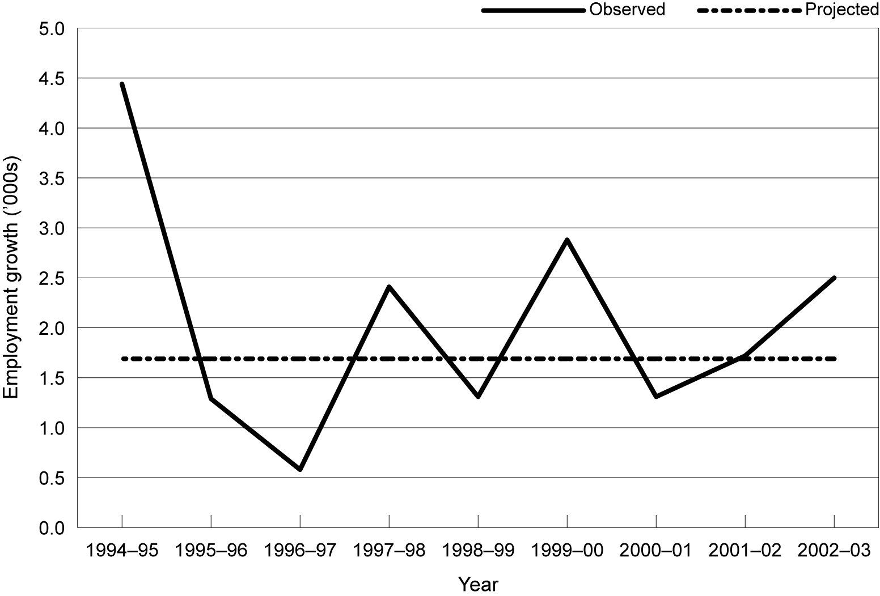
Figure 6 Comparison of actual and projected growth rate of employment for all occupations, 1993–94 to 2002–03
Source: For forecast data: Meagher (1997); for actual data, ABS (2005)
A complex model of the whole economy cannot in practice do better than project trends; it is implausible to suppose that it could anticipate the fluctuations that will occur in overall economic activity as the macro-economy is buffeted by shifts in the global economy, investment, consumer confidence, monetary policy and so forth. The MONASH model projected a trend rate of growth of 1.69% for total employment over the period 1995–2003—indicated in figure 6 by the dotted line. As shown, the actual rate of growth of employment deviated quite sharply from this trend on an annual basis, even though the macro-economic environment was quite benign over the period; that is, there was no recession. If we consider the period as a whole, the model’s expected average annual growth (1.69% pa) substantially underestimated the actual growth (2.4%). After nine years, the model underestimated total employment by 400 000 people, or 4.5% of the forecast end period employment.
We turn next to see how the model fares when forecasting employment at a detailed (Australian Standard Classification of Occupations three-digit) occupational level—electrical and electronics tradespersons and road and rail drivers. We have chosen these occupations because we can match the definition used in the projections with the definition used in the ABS measure of outcomes, while retaining the sort of detail that is valuable for VET capacity-planning.
Figure 7 shows that, by the end of the period, the forecast employment of electrical tradespeople was impressively close to the mark. On the way, however, the model consistently overestimated electrical trades employment. If, for example, the projection had finished in 2001, the model would have over-estimated electrical trades employment by 33 000, and by 25 000 a year later. The projections deviate much further from the actual outcomes for the road and rail transport drivers. The model consistently overestimates the level of employment of drivers: after nine years it is projecting 60 000 more jobs than actually occurred. Is a projection that gets within 20 000 to 30 000 (or 60 000) of the actual number valuable for VET capacity planning? The answer is probably not. Most of the sudden increase in employment in the electrical trades (25 000 between 2002 and 2003) could not have been supplied from newly qualified tradespeople, since the numbers completing their trade qualifications in a year are only a fraction of this number. The best data that we could obtain from the National Centre for Vocational Education Research (NCVER) of the number who completed an electrical trade qualification in 2003 was very imprecise. It showed that 36 000 VET graduates obtained a trade job and 16 300 obtained a certificate III (which includes a trade qualification) and went on to work in one of mining, manufacturing, electricity gas or water, or construction, the industries where the electrical trades are mostly found. Since the latter group includes all those who obtained a certificate III then found a job in one of those industries, it is clear that the number of newly qualified electrical tradespeople (who are unlikely to be found in the remaining industries) must be only a fraction of this number. Most of the increased employment in the electrical trades must have come from movement of trades-qualified people who were previously employed in some non-electrical trades job, were unemployed, or were not in the workforce.
Figure 7 Comparison of predicted and actual change in employment for selected occupations, 1996–2002
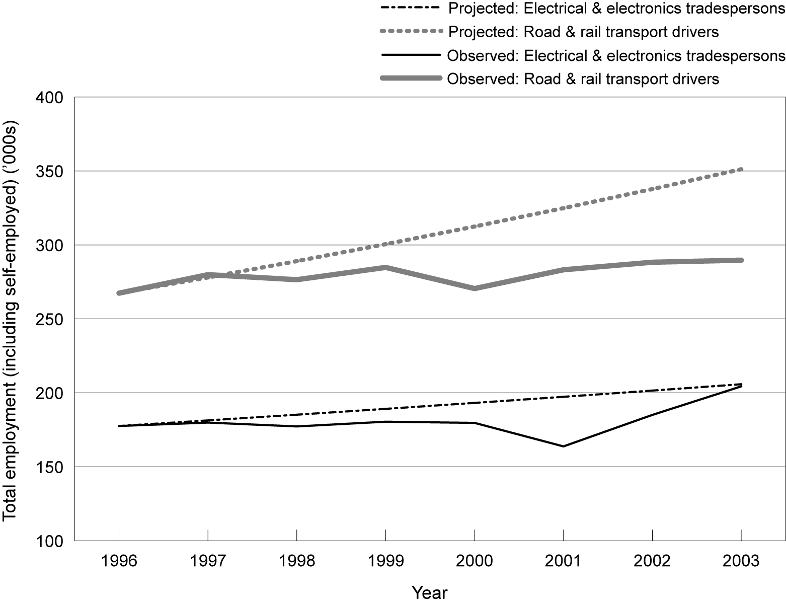
Source: For forecast data, Meagher (1997); for actual data, ABS (2005)
There is an important message here. Employment levels in many occupations fluctuate from year to year in ways that cannot possibly be matched by variations in the number of new graduates from the VET system. New graduates are part of the supply that meets emerging demand, but only a part. Perhaps the best that the VET sector can do to tailor its output to the needs of the labour market is to focus on the longer-term trends. These trends should ideally combine projections of net new employment plus replacement demand (as people with the skills in question leave the labour force, or move to other jobs). In this way, it will expand its provision of those skills experiencing a general rise in demand and contract its provision of skills that are facing static or falling employment. The sector would not try to tailor provision of new skills to jobs growth precisely, but would rely on the many other ways that the labour market has of matching supply to demand in a dynamic environment.
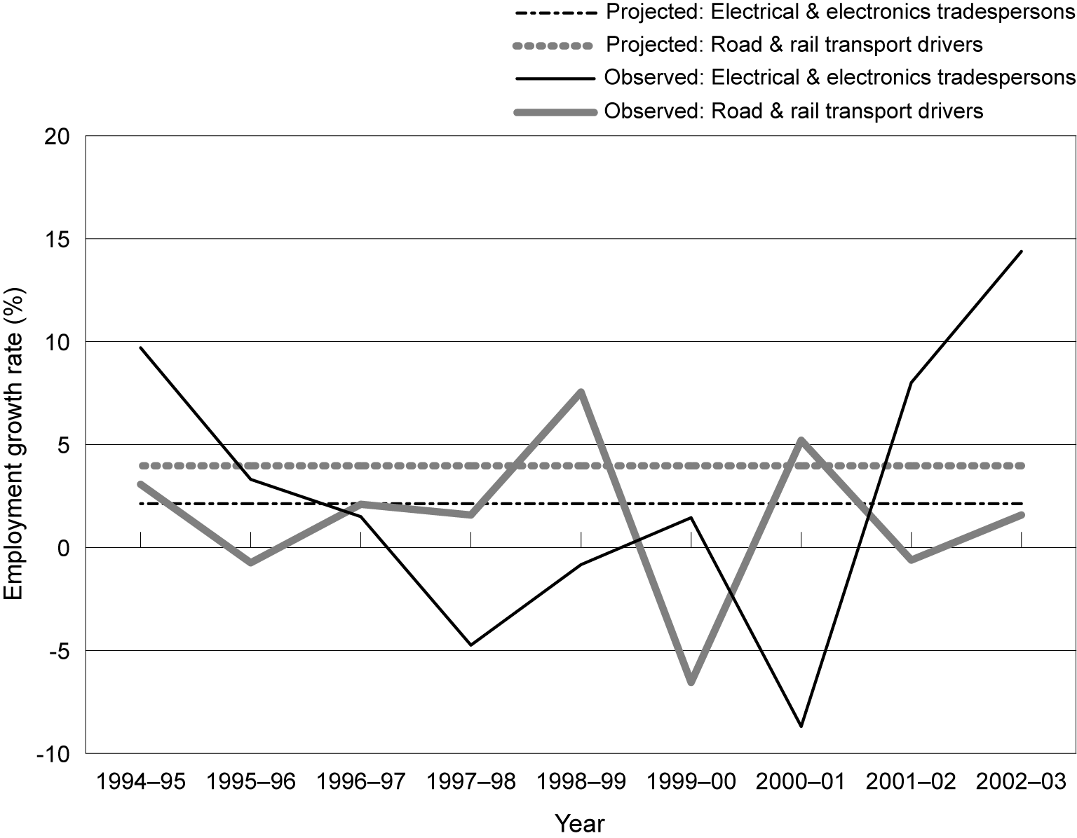
Model-based projections of demand growth are likely to be valuable if their purpose is understood as distinguishing skills that are likely to be in growing demand from skills likely to be in static or falling demand. They will be much less satisfactory if they are expected to provide detailed information on a year-by-year fluctuation in demand for specific skills and, for example, by region. Figure 8 shows the disjunction between projections and outcomes that arises if we try to predict the annual change in demand, as distinct from the general trend.
Figure 8 Comparison of actual and projected employment of electrical trades and drivers, 1996–2003
Source: For forecast data Meagher (1997); for actual data, ABS (2005)
The model projects a constant level of growth of 3.97% per annum for road and rail drivers and 2.13% per annum for the electrical trades. In fact, the actual path followed by employment in the two occupations fluctuated a good deal, with employment declining in a number of years (by as much as 9% for the electrical trades), then bouncing back to rise by 14% in the final year of the period. For the electrical trades, forecast growth exceeded actual growth in four of the years and vice-versa for the other four years. For the drivers, actual growth equalled or exceeded forecast growth in only two of the eight years. Clearly, the model is unable to track the path of actual employment with any precision.
We offer figure 9 as a final perspective on the ability of a formal model of the economy to project future demand for particular occupations. Here, we just compare the number employed at the end of the forecast period with the number that the model predicted would be employed. As we noted before, the model was very accurate in its prediction of electrical and electronics tradespeople. But it seriously overestimated the number of numerical clerks (whose numbers fell by 20 000 rather than rising by 80 000 as forecast). In three of the five cases, the model got the direction of change wrong: numerical clerks, sales representatives and construction and mining labourers. This inaccuracy is a reflection, not so much on the quality of the modelling, but on the difficulty of the task.
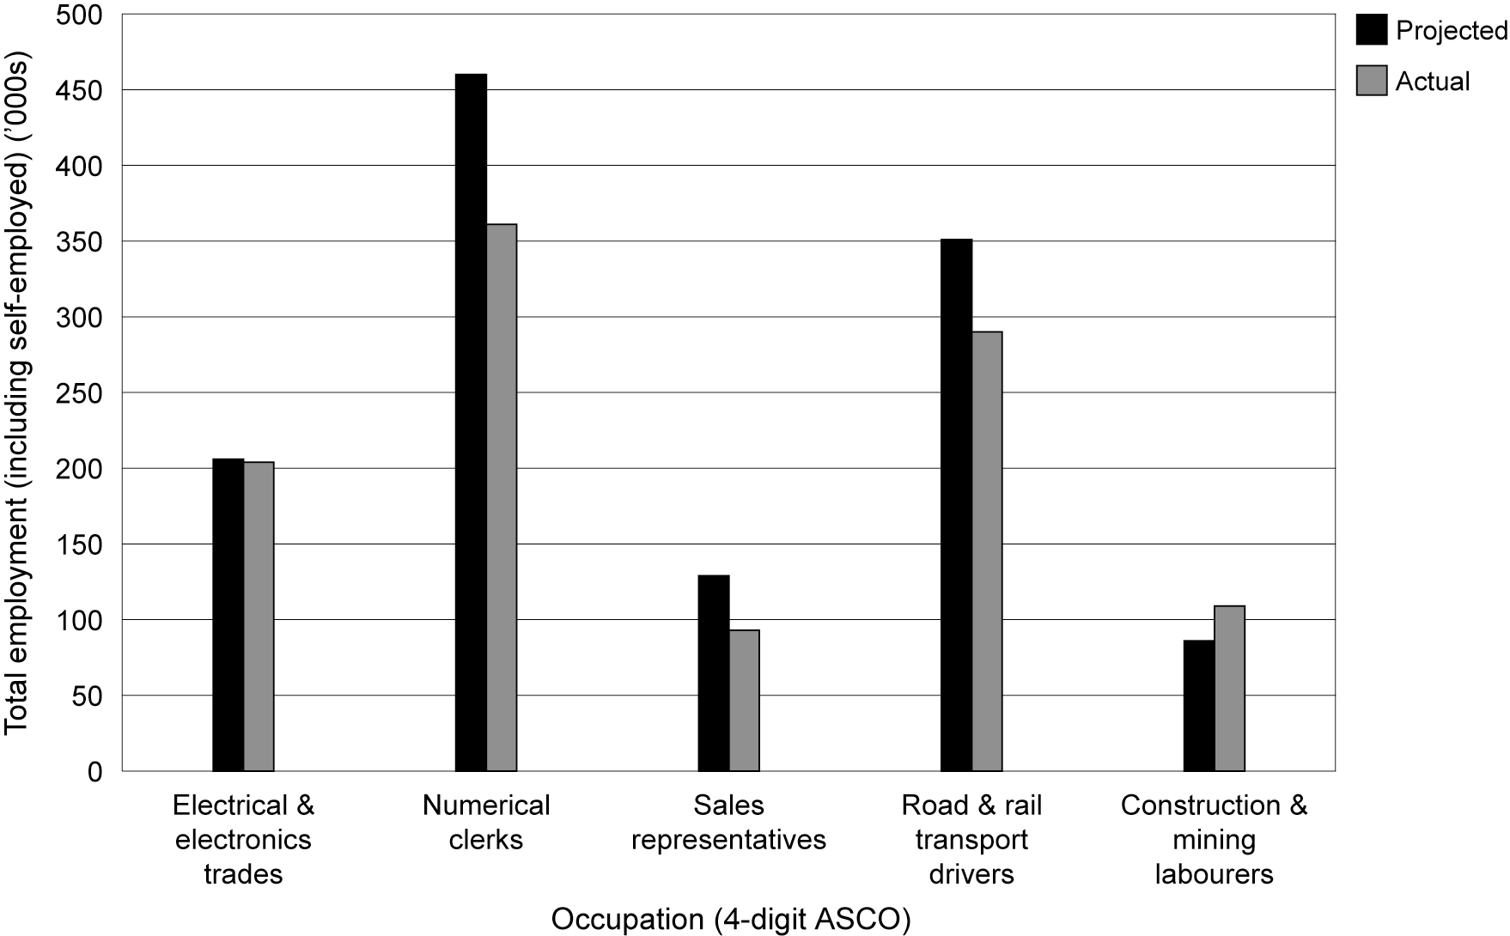
We do not claim, in this section, to have provided a full or fully satisfying evaluation of the MONASH model and its capacity to project the demand for particular vocational skills. But we do argue that the evidence we have presented supports a conclusion that it is not at present possible to project future skills needs with much accuracy. This is certainly the case where the projections are made at a detailed level, such as for a particular trade or diploma level skill. No matter how much we might wish it were otherwise, planners just have to manage with quite high levels of uncertainty about future demand.
Figure 9 Comparison of projected and actual employment in selected occupations, 2003
Source: For forecast data, Meagher (1997); for actual data, ABS (2005)

Other ways of looking forward
In-depth analysis beyond the forecast numbers can be helpful in fully understanding the real pattern of skills demand. Demand for skills can be created through job turnover resulting from retirement, family care, undertaking education, taking another position, or retrenchment of workers owing to the failure of companies and businesses. The analysis of the overall job opportunities should take into account both employment expansion and the demand due to turnover (replacement demand). Job opportunities may exist even in occupations in decline.
The study by Shah and Burke (2003) provides an example of forecasts of job openings for new entrants in the nine re-grouped occupations due to turnover. Table 4 shows the forecast net replacement needs in defined occupational groups for the period 2002–06. Net replacement equals the sum of the outflows (individuals leaving the occupations) less the sum of re-entrants.
The average annual net replacement rate for all occupations is estimated to be 2.1%, or around one million over five years. The rate of replacement in ‘insulated occupations’ is the highest (2.6%), while that for ‘globally advantaged occupations’ is the lowest (1.5%). The average rate for ‘vulnerable occupations’ is 2.0%. These rates reflect the age and gender profiles of the respective groups and the average job turnover within these groups.
There are significant variations in the net replacement rates across all other sub-groups except for both of the globally advantaged sub-groups. For the ‘in-person low-skill’ sub-group the net replacement rate is high (3.9%). This reflects the extremely high turnover of the workforce, in which mostly young people are employed, many of whom are still at school. These jobs are often part-time and casual in nature.
Table 4 Forecasts of net replacement needs in 2002–06, Australia
 |  | Net replacement
Occupational grouping* | Employment 2001 (’000) | ’000 | Average annual rate (%)
All occupations | 9090.4 | 993.7 | 2.1
Globally advantaged occupations | 1993.6 | 158.1 | 1.5
Conceptual | 1478.6 | 116.9 | 1.5
Technical | 515.0 | 41.2 | 1.5
Insulated occupations | 3344.5 | 451.2 | 2.6
In-person professional | 758.8 | 73.2 | 1.9
In-person skilled | 1274.3 | 112.6 | 1.7
In-person low-skill | 1311.4 | 265.4 | 3.9
Vulnerable occupations | 3752.3 | 384.4 | 2.0
Advanced skill | 1030.0 | 107.1 | 2.0
White-collar | 1046.0 | 91.7 | 1.7
Blue-collar | 664.2 | 58.8 | 1.8
Manual low-skill | 1012.0 | 126.7 | 2.4
Note: * Occupational grouping method is discussed in an earlier sub-section, that of ‘globalisation’.
Source: Shah and Burke (2003, p.10)
Another dimension of extending occupational forecasts is to conduct analysis at a local level. There are several reasons why a local dimension is valuable. One is that occupational structures vary by geographic locality. The other reason is the availability of statistics and the knowledge of a certain local area. Adjusting higher-level forecasts to local-level forecasts in the light of local information can amend the forecasts and make them more useful.
Structured case studies conducted in collaboration with employers can supplement and inform occupational forecasting. Case studies of those forces driving change in skill demand, such as technological change and consumer demand, can also help us to identify the skill demand that may prevail in future. Coupled with the use of more general forecasting techniques, this may be a useful direction in which to extend investigation into changing skills demand.
Surveys of managers and employees in some industries prove useful in overcoming the shortcomings of existing labour force data that arise because some industries employ a very small proportion of the Australian workforce (for example, minerals industry), and its employees are therefore not adequately represented in economy-wide sample surveys (for example, ABS monthly labour force survey). Such surveys involve collecting detailed information from the existing management and employees on their current situation and their expectations. Although these surveys are costly, they can be a most useful tool where there is reason to believe there is a risk of serious future imbalances in supply and demand for particular skills.
Employers and employees have different labour market experiences. The expertise of each regarding the labour market can help in building a full picture of skill supply and skill demand. The research into the demand and supply of skills in Australian aged care facilities, conducted by Richardson and Martin (2004), provides an example of success in using this strategy. In that study, the researchers successfully surveyed all employers in the industry and a sample of 6000 of their employees to develop a nuanced picture of how skill needs were being met, where there was additional capacity in the existing labour force, and how it might be further developed to supply future skill needs. That research model could be applied to other industries.
A survey of a sample of current employees in the workplace can capture information about a range of concerns relating to the skills demanded. These concerns include: employed people’s qualifications and skills; the types of training they have received on or off the job; the extent to which they use their skills in their work; what skills they believe to be actually required for their jobs; their use of computer and other technology on the job; their career pathways in their current jobs; and their expected career futures, including whether they expect to remain in their present industry sector.

What is to be done?
How should the VET sector decide what to teach in the light of the virtual impossibility of reliable projections of the demand for skills, at the necessary level of detail?
We counsel against trying to project the number of new VET graduates who will be required, by level and type of skill and by location, and then using this to determine the shape of skills training. We do so for two reasons. One is the obvious point: that it cannot be done with any accuracy at the level of detail that is needed for deciding just what to teach and where. The other is a more comprehensive point. The labour market is a dynamic entity. People are constantly changing their jobs, learning new skills from their work, moving to new locations, moving in and out of the labour force and changing the number of hours per week that they work. At the same time, firms are being born, growing, dying, declining, altering the size and skill set of their workforce, recruiting strategic new skills, training some of their existing staff with the incremental skills they find they need. In all of this, formal vocational education has an important, but modest role to play. It is a misunderstanding of how the labour market adjusts to believe that there is a direct, one-to-one relation between an expansion in output, the associated increase in skills needed to produce that extra output, and a requirement for the VET system to provide those extra skills.
As we have shown, there is only a loose match between the qualifications that people have and the jobs they do. Many people have qualifications they do not utilise in their current job. Many also work in skilled jobs for which they have no formal qualification. So it is important to appreciate that the VET sector does not need to attempt to identify every future skill vacancy and then train someone to fill it. There is much to be said, rather, for focusing on what people want to study, rather than on what future employers are anticipated to need. Individuals themselves will have a feel not only for what they like and are good at, but where the future job opportunities lie. The labour market is very dynamic and shortages and surpluses usually sort themselves out over time through the continuing search of employers and workers for a good match. For many, this search includes a willingness to move location. For this reason and also because it is very difficult to forecast regional demand, we believe that efforts at forecasting should not be dissipated in seeking detailed regional accuracy. We have emphasised also that many work skills are learned on the job. Indeed, the amount of this on-the-job training probably exceeds that of the formal training system and by its nature it is closely linked to what employers want—at least at the time, if not into the future.
At the same time, there is value in the VET sector being able to get the broad structure of its offerings into alignment with the future needs of the economy. Here, the best strategy is likely to require a combination of steps. These include the following.
- Use the best available model of the economy to project the expected growth or decline of occupations and volume of replacement vacancies, at a fairly broad level.
- Check these projections against other sources of information, such as those contained in the Department of Employment and Workplace Relations job prospects listing.
- Confine these projections to around five years and update them regularly with the latest information.
- Where more detail is required, retain an Australia-wide focus and disaggregate by skill level or type.
- Where a regional labour market is important, use local information from employers’ associations, graduate destination surveys, recruitment agencies and similar sources to refine the broad projections.
- Undertake separate, bottom-up, high-quality studies of expected skills demands for those major skills that take a long time to learn and gear up to teach—it is for these that the ability to make accurate projections is of most importance.

References
ABS (Australian Bureau of Statistics) various years, Labour Force Survey, ABS, Canberra.
——1996–2004, Australian labour market statistics, cat.no.6105.0, ABS, Canberra.
——1997, Australian standard classification of occupations, 2nd edn, cat.no.1220.0, ABS, Canberra.
——2001, Education and work: Australia, cat.no.6227.0, ABS, Canberra.
——2004, Education and work: Australia, cat.no.6227.0, ABS, Canberra.
——2005, Labour force, cat.no.6291.0.55.001 (data cube E08), ABS, Canberra.
Access Economics 2005, Improved forecasts of employment growth and net replacement rates, report for the Victorian Office of Training and Tertiary Education, Melbourne.
Autor, D, Levy, F & Murnane, R 2003, ‘The skill content of recent technological change: An empirical exploration’, The Quarterly Journal of Economics, vol.118, no.4, pp.1279–334.
Bartlett, C & Ghoshal, S 1993, ‘The changing role of top management, Harvard Business Review, May/June, pp.90–6.
Berman, E & Machin, S 2000, ‘Skill-biased technology transfer around the world’, Oxford Review of Economic Policy, vol.16, no.3, pp.16–22.
Bloom, N, Conway, N, Mole, K, Möslein, K, Neely, A & Frost, C 2004, Solving the skill gaps: Summary report from CIHE/AIM Management Research, Council for Industry and Higher Education and Advanced Institute of Management, London.
Borghans, L, van Eijs, P & de Grip, A 1994, ‘An evaluation of labour market forecasts by type of education and occupation for 1992’, Report ROA-R-1994/4E, Research Centre for Education and Labour Market, University of Maastricht, Limburg, The Netherlands.
Boswell, C, Stiller, S & Straubhaar, T 2004, ‘Forecasting labour and skills shortages: How can projections better inform labour migration policies?’, paper prepared for the European Commission, DG Employment and Social Affairs, Hamburg Institute of International Economics, Germany.
Burns, M & Shanahan, M 2000, Labour market models and their use in projecting vocational education and training requirements, NCVER, Adelaide.
Cörvers, F & Heijke, H 2004, ‘Forecasting the labour market by occupation and education: Some key issues’, ROA working paper no. ROA-W-2004/4, Research Centre for Education and Labour Market, University of Maastricht, Limburg, The Netherlands.
Haskel, J & Holt, R 1999, ‘Anticipating future skill needs: Can it be done? Does it need to be done?’, a paper for the Skills Task Force, Department of Economics, Queen Mary and Westfield College, London.
Heijke, H (ed.) 1994, Forecasting the labour market by occupation and education, Kluwer Academic Publishers, Boston, Dordrecht and London.
Hollister, R 1967, A technical evaluation of the first stage of the Mediterranean Regional Project, OECD, Paris.
Hughes, G 1993, ‘Projecting the occupational structure of employment in OECD countries’, Labour market and social policy occasional papers, no.10, OECD, Paris.
Kim, Y 2002, ‘A state of art review on the impact of technology on skill demand in OECD countries’, Journal of Education and Work, vol.15, no.1, pp.89–109.
Lewis, P 2004, ‘The Australian labour market and unemployment in 2004’, paper presented to the HR Nicholls Society’s XXVth Conference, Melbourne, 6–8 August 2004.
Machin, S 2001, ‘The changing nature of labour demand in the new economy and skill-biased technology change’, Oxford Bulletin of Economics and Statistics, vol.63, no.1, pp.753–76.
Maglen, L 2001, ‘Australians working in a global economy and what this means for education and training’, Working paper no.39, Centre for the Economics of Education and Training, Monash University, Melbourne.
Meagher, G 1997, ‘Changes in the demand for labour in Australia’, in Changing labour markets: Prospects for productivity growth, workshop proceedings, Productivity Commission, Melbourne.
Meagher, G, Adams, P & Horridge, J 2000, ‘Applied general equilibrium modelling and labour market forecasting’, preliminary working paper no. IP-76, Centre of Policy Studies, Monash University, Melbourne.
Neugart, M & Schömann, K (eds) 2002, Forecasting labour markets in OECD countries, Edward Elgar, Cheltenham.
OECD (Organisation for Economic Co-Operation and Development) 1994, Employment outlook, OECD, Paris.
——2005, Employment outlook, OECD, Paris.
Pappas, N 1998, ‘Changes in the demand for skilled labour in Australia’, in Working for the future: Technology and employment in the global knowledge economy, ed. P Sheehan & G Teggart, Victoria University Press, Melbourne.
Parnes, H 1962, Foresting educational needs for economic and social development, OECD, Paris.
Polo, C & Sancho, F 1993, ‘Insights or forecasts: An evaluation of a CGE model of Spain’, Journal of Forecasting, vol.12, no.5, pp.437–48.
Productivity Commission 2005, Economic implications of an ageing Australia, research report, PC, Canberra.
Richardson, S 2004, Employers’ contribution to training, NCVER, Adelaide.
Richardson, S & Martin, B 2004, The care of older Australians: A picture of the residential aged care workforce, research report of the Aged Care Workforce Project, National Institute of Labour Studies, Flinders University of South Australia, Adelaide.
Shah, C & Burke, G 2003, ‘Project 2000–02: Changing skill requirements in the Australian labour force in a knowledge economy’, Working paper no.48, Centre for the Economics of Education and Training, Monash University, Melbourne.
United States Census Bureau 2005, Statistical abstract of the United States: 2004–05, Census Bureau, Washington, DC.
Van Eijs, P 1993, ‘The manpower requirements approach: Background and methodology’, ROA working paper no. ROA-RM-1993/3E, Research Centre for Education and Labour Market, University of Maastricht, Limburg, The Netherlands.
Warwick Institute for Employment Research website <http://www2.warwick.ac.uk/fac/soc/ier/ research/forecast>.
Willems, E 1996, ‘Manpower forecasting and modeling replacement demand: An overview’, ROA working paper no. ROA-W-1996-4E, Research Centre for Education and the Labour Market, University of Maastricht, Limburg, The Netherlands.

Support document details
Assessing the reliability of the MONASH labour market forecasts: Some comments on a report by the National Institute of Labour Studies is a response by GA Meagher to the report by Richardson and Tan. It can be accessed from NCVER’s website <http://www.ncver.edu.au>. This document contains:
- Introduction
- Are the forecasts MONASH forecasts?
- Is the NILS sample representative?
- Coping with uncertainty
- Concluding remarks.

Appendix 1
Skills consortium publications
The following is the complete list of titles produced by the National Institute of Labour Studies, Flinders University and the Centre for Post-compulsory Education and Lifelong Learning, University of Melbourne, through the research project, ‘A well-skilled future: Tailoring VET to the emerging labour market’.
Forecasting future demands: What we can and cannot know
Sue Richardson and Yan Tan
Future skill needs: Projections and employers’ views
Diannah Lowry, Simon Molloy and Samuel McGlennon
Demographic impacts on the future supply of vocational skills
Yan Tan and Sue Richardson
Skill acquisition and use across the life course: Current trends, future prospects
Bill Martin
What is a skill shortage?
Sue Richardson
Changing forms of employment and their implications for the development of skills
Sue Richardson and Peng Liu
Changing work organisation and skill requirements
Bill Martin and Josh Healy
Social area differences in vocational education and training participation
Richard Teese and Anne Walstab
Participation in vocational education and training across Australia: A regional analysis
Anne Walstab and Stephen Lamb
Current VET strategies and responsiveness to emerging skill shortages and surpluses
Jack Keating
Matching supply and demand: International perspectives
Jack Keating
Impact of TAFE inclusiveness strategies
Veronica Volkoff, Kira Clarke and Anne Walstab
A well-skilled future
Sue Richardson and Richard Teese

* A full list of research reports resulting from this research consortium is given in appendix 1.
This assumption, which was acceptable for most of the past 30 years, is increasingly questionable, as the economy operates with unemployment levels of 5% or lower and there are increasing signs of shortages of particular skills.
The first group relates to many of the professionals and associate professionals in business-related occupations. Imports and exports, information technology, general management, engineering, manufacturing, sales and marketing, agriculture, finance and other occupations are some examples in this group. The second group involves those occupations whose services or products are most subject to substitution by overseas workers or products. These occupations include manufacturing trades, white-collar clerical occupations, blue-collar operative occupations, and manual low-skill occupations. The third group stands for those that are largely insulated from direct global competition due to their embedded nature in the personal or customised services they provide, although even this group is not entirely insulated because of international flows of labour (e.g. taxi drivers). These occupations include local trades (e.g., building and construction trades, horticultural trades), professional in-person occupations (e.g., medical practitioners, school teachers), skilled in-person occupations (e.g., nurses, hairdressers), and low-skill in-person occupations (e.g., sales assistants, bus and taxi drivers).
United States Census Bureau (2004–05, table 599, Employment projections by occupation: 2002 and 2012).
There are exceptions of course: farmers are found overwhelmingly in the agricultural industry, carpenters in the building industry and teachers in the education industry.
Pames divided the manpower requirements approach into eight steps. The first step is data collection, choosing the classification system and describing the structure of employment. The second step forecasts the total labour supply, based on a population forecast, combined with age-sex specific labour force participation rates. The third and fourth steps are emphasised as the most important and most crucial steps in the manpower requirements approach. The two steps involve forecasting the total employment by sector of industry in the target year (step 3), and then allocating this employment by industry among the different occupational classes and aggregating over the sectors of industry to obtain the forecast of employment by occupation (step 4). To produce a forecast of employment by sector of industry, the basic method adopted in the approach comprises an incorporation of the economic targets for GDP, broken down by major sector, and a projection of labour productivity. The fourth step deals with the translation of the sectoral forecasts into the demand by occupational group. In the fifth step, the forecast of the occupational structure of employment needs to be converted into a forecast of future educational needs, based on the then educational structure of employment within each occupation. Step 6 forecasts future labour supply, which is broken down by educational category. Step 7 computes the differences between the forecasts of labour demand and labour supply. The last step is to determine the required future enrolments for the various types of education.
Information provided on request from NCVER, August 2005.
The Victorian Office of Technical and Tertiary Education bases its planning on this combination of replacement and growth demand.
We are aware that the ABS data of actual employment are derived from sample surveys of the labour force. As such, they are subject to sampling error—the more so the narrower the occupation or skill in question. This means that some of the observed variation in employment from year to year may be a statistical artefact rather than a real change.

