Qualifications use for recruitment
in the Australian labour market

Jack Keating
Tanya Nicholas
John Polesel
Jocelyn Watson
The University of Melbourne
The views and opinions expressed in this document are those of the author/project team and do not necessarily reflect the views of the Australian Government, state and territory governments or NCVER

© Australian Government, 2005
This work has been produced by the National Centre for Vocational Education Research (NCVER) on behalf of the Australian Government and state and territory governments, with funding provided through the Department of Education, Science and Training. Apart from any use permitted under the Copyright Act 1968, no part of this publication may be reproduced by any process without written permission. Requests should be made to NCVER.
The views and opinions expressed in this document are those of the author/project team and do not necessarily reflect the views of the Australian Government, state and territory governments or NCVER.

The author/project team was funded to undertake this research via a grant under the National Vocational Education and Training Research and Evaluation (NVETRE) Program. These grants are awarded to organisations through a competitive process, in which NCVER does not participate.
The NVETRE program is coordinated and managed by NCVER, on behalf of the Australian Government and state and territory governments, with funding provided through the Department of Education, Science and Training. This program is based upon priorities approved by ministers with responsibility for vocational education and training (VET). This research aims to improve policy and practice in the VET sector. For further information about the program go to the NCVER website <http://www.ncver.edu.au>.
ISBN 1 921169 21 4 print edition
1 921169 27 3 web edition
TD/TNC 84.07
Published by NCVER
ABN 87 007 967 311
Level 11, 33 King William Street, Adelaide SA 5000
PO Box 8288 Station Arcade, Adelaide SA 5000, Australia
ph +61 8 8230 8400, fax +61 8 8212 3436
email ncver@ncver.edu.au
<http://www.ncver.edu.au>

Contents
Tables and figures 4
Key messages 6
Executive summary 7
Background 9
Qualifications 11
Qualifications and employment 13
The survey of employers 17
Survey details 17
Labour turnover and demand 17
Skills demand 18
Recruiting practices—employer searching 20
Qualifications 21
Selection 22
Attributes signalled by qualifications 30
Trust in qualifications 32
Changes in award and regulatory requirements 34
Further qualifications 35
Conclusions 36
Policy implications 40
References 41
Appendix 43

Tables and figures

Tables
1 Percentage of employees identifying specific educational qualifications as necessary to obtaining employment 16
2 Percentage of firms taking into consideration applicant qualifications when recruiting employees, by industry sector and occupational area 24
3 Correlation between university or vocational/technical qualifications and perceptions of potential employees (%) 30
4 The level of importance assigned to the various uses of
employee qualifications (number and percentage of firms responding) 32
5 Negative aspects of qualifications (% agreeing) 33
6 Number of firms (by industry sector) indicating the
importance of company-based qualifications being AQF qualifications (frequency of responses) 34
7 Impact of changes in award and regulatory arrangements
upon number of positions that require minimum or specific qualifications (number of firms responding) 34
8 Number of firms indicating their willingness to encourage employees to gain further qualifications (number/percentage
of firms responding) 35
9 Percentage of firms indicating that they encourage
employees to gain further qualifications, by employee/
qualification category (%) 35
10 Returns by state and territory 43
11 Returns by area 43
12 Number of firms by firm size 44
13 Percentage of part-time employees by firm size (frequency of responses) 44
14 Percentage of part-time employees by industry sector
(frequency of responses) 44
15 Returns by industry sector 45

Figures
1 Relationship between graduate and employer searching and selection activities 14
2 Number of employees which have departed firms over the
past 12 months or the past 3 years 17
3 Difficulties in recruiting employees by occupational
categories (%) 18
4 Main reasons given by employers for encountering difficulties
in recruiting employees (%) 19
5 Reasons for difficulty in filling vacancies by occupational
categories (%) 19
6 Means by which firms locate potential employees by
occupational category (%) 20
7 Means by which different firm sizes locate potential
employees (%) 21
8 What firms consider to be qualifications, % responding ‘yes’ 22
9 Means of selecting employees by occupational category (%) 22
10 Means of selecting potential employees by firm size (%) 23
11 Percentage of firms (by size) which consider the qualifications
of applicants in the selection process 24
12 Importance of criteria for selection of employees for
management, administration and professional occupations (%) 25
13 Importance of criteria for selection of employees for clerical,
sales and service occupations (%) 26
14 Importance of criteria for selection of employees for technical
and trade occupations (%) 26
15 Importance of criteria for selection of employees for plant and machine operators and labourers (%) 27
16 Criteria for selection ranking ‘very important’ or ‘important’
to the selection of employees, by firm sector (%) 28
17 How qualifications are used to select employees for higher
paid positions across occupational area 29
18 How qualifications are used to select employees for positions
where regulations and awards require the qualifications, across occupational areas 29
19 How qualifications are used to select employees for positions
with particular skill needs, across occupational areas 30
20 Factors which influence trust or confidence in qualifications,
across all firms (%) 32

Key messages
The use of qualifications by employers is poorly understood and documented. This study explored how employers use qualifications in their recruiting processes.
- The study found that about half of the 359 employers surveyed used qualifications as a screening mechanism and minimal requirement in their selection processes, while a quarter used them as a sorting or ranking mechanism. Employers valued qualifications as a signal of greater potential for further learning and skills acquisition.
- As a signal of immediate competence, employers placed a high priority on previous work experience and experience in their industry. Employers also considered personal qualities in their recruitment decisions.
- These uses of qualifications by employers do not apply across the board to all positions within the enterprise. They apply more to professional, managerial and clerical employees. Employers typically rely on networks and local contacts and work experience for operator level and technical trades positions. The growth of casual employment has not altered these behaviours.
- The detailed results suggest that qualifications are embedded in employers’ recruitment decisions. However, there is room to build stronger currency of vocational education and training (VET) qualifications by linking them with industry and work experience to reflect the behaviours and experiences that are most valued by employers.

Executive summary
There has been a high level of national and international interest in qualifications and qualifications systems over a number of years, and some nations, including Australia, have invested in national qualification frameworks. These developments are an expression of the increasing roles of qualifications, especially in the context of the industrial and social demands of knowledge-based industries and lifelong learning. This, in turn, has given a stronger role to government in the design and management of qualifications.
The history of the education and training sectors in Australia has led to the different constructs of qualifications for the school, vocational education and training (VET) and higher education sectors, and to the different governance arrangements within these three sectors. These different constructs and governance arrangements continue to restrain policy options for qualifications. One prominent feature is the high degree of institutional separation between the school, VET and higher education sectors.
The use of qualifications by tertiary education providers is well documented and can be demonstrated statistically on an annual basis. The use of qualifications by employers, however, is poorly documented. Yet, employment outcomes remain a primary purpose of most qualifications.
Qualifications as testimonies of individual learning carry intrinsic and economic or exchange value. Intrinsic value can be associated with status and, traditionally, has been important for academic qualifications within educational hierarchies. Exchange value has been associated with the utility of the learning, especially in industrial settings. These values are present in most qualifications, and the extent of this value is influenced by a variety of factors.
The study examined the use made of qualifications in recruitment (external and internal) processes by employers through an interview-based survey of 359 employers across Australia. Employers were classified into six industry types and they were asked to respond to a range of questions relating to four categories of employees. The survey was administered using regional coordinators from the Enterprise and Career Education Foundation (ECEF) as enumerators. It was designed to represent industry areas, geography and firm size; however, difficulties encountered in the administration of the survey resulted in a bias of returns from Victoria.
Employers were asked a series of questions about their use of qualifications for searching and selecting employees, the attributes that are signalled by qualifications, the relevance and value of these attributes within selection criteria, and the factors that influence their trust in qualifications.
The study acknowledges the wide range of variables that influence the features of recruitment and selection processes. It locates these behaviours in two sets of searching and selection activities: those of graduates and those of employers. These activities vary, for both graduates and employers, with the types of qualifications. They also vary with environmental factors, including those that are associated with national and regional institutions and cultures.
To an extent the survey confirms the findings of previous Australian studies. It verifies that employers place a high degree of value in personal qualities of their workers, and that they place a high priority on previous work experience and experience in their industries. It indicates that about half of all employers use qualifications in their selection processes and most regard qualifications as important assets for potential recruits. Given the number of employers that experienced difficulties in finding suitable recruits these levels could be regarded as significant.
The variations in the use of, and attitudes towards, qualifications across types of firms and categories of employers are consistent with overseas findings about the different industry and occupational search and selection patterns. Employers typically rely upon networks and more localised contacts for operator-level positions, and search more widely for managerial and clerical employees. These behaviours do not appear to be greatly affected by the growth of contingent employment.
Employers’ concepts of, and reliance upon, qualifications are relatively subjective. What constitutes a qualification is what is relevant to them and their recruitment and skills needs. The secondary role of qualifications, behind industry and general work experience as criteria for selection, is not primarily an expression of relative trust. Rather it is related to employers’ views of what provides the better preparation and background for recruits, together with a high value placed on risk minimisation. Most employers acknowledge that qualifications signal greater potential for learning and skills acquisition, but they see them as weaker signals for more immediate workplace competence. This is further validated by the overall preference of employers for vocational education and training compared with upper secondary and university qualifications, although university qualifications obviously have stronger currency in some sections of the labour market.
In general, qualifications in the Australian labour market play both a sorting and a screening role although it would seem that the sorting role is stronger. The sorting role is where qualifications are used to allocate different applicants as potential recruits for different types of jobs or occupations. A screening function is where qualifications are used to eliminate or screen out applicants for positions or occupations.

Background
Qualifications have gained a significant amount of policy attention across nations, especially in Europe, in recent years. The Organisation for Economic Co-operation and Development (OECD), the International Labour Organisation (ILO) and the European Centre for the Development of Vocational Training (CEDEFOP) have investigated qualifications and qualifications policy. A growing number of nations are investing in qualifications frameworks, which in many cases are administered by national or regional qualifications authorities.
These activities have a number of purposes. They include the promotion of lifelong learning, issues of the quality of education and training in a period of rapid expansion, and a shift in educational management towards outcomes in a period of expansion and increased complexity and change.
Qualifications are subjected to conflicting demands. Policies of expanding participation in both initial and continuing education and training have created demands upon qualifications and qualifications systems to be more accessible, flexible, relevant to learning needs and styles, and more user-friendly. These demands conflict with the need to maintain standards and with the traditional role of most qualifications of restricting access to occupations and academic hierarchies.
Despite predictions to the contrary (Collins 1979; Dore 1976; Wolf 1997) in the late 20th century, the economic returns for qualifications appear to have become greater. Notwithstanding increases in the number of degree holders in almost all OECD nations, the private rates of return for degrees have increased in most of these countries (OECD 2000; OECD 2004). Education has emerged as ‘the single most important determinant of occupational success in industrialized societies’ (Muller & Shavit 1998, p.1), and Bassi (1998) refers to the ‘well documented increase in the economic returns on educational credentials’ (p.23). Brunello and Comi’s (2003) study of 11 European countries indicates that employees with tertiary education have steeper-earnings profiles than employees with upper secondary or lower education. Thus, education provides both an initial labour market advantage and a permanent advantage that increases with time in the labour market.
The returns to technical and vocational qualifications, however, are more variable. Ryan (2002) found considerable variations in the rates of return for vocational education and training (VET) qualifications in Australia. This is largely due to individual circumstances, especially age and gender and whether there is a loss of earnings from participating in a course. Most university degrees are completed at the end of the initial education period, whereas many VET qualifications are undertaken by adults after a period of full-time work.
Apart from lifetime earnings, the other returns to qualifications are access to employment. Qualifications typically play formal and informal roles in selection decisions by employers of their employees. A measure of the formal role of qualifications in selection can be observed through calculations of the ratio of advertised vacancies that specify qualifications as minimum requirements for employment. This measure, however, has some major limitations:
- It does not measure the use of qualifications in selection processes that are internal to the company.
- Qualifications may play a part in the searching processes that employers undertake when seeking labour.
- Qualifications are likely to play a process in the sorting and final decision-making processes that employers undertake when a selection of candidates for recruitment is available.
Qualifications are the best available proxies or measures of skills. In the current context of apparent skill shortages the returns to individuals for qualifications will be a key factor in their decision to gain skills and the recognition for them.

Qualifications
Qualifications can be located within a market model where demand and supply each have two aspects. On the supply side first there are the intrinsic purposes of the learning and the qualification. These purposes are the basis for the liberal ideal of education, and have existed well before the creation of qualifications in such forms as the Socratic tradition. However, they also have come to be expressed through qualifications and the hierarchy of titles and the rituals of qualification awardings. As intrinsic value, therefore, qualifications carry status value, which is inherently hierarchical. Status is relative to the position in the hierarchy and the relative scarcity of the qualification. Second, qualifications carry exchange value for the graduate within employment. They enhance the prospects and range of employment opportunities and earning capacities.
On the demand side qualifications can be regarded as packages of information about the knowledge, skills and experiences of individuals. The form or construct of the information can vary, but in Australia the 12 sets of qualifications within the Australian Qualifications Framework (AQF) are relatively standardised. Historically there have been two sets of demand. First, educational institutions typically use qualifications as a basis for entry into, and credit towards, other courses and qualifications. Second, qualifications are used by employers as indicators of sets of skills that are required or seen as valuable in the workplace. In some cases, such as elements of the public sector or a prestigious law firm, this demand can be partially for the status value of qualifications.
This mixture of intrinsic and exchange value is reflected in the Australian Qualifications Framework descriptors for qualification in Australia (Australian Qualifications Framework Advisory Board 2002). The descriptors are essentially outcomes-based and therefore mainly concern skill types and levels. However, they identify intrinsic features of qualifications, including the ‘completion’ of school for senior secondary qualifications, and ‘ethical standards’ for higher education qualifications. At least some qualifications go beyond learning outcomes, and concepts such as ‘communities of practice’ and ‘cognitive growth and transmission’ have their place within qualifications. Senior secondary qualifications typically continue to espouse the liberal ideal, which, to an extent, continues to be represented in the Adelaide Declaration on the Goals for Schooling (Ministerial Council on Education, Employment, Training and Youth Affairs 1999).
Considerable research has been undertaken over the past decade into the human resource needs of industry. However, little is known about the ways in which employers actually use qualifications in the internal and external recruitment processes. Knowledge on the demand side factors is variable. There is a growing body of knowledge concerning the demand by individuals for qualifications, and the conditions that are conducive to the increase in individual demand for qualifications. Prominent amongst these factors is the perception of the utility of qualifications in the labour market—both for recruitment and career advancement— together with the labour market status of individuals. On the other hand, knowledge of the use by employers of qualifications is poor. Despite numerous surveys little is known of either the behaviour of employers in the use of qualifications in personnel and management practices or the factors that influence this behaviour.
There is evidence of interaction between qualifications and employment behaviour (CEDEFOP 1999), where qualification structures and the relationships between providers and enterprises influence employer skills demands. Some countries have formal relations between qualifications and labour markets, like the link between the regulated occupational labour markets and the Dual System in Germany (Lutz 1981; Marsden & Ryan 1995), or enterprise–provider relations reinforced by cultural values in Japan (Ishida 1998).
There is some evidence that the notion of ‘high trust’ relations identified in some Asian and Northern European nations (Fukuyama 1995) has implications for qualifications use by employers. More individualistic and low trust societies, such as in Australia, are likely to have weaker links between qualifications and personnel management behaviours.
More robust relationships between qualifications and employers typically have been based upon ‘communities of trust’ (OECD 2001). It is likely that these communities are weakening with the decline of occupational labour markets and regulations and the decline of union membership.
There has been a tendency for providers and awarding bodies to overestimate the currency of their qualifications in the labour market (Keating 1993). The recent interest in structured work placements for VET in Schools programs may indicate an awareness of the importance of links between education and training programs and the workplace in recruitment. For example, Polesel and Teese (2002) have found that employers in Victoria have used the work placement components of VET in Schools programs as one means of recruiting prospective employees. The use of patronage and networks for recruitment has been significant, and can be more prevalent in some elements of the labour market, especially those for low-skilled workers (Davis 1987; Day & Malcolm 1984). These behaviours are influenced by cyclical factors, and are more likely to be used in a context of labour and skills shortages, as Shelly (1988) demonstrated in the United Kingdom.
In Australia there has been little research into the recruitment behaviour of employers. Some exceptions are Buon (1993), who examined the use of credentials in the recruitment of training professionals, and Stanton (1995), who surveyed a small sample of large enterprises. The most comprehensive analysis is that of Wooden and Harding (1997), which places ‘education’ after ‘attitude’, ‘skills’, ‘experience’ and ‘appearance’ as selection criteria. Education is prominent only for skilled white collar workers.
Apparent growth in the demand for this category of worker (Wooden 1995) may be leading towards higher employer demand for qualifications, although the pronounced shift towards part-time employment also may be causing a disproportionate rise in individual demand compared to employer demand for qualifications (Hawke, Keating & Lamb 2004). The accompanying decline in internal labour markets also may be influencing the use of qualifications for career enhancement (Marsden 1991). One possible impact is an increase in the demand for currency and fit of qualifications for career advancement. This may contrast with a possible trend away from occupationally specific entry level qualifications as occupational labour markets continue to decline. Furthermore, as Wright (1991) has shown, labour and personnel management practices in industry have shown contradictory trends, and the increased use of specialised personnel functions in industry could have a variety of impacts in employment practices. The question of employer use of qualifications, therefore, is both complex and dynamic.
Hofstede’s (1984) and Maurice, Sellier and Silvestre’s (1986) seminal studies show considerable international variations in organisational behaviours that influence both recruitment and internal promotions practices. Fukayama (1995) has characterised the cultural characteristics of high- and low-trust societies. Consistent with these typologies Rosenbaum and Kariya (1991) found that school credentials were little used by employers when selecting school leavers in the United States of America, in comparison to high use in Japan. Upon this basis, it would be expected that Australia, with similar cultural characteristics to the United States, would have relatively poor use of qualifications by employers. On the other hand, in Britain, which also has similar cultural characteristics to Australia, Smith’s (1996) findings of employers’ awareness and use of vocational qualifications were quite positive. It also is possible that there are regional variations in the use by employers of qualifications. Gray, Jesson and Tranmer (1994), for example, found that there were regional variations in the use by employers of school qualifications in Britain.

Qualifications and employment
It seems that there is a lack of literature that locates qualifications within the behaviours of labour recruitment and human resource management. This has not been the case at the macro level where there is a substantial body of literature that examines qualifications within such propositions as human capital, sorting and screening theories. Nearly all of this literature, however, is international, and there are few examples of these literatures that link with the more recent literature on labour market types and skills formation and diffusion in the context of globalisation.
There is a lack of knowledge, therefore, about the:
- use made by employers of qualifications in recruitment at the entry level and in recruitment and personnel management at post-entry level within the firm internal and external labour markets (see Marsden [1991] for labour market typologies)
- factors that influence these uses of qualifications by employers
- factors that influence the degree of trust in qualifications by employers.
The milieu for qualifications is extremely dynamic, and in locations such as Europe the emergence of regional labour markets is having an impact upon qualifications. An example is the adoption in some of the northern regions of France of some of the British National Vocational Qualifications (NVQs) in the 1990s. At the same time, qualification markets are emerging, with the growth of both generalist (for example International Baccalaureate) and company-based (for example, Microsoft and Cisco) qualifications. Australia is less exposed to some of these developments. On the other hand, historically it has needed to deal with qualifications held by immigrants, and qualifications authorities are now conscious of the international developments.
A further purpose, therefore, is to gain knowledge about how employers respond to international and company-based (vendor) qualifications.

The interaction between qualifications and the labour market
Qualifications can be seen as information systems that are located within two sets of behaviours. On the one hand, graduates use qualifications as a means of gaining employment or promotion. They do this as either external or internal to the firm. They typically engage in two activities: search activities and selection activities. These behaviours vary with the type of qualification; for example, graduates with higher levels of qualifications typically have wider and longer search activities, and are prepared to wait longer before accepting a position. There also are differences in occupational patterns and in gender patterns. Males are more likely to engage in wider search patterns.
On the other hand, employers also engage in the same activities. They search for recruits, either externally or internally, and they make selection decisions. Different types of firms in different types of industries behave differently. As well, they behave differently for different types of positions. These sets of behaviours intersect for both external and internal recruitment.
They can be described diagrammatically (see figure 1).
Figure 1: Relationship between graduate and employer searching and selection activities
 | Graduate |  |  |  |  | Employer
Job Search activities  Job selection |  |  |  |  | Search activities  Employee selection
Qualifications  Type of qualification  Level of qualification  Awarding institution(s) |  |  |  |  | Enterprise  Industry sector  Size of firm  Other characteristics:   international technology etc.
Context
Social and Industrial characteristics:
 high/low trust
 institutional and state interventions
 labour market structures/regulations and traditions
 occupational characteristics—
e.g. licensing, institutional links
 industrial cultures
 public and private sectors
 the economic cycles etc.
The relationship between the two sets of activities is influenced by the characteristics of the qualifications and the enterprises. For example:
- There is a tendency for different types of qualifications to relate differently with the labour market. For example, in the United States vocational qualifications have better private rates of return in the short and medium term than general qualifications at the sub-baccalaureate levels (Grubb 1999). This analysis matches Mane’s (1999) findings that for non-college-bound school graduates in the United States, the short- and medium-term labour market payoffs for vocational courses are greater than for general courses. On the other hand, in Ireland, the low levels of institutional trust have led to a higher use of general qualifications (Breen & Whelan 1998).
- There are different types of links between enterprises and providers and awarding institutions. Japan has strong institutional links between employers and schools and colleges but weak links with occupational qualifications. Institutional links are relatively weak in the United States and the United Kingdom, except at the high elite level (Ivy League and Oxbridge).
- Larger enterprises and government enterprises tend to seek higher levels of qualifications and attach greater importance to qualifications within the selection processes (Sanyal 1987).
- Trans-national enterprises also tend to seek higher level graduates, and all tend to favour more general qualifications.
- Industry sectors behave differently. Traditional manufacturing and construction sectors tend to maintain tighter occupational communities and the associated attachment to traditional occupational qualifications.
- Nations have different industrial and organisations cultures, as demonstrated in Maurice, Sellier and Silvestre’s (1986) seminal study of Germany and France. Different cultures of organisational management and hierarchies, industry–government relations, and the relationship between social status and education credentials all have an impact upon employers’ perceptions and use of qualifications.
- Enterprises with different levels of technological investment and innovation will tend to relate in different manners to qualifications. In general, more high tech companies will demand higher levels of skills and qualifications. However, where education and training providers cannot keep up with the new technology, enterprises will place greater value in industry experience, as is the case in the information and communications technology (ICT) sector.
- Employers will behave differently within different stages of the economic cycles because the relationship between the demand and supply of labour will change. Typically within recruitment processes employers tend to use qualifications more during periods of economic downturn (Unwin 1999; Shelly 1988).

Other influences upon employment decisions
As information systems the key characteristic of qualifications is that they are formalised and standardised. Therefore they have a degree of consistency and objectivity, despite their imperfections (for example, see Teese 2001). The main alternatives to qualifications as information systems are networks. Networks are more varied than qualifications, although they can overlap— for example through alumni.
There is evidence that networks work differently for different types of employment. Petersen, Saporta and Seidel (2000) have found that networks are very influential in the United States labour market, and explain most apparent prejudices in racial and gender selection processes. This arguably can be extended to social class. In the recruitment process, networks need to be defined broadly. They include family and friends. Employees, for example, can be effective and reliable sources of referral. They can include schools and colleges—as is the case in Japan—and be in organisational forms such as recruitment agencies. In Australia, there has been a concern at the impact upon VET qualifications of the growth of labour hire firms, although United States evidence suggests that these agencies may be effective sorters of skills.
Montgomery (1991) also argues that workers who are ‘well connected’ tend to fare better in the labour market. He extends his argument to suggest that social and labour market stratifications are interacting more vigorously, and thus help to explain a growing wage disparity in the United States. These wage trends are similar in the United Kingdom and Australia, and contrast with greater stability in countries such as Germany and Denmark.
The other mechanism is direct observation or sampling. Obviously, with internal labour markets this is a common practice. However, apprenticeships, traineeships and contingent employment all provide employers with the opportunity to sample potential recruits. In Germany, for example, the low rate of youth, compared to adult, unemployment clearly is because most school leavers enter apprenticeships, allowing employers the opportunity to directly observe potential workers. Sampling allows employers an opportunity to reduce risk, especially for lower paid positions.

Graduates’ perceptions of qualifications in the Australian labour market
An alternative means of examining the question of employers’ use of qualifications is to consider the views of graduates. Long (1999) examined the 1993 ABS survey of employees’ subjective view on the qualifications that they needed to obtain their job, and the results are shown in table 1. The percentages of each type of graduate who regarded their qualification as necessary to obtain employment are shown.
Table 1 indicates that undergraduate diplomas were cited most frequently by employees, followed by degrees. Overall, 41.9% of employees indicated that they needed their highest qualification to obtain the job. This was highest for females with associated diplomas (69.4%) and lowest for males with basic vocational qualifications (20.2%). These results represent the 47.8% of employees with post-school qualifications. If employees’ perceptions are accurate, this would indicate a strong screening effect for qualifications.
Table 1: Percentage of employees identifying specific educational qualifications
as necessary to obtaining employment
Qualification type | Per cent
Higher degree | 39.7
Postgraduate diploma | 41.0
Bachelor degree | 53.9
Undergraduate diploma | 65.4
Associate diploma | 34.3
Skilled vocation | 38.0
Basic vocation | 29.0
Other | 21.9
In the absence of a similar study in Australia it is likely that there is a combination of screening and threshold selection, although this varies across qualifications. As Long points out, those workers in jobs for which they did not need their highest level of qualification receive lower wages than those workers with equivalent qualifications and who needed those qualifications to obtain the job. This suggests a screening effect. Long (1999) concludes that there is a substantial qualifications–employment mismatch in the Australian labour market, and this seems to be higher than in other countries.
Within the VET sector, another possible measure is the intention of people to complete or not complete a qualification. Davies, Polesel and Teese (2001) surveyed VET students’ (full- and part-time) intention to complete. The vast majority (over 96%) indicated that they did intend to complete and most indicated that this was for employment- and promotion-related reasons. Subjectively, therefore, VET qualifications are very important in the labour market.

The survey of employers

Survey details
Completed surveys were gained from 359 firms across the country. Returns are contained in the appendix.

Labour turnover and demand
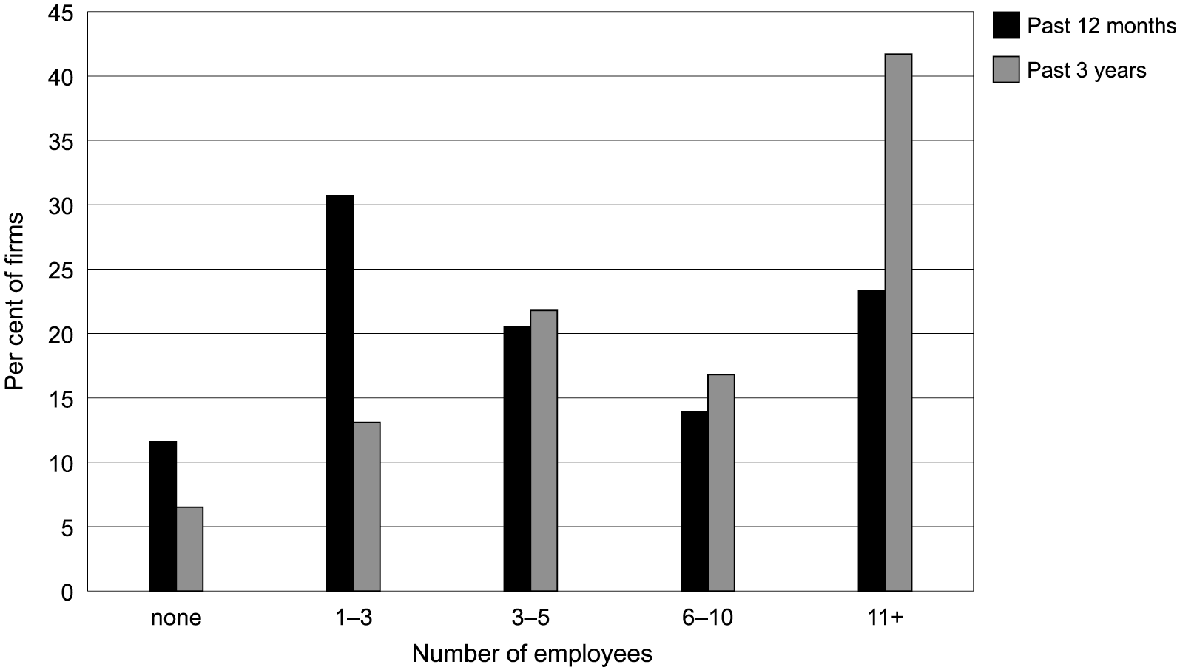
Indicators of labour turnover are shown in figure 2. Only a small number of firms had no staff turnover, and this suggests that most of the firms that were surveyed needed to recruit workers on a regular basis. Recruitment also was spread relatively evenly across different occupational categories and different industry sectors, and this would reflect the robust labour market in Australia in recent years.
Figure 2: Number of employees which have departed firms over the past 12 months or the past 3 years
Approximately 43% of firms indicated that they had difficulties in filling vacancies in one or more of the four categories of employment. As indicated in figure 3 the most frequently cited positions were those in the management, administrative and professional areas, and the least cited were those in the plant, machine and labouring areas. This is consistent with the data on recruitment patterns and suggests that the highest concentration of skills shortages are in the higher level service areas. However, over 15% of firms indicated that they had difficulty in filling vacancies in the technical and trades areas. Given that less than a third of firms indicated that they recruited workers in this area, these figures suggest a skills shortage in the area. The patterns of recruitment and the incidences of hard-to-fill vacancies indicate a buoyant demand for labour. They also tend to confirm other studies that locate the major areas of labour demand in high- and low-level service sectors, with weaker demand in the middle level skills areas (for example see Chappell et al. 2003).
Figure 3: Difficulties in recruiting employees by occupational categories (%)

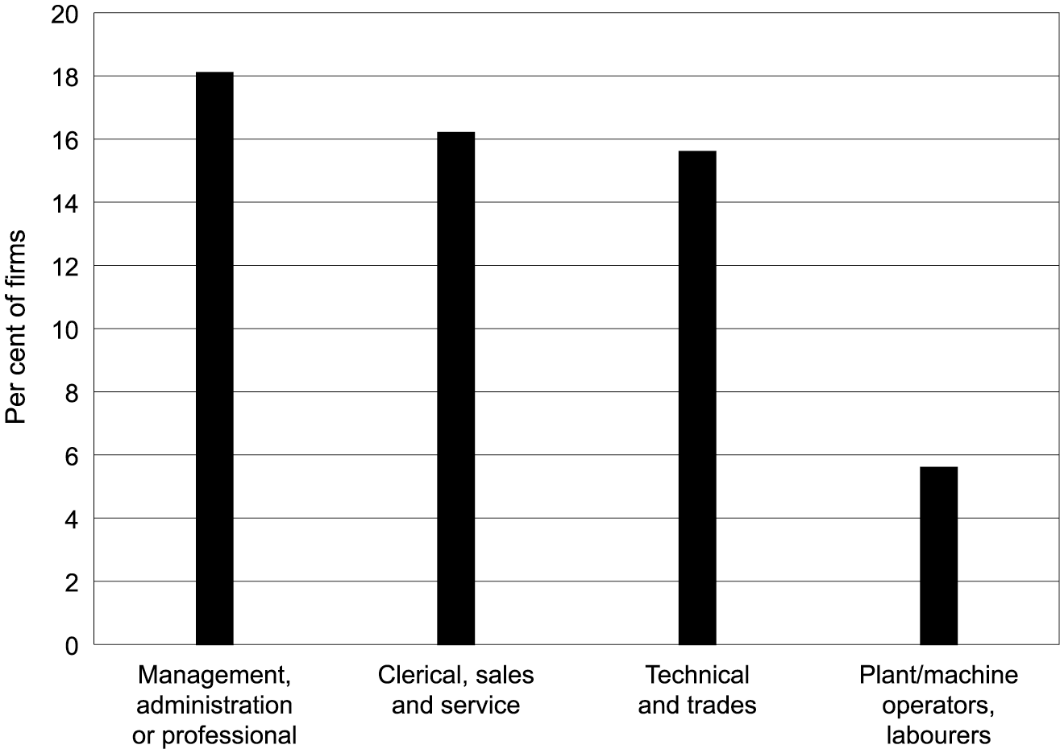
Skills demand
Respondents indicating that they had experienced difficulties in filling vacancies in any of the employment categories were asked to respond to a list of eight reasons for the difficulties encountered.
As figure 4 shows, the most frequently cited reason nominated by firms who encountered difficulty filling vacancies is lack of industry experience; this is followed by lack of applicants, and lack of general work experience. Approximately 40% of respondents indicated that they had difficulties filling vacancies because of a lack of specific qualifications. Lack of general education has the lowest response rate. It might be assumed that a ‘general education’ is signalled by either a Year 12 certificate (or possibly Year 10) or a general degree. These results are consistent with the argument that labour markets like the Australian labour market attach a low value to generalist qualifications, especially at the lower levels (Grubb 1999; Rosenbaum & Kariya 1991).
The results may have implications for senior secondary schooling. VET in Schools has been shown to enhance labour market outcomes (Polesel & Teese 2002; Polesel et al. 2004), as have work placements as part of course delivery elsewhere (Rosenbaum & Kariya 1991), and vocational programs at the sub-baccalaureate (Grubb 1999). On the other hand, the OECD (2001) and World Bank (De Farranti et al. 2003) both conclude that a broad foundation of secondary education is the key human capital ingredient for nations in the globalisation age. Put together these observations make a case for more vocational and work-connected studies in the senior years of schooling.

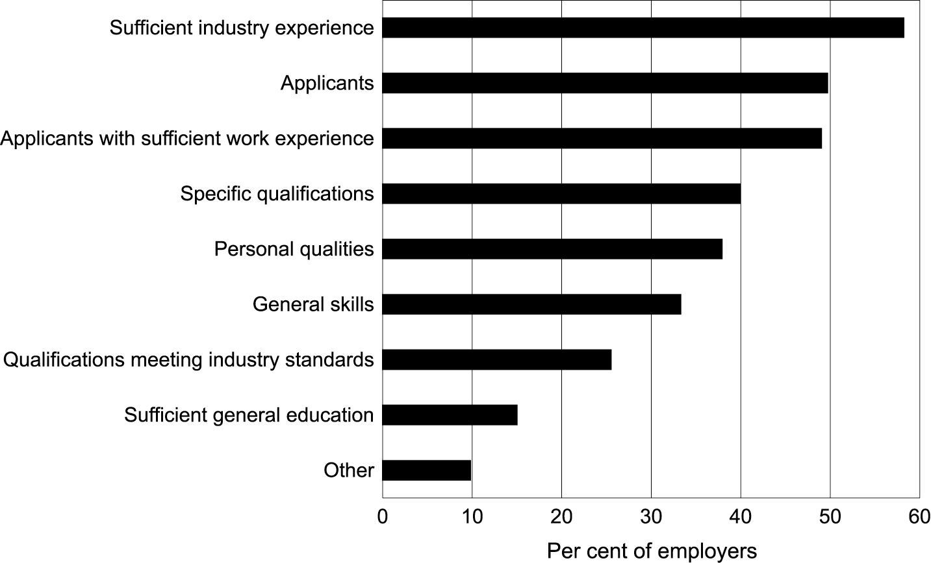
Figure 4: Main reasons given by employers for encountering difficulties in recruiting employees (%)
As shown in figure 5, the reasons cited most frequently for difficulty in filling vacancies have been applied to management, administrative and professional positions, and least frequently to plant and machine operators and labourers. Once again, these results tend to confirm the analysis of growing demand for high-level skill, and moderate demand for middle-level skills. In general, management and professional, and technical and trade positions are the most credentialed. Together, they represent about 70% of the frequencies.
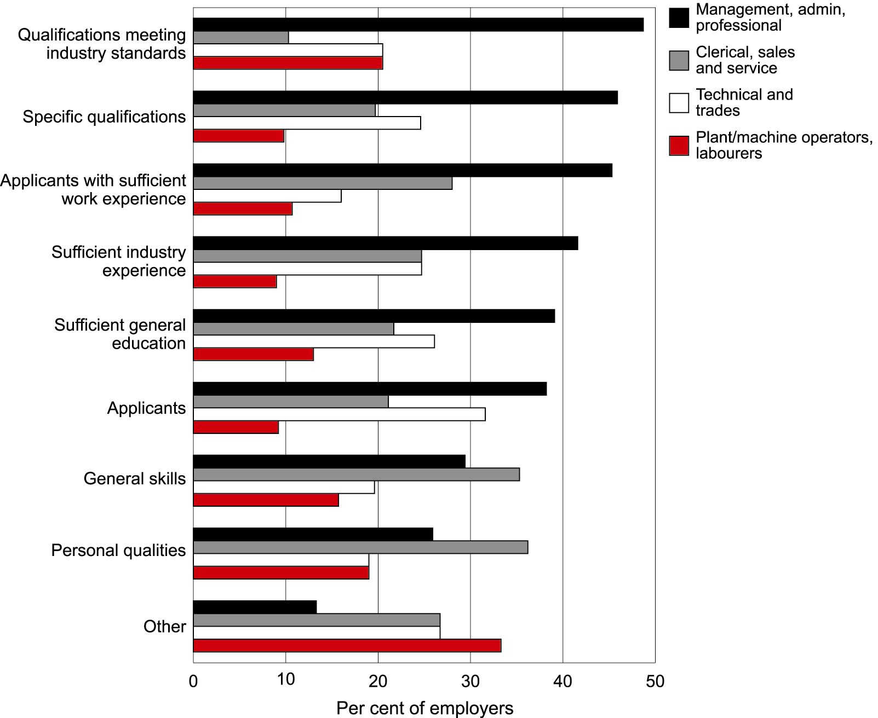
Figure 5: Reasons for difficulty in filling vacancies by occupational categories (%)

Recruiting practices—employer searching
Employers were asked to indicate the means by which they typically searched for workers. The results for four occupational categories are shown in figure 6, which shows a hierarchy of practices and that are consistent across occupational categories. Most frequent is advertising locally, followed by the use of networks and word of mouth, and the use of current staff to locate potential employees. External formal structures of employment agencies and the Jobs Network, as well as industry associations and unions, are comparatively weak. The use of work placements undertaken by school and technical and further education (TAFE) students is stronger than the use of the Jobs Network or industry associations and unions. As would be anticipated, the use of national and international advertising is limited.
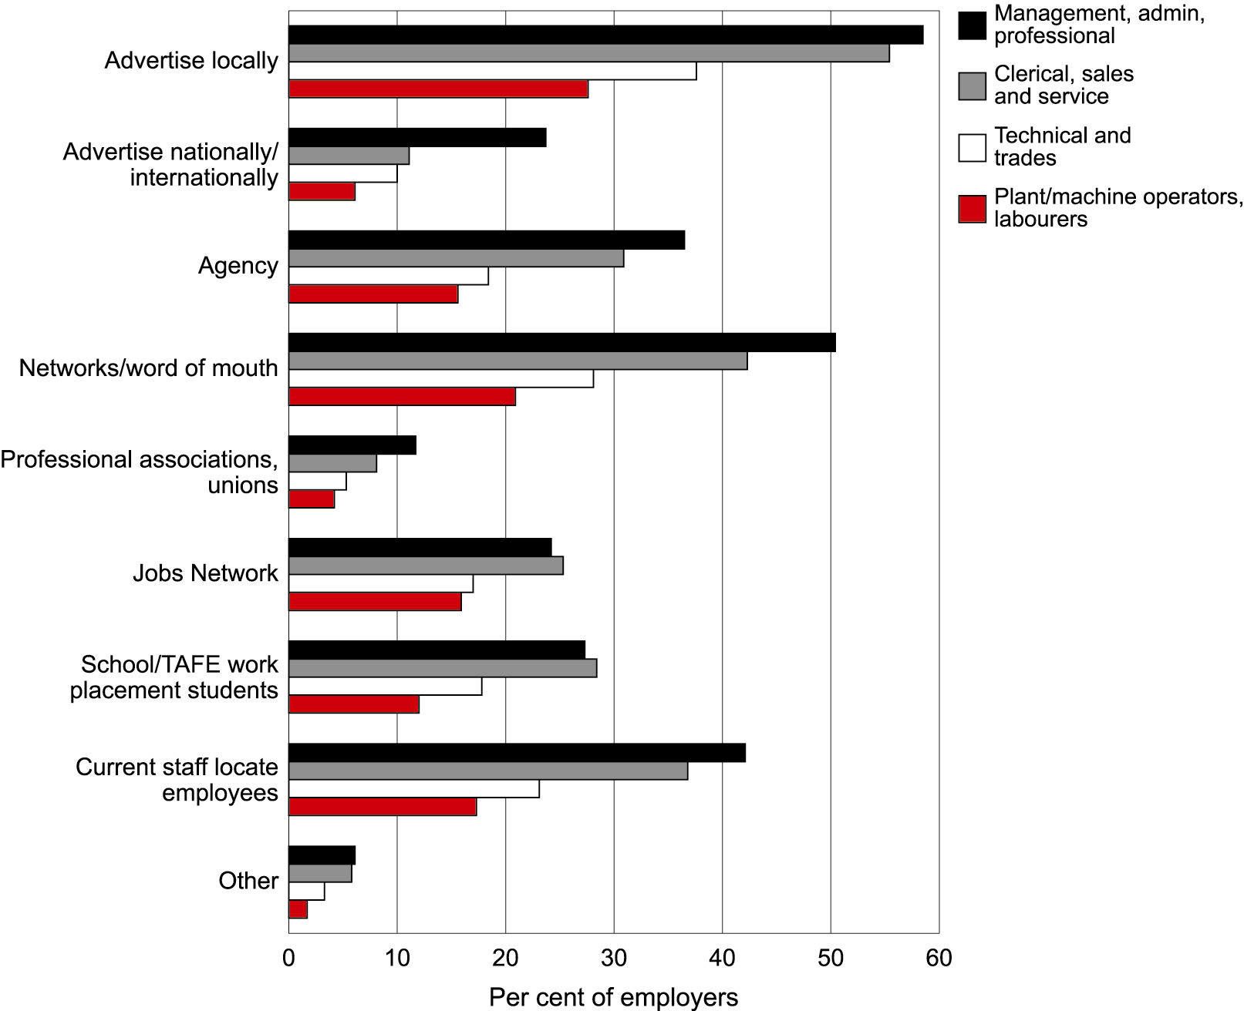
Figure 6: Means by which firms locate potential employees by occupational category (%)
The results suggest the following issues:
- Recruitment remains largely an internal function. Few firms use either employment agencies or the Jobs Network.
- Recruitment remains largely local. Few firms advertise nationally or internationally. Higher level positions (management, administrative and professional) are more likely to be advertised widely.
- After local advertising, networks are the main means of locating manual work positions—plant and machine operators, labourers, and technical and trades persons.
- Work placements have a capacity to locate students/trainees in employment.
The responses by firm size are shown in figure 7. These results are relatively intuitive, with larger firms citing most of the searching mechanisms and searching more widely and smaller firms concentrating upon networks and local advertising.
Figure 7: Means by which different firm sizes locate potential employees (%)
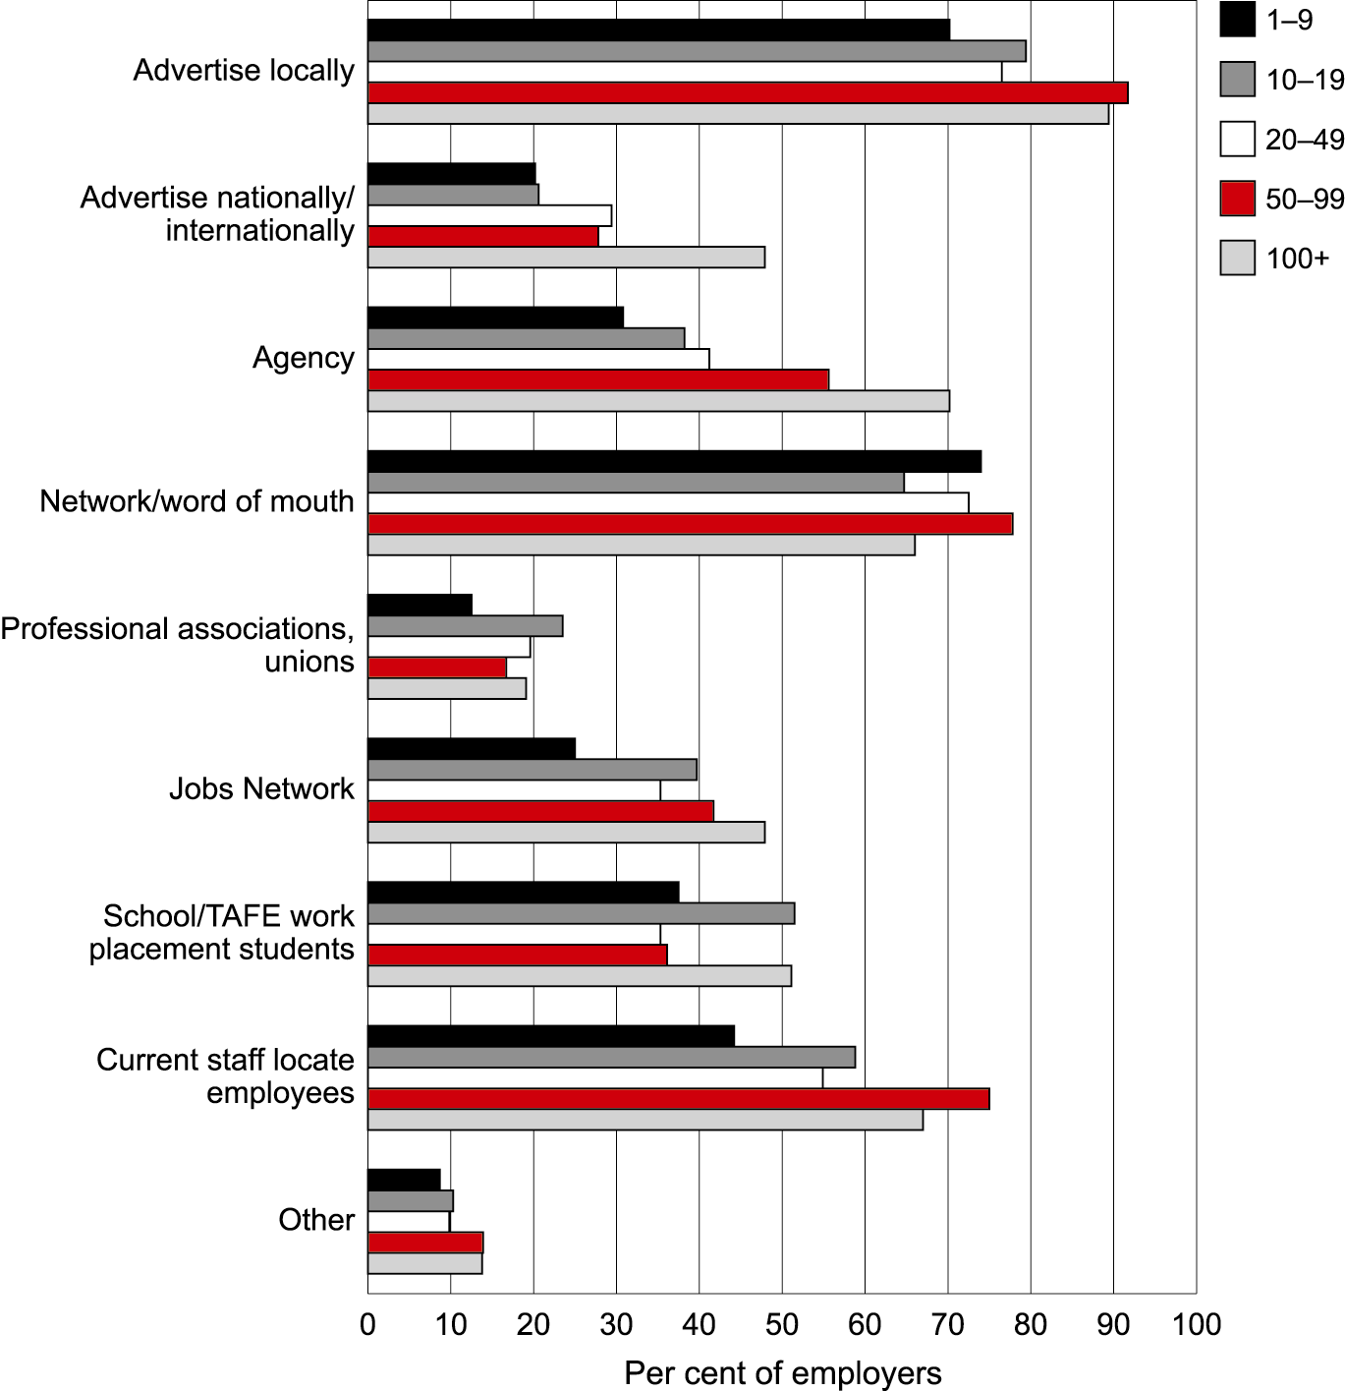
The combination of networks, use of current staff, and work placements indicates the importance of trust in recruitment decisions. These results confirm other studies that indicate the high degree of localisation for lower level positions, and the minimisation of risk and costs in employment processes for these workers.
The results suggest relatively localised recruiting practices on the part of most employers. Only a quarter of management and clerical jobs are advertised nationally or internationally, and less than half of trade and technical and operator and labourer positions are advertised. Most employers that advertise also use other more localised searching methods, especially networks. Localised searching is more likely in a situation where employers need to fill vacancies relatively quickly, where they wish to reduce recruitment costs, and where they are less willing to take risks. These patterns are consistent with relatively short-term induction periods for workers so that the initial induction and training investments are minimised.
Smaller firms are more likely to use localised searching methods, and these behaviours are likely to be associated with selection processes and decisions that also minimise costs and risks. They also relate to patterns of trust, or what employers regard as the most reliable indicators of qualities in recruits that will minimise their risks.

Qualifications
Respondents were asked what they considered to be a qualification. The results are shown in figure 8 and show that VET qualifications are most commonly recognised by employers. The general pattern shows that only Australian Qualifications Framework qualifications (vocational education and training, degrees, and school certificates) are recognised by a majority of employers.
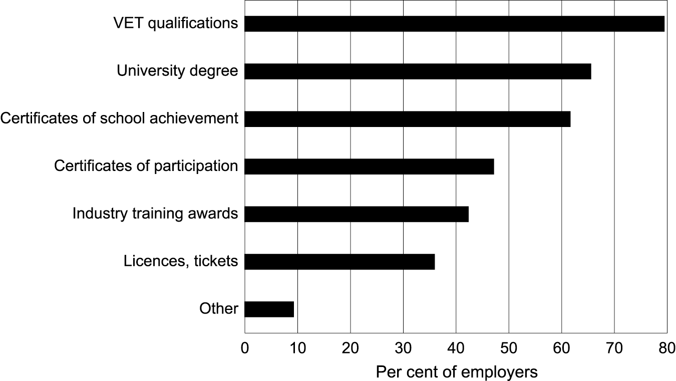
Figure 8: What firms consider to be qualifications, % responding ‘yes’

Selection
Figure 9 indicates firms’ use of each of seven methods used to select employees for each of the four occupational groupings.
Figure 9: Means of selecting employees by occupational category (%)
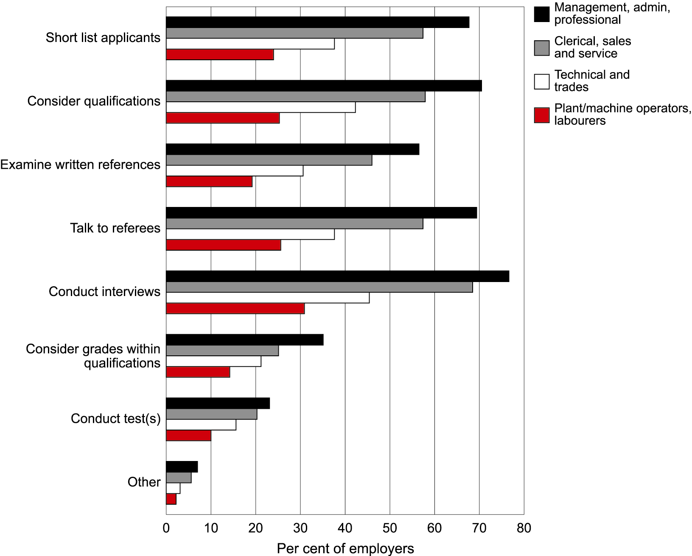
The results show strong differences in the percentage of firms that use each of the methods and the use of the different methods by occupational categories. The first five methods are used by a large number of firms, while few firms conduct tests or consider grades within qualifications. A majority of firms indicated they use the method of conducting interviews only. This suggests that most firms use these information systems selectively, and that in many cases the selection process is relatively informal and probably is linked to informal or network-based searching procedures.
The differences in behaviours across occupational groupings are quite consistent, and this also suggests a strong correlation between searching and selection behaviours. Formal and wider searching behaviours correlate with formal and more resource intensive selection methods that use wider information sources. Network-based searching correlates with selection processes that do not use wide information systems, including qualifications. It is likely that the searching and selection processes for technical and trade, and operators and labourers are relatively integrated.
Figure 10 compares the percentage of firms that use the different mechanisms by firm size. The higher percentages (compared to figure 9) are due to the aggregation of the occupational areas. The results are relatively intuitive, and indicate that only a majority of large firms conduct tests. This suggests a screening function that would be related to a large number of applicants for positions, which, in turn, is related to the wider searching behaviours of large firms.
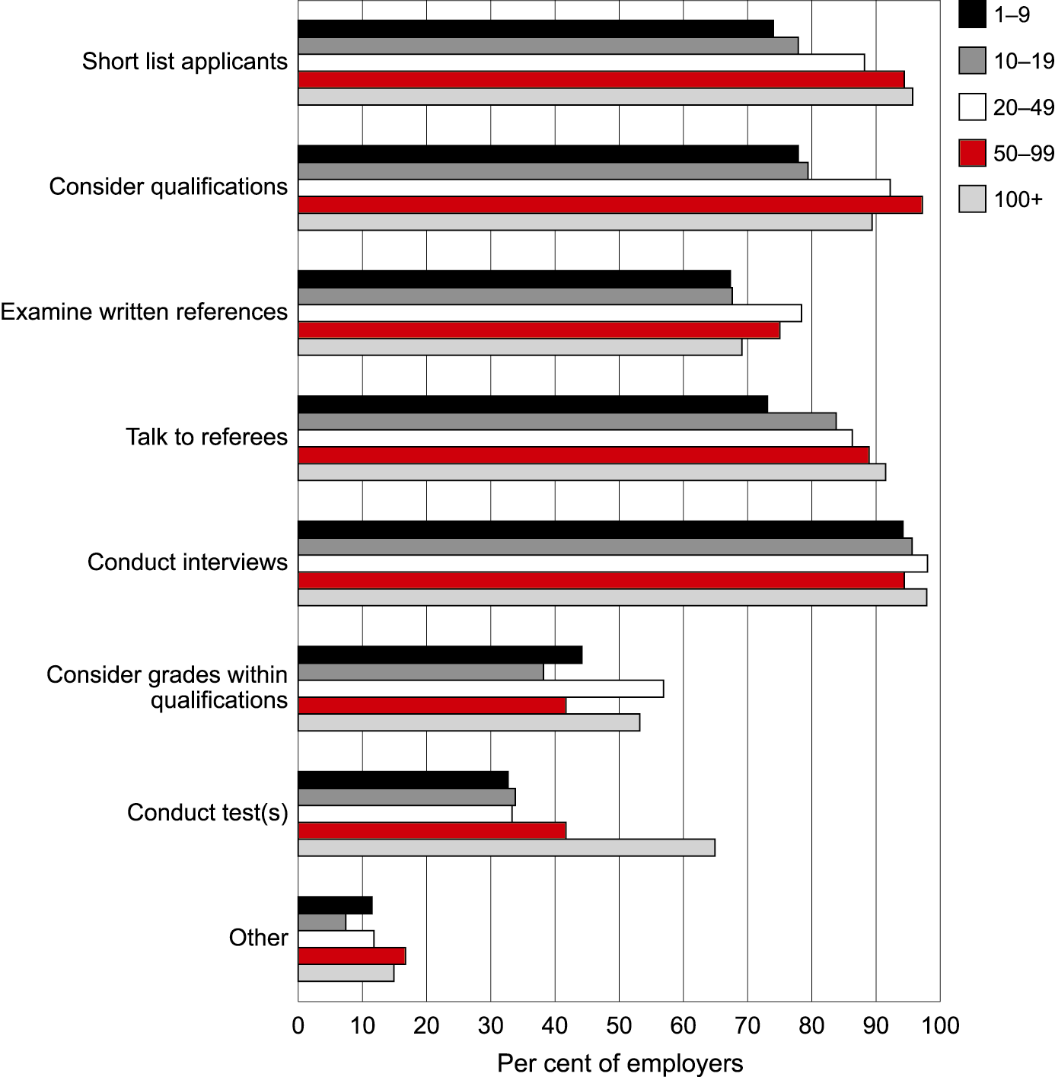
Figure 10: Means of selecting potential employees by firm size (%)
The results indicate that the majority of firms use relatively formal and extensive procedures for the selection of workers in the management, administrative and professional, and clerical, sales and services. The procedures typically include short listing applicants, a consideration of their qualifications, and interviews. Results for the other two categories, the use of grades and tests, are remarkably weaker. Less than a third of respondents for each of the methods indicated a positive response, although this does not mean that less than a third of employers use any of these mechanisms.
The results suggest relatively formal recruitment processes for managerial and professional and clerical and sales positions. They indicate that a majority of employers consider qualifications for these positions. However, a minority uses qualifications for technical and trades, and plant, machine and labouring positions.
Table 2 shows the percentage of firms in each sector that indicated that they consider qualifications when recruiting employees for the four occupational categories. The results need to be treated with caution owing to the low cell sizes for each of these industry and occupational groupings. Nevertheless, these data suggest that the more traditional and regulated industries continue to value qualifications more highly than the service sectors. This is not because of the existence of regulations, as this had low frequencies across all of the sectors, including the mining, manufacturing and construction, and wholesale trades and transport sectors.
Table 2: Percentage of firms taking into consideration applicant qualifications when recruiting employees, by industry sector and occupational area
Industry sector | Occupational area
 | A*  % | B*  % | C*  % | D*  %
Mining, manufacturing and construction | 72.1 | 57.4 | 70.5 | 54.1
Wholesale trades, transport services | 64.5 | 51.6 | 45.2 | 41.9
Retail, accommodation, restaurant, cafe | 57.7 | 64.1 | 39.7 | 12.8
Property, business services; finance and insurance | 72.7 | 63.6 | 29.1 | 16.4
Education, health and community services | 85.1 | 58.1 | 31.1 | 17.6
Cultural and rec services, personal and other services | 71.4 | 54.8 | 45.2 | 14.3
Note: * A: Management, administration or professional; B: Clerical, sales and service; C: Technical; and trades; D: Plant/machine operators, labourers.
Although larger firms are more likely to consider qualifications during the selection processes, as shown in figure 11, the difference in percentages are not significant. In fact, the large firms (100+) have recorded a lower percentage than medium size (20–99) firms.
Figure 11: Percentage of firms (by size) which consider the qualifications of applicants in the selection process
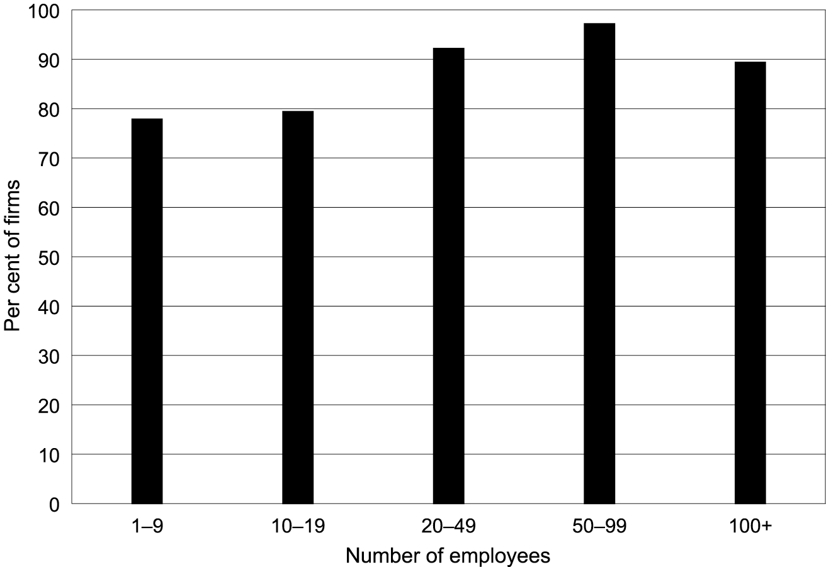

Criteria for selection
Figures 12 to 15 provide responses to the importance of seven criteria when selecting employees:
- previous work experience
- previous experience in your industry
- the highest level of qualification
- the qualification that meets the skills that are needed by the firm
- the qualification that meets regulatory or award requirements
- general skills (e.g. communications)
- personal qualities.
Respondents were asked to provide a rating of 1 (very important) to 5 (not at all important), for each of the four occupational categories.
Figure 12: Importance of criteria for selection of employees for management, administration and professional occupations (%)
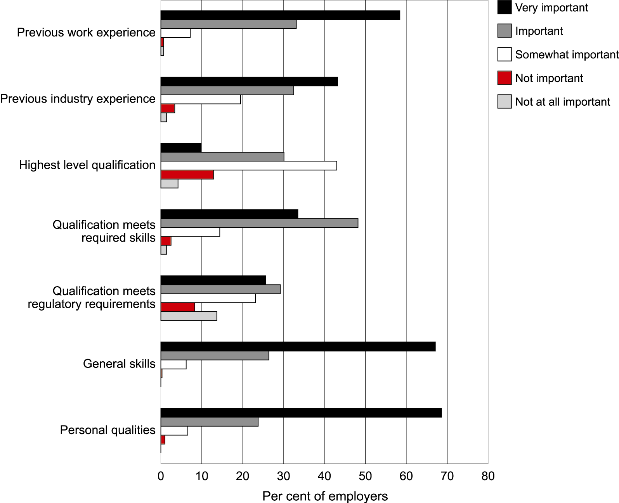
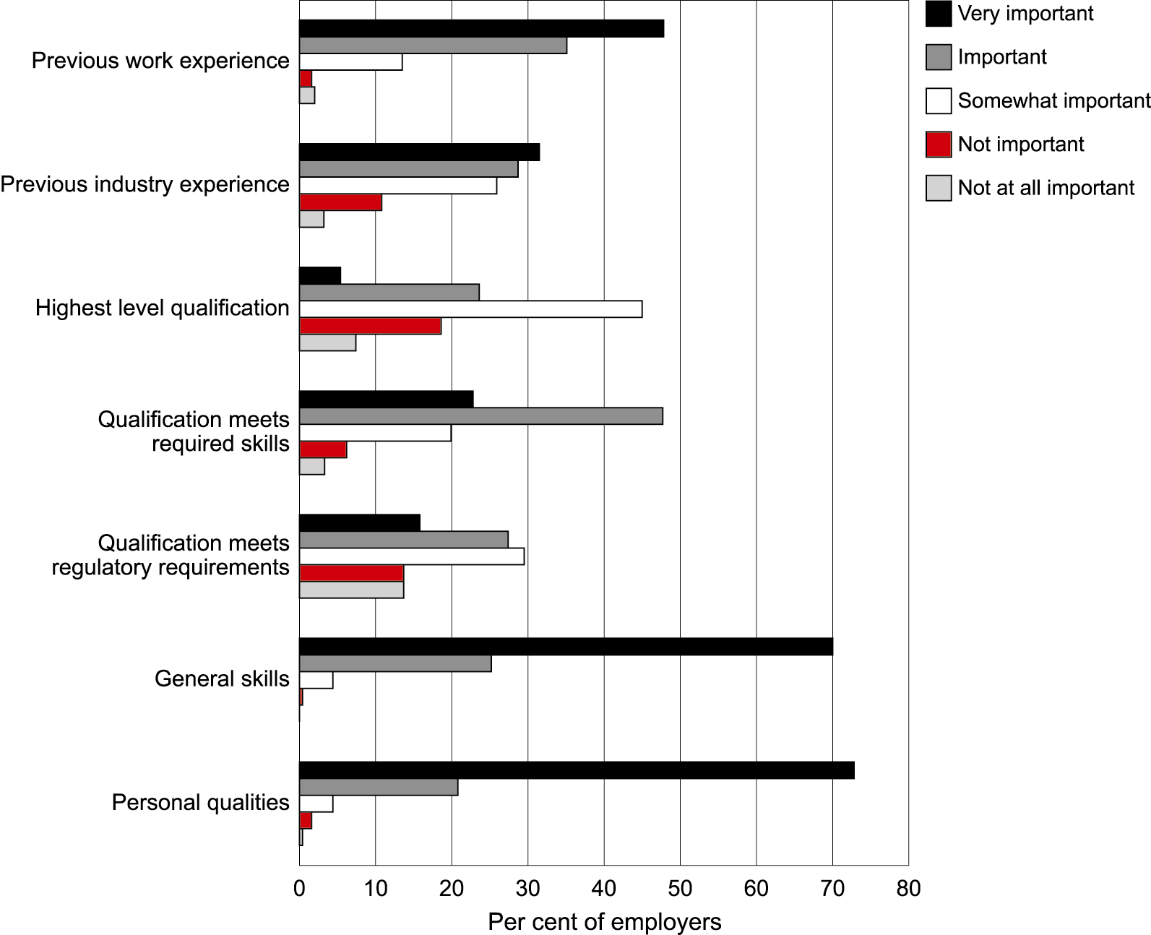
Figure 13: Importance of criteria for selection of employees for clerical, sales and service occupations (%)
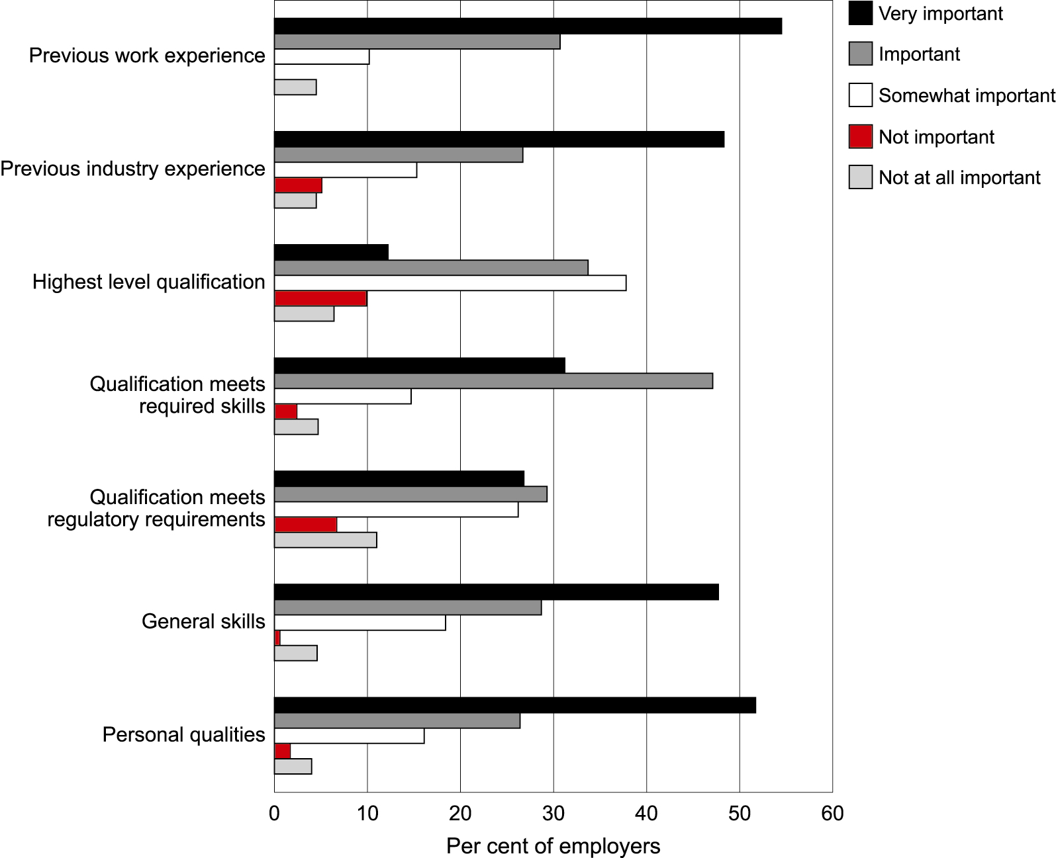
Figure 14: Importance of criteria for selection of employees for technical and trade occupations (%)
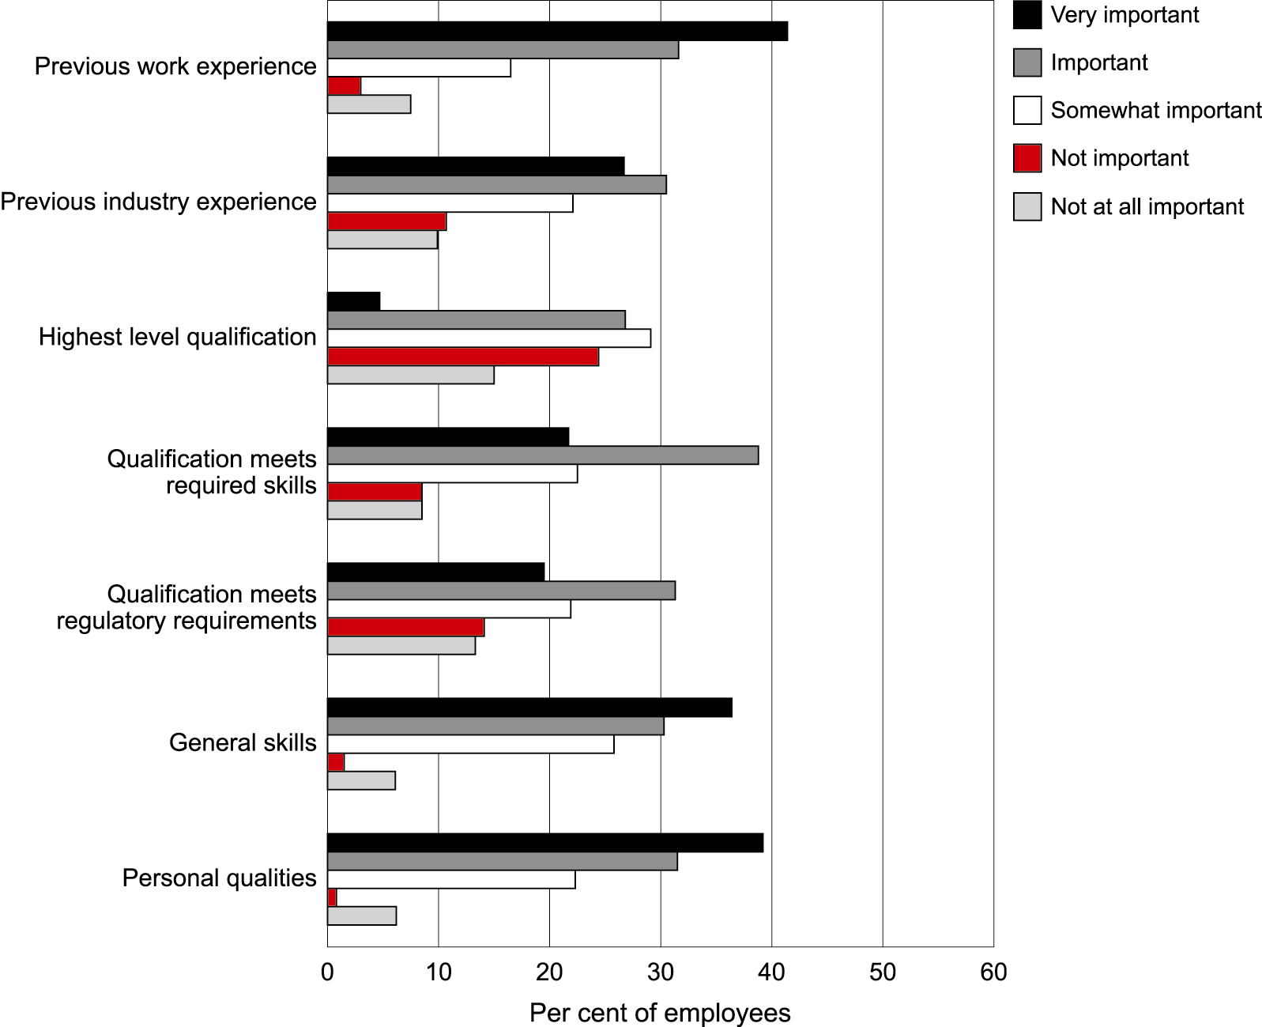
Figure 15: Importance of criteria for selection of employees for plant and machine operators and labourers (%)
The responses consistently rate general skills and personal qualities higher than the three criteria related to qualifications. This is consistent with the results of previous studies and anecdotal evidence in numerous reports. As well, general work experience and work experience within the industry also consistently rate higher than the three criteria related to qualifications. There are few differences in the trends across the categories of employees. As might be expected, previous work experience in the industry was rated highly for the technical trades and management. However, between 60 and 90% of employers rated general work experience as very important or important, and between 70 and 95% rated personal qualities as very important or important. There is an observable trend for employers to set stronger general criteria in the selection of management and clerical, sales and service positions. Experience within the industry is ranked highly for technical and trade positions.
The ranking of the importance of the ‘highest level of qualifications’ are close to normal distributions across the four groups of occupations, with slightly higher rankings for the white collar areas. However, over 60% of employers ranked qualifications meeting skills needs as important or very important for all four groups of occupations. As well, over 60% ranked meeting award requirements as important and very important.
It is of interest that private sector employers have more consistently identified personal qualities and general skills as the main criteria than public sector employers, as shown in figure 16. It is likely that these employers will seek to minimise risk more than public sector employers.
These results suggest that qualifications do play a role in the selection processes. However, it is unlikely that most employers place a high value in the intrinsic value of qualifications. This is not to say that they would not place value in generic qualities including personal qualities that qualifications signal, but that the status value of qualifications is not important to them. On the other hand, status overlaps with other factors such as licensing (Rottenberg 1987) that requires qualifications, a company profile of a ‘highly qualified workforce’, and networks where the ‘old college tie’ would have some impact. In general, these examples of status or intrinsic value would be weak, and probably are confined to small elements of industry.
If this is the case, the principal role of qualifications is their signalling capacity. This raises the question of what qualifications signal for employers, and how the signals provided through qualifications rank with other signals. The data suggest that employers rank personal qualities, generic work skills and specific industry skills in that order.
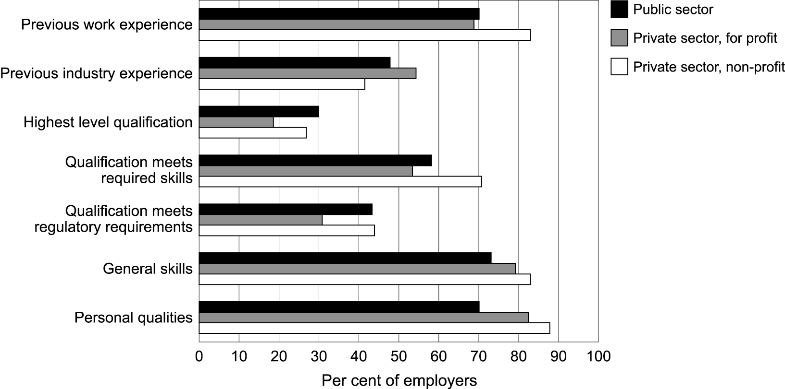
Figure 16: Criteria for selection ranking ‘very important’ or ‘important’ to the selection of employees, by firm sector (%)
The capacity for qualifications to signal qualities might be based upon three criteria. First is their capacity to embody the qualities that employers are seeking. Second is the amount of trust that employers have in qualifications. Third is the relative efficiency of the use of qualifications compared with other forms of information. As employers search wider, and as potential recruits also search wider, the efficiency of more informal sources of information such as networks declines. Therefore, it can be expected that qualifications become more important for positions that have more dispersed recruitment patterns.
It is useful therefore to gain some insights into how employers use qualifications within their recruitment processes. Therefore, subsequent questions were asked about how the qualifications are used in the selection processes, and about the qualities that qualifications signal for employers.

Use of qualifications in recruitment practices
Respondents were asked to indicate whether they used qualifications as minimum requirements for job specifications or to rank applicants, across three types of positions:
- higher paid positions only
- positions where regulations and awards required the qualification
- positions with particular skills needs.
The results are presented in figures 17 to 19. More employers, for all categories of recruits, use qualifications as a minimum requirement compared to them using a ranking instrument and less than a quarter of employers did not use qualifications in the selection processes. This suggests that qualifications are important in the selection processes, and that most potential recruits for most positions will be better off with a relevant qualification. Over half of all employers that responded have indicated that they use qualifications as a minimal requirement, and about a quarter use them to rank candidates. This indicates a strong sorting or threshold function.
Figure 17: How qualifications are used to select employees for higher paid positions across occupational area
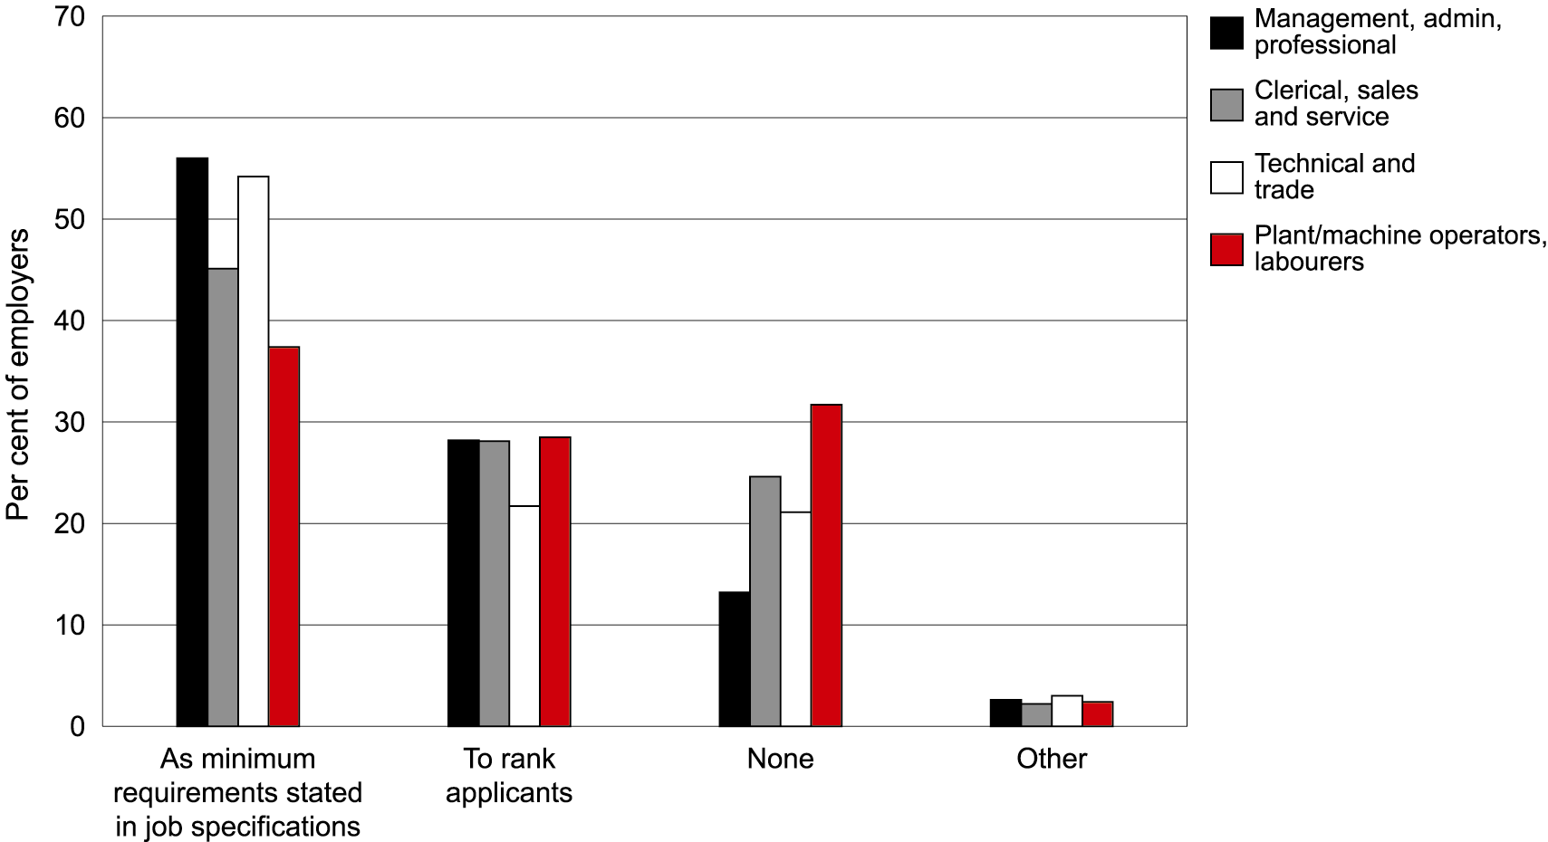
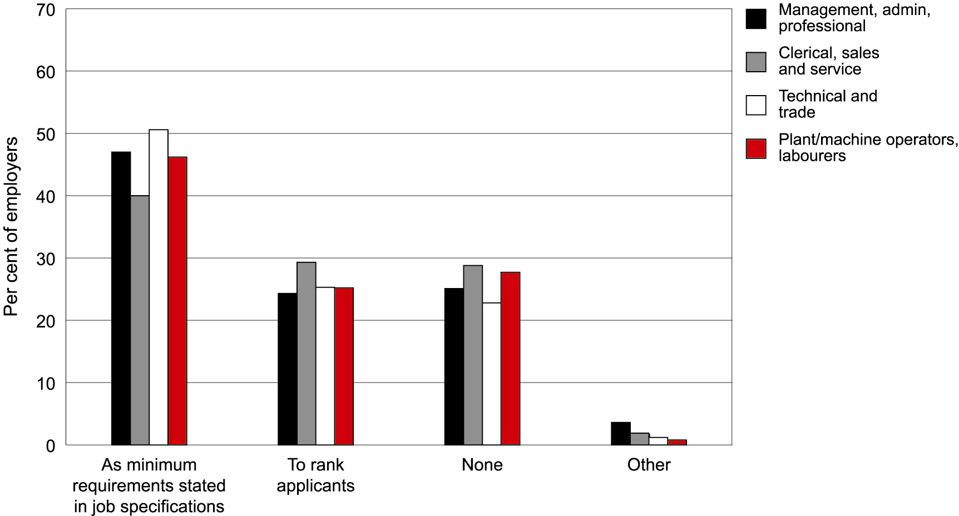
Figure 18: How qualifications are used to select employees for positions where regulations and awards require the qualifications, across occupational areas

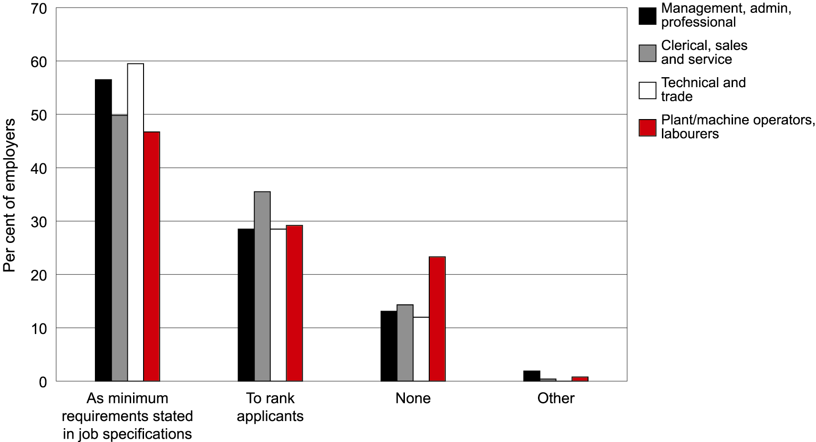
Figure 19: How qualifications are used to select employees for positions with particular skill needs, across occupational areas
There also is a slightly higher use of qualifications for positions with particular skills needs. This would suggest, therefore, a screening function that is mixed with the sorting function. It is possible that some sections of the labour market seek specific skills through qualifications—that is a screening use—although these employers still rely mostly upon evidence of industry experience as the verification for these skills. For most employers therefore, qualifications are necessary attributes for potential recruits. The most important signals are generic, although there also are specific screening signals and it can be difficult to separate generic and specific work skills.
These results indicate a stronger sorting or threshold use of qualifications than a screening use. It is likely that the screening use of VET qualifications is greater. However, even for positions with particular skill needs the sorting use is stronger than the screening.

Attributes signalled by qualifications
To gain further information on the signalling capacity of qualifications employers were asked what qualities and benefits qualifications signal for them. They also were asked to respond to both university and VET qualifications. A summary of the results is provided in table 3.
Table 3: Correlation between university or vocational/technical qualifications and perceptions of potential employees (%)
Qualifications signal … | Qualification type
 | University  % | Vocational/technical  %
Personal qualities and attitudes | 54.6 | 50.4
General skills | 56.3 | 64.6
Job skills | 39.8 | 59.9
Capacity to learn | 73.5 | 61.6
Reduction in induction training time | 29.5 | 35.9
Job stability | 27.6 | 28.4
The data suggest that most employers prefer vocational education and training to university qualifications as signals of most of the qualities in recruits. The obvious exception is the capacity to learn, and to a lesser extent personal qualities. VET qualifications score more highly in the categories of job stability, reduced training, job skills and general skills. However, the capacity to learn is the attribute that is frequently cited, followed by general skills, job skills and personal qualities. Few employers regarded qualifications as signalling job stability and a reduction in training needs and costs, although more employers in the industries with stronger traditions of workplace training, notably the mining/manufacturing sectors, cited these two qualities.
The data, therefore, may indicate that qualifications signal three sets of attributes: personal qualities, learning capacity, and work, industry and occupational skills. Although there are links between the three, there is a degree of industry-sector-based separation. A dominance of the capacity to learn within the property and business services sector may indicate that this capacity is valued most highly in the knowledge-based industries, especially as the value of job stability is quite low for this sector. Degree qualification scored most highly in this sector.
These data should be compared with those relating to the qualities that employers seek in their workers. Employers ranked personal qualities and general skills very highly, and it seems that most employers in most sectors think that qualifications signal these qualities. However, the degree of confidence in these signals is unknown. Given that more employers value work and specific industry experience more highly than qualifications, it is likely that there are some limits to, or hesitation in, their trust of qualifications. Verifiable work and industry experience appear to offer greater guarantees that potential workers have the general work skills and personal qualities that would make them productive employees.
It has been established that most employees in all sectors utilise qualifications as a selection criterion for most positions in all of the sets of occupations. As well, this is not primarily as a result of award and licensing requirements, although they are factors. Rather, it is because of their signalling capacities. It is likely, therefore, that qualifications are either or both a convenient signalling tool or a relatively reliable tool that can readily be quantified in terms of course length and context and be verified.
It is more difficult to verify positive work and industry experience, and in a more contingent labour market and with higher rates of labour mobility the reliability and validity of evidence of previous work and industry experience may weaken, relative to the reliability and validity of qualifications. The consistent high scores for both VET and university qualifications in their signalling role for capacity to learn, personal qualities and general skills can be seen as positive in the context of changes in industry and the predicted demand for generic skills (Chappell et al. 2003). It also is the case that in all but one of the industry sectors, employers cited general skills more frequently than specific work skills as being signalled by VET qualifications. Unfortunately the survey did not ask employers to differentiate between high and low level VET qualifications.
In this regard, the low percentage of firms that cited a reduction in induction time is of interest. Changes in industry and production that are taking place globally are frequently seen as putting pressure upon and shortening the capital investment cycles, including the human capital investment cycles. Employers are less inclined to take inexperienced workers, as they can no longer afford the period of low labour productivity during the induction period. It would seem that qualifications make a relatively weak contribution towards shortening the induction time. This may suggest that education and training providers should look at ways of strengthening these attributes.
A relatively low percentage of employers cited ‘personal qualities and attitudes’ as being signalled by vocational qualifications. Given that these attributes are most highly desired by employers, this raises the question of if and how personal qualities can better be represented within qualifications.

Trust in qualifications
Employers were asked to rank as very important, important or not important six characteristics of qualifications. The results are shown in figure 20.
Figure 20: Factors which influence trust or confidence in qualifications, across all firms (%)
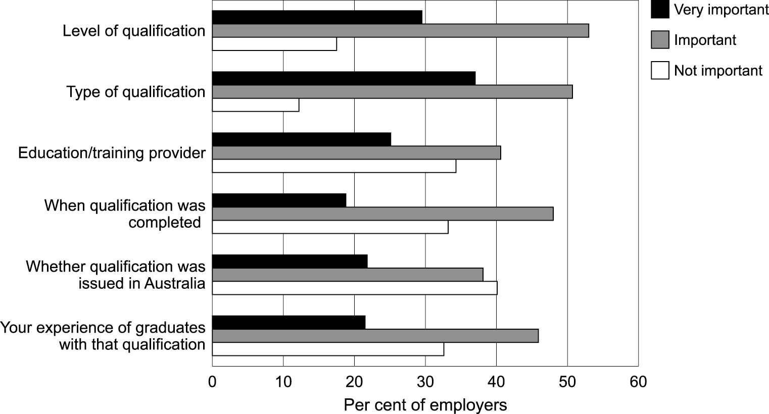
A minority of respondents indicated that any one of the characteristics was very important. However, a large majority indicated that the level and type of qualification are very important or important, and a majority gave positive responses to all six characteristics. The weakest response is to whether the qualifications were issued in Australia.
The results tend to confirm the lack of direct linkages between enterprises and education and training providers (although over 60% of respondents felt that the education or training provider was important). Conversely, the data could be taken to represent a relatively high degree of trust in the quality of qualifications in Australia. What employers probably question is whether institutional-based education and training can deliver the qualities that they want in recruits better or as well as work and industry experience.
Respondents were asked to rate the importance of qualifications for meeting skill needs, the recruitment processes, meeting regulatory and award requirements, and for internal human resource management. The results are shown in table 4. Once again they generally are positive and there is cause to regard these results in relative rather than absolute terms. That is, the positive responses tend to indicate that qualifications are of some use, but a full picture would only be revealed through comparisons with other sources of information for these purposes.
Table 4: The level of importance assigned to the various uses of employee qualifications (number and percentage of firms responding)
Importance | Qualifications are used to …
 | Meet current/future skill needs |  | Recruit/select new employees |  | Comply with regulations |  | Meet award requirements |  | Promote worker loyalty/reduce turnover
 | No. | % | No. | % | No. | % | No. | % | No. | %
Very important | 106 | 31.2 | 91 | 26.8 | 103 | 30.5 | 72 | 21.5 | 78 | 23.6
Important | 165 | 48.5 | 163 | 47.9 | 125 | 37.0 | 121 | 36.1 | 110 | 33.2
Neither | 38 | 11.2 | 59 | 17.4 | 47 | 13.9 | 67 | 20.0 | 64 | 19.3
Unimportant | 17 | 5.0 | 15 | 4.4 | 22 | 6.5 | 28 | 8.4 | 20 | 6.0
Not at all important | 14 | 4.1 | 12 | 3.5 | 41 | 12.1 | 47 | 14.0 | 59 | 17.8
The data indicate, however, that a quarter of employers regard qualifications as very important in the recruitment and selection processes, and over a quarter appear to regard qualifications as very important in meeting skill needs. This suggests that these employers regard qualifications as having strong signalling capacities. The fact that over 70% of respondents rated the two uses as important or very important suggests that there are at least moderate levels of trust in qualifications across most employers.
It needs to be recognised that these responses would not apply to all employees and all positions within firms. So, while a majority of employers have indicated that qualifications are important or very important for regulatory and award requirements, this may only apply to some positions and some employees. Nevertheless, these results, together with the indication that most employers use qualifications in strategies to maintain worker loyalty and the reduction of turnover, suggest that qualifications are embedded in the human resource cultures of most enterprises.
Employers were asked to nominate negative aspects of four categories of qualifications: low and high level general and vocational/technical qualifications. The results are shown in table 5. Consistent with other results, employers more frequently have nominated negative aspects of general and especially high level general qualifications, particularly those of over-qualified and dissatisfied workers. However, these results show greater variation across different types of qualifications for different effects. For example, low level general qualifications have the highest frequencies for employee turnover, and this is probably associated, at least in part, with school leavers that are more likely to be mobile. Employee turnover is cited frequently for all categories of qualifications.
Wage pressure is cited frequently for high general and vocational/technical qualifications. It is unknown whether this is because of award requirements, although this is unlikely for general qualifications.
Table 5: Negative aspects of qualifications (% agreeing)
 | Qualification type
 | High level general | High level technical or vocational | Low level  general | Low level technical or vocational
 | % | % | % | %
Leads to higher wages | 28.7 | 22.8 | 10.9 | 7.0
Over qualified and job dissatisfaction | 45.7 | 22.0 | 16.7 | 7.2
Increased employee turnover | 27.0 | 14.5 | 24.8 | 15.9
Signal poor personal qualities | 8.4 | 4.5 | 13.4 | 10.9
Other | 9.2 | 4.2 | 8.4 | 3.3
Respondents that recognise company-based qualifications were asked whether it is important that these should be Australian Qualifications Framework qualifications. The results are shown in table 6. Enumerators have reported that very few employers have heard of the Australian Qualifications Framework. This probably is not surprising, and there are no serious implications of this. However, it does give some insights into the relationship between employers and qualifications. The institutional relations tend to be immediate rather than structural. In other words, employers’ attitudes towards qualifications are based upon their own experiences and broad social, industry and industrial attitudes towards them, rather than through the structural relations of a qualifications framework. Thus qualification frameworks should be seen as a developmental and organisational tool rather than an instrument that has a role in maintaining user confidence in the quality of qualifications.
Table 6: Number of firms (by industry sector) indicating the importance of company-based qualifications being AQF qualifications (frequency of responses)
Industry sector | Qualifications should be AQF qualifications …
 | Always | Some-times | Never | Unsure | Total
Mining, manufacturing and construction | 22 | 20 | 5 | 13 | 60
Wholesale trades, transport services | 7 | 11 | 4 | 7 | 29
Retail, accommodation, restaurant, cafe | 14 | 31 | 17 | 13 | 75
Property, business services; Finance and insurance | 11 | 13 | 13 | 17 | 54
Education; Health and community services | 28 | 23 | 15 | 4 | 70
Cultural and recreation services; Personal and other services | 12 | 8 | 7 | 14 | 41
Note: AQF = Australian Qualifications Framework.
When explained what the Australian Qualifications Framework is, most employers responded that it was always or sometimes important for the qualification to be within the Australian Qualifications Framework. This probably indicates support for state-supervised accreditation and quality assurance arrangements.

Changes in award and regulatory requirements
The literature has linked regulated labour markets with the use of qualifications by employers in recruitment and human resource management. The most frequently cited example is that of Germany where the highly regulated labour market buttresses the dual system of apprenticeships by requiring a large number of positions in industry and occupations to have a qualifications base (Marsden 1997; Muller, Steinmann & Ell 1998). There have been attempts to reduce labour market regulation in nations such as the United Kingdom and Australia over the past two decades, and the decline of apprenticeship numbers has been attributed by some to these deregulatory initiatives (Gospel 1994). In Australia there has been a considerable degree of sensitivity over qualifications and their relationship with industrial awards, and for this reason VET qualifications within the Australian Qualifications Framework are no longer described as ‘levels’.
Therefore, it was seen as useful to ask employers about the impact of any changes in award and regulatory arrangements upon the number of positions that required minimum or specific qualifications. The results are shown in table 7. It can be seen that the overwhelming majority of employers reported no change. However, approximately 13% of all of the employers that were surveyed have indicated an increase in the number of positions that have been affected. Only 3% reported a decrease. The survey has not separated the impact of award and regulatory requirements. Given the industrial landscape for the period preceding the administration of this survey, it seems likely that the reasons behind the reported increases are regulatory and are related to issues such as health and safety and quality.
Table 7: Impact of changes in award and regulatory arrangements upon number of positions that require minimum or specific qualifications (number of firms responding)
 | Reduced | Increased | No change
Mining, manufacturing and construction | 2 | 13 | 40
Wholesale trades, transport services | 2 | 4 | 20
Retail, accommodation, restaurant, café | 2 | 5 | 59
Property, business services; Finance and Insurance | 4 | 8 | 33
Education; Health and community services | 1 | 14 | 46
Cultural and recreation services; Personal and other services | 1 | 6 | 31
Total | 12 | 50 | 229

Further qualifications
Finally, employers were asked whether they encouraged employees to gain further qualifications and the type of qualifications that they encouraged. The results are shown in tables 8 and 9.
Table 8: Number of firms indicating their willingness to encourage employees to gain further qualifications (number/percentage of firms responding)
Yes |  | No
No. | % | No. | %
318 | 88.6 | 35 | 9.7
Table 9: Percentage of firms indicating that they encourage employees to gain further qualifications, by employee/qualification category (%)
Employee/qualification category | % responding ‘yes’
All employees | 81.1
More senior employees | 5.3
Employees with low levels of qualifications | 11.9
Younger employees | 14.2
Employees in specific areas of the company | 18.2
All qualifications | 15.7
High level qualifications | 4.7
Qualifications relevant to firm | 33.3
These results would be expected. Employers tend to not discriminate, with a small number favouring younger and less well qualified employees. A good proportion favour qualifications that are relevant to the needs of the firm.

Conclusions
Post-school qualifications in Australia are oriented primarily towards employment. Vocational education and training qualifications have been developed directly from workplace practices and vetted by industry upon the criteria of their skill needs. Higher education qualifications have moved further towards criteria for employment outcomes, and most are subject to accreditation procedures that take account of the advice of professional and industrial bodies. There has been a substantial investment in qualifications in Australia, and there are relatively advanced quality assurance systems in both the VET and the higher education sectors.
The majority of labour market entrants now carry post-school qualifications, and the percentage is increasing. The capacity of qualifications to assist employers to locate the appropriately skilled potential workers, and their capacity for them to relay the attributes of graduates to employers, are important outcomes for employers and graduates, respectively. As has been discussed in this report, there is a wide range of intervening variables that will influence these outcomes. Nevertheless, there also are attributes of qualifications and the education and training programs that lead to qualifications that enhance the capacity of qualifications to articulate or connect with employment and employers’ skill needs.
Qualifications can be regarded by employers in two ways. For them they can have intrinsic qualities and as information systems that relay more specific qualities. In general, it is assumed that employers are motivated by human capital objectives, particularly the potential for high levels of labour productivity. These objectives are mitigated by market interventions in the form of regulations, licenses, and industrial awards. They can also be mitigated by other objectives, such as status, especially for high-level qualifications.
There is no clear line between intrinsic and the signalled qualities. The holders of qualifications may be regarded as having qualities such as a work ethic, a capacity to complete tasks over a long period, and reliability and punctuality. Qualifications can signal generic skills as well as a capacity to learn. They also can signal more specific knowledge and skills. In the absence of regulations it is unlikely that employers would separate these attributes when using qualifications to assist in recruitment decisions. Therefore, it is reasonable to generalise the qualities that employers attribute to qualifications.
Two other variables should be considered, however. First, there is a need to consider the location of qualifications within the selection process. This depends upon a range of other factors, such as the number of potential recruits, the searching behaviours of potential recruits, and the nature and level of investment in the recruitment processes by employers.
The survey has not been able to unravel all of these variables. Even if it could, it would not account for other factors such as the impact of economic cycles, and the large range of variables that influence the behaviours of different types of firms in different types of industries towards different types of workers. Nevertheless, the survey has revealed a number of views among Australian employers and can be summarised in the following way.
The results from the survey are consistent with those from other studies that indicate the importance for employers of personal qualities in potential employees, and the importance of general, and to a lesser extent specific, industry experience as the background for working in their firms. These two attributes, however, are of different genres, as personal qualities are an attribute while work and industry experience might be regarded as signalling mechanisms. There is an obvious link between the two, however, as it is likely that employers see general work experience as a reliable signal for personal qualities such as reliability, work ethic and honesty.
Qualifications, however, are used in the selection process, and their importance may be growing. Almost 50% of employers have indicated that they use qualifications in their recruitment and selection processes, and few have indicated that they are unimportant. Given the strength of the labour market at the time of the survey, the importance of qualifications could strengthen with a downturn in the economic cycle. The survey located a high level of difficulty faced by employers in locating suitable recruits. Under these circumstances, the selection process is likely to be shorter. In a period of increased labour supply, qualifications may have a stronger sorting or threshold role.
There are clear differences in the use of qualifications across different categories of workers and occupations. They have a stronger role in management, professional, sales and clerical positions than for trade and technical and plant, operator and labourer positions. These results have been despite the higher incidence of contingent employment in sales and clerical occupations. These results are consistent with previous studies of the role of networks, especially for trade positions.
Most employers tend to have a localised outlook towards recruitment, and this is matched by a subjective view of qualifications. What constitutes a qualification for employers is often based upon the potential utility of the qualification. Hence, the interaction between qualifications and other signalling devices is critical for the currency or exchange value of qualifications in the labour market. It would seem that qualifications rank behind evidence of industry experience in their capacity to relay or embody the attributes that are most wanted by employers. This is not because of the lack of trust in qualifications but because they signal experiences that are secondary to work and industry experience. Therefore, it is likely that qualifications that can relay both sets of experiences—the discipline of formal learning experiences and work experience—will have enhanced exchange value. This accords with other studies that locate considerable exchange value in work experience, and is reinforced by this survey that has located work placements for school and TAFE courses as a significant source of recruitment.
There also are clear differences in the attitude of employers to VET, school and university qualifications. As would be expected, senior school certificates have a weak currency in the labour market. For example, levels of short- and medium-term unemployment for male school leavers with Year 12 certificates are higher than for earlier school leavers. This is mostly because a good percentage of male early school leavers have left school to take employment that they have accessed through networks that are not available to Year 12 completers. Employers locate different qualities in general/academic qualifications to those in VET qualifications. Thus, it would be likely that if Australia had baccalaureate level vocational qualifications—as in the United States and several European countries—it is possible that they would have greater short-term currency than the general qualifications in the labour market. There are some indications that results from VET in Schools programs show these outcomes (Polesel & Teese 2002; Polesel et al. 2004). However, VET in Schools programs are not equivalent to the sub-baccalaureate programs in North America, and the work placements may be the major factor in contributing to their better employment outcomes.
The different attitudes towards degrees and VET qualifications are consistent with the higher rates of return for degrees. The ‘capacity to learn’ would be an important attribute in long term career progression.
The use of qualifications is a combination of sorting and screening. However, sorting or threshold use is stronger, although there are variations across industry sectors and occupations. Nevertheless, most employers use qualifications for sorting, even for positions with particular skill needs. The low use of grades within the selection process also indicates a relatively weak screening use. It also suggests that most of the pressure for grading within vocational education and training is probably a result of educational cultures and individual demand. Further evidence is that employers rate capacity to learn and general skills as the main attributes that are signalled by qualifications. There is a degree of mismatch between the attributes that are signalled and those that are most valued by employers. It is probably difficult for qualifications to strengthen their signalling capacity for ‘personal qualities and attributes’. However, there are implications for the relationship between provision and the employment market, and the portfolios that graduates carry into the labour market. These implications are strengthened especially when the evidence from this study indicates that most employers take a localised view of recruitment.
Employers’ trust in qualifications is most influenced by the level and type of qualification. This result is consistent with the findings on the attributes that employers believe are signalled by qualifications and their primary role as sorting mechanisms. The results would tend to support the need for strong quality assurance mechanisms. It is of interest that employers’ direct experience of qualifications is not significant. This reinforces the existence of trust in the current external arrangements, which needs to be protected. The results contrast with the attitude of industry towards qualifications in some developing countries (such as South Africa) where there are low levels of trust and where employers require direct experience of qualifications, especially vocational qualifications.
Employers use qualifications for a variety of purposes. The main purpose appears to be to meet future skill needs, and where they are used they mostly are used for the selection processes.
It also is of interest that they have a high use in meeting regulatory requirements. A significant number of employers have indicated that regulatory requirements have increased in recent years.
Few employers have heard of the Australian Qualifications Framework. However, their responses indicate that they are concerned that quality assurance arrangements should be in place.
There is a high degree of variation in employers’ views of the negative aspects of qualifications across different types of qualification. These data, together with other aspects of the survey, suggest employers are quite discriminating across qualification types: high and low level, general and vocational. Thus, employers do use qualifications to match job profiles, although this does not equate to a strong screening function. Nevertheless, at least a partial, or crude, screening function is likely to be present in many cases, and, thus, providers and accreditation authorities should take this into account.
Despite the weak screening use of qualifications there is little evidence of an education or qualifications hierarchy in the Australian labour market, as was predicted by Dore (1976) and Collins (1979). The argument that, in the absence of a strong allocative role for qualifications, employers will look towards the levels of qualification, especially in times of high levels of labour supply, appears to have applied in countries such as the United Kingdom (Shelley 1988), Japan (Ishida 1998) and Ireland (Breen & Whelan 1998). The survey, however, shows no indication of this. More employers have indicated their use of VET qualifications compared with higher education qualifications, and when combined with the attributes that are most valued and the typical searching patterns of employers, it is very likely that only a minority of employers would use qualifications in a hierarchical manner for sorting.
The reasons for this may be cyclical and could be an expression of ten years of growing demand for labour. However, the survey also suggests that it is related to the relatively localised and subjective behaviours of employers in the recruitment processes, and the status of qualifications in the selection processes. In other words, qualifications are used in the searching and short-listing processes. This is their sorting function, for which the current levels of labour supply do not invite a hierarchical use. Employers then invest in quite detailed selection procedures, with the vast majority conducting interviews. Within these processes qualifications play either little role or a combination of sorting and screening roles, but in an integrated manner with other information drawn from the selection processes.
All of this suggests that education and training systems and providers that wish to build stronger currency for their qualifications in the labour market (and most have policy positions indicating that they do) should look towards means of linking their qualifications and their course delivery with the labour market. In other words, they should look towards means of linking qualifications with the industry and work experience so that they can also be associated with behaviours and experiences that are most valued by employers.

Policy implications
The implications of these results for policy makers and designers involved within qualifications will be somewhat speculative. Employers have not been asked about the quality of qualifications or how they can be improved. Rather, they have been asked to describe their own behaviours in recruitment and selection and how qualifications are used in these processes. Although the results tend to confirm the results of previous studies, they are revealing in some particular ways.
Qualifications as bodies of information are secondary to evidence of previous work experience, in the selection processes in industry recruitment. However, they are significant and they signal a wide range of attributes for employers: personal qualities, the ability to learn, general skills, and specific industry skills. These are the main attributes that employers are seeking in employees. And if qualifications can be seen by employers as having a high degree of reliability, it is likely that employers’ use of them will be high.
The study also shows that employers tend to be localised in their recruitment and skills needs outlooks and that they tend to regard qualifications within this outlook. There is evidence that they doubt the usefulness of the face information carried by qualifications—descriptions of content and skills, grades, etc. But they do value other qualities that are related to the processes that lead individuals to gain qualifications. Confidence in qualifications, therefore, is related to trust in the quality assurance procedures that validate these processes.
The study suggests that most employers search locally for most employees, and this is likely to match the job searching behaviours of workers. The survey provides some evidence for this with its strong emphasis upon networks. Therefore, most enterprises seek their skills needs locally, either from within the enterprise or in a relatively localised area. This has implications for skills development and the supply of vocational education and training. It suggests the need for more research into regions and industry cluster demand and supply of skills.
Such strengthening will not come from the design of, or written information in, qualifications. Other mechanisms will need to be used to complement the qualifications. For employers, the other signals will be delivered through evidence of work and industry experience, and networks that can carry personal testament. Means of linking education and training with work experience would seem to be the obvious way of strengthening the currency of qualifications.

References
ABS (Australian Bureau of Statistics) 2003, Education and work, Australia, cat. no.6227.0, ABS, Canberra.
Australian Qualifications Framework Advisory Board 2002, Australian Qualifications Framework Implementation Handbook (3rd edn), AQFAB, Carlton South.
Bassi, LJ 1998, ‘Are employers’ recruitment strategies changing: Competence over credentials’, in From school to work: A comparative study of educational qualifications and occupational destinations, eds Y Shavit and W Muller, Clarendon Press, NY.
Breen, R & Whelan, CT 1998, ‘Investment in education: Educational qualifications and class of entry in the Republic of Ireland’, in From school to work: A comparative study of educational qualifications and occupational destinations, eds Y Shavit and W Muller, Clarendon Press, NY.
Brunello, G & Comi, S 2003, ‘Education and earnings growth: Evidence from 11 European countries’, Economics of Education Review, vol.23, no.1, February, pp.75–83.
Buon, T 1993, ‘Occupational credentialism: Employers use of educational credentials for the selection of training professionals’, MEd thesis, Macquarie University.
CEDEFOP (Centre for the Development of Vocational Training) 1999, European trends in the development of occupations and qualifications, vols 1 and 2, CEDEFOP, Thessaloniki.
Chappell, C, Hawke, G, Rhodes, K & Solomon, N 2003, High level review of training packages, Phase 1 report, Australian National Training Authority, Brisbane.
Collins, R 1979, The credentialled society: An historical sociology of education and stratification, Academic Press, Orlando.
Davies, M, Polesel, J & Teese, R 2001, Completion, non-completion and re-orientation, University of Melbourne, Melbourne.
Davis, D 1987, ‘Access of different socio-economic groups to trades in Australia’, Journal of Industrial Relations, vol.29, no.4, pp.460–69.
Day, N & Malcolm, C 1984, Youth employment and unemployment in an outer suburban area: A survey of employees, Melbourne State College, Melbourne.
De Ferranti, D, Perry, G, Gill, I, Guasch, J, Maloney, W, Sanchez-Paramo, C & Schady, N 2003, Closing the gap in education and technology, World Bank, Washington DC.
Dore, RP 1976, The diploma disease: Qualifications and development, Allen and Unwin, London.
Fukuyama, F 1995, Trust: The social virtues and the creation of prosperity, Free Press, New York.
Gospel, H 1994, ‘The survival of apprenticeship training: A British, American, Australian comparison’, British Journal of Industrial Relations, vol.12, no.4, pp.505–22.
Gray, J, Jesson, D & Tranmer, M 1994, ‘Local labour market variations in post-16 participation: Evidence from the end of the eighties’, ED Research Series, Youth Cohort Report no.26, Employment Department, Sheffield.
Grubb, NW, 1999, ‘The subbaccalaureate labor market in the United States: Challenges for the school-to-work transition, in From education to work: Cross-national perspectives, ed. Walter R Heinz, Cambridge University Press, NY.
Hauka, S, Keating, J & Lamb, S 2004, Alternative mechanisms to encourage individual contributions to vocational education and training, NCVER, Adelaide.
Hofstede, G 1984, Culture’s consequences: International differences in work-related values, Sage Publications, Beverly Hills.
Ishida, H 1998, ‘Educational credentials and labour-market entry outcomes in Japan’, in From school to work: A comparative study of educational qualifications and occupational destinations, eds Y Shavit and W Muller, Clarendon Press, NY.
Keating, J 1993, Education and the labour market: Challenging some assumptions, Incorporated Association of Registered Teachers of Victoria, Jolimont.
Long, M 1999, The match between educational qualifications and jobs, Centre for the Economics of Education and Training, Monash University, Clayton.
Lutz, B 1981, ‘Education and employment: Contrasting evidence from France and the Federal Republic of Germany’, European Journal of Education, vol.16, no.1, pp.73–86.
Mane, F 1999, ‘Trends in the payoff to academic and occupation-specific skills: The short and medium run returns to academic and vocational high school courses for non-college bound students’, Economics of Education Review, vol.18, pp.417–37.
Marsden, D 1991, ‘Institutions and labour mobility: Occupational and internal labour markets in Britain, France, Italy and West Germany, in The problem of youth: The regulation of youth unemployment, eds P Ryan, P Garonna and RC Edwards, Macmillan, London.
——1997, ‘The approaches of economists to the relationship between training and work: The case of Great Britain’, in Education and work in Great Britain, Germany and Italy, eds A Jobert, C Marry, L Tanguay and H Rainbird, Routledge, London.
Marsden, D & Ryan, P 1995, ‘Work, labour markets and vocational preparation: Anglo German comparisons of training in intermediate skills’, in Work Yearbook of Education, eds A Green and L Bash, Kogan Page, London.
Maurice, M, Sellier, F & Silvestre, JJ 1986, The social foundations of industrial power, MIT Press, Cambridge, Mass.
Ministerial Council on Employment, Education, Training and Youth Affairs 1999, ‘The Adelaide declaration on the goals for schooling in the twenty-first century’, viewed 28 April 2005, <http://www.curriculum.edu.au/mceetya/adeldec.htm>.
Montgomery, HD 1991, ‘Social networks and labour-market outcomes: Toward an economic analysis, The American Economic Review, vol.81, no.1, pp.13–23.
Mournier, A 2001, ‘The three logics of skills in French literature’, Working paper no.66, University of Technology Sydney, Sydney.
Muller, W & Shavit, Y 1998, ‘The institutional embeddedness of the stratification process: A comparative study of qualifications and occupations in thirteen countries’, in From school to work: A comparative study of educational qualifications and occupational destinations, eds Y Shavit and W Muller, Clarendon Press, NY.
Muller, W, Steinmann, S & Ell, R 1998, ‘Education and labour market entry in Germany’, in From school to work: A comparative study of educational qualifications and occupational destinations, eds Y Shavit and W Muller, Clarendon Press, NY.
OECD (Organisation for Economic Co-operation and Development) 2000, The role(s) of national qualification frameworks in promoting lifelong learning, issues paper for OECD Experts Meeting, September 2000, Paris.
——2001, Cities and regions in the new learning economy, OECD, Paris.
——2004, Education at a glance, OECD, Paris.
Petersen, T, Saporta, I & Seidel, M-D 2000, ‘Offering a job: Meritocracy and social networks’, American Journal of Sociology, vol.106, no.3, pp.763–816.
Polesel, J, Helme, S, Davies, M, Teese, R, Nicholas, T & Vickers, M 2004, VET in Schools: A post-compulsory education perspective, National Centre for Vocational Education Research, Adelaide.
Polesel, J & Teese, R 2002, Transitions from the VET in Schools Program: The 2000 Year 12 cohort, Department of Education, Employment and Training, Melbourne, viewed 18 April, 2005, <http://www.sofweb.vic.edu.au/voced/pdf/research/VET2000Transistions>.
Rosenbaum, JE & Kariya, T 1991, ‘Do school achievements affect the early jobs of high school graduates in the United States and Japan’, Sociology of Education, vol.64, no.2, pp.78–95.
Rottenberg, S 1987, ‘Occupational licensing and education’, in Economics of education: Research and studies, ed. G Psacharopoulos, Pergamon Press, New York.
Ryan, C 2002, Individual returns to vocational education and training qualifications, NCVER, Adelaide.
Sanyal, BC 1987, ‘Graduate unemployment and education’, in Economics of education: Research and studies, ed. G Psacharopoulos, Pergamon Press, New York.
Shavit, Y & Muller, W 1998, From school to work: A comparative study of educational qualifications and occupational destinations, Clarendon Press, NY.
Shelly, M 1988, ‘Has the bottom dropped out of the youth labour market’, in Education and the youth labour market, ed. D Raffe, Falmer Press, Lewes.
Smith, E 1996, Employers’ uses of NVQs/SVQs in human resource management, DfEE, The Stationary Office, Sheffield.
Stanton, J 1995, Business, industry and key competencies, National Industry Education Forum, Melbourne.
Teese, R 2001, Academic success and social power, Melbourne University Press, Melbourne.
Unwin, L 1999, Jungle trekking: Vocational courses and qualifications for young people, Skills Task Force Research Paper 5, DfEE, London.
Webblink, D & Hartog, J 2003, ‘Can students predict starting salaries? Yes!’, Economics of Education Review, vol.23, no.2, April, pp.103–113.
Wolf, A 1997, ‘Growth stocks and lemons: Diplomas in the English market-place 1976–1996’, Assessment in Education, vol.3, no.1, pp.33–49.
Wooden, M (ed.), 1995, The growth of part-time and casual work in the youth labour market and the implications for training arrangements, report to the Vocational Education and Training Division, DEET, AGPS, Canberra.
Wooden, M & Harding, D 1997, Trends in staff selection and recruitment, DEETYA, AGPS, Canberra.
Wright, C 1991, ‘Employment, selection and training procedures in Australian manufacturing, 1940–1960’, The Journal of Industrial Relations, June, pp.178–195.

Appendix
The survey was administered to 359 enterprises across Australia during 2003, and was based upon a stratified sample of Australian enterprises.
The Enterprise and Careers Education Foundation was approached for permission and support to approach the national network of regionally based foundation coordinators, of which there were approximately 80 at the time (mid-2002). Approximately 60 regional coordinators agreed to act as enumerators.
Table 10: Returns by state and territory
State/territory | Number | %
Unstated | 10 | 2.8
NSW | 48 | 13.4
NT | 4 | 1.1
Qld | 75 | 20.9
Tas. | 15 | 4.2
Vic. | 202 | 56.3
WA | 5 | 1.4
Total | 359 | 100.0
Some of the coordinators were unable to complete the interviews, and the eventual number of completed returns represents approximately 66% of the target. For the analysis, however, the state variable has not been used.
Table 11: Returns by area
Area | Number | %
Metro | 191 | 53.2
Regional | 97 | 27.0
Rural | 37 | 10.3
Remote | 2 | 0.6
Unstated | 32 | 8.9
Total | 359 | 100.0
The distribution across metropolitan, regional, rural and remote regions is shown in table 11. Despite the bias in returns this distribution provides a reasonable coverage of firms across Australia as indicated by ABS data.
Table 12: Number of firms by firm size
Firm size  (no. of employees) | Number | %
1–9 | 104 | 29.0
10–19 | 68 | 18.9
20–49 | 51 | 14.2
50–99 | 36 | 10.0
100+ | 94 | 26.2
Unstated | 6 | 1.7
Total | 359 | 100.0
The returns took some time to administer and be collected, mainly because enumerators appear to have under-estimated the time needed to complete interviews. As a consequence, they were still being received in late 2003. The returns were scan read and entered into an SPSS database.

Characteristics of firms
Respondents were asked to indicate the percentage of part-time employees in their firm. Table 13 provides the results, and, as would be expected, larger percentages of medium size and large firms have a higher percentage of part-time employees. In a similar manner, as shown in table 14, there is a high concentration of part-time employees in the accommodation, restaurant and café, education, health and community services, and cultural and recreational, personal and other service sector.
Table 13: Percentage of part-time employees by firm size (frequency of responses)
Firm size  (no. of employees) | Less than  5% | 5–10% | 11–20% | More than 20% | Total
1–9 | 57 | 12 | 6 | 24 | 99
10–19 | 31 | 9 | 9 | 16 | 65
20–49 | 29 | 6 | 6 | 8 | 49
50–99 | 13 | 5 | 7 | 11 | 36
100+ | 34 | 29 | 3 | 27 | 93
Total | 164 | 61 | 31 | 86 | 342
Table 14: Percentage of part-time employees by industry sector (frequency of responses)
Industry sector | Less than 5% | 5–10% | 11–20% | More than 20% | Total
Mining, manufacturing and construction | 45 | 8 | 3 | 3 | 59
Wholesale trades, transport services | 18 | 7 | 1 | 3 | 29
Accommodation, restaurant, cafe | 22 | 12 | 9 | 32 | 75
Property, business services; Finance and insurance | 32 | 11 | 5 | 5 | 53
Education; Health and community services | 25 | 15 | 10 | 24 | 74
Cultural and recreation services; Personal and other services | 19 | 7 | 1 | 15 | 42
Total | 161 | 60 | 29 | 82 | 332
Table 15 indicates the number of returns by the six industry sectors. Although there has been some variation from the proportions within the sampling profiles, they provide both usable cell sizes for some industry sector comparisons of results, and are a reasonable match with the proportions determined in the sampling frame.
Table 15: Returns by industry sector
Industry sector | Number | %
Mining, manufacturing and construction | 61 | 17.0
Wholesale trades, transport services | 31 | 8.6
Retail, accommodation, restaurant, cafe | 78 | 21.7
Property, business services; Finance and insurance | 55 | 15.3
Education; Health and community services | 74 | 20.6
Cultural and recreation services; Personal and other services | 42 | 11.7
Unstated | 18 | 5.0
Total | 359 | 100.0

For example, in the Netherlands Webblink and Hartog (2003) found that the level and structure of graduates’ employment and salary expectations were very accurate.

