GOOD
GUIDE
PRACTICE
VET RETENTION IN REMOTE ABORIGINAL AND TORRES STRAIT ISLANDER COMMUNITIES

INTRODUCTION

This good practice guide is based on the research project Enhancing training advantage for remote Aboriginal and Torres Strait Islander learners by John Guenther et al. on behalf of Ninti One Limited. The project examines five unique and successful vocational education and training (VET) programs in remote areas and identifies how retention and completion can be improved (to improve employability) and what other indicators of success (apart from completion) are important outcomes of training in remote communities. The project makes a vital contribution to furthering our understanding of Aboriginal and Torres Strait Islander experiences with VET in remote areas and explores the factors that boost engagement and retention in training and ensure that training meets the needs of these learners and their communities. This good practice guides synthesises the findings of the five case studies and looks at the factors that are important in enabling retention and ensuring good practice. More information on the research methods and individual case studies are available in the full report and the supporting documents.

HIGHLIGHTS
- Family, personal, community and cultural factors can prevent completion, but supportive families and communities can contribute to higher retention and completion. Trainers/providers can play a role in actively encouraging this family and community support.
- Positive, supportive and respectful trainers are necessary for helping students stay on track to complete their studies. Trainers need to facilitate communication between themselves, students and employers, listen to their students and provide administrative and advocacy support to students where required.
- Student peer relationships are important for creating a supportive learning environment, and trainers have a role in fostering this collegial learning environment.
- Local community ownership, along with cultural and local knowledge embedded in training programs, is vital for adding value and enhancing engagement in education and training, as well as strengthening the link between education and training and relevant local employment opportunities.

The research report and associated support document on which this good practice guide is based, are available at www.ncver.edu.au.

FACTORS ENHANCING COMPLETION
The focus of the study was to identify ways to improve retention in and completion of training courses by Aboriginal and Torres Strait Islander learners in remote areas. Inevitably students and trainers describe the barriers to participation and completion, along with the enabling factors. The key message here is that barriers continue
to exist for students — we can’t escape that — but the key questions focus on some of the ways in which we can
remove or reduce the burden of these barriers and facilitate
the factors that enable completion.

Family, personal, community and cultural factors

Family, personal, community and cultural factors often inhibited, rather than supported, completion. Personal circumstances, cultural obligations, health issues or competing family and community priorities tended to be the main reason for people dropping out of training, and this phenomenon is reiterated throughout the literature.
While these factors often contribute to attrition, they may also act as an enabling power in instances where community and family support is strong. Many students talked about family members who had shown the way through previous training and employment, acting as role models. Others cited elders actively encouraging participants to remain in the course. One of the students described her own family’s support:
For me it’s family commitments with the four kids. My parents look after my kids when I’m out here so then when they have to do things and I go home and try and organise to do my study from home.
(Health worker training program)

Trainers and training providers are never going to have the capacity to overcome the family and personal issues that interrupt study and prevent completion, but they can encourage family and community support by involving the

whole family, and even the community where possible, in the training. Examples could include family days, campus or site tours and inviting family members to attend student presentations or demonstrations. Involvement such as this may help family members to see and understand what it is students are undertaking and encourage buy-in and support from family members.

Aboriginal and Torres Strait Islander Health Practitioner Training at Batchelor Institute
Batchelor Institute has delivered training to health workers in the Northern Territory (NT) for 16 years and has trained many of the health workers currently registered
in the NT. Students enrol full-time in the course, which is delivered through a mixed-mode approach, with eight residential blocks per year, each lasting two weeks. Work placements take place between the blocks. The program is well-organised, appropriate, rigorous and effective in meeting the needs of the profession and students, and
key stakeholders in the institute recognise its success. The course has high enrolment numbers, but over the past few years, relatively low completions.
Factors contributing to retention and completion:

- accessible pathways into the course, such as being
employed through a traineeship

- coordinated support between the workplace and the training provider
- on-campus workshop-based program creating a focused
study opportunity

- role of personal support, particularly the relationships between students and staff, and family support including role models within the family.

Trainers, training coordination and support
On-the-job training for Anangu workers engaged in aged, and home and community care on the Anangu Pitjantjatjara Yankunytjatjara Lands.
Since 2006 TAFE SA has delivered training to those working in the community services and health sector on the Anangu Pitjantjatjara Yankunytjatjara (APY) Lands in the northwest of South Australia. This case study focuses on a training program for Anangu employees in aged, and home and community care in 2015.
There is a strong and consistent history of collaboration between TAFE SA (as the training provider) and the Nganampa Health Council and the Department of Community and Social Inclusion (as the employers). The training is highly regarded by both employers and Anangu workers. Despite these successes, data from 2015 show that only seven of the 44 students who enrolled completed their course. Training for employability was not a concern for this site as trainees were already employed. Employers aim to have staff qualified with certificates because of industry requirements.
Factors contributing to retention and completion:

- the importance of a supportive and flexible lecturer

- a tailored program, responsive to the workplace and individual learners
- the trainer’s knowledge and understanding of the workplace, local cultural knowledge, and industry requirements
- the employer’s role in supporting and accommodating workers, and the relationship between employer, employee and trainer creating an environment conducive to effective learning
- the relevance of training for work: employees could apply the skills they were learning and apply them to the workplace, making the learning and course relevant.

Several trainer qualities and characteristics of training delivery help learners stay on track. These include:
- trainers with positive, supporting relationships with
students, built on mutual trust and respect

- consistency in training staff, that is, avoiding rapid trainer turnover
- trainers who are committed to their training program, the students and the community they serve
- trainers who are adaptable and flexible, demonstrating a willingness to learn themselves, especially about cultural issues, for example:
[education providers] also getting an understanding of what some of the stuff, the issues they’ve got here that we’re dealing with, you know, on Country. It’s good for them to come out and go on Country. I think it’s very important to come out and go on Country.
If there are things they want to do here, it’s very
important for the trainers to actually come out here
and see what our rangers do for their Country.

(Ranger training program)

- trainers who are available to sit and listen to the needs
to students

- training coordination and support, including appropriate communication flow between trainers and students (and workplaces/employers where relevant), administrative support with paperwork and organising transport
- trainers who advocate for students, for example, helping them with letters of support and providing references for job applications.

RELATIONSHIPS WITH OTHER STUDENTS
Cairns-based Aboriginal and Torres Strait Islander training college
A Cairns-based Aboriginal college’s delivery of the Certificate IV in Indigenous Mental Health (Suicide Prevention) (IMH) in 2015 is the focus of this case study. As an Aboriginal and Torres Straits Islander-founded and controlled registered training organisation (RTO), the college provides training for front-line community and
human service organisations. The IMH course has Australian Skills Quality Authority accreditation and is delivered across four two-week residential blocks in Cairns, with a total of 500 to 550 hours of study over one year.
This course is judged successful by staff, students and stakeholders, and over half of the 2015 students graduated from the course. Of the 32 who applied and were accepted, 26 students commenced the course, with 17 completing.
Factors contributing to retention and completion:

- students highly motivated to complete the training
(for personal interest to contribute to the community,
professional development or employment-related reasons)

- high levels of employer demand for graduates

- student-centred approach and support for students

- culture of peer-to-peer respect and culturally sensitive
learning.
All case study sites reported that peer relationships between students contribute to a learning environment that supports completion. The positive associations with student peer relationships include:
  - having a sense of solidarity, sharing issues and
supporting each other

  - being part of a team and working together as a team to solve issues
  - being part of a tight community of learners, which is separate but not necessarily disconnected from community and family support
  - creating a learning environment where these peer relationships can be developed
It’s the environment that’s created. It’s a place for people to come and have a yarn, a cup of tea, have a feed together; it’s just a community environment.
(Yes I Can Literacy program)

Figure 1 Case study locations
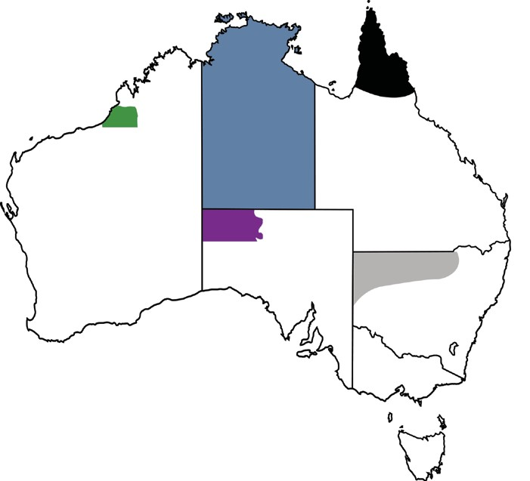
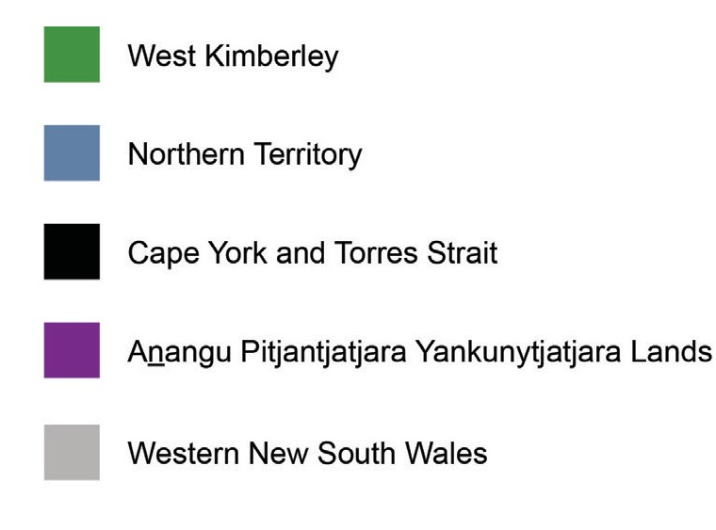
Note: Each shaded area represents an area serviced by one of the five case study sites.

FACTORS WHICH HIGHLIGHT SUCCESS
The common themes of success — across all of the case study sites — are discussed below but, as might be expected, varying factors and influences apply. This reflects the unique context, aims and specifics of each training program. The identification of common themes is not a reason to adopt ‘one size fits all’ approaches, but more an indication of what has been shown to work well.

Employment outcomes

Not surprisingly, positive employment outcomes are often cited as an indicator of success. Training is considered successful when it leads to employment or when it improves career prospects, as both trainers and students report.
I’m doing this course to help me better myself and to get a job. I used to be a health worker many years ago so I came back and to revise and get on top.
(Health worker training program)

For many, being employed at the time was the reason they undertook the training in the first place, since participation in training was a requirement of their employment (for example, the TAFE SA aged care program, the Batchelor Institute health worker program and the Western Australia Ranger training program). But while employment is strongly agreed as an indicator of successful education and training, Australian Bureau of Statistics employment data, along with the data from the case studies, show that employment
outcomes are not always the main pointers of success of VET
in remote areas.

Foundation skills

The development of foundation skills was also frequently cited as an indicator of training success across all case studies. This included:
- basic literacy and numeracy skills

- work-readiness and employability skills

- communication and writing skills

Kids were feeling blamed for where they were and child safety didn’t treat them well. I wanted to have a greater say. I wrote a letter for a client for the social

worker and the social worker approved of it and I signed it with minor changes. Got to be able to write letters and communicate.
(Indigenous Mental Health training program)

The development of foundation skills, particularly literacy and numeracy skills, is vital for a number of reasons. The possession of literacy, numeracy and work-readiness skills is important for gaining work. But these skills are also a key
aspect to building social capital and building the capacity of individuals and communities. Foundation skills can enable learners to negotiate ‘two worlds’ and can build confidence and communication skills. The benefits of strengthened foundation skills can also span the generations. As the
Yes I Can Literacy Campaign found, students were able to undertake reading and homework activities with their kids and grandkids, thus emphasising the importance of literacy and numeracy to younger generations.
Yes I Can Adult Literacy Campaign

Yes, I Can!, a mass campaign model for building adult literacy, was first introduced in Australia in 2012. After successful pilots, the campaign was extended and is currently in its second intake in Brewarrina, New South Wales. This case study focuses on the campaigns in Bourke and Brewarrina between 2014 and 2015.
Of the 51 adults who enrolled across three separate intakes, 40 successfully completed the literacy classes. Participants typically entered at pre-level 1 or level 1 on the Australian Core Skills Framework (ACSF). Successful completion of Yes, I Can! saw participants reach ACSF level 1 or 2.
The factors contributing to retention included:

- the use of a community development approach, meaning that the whole community takes responsibility for building literacy and numeracy skills
- leadership by staff, with facilitators and coordinators undergoing a process of growth and empowerment, similar to participants
- a common goal of increasing community literacy levels in a safe, supportive and locally run space.

Confidence and identity

The most common indicator of training success related
to boosting self-confidence and strengthening identity. Students are proud of their achievements, while trainers recognise the transformational impact of training in enabling students to speak out and develop confidence:
I didn’t know what his voice sounded like until he started the ranger program. I never heard his voice.
I heard him speak out there. We were shocked when he spoke. He was one kid we never heard until he was
a big man. (Ranger training program)

The case of the Anangu workers in the health program revealed their strong sense of achievement and satisfaction, knowing they were improving service delivery to their fellow Anangu community members and therefore contributing to their local community.

Local community ownership

Local community ownership and buy-in of a training course
is consistently seen as an important factor contributing to retention and a key indicator of a successful training program.
Training programs are more effective when they are designed and delivered in partnership with the local community. Trainers need to make the effort to engage with the community, to identify the community’s training needs and work with the community to put a program in place that meets those needs.
When we first enter a community, we do … a range of activities advertising, promoting, talking, door to door, through the survey about what we’re doing; what we want to do and whether they think there’s a need for it. When we do the doorknock, the household survey, which is a doorknock of each
household, we take names there of potential students if anyone wants to offer it up. Then of course everyone in the town knows … who needs help.
(Yes I Can Literacy Campaign)

We put our ideas into the program. We are able to
be part of the whole of the processes, including the employment of staff for the project, and being able to mentor the staff while they’re in the positions.
(Yes I Can Literacy Campaign)

Culture and local knowledge

Community ownership tends to be connected to the incorporation of culture and local knowledge into the training program. Where the learning is mediated by local trainers, in language, ‘on Country’, or for a cultural purpose, training is viewed as being more valuable and ultimately more successful. Training that embraces
and encompasses local culture and knowledge has the power to make connections between Country, technology and intergenerational knowledge, and relevant local employment options:
Old people know in Country where a certain spot is. They’re mapping. Young people like us have never been out there. We’ve got a four-wheel drive to take us there and a GPS. Whoever goes there first gets a marking on their GPS. We go in the motor car now with elders and workers and just follow the GPS up to a certain place. It’s really good.
(Ranger training program)

Related to this is the importance of having community elders taking a supportive and advisory role in the training program:
That was learning two-ways, you know, when we took over, we tell them all the names of the Country we learnt as kids, you know? It comes down to your grandmother … Yeah, because they’re saying here
cultural advisors play a bigger role to guide rangers on Country. Their role is also trainers, natural trainers, because of their knowledge, their cultural knowledge. They have to be the guidance, right through all this Country here.
(Ranger training program)

WHERE TO FROM HERE
Karajarri Ranger Training
The Karajarri rangers are based in Bidyadanga Community (formerly La Grange Mission), 200 km south of Broome. Part of the Kimberley Land Council’s Kimberley Ranger Network, the rangers are employed through the Working on Country scheme and undertake training in Conservation and Land Management with North Regional TAFE.
Established just over 10 years ago, the Karajarri rangers were one of the first ranger teams in the region. The program is highly regarded across the Kimberley, with the rangers demonstrating high-quality training and work
practices. Because of the ranger programs many community children aspire to be caring for Country professionals. Since the program’s commencement in 2005, 35 rangers have
been employed, all of whom enrolled in Certificate II in Conservation and Land Management (CLM), with many going on to certificate III and IV level study. Graduates who leave employment as rangers have been hired by other employers, such as mining companies.
Factors contributing to retention and completion:

- The progam uses a strengths-based on-the-job training model.
- Aboriginal ways (including governance principles, knowledge, and ways of working) are combined with Western scientific understandings and caring for Country knowledge, meaning training respects culture and is culturally relevant.
- Two-way learning is vital: elders are authoritative teachers, and rangers hold cultural knowledge as a foundation for learning. Knowledge is shared in such a way that teachers are regarded as learners too. Rangers learn but they also teach and mentor each other. Trainers and education providers are cultural learners when on Country.
- There is a genuine commitment to learning, and a culture of work and responsibility to Country characterise the program.
In the case studies, students and trainers alike often talked about processes more than outcomes, with the process of training and learning being viewed as beneficial in its own right: undertaking training isn’t merely about completing the qualification. Study participants were also mindful of the external factors that influence the success of a training program, including policy decisions, funding security and other systemic issues. While these are outside the control of local communities, trainers/training providers and students, they can have a huge impact on the success and longevity of a training program.
Study participants were predominantly focused on the transformative and sustaining aspects of training, for example, building confidence and foundation skills; encouraging community engagement and ownership; maintaining connections to language, culture, Country, and ‘Aboriginal Ways’; and intergenerational knowledge transfer. There was more emphasis on these factors as indicators of success than on employment outcomes. This isn’t to say that completion and employment outcomes aren’t important
in improving the wellbeing of remote Aboriginal and Torres Strait Islander learners. There is overwhelming research to show that education and employment are vital contributors to wellbeing, but they aren’t the only factors to consider or the only indicators of successful training programs.
The following considerations contribute to retention, and make learning valuable and relevant for students and their communities:
- ensuring students have the support they need from
family, community, trainers and each other

- ensuring that communities own and are involved in the development and delivery of training
- ensuring that cultural knowledge and language are
respected and integral to the training

While the factors and indicators of success discussed here aren’t easy to measure or quantify, they are no less important when it comes to designing, delivering and evaluating training programs.

REFERENCES
Fogarty, W, Schwab, R & Lovell, J 2015, Learning on Country Program: progress evaluation report, viewed
February 2017, <https://www.dpmc.gov.au/sites/ default/files/publications/LoCP%20progress%20 evaluation%20report%20-%20Final%20for%20public%20 release%20-%2015%20October%202015.pdf>, Department of the Prime Minister and Cabinet, Canberra.
Guenther, J et al. 2017, Enhancing training advantage for remote Aboriginal and Torres Strait Islander learners, NCVER, Adelaide.
Social Ventures Australia Consulting 2016, Consolidated report on indigenous protected areas following
social return on investment analyses, viewed February 2017, <http://www.socialventures.com.au/assets/ Consolidated-SROI-Report-on-IPA-WoC.pdf>, SVA Consulting for Department of the Prime Minister and Cabinet, Sydney.

© Commonwealth of Australia, 2017
This work has been produced by the National Centre for Vocational Education Research (NCVER) under the National Vocational Education and Training Research (NVETR) Program, which is coordinated and managed by NCVER on behalf of the Australian Government and state and territory governments. Funding is provided through the Department of Education and Training.
Published by NCVER ABN 87 007 967 311
Level 5, 60 Light Square, Adelaide 5000
PO Box 8288, Station Arcade, Adelaide SA 5000, Australia
P +61 8 8230 8400 E ncver@ncver.edu.au
W www.ncver.edu.au
TD/TNC 127.11
twitter.com/ncver
www.linkedin.com/company/ncver

