

RESEARCH REPORT
Choosing VET: investigating the VET aspirations of school students
Jennifer Gore
Hywel Ellis
Leanne Fray
Maxwell Smith
Adam Lloyd
Carly Berrigan
Andrew Lyell
Natasha Weaver
The University of Newcastle

Kathryn Holmes
Western Sydney University

Publisher’s note
The views and opinions expressed in this document are those of the author/project team and do not necessarily reflect the views of the Australian Government, state and territory governments or NCVER. Any interpretation of data is the responsibility of the author/project team.
Additional information relating to this research is available in In their words: student choice in training markets — Victorian examples and Choosing VET: aspirations, intention and choice. They can be accessed from NCVER’s Portal <https://www.ncver.edu.au>.
To find other material of interest, search VOCEDplus (the UNESCO/NCVER international database <http://www.voced.edu.au>) using the following keywords: access to information; aspirations; career information; occupation; perception; students; TAFE; vocational education and training.


© Commonwealth of Australia, 2017
With the exception of the Commonwealth Coat of Arms, the Department’s logo, any material protected by a trade mark and where otherwise noted all material presented in this document is provided under a Creative Commons Attribution 3.0 Australia <http://creativecommons.org/licenses/by/3.0/au> licence.
The details of the relevant licence conditions are available on the Creative Commons website (accessible using the links provided) as is the full legal code for the CC BY 3.0 AU licence <http://creativecommons.org/licenses/by/3.0/legalcode>.
The Creative Commons licence conditions do not apply to all logos, graphic design, artwork and photographs. Requests and enquiries concerning other reproduction and rights should be directed to the National Centre for Vocational Education Research (NCVER).
This document should be attributed as Gore, J, Ellis, H, Fray, L, Smith, M, Lloyd, A, Berrigan, C, Lyell, A, Weaver, N & Holmes, K 2017, Choosing VET: investigating the VET aspirations of school students, NCVER, Adelaide.
This work has been produced by NCVER on behalf of the Australian Government and state and territory governments. Funding is provided through the Australian Government Department of Education and Training.
COVER IMAGE: GETTY IMAGES/iStock
ISBN 978-1-925173-98-7
TD/TNC 129.16
Published by NCVER, ABN 87 007 967 311
Level 5, 60 Light Square, Adelaide, SA 5000
PO Box 8288 Station Arcade, Adelaide SA 5000, Australia

Phone +61 8 8230 8400 Email ncver@ncver.edu.au
Web <https://www.ncver.edu.au> <https://www.lsay.edu.au>
Follow us: <https://twitter.com/ncver> <https://www.linkedin.com/company/ncver>

About the research
Choosing VET: investigating the VET aspirations of school students

Jennifer Gore, Hywel Ellis, Leanne Fray, Maxwell Smith, Adam Lloyd, Carly Berrigan, Andrew Lyell and Natasha Weaver, University of Newcastle, and Kathryn Holmes, Western Sydney University
This study explores students’ post-school aspirations for vocational education and training (VET), focussing on the interest in vocational training among both primary and secondary school students, from the perspective of the students.
The views of more than 6000 students from Year 3 to Year 12 in New South Wales government schools were canvassed over a four-year period for possible interest in VET. This data was collected as part of an Australian Research Council (ARC) Linkage Project (2012—15). Survey, focus group and interview data involving students, as well as some of their parents/carers, teachers and careers advisers, enabled a unique account of interest in VET. It includes a detailed exploration of when VET begins to feature in students’ thinking about their futures, the kinds of students who think about VET, and under what conditions.
This research will inform how teachers, schools and VET providers might enrich the information available to students and their parents/carers and address current gaps and misunderstandings in students’ knowledge about VET.
Key messages
- There is more interest in VET-related occupations than in VET as an educational pathway and clear misalignment between educational and occupational aspirations, along with confusion about what TAFE offers and the pathway required to a VET-related occupation.
- Gender stereotypes pervade student ideas about their futures, particularly with regard to career choice.
- Primary and junior secondary students seem to have formed negative perceptions of TAFE (technical and further education), and their views of TAFE do not reflect contemporary realities.
- School students, even from a young age, and with limited understanding, form and firmer retain an impression that university is preferable to VET as a future study aspiration.
- VET and VET-related occupations appeal to certain kinds of students; these students are demographically opposite to those more likely to choose a university option. Students who indicate choosing a VET-related occupation are most likely to be characterised by one or more of the following: male, English-speaking background, from more disadvantaged backgrounds, and see themselves as average or below in academic ability compared with their peers.
- Primary and secondary schools have a significant role to play in the timing and substance of careers education, particularly in relation to VET study and careers requiring VET qualifications.

Dr Craig Fowler
Managing Director, NCVER

Acknowledgments
The authors wish to acknowledge the students, parents and carers and school staff who contributed to this project.
We also acknowledge and thank the members of the Project Advisory Group:
- Greg Baird (Careers Advisers Association NSW & ACT)
- Rosemary Brook (NSW Department of Education)
- David Nosworthy (NSW Primary Principals' Association)
- Paul Tracey (NSW Secondary Principals' Council)
- Christine Warrington (TAFE and Hunter Business Chamber)
- Dr Barry McKnight (University of Newcastle) — independent project consultant
We are grateful to Le Hoang Le, Felicia Jaremus and April Chisholm for their assistance in the preparation of this report.

Contents

Executive summary 8
Choosing VET 8
Choosing VET-related occupations 9
Implications 9
Introduction 11
Key research questions 12
Prior research on this topic 12
Research design 13
Sample 13
Variables 16
Data analysis 18
Choosing VET 20
Interest in VET for post-secondary education 20
Interest in VET from year to year 20
Who chooses VET? 22
Perceptions of VET 25
The influence of careers advice and career activities 31
Choosing VET-related occupations 34
Interest in VET-related occupations 34
Interest in VET-related occupations from year to year 34
Who chooses VET-related occupations? 36
Most popular VET-related occupations 40
Interest in VET-related occupations across the school years 41
Reasons for choosing VET-related occupations 42
Concluding remarks 49
VET appeals to certain kinds of student 49
Higher interest in VET-related jobs than in VET pathways 50
The significant role of schools 50
Implications 51
References 53
Appendix A 56
Appendix B 57
Appendix C 60

Tables and figures

Tables
1 Survey responses by year and student variables 15
2 Student background and school related variables, sources and measures 17
3 Interpreting odds ratios and effect sizes 18
4 Patterns of interest in vocational education 20
5 Regression: student aspirations for vocational education 24
6 Uncertainty about TAFE 29
7 Some understanding of TAFE 30
8 Patterns of interest in VET-related occupations 35
9 Regression: student aspirations for VET-related occupations 39
10 Top ten reasons for choosing VET-related occupations 42
11 Top ten reasons for choosing University-related occupations 42
12 Examples of students' reasons for interest in VET-related occupations: survey responses 43
B1 Top ten VET-related occupations 57
B2 Top ten VET-related occupations named by males and females 57
B3 Top ten VET-related occupations for students, by NAPLAN quartile 58
B4 Top ten VET-related occupations for students, by Year level 59
C1 Top ten reasons for choosing VET-related occupations, by gender 60
C2 Top ten reasons for choosing VET-related occupations, by NAPLAN quartile 61
C3 Top ten reasons for choosing a VET-related occupation, by Year level 62

Figures
1 Aspirations Longitudinal Study design 13
2 Highest level of education indicated by students, all survey responses 20
3 Patterns of interest in VET education across the survey years 21
4 Patterns of interest in VET education across the survey years, by gender 21
5 Patterns of interest in VET, by school sector 22
6 Educational and occupational aspiration alignment 31
7 Careers related activities for high school students 32
8 Student aspirations for VET-related occupations, all survey responses 34
9 Patterns of interest in VET-related occupations 35
10 Patterns of interest in VET-related occupations by gender 35
11 Patterns of interest in VET-related occupations by school type 36
12 Stability of interest in VET-related occupations, Years 3–12 41

Executive summary
This study explores students’ post-school aspirations for vocational education and training (VET). It is evident from searching the literature that there has been no substantive study investigating interest in VET among both primary and secondary school students. In recognition of the evidence demonstrating that aspirations are often well formed before careers activities typically occur — in the middle to late high school years — the study contributes a unique perspective, the aim being to inform policy and practice in the school and VET sectors.
This study investigates the ways in which school students and their parents, carers and teachers talk about VET.
Drawing on data from a four-year Australian Research Council (ARC) Linkage Project (2012—15), we consider student aspirations for VET and VET-related occupations. We investigate the reasons given by students for their interest in this sector and the ways in which school students, parents and carers and teachers talk about VET. Surveys with more than 6000 students in Year 3 to Year 12 from New South Wales public schools and focus group data from students, parents/carers, and teachers enable a unique account of how VET choices take shape and how vocational pathways are perceived.
Throughout the report, a distinction is made between student interest in vocational education and their interest in VET-related occupations. The main findings from these two sets of analyses are highlighted below. The term TAFE is used interchangeably with VET as this is the primary term used by students.

Choosing VET
Using logistic regression analysis we found that students who chose VET as their highest level of intended education were likely to be characterised by one or more of the following:
- From lower socioeconomic status (SES) backgrounds
- Attending schools in metropolitan locations
- Male
- In the early years of secondary school
- With lower cultural capital
- From English-speaking backgrounds
- From schools in the lower ICSEA quartiles
- Perceiving themselves as average or below for academic performance relative to their peers.
In talking about TAFE (technical and further education) and other VET options, students, parents/carers and teachers overwhelming portrayed this educational sector as a place of practical learning, a space designed to cater to less academically oriented students and set them up for success.
Despite careers activities in schools, including VET-focused activities, many students were unclear about TAFE or conveyed outdated rather than contemporary portrayals of the sector. There was evidence of a clear misalignment between educational and occupational aspirations. Many students were unclear about VET-related occupations and the pathway to those occupations.
Many students were unclear about TAFE or conveyed outdated perceptions of the sector.

Choosing VET-related occupations
Using logistic regression analysis we found that students who chose a VET-related occupation were likely to be characterised by one or more of the following:
- Lower cultural capital
- English-speaking background
- Lower SES; male
- In Years 3—4
- From schools in the lowest ICSEA quartiles
- In lower National Assessment Program — Literacy and Numeracy (NAPLAN) quartiles
- Perceiving themselves as average or below for academic performance relative to their peers
- Not participating in out-of-school academic tutoring.
Males were not only more likely to express an interest in VET-related occupations than females, but their specific occupational interests were also very different from those of the female students. The gendered nature of occupational choice was clear, with traditional male and female occupations dominating the lists of most popular occupations for both boys and girls.
The most frequently cited reasons for students’ interest in VET pertained to: a view that a particular job would be enjoyable or interesting; perceived benefits of the job; prior experiences related to the job; a desire to help others/make a difference; and a sense of their personal suitability. There was little difference in the reasons provided relating to gender, prior achievement, LBOTE (language background other than English) or year level.

Implications
In talking about TAFE and other VET options, students, parents/carers and teachers overwhelming portrayed this educational sector as a place of practical learning, designed to cater to less academically oriented students and set them up for success. Students often described VET institutions, and/or those attending them, as lacking in some way and expressed concern that a VET qualification would not provide them with a competitive edge. Despite careers activities in schools, including VET-focused activities, many students were unclear about TAFE, conveyed outdated rather than contemporary portrayals of the sector and were unclear about the pathway to VET-related occupations. A strong theme emerging from the data was confusion about VET.
These data, collected between 2012 and 2015, suggest that policy decisions such as prior broadening of the apprenticeship system, opening up the provider market and implementing the VET FEE-HELP program, all of which aim to improve the sector’s responsiveness to the
labour market and skills shortages (Atkinson & Stanwick 2016), appear to be falling short of their desired objectives. Only a small number of students expressed interest in vocational education. Many students were uncertain of the pathway to a VET-related occupation and/or held views of VET as only for those unable to make it to university. A substantial number of students who showed some interest in VET became disengaged from the idea of a vocational education as they moved through school.
Misalignment between educational and occupational aspirations indicates students lack contemporary information about the sector.
The Australian Government’s focus on widening participation in higher education in response to the Bradley Review (2008) has seen a steady increase in university participation (Universities Australia 2017), potentially drawing students away from VET pathways. If current and projected skill shortages in the VET sector are to be addressed, there is a pressing need for the sector to consider how it might attract a more diverse sample of school students. The evidence generated by this study provides a foundation for TAFE and other VET providers to explore ways of ensuring that students have both a greater awareness and a deeper understanding of the sector.
Misalignment between educational and occupational aspirations and confusion about TAFE indicate that many students lack clear, accurate and contemporary information about the VET sector. It suggests that schools and/or VET providers have more to do, in not only recruiting a more diverse range of students, but also in simply ensuring that students and their parents/carers have a greater awareness of what pathways are available and where they might lead.
Our data also signal the potential importance of information about VET being available in the junior secondary and primary years of schooling. While students reported a clear intensification of work experience and other careers activities during the later high school years, our data suggest that, by this point in their schooling, many students will have already formed strong (sometimes negative) views of TAFE and circumscribed their aspirations in ways that limit them to university pathways.

Introduction
The sample is drawn from 6492 students from Years 3 to 12 in NSW government schools.
This study explores students’ post-school aspirations for vocational education and training (VET). Who goes into VET is well documented (Australian Council for Educational Research 2002; Teese et al. 2006; Polesel 2010; Centre for Education Statistics and Evaluation 2013; Lamb 2014), and there is some research on who is considering VET in the senior high school years (Curtis 2008; Myers et al. 2015). However, no previous study has investigated interest in VET among younger school students. In so doing, this study builds on increasing recognition that aspirations are often shaped before careers education typically occurs — in the middle to late high school years (Goldstein & Oldham 1979; Archer, DeWitt & Wong 2014; Whitty, Hayton & Tang 2015; Gore et al. 2015; Gore, Holmes et al. 2017). It contributes additional evidence to demonstrate the importance of engaging with primary and secondary students when considering the future of the VET sector.
In addition to the age of students, the analytic focus of this study includes socioeconomic status, Aboriginality, student location, gender and other aspects of students’ lives (detailed below). Consideration of these variables, individually and in combination, enables a fine-grained account of the factors related to students’ career and educational interests in VET.
The study focused on those students who signalled an interest in VET from a sample of 6492 students from Year 3 to Year 12 in NSW government schools. Data gathered over a four-year period, as part of an Australian Research Council Linkage Project (2012—15; LP120100013), enabled a detailed exploration of when VET begins to feature in students’ thinking about their futures, what kinds of students think about VET, and under what conditions. Survey, focus group and interview data involving students, as well as some of their parents/carers, teachers, and careers advisers, enabled a unique account of interest in VET.
Quantitative data were in the form of surveys and linked demographic and academic achievement data. These were analysed for relationships between aspirations for vocational education or VET-related occupations and a range of student background and school-related variables. Student background variables were: gender, school location, language background, Indigenous status, SES, cultural capital, and year level. School-related variables were: prior achievement (NAPLAN), school ISCSEA, student self-perception of relative academic performance, and participation in out-of-school academic tutoring. Each of these measures, as operationalised for the project, is elaborated in table 2.
Qualitative data, in the form of open-ended survey responses and interview and focus group transcriptions, were analysed for insights into students’ deliberations about higher education and work. What are students’ concerns? Which factors are important in making decisions? What understandings do students have about VET?
Although the data were gathered in NSW schools, the insights from this study are broadly applicable across the national VET sector. The study has the potential to inform how teachers, schools and VET providers might enrich the information available to students and their parents/carers and address current gaps and misunderstandings in students’ knowledge about VET.

Key research questions
Three major research questions provided the basis for this study:
- What aspirations do school students, from Year 3 to Year 12, express for VET or VET-related careers?
- What reasons do school students give for their aspirations for VET or VET-related careers?
- In what ways do school students, parents/carers, teachers and careers advisers talk about students’ aspirations for VET or VET-related careers?
In this report, we use the terms ‘VET’ and ‘TAFE’ when discussing vocational education and training. Both terms were used by students, parents/carers and teachers in focus groups and surveys.

Prior research on this topic
In order to inform the study, a scoping review of the literature (Arksey & O’Malley 2005) was undertaken, focusing on VET-related educational and occupational aspirations. Our aim was to identify recent research that specifically addressed the VET aspirations of school students and thus establish a platform for this report. Given the current state of flux in the VET sector, the review was conducted to shed light on the changing perceptions of VET from students’ perspectives, and we anticipated significant recent research on this topic.
For this reason, we limited the scoping review to empirical studies, conducted in Australia and published in academic journals and within the period 2010—16. We found only 11 studies that met our criteria for inclusion. A few studies touched on some of the complex factors that influence student aspirations for VET or VET-related occupations such as location and gender (Dalley-Trim & Alloway 2010; Chesters & Smith, 2015; Gore et al. 2015); socioeconomic status (Somerville 2013; Gore et al. 2015); students from migrant backgrounds (Naidoo 2015); social capital (Chesters & Smith 2015); and ‘amotivation’ (Jung & McCormick 2010, 2011a, 2011b). However, no study was identified with a specific focus on school student aspirations for VET, and there was scant attention paid to the role of schooling in shaping students’ aspirations for VET (Galliott & Graham 2015; Galliott, Graham & Sweller 2015; Harwood et al. 2015). (See appendix A for the full list of articles.)
Most studies of students’ educational aspirations focus on university (for example, Naylor, Baik & James 2013; Gale et al. 2013; Khattab 2015; Gore, Holmes et al. 2017), and studies addressing occupational aspirations tend not to distinguish between careers requiring TAFE or university qualifications (Gale et al. 2013; Parker et al. 2013.)
The paucity of empirical studies addressing student aspirations for VET and VET-related occupations published in scholarly journals underscores the importance of conducting this study. Investigating who chooses VET, and why, provides vital data to inform policy and practice in relation to VET. Given that more than 26% of the adult population participates in VET (NCVER 2016b), understanding student aspirations for VET is critical to informing the role of schools and VET institutions in shaping the future of the sector.

Research design
This report on student aspirations for VET and VET-related occupations is based on data obtained from the Aspirations Longitudinal Study (see Gore et al. 2015; Gore, Holmes et al. 2017). Four cohorts of students from 64 government schools in New South Wales were involved in the study over four years of schooling, commencing when they were in Years 3, 5, 7, or 9. An accelerated longitudinal design, originally proposed by Bell (1953, 1954), was utilised. By measuring multiple cohorts, each starting at a different age, this design allows the inclusion of a larger span of ages in a shorter time period (Galbraith, Bowden & Mander, 2017). Figure 1 depicts the Aspirations Longitudinal Study design.
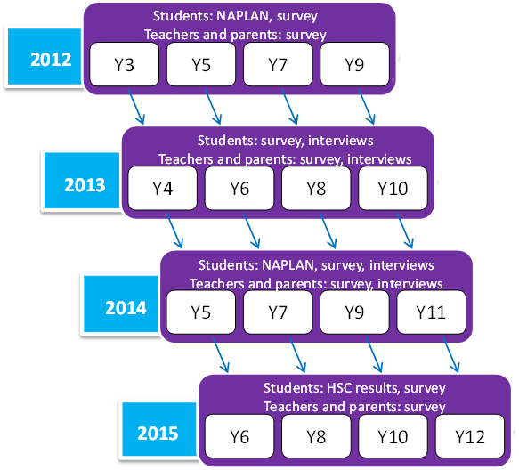
Figure 1 Aspirations Longitudinal Study design

Sample
Students were surveyed annually from 2012 to 2015, with surveys administered online by classroom teachers. Surveys were comprehensively piloted with a representative subset of four schools prior to study commencement. The primary and secondary student surveys differed slightly, with some questions omitted or modified to account for different levels of maturity. Parents/carers and teachers were also invited to complete online or paper surveys in each year of the study. A total of 6492 students completed the survey in one or more years, resulting in 10 543 student surveys. The survey was completed on one occasion only by 3639 students, on two occasions by 1893 students, three occasions by 722 students and four occasions by 238 students.

Focus groups were also conducted in order to gain a deeper understanding of students’ perspectives on their aspirations. Students were purposively sampled in relation to socioeconomic status, prior achievement and the prestige of their occupational aspirations (Gore et al. 2015). During the period 2013—15, 187 focus groups were conducted with 553 students. Student discussions focused on: their post-school plans; their job thoughts; who they discussed their future plans with; and their thoughts about university and/or TAFE. In addition, focus groups were conducted with 90 parents/carers and 215 teachers (including careers advisers and school principals) to gain their perspectives on student aspirations.
Table 1 details the sample of student surveys completed during the Aspirations Longitudinal Study. The sample is described in relation to the following major demographic variables: gender, Indigenous status, language background, school location, socioeconomic status and school year level.
For most variables, the distribution is relatively consistent across the four years of the study; for example, females constituted 47.8% of the sample in 2012, 49.9% in 2013, 50.9% in 2014 and 49.9% in 2015. For school location, the sample in the first year of the study is heavily weighted to metropolitan schools (91.3%), as most provincial schools were recruited into the study in 2013. This delayed entry of non-metropolitan schools also impacted on the distribution of other variables in 2012 by comparison with other years. For example, the proportion of Indigenous students increased as the study progressed, along with the relative proportion of students from low-SES backgrounds. The proportion of students with a language background other than English decreased as the study progressed.
Overall, similar numbers of surveys were completed by male (n = 5087) and female (n = 4994) students, while more surveys came from students in metropolitan (n = 6070) than in provincial areas (n = 4472). More than 6% of surveys were completed by Aboriginal and/or Torres Strait Islander students, well above the estimated 3% proportion of the Australian population (ABS 2012). The sample included: approximately equal numbers of responses from students across SES quartiles; 11% of responses from students from language backgrounds other than English; and lower numbers in Years 3—4 and Years 11—12 due to the accelerated longitudinal design (see table 1).

Table 1 Survey responses by year and student variables¹
Variable | 2012  (n = 2572) |  | 2013  (n = 3996) |  | 2014  (n = 1908) |  | 2015  (n = 2067) |  | Total  (n = 10543)
 | n | % | n | % | n | % | n | % | n | %
Gender
Male | 1315 | (52.2) | 1845 | (50.1) | 932 | (49.1) | 995 | (50.1) | 5087 | (50.5)
Female | 1203 | (47.8) | 1834 | (49.9) | 967 | (50.9) | 990 | (49.9) | 4994 | (49.5)
Indigenous status
Non-indigenous | 2395 | (96.1) | 3373 | (92.7) | 1753 | (92.6) | 1809 | (92.0) | 9330 | (93.4)
Indigenous | 98 | (3.9) | 265 | (7.3) | 141 | (7.4) | 157 | (8.0) | 661 | (6.6)
Language
English | 2050 | (81.4) | 3270 | (88.9) | 1806 | (95.1) | 1862 | (93.8) | 8988 | (89.2)
Other | 468 | (18.6) | 409 | (11.1) | 93 | (4.9) | 123 | (6.2) | 1093 | (10.8)
School location²
Metropolitan | 2347 | (91.3) | 1925 | (48.2) | 782 | (41.0) | 1016 | (49.2) | 6070 | (57.6)
Provincial | 224 | (8.7) | 2071 | (51.8) | 1126 | (59.0) | 1051 | (50.8) | 4472 | (42.4)
SES
Quartile 1 (low) | 451 | (18.6) | 819 | (22.7) | 440 | (24.0) | 531 | (29.7) | 2241 | (23.2)
Quartile 2 (low–mid) | 571 | (23.6) | 1007 | (27.9) | 576 | (31.4) | 507 | (28.4) | 2661 | (27.6)
Quartile 3 (mid–high) | 569 | (23.5) | 829 | (22.9) | 419 | (22.8) | 436 | (24.4) | 2253 | (23.3)
Quartile 4 (high) | 829 | (34.3) | 960 | (26.6) | 401 | (21.8) | 311 | (17.4) | 2501 | (25.9)
Student year level
Years 3–4 | 658 | (25.6) | 950 | (24.2) |  |  |  |  | 1608 | (15.4)
Years 5–6 | 706 | (27.5) | 1082 | (27.6) | 550 | (29.4) | 758 | (36.7) | 3096 | (29.7)
Years 7–8 | 674 | (26.2) | 1119 | (28.5) | 571 | (30.6) | 553 | (26.8) | 2917 | (28.0)
Years 9–10 | 553 | (20.7) | 772 | (19.7) | 515 | (27.6) | 544 | (26.4) | 2364 | (22.7)
Years 11–12 |  |  |  |  | 232 | (12.4) | 208 | (10.1) | 440 | (4.2)
Notes: 1. Totals vary because demographic data were not available for all survey responses.
2. Determined by school postcode and dichotomised as metropolitan or other (provincial).

Variables

Outcome variables
The two outcome variables of interest in this study were choosing VET — the educational aspiration — and choosing a VET-related career — the occupational aspiration.

Educational aspiration
We derived the educational aspiration variable from student responses to the question What is the highest level of education you plan to complete? Primary students chose from ‘High school’, ‘TAFE’, ‘University’, or ‘I don’t know’. Secondary students chose from ‘Year 11’, ‘Year 12’, ‘Certificate or Diploma from TAFE or other training provider’, ‘Bachelor’s degree from university’, ‘Master’s or Doctorate from university’, or ‘I don’t know’. For this study, both primary and secondary student responses were reduced to ‘High school’, ‘TAFE/VET’, ‘University’ and ‘I don’t know’.

Occupational aspiration
For the occupational aspiration variable, students were asked to nominate occupations of interest: What would you like to do when you grow up? (primary students), What kind of work you would like to be doing at 25 years of age? (secondary students). Student responses to these open-ended questions were coded using the Australian and New Zealand Standard Classification of Occupations (ANZSCO; ABS 2006). ANZSCO further classifies occupations into five skill level categories. Skill level 1 occupations typically require a university qualification; skill levels 2—4 require post-school qualifications in the vocational education sector, at TAFE or with a private VET provider. Skill level 5 occupations require limited post-school qualifications.

Independent variables
Variables considered for their relationship with student aspirations (educational and occupational) were grouped into student background variables and school-related variables, as detailed in table 2.
Table 2 Student background and school related variables, sources and measures
Variable | Source | Categories
Gender | School enrolment form | Categorised as male or female.
Aboriginal and/or Torres Strait Islander status | School enrolment form | Categorised as Indigenous or non-Indigenous.
Language background | School enrolment form | Categorised as English-speaking background or language background other than English (LBOTE).
School location | My School (www.myschool.edu.au) | Categorised as metropolitan, provincial, remote and very remote. However, all schools in the study were either metropolitan or provincial.
Socioeconomic status | School enrolment form | Calculated by combining the highest parental education and occupation levels for each student into an equally weighted proxy for student SES. Students from participating schools were divided into quartiles based on student SES data from all NSW government schools.
Cultural capital¹ | Survey | Cultural capital was operationalised using student survey responses to a series of 10 questions asking how often they participate in certain activities. These items were derived from those used in the PISA 2000 student survey (OECD 2000). The items began with a common stem: ‘How often do you do the following activities?’ (Listen to classical music; talk about music; go to the theatre to see a play, dance or opera performance; go to art galleries or museums; go to the cinema to watch a movie; go to a library; talk about books; play a musical instrument or sing; participate in dancing, gymnastics or yoga; talk about art). Frequency of involvement was self-reported by students on a four-point Likert-type scale: 1–never; 2–rarely, 3–sometimes or 4–frequently.
School year level | Department of Education, NSW | Categorised as Years 3–4, Years 5–6, Years 7–8, Years 9–10, Years 11–12 and used as a proxy for student age.
ICSEA | My School (www.myschool.edu.au) | The Index of Community Socio-Educational Advantage is a standardised scale measuring school advantage based on summarising student level data. A higher score indicates a relative lack of disadvantage. This national measure was developed to compare aggregate achievement results between schools using scores from NAPLAN. ICSEA scores were categorised using cut-offs from the state quartile values in each year.
Prior achievement | Department of Education, NSW | The most recent NAPLAN test scores for each student. Attainment was taken as the equally weighted composite of individual student reading and numeracy scores. Data for all NSW government schools in each year level were used to separate scores into quartiles.
Self-perception of relative academic performance | Survey | Perceived achievement relative to peers was a self-assessment item:  ‘How are your marks this year compared with other students?’ (Well below average, Below average, Average, Above Average, or Well above average?).
Access to academic tutoring | Survey | Categorised as yes/no in response to question:  Do you attend any out-of-school tutoring?
Note: For detailed information on the development of the cultural capital scale see Albright et al. (in press). For use in previous research see Gore et al. (2015), Gore et al. (2016), Gore, Fray et al. (2017), Gore, Holmes et al. (2017), Holmes et al. (2017).

Data analysis

Quantitative data
Logistic regression models were used to investigate aspirations for VET, examining the two outcomes variables: students who expressed interest in VET as their highest level of intended study by comparison with those who expressed interest in university; and students who expressed interest in VET-related occupations (skill levels 2—4) by comparison with those who named jobs requiring a university qualification (skill level 1). All student background variables and school-related variables were then included as potential predictors in a regression model for each outcome, reported as adjusted odds ratios and adjusted p-values.
In order to adjust for repeated measures, the logistic regression models were fitted within a Generalized Estimating Equation (GEE) framework, a method robust against violations of normality and missing data assumptions (Zeger, Liang & Albert 1988). The GEE model was compared with an equivalent random effects Generalized Linear Model on the same data and variables, both of which produced similar estimates and p-values. Data were analysed using SAS software version 9.4. Statistical significance was set at 0.05.

A note on interpreting odds ratios
In this analysis we use Monson’s (1990) common language description of effect sizes for odds ratios to indicate the substantive importance of the statistically significant variables (see table 3).
Table 3 Interpreting odds ratios and effect sizes
Less likely – odds ratio  effect size range | Descriptor | More likely – odds ratio  effect size range
0.9 to 1.0 | No effect | 1.0 to 1.2
0.7 to 0.9 | Weak effect | 1.2 to 1.5
0.4 to 0.7 | Moderate effect | 1.5 to 3.0
0.1 to 0.4 | Strong effect | 3.0 to 10

Qualitative data
To understand why students expressed interest in VET or VET-related occupations we carried out thematic coding of focus group transcripts. Using inductive and deductive logic (Creswell 2013), we employed NVivo, a qualitative software analysis tool, to assist with this coding. Open-ended survey responses, in which students provided reasons for interest in VET-related occupations, were analysed in the same way. Researchers coded and recoded student responses, and themes were expanded or reduced as necessary (Creswell 2013). A continuous process of reflection and discussion involving an ongoing conversation between coders ensured consistency and group consensus (Harry, Sturges & Klingner 2005) over emerging themes. Identified themes were included in a codebook as a reference point for use by all members of the research team (Guest, MacQueen & Namey 2011).
Pseudonyms are used in this report to protect the anonymity of the participants. For all quotations, demographic data provide context in the form of: pseudonym, gender, school year level, SES, prior achievement, location, for example (Tom, male, Year 12, high-SES, low to mid achievement, provincial school).

Presentation of results
The results of our analysis are outlined in the following two sections of this report:
- Choosing VET: who among school students expresses interest in VET as the highest level of education they intend to pursue and how is VET perceived?
- Choosing VET-related occupations: who among school students expresses interest in VET-related occupations and what reasons do they provide?
We follow the presentation of results with a brief discussion and concluding remarks.

Choosing VET

Interest in VET for post-secondary education
Of all student survey responses, 13.9% indicated VET as their highest level of intended education. With the remaining, 50.3% indicated university, 12.6% indicated high school, and 23.1% indicated that they didn’t know what level of education they planned to complete (see figure 2).
13.9% indicated VET as their highest level of intended education.
Figure 2 Highest level of education indicated by students, all survey responses

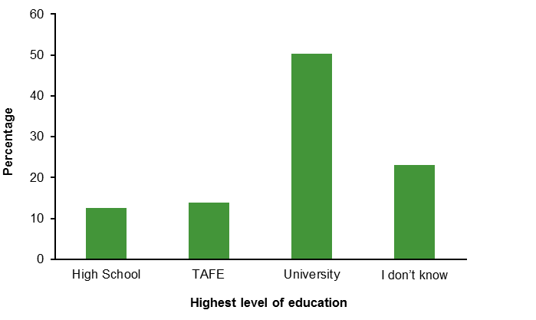

Interest in VET from year to year
The longitudinal nature of the data enabled the analysis of individuals’ interest in vocational education across the survey years (see table 4). Figure 3 shows the results of a cross-tabulation of student registration number by survey year. Of the students who completed at least two surveys and had indicated an interest in vocational education at least once, more than 50% were moving towards or holding a steady interest in VET. However, more than 37% of students had disengaged from the idea of vocational education during this time.
Table 4 Patterns of interest in vocational education
Pattern of interest | Description / explanation
‘Towards’ | First expressed interest in non-VET, then interest in vocational education in each subsequent survey
‘Steady’ | Expressed interest in VET in every survey
‘Returned’ | First expressed interest in vocational education, then education options other than VET, but returned to VET in the last survey
‘Brief’ | First expressed interest in non-VET, then VET in a later year, followed by a return to non-VET in the last survey
‘Away’ | Expressed interest in VET in one survey but not in subsequent surveys
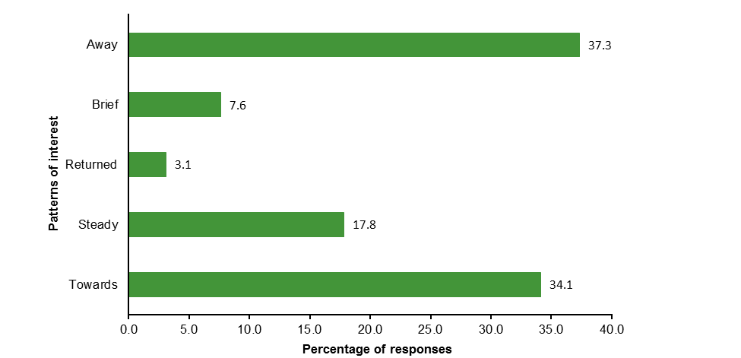
Figure 3 Patterns of interest in VET education across the survey years
Of the 37.3% of students who indicated they were moving ‘away’ from VET, 53.8% were male and 46.2% were female. Approximately equal numbers of males (49.0%) and females (51.0%) were moving ‘towards’ VET, and more males (54.0%) than females (46.0%) were remaining ‘steady’ towards vocational education during this time (see figure 4).
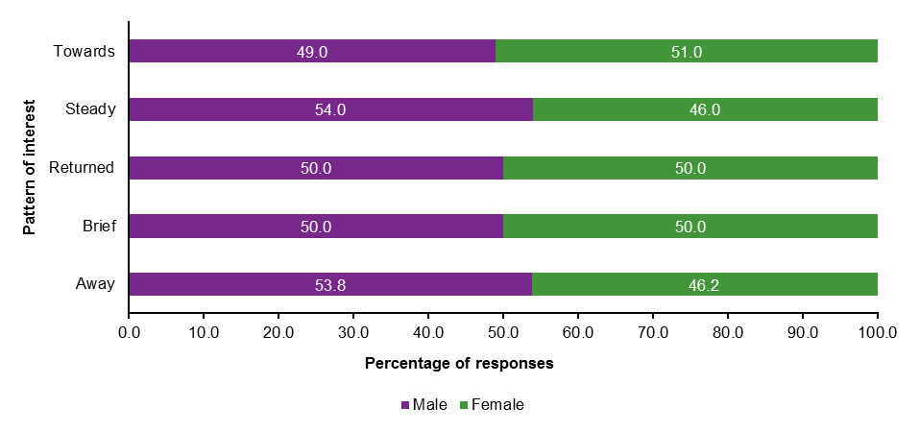
In order to understand patterns of difference between students in primary and secondary schools, we grouped students based on their first survey response into two categories, primary or secondary, depending on their school year level at the time of survey completion. Of the 37.3% of students who indicated they were moving ‘away’ from vocational education, 65.5% were in secondary school and 34.5% were in primary school. A greater proportion of secondary school students were also found to have a steady (73.8%) interest in VET or were moving towards vocational education (59.8%) (figure 5).
Figure 4 Patterns of interest in VET education across the survey years, by gender

Figure 5 Patterns of interest in VET, by school sector

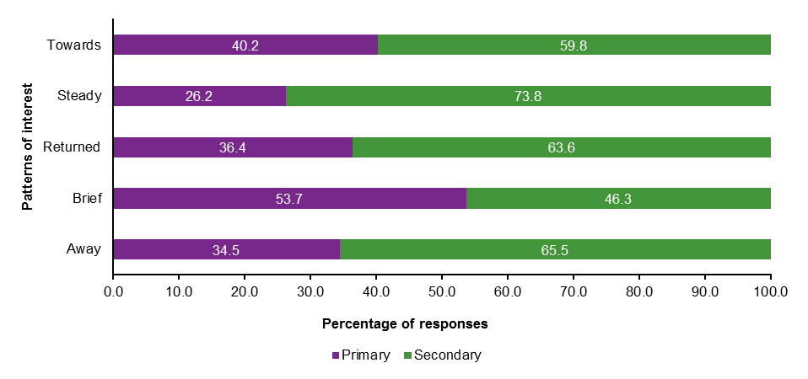
Who chooses VET?
The regression model (table 5) showed that the following variables were significant predictors of intention to pursue a VET pathway: gender, language backgrounds other than English, school location, SES, cultural capital, year level, ICSEA, NAPLAN, and self-perception of relative academic performance. Effects varied from weak to strong, indicating the substantive importance of the statistically significant variables.
These are explained in greater detail below:
- Gender (Male, OR = 1.33) and school location (Metropolitan, OR = 1.41) had weak effects on choosing VET. Males were more likely to aspire to VET than females and students in metropolitan locations were more likely to choose VET than students in provincial schools.
- Students from English-speaking backgrounds were more likely to choose VET than students from language backgrounds other than English (OR = 1.99). This is a moderate effect.
- Students from metropolitan locations were more likely to express interest in VET than students from provincial regions (OR = 1.41). This is a weak effect.
- Socioeconomic status was a significant predictor of interest in VET. There were moderate effects for students from low-SES, low to mid SES backgrounds, and mid to high SES backgrounds (quartile 1, OR = 2.17; quartile 2, OR = 2.15; quartile 3, OR = 1.81). Students from these quartiles were more likely to express an interest in VET than students in the highest SES quartile.
- Cultural capital was a significant predictor of interest in VET. Moderate effects were found for students in the two lowest cultural capital quartiles (quartile 1, OR = 1.53; quartile 2, OR = 1.53). There was a weak effect for those from the second highest cultural capital quartile (quartile 3, OR = 1.26) compared with students in the highest cultural capital quartile.
School students who are most likely to choose VET are demographically the opposite of students aspiring to university.
- Students in the first four years of secondary school (Years 7—8 and Years 9—10) were more likely to express an interest in VET than students in Years 3—4. Years 7—8 was found to have a moderate effect on VET aspirations (OR = 2.02) and Years 9—10 a weak effect (OR = 1.41).
- School ICESA was a moderate predictor of interest in VET, with students in a quartile 1 or 2 school more likely to choose VET (OR = 2.15 and 1.86 respectively) than those in the highest ICSEA quartile.
- NAPLAN was a significant predictor of interest in VET. A strong effect was found for students in the lowest NAPLAN quartile (quartile 1, OR = 4.07), while moderate effects were indicated for those in the middle NAPLAN quartiles (quartile 2, OR = 2.59, quartile 3, OR = 1.66) compared with the highest NAPLAN quartile.
- Self-perception of relative academic performance had a moderate effect on student aspirations for VET. Students who see themselves as ‘Well below average’ (OR = 2.04) ‘Below average’ (OR = 2.40) or ‘Average’ (OR = 2.17) by comparison with their peers were more likely to choose VET than students who see themselves as ‘Above average’ or ‘Well above average’.
- Indigenous status was not a significant predictor.
- Tutoring was not a significant predictor.

Summary
Taking all significant predictors into account, this analysis indicates that students who chose VET as their highest intended level of education were more likely to be male; from English-speaking backgrounds; attending schools in metropolitan locations; from lower SES backgrounds; with lower cultural capital; in secondary school; from schools in the lower ICSEA quartiles; and/or perceive themselves as average or below for relative academic performance.
The substantial number of significant predictors identified in this analysis indicates that the school students who are most likely to choose VET are demographically the opposite of students aspiring to university on nearly every variable tested. The significant variables in the regression are all important for understanding student educational aspirations. For example, even if all other variables are held constant, SES still has an effect on the outcome. This means that even when students are matched on age, gender, school ICSEA, and NAPLAN, SES has some weight in determining which of them would be more likely to aspire to VET than university. The same is true for all other significant variables. Even when adjusted for the full set of predictors, each significant variable carries weight in predicting who is more likely to choose VET. Implications for the VET sector are considered in the final section of this report.
Table 5 Regression: student aspirations for vocational education
Variable | TAFE vs uni aspirations
 | Yes, n (%) |  | No, n (%) |  | OR | Effect¹
Gender
Female² | 584 | (18.7) | 2545 | (81.3)
Male | 607 | (21.6) | 2208 | (78.4) | 1.33** | Weak
Aboriginal and/or Torres Strait Islander status
Non-Indigenous² | 1085 | (19.5) | 4481 | (80.5)
Indigenous | 96 | (29.6) | 228 | (70.4) | 0.72
Language background
Other² | 51 | (6.7) | 710 | (93.3)
English | 1140 | (22.0) | 4043 | (78.0) | 1.99*** | Moderate
School location
Provincial² | 674 | (18.2) | 3032 | (81.8)
Metropolitan | 569 | (22.9) | 1917 | (77.1) | 1.41*** | Weak
SES
Quartile 4² | 132 | (7.0) | 1759 | (93.0)
Quartile 3 | 265 | (18.9) | 1135 | (81.1) | 1.81*** | Moderate
Quartile 2 | 419 | (27.8) | 1087 | (72.2) | 2.15*** | Moderate
Quartile 1 | 346 | (31.9) | 738 | (68.1) | 2.17*** | Moderate
Cultural capital
Quartile 4² | 204 | (11.7) | 1541 | (88.3)
Quartile 3 | 286 | (17.4) | 1359 | (82.6) | 1.26* | Weak
Quartile 2 | 308 | (22.3) | 1076 | (77.7) | 1.53*** | Moderate
Quartile 1 | 385 | (31.3) | 845 | (68.7) | 1.74*** | Moderate
Year level
Year 3–4² | 125 | (13.0) | 840 | (87.0)
Year 5–6 | 247 | (11.9) | 1821 | (88.1) | 0.87
Year 7–8 | 435 | (29.4) | 1046 | (70.6) | 2.02*** | Moderate
Year 9–10 | 354 | (26.2) | 996 | (73.8) | 1.41* | Weak
Year 11–12 | 65 | (25.0) | 195 | (75.0) | 1.45
ICSEA national quartile
Quartile 4² | 117 | (6.3) | 1738 | (93.7)
Quartile 3 | 83 | (12.8) | 563 | (87.2) | 1.03
Quartile 2 | 644 | (28.2) | 1639 | (71.8) | 1.86** | Moderate
Quartile 1 | 399 | (28.3) | 1009 | (71.7) | 2.15*** | Moderate
NAPLAN score
Quartile 4² | 135 | (6.7) | 1878 | (93.3)
Quartile 3 | 306 | (17.7) | 1426 | (82.3) | 1.66*** | Moderate
Quartile 2 | 376 | (30.1) | 875 | (69.9) | 2.59*** | Moderate
Quartile 1 | 333 | (40.7) | 486 | (59.3) | 4.07*** | Strong
Self-perception of relative academic performance
Well above average² | 84 | (8.9) | 859 | (91.1)
Above average | 278 | (12.3) | 1983 | (87.7) | 1.13
Average | 632 | (29.8) | 1486 | (70.2) | 2.17*** | Moderate
Below average | 113 | (41.1) | 162 | (58.9) | 2.40*** | Moderate
Well below average | 29 | (39.2) | 45 | (60.8) | 2.04* | Moderate
Tutoring
Yes² | 166 | (15.5) | 903 | (84.5)
No | 1068 | (20.9) | 4031 | (79.1) | 1.03
Notes: OR = odds ratio. Quartile 1 is the lowest and Quartile 4 is the highest. *p < .05. **p < .01. ***p < .001.
1. Description of effect size from Monson (1990).
2. Reference category.

Perceptions of VET
An analysis was undertaken to determine the ways in which school students, parents/carers, teachers, and careers advisers talk about students’ aspirations for VET. It is important to consider these perceptions of VET, given that ‘the VET sector is crucial to the Australian economy; both for the development of the national workforce and as a major export industry’ (Australian Skills Quality Authority 2016, np). VET is also a key post-school pathway for many members of targeted equity groups (Productivity Commission 2011, p.21). Therefore, understanding perceptions of VET provides an important backdrop to efforts to increase overall levels of access to post-school education pathways.
Four major discourses emerged from our analysis of these data: VET as a place of practical learning; VET as an opportunity; VET as lacking prestige; and uncertainty about VET. These discourses are illustrated below.

VET as a place of practical learning
A strong discourse running through the interviews and focus groups was the idea of TAFE as a place of ‘practical’ learning. This idea is exemplified in the discussion below between Year 10 metropolitan school students, Oriel (female, Year 10, low to mid SES, low achievement) and Calais (male, Year 10, low to mid SES, low to mid achievement):
Oriel: Yeah, TAFE is for, like, electricians and hairdressers and all that.
Calais: Yeah, that stuff.
Oriel: It’s just like …
Calais: Practical stuff.
Oriel: Yeah.
Students valued the practical nature of TAFE, ‘learning what you’re going to do instead of … studying what you’re going to do’ (emphasis added), often informed by the experiences of another family member:
Wouldn’t TAFE be, like, more hands on; practical, like, studies or something?
(Lincoln, male, Year 9, low SES, mid to high achievement, provincial school)
My brother did, like, welding courses and that there and they say it’s like … it’s like more, like, activity with, like, actually learning what you’re going to do instead of, like, studying what you’re going to do.
(Tristan, male, Year 9, low SES and achievement, provincial school; emphasis added)
Many of the older students who had experience of TAFE, through VET in Schools (VETiS) programs running at their local TAFE institution, reported that they enjoyed the practical aspects. Tiffany, for example, said TAFE was ‘pretty good’ and:
It’s kind of laid back but you’re still learning and doing lots of different things … it’s theory and practical.
(Tiffany, female, Year 11, low to mid SES and achievement, provincial school)
Some students talked about the practical benefits of TAFE in terms of accessibility and affordability. One student said:
University has … better facilities and … a broader … region of stuff that you can do and TAFE is, like, a smaller … more convenient version of it.
(Tristan, male, Year 9, low SES and achievement, provincial school; emphasis added)
Many students talked about TAFE in terms of being a practical alternative to university. Scarlett for example, said:
Many students spoke of TAFE positively.
People who are already, like, don’t think they can pay for uni might just, like, give up on it. They don’t think they can do it so they just say, ‘Okay, well, I’m not going to get into uni or I can’t pay to go into uni so I’ll just go to TAFE’.
(Scarlett, female, Year 9, high SES, mid to high achievement, metropolitan school)
Some teachers, especially in provincial areas, also spoke of TAFE as an option for their students, espousing the practical nature of TAFE, as in the following example:
I think TAFE and Open Colleges is [sic] very popular. I think it’s more practical. I think they see it as equipping you for a job in the workplace. That’s my general feel about when they talk about going to TAFE. There’s also flexibility, they can go to TAFE at the same time as being at school and they know about that. So that’s more something that they can conceptualise, ‘I go to TAFE these days and I go to school these days and I’m getting practical, hands-on-the-job kind of experience’. So I think they see TAFE in a more approachable and feasible way to learn, whereas university they have to travel … and that means going away from home.
(Leslie, female teacher, low to mid ICSEA provincial school)
Parents/carers of students interested in TAFE also appreciated the practical nature of TAFE and the skills their children would gain, thus setting them up for successful futures.

VET as an opportunity
Another major discourse emerging from our discussions with participants related to the opportunities provided by VET. Many students spoke of TAFE positively, questioned the emphasis in schools on university education, and saw TAFE as a back-up plan or as providing opportunities for disengaged students.
Many students and their parents/carers spoke of TAFE very positively. Genesis (female, Year 9, SES and achievement not supplied, provincial school), for example, said, ‘When you go to TAFE it gives you opportunities and it opens up opportunities’. Other students, such as Lina (female, Year 7, low SES and achievement, provincial school) were told by their parents/carers, that ‘it’s a good start for what you want to do’.
Students also questioned the university-focused discourse of their schooling. For example:
There’s a big push to go to uni and stuff, but I think — I don’t know, I just don’t think there should be because there’s so much out there. They shouldn’t be [pushing us to go to uni] because there’s so much out there that you don’t need to go to uni for and it’s not for everyone. (Polly, female, Year 9, low to mid SES and achievement, provincial school)
Other students saw TAFE as an opportunity in terms of a second chance, suggesting that ‘I think going to TAFE would be a good idea if you fail your Higher School Certificate (HSC) or something because you can do Year 11 and 12 in one year at TAFE’ (female, Year 9, achievement and SES not supplied, provincial school).
Older students in particular talked about TAFE as a pathway to tertiary study. Ted (male, Year 11, high SES, mid to high achievement, metropolitan school), who wants to study psychology, worried that his Australian Tertiary Admission Rank (ATAR) wouldn’t be high enough and that he ‘didn’t have the right classes’ and would have do ‘bridging courses in
TAFE’. Hayden (male, Year 11, mid to high SES and achievement, metropolitan school) was also concerned about ATAR requirements for his aspiration of software engineering, but said ‘I want to see if I can find a way around; find an alternate [sic] path into that course’. Although he didn’t expressly cite VET, he showed a willingness to pursue his aspiration in whatever way possible. It could be that he wasn’t aware of specific VET opportunities that would allow him to do this. These responses from metropolitan students contrasted with provincial students of a similar age who didn’t express an awareness of any pathways to tertiary study; for example, participants in one Year 11 focus group believed the only pathways to university were ATAR or early entry.
Some students worried that TAFE would not provide them with a competitive edge in the labour market.
Some parents/carers declared that TAFE is sometimes ‘definitely the better option’ and ‘more suited to [some students’] and more suited to [their] abilities’ (Kelsey, female, parent, provincial school). Parents/carers also said that their perceptions of TAFE had changed, describing it as ‘a good alternative to university, definitely’, ‘fantastic’, ‘just as good … as uni’ and having ‘a lot to offer’.
Teachers also spoke of the opportunities afforded by VET pathways, especially for students who were less engaged in school.
I’ve had a Year 10 student, an Aboriginal girl, quite disengaged, come to me at the beginning of this year saying ‘can I do that TAFE stuff?’ And I said well the TVET courses will be next year, but we can get some work experience happening this year, with the possibility of looking at a school-based traineeship for next year with TAFE, so never too early. (Portia, female, careers adviser, low to mid ICSEA, provincial school)

VET as lacking prestige
The third discourse emerging from our qualitative data saw TAFE and VET as lacking in prestige. Students often described VET institutions, and/or those attending them, as lacking in some way. For example, TAFE was described by Brady as ‘the houso uni’ (Brady, male, Year 9, achievement and SES not provided, provincial school) and Scarlett commented that ‘you just don’t really hear good things about it. You hear that people go there when they can’t get into uni’ (female, Year 9, high SES, mid to high achievement, metropolitan school).
Other students, like Aubree (female, Year 9, missing SES, missing achievement, provincial school), acknowledged the negative discourse associated with TAFE, but disagreed: ‘I just don’t like the idea, like ‘everyone has to go to uni, otherwise you’re like a deadbeat’ or something’.
Some students worried that TAFE would be unable to provide them with a competitive edge. Lorie explained this concern:
I’ve thought about [training facility] which has good design things but again, like Guy said, university qualifies better than TAFE, so if it becomes a job — I don’t know, if you go to university and someone has a TAFE, they might choose university over TAFE.
(Lorie, female, Year 11, high SES, mid to high achievement, metropolitan school)
Another student, Audrey, didn’t think TAFE would necessarily lead to success:
Personally, like, I’ve just always picture uni, like, I don’t know, being more successful. If you do uni then you’ll be more successful afterwards compared to … if you just did the TAFE or apprenticeship or something. It depends what you want to do really.
(Audrey, female, Year 11, low to mid SES, mid to high achievement, provincial school)
In many focus groups, students compared TAFE with university, and often ranked TAFE and other VET options as secondary to university. In the following focus group, the students discuss the educational hierarchy as they perceived it:
Charles: Well, like, I just see university as, like …
Calais: The top for the smart people.
Charles: Yeah, like, the higher — the highest one, like, above TAFE.
Facilitator: And what about an apprenticeship?
Calais: It’s just for if you can’t get anything else I reckon.
(Year 10 provincial school males, Calais, low to mid SES and achievement and
Charles, low SES, mid to high achievement)
A few students, like Amos (male, Year 10, low SES, mid to high achievement, metropolitan school) mentioned that his parents/carers had influenced him to go to university instead of TAFE, because ‘TAFE is, like, lower than uni’.
Other students conveyed strong views about VET institutions as being for certain kinds of people. Shanae (female, Year 9, low SES, low to mid achievement, provincial school) thought that TAFE was for people who were ‘lazy … for people who don’t want to work as hard’. Sometimes students saw themselves as inferior and saw TAFE as the only option: ‘I think I might do that because I’m pretty dumb’ (Sandy, female, Year 9, low to mid SES and achievement, provincial school).
Parents/carers and teachers tended to emphasise TAFE as a pathway exclusively for the students they described as ‘less academic’ (Tyrion and Johann, male teachers at provincial schools; Demi and Ayra, female teachers at provincial schools). Some teachers, and careers advisers in particular, from schools with high numbers of students from low-SES backgrounds tended to focus more heavily on VET, and were strong advocates of TAFE and VET in Schools. For example, one careers adviser told us:
We’re very strong in vocational education and training. Most students take at least one VET course, plus they have the opportunity to be at TAFE as well. Some schools are cutting back on letting their students go to TAFE because of funding issues, but we feel that we should be offering the opportunities and the program that suit the students and not worrying about money and numbers and funding. So we’re one of the few schools [in the area] that are still saying ‘if you need a TAFE course, let’s try and get you into a TAFE course’. (Hanna, female careers adviser, low to mid ICSEA school)
Others we spoke to talked about VET options as more exclusively for students not ‘cut out for uni’ (Reed, careers adviser). TAFE, in some cases, was seen as an alternative pathway for those unsuccessful in gaining a place within a university program:
Plan B might be, ‘oh you didn’t get the marks, now what will you do? Will you look at a NewStep, will you look at a TAFE, will you look at a … ’, and you give them those options then and then you formulate those as their next three plans. So they’re never left out there with nothing. (Tori, female careers adviser, low ICSEA provincial school)

Uncertainty about VET
A strong theme emerging from the qualitative data was confusion about VET among students, and similar findings are evident in the quantitative data. This confusion was manifest in the misalignment between students’ occupational aspirations and their educational intentions. For example, some students intended to study at university despite aspiring to an occupation requiring VET study; others held occupational aspirations requiring university study but indicated VET as the highest level of study they intended to pursue. Educational pathways to careers are increasingly diverse, with some overlap across sectors. For example, TAFE NSW is offering eight bachelor degrees and two associate degrees in 2017, having offered degree programs since 2011 (TAFE NSW 2013, 2017). Despite this blurring of clear distinctions between sectors, stark misalignments included aspiring hairdressers who thought they required a university qualification and aspiring surgeons who intended studying at TAFE.
A strong theme emerging was confusion about VET among students.
In general, we found that students across all age groups had difficulty in understanding, or at least articulating, what they knew about VET and TAFE. Many students responded with ‘I don’t know’ to the focus group question What do you think studying at Uni/TAFE would be like? When given the opportunity to ask focus group facilitators questions about university and TAFE, many students were interested in the difference between the two. When asked what they knew about TAFE during the focus groups, many students responded with general, confused or uncertain responses. Predictably, such responses were most evident among younger students, as indicated in table 6, although even some Year 11 students expressed a lack of knowledge about TAFE.
Table 6 Uncertainty about TAFE
Year Level | Student response
Year 5 | Is TAFE a coffee shop? That’s what I heard (Name not supplied, male, SES and achievement not supplied, provincial school)
Year 7 | [TAFE is] kind of like university but not quite the same (Jennifer, female, low–mid SES and achievement, provincial school)
Year 8 | Is it more hands on, TAFE? (Logan, male, high SES, mid–high achievement, provincial school)
Year 9 | I have no idea about TAFE (Jenny, female, mid–high SES, low–mid achievement, provincial school)  Yes, me either (Tabatha, female, mid–high SES, low–mid achievement, provincial school)  We haven’t been taught anything about it (Elizabeth, female, mid–high SES, low–mid achievement, provincial school)
Year 11 | I don’t really focus on TAFE itself. I don’t know. I don’t know enough about it (Linsay, male, mid–high SES, low achievement, provincial school)
In general, older students were more informed about TAFE and were able to provide more detailed accounts of what studying at TAFE would be like. No student mentioned the possibility of undertaking a degree program at TAFE.
Table 7 Some understanding of TAFE
Year Level | Student response
Year 9 | TAFE’s more for courses, like mining courses and like stuff where you can get like apprenticeships and stuff … Uni is more studying and tests and essays and stuff (Alexa, female, mid–high SES, low–mid achievement, provincial school)
 | [At TAFE] you don’t get a degree, you just get a certificate and stuff, and do shorter courses (Trent, male, mid–high SES and achievement, provincial school)
Year 11 | If I can get an apprenticeship then I’ll definitely do that over TAFE (Thomas, male, mid–high SES, low–mid achievement, provincial school)
Year 12 | What I’ve been asking a lot lately is like a lot of people have different opinions on it. Like is it worth getting a degree or just go to TAFE? Like not waste your time and all those years at Uni? But what do you think? (Ellen, female, low SES, low–mid achievement, provincial school)
As the examples provided in tables 6 and 7 illustrate, despite obvious confusion, understandings about TAFE tended to become more accurate among older students, likely due to increased exposure to careers activities educational experiences and other forms of socialisation.
Some students shared concerns about gaining practical information on VET from teachers and career advisers.

Negotiating a pathway to vocational education
Students identified problems with VET pathways, including affordability, contributing to their uncertainty about vocational education. Isiah wanted to do an apprenticeship, but said ‘you can’t really live off a normal apprenticeship pay because it’s only like a couple of hundred dollars a fortnight’ (male, Year 9, low SES and achievement, provincial school). He planned to use an army pathway to reach his desired VET-related occupation as a mechanic.
Other students outlined concerns about gaining information from teachers and careers advisers regarding VET options. In fact, some students in our focus groups complained that their careers advisers focused too heavily on university options. Ellen said of her careers adviser:
She’s not a lot of help for me. Like, when I go and speak to her she just, you know, she’s really off topic. And when you ask her about, you know, ‘what would be better?’, she’s got her mind set on going to Uni … It’s just hard to speak to her about what would be better. And, you know, like, yeah, she doesn’t talk about other options, other than Uni, so like either going into the army or Uni.
(Ellen, female, Year 12, low SES, low to mid achievement, provincial school)
Teachers tended to view the practical nature of TAFE and other VET options in a positive light, but often only for less academically inclined students. Indeed some teachers complained that VET in Schools programs were almost distracting their high-achieving students:
There’s another negative impact about bringing so much association with TAFE into the schools, and that is a lot of our top end students are now selecting TAFE courses, and that is having, in my eye, a detrimental effect on their actual subject selections and our weighted — our ability to deliver subjects effectively in this school.
(Diane, female, teacher, low to mid ICSEA provincial school)

Alignment of education intentions and occupational aspirations
Student uncertainty about VET and TAFE is reflected in the alignment of educational and occupational aspirations for the students in our sample. In some instances, students aspired to VET as their intended highest level of education, but named an occupational interest that would typically require a university education.
On average, and at all year levels, VET aspirants showed weaker alignment between their educational and occupational aspirations.
Figure 6 depicts the percentage of alignment, or agreement, between students’ educational and occupational aspirations, comparing students naming TAFE as their highest educational intention and students naming university. It shows, for example, that nearly 50% of Year 3 students who indicated VET as their educational pathway, named an occupation that aligns with a VET qualification, while the alignment for Year 3 students who indicated a university pathway is closer to 65%.

Figure 6 Educational and occupational aspiration alignment

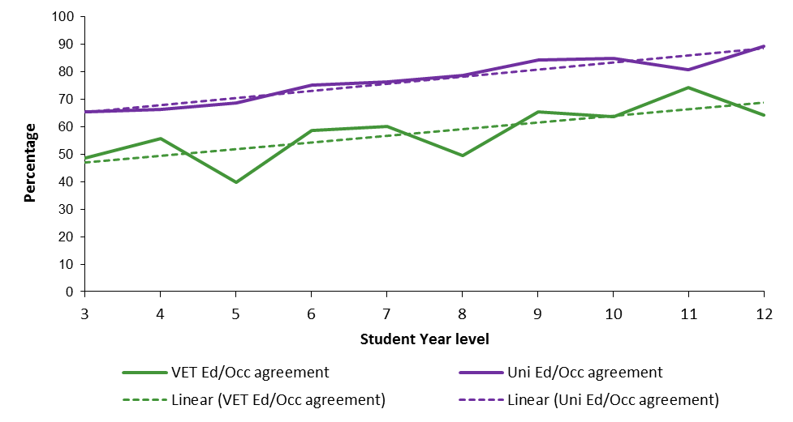
These data indicate that alignment between educational and occupational aspirations increases over the school years, for both VET and university aspirants. However, on average, and at all year levels, VET aspirants showed weaker alignment between their educational and occupational aspirations, with the average difference between VET and university aspirants being 19.0%. This pattern may reflect a lack of information about VET and VET-related careers, greater uncertainty among students thinking about VET, and shifting ideas about VET careers. In any event, the result reinforces the view derived from the qualitative data that many students are unclear about VET-related occupations and pathways to such occupations.

The influence of careers advice and career activities
Figure 7 reports the percentage of students who reported participation in specific careers activities across the high school years. The pattern of intensified careers activity during the later years of high school is consistent with the timing of most formal careers education in Australian schools and helps to explain the deeper understanding of TAFE among older students. Outward-looking activities such as work experience, TAFE and university open days, and employer presentations increase at this time. There is also a clear increase in the later high school years in the percentage of students accessing online and paper-based careers information and spending time talking with teachers and considering suitable careers.
Figure 7 Careers related activities for high school students

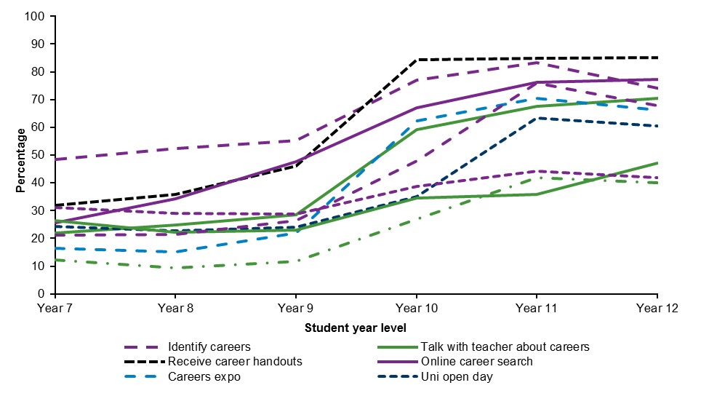
Predictably, teachers did not express the same degree of uncertainty about TAFE. However, their assumption that students know about TAFE might contribute to students’ lack of clarity about VET studies. For example, one high school teacher assumed her students already had a comprehensive understanding of TAFE:
Again, as Year 8 adviser, all students seem to know about TAFE. They all seem to know about the options and the difference between TAFE and uni, and how the courses differ, what kind of things they would study at uni and what things TAFE offers.
(Kate, high school teacher)
Such an assumption is in stark contrast to responses from many Year 9 students at the same school. For example, Jesse said ‘I don’t know much things about TAFE’ (male, Year 9, low SES and achievement, metropolitan school) and Walter said ‘nope, not at all’ (male, Year 9, mid to high SES and achievement, metropolitan school), when asked if they knew the difference between TAFE and university.
This pattern was evident at other schools also. High school teacher Michele, who described her school as ‘more academic’, with most students holding university aspirations, said that students ‘did have a good understanding of TAFE’ and assumed that the careers adviser ‘would definitely, as part of her discussion with the students, promote and tell them about TAFE’. A focus group with six Year 7 female students at this school indicated that none of them understood the difference between TAFE and university, despite having a TAFE campus next to the school. Older students at the school were more articulate about TAFE; for example:
TAFE’s more for, like, hospitality, or, like, physical jobs, like if you want to be a builder and sort of like a tradie or something like that.
(Isabell, female, Year 9, high SES, mid to high achievement, metropolitan school)
These examples highlight differences between what teachers confidently asserted that their students knew and what the students reported they actually know.
Teachers, career advisers, parents and carers may be making assumptions about what students do and don’t know about VET.
Parents/carers may also be making assumptions about students’ knowledge of TAFE. A number of parents/carers had been to TAFE themselves or experienced it indirectly through their own siblings, partners, or other older children, and expressed informed opinions in the focus groups. And yet, many students told us that, while parents or other family members went to TAFE, they had not conversed with those people about TAFE. Some parents/carers also admitted that they were ‘a bit out of touch with TAFE’ (Kirra, female parent of a primary school child).

Summary
In talking about TAFE and other VET options, students, parents/carers and teachers overwhelming portrayed this educational sector as a place of practical learning, designed to cater to less academically oriented students and set them up for success. Despite careers activities in schools, including VET-focused activities, many students were unclear about TAFE, conveyed outdated rather than contemporary portrayals of the sector and were unclear about the pathway to VET-related occupations.

Choosing VET-related occupations

Interest in VET-related occupations
Students were asked open-ended questions about their career aspirations for the future. Specifically, they were asked What would you like to do when you grow up? (primary students) and What kind of work you would like to be doing at 25 years of age? (secondary students). These aspirations were coded using ANZSCO and each response for a given skill level was counted once per survey. Of all student survey responses, 35.9% named a VET-related occupation (skill levels 2—4). Of the remaining survey responses, 50.9% named a skill level 1 occupation (typically requiring a university education) and 3.2% named jobs typically requiring a high school education (skill level 5); see figure 8. In 10% of the surveys no occupation was named by the respondent. Of those students who named a VET-related occupation (skill levels 2—4), 29.1% also expressed interest in the same survey in a skill level 1 occupation, which typically requires a university education, and 3.0% named a skill level 5 occupation (high school education).
Figure 8 Student aspirations for VET-related occupations, all survey responses

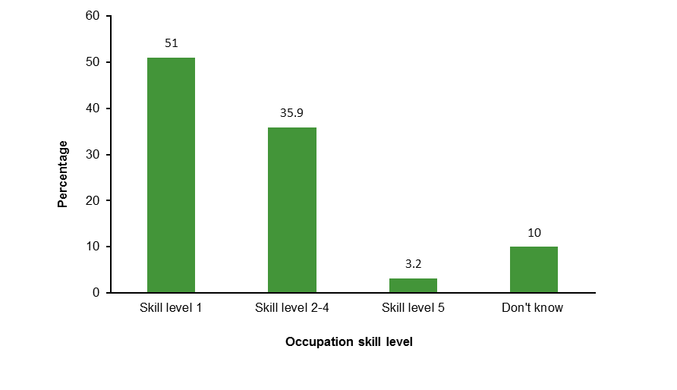Interest in VET-related occupations from year to year
The longitudinal aspect of the data enabled an analysis of individuals’ interest in VET-related occupations across the survey years (see table 8). Figure 9 shows the results of a cross-tabulation of student registration number by survey year. Of the students who completed at least two surveys and had indicated interest in a VET-related occupation at least once, more than 60% were moving towards or holding a steady interest in a VET-related occupation. However, more than 25% of students had disengaged from the idea of a VET-related occupation during this time.
Table 8 Patterns of interest in VET-related occupations
Pattern of interest | Description / explanation
‘Towards’ | First expressed interest in a non-VET occupation, then interest in a VET occupation in each subsequent survey
‘Steady’ | Expressed interest in a VET occupation in every survey
‘Returned’ | First expressed an interest in a VET occupation, then occupation options other than VET, but returned to VET in their last survey
‘Brief’ | First expressed interest in an occupation other than VET, then chose a VET occupation in a later year, then returned to a non-VET occupation in the last survey
‘Away’ | Expressed interest in a VET occupation in one survey but not in subsequent surveys
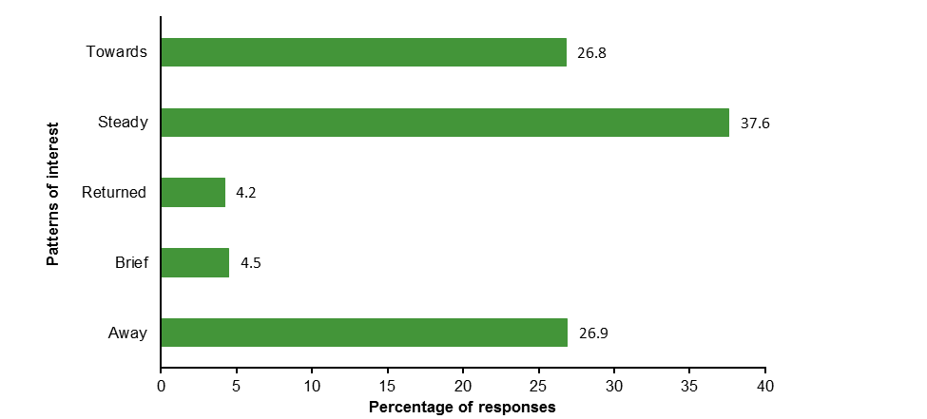
Figure 9 Patterns of interest in VET-related occupations

The pattern of interest between male and female respondents differed, particularly with reference to ‘steady’ or ‘returned’ interest in VET-related occupations. Of the 37.6% of students who expressed a ‘steady’ interest in VET-related occupations, 65.0% were male and 35.0% were female. More males (64.3%) than females (35.7%) had ‘returned’ to interest in a VET-related occupation, while more females (52.6%) than males (47.4%) were moving ‘towards’ a VET-related occupation (figure 10).
Figure 10 Patterns of interest in VET-related occupations by gender

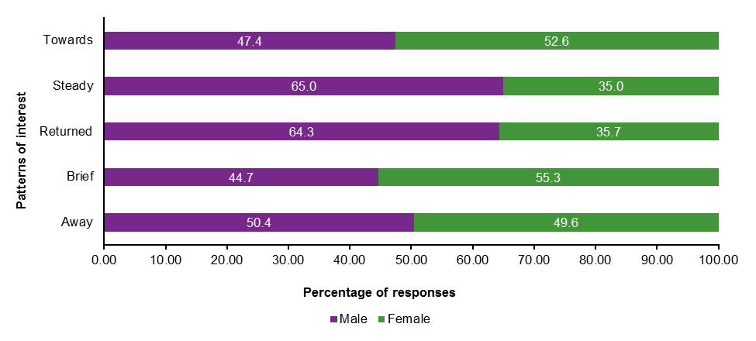

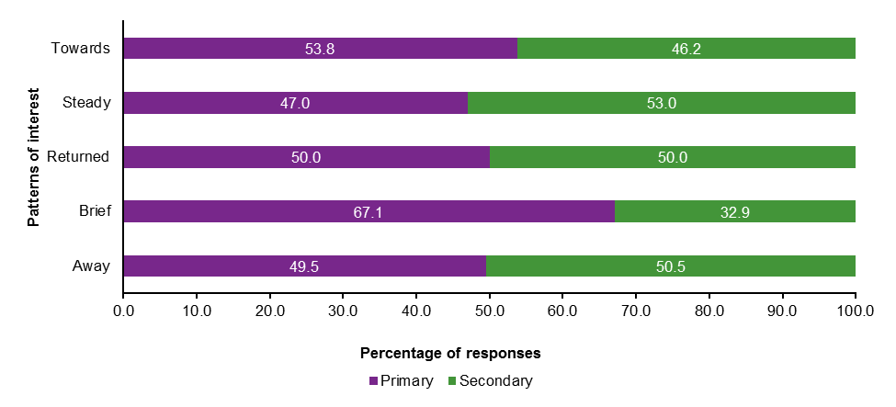
In order to understand patterns of difference between students in primary and secondary schools, we grouped students based on their first survey response into two categories — primary or secondary, depending on their school year level at the time of survey completion. Of the 37.6% of students who expressed a steady interest in a VET-related occupation, 53.0% were in secondary school and 47.0% were in primary school. More primary school students (67.1%) indicated a brief interest in VET-related occupations than those in secondary school (32.9%) (figure 11).
Figure 5 Patterns of interest in VET-related occupations by school type

Who chooses VET-related occupations?
The regression model (table 9, page 39) showed that the following variables were significant predictors of intention to pursue a VET pathway: gender, LBOTE (language background other than English), SES, cultural capital, year level, ICSEA, NAPLAN, self-perception of relative academic performance, and participation in academic tutoring. Effects varied from weak to strong, indicating the substantive importance of the statistically significant variables.
These are explained in greater detail below:
- Male students were more likely to express an interest in a VET-related occupation than female students (OR = 2.46). This is a moderate effect.
- Students from English-speaking backgrounds were more likely to choose a VET-related occupation (OR = 1.32) than students from non-English-speaking backgrounds. This had a moderate effect.
- Socioeconomic status was a significant predictor of interest in VET-related occupations. Weak effects were indicated for students from low SES, low to mid SES backgrounds, and mid to high SES backgrounds (quartile 1, OR = 1.35; quartile 2, OR = 1.41; quartile 3, OR = 1.24), who were more likely to express interest in VET-related occupations than students in the highest SES quartile.
- Cultural capital was a significant predictor of interest in VET-related occupations. Moderate effects were found for students in the two lowest cultural capital quartiles (quartile 1, OR = 2.07; quartile 2, OR = 1.77). There was a weak effect for those from the second highest cultural capital quartile (quartile 3, OR = 1.30). These students were more likely to indicate interest in VET-related occupations than students in the highest cultural capital quartile.
- Year level was a significant predictor of interest in VET-related occupations. A moderate effect was indicated for students in Years 5—6 (OR = 0.68), Years 7—8 (OR = 0.56), Years 9—10 (OR = 0.45), and Years 11—12 (OR = 0.52). Students in all year levels were less likely to indicate an interest in VET-related occupations than students in the Years 3—4 reference group.
- School ICESA was a significant predictor of interest in VET-related occupations, with students in quartile 1 schools more likely to indicate a VET-related occupation (OR = 1.30) than students in quartile 4 schools. This is a weak effect.
- NAPLAN was a significant predictor of interest in VET-related occupations. A strong effect was found for students in the lowest NAPLAN quartile (quartile 1, OR = 3.71). Moderate effects were indicated for those in the middle NAPLAN quartiles (quartile 2, OR = 2.15, quartile 3, OR = 1.57). Students in the lower NAPLAN quartiles were more likely to indicate VET-related occupations than students in the highest NAPLAN quartile.
- Self-perception of relative academic performance predicted student aspirations for VET-related occupations. Students who see themselves as ‘Well below average’ (OR = 1.94) and ‘Average’ (OR = 1.64) were more likely to choose a VET-related occupation than students who see themselves as ‘Well above average’. This was a moderate effect. A weak effect was indicated for students who saw themselves as ‘Below average’ (OR = 1.39).
- Students who did not participate in academic tutoring outside school were more likely to express an interest in VET-related occupations (OR = 1.23) than students participating in tutoring. This is a weak effect.
- Indigenous status was not a significant predictor.
- Location was not a significant predictor.

Summary
Taking all significant predictor variables into account, this analysis indicates that students who expressed interest in VET-related occupations (rather than jobs requiring university qualifications) were likely to be characterised by one or more of the following: male, an English-speaking background, lower SES, lower cultural capital, in Years 3—4, in the lowest ICSEA schools, in lower NAPLAN quartiles, seeing themselves as average or below, and not participating in out-of-school tutoring.
As with students choosing VET as the educational pathway they intended to pursue, the substantial number of significant predictors identified in this analysis indicates that the school students who are most likely to choose VET-related occupations are demographically opposite to students aspiring to occupations requiring university qualification. This is not surprising, given that we chose these variables precisely because of their individual association with occupational aspirations.
Having so many variables significant in the presence of all other variables highlights that each variable is important in describing occupational aspirations. For example, even if all other variables are held constant, cultural capital still has an effect on the outcome. This means that, even when students are matched on SES, age, gender, school ICSEA etc., cultural capital has some weight in determining which of them would be more likely to aspire to VET-related occupations than occupations requiring university qualifications. The same is true for all other significant variables: each carries weight in predicting who is more likely to choose VET-related occupations. The implications for the VET sector are considered in the final section of this report.
Table 9 Regression: student aspirations for VET-related occupations
Variable | TAFE vs uni aspirations
 | Yes, n (%) |  | No, n (%) |  | OR | Effect¹
Gender
Female² | 1172 | (26.8) | 3199 | (73.2)
Male | 2012 | (47.5) | 2220 | (52.5) | 2.46*** | Moderate
Aboriginal and/or Torres Strait Islander status
Non-Indigenous² | 2897 | (36.3) | 5077 | (63.7)
Indigenous | 259 | (46.5) | 298 | (53.5) | 0.90
Language background
Other² | 211 | (23.1) | 703 | (76.9)
English | 2973 | (38.7) | 4716 | (61.3) | 1.32* | Weak
School location
Provincial² | 1808 | (34.8) | 3381 | (65.2)
Metropolitan | 1514 | (40.0) | 2271 | (60.0) | 1.10
SES
Quartile 4² | 604 | (26.1) | 1713 | (73.9)
Quartile 3 | 686 | (35.0) | 1272 | (65.0) | 1.24* | Weak
Quartile 2 | 1005 | (42.4) | 1363 | (57.6) | 1.41*** | Weak
Quartile 1 | 810 | (45.5) | 970 | (54.5) | 1.35** | Weak
Cultural capital
Quartile 4² | 530 | (23.7) | 1707 | (76.3)
Quartile 3 | 727 | (32.1) | 1539 | (67.9) | 1.30*** | Weak
Quartile 2 | 884 | (42.0) | 1221 | (58.0) | 1.77*** | Moderate
Quartile 1 | 1047 | (51.9) | 972 | (48.1) | 2.07*** | Moderate
Year level
Year 3–4² | 547 | (40.2) | 813 | (59.8)
Year 5–6 | 949 | (35.1) | 1751 | (64.9) | 0.68*** | Moderate
Year 7–8 | 922 | (37.8) | 1514 | (62.2) | 0.56*** | Moderate
Year 9–10 | 726 | (36.2) | 1278 | (63.8) | 0.45*** | Moderate
Year 11–12 | 135 | (35.6) | 244 | (64.4) | 0.52*** | Moderate
ICSEA national quartile
Quartile 4² | 576 | (25.6) | 1677 | (74.4)
Quartile 3 | 336 | (35.4) | 614 | (64.6) | 0.95
Quartile 2 | 1442 | (40.0) | 2165 | (60.0) | 1.26
Quartile 1 | 968 | (44.7) | 1196 | (55.3) | 1.30* | Weak
NAPLAN score
Quartile 4² | 513 | (21.6) | 1864 | (78.4)
Quartile 3 | 787 | (33.0) | 1598 | (67.0) | 1.57*** | Moderate
Quartile 2 | 903 | (43.3) | 1184 | (56.7) | 2.15*** | Moderate
Quartile 1 | 891 | (57.2) | 666 | (42.8) | 3.71*** | Strong
Self-perception of relative academic performance
Well above average² | 295 | (26.0) | 840 | (74.0)
Above average | 802 | (28.6) | 2006 | (71.4) | 1.15
Average | 1484 | (43.6) | 1917 | (56.4) | 1.64*** | Moderate
Below average | 228 | (47.8) | 249 | (52.2) | 1.39* | Weak
Well below average | 82 | (55.8) | 65 | (44.2) | 1.94* | Moderate
Tutoring
Yes² | 483 | (33.0) | 979 | (67.0)
No | 2812 | (37.8) | 4634 | (62.2) | 1.23** | Weak
Notes: Model 1 – student background variables only, Model 2 – all variables. OR = odds ratio; Quartile 1 is the lowest and Quartile 4 is the highest. *p < .05. **p < .01. ***p < .001.
1. Description of effect size from Monson (1990).
2. Reference category.

Most popular VET-related occupations
Gender stereotypes permeate student ideas about their futures, particularly with regard to career choice.
The most frequently named VET-related occupations in which students were interested are depicted in the tables located in appendix B. The most popular VET-related occupation was sportspersons, followed by animal attendants and trainers, and police (see table B1). Variables with a moderate to strong effect on aspirations for VET-related occupations, including gender (table B2), NAPLAN quartiles (table B3) and year level (table B4), were explored further in order to better understand the effect that these variables may have on student interest in VET-related careers. Note that in instances where a student listed multiple VET-related occupations, each job is included in this analysis.
Males were not only more likely to express an interest in VET-related occupations than females but their specific occupational interests were very different from those of the female students. Table B2 provides a list of the 10 most frequently named VET-related occupations for males and females (all survey responses). The gendered nature of occupational choice is clear, with traditional male and female occupations dominating the lists of most popular occupations for both boys and girls. Four occupations appeared among the most popular for both males and females: sportsperson, police officer, defence force member, and animal attendant and trainer. Motor mechanic, carpenter, electrician and chef featured in the list of most popular occupations for males, while females frequently named hairdresser, beauty therapist and child carer, among others. Although the top three occupations (sportspersons, police, defence) listed by males in the survey could be accessed by university pathways, the analysis here uses occupation skill levels from ANZSCO, which indicate the level of education typically required for particular occupations. These occupations are classified by ANZSCO as skill levels 2—4 and thus qualify for inclusion as VET-related occupations.
The ten most frequently named VET-related occupations by NAPLAN quartile are presented in table B3. Sportsperson, police, animal attendant and trainer, and defence were named in the top five occupations across all prior achievement quartiles. Driller, miner and shot firer appeared only in the lowest prior achievement quartile, and beautician only in the lowest two prior achievement quartiles. Electrician, sports coach and ambulance officer appeared only in the top achievement quartile.
There was some variation by year level in the VET-related occupations named by students. Police officer, defence force member and motor mechanic were consistently in the top 10 occupations across all year levels, with evidence of an increasing trend as students aged for those who named defence and motor mechanic. Interest in being a sportsperson was strong until the early years of high school, dropping in Years 9 and 10 and disappearing from the top 10 in Years 11 and 12. Hairdressing and beauty therapy were popular until the end of Year 10, but dropped out of the top 10 in Years 11 and 12. Fire and emergency worker was in the top 10 careers for students in Years 3—4 only; child carer in the top 10 for students in Years 9—10 only; and conference and event organiser, electrician, and ambulance officer and paramedic for students in Years 11 and 12 only (see table B4).

Interest in VET-related occupations across the school years
This study was uniquely positioned to provide insight into aspirations for VET-related occupations across the school years, given that the sample spanned Year 3 to Year 12. Figure 12 depicts students’ VET-related occupational aspirations by school year to explore whether the level of interest in VET changes as children age. A linear trend line was calculated and included in the graph.
The highest proportion of students indicating VET occupational interests were in Year 7.
The average proportion of students across all year levels who indicated interest in a VET-related occupation is 36.7%. The highest proportion of students indicating VET occupational interests were in Year 7, at 41.7%. The lowest proportion of students indicating VET-related interests were in Years 6 and 8, 34.0% each, and Year 12, 34.1%. These data demonstrate that the proportion of students expressing interest in VET-related occupations is reasonably stable across the school years.
It is also interesting to note the articulation of aspirations for VET-related occupations by our youngest age group (Year 3), with the level of interest decreasing over the course of schooling, from 39% in Year 3 to around 34% by Year 12.
Figure 6 Stability of interest in VET-related occupations, Years 3–12

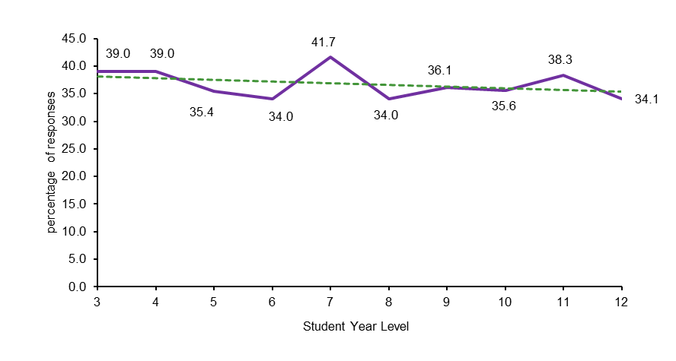

Reasons for choosing VET-related occupations
To better understand school students’ aspirations for VET-related occupations, we examined what students said about why they were interested in jobs in this sector of the labour market.
Tables 10 and 11 compare the reasons students provided for VET-related occupational aspirations and university-related occupational aspirations. The most frequently cited reasons pertained to students’ views that a particular job would be enjoyable or interesting (VET: 34.8%; university: 44.8%). More students aspiring to university-related occupations (16.4%) than VET-related occupations (8.9%) named helping others/altruism as a reason for their occupational choice. Experiences related to the occupation (12.3%) and patriotism (1.6%) were named among the top 10 reasons for their occupational choice by students who indicated an interest in a VET-related occupation, but not by students aspiring to a university-related education. On the other hand, aspirants to university-related jobs named invent, innovate or design (7.3%) and expanding knowledge (1.9%) as key reasons for their occupational choice, but these were not among the top 10 reasons named by students aspiring to VET-related occupations.
Table 10 Top ten reasons for choosing VET-related occupations
 | n | %
Enjoyment or interest | 1901 | 34.8
Benefits of the job | 786 | 14.4
Experiences | 672 | 12.3
Help others / altruism | 484 | 8.9
Personal suitability | 398 | 7.3
Views of the occupation | 271 | 5.0
Influence of others | 267 | 4.9
Passion or dream | 243 | 4.4
Vague, unknown or unsure | 206 | 3.8
Patriotism | 88 | 1.6
Table 11 Top ten reasons for choosing university-related occupations
 | n |  | %
Enjoyment or interest | 2640 | 44.8
Help other / altruism | 965 | 16.4
Benefits of the job | 571 | 9.7
Invent, innovate or design | 431 | 7.3
Personal suitability | 409 | 6.9
Passion or dream | 229 | 3.9
Influence of others | 174 | 3.0
View of the profession | 135 | 2.3
Expand knowledge | 110 | 1.9
Vague, unknown or unsure | 109 | 1.9
An illustration of the reasons for choosing a VET-related occupation is provided in table 12, using students’ own words (edited slightly for ease of reading). For reference we have indicated the gender, year level, SES, and prior achievement level for each student.
Table 12 Examples of students' reasons for interest in VET-related occupations: survey responses
Theme | Examples
Enjoyment or interest | Because I love bike riding and I have qualified for world championships in 2016, and it has just been my little kid dream (sportsperson, Year 7, male, mid–high SES and achievement, provincial)
Benefits of the job | My mum and dad thought it would be good for me because I like travelling (defence, Year 4, male, mid–high SES, high achievement, metropolitan)  These two jobs have good money, and need good maths and study and hard work (electrician, Year 6, male, low–mid SES, mid–high achievement, low–mid SES, provincial)
Experiences | Because I'm really good at it. Plus I'm one of twelve girls that represent N.S.W in dance. (dance teacher [private tuition], Year 6, female, low SES and achievement, provincial)  Because I’m in the right shape and form for it and I am already into the [town] cycle club and I also think it will be a good opportunity to represent Australia and my family in the Olympics and tour De France (sportsperson, Year 6, male, low SES, mid–high achievement, provincial)
Help others / altruism | Because I like doing hair and make up and photography and I would love to help people on their big day (hairdresser, beautician, photographer, Year 9, female, low SES and achievement, metropolitan)  I love working with young children and want them to be able to reach their full potential. (child care, Year 10, female, mid–high SES and achievement, metropolitan)
Personal suitability | I want to do this because I love animals and I loved them ever since I was born. I’ve always wanted to look after animals and when I get the chance I will take the job. And I have expertise in catching lizards and snakes and I love to look after birds and other animals and insects as in the spiny leaf insects (zookeeper, Year 9, female, low–mid SES and achievement, metropolitan)  Because it goes with my skills and I would love to help people every day (police officer, Year 8, male, low–mid SES and achievement, metropolitan)
Views of the occupation | Because it would be fun and I like to argue and I’m quite good at it (receptionist, Year 11, female, high SES, low–mid achievement, metropolitan)  Because it keeps your mind active and it’s all physical and mental work with numbers and you are always learning new things and meeting new people (vehicle painter, Year 9, male, low–mid SES, low achievement, metropolitan)
Influence of others | My dad wanted to be a police officer but couldn't due to height restrictions and I think it would be a more exciting job. I also want to work my way up to joining the Dog Squad (police officer, Year 9, male, high SES, mid–high achievement, metropolitan)  Because it is a family business and I have grown up around the business and I know a fair bit (diesel mechanic, Year 9, male, mid–high SES and achievement, metropolitan)
Passion or dream | I have been inspired by my cousins work in the army and I mashed my dream job with the army and that is what I got and I am quite happy with it (body artist, Year 12, no gender listed, low SES, no achievement data available, metropolitan)  Because music is my passion and my fathers, I would like to take this as far as I can go (music professional, Year 9, male, high SES, low–mid achievement, metropolitan)
Vague, unknown or unsure | Because that is what l would like to do (motor mechanic, Year 8, male, low–mid SES, no prior achievement data available, metropolitan)  Um I don’t know (motor mechanic, Year 6, male, low SES and achievement, metropolitan)
Patriotism | Because I love sport and representing my country would make me really proud. Also being active and healthy is really important. And it would be cool with everyone cheering for your team and being in a big Stadium (sportsperson, Year 6, female, high SES, no prior achievement data available, metropolitan)  I would like to be in the army because I want to protect the country (defence, Year 8, male, low–mid SES, high achievement, metropolitan)

To further illustrate reasons for choosing a VET-related occupation, we asked students in their focus groups to explain why they had chosen a particular career. These elaborated responses provide a deeper understanding of students’ aspirations for VET-related jobs than that gained from the analysis of their short survey responses.
From a young age, students cited financial benefits as an important consideration in forming their occupational interests.

Enjoyment or interest
Enjoyment and interest were cited by a number of students as reasons for their interest in particular VET careers. Lachlan, for example, articulated that an interesting job was the most important consideration for him in choosing a career. He wants to be a police officer, ‘Not just to impress mum and dad, just because it looks good. It looks interesting. It doesn’t get boring’ (Lachlan, male, Year 9, mid to high SES, low to mid achievement, provincial school). Enjoyment or interest in a career was reiterated by Donna, who was attracted to hairdressing and nail art, because they ‘look like fun and during my life I want to just work all the time but when I’m working have fun as well, and enjoy it’ (Donna, female, Year 7, High SES, low to mid achievement).
Students were also aware of challenges they might face in pursuing a future based on their enjoyment and interests. For example, Zach explained:
I love cooking and food so I want something like that, like something I will enjoy. But there’s not much out there involving cooking. But if you like — something in the navy and you get good pay for that as well. I just want something that I get good pay for and something I will enjoy, like cooking.
(Zach, male, Year 10, low to mid SES and achievement, provincial school)
Basing occupational choices on the likely interest or enjoyment they might provide is consistent with previous research reporting that the more value students place on enjoyment and interest, the more positive they were about an occupational choice and the stronger their intentions to pursue that occupation (Jung & McCormick 2011b).

Benefits of the job
Benefits provided by participating in a particular career primarily included reference to monetary rewards, but also included fame, particular experiences and conditions such as holidays, paid training or tuition, and job security. Other benefits named by students included the achievement of a personal goal, such as owning one’s own home.
From a young age, students cited financial benefits as an important consideration in forming their occupational interests. For example, Kalista explained:
Well when I was little I said I wanted to be a hairdresser, but then my dad’s just like, ‘you won’t get any money’, so I decided not to do that.
(Kalista, female, Year 5, mid to high SES and achievement, provincial school)
Another primary student, Vanessa, recognised the importance of money but placed more value on enjoyment:
You need a good job and you get paid so you can buy a house and that. But then it’s not so important because if you’re doing a job that you love and you really enjoy what you’re doing, it doesn’t really matter about money. But, like you get it to pay for bills and that, but still …
(Vanessa, female, Year 5, mid to high SES and achievement, provincial school)

Experiences
A number of students described how informal and formal experiences contributed to their interest in a particular career, including participation in school electives. One senior high school student placed significant weight on his positive experience in the elective subject wood technology, saying ‘that could influence me and I could become a carpenter for all I know’ (Thomas, male, Year 12, mid to high SES, low to mid achievement, provincial school).
Both informal and formal experiences help shape an interest in a particular career.
Formal experiences such as those provided by VET in Schools were often mentioned in the focus groups as having a positive influence on making career choices:
[I want to do] aged care. I have a traineeship now through school in aged care so I’m really liking it so far.
(Christina, female, Year 11, low to mid SES, low achievement, provincial school)
I’d like to be a chef; that’s pretty much it … I’m doing Hospitality at school, get a Certificate II and, with the traineeship, I get a Certificate II in Kitchen Operations, and then I can extend that after my two-year traineeship and get a certificate and take it somewhere.
(Angus, male, Year 11, low to mid SES, mid to high achievement, provincial school)
[My career aspiration has] changed a lot since I’ve started at TAFE because I suppose the thing is that I love my teacher at TAFE and our class is so tightknit and we’re all really close … So I suppose that just makes it a lot easier to pick what I want to do because I love it.
(Ellen, female, Year 12, low SES, low to mid achievement, provincial school)
Younger children commonly named informal experiences when justifying their occupational choices. Keely, for example, said she wanted to be a hairdresser because she likes to do hair, and mentioned playing with a toy: ‘I have this doll, it’s got hair on it, so I like put hers in plaits and then make like a pineapple thing’ (Keely, female, Year 5, mid to high SES and achievement, provincial school). Another student in the same focus group told the facilitator that Keely sometimes does people’s hair in class. Informal experiences such as these may help children develop their likes and dislikes, understand their abilities and build confidence (Archer, DeWitt & Wong 2014).
Mackenzie recognised the importance of experience in making career decisions:
I’ve always liked animals … We used to live out in the bush so we had horses and cows and we had poddy calves. We had ten of them and we always loved them but when I get older, my sister, she always cooks … and it’s always in kitchen lately that we’ve been cooking together … Cooking is really fun that’s why. If I experience something [else], that might help me change my opinion.
(Mackenzie, female, Year 6, low SES, missing achievement, provincial school)

Helping others/altruism
Students who took part in the focus groups frequently spoke of helping or caring for the interests of others, including animals, and/or making broader societal contributions. Daisy, for example, explained why she had expressed interest in becoming a police officer:
Personal suitability to a career was important in decision making.
Because they have always been there for us when we needed help and I feel I want to give back I guess. Not because I have to but because I like helping people.
(Daisy, female, Year 10, mid to high SES, low to mid achievement, metropolitan school)
Taylor wanted to be a personal trainer because she wanted to ‘help people, like, reach their goals and stuff’ (Taylor, female, Year 10, high SES, low to mid achievement, provincial school).
Public figures, such as those seen on television or with a visible role in the community, were also shown to have influence. Grayson, for example, explained why he chose to be veterinarian: ‘Just the show Bondi Vet, how he gets the enjoyment out of helping all these different animals and meeting new people’ (Grayson, male, Year 7, missing SES and achievement data, provincial school). For other students, a personal experience had influenced their desire to help others:
I’ve broken this arm three times and this arm twice, so I’ve been in a lot of ambulances, and been to hospital a fair bit. So I always used to tell mum that when I grew up I’d become a paramedic, and drive around in the ambulance helping people.
(Brenn, male, Year 5, low SES, mid to high achievement, provincial school)

Personal suitability
Students’ focus group responses also indicated that personal suitability was important in career decision-making. Adrianna, who was tossing up between being a beauty therapist, a personal development, health and physical education (PDHPE) teacher, or an accountant, said she wasn’t sure what she wanted to do because ‘I don’t know which one I’m really good at’ (Adrianna, female, Year 8, low to mid SES and achievement, provincial school). Alan, on the other hand, while unsure of a specific occupation, was certain he wanted to do something associated with art. He said:
Well, I’m really good at art … any sort of art; any. So that means, like, paints, drawing and basically everything that’s art. That is woodwork, all that. If it comes to owning the toy shop I’ll probably be a toy shop assistant. I’ll just keep doing stuff that compares to art because that’s all I’m good at.
(Alan, male, Year 6, low SES and achievement, metropolitan school)
Billy said he wants to be a fitter because ‘my dad’s a driller and when I go with him to the mines I’m really good with the stuff and it’s interesting’ (Billy, male, Year 6, low SES and achievement, metropolitan school).
Illustrating the link between understanding of self (Boersma et al. 2010) and fitness for an occupation (Super 1957; Holland 1985), students clearly connected their skills with particular occupations. In addition to understanding their personal identity, many students were beginning to understand their professional identity; that is, understanding ‘what does it mean to me to work in this sphere, do I have the necessary qualities for working in this field and am I willing and able to develop into a professional in this sphere of work?’ (Boersma et al. 2010, p.5). For example, Jye said that ‘When I did the survey I said electrician too … because I’m good with my hands and it’s good pay’ (Jye, male, Year 9, low SES and achievement, provincial school).
Students predominantly referred to immediate and extended family, peers and teachers for career advice.
School subjects and VET in Schools are other experiences that facilitated students’ awareness of their skills and suitability for particular types of work:
I loved doing tourism at TAFE so that would be my first choice because I know that I’ll love it and I’m going good at it so far. So I know that’s something I would enjoy doing in life.
(Ellen, female, Year 12, low SES, low to mid achievement, provincial school)

Influence of others
While a wide range of people were mentioned as influential in shaping students’ occupational interests, including various sporting personalities, other famous people and even movie characters, students predominantly referred to immediate and extended family members, peers and teachers. Some students indicated interest in an occupation because it was done by a family member: ‘I’d like to be a builder probably, because my dad’s a builder’ (Brayden, male, Year 6, low to mid SES, low achievement, metropolitan). On the contrary, Jose said he did not want to work in the construction industry, removing asbestos like his Dad did, ‘because it’s dangerous’ (Jose, male, Year 6, low SES and achievement, metropolitan school).
The focus group discussions also revealed advice provided to students by their parents/carers. Thomas, for example, had aspirations for a career in the army:
I’ve talked to my parents about it. My dad dropped out of school in Year 11 and he was, not regretful, but he knows that he should have got something like a trade or something like that to fall back on. So he wants me to do that.
(Thomas, male, Year 11, mid to high SES, low to mid achievement, provincial school)
And while Nolan aspires to becoming a professional soccer player, his Mum has advised him to consider other options:
Currently I'm working on becoming a professional soccer player, like, putting my all into that. But my Mum tells me to, like, have a fall back job, like, do well in school so if I don't make it, have something there, you know. Yeah. And if that doesn't work, just get a job and travel the world. That sounds appealing to me.
(Nolan, male, Year 11, unknown SES, low to mid achievement, provincial school)

Reasons for choosing VET-related occupations, by selected variables
The most frequently named reasons for interest in a VET-related occupation are depicted in tables located in appendix C. Variables that had a moderate to strong effect on aspirations for VET-related occupations — gender (table C1), NAPLAN quartiles (table C2), and year level (table C3) — are included here in order to consider the effect of these variables on student interest in VET-related occupations. Note that in instances where a student listed multiple reasons, each reason is included.
For both male and female students, enjoyment is the primary reason for interest in VET-related occupations. Indeed, male and female responses are similar for the top nine reasons provided for VET-related occupational interests. The only difference between the two lists is the inclusion of ‘expand knowledge’ for female respondents and ‘patriotism’ for male respondents (see table C1).
With reference to prior achievement, as measured by NAPLAN, there were few differences of note when reasons for occupational choice were compared across the prior achievement quartiles. ‘Patriotism’ was included for those from low, low to mid and mid to high prior achievement quartiles, and ‘invent, innovate or design’ was included in the top 10 reasons for occupational choice only by those with high prior achievement (see table C2).
Similar to the previous results that reported differences by gender, language background and prior achievement, few differences were noted in student choice by Year level. ‘Expand knowledge’ was included as one of the top reasons named by students in Years 3—4, Years 9—10 and Years 11—12, but not included by those in Years 5—6 and Years 7—8. ‘Patriotism’ was included for those in Years 5—6 and Years 7—8, but not for those in Years 3—4, Years
9—10, and Years 11—12 (see table C3).

Concluding remarks
School students’ aspirations for VET or VET-related occupations have rarely been investigated. This study was thus uniquely positioned to provide essential evidence to fill this void, drawing on a comprehensive dataset involving survey and interview data with students, parents/carers and teachers across the primary and secondary years of schooling. We found:
- that VET and VET-related occupations appeal to certain kinds of students
- more interest in VET-related occupations than in VET, with some misalignment between the two
- perceptions of VET as a place of practical learning, offering great opportunities, especially for less academically inclined students
- students’ interests in VET-related occupations were primarily motivated by enjoyment, interest, perceived benefits, altruism, personal suitability and prior related experience
- primary and secondary schools had a significant role to play in the timing and substance of careers education, particularly related to VET study and subsequent careers requiring VET qualifications.

VET appeals to certain kinds of student
Our regression analyses indicate that certain kinds of students aspire to VET and/or VET-related occupations. While NSW TAFE enrolment data suggest that approximately equal numbers of males and females are enrolled in TAFE programs (TAFE NSW 2013), our data indicate that, among school students, males are around 1.3 times more likely to express interest in TAFE and nearly 2.5 times more likely to express interest in VET-related occupations than females, even when adjusting for all other variables considered in our modelling. These findings may signal shifting gender composition down the track.
Furthermore, students expressing interest in the VET sector (educational or occupational) were significantly more likely to have lower prior achievement and a lower sense of their relative academic performance. These results align with students’, teachers’ and parents/carers’ perceptions of VET more broadly as an educational option for students who do not have the academic aptitude to attend university.
Students interested in the VET sector were also more likely to be from lower SES backgrounds, with lower levels of cultural capital, from lower ICSEA schools and from English-speaking backgrounds. In an environment of deregulation and increasing fees, providing clear educational pathways to this group of less advantaged students is critical. Further increases in fees for VET are likely to thwart attempts to widen participation overall, especially if this group of less advantaged students is unable or unwilling to find viable ways to overcome financial constraints. Our results signal the need for TAFE to continue to provide educational and occupational pathways for these students.
However, if current and projected skill shortages are to be addressed, there is a pressing need for TAFE to consider how it might attract a more diverse sample of school students. Despite current efforts to attract a wider range of clientele (with the expansion of TAFE programs and the inclusion of degrees), the fact that students in the primary years hold understandings of TAFE and aspirations to attend TAFE and/or pursue VET-related occupations that are similar to those of older students means that the system is likely to reproduce itself. This evidence provides a foundation for TAFE and other VET providers to explore ways of ensuring that students have both a greater awareness and a deeper understanding of the sector.
While almost 36% of students indicated interest in a VET related job, only 14% indicated that TAFE was their highest level of intended education.

Higher interest in VET-related jobs than in VET pathways
An important finding of this study is the difference between student aspirations for VET and VET-related occupations. While just over a third of all students indicated interest in a VET-related job (35.9%), only 13.9% indicated that TAFE was their highest level of intended education. This result might mean that some students plan to go to TAFE and then on to university. Alternatively, as our data suggest, it signals a lack of understanding about and/or lack of appeal of TAFE.
The misalignment between educational and occupational aspirations and confusion about TAFE indicate that many students lack clear and accurate information about the VET sector, suggesting that schools and/or VET providers have more to do in not only recruiting a more diverse range of students, but also in simply ensuring that students and their parents/carers have a greater awareness of what pathways are available and where they might lead.
Our qualitative data also indicate enduring views of TAFE/VET as inferior to university study. Many students, parents/carers and teachers perceived TAFE as only for the less academically capable students. Some students, in particular, believed that their occupational futures would be more constrained without a university education, in terms of both options and future success.

The significant role of schools
In talking about TAFE and other VET options, students, parents/carers and teachers overwhelming portrayed this educational sector as a place of practical learning, one designed to cater to less academically oriented students and set them up for success. Despite careers activities in schools, including VET-focused activities, many students were unclear about TAFE, conveyed outdated rather than contemporary perceptions of the sector, and were unclear about the pathway to VET-related occupations. Indeed, our data suggest that VET was less valued than university education (Department of Education and Communities, 2012), and many teachers reinforced the idea that VET was a choice for those who were ‘not suitable’ for university study (economic Security4Women, 2014).
Schools play a significant role in preparing students for VET and thus shaping the future of the sector. An increase in the level of student interest in VET is likely to require changing perceptions of TAFE as a lower-status destination, one designed for students who are unsuited to university study. Strategies for addressing perceptions will likely require additional investment in both TAFE outreach to schools and teacher development. Most teachers’ education experience is limited to university, the site of the vast majority of teacher education. Without first-hand knowledge of TAFE, it is likely to be critical that teachers have greater ease of access to good-quality information about VET pathways. Careers advisers, many of whom have extensive first-hand knowledge of TAFE and private VET providers, have a vital role in changing perceptions of the VET sector. Furthermore, if teachers and careers advisers are to pass on up-to-date and accurate information to their students and convey positive perceptions of TAFE, it is critical that they understand the changing face of the VET sector and the career possibilities it provides.
Accurate and contemporary information about VET should be available in the junior secondary and primary years of schooling.
Our data also signal the potential importance of such information being available in the junior secondary and the primary years of schooling. While students reported a clear intensification of work experience and other careers activities during the later high school years, our data suggest that, by this point in their schooling, many students will have already formed strong (sometimes negative) views of the VET sector and circumscribed their aspirations in ways that limit them to deliberations about university pathways.
Changing perceptions of, and increasing interest in, VET is likely to require concerted, coordinated efforts that use inclusive, non-stigmatising, non-deficit language while highlighting the full range of opportunities and pathways available to students in the VET sector. Teachers will need active support from and engagement with government and VET providers if they are to fully inform students about the opportunities that the VET sector provides.

Implications
These data suggest that policy decisions such as broadening the apprenticeship system, opening up the provider market and implementing the VET FEE-HELP program, all of which aim to improve the sector’s responsiveness to the labour market and skills shortages (Atkinson & Stanwick 2016), appear to be falling short of their desired objectives. Only a small proportion of students expressed interest in vocational education. Many students were uncertain of the pathway to a VET-related occupation and/or held views of VET as only for those unable to make it to university. Despite evidence that more than 15% of school students between the ages of 15 and 19 nationwide participate in the VET in Schools program (NCVER 2016a), a substantial number of students who showed some interest in VET disengaged from the idea of a vocational education as they moved through school. A possible explanation for this finding might be the limited understanding of TAFE and VET among younger students.
The Australian Government’s focus on widening participation in higher education in response to the Bradley Review (2008) has seen a steady increase in university participation (Universities Australia 2017), potentially drawing students away from potential VET pathways. With 14% of students in Years 3 to 12 aspiring to VET and 50% aspiring to a university education, initiatives that strengthen the appeal of VET might be critical to the sector. Recent gains made in the university enrolment of students from equity target groups through the widening participation agenda, together with ‘credential inflation’ (the devaluation of educational credentials over time; Collins 1979, 2002), may be impacting on the level of interest in VET. Policies that enhance opportunities for VET as a pathway to higher education and which increase opportunities for achieving degrees through VET study may be important in developing students’ interest and participation in the VET sector. VET providers have a significant opportunity to highlight their role in pathways to higher education and in the provision of higher education through degree and higher apprenticeship programs.
Our data suggest that gender stereotypes pervade student ideas about their futures, particularly with regard to career choice. Strategies that support students in a diverse range of schooling and careers experiences may encourage students from a diverse range of backgrounds to participate in VET. In particular, one method of addressing identified skills shortages could be to support female participation in non-traditional areas and in VET overall. Equally, VET providers and school leaders have a significant role to play in exposing students to a diverse range of experiences.
Policy that supports the promotion of VET opportunities and pathways and highlights the significant range of options available to students is important in overcoming the negative perceptions of VET held by many students and their teachers. Likewise, the promotion of VET opportunities and pathways by VET providers, whereby the significant range of options available to students is highlighted, is important in overcoming the negative, gendered and often outdated perceptions of the sector held by many students and their parents and teachers. School leaders might play a significant role in disseminating accurate and timely information to teachers and the school community regarding VET opportunities and pathways that support student understandings of VET.

References
Albright, J, Gore, J, Smith, M, & Holmes, K (in press), ‘Operationalising Bourdieu for the study of student aspirations: conceptual and methodological challenges’, In G Stahl, D Wallace, C Burke, & S. Threadgold (eds), International perspectives on theorizing aspiration: applying Bourdieu’s tools, Bloomsbury London.
Archer, L, DeWitt, J & Wong, B 2014, ‘Spheres of influence: what shapes young people’s aspirations at age 12/13 and what are the implications for education policy?’, Journal of Education Policy, vol.29, pp.58—85.
Arksey, H & O’Malley, L 2005, ‘Scoping studies: towards a methodological framework’, International Journal of Social Research Methodology, vol.8, pp.19—32.
Atkinson, G & Stanwick, J 2016, Trends in VET: policy and participation, NCVER, Adelaide.
ABS (Australian Bureau of Statistics) 2006, ANZSCO — Australian and New Zealand standard classification of occupations, Canberra, Australia.
——2012, Estimates of Aboriginal and Torres Strait Islander Australians, June 2011, cat.no.328.0.55.001, Canberra.
Australian Council for Educational Research 2002, Vocational education and training: participation, achievement and pathways, LSAY briefing reports, ACER, Camberwell, Victoria.
Australian Skills Quality Authority 2016, Australia's VET sector, viewed 16 December 2016, <http://www.asqa.gov.au/about/australias-vet-sector/australias-vet-sector.html>.
Bell, R 1953, ‘Convergence: an accelerated longitudinal approach’, Child Development, vol.24, no.2, pp.145—52.
——1954, ‘An experimental test of the accelerated longitudinal approach’, Child Development, vol.25, no.1, pp.281—6.
Bender, R & Grouven, U 1998, ‘Using binary logistic regression models for ordinal data with non-proportional odds’, Journal of Clinical Epidemiology, vol.51, pp.809—16.
Bradley, D, Noonan, P, Nugent, H & Scales, B 2008, Review of Australian higher education: final report, DEEWR, Canberra.
Boersma, A, ten Dam, G, Volman, M & Wardekker, W 2010, ‘“This baby … it isn't alive”: towards a community of learners for vocational orientation’, British Educational Research Journal, vol.36, no.1, pp.3—25.
Centre for Education Statistics and Evaluation 2013, NSW VET Students 2013 VET bulletin, NSW Department of Education and Communities.
Chesters, J & Smith, J 2015, ‘Social capital and aspirations for educational attainment: a cross-national comparison of Australia and Germany’, Journal of Youth Studies, vol.18, pp.932—49.
Collins, R 1979, The credential society: an historical sociology of education and stratification. Academic Press, New York.
——2002, ‘Credential inflation and the future of universities’, in S Brint (ed.) The future of the city of intellect: the changing American university, Stanford University Press, Palo Alto, pp.23—46.
Creswell, J 2013, Qualitative inquiry & research design, SAGE Publications, California.
Curtis, D 2008, VET pathways taken by school leavers, LSAY research report no.52, ACER, Camberwell, Victoria.
Dalley-Trim, L & Alloway, N 2010, ‘Looking “outward and onward” in the outback: regional Australian students' aspirations and expectations for their future as framed by dominant discourses of further education and training’, The Australian Education Researcher, vol.37, pp.107—25.
Department of Education and Communities (2012), NSW Government review of tertiary pathways, Sydney, Department of Education and Communities, viewed 10 December 2015, <https://www.det.nsw.edu.au/media/downloads/about-us/statistics-and-research/public-reviews-and-enquiries/review-tertiary-pathways.pdf>
economic Security4Women (2014), Women and girls into non-traditional occupations and industries: Broadening career options for secondary school students [Report], viewed 10 December 15 http://www.security4women.org.au/wp-content/uploads/eS4WCareer-Exploration-Project-Report-20140615.pdf.
Galbraith, S, Bowden, J & Mander, A 2017, ‘Accelerated longitudinal designs: an overview of modelling, power, costs and handling missing data’, Statistical Methods in Medical Research, vol.16, pp.374—98.
Gale, T, Parker, S, Rodd, P, Stratton, G, Sealey, T & Moore, T 2013, Student aspirations for higher education in Central Queensland: a survey of students' navigational capacities, report submitted to CQ University, Australia, Centre for Research in Education Future and Innovation (CREFI), Deakin University, Melbourne.
Galliott, N & Graham, L 2015, ‘School based experiences as contributors to career decision-making: findings from a cross-sectional survey of high school students’, The Australian Education Researcher, vol.42, pp.179—99.
Galliott, N, Graham, L & Sweller, N 2015, ‘Who struggles most in making a career choice and why? Findings from a cross-sectional survey of Australian high-school students’, Journal of Psychologists and Counsellors in Schools, vol.25, pp.133—51.
Goldstein, B & Oldham, J 1979, Children and work: a study of socialization, Transaction Books, New Brunswick, New Jersey.
Gore, J, Holmes, K, Smith, M, Southgate, E & Albright, J 2015, ‘Socioeconomic status and the career aspirations of Australian school students: testing enduring assumptions’, The Australian Educational Researcher, vol.42, pp.155—77.
Gore, J, Barron, RJ, Holmes, K, & Smith, M 2016, ‘Who says were not attracting the best and the brightest? Teacher selection and the aspirations of Australian school students’, The Australian Educational Researcher, vol.43, pp.527—49.
Gore, J, Fray, L, Wallington, C, Holmes, K & Smith, M 2017, ‘Australian school student aspirations for military careers: traditional perceptions in shifting contexts’, Armed Forces & Society, vol.43, pp.238—59.
Gore, J, Holmes, K, Smith, M, Fray, L, McElduff, P, Weaver, N, & Wallington, C 2017, ‘Unpacking the career aspirations of Australian school students: towards an evidence base for university equity initiatives in schools’, Review of Education, vol.3, no.1, pp.68—71, doi:10.1080/07294360.2017.1325847.
Guest, G, MacQueen, K & Namey, E 2011, Applied thematic analysis, Sage Publications, London.
Harry, B, Sturges, K & Klingner, JK 2005, ‘Mapping the process: an exemplar of process and challenge in grounded theory analysis’, Educational Researcher, vol.34, pp.3—13.
Harwood, V, McMahon, S, O’Shea, S, Bodkin-Andrews, G & Priestly, A 2015, ‘Recognising aspiration: the AIME program’s effectiveness in inspiring Indigenous young people’s participation in schooling and opportunities for further education and employment’, Australian Educational Researcher, vol.42, pp.217—36.
Holland, M 1985, Making vocational choices: a theory of vocational personalities and work environments, Prentice-Hall, Englewood Cliffs, New Jersey.
Holmes, K, Gore, J, Smith, M, Lloyd, A 2017, ‘An integrated analysis of school student aspirations for STEM careers: which student and school factors are most predictive?’, International Journal of Science and Mathematics Education, pp.1-21.
Jung, JY & McCormick, J 2010, ‘Amotivation and the occupational decision: an investigation of Australian senior high school students’, British Journal of Guidance & Counselling, vol.38, pp.441—58.
——2011a, ‘Occupational decision-related processes for amotivated adolescents: confirmation of a model’, Journal of Career Development, vol.38, pp.275—92.
—2011b, ‘The occupational decision: a cultural and motivational perspective’, Journal of Career Assessment, vol.19, pp.75—91.
Khattab, N 2015, ‘Students’ aspirations, expectations and school achievement: what really matters?’, British Educational Research Journal, vol.41, pp.731—48.
Lamb, S 2014, ‘TVET and the poor: challenges and possibilities’, International Journal of Training Research, vol.9, pp.60—71.
Monson, R 1990, Occupational epidemiology, CRC Press, Florida.
Myers, P, Vickers, N, Ward, A & Parkes, A 2015, NSW secondary students’ post-school destinations and expectations, Social Research Centre, Melbourne.
Naidoo, L 2015, ‘Imagination and aspiration: flames of possibility for migrant background high school students and their parents’, Australian Journal of Teacher Education, vol.40, pp.102—15.
Naylor, R, Baik, C & James, R 2013, Developing a critical interventions framework for advancing equity in Australian higher education, University of Melbourne, Centre for the Study of Higher Education.
NCVER (National Centre for Vocational Education Research) 2016a, Young people in education and training 2015 — Australia, NCVER, Adelaide.
——2016b, Australian vocational education and training statistics: total VET students and courses 2015, NCVER, Adelaide.
OECD (Organisation for Economic Co-operation and Development) 2000, Program for International Student Assessment: Student Questionnaire (US English Version), viewed 12 June 2016 <https://nces.ed.gov/surveys/pisa/pdf/quest_pisa_2000_student.pdf>.
Parker, S, Stratton, G, Gale, T, Rodd, P, & Sealey, T 2013, Higher education and student aspiration: a study of the adaptive preferences of Year 9 students in Corio, Victoria, report to the Access & Equity Unit, Deakin University, Australia, Centre for Research in Education Futures and Innovation (CREFI), Deakin University, Melbourne, Australia.
Polesel, J 2010, ‘Vocational education and training (VET) and young people: the pathway of the poor?’, Education + Training, vol.52, pp.415—26.
Productivity Commission 2011, Vocational education and training workforce, Productivity Commission research report, Canberra.
Robinson, DH & Levin, JR 1997, ‘Research news and comment: reflections on statistical and substantive significance, with a slice of replication’, Educational Researcher, vol.26, pp.21—6.
Somerville, M 2013, ‘The ‘placetimemattering’ of aspiration in the Blacktown Learning Community’, Critical Studies in Education, vol.54, pp.231—44.
Super, D 1957, The psychology of careers, Harper, New York.
TAFE NSW 2013, TAFE NSW enrolments and delivery, TAFE NSW, viewed 28 February 2017, <https://www.tafensw.edu.au/__data/assets/pdf_file/0006/9474/Statistical-Compendium-2013.pdf>.
——2017, TAFE NSW degrees, TAFE NSW, viewed 15 March 2027, https://www.tafensw.edu.au/__data/assets/pdf_file/0010/24859/TAFE-degrees-2017.pdf#24859.
Teese, R, Nicholas, T, Polesel, J & Helme, S 2006, The destinations of school leavers in Victoria: report of the 2005 On Track project, Department of Education and Training, Communications Division, Melbourne.
Universities Australia 2017, Data snapshot 2017, viewed 12 June 2016 <https://www.universitiesaustralia.edu.au/australias-universities/key-facts-and-data#.WSOezEdDAg0>.
Whitty, G, Hayton, A & Tang, S 2015, ‘Context and implications document for: who you know, what you know and knowing the ropes: a review of evidence about access to higher education institutions in England’, Review of Education, vol.3, pp.68—71.
Zeger, SL, Liang, K-Y & Albert, PS 1988, ‘Models for longitudinal data: a generalized estimating equation approach’, Biometrics, vol.44, pp.1049—60.

Appendix A
Overview of studies included in the scoping review
Author(s) | Publication | Participants | Data Sources
Chesters & Smith (2015) | Journal of Youth Studies | 3586 Australian students  2517 German students | Surveys
Dalley-Trim & Alloway (2010) | The Australian Educational Researcher | 41 focus groups, 13 locations | Semi-structured interviews
Galliot, Graham & Sweller (2015) | Journal of Psychologists and Counsellors in Schools | 706 students | Online survey
Galliot & Graham (2015) | The Australian Educational Researcher | 706 students | Online survey
Gore et al. (2015) | The Australian Educational Researcher | 3504 students | Online survey
Harwood et al. (2015) | The Australian Educational Researcher | 91 mentor surveys,  86 mentees 79 mentors interviews,  15 university campuses | Surveys  Semi- structured interviews  Ethnographic observations
Jung & McCormick (2010) | The British Journal of Guidance & Counselling | 492 students | Questionnaire
Jung & McCormick (2011a) | Journal of Career Development | 566 students | Questionnaire
Jung & McCormick (2011b) | Journal of Career Assessment | 566 students | Questionnaire
Naidoo (2015) | Australian Journal of Teacher Education | Students, teachers, parents | Ethnography
Somerville (2013) | Critical Studies in Education | 144 kindergarten and 87 Year 5 students | Drawings and text

Appendix B
Table B1 Top ten VET-related occupations
 | Occupation | n | %
1 | Sportspersons | 1091 | 21.5
2 | Animal attendants and trainers | 482 | 9.5
3 | Police | 479 | 9.5
4 | Defence force members – other ranks | 399 | 7.9
5 | Motor mechanics | 250 | 4.9
6 | Hairdressers | 246 | 4.9
7 | Chefs | 162 | 3.2
8 | Beauty therapists | 147 | 2.9
9 | Carpenters and joiners | 135 | 2.7
10 | Fitness instructors | 118 | 2.3

Table B2 Top ten VET-related occupations named by males and females
 |  | Males |  |  | Females
 |  | n | % |  | n | %
1 | Sportspersons | 848 | 29.8 | Animal attendants and trainers | 361 | 17.9
2 | Police | 316 | 11.1 | Hairdressers | 234 | 11.6
3 | Defence force members – other ranks | 311 | 10.9 | Sportspersons | 207 | 10.3
4 | Motor mechanics | 220 | 7.7 | Beauty therapists | 142 | 7.0
5 | Carpenters and joiners | 123 | 4.3 | Police | 134 | 6.6
6 | Animal attendants and trainers | 107 | 3.8 | Child carers | 100 | 5.0
7 | Electricians | 80 | 2.8 | Chefs | 79 | 3.9
8 | Chefs | 76 | 2.7 | Defence force members – other ranks | 70 | 3.5
9 | Drillers, miners and shot firers | 70 | 2.5 | Fitness instructors | 68 | 3.4
10 | Other miscellaneous technicians and trades workers | 60 | 2.1 | Veterinary nurses | 59 | 2.9

Table B3 Top ten VET-related occupations for students, by NAPLAN quartile
 |  | Quartile 1 |  |  | Quartile 2 |  |  | Quartile 3 |  |  | Quartile 4
 |  | n | % |  | n | % |  | n | % |  | n | %
1 | Sportspersons | 225 | 18.3 | Sportspersons | 238 | 18.1 | Sportspersons | 221 | 20.6 | Sportspersons | 306 | 37.4
2 | Police | 133 | 10.8 | Police | 129 | 9.8 | Animal attendants and trainers | 130 | 12.1 | Animal attendants and trainers | 71 | 8.7
3 | Animal attendants and trainers | 107 | 8.7 | Animal attendants and trainers | 125 | 9.5 | Police | 106 | 9.9 | Defence force members – other ranks | 62 | 7.6
4 | Hairdressers | 103 | 8.4 | Defence force members – other ranks | 115 | 8.8 | Defence force members – other ranks | 82 | 7.6 | Police | 53 | 6.5
5 | Defence force members – other ranks | 82 | 6.7 | Motor mechanics | 68 | 5.2 | Motor mechanics | 46 | 4.3 | Chefs | 29 | 3.5
6 | Motor mechanics | 73 | 5.9 | Hairdressers | 64 | 4.9 | Hairdressers | 46 | 4.3 | Motor mechanics | 20 | 2.4
7 | Beauty therapists | 48 | 3.9 | Beauty therapists | 53 | 4.0 | Chefs | 39 | 3.6 | Fitness instructors | 19 | 2.3
8 | Carpenters and joiners | 31 | 2.5 | Chefs | 42 | 3.2 | Carpenters and joiners | 34 | 3.2 | Electricians | 16 | 2.0
9 | Chefs | 30 | 2.4 | Fitness instructors | 36 | 2.7 | Fitness instructors | 34 | 3.2 | Ambulance officers and paramedics | 16 | 2.0
10 | Drillers, miners and shot firers | 30 | 2.4 | Child carers | 35 | 2.98 | Child carers | 25 | 2.3 | Sports coaches, instructors and officials | 16 | 3.08

Table B4 Top ten VET-related occupations for students, by Year level
 |  | Years 3–4 |  |  | Years 5–6 |  |  | Years 7–8 |  |  | Years 9–10 |  |  | Years 11–12
 |  | n | % |  | n | % |  | n | % |  | n | % |  | n | %
1 | Sportspersons | 269 | 38.4 | Sportspersons | 481 | 35.1 | Sportspersons | 248 | 16.6 | Defence force members – other ranks | 125 | 10.2 | Defence force members – other ranks | 30 | 13.9
2 | Police | 99 | 14.1 | Animal attendants and trainers | 137 | 10.0 | Animal attendants and trainers | 158 | 10.6 | Police | 84 | 6.8 | Motor mechanics | 18 | 8.3
3 | Animal attendants and trainers | 92 | 13.1 | Police | 136 | 9.9 | Defence force members – other ranks | 137 | 9.2 | Animal attendants and trainers | 81 | 6.6 | Police | 11 | 5.1
4 | Hairdressers | 34 | 4.9 | Defence force members – other ranks | 74 | 5.4 | Police | 137 | 9.2 | Sportspersons | 78 | 6.4 | Carpenters and joiners | 10 | 4.6
5 | Defence force members – other ranks | 30 | 4.3 | Hairdressers | 71 | 5.2 | Motor mechanics | 99 | 6.6 | Motor mechanics | 74 | 6.0 | Chefs | 10 | 4.6
6 | Motor mechanics | 14 | 2.0 | Chefs | 45 | 3.3 | Hairdressers | 72 | 4.8 | Hairdressers | 63 | 5.1 | Fitness Instructors | 10 | 4.6
7 | Chefs | 13 | 1.9 | Motor mechanics | 42 | 3.1 | Chefs | 54 | 3.6 | Beauty therapists | 56 | 4.6 | Animal attendants and trainers | 9 | 4.2
8 | Fire and emergency workers | 13 | 1.9 | Sports coaches, instructors and officials | 29 | 2.1 | Carpenters and joiners | 53 | 3.5 | Fitness instructors | 54 | 4.4 | Conference and event organisers | 8 | 3.7
9 | Beauty therapists | 13 | 1.9 | Beauty therapists | 27 | 2.0 | Beauty therapists | 48 | 3.2 | Child carers | 51 | 4.2 | Electricians | 8 | 3.7
10 | Waiters | 10 | 1.4 | Carpenters and joiners | 22 | 1.6 | Fitness Instructors | 38 | 2.5 | Carpenters and joiners | 45 | 3.7 | Ambulance officers and paramedics | 8 | 3.7

Appendix C
Table C1 Top ten reasons for choosing VET-related occupations, by gender
 |  | Females |  |  | Males
 |  | n | % |  | n | %
1 | Enjoyment | 890 | 38.9 | Enjoyment | 951 | 32.2
2 | Experiences | 338 | 14.8 | Benefit of the job | 528 | 17.9
3 | Help others / altruism | 268 | 11.7 | Experiences | 312 | 10.6
4 | Benefit of the job | 214 | 9.4 | Help others / altruism | 193 | 6.5
5 | Personal suitability | 163 | 7.1 | Personal suitability | 218 | 7.4
6 | Passion or dream | 102 | 4.5 | View of the profession | 165 | 5.6
7 | View of the profession | 95 | 4.2 | Influence of others | 169 | 5.7
8 | Influence of others | 89 | 3.9 | Passion or dream | 125 | 4.2
9 | Vague | 55 | 2.4 | Vague | 139 | 4.7
10 | Expand knowledge | 38 | 1.7 | Patriotism | 79 | 2.7

Table C2 Top ten reasons for choosing VET-related occupations, by NAPLAN quartile
 |  | Quartile 1 |  |  | Quartile 2 |  |  | Quartile 3 |  |  | Quartile 4
 |  | n | % |  | n | % |  | n | % |  | n | %
1 | Enjoyment | 432 | 33.3 | Enjoyment | 515 | 35.1 | Enjoyment | 428 | 36.3 | Enjoyment | 315 | 36.8
2 | Benefit of the job | 191 | 14.7 | Benefit of the job | 209 | 14.3 | Benefit of the job | 167 | 14.2 | Experiences | 115 | 13.4
3 | Experiences | 168 | 12.9 | Experiences | 192 | 13.1 | Experiences | 125 | 10.6 | Benefit of the job | 114 | 13.3
4 | Help others / altruism | 117 | 9.0 | Help others / altruism | 142 | 9.7 | Help others / altruism | 95 | 8.1 | Personal suitability | 75 | 8.8
5 | Personal suitability | 87 | 6.7 | Personal suitability | 102 | 7.0 | Personal suitability | 94 | 8.0 | Help others / altruism | 61 | 7.1
6 | View of the profession | 67 | 5.2 | View of the profession | 70 | 4.8 | View of the profession | 66 | 5.6 | Influence of others | 47 | 5.5
7 | Influence of others | 75 | 5.8 | Influence of others | 66 | 4.5 | Passion or dream | 62 | 5.3 | View of the profession | 37 | 4.3
8 | Passion or dream | 39 | 3.0 | Passion or dream | 60 | 4.1 | Influence of others | 51 | 4.3 | Passion or dream | 35 | 4.1
9 | Vague | 73 | 5.6 | Vague | 53 | 3.6 | Vague | 34 | 2.9 | Invent, innovate or design | 22 | 2.6
10 | Patriotism | 24 | 1.8 | Patriotism | 22 | 1.6 | Patriotism | 19 | 1.6 | Vague | 17 | 2.0
Table C3 Top ten reasons for choosing a VET-related occupation, by year level
 |  | Years 3–4 |  |  | Years 5–6 |  |  | Years 7–8 |  |  | Years 9–10 |  |  |  | Years 11–12
 |  | n | % |  | n | % |  | n | % |  | n |  | % |  | n | %
1 | Enjoyment | 251 | 34.2 | Enjoyment | 518 | 35.1 | Enjoyment | 447 | 35.5 | Enjoyment |  | 350 | 35 | Enjoyment | 58 | 32.2
2 | Benefit of the job | 130 | 17.7 | Benefit of the job | 207 | 14 | Benefit of the job | 178 | 14.1 | Benefit of the job |  | 156 | 15.6 | Benefit of the job | 24 | 13.3
3 | Experiences | 80 | 10.9 | Experiences | 202 | 13.7 | Experiences | 137 | 10.9 | Experiences |  | 109 | 10.9 | Experiences | 23 | 12.8
4 | Help others/ altruism | 67 | 9.1 | Personal suitability | 128 | 8.7 | Help others/ altruism | 123 | 9.8 | Help others/ altruism |  | 78 | 7.8 | Help others/ altruism | 19 | 10.6
5 | Personal suitability | 63 | 8.6 | Help others/ altruism | 126 | 8.5 | Personal suitability | 74 | 5.9 | Personal suitability |  | 65 | 6.5 | Passion or dream | 17 | 9.4
6 | Influence of others | 48 | 6.5 | Influence of others | 79 | 5.4 | View of the profession | 66 | 5.2 | Passion or dream |  | 59 | 5.9 | Personal suitability | 12 | 6.7
7 | View of the profession | 30 | 4.1 | View of the profession | 65 | 4.4 | Influence of others | 59 | 4.7 | View of the profession |  | 55 | 5.5 | View of the profession | 8 | 4.4
8 | Vague | 28 | 3.8 | Passion or dream | 59 | 4 | Vague | 57 | 4.5 | Vague |  | 41 | 4.1 | Influence of others | 8 | 4.4
9 | Passion or dream | 18 | 2.5 | Vague | 36 | 2.4 | Passion or dream | 45 | 3.6 | Influence of others |  | 39 | 3.9 | Vague | 7 | 3.9
10 | Expand knowledge | 8 | 1.1 | Patriotism | 26 | 1.8 | Patriotism | 40 | 3.2 | Expand knowledge |  | 23 | 2.3 | Expand knowledge | 2 | 1.1


National Centre for Vocational Education Research
Level 11, 33 King William Street, Adelaide, SA 5000
PO Box 8288 Station Arcade, Adelaide SA 5000, Australia
Phone +61 8 8230 8400 Fax +61 8 8212 3436
Email ncver@ncver.edu.au Web <http://www.ncver.edu.au> <http://www.lsay.edu.au>
Follow us: <http://twitter.com/ncver> <http://www.linkedin.com/company/ncver>

National Centre for Vocational Education Research
Level 11, 33 King William Street, Adelaide, SA 5000
PO Box 8288 Station Arcade, Adelaide SA 5000, Australia
Phone +61 8 8230 8400 Fax +61 8 8212 3436
Email ncver@ncver.edu.au Web <http://www.ncver.edu.au> <http://www.lsay.edu.au>
Follow us: <http://twitter.com/ncver> <http://www.linkedin.com/company/ncver>

National Centre for Vocational Education Research
Level 5, 60 Light Square, Adelaide, SA 5000
PO Box 8288 Station Arcade, Adelaide SA 5000, Australia
Phone +61 8 8230 8400 Email ncver@ncver.edu.au
Web <https://www.ncver.edu.au> <https://www.lsay.edu.au>
Follow us: <https://twitter.com/ncver> <https://www.linkedin.com/company/ncver>

ICSEA = Index of Community Socio-Educational Advantage. See <http://www.myschool.edu.au> for details.
‘Provincial’ is used here to reflect the terminology used by the MySchool website, 2012—15 (when survey data were collected). During this time MySchool used Very Remote, Remote, Provincial and Metropolitan to categorise school locations. From 2016 MySchool uses Major Cities, Inner Regional, Outer Regional, Remote and Very Remote categories aligning with the Australian Statistical Geography Standard (ASGS) (ABS 2011). There were no remote or very remote schools involved in this study; however, we are currently undertaking a study gathering similar data from a cross-sectional sample of students in remote and very remote schools in NSW.
The veracity of the logistic regression was verified against the related multinomial logistic regression models (High school; TAFE/VET; University, for the education outcome; and, skill level 5; skill levels 2—4; skill level 1 for the occupational outcome). While providing comparable results, the multinomial models are less preferred because the interpretation is less intuitive than the logistic models. As Bender and Grouven (1998) explain, the multinomial model assumes equal ordinal steps between the outcome categories (the proportional odds assumption). However, accepting this assumption effectively masks the differences between the individual outcome categories, which are of specific interest in this study.
Student registration numbers are a unique student identifier, provided to each student by the NSW Department of Education.
For SES, cultural capital, ICSEA, and NAPLAN, quartile 4 (high) is the reference category.
See Monson (1990) and page 18 of this report for an explanation of effect sizes.
Early entry programs are offered by some universities and rely on student attributes and abilities to determine suitability for university entry. Application is generally made direct to the university and students are advised of their success late in the year preceding commencement of university study.
For SES, cultural capital, ICSEA, and NAPLAN, quartile 4 (high) is the reference category.
See Monson (1990) and page 18 of this report for an explanation of effect sizes.
Occupations are reported at the ANZSCO 4-digit level. Of the 507 ANZSCO 4-digit level occupations, 161 occupations were identified by students, indicating reasonable breadth.
Students were able to provide multiple reasons for their interest in a particular occupation.

