Participation in vocational education and training across Australia:
A regional analysis

Anne Walstab
Stephen Lamb

Centre for Post-compulsory Education and
Lifelong Learning, University of Melbourne
The views and opinions expressed in this document are those of the author/project team and do not necessarily reflect the views of the Australian Government, state and territory governments or NCVER

Publisher’s note
Additional information relating to this research is available in Participation in vocational education and training across Australia: A regional analysis—Support document: Maps and tables and Participation in vocational education and training across Australia: A regional analysis—Support document: Drivers of participation in VET: Three regional case studies. They can be accessed from NCVER’s website <http://www.ncver.edu.au/publications/1998.hmtl>.
© Australian Government, 2008
This work has been produced by the National Centre for Vocational Education Research (NCVER) on behalf of the Australian Government and state and territory governments with funding provided through the Australian Department of Education, Employment and Workplace Relations. Apart from any use permitted under the Copyright Act 1968, no part of this publication may be reproduced by any process without written permission. Requests should be made to NCVER.
The views and opinions expressed in this document are those of the author/project team and do not necessarily reflect the views of the Australian Government, state and territory governments or NCVER.
The author/project team was funded to undertake this research via a grant under the National Vocational Education and Training Research and Evaluation (NVETRE) Program. These grants are awarded to organisations through a competitive process, in which NCVER does not participate.
The Consortium Research Program is part of the NVETRE program. The NVETRE program is coordinated and managed by NCVER on behalf of the Australian Government and state and territory governments with funding provided through the Department of Education, Employment and Workplace Relations. This program is based upon priorities approved by ministers with responsibility for vocational education and training (VET). This research aims to improve policy and practice in the VET sector. For further information about the program go to the NCVER website <http://www.ncver.edu.au>.
ISBN 978 1 921412 26 4 web edition
TD/TNC 92.24
Published by NCVER
ABN 87 007 967 311
Level 11, 33 King William Street, Adelaide SA 5000
PO Box 8288 Station Arcade, Adelaide SA 5000, Australia
ph +61 8 8230 8400 fax +61 8 8212 3436
email ncver@ncver.edu.au
<http://www.ncver.edu.au>
<http://www.ncver.edu.au/publications/1998.html>

About the research
There are wide variations in participation and take-up of vocational education and training (VET) across regions in Australia. Investigating the reasons for these differences was one of the tasks undertaken by a consortium of researchers from the National Institute of Labour Studies, Flinders University, and the Centre for Post-compulsory Education and Lifelong Learning, University of Melbourne, in work commissioned by the National Centre for Vocational Education Research.
Walstab and Lamb set out to identify the main drivers of and barriers to participation in regional Australia. Having mapped regional participation rates, they went on to identify ‘exceptional’ regions, those with unusually high or low rates of participation, and to draw conclusions about what drives regional differences in VET participation.

Key messages
- Economic factors have a strong influence on participation in VET. The composition of industry structure plays a major part. So too do labour market conditions. As unemployment rates rise, participation tends to fall.
- These explanations do not, however, suffice when it comes to participation in the exceptional regions identified in the study, pointing to the significant impact that local policies, community partnerships and other specific factors can have on training rates.
- The large variations across the regions of Australia in rates of VET participation exist at all qualification levels but more so for basic and diploma levels.
- VET participation is stronger in the rural areas of Australia, particularly for basic- and middle-level VET awards. The reverse is true for participation in diploma-level VET.
- Patterns of participation across regions vary by type of provider, funding and mode of delivery. Some regions with lower levels of participation in technical and further education- (TAFE)-based VET have high levels of participation in VET delivered by private providers.
- Demographic factors are also important. This is noticeable at higher award levels, where participation is influenced by the social, cultural and educational backgrounds of the population.
This report has a companion piece written by Richard Teese and Anne Walstab, Social area differences in vocational education and training participation. For a synthesis of this consortium’s entire program of work, see A well-skilled future by Sue Richardson and Richard Teese.

Tom Karmel
Managing Director, NCVER

Contents
Tables and figures 6
Executive summary 7
Introduction 10
Aims and methodology 11
Data sources 12
Limitations 13
Structure of the report 13
National participation rates 15
Regional differences in participation 19
Factors affecting regional differences 22
Variance analysis 24
Exceptional regions 26
Differences based on provision, funding and mode of delivery 28
Type of provider 28
Mode of delivery 30
Funding source 32
Conclusions 33
References 35
Appendices 36
1 Region names, Australia and major cities 36
2 Skills consortium publications 38
Support document details 39

Tables and figures

Tables
1 Drivers of participation in VET, 15–64 years, 2004 23
2 Variance analysis of factors influencing VET participation,
15–64 years (adjusted R2 expressed as percentages) 25
3 Training organisation type by level of VET 28
4 Delivery type by level of VET 30
5 Funding source, by level of VET 32

Figures
1 Total number of students in VET, Australia, 1995 to 2004 15
2 Number of enrolments and students in VET, by level of study, 2004, 15–64 years 17
3 Participation rates in VET (award and non-award courses),
2004, by region, Australia and major cities, 15–64 years 20
4 Regions with high or low levels of participation in VET (award
& non-award courses) 27
5 Regions with high or low levels of participation in basic level
VET (certificates I and II) 27
6 Regions with high or low levels of participation in middle level VET (certificates III and IV) 27
7 Regions with high or low levels of participation in diploma
VET (diploma and above) 27

Executive summary
This report is a component of the research program entitled A well-skilled future: Tailoring VET to the emerging labour market, in which the evolving labour market and changing work organisation and management in the context of the vocational education and training (VET) sector are examined. The research has been undertaken by a consortium of researchers from the National Institute of Labour Studies and the Centre for Post-compulsory Education and Lifelong Learning of the University of Melbourne.
This report aims to map patterns of VET participation and to identify the main drivers of participation in terms of both supply (provision factors) and demand (demographic and economic characteristics of communities). It does this by presenting two main types of analyses: the mapping of regional participation rates and regression analyses which predict participation, given key regional data.
The first type of analysis provides a series of maps which present regional participation rates in VET across Australia. The regions are based on Australian Bureau of Statistics (ABS) Statistical Divisions for Australia. Each analysis of participation contains a map of Australia displaying these broad regions. For the major capital cities, Statistical Sub-divisions are used to measure variation across urban Australia. VET participation is categorised as: basic-level VET (enrolment in certificate II or II award-level courses); middle-level VET (enrolment in certificate III or IV award-level courses); and diploma-level VET (enrolment in diploma or associate diploma award courses).
The results of regression analyses help to identify the main factors that account for differences in participation rates across the regions. A range of demographic and economic factors are used to predict participation. The demographic factors include age, language background, Indigenous status, educational attainment levels, and remoteness (based on the Accessibility/Remoteness Index of Australia [ARIA]). The economic factors include levels of unemployment and the industry profile (main Australian and New Zealand Industry Code [ANZIC] categories) of the regional populations in employment.
From the analyses it is possible to identify the regions where we cannot predict very well the levels of participation, based on the drivers included in the regression analyses. Further work on these regions will be important for gaining an understanding of local factors and policies that produce high levels of participation, as well as the factors that work as barriers inhibiting involvement of communities in VET.

Findings
Participation in VET reveals contrasting regional patterns. In particular, overall VET rates (award and non-award combined) were relatively high in non-metropolitan regions compared with urban areas. However, this varies by level of VET study. Rates of participation in basic level VET are much higher in non-metropolitan regions than in metropolitan regions. This situation is reversed for participation in diploma-level courses, where rates are much higher in city areas. This is a constant pattern, mirrored across the analyses of rates of participation by type of provider, mode of delivery, and source of funding. When rates are disaggregated by qualification level, the contrast between city and country regions becomes more extreme.
There are regions of the country where relatively high rates of participation occur consistently across a range of analyses. One of these regions is along the Murray River, the border of Victoria and New South Wales, where there are relatively high rates of participation compared with other parts of the nation. This is particularly so when looking at rates of total VET participation, campus-based VET and fee-for-service funded courses. Other regions that stand out include:
- The north-west corner of Australia (Pilbara and Kimberley regions) has high rates of participation in basic and middle-level VET.
- The Northern Territory has relatively low rates of participation in technical and further education (TAFE), but relatively high rates of participation in private providers.
- Central Queensland has relatively high rates of participation in middle-level VET (and particularly when this is delivered in TAFE).
- Tasmania and Victoria showed high regional rates of participation in employment-based VET.
Patterns of participation vary by type of provider, funding and mode of delivery. Some regions with lower levels of participation in TAFE-based VET have high levels of participation in VET delivered by private providers. For example, the Northern Territory has nationally low levels of participation in TAFE-delivered VET, but high rates for VET delivered by private providers. The national participation rate in VET courses delivered at private providers was 1.1%. However, the Northern Territory rate was 5%. The neighbouring Pilbara region in Western Australia also has a relatively high rate of 3.4% for all VET.
The results from the regression analyses suggest that participation in VET is influenced to a large degree by economic factors. Industry structure plays a major part. So to do labour market conditions. In this sense VET participation is largely dependent on a region’s economy and industry. As unemployment rates rise, participation tends to fall. This is the case across most levels of VET. Regions with more workers in retail, in manufacturing and in the hospitality industry tend to have higher rates of participation, all else equal. For all VET (award and non-award together), unemployment rates and industry structure accounted for almost 40% of the variation in participation rates.
Demographic factors are more important for participation at higher award levels, mainly diploma-level VET, but at other levels contributed little beyond that accounted for by economic factors in explaining regional differences.
Demographic factors are also important for participation in VET delivered by private providers. VET delivered by private providers is much more influenced by the characteristics of those living in the community than by labour market or industry structure. Demographic factors explained more than double the regional variation in participation in VET delivered by private providers than did economic factors. The reverse is true for TAFE-based VET.
By examining the differences in participation that cannot be attributed to the various factors (residual or unexplained variation), it was possible to identify the regions in which levels of participation are not explained very well by the economic and demographic factors included in the regression models. In these regions, levels of participation either exceed what might be expected, given the social and economic profiles of regions, or are well below what might be expected. It may be the case that local policies, such as community partnerships or other arrangements or programs, contribute to the unusual rates of participation.
Analyses of residuals derived from the regression models helped identify these ‘exceptional’ regions—where levels of participation are not explained very well by the economic, demographic and provision factors included in the regression models. In these regions, the level of participation is either exceeding what might be expected, given social and economic profile, or is underperforming. This is true for several regions. For award-level VET, regions with consistently above average rates include: East Gippsland (Victoria), Hume city (Victoria), Pilbara (Western Australia), Mallee (Victoria), Kimberley (Western Australia), and Mersey–Lyall (Tasmania). Regions with lower than expected rates of participation in all VET include Midlands (Western Australia), South West (Western Australia), Yorke and Lower North (South Australia), Moreton (Queensland) and Far North (Queensland).
Further work was undertaken to investigate whether there are policy, program, community or other factors which help shape the unusually high or low levels of participation apparent in the regions. This was achieved through case-study work of selected regions and is presented in the support document.
A further support document contains detailed maps showing participation rates across regions of Australia. It also contains the results of all of the regression analyses and analyses of the unexplained variations in order to identify ‘exceptional’ regions.

Introduction
Technological advances in recent decades, combined with the rapid development of globalisation, have precipitated significant change in labour markets across the world. In Australia, the impact of these changes has manifested in a number of ways: the decline of some traditional industry sectors and the rise of others (most notably growth in the services sector); a shift in the occupational structure of the workforce (with white-collar jobs overtaking the number of blue-collar jobs); and internal changes in the tasks being done at work with a general increase in the demand for higher-level skills. While skill supply and demand in the workplace have never been static, in recent times the pace of change has accelerated dramatically, impacting on new and existing workers alike. If the primary purpose of the vocational education and training system is to ‘provide skills and knowledge for work’, then it is well placed to help Australian workers adjust to the changing demands of the labour market (ANTA 2004, p.2). Indeed, this role has been articulated in the national VET strategy to 2010, with the first objective that:
Industry will have a highly skilled workforce to support strong performance in the global economy. (ANTA 2004, p.2)
While acquisition of skills and educational qualifications are important outcomes for students, the benefits of VET are more than economic. Lifelong learning—both formal and informal—promotes social cohesion and inclusion, and VET makes a significant contribution to this.
To respond to the changes that are occurring in the labour market and to promote greater opportunity for higher skilled, more stable and more rewarding jobs, the workforce must be skilled and trained to meet modern labour market needs, and the demands of new and rapidly changing technologies. VET has an important role to play in raising the quality of work, increasing job satisfaction and motivating workers, as well as enhancing productivity. While there is policy and community-level recognition of the importance of the role of VET in the context of a changing workforce, there are wide variations in participation and the take-up of VET across different regions of Australia. Some of this variation may be due to differences in the populations of different regions, because the participation of Australians in vocational education and training varies in terms of demographic aspects such as age, gender, Aboriginality, locality, and socio-economic status (Teese & Walstab 2008). Some of the variation is also likely to be related to regional labour markets and workforce composition.
Regions vary in their capacity to be responsive. The barriers may be ones of access. These include remoteness from a provider, shortage of training places, tuition costs, or poor attainment at school. Or the barriers could be economic, such as high opportunity costs or low wage dividends to training at certain levels, unemployment rates and industry structure. The barriers may be cultural, linked to attitudes associated with social, racial and ethnic values and lifestyles.
The purpose of this report is to take these factors into account and identify the regions where participation is well above or well below average. Potentially, the industries and communities in these regions are likely to be benefitting from high levels of participation or being disadvantaged by low participation. By identifying such regions, it may be possible to learn more about the mechanisms and processes that are needed to enhance participation. To identify the mechanisms operating in these ‘exceptional’ regions requires further intensive case study work. Contextual studies of this sort are valuable because they focus not only on individual factors affecting participation in VET, but the role of VET in community development, both economic and social. Part of the value of the current study is that it will help identify some of the contexts that should be chosen for this more detailed research. Case studies of some of these selected regions are presented in the support document.

Aims and methodology
This report, undertaken by the Centre for Post-compulsory Education and Lifelong Learning at the University of Melbourne, is part of the larger research program, A Well-Skilled Future: Tailoring VET to the Emerging Labour Market. Labour market changes and variation in the demands for work associated with growth and change in industry requires a responsive VET sector. The capacity for the sector to respond to emerging skill needs is by no means only a matter of institutional policies and adaptiveness (supply side activity). It is also partly a matter of how VET is perceived and how it is used by the population.
This study looks at the patterns of participation in vocational education and training across regions of Australia. It aims to identify the main drivers of VET participation in terms of supply (provision factors) and demand (demographic and economic characteristics of communities). It does this by presenting two main types of analyses: (1) the mapping of regional participation rates, and (2) regression analyses which predict participation given key regional data.
The two main types of analyses undertaken for the study are outlined below.

1 Mapping of regional VET participation rates
Regions, their settings and attributes, have a significant bearing on the willingness of individuals to undertake training, and the level at which they do (Teese 2001). As such, regions provide a framework for examining and reporting patterns of participation in VET, permitting an analysis that allows for a range of data describing community setting (including local industry structure and occupational profile, VET provision, and population characteristics). VET supply and demand can then be viewed within this regional context, and the extent to which the profile of the region impacts on levels of participation can be examined.
The report contains a series of maps which present regional participation rates in VET across Australia. VET data has been assigned to regions according to where students live, rather than where their VET course is delivered. The regions are based on ABS Statistical Divisions (SDs) for Australia. Each analysis of participation contains a map of Australia displaying these broad regions. For the major capital cities, Statistical Sub-divisions (SSDs) are used to measure variation across urban Australia. Each analysis contains separate maps for Sydney, Melbourne, Brisbane Perth and Adelaide. SDs and SSDs are levels of the Main Structure framework of statistical geography as detailed in the Australian Standard Geographical Classification and are based on 2001 boundaries (ABS 2001). SSDs aggregate to form SDs, and they cover Australia without gaps or overlaps. The ABS describes non-metropolitan SDs and metropolitan SSDs as being relatively homogenous regions (socially and economically) with identifiable links between inhabitants (ABS 2001, pp.13, 15). Labelled maps of Australia (SDs) and major cities (SSDs) are given in Appendix 1. There are 100 regions in total.

2 Regression analyses: predicting drivers and barriers of VET participation
Once we have established the extent to which participation in VET varies across regions, linear regression analyses are used to identify the main factors that account for the differences. The aim is to identify the drivers of participation within the regional context. No doubt there are a range of factors at work and the regression analyses provide an opportunity to investigate the extent to which the profile of a region impacts on the supply and demand of VET.
The regression models use a range of demographic and economic factors to predict participation in VET. The demographic factors include language background, Indigenous status, educational attainment levels, and level of remoteness. The economic factors include levels of unemployment, and the industry profile (main ANZSIC categories) of the regional populations.
The results of the regressions are presented in three ways.
Firstly, a table reporting the standardised estimates (or beta coefficients) resulting from the regressions is presented. The estimates are provided as average percentage point gains and losses associated with a factor, and the level of significance is marked. This allows for the identification of factors—whether they be demographic or economic characteristics—which have a significant influence on differences in participation across regions, and if they are drivers of, or barriers to participation.
Secondly, a group of tables reporting variance estimates based on the results of the regression analysis. These tables present an analysis of the variance associated with the different groups or blocks of drivers of participation. It enables us to look at how much of the difference across regions is due to the different groups of drivers or factors.
Thirdly, while the first two sets of results derived from the linear regression analyses attempt to identify the factors that shape VET participation at a regional level, the final set identifies regions where we cannot predict very well the level of participation, based on the factors included in the model. These findings are presented as a series of bar charts which graph regions with unexpectedly high or low levels of participation in VET. The figures presented for each region are standardised residuals (unexplained variance reported in units of standard deviation). Local policies, community partnerships, other factors may contribute to the results for these outliers.

Data sources
Three main datasets are used in the analyses presented in this report.

1 AVETMISS (source: NCVER)
The primary source is the national collection of data from VET providers, the Australian Vocational Education and Training Management Information Statistical Standard (AVETMISS). An enrolment-level file was provided for analysis by NCVER. The reference year for the data—and consequently all analyses presented in this report—is 2004.
AVETMISS data include information on all publicly funded VET delivered in TAFE institutes, other government providers including agricultural colleges, universities and community education providers as well as private providers. It does not collect information regarding fee-for-service courses at private providers, nor VET in Schools activity delivered entirely within schools, nor any programs delivered at any overseas campuses. It is restricted to programs with a vocational focus, which means ‘non-vocational’ programs (recreation, leisure, self-development and personal enrichment activity) are excluded.

2 2001 Census Data (source: ABS)
A range of statistics reporting regional characteristics (at SD and SSD level) are used as independent variables in the regression analyses. These include demographic variables (indigenous population, population speaking a language other than English at home), those relating to educational attainment (highest level of schooling Year 10 or below, post school qualification of diploma or above), socio-economic status (SEIFA index of disadvantage), level of remoteness (based on the ABS remoteness structure), and labour market status (unemployment rate), industry and occupational structure of the region (based on where workers live).

3 2004 Estimated Residential Population (source: ABS)
Regional figures estimating the residential population by age and gender for 2004 (at SD and SSD level, 2001 AGSC structures) were provided by the ABS. These were used when calculating VET participation rates.

Limitations
Some limitations of the methodology are embedded in the nature of the regional structure. The region used in this report is based on ABS Statistical Divisions (SDs) and Statistical Sub-Divisions (SSD). The region refers to a spatial unit defined by ABS for its own purposes and is not related directly to VET provision. However, the regional units used in the report do provide a framework for examining and reporting patterns of participation in VET, permitting an analysis that allows for a range of data describing community setting. Statistical divisions are particularly useful because they were originally designed to be delimited on the basis of socioeconomic criteria and, where possible, embrace contiguous whole local government areas. The boundaries so defined were designed to be changed only at infrequent intervals, for example, at periods of 15–20 years.
Regional participation rates are calculated using the postcode of the home address of each student. A postcode to statistical local area (SLA) concordance file provided by the ABS was then used to aggregate the associated data to SD or SSD level. The concordance is population weighted so where a postcode boundary intersects two or more SLAs, the postcode has been assigned to the SLA which contains the largest share of the postcode population. This issue is minimised at SD level, as these regions are large and stable (they are the second biggest region to state/territory boundaries).
A further limitation is linked to data collection: the possible overstatement of the number of VET students in the AVETMISS dataset, as students enrolled in more than one training organisation are counted at each provider. NCVER research suggests this effect is small.

Structure of the report
This report examines the supply of vocational education and training in Australia. It maps patterns of participation at different qualification levels from a provision perspective, by training organisation type, by mode of delivery and by funding source. After investigating how VET participation rates vary across regions, a regression analysis is undertaken to determine what factors influence this variation, and to identify the regions where participation is higher or lower than expected, given the provision, demographic and economic characteristics of the region.
The report is structured as follows:
The introduction provides the background to the report. It outlines the aims and methodology as well as the data sources and limitations.
The next chapter looks at national rates of VET participation including by award level. A description is provided of the methodology used to classify VET activity by qualification level which forms the basis of the regional analyses.
The following chapter examines regional differences in VET participation. It presents maps of the rates of participation across the different regions of Australia. The maps are colour-coded to reflect variations in participation. It highlights the regions which have high levels of participation as well as regions which have low levels. Selected examples are included here. Full results are given in a support document available on the NCVER website.
The chapter, ‘Factors affecting regional differences’, identifies some of the different factors that shape regional variations in rates of participation in VET. Variations in the patterns of VET participation across regions may well reflect the differences in industry, labour markets and the make-up of populations. This chapter presents results from a series of regression analyses which use a range of demographic and economic factors to predict participation in VET. It includes information on the impact of individual factors as well as estimates of the effects of different groups of variables, economic and demographic.
The chapter, ‘Exceptional regions’, uses the results of the regression analyses to identify ‘exceptional’ regions, that is, regions which have unexpectedly high or low rates of participation in VET, taking account of differences in the population, labour market and industry characteristics of regions. It may be that local policies tied to providers or community and industry arrangements are influencing the patterns of unusually high or low rates of participation.
The following chapter examines regional differences according to type of VET provider, funding source and delivery mode. Regions may vary in patterns of participation according to some of these provider dimensions. For example, some regions may have high levels of participation in TAFE-delivered VET, but not by private providers. It is important to consider whether or not differences in provision according to training organisation type, delivery mode and funding source are associated with regional variations.
The conclusion briefly sums up the key findings of the report.
Appendix 1 contains maps with labelled regions. These will help readers identify the location of regions referred to in the report.
Only one or two selected examples of the maps of participation rates and tables of regression results are provided in this report. One of the support documents contains all of the detailed maps, tables and figures derived from the various analyses undertaken for this report, while the other contains three case studies.

National participation rates
The VET system enrols very large numbers of Australians. The numbers have grown considerably over the last decade. In 2004—the reference year of this study—the number of students in VET totalled 1,595,232, which was over 25 per cent more than in 1995 (see Figure 1). Most students are of adult working age (95.4 per cent were aged between 15 and 64 years).
VET activity is not only measurable in terms of student numbers. Information about VET participation rates can be presented in a number of ways. For example, in 2004 there were 7,288,754 course enrolments in VET, involving 1,521,964 individuals between 15 and 64 years of age. The number of course enrolments encompasses the total VET effort for that year. But effort measured in this way does not provide an estimate of the percentages of Australians engaged in VET activity, since individuals can enrol in multiples courses. To examine the rates of participation based on population rather than courses requires an assessment based on individuals. By reporting numbers of students some VET activity is excluded as it does not allow for multiple enrolments per person.
Figure 1 Total number of students in VET, Australia, 1995 to 2004
Source: NCVER, Students and courses 2004
The focus in this report is on participation across the different types and levels of VET (award and non-award courses) and seeks to include all activity at that level. The key measures are participation rates, i.e. proportions of the population participating in VET, and as such include student rather than course enrolment counts, so that an individual is only counted once in each rate. Six components are presented, each corresponding to a different combination of course enrolments (but still counting just one enrolment per person).
The six components are:
1 All VET (award and non-award major qualification, 11 per cent of all 15–64 year-olds) This includes all students enrolled in VET in 2004 aged 15 to 64 years (1.52 million people). It includes both award and non-award VET. If a student was enrolled in more than one course, the details relating to the highest level of qualification undertaken are included, based on the following hierarchy: Advanced Diploma and above, Diploma, Certificate IV, Certificate III, Certificate II, Certificate I, School level, non-award. If a student had enrolled in more than one course at the same qualification level, the course with the greater number of contact hours was included, followed by the most recent activity.
2 Non-award VET (3.9 per cent of all 15–64 year-olds) Participation in non-award VET includes the numbers of students enrolled in a non-award course (including subject only and statement of attainment), with individuals enrolled in multiple courses only counted once.
3 Award-level VET (7.8 per cent of all 15–64 year-olds) Participation in award-level VET is a measure of the total number of students who were enrolled in at least one award-level certificate course taken as a proportion of all people aged 15–64 yeas of age.
Separate rates are also provided for the following groupings of award-level certificates:
4 Basic-level VET (Certificates I & II, 2.7 per cent of all 15–64 year-olds) This comprises VET activity at a Certificate I and II level (368,474 students aged 15–64 years). It includes one enrolment at this level per student. It is feasible that students could be enrolled in another course that is not a Certificate I or II. However, if a student is enrolled in more than one course at the basic VET level, information pertaining to the Certificate II course is recorded. Where there is more than one course enrolment at the same level, the course with the greatest number of scheduled hours, followed by the most recent activity, is included.
5 Middle-level VET (Certificates III & IV, 4.5 per cent of all 15–64 year-olds) This includes VET activity at a Certificate III and IV level (615,687 students aged 15–64 years). It includes one enrolment at this level per student. Students could be enrolled in a different course that is not a Certificate III or IV. However, if a student is enrolled in more than one course at this level, information pertaining to the Certificate IV course is recorded. Where there is more than one course enrolment at the same level, the course with the greatest number of scheduled hours is included, followed by the most recent activity.
6 Diploma-level VET (Diploma and above, 1.2 per cent of all 15–64 year-olds) This includes VET activity at a Diploma level or above, i.e. Advanced Diploma or Bachelor Degree (473,782 students aged 15–64 years). It includes one enrolment at this level per student. It is feasible that students could be enrolled in a different course that is not at these award levels. However, if a student is enrolled in more than one course at these levels, information pertaining to the highest award course is recorded. Where there is more than one course enrolment at the same level, the course with the greatest number of scheduled hours, and then the most recent activity, is included in the analysis.
Presenting an analysis of VET participation based on the six components recognises the multifaceted nature of VET.
The breakdown of the 2004 VET cohort is provided in Figure 2. As demonstrated, 21.8 per cent of all VET enrolments are at a basic level (with 4.8 per cent in Certificate I and 17.0 per cent in Certificate II courses), 48.1 per cent of course enrolments are at a middle level (with 34.1 per cent in Certificate III and 14.0 per cent at Certificate IV), and 15.6 per cent of VET course enrolments are at a diploma or above level (11.8 per cent in Diploma courses, and 3.8 per cent Advanced Diploma or above). The pie chart on the top right of Figure 2 is based on the number of individuals rather than the number of enrolments in 2004. While individuals can have multiple enrolments, the results presented in the pie chart on the top right treat each individual as having only one enrolment, based on the highest level of study for each individual.
Figure 2 Number of enrolments and students in VET, by level of study, 2004, 15–64 years
VET course enrolments
All VET (major qualification)
7,288,754 enrolments
1,521,694 students
Basic-level VET
368,474 students
Middle-level VET
615,689 students
Diploma-level VET
473,782 students
537,815 students
Non-award VET
Total Award VET
1,077,701 students
Certificate I
7.1%
Certificate II
22.2%
Certificate III
37.3%
Certificate IV
17.3%
Diploma
12.0%
Advanced
Diploma+
4.2%

According to this chart, 20.7 per cent of students were doing a basic-level course as their highest level of study (5 per cent in certificate I and 15.7 per cent in certificate II), 38.6 per cent of students were undertaking a middle-level VET course (26.4 per cent in certificate III and 12.2 per cent in certificate IV), and 11.5 per cent had enrolled in a diploma-level course (8.5 per cent in a diploma and 3.0 per cent an advanced diploma).
Figure 2 also shows the breakdown between certificate I and II if one basic VET enrolment per person is recorded (23.7 per cent certificate I and 76.3 per cent certificate II). Similarly, it illustrates this distribution for middle-level VET (66.7 per cent certificate III and 33.3 per cent certificate IV) and diploma-level VET (74.1 per cent diploma-level and 25.9 per cent advanced diploma).
Participation in non-award VET courses involved 537,815 students or 35.3 per cent of all students enrolled in VET. Of these, 6.6 per cent were also studying award courses. This means that
28.7 per cent were undertaking non-award courses only.
The classification of VET activity into the six categories forms the basis of our regional analysis presented in the following chapters.

Regional differences in participation
Australia’s future economic prosperity will depend in part on the productive capacity of the national workforce. Essential to the development of that productive capacity is growth in the levels of vocational skills. However, there are considerable variations in the provision of training and in levels of participation in VET across different regions of Australia. Of course, some of the variation is expected, because regions have different industry structures and different populations, not all equally placed to require or facilitate engagement in VET. The purpose of this chapter is to map the variations in participation across the different regions of Australia.
At a national level in 2004, 11 per cent of the 15–64 year old population undertook a vocational education and training course. However, the rates varied substantially by location. Figure 3 maps the regional participation rates in all VET (total award and non-award). Figures presenting non-award, total award, basic, middle and diploma-levels of VET, respectively, are provided in the technical support document to this report. Each map illustrates regional VET participation rates—the number of people who live in the region who enrolled in VET in 2004 as a proportion of the 15–64 year-old population (or appropriate subpopulation) of the region. The range across all regions (i.e. the difference between the minimum and maximum regional participation rates) is divided into five equal intervals. The regions are then shaded according to the quintile in which their participation rate fits:
Red Highest quintile
Orange Second highest quintile
Yellow Middle quintile
Green Second lowest quintile
Grey Lowest quintile
Thus within each set of maps (on the one page, Australia and major cities) comparisons can be made according to colour, as all regions are shaded according to the same scale. When comparing sets of maps (across more than one page) it is important to remember that, while the colours always represent the same quintile (relative position), the values they represent vary according to each analysis.
Figure 3 maps regional participation rates in VET across Australia (see the Appendix for names of regions to show where regions are located). While the mean regional participation rate is
12.2 per cent, there is much variation across the regions. The rates vary from 5.2 per cent of the population participating in metropolitan Brisbane Beaudesert Shire, to 29.5 per cent in East Gippsland, a region in country Victoria. This high rate of participation in East Gippsland continues along the Murray river separating Victoria from New South Wales, with the areas of Ovens–Murray (Victoria, 26.3 per cent), Mallee (Victoria, 21.0 per cent), and Murray (NSW, 20.8 per cent) also exhibiting relatively high rates of participation in VET.
High to mid rates across non-metropolitan regions of Australia are contrasted by the relatively low rates of participation in our cities. All metropolitan regions, except Hume in Melbourne, are in the bottom two quintiles (shaded grey and green). Beaudesert (5.2 per cent), Eastern Suburbs of Sydney (6.3 per cent) and Central Metropolitan Perth (6.5 per cent) have particularly low participation rates.
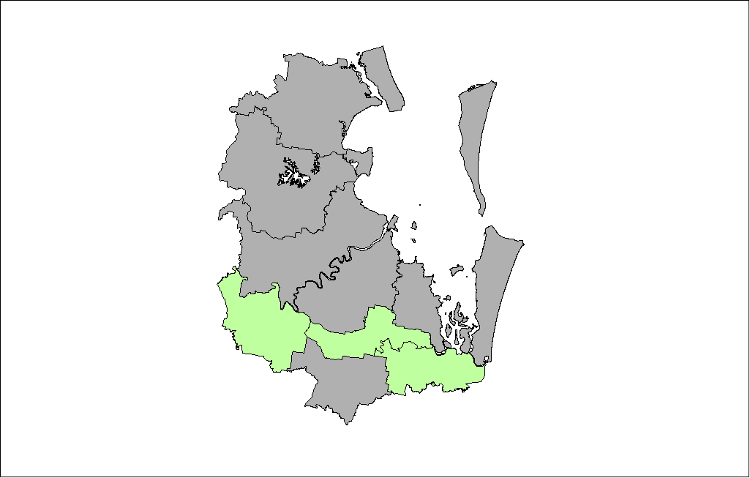
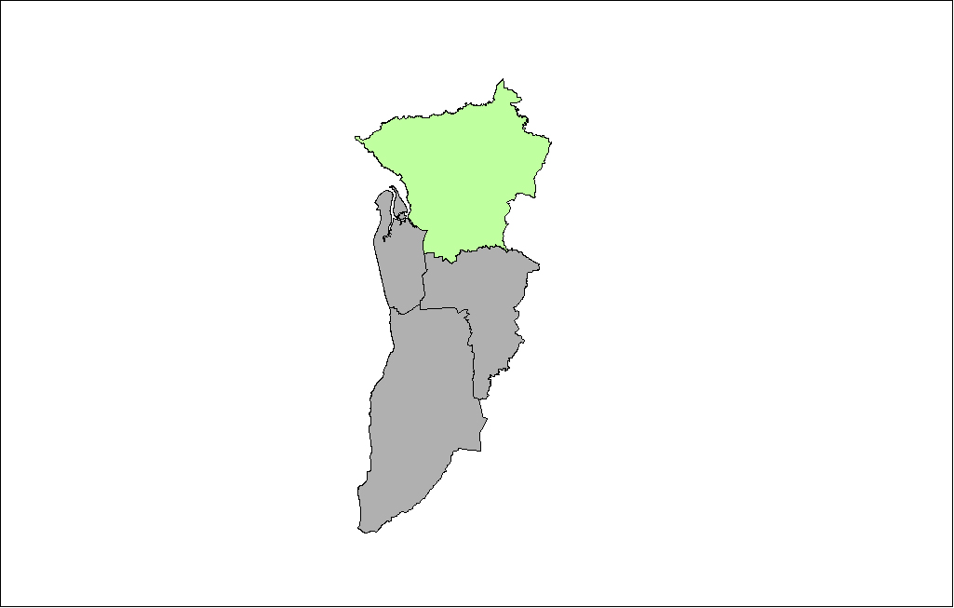
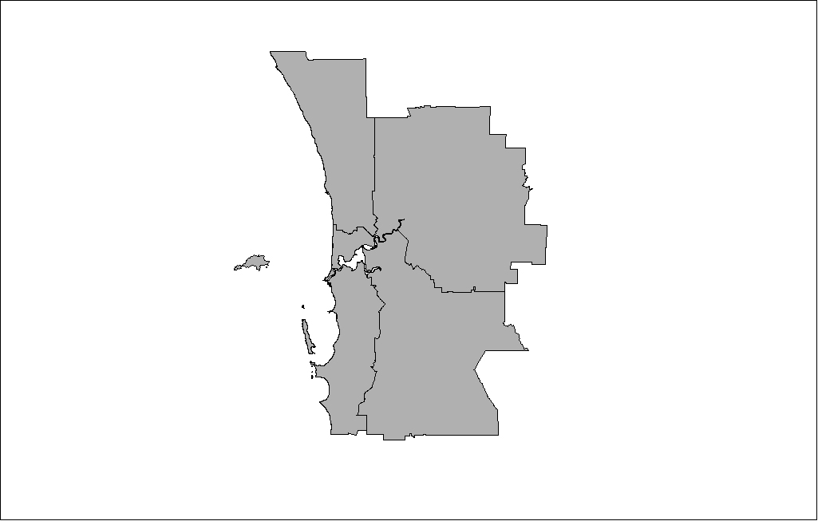
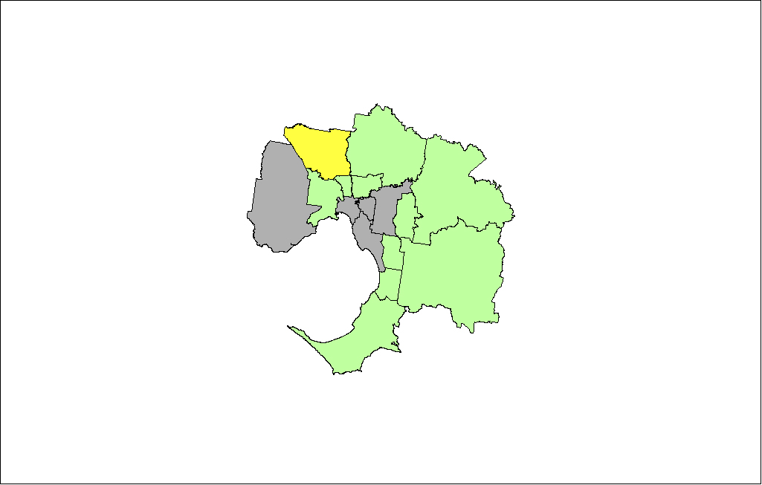
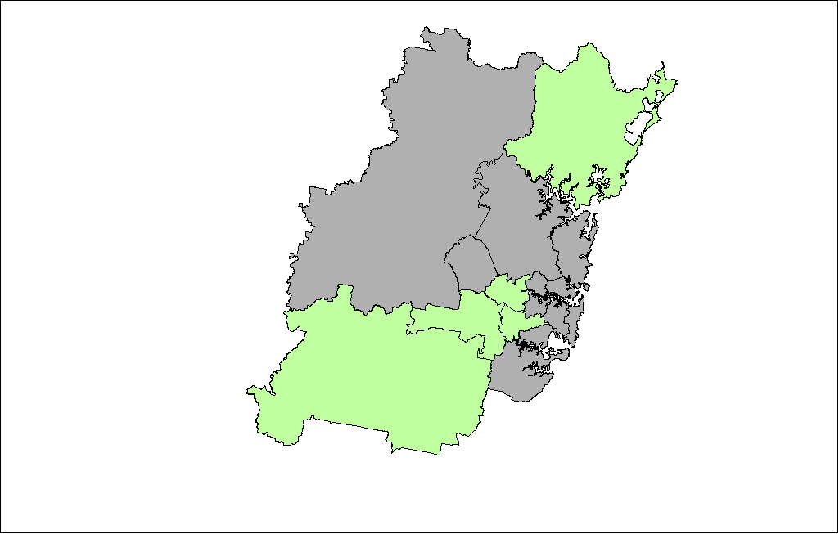
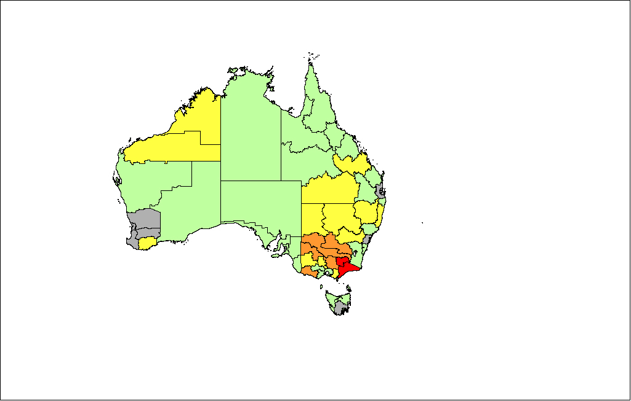
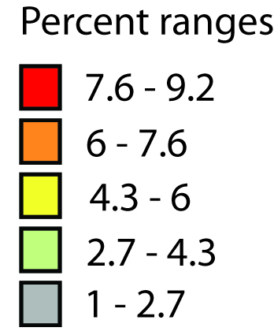
Figure 3 Participation rates in VET (award and non-award courses), 2004, by region, Australia and major cities, 15–64 years
24.6 – 29.5
19.8 – 24.6
14.9 – 19.8
10.1 – 14.9
5.2 – 10.1
Percent ranges
SYDNEY
BRISBANE
ADELAIDE
PERTH
MELBOURNE
National participation rate 11.0%
Mean regional rate 12.2%

This country–city divide becomes even more apparent when participation rates in basic-level VET are examined (Figure S3, support document). The national participation rate in basic VET in 2004 was 2.7 per cent, while the mean regional rate was 3.3 per cent. Relatively high rates of participation in Certificate I and II courses were found in the Western Australian areas of Pilbara (9.2 per cent), Kimberley (7.5 per cent) and Lower Great Southern (6.5 per cent), and again along the Victoria–NSW border (East Gippsland 8.4, Mallee 7.6, and Goulburn 7.1 per cent). In contrast, the regions in the major cities all have relatively low participation rates in basic VET compared with the non-metropolitan regions (with the exception of Hume City in Melbourne with participation at 7 per cent). The metropolitan areas of Sydney, Perth, and Adelaide are all have rates in the bottom quintile, with the majority of Brisbane and Melbourne also in the lowest fifth.
Participation in middle-level VET also varies across regions of Australia (see Figure S4, support document). Nationally, 4.5 per cent of the 15 to 64 year old population were undertaking a Certificate III or IV course. The mean regional rate was 4.8 per cent. Again, participation rates are relatively high in the non-metropolitan regions. A number of areas in West Australia (Pilbara
7.3 per cent, Kimberley 6.8 per cent), Queensland (Mackay 7.8 per cent, Central 7 per cent and Fitzroy 7 per cent) and Victoria (Mallee 8 per cent, Ovens–Murray 7.5 per cent, Goulburn
7.2 per cent, East Gippsland 7.1 per cent, Western District 6.9 per cent, Gippsland 6.9 per cent) have participation rates in the top quintile. The contrast in levels of activity in urban and rural regions is not as stark as seen in maps of participation in basic-level VET, especially in the outer suburbs of Melbourne and areas in southern Brisbane (with the exception of Beaudesert). Nevertheless, metropolitan areas in Sydney, Perth and Adelaide have relatively low levels of participation in Certificate III and IV courses.
A different picture is found when regional rates of participation in diploma-level VET are examined (see Figure S5, support document). While overall the rates are lower than for basic and middle-level courses (across Australia, 1.2 per cent of the population were enrolled in VET at this level), the activity is concentrated in the cities. Regionally, the rates vary from 0.2 per cent (Upper Great Southern) to 2.4 per cent (Melbourne Hume City). Higher rates of participation are found in the urban areas of Melbourne, Brisbane, Sydney and Canberra.
Participation in non-award VET courses varies considerably across regions and states (Figure S6, support document). The regions with the highest levels of participation are in New South Wales and Victoria. In New South Wales, for example, several regions, particularly those along the Murray River, have mean rates of participation above 10 per cent. The Northern Territory, much of Western Australia and the city areas of Melbourne, Brisbane and Perth have comparatively low levels of participation, less than 4 per cent on average.

Factors affecting regional differences
Regional variations in VET participation are in one way not unexpected. Regions have different industry structures and different populations. Variations in the patterns of VET participation across regions are likely to reflect the differences in industry, labour markets and the make-up of populations. But which characteristics of regions most account for the differences in participation rates? Is it the types of industry and business located in regions? Is it linked to demographic factors such as educational attainment levels, ethnic composition or remoteness? Or is it combinations of these things?
The purpose of this chapter is to identify some of the different factors that shape regional variations. It will provide results from a series of regression analyses which use a range of demographic and economic factors to predict participation in VET. The demographic factors are based on data from the ABS Census. They include measures for differences based on the size of the indigenous population, the numbers in the population from non-English speaking language backgrounds, age differences, remoteness of the region and educational attainment levels. Some of the demographic measures are based on population rates: the proportion of the population that is Indigenous, the proportion speaking a language other than English at home, and the proportion with a post-school diploma or above. Age is measured as the proportion of 15–24 year-olds. Remoteness is the proportion of the population living in rural or remote areas (based on the ABS remoteness index, ARIA).
Economic factors are also derived from the Census and include the unemployment rate and the industry profile (based on the main ANZIC categories) of the workers who live in the region. The industry variables are shares. It is not possible to include all of the industry groups in a regression model because this leads to the model being over-determined. It is common practice in research looking at industries to exclude one or more categories. At least one category needs to be omitted to derive estimates. In the analyses presented in this chapter, the omitted categories are Agriculture/forestry/fishing, communication services, property and related, and financial services.
Table 1 presents the results from the regression analyses which were undertaken in order to determine what shapes the regional differences illustrated in the maps. The table identifies the key drivers derived from the regression analysis results for predicting participation separately in total VET (award and non-award), then for award-level VET (total, basic, middle and diploma-level) and non-award VET. The regional participation rates (i.e. the dependent variables) have not been population-weighted. The issue of population weighting is an important one when looking at national influences on participation in VET. However, our study is looking at factors shaping regional differences and to do that we need to treat each of the regions as single equivalent units. In this situation it is more appropriate to carry out the analyses without weighting by the size of the units. Other research looking at regional variations has explored population-based weighting and found that weighting leads to greater error when comparing the effects of regions (Frohlich et al. 2001).
The results are presented as percentage point gains or losses associated with each factor. The gains or losses were calculated from standardised estimates for each independent variable. Standardised estimates (Beta coefficients) are based on standard deviations of the metric or scale of each variable. Standardised estimates can be used to judge the relative predictive power of the independent variable. Beta is the average amount the dependent variable increases when the independent variable increases one standard deviation and other independent variables are held constant. The Beta estimates were transformed into a percentage point gain or loss for each factor by multiplying the original Beta coefficient by the standard deviation estimate for the dependent variable (rate of VET participation). Mean regional rates are presented at the top of the table. Variations (up or down) for each factor are relative to the mean rate.
The tables contain one column for each analysis: all VET (award and non-award), award-level VET (total, basic, middle and diploma-level) and non-award VET. The factors identified as exerting a statistically significant influence are marked by asterisks, with the number of asterisks reflecting the level of significance, where * p<.10; ** p<.05; *** p<.001.
Table 1 Drivers of participation in VET, 15–64 years, 2004
 | All VET (award & non-award) | Award |  |  |  | Non-award
 |  | Total | Basic | Middle | Diploma
Mean regional rate | 12.15 | 8.61 | 3.28 | 4.85 | 1.11 | 4.3
Standard deviation | 4.20 | 2.66 | 1.75 | 1.27 | 0.46 | 2.7
Range | 24.21 | 12.45 | 8.19 | 5.57 | 2.16 | 16.0
DEMOGRAPHIC
Indigenous Status
Indigenous | 0.35 | 0.27 | 0.47 | -0.02 | -0.18** | -0.15
Language Background
Non-English speaking | 0.45 | 0.13 | 0.04 | -0.15 | 0.16*** | 0.26
Educational Attainment
Diploma or above | -1.81 | -1.08 | -0.46 | -0.70** | 0.07 | -0.92
Rurality
Level of remoteness | 0.09 | -0.03 | 0.08 | 0.17 | 0.24 | -0.04
Age
Proportion 15–24 years | 0.29 | 0.03 | -0.04 | 0.19 | 0.06 | 0.11
ECONOMIC
Labour Force Status
Unemployed | -1.89*** | -0.81** | -0.32 | -0.41** | -0.09* | -1.15***
Industry profile
Mining | 0.35 | 0.56* | 0.32 | 0.20 | 0.12** | -0.18
Manufacturing | 1.18 | 1.02** | 0.53* | 0.41* | 0.20*** | 0.26
Electricity, Gas & Water Supply | 0.82** | 0.43* | 0.23 | 0.21* | 0.03 | 0.40
Construction | -1.33** | -0.71* | -0.59** | -0.16 | -0.03 | -0.87**
Wholesale Trade | -1.01 | -0.82 | -0.59* | -0.23 | -0.08 | -0.07
Retail Trade | 1.78** | 0.97* | 0.50 | 0.40 | 0.24*** | 0.81
Accommodation, Cafes & Restaurants | 1.40** | 0.34 | 0.09 | 0.29* | -0.08 | 1.29***
Transport & Storage | -0.82* | -0.24 | -0.03 | -0.07 | 0.00 | -0.61**
Government Administration & Defence | -0.51 | -0.25 | -0.24 | -0.15 | 0.16** | -0.25
Education | 0.29 | 0.57 | 0.27 | 0.36* | 0.02 | -0.22
Health & Community Services | -0.29 | -0.61 | -0.42* | -0.26 | 0.02 | 0.32
Cultural & Recreational Services | -0.96 | -0.20 | -0.27 | 0.01 | 0.10 | -1.00**
Personal & Other Services | -0.36 | -0.25 | -0.01 | -0.24 | -0.09* | 0.06
Note: * p<.10; ** p<.05; *** p<.001
Table 1 shows that differences in regional participation rates in all VET courses (award and non-award combined) are for the most part driven by economic factors. The unemployment rate, for example, has a significant influence, with participation in VET decreasing as unemployment increases. A one standard deviation unit increase in unemployment is associated with a 1.89 percentage point fall in VET participation. Industry profile too is very important, with the strongest influence coming from Retail Trade (1.78 per cent gain) and Manufacturing (1.18 per cent gain). An increase in the proportion of workers in Utility Supply and Accommodation, Cafes and Restaurants sees corresponding increases in levels of VET participation. Construction and Transport and Storage services, however, have a negative impact on VET participation.
Demographic variables—age profile, indigenous population, educational attainment levels, and remoteness—do not have significant effects on all VET participation, after controlling for economic factors.
Economic factors continue to have a strong influence over all award qualification levels (basic, middle, diploma). This is an important finding, as it implies that regional labour markets and industry have a significant impact on levels of VET activity. For example, having a stronger manufacturing base is associated with significantly higher levels of participation at all award levels. An industry base that has a higher concentration of workers in utility services (electricity, gas and water supply) has a significantly higher level of participation in middle-level VET award courses. The more white-collar industries such as government administration and defence, and retail are associated with significantly higher levels of participation in diploma-level VET, all else equal. Alternatively, construction and wholesale trade are associated with lower levels of participation in basic VET courses, that is, where regional populations have higher concentrations of workers in the construction industry and in wholesale trade industries, levels of participation in basic VET are significantly lower, all else equal.
Unemployment levels also influence VET participation. Apart from basic award-level VET, participation in VET is significantly lower in regions that have higher rates of unemployment. This is true for participation in non-award VET (-1.15) as well as for middle (-0.41) and diploma-level VET (-0.09).
However, economic factors are not the only drivers of regional differences in VET participation. The social and demographic profile of a region is also important, particularly for higher qualification levels. Table 1 shows that participation in diploma-level VET is stronger in areas which have higher proportions of non-English speakers, after controlling for other things. Diploma-level VET participation is lower in regions with higher proportions of the population from indigenous backgrounds.

Variance analysis
Table 2 summarises the impact of each of the major groups of factors, economic and demographic. The table provides a measure of how well the models predict participation, reporting adjusted R² expressed as percentages. The adjusted R² measures the amount of variance in VET participation explained by each block of factors. Two values are provided. The first value for R² is that derived after each set of factors (economic and demographic) is entered into the regression model separately.
A second value is given as a result of the factors being entered in a hierarchical manner (‘cumulative’): economic factors were entered first, and then demographic characteristics. Variables within each group of factors were entered simultaneously, and all the previous variables were retained before entering the variables in the next block.
In terms of estimating the importance of the relative values, the following can be used as a guide:
- R² ≤ 10 per cent, the variables in the model do not explain much of the variation across regions (model provides a poor fit)
- 11 – 30 per cent, the model explains a modest amount of the variation (model is a modest fit)
- 31 – 50 per cent, the model explains a reasonable amount of variation (model is a reasonable fit)
- R² > 50 per cent, the model explains much of the variation (model is a strong fit) (Muijs (2004).
Table 2 Variance analysis of factors influencing VET participation, 15–64 years (adjusted R² expressed as percentages)
Factors | All VET  (award &  non-award) |  | Award |  |  |  |  |  |  |  | Non-award
 |  |  | Total |  | Basic |  | Middle |  | Diploma
 | separate* | cumulative | separate* | cumulative | separate* | cumulative | separate* | cumulative | separate* | cumulative |  | separate* | cumulative
Economic | 39.3 | 39.3 | 35.1 | 35.1 | 41.1 | 41.1 | 36.6 | 36.6 | 41.7 | 41.7 |  | 36.0 | 35.3
Demographic | 17.1 | 39.7 | 24.8 | 37.1 | 34.0 | 43.9 | 34.0 | 43.8 | 40.0 | 51.7 |  | 8.7 | 33.4
Note: *Inclusion of this block of factors only
The results presented in Table 2 tend to confirm the patterns of Table 1, that economic factors are very influential in terms of VET participation. By themselves, they account for 39.3 per cent of the variance for participation in all VET (award and non-award). This is more than double the level for the block of demographic factors (17.1 per cent). Moreover, when the demographic factors are added to the model, they add little further to explaining VET participation above and beyond that contributed by the block of economic factors.
For every type of VET, the economic factors explain more of the variance. This is particularly noticeable for non-award VET where industry and employment account for 36 per cent of the variation in participation, while the demographic factors account for only 8.7 per cent. Participation in non-award VET is far more dependent on regional labour markets and industry than on the demographic characteristics of the population.
Demographic factors have more impact on participation at the higher award levels of VET. While accounting for about 34 per cent of the variation in basic-award-level VET across regions, they account for 40 per cent at diploma-level. This reveals the extent to which diploma-level VET is influenced by population education levels, the size of the indigenous population, age and ethnic composition. Economic factors are also very important, accounting for 41.7 per cent of the variance. However, the demographic factors contribute a further 10 percentage points above and beyond the influence of economic factors, an independent rate substantially higher than for middle and basic VET. Across the three award levels, the independent contribution of the demographic factors increases as the award level rises. This is consistent with the view that, while economic factors are major determinants of VET participation, the social, racial and ethnic compositions of populations become influential factors at the higher award levels in VET.
Economic factors are major influences on VET participation. Regional labour markets and industry shape levels of VET participation. Demographic factors have less impact, though are important, especially for the higher levels of VET.

Exceptional regions
Differences in labour markets, industry and population can account for a lot of the variation in VET participation across regions of Australia. However, there are some regions where this is much less the case. In some regions, even after taking account of economic and demographic factors, VET participation rates can be unusually high or low. For example, one region may have similar employment and unemployment levels as another region, as well as a similar industry base and population, but VET participation rates may be very different. This chapter uses the results of the regression analyses to identify ‘exceptional’ regions, that is, regions which have unexpectedly high or low rates of participation in VET, after taking account of differences in the population, labour market and industry characteristics of regions.
Identification of exceptional regions is achieved by examining residuals derived from the regression analyses. Residuals can be calculated for each region and represent the amount of unexplained variance, the difference between the observed VET participation rate and the mean predicted rate after controlling for the range of economic and demographic factors. Large residuals can be due to factors that are not included in the models (such as local policies). While most of the regression models showed quite a good fit, particularly for diploma-level VET, an analysis of the residuals revealed a number of regions with quite large levels of unexplained variance. Labour markets, economy, industry and population differences do not explain very well the level of VET activity in these regions.
Regions with above or below expected rates of participation for all VET (award and non-award), basic, middle and diploma-level VET (award) are plotted in Figures 4 to 7. The bar charts present those regions with unusually high or low levels of participation in VET. The figures presented for each region are standardised residuals (unexplained variance reported in units of standard deviation). Reported in the charts are those regions which are more than one standard deviation above or below the mean predicted level of participation. These are the regions where the control factors do not explain the rate of participation very well. The regions not represented in the charts are those where the levels of participation do not vary much from the predicted mean, that is, variation is related more closely to the factors in the models.
The results show that some regions consistently have very high levels of unexplained variance. Figure 4, for example, shows us that there are two regions with very high levels of unexplained variance (i.e. more than 2 standard deviations above the predicted mean) in all VET (award and non-award): East Gippsland (Victoria) and Ovens–Murray (Victoria). For award-level VET, regions with consistently above average rates include: East Gippsland (Victoria), Hume city (Victoria), Pilbara (WA), Mallee (Victoria), Kimberley (WA), and Mersey–Lyall (Tas). Figure 4 shows that regions with lower than expected rates in all VET include Midlands (WA), South West (WA), Yorke and Lower North (SA) Moreton (Qld) and Far North (Qld).
It may be that local policies tied to providers or community and industry arrangements are influencing the patterns of unusually high or low rates of participation. Such regions may help us learn more about the effects and role of education and training policies and elements such as community partnerships. To identify the mechanisms operating in these exceptional regions requires further intensive case study work. Such contextual studies are valuable because they focus not only on individual factors affecting participation in VET, but on the role of VET in community development, both economic and social. Case studies of some of these selected regions are presented in the support document.
Figure 4Regions with high or low levels of participation in VET (award and non-award courses)
Figure 5Regions with high or low levels of participation in basic-level VET (certificates I and II)
Figure 6Regions with high or low levels of participation in middle-level VET (certificates III and IV)
Figure 7Regions with high or low levels of participation in diploma VET (diploma and above)

Differences based on provision, funding and mode of delivery
This chapter presents regional patterns of participation for different types of VET providers, for different sources of funding, and for different modes of delivery. Regions may vary in patterns of participation according to some of these provider dimensions. For example, some regions may have high levels of participation in TAFE-delivered VET, but not for private providers. Similarly, some regions may deliver much more of their VET through online mode rather than campus-based. It is important to consider whether or not differences in provision according to training organisation type, delivery mode and funding source are associated with regional variations. It is also important to measure whether such variations are due to differences in the economic and demographic characteristics of regions or not. For that reason, in addition to maps of VET participation across the different categories, this chapter will also present the results of regression analyses, including variance tables and plots of residuals to identify exceptional regions. Most of the maps and tables of results are provided in the support document to this report, available on the NCVER website.

Type of provider
Across Australia, VET is delivered through a number of different types of providers (see Table 3). In 2004, there were 1,950 registered training organisations (NCVER 2005, p.8). The vast majority of VET is delivered in TAFE institutes (79 per cent of all VET), and the rate of delivery increases by TAFE as the qualification award level increases, so that nearly all (97 per cent) of advanced VET (diploma and above) is supplied by TAFE institutes. When looking at VET overall, there is a similar proportion delivered at community education and private providers (9 per cent and 10 per cent respectively). However, private providers have a higher share of award courses, delivering 16 per cent of Certificate I and II courses, and 15 per cent of Certificates III and IV courses (compared with 7 per cent and 3 per cent at community education providers). VET delivered at agricultural colleges and multi-sector universities accounts for only a very small proportion of VET.
Table 3 Training organisation type by level of VET
 | All VET  (%) | Basic level  (%) | Middle level  (%) | Diploma level (%)
TAFE | 79.1 | 73.9 | 80.5 | 96.9
Community Education | 9.0 | 7.4 | 3.1 | 0.5
Private Provider | 10.4 | 15.9 | 14.7 | 1.5
University | 1.0 | 1.7 | 1.2 | 0.8
Agricultural college | 0.5 | 1.0 | 0.5 | 0.2
Total | 100.0 | 100.0 | 100.0 | 100.0

Regional differences in TAFE participation
Nationally, 8.7 per cent of the population participated in VET delivered at a TAFE provider in 2004. The mean regional rate was 9.5 per cent, but there was great variation across the regions. For example, 22.4 per cent of the population of Victoria’s East Gippsland was participating in some form of TAFE-delivered VET, while only 1.1 per cent of the Darwin population enrolled in a VET course at TAFE (the rate for NT – Balance was 3.1 per cent)(see Figure S13, support document). Apart from the Northern Territory and South Eastern WA, the non-metropolitan areas had higher rates of participation than the urban regions, which for the most part had levels of participation in the second lowest quintile.
The regression analyses, undertaken to identify drivers of participation in VET delivered at TAFE institutes, show that for VET overall, the factors which were significant in the regression analysis were mainly economic variables (see Table S5, support document). Three industry areas had significant positive effects on participation—manufacturing (1.01 per cent), accommodation, cafes and restaurants (1.58 per cent), and utility services (0.57 per cent). Three industry areas had significant negative effects on participation—construction (-0.93 per cent), health and community services (-0.94 per cent), and cultural and recreational services (-2.03 per cent).
Demographics factors were influential at the higher award levels. An increase in the indigenous population saw a predicted decrease in TAFE participation for diploma-level VET delivered in TAFE. As the level of remoteness increases, however, so does the level of TAFE participation, all else equal. The variance analysis in Table S6 (support document) shows that when entered separately into the all VET (award and non-award) model, demographic factors can explain 18.6 per cent of variation. The economic factors explain more than double this level of variance when entered separately (40.9 per cent). However, demographic factors are more influential for diploma-level VET, explaining 44.3 per cent of regional variance, compared with 39.9 per cent for economic factors entered separately.
The analysis of exceptional regions, those with unusually high or low levels of TAFE-delivered VET, shows that the number of such regions for all VET and basic VET is far fewer than for middle and diploma VET (see Figures S17 to S20, support document). The regions of Pilbara (WA) and East Gippsland (Victoria) appear on all four charts as having greater than expected participation. South East WA features on all four charts with lower than expected participation.

Regional differences in private provider participation
The national participation rate in VET courses delivered at private providers was 1.1 per cent. This relates only to publicly funded courses offered by private providers, not fee-for-service. However, much higher rates are apparent in the Northern Territory with a 5 per cent mean participation rate (participation rates in all VET undertaken at private providers is mapped in Figure S21, basic-level VET in Figure S22 and middle-level VET in Figure S23, located in the support document). The neighbouring Pilbara region in WA also has a relatively high rate of 3.4 per cent for all VET. Rates in the cities, with the exception of Northern Adelaide (which has a rate of 2.3 per cent), are in the lowest two quintiles.
Nationally, the rate of participation in basic-level private provider courses is very low at 0.4 per cent. However, rates of participation are relatively high again in Pilbara (2.4 per cent) and the NT (1.9 per cent). The Victorian Mallee region has a rate of 1.5 per cent. Again, in the city areas, Northern Adelaide is the highest at 1.3 per cent of the population. There is a slightly higher (but still low) rate of participation in middle-level private provider courses (0.7 per cent). The highest rate is found in North West Queensland (1.7 per cent). Rates are relatively high in Victoria (overall, including south-eastern metropolitan regions) and the Eyre region of South Australia.
What factors influence regional differences in participation in private providers? The drivers of participation identified in the regression analyses reveal that participation is driven by both economic and demographic factors (see Table S8, support document). For all VET, participation is significantly higher in areas where there is a stronger concentration of workers in manufacturing, government administration and defence and cultural and recreational service industries. It is significantly lower in areas where there are more highly educated populations. The proportion of the population living in rural or remote locations has a positive effect for basic-level VET, and for middle-level VET.
The variance analysis (Table S9 in the support document) suggests that demographic factors, rather than economic ones, are the main influences on participation delivered by private providers. Demographic factors have a large effect, explaining 47.5 per cent of the regional variance for all VET. This is more than double for the economic drivers with the demographic factors accounting for an additional, independent 30 percentage points to the variance accounted for by the economic factors alone. This was true for basic and to a lesser extent middle-level VET. For diploma-level VET (most of which is delivered in TAFE rather than provider providers, the effects are reversed).
While the economies in different regions are important determinants of VET participation delivered in TAFE institutes, it is the social, age, cultural and ethnic characteristics of populations that are strongly associated with VET participation in private providers.

Mode of delivery
VET in Australia is delivered in a number of ways. The mode of delivery can include college or campus-based (both self-paced and lock step), online and remote-access (including correspondence), employment-based (for example, industrial/work experience, field placement, fully on-the-job training) and other, including combinations of the above. The breakdown of delivery mode by level of study is given in Table 4.
Three-quarters of all VET is delivered in the traditional way, on campus. This decreases slightly to 70 per cent of middle-level VET, but increases to 84 per cent of diploma-level. Similar proportions of VET are delivered online (8.3 per cent) and in the workplace (8.2 per cent). However, the proportion of VET delivered in the workplace increases at basic and middle VET levels, which likely reflects the role of apprenticeships and traineeships. Very little employment-based VET occurs at diploma level. Online learning drops to 6.6 per cent for basic VET and increases to
9 per cent of diploma-level courses.
Table 4 Delivery type by level of VET
 | All VET  (%) | Basic level  (%) | Middle level (%) | Diploma level (%)
Campus-based | 74.8 | 72.5 | 69.7 | 84.4
Online and remote-access | 8.3 | 6.6 | 8.5 | 9.0
Employment-based | 8.2 | 12.4 | 11.3 | 1.4
Other (including combinations) | 8.7 | 8.4 | 10.5 | 5.3
Total | 100.0 | 100.0 | 100.0 | 100.0

Regional differences in campus-based VET
The national participation rate in campus-based VET is 8.1 per cent, but varies across regions (see Figures S33 to S36 in the support document). There are very strong levels of participation in the non-metropolitan regions of Victoria and NSW (highest rate of 17 per cent in Ovens–Murray in Victoria). The metropolitan regions have lower rates in general than their non-metropolitan counterparts, and inner suburban areas are lower still than outer areas.
There is a reverse of the metropolitan–non-metropolitan pattern for participation in campus-delivered diploma-level courses. While rates are lower overall (national rate 1.0 per cent), rates are highest in the cities (2.2 per cent in Hume city, Victoria, is the highest rate).
The drivers identified in the regression analysis and the variance analysis show that participation in all campus-based VET is largely driven by economic factors, particularly the industry profile of regions (see Tables S16 and S17 in the support document). Demographic factors become more influential at the higher award levels, adding substantially to the levels of explained variance and indicating that participation rates in campus-based diploma-level VET are dependent on population characteristics as well as on industry and labour market conditions.

Regional differences in online and remote-access VET
VET delivered using online or remote-access involves 8.3 per cent of all VET students, or 125,121 students. Regional participation rates in online courses vary (see Figures S41 to S44, support document). The rate of participation ranges across regions from 3.6 per cent in Fitzroy (Queensland), to 0.2 per cent in Melbourne’s Greater Dandenong City. Rates are also relatively high in Queensland’s Central West (3.5 per cent) and several regions in South Australia (Eyre 3.4 per cent, Murray Lands 3.1 per cent and Northern 3 per cent). Participation rates in Victoria (including Melbourne), Tasmania, Northern Territory, Canberra, Sydney and Perth are particularly low. Brisbane is the only metropolitan area with mid to high rates (Gold Coast City 2.4 per cent).
Drivers of online delivery, as found in the regression analysis, involve both demographic characteristics of regions as well economy (see Tables S19 and S20 in the support document). For all VET the level of remoteness has a significant positive impact on the level of participation (i.e. the more rural or remote, the greater the participation in online learning), possibly reflecting the difficulty in accessing VET campuses for those in remote areas. Other demographic variables, including the proportions of the population from non-English speakers and from Indigenous backgrounds have a negative effect on participation in online courses.
The variance table shows that economy and demography are both influential when it comes to online and remote access learning in VET. For all VET, both blocks of factors account for a similar level of variance when entered separately (31.3 per cent for demographic factors, and 32.3 per cent for economic factors). Interestingly, both groups of factors explain much less of the variance for diploma-level VET delivered online than for middle and basic levels of VET (half the rate for online delivered diploma-level VET than for the same mode of delivery basic-level VET).

Regional differences in employment-based VET
About 8.2 per cent of students in VET undertake their study through employment-based training (122,711 students). Nationally the participation rate is 0.9 per cent. Many areas of Australia have very little participation in employment-based VET (see Figures S49 to S51 in the support document). However, a few areas stand out. The Tasmanian regions of Mersey–Lyell (4.8 per cent participation) and Northern (3.4 per cent participation) are the two highest rating regions (and for basic and middle-level VET also). Some areas of Victoria also have relatively high rates of participation in employment-based VET. These are Goulburn (3.1 per cent) and Ovens–Murray (2.9 per cent).
The drivers identified from the regression analysis show that employment-based VET is almost completely dependent on economic factors, such as regional industry base and labour market (see Tables S22 and S23, support document). For all VET, the economic factors accounted for about
28 per cent of variance in participation in workplace VET. Demographic factors accounted for only 1.2 per cent. This varied little across award levels—the industry and economic base of regions accounted for between a quarter and almost a third of the variation across regions in work-based VET participation, and the demographic factors between 0 and 5 per cent.
Higher levels of participation in work-based VET were recorded in regions with a higher concentration of workers in manufacturing industries and lower levels in regions where workers were more often in the construction industry.

Funding source
There are four different sources of funding for VET courses:
1 Commonwealth and state recurrent funding,
2 Commonwealth and state specific-purpose funding,
3 Fee-for-service funding, and
4 Funds from full fee-paying overseas clients.
The funding distribution for each level of VET for 2004 is given in Table 5. The figures show that 69 per cent of all VET activity is financed through Commonwealth and state recurrent funding, and higher proportions for award courses (77 basic-level VET, 81 per cent middle-level and 84 per cent diploma-level). The next main source of funding is fee-for-service, which accounts for 27 per cent of all courses, 18 per cent of basic-level VET and 16 per cent at middle-level, and 10 per cent at diploma-level.
Table 5 Funding source, by level of VET
 | All VET  (%) | Basic level  (%) | Middle level  (%) | Diploma level (%)
Government recurrent | 69.0 | 77.3 | 81.4 | 83.7
Government specific | 2.4 | 3.7 | 1.9 | 0.3
Fee-for-service | 27.2 | 18.4 | 15.7 | 10.3
Full fee-paying overseas | 1.4 | 0.7 | 1.0 | 5.7
Total | 100.0 | 100.0 | 100.0 | 100.0

Regional differences in participation in fee-for-service VET courses
Fee-for-service courses, excluding those delivered by private providers, account for 27 per cent of VET students (413,246 students). Nationally the participation rate is 3 per cent, though the rate varies substantially by region (see Figures 63 to 66, in the support document). There are relatively high levels of activity for all VET in East Gippsland (13.9 per cent), Ovens–Murray (10 per cent) and along the Murray river, on both the Victorian and NSW sides. Activity is relatively low elsewhere, including in the metropolitan regions (expect Hume City in Melbourne).
Regional differences in participation in basic-level VET are concentrated even further. There are relatively high rates in East Gippsland (Victoria, 4 per cent), Ovens–Murray (Victoria, 2.7 per cent), and Goulburn (Victoria, 2.8 per cent) and very low rates elsewhere, except again, Hume City in Melbourne (3.3 per cent). The national participation rate in basic-level fee-for-service VET is a low 0.5 per cent.
Participation in middle-level fee-for-service courses shows relatively high levels of participation again in the regions either side of the Victorian and NSW border (the highest regional rate is 2.2 per cent in Goulburn). Other areas of Australia where participation is relatively high are in Tasmania and Queensland. North-west Melbourne and southern Brisbane also have areas with relatively high rates.
Fee-for-service VET participation is driven mainly by economic factors (see Tables S31 and S32, support document). At all levels of VET, unemployment has a negative effect on participation. As the unemployment rates rise, participation in fee-for-service VET courses falls. The effect if significant at all levels, except diploma-level VET where it remains negative, but not significant. Regional industry is very important. Where manufacturing, retail and utility services are more prominent, so too is participation in fee-for-service courses. Provision of fee-for-service VET may be tied more to these sorts of industries.

Conclusions
This report has examined regional variations in VET participation and some of the factors that contribute to regional differences. The national participation rate in VET in 2004 by the working-aged cohort was 11 per cent. This dropped to 2.7 per cent of the population undertaking a basic VET course, 4.5 per cent a middle-level VET course and 2.7 per cent a diploma-level course.
The maps of participation in VET reveal contrasting regional patterns. In particular, overall VET rates were relatively high in non-metropolitan regions compared with urban areas. However, level of VET study makes a difference. Rates of participation in basic-level VET are much higher in non-metropolitan regions than in metropolitan regions. This situation is reversed for participation in diploma-level courses. This is a constant pattern, mirrored in the analyses of rates of participation by type of provider, mode of delivery, and source of funding. When rates are disaggregated by qualification level, the contrast between city and country regions becomes more polarised.
There are regions of the country where relatively high rates of participation occur across a number of analyses. One of these regions is along the Murray river, the border of Victoria and NSW, where we constantly see relatively high rates of participation on a national scale. This is the case when looking at all VET participation, campus-based VET and in particular fee-for-service funded courses. Other regions that stand out include:
- The north-west corner of Australia (Pilbara and Kimberley regions) has high rates of participation in basic and middle-level VET.
- The Northern Territory has relatively low rates of participation in TAFE, but relatively high rates of participation in private providers.
- Central Queensland has relatively high rates of participation in middle-level VET (and particularly when this is delivered in TAFE).
- Tasmania and Victoria showed high regional rates of participation in employment-based VET.
Patterns of participation vary by type of provider, funding and mode of delivery. Some regions with lower levels of participation in TAFE-based VET have high levels of participation in VET delivered by private providers. For example, the Northern Territory has nationally low levels of participation in TAFE-delivered VET, but high rates for VET delivered by private providers. The national participation rate in VET courses delivered at private providers was 1.1 per cent. However, the Northern Territory rate was 5 per cent. The neighbouring Pilbara region in WA also has a relatively high rate of 3.4 per cent for all VET.
The results from the regression analyses suggest that participation in VET is influenced to a large degree by economic factors. The composition of industry structure plays a major part. So too do labour market conditions. As unemployment rates rise, participation tends to fall. This is the case across most levels of VET. Regions with more workers in retail and in manufacturing and the hospitality industry tend to have higher rates of participation, all else equal. For all VET (award and non-award together), unemployment rates and industry structure accounted for almost 40 per cent of the variation in participation rates. Demographic factors were more important for participation at higher award levels, mainly diploma-level VET, but at other levels contributed little beyond that accounted for by economic factors in explaining regional differences.
In terms of VET participation, therefore, economy and industry matter. They are the main drivers of VET participation. This could be described as meaning that VET participation is more dependent on what regions possess in terms of business and labour than in terms of who is living in the region, in terms of the social, age, ethnic and racial composition of the population.
This does need to be qualified, however. The demographic factors were important at particular award levels. The proportion of non-English speakers living in a region has a significant positive effect on participation at a diploma level, for example. More strikingly, participation in VET delivered by private providers is much more influenced by the characteristics of those living in the community than by labour market or industry structure. Demographic factors explained more than double the regional variation in participation in VET delivered by private providers than did economic factors. The reverse is true for TAFE-based VET.
Analyses of residuals derived from the regression models helped identify ‘exceptional’ regions, those in which levels of participation are not explained very well by the economic, demographic and provision factors included in the regression models. In these regions, the level of participation is either exceeding what might be expected, given social and economic profile, or is underperforming. This is true for several regions. For award-level VET, regions with consistently above average rates include: East Gippsland (Victoria), Hume city (Victoria), Pilbara (WA), Mallee (Victoria), Kimberley (WA), and Mersey–Lyall (TAS). Regions with lower than expected rates of participation in all VET include Midlands (WA), South West (WA), Yorke and Lower North (SA) Moreton (QLD) and Far North (QLD).
Further work is needed to investigate whether there are policy, program, community or other factors which help shape the unusually high or low levels of participation apparent in the regions. It may be that local policies tied to providers or community and industry arrangements are influencing the patterns of unusually high or low rates of participation. Such regions may help us learn more about the effects and role of education and training policies and elements such as community partnerships.
To identify the mechanisms operating in these exceptional regions requires further intensive case study work. Such contextual studies are valuable because they focus not only on individual factors affecting participation in VET, but on the role of VET in community development, both economic and social.

References
Australian Bureau of Statistics (ABS) 2001, Australian Standard Geographical Classification ASGC 2001, cat.no.1216.0, ABS, Canberra.
Australian National Training Authority (ANTA) 2004, Australia’s National Strategy for Vocational Education and Training 2004–2010, ANTA, Brisbane.
Frohlich, N, Carriere, K, Potvin, L & Black, C 2001, Journal of Epidemiology and Community Health, vol.55, December, pp.913–20.
Muijs, D 2004, Doing quantitative research in education with SPSS, Sage, London.
National Centre for Vocational Education Research (NCVER) 2005, Students and courses 2004, NCVER. Adelaide.
Teese, R 2001, ‘Social selection in vocational education and training: How the social profile of award levels in VET is formed and the policy implications’, plenary address, 10th National Vocational Education and Training Research Conference, Deakin University, Geelong.
Teese, R & Walstab, A 2008, Social area differences in VET participation, NCVER, Adelaide.

Appendix 1: Region names, Australia and major cities
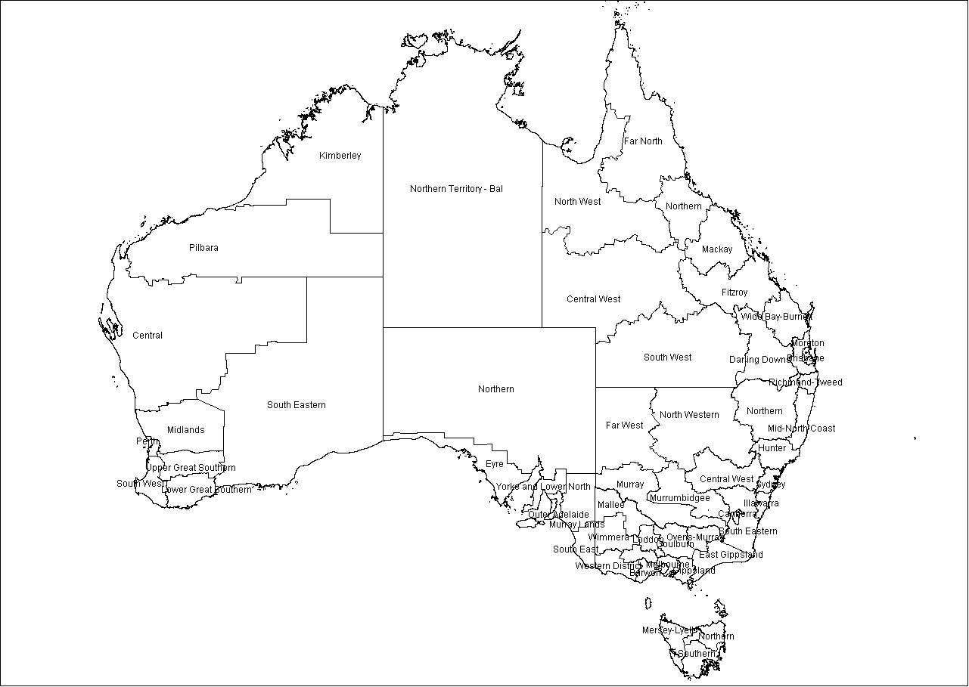

Greater Hobart
Perth

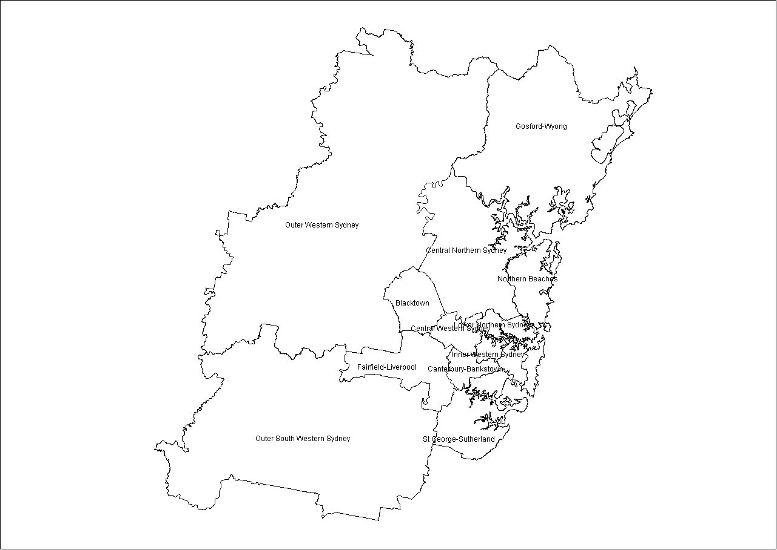
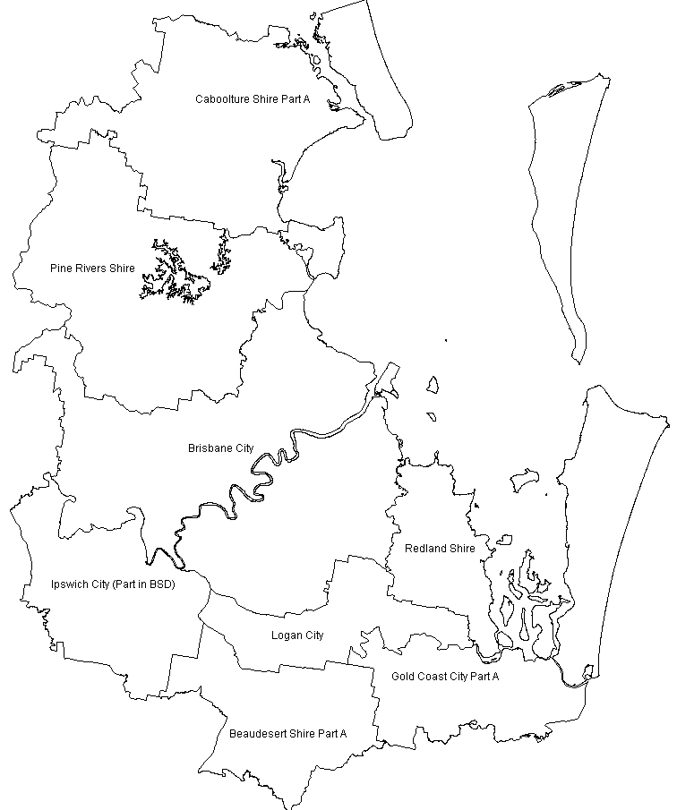
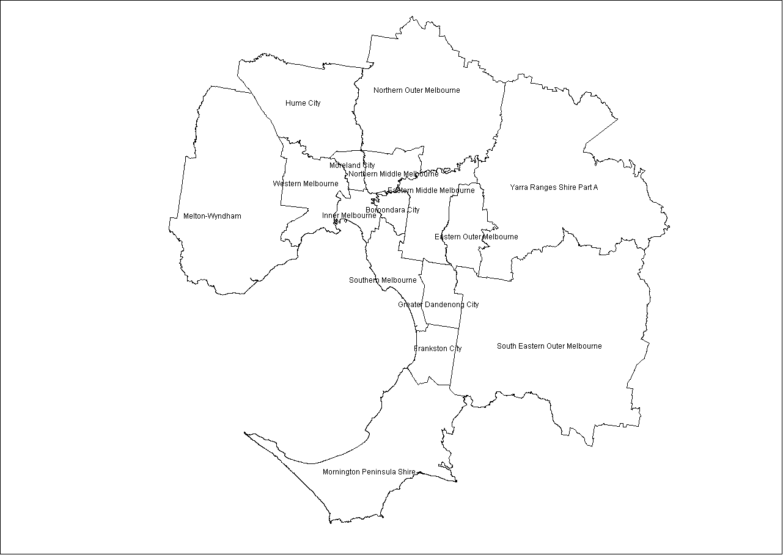
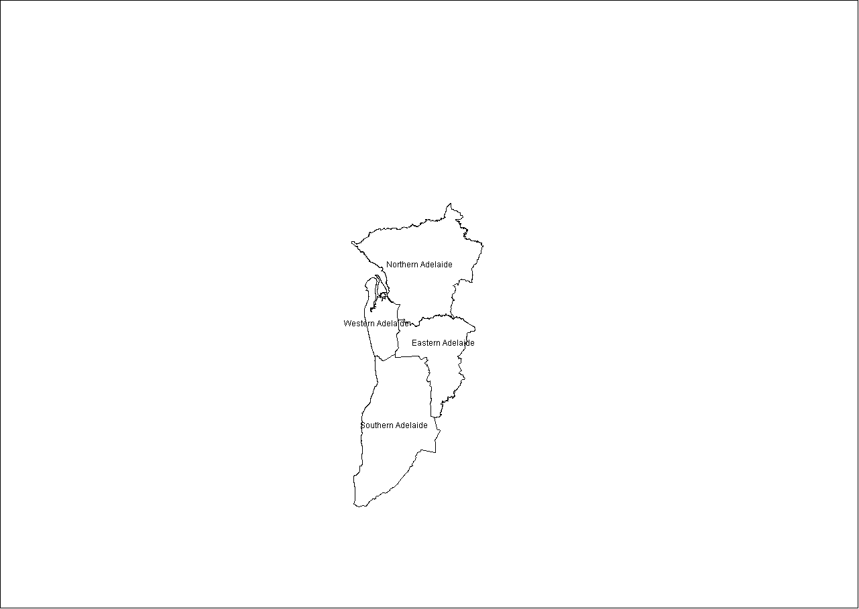
Sydney
Brisbane
Melbourne
Adelaide

Appendix 2: Skills consortium publications
The following is the complete list of titles produced by the National Institute of Labour Studies, Flinders University and the Centre for Post-compulsory Education and Lifelong Learning, University of Melbourne, through the research project, A well-skilled future: Tailoring VET to the emerging labour market.
Forecasting future demands: What we can and cannot know
Sue Richardson and Yan Tan
Future skill needs: Projections and employers’ views
Di Lowry, Simon Molloy and Samuel McGlennon
Demographic impacts on the future supply of vocational skills
Yan Tan and Sue Richardson
Skill acquisition and use across the life course: Current trends, future prospects
Bill Martin
What is a skill shortage?
Sue Richardson
Changing forms of employment and their implications for the development of skills
Sue Richardson and Peng Liu
Changing work organisation and skill requirements
Bill Martin and Josh Healy
Social area differences in vocational education and training participation
Richard Teese and Anne Walstab
Participation in vocational education and training across Australia: A regional analysis
Anne Walstab and Stephen Lamb
Current vocational education and training strategies and responsiveness to emerging skill shortages and surpluses
Jack Keating
Matching supply and demand: International perspectives
Jack Keating
Impact of TAFE inclusiveness strategies
Veronica Volkoff, Kira Clarke and Anne Walstab
A well-skilled future
Sue Richardson and Richard Teese

Support document details
Additional information relating to this research is available in Participation in vocational education and training across Australia: A regional analysis—Support document: Maps and tables and Participation in vocational education and training across Australia: A regional analysis—Support document: Drivers of participation in VET: Three regional case studies. They can be accessed from NCVER’s website <http://www.ncver.edu.au/publications/1998.html>. It contains the following:
- Maps and tables
- Case studies

