Developing VET applied research: steps towards enhancing VET’s role in the innovation system
Francesca M Beddie and Linda Simon
INTRODUCTION
This guide suggests ways the vocational education and training (VET) sector can develop an applied research capability to help secure its place in Australia’s innovation system. It is based on a project examining VET applied research, which also created a development framework for VET applied research capabilities.

BENEFITS FOR DIFFERENT VET STAKEHOLDERS
The overall benefits of an improved applied research capability for different players in the VET system are highlighted below.

Registered training organisations (RTOs)
- Greater evidence base for strategic planning and quality assurance.
- More sophisticated partnerships with industry, the community and other research organisations.
- More employable graduates.
- New income streams.

Educators
- Effective ways to maintain industry currency, improve teaching and develop capabilities and qualifications.
- Opportunities for promotion.
- Job satisfaction.

Students
- Additional capabilities and attributes, such as creative thinking, project management and presentation skills.
- Real-world experience and industry contacts.

Employers
- New research and problem-solving partnerships, sometimes with inexpensive student engagement.
- Mechanisms to allow for risk taking and experimentation that suit the business in terms of cost and timeframes.
- Opportunities for recruitment of a greater diversity of talent.
- Ways to bring new ideas into business operations and commercial endeavours.

System-wide
- Wider dissemination of innovation ideas in the real world and more potential for commercialisation.
- Improved VET graduates, with an innovation mindset.
- Better use of public infrastructure.
- Stronger place-based innovation.

WHY BUILD A VET RESEARCH CAPABILITY?

The VET sector is under pressure from the exponential increase in university places. This, on top of cutbacks to government funding over the last decade and a lack of clarity about VET’s role now that it is squeezed between universities and schools, has led to a precarious position for the VET sector and the need to consider changes to traditional delivery. Establishing a viable place in Australia’s tertiary education system will involve being able to strike a balance between creating and transferring knowledge, generating economic activity and helping to solve industry and societal problems. This capability is encapsulated in the term ‘VET applied research’. We see VET applied research occupying a niche between academic research and industry
CONTENTS

Why build a VET research capability?
What will it take?
What needs to be done in the VET sector?
What does the VET workforce need?
How does an RTO build research capability?
How can policy settings and system-wide initiatives help?
What next?
References
2
4
5

9

12

14
15
16
innovation — and sometimes collaborating with both these endeavours. In essence, we are talking about research with a focus on solving real- world problems, both in industry and in VET practice. Such activity
can create new knowledge, and/or use existing knowledge in new and creative ways.

Figure 1 VET applied research: a missing piece in the innovation system
Pure basic research
Scholarly practice
Interactive research/ Application
Use-inspired basic research
Solving enterprise problems
Inquiry evaluation
Experimental development
Knowledge translation &
dissemination

The development of an applied research capability will help training organisations to drive change in the national training system so that it produces creative and entrepreneurial graduates through high-quality, industry-focused teaching, applied research and innovation.
RTOs with an applied research capability will also get a head start in being able to look elsewhere for income at a time when the competition for the education dollar is intense. According to the Mitchell Institute (O’Connell & Torii 2016), over the last decade spending on VET fell to 4% below 2005 levels, while higher education expenditure rose by 45%. Another set of figures (Productivity Commission 2017, p.5) shows that recurrent expenditure on VET totalled $5.4 billion in 2015. This compares with the $11.2 billion Commonwealth Government contribution to the operating revenues of Australian universities. A potential source of income for VET is from research and development (R&D) budgets, including around $10 billion of government funds in 2016—17 (Department of Industry, Innovation and Science 2016).
But it’s not just about money: a motivating culture that recognises and develops VET professionals’ capabilities is also critical to a changed role for the VET sector. Without this, the innovation dollars will not flow, nor will VET organisations be able to deliver the best-equipped graduates or meet their potential as strong industry partners.
This guide seeks to assist RTOs to consider how they can position their organisation, staff and students to become a recognised part of the National Innovation and Science Agenda (NISA). It draws on the experience of Australian, Canadian and European VET organisations and is designed to help people in the system take the next steps towards shaping VET applied research efforts that drive innovation in industry and in the VET sector.

R | elated publications
The full report, VET applied research: driving VET’s role in the innovation system, can be found at: <https://www/ncver.edu.
au.publications/all-publications/vet-applied-research-driving-vets-role-in- the-innovation-system>.
See also: Explaining the VET applied research developmental framework
<https://www/ncver.edu.au.publications/all-publications/explaining-the- vet-applied-research-developmental-framework>.

WHAT WILL IT TAKE?

The foundations for a greater VET role in NISA exist: VET’s fundamental differentiation from other education sectors has been its link to employers, enterprises and the workplace. Moreover, in the public arena, TAFE (technical and further education) institutes often have strong connections with their communities. These two features are essential planks in innovation ecosystems.
Greater investment in VET’s human capital and infrastructure from the RTOs themselves, governments and industry is necessary as part of this revitalisation of VET.
Figure 2 Innovation science and research system
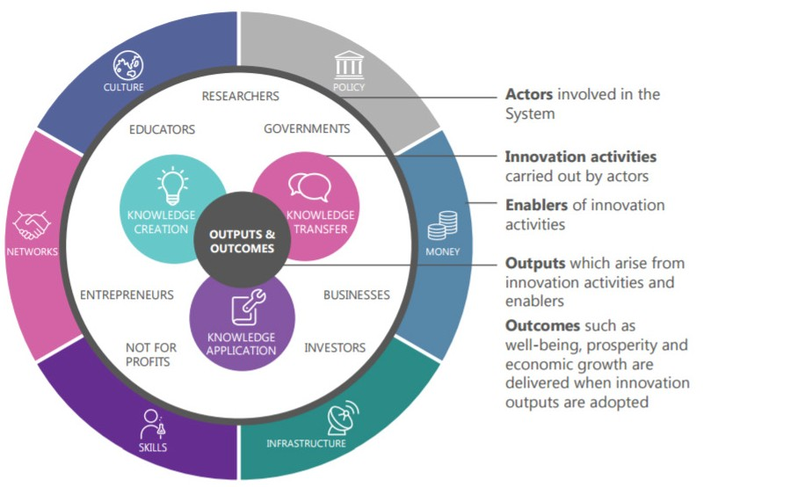
Source: ISA 2016, p.x

Does the VET workforce have the capability to help businesses innovate? In terms of helping businesses to solve problems, adapt to new regulations, change the processes at work and upskill workers to adapt to new technologies, the answer is ‘yes’ for some, although not all, training providers. VET institutions also have
the potential to help turbo-charge incremental innovations by transforming these into new knowledge, which can be disseminated across industry and can inform the development of new training. VET can be part of Australia’s drive to turn good ideas into commercial and community successes. Currently, as Innovation and Science Australia (ISA) observes, Australia’s VET sector is an underused resource in the innovation system by comparison with other leading innovation nations.
The ISA sees the potential for VET providers and people with VET qualifications to be innovators by developing products or services in collaboration with industry partners, as well as diffusing new ideas, technology and processes developed elsewhere, including through retraining.
At the institutional level, there are obstacles to maximising this potential. The ISA cites the long timeframes required to make changes to VET training packages, which can hinder the sector’s ability to respond to current industry needs; and the inadequate resources available to assist teachers to keep up with the latest technologies and innovations (ISA 2016, pp.384—8). We argue that building the VET workforce’s applied research capacity is also a requirement for greater VET involvement in innovation.

WHAT NEEDS TO BE DONE IN THE VET SECTOR?
‘Name and claim’ current
achievements as a first step, ensuring what is claimed is up to standard.

This research project has identified a basis on which registered training organisations can themselves begin to develop an applied research and innovation capability. Modest achievements from within can demonstrate capacity and encourage support.
- ‘Name and claim’ current achievements as a first step, ensuring that what is
claimed is up to standard.
- Make sure that industry and other public research organisations understand what VET institutions do and how they can add value.
- Uncover achievements by collating and publicising these. This may require a new way of assessing current activity and considering its contribution to innovation, as well as devising measures to collect data on success, such as:
  - market uptake of a product, patents, trademarks
  - improved sales and profits
  - better health and safety
  - additional sources of finance
  - new spin-off enterprises or start-ups.
- Raise awareness within VET about the nature of VET applied research and what it would take to convert current practice into new knowledge.

N | ame and claim current achievements
Example 1: A private RTO specialising in both laboratory operations and workplace delivery has highlighted the importance of incremental process innovation to its clients. This has resulted in changed worked practices in the laboratory and further business opportunities for the RTO in delivering
competitive systems training. Seeing this through an applied research lens
rather than a business-as-usual perspective can reveal the added value of the knowledge this RTO offers.

Example 2: Initiatives in Victoria have led to the establishment of the VET Practitioner Research Network (VPRN), which has the support of a range of existing research and VET groups. This community of practice is led by the
practitioners themselves ‒ and driven by a shared interest in showcasing their
work with their peers.

Example 3: RedSpace at TAFE Queensland has started the job of naming and
claiming. In late 2016 it published a collection of exemplars of its applied research effort. The collection brings activity not currently labelled ‘research’ to the surface and shows that most educators who are working with employers to resolve
problems see this as ‘just part of the job’; that learners are already doing applied
research within the curriculum; and that staff members undertake research as part of their professional practice, even if they don’t label their activity thus.

- Have institutional and research leadership to drive the goal of becoming part of the innovation and applied research system. This is a critical launchpad.
Institutional and research leadership is a critical launchpad.
- At an institutional level, it is essential to have enough autonomy to initiate and run the industry partnerships and control the budgets associated with this. For example, an individual TAFE college may wish to seed its own research effort or initiate an industry pilot or apply for a local grant.
- Appoint research leaders and foster research partnerships.
- Ensure the focus remains on applied research for industry innovation and workforce development.

Research leadership
Example 1: Holmesglen Institute, in partnership with Healthscope, is building a private hospital at its Moorabbin campus. The partners have funded an associate professor position to develop a program of applied research that will underpin
both the healthcare teaching program and the provision of patient care (Interview, November 2016).

Example 2: William Angliss Institute has created a College of Eminent Professors to mentor and work with staff and provide research support.

- Engage with industry and the community as problem-solvers as well as educators, necessary to situate RTOs as important links to innovation in their relevant industries and communities.
- This could involve rethinking current business models, for example, seeing teachers and/or students as partners with industry on research projects rather than as purely educators or learners.
Industry engagement
Example 1: At the Gold Coast (TAFE Queensland), students from the Diploma of Graphic Design helped an entrepreneur with her idea for an online car-swapping marketplace. The students researched and prepared ideas for a promotion
campaign and then pitched these to the businesswoman. Film and TV students are now preparing two films for VehiclesXChanges (RedSpace 2016).

Example 2: Skilling the Bay is an innovation ecosystem established to meet the
changing economic and community needs of the Geelong area in Victoria. It brings together Gordon TAFE, Deakin University and the Victorian Government to work
with the community on skills development and education. The Skilling for Advanced Manufacturing – Composite Materials course is run through Gordon TAFE. It
develops skills for the emerging carbon fibre composites sector in Geelong and retrains unemployed workers. Applied research identified these needs in the
community and local industry and how to address them (Interview, January 2017).

n

- Start building a research and evaluation culture.
Fund time release for R&D: time release emerges consistently as a major factor driving research activity.
- Adapt a business model that aims to make the organisation part of the innovation system. The value of the applied research function needs to be demonstrated upwards to the executive and downwards to practitioners.
- Fund time release for research and development: time release emerges consistently as a major factor in driving research activity. This should be an eligible expense in grants for VET applied research.
- Buy in research expertise or partner with universities or other research centres to build capacity and support the business model.
- As well as time release for those engaging in research/innovation activity, staff may need to upskill (see figure 3: VET applied research developmental framework on page 10). This could occur through formal education and professional development, for example, short courses, mentoring or attendance at conferences.
- Training in basic and advanced research methods is important, as is the development of capacity to write grant applications, disseminate the results of the research, and collaborate with other research and industry partners, including on evaluation.
- Embed applied research projects in the curriculum using a scaffolding approach, which introduces students to the concepts and skills they will need for undertaking the research. Undertaking applied research in conjunction with an industry partner could be a capstone project for students nearing the end of their study.
- Also important is recognition of effort. This can be done, for example, by awarding professional development points.
- Introduce or adopt a code of research ethics (such as the Australian VET Research Association [AVETRA] code <https://www.avetra.org.au/pages/ code-of-practice.html>).

B  p | uilding research activities into rofessional development
Example 1: English Australia, the peak body for the ELICOS (English Language Intensive Courses for Overseas Students) sector, offers, in partnership with
Cambridge ESOL, an action research program to raise the levels of professional practice in ELICOS. The program has enhanced the professionalism of teachers and developed networks of teachers interested in action research and in different areas of teaching; increased the engagement of teachers in research with academic researchers; and encouraged teachers to do further study (English Australia 2017).

Example 2: TAFE SA, in partnership with Griffith University, is running an action research program. Practitioners identify a challenge and undertake literature
reviews, or conduct interviews, or build and implement surveys. They then analyse the data and report their findings in a rigorous way. Upon successful completion,
staff may be eligible to apply for credit towards a Griffith University Graduate Certificate of Training and Development. This has led to a further research
program, which will involve engagement with industry through applied research projects (Interview, March 2017).

- Use physical campuses, equipment and knowledge differently to enable them to act as hubs, incubators and consultants and cultivate a broker role, whereby the RTO could:
Become an innovation hub and cultivate a broker role.
- identify problems in the industry or in the community
- appoint experts to investigate these (from TAFE, universities or elsewhere)
- translate findings into practical solutions
- deliver to the end-user (for example, farmer or local business or community organisation)
- offer advisory and networking services.

U | se the physical infrastructure
Example 1: The large-scale facilities, processes and expertise at TAFE
Queensland SkillsTech can accelerate the development of the skills needed to
adapt to innovation. Suppliers sometimes donate new major equipment for the use of apprentices (RedSpace 2016, p.18).

Example 2: The Textile and Fashion Hub at Kangan Institute offers sampling and short-run manufacturing services and industry-relevant training courses for designers and small businesses, as well as customised industry training
for manufacturers. The hub has the very latest in industry-standard technology and is operated by industry experts, who are available to assist designers and
businesses with the knitting and printing of garments (Interview, November 2016).
- Establish an applied research and innovation centre, a step that will consolidate efforts to position the RTO(s) in the R&D system.
— Use dedicated researchers (from the RTO or co-opted), who work alongside VET teachers and businesses.

E | stablish a research centre
Example 1: TAFE Queensland’s RedSpace: Centre for Applied Research and Innovation was established in 2015 to: support business innovation, workforce capability building and innovation in educational delivery; enhance student
learning outcomes through the cultivation of entrepreneurial and innovation
capabilities in projects with industry and enterprises; and drive applied research in areas of specialisation (Interview, November 2016).

Example 2: The Holmesglen Centre for Applied Research and Innovation supports a network of faculty research centres, which work on applied research and
innovation projects in cooperation with industry and not-for-profit partners. As
well as involving expert staff members from both the higher education and TAFE arms of the institute, Holmesglen encourages student involvement in its program
of applied research and innovation. When necessary, the centre brings in external advice to find solutions to problems affecting industry and the community sector
(Interview, November 2016).

WHAT DOES THE VET WORKFORCE NEED?

VET educators require technical competence and expertise, as well as pedagogical skills. Many educators and other professionals have a large number of transferable skills, gained through a variety of qualifications and experience, including many of those outlined in our VET applied research developmental framework. What needs further attention is the ability to recognise these skills and adapt them to new projects, including those involving applied research.
Time and support for working on applied research projects are essential for developing applied
research capabilities.
As part of the project, we developed a tool to help VET educators and other professionals assess whether they are ‘applied research literate’ and therefore equipped to engage in the innovation system. The tool identifies the skills and capabilities that they and their team may already have or need to foster. Not everyone will require all of these skills on all occasions: VET applied research is most commonly a team effort.
The VET Applied Research developmental framework (figure 3) recognises that skills/capabilities are needed in the three specific areas of learning, communicating and organising, all of which have application beyond research activities but which are also essential skills for conducting applied research projects with a real-world focus. This framework has a specific application to the VET sector, in that it draws on the skills and capabilities identified by participants in this research project — VET professionals, researchers, policy advisors and industry representatives — and on skills identified in several VET training packages, most notably the Training and Education training package.
The framework does not imply a checklist of skills but rather an opportunity to identify the types of skills and capabilities that a team could develop and/or source. Such identification enables the mapping of these skills and capabilities to qualifications that already exist in the VET sector, thereby recognising the expertise that already exists in the organisation or what gaps need filling through recruitment or further staff development. Individuals, teams and RTOs can use the framework as an audit tool when undertaking or planning to undertake VET applied research.
More detail on the framework is given in the accompanying document, Explaining the VET applied research developmental framework <https://www.ncver. edu.au.publications/all-publications/explaining-the-vet-applied-research- developmental-framework>.

Figure 3 VET applied research developmental framework

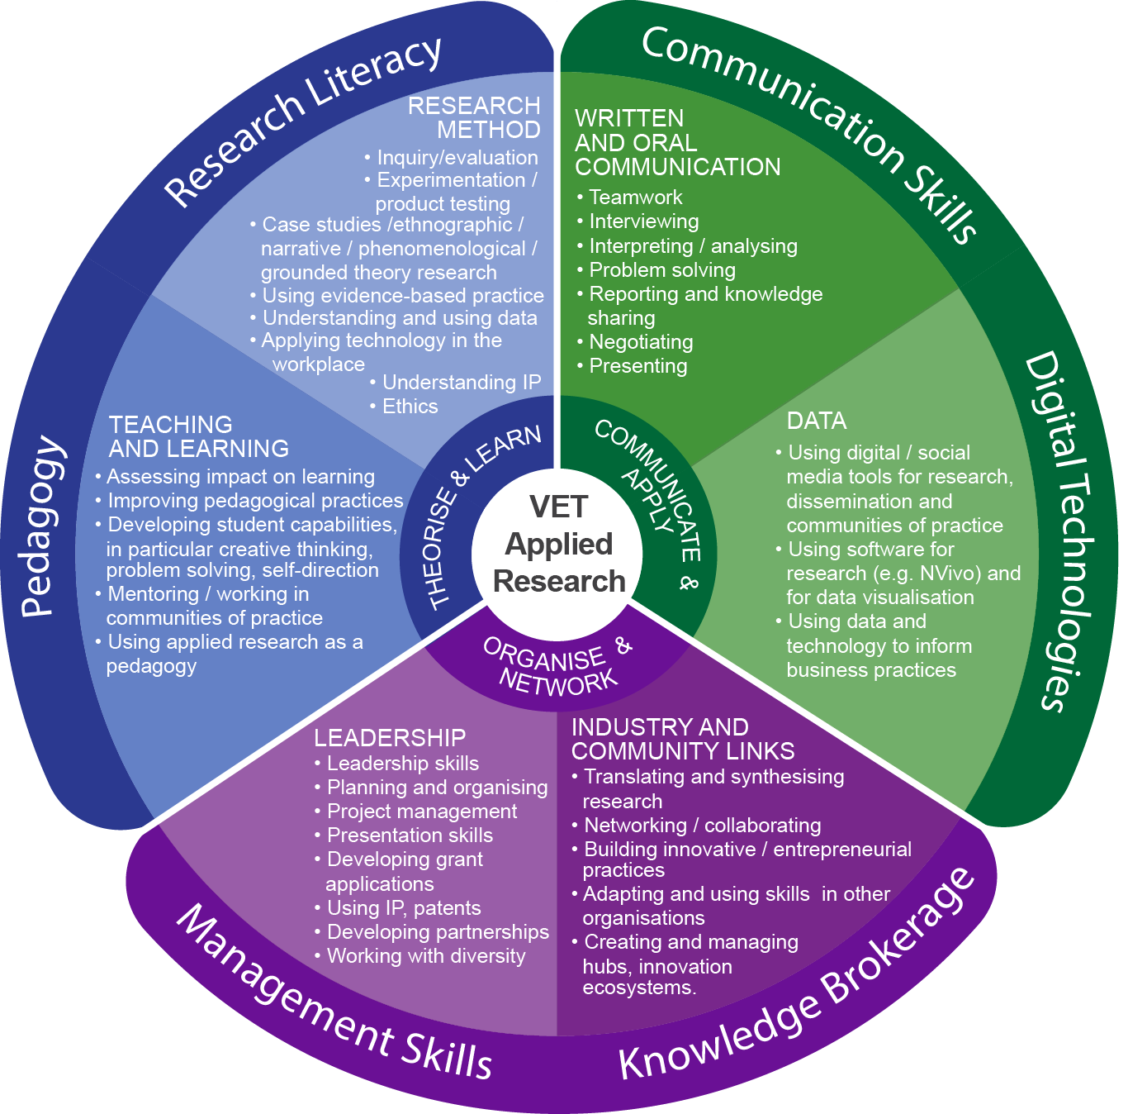

A | team-based approach
In a project with an industry partner, Holmesglen Institute identified the teachers with the technical skills needed to test state-of-the art technology for a building
development and to oversee the work of apprentices on the project. These teachers were separated from those with research qualifications, who were to write up the
project, including with a view to influencing the development of a new qualification in building and construction (Interview, November 2016).

While there is no longer any systemic approach to professional development in the VET sector, individual VET institutions are pursuing a range of developmental programs. These include:
- time and support for working on applied research projects and participating in communities of practice
- a commitment to scholarly practice, especially in the higher education sectors of VET
- scholarships/bursaries to fund higher qualifications, including doctorates
- funding to attend conferences, nationally and internationally
- mentoring and networking opportunities
- workshops and training sessions
- access to journals (academic and industry)
- membership of professional and industry associations and involvement in events such as AVETRA’s OctoberVET.

R | esearch as part of teaching and learning
Applied research and inquiry are embedded in TAFE Queensland’s Learning and Teaching Framework. The framework’s Critical Participatory Action Research
(CPAR) program, undertaken in pods and supported by mentors, nurtures reflection and problem-solving skills. Participation in the program is a formal part of teachers’ professional development (Interview, November 2016).

HOW DOES AN RTO BUILD RESEARCH CAPABILITY?

Both the literature and the interviews undertaken for this project point to the need not only to develop an individual’s research capacity but also the research capability of the organisation. In summary, the RTO capabilities required are:
Build the research
capability of the organisation as well as of the
individual.
- Having an organisational culture that cultivates inquiry, investigation, evaluation, research and risk-taking:
- Such an organisation needs to be open to collaboration with others in the
research field.
- A commitment to being a research organisation means more than a divide between those who teach courses at diploma and above and those who don’t.
- Active leadership:
- Managerialist cultures do not necessarily encourage good research, but leaders do need to set the direction of the research effort and its code of ethics, as well as incorporate research into their strategic planning.
- The connection between an applied research/research capability and the policies and decision-making of the organisation needs to be clear to all staff.
- Tolerating risk:
- Organisations need to be willing to push the boundaries of how they operate.
- Organisations need to support their staff through their failures, as well as celebrate their successes: the freedom to experiment is an important part of undertaking applied research.
- Sourcing funding, especially seed funding for initial research projects:
- If applied research is part of the work of the organisation, then it will also be a line in the annual budget.
- Cultivating new sources of funding is essential, including from public R&D budgets, as is aligning research activity to funders’ interests, either in solving industry problems, expanding the evidence base for policy or improving training.
- Getting access to expertise:
- RTOs need the guidance of experts from within or beyond the organisation to mentor, teach and support others.
- This could be achieved by creating a prominent position in the leadership team or by establishing clear and explicit relationships with a university. As more RTOs move to develop a higher education capacity, this expertise will become be part of their structure.

- Dissemination capacity:
Getting the
research findings to the right
audience in the
right language is crucial.
- Getting the research findings to the right audiences in the right language is an important part of the research cycle, a process that calls for communication and marketing capacity, as well as intellectual property (IP) and copyright expertise. (Remember! If you demonstrate, sell or discuss your invention in public or publish information on it before you file, you cannot get a patent.)
- Human resources (HR) policies that support a ‘research capable’ staff:
— These policies embrace both recruitment and professional development, as well as allocation of teaching and research loads.
- Networks:
- A research-active RTO will devote time to its industry and community partnerships, as well as to participating in the broader research world.
- Educators and others need opportunities to network nationally, to access resources and grant opportunities, and to have a platform to discuss their research efforts.
- Flexibility and responsiveness:
— As in other areas of RTO endeavour, establishing a competitive position in the research world requires the ability to respond to industry needs in a timely way.
- A connection to VET pedagogy:
— While some research may take place away from teaching programs, VET applied research can be used to influence the educational product delivered and can involve students.

Building innovative capability aligns with a research culture in RTOs
In a case study of the then West Coast Institute of Training, Mitchell (2009, p.iii) quotes the strategies used by its Managing Director, Sue Slavin, to build innovative capability:
- promoting a vision focused on achieving sustainability not short-term wins
- creating an executive team willing to stretch themselves, take risks and learn
- developing a leadership culture of rigorous debate and the scorning of ‘yes men’
- being willing to critically reﬂect on the organisation’s current strengths and weaknesses
- networking outside the organisation to obtain and bring back new ideas
- using literature, coaches and external speakers to challenge the thinking of staff
- continually investing in the development of staff
- adopting the expression, ‘Resourceful, Agile, Partnered’, to describe the common approach by staff
- offering an open door to staff who want to share any issues, positive or negative
- implementing a rewards schemes for staff innovation and enterprise
- celebrating staff creativity and ingenuity.

HOW CAN POLICY SETTINGS AND SYSTEM-WIDE INITIATIVES HELP?

- At federal and state government levels, there needs to be recognition that increasing knowledge generation is only a first step towards better productivity: knowledge must also be properly absorbed and circulated. Specifically, this calls for:
Increasing knowledge
generation is
only a first step towards better productivity:
knowledge must also be properly absorbed and
circulated.
- fostering the potential for VET to contribute to Australia’s innovation system
- supporting VET to prepare creative workers at the trades and para- professional level, as well as in its role in upskilling existing workers
- acknowledging that funding is required to build capacity in the VET workforce.
- The system could support a culture of evaluation and considered risk taking by:
- encouraging the evaluation of projects and the dissemination of learnings to relevant end-users (industry players and tradespeople, for example), as well as to training product developers. In this way, the innovation cycle
- would also embrace the future training of VET students and the upskilling of existing workers
- ensuring that quality assurance regimes do not stifle innovation and
- experimentation
- measuring research output and impact. This would require acknowledgment of the particular nature of VET research and the adoption of a set of measures that do not merely mirror those of universities but also capture the impact of knowledge generation and dissemination on industry innovation, on workplace activity and on students’ capabilities. Possible evaluation measures could include:
  - funded research
  - unfunded research
  - quantifying publications, grants and presentations with bibliometrics that extend beyond academic publications to trade journals, media etc.
  - improved productivity in the industry partner
  - patents
  - graduate employment outcomes.
- Ensure that other policy decisions do not have perverse effects, for example, by deflating demand for paraprofessional qualifications or removing subsidies in areas of strong innovation potential (for example, VET loans for high-cost
digital programs; government-funded places for specialist technician training at diploma level).
- Align industrial regimes to the new world of work and occupational identity.

WHAT NEXT?

This research has highlighted some next steps that could build momentum for increasing VET’s applied research capabilities and open up possibilities for greater interaction in the innovation system.
- Professional standards for research and measures of impact need to be established to create benchmarks for VET applied research. These would have direct links to the quality of teaching and learning.
— Such standards would help to have qualified VET organisations acknowledged as publicly funded research organisations, which would in turn open up eligibility for R&D and innovation funds and/or for
participation as research partners in organisations such as the Cooperative Research Centres.
- A national coalition of VET associations, either as a VET professional association or through another appropriate structure, should be established to advocate for the place of research in the sector, provide communities of practice, operate as a clearinghouse for research, and provide professional development for the sector.
— TAFE Directors Australia, the VET Practitioner Research Network and the National Centre for Vocational Education Research would be in a position to support such an effort by, respectively, building a coalition of interested RTOs and peak bodies, nurturing the existing VPRN community of practice, and building a special collection for VET applied research in VOCEDplus.
- A national professional development fund would kick-start capacity building across the sector.
— Funding for pilot projects with industry partners would raise awareness of the potential for collaborations between VET research and industry.
- The VET applied research developmental framework lends itself to further analysis and testing to identify and/or develop the common sets of skills that are frequently used or which are found to be missing in the VET sector. It would then become a more detailed guide for professional development activities.
Training package developers, especially in the Training and Education Training Package, could also consider how these skills sets might be incorporated into pathways for the profession.
— The VET Development Centre would be a possible place to oversee such work.
- The Australian Government’s higher apprenticeship pilots will explore innovative training solutions to meet the need for advanced training outside the traditional university system (Andrews 2016).
- Applied research projects within these pilots would help to develop apprentices’ research skills and scholarly practice, project management abilities and teamwork.
- The pilots represent an opportunity to gather data on applied research as pedagogy in order to enhance VET teaching and learning practices and to better understand the capabilities required of the VET workforce.

REFERENCES

Andrews, K 2016, ‘Two new higher apprenticeship pilot programs partner with industry’, media release 5 September 2016, viewed 30 November 2016, <https://ministers.education.gov.au/andrews/two- new-higher-apprenticeship-pilot-programs-partner-industry>.
COAG (Council of Australian Governments) 2012, National Agreement for Skills and Workforce Development (NASWD), COAG, Canberra.
Department of Industry, Innovation and Science 2016, The Australian Government’s 2016—17 Science, Research and Innovation Budget Tables, Minister for Industry, Innovation and Science’s foreword, 18 August 2016, viewed 28 April 2017, <https://www.industry.gov.au/innovation/ reportsandstudies/Documents/2016-17-SRI-Budget-Tables.pdf>.
English Australia 2017, Award for action research, viewed 7 April 2017, <http://www.englishaustralia. com.au/action_research_award#Background>.
Innovation and Science Australia 2016, Performance review of the Australian Innovation, Science and Research System 2016,Commonwealth of Australia, viewed 10 February 2017, <https://
industry.gov.au/Innovation-and-Science-Australia/Documents/ISA-system-review/Performance-
Review-of-the-Australian-Innovation-Science-and-Research-System-ISA.pdf >.
Kangan Institute 2017, Textile and Fashion Hub, viewed 28 April 2017, <https://www.kangan.edu.au/ textile-and-fashion-hub>.
Mitchell, J 2009, Reinvention through innovation: how West Coast TAFE works with clients to reinvent itself and improve its services, West Coast TAFE, Perth.
O’Connell, M &Torii, K 2016, Government spending on education: the winners and losers, viewed 3 January 2017, <http://www.mitchellinstitute.org.au/opinion/government-spending-on-education- the-winners-and-losers>.
Productivity Commission 2017, Report on government services, Commonwealth of Australia, viewed
8 February 2017, <http://www.pc.gov.au/research/ongoing/report-on-government-services/2017/ child-care-education-and-training/vocational-education-and-training/rogs-2017-volumeb- chapter5.pdf>.
RedSpace 2016, ARIES case studies, TAFE Queensland, Brisbane.

© Commonwealth of Australia, 2017

With the exception of the Commonwealth Coat of Arms, the Department’s logo, any material protected by a trade mark and where otherwise noted all material presented in this document is provided under a Creative Commons Attribution 3.0 Australia <http://creativecommons.org/licenses/by/3.0/au> licence.
The details of the relevant licence conditions are available on the Creative Commons website (accessible using the links provided) as is the full legal code for the CC BY 3.0 AU licence <http://creativecommons.org/licenses/ by/3.0/legalcode>.
The Creative Commons licence conditions do not apply to all logos, graphic design, artwork and photographs. Requests and enquiries concerning other reproduction and rights should be directed to the National Centre for Vocational Education Research (NCVER).
This document should be attributed as Beddie, F & Simon, L 2017, Developing VET applied research: steps towards enhancing VET’s role in the innovation system, NCVER, Adelaide.
This work has been produced by NCVER on behalf of the Australian Government and state and territory governments. Funding is provided through the Australian Government Department of Education and Training.

The views and opinions expressed in this document are those of the author/project team and do not necessarily reﬂect the views of the Australian Government, state and territory governments or NCVER.
IMAGES: GETTY IMAGES/ISTOCK ISBN 978-1-925173-94-9
TD/TNC 129.12

Published by NCVER ABN 87 007 967 311
Level 5, 60 Light Square, Adelaide SA 5000
PO Box 8288, Station Arcade, Adelaide SA 5000, Australia P +61 8 8230 8400
E ncver@ncver.edu.au W www.ncver.edu.au
twitter.com/ncver www.linkedin.com/company/ncver

