SUPPORT DOCUMENT

Drivers of participation in VET: Three regional case studies—Support document

Anne Walstab
Kira Clarke
Centre for Post-compulsory Education and Lifelong Learning, The University of Melbourne

This document was produced by the author(s) based on their research for the report Participation in vocational education and training across Australia: A regional analysis, and is an added resource for further information. The report is available on NCVER’s website: <http://www.ncver.edu.au>

The views and opinions expressed in this document are those of the author(s) and do not necessarily reflect the views of the Australian Government, state and territory governments or NCVER. Any errors and omissions are the responsibility of the author(s).
© Australian Government, 2008
This work has been produced by the National Centre for Vocational Education Research (NCVER) on behalf of the Australian Government and state and territory governments with funding provided through the Australian Department of Education, Science and Training. Apart from any use permitted under the CopyrightAct 1968, no part of this publication may be reproduced by any process without written permission. Requests should be made to NCVER.

Contents
Executive summary 4
Introduction 7
1. Ovens–Murray 10
2. Hume City 18
3. Midlands 26
Conclusions 32
References 35
Appendix 1 36
Appendix 2 39
Table 1: Interview participants 9

Key messages
This report is part of the larger research program commissioned by the National Centre for Vocational Education Research, A Well-Skilled Future: Tailoring VET to the Emerging Labour Market, and follows on from a study of national participation in vocational education and training (Walstab & Lamb, 2007). Case-study work was undertaken in three regions (one metropolitan and two non-metropolitan) with unusually high or low levels of VET participation to gain an understanding of local factors and policies that produce high levels of participation as well as the factors that work as barriers operating to suppress involvement of communities in VET.
- The case studies indicate that high levels of participation in VET can be achieved through two models of provision: a community partnership model and a market-based model.
- The market-based model is characterised by: a range of providers including private and community providers and TAFE institutes; industry growth and diversification as key in defining role of VET providers; competition between providers particularly for fee-for-service and industry training; all providers established a skills assessment unit; development of customised training programs, modules, competencies, qualifications; flexibility in delivery (workplace, campus, on-line, blended delivery) and timelines for training; focus on appropriate pedagogy suited to need; continual liaison with industry by staff to maintain relevance of courses and skills; work-placements as feature of all training; local government has limited or no role.
- The community partnership model is characterised by: partnerships facilitated through local government; strong partnerships between VET providers, local businesses, local government and schools; providers establishing a business development unit comprising industry liaison officers; regular liaison and monitoring by providers of businesses in region; flexible delivery: workplace, campus,-based, online, combinations; for individuals and groups, strong focus on needs assessment, designing and developing targeted programs.

Executive summary
This report is part of the larger research program commissioned by the National Centre for Vocational Education Research, A Well-Skilled Future: Tailoring VET to the Emerging Labour Market, and follows on from a study of national participation in vocational education and training (Walstab & Lamb, 2007). This report examined patterns of participation in VET across different regions of Australia by presenting two main types of analyses: (1) the mapping of regional VET participation rates, and (2) regression analyses which predict participation given key regional data and identify ‘exceptional’ regions, those which have unusually high or low rates of participation despite what might be expected given their industry base and population.
Case-study work was undertaken in three regions (1 metropolitan and 2 non-metropolitan) with unusually high or low levels of VET participation to gain an understanding of local factors and policies that produce high levels of participation as well as the factors that work as barriers operating to suppress involvement of communities in VET.
The findings of the case study work are presented in this report. The regions selected were:
- Ovens–Murray region, Victoria (higher-than-expected-levels of participation)
- Hume City region, Victoria (lower-than-expected-levels of participation).
- Midlands region, Western Australia (higher-than-expected-levels of participation)
Fieldwork in the three regions was undertaken to investigate whether there are policy, program, community or other factors which help shape the unusually high or low levels of participation apparent in the three regions (e.g. a densely populated VET landscape, collaborative local networks, community attitudes). It may be the case that local policies tied to providers or community and industry arrangements are influencing the patterns of unusually high or low rates of participation. Contextual studies of this sort provide the opportunity to focus not only on individual factors affecting participation in VET, but the role of VET in community development within a particular local area, both economic and social.
Case studies
1. Ovens–Murray
Recent rapid industry growth and diversification and the regional economic boom were reported as having shaped the dynamics of the regional VET sector. The competitive market model and strong employment incentives for learners were viewed as driving forces behind the high level of competition between the two TAFE institutes and the two large community providers. This competition also appears to have sparked innovation within the regional VET sector, in both the breadth of provision, responsiveness to industry training needs and strategies for engaging learners. Particularly fierce competition was described in the fee-for-service area between the TAFE institutes, as well as between the TAFE and ACE sectors.
Industry change in the Ovens–Murray region has had a significant influence on VET demand. Movement of some manufacturing off-shore was described as having contributed to recent redundancies, along with a corresponding need for re-skilling and up-skilling of those made redundant and of existing workers moving into newer technology driven industries. Declining agricultural productivity in the region due to drought was also described as driving migration towards the regional centres and generating a demand for re-skilling for former agricultural workers. Industry regulation had also led to skills recognition in the region.
A number of other factors were reportedly contributing to levels of participation in VET in the Ovens–Murray region, including the availability of programs not offered in neighbouring regions and high levels of participation in VET by young people.
2. Hume City
The definitive feature of VET provision arising from the interviews in Hume City is the highly collaborative nature of the relationships between providers in the region. This model of operation is structured around a council-based strategy, which draws together in partnership local education providers (TAFE institutes, community providers, universities, schools), other local networks (LLEN and job network providers), and industry representatives, with the aim of improving the educational attainment levels of the local population.
The network has set up an environment that fosters collaboration within educational sectors and across sectors. The providers delivering VET in Hume City reported a high level of collaboration facilitated by the network. The community education providers in the region were described as being leaders in their field in terms of partnering to provide courses. Access to good information from different sources was seen as essential for all stakeholders in being responsive in the region. The region was responding to the needs of individuals through demand-driven provision and flexible delivery. A proactive and flexible approach to meet employer and industry training needs was also being taken.
3. Midlands
There were a number of factors impacting on the region’s responsiveness to the training needs of industry and individuals. The geographic spread of the region’s population and the lack of population density in any location was the dominant factor adversely impacting on provision in the Midlands region. The lack of flexibility in the funding model (based on numbers in a class) constrains the ability of VET providers to be responsive to the training needs of the region. Both TAFE respondents and several community representatives highlighted the impact of service delivery difficulties. There was a particular focus on the challenge of delivering to a very geographically dispersed population with very limited access to public transport and disjointed community infrastructures.
Other barriers to VET participation included the difficulty in attracting, training and retaining expert and specialist staff, which were reported as posing a threat to the capacity of the TAFE to continue effectively delivering a breadth of programs. The exodus of young people from the region saw limited post-school transition to VET providers in the region. The heavy reliance on the agriculture industry and a lack of large businesses in the region was also felt to contribute to low VET participation. Community attitudes to education and training were also believed to have played a role. The primary motivation for undertaking VET in the region was to get a job. The very low levels of unemployment in the region had removed the main incentive for training. There was also limited collaboration and partnership between providers in the region due to the geographic spread and fragmentation of community services and infrastructure.
Models of provision
It is apparent from looking at variations in the patterns of VET participation across Australia that not all regions are equally placed when it comes to responding to changes in labour market demands (Walstab & Lamb, 2007). We know from the regional analyses that industries and industry base of regions are a very important determinant or influence on VET participation rates. Some of the regional differences identified in the analyses suggest that there needs to be improvements in some regions in how skill shortages and labour market demands are assessed and responded to. In other regions, market based models and community partnerships are responsive to both community and industry need.
The case studies indicate that high levels of participation in VET can be achieved through two models of provision: a community partnership model and a market-based model.
The market-based model is characterised by:
- Range of providers including private and community providers and TAFE institutes
- Industry growth and diversification as key in defining role of VET providers
- Competition between providers particularly for fee-for-service and industry training
- All providers established a skills assessment unit:
- Development of customised training programs, modules, competencies, qualifications
- Flexibility in delivery (workplace, campus, on-line, blended delivery) and timelines for training
- Focus on appropriate pedagogy suited to need
- Continual liaison with industry by staff to maintain relevance of courses and skills
- Work-placements as feature of all training
- Local government has limited or no role.
The community partnership model is characterised by:
- Partnerships facilitated through local government
- Strong partnerships between VET providers, local businesses, local government and schools
- Providers establishing a business development unit comprising industry liaison officers
- Regular liaison and monitoring by providers of businesses in region
- Flexible delivery: workplace, campus,-based, online, combinations
- For individuals and groups, strong focus on: needs assessment, designing and developing targeted programs.
Issues identified in extending the models to other areas included: attracting and retaining quality staff; the industry base of regional labour markets; role and capacity of local government; and distance and population density within a region.
While the collaborative and competitive models may not be equally relevant or sustainable, they contain similar processes and mechanisms which drive high levels of participation in VET. The case studies show that the VET sector has already developed effective models of responding to emerging skill needs and to individual demand. Which model works best will depend on the particular nature of a region. The operation of these models in diverse settings confirms the responsiveness of the VET sector to both industry and individual need.

Introduction
Background
This report is part of the larger research program commissioned by the National Centre for Vocational Education Research (NCVER), A Well-Skilled Future: Tailoring VET to the Emerging Labour Market, and follows on from a study of national participation in vocational education and training (Walstab & Lamb, 2007). This report examined patterns of participation in VET across different regions of Australia by presenting two main types of analyses: (1) the mapping of regional VET participation rates, and (2) regression analyses which predict participation given key regional data and identify ‘exceptional’ regions, those which have unusually high or low rates of participation despite what might be expected given their industry base and population. The primary dataset used for this study was the national collection of data for VET providers, AVETMISS, provided to the researchers by NCVER. The reference year was 2004.
The study found that there are large variations across the regions of Australia in levels of VET participation. The maps of participation in VET reveal contrasting regional patterns. In particular, overall VET rates (award and non-award combined) were relatively high in non-metropolitan regions compared to urban areas. However, this varies by level of VET study. Rates of participation in basic level VET are much higher in non-metropolitan regions than in metropolitan regions. This situation is reversed for participation in diploma-level courses, where rates are much higher in city areas. This is a constant pattern, mirrored across the analyses of rates of participation by type of provider, mode of delivery, and source of funding. When rates are disaggregated by qualification level the contrast between city and country regions becomes more polarised.
The results of regression analyses help identify the main factors that account for differences in participation rates across the regions. A range of demographic and economic factors were used to predict participation. The demographic factors include age, language background, indigenous status, educational attainment levels, and remoteness. The economic factors include levels of unemployment and the industry profile of the regional populations in employment. The results from these analyses suggest that participation in VET is influenced to a large degree by economic factors. The composition of industry structure plays a major part. So too do labour market conditions. In this sense VET participation is largely dependent on a region’s economy and industry. As unemployment rates rise, participation tends to fall. This is the case across most levels of VET. Regions with more workers in retail and in manufacturing and the hospitality industry tend to have higher rates of participation, all else equal. For all VET (award and non-award together), unemployment rates and industry structure accounted for almost 40 per cent of the variation in participation rates. Demographic factors are more important for participation at higher award levels, mainly diploma-level VET, but at other levels contributed little beyond that accounted for by economic factors in explaining regional differences.
In terms of VET participation, therefore, the study found that economy and industry matter. They are the main drivers of VET participation. This could be described as meaning that VET participation is more dependent on what regions possess in terms of business and labour than in terms of who is living in the region in terms of the social, age, ethnic and racial composition of the population. This does however need to be qualified. The demographic factors were important at particular award levels. The proportion of non-English speakers living in a region has a significant positive effect on participation at a diploma level, for example. More strikingly, participation in VET delivered by private providers is much more influenced by the characteristics of those living in the community than by labour market or industry structure. Demographic factors explained more than double the regional variation in participation in VET delivered by private providers than did economic factors. The reverse is true for TAFE-based VET.
Aims and methodology
From analyses of variance undertaken in the companion report Participation in VET across Australia: a regional analysis (Walstab & Lamb, 2007), it was possible to identify the regions in which levels of participation are not explained very well by the economic and demographic factors included in the regression models. In such regions, levels of participation either exceed what might be expected, given the social and economic profiles of regions, or are lower than what might be expected. This was true for several regions. Case-study work was undertaken in three regions (1 metropolitan and 2 non-metropolitan) with unusually high or low levels of VET participation to gain an understanding of local factors and policies that produce high levels of participation as well as the factors that work as barriers operating to suppress involvement of communities in VET.
The findings of the case study work are presented in this report. The regions selected were:
- Ovens–Murray region, Victoria (higher-than-expected-levels of participation)
- Hume City region, Victoria (lower-than-expected-levels of participation).
- Midlands region, Western Australia (higher-than-expected-levels of participation)
Fieldwork in the three regions was undertaken to investigate whether there are policy, program, community or other factors which help shape the unusually high or low levels of participation apparent in the three regions (e.g. a densely populated VET landscape, collaborative local networks, community attitudes). It may be the case that local policies tied to providers or community and industry arrangements are influencing the patterns of unusually high or low rates of participation. Contextual studies of this sort provide the opportunity to focus not only on individual factors affecting participation in VET, but the role of VET in community development within a particular local area, both economic and social.
The fieldwork for these case studies was carried out concurrently with researchers conducting Program 5 of A Well-Skilled Future project, which involved a national study of TAFE inclusiveness strategies (Volkoff, Clarke & Walstab, 2007). Case studies of the same three regions focusing on inclusiveness strategies used by TAFE institutes are detailed in Models of TAFE Inclusiveness, case studies of three Australian regions (Clarke & Walstab, 2007).
Table 1: Interview participants
Type of interviewee | Number of respondents
 | Ovens–Murray | Hume City | Midlands
TAFE Staff | 12 | 12 | 10
TAFE Management Staff | 5 | 7 | 3
Adult Community Education (ACE) Staff | 7 | 5
Representatives from Local Government | 4 | 2 | 1
Representatives from Industry/Business | 3 | 3 | 1
Representatives from Community Organisations | 5 |  | 1
Private providers/group training organisation staff |  | 1 | 1
Representatives from Local Learning and Employment Networks | 2 | 2
School staff |  |  | 4
State government staff |  |  | 5

A sample of stakeholders in each region was interviewed. As shown in Table 1 above, in addition to interviewing representatives from VET providers, consultations were also conducted with representatives from local government, community organisations, schools and industry. During the fieldwork, documentation was gathered from interviewees to supplement the interview data. This documentation included program descriptions and evaluations, environmental scans, and internal policy documents.
Data used in this report to illustrate regional VET delivery is sourced from the 2004 AVETMISS dataset, provided to the researchers by NCVER, and includes only that data relating to delivery which occurs within each region (i.e. as measured by students studying in the region), unless otherwise specified. Similarly, interview data refers only to those campuses and delivery locations within the regions. In all three regions, the VET providers involved in the case studies were not necessarily operating entirely within the region under examination. For example TAFE institutes may have had campuses or delivery locations in neighbouring and other regions. The case studies do not attempt to provide an evaluation of individual VET providers.
Structure of the report
This report is structured as follows:
The introduction provides the background to the report. It outlines the aims and methodology as well as the data sources and how the case study regions were identified.
The case studies (1. Ovens–Murray, 2. Hume City and 3. Midlands) follow.
The conclusion briefly sums up the key findings of the report.
Appendix 1 contains labelled maps of the regions used in the original analysis.
Appendix 2 contains tables of AVETMISS data relating to the three case study regions.
There is a companion report to the case studies, Participation in VET across Australia: a regional analysis (Walstab & Lamb, 2007) which also has a support document available from the NCVER website. The support document contains detailed maps showing VET participation rates across regions of Australia. It also contains the results of all of the regression analyses and study of residuals used to identify ‘exceptional’ regions.

1. Ovens–Murray
Background
While there are large variations across regions of Australia in levels of VET participation, there are some areas of the country where relatively high rates of participation occur across a number of different types of VET provision (Walstab & Lamb, 2007). One of these regions is along the Murray river where it separates Victoria from NSW. The statistical division of Ovens–Murray, located in this area on the Victorian side of the border, is one such region where 26 per cent of the working-aged population were enrolled in VET (award and non-award courses) in 2004, which is more than double the national VET participation rate of 11 percent.
The region
The Ovens–Murray region – with a population of nearly 100,000 – is internally very diverse, both demographically and geographically. There are two regional centres, Wodonga and Wangaratta (with approximately 35,000 and 27,000 residents respectively), both of which have experienced significant population and economic growth in recent years. Wodonga is located on the regional border, a position that facilitates and attracts inter-regional traffic for training, employment and access to services. Recent population fluctuations differ markedly outside the two centres, with some of the growth of the regional centres reportedly at the expense of several declining surrounding rural towns. Drought and downturn in the agricultural sector, the development of one of the regional centres as a major transport and logistics hub and diversification of manufacturing industries were all reported to be propelling strong demand for skilled labour and high VET participation rates. A rapidly ageing population and an outwardly mobile youth population were key challenges facing both the VET sector and the region’s employers. Several stakeholders also described a trend of people returning to their home towns around the age of thirty, to have children. One of the regional centres was described as contradicting the state regional trend and had seen a slight increase in recent years in the 15-35 age bracket (ABS, 2002-2006). This is in contrast to the surrounding towns, which all reported issues associated with youth exodus.
VET landscape
The Ovens–Murray region has a heavily populated VET landscape, with two TAFE institutes, two large adult community education (ACE) providers and seventeen smaller ACE providers all operating within the region. There are also several group training companies. Private providers however are limited in number and make up only 4.4 per cent of regional delivery (as noted in the introduction, fee-for-service delivery by private providers is excluded from this analysis).
One TAFE is based in Wodonga and has two vocational training centres and four study centres located in various small rural towns in the region. This TAFE reported a cross border agreement with a TAFE operating in a neighbouring region in New South Wales. The other TAFE in Ovens–Murray has a campus in Wangaratta. This Wangaratta campus is a main campus of an institute which is based in and administered from a neighbouring region.
The two large ACE providers, one based in Wodonga and one based in Wangaratta, were described by other regional stakeholders as being highly competitive with the TAFE institutes and “having their finger on the pulse of the community”. Both of these large community providers have been operating for more than thirty years and are significantly larger in size than the other community providers in the region. Community-based VET providers play a significant role in the region, contributing 30 per cent of regional delivery (compared to 65.5 per cent delivered by TAFE, as measured by the share of VET students studying in the Ovens–Murray region in 2004).
Drivers of VET participation
Competition between providers
Recent rapid industry growth and diversification and the regional economic boom were reported as having shaped the dynamics of the regional VET sector, and viewed as driving forces behind the high level of competition between the two TAFE institutes and the two large community providers. This competition also appears to have sparked innovation within the regional VET sector, in both the responsiveness to industry training needs and strategies for engaging learners. Particularly fierce competition was described in the fee-for-service area between the TAFE institutes, as well as between the TAFE and ACE sectors:
There is not a lot of love lost between [TAFE A] and [TAFE B], but they are all competitors in an open market I guess.
What we’ve had is head to head competition with [a community provider], when all they’ve done is watered down an already thin market. (TAFE staff member)
The ACE sector in this region is well established, well connected to community and industry and described by other stakeholders as being very responsive and firmly entrenched as key players in the regional education system. There was a breadth of accredited and non-accredited provision accessible through ACE providers and this was viewed as providing those organisations with multiple points of contact with the community and the potential to engage in community capacity building in a way that the TAFE institutes were sometimes restricted from.
Respondents from the TAFE institutes were philosophical about the role performed by the community providers. While there was a strong belief that the two large community providers in the regional centres may be encroaching on the traditional TAFE territory and concern about the “negative impact on the community” of the competition between the sectors, there were several TAFE respondents who suggested that the success of the two large community providers in particular was their track record of filling gaps in the training market.
While the VET landscape in the two regional centres is operating very much under a competitive model, economic constraints and provision issues have required a more collaborative approach outside the two regional centres. In these small towns where the demand for VET is reportedly not as high as in Wodonga and Wangaratta, the community providers and TAFE institutes are more likely to work together in the provision of VET programs. For example, one rural community provider reported having partnered with one of the TAFE institutes to access funding. Both TAFE institutes described collaborating with the smaller community providers outside the regional centres and “benefiting from” or “leveraging” off the close connections those providers have with their communities. As one TAFE staff member commented:
We’ve got a very strong partnership with one of the ACE providers down at [name of small town]. We’ve tried a number of times to get programs happening in [name of small town], but we have realised that the [ACE provider] has probably got the best opportunity to offer VET type programs because of their connection with the community. That partnership has been a very strong platform on which we work there.
Industry change
Most interviewees emphasised that the majority of the recent regional industrial growth had occurred around the two regional centres. Particular mention was made of growth in the transport and logistics, aged care and certain manufacturing sectors. Some tourism growth was also described in two of the rural shires. While all interviewees spoke about the regional economic growth, most tempered the impact of the recent boom by suggesting the growth was “not as large as many people believed” and was not as significant as that experienced in metropolitan areas. Several interviewees cautioned that despite increased workforce participation and lower unemployment rates than in previous years, the socio-economic status of the long-term unemployed population had worsened.
Industry change in the Ovens–Murray region has had a significant influence on VET demand. Migration to the regional centres from outside the region, buoyed on by the economic boom, was described as both filling some of the skilled labour shortages and generating demand for training provision and local services. Movement of some manufacturing off-shore was described as having contributed to recent redundancies, along with a corresponding need for re-skilling and up-skilling of those made redundant and of existing workers moving into newer technology driven industries. Declining agricultural productivity in the region due to drought was also described as driving migration towards the regional centres and generating a demand for re-skilling for former agricultural workers.
Providers also reported increased demand for training due to regulation of key regional industries, with particular mention made of the aged care industry. This industry was described as having required skills recognition for employees, many of whom had worked in the industry for many years but had never received formal qualifications.
The movement of young people out of Ovens–Murray was also seen as placing pressure on employers to retain or re-engage older workers in the workforce. In several industries, this had required re-skilling, up-skilling and skills recognition. Businesses and VET providers described the barrier of low literacy and numeracy as being particularly challenging amongst older existing workers being up-skilled or re-skilled as part of industry growth, diversification or regulation. All providers consulted described programs aimed at improving literacy and numeracy skills.
Competition between providers driving regional response to industry training needs
While the four dominant providers appeared well connected to industry, there were suggestions from employers, local government representatives and several VET interviewees that enhanced VET-industry interaction was needed. Respondents from the providers described a conscious shift within their organisations towards approaches focused on customisation and flexibility when engaging with industry. As one TAFE trainer explained,
We do all out traineeship assessment on site, because the employers can’t afford any downtime for the students to come on campus…we also do this for upskilling and skills recognition for existing workers. They don’t have time to come in for classes, often they don’t need to, they just need to refresh some things and get tested….We base our training around each company’s policies and procedures, so they are customised and specific to their needs, not just what the training package thinks they need.
These measures appeared to be instigated – as least in part – by the competitive nature of provider relationships in the region.
While the VET sector was quite positive about their engagement with regional industries, some respondents outside the VET sector referred to an historical disconnection between providers and industry. Referring to consultations with employers and industry, one LLEN respondent reported that:
One of the things that became evident in [the survey findings], was a high level of satisfaction coming from industry about VET training and particularly about the TAFE servicing local employers. They used to talk about how TAFE didn’t meet their needs, they had to fit in with what TAFE offered rather than TAFE giving them what they needed. Also, there were issues to do with quality. Employers saying “I don’t know what that lot down there are training, but we can’t get workers with the right skills.”
These more recent improvements were seen to be driven by the intense competition between the providers.
There were times when some of those major industry clients dealt with [the community provider] in preference to dealing with TAFE. But some of those have now gone back to TAFE because TAFE has upped its game… it’s a competitive environment.
VET providers themselves noted this historical disconnection which they were currently addressing through changing practices and “new ways of communicating with industry.” Discussing the benefits of increased industry engagement and the importance of communicating these capabilities to employers, one TAFE respondent commented:
By taking on industry advice, you start to temper the way you are addressing their needs. They start to see you as addressing their needs. You therefore become their preferred TAFE. They take more ownership of what is happening in the program and they feel they can have more input into the program and you remove this ivory tower mentality which some of our teachers had which was ‘we can tell you how we do it’, even though they haven’t worked in the industry for ten years. We’ve removed that, we are still trying to make it better. We address industry needs by actually having that dialogue with industry. And then by being willing to show that you are willing to make those changes to address the industry position.
Some challenges were ongoing. Employers experienced difficulties releasing people for training and difficulty in negotiating for VET providers to deliver within industry timeframes and working patterns. Employers wanted good communication, for providers to structure courses to suit their needs, and feedback regarding the progress of their apprentices and trainees undertaking off-the-job training. If local providers lack responsiveness, employers can go elsewhere, as one employer, expressing dissatisfaction with regional provision stated, ‘Last time I had to use an RTO from Melbourne, which I don’t like doing. The money leaves the region.”
Citing industry changes and regulation as driving a shift in training needs, all VET providers interviewed spoke about the need for innovative and flexible responses to industry needs. In several cases providers reported a preference from industry for customised skills sets. There was some concern about the difficulty in being responsive and flexible within the current system of training packages and qualifications. Several respondents shared the view that it was “vital that training reflects local needs”.
VET provider innovation in engaging with industry
VET providers in the region were responding to the needs of industry in the region in a number of innovative ways. Both TAFE institutes described the introduction, in recent years, of sophisticated mechanisms for industry consultation. One TAFE had recently established twenty industry reference groups, each to liaise with a different industry sector. They also reported ‘embedding’ staff within industry to work in front-line skills analysis for and respond with the necessary training responses, which often involved a “customised training solution” for particular businesses or industries. In describing their relationship with industry, one respondent from this TAFE referred to a three tiered model of engagement – transactional, preferred provider and partnership, which they had developed following a similar model adopted by another TAFE:
There are three levels of interaction we can have with industry. One is transactional relationship, i.e. you want something done and we’ll do it. We are one of many, we’ll put in our price in, if you like us, that’s fine. The next level up is as a preferred provider status. We know them really well, they know us really well. They are happy to take our advice and seek our involvement. The third level up, which is where some of our industry sectors are heading now, is true partnership stuff.
To illustrate the way the TAFE was moving towards the partnership model of engagement, this respondent gave the example of fee-for-service engagement with the food industry:
We are now at the point where some of our major industries are saying ‘training is not our core business, it is your core business. You come and run our training arm.’ We have embedded trainers, they live and breathe within that company but they are employed by us.
TAFE institutes sought to engage locally with industry, as well as on a broader state-wide basis. Within the region, one TAFE referred to “going down a road of specialisation which is based around the economic development of the region” and “providing courses, programs, first and foremost related to the major growth industries in the region.” The TAFE reported working with local government to develop one of their agricultural training centres as a centre of excellence, establishing a specialist foods industry centre and training for the transport and logistics sectors.
This TAFE had also partnered with the dairy industry to tender for funding to establish a national centre for education. A gap in the market was reported following the closure of a tertiary institution’s rural campus for vocational delivery. Industry dissatisfaction with existing delivery was the driving force behind the partnership, as one TAFE respondent highlighted:
They were very unhappy with the lack of consistency, lack of consistent quality and everyone using different resources and different tools for assessment. So this is about let’s actually work with an industry, while it is a very big thing in our local area, let’s look at it from a much bigger perspective across Victoria so there will be consistency in terms of the curriculum that is delivered and the consistency of assessment. And all those delivering across the state will work together and there will be one system.
This dual approach was commended by a representative of a state-wide industry group, who felt that the best approach when engaging with industry was for VET providers to “look at mainstream industry representatives, state and national data and understand how these broader changes will have local impacts. If you are smart, you engage local and state wide.”
One TAFE institute reported establishing a department for skill delivery in the transport and logistics industry. There was extensive industry involvement and consultation during the establishment of that unit and on-going engagement with industry to inform provision and delivery. Respondents from all consulted providers emphasised flexibility as the key to being responsive to industry.
Both TAFE institutes and the large community education providers in the region reported gathering information from employers and industry through informal forums, anecdotal evidence from their staff, knowledge sharing with local government and employment agencies and employer surveys. There were reports from several VET respondents that data gathering about industry and community needs was still largely conducted on an ad hoc basis and formalisation in the future would increase the effectiveness of that consultation. Both the LLENs had conducted employer surveys and environmental scans.
The community education providers were engaging with industry in similar ways. One of the larger providers was reported to have had a track record of enhanced flexibility in providing customised responses to the industry training needs, particularly when working with small to medium sized businesses and had recently employed an industry relationship manager to facilitate these services. Representatives from one community provider reported that the lack of access to funding from the state government’s Priority Education and Training Program (PETP), which had been unavailable for to them for several years, had undermined their capacity for industry training and to engage with employers. At the time of the fieldwork, the community providers had recently re-gained access to PETP funding and it was expected that it would aid increased business between the community provider and industry.
Other drivers of VET participation
A number of other factors were reportedly contributing to levels of participation in VET in the Ovens–Murray region.
Program offerings
The availability of programs in Ovens–Murray that were not offered in neighbouring regions was seen to be a driver of participation in some cases. For example trade training was available at a TAFE campus in one of the regional centres, and corresponded to an absence of such delivery in the adjacent statistical division. Anecdotal evidence suggested this contributed to significant inter-regional traffic of learners to this TAFE to access trade training.
Participation by young people
Both the participation data and reports from interviewees indicate that demand for training from young people – both early school leavers and school completers – is very strong in the Ovens–Murray region. For example, nearly half of all 15-19 year olds living in the region and nearly four in ten young people aged 20-24 years were enrolled in VET in 2004 (48 per cent and 39 per cent respectively, compared to national mean regional rates of 28 per cent and 20 per cent). Several respondents referred to the high cost of university study as a reason for young people engaging in VET.
Regional stakeholders expressed concern about the region’s battle to raise school retention rates and the challenge for VET providers in delivering programs for young people with low literacy and numeracy skills and a history of poor educational achievement and disconnection from learning. One VET sector respondent sharing this concern suggested that:
Even though the state wide figures have moved quite well on school retention we still have a lot of early school leavers in this region. There is a big issue of kids that don’t have the basic set of skills.
One of the large community providers had responded to the issue of disengaged youth with a model of alternative education provision that involved both youth pathways programs and a registered school. There was talk that the community provider in the other regional centre would also register as a school in the near future. At the time of the fieldwork both regional centres were undergoing changes in the secondary school systems involving mergers, new alternative provision and the introduction of a Technical Education College in one of the centres.
Youth support service
A youth support service provider operating in part of the region was identified by many stakeholders as playing a very significant role in the region and actively facilitating access to and participation in training. The organisation was involved in multiple partnerships with education providers and was referred to frequently as an important partner in providing holistic educational responses for disadvantaged youth. For example, they had facilitated a program in partnership with local secondary schools and TAFE, which enabled students identified as being at risk of disengaging with education to spend three days a week out of the school environment working towards a Certificate II in Horticulture.
Local Learning and Employment Networks
The Local Learning and Employment Networks also worked to facilitate links between VET providers, schools, industry, employers and young people. For example, one of the LLENs facilitated a partnership between one of the TAFE institutes and a rural shire, aimed at providing opportunities for disengaged young people in that shire to re-engage with education and employment. The program is project based and works to build participants’ confidence and self-esteem through a supportive learning environment.
LLENs in the region also undertook major employer surveys and environmental scans, disseminating findings to VET providers.
Local Government
Local government was described as having limited involvement in VET provision and playing a minimal role in supporting or facilitating access to training. One exception to this was a rural shire which had recently completed an Education Strategy. While still to be disseminated to stakeholders, it was expected to provide some strategic focus for community education in the municipality. One of the TAFE institutes also described a very positive relationship with this council; the TAFE had partnered with the council to establish a joint regional library. While the partnerships were described as being in their infancy, they were heralded as a “step in the right direction.” One TAFE respondent describing the engaging with the council as “as a pooling of resources” and “about getting some synergies and stopping duplication”.
Community agencies
The two regional centres were described as ‘magnets’ for disengaged youth, the homeless and welfare recipients from the surrounding rural towns. The resulting concentration of disadvantaged people in the two centres was described as generating increased demand for support services and holistic training responses. Several interviewees also suggested that the training requirements tied to welfare payments was contributing to the participation of “involuntary” or “reluctant” learners. All VET providers described the increasing outcomes based focus of employment and community support services. They saw this as a possible reason for increased demand for VET amongst long-term unemployed, women returning to work and people with a disability, because those agencies were actively directing their clients to VET providers.
While community input into VET provision planning was often reported to be limited, there was some consultation in relation to holistic support mechanisms. For example, Indigenous organisations and welfare agencies were involved in customising and implementing programs for Koorie, sole parent and unemployed cohorts.
Towards a more collaborative environment
High rates of participation in the Ovens–Murray region appeared to be underpinned by the significant level of competition between the providers. While a densely populated VET landscape improves access to training simply through the number of providers delivering courses in the local area, the competition also seems to have sparked innovation in breadth of provision, responsiveness to industry training needs and strategies for engaging learners. In some parts of the region, respondents conceded that there was more work to be done in building “dialogues”, “bridges” and “partnerships” between the VET sector and industry. At the time of the fieldwork, there were some “initial discussions” taking place aimed at developing more partnership and collaboration within the VET system. In other areas, particularly the smaller towns, there was more need for and reliance on partnership.

2. Hume City
Background
The maps of participation in VET published in the companion report reveal contrasting regional patterns across Australia (Walstab & Lamb, 2007). Specifically, overall VET participation rates – as measured by the proportion of the population enrolled in VET in 2004 – were relatively higher in non-metropolitan regions than in urban areas, with one exception: the statistical subdivision of Hume City, located in the north-west of Melbourne. The region of Hume City has relatively high rates of participation across all award levels, particularly in comparison to other metropolitan regions (16.7 per cent in all VET (award and non-award), 7 per cent in basic-level VET, 6.2 per cent in middle-level VET, and 2.4 per cent in diploma-level VET, compared to national rates of 11 per cent, 2.7 per cent, 4.5 per cent and 1.2 per cent respectively). Furthermore, the regression analyses revealed Hume City to consistently have very high levels of unexplained variance (i.e. more than 2 standard deviations above the predicted mean rate), having taken account of the economic and social characteristics of the region, which would suggest that factors other than the economic and social variables are driving VET participation in the region.
The region
Hume City is located on the urban-rural fringe of Melbourne. The municipality is internally very diverse and was commonly described by respondents as consisting of three distinct sub-regions – Broadmeadows, Craigieburn and Sunbury. Broadmeadows, frequently described by interviewees as “socially and economically depressed”, comprises some large manufacturing areas and pockets of government housing. The area has a large migrant population with the 2001 Census indicating more than a third of residents were born in a non-English speaking country (ABS, 2001). Craigieburn is a rapidly growing new housing area, with a predominantly young population and has lower levels of school completion amongst its adult residents than Hume as a whole (Hume City Council, 2005). Craigieburn was described as “pretty typical of all new outer perimeter housing estates” and was coming to terms with the development of appropriate service provision. Sunbury is semi-rural, quite isolated in terms of transport routes and not as densely populated as the rest of Hume City.
Hume City region has a well developed and growing industry base, including Melbourne Airport and various large manufacturing plants, including Ford and Visy. In recent times changing industry needs have led to downsizing and factory closures and several large businesses re-locating off-shore or to other parts of Australia. This volatile economic environment was described by a number of interviewees from TAFE as contributing to an increasing demand for re-skilling amongst older workers.
VET landscape
Hume City has a large and diverse tertiary landscape, including range of VET providers who are operating in a highly collaborative environment. There is one TAFE who is the dominant VET provider. The institute has a campus at Broadmeadows and a flexible learning centre at Craigieburn, plus five campuses or teaching facilities outside the region. A dual sector university based in a neighbouring region also has a small campus at Sunbury. There are nine ACE providers, and a small number of private RTOs, attracting less than one per cent of learners (again, fee-for-service delivery by private providers is excluded here).
Drivers of VET participation
Community-based partnerships
The definitive feature of VET provision arising from the interviews in Hume City is the highly collaborative nature of the relationships between providers in the region. This model of operation is structured around a council-based strategy, established in 2003, which draws together in partnership local education providers (TAFE institutes, community providers, universities, schools), other local networks (LLEN and job network providers), and industry representatives, with the aim of improving the educational attainment levels of the local population. The statistical subdivision of Hume City corresponds to the local government area and as such has one council operating across the region. This council was described by one regional provider manager as having “a connectedness with their residents that is quite different to a lot a different areas. They’re not just rates, rubbish and recycling, they’re consultative”. Parts of Hume City have long been characterised by issues of severe socio-economic disadvantage, intergenerational unemployment, low levels of educational attainment and a very culturally diverse population. Taking a proactive response, the council looked at international models of addressing social and economic disadvantage in communities, and in 2001 launched a social justice charter. The network providing the backbone to the community-partnership model discussed here is part of the council’s lifelong learning strategy, which also includes “hard infrastructure” such as two learning centres (containing libraries, computer and conference facilities, classrooms and meeting places). External funding through various state government departments, partnerships with key business organisations located in the region, philanthropic organisations, and major non-government institutions was pivotal in the establishment of the ‘learning precinct’. Central to the lifelong learning policies of the council are the residents of Hume. One purpose of the Lpolicy, is to make the precinct “something the average citizen on the street can relate to and enjoy” (Phillips, Wheeler & White, 2005).
The larger of the two learning centres and the associated network of providers and community stakeholders play a major role in facilitating regional VET delivery. The centres are not RTOs themselves; instead the various learning spaces are used by the region’s VET providers for delivering accredited and non-accredited courses. In addition to the TAFE, the dual sector university and the ACE providers within the region, who are all members of the network and regularly deliver through the learning precinct, there is a TAFE from a neighbouring region, two other extra-regional universities and several extra-regional ACE providers who also access the local government’s facility in order to deliver to the local community.
The partnership of providers works together on co-ordinated ‘learning strategies’ for the region which have been put in place to action the lifelong learning policies. The strategies range from organising mentoring programs to language and literacy strategies and to creating a ‘learning hub’, a ‘first-port-of-call’ contact point for anyone wanting to know about education and training opportunities in the Hume City region. The strategies were under evaluation at the time of the fieldwork, although regular informal evaluation occurs through the network. As one member explained,
We’ve set up action plans and measures so we follow up on where the project is at and whether any support is needed for that project to go further. And how can we can then feed that information into other areas to support them as well. It’s an ongoing thing and some projects started in 2004 and have completed and others are starting this year, and there’s another lots of projects starting next year.
Inter-sectoral collaboration
The local-government initiated network has set up an environment that fosters collaboration within educational sectors and across sectors. The council itself would like to see established a “pathway mentality for people. When you go into the local neighbourhood house, the person in that neighbourhood house has an incredibly good understanding about what is happening at the TAFE, an interconnectedness”. The providers delivering VET in Hume City reported a high level of collaboration facilitated by the network.
It’s really making the different partners and different community providers really look at working together and collaborating, and it breaks down some of the those barriers. You sort of think… we’re all working as one, we’ve got one goal and we work together towards achieving that, so it’s been really good. Before everyone was working independently, there was nothing there really to bring them together. Everyone was aware of what the other was doing, but I think this has brought people in together, working together and really being aware of the community and the community’s needs.
(TAFE respondent)
Respondents from both TAFE and ACE described two-way referrals between the sectors and there were some suggestions that each sector had particular strengths in catering to the needs of certain groups. For example, ACE was described by interviewees from both sectors as working effectively with learners from a language background other than English and that engaging these learners initially through the ACE sector was sometimes more successful than through TAFE. As respondent employed in the adult community education sector stated,
In an ideal world we’re dealing with different cohorts. If a person walks into an ACE organisation and their pathway is for employment, and they’ve got Year 12 qualifications, we’d be expecting, nine times out of ten that they would be referred to the TAFE. Unless there were barriers to them participating; if they had a CALD background and couldn’t speak English, or they had a disability. Then we would say well that’s fine, that makes sense. And I think the providers are very clear about that.
The main TAFE institute within the region was described as having a “unique and very hands-on and active role in the [network] and are incredibly interconnected into this community learning strategy at various levels throughout their organisation.” The importance of the TAFE being “connected to the community” was noted by several ACE respondents. As one community provider manager noted,
We’ve got a TAFE who works in a whole range of ways to do outreach work in the community. To connect to community. And that kind of work requires people with rather specialised skills. And higher education institutions on the whole don’t actually generally understand how to work with community. But our TAFE does it particularly well here, and they connect well to us. And they value, some of the major players within the TAFE do value us. They are very proactive in working out in the community, they have some very good operators at all levels. They seek out information and they seek out partnerships. And those partnerships are not about money, they are about participation.
Within sector collaboration
The community education providers in the region were described as being leaders in their field in terms of partnering to provide courses. Provider staff and ACFE regional staff alike commented on the collegial relationships between ACE organisations. Provider staff spoke about the general willingness to “help each other out”, to share information and act as mentors. Providers tended to specialise in a particular subject area (e.g. First Aid, Aged Care) and either referred students to the specialist provider, or if there were enough students to make up a class, the specialist provider delivered on-site at the non-specialist provider.
We actually deliver a range of programs at [another community provider]. They are essentially new and have very little chance in getting the ACFE funding, and so we take our ACFE funding and deliver programs there.
These relationships were seen as an economic imperative, as it was one way of keeping the fees to a minimum and filling courses, “Those relationships make it sustainable, we have to survive”. The community providers in Hume City were also viewed as being “astute” in terms of using available information for their strategic planning.
They’re looking forward all the time, the [community] providers in Hume. As opposed to some regions where same old same old occurs. They’re aware of the statistics, they’re aware of what they have to do, they’re well informed, and they communicate. In a word, it’s connectedness at every level.
Access to good information from different sources was seen as essential for all stakeholders in being responsive in the region.
The more knowledge you’ve got the better equipped you are to make a decision or do something that might work.
Responding to the needs of individuals
Demand-driven provision and flexible delivery
One of the TAFE campuses in the Hume City region was set up in order to be able to pilot or develop new models of delivery. In particular the focus was flexible delivery, which can include face-to-face classroom time, online courses, correspondence or a combination of these delivery modes. When the campus was first established in 2003, it was based on a student demand driven concept. Initially there were no specific programs run from this campus, instead programs were developed and designed around the students “walking in the door and saying, ‘well I want to learn this’”. The TAFE campus was able to operate in this way by using its own resources and linking with the TAFE institute’s learning, research and development department to develop programs quickly.
This way, the TAFE campus is better positioned to cater for the individual needs of a student. In describing how the programs work, one TAFE respondent explained,
We’re very much basing our programs at that particular centre around a demand driven thing, where they come in and say, “I want to go back and work in an office, but I haven’t got the computer skills, I haven’t got some other administrative skills that I need, so I want to do a course. Now I’ve got two kids at home so I can only come in at certain times”. So we can tailor a course for them, and customise an individual learning plan, and say ok, we’ll start you off slowly and then build it up, and hopefully complete this and this should build a pathway for you to go into work or into further study, whether it be further study here or higher education or whatever.
Students being able to access computers and internet connections readily at home is a change that is facilitating the development of this type of delivery. Staff members felt this flexibility allowed students to more readily fit their VET study into their “their lifestyle, so they’re coming back and re-enrolling and other people are coming in”.
Young people in VET
A majority of interviewees emphasised that youth disengagement from education was a critical issue for the regional VET system. In recent times the north-west Melbourne has experienced high levels early school leaving (Teese et al, 2006), which was identified by almost all interviewees as generating significant demand for VET from 15-19 year olds and a major driver for the region’s high VET participation. There are strong transitions to VET destinations by the region’s high school completers and early school leavers, which further illustrates the demand for VET from the 15-19 year-old cohort (On Track, Victorian Department of Education and Training, 2005). Transition to VET programs or apprentice or traineeships by Year 12 completers was above the Victorian average (38 per cent compared with 29 per cent). One TAFE respondent cautioned that participation did not necessarily equate to completion or post-qualification employment:
It would be interesting to have completion rates to match outcomes, because obviously completion rates in secondary school are very very weak. To see if these Year 10s, the cohort flowing through that we’re picking up… it will interesting to see how many are actually getting through and then how many are actually finding useful work.
Another TAFE staff member felt that one reason why early school leavers were returning to take up their VET study was “because they haven’t got work and they’re trying to look for something to do. Unemployment with young people is an issue”.
At the campus specialising in flexible delivery discussed above, it was thought that one of the largest programs they had offered since its inception was the Victorian Certificate of Applied Learning, for “a lot of young people who are mainly not fitting into mainstream schooling.” The flexible approach had worked well for this group:
It’s a little bit less structured but allowing for students to develop independent learning skills and we sort of induct them and teach them skills to prepare them for work ultimately. So they are job ready when they leave. And we’ve built in pathways for the students so at the end of it they know that there’s a direction for them to go into, and we try and map a lot of the programs that we do into other courses, so they’ve got the ability then to maybe credit transfer or RPL into other pathways and programs.
Community attitudes to VET in the Hume City region varied. Some respondents felt there was a lack of understanding about VET opportunities and pathways amongst some in the parent community. Conversely, other interviewees pointed to the desirability of a VET pathway for those wanting to work:
They’re coming to us because they’re looking for employment, they’re looking for a vocational skill to gain some form of employment. That’s the primary reason they’re coming to VET. Which is fine because it’s what we’re geared for.
Transport and locality
Poor public transport infrastructure was cited by a vast majority of interviewees as a significant issue in the region. Sunbury and Craigieburn in particular were seen as quite isolated, with limited bus operation between the main train lines. One respondent from a VET provider explained:
The further out you go in Hume, the infrastructure problems start arising. I know for a fact that we’ve only just got a bus line that is linking in to where our centre is in Craigieburn. Until then, the bus stopped half way and you couldn’t access it; you had to walk or you had to drive.
The lack of public transport was seen to go hand in hand with residents preferring to study in their local area. VET provider staff commented:
People won’t cross the road. They won’t cross the highway and they won’t cross [the main] street. That’s an issue.
People essentially seem to want to access services in their local area. They are not prepared to travel any great distances. A lot of people in the neighbourhood won’t travel across the railway line to the library. So it’s very much VET providing local services. But also making it accessible to people from a broader geographic area.
Moving out of the local area was seen in some cases to be a positive step. As one community provider respondent noted, this move often coincided with a pathway to TAFE or employment:
If they’re ready to go a bit further, to move out. It’s often part of a pathway because once they’ve completed [their course] they’re ready to take the next step and move onto TAFE or spend some time in the workforce and then think about their further education options. Over time they become bigger picture thinkers.
Responding to the needs of businesses
Providers in the region spoke about the importance of a proactive and flexible response to meet employer and industry training needs. The TAFE in the region, for example, was well positioned to do this, having established a business development unit whose role is to generate and maintain training needs of clients outside the “traditional profile” i.e. fee-for-service delivery or the “private sector paying us for training and related services”, which was estimated to about around 40 per cent of revenue.
The model used by providers to respond to business training needs involved liaising with industry associations and individual businesses to develop customised training solutions. This involved:
- Assessing individual business training needs. This was a two-way assessment with the VET provider needing to check that the business is compatible with the industries it has expertise in. As one TAFE staff member described, assessing business training needs involves “going into an organisation, seeing what their needs, strategic issues and their skills issues are, and designing things to particularly to meet their set of needs. That’s what most industry wants.”
- Developing programs with businesses for their staff, with course design around the needs of the business. “It’s not just a case of shunting people into programs but it’s more integrated learning.”
- Responding to skills shortages in individual businesses by providing specialist training. One respondent gave an example of a company where, “they’ve got some dramatic skills shortages in relation to tradespeople: engineers, welders, sheet metal workers, those types of things. They want to enter into an agreement with us to provide them with some specialist training and potential staff. Because they’ve just won a big job, they need 70 new tradespeople and they don’t know how they’re going to get them. So they’re partnering with us to try and provide that service to them. Their issue is that in those particular areas of trade engineering, there are massive skills shortages. So can we bring them some assistance in trying to fill those skill needs. Skill shortages were also described as being at the “high, design intensive end”.
- Securing state government funds for the re-skilling of workers in companies that are restructuring, downsizing or closing down altogether to assist them in finding new jobs or new roles in different organisations. “So what we do, is if we hear of someone closing down in this side of town, we’ll go to the government and say, are there any funds available for us to go to that employer and offer them an exit strategy for their staff. And then the state government will say yes or no. And based on that we’ll collect the funds and go out and provide the service.”
- Providing flexible delivery. This includes delivery in the workplace, campus-based or face-to-face delivery, online or combinations. As one TAFE respondent explained “we have a model now where we embed our people out in the organisations and have them deliver and be almost effectively part of the staff of the organisations”. This was seen as very successful model, better able to meet employers’ needs and more easily provide for training customised to particular workplaces.
- Going beyond traditional supply of apprenticeship training: liaising with business and industry to overcome stereotypes regarding what VET offers. This is proactive work –getting out there and explaining to individual businesses what TAFE is capable of providing in terms of flexible courses and delivery. “It’s all about word of mouth, about meeting the right people, making presentations. It’s probably about half and half. In the commercial area, not much of industry is aware of what TAFE is capable of doing now. If they come to us, it tends to be for what they think TAFE does, which is apprenticeship training. They very rarely come to us to do customised training solutions to meet their needs. We have to go to them and explain, this is what we’re capable of doing now.”
- Talking to industry to see what skills they need students to have for pathways into that industry (for example, in development of training packages). Industry associations spread the word through their sector. “The minute you fall behind, the minute you’re not meeting industry needs, you’re not going to have people ready to go to those particular jobs.”
An industry representative confirmed proactive engagement with VET providers in the region, in particular focussing on curriculum and shaping training packages. Industry associations also gather information on skills gaps from their members and use that to communicate with providers. The TAFE in the region was described as having “quite an effective dialogue with industry”.
Sustainability
The region was well placed to be responsive to the training needs of individuals as well as business and industry. Access to accurate and up-to-date information was seen as a crucial precursor to this responsiveness. With its strong connections in the community, the council-driven network of providers was well placed to provide this information. The network used a range of mechanisms to gather information:
Some of it is just the good old demographic stuff, but a lot of it is discussion with community groups. And discussion with our [network] members, so we know our members will say “there is a growing CALD community” and we know there is not a lot being done for them. We are a little bit opportunistic. Something rolls along and we grab it. We have a research department and a social development department in council. But a lot of it is declared need by the community or interested groups.
While the network and learning policies of the Hume City council are still in their infancy, stakeholders reported a change in the way providers operated in the region, with a move away from competition towards collaboration, which was viewed as a more sustainable model over the longer term, and was also to the benefit of the organisations involved. As one VET respondent noted, this was a deliberate strategy of the council:
And Hume wants to work in that way. It wants providers to cooperate rather than compete. Because it sees that the need is very substantial. And competition will just erode the resources that are available. The message I’m trying to give is that the network is the glue that holds everyone together.
The providers were also made to feel valued within the region. As one respondent noted:
The beauty of working with Hume with provision of courses is that their strategy is aimed at improving the qualifications of residents of Hume and particularly young people. So as a provider you’ve got something to offer. Whereas in other municipalities, you’re just an education providers.
In turn, the lifelong learning policy of Hume City was seen as “not just lip service”.
If anything works in Hume and it doesn’t work anywhere else, it is because of all the players, because of the connectedness that they have. Everybody knows what everybody else is doing and they work together. It’s not just a catch phrase and they all go back into their silos and do whatever they want to do. People actually genuinely share ideas. It’s a natural consequence for them now. And that wasn’t the case 5 years ago.
Many respondents felt that seeing tangible improvements in learning outcomes in the region was the most important factor in the long term viability of the model. The “tangible infrastructure” of the learning centre facilities was also seen to play a role here.
You can’t argue with anybody who is actually increasing outcomes for learners in the area in which you live and care about. They tackle every facet of education and reward it and celebrate it.
The tangible benefits of partnerships were also clear to the stakeholders. As one community provider respondent stated,
There’s a lot of things that wouldn’t run without partnerships. We’re not all that well resourced and we do need to bring partners on board. We need sometimes the additional expertise, sometimes the dollars, sometimes its assistance to put bums on seats when necessary. So for a whole range of reasons the partnerships are absolutely essential. It’s just opened the doors I think, it’s just widening the doors for people. There are great benefits in able to be able to do partnerships.
Time restrictions, maintaining enthusiasm and continued funding were cited as potential barriers to the success of the partnership model. An ongoing review and monitoring process was seen as one way of maintaining continuity.
It’s a balance between how much you can put in and what you do. (TAFE respondent)
Above all, sustainability of partnerships was about all parties being honest and open, and fundamentally, having “no hidden agendas”. According to one industry representative,
Sustainability is about open and transparent dialogues and very high levels of consultation.

3. Midlands

Background
The regression analyses undertaken in the case study companion report revealed that a number of regions across Australia have lower than expected levels of participation in VET having controlled for the economic and social demographics of the region (Walstab & Lamb, 2007). The Midlands region is one such region; the region has a relatively low rate of VET participation compared to the national average (8 per cent compared to 11 per cent respectively) and a level of unexplained variance one standard deviation below the mean predicted level of participation in all VET (award and non-award courses).
The region
The Midlands region, located in Western Australia to the north-east of Perth, makes up 70 per cent of the larger Wheatbelt district. Midlands has a very geographically dispersed population with just over 52,000 people living across 110,546 square kilometres, or an area half the size of Victoria (ABS 2005). There are no major cities within the region. Instead, more than thirty small towns are scattered across the district, with the three main centres of Northam (population approximately 10,000), Merredin (population 3,500) and Moora (population 2,500) (population figures include town and surrounds, ABS 2005). One respondent described Midlands as a “federation of sub-regions”, each with “it’s own unique demographics”. With rising housing prices in Perth driving some more socio-economically disadvantaged people out of the metropolitan housing market, the Midlands region was reported to be attracting increasing development of government housing and people not able to afford to live in the city. While the opinions of respondents were mixed as to the impact that this was having on the region, there were some suggestions that it was increasing the density of socio-economic disadvantage. The region has an historical reliance on the wheat industry, and agriculture is still the dominant sector. There are few large businesses based in the region, with small businesses being the norm. A number of interviewees identified government departments as the major employers, particularly in the areas of education, health and welfare.
VET landscape
There are a limited number of providers operating in the Midlands region. There is one TAFE institute, with three campuses and four satellite locations within the region and a further four locations in a neighbouring region. The college was established in 1994 and respondents described its initial role as filling a gap in vocational training which in the past had only been delivered in a minimal way as ‘outreach’ from a college based in the outer suburbs of Perth. The TAFE is the dominant provider of VET in the area. There is also a private RTO and group training company operating in the region. This is a small provider which has only been operating as an RTO for the past 3 years (although it was established in 1998 as a group training scheme to manage apprenticeships). In 2004, the private provider attracted 2.7 per cent of learners studying VET in the region, and this has reportedly increased in recent years. At time of fieldwork the private provider employed 350 apprentices and trainees, 190 of whom were school-based.
The TAFE in Midlands had attracted a high proportion of Indigenous people to their courses, with 14.3 per cent of learners in 2004 identifying themselves as Aboriginal or Torres Strait Islander. This is a much higher level indigeneity than found in the general population of the Midlands region (4.2 per cent), and higher than for TAFEs servicing similar levels of remoteness across Australia (where the average is 8.3 per cent). Inclusiveness strategies used by the TAFE to support Indigenous students are detailed in Models of TAFE Inclusiveness, case studies of three Australian regions (Clarke & Walstab, 2007).
Barriers to VET participation
There were a number of factors impacting on the region’s responsiveness to the training needs of industry and individuals.
Geography and dispersion
The geographic spread of the region’s population and the lack of population density in any location was a dominant factor adversely impacting on provision in the Midlands region. With no critical mass of population in any individual area, the economies of scale often achieved in other regions were not viable, and this impacted on VET provision in a number of ways. The Midlands was described as one of the “most difficult regions to service in WA – there are a lot of small towns and they are not on a single road”. The distances between TAFE campuses added to the cost of delivery, with lecturers “who are in the car for 3 or 4 hours to drive from [one campus] to [another] and back. So you’ve got additional costs in terms of running classes”. This was felt to be in contrast to other regions:
If you’re in the middle of a Perth suburb with a medium population density, your service delivery per student is very low, because they will come there every day; there’s a big canteen, the economies of scale in food and a whole range of things. If you’ve got to drive out to six people a day and go and service them it’s a very high cost per student.
The population was described as being “quite static” which impacted on VET offerings, as one TAFE respondent reported:
We have to continue to reinvent ourselves in terms of what we are offering to local communities. Because we are never going to have viable numbers and we can’t keep recycling the same stuff. We might run out of the people to do that program within a few years.
All interviewees believed a lack of flexibility in the state funding model (based on the number of students in a classroom) constrained the ability of VET providers to be responsive to the training needs of the region, particularly in the more remote areas. As one TAFE staff member explained, “you go to the smaller towns, there’s no way you can 11 people interested in one subject or one course. And yet that’s how you get funded. So funding is a real issue for us.” In addition, delivery of courses was often not classroom based.
Some of our lecturers will never stand in front of the face-to-face class. They deal with people as individuals, they are workplace assessors, they are workplace trainers. There are different categories of people. Industrially they are all lumped into one sector as a lecturer. They all have to have the same qualification. The funding model is bums on seats in the classroom. It’s totally inappropriate. (TAFE staff member)
There a reported mismatch between the needs of the region and the TAFE funding models. “The way you can deliver is dictated by models that have been designed for Perth, but not for our region”.
Both TAFE respondents and several community representatives highlighted the impact of “service delivery difficulties.” There was a particular focus on the challenge of delivering to a very geographically dispersed population with very limited access to public transport and disjointed community infrastructures. There are 28 small local governments in the Midlands region, ranging in population size from just 250 to 6,500. One community respondent suggested that “the disadvantage in this region is to do with fragmentation” and “it’s not duplication it’s replication”.
The limited public transport in the region was identified as a significant barrier to VET participation. The train line connecting Perth to Kalgoorlie travels through Northam and Merredin, but this was described as being “of no great consequence for people who want vocational services”. The lack of other services such as childcare and the shortage of student accommodation near the TAFE campuses was also believed to restrict VET participation.
While until recently there had been a severe lack of IT capacity in the region, the very slow speed internet connection posed a serious barrier to effective service delivery through online methods. As one community stakeholder explained, “we are one of the last bits of Australia to drag and claw our way out of copper wire. So here we were trying to create a service delivery model that could use remote service delivery in a region that didn’t have the physical infrastructure to do the remote service delivery”. The TAFE worked in conjunction with the Telecentres in the region to deliver online courses and also for videoconferencing. The lack of resources meant there was limited time for staff to develop online learning resources.
Attracting and retaining quality staff
TAFE staff consistently described the difficulty in attracting and retaining expert and specialist staff. This was also an issue for schools and the private provider. It was reportedly particularly difficult to attract staff in the context of the resources boom in the north-west of the state:
We have to compete with the packages that the mining companies are offering to attract suitable applicants in some of our positions. So in the end we are really grabbing people off the street and hoping that we can train them.
Who would like to come here to teach some of the skills in the mine when they can go up north and get $120,000 as an electrician? Why would you bother to stay?
Difficulties in staff recruitment were reported as posing a threat to the capacity of the VET providers to continue to effectively deliver a wide range of programs in terms of subject areas and qualification levels. The requirement of staff needing a Certificate IV was hindering recruitment in the more remote areas where there is heavy reliance on part-time teachers.
Since the qualifications have become more complex and more involved, that has restricted our capacity in terms of local lecturing staff. There’s now this onerous requirement. And we rely very heavily for quite a long time on part time lecturers. And for them to meet the new requirements is something that has really put them off.
In general, TAFE staff tended to be based in the largest regional town, which is only 100 km from Perth. This added significant costs as the TAFE staff were driving up to 1,000 km per week to deliver courses and make workplace visits across the region.
Young people leaving the region
Interviewees from the TAFE and elsewhere reported significant migration of young people to Perth. One community respondent described the result as “a population structure which sees a loss of people between the age of 15 and 30.” There are four Senior High Schools in the region (including a college of agriculture) and 12 District High Schools. All of the schools have some capacity for VET in Schools delivery, and each of the Senior High Schools reported strong links with TAFE and the private provider. In particular the proximity of senior high schools to the TAFE campuses was seen as a reinforcing these ties. However there was limited transition by school completers to further training at the TAFE in the region. TAFE staff viewed VET in Schools programs and school-based apprentice and trainee programs as important tools for engaging young people in training, “getting kids involved. I think there’s a growing awareness of the need for the continuum, the lifelong learning.” The private provider was working with the district education office to establish a Local Community Partnership program for school students.
A common reason given for young people leaving Midlands was a lack of educational opportunities. The exodus to educational and training institutions outside the region was described as in part due to the lack of breadth and depth of provision brought on by limited resources (including human resources) and funding. The age profile of VET learners in Midlands indicates a sharp drop-off in participation after 20 years of age and this trend was supported by anecdotal evidence from TAFE respondents (see Appendix 2). TAFE’s main response had been to create articulation courses with the local university campus, as well as universities in Perth. It was felt that this strategy could benefit from being marketed more widely.
Industry structure
There are few large businesses based in the region, with small businesses being the norm. A number of interviewees identified government departments as the dominant employers, particularly in the areas of education, health and Centrelink. It was felt that few small business employers had a mindset or resources that facilitated training.
Once you’ve got a job there’s not a commitment to lifelong learning. You don’t get a lot of businesses who will give people time off during the day to go to courses or who pay for them to go and do their study and that sort of stuff. If you’ve got a job, turn up to work, do your work and go home. If you want to study, do it in your own time. So you haven’t got a culture of education in the businesses. (Community respondent)
The lack of demand for higher level qualifications in the region was seen as a result – at least in part –of the region’s industry structure. The majority of businesses were described as “hinging on agriculture”. The impact of the recent drought was all pervasive:
Everything we’ve got revolves around being agricultural based. Whether the blokes down in the car yards sell cars depends on what the crops were like the year before and things like that.
A number of TAFE respondents suggested that part of the reason for the low rate of regional participation was that the agricultural sector did not generate high demand for training.
The TAFE and private provider undertake a great deal of delivery and assessment in the workplace, especially for apprentices and trainees. As a consequence, many employers are not required to make their apprentices and trainees available for ‘block release’ which was seen as a successful strategy in the region.
The economic boom in Perth and the north-west of Western Australia had reportedly had a three-fold impact on Midlands. Firstly, there are severe skill shortages in the region, particularly in the area of construction (“no one can get a house built”). Secondly, population growth in Perth had seen more people move to the Midlands due to its affordability, which was expected to influence growth particularly in the services sector. In addition, opportunities for business (and subsequently training) had been created. One such example in the planning phase, was to see Midlands become a servicing centre for a mining equipment, which in turn will create training opportunities. There was some concern expressed about the preparedness of TAFE to capitalise on these opportunities and not lose out to competition from the outer suburbs of Perth:
Suddenly realising that there are other people out there and if we don’t start reacting or being proactive, then we are going to lose business. (TAFE staff member)
Some examples of TAFE working with new industries included partnering with a wind farm, a citrus orchard, and creating a salmon gum nursery. An industrial park in the region was also providing new opportunities. The private provider was targeting enterprise training for small businesses.
While there are low levels of educational attainment amongst the general population of the Midlands, there are many people with high level skills – gained from years in the workforce–who have no formal training. The TAFE has developed skills recognition programs targeting this group, particularly in primary industries and agriculture. One TAFE interviewee attested to their success with this program:
I think it’s a fantastic way in actually engaging people, giving them confidence, helping them change that, how they value training. And we found with a large proportion of people who have actually had their skills recognised they were then prepared to move on, and undertake further formal training.
Community attitudes to VET
The primary motivation for undertaking VET in the region was to get a job. Seen in part as a consequence of this, many felt that education and training were not valued by the community. In addition, the very low levels of unemployment in the region had removed the main incentive for training. As one TAFE teacher described:
There are those who don’t participate because they are already in employment. There are also those who don’t value education and training as much as we would like them to, it’s really another mind set. You know, ‘look I’m working, what do I need that for’.
While the TAFE is the dominant tertiary provider in the region, some members of the community felt the TAFE had faced difficulty ‘marketing’ itself and there was a “fairly poor understanding about what TAFE can do.” There were some suggestions that perceptions of the TAFE were having an on-going impact on the college’s capacity to connect with their communities. One response recommended by those both outside and within TAFE was harness the value of having TAFE staff members living in the local community and not just centralised in the main regional town. Many respondents noted a risk of there being ‘no real connection’ when members of the TAFE community were not living in the local area. TAFE staff talked about the advantages of a local presence:
I find that wherever we have a local presence in terms of a lecturer or a person who is very committed to VET we have success. And that is shown very clearly in our stats, in our participation. It varies according to the effort that is put in at the local level.
I think probably the most important thing behind having local lecturers is that if they’re in communities they are then your eyes, your ears, and your sales people. I think a lot of our lecturers are probably our best links with industry. They’re the ones that are talking to them, and are training their people.
Many respondents felt that an important step in engaging the community was to have better marketing for TAFE, VET pathways and opportunities in general. Recent surveys of local businesses and the compilation of employer databases would facilitate this process. Access to good information regarding the needs of potential learners in the region was seen as critical.
Some respondents from the TAFE expressed concerns that restrictions within the training profile as prescribed by the state training authority made provision of non-award courses very difficult. However, it was felt that there would be longer-term benefits in engaging learners in these courses, as access to these programs in the region was limited, and there was the potential for this group, once engaged, to move into award courses.
Cohesiveness
TAFE staff described a limited capacity for partnership in the region due to the geographic spread and fragmentation of community services and infrastructure. While there are some community partnerships, committees and networks, it was felt these were perhaps not utilised as well they could be, and there was much variation across the region. Many respondents would have liked to have seen greater collaboration between providers and other agencies. Examples of successful partnerships included: TAFE working with another Perth-based TAFE to provide a mobile training van; the private provider joining with another service agency to visit clients in remote areas.

Conclusions
The case study companion report Participation in VET across Australia: a regional analysis (Walstab & Lamb, 2007) examined regional variations in VET participation and some of the factors that contribute to regional differences. We know from this report that industries and industry base of regions are a very important determinant or influence on VET participation rates. Some of the regional differences identified in the analyses suggest that there needs to be improvements in some regions in how skill shortages and labour market demands are assessed and responded to. In other regions, market based models and community partnerships are responsive to both community and industry need. Analyses of variance identified ‘exceptional’ regions, i.e. those in which levels of participation are not explained very well by the economic, demographic and provision factors included in the regression models. In these regions, the level of participation is either exceeding what might be expected, given social and economic profile, or is lower than expected. Case-study work was undertaken in three of these regions (two with unusually high and one with unusually low levels of VET participation) was undertaken to identify how context acts on provision and either promotes or constrains responsiveness. Through these investigations it is possible to learn more about the mechanisms and processes that enhance participation as well as the barriers that constrain levels of participation in VET.
The case studies indicate that high levels of participation in VET can be achieved through two models of provision: a market-based model and a community partnership model. In the Ovens–Murray region for example, recent rapid industry growth and diversification and the regional economic boom were reported as having shaped the dynamics of the regional VET sector. The competitive market-driven model and strong employment incentives for learners were viewed as driving forces behind the high level of competition between the two TAFE institutes and the two large community providers. This competition also appears to have sparked innovation within the regional VET sector, in both the breadth of provision, responsiveness to industry training needs and strategies for engaging learners.
The market-based model is characterised by:
- Range of providers including private and community providers and TAFE institutes
- Industry growth and diversification as key in defining role of VET providers
- Competition between providers particularly for fee-for-service and industry training
- All providers established a skills assessment unit:
- Development of customised training programs, modules, competencies, qualifications
- Flexibility in delivery (workplace, campus, on-line, blended delivery) and timelines for training
- Focus on appropriate pedagogy suited to need
- Continual liaison with industry by staff to maintain relevance of courses and skills
- Work-placements as feature of all training
- Local government has limited or no role.
On the other hand, the definitive feature of VET provision arising from the interviews in Hume City is the highly collaborative nature of the relationships between providers in the region. This model of operation is structured around a council-based strategy, which draws together in partnership local education providers (TAFE institutes, community providers, universities, schools), other local networks (LLEN and job network providers), and industry representatives, with the aim of improving the educational attainment levels of the local population.
The community partnership model is characterised by:
- Partnerships facilitated through local government
- Strong partnerships between VET providers, local businesses, local government and schools
- Providers establishing a business development unit comprising industry liaison officers
- Regular liaison and monitoring by providers of businesses in region
- Flexible delivery: workplace, campus,-based, online, combinations
- For individuals and groups, strong focus on: needs assessment, designing and developing targeted programs.
In the Midlands region, VET participation was constrained by the geographic spread of the region’s population and the lack of population density in any location. Other barriers to VET participation included: the difficulty in attracting, and retaining quality staff; the exodus of young people from the region; industry structure with a heavy reliance on the agriculture industry and the lack of large businesses in the region; community attitudes to VET; limited collaboration and partnership between providers.
While the collaborative and competitive models may not be equally relevant or sustainable, they contain similar processes and mechanisms which drive high levels of participation in VET. Critical elements for provision identified in the case studies included:
- Providers understanding need through information, both about the community (by identifying potential learners and their training needs) and business (by proactively engaging with industry to identify training needs, skill gaps and changing skills demand).
- Providers responding to need through flexibility, through course design (by customising curriculum to meet individual and industry needs), flexible delivery (meaning face-to-face, employment-based, online, community based, blended delivery), location (accessible, culturally appropriate), and staffing (through attracting and retaining expertise).
- Providers working in partnership to maximise value of resources (by maximising access and effectiveness through collaboration), and creating pathways (across the community, between sectors, with and between providers).
- Improving through evaluation (including assessing outcomes, understanding destinations, seeking feedback).
- Supporting transitions to work for students and articulation to further study or training.
The case studies show that the VET sector has already developed effective models of responding to emerging skill needs and to individual demand. Both the community partnership and the market-based model are effective in lifting participation rates in VET to levels above what would be expected from regional economic and demographic influences. Which model works best will depend on the particular nature of a region. For example, remoteness in some country regions will not support multiple providers and works against competition. But on the other hand remoteness strengthens the argument for good relationships betweens VET providers and schools. The operation of these models in diverse settings confirms the responsiveness of the VET sector to both industry and individual need. A densely populated VET landscape, collaborative local networks, positive community attitudes and responsiveness to the motivations of potential students are essential components of this.

References
ABS 2002–06, Population by Age and Sex, Australia (series), cat.no.3235.0.55.001, Electronic Delivery, 2002–06.
Clarke, K & Walstab, A 2007, Models of TAFE Inclusiveness, case studies of three Australian regions, NCVER, Adelaide.
Phillips, I, Wheeler, L & White, K 2005, Hume Global Learning Village Learning Together Strategy 2004/2008 Evaluation, a report on progress to date, Australian National Training Authority.
Teese, R, Robinson L, Walstab, A, Lamb, S & Lacey, M 2005, Opportunities and Outcomes in the North-West of Melbourne: a study of educational provision in a context of urban change, Victorian Department of Education and Training.
Volkoff, V, Clarke, K & Walstab, A 2007, Impact of TAFE Inclusiveness, NCVER, Adelaide.
Walstab, A & Lamb, S 2007, Participation in VET across Australia: a regional analysis, NCVER, Adelaide.

Appendix 1
Region names, Australia and major cities
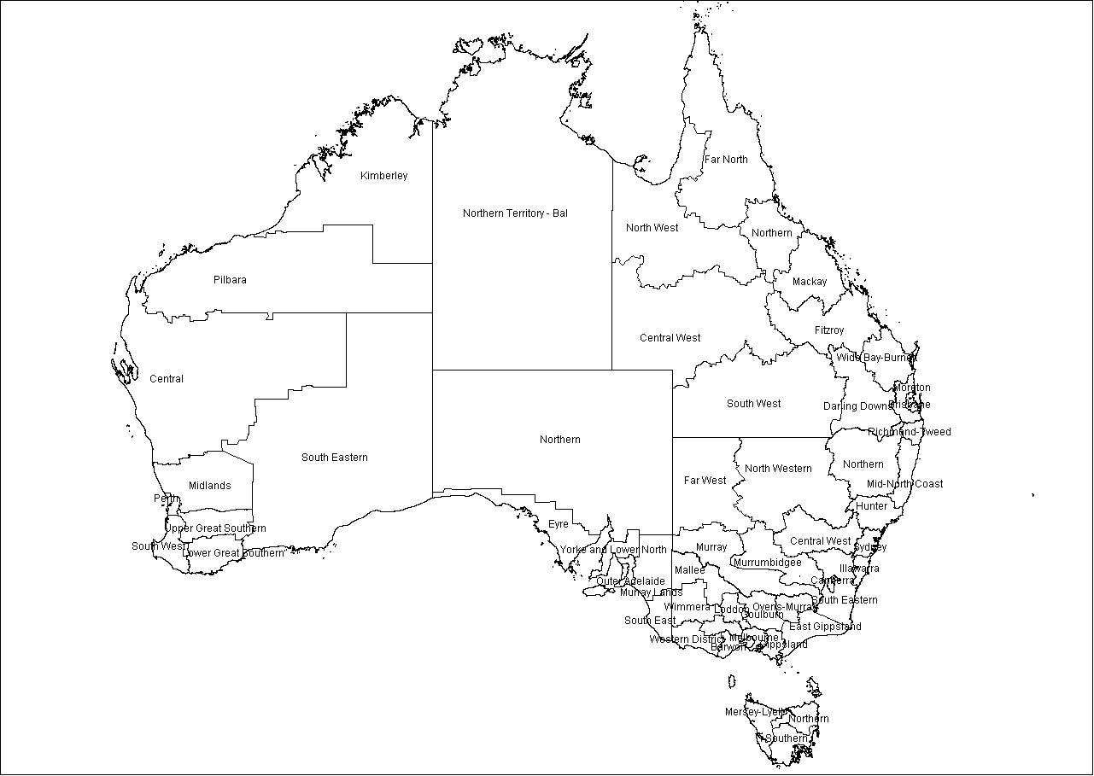
Greater Hobart

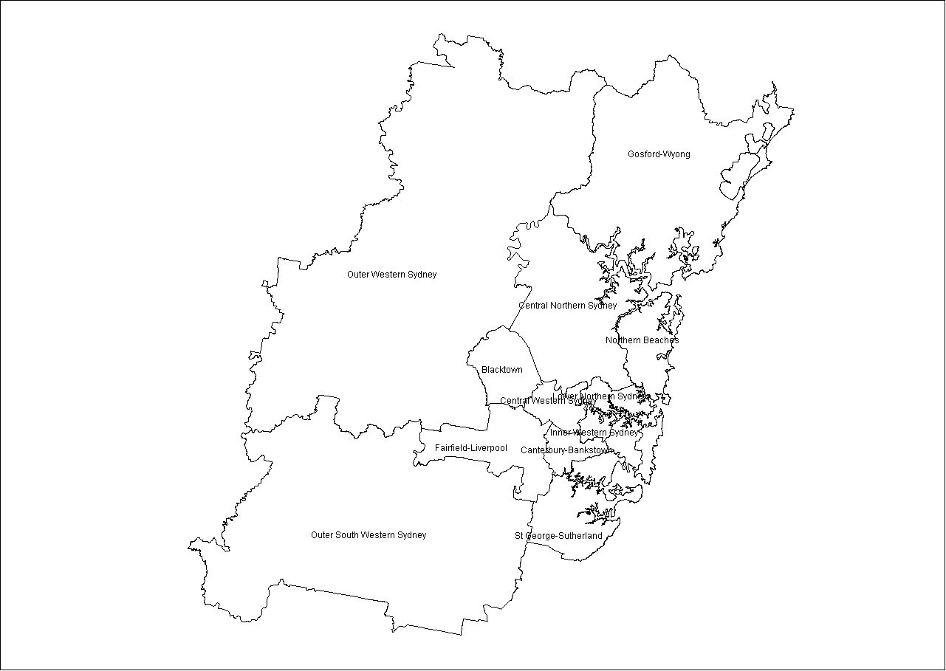

Sydney
Perth

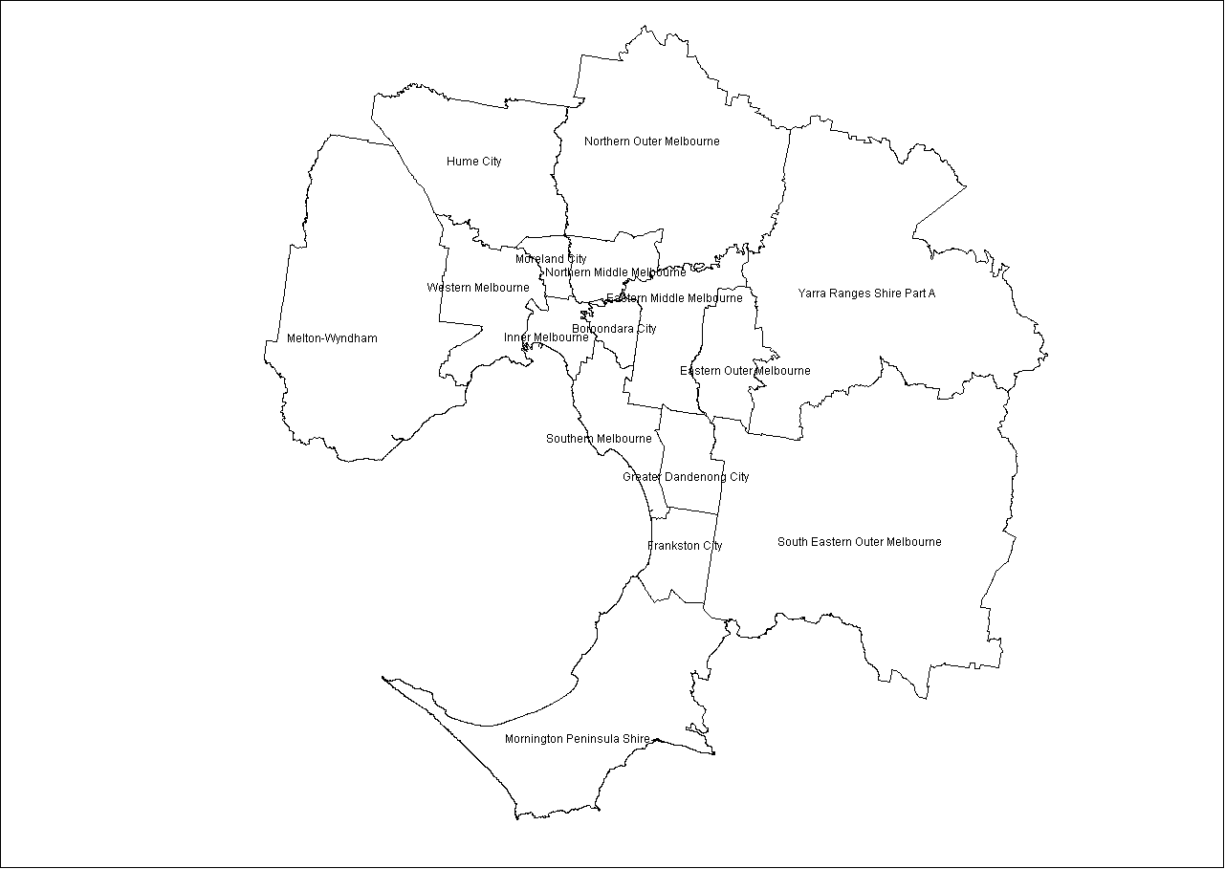
Melbourne

Brisbane

Adelaide
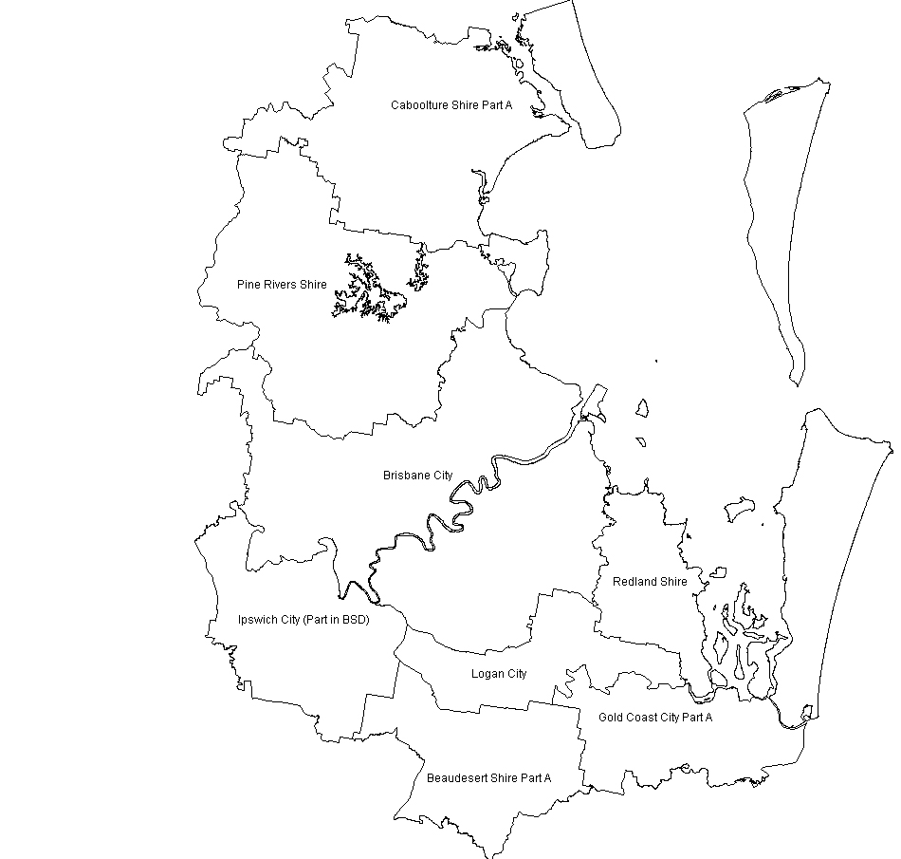


Appendix 2
VET delivery in the three case study regions
Source: NCVER (AVETMISS 2004)
Table A: Level of study in all VET (major qualification) (per cent distribution of students), 2004
 | Per cent
 | Ovens–Murray | Hume City | Midlands | Australia
Non-award/ Statement of attainment | 40.3 | 16.5 | 3.8 | 28.7
Certificate I | 2.0 | 8.3 | 9.1 | 5.0
Certificate II | 20.8 | 19.1 | 34.2 | 15.7
Certificate III | 22.7 | 32.3 | 36.7 | 26.4
Certificate IV | 8.8 | 11.0 | 14.7 | 12.2
Diploma | 4.1 | 8.7 | 1.6 | 8.5
Advanced Diploma and above | 1.3 | 3.0 | 0.0 | 3.0
School level (Year 11/12) | 0.3 | 1.2 | 0.0 | 0.6
Total | 100.0 | 100.0 | 100.0 | 100.0
Table B: Funding source, all VET (major qualification) (per cent distribution of students), 2004
 | Per cent
 | Ovens–Murray | Hume City | Midlands | Australia
Commonwealth and state recurrent funding for VET | 52.2 | 55.1 | 87.8 | 69.0
Commonwealth and state specific purpose funding for VET | 0.4 | 0.6 | 0.0 | 2.4
Fee-for-service funding (excluding private providers) | 47.2 | 43.3 | 12.2 | 27.2
Full fee-paying overseas client | 0.2 | 1.0 | 0.0 | 1.4
Total | 100.0 | 100.0 | 100.0 | 100.0
Table C: Provider type, all VET (major qualification) (per cent distribution of students), 2004
 | Per cent
 | Ovens–Murray | Hume City | Midlands | Australia
TAFE | 65.5 | 95.6 | 97.3 | 79.9
University | 0.0 | 0.0 | 0.0 | 1.0
Community Education Provider | 30.1 | 3.7 | 0.0 | 9.0
Agricultural College | 0.0 | 0.0 | 0.0 | 0.5
Private provider (excluding fee-for-service) | 4.4 | 0.8 | 2.7 | 10.4
Total | 100.0 | 100.0 | 100.0 | 100.0
Table D: Age distribution, all VET (major qualification) (per cent distribution of students), 2004
 | Per cent
 | Ovens–Murray | Hume City | Midlands | Australia
15-19 years | 15.0 | 30.3 | 27.7 | 23.5
20-24 years | 11.0 | 20.9 | 11.7 | 17.5
25-34 years | 20.2 | 20.8 | 22.0 | 20.8
35-49 years | 34.6 | 20.7 | 27.8 | 26.5
50-64 years | 18.2 | 7.4 | 10.7 | 11.6
Total | 100.0 | 100.0 | 100.0 | 100.0

