

**Do course durations matter to training quality and outcomes?**

**Josie Misko and Patrick Korbel**National Centre for Vocational Education Research

**Research Report**

### Publisher’s note

The views and opinions expressed in this document are those of NCVER and do not necessarily reflect the views of the Australian Government, or state and territory governments. Any interpretation of data is the responsibility of the author/project team.

To find other material of interest, search VOCEDplus (the UNESCO/NCVER international database <[http://www.voced.edu.au](http://www.voced.edu.au/)>) using the following keywords: course durations; community services; security qualifications; mandatory work placements; student outcomes; nominal hours, volume of learning; early childhood education and care qualifications, aged care, home care, and disability qualifications.

**© Commonwealth of Australia, 2019**

G:\pub_prod\PublicationComponents\logos\Creativecommons\CC BY logo.eps

With the exception of the Commonwealth Coat of Arms, the Department’s logo, any material protected by a trade mark and where otherwise noted all material presented in this document is provided under a Creative Commons Attribution 3.0 Australia <http://creativecommons.org/licenses/by/3.0/au> licence.

The details of the relevant licence conditions are available on the Creative Commons website (accessible using the links provided) as is the full legal code for the CC BY 3.0 AU licence <http://creativecommons.org/licenses/by/3.0/legalcode>.

The Creative Commons licence conditions do not apply to all logos, graphic design, artwork and photographs. Requests and enquiries concerning other reproduction and rights should be directed to the National Centre for Vocational Education Research (NCVER).

This document should be attributed as Misko, J & Korbel, P 2019, Do course durations matter to training quality and outcomes?, NCVER, Adelaide.

This work has been produced by NCVER on behalf of the Australian Government and state and territory governments, with funding provided through the Australian Government Department of Employment, Skills, Small and Family Business.

COVER IMAGE: GETTY IMAGES

ISBN 978-1-925717-36-5

TD/TNC 136.07

Published by NCVER, ABN 87 007 967 311

Level 5, 60 Light Square, Adelaide SA 5000  
PO Box 8288 Station Arcade, Adelaide SA 5000, Australia

**Phone** +61 8 8230 8400 **Email** [ncver@ncver.edu.au](mailto:ncver@ncver.edu.au)   
**Web** <https://www.ncver.edu.au> <<https://www.lsay.edu.au>>

**Follow us:** <https://twitter.com/ncver> <https://www.linkedin.com/company/ncver>



# About the research

### ***Do course durations matter to training quality and outcomes?***

### Josie Misko and Patrick Korbel, National Centre for Vocational Education Research

The connection between course durations, training quality and outcomes is of great interest to regulators, providers, industry stakeholders and the students themselves. In 2017, the Australian Skills Quality Authority (ASQA) undertook a strategic review of the issues related to unduly short training, recommending ‘that training package developers be able to respond to industry-specific risks by setting mandatory requirements, including an amount of training’(ASQA 2017, p.114).

The ASQA review also noted that terms such as ‘amount of training’, ‘duration and volume of learning’ are often used inconsistently. Discussions with stakeholders during this research similarly revealed that the terms are sometimes used interchangeably.

This research focused on the following qualifications: Certificate III and Diploma in Early Childhood Education and Care; Certificate III in Individual Support; Certificate IV in Disability; and Certificate II and III in Security Operations. The research was conducted in two parts: a qualitative analysis through consultations with providers, regulators and industry stakeholders to investigate how course durations affect the quality of training, and a quantitative analysis of course durations and how they affect subject outcomes.

For the quantitative analysis, duration is calculated as the length of time between a student starting and finishing training activity within a course, based on graduates who have not been granted recognition of prior learning (RPL) to complete a qualification. The resultant figure was then used to divide registered training organisations (RTOs) into two groups — those with the lowest graduate course durations and those with the highest.

Key messages

* The consultations highlighted some unease between the desire to specify minimum course durations to ensure that providers act appropriately and the desire to uphold and apply the fundamental features of competency-based training (generally perceived to be not time-based). This tension may always exist however in a system aiming to be flexible enough to meet the skill needs of different students and industry sectors, but rigorous enough to ensure that providers meet the quality standards required.
* The common view among study participants is that a high-quality training experience is not solely determined by the length of the course. Nevertheless, courses considered to be an appropriate or adequate length are those perceived as providing sufficient time for teachers to ensure that students can acquire the theoretical knowledge and practical skills to attain and demonstrate competency, and for assessors to conduct rigorous, reliable and valid assessments of student performance. These are deemed to be the key factors in producing high-quality outcomes.
* Quality is also perceived to be mediated by student and teacher ability and talent, as well as availability of and accessibility to required resources. These include: up-to-date and useful learning resources, equipment and materials; functioning online technologies (where permitted for training); and valuable practical experiences, via suitable work placements or realistic simulations (in the case of security qualifications).
* Any specification or guidance on ‘course durations’, ‘amount of training’ or ‘volume of learning’ for qualifications should be based on the Australian Qualifications Framework (AQF) level; the complexity of competencies and knowledge that are to be achieved; and the amount of content to be covered. It should also take account of the prior experience and knowledge of individual students.
* The statistical analysis finds that, across qualifications, typical graduate course durations for providers (as indicated by the median) vary across a range of course durations.
* In terms of how course durations affect outcomes, the only clear observation was a consistent pattern of higher proportions of withdrawals at courses with the highest median durations. This in turn resulted in lower pass rates for courses with longer durations. For some qualifications the differences are more marked than others.
* Regardless of course duration or the level of occupational licensing regulation applied in some jurisdictions, very high pass rates are observed for Certificate II and III qualifications in Security Operations by comparison with the average pass rates of other qualifications at the same AQF level.

Simon Walker  
Managing Director, NCVER

# Acknowledgments

The researchers acknowledge the time and effort taken by representatives from RTOs, peak industry bodies, regulators, and skills service organisations in participating in the consultations and providing candid accounts of processes both used and anticipated and how course durations may or may not affect training quality and outcomes.

P:\PublicationComponents\Icons\PaperClip_Purple.emfP:\PublicationComponents\Icons\References_Green.emfP:\PublicationComponents\Icons\Intro_Green.emfP:\PublicationComponents\Icons\ExecutiveSummary.emfContents

Executive summary 9

Introduction 13

Background 13

Scope of the study 13

Key research questions 14

Limitations 15

Remainder of report 16

Early childhood education and care 17

Provider consultations 17

Statistical analysis of how course durations affect subject results 23

Individual support and disability 29

Provider consultations 29

Statistical analysis of how course durations affect subject results 32

Security operations 38

Provider consultations 38

Statistical analysis of how course durations affect subject results 43

References 48

Appendix 49

A ASQA 2017 Strategic review on unduly short training 49

B List of named and de-identified organisations and participants   
in consultations 50

C The concepts of volume of learning, amount of training   
and nominal hours 52

D The importance of time for work placements 53

E Regulator perspectives, Education Standards Board SA 56

F Descriptive statistics — Early Childhood Education and Care 58

G The standards for aged care service providers 59

H Descriptive statistics — Individual Support and Disability 60

I Delivery approaches used by colleges delivering qualifications   
in Security Operations 61

J Australian Security Industry Association Limited (ASIAL) 63

K Regulatory agency for security operations qualifications   
(New South Wales) 65

L Descriptive statistics — Security Operations 67

M Subject outcomes by qualification level 68

# Tables and figures

## Tables

1 Subject outcomes for all students at selected RTOs studying Certificate III in Early Childhood Education and Care, 2015—17 (%) 25

2 Subject outcomes for all students at selected RTOs who were studying Diploma of Early Childhood Education and Care, 2015—17 (%) 28

3 Subject outcomes for all students studying Certificate III in Individual Support at selected RTOs, 2015—17 (%) 34

4 Subject outcomes for all students studying Certificate IV in Disability at RTOs with the highest and lowest median course durations, 2015—17 (%) 37

5 Subject outcomes for all students studying Certificate II in Security Operations at selected RTOs, 2015—2017 (%) 45

6 Subject outcomes for all students studying Certificate III in Security Operations at selected RTOs, 2015—17 (%) 47

B1 List of de-identified organisations and participants in consultations 50

F1 Descriptive statistics on course durations for Certificate III   
in Early Childhood Education and Care by funding source and provider type, 2015—17 58

F2 Descriptive statistics on course durations for Diploma of Early Childhood Education and Care by funding source and provider type, 2015—17 58

H1 Descriptive statistics on course durations for Certificate III in Individual Support by funding source and provider type, 2015—17 60

H2 Descriptive statistics on course durations for Certificate IV in Disability by funding source and provider type, 2015—17 60

L1 Descriptive statistics on course durations for Certificate II in Security Operations by funding source and provider type, 2015—17 67

L2 Descriptive statistics on course durations for the Certificate III in Security Operations by funding source and provider type, 2015—17 67

M1 Subject outcomes by qualification level, 2015—17 (%) 68

## Figures

1 Graduates of Certificate III in Early Childhood Education and Care by number of subjects granted as RPL, 2015—17 23

2 RTOs by minimum duration for a graduate to complete Certificate III in Early Childhood Education and Care between 2015 and 2017 24

3 RTOs by median duration for graduates to complete the Certificate III in Early Childhood Education and Care between 2015 and 2017 24

4 Graduates of Diploma of Early Childhood Education and Care by number of subjects granted as RPL, 2015—17 26

5 Median duration of graduates of Diploma of Early Childhood   
Education and Care by number of subjects granted as RPL, 2015—17 26

6 RTOs by minimum duration for a graduate to complete Diploma of Early Childhood Education and Care between 2015 and 2017 27

7 RTOs by median duration for graduates to complete Diploma of Early Childhood Education and Care between 2015 and 2017 27

8 Graduates of Certificate III in Individual Support by number of subjects granted as RPL, 2015—17 32

9 RTOs by minimum duration for a graduate to complete Certificate III in Individual Support between 2015 and 2017 33

10 RTOs by median duration for graduates to complete Certificate III in Individual Support between 2015 and 2017 33

11 Graduates of Certificate IV in Disability by number of subjects granted as RPL, 2015—17 35

12 Median duration of graduates of Certificate IV in Disability by number of subjects granted as RPL, 2015—17 35

13 RTOs by minimum course duration for a graduate to complete Certificate IV in Disability between 2015 and 2017 36

14 RTOs by median duration for graduates to complete Certificate IV in Disability between 2015 and 2017 36

15 Graduates of Certificate II in Security Operations by number   
of subjects granted as RPL, 2015—17 43

16 RTOs by minimum duration for a graduate to complete Certificate II in Security Operations between 2015 and 2017 44

17 RTOs by median course duration for graduates to complete Certificate II in Security Operations between 2015 and 2017 44

18 Graduates of Certificate III in Security Operations by number   
of subjects granted as RPL, 2015—17 45

19 RTOs by minimum duration for a graduate to complete Certificate III in Security Operations between 2015 and 2017 46

20 RTOs by median duration for graduates to complete   
Certificate III in Security Operations between 2015 and 2017 46

# P:\PublicationComponents\Icons\ExecutiveSummary.emfExecutive summary

The consultations with providers, regulators and industry peak bodies identified that course durations are among the key facilitating factors in a high-quality training program. On the other hand, the only clear observation emerging from the statistical analysis of the study’s qualifications of interest was a consistent pattern of higher proportions of withdrawals from courses with the highest median durations.

Evaluating how course durations affect the educational achievement or practical performance of students is not an easy task. Our stakeholder consultations have helped to provide some explanations about how course durations can affect the quality of the student training experience and the development of knowledge and skill, while our statistical analysis has shed some light on the relationship between course duration and subject results. Taken together, they provide us with nuanced picture, one that suggests that ‘time’ in courses is only one aspect of the issue. Other crucial aspects include understanding teacher excellence in training delivery, the extent to which students have mastered the skill and knowledge to the required standards, the relevance of the qualification to both students and industry, and the extent to which the training delivers the desired employment and or further training outcomes for the students. Also important are the indicators of employer and student satisfaction with training and the validity of assessments.

## Key lessons from the field

Providers, regulators and industry peak bodies from across the community services and security areas displayed little appetite for accepting the qualifications of registered training organisations (RTOs) that advertise and/or deliver qualifications in extremely short durations, particularly those offered over a weekend. Furthermore, the research identified a widespread tension between the desire for course durations that ensure that RTOs have enough time to cover the required content, as well as to provide adequate opportunities for student learning and practice, and the application of the fundamental philosophy of competency-based training, which is, in theory, not time-based.

There is generally strong support for the notion that course durations — of appropriate length for the qualification concerned — do play a part in achieving high-quality outcomes in our qualifications of interest. Adequate course durations give teachers the time to facilitate the comprehensive learning of the required knowledge and practical skills by students; students to put the learning into practice; and assessors to conduct rigorous assessments that result in valid and reliable judgements of student competency.

Course durations are, however, considered only part of the picture, with some providers giving more prominence to them than others. Other factors play a role in determining whether the durations are sufficient to achieve the desired outcomes. These relate to the individual attributes and capacity of the students, trainers and assessors, and workplace mentors. Also important are the availability of the required support, equipment and materials and the opportunities for work placements, as well as the volume of content to be covered.

A further issue influencing durations is the requirement for employers in some growth industries to have quick access to trained personnel to meet workforce demands or regulatory requirements; that is, having workers trained in shorter time frames.

In relation to the education and caring qualifications of interest to our study, providers and most other stakeholders strongly agree that course durations do, and should, vary according to whether the student is a new entrant to the industry or has previous course-related and industry experience, and whether the student requires extra tuition and time to acquire skills to the required standard. Providers from regional locations also indicated that typically students who live in regional, remote and rural locations will need to undertake their learning via distance learning or e-learning methodologies, which are dependent on access to reliable internet and telephone connections. When accessibility is interrupted, the amount of time that can be used for learning is reduced. Students in these areas are also dependent on the availability of work placements from a more limited number of centres.

In terms of the security qualifications examined, the situation is complicated by the differing licensing requirements across jurisdictions. In some states, for example, the number of hours and days that must be completed are mandated, as are the modes of delivery to be used (namely, face-to-face delivery). In other states, more flexibility is allowed, enabling the use of online learning for some components. However, even in states where course durations are mandated, providers recognise that hours may have to be increased when students require more support. The consultations also uncovered instances where providers exceeded the state regulator’s licensing requirements — for the purposes of not only assisting students who need more time to achieve the competencies, but also to meet their own specific requirements.

The concept of ‘amount of training’ is not always understood as separate from the concept of course duration. Good examples of how ‘amount of training’ can be used are provided by the Australian Security Industry Association (ASIAL), the peak body for the security industry, in its application of the concept of ‘auditable hours’ to ensure that students acquire adequate training for their occupations. The ARTIBUS and Innovation Skills Service Organisation (SSO) has also applied the concept of ‘amount of training’ by specifying the number of times that certain skills need to be demonstrated to prove competency. The Australian Skills Quality Agency (ASQA) has reported industry support for developing and applying concepts like ‘amount of training’ to training package guidance materials to ensure that RTOs do not apply unduly short durations, while SkillsIQ, the SSO developing the early childhood education and care qualifications, also reports some interest from employers on these issues.

Any specification of course durations, or ‘amount of training’, should also take account of the Australian Qualifications Framework (AQF) level of the qualification, the volume of content to be covered, the complexity of the competencies, and the type of knowledge to be achieved.

There is strong support for maintaining the mandatory work placements for qualifications in Early Childhood Education and Care, and Individual Support and Disability, requiring at least 120 hours (and often more) for certificate III and IV qualifications and 240 hours for diploma qualifications. The Certificate II in Security Operations is the exception, in that this industry does not accept students for work placement or experience; instead, realistic simulations are an essential part of the training.

A review of the Australian Qualifications Framework is currently underway. It remains to be seen whether it raises any issues about the suitability of the current ‘volume of learning’ hours that are attached to different levels and types of qualifications.

## Statistical findings

Findings from the statistical analysis show that most providers are not delivering the selected courses in the same duration and that they vary across a range of durations. For the Certificate III and Diploma in Early Childhood Education and Care, Certificate III in Individual Support, and Certificate IV in Disability, we observe that:

* The main difference between the RTOs with the lowest and highest median graduate course durations was the proportion of subject withdrawals. Students studying at RTOs with the highest median course durations withdrew from relatively more subjects than students studying at RTOs with the lowest median course durations. This situation is then reflected in the higher proportions of subjects passed by students at RTOs with the lowest median graduate course durations, compared with RTOs with the highest median graduate durations.
* For some qualifications, the differences in subject results achieved between RTOs with the lowest and highest median graduate course durations are large. In the Certificate III in Individual Support, the proportion of student subject withdrawals at RTOs with the highest median graduate course durations is over 10 times that of those at RTOs with the lowest median graduate course durations.
* The higher subject withdrawal rates associated with longer graduate course durations amongst these courses may possibly be attributable to the fact that longer course durations may have a more substantial and sustained effect on work and life commitments than shorter course durations.
* With one exception, subject fail rates were not observed to vary markedly with typical lower and higher durations (as indicated by the median). The exception to those general trends was the Certificate III in Early Childhood Education and Care, where there was a higher proportion of subjects failed by students at RTOs with the lowest median graduate durations.
* Median durations were also analysed by funding source and provider type, although no consistent pattern across the qualifications was noted. By funding source, median durations for domestic fee-for-service-funded training (compared with government-funded training) were slightly shorter for the Diploma of Early Childhood Education and Care (2 months), but longer for the Certificate III in Early Childhood Education and Care (1 month). Similarly, by provider type, median durations were slightly shorter at private training providers (shorter by 2 months compared with TAFE institutes) for the Diploma of Early Childhood Education and Care, but longer for the Certificate III in Early Childhood Education and Care (longer by 1 month compared with TAFE institutes). Median durations across funding sources and provider types were similar for the other qualifications (where there was a sufficient number of graduates to analyse).

Very different patterns to these other qualifications are observed for both the Certificate II and Certificate III in Security Operations:

* Almost all subjects were passed, irrespective of whether students were at RTOs with the lowest median graduate course durations or at those with the highest median durations.
* Across both qualifications, the proportion of subjects passed was at least 97%, compared with 83% across all certificate II level qualifications and 79% across all certificate III level qualifications.
* We observe the same patterns of very high pass rates even in those jurisdictions that are highly regulated (including Western Australia and New South Wales) and which also support high levels of independent assessment.
* Further investigation may explain why such patterns of very high passes occur in the assessment of these qualifications.

Although statistical information on course durations can provide some markers for action and decision-making, it cannot, on its own, tell us very much about the quality of the training delivered or experienced. Although we can speculate that students have withdrawn because they have been able to get a job without the qualification they originally thought necessary, or that work and other life commitments have become a priority, we require more information about the actual student experience in the training program to make any definitive comment on the link between duration and withdrawals and ultimately, course quality.

# P:\PublicationComponents\Icons\Intro_Green.emfIntroduction

## Background

The overarching aim for this project has been to determine the evidence for a relationship between course duration and quality of outcomes. A secondary aim is to investigate whether the addition of course duration specifications for training packages could improve the quality of outcomes from vocational education and training (VET).

The Australian Skills Quality Authority has undertaken a range of strategic reviews of specific qualifications (ASQA 2013a, 2013b, 2015b, 2015c), the most recent of which specifically targeted unduly short course durations (ASQA 2017). The findings indicated that a quarter of the courses had advertised durations that were less than the minimum AQF-suggested volume of learning hours, with around 8% advertising course durations of less than half of the minimum AQF volume of learning hours. This review (more detail is given in appendix A) formed part of a general debate within government, providers and industry on whether qualifications are being devalued by unscrupulous providers, who are prepared to award national qualifications based on very little evidence and often to students completing courses of very short durations, prompting suggestions that the competency-based qualification system has the potential to be undermined by such occurrences.

There is no established evidence that the duration of a course is the primary determinant of its quality: quality is a consequence of many inter-related factors. Extremely short durations, however, especially for students with no previous work experience in the industry sector served by the qualification, may not enable the student to acquire sufficient knowledge and practical skill to display the comprehensive understanding and practical competency that can only be acquired through repeated practice.

Given the substantial body of work undertaken by ASQA in identifying and highlighting the courses delivered in durations shorter than those prescribed by the AQF ‘volume of learning’ indicators, the key focus of this current study is on exploring the observed associations between the delivery of such shorter duration courses and the key outcomes for learners, employers, providers and regulators.

## Scope of the study

The study looks at six qualifications, selected to align with recent ASQA reviews, and the growing demand for these qualifications:

* *Early childhood education and care***:** Certificate III and Diploma in Early Childhood Education and Care (CHC30113 and CHC50113)
* *Individual support and disability***:** Certificate III in Individual Support (ageing, home care and disability) and Certificate IV in Disability (CHC33015 and CHC43115)
* *Security operations***:** Certificate II and III in Security Operations (CPP2012 and CPP30411, respectively).

For each set of qualifications, we discuss the findings from our consultations; this is followed by a statistical analysis of course durations and subject outcomes.

## Key research questions

* How do course durations affect the quality of learning?

To answer this research question, we consulted with providers (mostly managers and training practitioners at various levels of seniority), and representatives from industry and government (including peak bodies, training councils, relevant skills service organisations and regulators). Appendix B provides a list of the organisations (named and de-identified) participating in the consultations. The questions guiding the semi-structured consultations were customised to the roles of the various respondents, but they were all aimed at understanding the extent to which course durations affected the quality of outcomes. The questions were organised around the following general areas:

* contextual and background information about arrangements for the delivery and assessment of training, including hours allocated to different units and work placements
* experiences of how course durations have affected the quality of learning for students
* perceptions of the importance of time for the acquisition of skills.
* What is the profile of course durations in-each of the six courses?

We examine the range of course durations for each qualification by provider type, the uptake of recognition of prior learning (RPL) and the source of funding. We estimate course durations from the enrolment data submitted to the National VET Provider and National VET in Schools collections (using data from 2015 and 2017). Estimated durations are based on the length of time between the earliest known date of activity and the latest known date of activity.[[1]](#footnote-1) We do this for all subjects that a student has passed or had granted as RPL as part of one of those courses.

* How do subject enrolment outcomes differ across courses with different durations?

We first established the minimum number of subjects required to complete a qualification from information given on training.gov.au.[[2]](#footnote-2) We assumed that graduates who have one less subject than the minimum number have completed the relevant and mandatory unit of competency dealing with first aid or responding to emergencies for their particular qualifications. We then used graduate data for those completing between 2015 and 2017 from the Total VET Activity collections, comprised of the National VET Provider Collection and the National VET in Schools Collection, to depict for each qualification the profile of graduates who were or were not granted RPL. We keep in our analysis only the data of those *not* using RPL for completion of their qualification.[[3]](#footnote-3)

Using this information, we graph the profile of RTOs according to how long it took their graduates to complete qualifications, using our estimated durations method.[[4]](#footnote-4) Firstly, we plot RTOs according to the minimum graduate duration at each RTO to show the range of shortest durations across those RTOs. Secondly, we plot RTOs according to the median graduate duration at each RTO to show the range of typical course durations. These two plots visually explore the graduate duration profile across RTOs delivering each qualification. We also analyse graduate durations according to funding source (government funded, fee-for-service) and provider type (school, TAFE, university, enterprise provider, community education provider and private training provider).

Selecting the RTOs at the lowest and highest ends of the scale of median graduate durations and comparing the subject outcomes for all students (not only graduates), we analyse any differences in subject outcomes between those two groups of RTOs. We concentrate on differences in the percentage of subjects from which students withdrew and subjects in which students were granted recognition of prior learning (RPL).

## Limitations

Our consultations focused on the issues that have been most common across the providers consulted. Only the six courses selected are covered. The diversity of practices, industries and locations more broadly means that it is difficult to generalise too widely on the extent to which course durations affect training quality and outcomes in other qualifications. Nevertheless, we gain some insights from practices in the different fields, which can be used to inform the sector in general.

In interpreting and using the statistical data, the following limitations apply:

* The duration of the training activity is not a direct measure of the volume of teaching or learning that has been undertaken (see appendix C for definitions of volume of learning, amount of training, nominal hours). The calculation of course duration does not account for the intensity of the training activity (for example, number of hours per day) or the frequency or pattern of training (for example, part-time students or students taking extended breaks from training).[[5]](#footnote-5)
* The analysis relies on a student having a unique student identifier (USI) and its being reported to NCVER’s collections.[[6]](#footnote-6) The USI coverage (for students with a USI) in the 2017 collections was 86%.[[7]](#footnote-7)
* There are no strict validation rules in place regarding the submission of activity start and end dates to NCVER.[[8]](#footnote-8) An exception is that the start date must not be more than five years prior to the collection year.
* In many instances, we have identified fewer subjects reported in the data than are required for the completion of the course. These cases were excluded from the analysis (except where noted, when students were commonly missing a single unit).
* Excluded from the analysis are data for students for whom the latest year of activity was 2014.[[9]](#footnote-9)
* The observed minimum and maximum course durations are much shorter and longer than would be expected, but they are reported for completeness.

## Remainder of report

The remainder of the report deals separately with qualifications in Early Childhood Education and Care, Individual Support (aged care, home care and disability), Disability, and Security Operations. For each set of qualifications, we discuss findings from our consultations with providers, and industry and regulator stakeholders. This is followed by a presentation of the findings from our statistical analysis of course durations and subject outcomes, where data from the NCVER collections on Total Training Activity have been used.

# Early childhood education and care

## Provider consultations

#### Durations and delivery arrangements

Our consultations with providers reveal a range of durations for both the certificate III and diploma qualifications in Early Childhood Education and Care, with durations in some cases increasing substantially for a number of providers according to whether they are delivered externally or online. In general, RTOs participating in the consultations deliver the certificate III qualifications in about half the time they take to deliver the diploma qualifications. Certificate III qualifications generally take between five and six months to complete in some RTOs and around nine to 12 months in others. Diploma qualifications take between 12 to 24 months.

The Diploma in Early Childhood Education and Care is delivered in a variety of ways and across a range of time frames, depending on whether students are accessing the training through on-campus or off-campus arrangements. While providers may differ in the way they structure the course content and deliver the training, including the provision of learning support to students, there is typically a combination of face-to-face training, practical workshops, industry work placement and guided learning, the last undertaken in the student’s own time.

The use of online learning platforms, both by campus-based students and those studying remotely, is common. For one participating provider, online learning is core to its delivery strategy and students undertake all of their theoretical or knowledge components via guided learning activities using the college’s online learning platform. With this provider, face-to-face training is used in workshops to discuss the learning and clarify any issues.

All providers reported that they facilitate work placements, with, as a minimum, 120 hours for the certificate and 240 hours for the diploma. They also noted that they will also use their professional judgement to increase the number of hours where necessary to bring students up to standard and also to the level where learning has become embedded in students’ practice.

In places with facilities that can be used for simulations (including play groups) students can practise the key roles required in a centre (including director, team leader and educator roles) prior to embarking on a work placement. Practitioners claim that this enables students to meet parents and children as part of the play group prior to going on their placement.

The methods used for delivery will also affect how the hours are allocated. Where the ‘Flipped Classroom’[[10]](#footnote-10) approach is used, students are given access to topics on the provider’s e-learning platform. Students must complete this learning prior to coming to a face-to-face workshop.

Across providers there are arrangements for students to be screened or assessed for English language, literacy and numeracy difficulties prior to commencing the course and to access support if required. Where such learning support is not available in house and students require substantial help with these skills before they are ready to participate in the class, opportunities are available for providers to partner with other RTOs who may be delivering relevant programs, for example, the Skills for Education and Employment (SEE) program, the Certificate II in Skills and Vocational Training (Foundation Skills) program, or other qualifications aimed at developing English language proficiency. This enables students who do not pass the initial screening to develop their skills. In some cases, students who do not pass such tests are not enrolled in the course.

Student completion of the Core Skills Profile for Adults (the CSPA) test means that providers can identify student proficiency with English language and comprehension and use this to recommend or apply learning support required.

Childcare work requires people who can speak and understand English. Parents want carers and educators who can speak and understand English. There is also a need for enough time to help students adopt and understand appropriate cultural practices in terms in what is acceptable for childcaring and educating in Australia. (Early Childhood Education and Care program coordinator)

Providers say they use a range of information sources to determine the length of their course (generally listed as hours) and note that they will adjust their timelines to provide extra support for those students who require it.[[11]](#footnote-11) They will generally refer to the nominal hours listed in the Victorian Purchasing Guide[[12]](#footnote-12), look for references to the ‘volume of learning’ given in the AQF[[13]](#footnote-13) for the relevant level of the qualification, and locate the training package information on the size (the number of units and associated content to be covered) of the qualification (in terms of the units that must be covered).

While course durations (up to a certain baseline) are considered pivotal to the quality of teaching and learning, they do not tell the whole story. This is because in many cases more time is required to enable teachers and workplace mentors to perform their teaching, mentoring and assessment roles to meet the required standards. Additional time may also be needed to allow students to learn the necessary knowledge and skills to meet and/or surpass the competency levels required for employment and for achieving qualifications. However, while providers participating in the consultations consider course durations to play a key role in producing quality outcomes, they strongly believe that they do not work in isolation from other factors; namely, the expertise and engagement of teachers, the quality of the experiences provided, including during the work placement, and the willingness and capacity of the student to participate and complete the training.

The lack of a specified duration included in training packages is also felt by some participants in the consultations to add to the uncertainty about what should be considered as acceptable course durations. Some believe that this may have resulted in providers in the market offering courses in unduly short durations. A view held by some participants in the consultations is that there should be a minimum duration specified for qualifications and this should be based on the amount of time students spend in contact with teachers and trainers. Further, some participants believe that minimum durations should be mandatory for all providers. These views conflict with those consultation participants who believe that any focus on time durations would undermine the fundamental principles of competency-based training, principles intended to allow students to complete courses according to their rate of progression and achievement of competency.

A number of external factors not primarily concerned with the task of teaching and learning are considered by providers to affect the amount of teaching and learning time available for courses and, thus, the quality of the outcomes. They include:

* delays in the availability of resources required to deliver or assess the training and in the required clearances enabling students to work with vulnerable populations and attend work placements
* availability, accessibility and reliability of telephone and internet connections (for e-learning and distance learning)
* regulatory considerations, which also affect the amount of training to be conducted and the competencies to be achieved during course time.[[14]](#footnote-14)

While providers do not feel that these factors are a justification for poor-quality training or shorter course durations, they result in a reduction of the time that teachers have to present and facilitate learning and the amount of time that students have to practise skills.

In the main, providers participating in the consultations recognise the importance of durations of sufficient or reasonable length, those that assist students to get through the material, revisit what they have learnt and increase the depth of understanding of their occupations, industry sectors and the clients with whom they will be working. Durations of appropriate length mean more opportunity for teachers to provide students with feedback on their assignments, enabling them to make improvements, clarify questions and provide explanations to help with other issues. Students have more opportunities to ‘learn, contribute, discuss and reflect’, either in self-directed learning or in learning with their peers. This is felt to develop depth of underpinning knowledge.

It was generally accepted by participants that, in determining a ‘reasonable or sufficient amount of time’, providers need to consider the nature of the skills and knowledge that students bring with them. Although ‘time’ is generally felt to be an important consideration across providers, it is often qualified by comments like: ‘but you need to look at the quality of the time they spend in the classroom or in learning’. Student numbers was an issue as well: too many students would mean that the trainer would lack the time to look at the individual skills of students.

Providers reported a range of essential skills and knowledge they would include in courses if they had more course time with students. These include job-search skills, study and confidence-building skills for those returning to study after long absences, leadership skills for those preparing for supervisory roles, and flexibility in dealing with different challenges for those working in disability areas. More time with students would enable the development of greater in-depth knowledge of their intended occupations, the associated legal and regulatory issues, and industrial standards and protocols. Some providers currently offer such training (especially job-search skills and resumé writing) to their students outside course hours and on a voluntary basis.

As a senior lecturer in Childhood Education and Care emphasised: ‘We are focused on helping students get through so long as they meet the standards that are required; being able to meet the standards is critical’.

Practitioners from participating providers also reported that having more time available enables them to implement learning support programs. For example, in one participating college each student has a learning support plan, which takes account of their individual profiles and special needs, in addition to any employer feedback on performance in work placements. If the student requires more time to develop the required practical skills, then it is common for the RTO to schedule more time for the student to hone their skills. Learning support in another college is available in ‘study classes’, which are offered on a Wednesday evening (to suit those who are working) and a Friday morning. Students in these workshops will have access to trainers who can help them to clarify requirements for assignments and develop strategies that assist them to address feedback received on assessments.As an RTO manager explained: ‘No matter how long it takes, we want to support them even after the set number of hours have been completed’.

Longer durations do not necessarily guarantee completions, and in the experience of another provider they can be associated with higher drop-out rates, especially for distance students.

#### Mandatory work placements and how they affect perceived quality

Time for work placements must also be factored into course durations, not only for the practical experience they provide for students, but also because they can enable students to move into jobs. (Appendix D gives more details on the approaches used by different providers.) Employers use the work placement to identify students they might want to employ in their facilities or centres in the future. In fact, providers say that if the student is competent the employer will want them to stay on in the centre when they graduate. Trainers and assessors can use the work placement to visit the worksite to consult with educational leaders and mentors on the student’s progress and to implement any necessary remedial actions. A work placement also gives trainers and assessors sufficient time to assess the competency of students. However, the real issues do not relate to the need for the placements but the ability of industry to provide enough placements for the colleges that require them. It is important that industry understands its critical role in the development of the skills required to provide a pipeline of work-ready candidates. On the necessity for work placements, a lecturer in Childhood Education and Care confirms: ‘If there were no time for work placements, then students would not get to understand that no two children are the same’.

It is also important to note that providers commonly believe that the experience students receive in the placement is only as good as the work site (the personnel) that provides it. The type of practice and understanding modelled in the site is important for student learning.

In looking at how course durations affect the quality of the training, it is instructive to learn from the experiences of teachers who have delivered the same course in longer and shorter durations.

##### Box 1: Practical trials of shorter course durations in one large provider

In delivering the Certificate III in Early Childhood Education and Care one provider participating in the consultations wanted to investigate whether the course that currently takes nine to 12 months to complete could be completed in six months   
(a course duration that was beginning to appear as the norm in the private sector). Teachers report that the shortened course did not provide adequate time for the units to be covered sufficiently, finding that, although the more competent students managed to pass all the units in the available time, others did not pass all the units required. Nevertheless, the competent students felt pressured, while the others perceived themselves as failures. Additional pressures were also felt by the teachers because they had to rush through classes to cover the units and to arrange placements. A return to the original nine to 12-month duration ensued, further prompted by some negative feedback from employers about student work-readiness, as well as the introduction of additional units into the next version of the training package.

#### Industry perspectives

Our discussion with the skills service organisation that develops Early Childhood Education and Care qualifications (SkillsIQ) confirms the lack of reference to course durations and ‘amount of training’ in these training packages. The only time-related specifications are those that mandate the number of hours of work placement required for the assessment of competency in specific units of competency.

Prescriptions of time are also felt to have other consequences, such as restricting the ability of RTOs to be innovative in their training and delivery or proactive in making their own decisions about how they will approach the structuring of training. Although employers were reported to have raised issues at times about the adequacy of the prescribed hours of work placements, more often than not the issue was related to the quality of the training and the resources and experiences available to students in the workplace rather than the duration of the placement.

Mandated duration may have additional implications for learners, as it locks them into an inflexible time period for training, which may be unrealistic in some cases. As a skills service organisation representative explains:

If we are going to specify minimum durations then how are we going to deal with recognition of prior learning (RPL) and prior and current experience, especially when those who have had prior experience in the sector may be able to demonstrate competency sooner than those with no experience. Furthermore, if we were to recommend durations there is a very real chance that students (say, in aged care, but also in other qualifications like hospitality) may not complete, especially if the employer does not want to send them for training due to the time required out of the workplace or if they decide to just stop training and set up their own businesses as they feel they ‘know enough’ to do so. This has occurred within the hairdressing industry.

#### Regulator perspectives

In our consultations we also spoke to a state regulator for the early childhood education and care sector: the Education Standards Board of South Australia (ESB), the state government authority that regulates early childhood services and schools. This work is done to ‘ensure high-quality education services and high standards of competence and conduct by providers’. The board’s main functions are: approving early childhood services; assessing and rating early childhood services; educating about compliance with the law; taking action if providers are not complying with the law; registering schools and reviewing the registration of schools. The Education Standards Board adheres to the National Quality Framework for the regulation, assessment and quality improvement for early childhood education and care and outside school hours care services across Australia. The Australian Children’s Education and Care Quality Authority (ACECQA) National Quality Standard is a key component of the National Quality Framework.[[15]](#footnote-15)

The Education Standards Board’s interest in the question of course duration and quality, including that related to work placements, is mainly concerned with its role in monitoring the qualifications of educational leaders in childcare centres (mainly the Diploma of Early Childhood Education and Care). Our consultation with the Chief Executive/Registrar and senior officers of the board provided us with further insights into how course durations, especially when they are too short, can compromise the quality of training, including in work placements. The consultations with the South Australian regulator also confirmed views provided by other participants: that course durations cannot on their own guarantee quality.

Shorter course durations (especially for new entrants to the sector) are perceived to have consequences for the student in relation to work placements, as well as when he or she commences employment in a centre. These relate to the risk of poor-quality care and learning for children and the potential for compromising the safety of both the student and the child. As explained by an officer from the South Australian Education Standards Board:

Course duration is one factor, but we have to think more holistically and consider the capacity of the student to learn and the quality of the assessment process. A robust assessment should and could identify shortcomings in the training.

There is strong support for specifying the amount of training and course durations in training packages, especially for new entrants to the field. The amount of training expected of experienced workers will depend on the quality and nature of their experience. In these cases, the real issue is concerned with validating the experience. Notwithstanding these considerations, it is felt that there may still be a need for experienced educators coming into the system to update their skills and knowledge (such as first aid, occupational health and safety, current legislation and Australian Children’s Education and Care Quality Authority standards).

Without a specific duration or amount of training mandated, students who come into the diploma and lack a certificate III are considered to pose a risk to the esteem in which the qualification is held.

Appendix E provides a more detailed account of our consultation with the regulator.

## Statistical analysis of how course durations affect subject results

We profile course durations in the Certificate III in Early Childhood Education and Care and the Diploma of Early Childhood Education and Care and analyse how these durations affect subject outcomes.

#### Certificate III in Early Childhood Education and Care

According to the training package guidelines for this qualification[[16]](#footnote-16), students are required to complete 18 subjects, including HLTAID004: Provide an emergency first aid response in an education and care setting. Where students have only 17 completed subjects recorded, we assume that they have completed this first aid unit. In our analysis we also consider only graduates for whom we have a record of only 17 or 18 subjects passed or granted as RPL.

We find that the vast majority of graduates completed the qualification without any subjects granted as RPL, so we further restrict our analysis to the 24 794 graduates who passed 17 or 18 subjects (indicated in purple) of the total of 25 787 graduates (figure 1).

Figure 1 Graduates of Certificate III in Early Childhood Education and Care by number of subjects granted as RPL, 2015–17

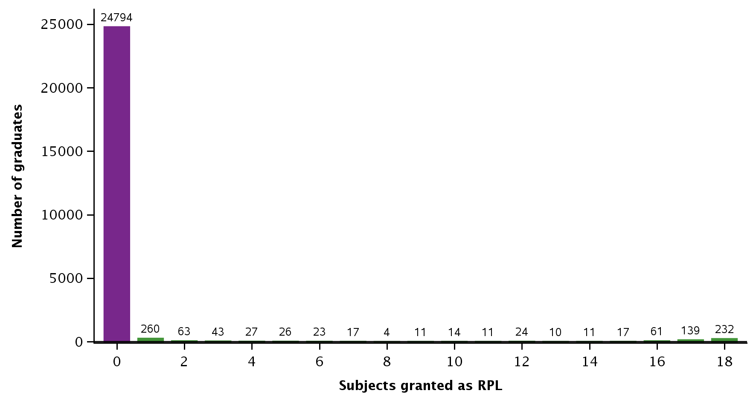

Note: Only includes graduates with a record of only 17 or 18 subjects passed or granted as RPL. For some graduates we identified more or less than 17 or 18 subjects, but they are excluded from this analysis.

As these graduates with no recorded RPL have completed all of the training and assessment required to be passed as competent, we can compare their durations at different providers. We restrict our analysis to the 166 RTOs with a minimum of 25 graduates between 2015 and 2017 to reduce the impact of any outliers.

Of these RTOs, there were 78 RTOs (47%) with at least one graduate completing their qualifications in fewer than four months (figure 2). Median durations at these RTOs varied by up to 20 months, but the median duration was 6 to 11 months at most RTOs (figure 3). However, for almost all of these RTOs, at least half of their graduates were taking at least four months to complete the qualification (figure 3).

Figure 2 RTOs by minimum duration for a graduate to complete Certificate III in Early Childhood Education and Care between 2015 and 2017

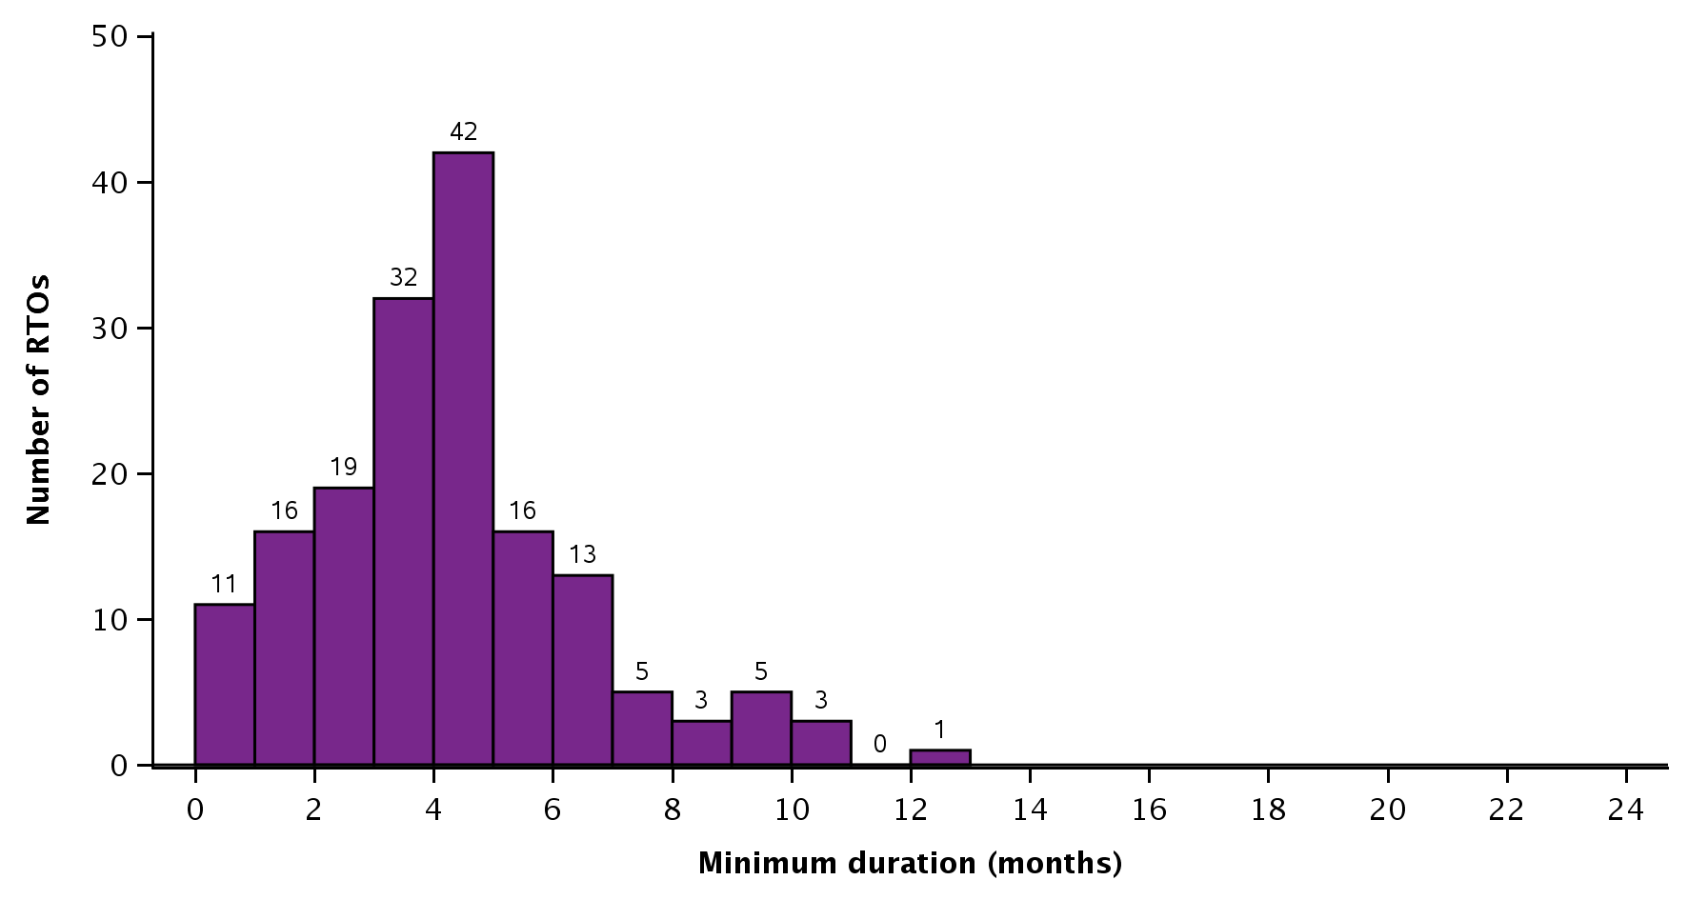

Notes: Figure indicates the minimum observed duration at each RTO between 2015 and 2017, so it may only represent the duration of a single graduate at each RTO. Only includes the 166 RTOs with at least 25 graduates between 2015 and 2017. Only includes the 24 794 graduates that passed 17 or 18 subjects and had no RPL granted (figure 1).

Figure 3 RTOs by median duration for graduates to complete Certificate III in Early Childhood Education and Care between 2015 and 2017

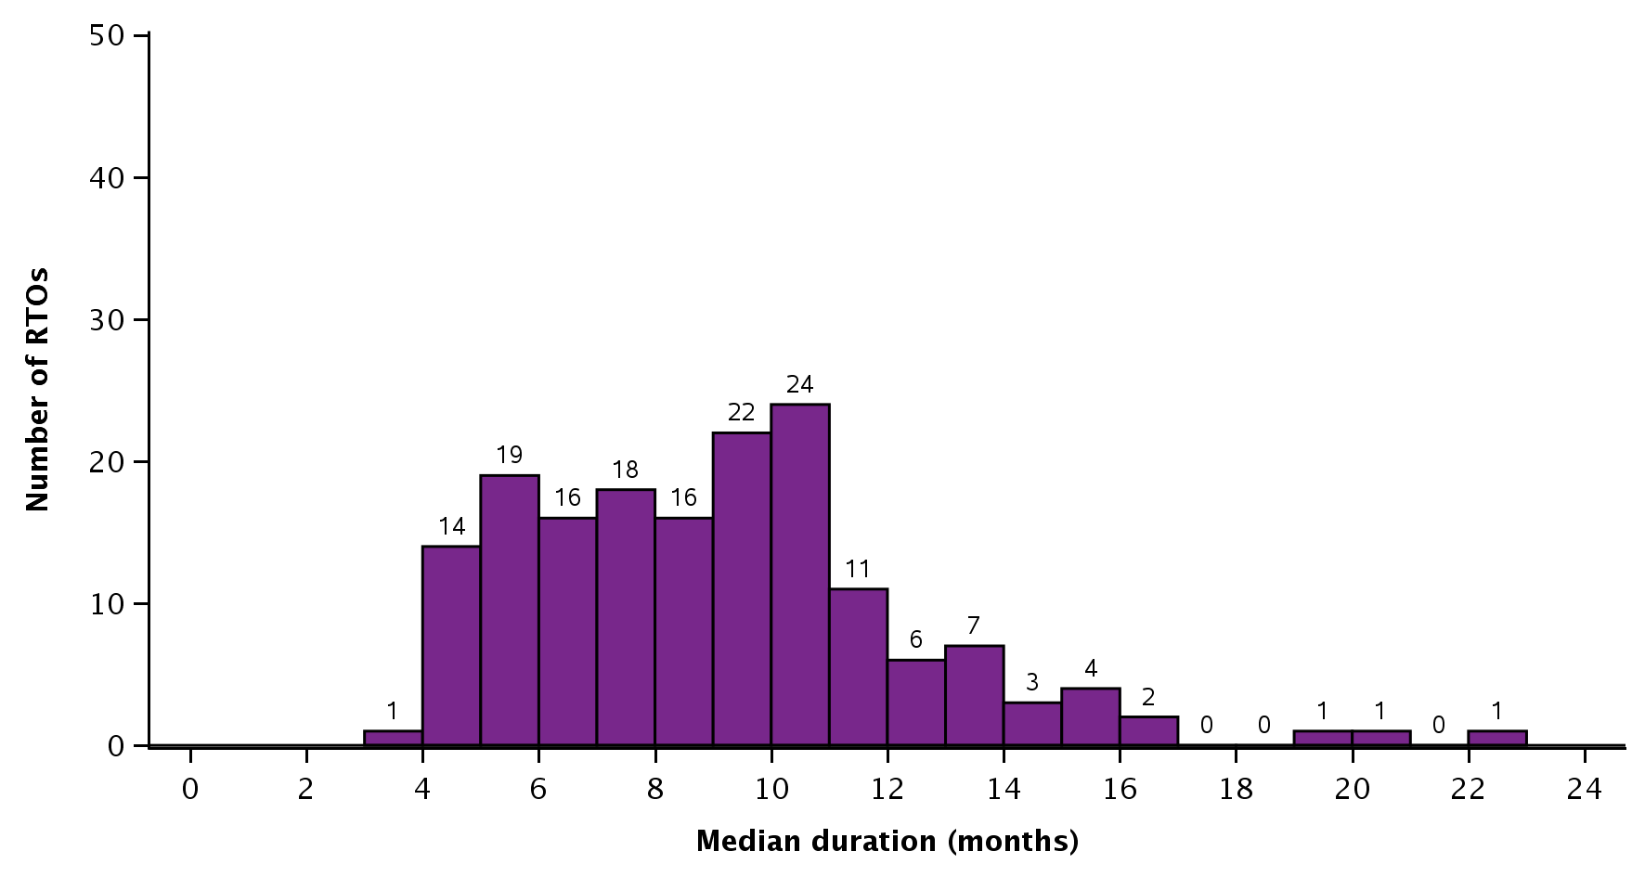

Notes: Only includes the 166 RTOs with at least 25 graduates between 2015 and 2017. Only includes the 24 794 graduates who passed 17 or 18 subjects and had no RPL granted (in figure 1).

There is a little variation in course durations when considering funding source and provider type (appendix F, table F1). Median durations were around one month shorter for government-funded training compared with domestic fee-for-service-funded training. When we examine median durations by provider type, we find that they are shorter for graduates training at TAFE (technical and further education) institutes compared with community education providers and private training providers.

The minimum and median durations give an indication of how long graduates take to complete the qualification, but on their own these are not reliable indicators of the quality of the training or outcomes. If we look at subject outcomes, however, we can gain a limited indication of the experience of all students (including graduates) at these RTOs. To do this we modify the scope of our analysis and consider the subject outcomes of all students studying the Certificate III in Early Childhood Education and Care at RTOs, concentrating on the lower and higher ends of the scale in figure 3.

For RTOs with the lowest median durations for graduates, 8% of subject enrolments for all of their students resulted in a fail, compared with 1% at RTOs with the highest median durations for graduates (table 1). The difference between the percentage of subject withdrawals was similar. While there is some variation, this does not indicate extreme differences between these groups of RTOs.

However, there are more subject enrolments ending in a withdrawal at RTOs where graduates tend to take longer to complete. This could be a result of the characteristics of those students (related to personal reasons) rather than the quality of the training at those RTOs.

Table 1 Subject outcomes for all students at selected RTOs studying Certificate III in Early Childhood Education and Care, 2015–17 (%)

|  |  |  |
| --- | --- | --- |
|  | RTOs with lowest median  duration (3–5 months) | RTOs with highest median duration (15–23 months) |
| Assessed – pass | 77 | 73 |
| Assessed – fail | 8 | 1 |
| Withdrawn | 15 | 22 |
| RPL – granted | <1 | 3 |
| Total | N = 58 210 | N = 81 265 |

Note: The two groups are based on the 10 RTOs with the lowest median duration and the 10 RTOs with the highest median duration, based on figure 2. Includes all enrolments in the Certificate III in Early Childhood Education and Care by all students at selected RTOs (not just enrolments by graduates).

#### Diploma of Early Childhood Education and Care

Twenty-eight subjects are required to complete the diploma.[[17]](#footnote-17) Once again our assumption is that students with 27 subjects recorded had already completed HLTAID004: Provide an emergency first aid response in an education and care setting. Here we consider only graduates for whom we have a record of only 27 or 28 subjects passed or granted as RPL.

A majority of the 11 584 graduates completed the qualification without having any subjects granted as RPL; that is, 8738 graduates (75%) (indicated in purple in figure 4). However, a substantial number — 1814 graduates (16%) — had all or almost all of their subjects granted as RPL. Understandably, graduates with at least 26 subjects granted as RPL had significantly shorter median durations than other graduates (figure 5)

Figure 4 Graduates of Diploma of Early Childhood Education and Care by number of subjects granted as RPL, 2015–17

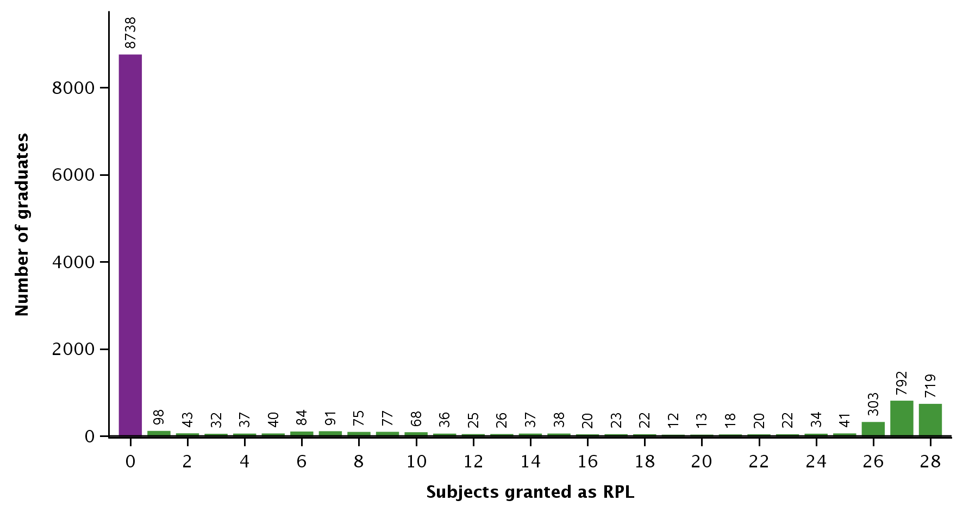

Note: Only includes graduates with a record of only 27 or 28 subjects passed or granted as RPL. For some graduates we identified more or less than 27 or 28 subjects, but they are excluded from this analysis.

Figure 5 Median course duration of graduates of Diploma of Early Childhood Education and Care by number of subjects granted as RPL, 2015–17

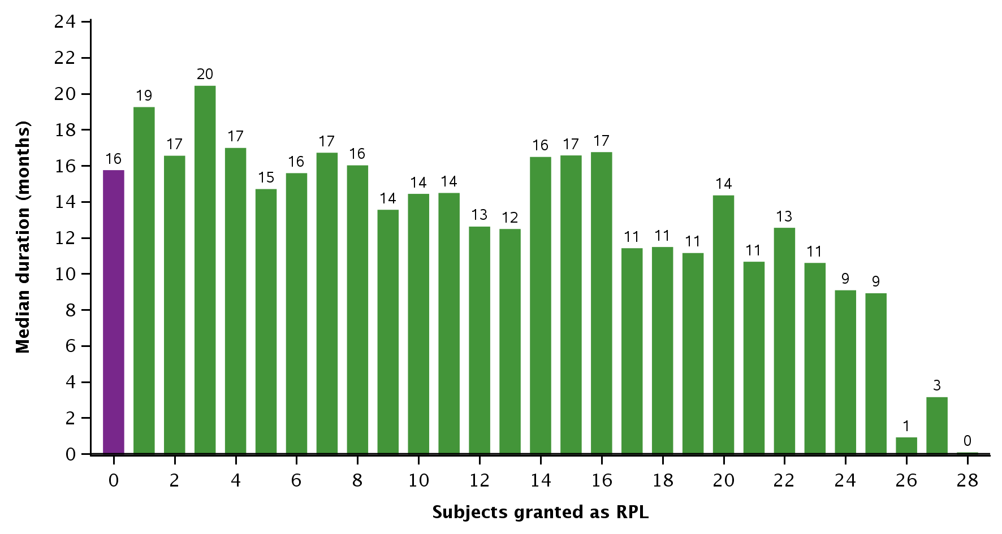

Note: Only includes graduates with a record of only 27 or 28 subjects passed or granted as RPL. For some graduates we identified more or less than 27 or 28 subjects, but they are excluded from this analysis.

From here, we further restrict our analysis to the 8738 graduates who passed 27 or 28 subjects and had no subjects granted as RPL (figure 4).

As these graduates have completed all of the training and assessment required to be passed as competent, we can compare the durations between providers. To reduce the impact of any outliers, we also restrict our analysis to the 78 providers with a minimum of 25 graduates between 2015 and 2017.

There appears to be more variation in the minimum and median durations for graduates who completed the Diploma of Early Childhood Education and Care (figures 6 and figure 7), compared with those for the Certificate III in Early Childhood Education and Care (figures 2 and 3). Median durations at these RTOs varied by up to 22 months, but the median duration was 10 to 17 months at most RTOs (figure 7). One explanation could be that students might be studying the diploma part-time while working in childcare.

Figure 6 RTOs by minimum course duration for a graduate to complete Diploma of Early Childhood Education and Care between 2015 and 2017

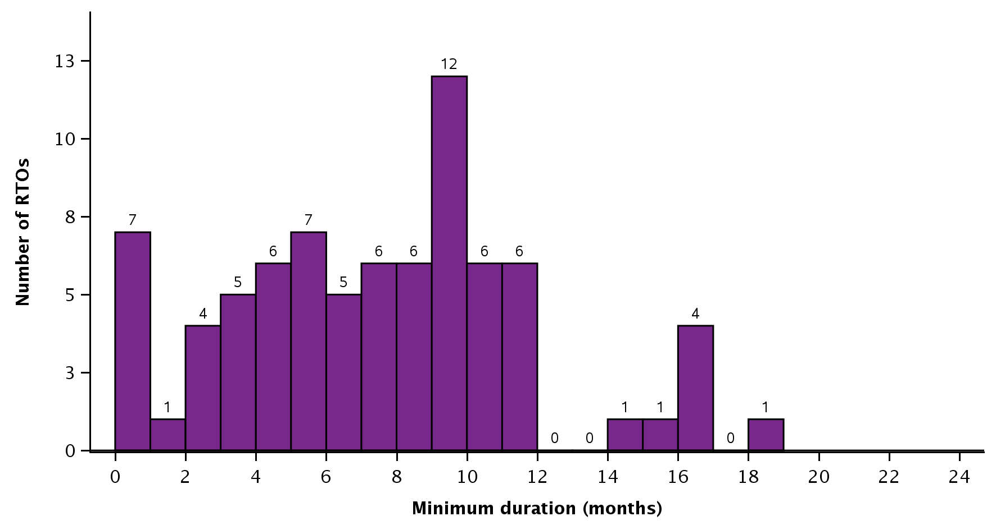

Notes: Figure indicates the minimum observed duration at each RTO between 2015 and 2017, so it may only represent the duration of a single graduate at each RTO. Only includes the 78 RTOs with at least 25 graduates between 2015 and 2017. Only includes the 8738 graduates who passed 27 or 28 subjects and had no RPL granted (figure 4).

Figure 7 RTOs by median duration for graduates to complete Diploma of Early Childhood Education and Care between 2015 and 2017

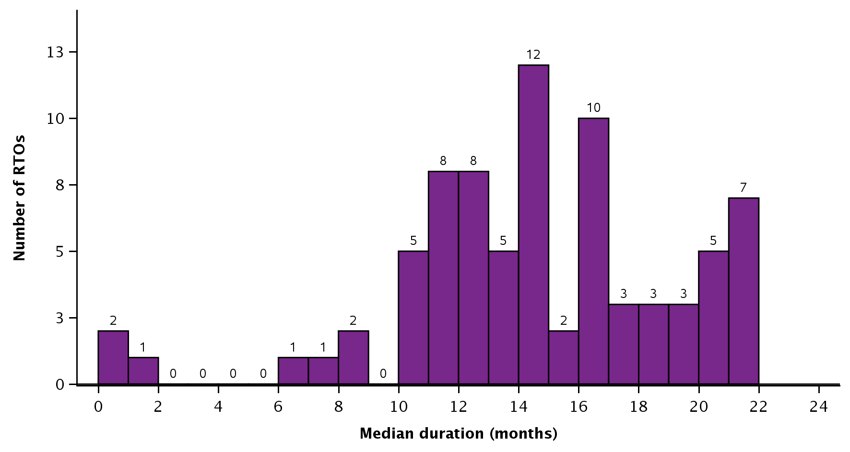

Note: Only includes the 78 RTOs with at least 25 graduates between 2015 and 2017. Only includes the 8738 graduates who passed 27 or 28 subjects and had no RPL granted (figure 4).

The RTOs with median course durations of fewer than nine months are worth further investigation, as this is based on graduates who had no RPL granted (figure 7). One of those RTOs was only registered from April 2016 to June 2017 and another voluntarily relinquished its registration in April 2017. Two other RTOs advertise the qualification on their respective websites as taking at least 18 months. We have limited ability to investigate these cases and cannot preclude the possibility of errors in data reporting.

We find some variation in course durations when we analyse them by funding source and provider type (appendix F, table F2). In contrast to the findings for the Certificate III in Early Childhood Education and Care, median durations were around two to three months longer for government-funded training (compared with domestic fee-for-service training) and training at TAFE institutes (compared with community education providers and private training providers).

The minimum and median durations give an indication of how long graduates are taking to complete the qualification, but on their own they are not reliable indicators of the quality of the training or outcomes. To fill this gap, we can get some indication of the experience of students at these RTOs by looking at their subject outcomes (table 2). We expand the scope of our analysis to consider the subject outcomes of all students (not only graduates) studying the Diploma of Early Childhood Education and Care at RTOs whose median course durations are at the lower and higher ends of the scale in figure 7.

At RTOs with the lowest median durations for graduates, 24% of subject enrolments for all students resulted in a positive RPL assessment, compared with 6% at RTOs with the highest median durations for graduates (table 2). The difference between the percentage of subject withdrawals is similar.

The relatively high percentage of RPL at RTOs where graduates tend to take less time to complete (table 2) does not explain the results in figure 5 (which are based on graduates that recorded no subjects granted as RPL).

Similar to the Certificate III in Early Childhood Education and Care, there were more withdrawals for students at RTOs with longer graduate course durations. This could be a result of the characteristics of those students (perhaps personal reasons) rather than the quality of the training at those RTOs.

Table 2 Subject outcomes for all students at selected RTOs who were studying in Diploma of Early Childhood Education and Care, 2015–17 (%)

|  |  |  |
| --- | --- | --- |
|  | RTOs with lowest median  duration (0–10 months) | RTOs with highest median duration (21–22 months) |
| Assessed – pass | 72 | 66 |
| Assessed – fail | 1 | 2 |
| Withdrawn | 3 | 25 |
| RPL – granted | 24 | 6 |
| Total | N = 44 710 | N = 202 538 |

Note: The two groups are based on the 10 RTOs with the lowest median duration for graduates and the 10 RTOs with the highest median duration for graduates, based on figure 7. Includes all enrolments in the Diploma of Early Childhood Education and Care by all students at selected RTOs (not just enrolments by graduates).

# Individual support and disability

## Provider consultations

#### Durations and delivery arrangements

The Certificate III in Individual Support (ageing, home, community, disability) is reported by providers to take, on average, about four to six months to complete, with duration extended for those students who require extra assistance. Here we focus mainly on the aged care specialisation. The Certificate IV in Disability, which focuses on supervisory skills, will generally take students about six months to a year to complete.

Providers claim that they use a range of information to determine the length of their course (generally listed as hours) and note that they will adjust their timelines to provide extra support for those students who require it.[[18]](#footnote-18) They will generally refer to the nominal hours listed in the Victorian Purchasing Guide[[19]](#footnote-19), look for references to the volume of learning in the AQF[[20]](#footnote-20) for the relevant level of the qualification, and locate the training package information on the size (the number of units and associated content to be covered) of the qualification (in terms of the units that must be covered).

These qualifications are new and notably have more competencies and material to get through by comparison with the prior qualifications. This is perceived to have resulted in a major shift for course developers and to have increased course duration length. Regulatory changes have also affected the requirements for qualifications in disability studies. For example, in the new Certificate IV in Disability, RTOs are required to engage more regularly with industry, increase their focus on duty-of-care issues and legislative frameworks, and comply with extra regulatory frameworks. In addition, students are not only required to develop a depth of understanding but also have the ability to articulate the reasons for things being done in a certain way. Sufficient time for reflection and discussion is considered essential for students to develop these skills. Other complexities, such as those associated with the implementation of the National Disability Insurance Scheme, have affected how other disability qualifications are delivered. Suggestions are made for more industry-based professional development to help these workers.

Providers report that shorter course durations are especially preferred by students wanting to enter the job market as rapidly as possible (particularly new migrants and unemployed Australians) to enable them to earn income to support themselves and their families. These economic considerations are also felt to be critical because of the potential for students to be exploited by unscrupulous providers. Providers also report that shorter courses are also preferred by employers, who need to find suitably qualified employees not only to meet staff shortages but also to ensure that they remain compliant with their regulatory obligations.

For some practitioners, the question of longer course durations needs to be considered in terms of the opportunity costs for the student. For example, providers have speculated that the issue of course durations may distort the choices students make about pursuing a VET or university course. These are similar viewpoints to those reported by ASQA (2017) in its strategic review of unduly short course durations. While not directly related to the design of the regulatory framework, such external pressures should be considered because of the effects they may have on student choice of qualification.

Providers support course durations of sufficient or reasonable length to help students get through the learning material, revise what they have learnt and develop a strong understanding of the occupations and industry sectors they will be entering and the clients with whom they will be working. More time means that teachers can provide considered feedback to students, in class and on their assignments. More time also allows students to ask questions of clarification, apply the feedback they have been given, and practise the skills they have been taught. Students have more opportunities to ‘learn, contribute, discuss and reflect’, either in self-directed learning or in learning with their peers, which is considered to develop depth of underpinning knowledge. In the words of one provider:

If you are teaching someone to drive a car you would not expect them to be able to understand the road rules, learn the skills, understand the safety issues, and get the practice in a day or a weekend, they will need a reasonable amount of time. (Educational manager, aged care)

The availability of learning support (in different forms) is common, with participants indicating that some students will benefit from having more time to comprehend the learning content and practise the skills required. On many occasions it is the students who have not previously been employed and/or have no or limited experience with using information technology tools who struggle with the time-management skills needed to complete their studies. Competencies like ‘what to do in an emergency’ may also prove difficult for some students, irrespective of their academic abilities.

There is a strong demand for workers in the aged care industry, resulting, it is believed, in students rushing to train for jobs in this sector and providers rushing to deliver the Certificate III in Individual Support (Aged Care). Again, we refer to the trial of shorter course durations for the Certificate III in Aged Care, replaced by the Certificate III in Individual Support (Aged Care).

##### Box 2: Trial of shortened aged care course

One public provider implemented a trial of a shortened course for the Certificate III in Aged Care. The original course duration was six months. The trial delivered an intensive six-week course prior to the student embarking on work placement. This approach was found not to be manageable, mainly because students could not accommodate the blocks of time required for the intensive up-front training in their work and life commitments. For the teachers, this condensed approach meant they were constantly working with students who needed to catch up on their learning. Due to these issues a decision was made to return to the original six-months approach.

#### Industry perspectives

The SSO that develops qualifications for Early Childhood Education and Care also has responsibility for Aged Care and Disability qualifications. We have already reported on the position of SkillsIQ on the issue of course durations. The sentiments they have expressed about course durations also apply here.

Our discussion with the Aged Care Services Association (ACSA), one of the peak bodies for the aged care sector, reveals that in recent times issues relating to course durations have been preoccupying the sector, especially when students are perceived to graduate from programs without the required skills. Also noted was that some attempt has been made to incorporate time specifications into the training package competencies for these qualifications by specifying that assessments must be undertaken in the workplace for specific units. This ensures that students will have been given the opportunity to become competent in these skills and to demonstrate competence in the workplace.

However, the Aged Care Services Association is reluctant to make an association between course durations and the quality of training outcomes, mainly because of the many other factors that need to be considered, including both the ability of students to undertake the learning and teachers to deliver the training.

#### Regulator perspectives

We also sought information from the regulator for the aged care sector: the Aged Care Quality and Safety Commission, formerly the Australian Aged Care Quality Agency (AACQA). Our discussions with an agency officer revealed that there are no mandatory qualifications for aged care and home care workers.

The education and training of the residential aged care workforce and home care workforce is achieved by application of current (but soon to be replaced) standards for quality assurance: the Accreditation Standards and the Home Care Common Standards.[[21]](#footnote-21)

Officers from the regulator (formerly AACQA) will visit sites to assess the extent to which these sites are implementing the standards and achieving the specified outcomes. As explained by an AACQA officer: ‘In this case we would be looking to see evidence of appropriate training of staff and evidence of quality performance’. The Accreditation Standards refer to the need for service providers to have appropriately skilled and trained staff, and service providers are expected to meet these standards. Accordingly, providers will devise their own induction programs for new workers, which may include a range of relevant topics such company orientation, mandatory training, manual handling, fire safety, managing feedback and so on. The regulator will examine the service’s philosophies and policies that relate to training but will also look for indicators of performance that show that such training has occurred and that the required outcomes have been achieved.

In our consultation with AACQA we discovered that a diversity of recruitment approaches are used by employers, with most organisations perceived to prefer potential employees holding the certificate III qualification or who are willing to undertake it. Some will only take those who have completed this qualification; other organisations will accept qualifications considered to be equivalent or relevant. Sites in remote locations have difficulties in recruiting workers with the appropriate qualifications or experience, an issue revealed to us previously in our consultations with practitioners.

More details on the different standards are provided in appendix G. We note that it is up to the aged care services to demonstrate compliance with the standard for recruiting appropriately skilled staff.

## Statistical analysis of how course durations affect subject results

### Certificate III in Individual Support

Thirteen subjects are required to complete the Certificate III.[[22]](#footnote-22) Our assumption is that students with 12 subjects recorded had already completed the elective HLTAID003: Provide first aid. We consider only graduates for whom we have a record of only 12 or 13 subjects passed or granted as RPL.

As the vast majority of graduates completed the qualification without having any subjects granted as RPL, we further restrict our analysis to the 26 706 graduates who passed 12 or 13 subjects (indicated in purple) from the total of 27 793 graduates (figure 8).

Figure 8 Graduates of Certificate III in Individual Support by number of subjects granted as RPL, 2015–17

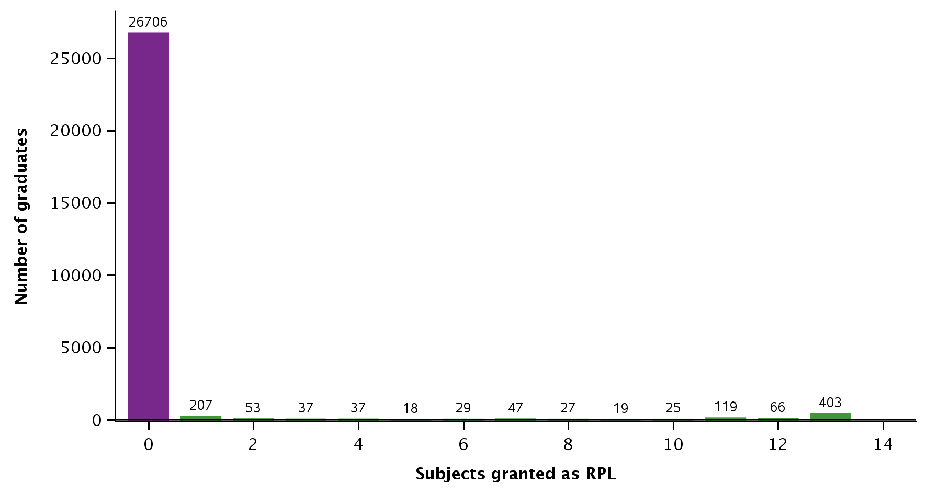

Note: Only includes graduates with a record of only 12 or 13 subjects passed or granted as RPL. For some graduates we identified more or less than 12 or 13 subjects, but they are excluded from this analysis.

As these graduates have completed all of the training and assessment required to be deemed as competent, we can compare the course durations between providers. To reduce the impact of outliers, we confine our analysis to the 183 RTOs with a minimum of 25 graduates between 2015 and 2017. Median durations at these RTOs varied by up to 13 months, but the median duration was 3 to 7 months at most RTOs (figure 10).

Figure 9 RTOs by minimum course duration for a graduate to complete Certificate III in Individual Support, 2015–17

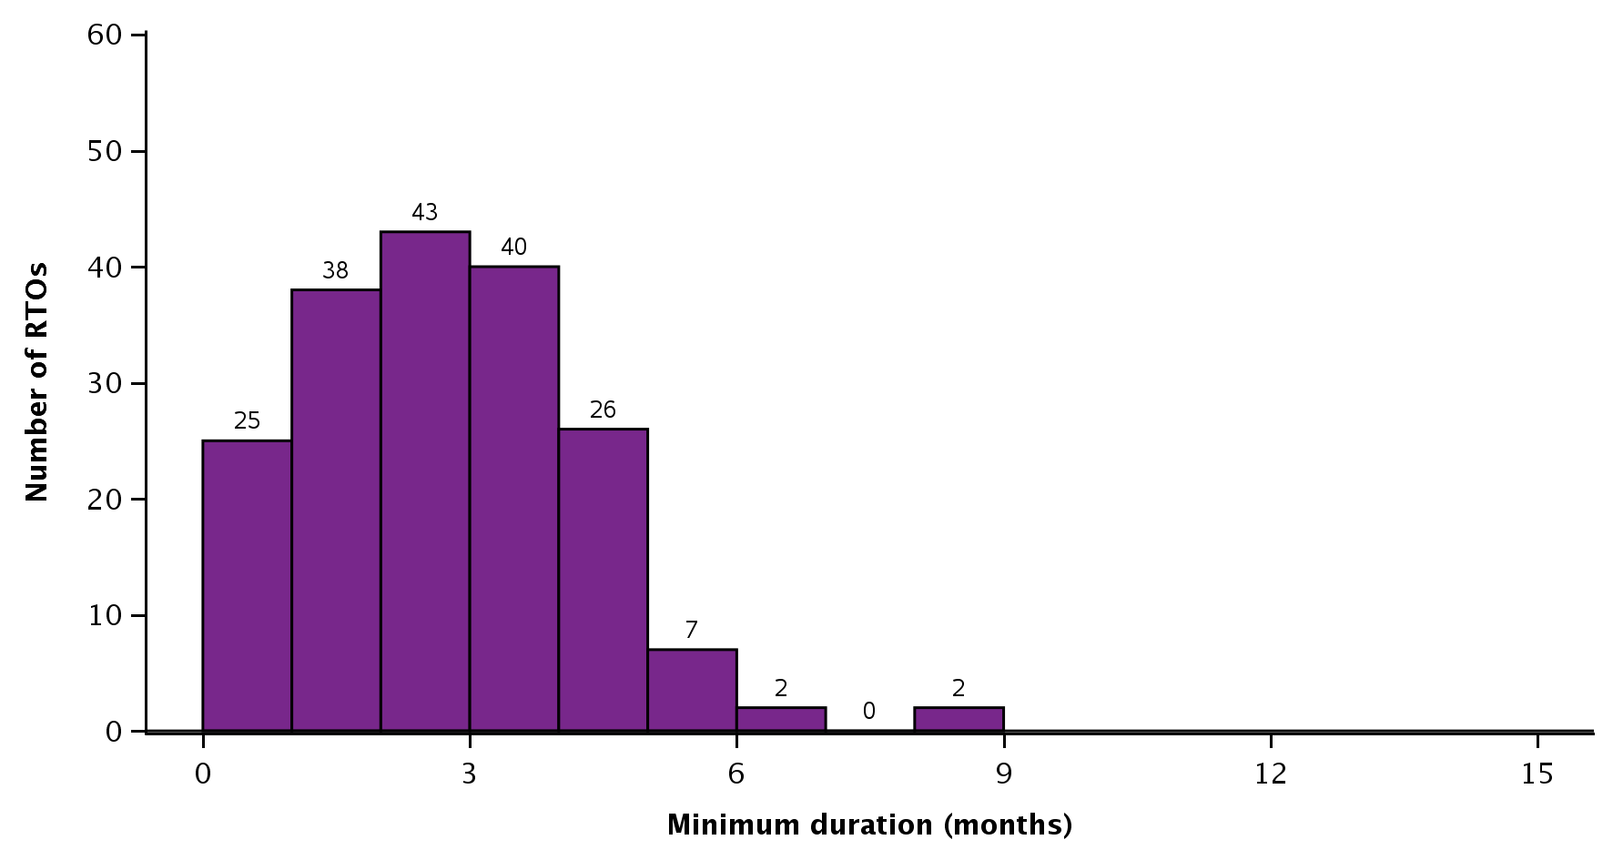

Note: Figure indicates the minimum observed duration at each RTO between 2015 and 2017, so it may only represent the duration of a single graduate at each RTO. Only includes the 183 RTOs with at least 25 graduates between 2015 and 2017. Only includes the 26 706 graduates who passed 12 or 13 subjects and had no RPL granted (figure 8)

Figure 10 RTOs by median duration for graduates to complete Certificate III in Individual Support between 2015 and 2017

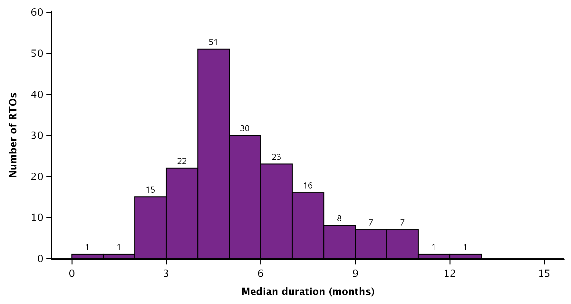

Note: Only includes the 183 RTOs with at least 25 graduates between 2015 and 2017. Only includes the 26 706 graduates who passed 12 or 13 subjects and had no RPL granted (figure 8).

There were no significant variations in durations when considering funding source and provider type (appendix H, table H1). Median durations were similar for government- funded and fee-for-service graduates and TAFE institutes and private training providers. However, median durations were slightly longer (by around one month) at community education providers.

Figures 9 and 10 present information on minimum and median graduate course durations for RTOs in the analysis. As indicated earlier, information on minimum and median graduate course durations are not, on their own, reliable indicators of the quality of the training or outcomes experienced by students. We fill this gap by looking at the subject results for all students (not only graduates) and comparing outcomes for RTOs with the lowest median graduate course durations with those with the highest median graduate course durations (table 3).

We find that, at RTOs with the lowest median graduate course durations, just 4% of subjects enrolled in by all students ended in a withdrawal, compared with 49% at RTOs with the highest median graduate course durations (table 3). The percentage of subjects resulting in a fail or subjects granted as RPL are similar.

At RTOs with a tendency for longer graduate course durations there were more subject withdrawals. This could be due to the personal characteristics of those students rather than the quality of the training at those RTOs.

Table 3 Subject outcomes for all students studying Certificate III in Individual Support at selected RTOs, 2015–17 (%)

|  |  |  |
| --- | --- | --- |
|  | RTOs with lowest median  duration (0–3 months) | RTOs with highest median duration (10–13 months) |
| Assessed – pass | 94 | 48 |
| Assessed – fail | 0 | 3 |
| Withdrawn | 4 | 49 |
| RPL – granted | 1 | 1 |
| Total | N = 27 115 | N = 26 972 |

Note: The two groups are based on the 10 RTOs with the lowest median duration for graduates and the 10 RTOs with the highest median duration for graduates, based on figure 10. Includes all enrolments in Certificate III   
in Individual Support by all students at selected RTOs (not just enrolments by graduates).

### Certificate IV in Disability

Fourteen subjects are required to complete the Certificate IV in Disability.[[23]](#footnote-23) We consider only graduates for whom we have a record of only 14 subjects passed or granted as RPL.

Over three-quarters (79%) of the 2732 graduates had completed the qualification without having any subjects granted as RPL (indicated in purple in figure 11). However, there was a sizeable group of 251 graduates (9%) who had been granted RPL for all of their subjects. Not unexpectedly, graduates with all subjects granted as RPL generally took a third of the time as graduates with no subjects granted as RPL (figure 12).

Figure 11 Graduates of Certificate IV in Disability by number of subjects granted as RPL, 2015–17

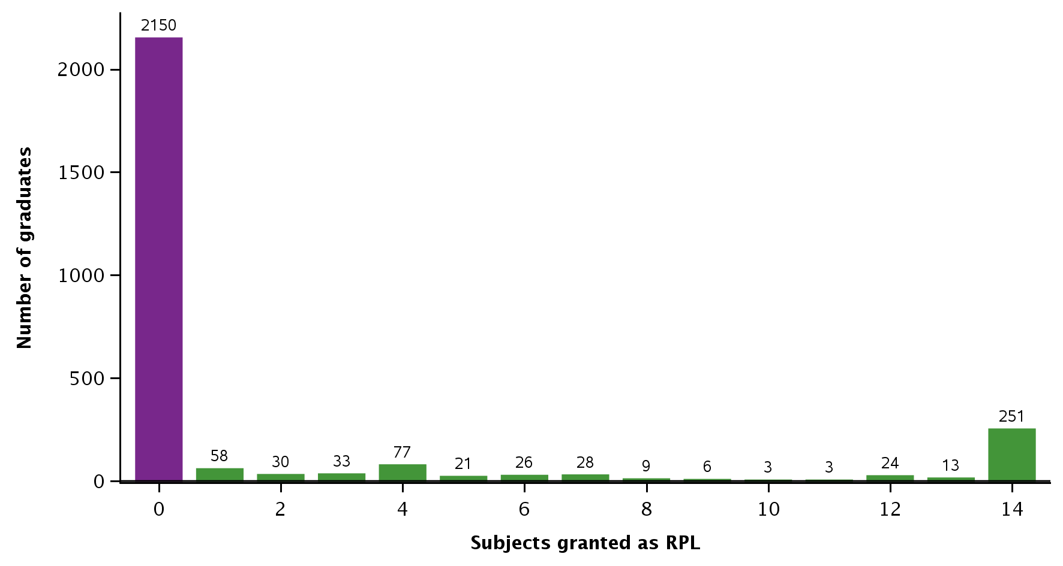

Note: Only includes graduates that had a record of only 14 subjects passed or granted as RPL. Those graduates identified as having either more or less than 14 subjects were excluded from this analysis.

Figure 12 Median course durations for graduates of Certificate IV in Disability by number of subjects granted as RPL, 2015–17

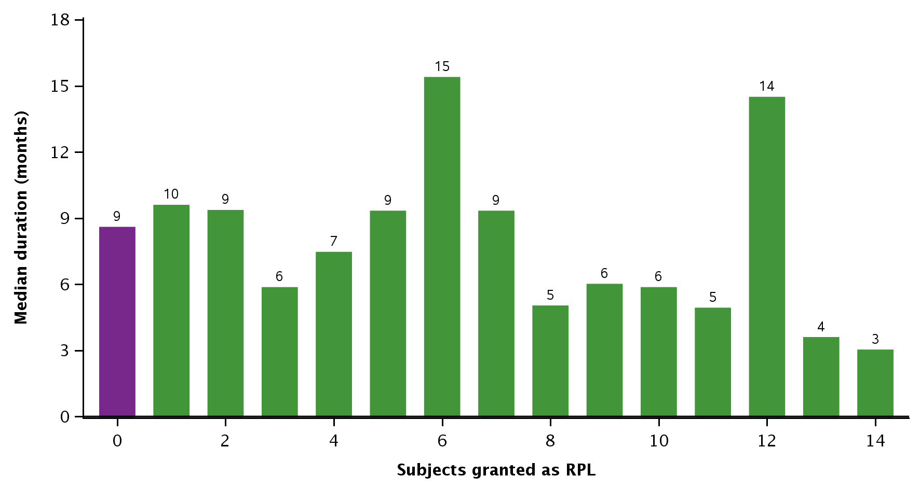

Note: Only includes graduates with a record of only 14 subjects passed or granted as RPL. For some graduates we identified more or less than 14 subjects, but they are excluded from this analysis.

From here, we further restrict our analysis to the 2150 graduates who passed 14 subjects and had no subjects granted as RPL (figure 11). As these graduates have completed all the training and assessment required to be deemed competent, we can compare the graduate course durations between providers. Once again, we reduce the impact of outliers by including in our analysis only the 22 providers with a minimum of 25 graduates between 2015 and 2017. Median durations at these RTOs varied by up to 8 months, but the median duration was 5 to 7 months at most RTOs (figure 14).

Figure 13 RTOs by minimum course duration for a graduate to complete Certificate IV in Disability, 2015–17

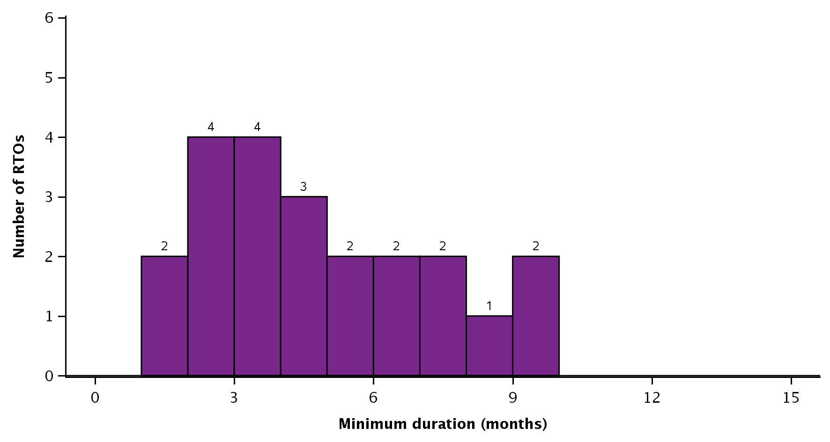

Note: Figure indicates the minimum observed duration at each RTO between 2015 and 2017, so it may only represent the duration of a single graduate at each RTO. Only includes the 22 RTOs with at least 25 graduates between 2015 and 2017. Only includes the 2150 graduates who passed 14 subjects and had no RPL granted (figure 11).

Figure 14 RTOs by median course duration for graduates to complete Certificate IV in Disability, 2015–17

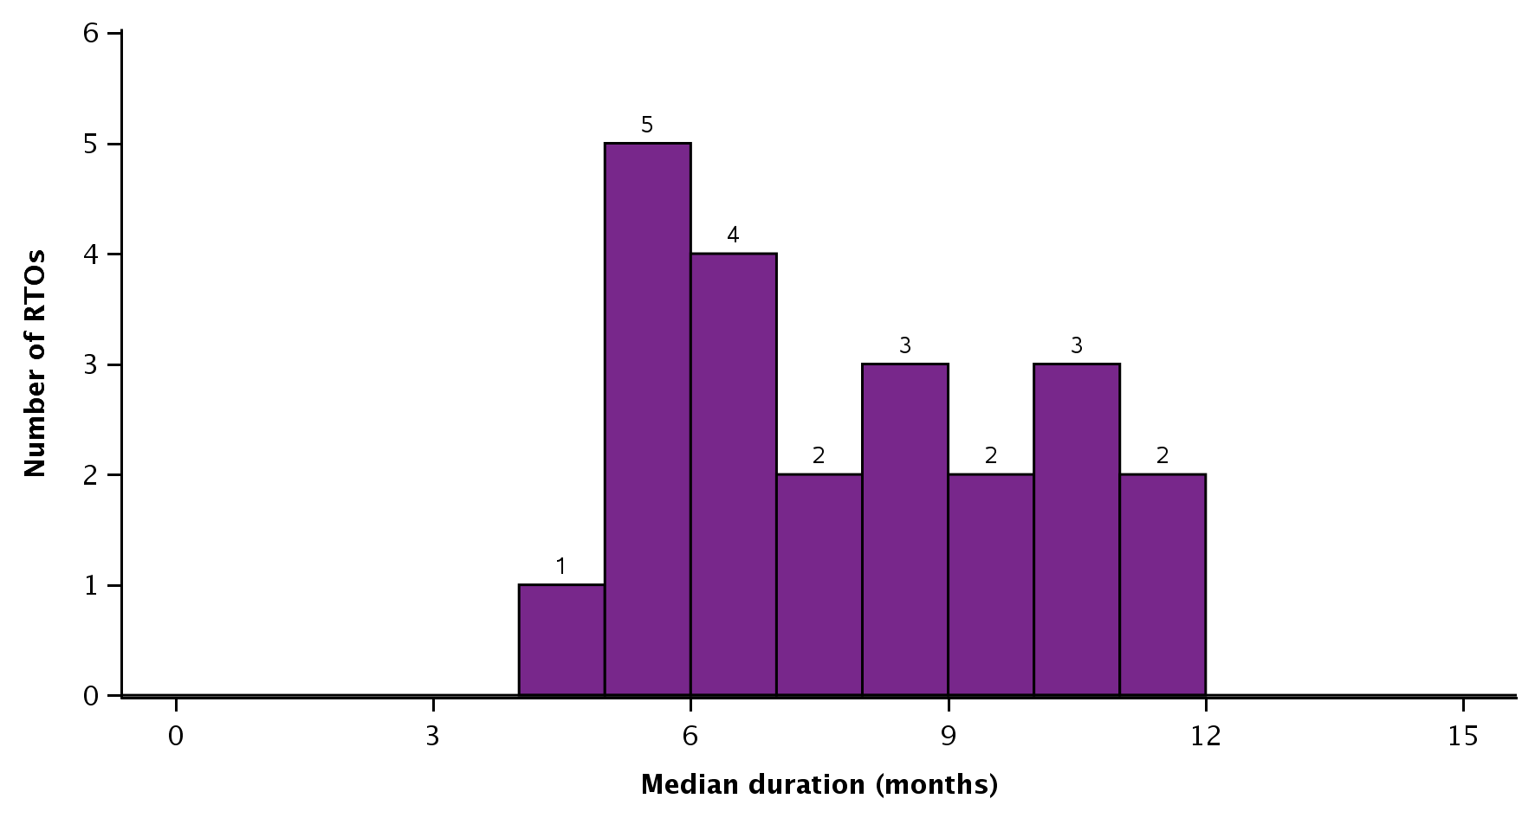

Note: Only includes the 22 RTOs with at least 25 graduates between 2015 and 2017. Only includes the 2150 graduates who passed 14 subjects and had no RPL granted (figure 11).

No significant variation in course durations is found when considering funding source and provider type (appendix H, table H2). Most graduates for this qualification were government-funded and had studied at a private training provider; however, their course durations were similar to the course durations of graduates who were not-government-funded or attended a public training provider.

Figures 13 and 14 present information on the minimum and median graduate course durations. To get a more reliable indicator of the quality of student outcomes, we compare the median graduate course durations at RTOs with the lowest and the highest median graduate course durations (table 4). In doing so, we consider the subject outcomes for all students, not just the graduates.

The RTOs with the highest median course durations had a higher percentage of withdrawals (table 4). This is similar to our findings for Certificate III in Individual Support. However, in this case there was also a substantial percentage of withdrawals at RTOs with the lowest median durations. Both groups of RTOs also had a relatively high percentage of failures.

Table 4 Subject outcomes for all students studying Certificate IV in Disability at RTOs with the highest and lowest median course durations, 2015–17 (%)

|  |  |  |
| --- | --- | --- |
|  | RTOs with lowest median  duration (5–6 months) | RTOs with highest median duration (10–12 months) |
| Assessed – pass | 80 | 71 |
| Assessed – fail | 6 | 8 |
| Withdrawn | 10 | 20 |
| RPL – granted | 4 | 1 |
| Total | N = 7 451 | N = 6 857 |

Note: The two groups are based on the five RTOs with the lowest median duration for graduates and the five RTOs with the highest median duration for graduates, based on figure 14. Includes all enrolments in Certificate IV in Disability by all students at selected RTOs (not just enrolments by graduates).

# Security operations

## Provider consultations

#### Durations and delivery arrangements

The findings from our consultations in this area show a lack of consistency across jurisdictions and providers of what is considered a sufficient duration. In Victoria, New South Wales and Western Australia[[24]](#footnote-24), for example, while the licensing body regulates the required minimum course durations (in hours), these differ for each of these states. For its part, South Australia has specified the units of competency that must be completed for the various licences. However, it is hoped that the establishment of the Security Industry Regulator Forum will help to further the cause of a consistent national approach.

The key drivers for adopting mandatory time requirements for security qualifications in certain jurisdictions have been experiences of inadequate training and assessment, resulting in graduates who have proved to be less than competent, as well as students who have crossed state borders to acquire qualifications (based on less rigorous prescriptions), subsequently using these qualifications to obtain licences to operate in states with more stringent requirements.

Across providers, the clustering of units of competency to cover the knowledge and skill required is common. In addition, training and assessment combines learning of essential content with practical skills development in simulated environments, mainly using scenarios and role plays. The use of online learning in states with mandatory requirements for face-to-face training, learning and assessment conducted over a certain number of days is not an option. Some states have provision for those who want to deliver some of the units online, but they must obtain approval from the regulator in that state. Where providers have more flexibility in how they deliver the training, students may complete assignments and quizzes and access information online. For all providers, however, the licence requirements are the drivers of how learning and assessment is conducted, as this is the main outcome. The traditional teaching principles of ‘explain, demonstrate, practise and give feedback’ are commonly adopted by providers. In two of the four states consulted, assessment items are prepared by the regulator; in the other states the regulator establishes the units of competency that must be completed.

In the security industry there is no provision for work placements for students in guarding and crowd-controlling programs, mainly because security firms want to be perceived as having experienced workers and therefore do not want ‘learners’ on site. To develop practical skills, scenario-based training and role plays are used and these are made as authentic as possible. The scenarios and role plays aim to develop knowledge and understanding of the approaches adopted in different situations; for example, screening people for intoxication and for prohibited items, responding to emergencies and dealing with conflict situations.

In appendix I we present the variety of approaches used by the providers of security operations qualifications participating in the consultations.

Prior to being accepted for a security operations course, students must undertake an English language, literacy and numeracy test. Students who do not pass this test are not accepted into the course but are generally referred to external providers of language, literacy and numeracy training. In one state, even those graduates who have already been judged as competent by the RTO must sit for another language and literacy competency test to be able to apply for their security licence.

Although it is difficult to draw a common theme from the consultations on the extent to which course durations affect training quality, there is nevertheless strong agreement among consultation participants that weekend qualifications should not be accepted, mainly because they are perceived to pose a risk to public safety and the industry itself.

Consultations with providers in Victoria, New South Wales and South Australia[[25]](#footnote-25) confirm the lack of consistency across state borders, making it difficult to give a consistent account of what a suitable course duration should be for entry-level workers in the security industry. The industry peak body’s assessment of having 130 hours of ‘auditable’ hours for certificate II qualifications is mostly welcomed; however, there are those who believe that around 80 hours would suffice. Even in those systems where the number of hours has been mandated, some people argue that the hours could be reduced.

However, providers strongly agree that adequate course durations matter and generally accept that between two and four weeks of training should be sufficient for students to acquire both the practical and knowledge components for the Certificate II in Security Operations. There is no appetite for either the 600 hours recommended by the AQF or for courses of very short durations.

The concerns over short-duration courses are associated with qualifications delivered over two or three days or over a weekend. In addition to these courses being perceived as posing a risk for public safety, they are also considered to result in a loss of public confidence in the industry itself. It is generally felt that when courses are not long enough, trainers cannot cover topics comprehensively nor are students able to gain the depth of knowledge required. That said, as has been emphasised in other areas, a strong view prevails that quality outcomes cannot be solely linked to the duration of courses but must be assessed in terms of the skills and engagement of the facilitator and the quality of the learning activities provided. Providers participating in the consultations also highlighted the commercial realities for both the student and the industry of increasing the durations of courses. As the manager of a law enforcement agency commented: ‘We need to think about it from the work and job function and we need to train them for that. If we do not do so we are doing them an injustice’*.*

Providers consulted also referred to the fact that specifying durations runs counter to the tenets of competency-based training, which, as noted earlier, in its pure form does not encourage concepts of time-based training, although it is implicit that sufficient time enables the student to demonstrate that they have acquired competency, which can be repeated to the required standard. ‘Sufficient’ time may also vary according to how quickly students are able to achieve this competency. In the words of one trainer and director of an RTO delivering security qualifications: ‘Duration has nothing to do with competency. If you can show me and you can tell me [to the required standards], then you are competent’.

#### Industry perspectives

Consultations with ARTIBUS Innovation, the skills service organisation with responsibility for security qualifications, and the Australian Security Industry Association Ltd(ASIAL) reveal a drive for more consistency in the way security qualifications are delivered across jurisdictions, the aim being to reduce the tendency for students to jurisdiction-shop, which drives ‘quick’ training delivery.

There is support for the view that time on its own cannot deliver high-quality outcomes and that it is the competency that is developed and demonstrated during that time which is the key. While ‘time’ may give students more opportunities to develop knowledge and understanding, and to practise specific skills, on its own it is perceived as being unable to develop the communication skills required for negotiating conflict situations, comprehending and providing clear and intelligible instructions, and understanding client needs. It is also important to recognise that some attributes, such as exercising autonomy and discretion, will develop with time spent on the job rather than time spent in training.

The SSO has reviewed the training package and changes have been recently endorsed. In balancing the need to provide sufficient amounts of training while respecting the principles of competency-based training, the SSO has been working with regulators and industry stakeholders to develop the new requirements. These do not overtly highlight ‘time in training’ but they do refer to the quality of performance (in a certain task) to be judged as competent. The inclusion of the word ‘must’ into the requirements introduces some mandatory elements. Obviously, time has to be available if students are to practise and complete a competency over a specified number of assessment events, as well as develop depth of understanding, especially with regard to regulations, responsibilities, safety and company policy. This focus on specific assessment requirements is felt to give the ASQA auditors more evidence for making judgements between compliant and non-compliant behaviour. As the manager, industry development, in ARTIBUS Innovation confirmed: ‘It is the path to compliance that can help to restore confidence in the qualification and the industry itself’.

Our consultation with the Australian Security Industry Association revealed that the peak body is concerned about the negative impact that unduly short course durations have on the quality of training outcomes. The quality-assuring of security qualifications is also felt to be fundamental to protecting the integrity of the qualification and the providers that deliver them.

The Australian Security Industry Association has deliberated long and hard in establishing an industry benchmark for ‘amount of time’ to be spent in training for the basic security qualifications and has released a position statement. For the Certificate II in Security Operations (the basic security qualification for unarmed guards and crowd controllers), a benchmark of 130 auditable hours and a single set of 15 mandatory units for entry-level workers has been adopted; there are no elective options. For progression into more specialist positions, students would be required to undertake more auditable hours of training. As the chair of the Australian Security Industry Association explained: ‘In an ideal world we would expect that providers would do the right thing. However, we have set a marker in the sand to ensure that they do the right thing’.

The benchmark is based on the complexity of skill levels and tasks, consultations with and surveys of association members, and affordability of course costs for students. The issues considered include the economic realities for students wanting to enter the labour market (where guarding jobs are intermittent and casual and are generally not highly paid) and training hours in similar programs overseas systems.

The Australian Security Industry Association does not support the 600 hours recommended in the Australian Qualifications Framework for the entry-level certificate II qualifications and holds the view that, if these hours are enforced by ASQA auditors, then the provision of suitably trained security services will be compromised. Students would not be able to afford the training, RTOs would not be able to operate without students, and the industry would decline. A fuller account of findings from our consultation with ASIAL appears in appendix J.

#### Regulatory considerations

The Financial, Administrative and Professional Services Training Council (FAPSTC) in Western Australia provides training advice to the regulator, the Western Australia Police Licensing and Enforcement division, on security qualifications to assist the regulator to decide what is to be mandated. Our discussions with the training council revealed that in Western Australia 80 hours of training is mandated for security guards and crowd controllers, with 112 hours required if the two licences are combined. RTOs who want to deliver the security training for licences must be approved by the regulator. There is no general provision for online learning and those RTOs who do want to deliver units via online methodologies must seek permission from the regulator. Once students complete their qualifications, they need to take another test before they are issued with a licence. This competency test comprises 20 multiple-choice questions and 10 short-answer questions. This is one of the conditions for applying for a licence. In view of changes included in the recently endorsed training package, the Financial, Administrative and Professional Services Training Council is likely to recommend to the WA Police Licensing and Enforcement Division that the mandated hours of training for Certificate II Security Operations be about 120 hours as an absolute minimum.

The key drivers of these mandated approaches have been concerns over the quality of the training being delivered and the quality of the skills of the graduates. The additional competency test is used to identify those students awarded a qualification by RTOs who have not been rigorous in their training and assessment. Such graduates have also been found to lack the requisite English language, literacy and numeracy skills and other knowledge required to undertake their roles in the industry. This was identified as occurring even though students were being screened for these skills at the RTO level. When the test was first implemented, only about half of the students passed the test; over time this has increased to 75%. These developments made it clear that, even in systems like Western Australia, where course durations are set, it was not possible to rely solely on the awarded qualifications to issue the licence.

We also consulted with the agency that regulates training for security operations qualifications in New South Wales — the Security Licensing & Enforcement Directorate (SLED), which was established after the enquiry by the Independent Commission Against Corruption (ICAC) into the fraudulent behaviour of some RTOs. Given the power to regulate and to enforce training for security licences in New South Wales, the agency investigated concerns that qualifications were being awarded to students who had not completed the requirements, or who had not undertaken the training at all. The Security Licensing & Enforcement Directorate consequently decided to regulate the number of hours to be spent in training for licensing. The directorate determined that training, with appropriate assessment, for a Class 1AC Security Licence Course (NSW) would be delivered in a minimum of 102 hours of face-to-face training over approximately 13 days, with no online learning. RTOs that wanted to deliver qualifications for security licences also had to be to be approved by the directorate. However, having a minimum standard of duration does not preclude RTOs from increasing the number of hours to deliver extra practical examples or to support students who require additional training.

The establishment of mandatory minimum durations and mandatory assessments conducted by the Security Licencing & Enforcement Directorate (designed in conjunction with industry) for security qualifications is felt by the directorate to have improved the quality of outcomes, in that it has allowed the directorate to undertake unannounced audits to check that providers are delivering training according to its requirements. However, after consultations with industry stakeholders, industry peak bodies and large security companies, the Security and Licencing Directorate has also come to the view that the AQF-specified volume of learning — 600 hours — is not realistic for what is required.

According to the directorate, course durations do matter, but the minimum durations must be balanced by considerations of the practical job outcomes, including the intensity of occupational roles, practical workplace outcomes and the level of critical thinking involved. The current Security Licensing & Enforcement Directorate benchmark for the 1AC course may likely increase in view of the new content and the more comprehensive assessment arrangements in the recently endorsed training package. It is also felt that training via online courses and very short courses is a risk to the public because they cannot provide training and assessment to the required standards. The consequences are felt to be especially critical if the training has not covered the essential legislative requirements such as powers of arrest and the restraining of people. Appendix K has a fuller account of these findings from the directorate.

## Statistical analysis of how course durations affect subject results

We now consider the profile of course durations in the area of security operations to determine how they affect subject outcomes. The two qualifications of interest in this area are the Certificate II in Security Operations and the Certificate III in Security Operations.

#### Certificate II in Security Operations

Twelve subjects are required for completion of the Certificate II in Security Operations.[[26]](#footnote-26) Our assumption is that students with 11 subjects recorded have already completed the HLTFA311A: Apply first aid. We therefore consider only those graduates for whom we have a record of only 11 or 12 subjects passed or granted as RPL.

As 87% of graduates completed the qualification without having any subjects granted as RPL (figure 15), we further restrict our analysis to the 11 669 graduates who passed 11 or 12 subjects (indicated in purple) from the total of 13 391 graduates.

Figure 15 Graduates of Certificate II in Security Operations by number of subjects granted as RPL, 2015–17

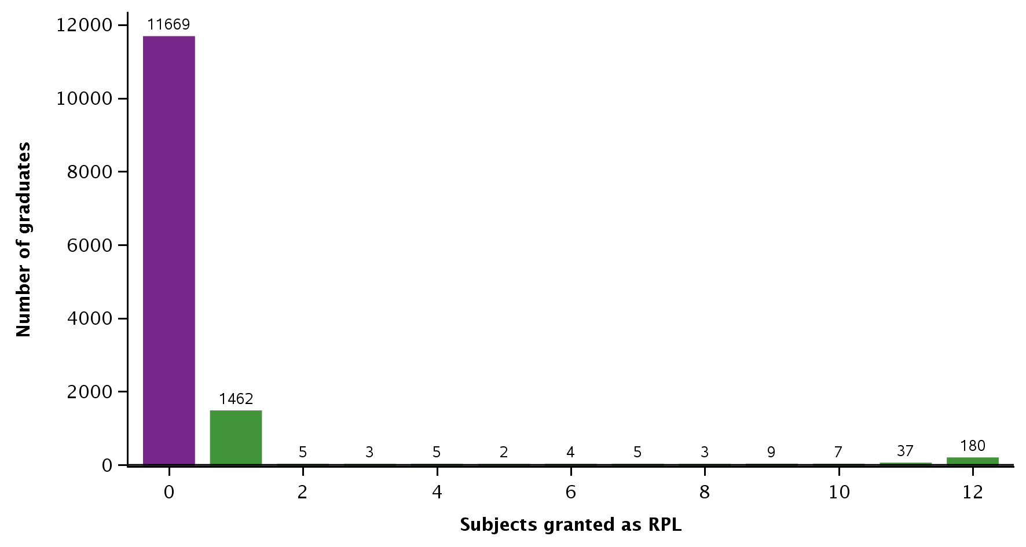

Note: Only includes graduates with a record of only 11 or 12 subjects passed or granted as RPL. For some graduates we identified more or less than 11 or 12 subjects, but they are excluded from this analysis.

We can compare the durations of different providers according to the time taken for graduates to complete their qualifications. To do this we restrict our analysis to the 23 RTOs with a minimum of 25 graduates between 2015 and 2017. We do this to reduce the impact outliers. In figures 16 and 17 we present information on RTOs by minimum and median graduate course durations. Median durations at these RTOs varied by up to 6 weeks, but the median duration was 0 to 2 weeks at most RTOs (figure 17).

Figure 16 RTOs by minimum course duration for a graduate to complete Certificate II in Security Operations, 2015–17

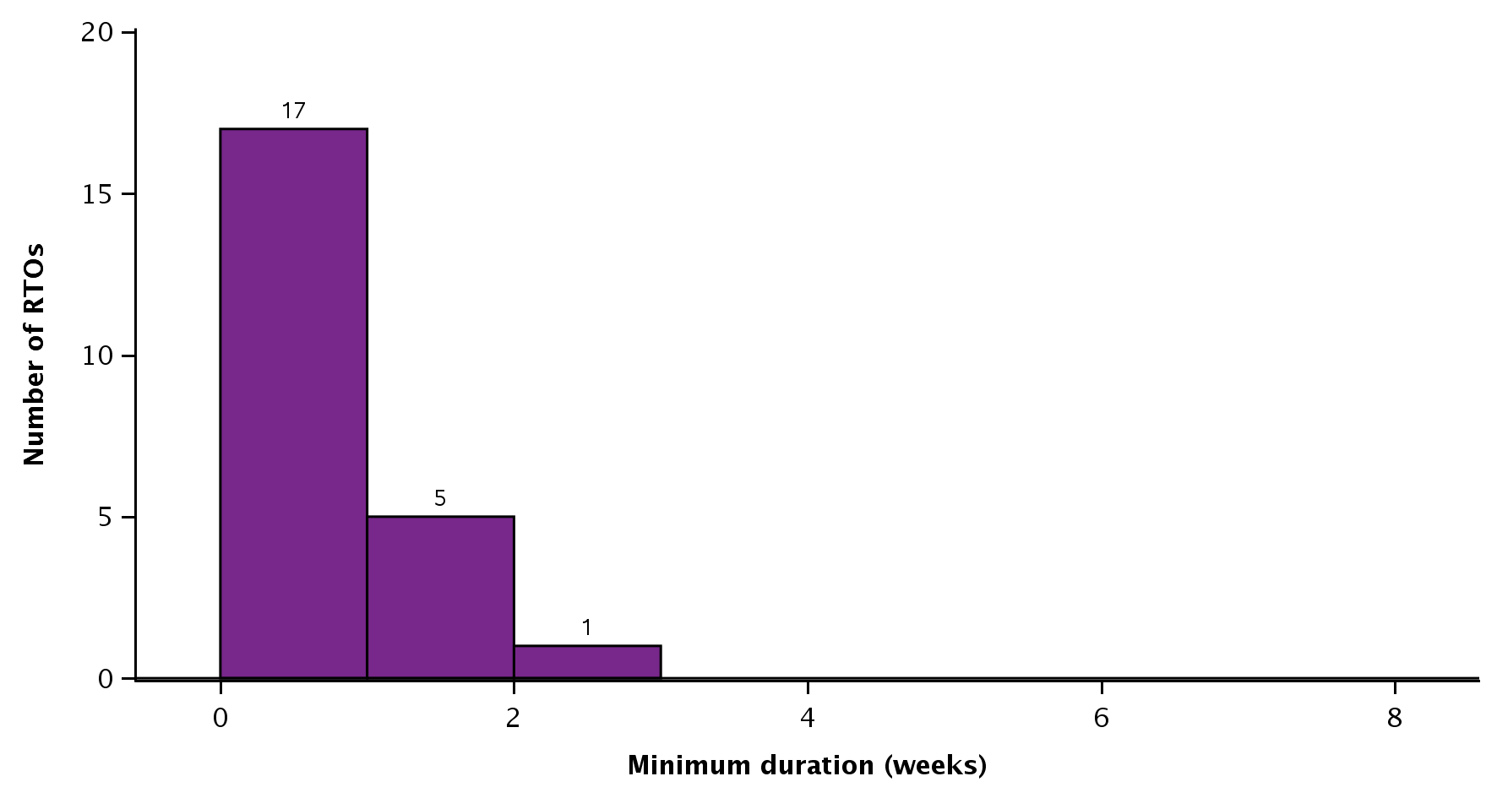

Note: Figure indicates the minimum observed duration at each RTO between 2015 and 2017, so it may only represent the duration of a single graduate at each RTO. Only includes the 23 RTOs with at least 25 graduates between 2015 and 2017. Only includes the 11 669 graduates who passed 11 or 12 subjects and had no RPL granted (figure 15).

Figure 17 RTOs by median course duration for graduates to complete Certificate II in Security Operations, 2015–17

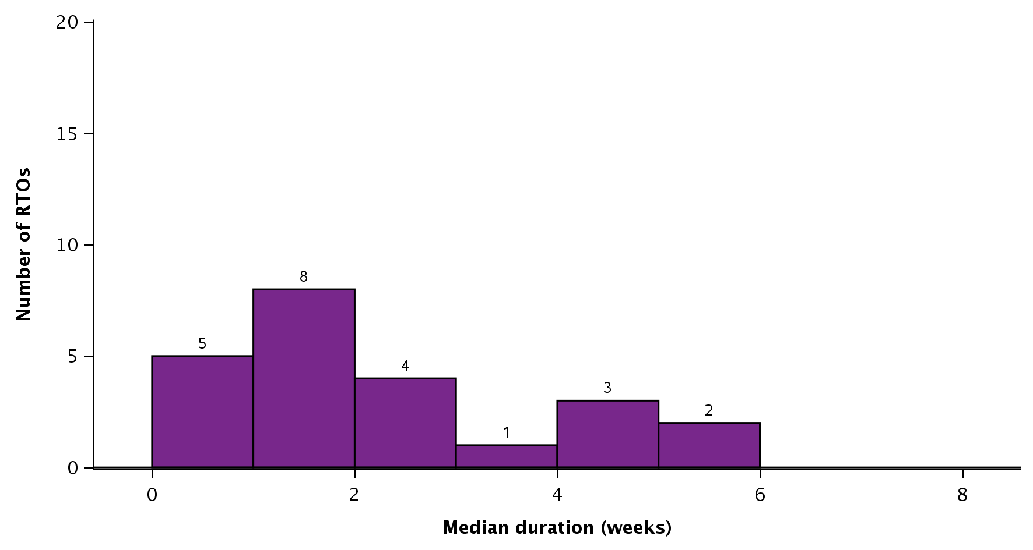

Note: Only includes the 23 RTOs with at least 25 graduates between 2015 and 2017. Only includes the 11 669 graduates who passed 11 or 12 subjects and had no RPL granted (figure 15).

When we analyse the data by funding source and provider type, we find that almost all graduates were undertaking fee-for-service training and studying at private training providers (appendix L, table L1).

We expanded the scope of our analysis to compare the subject results for all students (not only graduates) at RTOs with the lowest median graduate course durations with RTOs with the highest median graduate course durations. We find that almost all subjects were passed by students irrespective of whether they attended RTOs with the lowest median graduate course durations or the highest median graduate course durations (table 5). There were negligible percentages of failures, withdrawals and RPL[[27]](#footnote-27) across both groups of RTOs.

The percentage of passes for the Certificate II in Security Operations is much higher than the 83% of subjects passed across all certificate II level qualifications (appendix M, table M1). This may require further investigations of the types of training and assessment approaches that lead to such outcomes.

Table 5 Subject outcomes for all students studying Certificate II in Security Operations at selected RTOs, 2015–17 (%)

|  |  |  |
| --- | --- | --- |
|  | RTOs with the lowest median duration (0–1 week) | RTOs with the highest median duration (4–5 weeks) |
| Assessed – pass | 99 | 100 |
| Assessed – fail | <1 | <1 |
| Withdrawn | <1 | 0 |
| RPL – granted | <1 | <1 |
| Total | N = 55 520 | N = 58 706 |

Note: The two groups are based on the five RTOs with the lowest median duration for graduates and the five RTOs with the highest median duration for graduates, based on figure 17. Includes all enrolments in the Certificate II in Security Operations by all students at selected RTOs (not just enrolments by graduates).

#### Certificate III in Security Operations

Fourteen subjects are required to complete the Certificate III.[[28]](#footnote-28) We consider only graduates for whom we have a record of only 14 subjects passed or granted as RPL.

As 95% of graduates completed the qualification without having any subjects granted as RPL, we concentrate our analysis on the 10 631 graduates (indicated in purple) who passed the 14 subjects without RPL (figure 18).

Figure 18 Graduates of Certificate III in Security Operations by number of subjects granted as RPL, 2015–17

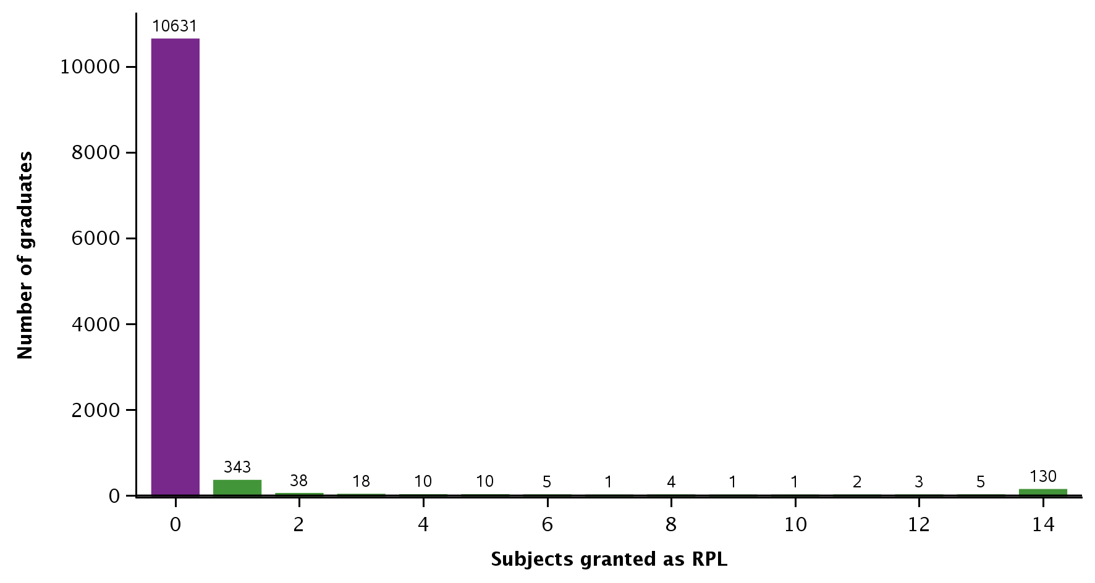

Note: Only includes graduates with a record of only 14 subjects passed or granted as RPL. For some graduates we identified more or less than 14 subjects, but they are excluded from this analysis.

Once again, we compare the course durations for graduates between providers. We restrict our analysis to the 29 RTOs with a minimum of 25 graduates between 2015 and 2017 to reduce the impact of any outliers. The distribution of RTOs by minimum and median course durations for graduates are presented in figures 19 and 20. Median durations at these RTOs varied by up to 13 weeks, but the median duration was 1 to 4 weeks at most RTOs (figure 20).

Figure 19 RTOs by minimum duration for a graduate to complete Certificate III in Security Operations between 2015 and 2017

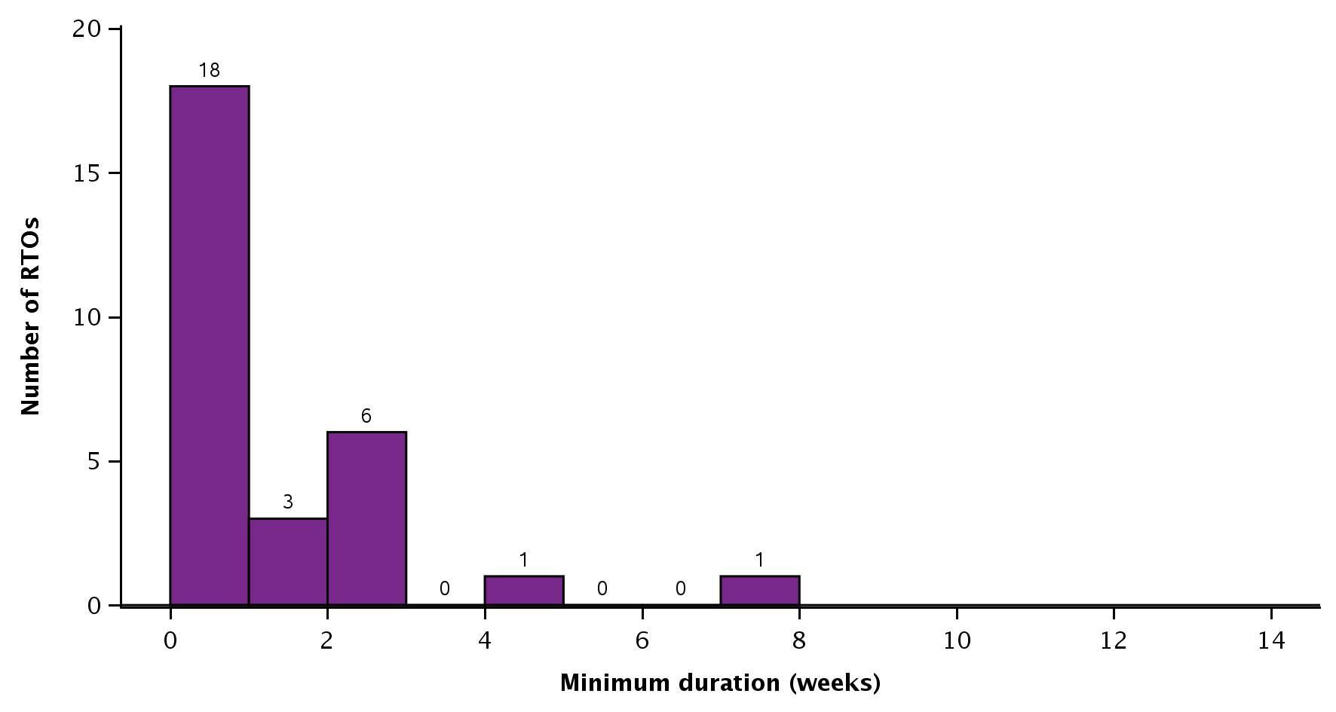

Note: Figure indicates the minimum observed duration at each RTO between 2015 and 2017, so it may only represent the duration of a single graduate at each RTO. Only includes the 29 RTOs with at least 25 graduates between 2015 and 2017. Only includes the 10 631 graduates who passed 14 subjects and had no RPL granted (figure 18).

Figure 20 RTOs by median duration for graduates to complete Certificate III in Security Operations between 2015 and 2017

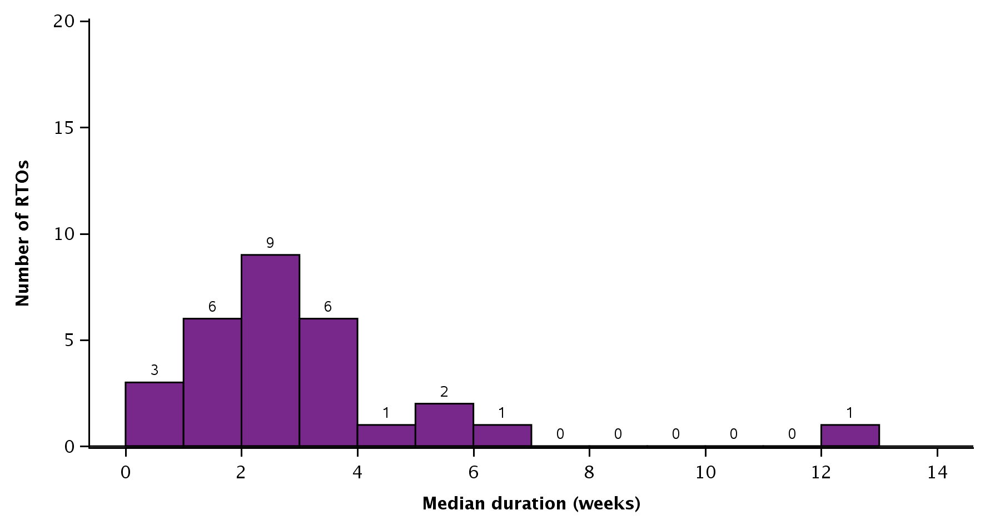

Note: Only includes the 29 RTOs with at least 25 graduates between 2015 and 2017. Only includes the 10 631 graduates who passed 14 subjects and had no RPL granted (figure 18).

Our analysis of graduate course durations by funding source indicates that median graduate course durations were similar for government-funded and fee-for-service graduates. In addition, almost all graduates were studying at private training providers (appendix L, table L2).

Once again, we use subject outcomes to gain some indication of the impact of course durations on subject results. In table 6 we consider the subject results of all students (not only graduates) studying the Certificate III in Security Operations at RTOs with the lowest and the highest median graduate course durations.

Almost all subjects were passed at RTOs irrespective of whether their graduate course durations were at the lowest or highest ends of the scale (table 6). However, there was a marginally higher percentage of withdrawals at RTOs with the highest median durations.

Similar to the Certificate II in Security Operations (above), the percentage of passes for the Certificate III in Security Operations is much higher than the 79% of subjects passed across all certificate III level qualifications (appendix M, table M1). Further investigations into the training and delivery approaches used to produce such outcomes may be warranted.

Table 6 Subject outcomes for all students studying Certificate III in Security Operations at selected RTOs, 2015–17 (%)

|  |  |  |
| --- | --- | --- |
|  | RTOs with the lowest median duration (0–1 week) | RTOs with the highest median duration (4–12 weeks) |
| Assessed – pass | 99 | 97 |
| Assessed – fail | <1 | <1 |
| Withdrawn | <1 | 2 |
| RPL – granted | 1 | 1 |
| Total | N = 51 547 | N = 71 744 |

Note: The two groups are based on the five RTOs with the lowest median duration for graduates and the five RTOs with the highest median duration for graduates, based on figure 17. Includes all enrolments in the Certificate III in Security Operations by all students at selected RTOs (not just enrolments by graduates).

# P:\PublicationComponents\Icons\References_Green.emfReferences

ASQA (Australian Skills Quality Authority) 2013, *Training for aged and community care in Australia*, viewed August 2013, <<https://www.asqa.gov.au/sites/g/files/net2166/f/publications/201705/strategic_reviews_2013_aged_care_report.pdf?v=1496213753>>.

——2015a, ‘Fact sheet, Determining the amount of training’, viewed April 2019, <https://www.asqa.gov.au/sites/default/files/FACT\_SHEET\_Amount\_of\_training.pdf?v=1508135481>.

——2015b, *Training in security program in Australia* , viewed July 2017, <<https://www.asqa.gov.au/sites/g/files/net2166/f/Strategic_Review_Report_2016_Training_in_security_programs_in_Australia.pdf>>.

——2015c, *Training for early childhood education and care in Australia*, viewed August 2017, <<https://www.asqa.gov.au/sites/g/files/net2166/f/publications/201705/strategic_review_2015_early_childhood_education_report.pdf?v=1496213447>>.

—— 2017, *Strategic review on unduly short training*, viewed September 2017, <<https://www.asqa.gov.au/news-publications/media/asqa-releases-findings-national-strategic-review-course-duration>>.

McDonald, B 2018, *Total VET program completion rates*, NCVER, Adelaide, viewed April 2019, <https://www.ncver.edu.au/research-and-statistics/publications/all-publications/total-vet-program-completion-rates>.

# P:\PublicationComponents\Icons\PaperClip_Purple.emfAppendix

## Appendix A: ASQA 2017 Strategic review on unduly short training

A key aspect of the 2017 Australian Skills Quality Authority review was to examine, between March 2015 and October 2015, the websites of ASQA-regulated RTOs to collect the course duration information advertised on RTO websites. This part of the review investigated the websites of 1181 RTOs and comprised 11 677 advertisements showing course durations; this included 1098 training package qualifications. The review documented those qualifications where short course durations were the most prevalent, as well as the areas where such durations would have the most negative effect. In doing so, the review noted whether the advertised course durations were less than the minimum or less than half of the minimum volume of learning hours suggested by the Australian Qualifications Framework.

The ASQA review made recommendations:

* For the VET system to ‘strengthen’ the Standards for Registered Training Organisations 2015 by spelling out what is meant by ‘amount of training’, and to do so in terms of the supervised learning and assessment requirements, both in training package and accredited courses qualifications.
* That risks posed to industry by inadequate course durations be considered by industry reference committees to ensure that training delivery requirements, including mandatory ‘amount of training’, are listed in the endorsed components of training packages (if judged to be required) and/or in the companion volume of training packages (if this is judged to be ‘a more proportionate response to the risk’). Also recommended was the inclusion of this ‘amount of training’ information in public disclosure statements to enable transparency and course comparisons.

## Appendix B: List of named and de-identified organisations and participants in consultations

Table B1 List of de-identified organisations and participants in consultations

| Organisation | Qualifications discussed | Organisation type | Practitioners |
| --- | --- | --- | --- |
| **Early childhood education and care and individual support  (aged care, home care, and disability)** | | | |
| College A | Early Childhood Education and Care (certificate III, diploma)  Certificate III Individual Support (Aged Care) | Private RTO | Chief Executive Officer  Coordinator, Early Childhood Education and Care  Chief Executive Officer  Specialist Facilitator |
| College B | Early Childhood Education and Care (certificate III, diploma)  Certificate III Individual Support (Aged Care) | Private RTO | Coordinator, Training and Development  Coordinator, Training and Development |
| College C | Early Childhood Education and Care (certificate III, diploma)  Certificate IV Disability | Private RTO | RTO Manager |
| College D | Early Childhood Education and Care (certificate III, diploma)  Certificate III Individual Support (Aged Care) | Public RTO | Senior Lecturer  Senior Lecturer  Senior Lecturer  Lecturer  Lecturer  Lecturer  Lecturer  Lecturer  Educational Manager |
| Aged Care Services Australia | Certificate III Individual Support (Aged Care, home care, disability) | Industry Peak Body | Manager Workforce and Industry Development |
| Education Standards Board (SA) | Early Childhood Education and Care (certificate III, diploma) | Services regulator | Chief Executive/Registrar  Senior Manager  Senior Manager |
| Australian Aged Care Quality Agency | Individual Support (ageing, home care) (certificate III | Services regulator | Agency Officer |
| SkillsIQ | Early Childhood Education and Care (certificate III, diploma)  Certificate III Individual Support (Aged Care, home care, disability) | Skills service organisation | General Manager |
| **Security operations** | | | |
| College SEC-A | Certificate II Security Operations | Enterprise RTO | RTO Manager |
| College SEC-B | Certificate II Security Operations | Private RTO | Chief Executive Officer  Administration Manager  Trainer and Assessor |
| College SEC-C | Certificate II Security Operations | Private RTO | Director and Principal Trainer |
| Artibus & Innovation SSO | Certificate II/III Security Operations | Skills service organisation | Manager, Industry Development |
| Security Licensing and Enforcement Directorate (NSW) | Certificate II/III Security Operations | Regulator | General Manager, Industry Regulation  Acting Manager, Industry Regulation |
| Australian Security Industry Association Ltd (ASIAL) | Certificate II Security Operations | Industry peak body | Chief Executive Officer  Compliance and Regulatory Affairs Advisor |
| Financial, Administrative and Professional Services Training Council (FAPSTC) (WA) | Certificate II/III Security Operations | FAPSTC  (on ARTIBUS INNOVATION, Regulator TAG) | Project Manager |

## Appendix C: The concepts of volume of learning, amount of training and nominal hours

The concepts of volume of learning, amount of training and nominal hours are used in the Australian VET system to establish a set of ‘notional durations’ to assist RTOs in their development of training and assessment activities that will enable them to provide adequate and sufficient training for learners. Nominal hours are also established as a tool for reporting purposes.

***Volume of learning***

In the AQF the *volume of learning* is defined as ‘a dimension of the complexity of a qualification. It is used with the level criteria and qualification type descriptor to determine the depth and breadth of the learning outcomes of a qualification. The volume of learning identifies the notional duration of all activities required for the achievement of the learning outcomes specified for a particular AQF qualification type. It is expressed in equivalent full-time years’.

It refers to teaching, learning and assessment activities that are required to be undertaken by the typical student to achieve the learning outcomes. These activities may include: guided learning (such as classes, lectures, tutorials, online study or self-paced study guides), individual study, research, learning activities in the workplace and assessment activities. In the AQF the generally accepted length of a full-time year, used for educational participation, is 1200 hours. A breakdown of the number of hours required for the different VET qualifications is provided in the ASQA User Guides to the Standards for VET Accredited Courses <<https://www.asqa.gov.au/sites/g/files/net2166/f/Users_guide_to_the_Standards_for_VET_Accredited_Courses.pdf>>.

***Amount of training***

The concept of amount of training is used by the Australian Skills Quality Authority as a practical approach to determining the quantity of training and assessment needed by learners to ‘meet the requirements of each training product, and to gain the skills and knowledge specified the relevant training product’ (ASQA, 2015a, p.1). These requirements will vary according to whether training products are full qualifications, units of competency or skill sets, the background and prior experience and skills of learners, and the mode of delivery to be used. If RTOs are delivering a full AQF qualification, they should consider the breadth and depth of knowledge and skills required, the application of such knowledge and skills, and the AQF volume of learning. If they are not delivering a full qualification (that is, a unit of competency or a skill set), then the amount of training should be a proportion of the AQF volume of learning. For learners with no prior relevant experience, the amount of training will match closely the AQF volume of learning time frames, while the amount will be less for those with the defined workplace experience, skill and knowledge. The training and assessment strategy must detail why and how they have determined the amount of training they will use and provide justification for the time frames selected.

***Nominal hours***

Nominal hours are a set of hours of supervised training that are allocated to a qualification and are generally used by jurisdictions for reporting purposes and for determining the amount of effort that has been applied to produce outcomes. The Australian Vocational Education and Training Statistical Standard (AVETMISS) provides a strict definition of nominal hours for reporting purposes. AVETMISS defines nominal hours to be ‘a value assigned to a program or subject that nominally represents the anticipated hours of training deemed necessary to conduct training and assessment activities associated with the program or subject. They must be the value of supervised nominal hours as determined by its accreditation or endorsement body and will not include any already achieved pre-requisites. They will assume a typical classroom- based delivery and assessment strategy, and do not include hours associated with non-supervised work experience, field work, work placement or private study. Where a program or subject consists entirely of one or more of these components then the Nominal Hours value must be zero. The value represents the hours deemed necessary for the whole program or subject whether or not the delivery is within one collection period’ (AVETMISS Data Element, Edition 2.3 November 2016 p.99).

Some jurisdictions use nominal hours as a basis for government-subsidised training and/or as a tool to determine the nominal duration of training contracts for apprenticeships and traineeships. The aim for having a nationally agreed set of nominal hours to use for consistent reporting purposes dates back to 2006. Victoria agreed to take the lead for establishing nominal hours for all training packages and their revisions, but other jurisdictions were free to have purchasing hours that differed from these national nominal hours.

## Appendix D: The importance of time for work placements

Adequate time in supervised work placements is believed to be essential in qualifications requiring interaction and working with vulnerable populations (adults, adolescents and infants, and young children) because this experience cannot be effectively replicated in simulations. Work placements are perceived to have benefits for students, employers, and the providers.

* Students can put the learning and knowledge acquired off the job into practice in a real workplace setting and develop their practical skills, as well as the areas where improvement is needed. Later they can use this experience as a reference point. They are also able to access the human interaction that cannot be simulated. Having done a work placement, a student will have more confidence when applying for a job in the same area. For some it can also help them to make the decision on whether or not to stay in the industry. It is not uncommon for students to decide that the industry is not for them during or after their first placement.

### Practical applications in the field

* College A has decided that for its certificate III qualifications in both Early Childhood Education and Care and Individual Support (aged care) it will have students undertake 160 hours of work placement rather than the 120 hours. For both qualifications, students go into the workplace for a two-week placement after the initial seven weeks of their course. Students will then come back into the college and engage in another five to six weeks of training and then go back to the same employer for another two weeks of work placement. College A has its own simulated set-up for students undertaking Individual Support (ageing) qualifications, where students can learn to shower clients, make beds and use lifters prior to undertaking work placements. This also enables them to understand the occupational health and safety issues that need to be addressed for their own safety and for the safety of residents.
* College B has decided to have students in the Certificate III Early Childhood Education and Care program undertake placements once they have completed the initial five units (four of which are the foundation units). Students will spend an initial two days in the childcare centre; on day one they will spend time with their mentor to become familiar with the policies and procedures of the site and have discussions with the director regarding the operational aspects of the site, including enrolment forms, the Early Learning Framework, and the relevant standards. On day 2 students will accompany the mentor to observe and interact with children. This might include helping at mealtimes (morning teas and lunchtimes), as well as interacting with students at play. This helps the student understand the business and teaches some of the key employability skills. They will return to complete their placements as they progress through the course.
* In the Certificate III in Individual Support (aged care) students will undertake six practical components, mainly at the college’s skills lab. These practicals cover skills such as manual handling, meal time management, personal care, employability skills and individualised care. The other practical components are done in the work placement. Work placements at this college require students to complete an assignment related to the unit of competency being assessed. Trainers will visit the student on placement, consult with facility directors, observe their performance and have the work placement mentor or supervisor rate students on a list of competencies. The workplace supervisor or mentor plays a major role in workplace assessments.
* The Certificate IV Disability qualification is mostly undertaken by students who are already working. A work placement of 120 hours is required. In the superseded qualification there was less material to get through than in the current qualification; the work placements were also shorter. With the new qualification the quality is perceived to have been improved.

Although the college believes that the amount of time allocated for work placements is sufficient (because many of the students get jobs resulting from their work placements), it is also of the view that the quality of the experience in the workplace should also matter.

* College C delivers the Certificate III and Diploma in Early Childhood Education and Care, the Certificate III in Individual Support (disability) and the Certificate IV Disability. A similar process is adopted for the work placements, which require certificate III and IV students to undertake 120 hours of placement and diploma students to undertake 240 hours of placement. Trainers will visit the student during the work placement at least three or four times. On these visits the trainer will observe the student performing the tasks and have discussions with the site supervisor about any issues the site is experiencing with the student or issues the student is dealing with. For the Diploma in Early Childhood Education and Care (which is delivered by distance), placements must take place at a physical site in two separate blocks of time. The first block of the placement is comprised of 120 hours and allows the students the opportunity to put their initial learning into practice. The second block of placements is also comprised of 120 hours. There is a break between the first block and the second block, during which students can reflect on the feedback they have received about their placement performance and put in place some improvement strategies to apply to their practice in their second block.
* College D delivers a range of Community Services qualifications. Here we focus on Certificate III and Diploma in Early Childhood Education and Care qualifications. This college also allocates more hours to the placements, with students completing around 160 hours for the certificate III qualifications and around 290 or so hours for the diploma qualifications. Some of the teachers would prefer students to have even more hours and believe that the introduction of the new training package may require students to undertake more hours. Certificate III and Diploma in Early Childhood Education and Care students from this college also undertake placements (preferably with the same employer) throughout the duration of the course, mainly in sync with the units of competency (which have been organised into clusters) being undertaken during that term. They will complete work placements in each of the four terms (ideally at the end of the cluster), where they will be expected to complete an assignment. There is some flexibility to suit the individual circumstances of students (with some students undertaking most of their work placements in separate rather than work-learning integrated blocks of time). Teachers and trainers visit the students in their work placements to consult with site supervisors and observe student performance in the workplace and provide them with feedback. Assessments are generally conducted by assessors from the college. Students who are undertaking all of their learning via e-learning methodologies are required also to undertake a work placement in a physical site. Ensuring that students have access to quality work placements has specific challenges for students from regional, rural and remote locations.
* College D also delivers the Certificate III Individual Support (ageing, home care, disability) and the Certificate IV in Disability. Work placements for all of these qualifications are of 120 hours duration, with the majority of students achieving competency in this number of hours. Should some students not be able to achieve competency in this amount of time, then the college negotiates with the employer to determine whether this has been due to gaps in the students’ knowledge and skill or because the student was unable to demonstrate all the competencies required because opportunity to do so was not provided at the worksite. For students who have already completed 120 hours for a Certificate III in Individual Support qualification (say in aged care) and then return to the college to complete their disability specialisation, the number of hours spent in work placements is around 180 hours. In the main, the placement hours implemented across the qualifications are felt to be sufficient. The experience during the 120 hours may be slightly different for new entrants and those who have already had experience in the role itself or who have a history of work. For example, the new entrants may spend more time becoming familiar with the work placement on commencing the placement, while the experienced student may be more confident and able to understand what it is like to be part of a team and consequently able to contribute more at an earlier time.
* To ensure that workplace assessments are undertaken according to ASQA requirements, College D has decided that the collection of evidence for workplace assessments must not rely substantially on third party verifications and that there must be greater involvement in this task by trained assessors. A difficulty with this approach, as highlighted by the college representative, is that at times the realities of the workplace — including the protection of confidentiality and privacy of residents and clients — may prevent assessors from observing students undertaking certain workplace tasks. There are also other challenges related to the ability of any assessor (and not only from this college) to be present on every occasion that the student interacts with the residents or clients or performs a required task. The assessment tools are currently being revisited and the college has adjusted its assessment practice by training up the staff in the centres to enable them to provide the required assessment support. The college is also implementing principles of workforce development to train the staff in centres to become trainers and assessors.

## Appendix E: Regulator perspectives, Education Standards Board SA

In this section we provide a fuller account of our consultations with the Education Standards Board in South Australia

### Education Standards Board in South Australia

We spoke to the Education Standards Board of South Australia, the state government authority that regulates early childhood services and schools. This work is done to ‘ensure high-quality education services and high standards of competence and conduct by providers’.  The board’s main functions are: approving early childhood services; assessing and rating early childhood services; educating about compliance with the law; taking action if providers are not complying with the law; registering schools and reviewing the registration of schools. The board adheres to the National Quality Framework[[29]](#footnote-29) for the regulation, assessment and quality improvement for early childhood education and care and outside school hours care services across Australia. The Australian Children’s Education and Care Quality Authority (ACECQA) National Quality Standard is a  key component of the National Quality Framework.[[30]](#footnote-30)

Service providers are required to implement the ACECQA standards. These standards cover seven major areas and are concerned with the centre’s educational program and practice, children’s health and safety, physical environment, staffing arrangements, relationships with children, collaborative partnerships with families and communities, governance and leadership.[[31]](#footnote-31) The board regulates the services and monitors their compliance with regulations and standards. In its approach to quality assurance it is keen to apply the principles of continuous improvement.

Its interest in the question of course duration and quality, including that related to work placements, mainly concerns its role in monitoring the qualifications of educational leaders in centres (mainly the Diploma of Early Childhood Education and Care). Our consultations with the Chief Executive/registrar and senior officers of the board have provided us with further insights into how course durations — especially when they are too short — can compromise the quality of training, including in work placements. The consultations with the SA regulator also confirmed insights provided by other participants that course durations cannot on their own guarantee quality.

Shorter course durations (especially for new entrants to the sector) are perceived to have consequences for the student on work placements, as well as when he or she commences employment in a centre. These relate to the risk of poor quality of care and of learning for children, and the risk for compromising the safety of both the student and the child.

Course duration is one factor, but we have to think more holistically and consider the capacity of the student to learn and the quality of the assessment process. A robust assessment should and could identify shortcomings in the training. (Officer from the South Australian Education Standards Board)

There is strong support for specifying the amount of training and course durations in training packages, especially for those new to the field. The amount of training expected of experienced workers will depend on the quality and the nature of the experience of the individual. In these cases, the real issue is about validating the experience. Notwithstanding these considerations, it is felt that there may still be a need for experienced educators coming into the system to update their skills and knowledge (such as first aid, occupational health and safety, current legislation and ACECQA standards).

Not expecting a specific duration or amount of training for students coming into the diploma without having first done a certificate III is considered to pose a risk to the esteem in which the qualifications is held.

Whether the hours recommended for work placements in training packages are 120 hours for certificate III or 240 hours for the diploma these durations are not perceived by board respondents to guarantee the quality of student knowledge and practice. Although fast-tracking is generally believed to diminish the opportunities for students to practise the skills to required industry standards, durations on their own are perceived to be immaterial if the quality and scope of the practical experience is poor, especially if it does not provide the student with the standard of skills they require to be work-ready. If the service where the work placement is undertaken does not aim to provide high-quality care, then this too will diminish the quality of the student experience and will result in the development poor skills. Furthermore, if the work placement does not provide students with practice in working across the different age groups (that is, of infants and young children), then the student may not achieve the competencies according to the assessment requirements set out in the training package and required by industry.

For students who want to be assessed as competent, these board officers believe that the key is to understand that children are unique and that graduates/educators need to adjust their practice accordingly. They will also be required to adapt to the challenges in the work environment in which they find themselves and to keep in mind the educational and social wellbeing requirements of the child.

In those work placements where mentors are expected to provide input into the assessments (for example, in third party verifications), the quality of this assessment is also felt to be dependent on the skills of the mentor. If the mentor does not possess the quality skills required, then the assessment cannot hope to produce a valid and reliable judgement of competence. In addition, a shorter course duration, one that does not instil in would-be leaders the ability to identify risk and its consequences, is perceived to compromise the training and the modelling of good practice for students.

An effective work placement is also judged to be one that gives students opportunities to work with the different age groups and to learn from mentors and trainers who are skilled and knowledgeable and who are up to date with developments in the profession and industry. A study plan that sets out what each individual student requires is also recommended as good practice for RTOs.

## Appendix F: Descriptive statistics – Early Childhood Education and Care

Table F1 Descriptive statistics on course durations for Certificate III in Early Childhood Education and Care by funding source and provider type, 2015–17

|  |  |  |  |  |  |  |  |
| --- | --- | --- | --- | --- | --- | --- | --- |
|  |  | Graduates | Number of months | | | | |
|  |  |  | Minimum | Quartile 1 | Median | Quartile 3 | Maximum |
| Overall | | 24 794 | 0 | 6 | 9 | 11 | 50 |
| Funding source | |  |  |  |  |  |  |
|  | Government-funded | 18 973 | 0 | 5 | 9 | 11 | 47 |
|  | Fee-for-service (domestic) | 3 993 | 0 | 6 | 10 | 17 | 50 |
|  | Fee-for-service (international) | 1 828 | 0 | 5 | 7 | 8 | 30 |
| Provider type | |  |  |  |  |  |  |
|  | School | 287 | 5 | 9 | 10 | 21 | 45 |
|  | TAFE | 8 905 | 0 | 5 | 8 | 11 | 47 |
|  | University | 298 | 2 | 4 | 9 | 12 | 34 |
|  | Enterprise provider | 135 | 0 | 6 | 7 | 10 | 31 |
|  | Community education provider | 3 237 | 2 | 7 | 9 | 11 | 38 |
|  | Private training provider | 11 932 | 0 | 6 | 9 | 12 | 50 |

Note: Only includes the 24 794 graduates that passed 17 or 18 subjects and had no RPL granted.

Table F2 Descriptive statistics on course durations for Diploma of Early Childhood Education and Care by funding source and provider type, 201517

|  |  |  |  |  |  |  |  |
| --- | --- | --- | --- | --- | --- | --- | --- |
|  |  | Graduates | Number of months | | | | |
|  |  |  | Minimum | Quartile 1 | Median | Quartile 3 | Maximum |
| Overall | | 8 738 | 0 | 12 | 16 | 19 | 64 |
| Funding source | |  |  |  |  |  |  |
|  | Government-funded | 6 097 | 1 | 12 | 16 | 19 | 47 |
|  | Fee-for-service (domestic) | 2 464 | 0 | 11 | 14 | 19 | 64 |
|  | Fee-for-service (international) | 177 | 3 | 17 | 17 | 21 | 34 |
| Provider type | |  |  |  |  |  |  |
|  | School | 14 | 15 | 16 | 17 | 24 | 27 |
|  | TAFE | 1 449 | 1 | 15 | 17 | 21 | 43 |
|  | University | 152 | 16 | 16 | 17 | 17 | 35 |
|  | Enterprise provider | 26 | 3 | 9 | 10 | 12 | 37 |
|  | Community education provider | 719 | 1 | 12 | 14 | 18 | 46 |
|  | Private training provider | 6 378 | 0 | 11 | 15 | 19 | 64 |

Note: Only includes graduates who passed 27 or 28 subjects and had no RPL granted.

## Appendix G: The standards for aged care service providers

* Accreditation Standards[[32]](#footnote-32): there are four standards and 44 outcomes across the standards. Standard 1 deals with Managements systems, staffing and organisational development, Standard 2 Health and Personal Care, Standard 3 Care Recipient Lifestyle, and Standard 4 Physical environment and safe systems. Each standard has an outcome called Education and staff development (that is, 1.3, 2.3, 3.3 and 4.3). These outcomes each note that ‘Management and staff have appropriate knowledge and skills to perform their roles effectively’. In addition, Standard 1.6, which focuses on human resource management, refers to the need for services to demonstrate that they have ‘appropriately skilled and qualified staff sufficient to ensure that services are delivered in accordance with these standards and the residential care service’s philosophy and objectives’. This means that it is up to the services to ensure that their staff are appropriately skilled.
* Home Care Common Standards[[33]](#footnote-33): Standard 1 deals with Effective management, Standard 2 with Appropriate access and service delivery, and Standard 3 Service user rights and responsibilities. There are 18 expected outcomes across the three standards. Standard 1.7 notes that the organisation must demonstrate that ‘appropriately skilled and trained staff/volunteers are available for the safe delivery of care and services to service users’.
* National Aboriginal and Torres Strait Islander Flexible Aged Care Program Quality Standards[[34]](#footnote-34): there are two standards and nine outcomes across them. Standard 2.4 is concerned with human resources and refers to the service having in place ‘effective staff recruitment and retention [to] ensure that service users’ needs are met’.
* The new Aged Care Quality Standards[[35]](#footnote-35): the Aged Care Quality Standards will apply to all aged care services, including residential care, home care, flexible care and services under the Commonwealth Home Support Programme. Each standard is written in terms of consumer outcome, the organisation statement, and the requirements. Standard 7, Human resources, requires organisations to have a workforce that is sufficient and is skilled and qualified to provide safe, respectful and quality care and services. Here each of the outcomes refers in some way to aspects of education, training and assessment. Under this standard the organisation will be expected to demonstrate the following:
* The workforce is competent, and members of the workforce have the qualifications and knowledge to effectively perform their roles (Standard 7, Requirement (3)(c)).
* The workforce is recruited, trained, equipped and supported to deliver the outcomes required by these standards (Standard 7, Requirement (3)(d)).
* Regular assessment, monitoring and review of the performance of each member of the workforce (Standard 7, Requirement (3)(e)).

## Appendix H: Descriptive statistics – Individual Support and Disability

Table H1 Descriptive statistics on course durations for Certificate III in Individual Support by funding source and provider type, 2015–17

|  |  |  |  |  |  |  |  |
| --- | --- | --- | --- | --- | --- | --- | --- |
|  |  | Graduates | Number of months | | | | |
|  |  |  | Minimum | Quartile 1 | Median | Quartile 3 | Maximum |
| Overall | | 26 706 | 0 | 4 | 5 | 7 | 65 |
| Funding source | |  |  |  |  |  |  |
|  | Government-funded | 19 190 | 0 | 4 | 5 | 7 | 52 |
|  | Fee-for-service (domestic) | 6 320 | 0 | 3 | 5 | 7 | 65 |
|  | Fee-for-service (international) | 1 196 | 1 | 3 | 5 | 5 | 20 |
| Provider type | |  |  |  |  |  |  |
|  | School | 53 | 4 | 5 | 8 | 9 | 18 |
|  | TAFE | 7 030 | 0 | 5 | 5 | 8 | 52 |
|  | University | 297 | 4 | 5 | 5 | 8 | 27 |
|  | Enterprise provider | 266 | 3 | 7 | 8 | 11 | 36 |
|  | Community education provider | 2 163 | 0 | 4 | 6 | 9 | 37 |
|  | Private training provider | 16 897 | 0 | 3 | 5 | 7 | 65 |

Note: Only includes graduates who passed 14 subjects and had no RPL granted.

Table H2 Descriptive statistics on course durations for Certificate IV in Disability by funding source and provider type, 2015–17

|  |  |  |  |  |  |  |  |
| --- | --- | --- | --- | --- | --- | --- | --- |
|  |  | Graduates | Number of months | | | | |
|  |  |  | Minimum | Quartile 1 | Median | Quartile 3 | Maximum |
| Overall | | 2 150 | 1 | 6 | 9 | 11 | 42 |
| Funding source | |  |  |  |  |  |  |
|  | Government-funded | 1 681 | 1 | 6 | 9 | 11 | 42 |
|  | Fee-for-service (domestic) | 439 | 2 | 6 | 8 | 12 | 40 |
|  | Fee-for-service (international) | 30 | 6 | 10 | 11 | 12 | 22 |
| Provider type | |  |  |  |  |  |  |
|  | School | 63 | 4 | 5 | 5 | 6 | 10 |
|  | TAFE | 421 | 2 | 5 | 9 | 10 | 27 |
|  | University | 49 | 4 | 7 | 7 | 9 | 20 |
|  | Enterprise provider |  |  |  |  |  |  |
|  | Community education provider | 368 | 2 | 8 | 10 | 12 | 42 |
|  | Private training provider | 1 249 | 1 | 6 | 8 | 12 | 40 |

Note: Only includes graduates who passed 14 subjects and had no RPL granted.

## Appendix I: Delivery approaches used by colleges delivering qualifications in Security Operations

Here we describe the approaches to providing practical experience for students in security operations training.

* College SEC-A is an enterprise RTO and mainly teaches the certificate II qualifications according to the requirements mandated by the regulators in the state in which it operates. It has chosen a course duration that is about two days longer than that mandated by the state and required for the licence. The extra time is felt to be required to cover the needs of this enterprise. The course is delivered via face-to-face training; there is no online learning, mainly because the regulator is generally not in favour of online learning for security licences; however, providers are able to apply to deliver some of the units online after they have been approved by the regulator. Students have access to simulated experiences, whereby actors are used in scenarios and role plays, presented in the facility itself after hours (when there are no clients present). The actors play the role of the customer or criminal and the students must provide the response. Students are also taken into a special soft-floor room where skills can be practised. These scenarios and role plays are used not only for practising skills, but also for practical assessments.
* SEC-B College operates in the private sector in a different state; this state requires the certificate II qualification and some other mandated number of units but no mandated hours. In this state the regulator is more flexible in how the training can be undertaken. It delivers the mandated units using a combination of face-to-face training and guided study (using a variety of techniques, including online learning for some of the subjects). Trainers are available to help students with their learning throughout the duration of the course. Students will undertake their practical assessments in scenarios and role plays during the face-to-face component of the course; they will complete written assignments, quizzes and assessments as self-paced guided study, including online. They have up to 12 months in which to complete the qualification. Throughout that time students have access to trainers and to learning support. In addition, the clustering of units of competency enables trainers to assess multiple dimensions of competency, via multi-task scenario-based practical activities. There is also provision for students who do not acquire the skills and knowledge to take longer or repeat the course. Although the xollege director is adamant that the qualifications undertaken in extremely short durations should not be accepted, he is convinced that time spent in training is not a true indicator of competency, and that there are other important factors that need to be considered: We have had hundreds of success stories about people getting jobs and all started in our training programs’.
* SEC-C College operates in a state which has mandated hours and mandated days over which training is to be provided. It mostly delivers certificate II qualifications (unarmed security guards and crowd controllers) in the mandated days and hours of face-to-face training. Its student profile mostly comprises unemployed new entrants to the field. It assesses its students using mandated assessments designed by the regulator. Training resources that can be used for the course are accessed from a variety of sources, including from the Security Training Association. Students who do not pass the language, literacy and numeracy test are advised of the courses they can undertake to develop these skills but are found rarely to return to undertake another test. Although the college willingly implements the regulated training hours, those mandated by the state regulator, the director is of the view that the training could be effectively completed in four-fifths of the mandated time; having the longer time is believed not to have made a difference to learning quality for students, especially as the course is now found to have a lot of repetition. Screening for adequate language and literacy skills is generally conducted prior to the course. When applicants cannot pass the test to the required standard, they are advised of courses that will help them to develop these skills and to re-apply for the course once they feel their skills are sufficient to pass the test. In the main, such applicants are reported to rarely come back to do a second test and access training. In Western Australia students must also pass another test (the competency test) after they have acquired their qualifications to become eligible to apply for a licence.

## Appendix J: Australian Security Industry Association Limited (ASIAL)

We also consulted with the peak body for the security industry — the Australian Security Industry Association Ltd (ASIAL), which represents 2600-member organisations. ASIAL considers unduly short course durations to have a clear impact on the quality of outcomes, especially in terms of students being made aware of and practising skills required for protecting their own safety and the safety of the public, especially in crowd control.

The association has spent considerable time in establishing an industry benchmark for *amount of time* to be spent in training for the basic security qualifications, the certificate II qualification, and has released a statement on where it stands. For the Certificate II in Security Operations (the basic security qualification for unarmed guards and crowd controllers), it has adopted a benchmark of 130 auditable hours and a single set of 15 mandatory units, with no elective options. This is considered to be ample time for the training of entry-level workers. For progression into more specialist positions, students would be required to undertake more auditable hours of training.

The benchmark has been based on the complexity of skill levels and tasks, consultations with and surveys of ASIAL members, affordability of course costs for students, and the economic realities for students wanting to enter a labour market where guarding jobs can be intermittent and casual and are generally not highly paid. It has also taken heed of the number of hours of training required for completing security licences of the same type overseas.

In arriving at the benchmark, ASIAL also had to consider how to balance employer need for trained workers with the capacities of those who are coming into the industry to undertake the training. The industry needs people who can communicate, read and follow instructions and procedures, as well as write basic reports in plain English. Although the level and complexity of the literacy and language skills required to write such reports may not be too high, the industry cannot have people unable speak and write in English.

In an ideal world we would expect that providers would do the right thing. However, we have sought to set a marker in the sand to ensure that they do the right thing. (Security industry peak body chair)

The Australian Security Industry Association reports that it is also keen to support state regulators in their granting of security licences and is also prepared to adjust these hours to suit the needs of regulators acting as a collective. The association is also keen to satisfy the needs of employers and is challenged by having to balance the requirements of large business with those of small business. The issue of coming up with suitable course durations is especially pertinent here.

The quality-assuring of security qualifications is also felt to be fundamental to protecting the integrity of the qualification and the providers that deliver them. However, it is the Australian Security Industry Association’s position that these processes need to be targeted at the right level. The association is also of the view that if the 600 volume of learning hours recommended in the AQF for the certificate II qualifications is enforced by ASQA auditors, then the provision of suitably trained security services will be compromised. Students would not be able to afford the training, RTOs would not be able to operate without students, and the industry would decline.

The Australian Security Industry Association supports the application of what it calls ‘modern methods of training delivery to allow more flexibility’ for some units of competency. It also supports the use of recognition of current competencies where adequate evidence is provided of ‘significant industry and associated experience’, the strengthening of assessment processes, and the aligning of ASQA audits ‘with the scope of industry training requirements articulated in its position (ASIAL position on entry-level training, 11 May 2016). The association is prepared to consider e-learning as a delivery and learning technique if all of the regulators accept it.

## Appendix K: Regulatory agency for security operations qualifications (New South Wales)

We also consulted with the agency that regulates training for security operations qualifications in New South Wales and find that the following approach has been implemented.

The Security Licensing & Enforcement Directorate (SLED) was established after the enquiry by the Independent Commission Against Corruption (ICAC) into the fraudulent behaviour of some RTOs. It was given the power to regulate and enforce training for security licences in New South Wales. The concerns were that qualifications were being awarded to students who had not completed the requirements or who had not undertaken the training at all. In view of this, the directorate decided to regulate the number of hours to be spent in training for licensing, determining that training, with appropriate assessment, for a Class 1AC Security Licence Course (NSW) would be delivered in a minimum of 102 hours of face-to-face training, over approximately 13 days and with no online learning. RTOs who wanted to deliver qualifications for security licences were also to be approved by the directorate. However, having a minimum standard of duration does not preclude RTOs from increasing the number of hours to deliver extra practical examples or to support students who require additional training.

The duration for courses designated by the Security Licensing & Enforcement Directorate was perceived to be ‘just about right’ for the former training package units. However, in view of the changes included in the recently endorsed new training package — the extra topics that have been identified (including competencies for dealing with crowded places, sexual assaults, threats, and protecting self and others) — the current directorate benchmark for the 1AC course may likely increase to accommodate the new content and the more comprehensive assessment arrangements.

The concerns about time in training were triggered for the Security Licensing & Enforcement Directorate Directorate because of the number of students crossing to states without the same level of regulation. For example, students would go to Queensland, which does not have the same level of regulation as New South Wales, and apply for mutual recognition once they had obtained the Queensland security licence.

The establishment of mandatory minimum durations and mandatory Security Licensing & Enforcement Directorate assessments (designed in conjunction with industry) for security qualifications is felt by SLED to have improved the quality of outcomes, because it has allowed the directorate to undertake unannounced audits to check that providers are delivering training according to its requirements. This can include the inspection of workbooks and the number of hours completed. It has also improved SLED’s confidence that anyone who has acquired a qualification in New South Wales has completed the competencies according to training package standards.

There is also an appetite for more collaboration with interstate regulators and industry to establish a consistent set of requirements across state borders. The establishment of a consistent benchmark is believed to help remove the pressure on reputable RTOs to lower standards and costs, enabling them to compete with less reputable RTOs in the open market.

The screening of applicants for adequate language, literacy and numeracy skills is required under the directorate’s standards. When a student does not meet the language, literacy and numeracy requirements, the Security Licensing & Enforcement Directorate is notified by the approved training provider.

### Amount of training

The Security Licensing & Enforcement Directorate is also of the view that if it adopted a concept such as ‘amount of training’, it should be based on the skills required to participate in the security industry. Guidance about the ‘amount of training’ considered to be sufficient for the delivery and assessment of security qualifications would be welcomed.

The AQF volume of learning hours (600 for Certificate II and 1200 for Certificate III) are considered by the directorate (and also by providers and industry consulted for this study) not to be realistically achievable in the security industry. In consulting with industry stakeholders, industry peak bodies and large security companies, the Security and Security Licensing & Enforcement Directorate has come to the view that the AQF volume of learning of 600 hours is also not realistic for what is required. Such benchmarks are felt to be too onerous for industry and for students. In determining the amount of training for qualifications for security qualifications (especially at the certificate II level, the main qualification for the security industry), there is a need also to take account of the requirements of the client group, mostly unemployed people looking to enter a labour market where jobs are not well paid. The cohort is comprised of mostly school leavers, new migrants and others who have come from other occupations and want to use the licence to get a second job to top up incomes.

The Security Licensing & Enforcement Directorate is of the opinion that course durations do matter, but the minimum durations must be balanced by practical considerations of the job outcomes, including the intensity of occupational roles, practical workplace outcomes and the level of critical thinking involved. However, it is generally felt that training via online courses and very short courses (for example, two-day programs) are a risk to the public because they cannot provide the adequate training and assessment to required standards. The consequences are felt to be especially critical if the training has not covered the essential legislative requirements such as powers of arrest and the restraining of people.

Recognition of prior learning is not an option under the Security Licensing & Enforcement Directorate system. However, credit transfer is available for students who have completed units with another SLED-approved RTO. One of the reasons for such a strict stance on RPL is that it creates an increased opportunity for fraudulent RPL evidence to be presented, as identified by the Independent Commission Against Corruption enquiry.

## Appendix L: Descriptive statistics – Security Operations

Table L1 Descriptive statistics on course durations for Certificate II in Security Operations by funding source and provider type, 2015–17

|  |  |  |  |  |  |  |  |
| --- | --- | --- | --- | --- | --- | --- | --- |
|  |  | Graduates | Number of months | | | | |
|  |  |  | Minimum | Quartile 1 | Median | Quartile 3 | Maximum |
| Overall | | 11 669 | 0 | 1 | 2 | 5 | 166 |
| Funding source | |  |  |  |  |  |  |
|  | Government-funded | 617 | 0 | 0 | 1 | 3 | 40 |
|  | Fee-for-service (domestic) | 11 046 | 0 | 1 | 2 | 5 | 166 |
|  | Fee-for-service (international) | 6 | 2 | 3 | 4 | 5 | 24 |
| Provider type | |  |  |  |  |  |  |
|  | School |  |  |  |  |  |  |
|  | TAFE | 8 | 0 | 2 | 2 | 4 | 6 |
|  | University |  |  |  |  |  |  |
|  | Enterprise provider |  |  |  |  |  |  |
|  | Community education provider |  |  |  |  |  |  |
|  | Private training provider | 11 661 | 0 | 1 | 2 | 5 | 166 |

Note: Only includes graduates who passed 11 or 12 subjects and had no RPL granted.

Table L2 Descriptive statistics on course durations for Certificate III in Security Operations by funding source and provider type, 2015–17

|  |  |  |  |  |  |  |  |
| --- | --- | --- | --- | --- | --- | --- | --- |
|  |  | Graduates | Number of months | | | | |
|  |  |  | Minimum | Quartile 1 | Median | Quartile 3 | Maximum |
| Overall | | 10 631 | 0 | 1 | 2 | 3 | 115 |
| Funding source | |  |  |  |  |  |  |
|  | Government-funded | 8 340 | 0 | 1 | 2 | 3 | 115 |
|  | Fee-for-service (domestic) | 2 291 | 0 | 1 | 2 | 3 | 108 |
|  | Fee-for-service (international) |  |  |  |  |  |  |
| Provider type | |  |  |  |  |  |  |
|  | School |  |  |  |  |  |  |
|  | TAFE | 5 | 1 | 3 | 3 | 6 | 88 |
|  | University |  |  |  |  |  |  |
|  | Enterprise provider |  |  |  |  |  |  |
|  | Community education provider |  |  |  |  |  |  |
|  | Private training provider | 10 626 | 0 | 1 | 2 | 3 | 115 |

Note: Only includes graduates who passed 14 subjects and had no RPL granted.

## Appendix M: Subject outcomes by qualification level

Table M1 Subject outcomes for all Australian Qualification Framework (AQF) qualifications by qualification level, 2015–17 (%)

|  |  |  |  |  |  |
| --- | --- | --- | --- | --- | --- |
|  | Certificate I | Certificate II | Certificate III | Certificate IV | Diploma or higher |
| Assessed – pass | 70 | 83 | 79 | 74 | 65 |
| Assessed – fail | 14 | 8 | 5 | 5 | 7 |
| Withdrawn | 15 | 8 | 9 | 13 | 21 |
| RPL – granted | 1 | 2 | 7 | 8 | 7 |
| Total | N = 2 674 019 | N = 11 011 596 | N = 21 299 750 | N = 9 603 662 | N = 11 138 024 |

Source: National VET Provider and National VET in Schools Collection.

P:\PublicationComponents\logos\Social Media\InBug-16px_0.pngP:\PublicationComponents\logos\Social Media\Twitter_blackbox.pngP:\PublicationComponents\logos\NCVER LOGOS\WMF - word\No lines\NCVER_Floating_Blue.wmf

**National Centre for Vocational Education Research**

Level 5, 60 Light Square, Adelaide, SA 5000  
PO Box 8288 Station Arcade, Adelaide SA 5000, Australia

**Phone** +61 8 8230 8400 **Email** [ncver@ncver.edu.au](mailto:ncver@ncver.edu.au)   
**Web** <https://www.ncver.edu.au> <<https://www.lsay.edu.au>>

**Follow us:** <<https://twitter.com/ncver>> <https://www.linkedin.com/company/ncver>

1. These dates are defined in the Australian Vocational Education and Training Management Information Statistical Standard (AVETMISS). The activity start date is the date that training activity starts for a student in a subject enrolment. It is the start of training activity itself (e.g. the date the student attends their first class, commences online module etc.) and not the date the student enrols. In assessment-only cases (including RPL) it is the date that assessment started. The activity end date is the date that training activity and assessment ends for a student in a subject enrolment. It includes the conclusion of any on-the-job training components and the time required for the trainer to determine the final outcome for the subject. [↑](#footnote-ref-1)
2. Training.gov.au is ‘the National Register on Vocational Education and Training (VET) in Australia.  It is the authoritative source of Nationally Recognised Training (NRT), which consists of: Training Packages; Qualifications; Units of competency; Accredited courses and Skill sets. [It is also] the national register of Registered Training Organisations (RTOs) who have the approved scope to deliver Nationally Recognised Training, as required by national and jurisdictional legislation within Australia’ <<https://training.gov.au/Home/About>>, viewed May 2019. [↑](#footnote-ref-2)
3. Our analysis relies on the longitudinal dataset created for estimating VET completion rates (McDonald 2018), which linked program enrolments across four years; in our case we are interested in 2015—17. Students who have completed the specified course according to the longitudinal dataset were linked back to their enrolment information using their unique student identifier (USI). At least 50% were successfully linked for each qualification. [↑](#footnote-ref-3)
4. See the duration definition in the second research question. To reduce the impact of outliers we restrict our analysis to RTOs with at least 25 graduates. [↑](#footnote-ref-4)
5. For example, two students may undertake a course of 12 weeks duration: one student may be trained for 10 hours a week (120 hours in total) and the other may be trained for 20 hours a week (240 hours in total). [↑](#footnote-ref-5)
6. A valid USI is only required for program completions from 1 January 2015 (and is not required upon enrolment). Students may have undertaken subjects as part of the program which were not reported under their USI, meaning that not all subjects were included in the calculation of training activity duration. [↑](#footnote-ref-6)
7. <https://www.ncver.edu.au/\_\_data/assets/pdf\_file/0029/58079/De-duplication-in-student-counts.pdf>. [↑](#footnote-ref-7)
8. Although providers are instructed not to submit generic dates (for example, first or last day of the calendar year or term in which the training occurred), there are no validation checks for this, so we can never be sure that this is not occurring in the data. [↑](#footnote-ref-8)
9. They were excluded on the assumption that there would significant amounts of unreported activity from 2013 or earlier, prior to the introduction of total VET activity reporting. [↑](#footnote-ref-9)
10. Here students will use resources and learning materials on a certain topic to undertake learning in their own time before they come to the classroom to receive instruction and engage in topic-related group discussions with peers and with teachers. [↑](#footnote-ref-10)
11. In some cases, they say that it could take those students who struggle with the learning or with fitting it in with their work and family commitments around twice the amount of time than others without these challenges to complete the qualification. [↑](#footnote-ref-11)
12. <https://www.education.vic.gov.au/training/providers/rto/Pages/purchasingguides.aspx>. [↑](#footnote-ref-12)
13. <https://www.aqf.edu.au/sites/aqf/files/volume-of-learning-explanation-v2-2014.pdf>. [↑](#footnote-ref-13)
14. The introduction of the Australian Children’s Education and Care Quality Authority (ACECQA) standards has affected what is to be covered in the training and the practical work placements for Early Childhood Education and Care students, including for existing workers in centres who may be undertaking studies towards required qualifications. [↑](#footnote-ref-14)
15. <https://www.acecqa.gov.au/nqf/about>. [↑](#footnote-ref-15)
16. <https://training.gov.au/Training/Details/CHC30113>. [↑](#footnote-ref-16)
17. <https://training.gov.au/Training/Details/CHC50113>. [↑](#footnote-ref-17)
18. In some cases, they say that it could take those students who struggle with the learning or with fitting it in with their work and family commitments around twice the amount of time as those without these challenges to complete the qualification. [↑](#footnote-ref-18)
19. <https://www.education.vic.gov.au/training/providers/rto/Pages/purchasingguides.aspx>. [↑](#footnote-ref-19)
20. <https://www.aqf.edu.au/sites/aqf/files/volume-of-learning-explanation-v2-2014.pdf>. [↑](#footnote-ref-20)
21. The Aged Care Quality Standards will ‘replace the Accreditation Standards, Home care Standards, National Aboriginal and Torres Strait Islander Flexible Aged Care Program Quality Framework Standards and the Transition Care Standards (<<http://www.aacqa.gov.au/providers/news-and-resources/aged-care-quality-standards>>). [↑](#footnote-ref-21)
22. <https://training.gov.au/Training/Details/CHC33015>. [↑](#footnote-ref-22)
23. <https://training.gov.au/Training/Details/CHC43115>. [↑](#footnote-ref-23)
24. In our consultations for these qualifications we also included discussions with the Financial and Administrative and Professional Services Training Council, which provides advice to the Western Australian regulator for security licensing and enforcement. [↑](#footnote-ref-24)
25. Victoria and New South Wales have mandatory requirements for the number of hours and units that must be completed. South Australia has mandatory units that must be completed but does not stipulate hours required. [↑](#footnote-ref-25)
26. <https://training.gov.au/Training/Details/CPP20212>. [↑](#footnote-ref-26)
27. For this qualification RPL is rarely encouraged for licensing purposes. [↑](#footnote-ref-27)
28. <https://training.gov.au/Training/Details/CPP30411>. [↑](#footnote-ref-28)
29. <<https://www.acecqa.gov.au/nqf/about>>. [↑](#footnote-ref-29)
30. <http://www.esb.sa.gov.au/>. [↑](#footnote-ref-30)
31. <<https://www.acecqa.gov.au/nqf/national-quality-standard>>. [↑](#footnote-ref-31)
32. <https://www.aacqa.gov.au/providers/residential-aged-care/resources/brocah0011accreditationstandardsfactsheetenglishv14.1.pdf>. [↑](#footnote-ref-32)
33. <https://www.aacqa.gov.au/providers/home-care/processes-and-resources/resources-specifically-for-home-care/fact-sheets/homecarecommonstandardsv14\_0.pdf>. [↑](#footnote-ref-33)
34. <https://www.aacqa.gov.au/providers/Flexibleagedcareprogramstandardsv14\_0.pdf>. [↑](#footnote-ref-34)
35. <http://www.aacqa.gov.au/providers/news-and-resources/aged-care-quality-standards>. [↑](#footnote-ref-35)