

**Identifying work skills: international approaches**

**Gitta Siekmann  
Craig Fowler**

National Centre for Vocational Education Research

**Discussion Paper**

### Publisher’s note

The views and opinions expressed in this document are those of the author/project team and do not necessarily reflect the views of the Australian Government, or state and territory governments or NCVER. Any interpretation of data is the responsibility of the author/project team.

Additional information relating to this research is available in *Identifying work skills: support document – case summaries*. They can be accessed from NCVER’s Portal <https://www.ncver.edu.au>.

To find other material of interest, search VOCEDplus (the UNESCO/NCVER international database <[http://www.voced.edu.au](http://www.voced.edu.au/)>) using the following keywords: access to information; agency role; best practice; case study; employability; governance; job skill; skill analysis; skills needs; workforce development; workforce planning.

P:\PublicationComponents\logos\Social Media\InBug-16px_0.pngP:\PublicationComponents\logos\Social Media\Twitter_blackbox.png

**© Commonwealth of Australia, 2017**

G:\pub_prod\PublicationComponents\logos\Creativecommons\CC BY logo.eps

With the exception of the Commonwealth Coat of Arms, the Department’s logo, any material protected by a trade mark and where otherwise noted all material presented in this document is provided under a Creative Commons Attribution 3.0 Australia <http://creativecommons.org/licenses/by/3.0/au> licence.

The details of the relevant licence conditions are available on the Creative Commons website (accessible using the links provided) as is the full legal code for the CC BY 3.0 AU licence <http://creativecommons.org/licenses/by/3.0/legalcode>.

The Creative Commons licence conditions do not apply to all logos, graphic design, artwork and photographs. Requests and enquiries concerning other reproduction and rights should be directed to the National Centre for Vocational Education Research (NCVER).

This document should be attributed as Siekmann, G & Fowler, C 2017, *Identifying work skills: international approaches,* NCVER, Adelaide.

This work has been produced by NCVER on behalf of the Australian Government and state and territory governments. Funding is provided through the Australian Government Department of Education and Training.

COVER IMAGE: GETTY IMAGES/iStock

ISBN 978-1-925717-06-8

TD/TNC 130.06

Published by NCVER, ABN 87 007 967 311

Level 5, 60 Light Square, Adelaide, SA 5000  
PO Box 8288 Station Arcade, Adelaide SA 5000, Australia

**Phone** +61 8 8230 8400 **Email** [ncver@ncver.edu.au](mailto:ncver@ncver.edu.au)

**Web** <https://www.ncver.edu.au> <<https://www.lsay.edu.au>>

**Follow us:** <https://twitter.com/ncver> <https://www.linkedin.com/company/ncver>

# About the research

Identifying work skills: international approaches

### Gitta Siekmann and Craig Fowler, National Centre for Vocational Education Research

The digital revolution and automation are accelerating changes in the labour market and in workplace skills, changes that are further affected by fluctuations in international and regional economic cycles and employment opportunity. These factors pose a universal policy challenge for all advanced economies and governments. In the workplace, people seek to acquire contemporary and relevant skills to gain employment and retain transferable skills to maintain employment.

The central purpose of this paper is to investigate how other nations or regions are dealing with these issues. What approaches are they taking to understanding the mix and dynamics of the skills attained by individuals and, more broadly, the totality of skills that in aggregate constitute a highly capable and adaptable labour force, one that supports firm viability and greater national productivity.

This research has examined a range of initiatives and approaches being developed or in use in selected countries, including the United States, Singapore and New Zealand, and agencies/organisations; for example, the European Commission and the Skills for the Information Age Foundation. In doing so, it showcases the good practices used to ensure that occupational-level skills information remains current and widely accessible.

Key messages

* International practice is moving to establish and maintain a more dynamic inventory of job-specific skills, with these organised, classified and interrelated by means of a practical skills taxonomy, and set within a coherent skills information framework. Such a categorisation is more detailed than qualifications and occupational titles; these are poor proxies and become outdated by comparison with the real-time skills needed and performed in workplaces. Well-integrated and well-organised skills intelligence is becoming increasingly useful to multiple end-users for many different purposes.
* Policies to reduce skills imbalances and prepare for future skills in demand can be more successful if they are underpinned by accurate and timely information about skills needs. A good practice approach to this issue is a comprehensive skills framework, into which a variety of data are integrated, including up-to-date information directly sourced from workers and employers, complemented by, for example, online job-vacancy data analyses.

This paper, as well as the companion case studies of both international best practice and evolving practice (available at <https://www.ncver.edu.au), provides content upon which to reflect on current Australian approaches. These issues appear to deserve separate and wider public discussion. As a preliminary and debatable observation, Australia has multiple and valuable skills information resources and existing repositories, although their full potential remains unrealised, given the lack of an integrating skills framework of the ambition, scope and complexity of other nations.

Dr Craig Fowler  
Managing Director, NCVER

# Acknowledgments

The author would like to thank all those who gave their time and ideas to this project. In particular:

* Robin Shreeve provided eye-opening comments and suggestions on an early draft of the paper
* Chandrah Shah helped shape our understanding of skill forecasting and skill formation in various learning environments
* Francesca Beddie patiently responded to numerous questions we had about the utility of this paper
* Our colleague Josie Misko provided valued advice on the structure of the final draft
* The paper would not read half as well were it not for Penelope Curtin’s dedicated editing work.

P:\PublicationComponents\Icons\Intro_Green.emfP:\WorkInProgress\ShaunPubs\Making good choices\PaperClip Green.emfP:\WorkInProgress\ShaunPubs\Making good choices\PaperClip Corporate Blue.emfP:\PublicationComponents\Icons\References_LightBlue.emfP:\PublicationComponents\Icons\Discussion purple.emfP:\PublicationComponents\Icons\Download_green.emfP:\PublicationComponents\Icons\Data collection.emfP:\PublicationComponents\Icons\Framework blue.emfP:\PublicationComponents\Icons\Choice.emfP:\PublicationComponents\Icons\ExecutiveSummary - corp blue.emfContents

Executive summary 7

Approach 7

Key findings 8

Observations and learnings 10

Introduction 11

Future of work 12

About the study 14

Selection of international approaches 15

Selection process 15

Defining occupational skills 16

Presentation of key findings 18

Skills frameworks, governance and benefits 19

Stakeholder consultations 21

Collection and assembly of skills data 22

Content model of occupational features 22

Drawing from a variety of data sources 23

Data update cycle 28

Access and utility 29

Access to skills information 29

Usefulness of skills information 32

Discussion 38

The future for Australia? 39

Conclusion 40

References 41

Websites of selected skill cases 44

Appendix A 45

Initial list of skill information initiatives 45

Appendix B 47

Categorisation of skills after Cunningham & Villasenor 2011 47

# Tables, figures and boxes

## Tables

1 Desktop analysis: search criteria 15

2 Selected skills information approaches 16

3 Skills categorisation 17

## Figures

1 Flow of skills information 15

2 Core skills for resilience for a changing world of work 17

3 OECD skills strategy 20

4 O\*NET® content model: anatomy of an occupation 23

5 Common skills reported by mechanical engineers across different   
industries (LinkedIn Analytics) 28

6 Training profile for ‘Legal, social and cultural associate   
professionals’ wanting to switch to ‘Business and administration   
associate professionals’ jobs (Italy) (Vandewyer 2017) 30

7 Role of ESCO classification 31

8 ESCO classifications supporting and integrating instruments and   
services of skills information 32

9 NZ Vocational Pathways Profile Builder Overview 36

## Boxes

1 Illustration by Karsten & West 2017 — Will the future of ongoing   
upskilling in the workplace look like this? 13

2 Defining skills, jobs and occupations 16

3 O\*NETs range of instruments and services 35

# 

# Executive summary

P:\PublicationComponents\Icons\ExecutiveSummary.emfThe world of work is changing in ways that make it increasingly difficult for a large proportion of the workforce to gain and maintain consistent employment. More than ever, existing and future workers need to prepare for the changing skills requirements of jobs. With advancements in technology, the skills profiles within jobs, and the jobs themselves, are rapidly evolving, a situation that places huge expectations on national vocational education and training (VET) systems in servicing and responding to the rapidly changing needs of employers, as well as the job aspirations of students.

This is a multifaceted public policy issue: workers need contemporary and relevant skills to gain employment and transferable skills to traverse the labour market and so maintain their employment; employers need a highly capable and adaptable workforce; and governments seek to ensure, by means of coherent public policy and efficient investment, effective relationships between students, training providers and employers.

So how are other nations addressing the issue of ensuring their workforces possess the skills required for the future? What are other countries or regions doing about skills descriptions, analyses and frameworks to accommodate these skills: how are they approaching the challenge of identifying discrete job skills; of building and maintaining a dynamic inventory of such skills; and of assembling these into a well-organised and practical skills taxonomy, one where interrelated skills are classified and integrated? And, practically how is all of this information collated for the betterment of training? Further, how are skills at different levels to be recognised within such skills frameworks, how do clusters or aggregates of such skills relate to any named occupations, and how can training content and qualifications be responsively adjusted to drive a dynamic training system.

In Australia, standardised occupational skills data for informing training is mainly found in training packages, foundation skills frameworks and in occupational standards in classification systems such as ANZSCO (Australian and New Zealand Standard Classification of Occupations). These repositories, particularly the latter, have potentially slower information-update cycles and risk being unable to keep abreast of the rapidly changing employment and occupational requirements.

## Approach

This report provides a summary overview of occupational skills information practices in selected countries and organisations, with the aim of highlighting the approaches adopted by each to the design, content, update and provision of skills information. In addition, it showcases good practice in ensuring such information is current and accessible.

We conducted a desktop analysis of the skills information frameworks and systems that were readily available on public websites, along with the associated documentation on these sites. The frameworks and systems identified were mainly government or intergovernmental agency websites (for example, OECD, European Commission). The search particularly focused on the level of detail of skills information within occupations, its currency and accuracy in regard to describing ‘on-job workplace reality’, and evidence of this skilling intelligence being used to update vocational training in a timely manner.

Thirteen cases were studied in detail. These came from the following countries, agencies and organisations: United States, United Kingdom, New Zealand, Canada, Finland, Switzerland, Singapore, Organisation for Economic Co-operation and Development (OECD), European Commission, Cedefop (European Centre for the Development of Vocational Training), Skills for the Information Age (SFIA) Foundation, and Burning Glass Technologies. This report summarises the major themes to emerge, with greater detail provided in the support document accompanying this report.

## Key findings

Of the organisations and countries, four cases stood out. These were the Occupational Information Network Program, O\*NET, from the United States; Singapore’s Skills Framework; the classification of European Skills, Competences, Qualifications and Occupations (ESCO); and an information technology (IT) framework developed by an industry body (SFIA Foundation). Other approaches of merit came from the United Kingdom, New Zealand and Canada. The main features of the identified exemplar organisations are summarised below, while an overview on each follows.

* *Characteristics of successful skills information initiatives*

A number of features were common to the successful skills information initiatives, including strong governance structures, processes to ensure timely and up-to-date data acquisition, logical structures and taxonomies of skills descriptions, and public access to such skills information.

In the good practice skills information systems, the government took the lead, but with stakeholder collaboration and buy-in. Often a dedicated skills agency, the skills information body is linked with an industry organisation or sector-specific councils and has regional representation. Such agencies support skills information initiatives, systems and programs.

* *Identification and sourcing of data*

Every data source has inherent strengths and weaknesses, meaning that drawing from a variety of sources is desirable. These sources include worker, employer and industry surveys, job vacancy and labour market information (LMI), and econometric exercises.

The O\*NET system provided a good practice example of how to link detailed skills information to the nation’s standard occupation classification system. To ensure currency, new or ‘modified’ occupations are added in an expanded O\*NET version of the classification system.

* *Access to and utility of skills information*

Several skills information initiatives aim to act as ‘first stop or one stop websites’, that is, information portals catering for a range of stakeholders. For example, Cedefop envisions skills information access as comprising an interactive platform, supporting data and features that respond to the needs of different types of users — policy-makers, training or career practitioners or experts in skills needs anticipation.

* *Usefulness of skills information for curriculum developers and trainers*

While many skills information models and frameworks aim to address this issue, this study was less successful in identifying clear examples of organisations where such skills information rapidly informs training, thus leading to modifications and updating. Worth mentioning here is the Ofsted[[1]](#footnote-1) process in the UK whereby a training provider is assessed on how well the leadership and management team successfully incorporate labour market information into the planning, establishment and management of curriculum and learning programs.

### Identified exemplar bodies

As flagged above, the desktop research singled out four international organisations whose approaches to the provision of skills information in meeting the needs and interests of learners, employers, and the local and national community were considered to represent best practice.

#### United States: O\*NET

With a particular focus on providing occupational profile information to students and job seekers, O\*NET is the primary source of skills information in the United States. Readily accessible to a range of stakeholders, it uses a common language for defining and describing occupations, while its flexible design can capture changing job requirements.

Central to the program is the O\*NET database, containing information on hundreds of standardised and occupation-specific descriptors. The model is based on the rationale that every occupation requires a different mix of knowledge, skills and abilities and is performed using a variety of activities and tasks.

The model embodies the character of both occupations (via job-oriented descriptors) and people (via worker-oriented descriptors). It also allows occupational information to be applied across jobs, sectors or industries (cross-occupational descriptors) and within occupations (occupational-specific descriptors).

O\*NET’s main feature is the use of standardised surveys of job incumbents, which request information on the level of skills performed and their perceived importance in the job.

#### Singapore: Skills Frameworks

Launched in 2016, Singapore’s skills strategy (Skills Futures), aims to make every student and worker responsible for their own learning path. Every Singaporean over the age of 25 years is provided with a lifelong $500 credit to use towards a range of government-supported training and education courses.

This strategy makes use of the skills information program — Skills Frameworks — to enable informed decision-making by students, employees, employers and educators. The Skills Frameworks program is being rolled out sector by sector and currently includes hotel and accommodation services, early childhood care and education, precision engineering and sea transport.

The Skills Frameworks website aims to provide up-to-date information on employment, career pathways, occupations, job roles and existing and emerging skills, as well as relevant education and training programs. A list of training programs that address skills gaps in each sector is included on the framework website.

#### European Commission: ESCO

In July 2017, ESCO, the classification of European Skills, Competences, Qualifications and Occupations, an integrated skills, occupations and qualifications platform was launched, the objective being to aid labour mobility in Europe.

ESCO, a multilingual platform, assembles disparate skills information via website-tagging technology (semantic web[[2]](#footnote-2)), identifying and categorising skills, competences, qualifications and occupations relevant to the European Union (EU) labour market and education and training, and systematically shows the relationships between the various elements.

ESCO provides information about the skills required when working in a specific occupation or gained as a result of a specific qualification; it also displays the qualifications required or often requested when seeking work in a specific occupation.

It is envisaged that, by 2018, the system will possess the capacity to translate across the occupational or skills classifications and similar de facto standards of member nations, helping to strengthen the interconnectivity of national systems and enabling cooperation between member state authorities.

#### IT community: Skills Framework for the Information Age (SFIA)

SFIA is a globally accepted common language for the skills and competencies required in the digital world. Begun as an initiative in the UK in 2000, this IT skills framework describes itself as the de facto global IT skills framework, now being used in nearly 200 countries by organisations and individuals to characterise and manage skills. SFIA does not define occupational roles or jobs; rather, it delivers flexible building blocks of skills descriptions at various levels of competence.

SFIA is a model suited to those fast-changing workplaces that are transitioning static job roles to more flexible project-aligned team-building IT skills. Individuals working in these organisations are described as ‘distributed IT professionals’ and are placed and used as needed throughout organisations.

## Observations and learnings

The findings from the desktop survey highlighted the following significant issues:

* The examples of good practice frameworks demonstrate that occupational skills analyses encapsulate more than merely an analysis of qualifications and occupational titles, given that these can represent poor proxies for the actual discrete skills required and performed in diverse workplaces.
* Policies to reduce skills imbalances and prepare for future in-demand skills can only be successful if they are underpinned by accurate and timely information about skills needs, which in turn is supported by a comprehensive content model, established from a diversity of data sources, including sourcing information directly from workers and employers via regular and frequent surveys, as well as from online-vacancy data analyses.
* International best practice typically includes a dedicated skills agency, under the auspices of a national government, whose role is to coordinate skills information services. An important element of the design and construction of a skills information framework is consultation and cooperation with multiple stakeholders.
* Rethinking how occupational skills information could be analysed, stored and made accessible could provide an opportunity to simplify the structure and update of training products.

While this paper did not set out to make comparative analyses between Australia’s situation and international examples and case studies, the findings from the 13 selected examples of international practices (see support document) do prompt reflection on Australia’s present arrangements and offer an evidence base from which future discussion and debate could be initiated.

Australia already supports multiple information resources and repositories for existing skills, occupations and qualifications, for example, JobOutlook, managed by the Department of Employment; ANZSCO; training.gov.au; MySkills.gov.au, the Australian Core Skills Framework (ACSF), the Core Skills for Work Development Framework (CSWDF) and the Australian Qualifications Framework (AQF). International evidence and comparisons suggest that the full potential of these various resources may be unrealised, given the lack of an up-to-date and widely accessible integrated skills information framework.

From a narrow VET perspective, failing to address the issue of the lack of such a framework may risk the currency of training package information, while standard occupational information is likely to become increasingly disconnected from job reality. The lack of an accessible, comprehensive and up-to-date skills information framework means that individuals may fail to develop the appropriate set of skills for work and employers may have trouble finding people with the right skills sets.

The evidence indicates that other nations are making concerted efforts to create such frameworks, populated with contemporary and cross-referenced skills intelligence and maintained close to real time, the aim being to steer policy and inform training practices, which begs the question: what might be adapted from these various examples to benefit Australia?

# P:\PublicationComponents\Icons\Intro_Green.emfIntroduction

Skills are a key enabler to the prosperity of nations and to better lives for individuals in the twenty-first century. Skills contribute to economic growth both directly, through increased productivity, and indirectly, by creating a greater capacity in workers and firms to adopt new technologies and ways of working (OECD 2011, Productivity Commission 2017). The future risk of a widening mismatch between skills in demand and those in supply is largely the result of rapid advancements in technology. Moreover, the world of work is changing in ways that could make it more difficult for people to gain and maintain the skills needed for ongoing, consistent employment (Hajkowicz et al. 2016).

To navigate this environment, VET students and graduates, particularly at the low and middle skills level, need access to sound career advice and training based on up-to-date skills information. Young job seekers in particular face significant challenges, with up to 30% of young Australians aged 15—24 years now unemployed or underemployed (Foundation for Young Australians 2017). Not only is accurate and timely information needed on how skills are changing within occupations, but also which skills are transferrable across occupations (Cunningham & Villasenor 2014; Department of Employment 2017; European Political Strategy Centre 2016; Foundation for Young Australians 2017; Productivity Commission 2017, Snell et al. 2016, World Economic Forum 2016). Estimates suggest that on average when a person trains for or works in one job, they acquire skills for 13 others (Foundation for Young Australians 2017).

Australians entering the workforce today might have as many as five different careers and make 17 changes in employers over their working lives (McCrindle Research 2014). On average, by 2020, more than a third of the desired core skills sets of most occupations may be comprised of skills that today are not considered crucial to the job (World Economic Forum 2016). In many industries and countries, the most in-demand occupations or special skills sets did not exist 10 or even five years ago, and the pace of change is set to accelerate. The World Economic Forum (2016) estimates that 65% of children entering primary school today will ultimately end up working in completely new job types — jobs that do not yet exist.

To keep up with changes in the workplace, up-to-date occupational skills profiles need to be maintained and contain comprehensive descriptions of different skills types, including technical and non-technical or enabling skills; employers are increasingly placing a greater emphasis on non-technical and social skills or attitudes such as adaptability, resilience, team-working and communication (Cunningham & Villasenor 2014).

These discrete occupational skills are hard to track reliably for the purposes of analysis and statistics and therefore most commonly estimated by: the qualifications that individuals have previously acquired; or the occupational classification of the jobs they do (Dickerson et al 2012). Both of these approaches have the significant advantage of being relatively simple to measure, although they are poor proxies for the actual skills required by employers and used by individuals in the workplace (Beblavý et al. 2016, Dickerson et al. 2012, Lowry, Molloy & McGlennon 2008, National Research Council 2010). This predicament in terms of occupational titles and in this case, underpinning technical skills is illustrated by the following quote:

The federal [US] government might have data on the demand for ‘computer programmers’, but you might know from your friends in IT that ‘computer programmer’ is not a very helpful term, says Matthew Sigelman, chief executive of Burning Glass Technologies. Are employers looking for programmers in Java or .NET or C#? That’s what we’re looking for. (Martinez 2016, p.1)

## Future of work

Some commentators claim that the impact of technology and changing employment models (for example, length of contracts, location of work) are causing ‘tectonic shifts [that] are re-shaping the ways that work is performed’ (European Political Strategy Centre 2016, p.1). While substantial occupational disruption is expected, the relationship between technological innovation and employment is much more complex than is commonly understood (Spoehr et al. 2017). In relation to automation, routine tasks and capabilities rather than occupations themselves need to be the focus of assessments of the likely impacts of automation on employment. Such routine tasks are generally associated with jobs that require low and mid-range skills. The impact of automation on job skills can be estimated by the time that different tasks in a job take and which tasks are replaced or augmented by technology (AlphaBeta 2017). In the extreme case, this could mean that complete jobs are replaced, but it is more likely that workers spend more time on other tasks that cannot be automated. By way of example, retail workers may be spending less time at the register and more time helping customers, while factory workers may spend less time on the assembly line and more time optimising production and training other workers (AlphaBeta 2017).

In this new world of work, qualifications based on technical skills and technical knowledge are unlikely to be sufficient (Business Council of Australia 2017). Creativity, emotional intelligence and transferrable or transversal[[3]](#footnote-3) skills will be in higher demand in the future (Business Council of Australia 2017; Cunningham & Villasenor 2014; Department of Employment 2017; European Political Strategy Centre 2016; Foundation for Young Australians 2017; World Economic Forum 2016). Research by the Department of Employment (2017) has found that more than two-thirds of Australian employers place at least as much emphasis if not more on employability skills than they do on technical skills, a finding reflected in a global survey of employers and human resources managers conducted by the World Economic Forum (2016). Occupations requiring strong social and non-routine analytical skills have grown dynamically in line with consistent growth in wages since the 1980s (Cunningham & Villasenor 2014; European Political Strategy Centre 2016), while interaction with digital technology will continue to rise (Committee for Economic Development of Australia 2016; Reeson et al. 2016; World Economic Forum 2016).

### Training systems and skills information

An effective training system must therefore build people’s capabilities to find work and to move between jobs and have a particular focus on ensuring that students and graduates, and specifically those who are disadvantaged in the changing labour market, continue to have opportunities to learn new skills (Beddie, Hargreaves & Atkinson 2016). Research by Snell, Gekara and Gatt (2016) found that due to a lack of advice workers focus on their technical skills when applying for jobs and do not consider other skills they may have developed, such as communication and knowledge of workplace health and safety.

Data modelling by the CSIRO (Reeson et. al 2015) for TAFE Queensland determined which skills and abilities are becoming more and less important in the workplace. Their modelling indicated that technology-design skills were represented in the jobs with the greatest employment growth, followed by mathematics, computer use and critical thinking skills. In the non-technical skills set the top three skills were service orientation, negotiation and active listening. Entrepreneurship and lifelong learning should also be added to the core skills (Payton 2017).

The CSIRO (Reeson et. al 2015) report notes a troubling gap between the skills profile of the current workforce and the growing demand for more highly skilled workers. Given that VET providers train a large segment of the Australian workforce, the nation’s competitiveness depends on VET providers training larger and more diverse student populations at higher skills levels (Reeson et al. 2015). Rapid change in work skills requires complementary well-managed and swift responses in the adjustment of training products, that is, training packages and accredited courses (Productivity Commission 2017). Relevant and timely information on skills needs is therefore key to updating vocational education curricula. Moreover, in line with maintaining currency in content, and doing it quickly, workplace training of the future may look very different (box 1).

**Box 1 Will the future of ongoing upskilling in the workplace look like this?**

The following example stretches the boundaries of traditional work-based learning methods. Augmented reality uses sensors and a network connection to display relevant information on a screen when and where it is needed, serving as an example of innovative combinations of human labour and computers. ‘In a factory setting, workers could wear adapted glasses, combining a camera and photo-recognition software, to identify objects and display relevant information on a tiny screen mounted to the frame. The worker is free to manipulate a tool or machine as they read the instructions for the task.’ Just as new technology forces workers to learn new skills, employers could also use it to train workers in those skills. ‘By delivering information in the physical environment where it is used, augmented reality can condense the amount of time spent in classroom instruction and on-the-job training’.

(Adapted from Karsten & West 2017)

As expressed during a symposium on training product reform[[4]](#footnote-4) in 2016, what is required is a system in which the skills described in training products are aligned to the needs of the modern and changing labour market, with these skills not only leading to employment but also being transferable (Beddie, Hargreaves & Atkinson 2016). In considering contemporary work patterns, participants at the symposium agreed that training products must capture the entire range: from a requirement to do a specific task, to a worker’s capacity for holistic workplace awareness and social interaction beyond a particular job. The importance of an evidence base to underpin reform was raised, including information about possible future demand for skills and the likely types of skills, good data and research about the current system, and pilots to test new approaches (Beddie, Hargreaves & Atkinson 2016).

Information about foundation skills as described in two separate frameworks (Australian Core Skills Framework and Core Skills for Work Developmental Framework, Department of Industry, Innovation, Science, Research and Tertiary Education 2012, 2013) are of particular relevance as employers place increasing importance on skills like numeracy, literacy and employability skills. The Core Skills for Work Developmental Framework was recently used as a tool to investigate whether vocational training in the early childhood and aged care sectors focusses on the skills employers value most (Perkins 2017).

More comprehensively, some high-level information about the types and levels of occupational skills is found in national occupational classification systems (for example, ANZSCO in Australia). However, common to all standard classifications is a relatively slow update cycle, which may miss crucial changes in some areas of skills, for example, digital and communication skills or traits like adaptability and resilience. The relatively static nature[[5]](#footnote-5) of skills descriptions in occupational categories in ANZSCO can be problematic as it simply classifies occupations on the basis of entry-level skills, and thus fails to register increasing levels of proficiency within a job (Fraser, Junor & Hampson 2011).

The call to transition from occupations to occupational skills is echoed in migration policy, which highlights the usefulness of current skills descriptions by comparison with occupational titles. In an inquiry into migrant intake, the Productivity Commission (2016) noted that ANZSCO was found to be problematic because it is out of date for many occupations, or even missing relevant occupations; other inadequacies include brevity and ‘static’ skills descriptions in occupational classifications. Also not taken into account in ANZSCO is that occupation-specific skills can change by industry context: the same occupational title can encompass different skills profiles. For example, mechanical engineers in the transport industry have a different skills profile from those who work in the healthcare industry or infrastructure sectors (State & Rodriguez, cited in World Economic Forum 2016).

## About the study

The objectives of this research are to:

* explore and document international best (and evolving) practices in the development and use of skills information frameworks and systems
* understand the policy context, governance arrangements and intended benefits arising from the establishment and maintenance of such frameworks and systems
* identify common practices in the management of data including the capture, structure and update of skills data within skills repositories
* investigate how the management of skills information could be integrated with skills and occupational standards (the equivalent of training packages and ANZSCO in Australia)
* examine evidence of the usefulness of and access to skills information resources, including how such resources link with and inform adjustments to skills training content.

Detailed information on 13 international skills information frameworks is provided in the support document. In the remainder of this report, important key principles and highlights are derived from these international case studies in order to identify the common features across current or evolving international best practice. This research examines these practices and identifies reasons for building and maintaining skills frameworks and investigates how skills information is captured, organised and classified within practical skills taxonomies.

This paper does not explore or compare current Australian arrangements with these international examples. The objective of this paper is to provide a comprehensive international review that offers an evidenced-based platform to inform local debate, including the merits or otherwise of adapting such approaches to Australian practice.

# Selection of international approaches



We conducted a desktop analysis of the frameworks, systems and tools readily available on public websites, and consulted the documentation associated with these sites in search of good practice examples of skills information initiatives in other countries, regions or industry bodies. These were mainly government or intergovernmental agency websites (for example, OECD, European Commission).

## Selection process

To this end, the general suitability of skills information approaches was based on the notion of sourcing occupational skills information where it originates, that is in the workplace, flowing through to where the demand is for skills information (Figure 1). This information is of use for a range of stakeholders:

* Individuals such as students, employers and career advisors looking for training advice
* Developers of training content and trainers wanting to update their content
* Governments adjusting their workforce policies.

Figure 1 Flow of skills information

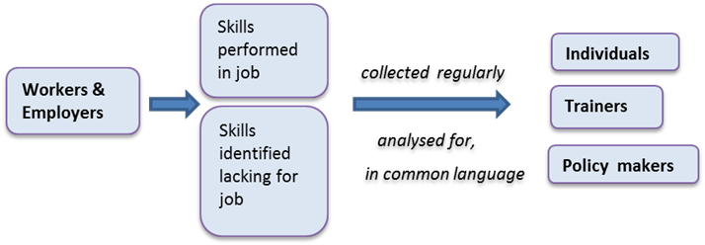

With this approach in mind, the search criteria for the desktop analysis included keywords and synonyms in the English and German languages, based on the objectives of this study (table 1). The education research database, VOCEDplus, Google and Google Scholar served as search engines. The year range was limited to January 2010 to March 2017.

Table 1 Desktop analysis: search criteria

|  |  |
| --- | --- |
| Objective | Examples of search terms |
| Selection of international practices in development of skills information frameworks/systems | skill\* system, model, framework, database, classification taxonomy, strategy, competency\*, capability,  vocational education, VET, TVET, |
| Management of skills data | data/information sourc\*, collect\*, survey |
| Integration with national standards | standard classifications, skill/competency standards |
| Evidence of utility | curriculum develop\*, train\*, educat\*, learn\*, policy |

\* Asterisks in search terms denote wildcard characters.

This search led to a ‘long’ list of 17 cases, which fully or partially addressed our search criteria (appendix A). This list was further refined on the basis of similarity of economies among countries, shared history of or highly regarded tertiary education systems, or prominence in the broader skills information literature. The final list (table 2) contained 13 cases that either addressed all or at least one of the four key objectives and those that, despite their not fully fulfilling the criteria, presented a new idea or concept of interest, for further investigation. The case studies (presented in the support document) in turn informed the key findings and conclusions in this report. Each skills case provides an overview, purpose, operation, highlights and examples of application.

Table 2 Selected skills information approaches

|  |  |  |  |
| --- | --- | --- | --- |
| Case | Country/organisation | Title or description | Type of initiative |
| 1 | OECD | Skills strategy | Skills strategy framework |
| 2 | CEDEFOP | Skills anticipation | Skills information guidelines |
| 3 | USA | O\*NET | Skills information framework |
| 4 | Singapore | Skills Frameworks | Skills information framework |
| 5 | UK | Futures Programme | Project-based industry program |
| 6 | Canada | FutureSkills Lab | Skills funding proposal |
| 7 | Switzerland | Skilling overview | Skills information overview in TVET |
| 8 | New Zealand | 1) Skills strategy proposal  2) Vocational Pathways | 1) Skills strategy proposal  2) VET learning to earning initiative |
| 9 | Finland | Skills anticipation activities | Skills anticipation model |
| 10 | European Commission | ESCO | Occupation and Skills Classification Database |
| 11 | IT industry community | SFIA | IT industry skills information framework |
| 12 | Burning Glass Technologies | Real-time job data analysis | Internet vacancy data analysis |
| 13\* | NSW BVET /Researchers Wheelahan & Moodie | Capability framework | Normative capability framework |

\* The theoretical capability framework developed by researchers Wheelahan and Moodie (2011) was included in the selection as it provides a broader background to training and skilling by focusing on the capability of learners.

## Defining occupational skills

The notion of ‘skill’ can be an elusive and difficult concept to define (Lowry, Molloy & McGlennon 2008). A number of different definitions for skills are used, mainly to distinguish them from similar or related concepts such as knowledge, competencies, tasks and jobs.

These approaches to skills definitions are more of academic interest and are not immediately useful in the realm of policy-making. Alongside the challenge of defining and measuring skills, personal characteristics such as motivation, empathy, inquisitiveness, a sense of humour etc. need to be considered. For the purpose of this report we adopted the definitions given in box 2.

**Box 2 Defining skills, jobs and occupations**

Skill and Competency: for practical purposes no distinction is made between competency and skill. A skill is the ability or capacity of an individual to act appropriately in a given situation. It involves the application of knowledge (explicit and/or tacit), the use of tools, cognitive and practical strategies and routines, and implies beliefs, dispositions and values (for example, attitudes) (OECD 2016a).

Job: a job is defined as an explicit or implicit contract (relating to the provision of labour input, not to supplying output of a good or service) between a person and a resident institutional unit to perform work (activities which contribute to the production of goods or services within the production boundary) in return for compensation (including mixed income of self-employed persons) for a defined period or until further notice (OECD 2002).

Occupation: a set of jobs whose main tasks and duties are characterised by a high degree of similarity constitutes an occupation. Persons are classified by occupation through their relationship to a past, present or future job (OECD 2001).

For the purpose of comparing and referencing skills, it is practical to provide skills categories or types. A useful categorisation of skills types in a skills policy context is provided by Cunningham and Villasenor (2014), whose framework — comprising four categories of skills type — is based on a meta-analysis of employer surveys. Cunningham and Villasenor’s categorisation (table 3) enables tailored approaches to skills development in training and assessment. For example, technical skills can be taught and assessed by a work supervisor, but attitudes and social skills are better observed by skilled pedagogues and counsellors. A comprehensive list of individual skills, by category, is found in appendix B. Skills from all four categories are usually present in all jobs but to varying degrees.

Table 3 Skills categorisation

|  |  |  |
| --- | --- | --- |
| Skill category | Definition | Example |
| Technical | Technical skills can be defined as those abilities that are associated with the specific knowledge required by an individual to carry a task. | This may be the ability to repair a car’s muffler, the knowledge to identify specific bacteria under a microscope, or the know-how to sew a dozen shirts per hour. |
| Lower-order cognitive | Ability to capture basic academic knowledge. | Literacy and numeracy. |
| Higher-order cognitive | Ability and capacity to deal with complex information processing in a professional environment. | Critical thinking, time management. |
| Socio-emotional | Referred to by economists as non-cognitive skills, these are behaviours, attitudes and personality traits that determine how we do things. | Teamwork, customer awareness, honesty. |

Source: adapted from Cunningham and Villasenor (2014).

A useful depiction of the composition of skills types and how they make up the skills profile of an occupation is the T-shaped skills model (European Political Strategy Centre 2016). The vertical line in the ‘T’ represents the depth of an expertise in a single field (domain knowledge), while the top horizontal bar is the ability to collaborate across disciplines (figure 2). These skills are founded on a base of core literacies common to all jobs.

Figure 2 Core skills for resilience for a changing world of work

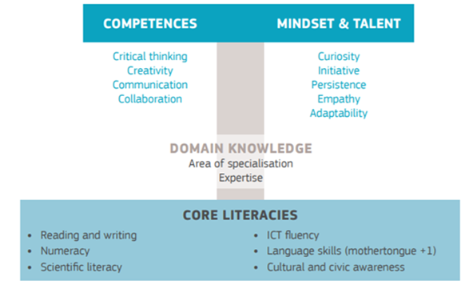

Source: European Political Strategy Centre (2016).

## Presentation of key findings

As flagged earlier, the findings of this study are based on 13 skills cases (referenced in the text by their case numbers), identified from a desktop audit and complemented by insights from a country comparison conducted by the OECD (2017b). In this report the observations and findings from the case studies are presented according to the themes of:

* the rationale for skills frameworks
* their governance arrangements and the benefits flowing from them
* the collection and assembly of skills data
* access to and the usefulness of information on skills.

# Skills frameworks, governance and benefits



The supply of and demand for skills is shaped by both structural and cyclical factors, each of which affects countries in different ways. For instance, economic growth, changes in the composition of economic output over time and the so-called megatrends are all important macroeconomic factors influencing the demand for skills (Case 1, OECD 2017a). On the other hand, labour market trends, migration, and training and education outcomes play an important role in defining the supply of skills.

Many countries have developed skills strategies to address some or all of these issues from national perspectives (Case 1, OECD 2017a). To facilitate a cross-government approach and learning on effective skills policies and to address the global dimensions of the supply of and demand for skills, the OECD suggests that a successful skills strategy will result if the following steps are taken in its development:

* Establish a common language to describe skills
* Improve the measurement of skills
* Identify essential skills for the future
* Understand skills mismatch
* Improve skills training for the unemployed
* Develop sound strategies for skills financing
* Provide guidance for national policy development and implementation (Case 1, OECD 2017a).

Further, during the process collaboration must occur across ministerial portfolios and levels of government, while engaging all relevant stakeholders — employers, trade unions, and education and career organisations. Integral to a skills strategy is the provision of good information for the public, businesses and policy-makers (figure 3, emphasis added). To tackle skills imbalances, it is essential that countries develop effective skills policies, based on reliable information relating to skills needs (Case 2, Cedefop 2016; Case 1, OECD 2017a). This includes setting up systems for the assessment and anticipation of skills needs and ensuring that this information feeds into education, training and labour market policy (Case 2, Cedefop 2016).

Figure 3 OECD skills strategy

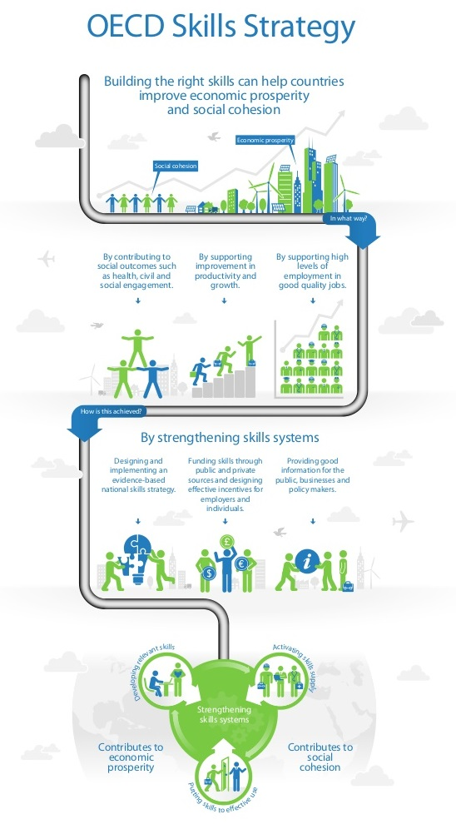

Source: OECD (2014; our emphasis added).

## Stakeholder consultations

A review by the OECD (2017b) found that, in some countries, the key stakeholder ministries such the departments of education and employment, public employment services or education providers are not sufficiently engaged in the collection and use of information on current and future skills needs. As skills imbalances affect a number of different actors, it is critical to involve a representative group of stakeholders. In the majority of the countries involved in the OECD review (2017b), the government plays a key role in collecting information on skills needs, although in some, special bodies are tasked to carry out the assessment. Methods for assessing current and future skills needs range from econometric models and composite indices, to recruitment difficulties surveys.

Coordinated mechanisms need to be in place to ensure that stakeholders work effectively together to assess and use skills needs information (OECD 2017b). Several examples of good practice are available, the best being the UK Commission for Employment and Skills (UKCES), an agency comparable with Australia’s (now-defunct) Skills Australia/Australian Workforce and Productivity Agency. The UK Commission for Employment and Skills (abolished in 2017) played a key coordination role in the production of skills intelligence and in encouraging responses at the sectoral and regional level through industry skills bodies (UK Case 5). Industry councils also play a key coordination role in Canada and Singapore (Cases 6 and 4), while independent bodies such as national skills advisory groups help improve coordination in Finland (Case 9).

### Engagement mechanisms

A variety of mechanisms have proved successful in helping stakeholders to reach consensus, including working groups (for example, the inter-ministerial skills working groups in the United States) or roundtables with specific objectives and timelines (for example, in the Netherlands, where they are used to enhance collaboration across regional/sub-regional administrative levels) (OECD 2017b).

In the majority of the countries surveyed by the OECD a variety of ministries, government agencies, bodies at regional and sub-regional administrative levels, and the social partners are involved in discussions on future skills needs and in the subsequent development of appropriate policy responses. The number of actors, as well as the diversity of interests and institutional objectives, may make it difficult to reach consensus when deciding, first, what the skills needs are and, second, the most appropriate policy response (OECD 2017b).

### Being realistic

Encouraging dialogue between stakeholders is an obvious first step, but it pays to be realistic, by entering the process with ‘open eyes’ and recognising that agencies and stakeholders have limited time for debate and discussion (OECD 2017b). Several mechanisms exist across the countries to facilitate consensus-building and to overcome potential conflict among the stakeholders involved in skills needs assessment. These mechanisms include inviting stakeholders to participate in the advisory boards of key agencies or actively involving them through thematic workshops: Singapore, UK and the IT body SFIA (Cases 4, 5 and 11 respectively) provide examples how this can be achieved. Other consensus-reaching mechanisms include developing a legal framework that requires the engagement of different stakeholders in the process; involving high-level political representatives; and framing the discussions around very concrete and short-term objectives (OECD 2017b).

# Collection and assembly of skills data



Policies to reduce skills imbalances can only be successful if they are underpinned by accurate and timely information on skills needs. An effective skills information framework demands the inclusion of high-quality — timely and relevant — skills information, achieved through a variety of data-collection exercises. Most countries conduct some form of skills needs assessment, including future skills needs, but there are important differences in the quality of these data and the way they are used (OECD 2017b).

The OECD review (2017b) confirms that the level of stakeholder involvement in skills-assessment activities varies widely across countries, with several types conducted in each of the countries examined. For instance, many initiatives rely on a mix of information from econometric analyses, job-vacancy information, employer and industry surveys, wage and employment pressures, and forecasting exercises (OECD 2017b). The mechanisms designed to enhance collaboration and coordination among the relevant parties also differ significantly.

Looking at the skills cases in this report: at one end of the scale is a system such as that operating in Switzerland, where skills information processes are integrated in the creation and update of training curricula (Case 7). The VET system in that country has a long tradition of industry-led workplace training, whereby skills in demand are closely monitored by the training system. In other countries, more responsibility for identifying relevant skills for work is placed on individuals such as training providers and students. This is the case in countries like the United Kingdom, Canada and the United States, where the link between vocational training qualifications and occupations, apart from apprenticeships and ‘registered’ occupations, is less direct (Wheelahan & Moodie 2017). Identifying skills within occupations, via their occupational information network, O\*NET, has been a long established exercise in the United States (Case 3).

## Content model of occupational features

A comprehensive skills information framework addresses the labour market and workplace factors that affect how an occupation is shaped (figure 4). The content model of O\*NET (Case 3), which was developed using research on job and organisational analyses, strives to reflect the character of occupations (via job-oriented descriptors) and people (via worker-oriented descriptors). The content model also allows occupational information to be applied across jobs, sectors or industries (cross-occupational descriptors) and within occupations (occupational-specific descriptors). These descriptors are organised into six major domains, enabling the user to focus on the areas of information that specify the key attributes and characteristics of workers and of occupations.

Figure 4 O\*NET® content model: anatomy of an occupation

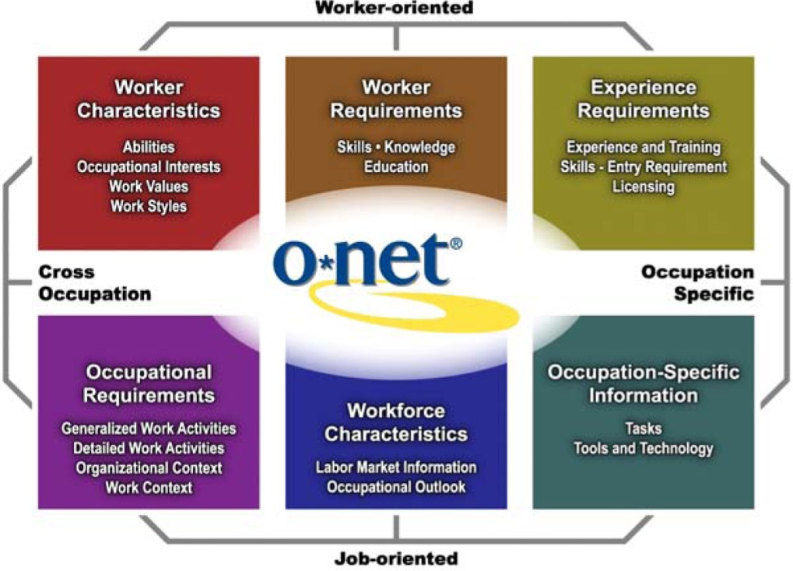

Source: US Department of Labor, Employment and Training Administration (2017).

## Drawing from a variety of data sources

Given the inherent strengths and weaknesses of the various types of skills data source, drawing from a variety of sources is desirable. For instance, the Migration Advisory Committee in the UK relies upon both quantitative information (for example, vacancy, wage and employment data) and qualitative stakeholder reports to assemble its shortage occupation list for migration policy (OECD 2017b).

In the US, the O\*NET skills information system conducts regular surveys of workers and job experts for skills, and accesses online vacancy data for technical or tool-related skills (for example, IT software skills) (Case 3). A number of other countries, among them Australia, and organisations, such as Cedefop, are using O\*NET’s data as a readily available occupational skills repository because a good correlation between occupations and the working environment exists. However, some limitations, and even problems, can arise when countries other than the US rely only on O\*NET content; this occurs when skills profiles are not mapped correctly to other countries’ occupations or if occupations exist in one country but not on O\*NET (Dickersen et al 2012).

Europe’s ESCO platform (Case 10), an integrated classification system of skills, occupations and qualifications, has been developed as part of an emerging semantic web for use in the labour market and the education and training sector. The semantic web aims to transform the internet from a collection of documents, such as job vacancies, CVs and training courses, into a web of interlinked, standardised and reusable data.

In New Zealand (Case 8), the Spotlight Skills Recognition Tool, a skills taxonomy, was developed initially for the purpose of validating underspecified and, consequently, under-recognised, interpersonal and work-organisation skills in the public administration, health and education sectors (Hampson, Junor & Smith 2008; NZ Ministry of Business, Employment and Innovation 2017). It has since been applied to jobs in the non-government social and community services sector in both New Zealand and Australia. For example, it was used to provide evidence of unrecognised skills in a recent successful application by the Australian Services Union for an equal remuneration order; affirming occupational descriptions were not in line with actual skills required and thus jobs were undervalued in this sector (Fair Work Australia 2012).

### Classification systems

Standard skills classification systems function as a complementary rather than a primary source of occupational skills information. Occupational categories do not facilitate comparisons of job skills requirements across jobs (National Research Council 2010), requiring instead a common metric or taxonomy, one where skills within occupations are classified. Such a taxonomy should be based on sound social science, and grounded empirically in direct measurements of the job tasks, aptitudes and duties of the incumbents of each occupation (National Research Council 2010). Skills classifications have become more prominent as it has become clear that the traditional occupational classifications have failed to reflect labour market transformation and the interdependencies between occupations (Markowitsch & Plaimauer 2009). Further, as Beblavy et al. (2016) note, new and emerging occupations are not being reflected in classification systems. Skills classifications such as facilitated by the European ESCO and US O\*NET databases have now become a key concept in the debate on new and emerging occupations (Beblavy et al. 2016).

The most prominent of classification systems is the O\*NET database, which contains hundreds of standardised and occupation-specific descriptors on occupations across the entire US economy. While O\*NET’s content model defines the information structure for a single occupation, the O\*NET-SOC taxonomy defines the set of occupations across the world of work (US Department of Labor, Employment and Training Administration 2017). Based on the Standard Occupational Classification external site, the O\*NET-SOC taxonomy currently covers almost 1000 occupations, all of which are updated constantly according to a specific schedule.

### Labour market intelligence

Labour market intelligence is a vital ingredient in a skills information framework. It includes occupational and skills analyses and forecasts, which enable understanding of skills gaps and therefore a better alignment between the supply of and demand for occupations and skills in the labour market. A number of countries and organisations place a strong emphasis on linking labour market intelligence to training information (Case 1, OECD 2017a; Case 5, UK Futures Programme).

#### Labour market intelligence and skills anticipation

Cedefop’s skills anticipation and matching resources (Case 2; Cedefop 2017) include guides and benchmarking tools on how to use labour market information effectively. The labour market information guide describes the relevant methods, approaches and components for the interpretation of labour market intelligence, as well as the conditions and operation of the labour market. It includes various measures, recent and projected trends, and restrictions and challenges to be considered in analysing labour market intelligence (Cedefop 2016).This guide provides advice and recommendations for policy- and decision‑makers on how to respond to market signals and how to react to early warning messages driven by labour market intelligence. Technical analysts and professionals can use this information as a means for identifying how labour market intelligence systems can be further developed and used for policy analyses and interventions.

SkillsDMC, a former industry skills council for the Resources and Infrastructure Training Package acknowledged the usefulness of the labour market guides developed by Cedefop and its partners and offered an example in its comprehensive *Resources and infrastructure: industry workforce analysis and forecast* (SkillsDMC 2017). Developed in 2016, the forecast aims to provide ‘information and reasoned forecasts on the Australian resources and infrastructure industry’s skilling needs, challenges and opportunities’ (p.3). In effect, this report serves as a long-term planning document for the rapidly transitioning resources and infrastructure industry, and for preparing industry participants for both the challenges and opportunities ahead.

### Surveys and other ‘traditional’ skills data sources

National, regular and standardised surveys of the workforce, employers and job experts are the backbone of first-class skills information systems and initiatives such as O\*NET (Case 3), Cedefop’s skills surveys (Case 2) and the OECD’s skills information instruments such as PIACC.

The Survey of Adult Skills, a product of the OECD Programme for the International Assessment of Adult Competencies (PIAAC), measures adults’ proficiency in several key information processing skills, namely, literacy, numeracy and problem-solving in technology-rich environments (OECD 2016b). Similar to the O\*NET survey approach, PIACC uses a ‘job-requirements approach’ to ask employed adults about a number of generic skills, including how intensively and how frequently they use these skills at work. Information is also collected on four broad categories of generic work skills: cognitive skills, interaction and social skills, physical skills, and learning skills.

#### O\*NET surveys are exemplary

The O\*NET model is exemplary in the scale, coordination and depth of its survey, by occupation, of the skills, abilities and knowledge of workers (Case 3). O\*NET re-surveys occupations on an ongoing basis and a completely new set of ratings becomes available about every five years. This has great potential use in capturing within-occupation skills change (Handel 2016), a situation which cannot be achieved by standard occupational classification systems. O\*NET’s Knowledge, Skills, Abilities, and Work Activities questionnaires ask two-part questions on both the importance and levels of a given skill or characteristic.

#### UK Employer Survey captures skills difficult to recruit

The UK undertakes employer surveys to gauge the country’s current level of skills demand and the extent to which they are experiencing skills shortages (Case 5). The most important one is the Employers Skills Survey (ESS, United Kingdom) which provides comprehensive insight into skills needs, vacancies, skills shortages and skills gaps (Cedefop 2017, Skill Panorama website ). The survey, which is conducted every two years, collects data from businesses with one or more employees across sectors and the UK, and covers employers’ recruitment activities, the occupations for which they have been recruiting, and whether they have experienced difficulties recruiting people with the desired skills. This provides an indication of skills mismatch at the occupational level. The strength of the survey is that it provides information about those skills employers find difficult to recruit. However, it is not always clear whether difficulties recruiting staff are due to, for instance, relatively poor working conditions or a genuine shortage of skills in the external labour market, although advances have been made over the years in addressing this issue (UK Commission for Employment and Skills 2016).

The employers skills survey feeds into a UK online portal (LMI for All). Now a repository of a vast range of skills data, LMI for All provides national-level data on labour market information for IT developers and others to produce a range of website tools to help inform career choices and decisions. The aim of LMI for All is to make skills and other labour market data available to a wide range of stakeholders (UK Commission for Employment and Skills 2016).

#### Canada’s FutureSkills Lab taps into employer’s own data

Canada’s FutureSkills Lab program (Case 6) recognised that corporations have a significant role in the generation and collection of labour market information and that this employer data is a critical resource for forecasting skills needs. For example, while employers may not know exactly how many engineers they will need in five to 10 years, they can, in all probability articulate the types of foundational skills (for example, technical literacy) needed. Given that some employers keep high-quality data, the FutureSkills Lab program would consider ways to unlock this valuable proprietary data, perhaps, it is suggested, by engaging employers on an annual skills and competency survey and offering a report of trends and findings in exchange.

### Real-time, online skills demand and supply data

Gaining access to traditional labour market information can pose several challenges; for example: the high cost of data collection; the data lag behind real-time developments in the labour market; and, occasionally, insufficiently detailed information to understand skills gaps. Real-time labour market information uses big-data analyses to overcome these shortcomings, utilising ‘big data’ information sources such as online job and resumé advertisements, which that can be exploited instantly.

Traditional labour market data are structured around broad job categories, and all jobs within those categories are presumed to be identical in terms of the skills, experience and education they require (Case 12, Burning Glass Technologies 2017). By contrast, real-time job-market data can be much more specific, reflecting how jobs differ within and across sectors and geographies.

#### Online job vacancy ‘mining’

In recent years online job advertisements have proliferated, and government agencies and the research community are increasingly experimenting with online job data, in particular breaking it down in order to study skills in demand and labour market dynamics more generally. Online job-advertisement data show great promise, especially in combination with other educational and labour market data. Used carefully, these data offer insight and suggest rich new areas for the development of employment and educational services (Case 12; Carnevale, Jayasundera & Repnikov 2014).

Compared with the point-in-time snapshots provided by survey-based labour market data, which rely on random sampling, online data are cost-effective and have the capacity to improve the accuracy of labour market forecasts. They are able to produce supplementary estimates of demand within detailed occupations, industries and geographies (Case 12; Carnevale, Jayasundera & Repnikov 2014), and also provide the relative demand for different types of skills and levels of education.

The real-time nature of job-vacancy data also allows for the early detection of labour demand trends, which gives job seekers, employers and policy-makers a forward-looking analytical tool. Real-time labour market indicators can be particularly useful in aligning education and training curricula with workforce needs in emerging or rapidly changing industries, such as healthcare and information technology (Carnevale, Jayasundera T & Repnikov 2014).

Online job-vacancy analyses demonstrate that the precise skills an employer expects from an occupational title can vary according to geography. Using the example of a marketing manager in the United States, in Chicago employers appear to emphasise project management skills, whereas in San Jose, the heart of Silicon Valley, it is product development skills, and in the ‘casino capital’, Las Vegas, employers request customer service skills above other skills (Case 12, Burning Glass Technologies 2017).

Tapping into individual online data on jobs and people thus provides new opportunities for better tracking and anticipating gaps in skills, mapping mismatches and marrying employers’ needs with employees’ capabilities. This approach also offers transparency, enabling individuals to understand potential career options and education and training requirements, and how these are remunerated in the labour market (World Economic Forum 2016). Interestingly, the O\*NET system (Case 3) uses online vacancy data only in the area of tools and technologies.

Online job-vacancy data analyses revealed that lower-skill jobs seem to face the widest gaps in foundational skills (Burning Glass Technologies 2016). In the online postings a number of foundational skills are emphasised out of proportion to what traditional job definitions would appear to require, suggesting that employers struggle to find people with these skills. Employers in fields such as hospitality, food and tourism, and personal care and services, expressed a particularly strong requirement for skills such as basic maths (Case 12, Burning Glass Technologies 2016).

Despite increased usage, there has been only limited research assessing the usefulness of this data source. In the US, and possibly in the Australian labour market, it is estimated that between 60 and 85% of job openings are now posted on the Internet, but these job ads are biased toward industries and occupations that seek high-skilled white-collar workers (Carnevale, Jayasundera & Repnikov 2014; Case 12, Burning Glass Technologies 2017).

Job-vacancy data are subject to systematic errors, introduced by how employers utilise the Internet for their talent search; the vendor data-collection processes; and the effectiveness of the artificial intelligence used to collect and single out the information from the advertisements. If ignored, systematic errors can undermine the predictive power of the data and distort public policy decisions. Currently, online job-vacancy data may not meet the traditional standards of labour market information or government statistics, but there is merit in carefully implementing this tool in conjunction with traditional data, particularly as it becomes more robust and viable (Carnevale, Jayasundera & Repnikov 2014). As Johnson (2016, p.1) notes:

Given significant limitations to real-time LMI itself, including examples where real-time LMI leads to suspect policy action, some experts see it as a useful supplement — or an additional labor market ‘lubricant’ — but not as a replacement for or savior of traditional systems.

#### Online resumé ‘mining’

As online resumé mining is an emerging data source, less information was found on this aspect in any of the skills cases. In New Zealand (Case 8) VET students are encouraged to build skills portfolios that demonstrate which units of their program relate to the various industry areas and their pathways. These portfolios are accessible to potential employers, who are able to gain insight into the applicability of the training undertaken by the student to the employer’s skills interests (see a portfolio illustration on page 36 in this report and NZ Case 8 in support document).

By way of an example of how to exploit online data on the skills supply side (job seeker data) and to map labour market changes, the analytics employed by the professional profile platform, LinkedIn, describe each job function as an agglomeration of skills (State & Rodriguez, cited in World Economic Forum 2016). This enables the platform to track changes in the skills landscape as members update their professional information, which in turn allows the platform to identify the clusters of skills associated with the profiles of members with common job functions and titles, and to map how these change over time. It also allows the identification of nuances and differences between the skills sets of common job functions in different industries or geographies.

For example, a skills heat map, a representation of data in the form of a map or diagram in which the intensity of data values are represented as colour intensity as shown in figure 5, can highlight that the most common skills reported by mechanical engineers vary across different industries (State & Rodriguez, cited in World Economic Forum 2016). Mechanical engineers working in various sectors of the mobility/transport industry have similar skills but their skills differ from the skills of those who work in the healthcare industry or the energy and infrastructure sectors.

Figure 5 Common skills reported by mechanical engineers across different industries (LinkedIn Analytics)

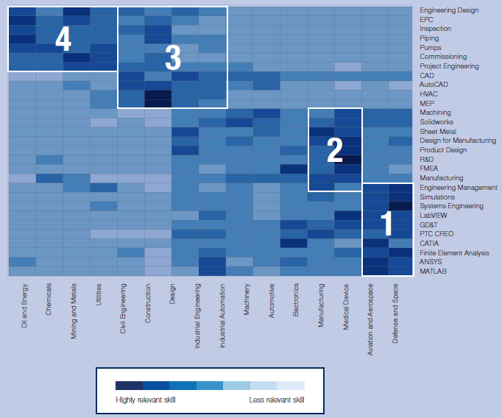

Source: State & Rodriguez, cited in World Economic Forum (2016, p.17).

By calculating the skills recently added to members’ profiles as a percentage of those who had already reported that skill, it becomes possible to identify the skills whose supply is on the rise in particular industries or geographies (State & Rodriguez, cited in World Economic Forum 2016). This supply-side analysis can be complemented by an analysis of skills demand — whether based on job listings, within job-hiring rates, government forecasts, or employer surveys — to identify emerging skills gaps and to inform training and skills programs, with the aim of preparing the workforce for future requirements.

Similar limitations to those of online job-vacancy data hold true for resumé data, specifically that the online professional profile is self-compiled and may be skewed towards industries with highly skilled professionals.

## Data update cycle

Skills information for occupations needs to be continually updated through regular surveys and online job data. Ideally, skills descriptions should keep pace with movement in the labour market. The frequency of updates can differ according to the type of occupation and skill. It makes sense for IT programmers to update information on programming skills annually (Case 11, SFIA), whereas in more traditional occupations, such as teachers, the principal pedagogical skills can be retained for a much longer period, with no need for annual updates.

The O\*NET system (Case 3) demonstrates that the frequency of updates is different for skills based on tools and technology, where online vacancy data are used. More enduring categories such as values and interest may be over five years old, whereas work activities or tools and technology may be updated every one to two years. The Singapore Skills Framework updates its information about every two years (Case 4).

# Access and utility



This section summarises the findings from the 13 skills initiatives on the output from skill information systems and the usefulness of skills information for various stakeholders.

Making the best use of the information relating to the assessment of current and future skills is a crucial challenge for many OECD countries (OECD 2017b). Governments usually use information about skills to:

* update occupational standards
* design or revise training policies for workers or the unemployed
* design, revise or decide on the allocation of courses in formal education.

This information is used in many countries to inform the development of vocational education and training programs or apprenticeships, while some governments may use the information to guide migration policy, as well as their transition to a digital or green economy (OECD 2017b). Career services use skills information to inform workers and students about trends in skill demand and supply.

## Access to skills information

Several skills information initiatives aspire to function as an information portal catering for a range of stakeholders, that is, ‘first stop’ or ‘one stop websites’. For example, Cedefop (Case 2) envisions its skills information output as a lively interactive platform with data and features responding to the needs of different types of users, irrespective of whether they are policy-makers, practitioners working in employment agencies and guidance services, or experts in skills needs anticipation. O\*NET (Case 3) leads the way, with information from the O\*NET database forming the heart of O\*NET OnLine, an interactive application for exploring and searching occupations.

### OECD Skills for Jobs database

Launched in July 2017, the OECD *Skills for Jobs* Database provides information for European countries and South Africa about skills shortages and surpluses, as well as data on qualification and field-of-study mismatch. Information about surplus and shortage at the occupational level is translated into skill needs by mapping the occupations to their skill requirements (Case 1, OECD 2017c). The database provides information on a wide range of skills, including cognitive skill, social skills, physical skills and a set of knowledge types which it sources from the O\*NET database. In the *Skill for Jobs* web tool the skill requirements of occupations can be compared to see which skills need to be further developed through training. These training profiles allow individuals to see which skill investments would be required to move from one occupation to another, and ideally from a surplus occupation to a shortage occupation (see example in figure 6, Vandeweyer 2017).

Figure 6 Training profile for ‘Legal, social and cultural associate professionals’ wanting to switch to ‘Business and administration associate professionals’ jobs (Italy) (Vandewyer 2017****)****

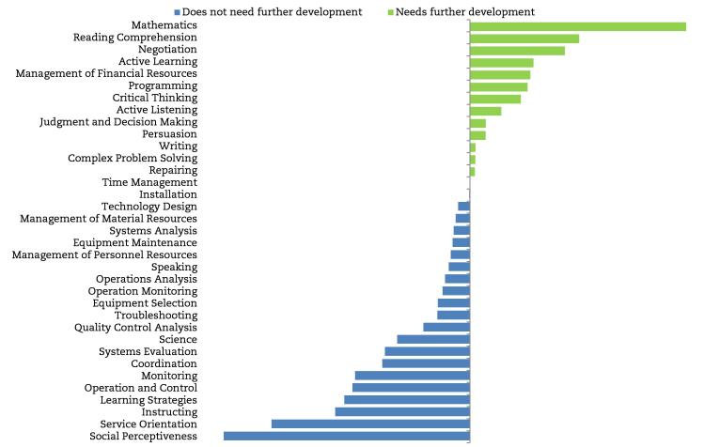  
Source: (OECD, Vandewyer 2017)

Career guidance counsellors can use the Skills for jobs web tool to provide advice that responds to labour market needs. Employers could use the Skills for Jobs web tool to identify occupational skill profiles that are similar to those they require in order to maximize their chances of recruiting for hard-to-fill vacancies (OECD 2017c).

### Examples from Singapore and the UK

The comparatively new Singapore Skills Framework site (Case 4) provides videos, information and frequently asked questions, specifically tailored to students, employees, employers, career advisors and training providers. Beginning in 2016, information on skills has become available progressively for selected industry growth sectors. The information is organised in a structured manner, starting with background information about the sector before detailing the workplace context and covering career pathways and occupations/job roles, as well as the skills needed for these occupations/job roles. The information in the Skills Framework also includes a listing of training programs to address skills gaps and for skills advancement.

The UK labour market portal (Case 5), LMI for All, has become a repository of a vast range of skills data and provides national-level data on labour market information. As mentioned earlier in the report, the aim of LMI for All is to make skills and other labour market data available to a wide range of stakeholders. Skills data with labour market indicators are mapped to Standard Occupational Classification (SOC) categories at a detailed occupational level (4-digits, the most detailed level in the UK classification system). Data are disaggregated to occupation, region, gender, age and employment status.

### Europe’s ESCO skills classification

An initiative worthy of close monitoring is Europe’s recently released ESCO platform — European Skills/Competences, Qualifications and Occupations (Case 10) — a classification that provides an integrated approach to information on skills, occupations and qualifications (figure 7).

Figure 7 Role of ESCO classification

P:\WorkInProgress\ShaunPubs\How to know what skills are needed for work\FIgure 7\Slide1.EMF

Source: Nomden (2012).

Interlinked (via semantic web technology) standardised and reusable data from different sources can then be fed into tools such as job-matching platforms, human resources systems, career guidance tools or statistical applications. As of July 2017, the platform offers three searchable data pillars: occupations, skills/competences and qualifications.

The skills pillar currently contains about 13 500 skills/competences and knowledge concepts, tagged by skill type/category. Each of these concepts comes with terms in each of the ESCO European languages and also includes an explanation of the concept, in the form of description, scope note and definition. The skills pillar is structured in four different modes:

* Through their relationship with occupations, that is, by using occupational profiles as entry point
* In collating transversal knowledge, skills and competences through a skills hierarchy
* Through relationships indicating how knowledge, skills and competences are relevant to other knowledge, skills and competences (in particular in cases of skill contextualisation)
* Through functional collections, which allow the selection of subsets of the skills pillar.

By connecting to other instruments on skills intelligence, the ESCO database aims to provide a clearer and more complete picture of labour market and education-related information. The use of a linked open-data approach ensures that the resulting product can be used by the majority of owners of practical career, training and labour market tools and labour market systems, thus enabling better services to stakeholders (see figure 8).

Figure 8 ESCO classifications supporting and integrating instruments and services of skills information

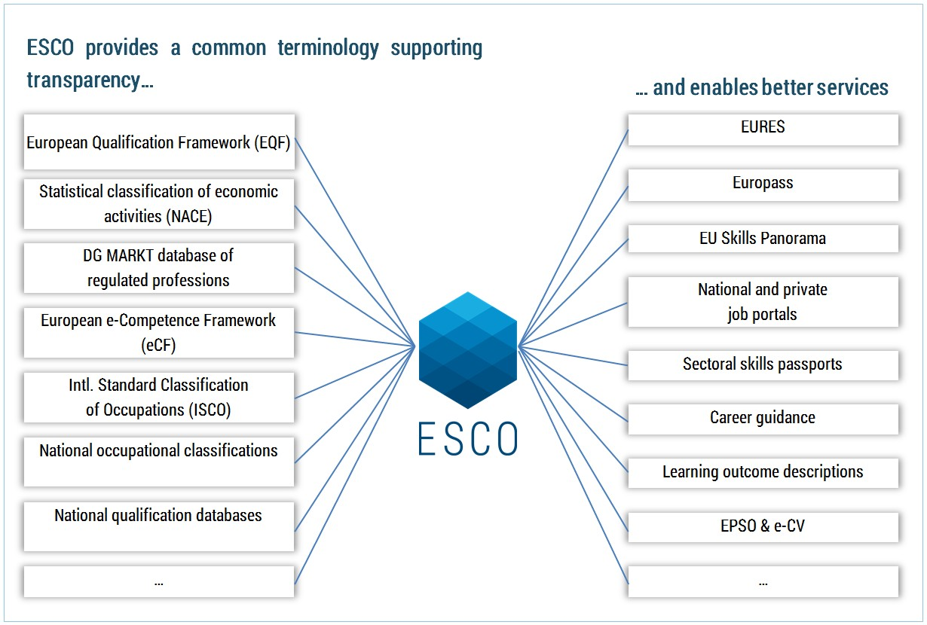

Source: European Commission (2017), p.10.

(A similar database created for Australia could conceivably interlink with comparable instruments and services, for example, ANZSCO, qualification frameworks and labour market information on the one hand and career, job and training portals and training assessment tools on the other hand.)

## Usefulness of skills information

### Curriculum developers and trainers

Many skills information models and frameworks address the usefulness of skills information for curriculum developers and trainers, but little is known about the actual usage and perceived benefits of these frameworks for this cohort.

Quality information on skills needs is crucial in the planning of training provision. In a limited country review, the OECD (2017b) found that at the government level this is only the case in France, where the public employment service estimates training needs according to information on expected recruitments from the national employer survey. Estimated training needs are used to decide on the amount and type of training to procure for the unemployed.

However, in other countries sectoral bodies and unions collect and/or use skills needs information to plan training provision. For instance, sector skills councils in the United Kingdom were previously instrumental in organising apprenticeships and facilitating linkages between training providers and firms (Cedefop 2017); to a large extent, this role has now been taken up by employer-led trailblazer panels (OECD 2017b).

#### Capability framework

The capability framework developed by Wheelahan and Moodie (2011; Case 13) proposes alternatives to the notion of competence that underpins competency-based training and aims to transform vocational education. The capability approach purports that freedom to achieve well-being is a matter of what people are able to do and to be, and thus the kind of life they are effectively able to lead. This type of framework is normative as it refers to an evaluative standard. It presents suggestions for thinking about the particular types of skills required to achieve well-being in work. The rationale for the development of the capability framework is that VET should prepare students for a broad occupation within loosely defined vocational streams rather than for the workplace tasks and roles associated with particular jobs (Wheelahan, Buchanan & Yu 2015). The capability framework calls for moving the focus:

* from competencies (‘skills’) to capabilities
* from products (training packages, assessment materials etc.) to processes (brokering standards, accreditation and assessment)
* from qualifications based on workplace tasks and roles to qualifications that prepare students for broad occupations within vocational streams.

#### Access to skills information

In the US, O\*NET (Case 3) has been endorsed by about 500 national and industry associations, for example, Bread Bakers Guild of America, International Warehouse Logistics Association, and the New York Academy of Sciences; all organisations encourage their members to contribute information to the O\*NET program.

The explicit objective of the Singapore Skills Framework (Case 4) is to encourage training providers to gain insights into sector trends and skills in demand. The information presented is designed to enable providers to make innovations to training and to contextualise curricula and training programs to suit the needs of the sector. Under the tab, Skills and Competencies Descriptions, technical and generic skills and competencies are identified for each job role, meaning that training providers can use this information to plan the courseware and curricula, and conduct research on ways to embed suitable pedagogies for achieving the learning outcomes. Training providers are also encouraged to use skills descriptions to help companies to develop progressive human resources practices for skills recognition and benchmarking.

In relation to the Singaporean VET system, Peter Noonan (2017) commented in *Campus Review* that, in the 1990s, the Australian VET sector was ‘the envy of the rest of the Asia-Pacific but now it might be the other way round’:

In Singapore, the formerly dilapidated Institutes of Technical Education have been entirely overhauled, materially and in spirit. Now, they emphasise future skills training, with a technology edge. Heavy government investment in both Singapore and Hong Kong has resulted in a multitude of modern campuses offering similarly innovative courses, like those with a sustainability focus, particularly in Singapore. This, in turn, has amped up the prestige of the sector, drawing in students who would have previously only considered a university education.

#### FutureSkills Labs

Canada’s FutureSkills Labs (Case 6) aims to identify innovative ways to link degrees and credentials to skills and competencies. As one potential approach, the program suggests mapping the skills demanded by employers, as expressed through pilot proposals, to information about the credentials of the employees who have been most successful in the past. Initiatives of this nature would provide greater clarity to employers seeking to hire workers with competencies not reflected by traditional credentials. Students could also use the FutureSkills Lab information to identify the qualifications required for their desired field of work.

The FutureSkills Lab would support programs that equip students and new graduates with the skills employers need, or skills associated with successful and scalable entrepreneurship. This support might include increasing opportunities for work-integrated learning or delivering training tied directly to market-identified skills needs. Priority for co-financing support would be allocated to those pilots that build skills important for future work success and which are unlikely to be made redundant in the near term through automation or other forms of innovation.

#### Information for training providers in Finland, Europe, UK and the global IT community

In Finland (Case 9) the education department runs a national project whose aim is to develop and pilot a forecasting model designed to identify the skills needs of the adult population, with the aim of informing decisions on education for this cohort of all types and levels. A new skills-anticipation tool, focusing on VET, is likely to be completed in 2018, triggered by the significant reform of the VET system currently underway. In 2016, skills assessment reports were published on industries in the food chain, retailing, games and services for the elderly sectors. Results from these skills-forecasting exercises will have an impact on the curricula for VET and higher education.

Europe’s skills database, ESCO (case 10), provides resources to enable education and training providers to undertake surveys and analyse data on current and future labour market needs, which can then be used as the basis for the further development of curricula.

The IT Skills Framework for the Information Age developed by the SFIA Foundation (Case 11) offers training providers the opportunity to map their courses to the framework, thus ensuring the most appropriate courses and certifications are selected for individuals. Professional bodies and membership organisations can map SFIA skills to their membership levels, certifications, professional development and mentoring programs. The framework can also be used to identify suitable mentors, supporting knowledge- and experience-sharing and coaching activities.

How labour market intelligence can be connected with training providers is demonstrated by the UK’s Future Programme (Case 5). As a component of the program, the Association of Colleges (AoC) and the UK Commission for Employment and Skills (2015) have produced a guide for curriculum developers designed to assist further education colleges to maximise the use of labour market intelligence. The guide provides a broad perspective of national and local labour market information across industry sectors and is intended to support college leaders with curriculum planning (Case 5). Through a defined inspection process conducted by Ofsted, a provider will be assessed on how well leadership and management teams successfully plan, establish and manage the curriculum and learning programs to meet the needs of learners, employers and the local and national community.

#### Job seekers, employees and career advisors

The O\*NET platform (Case 3) provides a wealth of up-to-date occupational skills information, with its database providing the basis for career-exploration tools, including assessment instruments for workers and students looking to find or change careers. These include a range of instruments and services (box 3).

**Box 3 O\*NETs range of instruments and services**

Source: National Center for O\*NET Development (2017).

The Interest Profiler Short Form matches a person’s interests and level of work experience to identify a possible suitable career. The easy-to-read career reports include the most critical on-the-job tasks and skills. Job seekers can also find local salary information, training opportunities and job postings. Customised versions are available and provide targeted services to veterans and to Spanish-speaking career explorers/job seekers.

In O\*NET OnLine Customizable Occupation Reports offer a range of information, from a broad overview to comprehensive detail on a specific subject. Occupations, or the entire O\*NET-Standard Occupational Classification hierarchy, can be searched by keyword search, and users are encouraged to explore across occupations, using Content Model descriptors such as abilities and interests.

Using the O\*NET Career Exploration Tools, students and workers may explore a range of career directions, based on their interests, work values and abilities. The computerised assessments and related materials are available as free downloads.

The aim of Singapore’s Skills Frameworks (Case 4) is to assist students to make informed decisions on education and training, career development and skills upgrading, using the sector, employment, occupation/job role, skills and training information available on the framework. The Sector and Employment Information section provides a broad overview of the sector and employment prospects. A section on occupations informs users of job scope, the work context and the attributes required by employers. A map on career pathways provides a description of typical career pathways and potential development prospects. As the occupations/job roles are mapped to skills and competencies, which in turn are linked to the relevant education and training programs given in the training program list, users can determine their preferred choice of study based on their aspirations.

New Zealand’s skills strategy (Case 8) emphasises the importance of informed career advice, advocating the provision of current information and lifelong learning advice for young people currently in the workforce, as well as their families. As part of this work, consideration is given to expanding and enhancing the range of information (including labour market information) and tools targeted at adults in the workplace on the nation’s career services website and within their ‘wrap-around’ suite of services.

It was proposed that the nation’s career services agency, in partnership with others, will be the lead organisation in advancing work in this area, as it has an evolving and sophisticated service delivery infrastructure, including web-based, phone-based and in-person services. It is widely recognised as the ‘go to place’ and has a track record of providing relevant, independent, accessible and user-friendly career information, advice and support.

NZ’s Vocational Pathways program (Case 8) provides new ways to achieve secondary vocational accreditations (NCEA[[6]](#footnote-6) Levels 1, 2 and 3), by developing pathways that progress to further study, training and employment. The Vocational Pathways provide a framework whereby students are able to show how their learning and achievement is valued in the workplace by aligning learning to the skills needed for industry. The online tool, Profile Builder, helps students to explore their study options. By inputting the skills/standards, a student is able to evaluate the program they are undertaking or considering undertaking, as well as viewing the pathway along which they are heading and thinking about where they would like to go.

Educators can also use the tool to plan programs that align to Vocational Pathways and support young people to achieve an award. Employers can view a student’s vocational profile to identify the sector (pathway) their credits relate to, how many sector-related credits they have achieved, and whether they have achieved a Vocational Pathways Award. An employer can then determine whether a student’s skills and interests align with those required by the selected industry.

Figure 9 provides an indication of the Vocational Pathways information relating to specific students, which employers can glean from the New Zealand Qualification Authority website. In this example, the student has gained NCEA Level 2 with two pathways: Manufacturing and Technology, and Primary Industries. The ticks of approval on these bars show the levels achieved and that the student will be awarded a Vocational Pathways Award in both pathways. Credits may appear in more than one pathway.

Figure 9 NZ Vocational Pathways Profile Builder Overview

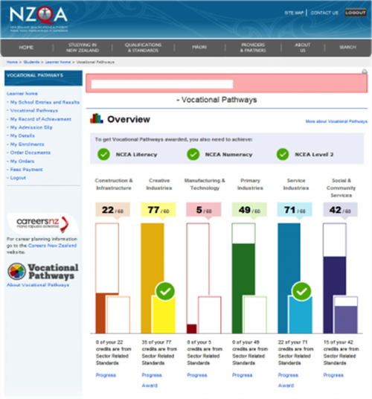

Source: NZ Ministry of Education (2017).

### Employers

Employers have the opportunity to use the resources contained in Singapore’s Skills Framework (Case 4) to design progressive human resources practices for recognising skills and making informed decisions on skills investment. Employers are encouraged to use the technical and generic skills and competencies as a means for understanding the breadth and depth of the skills requirements. The available skills and competencies descriptions can also be used during appraisals of individuals and their skills profile to discuss and assess skills match and skills gaps. The list of the training programs given in the Skills Framework enables employers to be able to identify the program that would address the skills needs of employees.

As a part of the UK Futures Programme (Case 5), small-scale public co-investment was offered to employers and industry to enable them to design and test solutions to their emerging or long-standing skills and productivity challenges. The program’s evaluation flagged that it was important to foresee difficult barriers in employer engagement in the program, to ensure it added value to existing initiatives.

Europe’s new skills classification database, ESCO (Case 10), has been designed to support employers to understand the knowledge, skills and competences that people have obtained through education, training or ‘on the job’ experience. The structure of the database allows employers to articulate the knowledge, skills, competences and qualifications they expect from their employees.

# Discussion



Now more than ever, existing and future workers need support to navigate an increasingly complex and uncertain world of work. The Productivity Commission (2017, p.86) warns that the current skill system across all education sectors ‘has fractures that put at risk its capacity to deal with the future labour market changes’. Changes in the work environment and longer working lives, and with workers having multiple and different ‘jobs’, will drive the formal education sector towards a lifelong learning model, along with ‘as needed’ training. This is the central argument recently made by the Business Council of Australia (2017) in its *Future-proof: protecting Australians through education and skills* discussion paper. Individuals need to be prepared to not only change jobs more often but also to transition to new jobs. This places greater emphasis on deep-detail understanding of skills, rather than occupations.

This chapter offers some summary discussion points emerging from the findings of the desktop analysis, at the end of which we highlight a number of implications for the VET system, especially training packages, arising from the potential establishment of a skills information framework in Australia.

### Skills, occupations and qualifications require different analyses

The good practice examples of skills frameworks described here recognise that occupational skills analyses require a far more detailed disaggregation than the equivalent for qualifications and occupational titles; these can be poor proxies for the actual skills required and performed in diverse workplaces. For many qualifications, there is a limited match between the qualifications that people have and the jobs they do (Mavromaras et al. 2013; Wheelahan & Moodie 2017). Investigating via the skills lens provides a more effective way to determine which key amalgam of skills is instrumental to students gaining a job or performing well in a job.

This issue is also relevant to job applicants: they need the capacity to recognise the distinct skills obtained from formal education, as well as those from informal learning. For managers, New Zealand offers the Spotlight Skills Recognition tool, designed to assist them to identify the employee skills that can be overlooked or taken for granted (‘hidden skills’); these are especially skills used in interacting and relating, coordinating and shaping awareness (Ministry of Business, Employment and Innovation 2017).

### Skills updates need to be linked to occupational classification systems

Policies to reduce skills imbalances and prepare for future skills in demand can only be successful if they are underpinned by accurate and timely information. At present, information relating to skills requirements is largely sourced from occupational classifications systems. The literature reviewed for this report is clear that the problem does not lie with the structure and content of occupational classifications but in their use as proxies for skills information. In the absence of up-to-date and forward-looking occupational skills information, this is often the next best alternative.

Rather than implementing a system of continuous update of skills information within occupational classification systems, which is not feasible in practical terms, a better solution is to keep occupational code information at a broad level and use external databases to tag skills to occupations, as done with the O\*NET system. The collection and mapping of skills data to occupational classifications in this program is a leading example of good practice. It uses a variety of data sources, including information directly from workers, employers and job experts, via regular and frequent surveys, complemented by online vacancy data analyses.

### Education needs to become more stackable

Both training content and its mode of delivery will continue to change. Courses and their associated qualifications are likely to become more modular to allow them to be completed progressively and flexibly alongside work. Following completion of a foundational qualification, the model of a ‘stackable’ VET system may be required, whereby workers’ existing skills are measured and efficiently built upon with new training modules (Payton 2017). This has been demonstrated by Singapore’s Skills Framework, where the training system is moving away from qualifications towards a modular system, one in which employers and learners can choose the training components.

### Skills information must be accessible to all

Governments focus on the productive capacity of society; individuals focus on preparation for their working lives and progression in the labour market; and employers focus on the immediate needs of their firms. With these requirements in mind, the ideal skills information framework will accommodate these sometimes conflicting interests and provide information tailored to all interest groups.

The exploration of international skills information frameworks, systems, initiatives and services confirmed that good practice approaches involve determined government leadership and excellent stakeholder collaboration and buy-in. The framework itself requires timely inputs of coherently and comprehensively sourced, analysed and assembled data coupled with useful outputs via an accessible data portal.

## The future for Australia?

Australia is also encountering an increasingly complex skills landscape, with its attendant problems of access to and availability of information relating to both current and future skills in demand. To this end, the development of an overarching skills information framework, on both the supply and demand sides, and containing relevant, timely and up-to-date data, could be investigated. In terms of the Australian VET system, such a skills framework would be particularly useful in updating skills standards in training packages and linking VET accredited units to skills identified on the demand side. The Productivity Commission (2017) noted in *Shifting the dial: 5 year productivity review* that training packages do not always serve the needs of employers and students with technical standards having proliferated over time and taking too long to update.

Recent discussions on training product reform (training packages and accredited courses) indicated that technical skills should not be compromised in training packages, but that broader capabilities and disciplinary knowledge need to be added to the training (Beddie, Hargreaves & Atkinson 2016). Snell, Gekara and Gatt (2016) argue further, that there is a need to reconceptualise how occupations are classified in Australia, such that the transfer of skills is better acknowledged and encouraged, underscoring that it is important to understand how all occupations invariably draw upon the skills inherent in other occupations. This is a similar concept to vocational streams, whereby occupations are grouped according to their shared knowledge, skills and practices, rather than according to specific workplace tasks and roles, the aim being to promote a more adaptable workforce (Wheelahan, Buchanan & Yu 2015). This is reiterated by the Productivity Commission (2017) urging to broaden the skill content of training packages to equip people with sufficient skills to adapt to changes in the workplace.

The Australian career site JobOutlook already takes advantage of the O\*NET skills repository, using its descriptors for ANZSCO occupational groups (Department of Employment 2017). This information is linked to the MySkills website, a platform primarily designed to enable students to find courses and training providers. The link allows individuals and curriculum developers to link qualifications with research on occupational labour market statistics and extensive skills descriptions (derived from US occupations through O\*NET) within intended occupations.

In a next step, this information could be mapped to units of competency in training products, as stored on the repository of accredited vocational training and providers, training. gov.au. During the 2016 training products symposium, participants proposed that ‘static’ course and unit information (stored as pdf documents) be transferred into a relational database of units of competencies (Beddie, Hargreaves & Atkinson 2016). The VET workforce, as well as employers and, potentially, learners, could then access specific information about the training packages, qualifications, skills sets and units of competency associated with their occupation of interest (Beddie, Hargreaves & Atkinson 2016).

A web-based occupation and skills information platform in the making is the Australian Industry Skills Committee’s National Industry Insights Web Platform, which, as the website explains, is being developed ‘to provide an easily accessible platform for industry stakeholders and IRCs (industry reference committees) to access data and information on their sector’ (Australian Industry Skills Committee 2017).

Rethinking how occupational skills information could be stored and accessed also offers a potential opportunity to simplify the structure and update of training packages. Research by Snell, Gekara and Gatt (2016), noted earlier, suggested that the Australian VET system could be improved by encouraging more transferability across occupations by means of making employability skills more applicable to all workplace contexts. Their proposal would see training packages drawn from a common language to describe competencies, skills and knowledge to make the content of training packages easier to understand.

## Conclusion

In summary, the international evidence is that other nations are making concerted efforts to create and use skills information frameworks, populated with contemporary and cross-referenced skills intelligence, maintained close to real time, to steer policy and inform training practices. A resource such as this will become increasingly useful to multiple end-users for a variety and diversity of purposes. Australia has multiple skills information repositories, yet their full potential remains unrealised, as a consequence of a lack of an integrating skills framework of the scope, ambition and investment evidenced in fast evolving international practice.

# References



AlphaBeta 2017, ‘*The automation advantage’*, viewed August 2017, <http://www.alphabeta.com/wp-content/uploads/2017/08/The-Automation-Advantage.pdf>.

Australian Industry Skills Council 2017, *National Industry Insights Web Platform*, viewed 1 October 2017, <https://www.aisc.net.au/content/national-industry-insights>.

Association of Colleges & UK Commission for Employment and Skills, 2015, *Using labour market intelligence in a college context*, viewed July 2017, <https://www.gov.uk/government/publications/using-labour-market-intelligence-in-a-college-context>.

Beblavý, M, Akgüc, M, Fabo, B & Lenaerts, K 2016, *What are the new occupations and the new skills? And how are they measured?* State of the art report, Working paper, Belgium.

Beddie, F, Hargreaves, J & Atkinson, G 2017, *Evolution not revolution: views on training products reform*, NCVER, Adelaide.

Burning Glass Technologies 2016, *Baseline skills the human factor: the hard time employers have finding soft skills*, Boston, MA.

——2017, *Same job title, different skills: why all jobs are local*, Boston, MA, viewed 1 October 2017, <http://burning-glass.com/same-job-title-different-skills/>.

Business Council of Australia, 2017, *Future-proof: protecting Australians through education and skills*, Melbourne, viewed 13 October 2017, <http://www.bca.com.au/publications/future-proof-protecting-australians-through-education-and-skills>.

Carnevale, AP, Jayasundera, T & Repnikov, D 2014, *Understanding online job ads data: a technical report*, Georgetown University, McCourt School on Public Policy, Center on Education and the Workforce, Washington, DC.

Cedefop (European Centre for the Development of Vocational Training) 2013, *Quantifying skill needs in Europe — occupational skills profiles: methodology and application*, EU, Luxembourg.

——2016, *Using labour market information*, Guide to anticipating and matching skills to jobs, vol.1, viewed 21 October 2017,<http://www.cedefop.europa.eu/en/publications-and-resources/publications/2215>.

——2017, *Skills anticipation in the UK*, Analytical Highlights, Skills Panorama, viewed 5 May 2017, <http://skillspanorama.cedefop.europa.eu/en/analytical\_highligths/skills-anticipation-uk>.

Committee for Economic Development of Australia (CEDA) 2016, *VET: securing skills for growth*, Melbourne.

Cunningham, W & Villasenor, P 2014, *Employer voices, employer demands, and implications for public skills development policy*, Policy research working paper no.WPS 6853, World Bank Group, Washington, DC, viewed 16 April 2015, <<http://documents.worldbank.org/curated/en/424791468149389907/Employer-voices-employer-demands-and-implications-for-public-skills-development-policy>>.

Department of Industry, Innovation, Science, Research and Tertiary Education 2012, *Australian Core Skills Framework: 5 Core skills, 5 Levels of Performance, 3 Domains of Communication*, Commonwealth of Australia, Canberra.

Department of Industry, Innovation, Climate Change, Science, Research and Tertiary Education 2013, Core Skills for Work Developmental Framework, Commonwealth of Australia, Canberra.

Department of Employment 2017, Australian Jobs 2017, Australian Government, Canberra, viewed 2 September 2017, <https://docs.employment.gov.au/system/files/doc/other/australianjobs2017.pdf>.

Department of Labor, Employment and Training Administration (United States) 2017, *The O\*NET content mode*l, O\*NET Resource Center, National Center for O\*NET Development, viewed 7 March 2017, <https://www.onetcenter.org/content.html>.

Dickerson, A, Wilson, R, Kik, G & Dhillon, D 2012, *Developing occupational profiles for the UK using O\*NET: a feasibility study*, Evidence report 44, UK Commission for Employment and Skills, London.

European Commission 2017, *ESCO strategic framework: European skills, competences, qualifications and occupations*, European Commission, Brussels, Belgium.

European Political Strategy Centre 2016, *Future of work, skills and resilience for a world of change*, European Commission, Brussels.

Fair Work Australia 2012, Equal remuneration decision, Australian Municipal, Administrative, Clerical and Services Union and others (C2010/3131), Australian Business Industrial (AM2011/50), viewed 30 October 2017, < http://www.mav.asn.au/mediacentre/channels/bulletins/workplace/Documents/Equal%20remuneration%20decision,%20Fair%20Work%20Australia.docx>.

Fraser, D, Junor, A & Hampson, I 2011, *Segmented skilling: static and dynamic ‘new economy’ skills*, UNSW Australian School of Business research paper no. 2011-IRRC-07, viewed 18 September 2017, <https://ssrn.com/abstract=1920006 or http://dx.doi.org/10.2139/ssrn.1920006>.

Foundation for Young Australians 2017, *The new work mindset: 7 new job clusters to help young people navigate the new work order*, Foundation for Young Australians, Melbourne.

Hajkowicz, SA, Reeson, A, Rudd, L, Bratanova, A, Hodgers, L, Mason, C, Boughen, N 2016, *Tomorrow’s digitally enabled workforce: megatrends and scenarios for jobs and employment in Australia over the coming twenty years*, CSIRO, Brisbane.

Hampson, I, Junor, A & Smith, M 2008, ‘The hidden skills spotlight: helping to mainstream gender equity in Aotearoa/New Zealand’, in XII Annual Conference of the International Research Society for Public Management, Queensland University of Technology, presented at XII Annual Conference of the International Research Society for Public Management, Queensland University of Technology, 26—28 March 2008.

Handel, MJ 2016, ‘The O\*NET content model: strengths and limitations’, *Journal of Labour Market Research*, vol.49, issue 2, pp.157—76.

Johnson, E 2016, ‘Can big data save labor market information systems?’, RTI Press policy brief no. PB-0010-1608, RTI Press, Research Triangle Park, NC, viewed 13 October 2017, <https://www.rti.org/rti-press-publication/can-big-data-save-labor-market-information-systems>.

Karsten, J & West, D 2017, ‘Can augmented reality bridge the manufacturing skills gap?, *TechTank*, Brookings Institute, viewed 22 August 2017, <https://www.brookings.edu/blog/techtank/2017/08/10/can-augmented-reality-bridge-the-manufacturing-skills-gap/>.

Lowry, D, Molloy, S & McGlennon, S 2008, *Future skill needs: projections and employers views*, NCVER, Adelaide.

Markowitsch, J & Plaimauer, C 2009, ‘Descriptors for competence: towards an international standard classification for skills and competences,’ *Journal of European Industrial Training,* vol.33.

Martinez, A 2016, ‘How community colleges use job-market data to develop new programs’, *Chronicle of Higher Education*, 15 June 2016, viewed 20 October 2017, <http://www.chronicle.com/article/How-Community-Colleges-Use/236802>.

Mavromaras, K, Healy, J, Richardson, S, Sloane, P, Wei, Z & Zhu, R 2013, *A system for monitoring shortages and surpluses in the market for skills*, final report to the Australian Workforce and Productivity Agency (AWPA) by the National Institute of Labour Studies (NILS), National Institute of Labour Studies, Flinders University, Adelaide.

McCrindle Research 2014, *Job mobility in Australia using HILDA and Department of Employment data*, viewed 22 August 2017, <http://mccrindle.com.au/the-mccrindle-blog/jobmobility- in-australia>.

National Center for O\*NET Development (United States), O\*NET Resource Center website, accessed 8 April 2017, <https://www.onetcenter.org/overview.html?p=2>.

National Research Council (United States) 2010, ‘A database for a changing economy: review of the Occupational Information Network (O\*NET)’, NT Tippins & ML Hilton (eds), Panel to Review the Occupational Information Network, Washington, DC.

New Zealand Ministry of Business, Employment and Innovation 2017, ‘Spotlight Skills Identification Tool’, New Zealand Government, viewed 17 June 2017, <https://www.employment.govt.nz/hours-and-wages/pay/pay-equity/spotlight-skills-recognition-tool/>.

New Zealand Ministry of Education 2017, ‘Vocational Pathways profile’, New Zealand Government, viewed 19 June 2017, <http://youthguarantee.net.nz/vocational-pathways/>.

Nomden, K 2012, ‘ESCO and the envisaged role of the European Taxonomy of Occupations, Qualifications, Skills and Competences for (Vocational) Education and Training’, DISCO Final Conference in Rome, European Commission, Brussels, Belgium.

Noonan, P 2017, Education leader praises Asia’s VET sector’, *Campus Review*, 28 July 2017, viewed 29 July 2017, <https://www.campusreview.com.au/2017/07/education-leader-praises-asias-vet-sector/>.

OECD (Organisation for Economic Co-operation and Development) 2001, ‘Occupation-ILO’, *Glossary of statistical terms*, viewed 8 June 2017, <https://stats.oecd.org/glossary/detail.asp?ID=1876>.

——2002, ‘Jobs-ESA’, *Glossary of statistical terms*, viewed 8 June 2017, <https://stats.oecd.org/glossary/detail.asp?ID=1472>.

——2011, *OECD Skills Strategy: towards an OECD skills strategy*, OECD, Paris.

——2014, *OECD Skills Strategy diagnostic report: Norway*, OECD, Paris.

——2016a, *The Survey of Adult Skills: reader’s companion*, 2nd edn, OECD Publishing, Paris, viewed 29 May 2017, <http://www.oecd.org/publications/the-survey-of-adult-skills-9789264258075-en.htm>.

——2016b, *Further results from the Survey of Adult Skills*, OECD Publishing, Paris, viewed 15 September 2017, <http://www.oecd.org/skills/piaac/skills-matter-9789264258051-en.htm>.

——2017a, *OECD skills outlook 2017 skills and global value chains*, OECD Publishing, Paris, viewed 16 May 2017, <<http://www.oecd.org/edu/skills-beyond-school/oecd-skills-outlook-2017-9789264273351-en.htm>>.

——2017b, *Getting skills right: good practice in adapting to changing skill needs: a perspective on France, Italy, Spain, South Africa and the United Kingdom*, OECD Publishing, Paris.

—— 2017c, *Getting Skills Right: Skills for Jobs Indicators*, OECD Publishing, Paris.

Payton, A 2017, *Skilling for tomorrow*, NCVER, Adelaide.

Perkins, K 2017, What employers really want, [rd] Research Developments, ACER, viewed 20 October 2017, <<https://rd.acer.org/article/what-employers-really-want>>.

Productivity Commission 2016, *Migrant intake into Australia: inquiry report*, viewed 2 July 2017, <<https://www.pc.gov.au/inquiries/completed/migrant-intake/report>>.

Productivity Commission 2017, Shifting the Dial: 5 year productivity review - Chapter 3: Future skills and work, viewed 28 October 201 <https://www. https://www.pc.gov.au/inquiries/completed/productivity-review/report/3-future-skills-work>.

Reeson, A, Mason, C, Sanderson, T, Bratanova, A & Hajkowicz, S 2016, *The VET era: equipping Australia’s workforce for the future digital economy*, report for TAFE Queensland, CSIRO, Canberra.

SkillsDMC Skills 2017, *Resources and infrastructure: industry workforce analysis and forecast,* Chatswood, NSW, viewed 20 October 2017, <http://sustainableskills.org/wp-content/uploads/2017/03/2016-Resources-and-Infrastructure-Industry-Workforce-Analysis-and-Forecast-SkillsDMC.pdf>.

Snell, D, Gekara, V & Gatt, K 2016, *Cross-occupational skill transferability: challenges and opportunities in a changing economy*, NCVER, Adelaide.

Spoehr, J, Worrall, L, Molloy, S & Sandercock, P 2017, *Assisting transition: growth prospects for the development of the assistive technology industry in South Australia*, Australian Industrial Transformation Institute, Flinders University of South Australia, Adelaide.

UK Commission for Employment and Skills, 2015, Using labour market intelligence in a college context) viewed July 2017 at https://www.gov.uk/government/publications/using-labour-market-intelligence-in-a-college-context.

UK Commission for Employment and Skills 2016, *LMI for all*, viewed 21 October 2017, <http://www.lmiforall.org.uk/>.

Vandewyer, M 2017 *The OECD Skills for Jobs database*. OECD Skills and Work, viewed 26 October 2017, <https://oecdskillsandwork.wordpress.com/2017/07/09/the-oecd-skills-for-jobs-database/>.

Wheelahan, L & Moodie, G 2017, ‘Vocational education qualifications’ roles in pathways to work in liberal market economies’, *Journal of Vocational Education & Training*, vol.69, no.1.

Wheelahan, L, Buchanan, J & Yu, S 2015, *Linking qualifications and the labour market through capabilities and vocational streams*, NCVER, Adelaide.

Wheelahan, L. and Moodie, G., 2011, Rethinking skills in vocational education and training: from competencies to capabilities. New South Wales Board of Vocational Education and Training (BVET), NSW Department of Education and Communities, Sydney.

World Economic Forum 2016, *The future of jobs*, viewed 20 October 2017, http://reports.weforum.org/future-of-jobs-2016/>.

## Websites of selected skill cases

Case 1

OECD, Skills website, viewed 21 October 2017, <http://www.oecd.org/skills/>.

OECD 2017, *OECD skills outlook 2017 skills and global value chains*, OECD Publishing, Paris, viewed 16 May 2017, <<http://www.oecd.org/edu/skills-beyond-school/oecd-skills-outlook-2017-9789264273351-en.htm>>

Case 2

Cedefop (European Centre for the Development of Vocational Training) 2017, *Assisting European Union countries in skills matching*, viewed 21 October 2017,<http://www.cedefop.europa.eu/en/events-and-projects/projects/assisting-eu-countries-skills-matching>.

Case 3

USA: O\*NET, viewed 21 October 2017, <https://www.onetonline.org/>.

Case 4

SkillsFuture Singapore, ‘Skills Framework’, viewed 21 April 2017, <http://www.skillsfuture.sg/skills-framework>.

Case 5

European Commission, Skills Panorama 2017, ‘Skills anticipation in the UK’, viewed 21 October 2017, <<http://skillspanorama.cedefop.europa.eu/en/analytical_highligths/skills-anticipation-uk>>. United Kingdom, Futures Programme.

UK Commission for Employment and Skills 2016, ‘UKCES Futures Programmes: overview’, viewed 21 October 2017, <https://www.gov.uk/government/collections/ukces-futures-programme-overview>.

Case 6

Canadian Advisory Council on Economic Growth 2017, *Building a highly skilled and resilient Canadian workforce through the* *FutureSkills Lab*, viewed 21 October 2017, <<http://www.budget.gc.ca/aceg-ccce/pdf/skills-competences-eng.pdf>>.

Case 7

Hoeckel, K, Field, S & Grubb, WN 2009, *Learning for jobs: OECD Reviews of vocational education and training: Switzerland*, OECD, viewed 21 October 2017, <https://www.oecd.org/switzerland/42578681.pd>.

OECD 2015, *A Skills Beyond School brief on Austria, Germany and Switzerland*, viewed 21 October 2017, <https://www.oecd.org/edu/skills-beyond-school/skills-beyond-school-Austria-Gemany-Switzerland.pdf>.

Swiss Agency for Development and Cooperation website, viewed 21 October 2017, <https://www.eda.admin.ch/eda/en/home/fdfa/organisation-fdfa/directorates-divisions/sdc.html>.

Swiss education, viewed 28 October 2017 <https://swisseducation.educa.ch/en>.

Case 8

New Zealand Ministry of Education, ‘Vocational Pathways’ website, viewed 21 October 2017, <http://www.youthguarantee.net.nz/vocational-pathways/>.

Case 9

European Commission, Skills Panorama 2017, ‘Skills anticipation in Finland’, viewed 21 October 2017, <http://skillspanorama.cedefop.europa.eu/en/analytical\_highligths/skills-anticipation-finland>.

Case 10

European Commission, ‘ESCO: European skills/competences, qualifications and occupations’ website, viewed 21 October 2017, < <https://ec.europa.eu/esco/portal/home>>.

Case 11

SFIA Foundation 2017, ‘Skills Framework for the Digital Age’, viewed 21 October 2017, <<https://www.sfia-online.org/en>>.

Case 12

Burning Glass Technologies, <http://burning-glass.com/>.

Case 13

NSW Board of Vocational Education and Training 2011, *Rethinking skills in vocational education and training - from competencies to capabilities*, by L Wheelahan & G Moodie, viewed 21 October 2017, <https://www.skillsboard.nsw.gov.au/bvet-projects>.

# Appendix A



## Initial list of skill information initiatives

### United States

O\*NET

<<https://www.onetonline.org/>>

* Identifying the most important 21st century workforce competencies: an analysis of the Occupational Information Network (O\*NET)

Burrus, Jeremy; Jackson, Teresa; Xi, Nuo; Steinberg, Jonathan

Princeton, New Jersey: Educational Testing Service, 2013

* The O\*NET content model: strengths and limitations

Handel, Michael J.

### Singapore

Skills Framework

[<http://www.skillsfuture.sg/skills-framework](http://www.skillsfuture.sg/skills-framework)>

* Related initiatives
* Industry Transformation Maps

<<https://www.mti.gov.sg/MTIInsights/Pages/ITM.aspx>>

<<https://www.mti.gov.sg/MTIInsights/SiteAssets/Pages/ITM/Images/Industry%20Transformation%20Maps_v13.pdf>>

* Jobs Bank

<<https://www.jobsbank.gov.sg/>>

### Canada/United States

* Canadian Occupational Projection System (COPS)

[<http://occupations.esdc.gc.ca/sppc-cops/w.2lc.4m.2@-eng.jsp](http://occupations.esdc.gc.ca/sppc-cops/w.2lc.4m.2@-eng.jsp)>

* Essential skills profiles

<<https://www.canada.ca/en/employment-social-development/programs/essential-skills/profiles.html>>

* e-Talent Canada

[<http://www.etalentcanada.ca/](http://www.etalentcanada.ca/)>

* Job Bank

<<https://www.jobbank.gc.ca/home-eng.do?lang=eng>>

* NYC Career Pathways

[<http://www1.nyc.gov/site/careerpathways/strategy/our-strategy.page](http://www1.nyc.gov/site/careerpathways/strategy/our-strategy.page)>

Reports:

* Career pathways: one city working together

<<http://www1.nyc.gov/assets/careerpathways/downloads/pdf/career-pathways-full-report.pdf>>

* Career pathways: progress update

[<http://www1.nyc.gov/assets/careerpathways/downloads/pdf/Career-Pathways-Progress-Update.pdf](%3chttp://www1.nyc.gov/assets/careerpathways/downloads/pdf/Career-Pathways-Progress-Update.pdf)>

### 

### Europe/UK

* European Skills, Competences, Qualifications and Occupations (ESCO)

<<https://ec.europa.eu/esco/portal/home>>

<<https://ec.europa.eu/esco/portal/escopedia>>

Industry application:

‘Future Skills processor’: competence profiles for the media sector based on ESCO [European Broadcasting Union]

<<https://ec.europa.eu/esco/portal/news/2f975ecc-3d63-42db-9e2c-2e0fabdd65e2>>

* EURES [European Job Mobility Portal]

<<https://ec.europa.eu/eures/public/en/homepage>>

* UK Futures programme

<<https://www.gov.uk/government/collections/ukces-futures-programme-overview>>

### Scotland

* Skills Scotland example Our Skillsforce <<https://www.ourskillsforce.co.uk/>>

### Finland

* Finnish government is reforming VET   
  [<http://valtioneuvosto.fi/en/article/-/asset\_publisher/1410845/ammatillisen-koulutuksen-reformi-uudistaa-koulutuksen-vastaamaan-opiskelijoiden-ja-tyoelaman-tarpeita](http://valtioneuvosto.fi/en/article/-/asset_publisher/1410845/ammatillisen-koulutuksen-reformi-uudistaa-koulutuksen-vastaamaan-opiskelijoiden-ja-tyoelaman-tarpeita)>
* Skills information flow chart [<http://valtioneuvosto.fi/documents/1410845/4203924/OKM\_uusi\_ammatillinen\_koulutus\_Englanti\_200417.pdf/8af1d772-883f-4a90-bcd6-3bbfab9a337a](http://valtioneuvosto.fi/documents/1410845/4203924/OKM_uusi_ammatillinen_koulutus_Englanti_200417.pdf/8af1d772-883f-4a90-bcd6-3bbfab9a337a)>

### New Zealand

* Vocational Pathways

[<http://www.youthguarantee.net.nz/vocational-pathways/](http://www.youthguarantee.net.nz/vocational-pathways/)>

The Vocational Pathways provide a framework for students to show how their learning and achievement is valued in the workplace by aligning learning to the skills needed for industry.

### Middle East

* National Occupational Skills Standards (NOSS), United Arab Emirates

<<https://www.nqa.gov.ae/EN/Pages/VET/NOSS.aspx>>

### Burning Glass Technologies

[<http://burning-glass.com/](http://burning-glass.com/)>

* Example

Labor Insight™

[<http://burning-glass.com/labor-insight/](http://burning-glass.com/labor-insight/)>

# Appendix B



## Categorisation of skills by Cunningham & Villasenor 2011

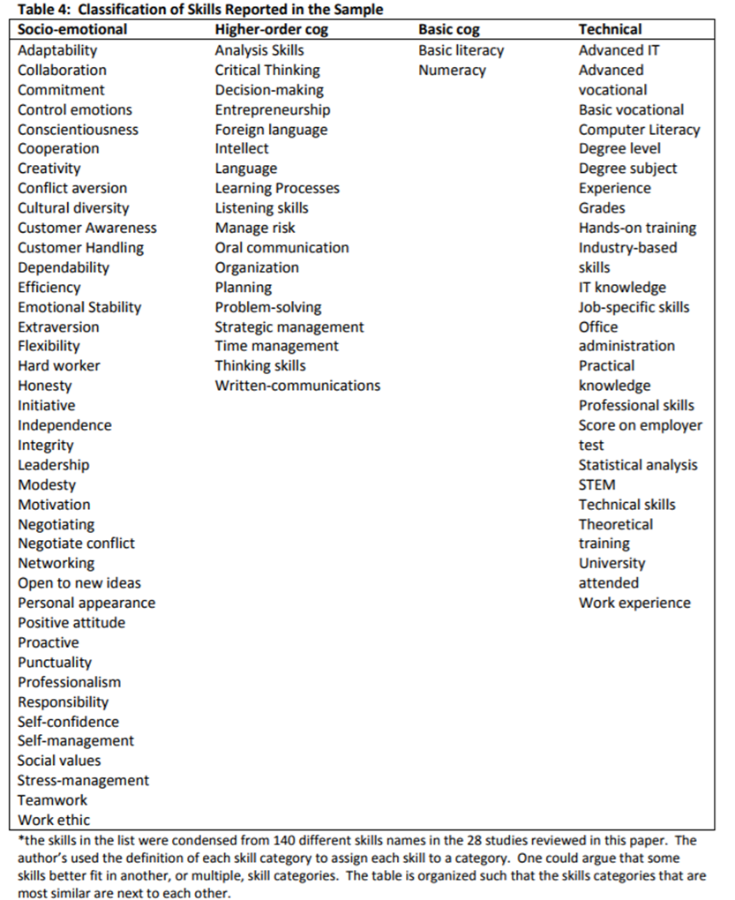

P:\PublicationComponents\logos\Social Media\Twitter_blackbox.pngP:\PublicationComponents\logos\Social Media\InBug-16px_0.pngP:\PublicationComponents\logos\NCVER LOGOS\WMF - word\No lines\NCVER_Floating_Blue.wmf

**National Centre for Vocational Education Research**

Level 5, 60 Light Square, Adelaide, SA 5000  
PO Box 8288 Station Arcade, Adelaide SA 5000, Australia

**Phone** +61 8 8230 8400 **Email** [ncver@ncver.edu.au](mailto:ncver@ncver.edu.au)   
**Web** <https://www.ncver.edu.au> <<https://www.lsay.edu.au>>

**Follow us:** <<https://twitter.com/ncver>> <https://www.linkedin.com/company/ncver>

1. UK Office for Standards in Education, Children's Services and Skills. [↑](#footnote-ref-1)
2. Semantic web, whereby web pages are structured and tagged in such a way that it can be read directly by computers. [↑](#footnote-ref-2)
3. Transversal skills: transversal knowledge, skills and competences are relevant to a broad range of occupations and sectors. They are often referred to as core skills, basic skills or soft skills, the cornerstone for the personal development of a person. [↑](#footnote-ref-3)
4. At the request of the Council of Australian Governments (COAG) Industry Skills Council (ISC) and the Skills Senior Officials Network (SSON), a National Training Product Reform Group, comprising representatives from all of the jurisdictions, considered the longer-term reform of training products at a symposium in 2016. [↑](#footnote-ref-4)
5. Revisions occurred in 2006, 2009 and then 2013. [↑](#footnote-ref-5)
6. National Certificate of Educational Achievement. [↑](#footnote-ref-6)