

**VET provider market structures: history, growth and change**

**Patrick Korbel  
Josie Misko**

NCVER

**Research report**

### Publisher’s note

The views and opinions expressed in this document are those of the author/project team and do not necessarily reflect the views of the Australian Government, or state and territory governments. Any interpretation of data is the responsibility of the author/project team.

To find other material of interest, search VOCEDplus (the UNESCO/NCVER international database <[http://www.voced.edu.au](http://www.voced.edu.au/)>) using the following keywords: Finance; Governance; Policy; Providers of education and training; Market reforms; Total VET activity; Statistics; VET market; Vocational education and training.

P:\PublicationComponents\logos\Social Media\InBug-16px_0.pngP:\PublicationComponents\logos\Social Media\Twitter_blackbox.png

**© National Centre for Vocational Education Research, 2016**

G:\pub_prod\PublicationComponents\logos\Creativecommons\CC BY logo.eps

With the exception of cover design, artwork, photographs, all logos, and any other material where copyright is owned by a third party, all material presented in this document is provided under a Creative Commons Attribution 3.0 Australia <http://creativecommons.org/licenses/by/3.0/au>.

This document should be attributed as Korbel, P & Misko, J 2016, *VET provider market structures: history, growth and change,* NCVER, Adelaide.

The National Centre for Vocational Education Research (NCVER) is an independent body responsible for collecting,  
managing and analysing, evaluating and communicating research and statistics about vocational education and training (VET).

NCVER’s in-house research and evaluation program undertakes projects which are strategic to the VET sector. These projects are developed and conducted by NCVER’s research staff and are funded by NCVER. This research aims to improve policy and practice in the VET sector.

The views and opinions expressed in this document are those of NCVER and do not necessarily reflect the views of the Australian Government or state and territory governments.

COVER IMAGE: GETTY IMAGES/iStock

ISBN 978 1 925173 55 0

TD/TNC 124.13

Published by NCVER, ABN 87 007 967 311

Level 11, 33 King William Street, Adelaide, SA 5000  
PO Box 8288 Station Arcade, Adelaide SA 5000, Australia

**Phone** +61 8 8230 8400 **Fax** +61 8 8212 3436

**Email** [ncver@ncver.edu.au](mailto:ncver@ncver.edu.au) **Web** <http://www.ncver.edu.au> <<http://www.lsay.edu.au>>

**Follow us:** <http://twitter.com/ncver> <http://www.linkedin.com/company/ncver>

# About the research

VET provider market structures: history, growth and change

### Patrick Korbel, Josie Misko, NCVER

The paper tracks the development of the Australian vocational education and training (VET) provider market over the last two decades in the context of significant policy changes and generally increased competition. It provides an insight into how the sector has arrived at its current position, painting a present-day picture of great diversity. More importantly, it prompts further, more fundamental, questions about the current structure of the provider market and whether it is optimally placed to deliver the skills and knowledge that students and the Australian economy require.

The now wider scope of the National VET Provider Collection has enabled reports on total VET activity (TVA). TVA data have been instrumental in this initial analysis of provider and student numbers, which builds on the paper *Making sense of total VET activity: an initial market analysis* (NCVER 2016).

## Key messages

* The VET provider market has been relatively stable over the last 15 years, with the number of providers remaining relatively stable during this time, although fewer providers entered and exited the system over the last five years than in the ten preceding years. VET market reforms and changing funding regimes over this period appear not to have driven major changes in provider numbers, despite the underlying turnover of providers.
* In terms of student numbers, the VET sector displays great diversity within and between different types of training organisations. While there are private providers with as many students as the largest TAFE (technical and further education) institutes, there are also many private providers with very small numbers of students. The top 100 providers represent around 50% of the total student population.
* The sector is characterised by a very large proportion of relatively small providers, with almost 2000 providers (around 40% of the total) with 100 or far fewer students. No evidence is provided, nor should any inferences be drawn, about provider quality. However, the challenges of ensuring that students are given sufficient information and regulating such diversity with so many small to very small providers should be recognised.
* The VET sector also has a larger number of providers relative to the higher education sector, noting that the sectors have many differences, including their purpose, funding and regulation, and that VET students are far more likely to be part-time than those in higher education. There are almost three times as many VET students than higher education students in Australia, but at least 35 times as many VET providers.
* Australia also has a larger number of VET providers than comparable markets overseas, based on the number of people of working age per provider. However, there are inherent difficulties in making such trans-national comparisons, particularly in the context of differing institutional arrangements.
* These observations indicate the need to further examine provider output and quality within and across different provider types and, in the light of this, consider whether or not the current provider market structure, as it has evolved, best serves Australia’s future skills and training needs.

Dr Craig Fowler  
Managing Director, NCVER

P:\PublicationComponents\Icons\References_Green.emfP:\PublicationComponents\Icons\Intro_Green.emfP:\PublicationComponents\Icons\ExecutiveSummary.emfContents

Tables and figures 6

Executive summary 7

Introduction 9

Provider registration patterns 10

Total VET activity 18

Higher education comparisons 24

International comparisons 27

The impact of VET FEE-HELP 29

Conclusion 30

References 32

Appendix A 34

Appendix B 35

# Tables and figures

## Tables

1 Initial registrations by training organisation type, 1998 11

2 Applications to ASQA for initial registration, 2011-2015 12

3 Number of TAFE institutes reporting in the National VET Provider Collection by state, 1996-2014 14

4 Training organisation activity in Total VET Activity, 2014 18

5 Training organisations and students by type, 2014 18

6 Students in higher education by institution type, 2014 24

7 Students in higher education, 2005-2014 25

8 International comparison of the ratio of working age population (15 to 64 year olds) to vocational education and training providers 27

9 Number of VET FEE-HELP providers, 2009-2014 29

A1 Changes in training provider registrations, 1995-2015 34

B1 Number of providers by size band, 2014 35

B2 Number of providers by remoteness, 2014 36

## Figures

1 Number of initial registrations each year, 1995-2015 10

2 Proportions of initial registrations each year by private training organisations, 1995-2015 12

3 Number of registered providers each year (registered since 1995), 1995-2015 13

4 Number of initial registrations and registrations expiring, 1995-2015 15

5 Number of cancelled and otherwise expired registrations, 1995-2015 16

6 Number of students in the 100 largest providers by provider type, 2014 20

7 Number of students in the 101st to 600th largest providers by provider type, 2014 21

8 Number of students in the 601st to 1100th largest provider by provider type, 2014 22

B1 Percentage of providers within each size band by provider type, 2014 35

B2 Percentage of providers within each provider type by size band, 2014 36

B3 Percentage of providers within each remoteness category by provider type, 2014 37

B4 Percentage of providers within each provider type by remoteness category, 2014 37

# P:\PublicationComponents\Icons\ExecutiveSummary.emfExecutive summary

Despite changes in policy and in funding regimes, the number of registered VET providers has remained relatively stable over the last 15 years.

The vocational education and training (VET) market in Australia has, by way of policy changes over the last two decades, been incrementally and increasingly opened up to competition. Initiatives and policy reforms such as the National Framework for the Recognition of Training (NFROT), user choice and the National Partnerships Agreement on Skills Reform, as well as VET regulation, have to a lesser or greater extent impacted on the number and diversity of training providers, including all TAFE (technical and further education) institutes, schools and community-based, enterprise, industry association and private providers.

This paper explores how these changes may have impacted on the numbers and structure of the VET provider market. We examine five aspects of this market to understand its historical and current state. We looked at:

* trends in VET providers in the market over the last 20 years
* comparisons between different types of providers, according to the number of students they have (based on 2014 data)
* comparisons with higher education providers in Australia
* comparisons with VET provider markets overseas
* any evident impact of the VET FEE-HELP policy.

We tracked the number of providers entering and exiting the market over the last 20 years using registration data from <training.gov.au>. Despite changes in policy and in funding regimes, the number of registered VET providers has remained relatively stable over that time. In fact, there have generally been fewer providers entering and exiting the system over the last five years than in the preceding 10 years.

We also found that private training providers comprise an increasing proportion of the new providers entering the market. There has also been a recent rise in the number of cancellations by the regulators.

Using data now available under the expanded National VET Provider Collection, along with new total VET activity (TVA) data (NCVER 2015a), we were able to compare the structures and characteristics of the VET market. For the first time we have a more comprehensive view of the VET provider market.

It has become clear that there is much diversity in the VET provider market. What stands out is that the market is characterised by a handful of larger providers with upwards of around 10 000 students and a substantial number of medium-sized providers with around 1000 students. However, there are nearly 2000 providers (around 40% of the total) with 100 or fewer students.

This large proportion of providers with relatively few students is striking and warrants future investigation. What factors have limited their growth? Do they provide niche training or crucial service in more isolated locations? How do they manage their operations? How can such diversity be effectively regulated? These issues immediately raise questions of the VET provider market’s comparability − its differences and similarities − with the higher education sector in Australia and also with comparable VET sectors in other countries.

The large VET providers (of all types, including public and private) with upwards of 10 000 students are similar in size to Australian public universities. The large group of medium-sized VET providers (with around 1000 students) are similar in size to Australian private higher education providers, although they are more numerous. However, there is not a substantial group of small to very small higher education providers, as seen in the VET sector, acknowledging that the sectors have inherent differences in students and missions.

Australian policy and practice appears to have supported the establishment of a relatively large number of providers.

Looking at the number of providers in the VET sectors of comparator countries, we see that Australian policy and practice appears to have supported the establishment of a relatively large number of providers. We have compared the ratio of the ‘working age’ population (as a proxy for persons who may be engaged in training) with the number of providers in each country. Of all of the countries in the comparison, Australia has the lowest ratio of working-age population to providers.

There are nominally 3129 people per provider in Australia, compared with 15 725   
people per provider in Ontario, at the other end of the spectrum. While the estimate   
of working-age population is soundly based, it is acknowledged that comparability of ‘providers’, given international institutional differences, is more problematic. This   
initial assessment, placing Australia at one extreme of providers per working-age population, requires a more detailed and complex analysis of provider size dispersion   
on a trans-national basis.

The VET FEE-HELP student loan arrangements are a more recent policy initiative, one that has seen significant growth, especially since about 2011−12. An examination of registration data reveals that 19 of the top 20 VET FEE-HELP providers in 2014 (in terms of numbers of students and amount of loans) were already in the market before the introduction of the scheme. While enrolments at these providers may have grown as a result of their being approved as VET FEE-HELP providers, the evidence indicates that these were established providers rather than new providers entering the market.

The structure of the sector may change as the market matures and further initiatives and reforms are implemented. As we collect more years of data with total VET activity scope, and our research uses this data, we will have a more complete view of the sector and the training market, their associated structures and performance.

# **P:\PublicationComponents\Icons\Intro_Green.emf**Introduction

Over the past two decades the VET market has been increasingly opened up to competition. This has in part been driven by funding policy reforms that support greater contestability across the training market, thereby increasing the numbers of private and other non-government providers in a market historically dominated by the TAFE institutes. The most recent VET system structural reforms, the National Partnerships Agreement on Skills Reform[[1]](#footnote-1), sought to improve competition in local training markets and required the implementation of strategies to enable public providers to operate in an environment of greater competition. An initial review of the outcomes was published in 2015 (ACIL Allen Consulting 2015).

Our understanding of the current VET market and the extent of non-government-subsidised provision has been enhanced by the capture and publication of information on total VET activity. Total VET activity reports the data on training activity and outcomes, irrespective of funding source (NCVER 2015a). In view of these developments, it is timely to take stock of the current state and structure of the VET market and to observe how its configuration has changed across the years. To this end we are interested in the following research questions, at least at the level of provider and numbers of students:

* What was the state of the market prior to the recent substantial reforms?
* How has the VET sector responded to recent market forces and restructures?

These questions will be considered by examining the registration patterns of new and existing providers and gleaning what we can from the first year of total VET activity data. We will also be interested to see how the VET sector compares with the higher education sector in Australia and with VET provision overseas, appreciating their inherent differences. In our investigation we will also take account of the recent introduction of VET FEE-HELP and the impact it has had, if any, on the VET provider market.

# Provider registration patterns

VET providers who intend to deliver accredited training must be registered with a relevant regulating authority, either the Australian Skills Quality Authority (ASQA) or the regulating authorities of Victoria and Western Australia.[[2]](#footnote-2)

We start by examining the number of providers registering for the first time, using data from the national training register, maintained by <training.gov.au>.[[3]](#footnote-3) We use 1995 as our starting point and trace the changes over the following 20 years. This approach will give an indication of whether the moves that commenced in the early 1990s[[4]](#footnote-4) to open up the market for training have actually resulted in increased registrations.

Between 1995 and 2015, 1998 was the peak year for registrations by private training organisations.

Between 1995 and 2015, the highest number of initial registrations was observed for 1998 (totalling 1650 initial registrations). This was also the peak year for registrations by private training organisations (742 registrations). This can clearly been seen in figure 1.

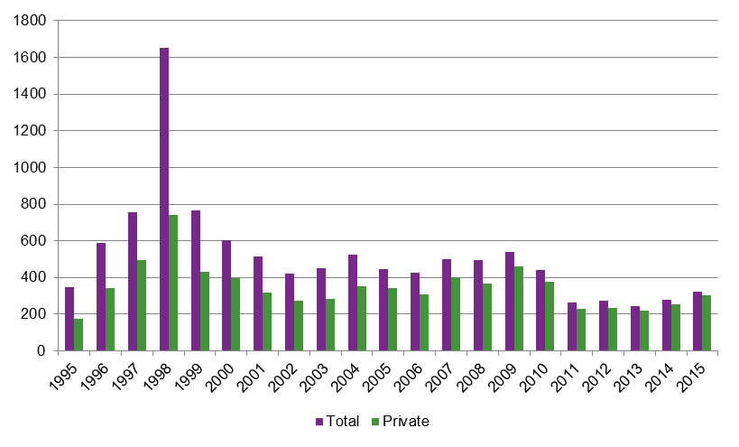Figure 1 Number of initial registrations each year, 1995−2015

Source: Based on data request from the Department of Education and Training (2016).

There are some key reasons for the peak in 1998; namely, 1998 was the first year of the implementation of the Australian Recognition Framework (ARF), which replaced the National Framework for the Recognition of Training, which had operated since 1992.

The Australian Recognition Framework comprised a set of standards for the registration of providers and a set of standards for those bodies that would be responsible for the registration and accreditation processes. Under the framework, training providers who wanted to deliver nationally accredited training had to meet the standards for registered training organisations (RTOs). State training authorities also had to meet the standards for state and territory registration and course accrediting bodies.

Since 2000, the number of initial registrations per year has clearly fluctuated, but overall  
it has been relatively stable.

Table 1 shows the breakdown of registrations in the peak year of 1998. The percentages of government schools, industry associations, Catholic schools and independent schools are relatively high compared with the following year (9, 7, 2 and 3%, respectively) and 2015 (less than 2% each).

This accords with the regulatory changes implemented under the Australian Recognition Framework around that time, which prompted many new organisations to register. In particular, it is not just the quantum of registrations that is atypical, but also the types of providers that were actually registering.

Table 1 Initial registrations by training organisation type, 1998

|  |  |  |  |
| --- | --- | --- | --- |
| Registered training organisation type | Count | Percentage | |
| Privately operated registered training organisation | 742 | | 45 |
| School − government | 238 | | 14 |
| Industry association | 213 | | 13 |
| Community-based adult education provider | 136 | | 8 |
| School − Catholic | 79 | | 5 |
| School − independent | 68 | | 4 |
| Enterprise − government | 63 | | 4 |
| Enterprise − non-government | 33 | | 2 |
| TAFE, skills institute or polytechnic | 29 | | 2 |
| Equipment and/or product manufacturer or supplier | 19 | | 1 |
| Other – not elsewhere classified | 14 | | 1 |
| Professional association | 9 | | 1 |
| University − government | 7 | | 0 |
| **Total** | **1650** |  | |

Source: Based on data request from the Department of Education and Training (2016).

Since 2000, the number of initial registrations per year has clearly fluctuated, but overall it has been relatively stable. The total number of initial registrations per year has remained between 245 and 604 and the number of initial registrations per year by private providers has been between 218 and 458, with an average of approximately 275 initial registrations per year since 2010 (248 for private providers).

This indicates that there has been no substantial increase in the number of providers (or private providers in particular) registering since the implementation of additional VET market reforms in the last five years. In fact, registrations during this period have generally been below the levels seen in the preceding 10 years.

The national regulator, the Australian Skills Quality Authority, was established on 1 July 2011 and the lower rates of registration in this period may be related to changes in the regulatory environment, or perhaps to the costs involved in registration. As shown in table 2, the number of applications to ASQA for initial registration has consistently been around 350 each year, except for 2013−14. The percentage of applications rejected fell considerably between 2011−12 and 2014−15.

Private providers comprise an increasing *proportion* of the total number of registrations each year.

Table 2 Applications to ASQA for initial registration, 2011−15

|  |  |  |  |  |
| --- | --- | --- | --- | --- |
|  | 2011−12 | 2012−13 | 2013−14 | 2014−15 |
| Number of applications received | 327 | 352 | 212 | 361 |
| Number of applications approved | 68 | 185 | 286 | 242 |
| Number of applications rejected | 48 | 42 | 44 | 25 |
| Applications rejected as a percentage of applications completed | 31.4 | 14.9 | 12.2 | 9.2 |

Note: Not all applications received in a financial year are completed within that year, so the number of applications approved and rejected do not sum to the number received.

Source: ASQA (2015).

Figure 1 above does, however, hint that the private providers comprise an increasing *proportion* of the total number of registrations each year. That is not surprising, given that private providers, community organisation providers and other non-government providers have to register if they are to access government funding or be eligible to deliver nationally accredited training and qualifications. Figure 2 examines this more closely.

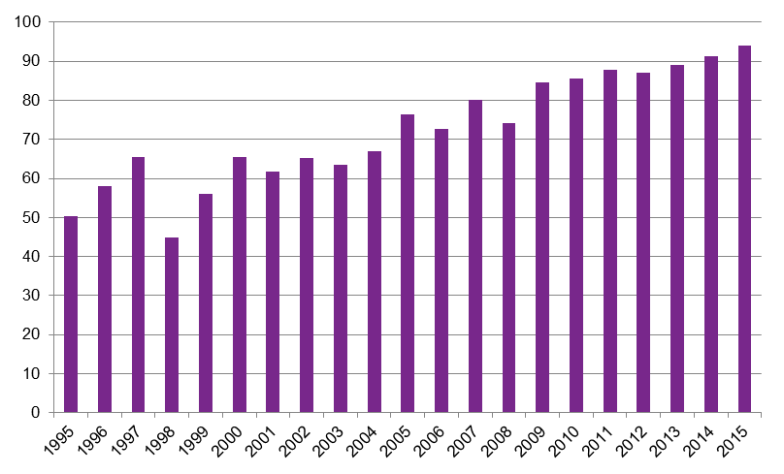Figure 2 Proportions of initial registrations each year by private training organisations, 1995−2015

Source: Based on data request from the Department of Education and Training (2016).

Between 1995 and 2015, the proportion of initial registrations by private providers rose steadily, from 50% in 1995 to 94% in 2015. This is an average rise of 2.2 percentage points each year between 1995 and 2015.

It is not clear whether this is because the market has incentivised private providers or, alternatively, whether registrations among other provider types have reached levels of saturation; that is, all the providers who are likely or able to register have done so and consequently there are relatively few new entrants into the sector. For example, new government schools are established at a relatively slow rate, so there are very few new schools that may wish to register as vocational training providers.

While figure 2 charts the number of initial registrations each year, it is also relevant to examine the total number of registered providers in each year. Figure 3 shows a cumulative count of providers registered since 1995 for each year, *minus* the number of providers whose registration expired in that year.

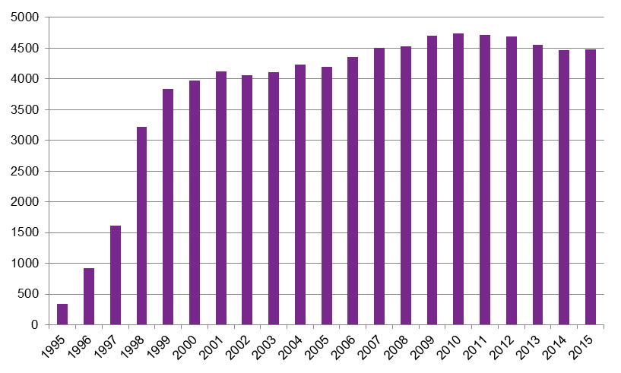Figure 3 Number of registered providers each year (registered since 1995), 1995−2015

Note: This only counts providers registered since 1 January 1995.

Source: Based on data request from the Department of Education and Training (2016).

Table 4 (page 18) indicates that there were 4989 registered training organisations in 2014, but only 4468 are represented in figure 3. This is because figure 3 only shows organisations that registered during or after 1995 (so any organisations already registered before that time are not included) and whose registration did not expire in that year.

This figure indicates that, after a burst of initial registrations between 1995 and 1998, the number of active providers has stayed relatively stable. Since 1999, there have been between 3832 and 4737 active providers in any one year. For all of the new providers registered there have been reasonably equivalent numbers of providers exiting the system. Figure 3 also supports the view that the number of providers has not risen significantly since 1999, despite reforms to the training market and the increased availability of contestable funding, as introduced by initiatives such as the ‘user choice’ policy in 1998 (Selby Smith & Ferrier 2001).

Any increases in the number of new providers may also have been offset by mergers or other amalgamations; for example, those driven by government policy between publicly owned colleges, historically part of the national TAFE network. In recent times there has been a trend towards amalgamating separate TAFE institutes into a fewer organisations with, over time, fewer numbers of provider registrations.

As seen in table 3, the number of TAFE institutes recorded in the National VET Provider Collection has decreased, from 98 in 1996 to 58 in 2014. The effect of consolidations and amalgamations during this time can be seen particularly in Victoria, South Australia and Western Australia. Further changes in Western Australia have recently been announced.[[5]](#footnote-5)

Table 3 Number of TAFE institutes reporting in the National VET Provider Collection by state, 1996−2014

|  |  |  |  |  |  |
| --- | --- | --- | --- | --- | --- |
|  | 1996 | 2001 | 2006 | 2011 | 2014 |
| New South Wales | 12 | 12 | 11 | 11 | 11 |
| Victoria | 28 | 20 | 20 | 18 | 14 |
| Queensland | 16 | 16 | 17 | 14 | 14 |
| South Australia | 10 | 8 | 1 | 3 | 3 |
| Western Australia | 22 | 12 | 10 | 11 | 12 |
| Tasmania | 4 | 1 | 1 | 2 | 1 |
| Australian Capital Territory | 2 | 1 | 1 | 1 | 1 |
| Northern Territory | 4 | 4 | 1 | 2 | 2 |
| **Total** | **98** | **74** | **62** | **62** | **58** |

Source: NCVER (1996, 2001, 2007, 2012, 2015b).

Figure 4 on the next page shows the amount of ‘turnover’ (that is, the number of providers entering and leaving the system) each year. While the numbers of registered providers each year in figure 3 look relatively stable, there could be some underlying turnover in the sector that this figure would reveal.

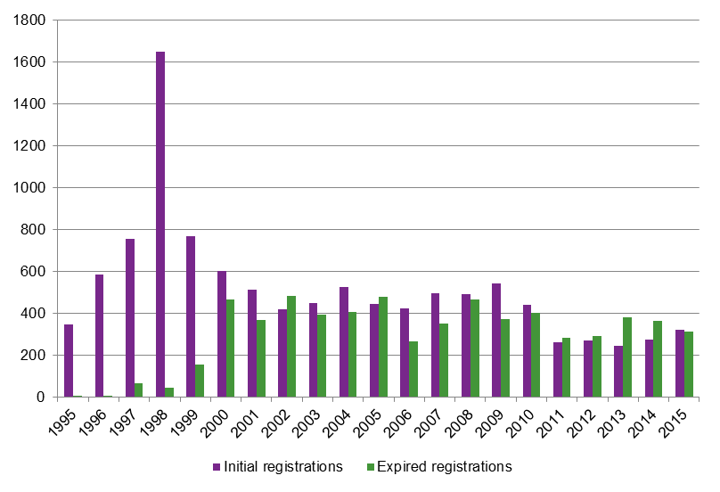Figure 4 Number of initial registrations and registrations expiring, 1995−2015

Source: Based on data request from the Department of Education and Training (2016).

From 2011 to 2015, as seen in figure 4, between 200 and 400 providers entered and left the system each year. In the 10 years prior to that, there was a higher level of turnover, with between 200 and 600 providers entering and leaving each year.

In the last five years, the number of initial registrations has been around 6% of the total number of providers and the number of expired registrations has been around 7% of the total. In the 10 years preceding that, the number of initial and expired registrations was around 10% of the total number of providers.

This does not indicate whether or not the amount of turnover in the sector is to be expected. However, it does indicate that the turnover has been relatively lower in the last five years compared with the preceding ten years. As noted above, this may be in part due to changes as a consequence of national regulation by ASQA, noting that Victoria and Western Australia in part retain their own regulation.

Figure 5 over the page examines more closely those providers leaving the system due to cancelled or otherwise expired registrations to determine the presence of any trends amongst the expired registrations.

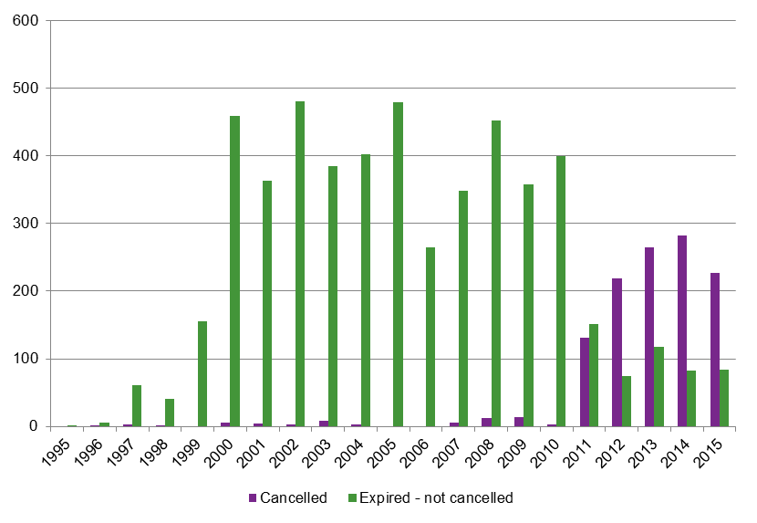Figure 5 Number of cancelled and otherwise expired registrations, 1995−2015

Turnover has been relatively lower in the last five years compared with the preceding ten years.

Source: Based on data request from the Department of Education and Training (2016).

Before 2011, there were usually five or fewer cancellations in any year. Cancellations were highest in 2008 and 2009 (12 and 13, respectively). The number of cancellations has been much higher since then, with 131 in 2011, 219 in 2012, 265 in 2013, 282 in 2014 and 227 in 2015. In the last four years, cancellations have represented about 70% of expired registrations.

At the same time, the number of expired (but not cancelled) registrations has decreased. These expired registrations (or withdrawn registrations) may include providers who applied for renewal, but were rejected by their regulator. Between 2000 and 2010 there were between 250 and 500 expired (but not cancelled) registrations each year, falling to fewer than around 150 between 2011 and 2015.

These figures do not necessarily indicate a quality problem: it is not possible to determine the exact cause of the increased number of cancellations. An increased number of cancellations could be the result of an increase in providers not meeting required standards, or it could be that regulators were more proactive about enforced cancellations. It could also be a consequence of a choice to review registrations mid-term, rather than waiting for a renewal application.

The Australian Skills Quality Authority has noted that a significant number of providers have left the VET sector since ASQA was established in 2011 and attributes this to competitive pressures and the regulatory decisions it has made (Australian Skills Quality Authority 2015). ASQA is transitioning to a risk-based regulation approach, whereby regulatory action is targeted at poor performers in the sector.

This section has shown that, in terms of providers, the training provider market has been relatively stable in the last 15 years and more so over the last five years. However, there have been some changes and shifts. Private providers represent an increasing *proportion* of new registrations. At the same time, there have been greater numbers of cancellations, typically by the national regulator.

Based on the data presented, there is no indication of great turbulence or an overwhelming influx of providers into the VET sector (with the exception of 1998, which has been explained) or a wholesale collapse of providers, who then leave the sector. Considering the number and variety of reforms, this aspect of the VET provider market has remained relatively stable.

There is no indication of great turbulence or an overwhelming influx of providers into the VET sector.

# Total VET activity

Given that the scope of the national VET collection has been expanded to have greater coverage of the training delivered by private providers, a more holistic picture of the VET provider market is now possible.

At this stage, only the first transitional year of data is available, but in time the picture will become even more comprehensive and robust.[[6]](#footnote-6)

Table 4 shows that there were 4989 registered organisations in 2014. There were 4601 distinct providers (registered and non-registered) who submitted data to the 2014 National VET Provider Collection. The calculations that follow are based on those 4601 providers and exclude those that were exempt, did not do any training, ceased operations or otherwise did not submit.

Table 4 Training organisations reporting data to the 2014 National VET Provider Collection (total VET activity)

|  |  |  |  |
| --- | --- | --- | --- |
|  | Registered1 | Non-registered | Total |
| Submitted2 | 3815 | 786 | 4601 |
| Exempt or closed and did not submit | 565 | na3 | 565 |
| Nil returns (estimated) | 255 | na3 | 255 |
| Missing (did not submit) | 354 | na3 | 354 |
| **Total** | **4989** | **786** | **5775** |

Notes: 1 Listed on <training.gov.au> in 2014.

2 Based on RTOs with enrolments in total VET activity scope of reporting.

3 Data not available.

Source: NCVER (2016).

Table 5 shows that approximately four million students were involved in vocational education and training that came under the scope of total VET activity in 2014.[[7]](#footnote-7) Based on the total number of providers, this means there was an *average* of 871 students per provider in 2014.

Table 5 Training organisations and students by type, 2014

|  |  |  |  |  |  |  |
| --- | --- | --- | --- | --- | --- | --- |
| Type | Providers | Students | Mean | Median | Minimum | Maximum |
| Schools | 960 | 202 415 | 211 | 82 | 1 | 16 832 |
| TAFE | 57 | 1 115 865 | 19 577 | 16 661 | 680 | 92 530 |
| Universities | 15 | 83 631 | 5 575 | 657 | 33 | 18 426 |
| Enterprises | 210 | 90 816 | 432 | 95 | 1 | 9 069 |
| Community | 497 | 190 604 | 384 | 129 | 1 | 10 900 |
| Private | 2 557 | 2 095 171 | 819 | 204 | 1 | 104 581 |
| Associations | 221 | 193 821 | 877 | 238 | 1 | 22 117 |
| Other | 87 | 36 166 | 416 | 80 | 1 | 8 815 |
| **Overall** | **4 604** | **4 008 489** | **871** | **146** | **1** | **104 581** |

Note: Some providers report data under multiple types, so the number of providers may differ from that reported in other publications. Students were also counted in each provider type in which they train.

Source: NCVER (2014).

Table 5 shows there to be very wide dispersion in student numbers across not only TAFE institutes and private providers, but also other categories of providers as well. There are underlying reasons for this dispersion and the variance in size.

One of the claims in relation to the benefits of greater competition amongst providers in the VET sector is that private providers can more effectively respond to the needs of industry and students.

Looking at the figures, there is a clear difference between the two largest groups of providers: TAFE institutes and private providers (which together have about 80% of all students). TAFEs had *on average* 19 577 students, over 20 times more than the average for private providers (819 students).

One of the claims in relation to the benefits of greater competition amongst providers in the VET sector is that private providers can more effectively respond to the needs of industry and students. This responsiveness may or may not be an attribute of their relatively small size and specialised offerings.

Universities that offer both VET and higher education courses and deliver vocational training, including those that are nominally ‘dual-sector’ institutions, are inherently large institutions, which by virtue of their ‘tertiary’ sector engagement are different from TAFE institutes.

In the case of schools and enterprise providers, issues specific to these providers explain why they may have fewer enrolled VET students and which relate to their function and purpose.

The average number of students for schools, shown in table 5, is the average across the schools that were registered providers and delivered the training. The average does not include schools that did not offer VET in Schools programs or training delivered by an external provider on behalf of the school.[[8]](#footnote-8) VET in Schools is just one part of the education provided by a secondary school.

The primary focus of enterprises is on their core business, with any training by an enterprise-based RTO offered within the context and needs of the overall enterprise. This is likely reflected in the lower average number of students they support compared with dedicated private providers. However, enterprises would need to be of a large enough size to justify becoming an RTO, which may explain their size relative to schools and community providers.

These results and observations indicate that both small and large providers exist across all types of providers and at very wide extremes. In most of these provider types, there were examples of providers with (apparently) only one reported student and then large providers with student numbers equivalent to roughly 10% of all the students in their provider sector. Across most types, at least 50% of the providers had fewer than 250 students. Overall, there are 1943 providers (around 42%) with 100 or fewer students.

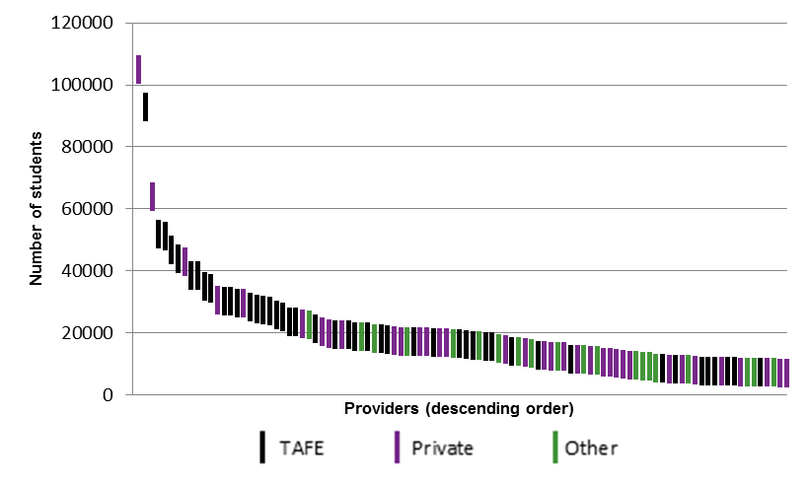Figure 6 Number of students in the 100 largest providers by provider type, 2014



Note: ‘Other’ includes providers of all types not covered under ‘TAFE’ or ‘Private’ in table 5.

Source: NCVER (2014).

Noting that there are close to four million students recorded in the first National VET Provider Collection with total VET activity scope, figures 6, 7 and 8 illustrate the dispersion and very long tail of small providers.

Around 30 providers each account for more than 20 000 students. Together these top 30 providers represent over one million students or 25% of the whole VET student population.

Around 70 providers each have enrolments of between 6000 and 20 000 students. These providers account for just under one million students between them, which represents just under 25% of the whole VET student population.

Together, the top 100 providers represent around 50% of the student population. The remaining approximately 50% of the population is covered by approximately 4500 providers, each with enrolments of fewer than 6000 students.

As seen in figure 7 on the next page, the number of students per provider decreases rapidly from the 101st largest provider to the 600th largest provider, which means that around 600 providers each have between 1000 and 20 000 students, with the remaining, about 4000, providers having about 1000 students or fewer.

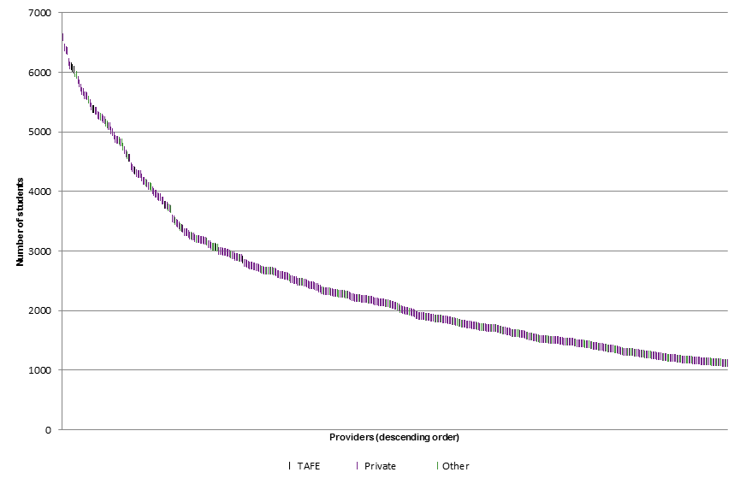Figure 7 Number of students in the 101st to 600th largest providers by provider type, 2014

**Number of students**

Note: ‘Other’ includes providers of all types not covered under ‘TAFE’ or ‘Private’ in table 5.

**Providers (descending order)**

Source: NCVER (2014).

Figure 8 Number of students in the 601st to 1100th largest provider by provider type, 2014



Note: ‘Other’ includes providers of all types not covered under ‘TAFE’ or ‘Private’ in table 5.

Source: NCVER (2014).

In figure 8 the number of students starts to level out from the 601st largest provider onwards, providing an illustration of the large bulk of providers with fewer than 1000 students.

The extraordinarily wide disparity between the sizes of providers clearly warrants further investigation.

The top 1100 providers depicted in figures 6, 7 and 8 represent almost 90% of the student population. Between them the remaining providers (approximately 3500) support only 10% of the students.

There are around 3000 providers with fewer than 500 students and almost 2000 providers with 100 or fewer students. Appendix B contains the summary statistics on the size of providers by type and remoteness.

A forthcoming NCVER report, *Shedding light: private ‘for profit’ training providers and young early school leavers*, reveals some of the strengths and difficulties of small providers (Myconos, Clarke & Te Riele 2016). Strengths included having a close-knit environment, flexibility, specialisation and being able to identify which students needed extra support. Many VET students require additional support outside the curricula (such as financial counselling, building foundational skills and mentoring) and the report noted that small providers still need to develop their student support infrastructure to match the services provided by larger and more established providers.

The extraordinarily wide disparity between the sizes of providers clearly warrants further investigation and prompts questions such as: how have the largest providers in the market achieved their position, particularly the non-TAFE providers? Further questions might focus on the limits to the growth of these small providers and their ability to undertake regulatory and compliance activities.

From public information contained in the Australian Business Register and company annual reports, we see examples of corporate ventures and partnering spanning the VET and higher education sectors, examples of approaches to strategic growth through the acquisition of training businesses, and examples of head entities controlling a number of business/trading entities that are training providers. In a few instances these companies have both local and international structures.

The numbers of registered providers listed on the Australian Stock Exchange (ASX) or are subsidiaries to listed companies were estimated to be 30 of 4989 RTOs (0.6%).[[9]](#footnote-9) The majority were indeed subsidiaries to major corporate enterprises and assumed to support their specific training activity.

These examples are market-based commercial arrangements, and as such their overall number, scale and complexity is uncertain. Some of the medium- and small-size providers included in table 5 and figures 6, 7, 8 may be separate providers but effectively operate under single corporate structures. However, it is unlikely that such arrangements account for the large numbers of registered medium- and small-size providers.

# Higher education comparisons

One possible, although not ideal, comparator for the VET sector is the higher education sector. What are the numbers of students per provider in that sector and how do they compare? Table 6 shows the statistics for higher education in Australia that can be compared with the statistics in table 5.

In presenting such a comparison, it is essential to note the differing missions, funding schemes and regulations between the two sectors and a potential bias in comparing student numbers due the nature of the study of each. The proportion of part-time VET enrolments (89%) is far greater than that of higher education (29%) (NCVER 2014; Department of Education and Training 2015d).[[10]](#footnote-10) This means there is a greater ratio of students to full-year training equivalents in VET than in higher education.

Public universities have a similar number of students to TAFE institutes. According to the higher education data, there were 37 public universities in 2014, compared with 57 TAFE institutes. TAFE institutes each had an average of around 20 000 students and public universities each had around 34 000 students. The range in student numbers is much smaller for public universities than TAFE institutes.

Table 6 Students in higher education by institution type, 2014

|  |  |  |  |  |  |  |
| --- | --- | --- | --- | --- | --- | --- |
| Type | Providers | Students | Mean | Median | Minimum | Maximum |
| Public | 37 | 1 263 653 | 34 153 | 31 395 | 11 559 | 67 076 |
| Private and other | 103 | 109 561 | 1 064 | 373 | 0 | 11 849 |
| **Overall** | **140** | **1 373 214** | **9 809** | **913** | **0** | **67 076** |

Note: Only includes providers with Higher Education FEE-HELP status. ‘Public’ includes providers listed in table A in the *Higher Education Support Act 2003*, excluding the Batchelor Institute of Indigenous Tertiary Education. The Tertiary Education Quality Standards Agency (TEQSA) reported 178 higher education providers registered in 2014 due to different inclusions and exclusions from the Department of Education and Training report (TEQSA 2016). According to TEQSA, there were 27 providers without FEE-HELP status in 2014, each with an average of approximately 742 students (20 023 in total).

Source: Department of Education and Training (2015b).

The number of private vocational training providers are much larger than the number of private higher education providers (2557 compared with 103), although around 50% of vocational students were at private training providers compared with fewer than 10% of higher education students at private higher education providers.

However, the average number of students in each private vocational training provider (819) was roughly similar to the average number of students in each private higher education provider (1064). Nevertheless, 13 large private VET providers had more than 16 661 students (that is, that were larger than 50% of TAFE institutes) and were of comparable size with public universities.

Table 7 Students in higher education, 2005−14

|  |  |  |  |  |  |  |  |  |  |  |
| --- | --- | --- | --- | --- | --- | --- | --- | --- | --- | --- |
|  | 2005 | 2006 | 2007 | 2008 | 2009 | 2010 | 2011 | 2012 | 2013 | 2014 |
| Total students | 957 177 | 984 061 | 1 029 846 | 1 066 095 | 1 134 866 | 1 192 657 | 1 221 008 | 1 257 722 | 1 313 776 | 1 373 230 |
| Average  (public) | 25 870 | 26 596 | 27 834 | 28 813 | 30 672 | 32 234 | 33 000 | 33 992 | 35 507 | 37 114 |
| Average  (all) | 6 837 | 7 029 | 7 356 | 7 615 | 8 106 | 8 519 | 8 721 | 8 984 | 9 384 | 9 809 |

Note: Only includes students at providers with Higher Education FEE-HELP status. Average (public) is a rough estimate, calculated by dividing the total number of students (not the number of students in public universities) by the number of public universities in 2014. The number of providers between 2005 and 2014 has been assumed to be the same as in 2014.

Source: Department of Education and Training (2015c).

The data in table 7 show a steady increase in the number of students in higher education from 2005 to 2014. For example, in 2005 there were 957 177 students and by 2014 that had increased to 1 373 230 students − a 43% increase or approximately 4.8 percentage points per year.

The public VET and higher education sectors are clearly very different in their make-up. Public universities capture a much larger proportion of the total market than public VET providers − 92% of higher education students were enrolled at public universities in 2014, compared with some 27% of VET students at TAFEs (Department of Education and Training 2015d; NCVER 2015a). However, the similarity between the average numbers of students is notable.

Perhaps this is not so surprising since public universities are often characterised as comprehensive institutions that conduct research and deliver teaching across a wide range of fields, different but similar to TAFE institutes, the latter also being large comprehensive institutions. Non-university higher education providers, on the other hand, tend to be more selective and specific about their fields of focus, much like private providers in the VET sector (Norton 2012; Group of Eight 2014).

The comparison indicates some core similarities and differences between the two sectors. Each sector supports a relatively small group of large institutions − public universities, TAFEs and large private VET providers − with the core difference being the research component of the mission of universities. Both sectors support a group of medium-sized institutions − the non-university higher education providers (NUHEPs) and predominantly private and other RTOs − which are focused on teaching in specialised areas (and do not focus on research).

Indeed, there are now a number of providers which operate across both sectors. As   
of 2011, there were 10 TAFE institutes registered as higher education providers, five dual-sector universities, 16 universities offering VET qualifications and 52 non-university higher education providers with vocational offerings (Norton 2012; Wheelahan et al. 2012). These providers are predominantly large- and medium-sized institutions.

The difference between the higher education and VET sectors is most apparent in the large group of small VET providers (mostly private RTOs), which has no equivalent in the higher education sector. This prompts us to consider the policies, regulations, funding schemes and markets that have produced this difference between the sectors. Why have these differences developed between the two sectors? It has been noted that graduate and vocational outcomes are crucial to students in both sectors (Norton 2012) and in countries such as New Zealand they are organised as a single tertiary sector.[[11]](#footnote-11)

This comparison also highlights the difficulties involved in assessing student views and experience of the VET sector compared with the higher education sector. In 2014, the VET sector had almost three times as many students, yet around 35 times as many providers as the higher education sector.

In 2014, the VET sector had almost three times as many students, yet around 35 times as many providers as the higher education sector.

Replicating the higher education Student Experience Survey (which forms a basis for the student-focused Quality Indicators for Learning and Teaching website) for the VET sector would be a difficult task. In order to provide similar provider-level statistics, there would need to be a sufficient sample of students from each of the large number of relatively small providers (almost 2000 with 100 students or fewer). Coverage of student views − as occurs through the Student Outcomes Survey (SOS) − from these small providers would be resource intensive and in effect would require a census of students (at least amongst smaller providers).

# International comparisons

Another source of comparators for the VET sector in Australia is the VET sectors of other countries. How does the Australian system differ from other systems around the world?

The institutional differences in the structures of the VET sectors across jurisdictions and the roles they occupy in their relevant economies mean that comparisons between them should be interpreted with caution. The mix of public and private training providers and how they are funded can affect how the sectors are structured and the impact of internal (e.g. regulation) and external (e.g. economic conditions) forces on the sector. The tradition and history of the training in each region and the skill and knowledge requirements in the local economy may also have an impact.

With these caveats in mind, the structure of Australia’s VET sector has been compared with those of similar economies.

Table 8 International comparison of the ratio of working-age population (15 to   
64-year-olds) to VET providers[[12]](#footnote-12)

|  |  |  |  |  |
| --- | --- | --- | --- | --- |
| Region | Year | Population | Providers | Ratio |
| Australia | 2014 | 15 611 000 | 4 989 | 3 129 |
| Canada (Ontario) | 2015 | 9 387 900 | 597 | 15 725 |
| Germany | 2012−13 | 53 259 812 | 9 426 | 5 650 |
| New Zealand | 2009 | 2 853 120 | 759 | 3 759 |
| South Korea | 2015 | 35 998 522 | 8 401 | 4 285 |
| United Kingdom | 2015 | 41 591 111 | 3 418 | 12 168 |

Note: Although effort has been made to source the most appropriate figures for population and training providers that cover the relevant time periods, these are only rough estimates.

As a crude first view of this, in table 8 we find that, among the selected regions, Australia has the lowest ratio of working-age population to training providers. Australia has about one provider for 3129 people of working age (a proxy for persons who could be engaged in training). The highest ratios are for Canada (Ontario) and the United Kingdom, where there is notionally one provider for 15 726 and 12 168 people of ‘working age’, respectively.

One hypothesis could be that the economies of scale would mean that regions with higher working-age populations would require fewer providers for the populations to receive comparable service, although it does not appear to be the case from this small sample (assuming similar levels of service). Germany has the largest ‘population’ (with over three times that of Australia), but its ratio is just less than twice that of Australia. The United Kingdom and South Korea have similar working-age populations, but very different ratios to providers.

Another hypothesis could be that the geographical size of Australia and the distribution of the population mean that a greater number of providers are needed, although this might be countered by population density arguments. Australia is unique in this regard, making comparison with other regions with similar geography and population distribution hard.

These observations are not conclusive, they only suggest that Australia has a system ‘skewed’ to one side.

While interesting, these observations are not conclusive. They only suggest that Australia has a system ‘skewed’ to one side. It is notable however that, when compared with higher education in Australia, in which there are some 140 providers in 2014 (table 6) the VET system has far greater numbers of providers spanning much the same geography.

# The impact of VET FEE-HELP

The growth in students undertaking training with VET FEE-HELP loans is a noted public issue[[13]](#footnote-13) and has prompted legislative and regulatory responses from the federal government. Has the growth in such numbers and loans coincided with a growth in the number of VET providers?

The evidence from figures 3 and 4 suggests that the number of providers has been relatively stable since the introduction of VET FEE-HELP in 2009.

The evidence from figures 3 and 4 suggests that the number of providers has been relatively stable since the introduction of VET FEE-HELP in 2009. Table 9 shows the growth in the number of providers formally approved as VET FEE-HELP providers (who had assisted students in that year) between 2009 and 2014.

Table 9 Number of VET FEE-HELP providers, 2009−14

|  |  |  |
| --- | --- | --- |
| Year | Number of providers |  |
| 2009 | 39 |  |
| 2010 | 55 |  |
| 2011 | 85 |  |
| 2012 | 105 |  |
| 2013 | 156 |  |
| 2014 | 224 |  |

Note: Only includes providers reporting students in that year, not all approved providers.

Source: Department of Education and Training (2010, 2011, 2012, 2013, 2014, 2015a).

The top 20 VET FEE-HELP providers in 2014 (by number of assisted students) represent almost 70% of total assisted students nationally for that year. Amongst these providers there appears to be only one new entrant following the introduction of VET FEE-HELP.[[14]](#footnote-14) Three other providers were also initial registrations in that period, but they were associated with previously registered organisations.

The top 20 VET FEE-HELP providers in 2014 (by total loan amount to full fee-paying students) represent over 75% of the total national loans for that year. Amongst these providers, only one was registered post-introduction (the same one as above). There were again two others who were associated with previously registered organisations.

This means that 19 of the top 20 VET FEE-HELP providers, representing about 75% of all VET FEE-HELP activity (based on two different measures), were operating before the introduction of the scheme. These providers may have grown in size through the opportunities afforded by VET FEE-HELP, but almost all of them were already established providers rather than new providers entering the market because of the availability of VET FEE-HELP.[[15]](#footnote-15)

# Conclusion

The VET market is complex and multi-layered and is shaped by an array of past policies that covered legislation, regulation and funding arrangements. Over the longer term, some 15 years or more, the number of providers in the market has remained relatively stable, with the level of turnover (numbers entering and exiting the system) being somewhat less over the last five years than during the preceding 10 years.

The data show that it was existing training providers who primarily applied to and accessed the VET FEE-HELP system.

The data demonstrate that private providers do represent an increasing proportion of initial registrations over this duration and that there has been a recent increase in the number of cancellations by the regulators. They also show that it was existing training providers who primarily applied to and accessed the VET FEE-HELP system. The large majority of these loans were made to students attending established rather than new providers, refuting views that the scheme is dominated by multiple new providers who entered the sector to take advantage of VET FEE-HELP.

Such observations are interesting, given more recent policy initiatives that have sought to introduce further competition and contestability into publicly subsidised training and the increasing focus on training quality.

Our analysis of the initial total VET activity data is an important first step in taking stock of the VET provider market, our aim being to better understand the market’s current structures. Reflecting on past trends also assists us to do this. In time, the National VET Provider Collection, together with future total VET activity reports, will provide a more complete picture of the sector and its changing nature.

More comprehensive answers will require a deeper understanding of the structure of the market. This will require not only monitoring the number of providers and the average number and span of students, but also undertaking a much closer analysis and tracking of provider and student performance.

This is especially challenging when the market includes such a ‘long tail’ of small to very small providers − almost 2000 providers (around 40% of the total) supporting 100 or far fewer students. No evidence is provided in this paper about provider quality. There are undoubtedly examples of small providers that serve local industry interests well, for example, those serving local communities in more regional or remote areas. However, the challenges overall at a national level − assessing quality, assisting students to make informed choices and regulating such diversity with so many small to very small providers − need to be recognised.

It is conceivable that future mergers and amalgamations among some categories of providers may result in a reduced number of providers with a greater concentration of students and therefore provide greater economies of scale that benefit both training quality and business efficiency.

Comparisons between the Australian VET and the higher education sectors need to be viewed with caution because sector-wide differences mean these statistics cannot tell the whole story. In terms of enrolments, there are some similarities between the VET and higher education sectors in Australia: there is a relatively small group of ‘larger’ providers (amongst TAFE institutes, private VET providers and universities) with upwards of 15 000 students and a group of medium-sized private VET and higher education providers with around 1000 students (although they are much more numerous in the VET sector).

However, the VET provider sector is starkly different from the higher education sector, in that 42% of its providers have 100 or fewer students, raising issues about critical business mass and capacities to regulate such extreme diversity. Student ‘demand driven’ policies in undergraduate higher education have clearly led to relatively greater growth in higher education compared with the VET sector.

The preliminary international comparisons undertaken are problematic to meaningfully interpret. Our initial assessment, which places Australia at one extreme of providers per working-age population, requires a more detailed and complex analysis of provider size dispersion on a trans-national basis. Our limited analysis suggests that the Australian VET sector has supported the establishment of a greater number of providers relative to other nations/regions. This may have many causes, including geographical distances, population densities, policy imperatives and institutional configurations. It also leaves unanswered whether or not the barriers to market entry in Australia have been set too low for too long.

The results indicate the need to further examine the parameters of provider size, output and quality within and across different provider types.

While this type of analysis clearly has inherent methodological limitations, the results indicate the need to further examine the parameters of provider size, output and quality within and across different provider types. Such an analysis would therefore deliver more comprehensive evidence at a system-wide level on whether or not the current VET provider market structure is optimal for Australia’s current and future skills and training needs, given the distribution and demographics of our labour force, the variety and reach of training offered and delivered (direct and online), and the absolute essentials of uniformly high quality.

These are important and fundamental questions to be addressed and the findings of this paper have put us in a better position to begin these further investigations.

# *P:\PublicationComponents\Icons\References_Green.emf*References

ACIL Allen Consulting 2015, *Review of the National Partnership Agreement on Skills Reform: final report*, Melbourne.

Australian Skills Quality Authority 2015, *Annual report 2014−2015*, Commonwealth of Australia, Canberra.

Bildungsberichterstattung 2014, *Bildung in Deutschland 2014,* Deutschen Institut für Internationale Pädagogische Forschung.

Central Intelligence Agency 2016, The World Factbook’, viewed March 2016, <https://www.cia.gov/library/publications/the-world-factbook/>.

Commonwealth of Australia 2016, *Redesigning VET FEE-HELP: discussion paper,* Canberra.

David Rumsey and Associates 1993*, First review of the National Framework for the Recognition of Training (NFROT): final report*, David Rumsey and Associates, Melbourne.

Department of Education and Training 2010, 2009 VET FEE-HELP statistical report − provider tables, data request, DET, Canberra.

—— 2011, 2010 VET FEE-HELP statistical report − provider tables, data request, DET, Canberra.

—— 2012, 2011 VET FEE-HELP statistical report − provider tables, data request, DET, Canberra.

—— 2013, 2012 VET FEE-HELP statistical report − provider tables, data request, DET, Canberra.

—— 2014, ‘2013 VET FEE-HELP statistical report − provider tables’, viewed March 2016, <https://docs.education.gov.au/node/36565>.

—— 2015a, ‘2014 VET FEE-HELP statistical report − provider tables’, viewed March 2016, <https://docs.education.gov.au/node/38381>.

—— 2015b, ‘2014 student summary tables’, viewed May 2016, <https://docs.education.gov.au/node/38123>.

—— 2015c, ‘2014 student summary time series’, viewed May 2016, <https://docs.education.gov.au/node/38121>.

—— 2015d, ‘2014 student summary’, viewed May 2016, <https://docs.education.gov.au/node/38117>.

—— 2016, All RTOs grouped by initial registration year(s), data requested January 2016, DET, Canberra.

Group of Eight Australia 2014, *Backgrounder: private higher education providers in Australia*, viewed March 2016, <<http://go8.edu.au/sites/default/files/docs/publications/backgrounder_-_private_higher_education_providers_in_australia_final.pdf>>.

Myconos, G, Clarke, KV, Te Riele, K 2016, *Shedding light: private ‘for profit’ training providers and young early school leavers*, NCVER, Adelaide.

NCVER (National Centre for Vocational Education Research) 1996, *Australian vocational education and training statistics 1996: in detail*, NCVER, Adelaide.

—— 2000, *Australian vocational education and training statistics 2001: in detail*, NCVER, Adelaide.

—— 2007, *Australian vocational education and training statistics: students and courses 2006: summary*, NCVER, Adelaide.

—— 2012, *Australian vocational education and training statistics 2011*, NCVER, Adelaide.

—— 2014, *National VET Provider Collection*, NCVER, Adelaide.

—— 2015a, *Australian vocational education and training statistics: total VET students and courses 2014*, NCVER, Adelaide.

—— 2015b, *Australian vocational education and training statistics: government-funded students and courses 2014*, NCVER, Adelaide.

—— 2016, *Making sense of total VET activity: an initial market analysis*, NCVER, Adelaide.

Nguyen, N 2010, *The impact of VET in Schools on the intentions and achievements of young people*, LSAY briefing paper 21, NCVER, Adelaide.

Norton, A 2012, *Mapping Australian higher education*, Grattan Institute, Melbourne.

OECD (Organisation for Economic Co-operation and Development) 2016, *OECD.Stat*, online database, viewed March 2016, <http://stats.oecd.org/>.

Selby Smith, C & Ferrier, F 2001, *User choice: the experience since 1998*, Centre for the Economics of Education and Training, Clayton, Vic.

Skills Funding Agency 2014, ‘Register of training organisations − October 2015’, viewed March 2016, <https://www.gov.uk/government/publications/register-of-training-organisations>.

Statistics Canada 2016, ‘Population by sex and age, by province and territory (number, both sexes)’, viewed March 2016, <http://www.statcan.gc.ca/tables-tableaux/sum-som/l01/cst01/demo31a-eng.html>.

Tertiary Education Quality and Standards Agency 2016, *Statistics report on TEQSA registered higher education providers*, Commonwealth of Australia, viewed May 2016, <http://www.teqsa.gov.au/sites/default/files/publication-documents/HEStatisticsReport2016\_190416.pdf>.

Wheelahan, L, Arkoudis, S, Moodie, G, Fredman, N & Bexley, E 2012, *Shaken not stirred? The development of one tertiary education sector in Australia*, NCVER, Adelaide.

# Appendix A

The following table shows the changes in training provider registrations over the last two decades. It is based on the data from the national training register held at <training.gov.au> and forms the basis for figures 1 through 5.

Table A1 Changes in training provider registrations, 1995−2015

|  |  |  |  |  |  |
| --- | --- | --- | --- | --- | --- |
|  | Initial registrations (total) | Initial registrations (private providers) | Expired registrations | Cancelled registrations | Registered providers |
| 1995 | 345 | 174 | 2 | 0 | 343 |
| 1996 | 587 | 340 | 8 | 2 | 922 |
| 1997 | 754 | 493 | 64 | 3 | 1 612 |
| 1998 | 1 650 | 742 | 43 | 2 | 3 219 |
| 1999 | 768 | 431 | 155 | 0 | 3 832 |
| 2000 | 604 | 395 | 465 | 5 | 3 971 |
| 2001 | 515 | 318 | 368 | 4 | 4 118 |
| 2002 | 420 | 274 | 484 | 3 | 4 054 |
| 2003 | 449 | 285 | 393 | 8 | 4 110 |
| 2004 | 526 | 352 | 405 | 3 | 4 231 |
| 2005 | 445 | 340 | 479 | 0 | 4 197 |
| 2006 | 425 | 309 | 265 | 0 | 4 357 |
| 2007 | 498 | 399 | 353 | 5 | 4 502 |
| 2008 | 493 | 366 | 465 | 12 | 4 530 |
| 2009 | 541 | 458 | 371 | 13 | 4 700 |
| 2010 | 440 | 377 | 403 | 3 | 4 737 |
| 2011 | 262 | 230 | 283 | 131 | 4 716 |
| 2012 | 271 | 236 | 293 | 219 | 4 694 |
| 2013 | 245 | 218 | 382 | 265 | 4 557 |
| 2014 | 276 | 252 | 364 | 282 | 4 468 |
| 2015 | 321 | 302 | 312 | 227 | 4 477 |

Note: Cancelled registrations are also counted in number of expired registrations. Registered providers only counts providers registered in 1995 or later that were registered in each respective year (minus those whose registrations expired in that year).

Source: Based on data request from the Department of Education and Training.

# Appendix B

The following table and figures show the number of providers by type within each size band. There are four bands: providers with 1 to 100 students, 101 to 1000 students, 1001 to 10 000 students and more than 10 000 students.

Table B1 Number of providers by size band, 2014

|  |  |  |  |  |  |
| --- | --- | --- | --- | --- | --- |
|  | 1−100 | 101−1000 | 1001−10 000 | 10 000+ | Total |
| Schools | 533 | 414 | 9 | 4 | 960 |
| TAFE | 0 | 1 | 19 | 37 | 57 |
| Universities | 3 | 6 | 2 | 4 | 15 |
| Enterprise | 108 | 78 | 24 | 0 | 210 |
| Community | 223 | 227 | 46 | 1 | 497 |
| Private | 904 | 1 198 | 431 | 24 | 2 557 |
| Associations | 71 | 108 | 39 | 3 | 221 |
| Other | 49 | 31 | 7 | 0 | 87 |
| **Total** | **1 891** | **2 063** | **577** | **73** | **4 604** |

Note: Some providers report data under multiple types, so the number of providers may differ from that reported in other publications.

Source: NCVER (2014).

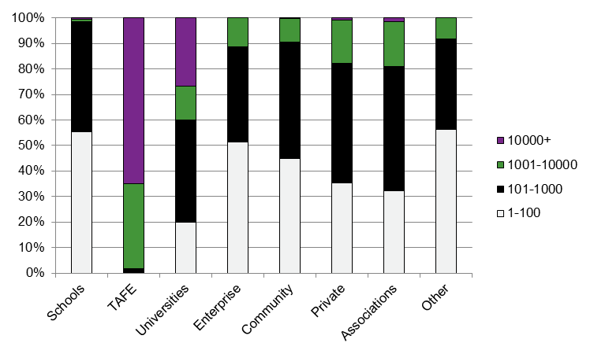

Figure B1 Percentage of providers within each size band by provider type, 2014

Source: NCVER (2014).

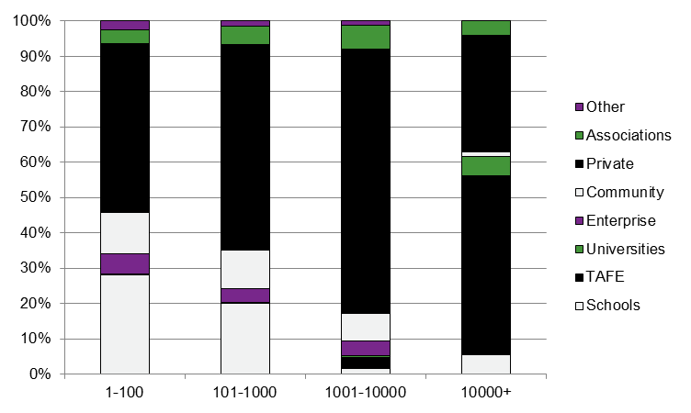Figure B2 Percentage of providers within each provider type by size band, 2014

Source: NCVER (2014).

The following table and figures show the number of providers by type within remoteness category.

Table B2 Number of providers by remoteness, 2014

|  |  |  |  |  |  |  |  |  |  |  |  |  |
| --- | --- | --- | --- | --- | --- | --- | --- | --- | --- | --- | --- | --- |
|  | Major cities | Inner regional | | Outer regional | | Remote | | Very remote | | Unknown | | Total |
| Schools | 550 | 238 | 135 | | 18 | | 10 | | 10 | | 961 | |
| TAFE | 28 | 17 | 8 | | 3 | | 1 | | 6 | | 63 | |
| Universities | 6 | 6 | 1 | | 1 | | 0 | | 2 | | 16 | |
| Enterprise | 155 | 20 | 14 | | 2 | | 0 | | 23 | | 214 | |
| Community | 275 | 153 | 53 | | 7 | | 1 | | 17 | | 506 | |
| Private | 1 974 | 345 | 143 | | 14 | | 5 | | 119 | | 2 600 | |
| Associations | 170 | 31 | 12 | | 1 | | 1 | | 12 | | 227 | |
| Other | 52 | 11 | 14 | | 3 | | 0 | | 7 | | 87 | |
| **Total** | **3 210** | **821** | **380** | | **49** | | **18** | | **196** | | **4 674** | |

Note: Providers can report under multiple types and remoteness categories and in this case they are counted under each category they appear, so the number of providers listed may differ from other publications.

Source: NCVER (2014).

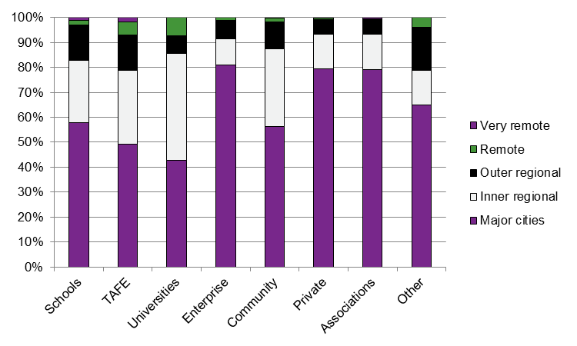Figure B3 Percentage of providers within each remoteness category by provider type, 2014

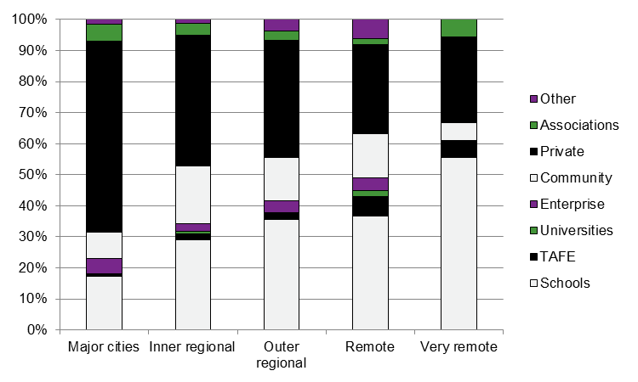Source: NCVER (2014).

Figure B4 Percentage of providers within each provider type by remoteness category, 2014

Source: NCVER (2014).

P:\PublicationComponents\logos\Social Media\Twitter_blackbox.pngP:\PublicationComponents\logos\Social Media\InBug-16px_0.pngP:\PublicationComponents\logos\NCVER LOGOS\WMF - word\No lines\NCVER_Floating_Blue.wmf

**National Centre for Vocational Education Research**

Level 11, 33 King William Street, Adelaide, SA 5000  
PO Box 8288 Station Arcade, Adelaide SA 5000, Australia

**Phone** +61 8 8230 8400 **Fax** +61 8 8212 3436

**Email** [ncver@ncver.edu.au](mailto:ncver@ncver.edu.au) **Web** <http://www.ncver.edu.au> <<http://www.lsay.edu.au>>

**Follow us:** <<http://twitter.com/ncver>> <http://www.linkedin.com/company/ncver>

1. <http://www.education.gov.au/national-partnership-agreement-skills-reform>. [↑](#footnote-ref-1)
2. The Victorian Registration and Qualifications Authority and the Training and Accreditation Council Western Australia have responsibility for regulating providers that only train domestic students and only operate in their states. [↑](#footnote-ref-2)
3. There may be inaccuracies in the initial registration dates due to retrospective changes by the regulators. In certain circumstances, the registration date may only reflect the most recent registration for that provider. Organisations may change or renew their registration and this can affect the recorded initial registration date (for example, amalgamations). [↑](#footnote-ref-3)
4. In 1992, the formal registration of private providers (including commercial, industry, other non-government and community providers) to deliver nationally accredited training was required under the National Framework for the Recognition of Training (NFROT) (David Rumsey and Associates 1993). Among other objectives, NFROT aimed to ensure national consistency in the recognition of VET training providers. [↑](#footnote-ref-4)
5. <http://www.dtwd.wa.gov.au/trainingproviders/training-sector-reform-project/Pages/changes-TAFE-WA.aspx>. [↑](#footnote-ref-5)
6. For more information on the scope of total VET activity and the state of the market, see the publication *Making sense of total VET activity* (2016) published by NCVER. [↑](#footnote-ref-6)
7. This figure may differ from other published figures because in this case students may have been counted multiple times if they train at more than one provider type. [↑](#footnote-ref-7)
8. The predominant strategies for delivering VET in Schools differ between school jurisdictions. Strategies include schools delivering the training as an RTO, auspicing arrangements between a school and an RTO and fee-for-service training from an RTO. For more information see Nguyen (2010). This leads to differences in how the training is reported, for example, in 2014 there were 564 schools based in Victoria delivering training, but only 14 in New South Wales (NCVER 2015a). [↑](#footnote-ref-8)
9. According to an NCVER internal analysis conducted in November 2015. [↑](#footnote-ref-9)
10. A full-time VET enrolment is defined as 540 hours per year or more. A full-time higher education enrolment is defined as 75% of a full study load for a course. [↑](#footnote-ref-10)
11. http://www.nzqa.govt.nz/studying-in-new-zealand/tertiary-education/ [↑](#footnote-ref-11)
12. The sources for these figures are: population of Australia, Germany and New Zealand from OECD (2016); population of South Korea and United Kingdom from CIA (2016); population of Canada (Ontario) from Statistics Canada (2016). Providers in Australia from NCVER (2016); providers in Canada (Ontario) from pers. comm. with André Diez de Aux, 5 January 2016; providers in Germany from the Bildungsbericht by the Deutschen Institut für Internationale Pädagogische Forschung (2014); providers in New Zealand from pers. comm. with Siobhan Clinton, New Zealand Qualifications Authority, 15 January 2016; providers in South Korea from pers. comm. with Doin Pyun; providers in the United Kingdom from the register of training organisations from the Skills Funding Agency (2015). [↑](#footnote-ref-12)
13. See recent paper arising from minister’s consultations (Commonwealth of Australia 2016). [↑](#footnote-ref-13)
14. According to the initial registration data in the data request from the Department of Education and Training. [↑](#footnote-ref-14)
15. This also does not capture the activity occurring in the remaining approximately 25% (in terms of

    students and loans) of the VET FEE-HELP market. [↑](#footnote-ref-15)