NCVER_Floating_Mono

Improving participation

and success in VET for disadvantaged learners: regional analysis

Centre for International Research on Education Systems

Victoria University

This document was produced by the author(s) based on their research for the report *Improving participation and success in VET for disadvantaged learners*, and is an added resource for further information. The report is available on NCVER’s Portal: <<http://www.ncver.edu.au>>.

The views and opinions expressed in this document are those of the author(s) and do not necessarily reflect the views of the Australian Government, state and territory governments or NCVER. Any errors and omissions are the responsibility of the author(s).

### ­

### 

**© Commonwealth of Australia, 2018**

G:\pub_prod\PublicationComponents\logos\Creativecommons\CC BY logo.eps

With the exception of the Commonwealth Coat of Arms, the Department’s logo, any material protected by a trade mark and where otherwise noted all material presented in this document is provided under a Creative Commons Attribution 3.0 Australia <http://creativecommons.org/licenses/by/3.0/au> licence.

The details of the relevant licence conditions are available on the Creative Commons website (accessible using the links provided) as is the full legal code for the CC BY 3.0 AU licence <http://creativecommons.org/licenses/by/3.0/legalcode>.

The Creative Commons licence conditions do not apply to all logos, graphic design, artwork and photographs. Requests and enquiries concerning other reproduction and rights should be directed to the National Centre for Vocational Education Research (NCVER).

This document should be attributed as Centre for International Research on Education Systems 2018, *Support Document: Improving participation and success in VET for disadvantaged learners — regional analysis,* NCVER, Adelaide.

This work has been produced by NCVER on behalf of the Australian Government and state and territory governments, with funding provided through the Australian Government Department of Education and Training.

Published by NCVER, ABN 87 007 967 311

Level 5, 60 Light Square, Adelaide, SA 5000  
PO Box 8288 Station Arcade, Adelaide SA 5000, Australia

**Phone** +61 8 8230 8400 **Email** [ncver@ncver.edu.au](mailto:ncver@ncver.edu.au)

**Web** <https://www.ncver.edu.au>

**Follow us:**  <https://twitter.com/ncver>  <https://www.linkedin.com/company/ncver>

Contents

Tables and figures 4

Introduction 5

Aims and approach 5

Framework and definitions 6

Regional framework 7

Regional VET participation rates 9

Deriving VET student counts 9

Deriving population counts 10

Variations in regional VET participation 11

Regional VET participation and provision 13

Regional VET participation and student experiences and outcomes 15

Regional VET completion rates 18

Calculating completion rates 18

Variations in regional VET completion 18

Relationship between the measures of completion at a regional level 20

Identifying regional drivers of VET participation 22

Model predicting regional VET participation 22

Variance analysis 23

Conclusion: identifying high performing regions for case studies 26

References 29

Appendix 1 Regional standardised residual scores 30

# Tables and figures

## Tables

1 Number of SA3 regions by state and territory and metropolitan status 8

2 Mean regional VET participation rates, for all students and target groups, by metropolitan status, 2014 (%) 11

3 Correlations between regional VET participation rates for different   
groups of students and regional VET course and provider   
characteristics, 2014 14

4 Correlations between VET regional participation and regional   
post-training views of quality of graduates’ experiences and   
post-training transition 16

5 Correlations between regional VET profiles and regional post-training   
views of quality of graduates’ experiences and post-training transition 17

6 Variance analysis of factors influencing regional VET participation 23

7 Regional drivers of VET participation, 2014 25

8 Correlations between Aggregate Standardised Residual Scores 26

9 Characteristics of VET activity in all regions and high performing   
regions (regional means), 2014 28

## Figures

1 Distributions of regional VET participation rates, all students, key target groups, 2014 12

2 Views on training of government-funded graduates by Indigenous status, disability status and LBOTE status, 2015 (%) 15

3 Regional distribution of award completion rates and subject completion rates, SA3s, 2014 19

4 Mean regional completion rates for all students and key target groups,

2014 20

5 Award completer rate and subject completion rate, compared, regions

2014 20

6 Aggregate Standardised Residual Scores for participation and award completion for target groups, regions, 2014 27

7 Characteristics of VET activity in high performing regions   
(deviation from regional mean), 2014 (%) 28

# Introduction

The VET sector in Australia enrols students from a wide variety of backgrounds in a diverse range of settings, fields of study and program levels, yet levels of student participation and success is uneven. Previous studies have shown that there are large regional variations in the take-up of VET across Australia, and that regional frameworks provide a useful mechanism for identifying and reporting effective provider practice (Lamb et al. 2011, Walstab & Lamb 2008). Identifying regions of similar demographic and economic characteristics that have greater success in engaging learners in VET, retaining them and helping them complete their award is important within the context of a national policy agenda which aims to increase the levels of educational attainment of the population (COAG 2009). Understanding and identifying which practices and activities work best to engage students and promote student success is important to assist providers in improving the quality of their VET delivery. It is also important for system authorities to assist them in targeting support for providers to raise levels of performance in student retention and completion.

## Aims and approach

This report forms part of a broader research project commissioned by NCVER and undertaken by the Centre for International Research on Education Systems at Victoria University. The wider project draws on large administrative datasets, provider-based survey data and targeted case studies to identify VET provider policies and practices that are most effective in improving student progress and outcomes, particularly for the most disadvantaged, including Australians with low attainment, unemployed people, Indigenous students, students from a non-English speaking background, and those with disabilities.

This report presents the findings from a regional analysis of VET participation and completion across Australia designed to identify communities achieving high levels of engagement and success with leaners from disadvantaged backgrounds. It will identify regions, performing at higher than expected levels given the demographic and economic profile of their community, which can then be examined more closely through case studies undertaken as part of the wider research project. These high performing regions are identified through a series of analyses, the findings of which are presented in the following sections of this report.

Four phases of analysis are reported.

The first phase of analysis examines the participation of the Australian population in vocational programs at a regional level, to assess the current levels of engagement in VET of disadvantaged groups of Australians. This includes exploratory work to identify the best method for measuring the VET population for inclusion in the calculation of regional participation rates. It also explores ways to measure other important indicators of success including course and subject completion.

The second phase of analysis explores the relationships between VET performance and VET provision at a regional level. This correlation analysis examines links between regional rates of VET participation for disadvantaged learners and regional VET course and provider characteristics, such as provider type, course Australian Qualifications Framework (AQF) level, delivery mode, and the number of delivery sites. Correlations between regional levels of VET participation and measures of student experience, such as views on the quality of teaching, assessment, and overall quality of training, are also examined, along with measures of student transition, such as improved employment status and participation in further education and training.

The third phase of analysis involves using regional data capturing population demographics and labour market profiles, in conjunction with the region-level VET participation and completion rates already calculated, to determine the relative impact of these community-based drivers of VET performance. Linear regression techniques are used to better understand the economic, demographic and policy factors influencing participation and achievement at a regional level.

The final phase of analysis returns to the results of the linear regression analyses and uses the standardised residuals (unexplained variance taken to represent regional performance) to identify areas with particularly high levels of participation and achievement among key groups, after controlling for regional differences in community profiles and labour markets.

The analysis draws on the following four datasets:

1. The *Total VET Activity* Confidentialised Unit Record File (CURF) for 2014, supplied by NCVER. This subject-level enrolment file represents total VET activity in Australia, as reported in the calendar year of 2014 to the Australian Vocational Education and Training Management Information Statistical Standard (AVETMISS). Program completions were provided in a separate file, linked to the CURF through a common identifier.
2. 2015 Government-funded *Student Outcomes Survey* CURF, supplied by NCVER. This respondent-level file of 2014 VET graduates and subject completers contains results from the student outcomes survey undertaken in 2015.
3. 2014 *Estimated Residential Population*, accessed from the Australian Bureau of Statistics (ABS 2015). Regional residential population estimates by age and gender for 2014 were accessible online through the ABS website.
4. 2011 *Census of Population and Housing Data*, accessed from the ABS. Demographic and economic characteristics of aggregate regional populations based on individual home address were downloaded using the TableBuilder facility on the ABS website.

## Framework and definitions

The main purpose of the analysis is to identify regions across Australia that are achieving high participation and completion rates for their disadvantaged populations. The analysis is informed by a three-dimensional framework which maps learner populations against VET performance at a regional level.

### Defining disadvantaged learners

Student demographic characteristics, self-reported on enrolment in a VET course, are used to define five key populations:

1. Indigenous students
2. Students with a disability
3. Students with a language background other than English (LBOTE)
4. Unemployed students
5. Students with low levels of prior educational attainment, defined here as having not completed Year 12 nor a Certificate III or above.

### Measuring VET performance

Assessments of VET performance are achieved through measures of participation, completion and experience, which are summarised below.

* Participation is defined by enrolment in a VET program and calculated by dividing the student counts by the corresponding population and then multiplying by 100. A full description is provided in the next section.
* Student completion is measured in the following two ways:
* A subject completion rate represents the ratio of the number of reported hours for subjects where competencies were achieved or passed to the reported hours for subjects where competencies were achieved or passed, not achieved or failed, or withdrawn or discontinued. The rate is derived for the calendar year.
* An award completion rate, calculated by dividing the number of students having completed any VET program in 2014 by the total number of students enrolled across the year (including students for whom the qualification has been issued as well as those yet to have their qualification issued).
* Student views on course experience are captured through the following indicators:
* Proportion of graduates strongly agreeing that they were satisfied with the quality of the training overall.
* Proportion of graduates satisfied with assessment.
* Proportion of graduates satisfied with their obtained generic skills and learning experiences.
* Proportion of graduates satisfied with the teaching.
* Proportion of graduates stating they achieved or partially achieved their main reason for training.
* Student transition to further study, training or work is represented by:
* The proportion of graduates and completers reporting improved employment circumstances following training.
* The proportion of graduates and completers employed or in further study after training.

Further details of specific elements are provided where results are presented in the report.

## Regional framework

This matrix of equity and VET performance is overlaid by a regional framework, allowing for regions to become the base unit of analysis. The regions are defined by ABS Statistical Area Level 3 (SA3) boundaries. SA3 regions are designed to have populations between 30,000 and 130,000 inhabitants, to reflect regional identity, and to have geographic and socio-economic similarities (ABS 2011). There are 328 SA3 areas across Australia used in the analyses, with migratory, off-shore and shipping regions excluded. These 328 regions cover the whole of Australia without gaps or overlaps. The number of SA3 areas across Australian states and territories is given in Table 1.

Table 1 Number of SA3 regions by state and territory and metropolitan status

|  |  |  |  |  |  |  |  |  |  |
| --- | --- | --- | --- | --- | --- | --- | --- | --- | --- |
|  | NSW | VIC | QLD | SA | WA | TAS | NT | ACT | AUS |
| Metropolitan | 46 | 40 | 39 | 19 | 21 | 6 | 4 | 9 | 184 |
| Non-metropolitan | 43 | 25 | 41 | 9 | 12 | 9 | 5 | 0 | 144 |
| Total | 89 | 65 | 80 | 28 | 33 | 15 | 9 | 9 | 328 |

Note: excludes Migratory – Offshore, Shipping and No Usual Address

Source: Australian Bureau of Statistics

# Regional VET participation rates

## Deriving VET student counts

The extent to which disadvantaged populations are engaging in VET across Australia can be measured by examining the level of student participation or enrolment in VET courses or programs. The National VET Provider Collection, managed by NCVER, is an administrative database containing enrolment data for all VET providers across Australia. A subject-level total VET activity (TVA) CURF for the 2014 calendar year was supplied to the project by NCVER. This annual collection adheres to the Australian Vocational Education and Training Management Information Statistical Standard (AVETMISS) to ensure consistency across all data fields and contains information regarding VET students, their programs or courses, providers and program outcomes (Anlezark & Foley 2016).

The TVA dataset was used in conjunction with ABS population data to calculate VET participation rates at the regional level for all students and students from the five target populations of disadvantaged Australians. A number of restrictions were imposed on the TVA dataset to better align the data with the scope of the study.

The VET population was restricted to students aged 15 to 64 years to best reflect the working-age population of Australia. Since the focus of the project is on post-school VET, any activity flagged as VET in Schools has been excluded. Similarly, ‘subject-only’ enrolments were removed from consideration as these are module enrolments not associated with a corresponding program or course.

The dataset was further restricted to include selected provider types, that is, TAFE institutes, universities, community providers and private providers, as these will form the focus of the case studies in the wider study. In addition, the data was limited to government-funded VET activity only. Government-funded VET activity has higher rates of participation by students from disadvantaged backgrounds than for total VET activity overall (Anlezark & Foley 2016). Moreover, in an analysis of the 2014 TVA data, NCVER noted that the proportion of data where student characteristics are unknown or missing is higher for the total VET activity, and therefore it is “difficult to be conclusive about where students live and their disability or Indigenous status” (Anlezark & Foley 2016, p.21). The government-funded component of the TVA has relatively small proportions of missing data with respect to student background characteristics.

VET enrolments where the student’s home address location is missing were also excluded from the analysis. Students are allocated to an SA3 region according to the location of their home address, rather than the location of delivery of their VET course. This is done using the supplied Statistical Level 2 variable, which in some jurisdictions is geocoded from students’ street addresses, and in others is derived from an ABS correspondence of home postcode and suburb.

A final adjustment was made in relation to VET delivered within correctional facilities. A small number of instances of VET activity in prisons could be identified via VET delivery location, and this has been removed from the dataset. The separate funding code used in some state collections to report VET delivered in correctional facilities does not form part of AVETMISS, so some of this activity may remain. Examining the provision of VET in corrections facilities is an important exercise, however, it does not fit within the purview of this project and leads to anomalies in regional participation rates.

In summary, as a result of the restrictions applied to the TVA CURF, VET participation in the analyses presented here always refers to an enrolment in a TAFE institute, university, community or private provider, in a government-funded VET course or program that is not part of a VET in Schools program, by students aged between 15 and 64, having supplied a home address on enrolment, and where delivery has not taken place in a correctional facility.

The regional framework was applied at subject-level to the remaining CURF, with students allocated to the appropriate SA3 based on their home location. Aggregate student counts were generated within each region or SA3. This approach allows for students who live in more than one SA3 across the calendar year to be included in the student count for each of those regions. The sum of students across the regions is 1 085 027. SA3 regions where the number of VET students was small (fewer than 200 students) were excluded from the analyses. This resulted in the exclusion of two regions from the ACT and one region from NSW.

The number of VET students across different target groups in each region has been calculated in a similar way. The subjects associated with each sub-population of VET students, identified through supplied background characteristics self-reported by students on enrolment, were selected before aggregating student counts within regions. This method was used to establish the number of VET students living in each SA3 from Indigenous backgrounds, students with a disability, LBOTE students and students with low levels of prior educational attainment.

A different approach was undertaken in identifying the number of unemployed students in each region. The National VET Provider Collection, which holds the VET activity across the entire calendar year, effectively offers a rolling count of unemployed students, as labour force status is reported by students on enrolment, which can occur at any time during the year. A count of unemployed individuals as provided in the TVA CURF will be higher than any point-in-time capture of unemployment, such as those offered by surveys such as the ABS Survey of Education and Work and the Census of Population and Housing. For this reason, counts of unemployed students were restricted to VET activity across one month. Students who were enrolled in August (the month corresponding to the Census) and who had indicated that they were unemployed were included in the aggregate student count at the regional level.

Selection of students from these target groups from the in-scope VET activity revealed 5.3 per cent of students overall identified as Indigenous, 8.6 per cent indicated they had a disability, 19.9 per cent came from a language background other than English, 12.6 per cent were unemployed and 34.2 per cent have low levels of prior educational attainment, that is they have not completed Year 12 nor a Certificate III or above.

## Deriving population counts

Participation rates are calculated by dividing the regional student counts by the corresponding population of the SA3, or sub-population for target groups, and then multiplying by 100. The data sources for these regional population figures varied according to availability. For all students, regional residential population estimates for different age-groups for 2014 were available from the ABS and were used to derive population figures for 15 to 64 year-olds at SA3 level.

Regional estimates for Indigenous, LBOTE, unemployed and low educational attainment populations for the appropriate age group were derived from 2011 ABS Census of Population and Housing data. These 2011 figures were adjusted to reflect the magnitude of the 2014 SA3 population to create regional estimates for each sub-population for 2014. Six SA3s with very small Indigenous populations were excluded from analyses of Indigenous populations, that is, where the adjusted population was fewer than 75 (three of these regions were already excluded due to small VET student numbers, see above).

Reliable regional population estimates for people with a disability were unavailable. Where there were estimates, the scope of disabilities included did not correspond to the AVETMISS categories in the TVA CURF. For these reasons, when calculating regional VET participation rates for students with a disability, the total 2014 population for 15 to 64 year-olds in each SA3 was used. Thus this participation rate is conceptually different to the others explored here, as it is not linked to the SA3 population of the target group, but rather the broader population of the region.

## Variations in regional VET participation

An examination of regional VET participation rates, derived using the approach described above, reveals that participation in vocational training varies markedly across different areas of Australia. Table 2 shows the mean regional rates of participation in the VET activity in-scope for this analysis, across all SA3s and for metropolitan and non-metropolitan regions separately, for all students and for key target groups. Metropolitan regions are based on the ABS Greater Capital Cities Statistical Areas (GCCSA) and accordingly some non-metropolitan regions will incorporate provincial towns.

The overall mean regional participation rate in the VET activity in scope for this report is 7%. The results show that, on average, 15.1% of the Indigenous population within a region is enrolled in VET. Furthermore, the mean rate of participation in VET across all regions is 6.6% for the LBOTE population, 19.4% for the unemployed and 7.5% for those with low levels of educational attainment. Expressed as a proportion of the total population in the SA3, the mean regional participation rate for students with a disability is 0.6%.

Overall participation is higher across non-metropolitan regions at 7.9% of the population compared to 6.2% in capital city areas. As Table 2 demonstrates, this pattern is mirrored across the different target groups, with regional means higher outside capital city areas across all groups.

Table 2 Mean regional VET participation rates, for all students and target groups, by metropolitan status, 2014 (%)

|  |  |  |  |
| --- | --- | --- | --- |
|  | Mean regional VET participation rates | | |
|  | All regions | Metropolitan regions | Non-metropolitan regions |
| All students | 7.0 | 6.2 | 7.9 |
| Indigenous | 15.1 | 14.1 | 16.3 |
| Disability | 0.6 | 0.5 | 0.8 |
| LBOTE | 6.6 | 6.0 | 7.4 |
| Unemployed | 19.4 | 18.0 | 21.2 |
| Low attainment | 7.5 | 6.9 | 8.3 |

Source: Authors’ calculations from the VET Provider Collection, 2014

The full extent of the variation is shown in Figure 1, which displays the distributions of regional VET participation rates for all students and for the key target groups.

Figure 1 Distributions of regional VET participation rates, all students, key target groups, 2014

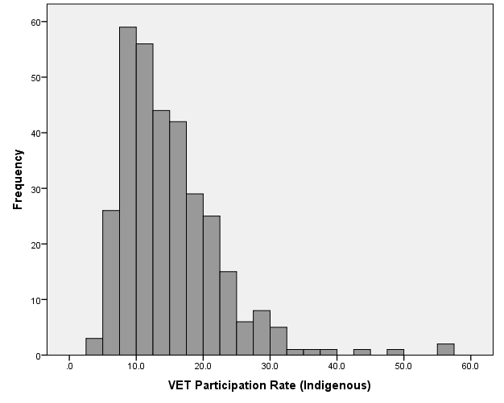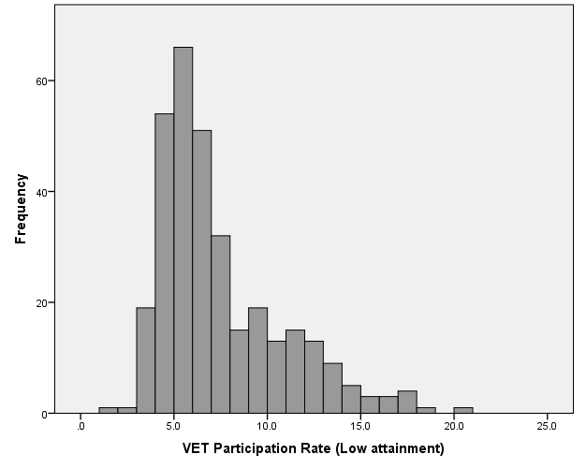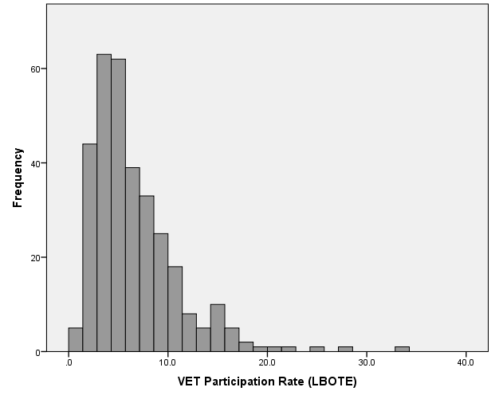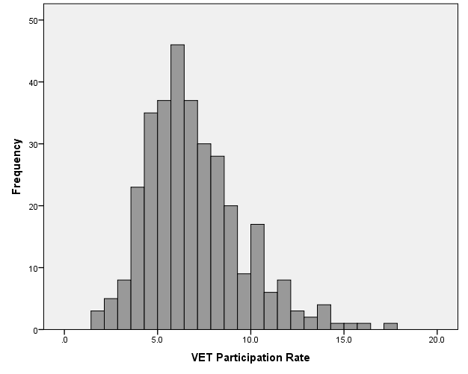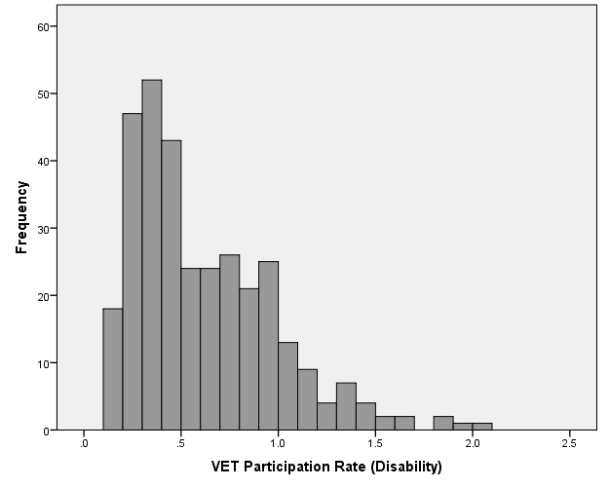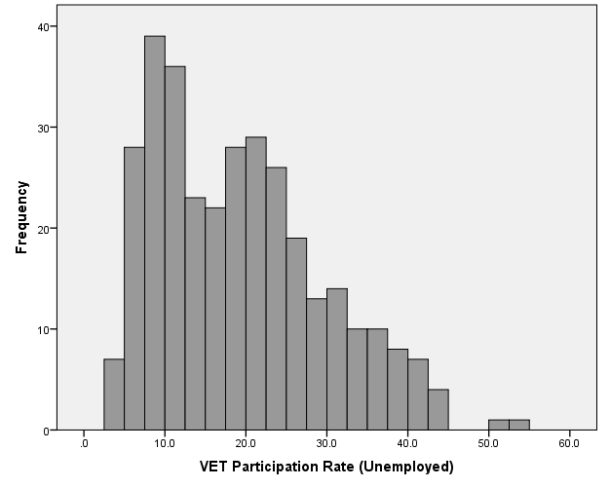

Source: Authors’ calculations from the VET Provider Collection, 2014

## Regional VET participation and provision

The use of VET differs across regions and population groups, as does the composition of the regions themselves, characterised as they are by their demographic and economic attributes as well as their capacity for VET provision. Further work is undertaken below to identify the main economic and demographic regional drivers of VET participation (supply-side) and ascertain their relative importance, while the question of provision (demand-side) is examined more closely first.

The relationship between participation and provision is considered through a series of correlation analyses which examine associations between regional rates of VET participation for students across the different target groups, and regional VET course and provider characteristics. These regional provision factors are drawn from the in-scope TVA CURF, and include the proportion of students in a region, as follows:

* Course characteristics
* AQF level, regional share of students enrolled in:
* Basic VET courses, defined as certificates I & II
* Middle VET courses: defined as certificates III & IV
* Advanced VET courses: defined as diploma and above
* Delivery mode, regional share of students enrolled in:
* Campus-based VET
* Online VET
* Employment-based VET
* Provider characteristics
* Provider type, regional share of students enrolled in
* TAFEs or Universities
* Community providers
* Private RTOs
* Number of delivery locations
* Number of TAFE/University delivery sites
* Number of community provider delivery sites
* Number of private provider delivery sites

Table 3 shows the correlations between regional rates of participation in VET for students from different backgrounds and profiles of regional VET provision. The strength of the association can be identified by the size of the correlation coefficient and level of statistical significance. Regions with relatively high concentrations of students in TAFE institutes or universities, for example, correspond to higher rates of participation in VET by Indigenous students (significant to 0.01 with positive correlation coefficients of 0.155). Conversely regions with higher proportions of students enrolled at private providers are associated with lower engagement of Indigenous students, students with a disability, LBOTE and unemployed students (significant to 0.01 with correlation coefficients of -0.265, -0.193, -0.144, -0.195 respectively). The reverse relationship exists for students with low levels of educational attainment; there is a positive association with more private provider activity and negative with TAFE and university activity (coefficients of 0.141 significant to 0.05, and -0.273 significant to 0.01 respectively).

These associations, however, are eclipsed by the significant and large positive correlations found between regional participation in community providers and higher rates of participation across all groups. Highlighting the role community providers play in serving some of our most disadvantaged populations, the associations are strongest for students with a disability, unemployed students and students with low prior educational attainment (all significant to 0.01, coefficients 0.620, 0.544, 0.453 respectively). This is mirrored by the significance of the number of community provider sites delivering VET in a region, to rates of participation by students from different backgrounds.

Other interesting findings in the correlation table concern the results for regions with higher proportions of students undertaking basic-level VET courses (certificate I or certificate II). Across all target groups, there is a significant positive association between the amount of basic VET activity occurring in a region and VET participation rates. Other levels of VET (advanced, middle) see a negative relationship with participation by students from disadvantaged groups.

There are some differences too across mode of delivery. Regions where there are relatively higher concentrations of students undertaking classroom-based learning correspond to higher rates of participation by students with low attainment, unemployed, and LBOTE students (significant to 0.01, correlation coefficients of 0.396, 0.232, 0.185, respectively). This carries through to Indigenous students (significant to 0.05, coefficient 0.118) but is not seen for students with a disability. Employment and online based courses see a significant negative correlation with students with low levels of prior educational attainment, and other groups.

Table 3 Correlations between regional VET participation rates for different groups of students and regional VET course and provider characteristics, 2014

|  |  |  |  |  |  |  |  |  |  |
| --- | --- | --- | --- | --- | --- | --- | --- | --- | --- |
|  | |  | | Regional VET Participation Rates (Target groups) | | | | | |
|  |  | | Indigenous | | Disability | LBOTE | Unemployed | Low attainment |
| Provider type | % TAFE/University | | .155\*\* | | .019 | .046 | .031 | -.273\*\* |
|  | % Community providers | | .372\*\* | | .620\*\* | .311\*\* | .544\*\* | .453\*\* |
|  | % Private providers | | -.265\*\* | | -.193\*\* | -.144\*\* | -.195\*\* | .141\* |
| AQF Level | % Advanced | | -.215\*\* | | -.264\*\* | -.297\*\* | -.097 | -.291\*\* |
|  | % Middle | | -.364\*\* | | -.392\*\* | -.325\*\* | -.363\*\* | -.122\* |
|  | % Basic | | .385\*\* | | .453\*\* | .437\*\* | .319\*\* | .286\*\* |
| Delivery mode | % Classroom | | .118\* | | .096 | .185\*\* | .232\*\* | .396\*\* |
|  | % Electronic | | .140\* | | .024 | -.051 | .108 | -.217\*\* |
|  | % Employment-based | | .004 | | -.137\* | -.134\* | -.132\* | -.231\*\* |
| Delivery locations | N TAFE/University sites | | -.013 | | .013 | .028 | -.031 | .183\*\* |
|  | N Community provider sites | | .309\*\* | | .398\*\* | .355\*\* | .436\*\* | .531\*\* |
|  | N Private provider sites | | -.099 | | -.185\*\* | -.125\* | -.190\*\* | .024 |

\*\* Correlation is significant at the 0.01 level (2-tailed)

\* Correlation is significant at the 0.05 level (2-tailed)

Source: Authors’ calculations from the VET Provider Collection, 2014

## Regional VET participation and student experiences and outcomes

VET performance can also be measured through the quality of student experience and post-training education and employment outcomes. NCVER conducts an annual survey of VET graduates and course completers in order to collect information on the views and outcomes of students who had been enrolled in government-funded VET programs, including course satisfaction and labour market transition. Publication of the aggregate results reveal some differences across target groups, some of which are presented in Figure 2 (NCVER 2015). The proportion of graduates employed or in further study holds the largest differential between populations. For example, 77.7 per cent of Indigenous graduates are actively engaged in the workforce or study, compared to 85.3 per cent of non-Indigenous graduates. The gap is greater for graduates with and without a disability (71.5 per cent and 86.3 per cent), and LBOTE graduates are less likely to be working or studying compared to their non-LBOTE counterparts (77.2 per cent and 87.2 per cent respectively).

Graduate views are not uniform across the target groups, as they face different challenges when undertaking training. For example, there is very little difference between the proportions of Indigenous and non-Indigenous graduates who report having achieved their main reason for training, and similarly for LBOTE and non-LBOTE graduates. Graduates with a disability, however, are less likely to have found that their training met their expectations compared to graduates without a disability (71.2 per cent compared to 81.4 per cent). All groups of graduates express satisfaction with the overall quality of training, with Indigenous students more positive than non-Indigenous students (90.2 per cent compared to 86.8 per cent).

Figure 2 Views on training of government-funded graduates by Indigenous status, disability status and LBOTE status, 2015 (%)

Source: NCVER 2015

Various measures of student experience and transition for regions were derived from the 2015 Government-funded student outcomes CURF for graduates. Graduates were allocated to the SA3 corresponding to their home address and respondents’ survey responses were aggregated at the regional level. These performance indicators measuring quality of student experiences and transition, were weighted to reflect the base population of graduates, and included:

* Proportion of graduates strongly agreeing that they were satisfied with the quality of training overall.
* Proportion of graduates satisfied with assessment.
* Proportion of graduates satisfied with their obtained generic skills and learning experiences.
* Proportion of graduates satisfied with the teaching.
* Proportion of graduates stating they achieved or partially achieved their main reason for training.
* The proportion of graduates reporting improved employment circumstances following training.
* The proportion of graduates employed or in further study after training.

Table 4 examines the relationships between regional levels of VET participation for different groups and regional measures of graduates’ experience and transition. Regions with relatively high rates of participation in VET by students with disabilities have positive correlations with regions where graduates were most satisfied with the overall quality of their training experience, and across different components, including assessment, generic skills and learning experiences and teaching. Regions where graduates were more likely to report satisfaction with the skills they have gained and the quality of their learning experiences also correspond to regions with higher rates of participation by students from all the target groups, and in particular unemployed students (coefficient of 0.175, significant to 0.01). Regions with higher rates of graduates reporting that they had achieved, or achieved in part, their main reason for training correspond to an extent with regions with higher VET participation rates by Indigenous and LBOTE students and students with a disability (significant to 0.05 and coefficients of 0.131, 0.132, 0.113 respectively). No significant relationships exist between regions where graduates are reporting improved employment circumstances following their training and VET participation. Transition to further study and work however is higher in regions with higher participation by Indigenous students.

Table 4 Correlations between VET regional participation and regional post-training views of quality of graduates’ experiences and post-training transition

|  |  |  |  |  |  |  |
| --- | --- | --- | --- | --- | --- | --- |
|  | | Regional VET Participation Rates (Target groups) | | | | |
|  | Indigenous | | Disability | LBOTE | Unemployed | Low attainment |
| % strongly agreeing that they were satisfied with the quality of the training overall. | 0.102 | | .191\*\* | 0.107 | 0.101 | 0.087 |
| % satisfied with assessment. | 0.015 | | .119\* | 0.108 | 0.062 | -0.017 |
| % satisfied with their obtained generic skills and learning experiences. | .119\* | | .155\*\* | .139\* | .175\*\* | .110\* |
| % satisfied with the teaching. | 0.025 | | .117\* | 0.052 | 0.033 | -0.019 |
| % stating they achieved or partially achieved their main reason for training. | .131\* | | .113\* | .132\* | 0.088 | -0.008 |
| % reporting improved employment circumstances following training. | 0.033 | | 0.000 | 0.044 | -0.045 | -0.036 |
| % employed or in further study after training | .145\*\* | | 0.101 | 0.106 | 0.081 | -0.006 |

\*\* Correlation is significant at the 0.01 level (2-tailed)

\* Correlation is significant at the 0.05 level (2-tailed)

Source: Authors’ calculations from the Government-funded Student Outcomes Survey, weighted, 2015 and VET Provider Collection 2014

It is also worth examining, at a regional level, correlations between the VET profile of a region and graduates’ reports on their training experiences and their further study and post-training labour market outcomes. These are given in Table 5. These results suggest that regions with a greater share of students enrolled in TAFEs or universities, and to a lesser extent community providers, are more likely to have graduates strongly agreeing that they were satisfied with the overall quality of their training, had achieved (in full or part) their main reason for training and following training report improved employment circumstances and in particular be more likely to be in study or work. The converse is true for regions with higher shares of students enrolled in private providers. Regions with higher shares of students in basic VET are more likely to report graduates achieving or partially achieving their main reason for training. They are also positively associated with graduates reporting being in work or further education, perhaps building on their basic level VET course. Regions with higher rates of employment-based training correspond with regions where graduates are more likely to report satisfaction with skills and learning experiences and to express greater satisfaction with teaching.

Table 5 Correlations between regional VET profiles and regional post-training views of quality of graduates’ experiences and post-training transition

|  |  |  |  |  |  |  |  |
| --- | --- | --- | --- | --- | --- | --- | --- |
|  | Graduate views on course | | | | | | |
|  | %  strongly agreeing they were satisfied with the quality of the training overall | %  satisfied with assessment | %  satisfied with their obtained generic skills and learning experiences | % satisfied with the teaching | % achieved or partially achieved their main reason for training | %  reporting improved employment circumstances following training | % employed or in further study after training |
| **Provider type** |  |  |  |  |  |  |  |
| % TAFE/University | .238\*\* | 0.046 | 0.085 | 0.028 | .332\*\* | .193\*\* | .303\*\* |
| % Community | .164\*\* | 0.102 | .154\*\* | .113\* | .125\* | 0.004 | 0.044 |
| % Private | -.264\*\* | -0.088 | -.126\* | -0.064 | -.366\*\* | -.187\*\* | -.314\*\* |
| **AQF Level** |  |  |  |  |  |  |  |
| % Advanced | -.368\*\* | -.152\*\* | -.201\*\* | -.161\*\* | -.193\*\* | -.166\*\* | -0.008 |
| % Middle | -0.056 | -0.039 | -0.072 | 0.007 | -.232\*\* | -0.006 | -.210\*\* |
| % Basic | .118\* | 0.083 | 0.082 | 0.043 | .249\*\* | 0.073 | .192\*\* |
| **Delivery Mode** |  |  |  |  |  |  |  |
| % Classroom | -.166\*\* | -0.083 | 0.034 | -0.055 | -.256\*\* | -.256\*\* | -.185\*\* |
| % Electronic | 0.098 | 0.026 | 0.049 | 0.016 | 0.087 | -0.032 | 0.039 |
| % Employment based | 0.075 | 0.079 | .131\* | .116\* | -0.005 | -0.002 | -0.025 |

Source: Authors’ calculations from the Government-funded Student Outcomes Survey, weighted, 2015 and VET Provider Collection 2014

# Regional VET completion rates

## Calculating completion rates

Measures of performance extend beyond participation in VET to the completion of VET activity. However, defining and measuring completion and retention in VET can be complex, given the diversity of program offerings and differing student intentions (McVicar & Tabasso 2016, Lamb & Walstab 2010). Some courses can be completed within months while others take several years. The flexible nature of VET means that non-linear pathways are not unusual and many students enrol with the intention of completing a single module or subject rather than an entire qualification.

Some measures of course completion track commencing cohorts forward over time, while others impute rates for the current cohort based on the behaviour of previous cohorts (McVicar & Tabasso 2016, Bednarz 2012). In the case of this study, access to a single calendar year of VET enrolment data means a different approach is required. A regional award completer rate was calculated by dividing the number of students who completed a VET program in 2014 living in a particular SA3 by the total number of students in the SA3. Completing students included those who had been issued their qualification as well as those who were eligible for completion but not yet issued. This was done by first matching the program completion information to the subject-level file and then aggregating at SA3-level to obtain student-level counts. This way a student is seen to have achieved course completion if they are eligible for qualification issue for any VET course across the calendar year.

It is important to note that this regional award completer rate does not take into account the nuances associated with measuring program completion in VET. The limitation of a single year of enrolment data means stronger measures of completion such as cohort completion rates cannot be calculated as these require tracking over different calendar years, especially for courses at mid and higher AQF levels. This limitation, however, applies across the total dataset. For these reasons, and because the VET activity in this project has been restricted in a particular way, completion rates presented in this report cannot be compared to those reported elsewhere.

An additional measure of completion was calculated at the subject or module level. Subjects take place and outcomes are available within the calendar year, so a single year of data is adequate for the purpose of calculating subject completion rates. Here, subject completion rates represent the ratio of the number of reported hours for subjects where competencies were achieved or passed to the reported hours for subjects where competencies were achieved or passed, not achieved or failed, or withdrawn or discontinued, expressed as a percentage. Since subject-level completion rates take into account the number of reported hours for a subject, they are effectively weighted for longer courses. This is similar to the methodology used by NCVER to calculate “subject load pass rates” (Bednarz 2012, p.8).

## Variations in regional VET completion

Just as VET participation rates varied across SA3s, analyses of completion rates calculated as described above also reveal considerable regional differences. Figure 3 shows the distribution of award completer and subject completion rates across the SA3s. Award completer rates range from 13.4 per cent to 50.2 per cent across the SA3s while subject completion rates vary from 58.2 per cent to 94.9 per cent at near full subject completion.

Figure 3 Regional distribution of award completion rates and subject completion rates, SA3s, 2014

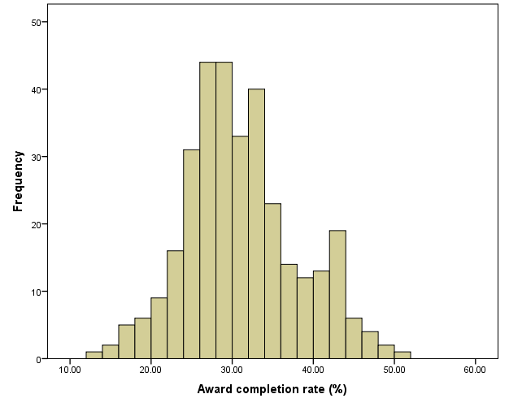

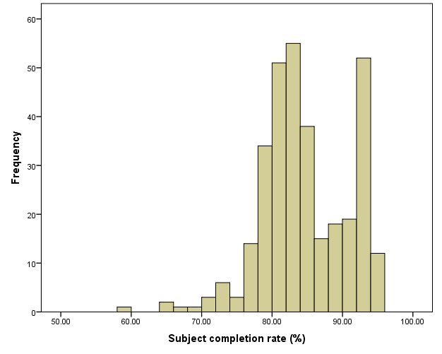

Source: Authors’ calculations from the VET Provider Collection, 2014

Some variation also exists in levels of completion across target groups. The regional means for all students and different groups of students are shown in Figure 4. The mean regional award completer rate overall is 31.1 per cent. The rate for LBOTE students is the same as for all students while unemployed students experience a higher rate at 36.7 per cent. However the rates for students with a disability, low attainment and for Indigenous students are lower than the overall rate at 28.4 per cent, 28.2 per cent, and 26.2 per cent respectively.

The overall mean subject completion rate for all students across SA3s is 83.2 per cent. Rates for unemployed students, LBOTE (CALD) students, and students with low levels of prior educational attainment are slightly lower at 80.3 per cent, 80.2 per cent and 79.9 per cent respectively. Mean regional subject completion rates are lower again for Indigenous students and students with a disability, at 76.0 per cent and 75.7 per cent respectively.

Figure 4 Mean regional completion rates for all students and key target groups, 2014

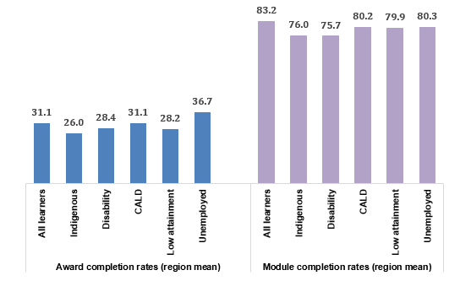

Source: Authors’ calculations from the VET Provider Collection, 2014

## Relationship between the measures of completion at a regional level

Some regions across Australia have relative high levels of award completer rates and some have relatively high levels of subject completion. Is there any relationship at the regional level between the two measures of VET completion? Figure 5 plots the award completer rate against subject completion rate for each region.

Figure 5 Award completer rate and subject completion rate, compared, regions 2014

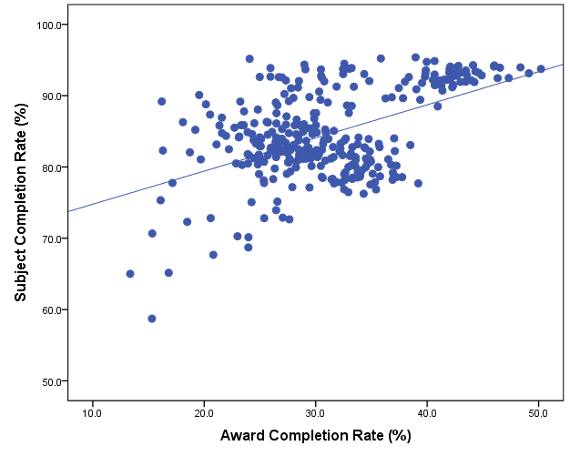

Source: Authors’ calculations from the VET Provider Collection, 2014

Figure 5 shows in general a positive predictive relationship between award completion and subject completion, this is not the case for all regions. Some regions that are experiencing very high rates of subject completion simultaneously have low rates of course completion. On the one hand, for some regions, success in subject completion is not translating to full course completion. On the other hand, some regions, shown here on the top right-hand side of the chart, are succeeding at course completion and subject completion with high rates across both measures.

# Identifying regional drivers of VET participation

## Model predicting regional VET participation

Regional-level VET participation rates presented in this report show significant variation across Australia for all students and across different target groups. While provision factors, as explored above, impact on the profile of VET offerings in a region and thus the capacity to engage students in training, the demographic and economic characteristics of a region will also influence regional demand for VET. Here, linear regression techniques are used to determine the relative impact of community-based drivers of VET performance. These analyses draw on a range of demographic, economic and policy variables to predict levels of VET participation, and to better understand the impact these factors have on participation at a regional level, for all students and across different target groups.

The following demographic characteristics were derived at the SA3 level from the ABS Census of Population and Housing for 2011, and were used as independent variables in the model. The following regional elements were taken into consideration:

* Proportion of young people (15 to 24 years)
* Proportion of Indigenous people
* Proportion of people with a language background other than English
* Proportion of people with low educational attainment (no Year 12 and no Certificate III or above)
* Proportion of people with low income
* Proportion of people with a severe disability
* Proportion of people living in remote or very remote Australia.

Regional characteristics used to describe the economic profile of a region were also obtained from the 2011 ABS Census at SA3 level. To minimise the number of independent variables in the regression model, correlations were used to combine some occupation categories and industry categories. The following are the resultant categories representing economic characteristics of the region:

* Proportion of unemployed people
* Proportion of people working across occupations, grouped as follows:
* Professionals
* Managers
* Technicians and Trades Workers
* Community and Personal Service Workers
* Clerical, Administrative and Sales Workers
* Machinery Operators, Drivers and Labourers
* Proportion of people working across industries, grouped as follows:
* Agriculture, Forestry and Fishing
* Mining
* Manufacturing, Transport, Postal and Warehousing
* Construction, Electricity, Gas, Water and Waste Services
* Wholesale, Retail and Other Services
* Accommodation, Food, Rental, Hiring and Real Estate Services
* Information Media and Telecommunications, Financial and Insurance, Professional, Scientific and Technical Services
* Public Administration and Safety, Arts and Recreation Services
* Education and Training
* Health Care and Social Assistance.

## Variance analysis

The results from the regression analyses show that the model designed to identify regional drivers of participation in VET is robust. As shown in Table 6, overall, the model is a strong fit, explaining 74.1 per cent of the variation in participation between regions, leaving about a quarter of the difference unexplained by the model. As single blocks of factors, economic characteristics of a region are most influential explaining 44.1 per cent of the variation. Demographic factors, as a block, explain 36.2 per cent of the regional variation, while policy factors (or state differences) on their own account for 27.3 per cent of the variance. It is, however, the combination of all three sets of factors which is able to most strongly predict VET participation.

Table 6 Variance analysis of factors influencing regional VET participation

|  |  |  |  |  |  |  |
| --- | --- | --- | --- | --- | --- | --- |
|  | Adjusted R2 (expressed as percentage) | | | | | |
| Regional characteristics | All Students | Indigenous | Disability | LBOTE | Unemployed | Low attainment |
| Economic | 44.1 | 9.4 | 42.5 | 19.0 | 23.1 | 18.3 |
| Demographic | 36.2 | 2.5 | 39.5 | 13.6 | 16.1 | 5.5 |
| Policy | 27.3 | 28.3 | 35.3 | 20.9 | 57.1 | 50.3 |
| Combined Adjusted R2 | 74.1 | 38.1 | 76.5 | 40.9 | 75.0 | 69.7 |

Source: Authors’ calculations from the VET Provider Collection, 2014

While the regression model has been designed to predict regional VET participation overall, it can be applied to regional participation rates across the different target groups. Table 6 also shows the impact of each group of factors when the regression model is applied in this way. The amount of variation explained by the model as a whole differs across the groups, ranging from 38.1 per cent for Indigenous participation rates to 75 per cent for participation by unemployed people. Economic factors remain influential when explaining differences in regional participation rates for all groups, with the exception of Indigenous students. Demographic factors are important too in influencing regional differences in participation of students with a disability.

However, in terms of explaining differences across target groups, and particularly in comparison to the relative importance for all students, policy factors are highly influential. This is especially the case for Indigenous students and students with low levels of prior educational attainment, and is also influential in terms of describing differences in regional participation rates for unemployed students. In the model, states and territories represent jurisdictional education and training policy differences, however other jurisdictional differences are encompassed here.

Table 7 shows more fined grained results from the regression analyses, which can be used to establish the most influential regional drivers of VET participation. The table shows the beta coefficients from the regression output, expressed as standardised estimates (multiplied by the standard deviation for the dependent variable), as percentage point gains or losses, for each factor for all students and across the target groups. Thus the percentage point increases and decreases are relative to the mean regional participation rate shown at the top of the table.

The table shows the strong influence that the industry profile of a region plays in driving differences in levels of VET participation. For all students, for example, a one standard deviation unit increase in the proportion of workers in Manufacturing, Transport, Postal and Warehousing industries corresponds with a 1.17 percentage point increase in VET participation. An increase in the proportion of workers in a region in Agriculture, Forestry and Fishing, and Healthcare and Social Assistance is also associated with increases in VET participation (0.96 and 0.59 percentage point gains respectively). Occupational factors are not influential once industry factors are included in the model.

Demography has less influence over the levels of regional participation, although having controlled for all other factors, the proportion of young people living in a region aged 15 to 24 years sees an increase in VET participation (0.27). Higher proportions of the population with low income sees a decrease in participation (-0.59), as does higher proportions of the population with a severe disability (-0.57).

Policy factors influence levels of participation by all students in VET, especially in Victoria (positive effect at 1.10) and Queensland (negative effect -1.05).

The importance of the industry structure of a region in driving regional VET participation rates carries through when looking at participation by students from different backgrounds. This is particularly the case when examining differences in levels of VET participation by unemployed students, where all industries are either a significant influence or relatively high percentage point magnitude, and is also important in terms of participation by Indigenous students and students with low levels of prior educational attainment. Industry plays less of a role for students with a disability and LBOTE students. Occupational factors are again dominated by industry, except for participation by students with low levels of educational attainment, where higher concentrations of Community and Personal Service workers in a region is associated with an increase in VET participation (0.52).

In terms of regional demographic characteristics, the proportion of young people in a region has a positive influence on rates of participation by LBOTE students, students with low attainment and students with a disability. The proportion of the regional population with a low income sees a corresponding decrease in VET participation rates across all groups.

Policy factors are influential in terms of explaining regional differences in VET participation, especially for unemployed students and students with low levels of educational attainment. For Victoria, this translates to an increase in participation, whereas, on the whole, other jurisdictions are associated with a decrease in participation.

Table 7 Regional drivers of VET participation, 2014

|  |  |  |  |  |  |  |
| --- | --- | --- | --- | --- | --- | --- |
|  | All Students | Indige-nous | Disability | LBOTE | Unemp-loyed | Low attainment |
| Mean regional VET participation rates | 7.0% | 15.1% | 0.6% | 6.6% | 19.4% | 7.5% |
| Standard deviation | 2.6% | 7.7% | 0.4% | 4.4% | 10.3% | 3.3% |
| **Regional demographic factors** | | | | | | |
| % 15 to 24 years | 0.27\*\* | 0.86 | 0.06\*\* | 0.8\*\* | 0.82 | 0.45\*\* |
| % Indigenous | -0.17 | -0.53 | -0.05 | -0.91 | -0.24 | -0.48 |
| % LBOTE | 0.03 | -0.33 | -0.03 | -0.16 | 0.47 | 0.03 |
| % Low attainment | 0.39 | -2.29 | 0.09 | 1.69 | 1.07 | -0.32 |
| % Low income | -0.59\*\*\* | -1.9\*\* | -0.09\*\*\* | -1.38\*\*\* | -1.79\*\* | -1.17\*\*\* |
| % Severe disability | -0.57\*\* | 0.04 | -0.01 | -0.81\* | -0.95 | -0.91\*\*\* |
| % Remote or very remote | 0.25\* | 0.14 | 0 | 0.04 | -0.43 | 0.36\* |
| **Regional economic factors** | | | | | | |
| %Unemployed | 0.26 | 0.78 | 0.04\* | 0.41 | -0.59 | 0.59\*\* |
| *Occupations* |  |  |  |  |  |  |
| % Managers | 0.06 | 1.89 | 0.07 | -0.82 | -1.22 | -0.53 |
| % Technicians and Trades Workers | -0.1 | 0.34 | 0.02 | -0.31 | -2.13 | -0.27 |
| % Community and Personal Service Workers | 0.28 | 0.57 | 0.03 | -0.4 | 0.95 | 0.52\* |
| % Clerical Administrative and Sales Workers | 0.15 | -0.04 | -0.04 | -0.68 | 0.8 | -0.56 |
| % Machinery Operators Drivers and Labourers | 0.69 | 0.06 | 0.1 | 0.1 | -0.21 | -0.07 |
| *Industry* |  |  |  |  |  |  |
| % Agriculture, Forestry and Fishing | 0.96\* | 2.66 | 0.01 | 0.92 | 5.26\*\* | 1.73\*\* |
| % Mining | 0.37 | 2.57\* | 0.03 | 0.17 | 3.15\*\* | 0.6 |
| % Manufacturing, Transport, Postal and Warehousing | 1.17\*\*\* | 4.15\*\* | 0.07 | 0.98 | 5.22\*\*\* | 1.58\*\* |
| % Construction, Electricity, Gas, Water and Waste Services | 0.16 | 0.17 | -0.01 | -0.52 | 1.5\* | 0.21 |
| % Wholesale, Retail and Other Services | 0.4 | 2.18\* | 0.05 | 1.07 | 1.06 | 0.81\*\* |
| % Accommodation, Food, Rental, Hiring and Real Estate Services | 0.33\* | 1.21 | 0.03 | 0.38 | 1.65\*\* | 0.42\* |
| % Education and Training | 0.34\*\* | 1.23\* | 0.04\* | 0 | 1.71\*\* | 0.51\*\* |
| % Health Care and Social Assistance | 0.59\*\*\* | 1.46\*\* | 0.11\*\*\* | 0.99\*\* | 1.96\*\* | 0.4\* |
| % Public Administration and Safety, Arts and Recreation Services | 0.57\* | 3.33\*\* | 0.05 | 1.35 | 2.42\* | 0.7 |
| **Policy factors** | | | | | | |
| Victoria | 1.1\*\*\* | 0.06 | 0.08\*\*\* | 0.91\*\*\* | 2.21\*\*\* | 2.03\*\*\* |
| Queensland | -1.05\*\*\* | -4.86\*\*\* | -0.2\*\*\* | -2.01\*\*\* | -7.86\*\*\* | -1.2\*\*\* |
| SA | -0.26\*\* | -2.25\*\*\* | -0.01 | -0.85\*\*\* | -2.07\*\*\* | -0.81\*\*\* |
| WA | -0.05 | -1.07\*\* | -0.08\*\*\* | 0.22 | -3.65\*\*\* | -0.36\*\* |
| Tasmania | -0.19\*\* | -2.39\*\*\* | -0.03\*\* | -0.17 | -1.74\*\*\* | -0.31\*\* |
| NT | -0.14 | -0.62 | -0.04\*\* | 0.22 | -1.97\*\*\* | -0.1 |
| ACT | 0.17 | -1.09 | 0.02 | -0.43 | -0.37 | 0.1 |

Note: \* p<.10, \*\* p<.05, \*\*\* p<.001

Source Authors’ calculations from the VET Provider Collection, 2014

# Conclusion: identifying high performing regions for case studies

The main purpose of the analysis is to identify regions across Australia that are best serving their disadvantaged populations in terms of VET participation and program outcomes. Results from the linear regression modelling can be used for this purpose. While the model was designed to predict regional VET participation overall, it was applied to measures of participation across the target groups and similarly to both course completion measures. The modelling generated standardised residuals for each region, which were saved as a measure of regional effect, to be used as a base for identifying high performing regions.

Standardised residuals represent the amount of unexplained variance in units of standard deviation and error, that is, the difference between the observed regional level of performance and the mean predicted rate after controlling for the range of regional demographic and economic factors outlined above. Standardised residuals also include some error. The regression modelling and resultant standardised residuals can be used to identify whether predicted performance is either exceeding what might be expected, is at a level similar to other regions, or is below an expected level, given the regional contextual factors. Regions with very high or very low (+/- 1 standard deviation) predicted performance are either exceeding what might be expected, given the economic and demographic profile of a region, or is underperforming.

In aggregate the standardised residuals give us a measure of regional effect, which can be used to identify regions which are doing well across all target groups. As such the residuals were aggregated, but capped at +/- 2 so no single score would influence the results. This was done separately for VET participation, award completion and subject completion. The relationships between these aggregate scores are given in Table 8. It shows that while there is a positive and significant relationship between the two completion measures, there is a negative relationship between participation and completion.

Table 8 Correlations between Aggregate Standardised Residual Scores

|  |  |  |  |  |  |
| --- | --- | --- | --- | --- | --- |
|  |  | Aggregate standardised residuals | | | |
|  |  | | Participation  (target groups) | Award completer rate  (target groups) | Subject completion rate  (target groups) |
| Aggregate standardised residuals | Participation (target groups) | | 1 | -.144\*\* | -.249\*\* |
| Award completer rate (target groups) | | -.144\*\* | 1 | .405\*\* |
| Subject completion rate (target groups) | | -.249\*\* | .405\*\* | 1 |

\*\*. Correlation is significant at the 0.01 level (2-tailed).

Source: Authors’ calculations from the VET Provider Collection, 2014

The softer results from subject completion suggest that while some regions are able to engage in VET those from disadvantaged backgrounds, higher participation and success in engagement has not yet been translated to higher award completion relative to areas of low participation. However there may be some other regions that are able to translate high participation to high completion.

These regions can be identified in Figure 6 in the first (top right-hand side) quadrant; they are high performing in terms of participation and outcomes with regional effect scores of greater than two standard deviations. While high participation reflects engagement with different groups, meeting the dual measures of high participation and high completion is the ideal.

Figure 6 Aggregate Standardised Residual Scores for participation and award completion for target groups, regions, 2014

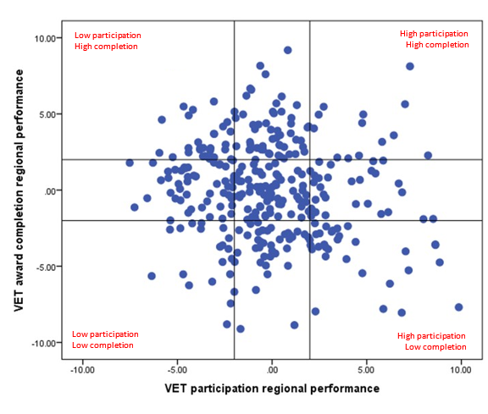Source: Authors’ calculations from the VET Provider Collection, 2014

There are 13 regions in this exceptional category (which are listed in Appendix 1). Table 9 and Figure 7 shows the characteristics of the VET activity in these high performing regions and for all regions (regional means). These show that as a group, these regions are more likely to have greater than average delivery at community providers and less at TAFE and universities. They are more likely to have VET delivered face-to-face in classrooms rather than online or in the workplace. On average, these regions offer more basic VET courses than across all regions and their student profile is over-represented by students with low levels of prior educational attainment, unemployed students and students with a disability. While this tells us about the differences in aggregate, case studies in these regions, with an emphasis on provider practice, will clarify what these regions are doing which enables them to engage and achieve with its most vulnerable populations.

Table 9 Characteristics of VET activity in all regions and high performing regions (regional means), 2014

|  |  |  |  |
| --- | --- | --- | --- |
|  |  | All regions (%) | High participation, |
|  |  | Regional mean | high completion regions (N=13) (%) |
| Provider type | TAFE/University | 62.2 | 56.3 |
|  | Community providers | 4.9 | 9.6 |
|  | Private providers | 33.7 | 34.8 |
| AQF level | Advanced | 13.4 | 12.6 |
|  | Middle | 70.7 | 70.2 |
|  | Basic | 20.7 | 24.4 |
| Delivery mode | Classroom | 62.9 | 67.9 |
|  | Electronic | 14.0 | 9.3 |
|  | Employment-based | 21.2 | 18.7 |
| VET student profile | Indigenous | 7.0 | 5.9 |
|  | With a disability | 8.5 | 10.3 |
|  | LBOTE | 15.0 | 13.1 |
|  | Unemployed | 11.5 | 12.8 |
|  | Low attainment | 33.6 | 36.2 |

Source Authors’ calculations from the VET Provider Collection, 2014

Figure 7 Characteristics of VET activity in high performing regions (deviation from regional mean), 2014 (%)

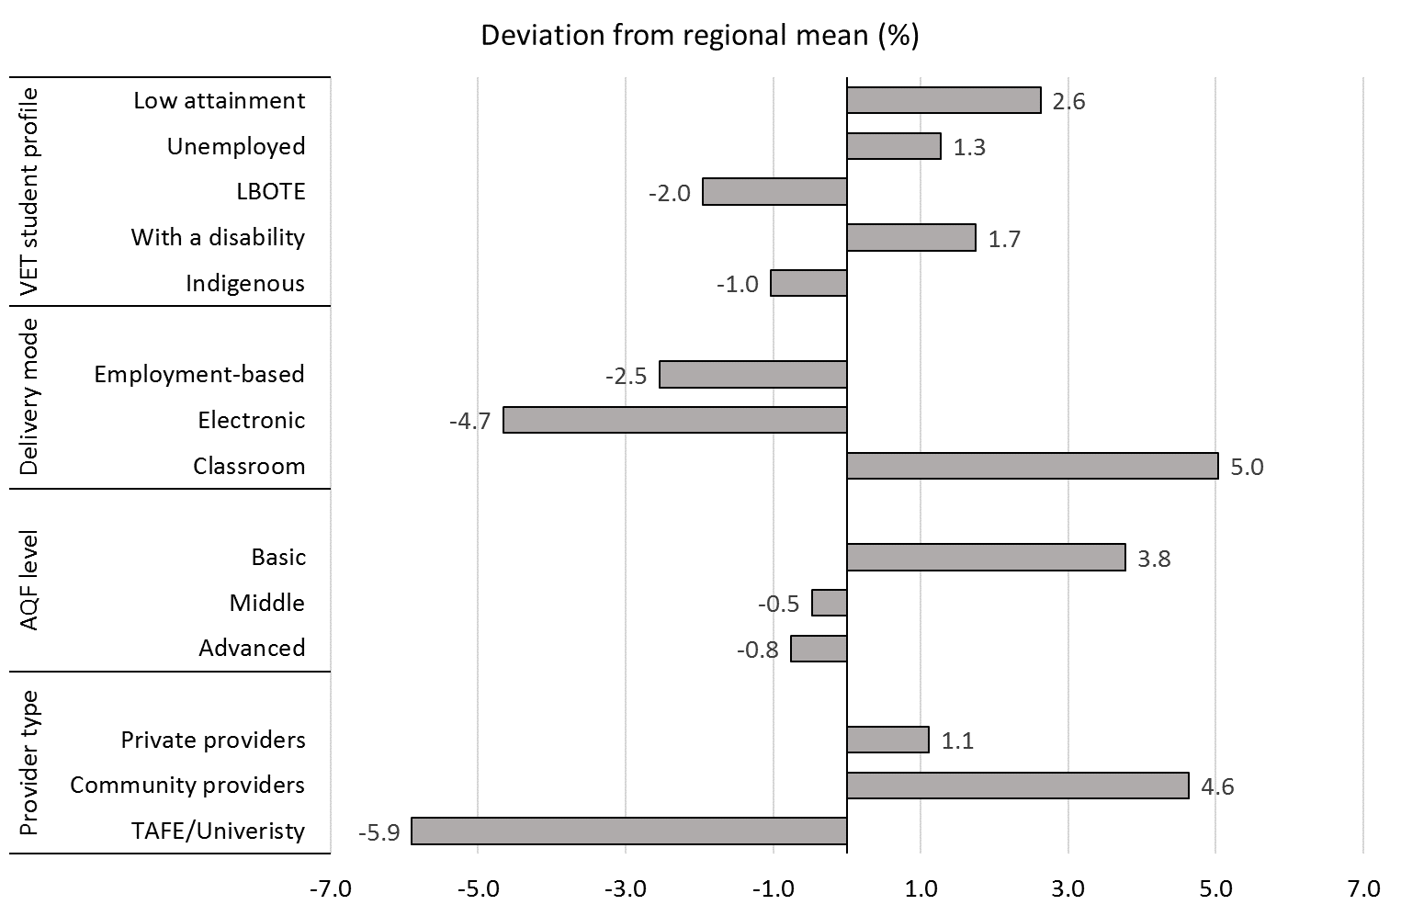

Source: Authors’ calculations from the VET Provider Collection, 2014

# References

Anlezark, A & Foley P 2016, *Making sense of total VET activity: an initial market analysis*, NCVER, Adelaide

Australian Bureau of Statistics 2011, *Australian Statistical Geography Standard: Volume 1 – Main Structure and Greater Capital City Statistical areas.* Catalogue No. 1270.0.55.001

Australian Bureau of Statistics 2015, *Population by Age and Sex, Regions of Australia,* Catalogue No. 3235.0

Bednarz, A 2012, *Lifting the lid on completion rates in the VET sector: how they are defined and derived, NCVER*, Adelaide

Council of Australian Governments, 2009, *National Education Agreement*, Commonwealth of Australia, Canberra

Davies, M, Lamb, S and Doecke, E, 2011, Strategic Review of Effective Re Engagement Models for Disengaged Learners, DEECD

McVicar, D & Tabasso, D 2016, The impact of disadvantage on VET completion and employment gaps, NCVER, Adelaide.

National Centre for Vocational Education Research 2015, Australian vocational education and training statistics: Government-funded student outcomes 2015, NCVER, Adelaide.

Walstab, A. & Lamb, S. (2008). Participation in vocational education and training across Australia: A regional analysis. Adelaide: NCVER

# Appendix 1 Regional standardised residual scores

Regions recommended for case studies:

|  |  |  |  |  |  |
| --- | --- | --- | --- | --- | --- |
| SA3 CODE | SA3 NAME | State | Aggregate  participation  effect  score | Aggregate  award  completer  effect  score | Aggregate  subject  completion  effect  score |
| 10303 | Lithgow - Mudgee | New South Wales | 6.42977 | 3.59451 | -1.60664 |
| 11001 | Armidale | New South Wales | 7.28711 | 8.12139 | 1.53462 |
| 20201 | Bendigo | Victoria | 2.46404 | 4.95256 | -1.06151 |
| 21003 | Moreland - North | Victoria | 5.81177 | 3.16421 | -2.70695 |
| 21601 | Campaspe | Victoria | 3.44438 | 2.13392 | 0.08538 |
| 21602 | Moira | Victoria | 4.59288 | 2.26424 | 3.62222 |
| 30305 | Rocklea - Acacia Ridge | Queensland | 2.21101 | 4.04762 | 3.10912 |
| 30306 | Sunnybank | Queensland | 4.81634 | 4.96574 | 1.38919 |
| 30402 | Kenmore - Brookfield - Moggill | Queensland | 4.75889 | 4.40665 | 0.03791 |
| 40504 | Yorke Peninsula | South Australia | 7.02631 | 5.63828 | 0.32485 |
| 50302 | Perth City | Western Australia | 2.72617 | 5.47302 | 5.85409 |
| 50901 | Albany | Western Australia | 8.24047 | 2.27777 | 4.43238 |
| 60302 | Huon - Bruny Island | Tasmania | 4.02419 | 2.08277 | -1.01596 |

Source: Authors’ calculations from the VET Provider Collection, 2014