NCVER_Floating_Mono

Identifying work skills — international case summaries

Gitta Siekmann

NCVER

This document was produced by the author(s) based on their research for the report *Identifying work skills — international approaches*, and is an added resource for further information. The report is available on NCVER’s Portal: <<http://www.ncver.edu.au>>.

### ­

### 

### Publisher’s note

The views and opinions expressed in this document are those of NCVER and do not necessarily reflect the views of the Australian Government and state and territory governments. Any errors and omissions are the responsibility of the author(s).

The majority of material in each case summary has been lifted mostly verbatim from original sources. These sources  are stated at the beginning of each case summary. Care has been taking in removing any unsubstantiated claims as to the quality of the product or service described.

**© Commonwealth of Australia**

G:\pub_prod\PublicationComponents\logos\Creativecommons\CC BY logo.eps

With the exception of the Commonwealth Coat of Arms, the Department’s logo, any material protected by a trade mark and where otherwise noted all material presented in this document is provided under a Creative Commons Attribution 3.0 Australia <http://creativecommons.org/licenses/by/3.0/au> licence.

The details of the relevant licence conditions are available on the Creative Commons website (accessible using the links provided) as is the full legal code for the CC BY 3.0 AU licence <http://creativecommons.org/licenses/by/3.0/legalcode>.

The Creative Commons licence conditions do not apply to all logos, graphic design, artwork and photographs. Requests and enquiries concerning other reproduction and rights should be directed to the National Centre for Vocational Education Research (NCVER).

This document should be attributed as Siekmann G 2017, *Support Document: Identifying work skills — international case summaries,* NCVER, Adelaide.

This work has been produced by NCVER on behalf of the Australian Government and state and territory governments, with funding provided through the Australian Government Department of Education and Training.

Published by NCVER, ABN 87 007 967 311

Level 5, 60 Light Square, Adelaide, SA 5000  
PO Box 8288 Station Arcade, Adelaide SA 5000, Australia

**Phone** +61 8 8230 8400 **Email** [ncver@ncver.edu.au](mailto:ncver@ncver.edu.au)

**Web** <https://www.ncver.edu.au>

**Follow us:**  <https://twitter.com/ncver>  <https://www.linkedin.com/company/ncver>

Contents

Tables and figures 6

Tables 6

Figures 6

Case 1 – OECD's skills strategy rationale 7

Source 7

Type 7

About 7

Purpose 7

Operation 7

Highlights 8

Illustration – Norway's skill strategy action Plan 9

Related systems and tools 10

Case 2 – Cedefop's skill anticipation framework 14

Source 14

Type 14

About 14

Purpose 14

Operation 14

Highlights 15

Illustration – Skill anticipation country profiles 17

Case 3 – USA's O\*NET 18

Source 18

Type 18

About 18

Purpose 18

Operation 18

Highlights 20

Challenges 25

Case 4 – Singapore's Skills Frameworks 26

Type 26

About 26

Purpose 26

Operation 27

Illustrations 29

Case 5 – UK's Futures Programme 32

Source 32

Type 32

About 32

Purpose 32

Operation 32

Highlights 33

Illustration 36

Other UK skill initiatives 37

Case 6 – Canada's FutureSkills Lab 39

Source 39

Type 39

About 39

Operation 40

Illustration - Training pilots 43

Case 7 – Switzerland's skilling - an overview 46

Source 46

Type 46

About 46

Purpose 46

Operation 47

Highlights 47

Case 8 – New Zealand's skills strategy proposal 50

Source 50

Type 50

About 50

Purpose 50

Operation 51

Highlights 52

Other systems & tools 53

Case 9 – Finland's skill anticipation activities 58

Source 58

Type 58

About 58

Purpose 58

Operation 59

Highlights 59

Case 10 – European Commission's skill classification ESCO (European Skills, Competences, Qualifications and Occupations) 62

Source 62

Type 62

About 62

Purpose 62

Operation 63

Highlights 64

Illustration: Child Care Worker Profile 66

Case 11 – SFIA's Skills Framework for the Information Age 68

Source 68

Type 68

About 68

Purpose 68

Operation 68

Highlights 69

Illustration 72

Case 12 – Burning Glass: Real-time job data analysis 75

Source 75

Type 75

About 75

Purpose 75

Operation 75

Highlights 76

Illustration 76

Case 13 – NSW BVET/Wheelahan's and Moodie's Capabilities Framework 79

Source 79

Type 79

About 79

Purpose 79

Operation 79

Highlights 80

Illustration 81

References 82

# Tables and figures

## Tables

1 O\*NET surveys & content (Handel 2016) 20

2 Example of O\*NET Occupation occupational data update 22

## Figures

1 OECD skills strategy flow chart 8

2 The use of information about skills in employment and education   
policy (OECD 2016) 12

3 Training profile for ‘Legal, social and cultural associate   
professionals’' wanting to switch to ‘Business and administration   
associate professionals’ jobs (Italy) (Vandewyer 2017) 13

4 O\* NET content model - Anatomy of an occupation 19

5 Importance and Level of skill characteristic 22

6 Future of retail - SkillsFuture retail sectoral manpower plan 30

7 Training programs for skill and knowledge deepening 31

8 Where FutureSkills programme fits into the existing governance system 40

9 Example pilot proposal energy sector proposal 43

10 Purpose and Goals of NZ skills strategy 51

11 Vocational Pathway Profile 56

12 ESCO structure 63

13 SFIA experience and competency level 69

14 Major SFIA skill categories 70

15 Summary – Example ‘Strategy and Architecture’ 72

16 IBSA IT framework (IBSA 2015) 73

# Case 1 – OECD's skills strategy rationale

Source

<http://www.oecd.org/skills/>

## Type

Skills strategy framework

## About

The Organisation for Economic Cooperation and Development (OECD) works with countries to develop skills strategies tailored to specific needs and contexts. The Organisation prepared a global skills strategy outline over the period 2011 to 2013. In its paper “Towards an OECD Skills Strategy” (OECD 2013), the OECD sets out the main issues which must be addressed by efficient and effective policies for skills formation and skills use.

## Purpose

To facilitate a cross-government approach and peer-learning on effective skills policies, and to address the global dimensions of the supply and demand for skills. The strategy focuses on:

* Establishing a common language to describe skills.
* Improving the measurement of skills.
* Identifying essential skills for the future.
* Understanding skills mismatch.
* Improving skills training for the unemployed.
* Developing sound strategies for skills financing.
* Guidance for national policy development and implementation.

## Operation

The strategy framework is being used to support countries in building more effective national skills strategies by:

* Working closely with inter-ministerial teams in capitals whose members include government officials from education, employment, economic development and innovation, among others.
* Engaging a broad range of stakeholders through interactive workshops to build a deep, shared understanding of the skills challenges facing their country.
* Identifying the country’s key skills challenges and designing concrete actions to improve the country’s skills system.

Each national skills strategy country project offers a tailored approach to focus on the unique skills challenges, context and objectives of each country. Each project leverages OECD comparative data and policy analysis, fosters collaboration across ministerial portfolios and levels of government while engaging all relevant stakeholders – employers, trade unions, and civil society organisations.

Figure 1 OECD skills strategy flow chart

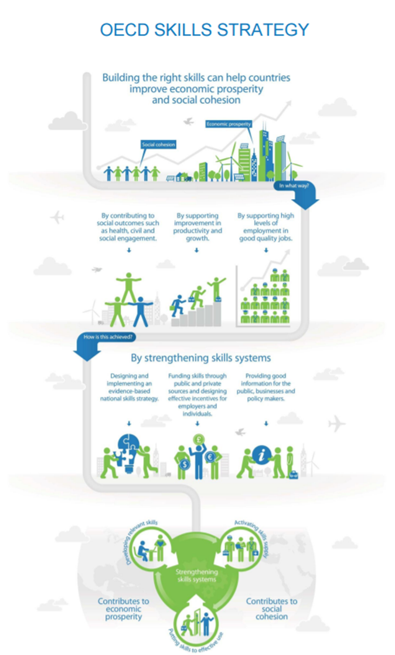

## Highlights

### Ownership, coordination and stakeholder involvement

The OECD is a unique forum where governments work together to address the economic, social and environmental challenges of globalisation. The OECD is also committed to understand and to help governments respond to new developments and concerns, such as corporate governance, the information economy and the challenges of an ageing population. The Organisation provides a setting where governments can compare policy experiences, seek answers to common problems, identify good practice and work to co-ordinate domestic and international policies.

### 

### Identification, collection and update of skill descriptions

A key element of successful reform is building a deep, shared understanding of the challenges facing the country. This phase would typically involve several diagnostic workshops that would involve all relevant ministries and national and/or regional stakeholders. Workshops use techniques designed by the OECD and adapted to the country’s context, in close consultation with the national project team. They are designed to facilitate dialogue among the stakeholders and highlight relevant international evidence. The main skills challenges identified are set out in a short OECD Skills Strategy Diagnostic Report and presented publicly.

### Practical outcomes

The action phase involves several stakeholder workshops that focus on tackling the skills challenges identified in the diagnostic phase and building agreement on what actions need to be taken and by whom. Project activities are designed to support, and contribute to, advancing the country’s own skills policy agenda.

A full National Skills Strategy country project, comprising a Diagnostic Phase and an Action Phase, would typically be carried out over a period of 18-24 months, in order to allow time for reflection and further discussion at the national level between workshops.

## Illustration – Norway's skill strategy action Plan

**What should the government do?**

* Provide relevant information and guidance to individuals, stakeholders and policy makers
* Strengthen the evidence-base on current and projected skills imbalances across occupations and regions.
* Make sure that this information is used by policy makers, public officials and heads of agencies and institutes at different administrative levels.
* Establish a high-quality lifelong career guidance system to provide youth and adults with personalised advice on labour market opportunities and education and training options. including a central national online platform for career guidance and information.
* Ensure high quality standards within the lifelong career guidance system. Make sure counsellors have relevant skills and tools to provide user-friendly up-to-date information on realistic job profiles, regional and national employment opportunities, including current and expected skills shortages, and skills development pathways.
* Pay stronger attention to the needs of the target groups described in here. Consider encouraging education institutions to publish information on employment outcomes of graduates by field of study to improve market signalling on the performance of institutions.

**What should stakeholders do?**

* Make better use of information on skills imbalances Individual employers, social partners and Statistics Norway can take steps to:
* Collaborate on effective ways to provide information on occupational and sectoral skills imbalances to government and social partners. Particular emphasis should be placed on collecting information on skills imbalances that are not easily measured using standard labour market indicators, such as skill shortages in specific regions or with regard to specific skills sets.
* Education for career guidance
* Develop a common career guidance system
* Skill scenarios/foresights
* Collaboration between federal and local ministries

## Related systems and tools

### OECD Skills for Jobs database

#### Source

<http://www.oecd.org/els/emp/skills-for-jobs-dataviz.htm>

#### About the database

Recently launched in July 2017, the *OECD Skills for Jobs Database* provides information for European countries and South Africa about skills shortages and surpluses, as well as data on qualification and field-of-study mismatch. The database provides information on a wide range of skills, including cognitive skill, social skills, physical skills and a set of knowledge types.

The goal of the database is to fill the knowledge gap about skill imbalances within and across countries. It is doing so by providing regularly-updated international evidence on skill shortages, surpluses and mismatch. Information about surplus and shortage at the occupational level is translated into skill needs by mapping the occupations to their skill requirements.

The aim of the OECD Skills for Jobs indicators is to monitor the evolution of skill mismatch and skill shortages in a way that:

* is comparable across countries
* can be regularly updated
* is available at a sufficient level of skill-disaggregation to be useful to policy makers
* allows mapping occupational shortages into skill needs.

Rather than using qualifications or occupations to describe skill needs, the OECD Skills for Jobs indicators use the occupational skills classification database, O\*NET, to translate occupations in shortage into a measure of skills in shortage. Three domains of competence are measured and presented – *skills, knowledge and abilities* – (based on the occupational information from the O\*NET database). Furthermore, circumventing the often subjective information on skill needs available from employer surveys, the OECD Skills for Jobs indicators are based on quantitative data from large-scale household surveys (OECD 2017).

While the approach is not widespread, some countries do have comprehensive occupational standards or descriptions of what skills are required by each occupation. Some examples according to the OECD (2017) are:

* Canada’s National Occupational Classification
* The United States’ O\*NET database
* Italy’s Occupations, Employment and Needs survey
* France’s Operational Repository of Occupations and Jobs (Répertoire Opérationnel des Métiers et des Emplois)
* Germany’s BIBB-IAB-Qualification and Occupational fields.

These exercises are run at country level and have not been used jointly, if not in ad-hoc empirical studies. At the European level, the European Skills, Competences, Qualifications and Occupations framework (ESCO) links occupations to the knowledge, skills and competences that are essential or optional when working in a specific occupation.

#### Classifications & O\*NET data mapping

O\*NET detailed occupational features are available for each US standard occupation. The mapping takes advantage of official crosswalks that had been developed between the US occupational codes (SOC) and International Standard Classification of Occupations (ISCO). The problem when recoding 6-digit SOC into 4-digit ISCO is that many SOC occupations are split over different ISCO occupations. Ideally one would know which share of a SOC occupation is attributed to an ISCO occupation (OECD 2017). However, this information is not (readily) available. As an approximation, it is assumed that employment from one SOC occupation is spread equally over the related ISCO occupations. Employment per SOC occupation is taken from the US Bureau of Labor Statistics Occupational Employment data. The O\*NET information is further aggregated the 2-digit ISCO level by taking employment weighted averages.

#### Application

In addition to identifying the type of skills that are in shortage or surplus in a economy, the OECD Skills for Jobs Database can be used to analyse how economies and jobs use and combine these skills. The results of this occupational analysis can be used to identify training priorities and key skills that would be needed for workers employed in occupations in surplus (whose employment prospects are poor) to move to occupations that are in high demand (or shortage), thus improving their labour market outcomes.

Career guidance counsellors can use the web tool to provide advice that responds to labour market needs. Employers could use the Skills for Jobs web tool to identify occupational skill profiles that are similar to those they require in order to maximize their chances of recruiting for hard-to-fill vacancies.

Information about discrete skills serves different analytical purposes and is designed to provide trends on what skills are (or will be) needed in the labour market so as to inform a wide array of different policies (OECD 2016). Figure 2 shows that skills information are used for a range of employment policies, such as updating occupational standards and designing and revising re-training programmes, as well as for multiple education policies (e.g. design and update of qualifications and curricula, and provision of information about labour market prospects to students). In addition, the skill information is used in several countries to inform migration policies. This information is useful for policy makers and other stakeholders in each individual country and, if anything, it is often underused to inform employment, education and migration policies in view of achieving a better use of existing skills (OECD 2017).

Figure 2 The use of information about skills in employment and education policy (OECD 2016)



### Illustration

The example below show that in Italy “Legal, social and cultural associate professionals”, which are in surplus, would need to invest in the development of skills such as mathematics, reading comprehension and negotiation, if they would like to move into “business and administration associate professionals” jobs, for which there is a shortage (Figure 3).

Figure 3 Training profile for ‘Legal, social and cultural associate professionals’ wanting to switch to ‘Business and administration associate professionals’ jobs (Italy) (Vandewyer 2017****)****

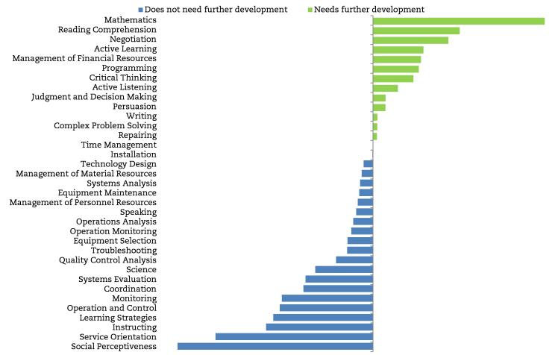Source: (OECD, Vandewyer 2017)

# Case 2 – Cedefop's skill anticipation framework

## Source

<http://www.cedefop.europa.eu/en/themes/identifying-skills-needs>

<http://www.cedefop.europa.eu/en/events-and-projects/projects/assisting-eu-countries-skills-matching>

## Type

Guidelines to establish a skills information infrastructure

## About

The guidelines were developed by the European Centre for the Development of Vocational Training (Cedefop), in cooperation with the ILO (UN International Labour Organization) and ETF (European Training Foundation). It focuses on high quality evidence on trends in the labour market and skill needs by producing regular skill supply and demand forecasts for Europe. Cedefop also investigates skill and competence needs in selected sectors, has collected its own European data on skills and jobs and is currently working on collecting and analysing data on skill demand using online job postings. All data and intelligence is delivered it to end-users via the European online source *Skills Panorama* (REF).

## Purpose

Better matching a country’s skill supply to the needs of its economy is a dynamic process that requires policies to increase education and training responsiveness to labour market needs. To inform the design of vocational or technical training and employment policies the framework provides guidance on how to identify and anticipates future skill needs and potential skill mismatches. It provides assistance and support to develop a skills anticipation infrastructure in countries and an integrative approach to skills governance.

## Operation

Mitigating skill mismatch due to technological obsolescence requires an integrative approach to skills governance among stakeholders, which can ensure a virtuous feedback loop between labour market and education and training actors. In 2017 Cedefop began to provide technical advice to countries asking for its support to improve their ‘governance of skills anticipation and matching’. In doing so, Cedefop works to identify country-specific challenges, bottlenecks and policy solutions for achieving effective skills governance. It employs the following tools:

* Big data analysis from online vacancies: Cedefop is joining forces with Eurostat and DG EMPL to develop a fully -fledged EU-wide system to collect and analyse data on skill demand using online job postings.
* European Company Survey: Cedefop and Eurofound are sharing expertise and resources to carry out the next European Company Survey. The survey will explore the strategies deployed by companies to meet their skill needs, through recruitment, HR development practices and work organisation. In this context, special emphasis will be put on the impact of digitalisation.
* European skills and jobs (ESJ) survey: is the first survey on skill mismatch carried out in the EU28 Member States, examines drivers of skill development and the dynamic evolution of skill mismatch in relation to the changing complexity of the tasks and skills required in people’s jobs.
* Forecasting skill demand and supply: Cedefop produces regular skill supply and demand forecasts for Europe and analyses the potential labour market imbalances.
* Skills Panorama: Cedefop manages a unique central access point for data information and intelligence on skill needs in occupations and sectors across Europe.

## Highlights

### Identification, collection and update of skill descriptions

The country support that Cedefop provides aims at improving methodological instruments that collect labour market and skills intelligence and seeks to facilitate effective dissemination and use of results in several policy spheres (e.g. education and training, employment, active labour market policies etc.), in collaboration with key national stakeholders. Using a common analytical framework and various methodological tools (e.g. stakeholder interviews, focus groups, Delphi methods).

Cedefop works closely together with governments in EU countries and appointed bodies of national stakeholders to collect information and facilitate policy consensus. In 2016 Cedefop, in collaboration with the ILO and ETF, published five methodological guides to anticipating and matching skills and jobs, targeted at EU policymakers and decision-makers.

#### Guide 1 – Using labour market information

This is an introductory tool for everyone who wants to understand how labour market intelligence can be used for better anticipation and matching of skills demand and supply. Technical analysts and professionals can use this guide as a source of inspiration on how LMI systems can be further developed and used for policy analyses and interventions.

#### Guide 2 – Developing skills foresights, scenarios and forecasts

This volume covers the development of skills foresights, scenarios and skills forecasts, and aims to support setting up skills forecasting systems at national level by means of quantitative and/or qualitative approaches. The guide is built on a number of experiences and case studies in both developed and developing countries. It proposes a set of instruments devised to help guide new initiatives in this area. Adapted to specific objectives and country contexts, elements of the methods described can be combined.

#### Guide 3 – Working at sectoral level

A sectoral focus and perspective are seen as essential in anticipating changing skills needs. The guide examines sectors as the key points where changes in skills demand occurs, the term sector being used to define specific areas of economic activity. By providing the reader with concrete examples and case studies, this publication is a tool for employment policy- and decision-makers to understand whether a sectoral approach is appropriate, as well as for technical analysts and professionals who want to know how it should be implemented.

#### Guide 4 – The role of employment service providers

This volume covers the role of employment service providers in skills anticipation and matching and aims to support transition and developing countries in establishing and strengthening the role of these providers. It identifies outstanding initiatives and good practices from around the world, and gives insights into strategic choices and experimental practices that different countries have undertaken in their attempts to match skills supply with labour market demands. The examples provided can be used by training providers, guidance and counselling officers, administrators and researchers.

#### Guide 5 – Developing and running an establishment skills survey

This volume covers the development and carrying out of establishment skills surveys. Such surveys are designed to generate data on employers’ skills needs and their human capital development strategies. If done regularly, the surveys help to analyse the trend in skills needs and identify potential skills bottlenecks. The audience for this guide is mainly those who make decisions about undertaking surveys and oversee their implementation (in ministries, human resource development agencies and other relevant bodies) and those directly involved in survey design and implementation, such as survey managers, data collectors and analysts.

#### Guide 6 – Carrying out tracer studies

This volume covers the development and carrying out of tracer studies and aims to contribute to the improvement of education in TVET and higher education through high-quality graduate surveys or tracer studies. The key objective of such studies is to identify the relevance of education/training for transition to a job and further vocational career in the first years after graduating.

### Big data analysis from online vacancies

Cedefop works with Eurostat and other agencies to develop a EU-wide system to collect and analyse data on skill demand using online job postings. Cedefop has already developed a prototype multilingual system, tested it in five countries (UK, DE, CZ, IT, IRL) and is now refining the tool. First data will be released in 2018 and the EU system will be fully operational end 2020.

### Presentation of skill intelligence

Skill information is envisioned as a lively interactive platform with data and features responding to the needs of different types of users, whether they are policy-makers, practitioners working in employment agencies and guidance services or experts in skill needs anticipation.

## Illustration – Skill anticipation country profiles

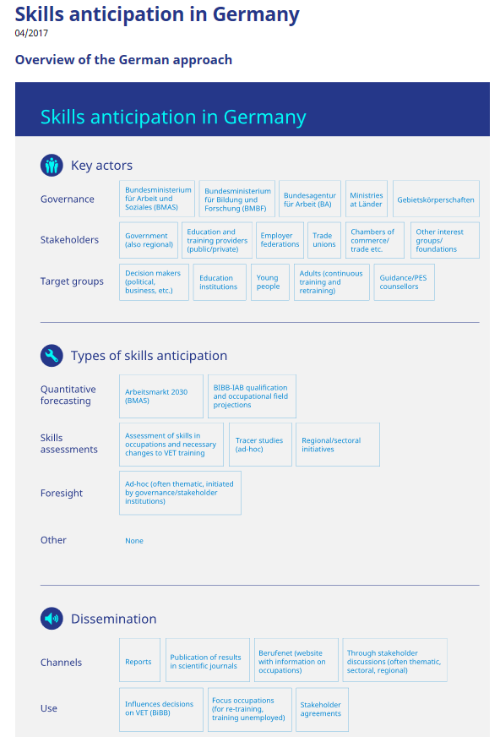

# Case 3 – USA's O\*NET

## Source

<https://www.onetcenter.org/aboutOnet.html>

## Type

Established operational occupational skills framework. The O\*NET system will be dealt with more comprehensively than other cases described here as this framework is the most advanced form found in this study to date

## About

O\*NET program stands for occupational information network and is the US primary source of skill information. The program is based on a long history of measuring job skill requirements and related job characteristics which were first published in 1939 to assist the Employment Service in matching job-seekers to vacant positions during the Depression (Handel 2016). In 1990 alternatives were considered by an advisory panel in response to methodological criticism which gave rise to O\*NET in 2001. It would use standardised surveys of a representative sample of job incumbents instead of only job analysts conducting workplace interviews and observations (Handel 2016). The first complete version of O\*NET became available in 2008.

The online site O\*NET Resource Center serves as a central point of information about the O\*NET program and is the main source for O\*NET products, such as the:

* O\*NET database
* O\*NET OnLine with occupational information and career exploration tools.

Central to the program is the O\*NET database, containing information on hundreds of standardized and occupation-specific descriptors.

## Purpose

The O\*NET program is an openly accessible source of occupational information for a range of stakeholders with a particular focus on providing occupational profile information to students and job seekers. O\*NET aims to operates as a timely, easy-to-use resource that supports employers, educators and job seekers to identify and develop the skills of the nation's workforce. It provides a common language for defining and describing occupations. Its flexible design can capture changing job requirements.

## Operation

Every occupation requires a different mix of knowledge, skills, and abilities, and is performed using a variety of activities and tasks. These distinguishing characteristics of an occupation are described by the O\*NET Content Model, which defines the key features of an occupation as a standardized, measurable set of variables (descriptors, Figure 4). This hierarchical model starts with six domains, describing the day-to-day aspects of the job and the qualifications and interests of the typical worker. The model expands to 277 descriptors predominantly collected by the O\*NET program, with more collected by other federal agencies such as the Bureau of Labor Statistics.

Figure 4 O\* NET content model - Anatomy of an occupation

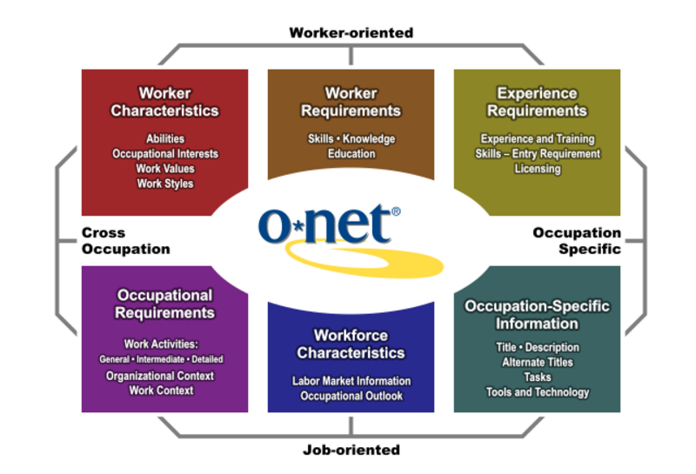

The Content Model was developed using research on job and organizational analysis. It embodies a view that reflects the character of occupations (via job-oriented descriptors) and people (via worker-oriented descriptors). The Content Model also allows occupational information to be applied across jobs, sectors, or industries (cross-occupational descriptors) and within occupations (occupational-specific descriptors). These descriptors are organized into six major domains, which enable the user to focus on areas of information that specify the key attributes and characteristics of workers and occupations.

Information is collected using a two-stage design in which:

* a statistically random sample of businesses expected to employ workers in the targeted occupations will be identified and
* a random sample of workers in those occupations within those businesses will be selected. New data will be collected by surveying job incumbents using standardised questionnaires.

The O\*NET Data Collection Program provides several hundred ratings, based on responses by the sampled workers to the O\*NET questionnaires. All respondents are also asked to complete a task questionnaire and provide some general demographic information.

*Abilities and Skills* information is developed by occupational analysts using the updated information from incumbent workers. On average, 614 O\*NET occupations were updated yearly between 2003—2016. By comparison the O\*NET occupational classification (O\*NET — SOC 2010) includes 1110 occupations.

Table 1 O\*NET surveys & content (Handel 2016)

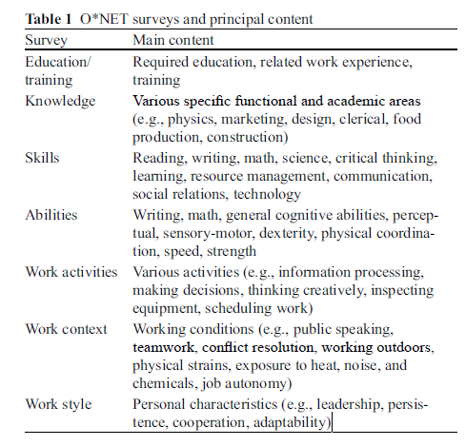

Source: Handel 2016

## Highlights

Ownership, coordination and stakeholder involvement

The Occupational Information Network (O\*NET) has been developed under the sponsorship of the US Department of Labor/Employment and Training Administration (USDOL/ETA). O\*NET partners and contributors are numerous, from different sectors, with well defined roles.

*The National Center for O\*NET Development* (Center) provides core staff with acknowledged expertise in the areas of occupational analysis and assessment research and development. Under the direction of government, the Center manages projects and contracts and provides technical support and customer service to O\*NET users. The Center leads a partnership of public and private-sector organizations that carry out the work of the O\*NET project.

In addition to the Center, the partnership currently includes the *Research Triangle Institute* (RTI), the *Human Resources Research Organization* (HumRRO*), North Carolina State University* (NCSU), technical *support* (MCNC), and a consultancy firm (Maher & Maher).

* RTI International (RTI) is a research organization that conducts applied and theoretical research for national and international governmental, industrial, and public service organizations. RTI designs, implements, and supervises the survey data collection designed to populate the O\*NET database and provides guidance on continuous improvement efforts.
* The Human Resources Research Organization (HumRRO) is a non-profit research and development organization that applies the latest advances in science and technology to the human performance needs of public and private organizations. HumRRO provides technical expertise on the O\*NET Content Model and in the areas of data collection, job analysis, assessment, and training.
* North Carolina State University (NCSU) is a nationally recognized leader in science and technology. The Industrial/Organizational psychology program invokes the scientist-practitioner model by conducting applied and theoretical research to study the world of work. It conducts research to support O\*NET initiatives, such as development of New and Emerging Occupations (N&E) and Tools and Technology (T2s).
* MCNC promotes technological development and enterprise in North Carolina through the technical use of electronic and information technologies in government and industry. MCNC houses the O\*NET database and provides Internet access and dissemination and strategic advice on technology.
* Maher & Maher is a specialized management and workforce development consulting firm. It provides web-based training services and products through the O\*NET Academy to promote and support the integration of O\*NET information throughout the workforce investment community.

Identification, collection and update of skill descriptions

O\*NET resurveys occupations on a continuous basis in a 5-year cycle with the latest completely new set of ratings made available in 2013. This has great potential utility for researchers interested in capturing within-occupation skill change (Handel 2016).

Updates include a range of data categories — which can be updated in different years and in different schedules. More enduring categories such as values and interest may be over 5 years old whereas work activities or tools and technology may be updated every 2 years. The data categories are:

* Abilities, Alternate Titles, Detailed Work Activities, Education , Interests , Job Zone, Knowledge, Sample of Reported Titles , Skills, Tasks, Tools & Technology, Work Activities, Work Context, Work Styles, Work Values.

Sources for updates can include (in order of contribution):

* Job Incumbents, Occupational Experts, Analyst Ratings, Customer & Professional Association Input, Employer Job Postings, Government Programs, Transactional Data, Web Research.

Information is collected using a two-stage design in which:

* a statistically random sample of businesses expected to employ workers in the targeted occupations will be identified
* a random sample of workers in those occupations within those businesses will be selected. New data will be collected by surveying job incumbents using standardized questionnaires.

The O\*NET Data Collection Program provides several hundred ratings, based on responses by the sampled workers to the O\*NET questionnaires. It is not feasible to ask each respondent to provide information for all data elements. To reduce the burden on respondents, the questions have been organized into three questionnaires, each containing a different set of questions. The sampled job incumbents for each occupation are randomly assigned one of the three questionnaires. All respondents are also asked to complete a task questionnaire and provide some general demographic information.

Figure 5 Importance and Level of skill characteristic

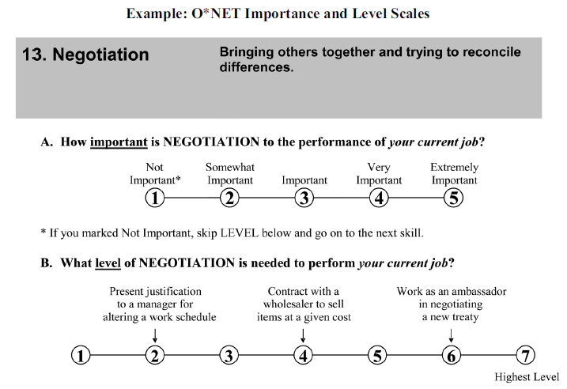

Individuals require about a half-hour to complete an allocated subset of questionnaires. Respondents receive a prepaid $10 incentive for completing the survey (Handel 2016).

Table 2 Example of O\*NET Occupation occupational data update

|  |  |  |  |
| --- | --- | --- | --- |
| Category | Source | Occupation1 Baker | Occupation 2 Computer Network Support Specialist |
| Abilities | Analyst | 2015 | 2014 |
| Alternate Titles | Multiple source | 2017 | 2017 |
| Detailed Work Activities | Analyst | 2015 | 2014 |
| Education | Incumbent | 2015 | 2014 |
| Interests | Analyst | 2008 | 2013 |
| Job Zone | Analyst | 2015 | 2014 |
| Knowledge | Incumbent | 2015 | 2014 |
| Sample of Reported Titles | Incumbent | 2015 | 2014 |
| Skills | Analyst | 2015 | 2014 |
| Tasks | Incumbent | 2015 | 2014 |
| Tools & Technology | Employer Job Postings | 2016 | 2017 |
| Work Activities | Incumbent | 2015 | 2014 |
| Work Context | Incumbent | 2015 | 2014 |
| Work Styles | Incumbent | 2015 | 2014 |
| Work Values | Analyst | 2008 | 2012 |

### 

### Presentation of skill intelligence

Central to the project is the O\*NET database and information from this database forms the heart of **O\*NET OnLine**, an interactive application for exploring and searching occupations.

### Complementing occupational classification systems

While the Content Model defines the information structure for a single occupation, the O\*NET-SOC taxonomy defines the set of occupations across the world of work. Based on the nation's Standard Occupational Classification (SOC), the O\*NET-SOC taxonomy currently includes 974 SOC occupations which currently have, or are scheduled to have, data collected from job incumbents or occupation experts. To keep up with the changing occupational landscape, the taxonomy is periodically revised; the last revision was in 2010.

O-NET complements the Standard Occupational Classification (SOC) system with about 100 additional occupations. O\*Net functions as information reservoir for occupations in classification system. One can look up occupational codes and titles and a vast amount of job and worker characteristics and indicators are returned.

### New and emerging occupations

In O\*NET, the identification of new and emerging occupations is based on two criteria that have to be met simultaneously (Beblavy 2016):

The occupation

(1) involves significantly different work than other occupations in the database and

(2) is not adequately reflected by the existing structure.

The O\*NET programme assembles ‘background’ information on these occupations, such as their development, employment numbers, education requirements, licensing and associations.

O\*NET focuses on the identification of new and emerging occupations in high-growth industries. Potential candidates are found by using a web-search methodology (i.e. searching the websites of sector associations and job portals, finding associations and educational programs) and by following leads from the US Department of Labor and the Employment and Training Administration.

A selection of new and emerging occupations is then made, for which occupational profiles are constructed (classified as ‘bright outlook’ occupations). Examples of such occupations are baristas, industrial ecologists and video game designers.

Usage by stakeholders

O\*NET has been endorsed by about 500 national and industry associations such as Bread Bakers Guild of America, International Warehouse Logistics Association or New York Academy of Sciences which encourage their members to contribute information to the O\*NET program.

*Job seekers and students*

The O\*NET database provides the basis for *Career Exploration Tools*, a set of assessment instruments for workers and students looking to find or change careers. These include the following:

##### My Next Move

My Next Move assists new job seekers, students, and other career explorers investigate occupations. The interactive web-based tool has numerous ways to search careers. The *O\*NET Interest Profiler Short Form* suggests careers matching a person's interests and level of work experience. Easy to read career reports include the most critical on-the-job tasks and skills. Job seekers can also find local salary information, training opportunities, and job posting. Specialised versions of *My Next Move* are available that provide targeted services to Veterans (*My Next Move for Veterans*) and to Spanish speaking career explorers/job seekers (Mi Próximo Paso).

##### O\*NET OnLine

O\*NET OnLine is a comprehensive web application for exploring the O\*NET database. Customizable occupation reports offer a range of information, from a broad overview to comprehensive detail on a specific subject. Occupations or entire O\*NET-Standard Occupational Classification hierarchy the can be searched by keyword search; users are encouraged to explore across occupations, using Content Model descriptors like abilities and interests. OnLine also offers tools like the *Skills Search for job seekers*, and the *Crosswalk* to convert other classifications to the O\*NET-SOC taxonomy.

##### Career Exploration Tools Professional assessment instruments

Using the O\*NET Career Exploration Tools, students and workers may explore a range of career directions, based on their interests, work values, and abilities. The computerized assessments and related materials are available as free downloads. In addition, workforce development professionals may be interested in the paper and pencil versions. These can be ordered, or print shop files for these tools can be downloaded and taken to a professional for printing.

##### Code Connector – O\*NET-SOC classification made easy

Designed specifically for job coding professionals, O\*NET Code Connector makes it easy to match job orders to an occupation in the O\*NET-SOC system.

Illustration - Personal Care Aide profile

Occupational skill report for can be viewed as summary, detail or custom report. The following example looks at the summary report with an example for each occupational skill item.

|  |  |
| --- | --- |
| Personal Care Aide | Example (not complete, for illustration only) |
| Tasks | Administer bedside or personal care, such as ambulation or personal hygiene assistance. |
| Technology Skills | Electronic mail software |
| Tools Used | Patient lifts or accessories |
| Knowledge | Customer and Personal Service |
| Skills | Service Orientation — Actively looking for ways to help people |
| Abilities | Oral Comprehension |
| Work Activities | Providing personal assistance, medical attention, emotional support, or other personal care to others such as coworkers, customers, or patients. |
| Detailed Work Activities | Administer basic health care or medical treatments. |
| Work Context | Contact With Others |
| Job Zone | [2] - an occupation that needs some preparation in terms of education, experience or on the job training |
| Education | High school diploma or equivalent (54%), less than high school diploma (34%) |
| Credentials with links to training, certifications, licenses | Career One Stop website: Pop up box for state; list of colleges & programs |
| Interests | Social |
| Work Styles | Dependability |
| Work Values | Relationships |
| Related Occupations | Home Health attendants, childcare workers |
| Wages & Employment | Median wage, state wage, employment, growth, openings, state trends, top industries |
| Job Openings | Career One Stop website - > vacancies by postcode |
| Additional Information | Bureau of Labor statistics , occupational outlook handbook by occupation |

## Challenges

### Demographic representation

The representativeness of the worker sample with respect to basic demographic information, such as education, gender, race, and ethnicity, is unknown even though O\*NET collects this information on its Background survey. It is possible that over-representation of more educated workers because of the survey’s cognitive burden biases estimates of skill demands upward, but this remains a hypothesis in the absence of the necessary data and analysis (Handel 2016).

### Uneven coverage

O\*NET’s coverage of certain content areas, such as technology and employee involvement practices, is too sparse, while other content is redundant. This redundancy does not seem to reflect design but rather a lack of coordination in the construction of a very long battery of items across multiple instruments (Handel 2016).

### Complexity

Many of the items themselves are vague, overly complex, and jargon-laden. O\*NET has recognized this fact implicitly in transferring responsibility for completing the Abilities and Skills questionnaires from incumbents to job analysts, who receive written information on the occupations they rate but do not make workplace site visits.

Despite these concerns, in the aggregate, 40 % of O\*NET’s 239 items correlate moderately or moderately strongly with wages and the figure is 48 % for the items from the four surveys using the Importance and Level format, suggesting reasonable criterion validity, though individual correlations often have unexpected absolute and relative magnitudes (Handel 2016).

# Case 4 – Singapore's Skills Frameworks

Source

<http://www.skillsfuture.sg/>

<http://www.skillsfuture.sg/skills-framework>

## Type

Newly developed operational skill information framework for selected industry sectors

## About

Launched in 2016, Singapore's SkillsFuture initiative aims to invest in human capital through education and training. The training system moving away from qualifications towards a modular system in which people could choose the training components. A SkillsFuture credit provides every Singaporean over the age of 25 with a $500 credit to use towards a range of government supported training and education courses. The credit never expires and is topped up periodically over the individual’s career. The program’s intent is to make every student and worker the leader of their own learning path, where they are free to choose the type of training they need to reach their own career goals, whether that means pivoting to a new industry or gaining specific hard or soft skills. Alternatively employers are provided the skills modules and they choose the units of training they want their staff to receive and then they approach a training provider who then draws up learning plans based on those units.

SkillsFuture leverages a Skills Frameworks programme to enable informed decision-making by students, employees, employers and educators. This is gradually rolled out sector-by-sector. It provides up-to-date information on employment, career pathways, occupations, job roles, existing and emerging skills, as well as relevant education and training programmes. A list of training programs that address skills gaps in each sector and role are included on the framework website.

## Purpose

The Skills Framework has been primarily developed for the Singaporean workforce with the objectives to build deep skills in the workforce, enhance business competitiveness and support employment and employability. It is designed to support individuals make well-informed choices in education, training and careers. At the same time it aids the development of an integrated high-quality system of education and training that responds to constantly evolving needs. The Framework aims to create a common skills language for individuals, employers and training providers. This further helps to facilitate skills recognition and support the design of training programmes for skills and career development.

## 

## Operation

The Skills Framework:

1. Spells out the skills and competencies needed for mastery and mobility. It identifies technical and generic skills and competencies that are needed to perform the work requirements of a job.
2. Provides up-to-date information about the sector and jobs to inform career and skills development. The Skills Framework covers the sector and employment information, including career pathways which are useful to inform career development and skills upgrading. The Skills Framework also captures emerging skills which are important to inform skills development for competitiveness.
3. Provides information on training programmes for skills acquisition. The training programmes listed in the Skills Framework are aligned with industry-validated skills and competencies captured in the Skills Framework. The training providers are responsible for the quality and rigour of their training programmes.

The training programmes listed in the Skills Framework are listed based on alignment to the knowledge and abilities underpinning the skills and competencies required for the job roles. As the knowledge, abilities, skills and competencies are validated with employers and key stakeholders, programmes that are aligned to the Framework will be of relevance to meet industry’s needs.

Highlights

Ownership, coordination and stakeholder involvement

The Skills Framework is co-created by the government and the industry with key stakeholders such as, employers, industry associations, unions, professional bodies, education and training providers. The Skills Framework provides key information collated by a range of stakeholders on sector and employment, career pathways, occupations/job roles, as well as existing and emerging skills required for the occupations/job roles.

### Identification, collection and update of skill descriptions

Special care was taken to describe skills within occupations. Each skill is carefully analysed and written to capture both occupational/job and personal domains of the skill for holistic development. Similar to occupations or job role description, skill descriptions provides overall introduction to the skills by summarising the performance expectations of the skills. The Framework site also provides a list of training programmes for skills upgrading and mastery.

Presentation of skill intelligence

Information is shared via an interactive and colourful website with structured information for students, employees, employers, training providers, lifelong learners. A main feature is introductive videos for each group. Skill information will be launched progressively starting from 2016 and have been launched for the following sectors:

* Hotel and Accommodation Services
* Early Childhood Care and Education
* Precision Engineering
* Sea Transport.

The information is organised in a structured manner, starting with background information about the sector before detailing the workplace context covering career pathways, occupations/job roles, as well as the skills needed for these occupations/job roles. The information in the Skills Framework is completed with a listing of training programmes to address skills gaps and for skills advancement. In detail, information is set up via the following five components:

1. Sector and Employment Information - This component describes the sector and employment landscapes and it includes useful statistics on the sector’s manpower and occupational/job requirements, in line with the Singapore's industry support program (Industry Transformation Maps).
2. Career Pathways - This component shows how the occupations/job roles in the sector are structured progressively based on sector norm. From the Career Pathways, users can identify vertical and lateral advancement opportunities.
3. Occupations/Job Roles Description - This component describes the skills requirement, work context and expected profile of the worker performing the occupational/job role. It provides an overall introduction to the occupation/job role.
4. Skill Description - Every occupation/job role in the Skills Framework contains a set of skills. Each skill is carefully analysed and written to capture both occupational/job and personal domains of the skill for holistic development. Similar to Occupation/Job Role Description, Skill Description provides overall introduction to the skills by summarising the performance expectations of the skills.
5. Training Programmes — Training Programmes link the skills in the occupations/job roles to programmes that are available in the market. The list of programmes is not limited to academic qualifications, and continuing education and training programmes. It will also list apprenticeships, recognition of prior learning and any other skills-based programmes and manpower initiatives such as SkillsFuture Earn and Learn Programme that are available in the sector.

### Usage by stakeholders

#### Students

The above components provide the following benefits from a student's perspective. They can use the Skills Framework to make informed decisions on education and training, career development and skills upgrading based on the sector, employment, occupation/job role, skills and training information in the framework. The Sector and Employment Information provides a broad understanding of the sector and employment prospects. The Occupation/Job Role Descriptions informs about the job scope, the work context and the attributes which are required by employers. The Career Map will provide an understanding of typical career pathways and potential development prospects. As the occupations/ job roles are mapped to skills and competencies that are linked to relevant education and training programmes under the Training Programmes Listing, one can determine their preferred choice of study based on aspirations.

#### Employers

Employers can use the Skills Framework to design progressive human resource practices to recognise skills and make informed decisions on skills investment. Employers can use the technical and generic skills and competencies under the Skills and Competencies Descriptions to explain the breadth and depth of the skills requirements. The Skills and Competencies Descriptions can also be used during appraisals to discuss and assess skills match and skills gaps. Through the Training Programmes Listing, employers can immediately identify the programmes that aim to address the skills needs of employees.

#### Individuals in their early and/or mid-career

Workers can use the Skills Framework to make informed decisions on education and training, career development and skills upgrading based on the sector, employment, occupation/job role, skills and training information in the framework. Based on the skills identified for the occupations/job roles, one can do a simple self-assessment to assess a skills match or skills gap. The government is working with the relevant parties to put in place occupation profiling tools to further enhance the skills assessment experience. More information will be provided when the service is ready.

#### Training providers

Training providers can use the Skills Framework to gain insights into sector trends and skills in demand, which allow them to innovate and contextualise their curricula design and training programmes to suit the needs of the sector. Under the Skills and Competencies Descriptions, there are technical and generic skills and competencies drawn up for each job role. Training providers can use this information to plan the courseware and curricula, and research on ways to embed suitable pedagogies to achieve the learning outcomes. Training providers are also encouraged to use the Skills and Competencies Descriptions, to help companies develop progressive HR practices for skills recognition and benchmarking.

#### Parents, teachers and career counsellors

People in advisory roles can use the Skills Framework to understand the sector and employment prospects and learn about the occupational/job scope, the work context and the work attributes which are demanded by the employers in the sectors. The framework provides informed advice to children and students as they choose their desired pre-employment training programme. The Career Map provides an understanding of typical career pathways and potential development prospects.

## Illustrations

### Retail Sector framework

For industries facing challenges in restructuring, such as those such which are domestically-focused and require a large pool of low-skilled workers, the specifically-tailored Industry Transformation Map encourages productivity growth through the use of technology and innovative business strategies. The report identified the retail industry as an example (Figure 6).

Figure 6 Future of retail - SkillsFuture retail sectoral manpower plan

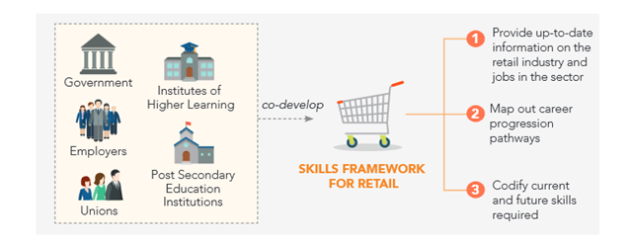

Source: https://www.spring.gov.sg/DevelopingIndustries/RT/Documents/Retail\_Sectoral\_Manpower\_Plan\_Publication.pdf

### Early Childhood Care and Education information structure

1. Sector and Employment Information click leads to a guide/brochure on occupations and skills in the sector.
2. Career pathways leads to a one page diagram on career pathways
3. Skills Maps and Standards (including occupational and skill descriptions) leads to two pages with four high level skill categories and paragraphs of occupational descriptions per each of the 13 occupations. Separate tracks per three career groups can be downloaded. Skill standards articulate the content of all skills required for each occupation. Skill categories across all occupations are:

* Developing the Child Holistically

This category focuses on the holistic development of children through programme development. This would include having a sound understanding of child development theories, pedagogy, the learning environment, interactions and relationships, as well as health, safety and nutrition.

* Collaborating with Families and the Community

This category focuses on establishing and sustaining strong partnerships with families and community stakeholders.

* Building Professional Capacity

This category focuses on the importance of life-long learning and taking ownership of one’s professional growth and development for the purpose of strengthening children’s learning and development.

* Building Organisational Capacity

This category focuses on enhancing capabilities, as well as aligning systems and structures within centres to realise centres’ goals and vision.

##### Occupational categories

**Educarer 1** (44 pages!): Occupation description; about 20 specific skills resembling the Australian units of competency style under each skill category and sub-categories (hierarchical). Each skills is categorised as follows:

Skills code, skill category, sub-skill category, skill name, skill descriptions, knowledge and analysis, application and adaptation, Innovation and value creation (n/a in this case); Social intelligence and ethics (n/a in this case ), Learning to learn (n/a in this case), Range of application.

1. Training programmes (still under development)

The Training Programmes provide information on courses that are available for aspiring and in-service educators to acquire or deepen skills relevant to the various occupations in the ECCE sector. Rather than full occupational qualifications, there are modular programs and providers mapped against single skill/skill categories to support skill deepening (Figure 7).

Figure 7 Training programs for skill and knowledge deepening



# Case 5 – UK's Futures Programme

## Source

<http://skillspanorama.cedefop.europa.eu/en/analytical_highligths/skills-anticipation-uk>

<https://www.gov.uk/government/collections/ukces-futures-programme-overview>

## Type

Temporary project based industry program

## About

Starting in 2014, the UK Future’s Programme trialled innovative approaches to workforce development through co-investments with employers and industry to test solutions to long-standing or emerging workforce development issues. Between 2014 and 2016 UK Commission for Employment and Skills (UKCES, abolished in March 2017) worked with industry to test ‘what works’ in addressing current or anticipated workforce development problems, e.g. – productivity, low skills, and mobility, that are restraining business performance. Essentially, the UK Futures Programme encourages a Research & Development approach to skills development and application in the workplace. The UK Futures Programme issued targeted competitions for grant receiverships with employers in selected industries aiming to achieve sustained economic recovery for the long term, driven by skills and talents of people.

## Purpose

To address emerging or long-standing skills and productivity challenges in close cooperation with industry. The Programme’s key objectives were to:

* Support collaborative approaches to workforce development issues amongst employers and, where applicable, wider social partners
* Encourage innovative approaches to addressing workforce development issues
* Identify ways to address new or persistent market or system failures which act as a brake on UK workforce competitiveness
* Identify ‘what works’ when addressing market failures in relation to workforce development, for adoption in policy development and wider business practice.

## Operation

The Programme offered small scale public co-investment to employers and industry, to design and test their own solutions to emerging or long-standing skills and productivity challenges. The programme was designed on the basis of learning from previous UKCES investments and from the ‘Innovation Lab’[[1]](#footnote-1) approaches being adopted in policy development. Key features included highly specified and targeted challenges , employer leadership and engagement, collaborative solutions, a strong emphasis on testing new (and ideally innovative) approaches with an appetite for risk and co-creation between public and private investors.

Targeted competitions were issued in response to selected areas to create impact through this Programme. The competitions were identified through the insights of UKCES Commissioners and from their research base. Collaborative employer-led projects were encouraged, as were proposals which also include wider social partners, such as trade unions and membership bodies. Single employer proposals were supported as well where there is potential for impact/learning to be applied in wider contexts.

## Highlights

### Ownership, coordination and stakeholder involvement

The Programme saw UKCES and industry co-creating projects to research, develop, pilot and / or scale innovative solutions to identified current and emerging workforce development issues that restrain business performance. Lessons learnt in employer and end-user engagement were:

* Utilising existing networks and relationships, usually through face-to-face conversations, is a more efficient and effective means of engaging employers and wider stakeholders than ‘cold’ approaches
* Intermediaries and sector bodies can facilitate access to networks. Their non-commercial status can be useful for engaging employers as they are viewed as independent, non-competitive and operating on behalf of the sector or for social good
* Small firms face significant information and resource barriers to engagement. For practical reasons, sector initiatives also tended to be geographically focussed
* It is easier to engage employers and stakeholders, especially those with whom there is little previous relationship, with a product or solution that is tangible (e.g. a demo or prototype), rather than an idea
* The employers targeted by the UKFP are often not sure of their needs or the benefits to be gained from training, due to their lack of previous engagement. Therefore, they are more likely to engage if the initial offer is at low or no cost to employers, to enable them to participate with minimal risk or commitment
* Senior teams within employer organisations need to be engaged to ensure organisational buy-in and commitment to change, and middle managers need to be on board for effective implementation.

### Identification, collection and update of skill descriptions

#### The Productivity Challenges

The *Future Programmes* funded five Productivity Challenges. Each Challenge was focused around specific skills for a sector/industry and workplace productivity challenge. Each Challenge comprised a number of distinct projects (between 5 and 7), most of which were employer led and based on partnerships between different organisations or companies.

*Challenge 1* — focused on designing solutions to the workforce challenges in the **offsite construction** industry

*Challenge 2* — focused on improving leadership and **management** through supply chains and networked organisations

*Challenge 3* — focused on improving progression pathways in the **retail and hospitality industries**

*Challenge 4* — focused on enhancing skills for innovation management and commercialisation in the manufacturing sector

*Challenge 5* — focused on developing leadership and entrepreneurship skills in **small firms** and the role of anchor institutes in supporting the development of small firms.

### Presentation of skill intelligence

UKCES placed strong emphasis on sharing what works to influence policy and wider practice. The success of the Programme is deemed crucially dependent on actively communicating findings and sharing good practice to influence employer practices and future public policy debates. There are a number of areas that were not supported through the Programme although deemed important. These included large scale delivery of training (‘participation’); projects that could be supported through already existing routes (‘mainstream’); and costs not directly linked to delivery of projects.

### Enhancing skills and capabilities program evaluation

This section considers evidence from the UKFP evaluation in relation to what works well and what was difficult to enhance skills and capabilities within sectors and businesses.

#### What works?

| **What works** | **Why or How does it work** |
| --- | --- |
| Engaging industry in discussions about what the skills gaps related issues are / | This is essential for tailoring provision to meet business needs and getting them to think about the importance of skills |
| Developing tangible tools and solutions, demonstrating to industry what good looks like. / | This enables business to understand what good practice looks like in action, rather than just being told the theory. Businesses gain significant value from approaches where they work with other businesses on practical solutions, through approaches like peer learning and mentoring |
| Baseline existing capabilities, to evidence gaps in knowledge / skills. / across a sector | This helps to communicate the need to upskill to businesses and identifies which skills need attention. Baselining can be effective both on an individual business level or |
| Targeting the right senior managers and leaders ./ | These employees are able to put learning into practice, through implementing action plans to support change. They are also able to cascade learning to junior managers to widen the reach of solutions |
| Testing new ideas and learning from mistakes./ | There are benefits in being open to try new ideas when it is not clear whether they will work and accepting that while some things may produce large gains, this cannot always be known in advance |
| Use of training methods that are tailored to the needs of end-users ./ | There are a wide range of training methods available, and different employee roles require a different mixture of methods. Identifying the correct methods is crucial for delivering the most effective training |
| Focussing on practical learning Employers were seeking support around very particular issues./ | They therefore wanted interventions which addressed these issues, and did so directly to minimise the time that they had to engage |
| Developing relationships between companies around finding solutions to issues relating to skills./ | There are many ways that companies can learn from each other and develop joint solutions to issues around skills. This can take the form of peer-to-peer learning, or the delivery of joint projects |
| High quality sessions tailored to need./ | Employers are attracted by sessions that are targeted to meet their specific issues, and that clearly add value beyond generic training provision |

#### What didn't work

|  |  |
| --- | --- |
| **What didn't work** | **Why it didn't work** |
| Enhancing skills in the wider sector, reach beyond the engaged companies./ | It is difficult to engage businesses or other stakeholders beyond those that are already known to project leads or have existing relationships with partners. |
| Creating new linkages remains time consuming and challenging./ | Short lifetime of the projects: Projects that seek to have a significant impact on skills within a business or the wider sector require time to develop, select the right partners and embed changes. Without enough time, impacts tend to be limited |

### Usage by stakeholders

UKCES’ ambition is for a sustained economic recovery for the long term, driven by the skills and talents of people. Their vision was articulated in their ‘Growth through People’ report. The report outlines 5 priorities for action if this ambition is to be realised:

* Employers should lead on skills and government should support them
* Improving workplace productivity should be recognised as the key route to increasing pay and prosperity
* ‘Earning and learning’ should be the gold standard in vocational qualifications
* Education and employers should be better connected to prepare people for work
* Success should be measured by a wider set of outcomes not just educational attainment

### Overall programme evaluation

The evaluator (SQW Group) states that the programme has shown that a relatively small amount of public cash investment can stimulate private investment and changed behaviour when supported by strong employer leadership and co-creation support from public sector project managers.

Across the Challenges, the Programme focussed on difficult barriers, to ensure it added value to existing initiatives. In so doing, it highlighted the important role Governments can play in supporting businesses to address these barriers, through information exchange and risk-sharing. This is particularly the case for addressing the long-term issue of management and leadership development in the UK and the management of UK workplaces.

## Illustration

### Addressing skills deficiencies in the offsite construction sector

This Productivity Challenge focused on addressing skills deficiencies associated with technological developments in the offsite construction sector.

UKCES’ own research found that the sector faces a number of skills barriers to realising its growth. These include the fragmentation of the sector, with a qualifications offered considered inadequate by employers, and specific skills problems including:

* Little collaboration between professions in offsite construction
* Marketing and business development: combining technical knowledge with strong customer-facing skills
* Project management, particularly the interface between offsite and onsite activities
* Design and IT skills, covering the design, construct and operation of buildings.

Selected project in the sector were:

*Skanska — Offsite Management School:* This project created an employer-led Offsite Management School with over 200 unique member companies and almost 300 individual learners.

*Laing O’Rourke - Addressing Skills Deficiencies in the Offsite Construction Sector:* They developed a live site scenario for training solutions allowing changes to be implemented in real time, cutting delays, improving ways of working and reducing waste.

*Steel Construction Institute (SCI) - Best Practice Guidance and Management Training for Light Steel and Modular Construction:* SCI consulted with over 75 companies to develop and test online learning and training resources, with over 1000 requests for best practice tools from the sector.

*Edinburgh Napier University - Offsite Construction Hub:* This project created an ‘Offsite Construction Hub’ to define and Case skill requirements and encourage collaboration between professions, engaging with over 200 employers to gather a broader sector understanding.

*Buildoffsite — Comparator project*: Buildoffsite expanded its online ‘comparison tool’ to evaluate onsite and offsite solutions at the early development stage; encouraging employers, surveyors, architects and engineers to consider offsite alternatives before committing to design solutions.

#### Learning

* Clear industry leadership is important and can galvanise competitors to become collaborators where there is a commonly experienced challenge.
* The breadth and depth of skill gaps were sometimes greater than projects first realised, but in recognising the gaps, corrective action could be taken – in fact it is crucial for employers in the sector to take responsibility and recognise these gaps otherwise they risk being left behind.
* Educators and businesses must work more closely together to ensure educational institutions and professionals keep up with technological advancements and ensure innovation can be capitalised upon.

## Other UK skill initiatives

### Working Futures

Not to be confused with the Futures Program is the Working Futures series of occupational projections, a skills forecasting initiative. The Working Futures series have been undertaken for many years, building upon similar projections also funded by the UK government. The projections of future skills demand by occupation have perhaps the most influence on policy. Initially they were used for planning purposes, i.e. when the government was involved directly in determining the courses and number of places to be funded in post-compulsory education. Now that there is less emphasis on planning as a result of the move to an increasingly market-like system, the projections have been used as an important source of information in helping people to decide which skills/qualifications to pursue.

Working Futures are aimed at policymakers and labour market intermediaries such as training providers. The Working Futures employment results are a key cornerstone of the *LMI for All* portal. The primary dissemination route seems likely to increasingly become LMI for All, and this is aimed at the widest possible number of users. Other skills anticipation activities (such as the skills foresight activities and skills surveys) are aimed more at intermediaries and policymakers.

More recently, *LMI for All*, an online portal providing national-level data on LMI for use in application and websites, has become a repository of a vast range of skills data. The aim of LMI for All is to make skills and other labour market data available to a wide range of stakeholders. Developed by UKCES, *LMI for All* draws information and data from national sources on skills assessments (both national and sectoral), occupational and skills forecasts, and regular surveys of employers. Skills data with labour market indicators are mapped to Standard Occupational Classification (SOC) categories at a detailed 4 digit level (the most detailed level in UK classification system).Data are disaggregated to occupation, region, gender, age and employment status.

### Using labour market intelligence in a college context

Identifying and using labour market intelligence (LMI) to inform the curriculum offer is a useful way for colleges to build credibility with the employers in the labour market(s) they serve. The Association of Colleges (AoC) and the UK Commission for Employment and Skills (UKCES 2015) have produced a guide for curriculum developers to help further education (FE) colleges maximise the use of Labour Market Intelligence (UKCES 2015). It provides a broad perspective of national and local LMI across industry sectors and is intended to support college leaders with curriculum planning.

Through a defined inspection process, a college will be assessed on how well the leadership and management team successfully plan, establish and manage the curriculum and learning programmes to meet the needs and interests of learners, employers and the local and national community.

Ofsted inspection process (Learning and Skills Improvement Service 2013): This process places emphasis on enabling learners to progress into “jobs that meet local and national needs”.

* Career development activities need to be informed by up to date LMI and employer information that is accessible and, as necessary, selected and interpreted for learners by staff who feel confident in using it.
* In many organisations, LMI is collected and stored by a wide range of staff working in different departments, including those working on business development and with Jobcentres as well as tutors on vocational programmes and in work‑based learning, producing a valuable local resource and offering insights into employers’ recruitment needs and practices, job profiles, expectations of applicants etc.
* Across the sector, Ofsted inspectors will consider:
* ‘Learners’ acquisition of qualifications and the skills and knowledge that will enable them to progress to their chosen career, employment and/or further education and training.’
* Provider weaknesses identified recently by Ofsted included:
* insufficient initial assessment of participants’ employability skills and barriers to employment
* failing to tackle participants’ barriers to employment
* insufficient priority being given to progression into work
* in adequate recordings of job outcomes.

# Case 6 – Canada's FutureSkills Lab

## Source

<http://www.budget.gc.ca/aceg-ccce/pdf/skills-competences-eng.pdf> - Advisory Council on Economic Growth - BUILDING A HIGHLY SKILLED AND RESILIENT CANADIAN WORKFORCE THROUGH THE FUTURESKILLS LAB

https://www.canada.ca/en/employment-social-development/programs/sectoral-initiatives-program.html

## Type

Future Skills Lab is a proposed initiative to inform skill funding decisions.

## About

Canada is looking for an overarching strategy to deal with the increased probability and scale of job dislocation, and to help prepare Canadian workers for the skill demands of the future economy. It took guidance by reports from the Unites States and Australia on the impact of automation. Within this environment, the Canadian Council of Economic Growth proposed in 2017 the formation of a national non-governmental organization to operate as a laboratory for skills development and measurement in Canada. Led by an executive team drawn from the private, non-profit, and education sectors, the ambitious *FutureSkills Lab* would invite all levels of government, private sector organizations, labour unions, not-for-profits, and other interested parties to partner on an opt-in basis. Through project partnerships and co-financing opportunities, new and innovative approaches to skills development and outcome measurement will be explored.

Purpose

The FutureSkills Lab intends to inform skills and training program funding decisions of multiple players, including government ministries, researchers, employers, and organizations dealing with labour market information. The initiative would catalyse and enable forward-looking approaches to preparing Canadians for the workforce. To accomplish its mission, the FutureSkills Lab has three core functions.

**1. Support innovative approaches to skills development:** Solicit, select, and co-finance innovative pilot programs in skills and competency development that address identified gaps among workers, postsecondary students, and youth

**2. Identify and suggest new sources of skills information:** Gather labour market signals of skill needs by building a portfolio of pilot proposals, support innovative labour market information initiatives focused on employer expectations, use web-based sources to extract and synthesize emerging labour market trends, and draw links between credentials and skills

**3. Define skills objectives and inform governments on skills programming**: Rigorously measure outcomes of forward-looking and targeted training programs and skills information initiatives, identify and disseminate best practices broadly to education and training stakeholders across

## Operation

The initiative is still at proposal stage. Its envisioned operation draws from the above listed core functions. Operational independence and freedom from political influence are seen to be critical to the FutureSkills Lab’s success. It must be nimble and entrepreneurial in order to respond to a rapidly changing work landscape. Much as the Canadian Institute for Health Information (CIHI) is accountable to Health Canada and the provincial and territorial Ministries of Health which fund it, the FutureSkills Lab would be fiscally accountable to a government department as well as to the Canadian public. The specifics of the accountability and reporting structure will need to be considered in the design and implementation of the FutureSkills Lab.

Figure 8 Where FutureSkills programme fits into the existing governance system

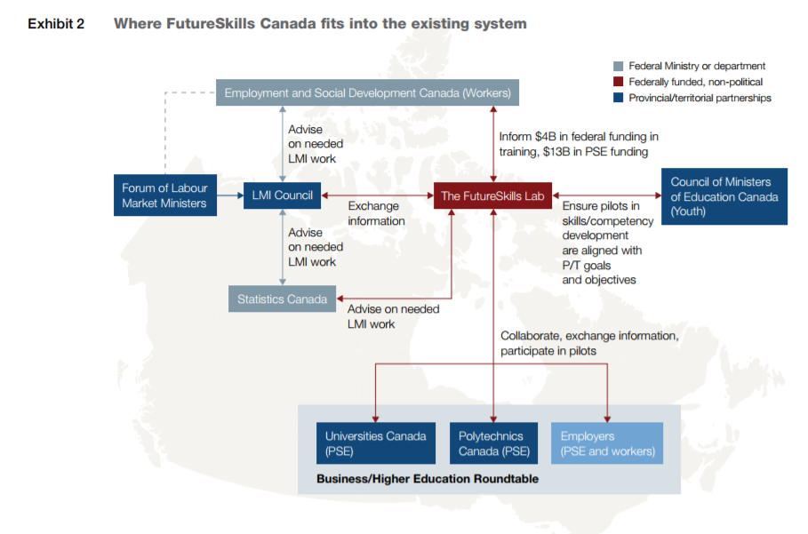

Highlights

Identification, collection and update of skill descriptions

While the forthcoming LMI Council has signalled intent to explore digital signals, development of the required expertise is likely beyond the LMI Council’s immediate scope. The FutureSkills Lab would fill this gap by employing specialized data scientists to forecast market competency requirements from job listing sites (e.g., LinkedIn, Crunchbase, AngelList, and Talent Egg), and cull useful insights from other sources (e.g., conference topics from groups like NextGen, and research priorities of academic institutions). More broadly, the FutureSkills Lab should regularly scan the global landscape for innovative, forward-thinking and comprehensive approaches to competencies development.

#### Employer data

Corporations have a significant role in the generation and collection of labour market information; such employer data is a critical resource for forecasting needed competencies. An employer may not know exactly how many engineers it will need in five to ten years, but can more likely articulate the types of foundational competencies (e.g., technical literacy) it will need. Some employers keep high-quality data, though less than before as occupational forecasting has become more difficult. The FutureSkills Lab would consider ways to unlock this valuable proprietary data, perhaps by engaging employers on an annual skills and competency survey and offering a report of trends and findings in exchange.

#### Training data

Rigorously measure outcomes of forward-looking and targeted training programs and skills information initiatives, identify and disseminate best practices broadly to education and training stakeholders across Canada, and determine a set of skills objectives for the future.

Should stakeholders choose to opt in, these objectives can then help inform the more than $17 billion in annual public spending on skills and training programs, the work of organizations that generate and analyse Canadian labour market information, and researchers and practitioners directly involved with training and education programs

#### Government agencies

The FutureSkills Lab would need to work closely with Statistics Canada and the Forum of Labour Market Ministers’ forthcoming Labour Market Information Council (LMI Council) to exchange information and prioritize areas for collection and analysis of labour market information. Open communication with the Council of Ministers of Education Canada will be critical to ensure that training pilots supported by the FutureSkills Lab are aligned with provincial and territorial goals and objectives in education policy. Regular sharing of information, results, and best practices with Employment and Social Development Canada and the Forum of Labour Market Ministers would help build the FutureSkills Lab into a trusted advisor on skills development 4 Building a highly skilled and resilient Canadian workforce through the FutureSkills lab throughout the workers’ life cycle. Further, collaboration and information sharing with other pan-Canadian organizations in this space – the Business / Higher Education Roundtable (BHER), Universities Canada, Polytechnics Canada to name just a few – will ensure complementary efforts.

Presentation of skill intelligence

The FutureSkills Lab would identify gaps in the measurement, data collection, and analysis of skills and competencies in Canada. Improved information would help all concerned— workers, employers, students, parents, policy makers, and training and education providers—make better informed decisions.

If it is to be valuable in this regard, the FutureSkills Lab must make all its knowledge, data, and outcomes widely accessible and visually comprehensible to Canadian workers, job seekers and employers. In areas where organizations such as Statistics Canada or the LMI Council have a clear mandate for data collection and analysis, the FutureSkills Lab would assume an advisory role by proposing areas for data analysis. In other areas where information exists but is not used, the FutureSkills Lab would support innovative approaches to data collection and analysis, for example by leveraging data from its portfolio of pilot proposals. This includes areas like employer expectations of future skills and competency needs, digital signals from job posting websites and other online sources, and links between credentials and skills.

Usage by stakeholders

*Workforce planning*

The portfolio of pilots gathered from private-sector employers, educational institutions, and not-for-profits would inform policy-makers and educational providers about where they should focus their investments and efforts. Currently, governments receive a considerable number of unsolicited proposals for funding of training programs each year, but they are not aggregated and analysed for trends. The FutureSkills Lab would manage the solicitation, review, aggregation, and analysis of such proposals, and would share widely the trends it observes in competency requirements.

*Training planning*

The FutureSkills Lab could use the information collected to identify innovative ways of linking degrees and credentials to skills and competencies. This is a complex challenge and one that will need to be addressed with a coherent national approach. As one potential tactic, the FutureSkills Lab might map the skills demanded by employers, as expressed through pilot proposals, with information about the credentials of the employees who have been most successful in the past. Progress on this front would provide greater transparency to employees looking to hire workers with competencies not reflected by traditional credentials, and to students looking to obtain the qualifications they need to succeed in their desired field of work. Working towards national accreditation standards would also create a more mobile workforce, to the benefit of employers who hire nationally, and workers who would qualify for a larger pool of jobs.

The FutureSkills Lab would support programs that can equip students and new graduates with the skills employers need, or skills associated with successful and scalable entrepreneurship. This support might include increasing opportunities for work-integrated learning, or delivering training tied directly to market-identified skills needs. Increased collaboration between employers and educational institutions is the first step in bridging the gap between employer expectations and graduate competencies. While many employers collaborate with post-secondary institutions, these arrangements mostly involve Canada’s largest employers. Approximately 70 percent of large Canadian businesses partner with postsecondary institutions to support internships or cooperative learning programs. This proportion is considerably smaller among small and medium-sized companies. The FutureSkills Lab should work with organizations such as BHER, Universities Canada, and Polytechnics Canada to increase collaboration, communication and experiential learning opportunities between employers and post-secondary institutions. The Lab could act as a conduit by, for example, co-financing innovative co-op programs or experimenting with cross-disciplinary programs.

The FutureSkills Lab would focus on identifying innovative approaches to skills development within both trade industries and knowledge-related disciplines, so collaboration with both colleges and universities will be important. Priority for co-financing support would go to those pilots that build skills important for future work success and are not being made redundant in the near term via automation or other forms of innovation.

## Illustration – Training pilots

Open communication with the Council of Ministers of Education Canada is seen as critical to ensure that training pilots supported by the FutureSkills Lab are aligned with provincial and territorial goals and objectives in education policy.

Figure 9 Example pilot proposal energy sector proposal

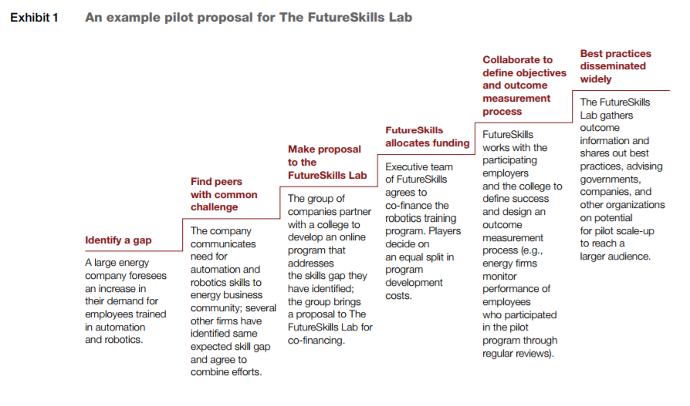

Other initiatives, systems or tools in Canada

### Sectoral initiatives

<https://www.canada.ca/en/employment-social-development/programs/sectoral-initiatives-program.html> Sectoral initiatives program: Federal Department of Employment and Social Development Canada (2015)

The Sectoral Initiatives Program (SIP) is a grants-and-contributions program with the objective of addressing current and future skills shortages by supporting the development and distribution of sector-specific labour market intelligence, national occupational standards, and skills certification and accreditation systems. The program’s mandate is to help industries identify, forecast, and address their human resources and skills issues. The SIP funds partnership-based projects for key sectors of the Canadian economy. These projects are developed and implemented by such industry partners as: workplace organizations, employer associations, education and training bodies, professional associations, unions, and Aboriginal organizations.

The objectives of the new programme are to:

* support a better match between skills and job market demands
* support more informed labour market decisions for job seekers, employers and students through the creation and dissemination of labour market intelligence
* support skills development to facilitate labour mobility.

### Essential skills profiles

<https://www.canada.ca/en/employment-social-development/programs/essential-skills/profiles.html>

Through research, the Government of Canada, along with other national and international agencies, has identified and validated key literacy and essential skills. These skills are used in nearly every job and throughout daily life in different ways and at varying levels of complexity. Literacy and essential skills are skills needed for work, learning and life; are the foundation for learning all other skills; and help people evolve with their jobs and adapt to workplace change. These correspond somewhat with Australian foundations skills and are reading, document use, writing, numeracy, oral communication, thinking, digital technology (originally, computer use), working with others and continuous learning.

**Essential skills profiles describe how workers in various occupations use each of the key essential skills. They include:**

* a brief description of the occupation
* examples of tasks that illustrate how each essential skill is applied
* complexity ratings that indicate the level of difficulty of the example tasks.

Over 350 profiles are organized by national occupational classification codes.

**Exploration of careers by essential skills profiles** opens up a list of occupations and an associated profile a list of example tasks that illustrate how each of the 9 essential skill is generally performed by the majority of workers in an occupation. The estimated complexity levels for each task, between 1 (basic) and 5 (advanced), may vary based on the requirements of the workplace.

Each skill group opens up to subset of specific examples for each occupation, e.g. for Accounting & Clerks the Thinking skill category would list the following for as a problem solving skill:

* Encounter delays due to equipment faults, e.g. discover that they cannot access accounting software because of faulty intranet systems. They contact supervisors and technology support staff to inform them of the glitches. They perform other work until the necessary applications are usable. (Skill Level 1)
* Discover that financial records are inaccurate, incomplete and missing, e.g. discover that they are missing invoices to match expenditures shown on bank statements. They speak with suppliers and co-workers to identify purchases made and seek assistance in obtaining copies of missing invoices. (Skill level 2)

**Guide to essential skills profiles (for users)** All essential skills profiles are developed based on the approach described in the essential Skills Research Project (ESRP). The Employment and Skills Development Canada (ESDC) database currently houses more than 350 essential skills profiles, some of which were developed in the mid- 1990 s. In order to provide clear, up-to-date information on the skills required of workers in different occupations, ESDC may review and update essential skills profiles. Titles are generally linked to an occupation or occupational group in the National Occupational Classification (NOC) and the corresponding NOC number (e.g. NOC 7611).

In situations where the NOC numbers or titles have been revised, NOC information included in the profiles is updated to reflect the changes.

**How are essential skills profiles used?**

Essential skills profiles are an important source of information in building a workforce that includes all kinds of skilled workers. The profiles have many purposes and can influence workers and learners in different ways, while helping prepare them for success at work. They can be used directly with individuals, and can also help build research, standards and curriculum. For example:

* Course, training and curriculum developers use the profiles to create learning programs, tools and activities to prepare people for work
* Researchers use the profiles to study work, literacy (i.e., reading, writing, document use and numeracy) and skill levels in Canada, and evaluate how teaching and learning opportunities relate to the essential skills required in the workplace
* Trainers and teachers use the profiles to help youth and adults understand how their learning applies to different occupations
* Guidance and career counsellors use the profiles to give advice on career options and learning plans
* Employers use the profiles to develop or choose the right kind of training for their employees and/or create job advertisements, interview questions and job evaluations
* Parents, mentors and advisors use the profiles to help students plan for their future
* Job-seekers, workers and learners use the profiles to understand how their own skills measure up to those needed in different occupations.

For example, the consultancy Workplace Education Development (WED) explores tailoring GED (diploma/certificate of high school equivalency) preparation courses using the Essential Skills Profiles. The project looks to generate a matrix that correlates the Essential Skills that are addressed by a generic academic accreditation such as the GED, and those used in a wide range of entry-level jobs, as described by the Essential Skills profiles. Both systems deal with the Essential Skills of reading text, using documents, writing, numeracy and problem solving. By developing curricula that integrate some of the varied work-related contexts of the Essential Skills profiles, instructors could help to make the concepts and tasks of an academic program more immediately meaningful and useful to workers.

# Case 7 – Switzerland's skilling - an overview

## Source

<https://www.oecd.org/edu/skills-beyond-school/skills-beyond-school-Austria-Gemany-Switzerland.pdf> (A SKILLS BEYOND SCHOOL BRIEF ON AUSTRIA, GERMANY AND SWITZERLAND, Fazeka & Fields 2015)

<https://www.eda.admin.ch/eda/en/home/fdfa/organisation-fdfa/directorates-divisions/sdc.html>

http://swisseducation.educa.ch/en (Swiss educations 2017)

https://www.oecd.org/switzerland/42578681.pdf (Learning for Jobs OECD Reviews of Vocational Education and Training Switzerland, Hoeckel, Field & Grubb 2009)

## Type

High level description about skill information within the vocational training system

## About

Switzerland shows persistently beyond marks in economy, including training and skill development outcomes. Switzerland has higher levels of participation in VET and in adult education and training than the EU average. Information to skills and demand and facilitation to training is achieved by close and historically and traditionally enduring industry involvement. Vocational skills development is guided by the key elements of a dual system, such as the alternation between theoretical and practical training and close cooperation between social partners. Switzerland has a small open economy strongly integrated into both European and global trade networks. It depends, to a significant extent, on a small number of high-end niche markets such as private banking and pharmaceuticals. In Switzerland two continuing parallel trends in education are important. First, the demand for most highly skilled technical professional education and training professions is forecast to be relatively stable between 2010 and 2020, so that they will decline in relative importance on the Swiss labour market; while demand for most of the managerial professions in SMEs and large enterprises is expected to expand in the coming decade.

## Purpose

Building on Switzerland’s Agenda 2030 and particularly the sustainable development goals on quality education and decent work in economic growth, the Swiss Agency for Development and Cooperation (SDC) focuses on creating efficient and flexible vocational skills development systems that take into account the needs of the local labour market. Its two priority action areas are:

1. Inclusive vocational skills development: Making vocational training available to as many people as possible requires a mix of both public and private training providers. The agency supports the development of national standards that facilitate the school-to-work transition and clarify the role of public and private vocational training institutions. In addition, to lower entry barriers so that the illiterate, the poor, and people from remote regions are also given the opportunity to access and attend vocational schools. Therefore, the agency promotes innovative teaching and learning methods, adapted to the needs of rural populations and those working in the informal sector. The seamless transition from basic education to vocational training opens up new perspectives for disadvantaged young people.
2. Global mobility: The Swiss economy increasingly requires skills which reflect European and global as well as national needs. The professional education and training (PET) system therefore needs to balance local with international skills requirements when defining qualifications. This is also necessitated by the enhanced international mobility both of workers and students. Globalising influences are strongest in sectors where trade and foreign direct investment play a crucial role. For example, the content of professions tied to business accounting standards are changing fast in response to the internationalisation of these standards and the client base of such services.

## Operation

In Switzerland, the content of each PET qualification, described in competency profiles and certified by Federal Office for Professional Education and Technology (OPET), is primarily determined by employers and professional associations through a certification process. Any company and professional association can contribute; but in practice companies more extensively engaged with the PET system contribute most fully. This ensures that the content of PET qualifications adequately respond to local business needs including Swiss national requirements.

Training plans (Bildungspläne) form the basis for the vocational teaching concept used for VET programmes. They are used to structure vocational education and training courses and guide vocational teachers and trainers in their work. They define not only the technical but also social and personal skills a student must acquire, the content of education (lessons at vocational schools, range of practical skills taught at the host company and content of industry courses) and specify the respective roles of vocational school, host company and industry training centre in providing these competencies. They also define the process of assessment.

## Highlights

### Ownership, coordination and stakeholder involvement

Close cooperation of several stakeholders: the public and private sectors steer, fund, and manage the training together. The tri-partite Swiss partnership arrangements including the Confederation, the cantons and professional organisations rely on the principles of consensus and cooperation. While this leads to a process of policy making and reform that is relatively lengthy, entailing extensive consultation and need for agreement, it should help to ensure responsiveness to stable and long term employer needs. Implementation of reform has been described as extremely smooth and quick since employer support for the reform is built-in. Close cooperation between the partners allows for adaptation to changes in the labour market

Dual-track approach: the V(P)ET system is based on the idea of learning in a real workplace and as part of a real-world working process. Training takes place at the host companies’ production facilities, not in a special, segregated training context. Company customers and cooperation partners are accustomed to being served by apprentices and accept this. The principle of learning on the job is combined with targeted theoretical inputs imparted at a VET school.

VET as business case: Because trainees are fully integrated into the productive work process, investing in VPET generally also pays off for companies involved. In the first year, the wage and training costs for apprentices will naturally significantly outweigh their productive output. This changes as trainees grow more productive, so that, after three or four years, the host company often generates net income from the relationship.

### Identification, collection and update of skill descriptions

Switzerland’s VET/PET system is strongly employer-driven. The involvement of professional organisations in the process of VET policy making is stipulated by law. Employers have responsibility for determining the content of VET (through ordinances which describe the competencies to be taught in every programme, and training plans) and of national examinations, and have the exclusive right to initiate the design of new ordinances, or update existing ones, and prepare training plans.

Labour market relevance: as occupations are defined and regularly reviewed by the professional associations, and training takes place largely in the workplace, the training received matches the needs of the labour market.

### Occupational skill profiles

Occupational skills profiles are written into so called VET ordinances (Berufsbildungsverordnungen). VET ordinances are issued at the request of professional organisations or, if necessary, at the cantons’ or the national secretariat for education and, research and innovation (SERI) own initiative. SERI issues education ordinances for each VET programme.

VET ordinances cover the legally relevant aspects applying to a given occupation: they define the occupational profile, the content of training, the criteria that qualified workers in the occupation must meet, the maximum number of students, and qualification procedures. Content has been carefully chosen and prepared and kept up to date by VET governance. Training providers just need to adopt the programs and student can be confident that the programs on offer lead to jobs.

### Routes of progression

Many countries have tried to emulate the dual apprenticeship systems of Austria, Germany, and Switzerland that alternate on-the-job training with school-based education. Such attempts have sometimes failed because of insufficient attention to the institutional context – including the range of further routes of progression. In Austria, Germany and Switzerland, the upper secondary vocational tracks are reinforced by labour-market relevant post-secondary options for their graduates. These career and learning routes help to professionalise the initial occupation by establishing a career structure and routes of progression.

To ensure that students enrolled in vocational education and training ultimately find employment, the government’s programmes aim to bring such training more into line with the needs of the labour market. This is achieved by getting the local private sector involved in developing occupational profiles and delivering training. Cooperation with the private sector is deemed important because it ensures that vocational skills development programmes actually meet the demand for specific qualifications in the labour market and improves the quality and relevance of the training itself.

Vocational education and training is a valued choice of young people in Switzerland because VET leads to a career. The system operates on the principle of ’no dead-end qualifications’ and enables VPET graduates to follow practically any career pathway. At the same time and under certain circumstances, graduates who qualify under the general education system (baccalaureate) can switch to VPET options.

Major reform activities in the past years represent an investment in vocational education and training, to respond more flexibly and swiftly to radical economic and technical changes. Since 2005, an average of 20 new or reformed training programs (educational ordinances) are entering the training market each year. Interestingly the majority of these are at the diploma level.

# Case 8 – New Zealand's skills strategy proposal

## Source

https://www.beehive.govt.nz/sites/all/files/NZ-Skills-Strategy-Action-Plan-2008.pdf (New Zealand Skills Strategy Action Plan, New Zealand Skills Strategy,2008)

<http://www.mbie.govt.nz/publications-research/research/construction-sector-productivity/ruma-karaitiana-skills-implementation-summary.pdf> (Moving from skills strategy development to implementation and managing change, Karaitiana 2012

## Type

Skill strategy proposal

## About

In 2008 the Skill New Zealand Tripartite Forum, a partnership of Government, Business NZ, Trade Unions, and the Industry Training Federation (ITF), released a skills strategy discussion paper. The proposed Skills Strategy and suggested actions aim to promote discussion, understanding and agreement about the fundamental importance of skills to New Zealand’s prosperity. The authors emphasised the need for an education system responding to the needs of employers and proposed actions relating to strengthening and building networks and gathering information on skills. The skills strategy is to a large part designed to lift labour productivity rather than labour utilisation. More people had been working and longer hours (against a low unemployment rate) with a moderate productive output – comparing an hour worked in NZ producing approx. 30 percent less than an hour worked in Australia (New Zealand Skills Forum 2008).

## Purpose

The Skills Strategy aims to a large part, to make better use of the current workforce by raising people’s skills and increasing the value of the work that they do (Figure 10).

Figure 10 Purpose and Goals of NZ skills strategy

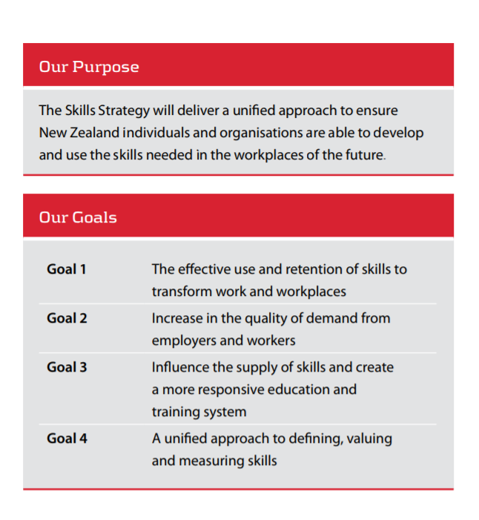

## Operation

The Skills Strategy emphasises the development of management and leadership capability within firms, as well as ways to support workers to better influence skills development within their workplaces.

This Skills Strategy aims to provide a shared understanding of the challenges New Zealand businesses, government and individuals face in meeting the demands of a growing economy. It was set up to agree on solutions and priorities for action that will result in continued economic growth.

The Skills Strategy is designed to putting actions into practice by:

* establishing a mechanism for debating and reaching agreement on the required skills and systems to drive productivity
* better co-ordinating and communicating work across government and New Zealand organisations and individuals
* identifying duplication or where there is a need to do more.

The development of the Skills Strategy was based on an understanding that the significant improvements in skills development and use needed to drive labour productivity and economic growth are going to require co-ordinated action and commitment from all stakeholders.

Aspects relating to occupational skill information models or frameworks are bedded down in the following actions under **Priority 3 Supply and demand of skills, and measurement of skill acquisition and retention:**

* Improve access to careers and labour market information and advice for adults in the workforce
* Undertake a targeted review of the qualifications system, focusing on diploma and certificate levels
* Develop and disseminate integrated skills information and create a shared language on skills
* Improve the provision of information, access to careers advice, and life-long learning advice for young people currently in the workforce, and their parents.

## Highlights

### Develop easily accessible information

**Develop easily accessible information about skills that meets the needs of individuals, employers, industries and regions**

The forum shared the insight that New Zealand has not had a strong tradition of bringing relevant and timely labour market information together to inform decision makers at all levels. A potential vehicle for doing this is therefore to bring together a comprehensive skills knowledge base to better inform decision making, particularly around the supply of skills and their utilisation in the workforce.

There is a lot of information relating to skills held by government departments, employers, education and training providers and individuals. We need to bring it all together in a coherent database in order for it to be useful to us in planning for our skill needs, including obtaining timely information on skills shortages to support decision making by a wide range of stakeholders.

The Department of Labour has begun work to develop an integrated database by bringing together existing data that it produces, e.g. information, relating to occupational trends and projections, wages, and vacancy rates. The Department wishes to expand this to include more sources of information. The data is intended to cover key areas of supply, demand and matching with the intention of making this available online and updated over time. In addition to bringing together labour market and skills information, we need to make sure that those who need it to support this work know about the database and have access to it.

The Department of Labour brings together key information for decision makers in the form of an integrated skills database which pools existing labour market information sources as well as several new areas such as occupational forecasts. The aim of the integrated skills database is to obtain current and future labour market information that improves our understanding of the supply of labour (by workers), the demand for labour (by employers), and how well we are able to match workers to suitable jobs. In addition to information on skills shortages brought together by the Department of Labour, we intend to supplement this with other information and insights from those working closely on the development and use of skills.

### Improve the provision of information

**Improve the provision of information, access to careers advice, and life-long learning advice for young people currently in the workforce and their families**

As part of this work, consideration will be given to expanding and enhancing the range of information (including labour market information) and tools targeted at adults in the workplace on Career Services website and within their wrap-around suite of services. It was proposed that Career Services, in partnership with others, will be the lead agency to take forward work in this area as it has an evolving and sophisticated service delivery infrastructure, (including web-based, phone-based and in person services), is widely recognised as the ‘go to place’ and has a track record of providing relevant, independent, accessible and user-friendly career information, advice and support.

User research commissioned by Career Services found that: key gaps in information identified by recent tertiary students looking back over their career pathway include the breadth of job options related to a subject/course and the realities (pros and cons) of courses and occupations parents’ degree of involvement in career decision-making with their child was dependent on their child’s drive and pro-activity the views expressed (overtly or inadvertently) by parents heavily influence their children’s decision-making options.

### Improve access to careers and labour market information

**Improve access to careers and labour market information and advice for adults in the workforce**

NZ Career Services are undertaking work to increase awareness of current government provision of career and labour market information relevant to adults in the workforce. This will involve expanding and enhancing the range of information (including labour market information) and tools targeted at adults in the workplace on the Career Services website and within their wrap-around suite of services. It will also include enhancing job vacancy links, updating salary and wage information, and updating the courses and qualifications information. They will investigate the best way of providing personal career management support to people in targeted industries and/or workplaces to build on this approach. Career Services, in partnership with others, will be the lead agency to take forward work in this area as it has an evolving and sophisticated service delivery infrastructure, (including web-based, phone-based and in-person services), is widely recognised as the ‘go-to place’ and has a track record of providing relevant, independent, accessible and user-friendly career information, advice and support.

## Other systems & tools

### Skill building and skill matching tools

Source: www.career/govt.nz

Aimed primarily at job seekers the governments career website provides career planning, job hunting tips, job data base, course information, cv tools and information for practitioners.

#### Skills Builder

Under the umbrella of getting career ideas the Skills Builder tool identifies exiting skills and further action like finding the right course or program.

The Skills Builder tool requires a taxonomy of skills matched to jobs. Instead of building and maintaining a database from scratch, Careers New Zealand identified and tested three different sources of skill-to-occupation matches. O\*Net produced the best results in terms of relevance to the New Zealand context and generation of suggested jobs based on existing skills. The alternative titles and direct work activity titles have been amended to: change US spelling and usage to New Zealand spelling and usage reduce length where necessary to work better for mobile users remove alternative titles not relevant in the New Zealand context remove duplicate alternative titles so that each unique alternative title now matches only one O\*Net occupation add additional job titles for unpaid work and match these to O\*Net direct work activities.

There are over 2000 direct work activities, each mapped to multiple jobs. It is these activities that are displayed as "skills" by the Skills Builder tool when a job is selected. They are also used when looking up an individual skill to add. Once a user's skills are identified, the O\*Net jobs that use those skills, or the more generic associated indirect work activities, are identified and given a score based on the number of matched skills and whether they are direct or indirect. They are ranked in order of score and the associated Careers New Zealand jobs are identified.

### Vocational Pathways

Source: www.Youthguarantee.net.nz

Vocational Pathways were developed to support young people in their transition from school to employment. The following issue gave rise to concern:

* Employers, families, and whānau have some difficulty understanding NCEA.
* Students engage more in their learning when they see its relevance to their lives.
* 70% of learners in New Zealand do not go on to university, and most curriculum choices focus on the 30% that do.
* Employers want to understand more about education, and vice versa, but the language used in both sectors does not always help the connection.

The Vocational Pathways were developed through a partnership between the Ministry of Education and the Industry Training Federation. Government agencies, the industry training sector, secondary and tertiary representatives, and industry and employer representatives worked together to develop the six Vocational Pathways. This was to create a “learning to earning map” as the foundation of the journey from education to employment. A sector consortia group was formed for each Vocational Pathway. This group, in consultation with their sectors and with broader education and employment agencies, decided which standards would be recognised as Recommended or Sector-Related. They wrote the descriptions for that sector and, in consultation with Careers NZ, decided on the jobs selected for that pathway. Information is available for students, employers and training providers.

#### Operation

The Vocational Pathways provide new ways to achieve the National Certificate of Educational Achievement (NCEA Levels) 1, 2 and 3 for secondary students and develop pathways that progress to further study, training and employment. Achieving NCEA Level 2 is the foundation for success in further education and the world of work. Level 3 builds upon this through shared opportunities across school, tertiary, and industry training. The Vocational Pathways provide a framework for students to show how their learning and achievement is valued in the workplace by aligning learning to the skills needed for industry. The six Vocational Pathways are:

* Primary Industries
* Services Industries
* Social & Community Services
* Manufacturing & Technology
* Construction & Infrastructure
* Creative Industries.

#### Profile Builder

The Profile Builder helps young people explore their study options. By inputting the standards a student may achieve from the programme they are undertaking or thinking of doing, students can see what pathway they are heading along and think about where they would like to go.

Educators can also use the tool to plan programmes that align to Vocational Pathways and support young people to achieve a Vocational Pathways Award.

#### Vocational Profile

Employers can view a student’s Vocational Profile as part of NCEA Level 2 to see:

* which sector (pathway) their credits relate to
* how many sector-related credits they have achieved
* whether they have achieved a Vocational Pathways Award.

An employer can then determine whether a student’s skills and interests align with those required by the selected industry. The screenshot below provides an employer with an indication of the Vocational Pathways information students can show from the NZ Qualification Authority (NZQA) website.

In Figure 11, The Vocational Pathways Award on this Record of Achievement shows that the learner has achieved: NCEA literacy, NCEA numeracy, NCEA Level 2 and a Vocational Pathways Award in two pathways – Creative Industries and Services Industries.

The Vocational Pathways Award is achieved by the student’s having at least 60 Recommended Credits in each pathway, including a minimum of 20 Sector-Related credits in each pathway.

Figure 11 Vocational Pathway Profile

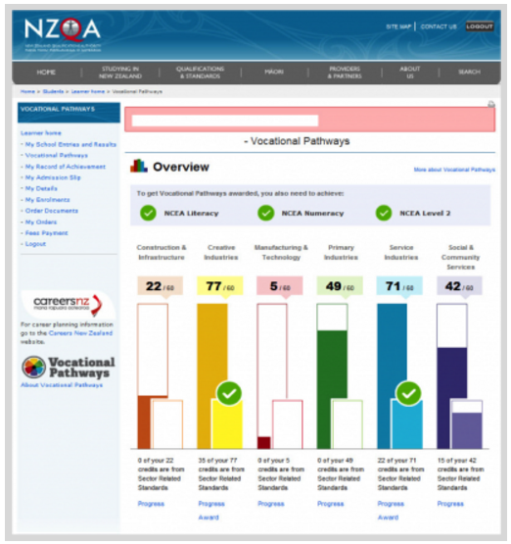

Source: (http://www.youthguarantee.net.nz/vocational-pathways/)

#### Updates

The Vocational Pathways are updated on a yearly basis, to show the standards and qualifications that are expiring and when they will no longer count towards a Vocational Pathways Award, and to show newly registered standards and qualifications mapped to Vocational Pathways. The annual maintenance process is described in more detail here.

#### Link to training

Vocational Pathways provide guidance for schools, Industry Training Organisations, and tertiary providers who wish to develop contextualised learning programmes using the Pathways. Contexts for learning are provided as examples to encourage development in the sector.

It outlines key ideas about Vocational Pathways and delivery approaches that align with a Vocational Pathway philosophy, drawing together secondary and tertiary perspectives on the competencies that are required for NCEA level 2, and exploring the connections within and across pathways. Programme design is a key feature. Assessment programmes are discussed, along with an example of an assessment programme. Questions are provided to apply the information to your programme and to share your thinking with colleagues.

VOCATIONAL PATHWAYS ENABLE EDUCATORS TO:

* know the recommended standards valued by employers in particular sectors
* develop relevant and coherent learning programmes that enable young people to achieve NCEA Level 2 with a Vocational Pathways Award, NCEA Level 3 or equivalent, and progress towards further study, training or employment
* share a student’s individual vocational profile with parents and whānau so they can more engaged in and support their young person's learning.

### Spotlight – Skill Identification Tool

Source: https://www.employment.govt.nz/hours-and-wages/pay/pay-equity/spotlight-skills-recognition-tool/

The Spotlight Skills Recognition Tool was designed to help managers write position descriptions, select staff, manage performance and encourage individual and career development.

The tool helps focus on the skills that job holders can build on in carrying out individual and group activities. It provides a better understanding of the skills used in service work that can be overlooked or taken for granted, especially skills used in interacting and relating, coordinating and shaping awareness.

Types of skills which are often overlooked are the skills of combining activities in work streams and those involved in the sensitive, responsive, and integrated delivery of appropriate services to people.

The classification framework consists of:

* Three sets of skills (shaping awareness, interacting/relating and coordinating)
* Five learning-based levels of each skill (from familiarisation through problem-solving, to expert system-shaping).
* A list of work activities shows the use of each skill element at each level. Selected activity examples can be used to help pinpoint the skills required in specific jobs, or be included in position descriptions.

The classification framework makes concepts such as ‘problem-solving’, ‘communication skills’ and ‘time management’ more precise, and provides a systematic way of naming different levels of the skills that are the basis of effective work performance.

# Case 9 – Finland's skill anticipation activities

## Source

<http://skillspanorama.cedefop.europa.eu/en/analytical_highligths/skills-anticipation-finland>

## Type

Skill anticipation model

## About

One of the strengths of the Finnish economy is the skills of its workforce as it is amongst the most highly educated in the EU. Finns traditionally rank high on international benchmarks for learning and skills, and the percentage of people aged 20 to 29 years participating in education is the second highest amongst OECD countries.

In Finland skills anticipation activities are well-established and linked to policymaking. Over recent years, socioeconomic factors such as the effects of the economic recession, the gradually decreasing number of people in the labour force, and the ageing population increased the need for better matching between the skills supply and demand. As a result, significant investment in skills anticipation has been undertaken. The aim is to steer the education system – both vocational education and training (VET) and higher education (HE) – to meet the needs of the labour market. This is being achieved by making skills anticipation more comprehensive, with input and feedback from the government (central, regional and local) and increasingly also from stakeholders including employers, trade unions, and labour market intermediaries as well as education institutions and their staff and students. Skills anticipation takes into account sectoral, occupational and geographical differences, and includes skills assessments, skills forecasting, skills foresight, and employer surveys.

## Purpose

The main aims of the skills anticipation system are to:

* Prepare forecasts concerning economic growth and employment
* Anticipate the medium and long term demand and availability of the workforce
* Anticipate developments in the occupational structure
* Anticipate the educational needs of the workforce
* Estimate the national and regional provision of education places for young people
* Ensure that young people have access to vocationally/professionally-oriented education and training.

## Operation

The core tools of skills anticipation in the country are models on quantitative forecasting of educational, the VATTAGE and MITENNA models. The VATTAGE model, the cornerstone of skills anticipation in the country, provides forecasts up to 2025 based on a model of the Finnish economy, while the MITENNA model provides the basis of anticipation of education needs and future oriented development of education. The Finnish National Agency of Education under the Ministry of Education and Culture plays a key role in anticipation activities and is supported in this role by the Skills Anticipation Forum, established in early 2017.

## Highlights

### Ownership, coordination and stakeholder involvement

In general, there is a high degree of stakeholder involvement in skills anticipation activities. Major trade unions, employers, regional councils, and representatives of educational institutions are involved in anticipation exercises. The responsibility of education providers for anticipating and responding to the labour market changes has increased, as operational targeting and steering powers have been devolved to universities, polytechnics, and VET providers. Providers are required to play an active role in addressing the national/regional labour market skills needs.

In addition, a wide range of national and regional EU-funded anticipation and foresight projects are carried out by organisations such as research institutes, labour market and industry organisations, VET providers, universities, and polytechnics.

Governance and funding of the relevant exercises are in the remit of four ministries (Education and Culture, Finance, Economic Affairs and Employment, and Social and Health Affairs). These ministries engage in a variety of skills anticipation exercises, taking advantage of the long term baseline forecasts of economic development.

### Presentation of skill intelligence

Dissemination of the data generated by skills anticipation exercises is an important element of the overall approach. There is a drive to make the outputs from anticipation exercises accessible to a wide audience (policymakers, employers, jobseekers and young people, etc.) through a range of channels including reports, workshops and online publications. Despite the focus on dissemination of skills anticipation data, there is a need to improve the user friendliness of the existing database to better inform students, job seekers and employers.

### Usage by stakeholders

Skills anticipation influences government policies on VET, higher education and adult education. Forecasts of future skills demand have an impact on decisions about education supply. The funding that higher education institutions receive from the Ministry of Education depends on the results from the long-term labour force assessments, the VATTAGE and MITENNA models. Skills anticipation results feed the so-called performance agreements that set the priorities and qualitative and quantitative targets that the institutions need to meet. Skills anticipation also has an impact on curriculum planning in VET and higher education institutions. There is, however, room for improvement, related to strengthening the links between skills anticipation results and the development of education strategies at sub-national levels; ensuring greater coherence among the various exercises taking place across the country; and providing user-friendlier labour market information to support informed decisions of school leavers and job seekers.

#### Workforce planning

##### VATTAGE Model

Skills forecasting is well-established in Finland, with multiple institutions engaged in various exercises. The baseline forecasts are produced by the VATT Institute of Economic Research for use by government ministries and agencies. The first forecast for 2005-2025 was published in 2010. It is based on the Finnish dynamic CGE-model, the so-called VATTAGE Applied General Equilibrium (AGE) model of the Finnish economy. (12) The forecasts are updated every five years, each time looking ahead with a fifteen-year horizon.

VATTAGE first produces a long-term baseline scenario of economic development based on several macro-economic variables that are considered key long-term drivers of employment. In the second phase, ‘political’ scenarios (alternative scenarios using different assumptions for the variables) are calculated. The VATTAGE model is supplemented with modules relating to sectoral and occupational employment. In the future, regional analyses will be incorporated into the model. Outputs from the VATTAGE model regarding future skills needs feed into the MITENNA model, (13) developed by the EDUFI through which the Ministry of Education and Culture articulates the education and training provision necessary to meet forecast demand.

##### MITENNA Model

Sectoral forecasts generated by the VATTAGE model are core to the MITENNA Model. The MITENNA model anticipates long-term educational needs (approximately 15 years ahead) based on labour market needs by calculating changes in labour demand, the number of people exiting the labour market, and the demand for new labour market entrants, while taking skills supply into consideration from all levels of the education system. The anticipation results are updated as new industry forecasts are released, which allows for the development of continuous anticipation data. MITENNA connects various forecasts, expert opinions and education policy objectives in order to anticipate future educational needs. This approach ensures that the results are not based on hypotheses of economic development produced by a single research institute, but on a wider process of future-oriented stakeholder dialogue.

#### Training planning

The Education Department currently runs a national project, which aims at developing and piloting a forecasting model on the skills needs of the adult population to support decisions on adult education of all forms and levels. A new skills anticipation tool focusing on VET is expected to be completed in 2018, triggered by a significant reform of the VET system currently underway. The reform affects the way skills relevant to this level of education are anticipated, leading to changes in the methodology and overall approach to skills anticipation. The focus will be on better anticipating skills needs and allowing the forecasting tool to be more responsive to the fast-changing environment.

In recent years, about two to three skills anticipation exercises have taken place annually at sectoral level in areas identified by the EDUFI, taking into consideration recommendations of the Education Committees and, as of 2017, by the Skills Anticipation Forum. In contrast to the VATTAGE and MITENNA models, these sector-based assessments take advantage of the qualitative-based anticipation model developed by the National Project on Anticipation of National Competences and Skills Needs (VOSE).

In 2016, skills assessment reports were published on the food chain, retailing, the games industry, and services for the elderly. Results from these VOSE-based skills anticipation activities have an impact on the curricula for VET and HE, particularly for polytechnics (universities of applied sciences).

##### EDUFI database

The governmental education regions (14 in total) produce their own forecasts on educational needs in their area based on nationwide forecasts and their own estimates for regional development. The regional forecasts aim to develop a robust evidence base for strategic development in regions, municipalities and communities. This information is used by the regions in their strategic planning and by the Ministry of Education when determining the licences to provide vocational upper secondary education and training (and their content). Information is also used in performance negotiations between the Ministry of Education and Culture, the universities and the polytechnics when agreeing on the scope of their educational provision.

# Case 10 – European Commission's skill classification ESCO (European Skills, Competences, Qualifications and Occupations)

## Source

https://ec.europa.eu/esco/portal/home

## Type

Skill classification database

## About

At the European level, two initiatives are particularly interesting: the European Skills, Competences, Qualifications and Occupations (ESCO) and the European Dictionary of Skills and Competences (DISCO) projects. DISCO is a comprehensive database of skill and competences terms (over 104,000) and sample phrases (over 36,000). In the database, skills and competences are classified, described and translated (currently 11 languages are supported). DISCO cannot only be used for the analysis of competences and skills across occupations, but it also functions as a tool for other applications such as CVs, job advertisements and matching, and the description of learning outcomes.

In contrast to DISCO, the ESCO classification goes beyond the concepts of skills and competences. In July 2017 the European Commission launched the first full version of the European classification of Skills, Competences, Occupations and Qualifications (ESCO). The classification is available in 26 languages (the 24 EU languages, Icelandic and Norwegian). The Commission developed ESCO to complement pre-existing European- and national level initiatives and instruments designed to enhance interoperability in the labour market and in education and training.

The publication of ESCO v1 is a key milestone in the achievement of objectives of the Europe 2020 strategy and the New Skills Agenda for Europe. The Commission has the ambition for ESCO to become the European classification for information exchange via the European job mobility portal (EURES). ESCO has been developed in close cooperation with CEDEFOP and a wide variety of stakeholders from the labour market and education and training sector.

## Purpose

The Commission developed ESCO as a complementary tool to the European Qualification Framework (EQF). Within the framework of the EQF, Member States relate their national qualification frameworks (NQF) to the EQF to allow qualification levels to be compared more effectively in Europe.

ESCO was set up to facilitate the dialogue between labour market and the education/training sector by providing a common language that helps to overcome labour market imbalances and increase occupational and geographical mobility in the EU. Transparency and common reference points aim to help people to exchange information with unambiguous and shared meaning, independent of the language or electronic systems used (semantic interoperability). The Commission also envisages integrating private, international and sectoral qualifications from other sources into ESCO in the near future. It is piloting this approach and discussing it with the Member States.

## Operation

The ESCO classification is being set up as a comprehensive classification that comprises three pillars and accounts for the relations between them (Figure 12). These three pillars are: (1) skills and competences (of a transversal, cross-sector, sector-specific and occupation-specific nature), (2) qualifications (awarded at the (inter-)national level, linked to tasks, technologies, occupations or sectors) and (3) occupations (structured hierarchically, linked to ISCO).

Figure 12 ESCO structure

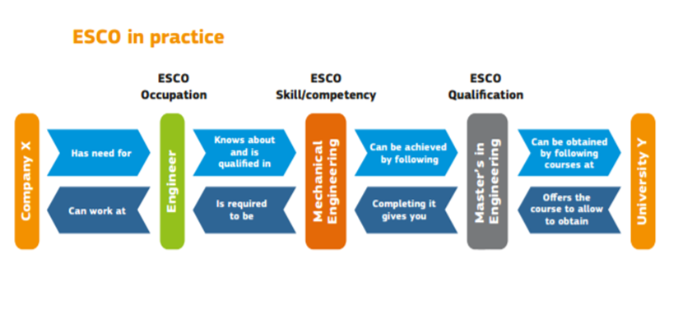

**Source: http://skillman.eu/?page\_id=36189**

The system will progressively include:

* **Classification systems**, controlled vocabularies and frameworks such as national occupational classifications, the International Standard Classification of Occupations (ISCO), the European Qualifications Framework (EQF) and the eCompetence Framework
* **Databases** with complementary information such as national qualification databases or the Commission Database on Regulated Professions
* **Technical or syntactical standards** such as Europass10, skills passports11 HR-XML12 or schema.org
* **Legislation** such as the Directive 2005/36/EC on the recognition of professional qualifications
* **Tools and services** that help people to develop their careers, such as EURES15, national job portals and career guidance tools.

Milestones to be achieved by the end of 2017 are the establishment of a system that allows the ESCO classification to be continuously updated; supports national developments in the journey to close the gap between the classifications of occupations, skills and qualifications; supports Member States that create machine-readable translation tables (mappings) between ESCO and their national classification, or that implement ESCO on a national level.

By 2018 the system is envisaged to translate between national occupational or skills classifications and similar de facto standards, helping to strengthen the interconnectivity of national systems and enable cooperation between Member State authorities. It will provide a common reference point to make it possible to communicate using different classifications and languages.

The first full version (ESCO v1) is available free of charge through the online ESCO service platform (<https://ec.europa.eu/esco/portal/home>) and covers about 3000 occupations, 13 500 knowledge, skills and competences . It will progressively display information on qualifications provided by the Member States.

Firstly, ESCO aims to support jobseekers to find the job that best matches their skills by providing a common language. As recruitment is increasingly digitised, both employers and jobseekers need to use digital tools that allow them to communicate in a meaningful manner. ESCO aims to make these digital tools work better together.

Secondly it fosters a link between employment and education, as education providers can use the database to describe the expected learning outcomes of their curricula and to understand the labour market trends and future skills needs better.

Thirdly the classification aims to connects labour markets at EU level, by acting as the digital enabler of labour market mobility. The Commission has the ambition for ESCO to become the European classification for the information exchange via EURES, the European job mobility portal.

## Highlights

Ownership, coordination and stakeholder involvement

European Commission (developed with CEDEFOP) ESCO is managed and supported by several bodies:

* The ESCO Board is made up of senior representatives from the stakeholders most directly concerned and provides the project with strategic guidance.
* The ESCO Maintenance Committee consists of technical classification experts. It develops the methodology for the development of ESCO together with the ESCO Secretariat and monitors the quality of the final product.
* The Sectoral Reference Groups are composed of sectoral experts from the labour market and education and training sectors. In total, 27 Sectoral Reference Groups develop the content of ESCO by defining occupational profiles, sector specific skills and competences and qualifications for their sector of the economy.
* The Cross-Sector Reference Group consists of experts in employment and education, related standards and classifications and an up-to-date knowledge of relations between education and training and the labour market. It deals with transversal skills and competences, the consistency of the skills and competences pillar and its relation to the qualifications pillar.

### 

### Identification, collection and update of skill descriptions

In order to develop the reference terminology, ESCO was built using existing sources – in particular, results from other European projects in the field of qualifications. The ESCO terminology has been published according to linked open data standards so that interested parties can access it easily and free of charge, and can link other data sources to ESCO as a reference. ESCO also supports users by providing technical information, guidelines for the use of ESCO and training.

### OUTPUT – Presentation of skill intelligence

ESCO’s primary objective is to contribute to better skills-based job matching online. It does so, by:

* Offering people the possibility of compiling CVs and vacancies using ESCO’s vocabulary in 25 languages, enabling them to exchange information across borders.
* Providing a tool for the automated analysis and interpretation of semi-structured and unstructured data (CVs and vacancies).
* Supporting skills-based job matching on the grounds of an individual’s work experience and qualifications.
* Shows how skills and competences developed in one occupation are applicable and transferable to another, i.e. cross sectoral skills and competences.

ESCO has been developed as part of an emerging Semantic Web (in the labour market and the education and training sector. The Semantic Web aims to transform the internet from a collection of documents, such as job vacancies, CVs and training courses, into a web of interlinked, standardised and reusable data. This data can then be fed into tools such as job matching platforms, HR systems, career guidance tools or statistical applications, making ESCO a building block for practical tools, applications and services.

The platform as of August 2017 offers three searchable data pillars: Occupations, Skills/Competences and Qualifications.

The skills pillar contains currently about 13500 skills/ competences and knowledge concepts by indicating the skill type. There is however no distinction between skills and competences. Each of these concepts comes with one preferred term and any number of non-preferred terms and hidden terms in each of the ESCO languages. It also includes an explanation of the concept in the form of description, scope note and definition. The skills pillar of ESCO does not contain a full hierarchical structure but is structured in four different manners:

* Through their relationship with occupations, i.e. by using occupational profiles as entry point;
* In the part of the transversal knowledge, skills and competences through a skills hierarchy;
* Through relationships indicating how knowledge, skills and competences are relevant to other knowledge, skills and competences (in particular in cases of skill contextualisation);
* Through functional collections that allow to select subsets of the skills pillar.

### 

### Usage for stakeholders

#### Employers

ESCO has been designed in supporting employers to

* Understand the knowledge, skills and competences that people have obtained through education, training or "on the job" experience;
* Express which knowledge, skills, competences and qualifications they expect from their employees;
* Find the right person for a job.

#### Job seekers

Similarly, the data platform provides information to job seekers to

* understand what employers need
* understand how they can develop their career through lifelong learning
* to document and describe their knowledge, skills and competences in order to find the right job.

#### Educators and Trainers

ESCO provides resources for education and training providers to

* undertake surveys and analyse data in order to obtain information on current and future labour market needs, which can then be used as a basis for the further development of curricula
* make the contents of their education and training offers more understandable for learners
* to increase the transparency and visibility of the qualifications they award.

#### Service providers

The data platform can help employment services and guidance counsellors to

* provide better e-services to their customers
* serve customers in several languages
* build partnerships with other service providers and exchange data with them, in particular to strengthen cooperation between public and private employment services, as well as with education and training providers.

## Illustration: Child Care Worker Profile

All components are hyperlinked to a skills and knowledge repository and provide a full description.

**Essential skills and competences**

* [supervise children](https://ec.europa.eu/esco/portal/skill?uri=http%3A%2F%2Fdata.europa.eu%2Fesco%2Fskill%2Ff8d4a24c-fb62-444e-9525-7aa5662f440d&conceptLanguage=en&full=true)
* [assist in children's development of basic personal skills](https://ec.europa.eu/esco/portal/skill?uri=http%3A%2F%2Fdata.europa.eu%2Fesco%2Fskill%2F8e09fe66-2649-4179-81ef-91fefa3ceee8&conceptLanguage=en&full=true)
* [handle chemical cleaning agents](https://ec.europa.eu/esco/portal/skill?uri=http%3A%2F%2Fdata.europa.eu%2Fesco%2Fskill%2F51a26193-9abe-4bce-9108-f50835be1c35&conceptLanguage=en&full=true)
* [communicate with youth](https://ec.europa.eu/esco/portal/skill?uri=http%3A%2F%2Fdata.europa.eu%2Fesco%2Fskill%2Fb5af495b-61f1-4330-9891-dca56d97d714&conceptLanguage=en&full=true)
* [play with children](https://ec.europa.eu/esco/portal/skill?uri=http%3A%2F%2Fdata.europa.eu%2Fesco%2Fskill%2F94b01483-f13d-48ba-b8a9-ef8f18fcb2dc&conceptLanguage=en&full=true)
* [attend to children's basic physical needs](https://ec.europa.eu/esco/portal/skill?uri=http%3A%2F%2Fdata.europa.eu%2Fesco%2Fskill%2Fbeb952e4-8a9c-47af-8a60-c6eb5c5f25bc&conceptLanguage=en&full=true)
* [maintain relations with children's parents](https://ec.europa.eu/esco/portal/skill?uri=http%3A%2F%2Fdata.europa.eu%2Fesco%2Fskill%2Fefe801a5-8704-4def-8a96-c32f7a6cb9fb&conceptLanguage=en&full=true)

**Essential Knowledge**

* [workplace sanitation](https://ec.europa.eu/esco/portal/skill?uri=http%3A%2F%2Fdata.europa.eu%2Fesco%2Fskill%2F06bd47bc-d9f3-4517-8e34-c55c2e81f8c2&conceptLanguage=en&full=true)

**Optional skills and competences**

* [prepare ready-made dishes](https://ec.europa.eu/esco/portal/skill?uri=http%3A%2F%2Fdata.europa.eu%2Fesco%2Fskill%2Fb72395ea-623b-4204-abef-a67592b0781a&conceptLanguage=en&full=true)
* [support children who have experienced trauma](https://ec.europa.eu/esco/portal/skill?uri=http%3A%2F%2Fdata.europa.eu%2Fesco%2Fskill%2F6caaeece-8a4a-44b3-bc78-d9687676c015&conceptLanguage=en&full=true)
* [support children's wellbeing](https://ec.europa.eu/esco/portal/skill?uri=http%3A%2F%2Fdata.europa.eu%2Fesco%2Fskill%2Fa65fb963-6faf-47b2-a3d9-c4e5e4d833c5&conceptLanguage=en&full=true)
* [relate empathetically](https://ec.europa.eu/esco/portal/skill?uri=http%3A%2F%2Fdata.europa.eu%2Fesco%2Fskill%2F996243ee-543f-4c36-a31a-e0f2403c0c5d&conceptLanguage=en&full=true)
* [support the positiveness of youths](https://ec.europa.eu/esco/portal/skill?uri=http%3A%2F%2Fdata.europa.eu%2Fesco%2Fskill%2F4a874516-eb34-4dc1-833d-864c5a448db2&conceptLanguage=en&full=true)
* [tolerate stress](https://ec.europa.eu/esco/portal/skill?uri=http%3A%2F%2Fdata.europa.eu%2Fesco%2Fskill%2Fd15f8745-28f8-4abf-a7b6-6cb8a304efd2&conceptLanguage=en&full=true)
* [manage children's problems](https://ec.europa.eu/esco/portal/skill?uri=http%3A%2F%2Fdata.europa.eu%2Fesco%2Fskill%2F07090471-265a-48ec-b744-72b357e801ed&conceptLanguage=en&full=true)
* [assess the development of youth](https://ec.europa.eu/esco/portal/skill?uri=http%3A%2F%2Fdata.europa.eu%2Fesco%2Fskill%2F28ca596e-5e2f-4149-a28d-42d2c4c20227&conceptLanguage=en&full=true)
* [clean rooms](https://ec.europa.eu/esco/portal/skill?uri=http%3A%2F%2Fdata.europa.eu%2Fesco%2Fskill%2F7bb01a18-4637-4535-ba18-258f48f705b8&conceptLanguage=en&full=true)
* [prepare sandwiches](https://ec.europa.eu/esco/portal/skill?uri=http%3A%2F%2Fdata.europa.eu%2Fesco%2Fskill%2F493a1805-6caa-4cda-8fd3-6495ec8ea451&conceptLanguage=en&full=true)
* [carry out wound care](https://ec.europa.eu/esco/portal/skill?uri=http%3A%2F%2Fdata.europa.eu%2Fesco%2Fskill%2F1c6736c2-77de-419c-9b84-8932e15abc21&conceptLanguage=en&full=true)
* [dispose waste](https://ec.europa.eu/esco/portal/skill?uri=http%3A%2F%2Fdata.europa.eu%2Fesco%2Fskill%2F5e433def-210d-4dfa-bf07-dbf6d04e0eaa&conceptLanguage=en&full=true)
* [work in a multicultural environment in health care](https://ec.europa.eu/esco/portal/skill?uri=http%3A%2F%2Fdata.europa.eu%2Fesco%2Fskill%2Fb55f61a4-5f9e-4741-ba95-9ac04b64119b&conceptLanguage=en&full=true)
* [assist children with homework](https://ec.europa.eu/esco/portal/skill?uri=http%3A%2F%2Fdata.europa.eu%2Fesco%2Fskill%2F12efe5f2-f7ec-4f03-b359-afba5b9f62de&conceptLanguage=en&full=true)
* [provide first aid](https://ec.europa.eu/esco/portal/skill?uri=http%3A%2F%2Fdata.europa.eu%2Fesco%2Fskill%2F1d21f6ad-340f-45da-a0a3-4e83867f47a6&conceptLanguage=en&full=true)

**Optional Knowledge**

* [common children's diseases](https://ec.europa.eu/esco/portal/skill?uri=http%3A%2F%2Fdata.europa.eu%2Fesco%2Fskill%2F7b34134b-eb4c-40da-98a0-98b6190aa93b&conceptLanguage=en&full=true)
* [baby care](https://ec.europa.eu/esco/portal/skill?uri=http%3A%2F%2Fdata.europa.eu%2Fesco%2Fskill%2F2362e36f-04e1-44be-b278-ba18ede03d28&conceptLanguage=en&full=true)
* [pedagogy](https://ec.europa.eu/esco/portal/skill?uri=http%3A%2F%2Fdata.europa.eu%2Fesco%2Fskill%2Fa117f32c-662b-4dd9-b739-1230dd04cb60&conceptLanguage=en&full=true)
* [babysitting](https://ec.europa.eu/esco/portal/skill?uri=http%3A%2F%2Fdata.europa.eu%2Fesco%2Fskill%2Fa6354281-5578-46ac-a9db-d179d9962b98&conceptLanguage=en&full=true)
* [disability care](https://ec.europa.eu/esco/portal/skill?uri=http%3A%2F%2Fdata.europa.eu%2Fesco%2Fskill%2F54411e8e-d62f-46d8-b87b-fce23f8e3bc8&conceptLanguage=en&full=true)

# Case 11 – SFIA's Skills Framework for the Information Age

## Source

https://www.sfia-online.org/en

## Type

Operational IT community skill framework

## About

SFIA is a globally accepted common language for the skills and competencies required in the digital world. SFIA does not define roles or jobs – it provides flexible ‘building blocks’ of skill descriptions at various levels of competence. It is a model addressing changing organisational landscape as it moves from static job roles to flexible project-aligned team-building. IT skills that used to be only found in people who would identify themselves as ‘IT professionals’ are now more distributed throughout organisations. Organisations themselves are moving away from traditional formal structures to the use of a more flexible pool of resources that can be aligned to short-term and agile teams for specific projects or activities.

The IT skills framework began as a UK initiative in 2000. It was preceded by a number of individual skills initiatives, some dating back to around 1990, that came together and collaborated to provide a single definitive framework for the IT industry. Since 2000, SFIA has become the de facto global IT skills framework, used in nearly 200 countries by organisations and individuals to characterise and manage their skills. The SFIA Framework strives to be relevant and useful through consultation activities where its extensive global user base comes together to collaborate on initiating, drafting and reviewing updates to the Framework.

## Purpose

A tool to describes skills required by professionals in roles involving information and communications technology. This assists organisations to remain viable by structured assess of IT related skills to create a plan for closing gaps and supporting continual improvement and transformational change.

## Operation

The framework itself does not provide instructions for improvement or the specific mix of skills that an individual or organisation should have. Context is important in the use of any framework, and it is crucial to understand the organisation’s needs rather than simply use the skills in an isolated manner to form a single job description or role profile. The specific mix will be different from one organisation to another.

SFIA is a practical resource for people who manage or work in information systems-related roles of any type. It provides a common reference model in a two-dimensional framework consisting of skills on one axis and seven levels of responsibility on the other. It describes professional skills at various levels of competence. It also describes generic levels of responsibility, in terms of Autonomy, Influence, Complexity and Business Skills. SFIA is updated frequently to remain in step with user needs and current thinking about information age capabilities. SFIA aims to give individuals and organisations a common language to define skill, abilities and expertise in a consistent way.

By defining core competencies as professional standards, SFIA helps organisations create roadmaps and development plans where both they and their employees can recognise a pathway to success and improvement. The skills and descriptions in the reference guide are likely to be the most used resource. The complete reference guide, which is an online and printable resource, describes the 97 skills in SFIA 6 in detail. Each skill entry comprises an overall definition and descriptions of each of up to seven levels at which the skill might be exercised. These descriptions provide a reference of how the skill and level combined produce a more detailed definition of what level of competency each skill is practiced at.

#### Responsibility and Skills

The seven levels in the framework are uses in two ways:

1. To provide generic levels of responsibility, with descriptions at each of the seven levels for the following attributes: AUTONOMY · INFLUENCE · COMPLEXITY · BUSINESS SKILLS
2. To reflect experience and competency levels within SFIA. The definitions describe the behaviours, values, knowledge and characteristics that an individual should have in order to be identified as competent at that level. Each level has a guiding word or phrase that acts as a brief indicator: FOLLOW · ASSIST · APPLY · ENABLE · ENSURE, ADVISE · INITIATE, INFLUENCE · SET STRATEGY, INSPIRE, MOBILISE (Figure 13)

Figure 13 SFIA experience and competency level

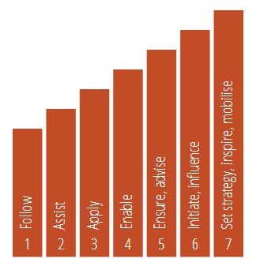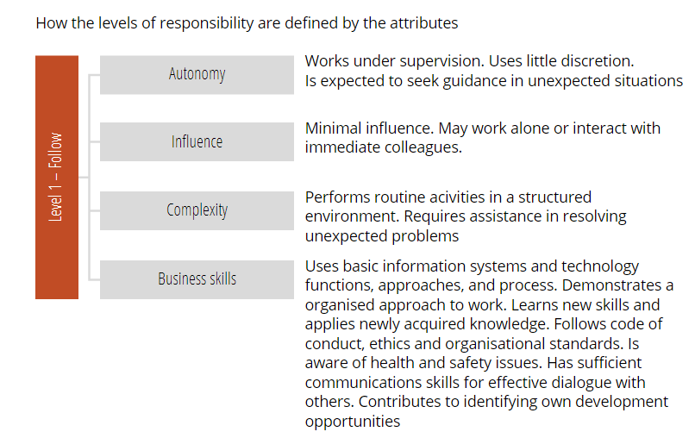

## Highlights

### Ownership, coordination and stakeholder involvement

The SFIA Foundation has five corporate members and works to maintain and distribute the framework. It encourages and supports its use within organisations using information systems. The Foundation is governed by its Board of Directors. Input to help define strategic direction is provided by the SFIA Council and Support for users of SFIA is provided by Accredited Consultants and Accredited Partners. The SFIA council consists of about 30 people representing significant organisations in the IT industry. The general exchange of information between users of SFIA is facilitated by the SFIA User Forum.

The corporate members of the SFIA Foundation have provided funds to establish SFIA, but are not permitted to take dividends from the Foundation. Any money collected by the Foundation can only be used for the benefit of the framework and its users. SFIA is available free of charge to companies and individuals who use SFIA purely as an internal management resource; they cannot distribute SFIA information or exploit SFIA commercially.

### Identification, collection and update of skill descriptions

The collaborative development style involves open consultation and input from people with practical experience of skills management in corporate and educational environments. The SFIA Framework aims to relevant, useful by being simple and generic. Skills are updated through a consultation activity where a global user base comes together to collaborate on initiating, drafting and reviewing updates to the Framework. Updates appear to happen every 2—3 years.

### Presentation of skill intelligence

#### Navigating

The skills are grouped into categories and subcategories for convenience of use (Figure 14). Like previous versions, colour codes are used to help identify the category the skill has been classified under.

Figure 14 Major SFIA skill categories

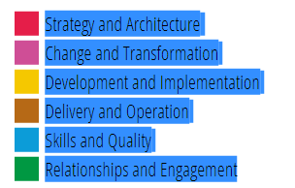

These categories and sub-categories do not equate to jobs, roles, organisational teams, or areas of personal responsibility. The grouping is intended to assist people who are incorporating SFIA skills in role profiles or job descriptions, or who are building an organisation's competency framework. The categories and sub-categories do not have definitions themselves, they are simply logical structural containers to aid navigation – it is usual for a specific job description to comprise skills taken from multiple categories and sub-categories.

SFIA skills are constructed with the following reference details:

Skill name - The name used for normal reference purposes

Skill code - A unique code used for short reference

Overall description - A broad definition of the skill, without any reference to the levels at which it might be practised

Level descriptions - Definitions of the skill for each of the levels at which it is practised. The phrasing facilitates their use as professional competencies.

Organisation and job/role design or re-design can be greatly assisted by SFIA, but common mistakes are made, including the assumption that the SFIA skills or categories are related to specific organisational units, departments, teams or jobs. SFIA does not describe roles, jobs or organisational units, but can provide building blocks to help create these. There are no organisational design templates, examples or suggestions in SFIA.

### Usage for stakeholders

Individuals can map their current skills and experience, identify their goals, and plan their professional development journey. The mapping of higher-education courses, qualifications, professional memberships, and training courses helps individuals and their managers to choose the right actions and activities to support the development they need. SFIA can help in the creation of Job/Position Descriptions and in advertising vacancies, and helps individuals to identify opportunities which match their skills and experience.

Organisations use SFIA for overall resource management. It can be used to quickly provide a baseline of the capability of the organisation, specific departments, teams, professional communities or individuals, and to identify skills gaps. SFIA describes the skills and levels of competency needed to operate effectively – ensuring that individuals can do their jobs properly, supporting the achievement of business and customer outcomes. Organisation structures, salary banding and benchmarking can be aligned to SFIA, facilitating a link to the skills and experience, focusing on the required capabilities and the value delivered.

During Recruitment SFIA helps employers to more accurately describe what they need, in language that potential employees understand. It helps move away from an over-reliance on certificates and qualifications that often only confirm a theoretical understanding of the relevant areas, and towards specifying competency based on having the right skills and an appropriate level of experience and responsibility.

#### Training planning

Education bodies, universities, colleges and training providers map their offerings to SFIA, to ensure the most appropriate courses and certifications are selected for individuals, providing the knowledge they need, so they can apply it to help develop the skills they require at the right level.

Professional bodies and membership organisations map SFIA to their membership levels, certifications, professional development and mentoring programmes. SFIA is used to identify suitable mentors, supporting knowledge and experience sharing and coaching activities.

Conference and event organisers can identify the target audience by mapping to SFIA levels of responsibility, skill categories or individual skills and levels – so individuals can select the sessions which best match their development needs.

## Illustration

SFIA is used extensively in the assessment of existing capability, at both an individual and an organisational level. SFIA does not attempt to cover all of the things that an individual may be required to do, as it doesn’t describe any product or technology-specific skills or knowledge, industry experience or qualifications. Figure 15 summarises the discrete skills required when operating at increasing levels of proficiency within the major skill category ‘Strategy and Architecture’.

Figure 15 Summary – Example ‘Strategy and Architecture’

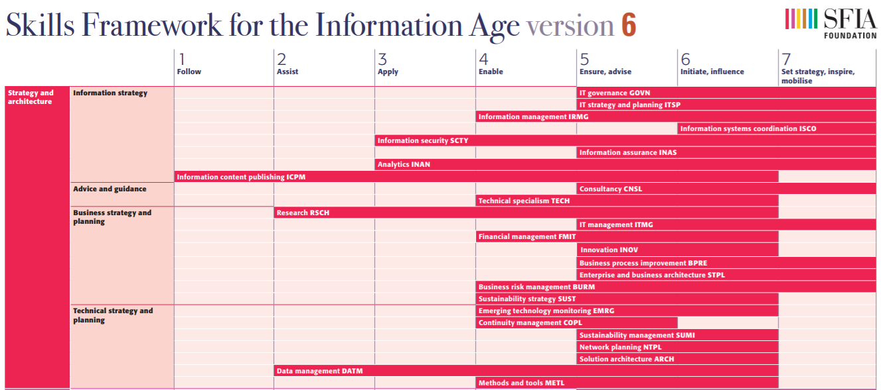

Source: https://www.sfia-online.org/en/sfia-6/framework-summary/view

**Example Service Desk Manager**: one might decide that a service desk manager requires some knowledge of a particular process framework and the specific service desk tools which are used in that organisation. They may also need specific industry experience, security clearance and defined qualifications.

In this example, SFIA would be used to define the generic level of responsibility (autonomy, influence, complexity and business skills), and the identified SFIA skills, which might, as an example, include customer service support (CSMG) at level 5, business process improvement (BPRE) at level 5, relationship management (RLMT) at level 4, IT management (ITMG) at level 5, and incident management (USUP) at level 5.

### SFIA – 2015 IBSA IT Framework mapping – Link to Training Packages

In late 2015 SFIA consultant Dennis Trevarthen from Ability Associates Australia worked with national skills body IBSA (Innovation and Business Skills Australia) to develop an IT Skills Framework (Figure 16). The objective was to create a framework that would guide further development of national qualifications and be capable of mapping to recognised schema like SFIA.

Figure 16 IBSA IT framework (IBSA 2015)

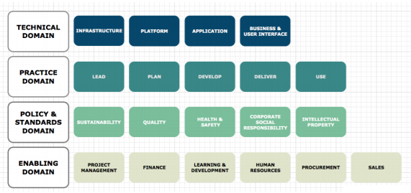

Source: <https://store.ibsa.org.au>

The framework introduced the concept of domains, placing technical skills at the centre with skills related to management practice, standards and policy supporting. Enabling domains supported the structure, but were not considered at the core.

Whilst the framework mapped to SFIA successfully, it identified some variation in emphasis with SFIA, especially regarding the relative place of enabling skills in IT. The SFIA strength in the practice domain was not found in associated national IT qualifications.

The paper presents a draft workforce skills framework and provides an explanation for the various dimensions. In addition, examples are provided on how the framework can be applied across training package, industry frameworks and workforce occupations. To be effective, the ICT workforce skills framework will be utilised to provide linkage between the Training Package, industry frameworks and the prevalent industry terminology used for various occupations.

The framework will potentially impact on these components of the ICT Training Package:

* The nomenclature, level and occupation outcomes for ICT qualifications.
* The scope and workforce focus of skill sets
* The performance focus and associated skills and knowledge required at the unit of competency level.

**Guiding Principles**

These principles have shaped the current approach to the framework: 1. It is possible to clearly differentiate between the types of skills applied in the ICT industry. 2. There are differences between working within the ICT industry, as opposed to using ICT skills across a range of other industries. 3. Generic business and other skills found across broad industry segments are not ICT industry skills. 4. Skills can be defined in core technical areas, organisational methods and process, compliance and enabling. 5. ICT skills can be identified across the range of AQF levels relevant to skill clusters.

6. Independence from third party frameworks is required, whilst providing for mapping and alignment where relevant.

**Framework Components**

The framework is made up of four domains, a number of associated skill clusters within each, and specific skills within each cluster. Domain Each domain represents a significant grouping of functions and skills that have a common role in supporting the ICT industry. Skill Cluster A skill cluster is a grouping of skills that contribute to a functional outcome within a domain. Skill A skill is an identified area of work performance that may contribute to one or more functional outcomes.

# Case 12 – Burning Glass: Real-time job data analysis

## Source

http://burning-glass.com/faq-on-real-time-jobs-data/

## Type

Real time labour market analytics

## About

Burning Glass Technologies is an analytics software company based in Boston and is playing a growing role in informing the global conversation on education and the workforce. according to the comanie's website its client base spans six continents, including education institutions, government workforce agencies, academic research centres, global recruitment and staffing agencies, major employers, and leading job boards. Since 2007, the company provides skill information services and planning tools based on a database that harbours information of job postings of a nation. This analytics offers can offer insights on which jobs are most in demand and the specific skills employers state.

## Purpose

Burning Glass Technologies delivers commercially job market analytics and publishes in-house research papers. The company website states that its services are designed to empowers employers, workers, and educators to make labour market data-driven decisions. Burning Glass strives to understand and share how the labour market works, with data that identify the skill gaps and tools that enable job seekers and employers to 'bridge that gap and connect more easily'.

## Operation

Real-time jobs data are compiled by scanning the internet daily using bots[[2]](#footnote-2) that seek out job postings on job boards, corporate websites, and other places where job ads are posted. For example, Burning Glass technology scans more than 40,000 sources, and at any given time, tracks about 3.4 million unique, currently active openings. To ensure that real-time figures provide a 'high fidelity' picture of the current job market, removing duplicate postings is an essential part of the collection process. Overall, close to 80% of all the postings Burning Glass collects are marked as duplicates. The software extracts top-line information about each job such as title, occupation, employer, and location, and then uses natural-language technology to read each job description to identify specific occupations, skills, and qualifications that employers are seeking. Job information is broken down into distinct elements and makes comparisons among them.

## Highlights

Identification, collection and update of skill descriptions

Real-time data represent an important complement to traditional survey-based labour market data, such as those produced by government agencies. First, job postings data provide a timely view on current market conditions. Some established labour data reports are based on observations that can be up to four years old, while the closely watched federal jobs report is released monthly. Fresh data is especially important in market areas experiencing rapid change.

In addition, real-time data can break down the job market to a precise level of detail. Traditional labour market data are structured around broad job categories, and all jobs within those categories are presumed to be identical in terms of the skills, experience, and education they require. By contrast, real-time job market data can be much more specific, reflecting how jobs differ within and across sectors and geographies.

A study published by the National Bureau of Economic Research concluded that job postings have become more specific over the last few years. The paper found that online job postings were 12% more likely to ask for specific cognitive skills, educational requirements, or experience levels in 2015 than in 2007 (Hershbein & Kahn 2016).

### Usage for stakeholders

#### Training planning

Many community-college systems in the US are turning to job-market data that are more up to date and more precise than ever before (Martinez 2016). The Kentucky Community and Technical College system, of which Big Sandy is part, is using data gathered from online job listings to develop more programs geared toward getting students ready for the work force. The system has been working with Burning Glass for about five years, and the real-time data are more current and detailed than data offered by the federal government, according to Alicia Crouch, the system’s vice chancellor for research and analysis (Martinez 2016).

"The federal [US] government might have data on the demand for ‘computer programmers,’ but you might know from your friends in IT that ‘computer programmer’ is not a very helpful term," says Matthew Sigelman, chief executive of Burning Glass. "Are employers looking for programmers in Java or .NET or C#? That’s what we’re looking for."

"Kentucky’s community-college system uses the job-market data to justify all new program development", says Ms Tracy. Just last week the system’s Board of Regents approved new associate-degree programs in electrical technology, physical therapy, and radiography (Martinez 2016).

## Illustration

The following illustration serves as an example of an informative output of an integrated occupational profile analysis using Burning Glass data.

In the US, the National Network of Business and Industry Associations (National Network) works to bridge the "skills gap" by better connecting the worlds of learning and work. The Network has partnered with a job vacancy analyst (Burning Glass Technologies) to develop occupational profiles that clearly articulate the skills and experience necessary for candidates to succeed in their job applications.

The resulting profiles reference specific data points that employers can use to build competency-based job descriptions, helping hiring managers communicate more effectively to job seekers, educational institutions, and training providers about the competencies they need to fill vacant positions.

Specifically, the profiles for any given occupation help to identify:

* Skills and certifications most valued by employers of the occupation
* Skills and competencies to emphasize in job descriptions
* Education and skill requirements that increase difficulty in filling a position in the occupation
* Alternative markets for sourcing talent to find qualified candidates.

The project resulted in 52 occupational profiles of the most in-demand jobs from across 17 of the National Network’s member industry associations. An example of a Solar Installer is provided in the following figure:

**Figure 17 Solar Installer Occupational Profile**

**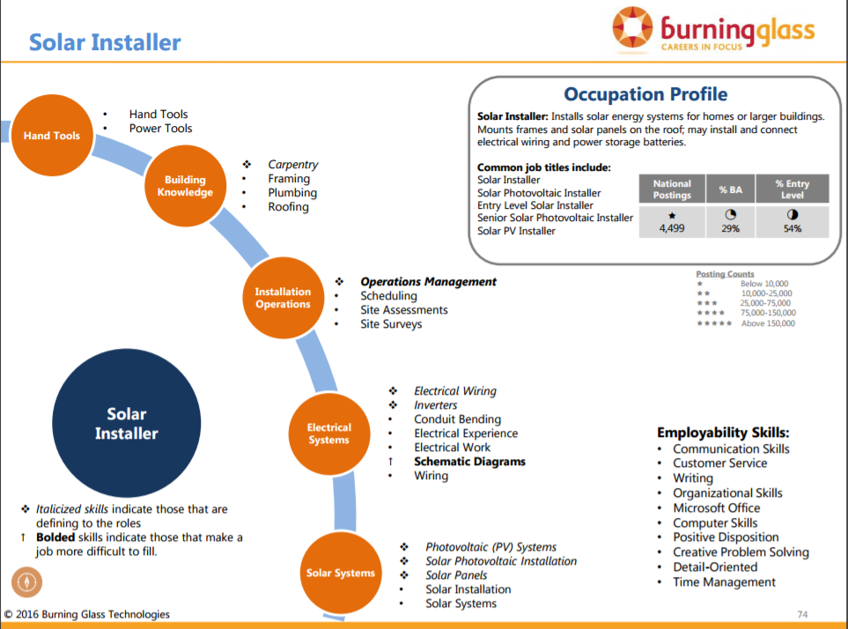**

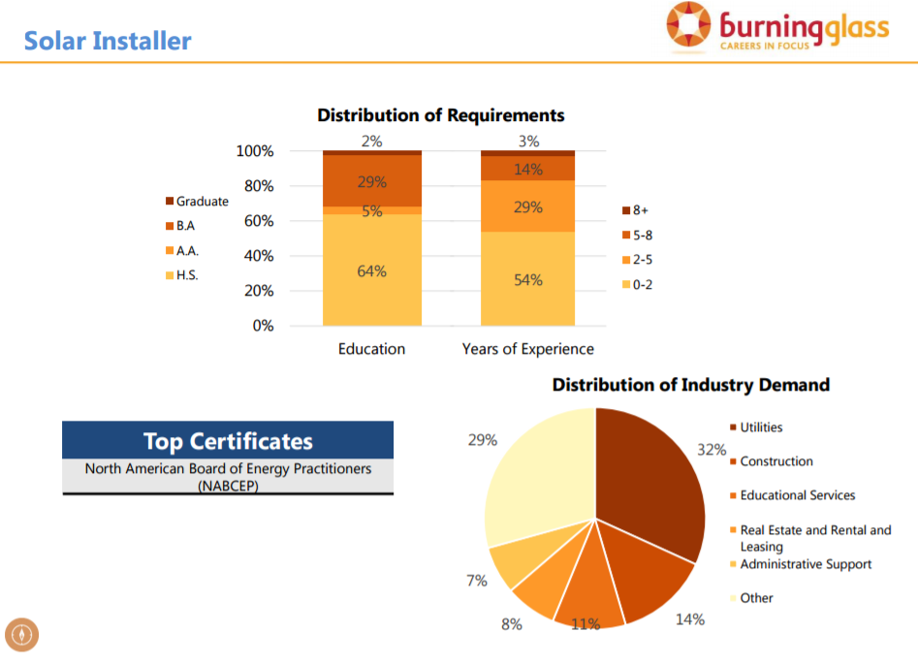

# Case 13 – NSW BVET/Wheelahan's and Moodie's Capabilities Framework

## Source

Report commissioned by NSW Board of Vocational Education and Training (now NSW Skills Board) and produced by Leesa Wheelahan and Gavin Moodie (2011) https://www.skillsboard.nsw.gov.au/sites/default/files/rethinking\_skills.pdf

## Type

Discussion paper including pilot proposals. The normative framework draws from capabilities approach developed by economist Amartya Sen (1985, 1992) and philosopher Martha Nussbaum (2000).

## About

The core characteristic of the capability approach is its focus on what people are effectively able to do and to be. In 2010 the New South Wales Board of Vocational Education and Training (BVET), (now NSW Skills Board) commissioned a paper to generate discussion about work, skill and qualifications. Commissioned researchers Wheelahan and Moodie (2011) based their focus on an individual's capability to deploy skills and knowledge for a successful working career. The capability approach is a broad normative framework for the evaluation and assessment of individual well‐being and social arrangements, the design of policies, and proposals about social change in society. This framework emphasises the importance of theoretical vocational knowledge.

## Purpose

To develop alternatives to the notion of competence underpinning competency based training and to transform vocational education further. While the paper presents suggestions for thinking about skill, it does not present a package of policy prescriptions that can be applied without problems (Wheelahan & Moodie 2011). The key rationale is that vocational education and training must prepare students for a broad occupation within loosely defined vocational streams rather than workplace tasks and roles associated with particular jobs.

## Operation

A capabilities framework relates the conditions individuals need to engage in to work and to progress through a career with the requirements of broad occupations. It focuses on what people need to be able to do to exercise complex judgements at work and what they need to be able to do in the future.

This approach recognises the diffuse study and employment destinations of VET graduates, while also recognising that there is a need to reform vocational qualifications by recognising the depth and complexity of vocational knowledge, as this is a core component of capability.

Learning outcomes, curriculum and pedagogy need to be based on the notion of development so that a key outcome of learning is that students are able to progress to the next level of knowledge and complexity of practice. A crucial component of a national VET qualifications framework would be accreditation of programs against the national standards by a group of experts.

The implications for policy are that the focus would move:

* in general**, from competencies to capabilities**
* **from products** (training packages, assessment materials etc) **to processes** (brokering standards, accreditation and assessment)
* **from qualifications based on workplace tasks** and roles **to qualifications that prepare students for broad occupations** within vocational streams.

## Highlights

### Implications for standards and assessment

The Capabilities Framework is an alternative approach to competence-based training (CBT) with a simpler version of standards. These standards would be based on preparing individual for broadly conceived occupations that have a number of different occupational destinations within a broad vocational stream. Standards would be based on the judgement of recognised experts as representing the best understanding at present for the needs of practice now and in the future in that broad occupational field. This would include the knowledge base of practice. National consistency and confidence in VET qualifications would be further supported by a national assessment framework.

### Information input

The capabilities approach starts with the person and not specific skills. An underpinning framework requires access to knowledge that underpins practice in occupations and professions, but also to industry specific knowledge and skills that transcends particular workplaces.

### Inclusion of providers and teachers

Wheelahan and Moodie (2011) emphasise that providers and teachers are more likely to invest in a program when they have developed the curriculum and assessment and this is more likely to be responsive to local needs. It would require negotiation over the development of the curriculum, the knowledge base, skills, and the nature of work placements. Collaboration between training organisations, teachers, and industry experts on curriculum, teaching and learning and assessment would help to increase trust in the outcome of, and reduce the risks associated with, assessment.

A capabilities approach is also thought help provide more curricular coherence between VET and higher education, support pathways and help overcome discontinuities in flows in education particularly if both seek self-directed individuals. The authors make comparisons with the German notion of 'Beruf', supporting the development of autonomous reasoning will require access to a systematically related body of theoretical knowledge, a set of practical skills, and a social identity within an occupation or vocation.

## Illustration

Options for piloting the new approaches outlined in this paper are suggested (Wheelahan & Moodie 2011, p.30-31) for Engineering, Aged care, Tourism & Hospitality.

### Engineering Australia

Engineers Australia’s national generic competency standards for associate engineers (which generally require an advanced diploma or associate degree) have three broad domains which are: knowledge base; engineering ability; and, professional attributes. The development of a simpler set of standards that covered the knowledge base of practice, industry specific requirements, and professional attributes would result in a better focus on the development of the individual in the context of their broad occupation. They would also underpin nationally portable qualifications.

### THE ICE accrediting body

The International Centre of Excellence in Tourism and Hospitality Education is a not-for-profit international accreditation and quality assurance agency. Originally established and funded by the Australian Federal Government (2004 – 2008), THE-ICE was awarded to and managed by the Sustainable Tourism Cooperative Research Centre (STCRC), the largest tourism and hospitality scientific research centre in the world at that time. With the endorsement and support of the Australian government, THE-ICE designed, developed and implemented strategic activities to:

* recognise excellence in tourism and hospitality education in Australia
* help in furthering the development of that excellence
* aid in the promotion of that excellence to future international students.

Today THE-ICE is a global network 32 institutions comprising of public and private universities, vocational institutions and private hotel schools from 14 countries.

# References

European Commission, 2017, ESCO Strategic framework European Skills, Competences, Qualifications and Occupations, accessed 12/8/2017, at <https://ec.europa.eu/esco/portal/document/en/01192a20-a7c0-4d0d-b5d3-29d1f9b819c8>.

Handel, MJ 2016, ‘The O\*NET content model: strengths and limitations’, Journal of Labour Market Research, vol.49, issue 2, pp.157—76.

Hershbein, B & Kahn LB 2016, Do Recessions Accelerate Routine-Biased Technological Change? Evidence from Vacancy Postings, NBER Working Paper No. 22762, The [US] National Bureau of Economic Research, Cambridge, MA.

Innovation and Business Skills Australia (IBSA) 2015, ICT WORKFORCE SKILLS FRAMEWORK, Discussion Paper, Innovation & Business Skills Australia, Melbourne.

Learning and Skills Improvement Service 2013, Enhancing employability and career development: Models and strategies for the further education and skills sector, Learning and Skills Improvement Service (LSIS), UK.

Martinez, A 2016, How Community Colleges Use Job-Market Data to Develop New Programs, The Chronicle of Higher Education, viewed 1 October 2017, <http://www.chronicle.com/article/How-Community-Colleges-Use/236802>.

OECD 2016, Getting Skills Right: Assessing and Anticipating Changing Skill Needs, OECD Publishing, Paris.

OECD 2017, Getting Skills Right: Skills for Jobs Indicators, OECD Publishing, Paris.

Vandewyer, M 2017 The OECD Skills for Jobs database. OECD Skills and Work, viewed 26 October 2017, <https://oecdskillsandwork.wordpress.com/2017/07/09/the-oecd-skills-for-jobs-database/>.

Wheelahan, L and Moodie, G 2011, Rethinking skills in vocational education and training: from competencies to capabilities. New South Wales Board of Vocational Education and Training (BVET), NSW Department of Education and Communities, Sydney

1. For each competition there least two workshops (innovation labs) where project teams share lessons learned and work together to address common problems. The workshop crucially depends upon a commitment from projects to engage fully with the day. There is an expectation to have at least two senior individuals from each project to attend the labs, and there will often be activities to complete in advance. [↑](#footnote-ref-1)
2. Bots, also known as web robot, are a software applications that runs automated tasks (scripts) over the Internet. [↑](#footnote-ref-2)