GOOD
GUIDE
PRACTICE

TEACHING DIGITAL SKILLS: IMPLICATIONS FOR VET EDUCATORS
The rise of Industry 4.0 and the digital economy has highlighted the need for the general workforce to hold digital skills. But what are the implications for vocational education and training (VET) educators in ensuring the workforce is appropriately skilled?

This good practice guide focuses on the implications for VET educators of the increasing need to include digital skills in VET delivery.
KEY MESSAGES
- It is critical that VET educators have the capacity to: use technology effectively in their teaching practice; use technology that is relevant to their industry; and help learners to develop their own digital skills.
- Professional development activities for building the
digital capability of VET educators can take many forms, including self-assessment tools, competency frameworks and short courses.
- Key to the successful uptake of digital skills capability
development by VET educators is a whole-of- organisation approach to the adoption and utilisation of digital skills.
A forum convened by NCVER in late 2019, VET’s response to Industry 4.0 and the digital economy: what works, has helped to shape this guide.
Participants at the forum included representatives from skills service organisations, members of the Education Industry Reference Committee, industry,
provider and practitioner-related bodies, policy makers, and relevant researchers.
A companion good practice guide has been developed for VET providers and policy makers focusing on the incorporation of digital skills into VET delivery.

TEACHING TECHNOLOGY AND TEACHING WITH TECHNOLOGY: THERE IS A DIFFERENCE
2

The rapid changes in technology, both in workplaces and everyday life, together with the ubiquity of digital devices and applications, mean that it is imperative for VET educators to develop their own digital skills and keep them current. This is important, as future VET students may very likely have greater levels of digital skills than the VET educators themselves. At the same time they may also expect the educators to use digital technologies to provide a flexible, convenient and engaging learning experience (Medlin 2016; Reeson et al. 2016).
The importance of possessing both the technological and pedagogical competencies to use digital technology is highlighted in a case study where augmented reality (AR) tools in training, assessment and workplace orientation were introduced. The case study is based on a forum participant’s experiences in recent years in engaging with new technologies — both in the workplace and the classroom — in their role as a training manager. Here the implications for VET educators of introducing new digital tools into a VET course are shown, with the concept of a ‘digital integrator’ described.

AUGMENTED REALITY IN TRAINING – IMPLICATIONS FOR VET EDUCATORS

Augmented reality (AR) app
An AR app was designed for workers producing the concrete panels used in lining the tunnels of a major rail infrastructure project in Sydney. Most of these workers were low-skilled and needed training in the areas of safety, quality, teamwork and communication. As the manufacturing plant had not yet been mobilised and training had to be delivered prior to workers accessing the worksite, the app was developed to enable practical assessments to be conducted in instances where accessing equipment and machinery was logistically impractical. Using AR for heavy plant and equipment allowed the workers to become familiar with the risks associated with manual handling and provided an interactive instructional mode of delivery. The app was activated using a QR code on tablets that highlighted hotspots, and provided ‘360’ videos, text and other key learning activities.

Augmented reality tool
A large engineering contractor commissioned the development of a comprehensive AR tool to provide workers with a simulated orientation to their worksite. The key focus was on safety, along with a clear explanation of the mission,
vision and values of the organisation. Much time and resources were invested into the design of the AR orientation – an immersive experience – with the feedback from students very positive. The RTO engaged to provide the training for these workers was tasked with facilitating the worksite orientation at the commencement of the training program,
using the AR tool.
Key learnings
- In relation to the AR app, based on feedback from both the workers and the trainers, it was identified that the technology could have been more effectively integrated into the delivery of the course in manual handling. To improve this, the training manager concluded that a ‘digital integrator’ was necessary. This individual would hold
dual competencies in digital tools and pedagogic practice to provide on-the-ground assistance during the planning and implementation phases. Mapping key learning outcomes and embedding the technology seamlessly into the course can be enabled through this critical role.
- In relation to the AR tool, while the students were very positive in their feedback about the tool having provided
them with an immersive experience, the training manager found that some trainers had difficulty transitioning from a more traditional style of teaching to using emerging technologies. Identifying the attitude and aptitude levels of users beforehand and their digital literacy, as well as worker/student profiles, are important. A digital integrator, someone who acts as the liaison between all parties, can facilitate the adoption of technology and support new users through this learning experience.
- Trainers also need mentoring in technical skills to support them to become proficient in using apps and tools and to
get the most value from them.

What then is needed to support the capability development of VET educators to enable them to be both competent users of technology and competent in teaching technology?

INCORPORATING DIGITAL SKILLS INTO VET DELIVERY: GOOD PRACTICE GUIDE

BUILDING THE DIGITAL SKILLS CAPABILITY OF VET EDUCATORS

- Using or developing self-assessment frameworks or tools is a good way to determine an educator’s baseline level of digital skills capability. From there, targeted professional development activities can be mapped. Examples of self- assessment frameworks or tools include:
  - The Digital Capability Framework and self-assessment questionnaire developed for the agricultural industry as part of the Growing a Digital Future initiative, managed by the Cotton Research and Development Corporation. While the focus in this tool is on developing the Australian agricultural workforce, the capability framework and self-assessment questionnaire are both relevant to the digital skills of VET educators, given that they are focused on digital literacy, digital communication, business transformation, and personal learning and mastery.
  - The Professional Educator College professional development application — the Educator Passport — provided by Chisholm TAFE to its educators, enabling them to assess their professional development needs, including digital skills. This tool also allows educators to register for professional development programs and track their progress.
- Tied to the increasing need to use technologies in their teaching practice is the requirement to change pedagogy to ensure that digital tools are used effectively not only in teaching but also in course design and assessment. The
European Framework for the Digital Competencies of Educators (DigCompEdu) outlines the key areas of competency required by educators as they deepen their engagement with digital learning and digital pedagogies. The key competency areas are shown in the figure below (Redecker 2017).
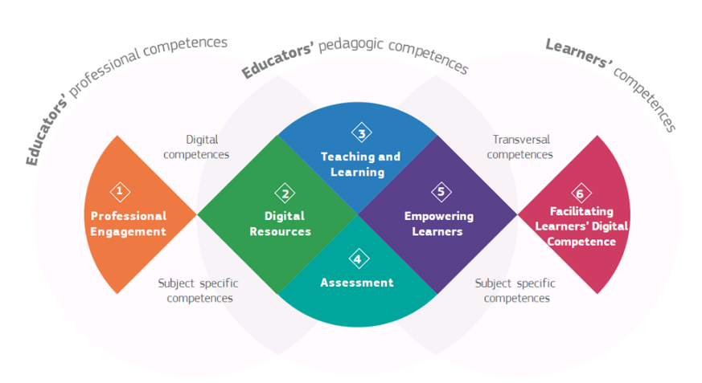

- A similar framework, and adapted from the DigCompEdu, is the Digital Teaching Professional Framework, developed by the Education and Training Foundation in the United Kingdom. The competencies in this framework focus on the relationship between good pedagogy and technology to enhance learning experiences. The key competency areas in this framework are:

  - planning your teaching
  - approaches to teaching
  - supporting learners to develop employability skills
  - subject-specific and industry-specific teaching
  - assessment
  - accessibility and inclusion
  - self-development

- VET educators need access to a suite of units or short courses, from which they can pick and choose to fill their identified digital skills gaps, as determined through a self-assessment tool. Upskilling opportunities provided in this way should be separate from, but complementary to, the Certificate IV in Training and Assessment.
  - The Enhance Digital Teaching Platform developed by the UK Education and Teaching Foundation provides VET educators and assessors with access to free, short, certified online self-learning training modules. These modules are mapped to the Digital Teaching Professional Framework, described above, and are designed to improve the use of technology in teaching and assessment to enhance learners’ experiences and outcomes.

NATIONAL CENTRE FOR VOCATIONAL EDUCATION RESEARCH
3

- To ensure industry currency, VET educators also need opportunities to engage with industry to identify the technology being used and how it is used. Options for this include joining industry associations, talking to people in industry or spending time working in the industry each year. Additionally, industry experts could visit learning sites to discuss the latest technologies with educators.

SUPPORTING THE DIGITAL SKILLS PROFESSIONAL DEVELOPMENT OF VET EDUCATORS

- A whole-of-organisation approach to digital skills adoption and utilisation is needed to facilitate and support the digital skills capability development of VET educators. This approach should consider both organisational responsibilities (such as leadership and governance, and infrastructure) and individual responsibilities (such as teaching and learning practices).
  - The European Union’s Digitally Competent Educational Organisations framework provides a useful structure for identifying the pedagogical, technological and/or organisational aspects a VET institution or provider may need to develop or enhance to support the digital skills capability of VET educators (Kampylis, Punie & Devine 2015).
- More broadly, national investment strategies that support a strategic approach to the ongoing digital skills
capability of the VET educator workforce could be considered. Reframing the Future, the staff development and change management initiative funded through the Australian and state and territory governments for about 10 years from the late 1990s, is an example of a national approach to the skills development of the VET workforce. A similar focus on funding national projects to assist in the development of the digital skills capability of the VET workforce and the subsequent sharing of learnings could be considered.

REFERENCES

Kampylis, P, Punie, Y & Devine, J 2015, Promoting effective digital-age learning: a European framework for digitally competent educational organisations, Publications Office of the European Union, Luxembourg.
Medlin, J 2016, The Australian literacy and numeracy workforce: a literature review, NCVER, Adelaide.
Redecker, C 2017, European Framework for the Digital Competence of Educators: DigCompEdu, Publications Office of the European Union, Luxembourg.
Reeson, A, Mason, C, Sanderson, T, Bratanova, A & Hajkowicz, S 2016, The VET era: equipping Australia’s workforce for the future digital economy, CSIRO, Clayton, Vic., viewed 21 August 2019, <https://web.archive.org/ web/20180312142624/http://tafeqld.edu.au/resources/pdf/about-us/research-papers/vet-era.pdf>.
UK Education and Training Foundation, ‘EdTech and digital skills support’, viewed 27 March 2020,
<https://www.et-foundation.co.uk/supporting/support-practitioners/edtech-support/>.

FOR MORE INFORMATION

These findings are based on an invitation-only forum held by NCVER, VET’s response to Industry 4.0 and the digital economy: what works, in November 2019. Additional related publications published by NCVER are:
VET’s response to Industry 4.0 and the digital economy: what works — support document by Bridget Wibrow, Michelle Circelli and Patrick Korbel, and Incorporating digital skills into VET delivery — good practice guide. Both are available at <www.ncver.edu.au>.
www.linkedin.com/company/ncver
twitter.com/ncver
ISBN 978-1-925717-51-8
TD/TNC 140.02
Published by NCVER ABN 87 007 967 311
Level 5, 60 Light Square, Adelaide 5000
PO Box 8288, Station Arcade, Adelaide SA 5000, Australia
P +61 8 8230 8400 E ncver@ncver.edu.au
W www.ncver.edu.au
© Commonwealth of Australia, 2020
This work has been produced by the National Centre for Vocational Education Research (NCVER) on behalf of the Australian Government and state and territory governments with funding provided through the Australian Department of Education, Skills and Employment.

