

**TECHNICAL PAPER**

**Student Outcomes Survey: self-reported graduate model review**

**Ben Sanders**National Centre for Vocational Education Research

### Publisher’s note

The views and opinions expressed in this document are those of NCVER and do not necessarily reflect the views of the Australian Government, or state and territory governments. Any interpretation of data is the responsibility of the author/project team.

InBug-16px_0Twitter_blackbox

**© National Centre for Vocational Education Research, 2018**

CC BY logo

With the exception of the Commonwealth Coat of Arms, the Department’s logo, any material protected by a trade mark and where otherwise noted all material presented in this document is provided under a Creative Commons Attribution 3.0 Australia <http://creativecommons.org/licenses/by/3.0/au> licence.

The details of the relevant licence conditions are available on the Creative Commons website (accessible using the links provided) as is the full legal code for the CC BY 3.0 AU licence <http://creativecommons.org/licenses/by/3.0/legalcode>.

The Creative Commons licence conditions do not apply to all logos, graphic design, artwork and photographs. Requests and enquiries concerning other reproduction and rights should be directed to the National Centre for Vocational Education Research (NCVER).

This document should be attributed as Sanders, B 2018, *Student Outcomes Survey: self-reported graduate model review,* NCVER, Adelaide.

This work has been produced by NCVER on behalf of the Australian Government and state and territory governments, with funding provided through the Australian Government Department of Education and Training.

COVER IMAGE: GETTY IMAGES/iStock

ISBN 978 1 925717 13 6

TD/TNC 131.01

Published by NCVER, ABN 87 007 967 311

Level 5, 60 Light Square, Adelaide SA 5000  
PO Box 8288 Station Arcade, Adelaide SA 5000, Australia

**Phone** +61 8 8230 8400 **Email** [ncver@ncver.edu.au](mailto:ncver@ncver.edu.au)   
**Web** <https://www.ncver.edu.au> <<http://www.lsay.edu.au>>

**Follow us:** <https://twitter.com/ncver> <https://www.linkedin.com/company/ncver>

Contents

Introduction 5

Methodology 6

Determining the status of self-reported graduates 6

Options considered 7

Results 8

Evaluating the options 8

Conclusion 10

Appendix A 11

Difference between total VET and government-funded student outcomes 11

Appendix B 13

Summary of VET data quality, 2007–17 13

Appendix C 15

Results for key survey measures under two different methods 15

Appendix D 21

Correctly classifying SRGs into their group under the new methodology 21

Correctly classifying SRGs into their group under the original methodology 22

References 23

# Tables and figures

## Tables

A1 Government-funded student outcomes scope matrix 11

A2 VET graduate outcomes scope matrix 12

B1 Percentage of self-reported graduates out all subject completers at sampling, 2007—17 14

C1 Comparison of government-funded SOS key measures using the model and the exact results to classify SRGs for the SOS, 2009 15

C2 Comparison of government-funded SOS key measures using the status of self-reported graduates at sampling and the exact results to classify SRGs for the SOS, 2009 16

C3 Comparison of government-funded SOS key measures using the model and the exact results to classify SRGs for the SOS, 2015 17

C4 Comparison of government-funded SOS key measures using the status of self-reported graduates at sampling and the exact results to classify SRGs for the SOS, 2015 18

C5 Comparison of government-funded SOS key measures using the model and the exact results to classify SRGs for the SOS, 2016 19

C6 Comparison of government-funded SOS key measures using the status of self-reported graduates at sampling and the exact results to classify SRGs for the SOS, 2016 20

## Figures

1 Correct Classification under the five options for determining group membership of SRGs for the 2015 SOS 8

2 Correct Classification under the five options for determining group membership of SRGs for the 2016 SOS 9

B1 Number of SRGs for ‘big’ SOS years, 2007—15 13

B2 Number of SRGs for ‘small’ SOS years, 2008—17 13

D1 Percentage of correctly classified SOS self-reported graduates under new methodology, 2009, 2015, and 2016 21

D2 Percentage of correctly classified SOS self-reported graduates under original methodology, 2009, 2015, and 2016 22

# Introduction

The National Student Outcomes Survey (SOS) collects information about students who completed their vocational education and training (VET) in the previous calendar year. The gathered information on the surveyed VET students includes their reasons for training, employment outcomes, satisfaction with training, and further study outcomes. The survey covers students who have completed a qualification (graduates) and those who have completed only part of a course and then left the VET system (subject completers). The National Centre for Vocational Education Research (NCVER) has conducted the survey with government-funded VET students annually since 1999. In 2016, the scope of the survey was expanded to report on the outcomes of graduates whose training was Commonwealth— or state—funded as well as fee-for-service graduates. These graduates were referred to as total VET graduates. An explanation of the difference between total VET and government-funded student outcomes can be found in appendix A. The expanded scope was applied to the 2017 survey for graduates (following a successful trial in 2016) and for the first time for subject completers and the series renamed VET student outcomes.

At the time of sample selection, insufficient information is available from the National VET Provider Collection to identify ‘actual’ subject completers. Instead, a sample of potential subject completers is chosen, which includes students who are continuing in the VET system. The status of respondents is determined through the survey responses. As such, respondents to the SOS include a number of students who were sampled as subject completers based on administrative data reported to the National VET Provider Collection, but self-identify in the questionnaire as graduates. For many years these ‘self-reported graduates’ (SRGs) were categorised as graduates in survey outputs, because the self-report was deemed to be more reliable than the collection data. However, it became apparent that many SRGs were not, in fact, graduates. In response to this issue, in 2012, NCVER created a logistic model that predicted the eligibility of a SRG being an ‘actual’ graduate based on their personal and training characteristics (Braysher 2012). This model has since been run annually for each SOS to assign group membership to SRGs. Those SRGs that were not predicted by the model to be a graduate were re-assigned to their original subject completer status.

One of the conditions of the initial analysis was that the model should be reviewed at least every four years to assess its ongoing validity and to make possible modifications should demographics and administrative data change and alter the predictive power of the model. The model was reviewed by NCVER in 2015 (unpublished). The review found some changes in data quality, but found no evidence that these changes were affecting the estimates. At the time no changes were recommended to the logistic model or graduate reclassification procedure, but it was recommended that the model be reviewed again at a later stage. In relation to data quality, the proportion of subject completers claiming to be self-reported graduates has declined significantly since 2007, particularly from 2015 to 2017, highlighting the improvement in the quality of the National VET Provider Collection data since the need to run the model arose (appendix B). Hence, it was appropriate to review the model again. This report presents the findings of an additional comprehensive review of the model and methodology.

# Methodology

## Determining the status of self-reported graduates (SRGs)

By definition, a Student Outcomes Survey (SOS) graduate must have completed their training in the previous calendar year to that of the survey. For example, to be an eligible graduate for the 2017 SOS, the student must have completed their training and been awarded a qualification in 2016. Furthermore, the qualification they received must be the same as that recorded in the National VET Provider Collection, which is used as the survey sampling frame.

In the process of creating a logistic model to predict the status of SRGs, it is necessary to determine the ‘true’ status of SRGs. For the analysis presented in this report, the set of rules/conditions used was based on data from three National VET Provider Collections for each SOS. Under the original methodology, students were considered eligible graduates if:

1. in any of the three relevant collections (corresponding to the source year and the two subsequent years) they were recorded as having completed a qualification in the source year
2. the qualification they received in the source year was the same as that for which they were sampled
3. they were recorded as having completed a qualification in the first year subsequent to the source year, and this qualification was the same as that for which they were sampled.

Note that SRGs meeting condition C are not graduates according to the SOS definition because they completed their training in the year of the survey rather than in the previous year. In this report we also consider using an alternative rule to classify SRGs as graduates: a SRG is considered to be a graduate if they meet conditions A and B above. This distinction has a significant effect on the predictive power of the logistic model when classifying self-reported graduates and also on some of the key survey measures from the SOS, which will be highlighted in this report.

To fit the logistic model, a data set that contained every SRG for each SOS from years 2007-09 was created that contained their personal and training characteristics, as well as their responses to the SOS. Using the relevant VET Provider Collections and rules stated previously, a variable was added to this data set that indicated whether a SRG was indeed eligible to be considered a graduate. This variable, representing a student’s eligibility, was treated as the binary response variable for the logistic model. For each SOS, the model fitted to the data set of 2007—09 SRGs is used to determine the probability of being a graduate for each of the students in the SOS of interest. An implication of this method is that we are assuming the SRGs from 2007—09 are representative of the SRG population for the SOS year of interest. It is conceivable that the characteristics that make up a SRG in 2017 or any other year could be different to that of those that made up one in 2007—09. Hence, this assumption could have significant implications and may not be appropriate.

## Options considered

In order to determine the best strategy going forward for group classification for those students who self-report as graduates in the SOS, five methods were considered and investigated:

1. Continue using the current method (logistic model based on 2007—09 data) and eligibility rules as developed by NCVER (A+B+C).
2. Continue using the current method (logistic model based on 2007—09 data) but with the updated eligibility rules (A+B).
3. Use a logistic model based on 2012—14 data with the updated eligibility rules.
4. Keep the status of all SRGs as they are at sampling, i.e. subject completers. It must be noted that after these students are kept as subject completers, they are then run through a process using their survey responses to determine whether they are continuing in the VET sector or not. Continuing students are not included in outputs published by NCVER.
5. Noting quarterly reporting is only available for government-funded data, for non-government funded records, keep the status of SRGs as they are at sampling – subject completers. For government-funded data, change the status of a SRG from subject completer to graduate if they are reported as an eligible graduate in the quarterly VET data collection from the first quarter of the year following the source year; otherwise, leave the status of SRGs as they are at sampling – subject completers.

Note that options 1, 2 and 3 all employ a logistic model with the original predictor variables of the model.

# Results

## Evaluating the options

To investigate the accuracy of each of the options, the percentage of correctly classified self-reported graduates for the 2009, 2015 and 2016 surveys, as well as the difference between estimates of key variables produced using the ‘exact’ classification of SRGs and the classification using the option was calculated. The ‘exact’ group that each SRG belonged to was determined using the relevant VET Provider Collections. For each SOS, three collections were used to govern whether a student was an eligible graduate. The collections used were: the collection from which the survey sample was selected (the source collection) and the two subsequent collections. To be considered an ‘exact’ graduate, a student must have completed their training in the previous calendar year to that of the survey, and that the recorded completion was the same program as the one they were sampled for in the SOS. This is consistent with how a graduate is defined for the SOS (using eligibility rules A+B). Using this ‘exact’ classification, the percentage of correctly classified SRGs can be determined.

Each of the five options considered were employed for the 2015 and 2016 SOS, and their correct classification percentage[[1]](#footnote-1) is illustrated in figure 1 and figure 2.

Figure 1 Correct classification under the five options for determining group membership of SRGs for the 2015 SOS

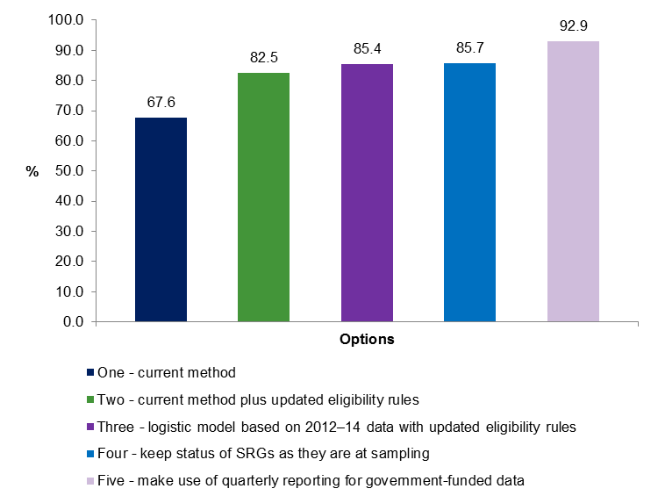

Figure 2 Correct classification under the five options for determining group membership of SRGs for the 2016 SOS

A comparison was then made as to whether using the model was more appropriate than just leaving the SRGs as they were at the time of sampling – subject completers. This was done by analysing how well the two methods predicted some of the key survey measures for the SOS in the chosen years. In this context, results for the key survey measures under the two methods were considered ‘accurate’ if there was no significant difference between them and the ‘exact’ results. It was observed that leaving the SRGs as subject completers will produce results for the key survey measures that are as good as, if not better than, the results that are calculated when the model is used (refer to appendix C). To validate the assumption, that leaving the SRGs as subject completers is more appropriate than using the model, the percentage of correct classifications was found to be higher in each of the chosen surveys when the SRGs were left as subject completers (refer to appendix D). However, it must be noted that if the methodology is changed, and the original rules (A+B+C) for eligibility are applied to determine the ‘exact’ group each student belongs to, then it is seen that the model performs slightly better (in terms of correct classification percentage) than leaving the students as subject completers (refer to appendix D).

# Conclusion

When analysing figures 1 and 2, it is noted that option five yields the best results in terms of correctly classifying the SRGs into their group. However, total VET activity (TVA) data are not reported quarterly, and so this option would not allow a consistent method of classifying SRGs across the SOS. The next best option in terms of correctly classifying the SRGs into their group is option four, which enables a consistent approach in determining what group a student belongs to in both government-funded and TVA data. Discontinuing the use of the model can also be justified by observing how the number of SRGs over the past ten years has seen a decline. There has also been a noticeable decrease in the percentage of SRGs out of the total number of subject completers at sampling since 2015 (a decrease from 33.2% in 2015 to 12.1% in 2017) (refer to appendix B). These results coincide with quarterly reporting for government-funded data being introduced in the 2015 survey (2014 National VET Provider Collection). With this quarterly reporting, data quality has likely been improved, and in turn the impact of lags in reporting have diminished, resulting in less SRGs in the SOS. This gives further evidence that abandoning the use of the model now may be the most appropriate time to do it.

In final, the recommendation going forward is to employ option four. That is, keeping the SRGs as they are at the time of sampling – subject completers. However, if at some point in the future TVA data are reported quarterly as well, then utilising option five may be the best and most suitable approach to classifying the group status of self-reported graduates.

For the 2017 SOS, option four was used to classify self-reported graduates. NCVER back casted data for the 2016 survey, employing option four as the classification method for SRGs. All surveys prior to, and including 2015 were not back casted, as the need to utilise this new methodology was not required during this period.

# 

# Appendix A

## Difference between total VET and government-funded student outcomes

The National Student Outcomes Survey is undertaken as a stratified, randomly selected sample from the National VET Provider Collection. In 2016, the National Centre for Vocational Education Research released two publications containing data from the National Student Outcomes Survey:

* *Government-funded student outcomes*
* *Total VET graduate outcomes*.

There are distinct differences in the data reported under these two scopes.

### *Government-funded student outcomes*

*Government-funded student outcomes* provides information on the outcomes of students who completed government-funded VET in Australia. In 2016 this was broadly defined as all activity delivered by government providers and government-funded activity delivered by community education and private training providers (see table A1).

Table A1 *Government-funded student outcomes* scope matrix

|  |  |  |  |
| --- | --- | --- | --- |
|  | TAFE and other government providers1 | Community education providers | Private training providers |
| Commonwealth and state funding | ✓ | ✓ | ✓ |
| Domestic fee-for-service2 | ✓ | ✗ | ✗ |
| International fee-for-service | ✗ | ✗ | ✗ |

Note: 1. In the Government-funded student outcomes publication, universities are reported as ‘TAFE and other government providers’.

2. In 2017 the government-funded scope was changed to not include domestic fee-for-service students. Results are based on the 2016 scope.

### *Total VET graduate outcomes*

*Total VET graduate outcomes* provide information on the outcomes of graduates who completed their VET in Australia. It includes the outcomes of graduates in receipt of Commonwealth— or state—funding, as well as those who paid for their training (see table A2). The mandatory reporting of nationally recognised training activity to the National VET Provider Collection provided a sampling frame to expand the scope of the National Student Outcomes Survey to include fee-for-service graduates from private training and community education providers. Fee-for-service graduates are those who paid for the training or whose employer paid for the training.

Table A2 Total *VET graduate outcomes* scope matrix

|  |  |  |  |
| --- | --- | --- | --- |
|  | TAFE and other government providers | Community education providers | Private training providers |
| Commonwealth and state funding | ✓ | ✓ | ✓ |
| Domestic fee-for-service | ✓ | ✓ | ✓ |
| International fee-for-service | ✗ | ✗ | ✗ |

In 2017, total VET subject completers have been included and the series has been renamed VET student outcomes.

# Appendix B

## Summary of VET data quality, 2007–17

Since 2010, the total number of self-reported graduates in each SOS has followed a decreasing trend (figures B1 and B2). To allow for years in this time series to be comparable, they were split into ‘big’ and ‘small’ SOS years.[[2]](#footnote-2), [[3]](#footnote-3), [[4]](#footnote-4)

Figure B1 Number of SRGs for ‘big’ SOS years, 2007–17

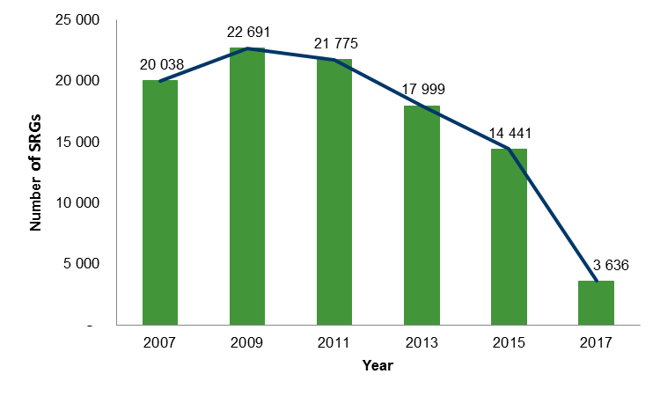

Figure B2 Number of SRGs for ‘small’ SOS years, 2008–16

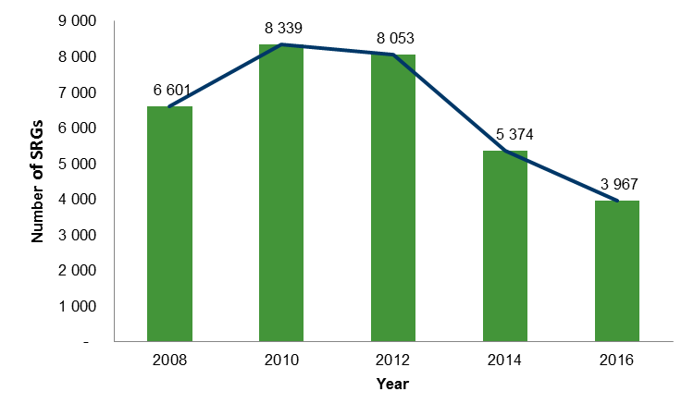

Improvements in data quality have a direct impact on group classification for students in the SOS, specifically the self-reported graduates. Table B1 displays how the percentage of SOS self-reported graduates out of the total number of subject completers at sampling has dropped dramatically since 2015. This is likely attributed to the introduction in 2015 of quarterly reporting for government-funded data.

Table B1 Percentage of self-reported graduates out of all subject completers at sampling,   
2007–17

|  |  |
| --- | --- |
| Year | Per cent (%) |
| 2007 | 29.1 |
| 2008 | 29.2 |
| 2009 | 30.1 |
| 2010 | 31.4 |
| 2011 | 32.8 |
| 2012 | 35.7 |
| 2013 | 33.8 |
| 2014 | 33.9 |
| 2015 | 33.2 |
| 2016 | 24.5 |
| 2017 | 12.1 |

# Appendix C

## Results for key survey measures under two different methods

Tables C1—C6 display key survey measures for the 2009, 2015 and 2016 SOS under two methods (the model, and leaving the SRGs as subject completers) and comparing them with the ‘exact’ results for the estimates.[[5]](#footnote-5) The highlighted cells in each table represent a statistically significant difference between the estimate when SRGs are classified using VET Provider Collection data (labelled Exact), and the estimate calculated when SRGs are classified under the method used. Statistical significance was assessed using a two-sample t-test with significance level 0.05.

Table C1 Comparison of government-funded SOS key measures using the model and the exact results to classify SRGs for the SOS, 2009

|  |  |  |  |  |  |
| --- | --- | --- | --- | --- | --- |
|  | Exact | Model | Margin of error | Margin of error | Significance testing |
|  | % | % |  |  |  |
| Graduates |  |  |  |  |  |
| Employed after training | 78.9 | 79.7 | 0.5 | 0.5 | sig dif |
| Employed or in further study after training | 89.0 | 89.6 | 0.4 | 0.4 | sig dif |
| Enrolled in further study after training | 35.4 | 35.0 | 0.6 | 0.6 | similar |
| Achieved main reason for doing the training | 85.8 | 86.1 | 0.4 | 0.4 | similar |
| Satisfied with the overall quality of training | 88.7 | 88.5 | 0.4 | 0.4 | similar |
| Of those employed after training |  |  |  |  |  |
| Found the training relevant to their current job | 79.3 | 79.7 | 0.6 | 0.5 | similar |
| Received at least one job-related benefit | 75.3 | 75.8 | 0.6 | 0.6 | similar |
| Of those not employed before training |  |  |  |  |  |
| Employed after training | 46.5 | 47.8 | 1.3 | 1.2 | similar |
| Of those employed before training |  |  |  |  |  |
| Employed after training at a higher skill level | 24.5 | 25.1 | 0.7 | 0.7 | similar |
| Subject completers |  |  |  |  |  |
| Employed after training | 74.9 | 74.7 | 0.6 | 0.6 | similar |
| Employed or in further study after training | 79.4 | 78.6 | 0.5 | 0.5 | sig dif |
| Enrolled in further study after training | 14.6 | 8.9 | 0.4 | 0.3 | sig dif |
| Achieved main reason for doing the training | 83.8 | 83.7 | 0.5 | 0.5 | similar |
| Satisfied with the overall quality of training | 86.2 | 86.2 | 0.5 | 0.5 | similar |
| Of those employed after training |  |  |  |  |  |
| Found the training relevant to their current job | 68.7 | 68.1 | 0.7 | 0.7 | similar |
| Received at least one job-related benefit | 60.0 | 58.8 | 0.7 | 0.8 | sig dif |
| Of those not employed before training |  |  |  |  |  |
| Employed after training | 31.6 | 30.4 | 1.2 | 1.3 | similar |
| Of those employed before training |  |  |  |  |  |
| Employed after training at a higher skill level | 12.5 | 10.9 | 0.5 | 0.5 | sig dif |

Table C2 Comparison of government-funded SOS key measures using the status of self-reported graduates at sampling and the exact results to classify SRGs for the SOS, 2009

|  |  |  |  |  |  |
| --- | --- | --- | --- | --- | --- |
|  | Exact | As sampled | Margin of error | Margin of error | Significance testing |
|  | % | % |  |  |  |
| Graduates |  |  |  |  |  |
| Employed after training | 78.9 | 78.5 | 0.5 | 0.5 | similar |
| Employed or in further study after training | 89.0 | 89.2 | 0.4 | 0.4 | similar |
| Enrolled in further study after training | 35.4 | 36.5 | 0.6 | 0.6 | sig dif |
| Achieved main reason for doing the training | 85.8 | 85.9 | 0.4 | 0.5 | similar |
| Satisfied with the overall quality of training | 88.7 | 88.8 | 0.4 | 0.4 | similar |
| Of those employed after training |  |  |  |  |  |
| Found the training relevant to their current job | 79.3 | 79.0 | 0.6 | 0.6 | similar |
| Received at least one job-related benefit | 75.3 | 74.9 | 0.6 | 0.6 | similar |
| Of those not employed before training |  |  |  |  |  |
| Employed after training | 46.5 | 46.0 | 1.3 | 1.3 | similar |
| Of those employed before training |  |  |  |  |  |
| Employed after training at a higher skill level | 24.5 | 24.1 | 0.7 | 0.7 | similar |
| Subject completers |  |  |  |  |  |
| Employed after training | 74.9 | 75.3 | 0.6 | 0.5 | similar |
| Employed or in further study after training | 79.4 | 80.0 | 0.5 | 0.5 | similar |
| Enrolled in further study after training | 14.6 | 15.6 | 0.4 | 0.4 | sig dif |
| Achieved main reason for doing the training | 83.8 | 83.9 | 0.5 | 0.5 | similar |
| Satisfied with the overall quality of training | 86.2 | 86.4 | 0.5 | 0.4 | similar |
| Of those employed after training |  |  |  |  |  |
| Found the training relevant to their current job | 68.7 | 69.6 | 0.7 | 0.6 | similar |
| Received at least one job-related benefit | 60.0 | 61.2 | 0.7 | 0.7 | sig dif |
| Of those not employed before training |  |  |  |  |  |
| Employed after training | 31.6 | 32.7 | 1.2 | 1.2 | similar |
| Of those employed before training |  |  |  |  |  |
| Employed after training at a higher skill level | 12.5 | 13.5 | 0.5 | 0.5 | sig dif |

Table C3 Comparison of government-funded SOS key measures using the model and the exact results to classify SRGs for the SOS, 2015

|  |  |  |  |  |  |
| --- | --- | --- | --- | --- | --- |
|  | Exact | Model | Margin of error | Margin of error | Significance testing |
|  | % | % |  |  |  |
| Graduates |  |  |  |  |  |
| Employed after training | 73.4 | 74.2 | 0.8 | 0.8 | similar |
| Employed or in further study after training | 84.6 | 85.2 | 0.7 | 0.6 | similar |
| Enrolled in further study after training | 32.8 | 32.6 | 0.8 | 0.8 | similar |
| Achieved main reason for doing the training | 79.7 | 80.4 | 0.7 | 0.7 | similar |
| Satisfied with the overall quality of training | 86.8 | 86.7 | 0.6 | 0.6 | similar |
| Of those employed after training |  |  |  |  |  |
| Found the training relevant to their current job | 77.9 | 78.8 | 0.9 | 0.9 | similar |
| Received at least one job-related benefit | 74.5 | 75.1 | 0.9 | 0.9 | similar |
| Of those not employed before training |  |  |  |  |  |
| Employed after training | 40.4 | 41.2 | 1.6 | 1.6 | similar |
| Of those employed before training |  |  |  |  |  |
| Employed after training at a higher skill level | 15.7 | 16.3 | 0.8 | 0.8 | similar |
| Subject completers |  |  |  |  |  |
| Employed after training | 71.6 | 71.3 | 0.8 | 0.9 | similar |
| Employed or in further study after training | 76.4 | 75.4 | 0.8 | 0.9 | similar |
| Enrolled in further study after training | 15.5 | 10.4 | 0.7 | 0.6 | sig dif |
| Achieved main reason for doing the training | 80.1 | 79.5 | 0.8 | 0.8 | similar |
| Satisfied with the overall quality of training | 84.7 | 84.6 | 0.7 | 0.7 | similar |
| Of those employed after training |  |  |  |  |  |
| Found the training relevant to their current job | 71.7 | 70.3 | 1.0 | 1.0 | similar |
| Received at least one job-related benefit | 64.0 | 62.6 | 1.0 | 1.1 | similar |
| Of those not employed before training |  |  |  |  |  |
| Employed after training | 32.2 | 32.0 | 1.7 | 1.8 | similar |
| Of those employed before training |  |  |  |  |  |
| Employed after training at a higher skill level | 8.9 | 7.7 | 0.7 | 0.7 | sig dif |

Table C4 Comparison of government-funded SOS key measures using the status of self-reported graduates at sampling and the exact results to classify SRGs for the SOS, 2015

|  |  |  |  |  |  |
| --- | --- | --- | --- | --- | --- |
|  | Exact | As sampled | Margin of error | Margin of error | Significance testing |
|  | % | % |  |  |  |
| Graduates |  |  |  |  |  |
| Employed after training | 73.4 | 73.4 | 0.8 | 0.9 | similar |
| Employed or in further study after training | 84.6 | 84.7 | 0.7 | 0.7 | similar |
| Enrolled in further study after training | 32.8 | 33.0 | 0.8 | 0.9 | similar |
| Achieved main reason for doing the training | 79.7 | 79.7 | 0.7 | 0.8 | similar |
| Satisfied with the overall quality of training | 86.8 | 86.9 | 0.6 | 0.7 | similar |
| Of those employed after training |  |  |  |  |  |
| Found the training relevant to their current job | 77.9 | 78.1 | 0.9 | 1.0 | similar |
| Received at least one job-related benefit | 74.5 | 74.5 | 0.9 | 1.0 | similar |
| Of those not employed before training |  |  |  |  |  |
| Employed after training | 40.4 | 40.6 | 1.6 | 1.8 | similar |
| Of those employed before training |  |  |  |  |  |
| Employed after training at a higher skill level | 15.7 | 15.7 | 0.8 | 0.9 | similar |
| Subject completers |  |  |  |  |  |
| Employed after training | 71.6 | 71.8 | 0.8 | 0.8 | similar |
| Employed or in further study after training | 76.4 | 77.0 | 0.8 | 0.8 | similar |
| Enrolled in further study after training | 15.5 | 16.9 | 0.7 | 0.6 | sig dif |
| Achieved main reason for doing the training | 80.1 | 80.1 | 0.8 | 0.7 | similar |
| Satisfied with the overall quality of training | 84.7 | 84.9 | 0.7 | 0.6 | similar |
| Of those employed after training |  |  |  |  |  |
| Found the training relevant to their current job | 71.7 | 72.1 | 1.0 | 0.9 | similar |
| Received at least one job-related benefit | 64.0 | 65.1 | 1.0 | 1.0 | similar |
| Of those not employed before training |  |  |  |  |  |
| Employed after training | 32.2 | 32.8 | 1.7 | 1.6 | similar |
| Of those employed before training |  |  |  |  |  |
| Employed after training at a higher skill level | 8.9 | 9.7 | 0.7 | 0.6 | similar |

Table C5 Comparison of government-funded SOS key measures using the model and the exact results to classify SRGs for the SOS, 2016

|  |  |  |  |  |  |
| --- | --- | --- | --- | --- | --- |
|  | Exact | Model | Margin of error | Margin of error | Significance testing |
|  | % | % |  |  |  |
| Graduates |  |  |  |  |  |
| Employed after training | 74.1 | 74.9 | 0.7 | 0.7 | similar |
| Employed or in further study after training | 85.0 | 85.4 | 0.6 | 0.5 | similar |
| Enrolled in further study after training | 32.2 | 32.3 | 0.7 | 0.7 | similar |
| Achieved main reason for doing the training | 82.4 | 82.9 | 0.6 | 0.6 | similar |
| Satisfied with the overall quality of training | 86.2 | 86.1 | 0.6 | 0.5 | similar |
| Of those employed after training |  |  |  |  |  |
| Found the training relevant to their current job | 76.8 | 77.9 | 0.8 | 0.8 | similar |
| Received at least one job-related benefit | 67.5 | 68.0 | 0.9 | 0.8 | similar |
| Of those not employed before training |  |  |  |  |  |
| Employed after training | 43.3 | 43.8 | 1.4 | 1.4 | similar |
| Of those employed before training |  |  |  |  |  |
| Employed after training at a higher skill level | 18.5 | 18.2 | 0.8 | 0.8 | similar |
| Subject completers |  |  |  |  |  |
| Employed after training | 71.6 | 70.8 | 1.2 | 1.3 | similar |
| Employed or in further study after training | 75.6 | 74.4 | 1.1 | 1.2 | similar |
| Enrolled in further study after training | 11.2 | 9.8 | 0.9 | 0.9 | sig dif |
| Achieved main reason for doing the training | 79.4 | 78.5 | 1.1 | 1.2 | similar |
| Satisfied with the overall quality of training | 82.6 | 82.3 | 1.0 | 1.1 | similar |
| Of those employed after training |  |  |  |  |  |
| Found the training relevant to their current job | 69.3 | 67.3 | 1.5 | 1.6 | similar |
| Received at least one job-related benefit | 52.5 | 50.5 | 1.6 | 1.7 | similar |
| Of those not employed before training |  |  |  |  |  |
| Employed after training | 33.9 | 33.5 | 2.4 | 2.5 | similar |
| Of those employed before training |  |  |  |  |  |
| Employed after training at a higher skill level | 9.2 | 8.9 | 1.0 | 1.1 | similar |

Table C6 Comparison of government-funded SOS key measures using the status of self-reported graduates at sampling and the exact results to classify SRGs for the SOS, 2016

|  |  |  |  |  |  |
| --- | --- | --- | --- | --- | --- |
|  | Exact | As sampled | Margin of error | Margin of error | Significance testing |
|  | % | % |  |  |  |
| Graduates |  |  |  |  |  |
| Employed after training | 74.1 | 74.1 | 0.7 | 0.7 | similar |
| Employed or in further study after training | 85.0 | 85.2 | 0.6 | 0.6 | similar |
| Enrolled in further study after training | 32.2 | 33.0 | 0.7 | 0.7 | similar |
| Achieved main reason for doing the training | 82.4 | 82.5 | 0.6 | 0.6 | similar |
| Satisfied with the overall quality of training | 86.2 | 86.2 | 0.6 | 0.5 | similar |
| Of those employed after training |  |  |  |  |  |
| Found the training relevant to their current job | 76.8 | 77.1 | 0.8 | 0.8 | similar |
| Received at least one job-related benefit | 67.5 | 67.5 | 0.9 | 0.9 | similar |
| Of those not employed before training |  |  |  |  |  |
| Employed after training | 43.3 | 43.4 | 1.4 | 1.4 | similar |
| Of those employed before training |  |  |  |  |  |
| Employed after training at a higher skill level | 18.5 | 18.1 | 0.8 | 0.8 | similar |
| Subject completers |  |  |  |  |  |
| Employed after training | 71.6 | 71.7 | 1.2 | 1.1 | similar |
| Employed or in further study after training | 75.6 | 75.9 | 1.1 | 1.1 | similar |
| Enrolled in further study after training | 11.2 | 11.5 | 0.9 | 0.8 | similar |
| Achieved main reason for doing the training | 79.4 | 79.5 | 1.1 | 1.1 | similar |
| Satisfied with the overall quality of training | 82.6 | 82.8 | 1.0 | 1.0 | similar |
| Of those employed after training |  |  |  |  |  |
| Found the training relevant to their current job | 69.3 | 69.4 | 1.5 | 1.4 | similar |
| Received at least one job-related benefit | 52.5 | 53.4 | 1.6 | 1.5 | similar |
| Of those not employed before training |  |  |  |  |  |
| Employed after training | 33.9 | 34.4 | 2.4 | 2.3 | similar |
| Of those employed before training |  |  |  |  |  |
| Employed after training at a higher skill level | 9.2 | 10.1 | 1.0 | 1.0 | similar |

For each SOS, it is observed that there is an equal or less amount of significant differences when using the method whereby SRGs are left as subject completers compared to that of when the model is used.

# Appendix D

## Correctly classifying SRGs into their group under the new methodology

Under the new methodology (not allowing a student to be considered a graduate if they completed their training in the year they took the survey) for eligibility, the ‘exact’ group each student belongs to was determined. Three National VET Provider Collections were used in order to conclude the ‘exact’ group. These collections were the source collection and the two following collections. For example, for the 2009 survey, the 2008-10 National VET Provider Collections were used. The percentage of correctly classified self-reported graduates under the two methods, i.e. the percentage that matched the ‘exact’ classification for the 2009, 2015 and 2016 SOS was determined and is displayed in figure D1. This was done to validate the assumption that leaving the SRGs as subject completers (option four) is more appropriate than using the model (option one), when the updated eligibility rules are used to determine the ‘exact’ group each student belongs to.

Figure D1 Percentage of correctly classified SOS self-reported graduates under new methodology, 2009, 2015 and 2016

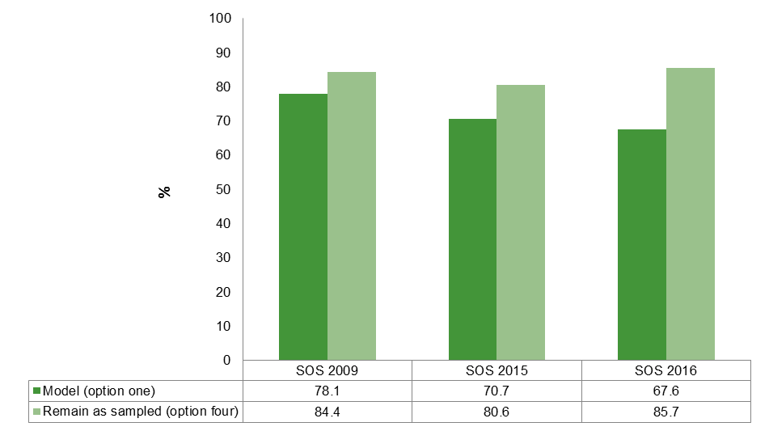

Observing figure D1, it is seen that leaving the SRGs as subject completers yields a higher correct classification percentage for each SOS year that was analysed.

## Correctly classifying SRGs into their group under the original methodology

The ‘exact’ group each student belongs to was determined under the original methodology (allowing a student to be deemed an eligible graduate if they had completed their training in the year they took the survey) for the same SOS years (2009, 2015 and 2016). The percentage of correctly classified self-reported graduates under the two methods was then determined and is displayed in Figure D2.

Figure D2 Percentage of correctly classified SOS self-reported graduates under original methodology, 2009, 2015, and 2016

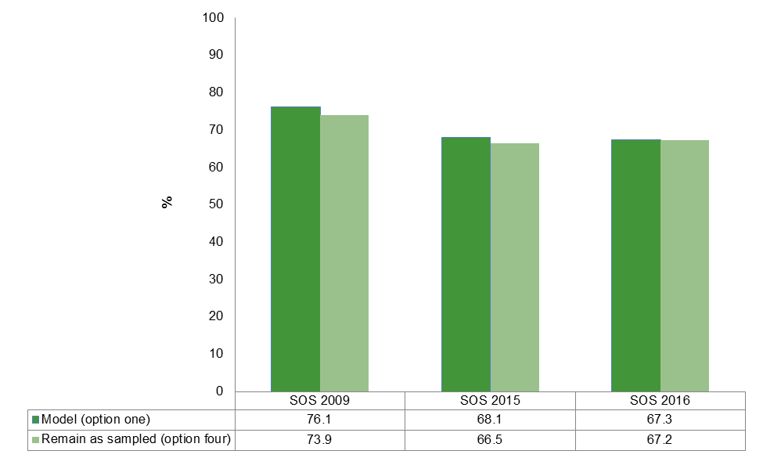

If the original rules for eligibility are applied to determine the ‘exact’ group each student belongs to, then it is seen that the model (option one) performs slightly better (in terms of correct classification percentage) than leaving the students as subject completers (option four). However, this is not appropriate as it does not align with the definition of a SOS graduate, which does not allow a student to be considered a graduate if they have completed their training in the same year as the survey.

# References

Braysher, B 2012, *An analysis of self-reported graduates*, NCVER, Adelaide.

NCVER 2017, About the National Student Outcomes Survey*,* viewed 15 June 2017, <https://www.ncver.edu.au/data/collection/student-outcomes>.

NCVER_Floating_Blue

**National Centre for Vocational Education Research**

Level 5, 60 Light Square, Adelaide, SA 5000  
PO Box 8288 Station Arcade, Adelaide SA 5000, Australia

**Phone** +61 8 8230 8400 **Email** [ncver@ncver.edu.au](mailto:ncver@ncver.edu.au)   
**Web** <https://www.ncver.edu.au> <<http://www.lsay.edu.au>>

**Follow us:** <<https://twitter.com/ncver>> <https://www.linkedin.com/company/ncver>

InBug-16px_0Twitter_blackbox

1. Results are based on government-funded data using the scope defined in 2016. This means that TAFE fee-for-service students are included in the government-funded scope, which is not the case for the scope defined in 2017. [↑](#footnote-ref-1)
2. Historically the survey was conducted to allow TAFE institute level reporting for graduates and subject completers every two years (big survey year), with national and state level reporting carried out every year. [↑](#footnote-ref-2)
3. In 2017, 15—17 year old students were excluded from the survey scope. [↑](#footnote-ref-3)
4. Results for each SOS from 2007—16 are based on government-funded data using the 2016 defined government-funded scope. Results for the 2017 SOS are generated from total VET activity (TVA) scope, as this was the first year subject completers were included in the TVA scope. [↑](#footnote-ref-4)
5. The estimates in tables C1—C6 are calculated under the 2016 defined government-funded scope (includes fee-for-service TAFE students). [↑](#footnote-ref-5)