VOCSTATS
This document contains some basic instructions to help you get started using the new software NCVER is using for VOCSTATS. More detailed information on using the software can be found at:
SuperWEB documentation
Logging on:
When presented with the logon screen you can enter the logon details you have previously been using under the old VOCSTATS software.
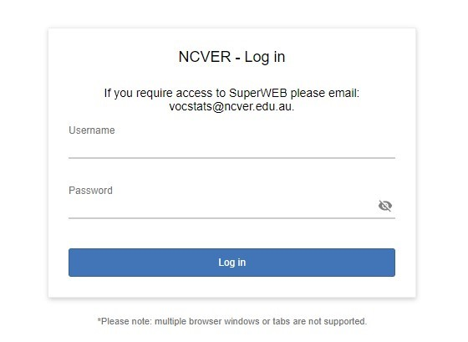

PLEASE NOTE: Password changes are not supported within the new software and will require you to contact the NCVER VOCSTATS administrators (vocstats@ncver.edu.au) to change if required.

Once logged onto VOCSTATS you will be presented with a general information page similar to below:
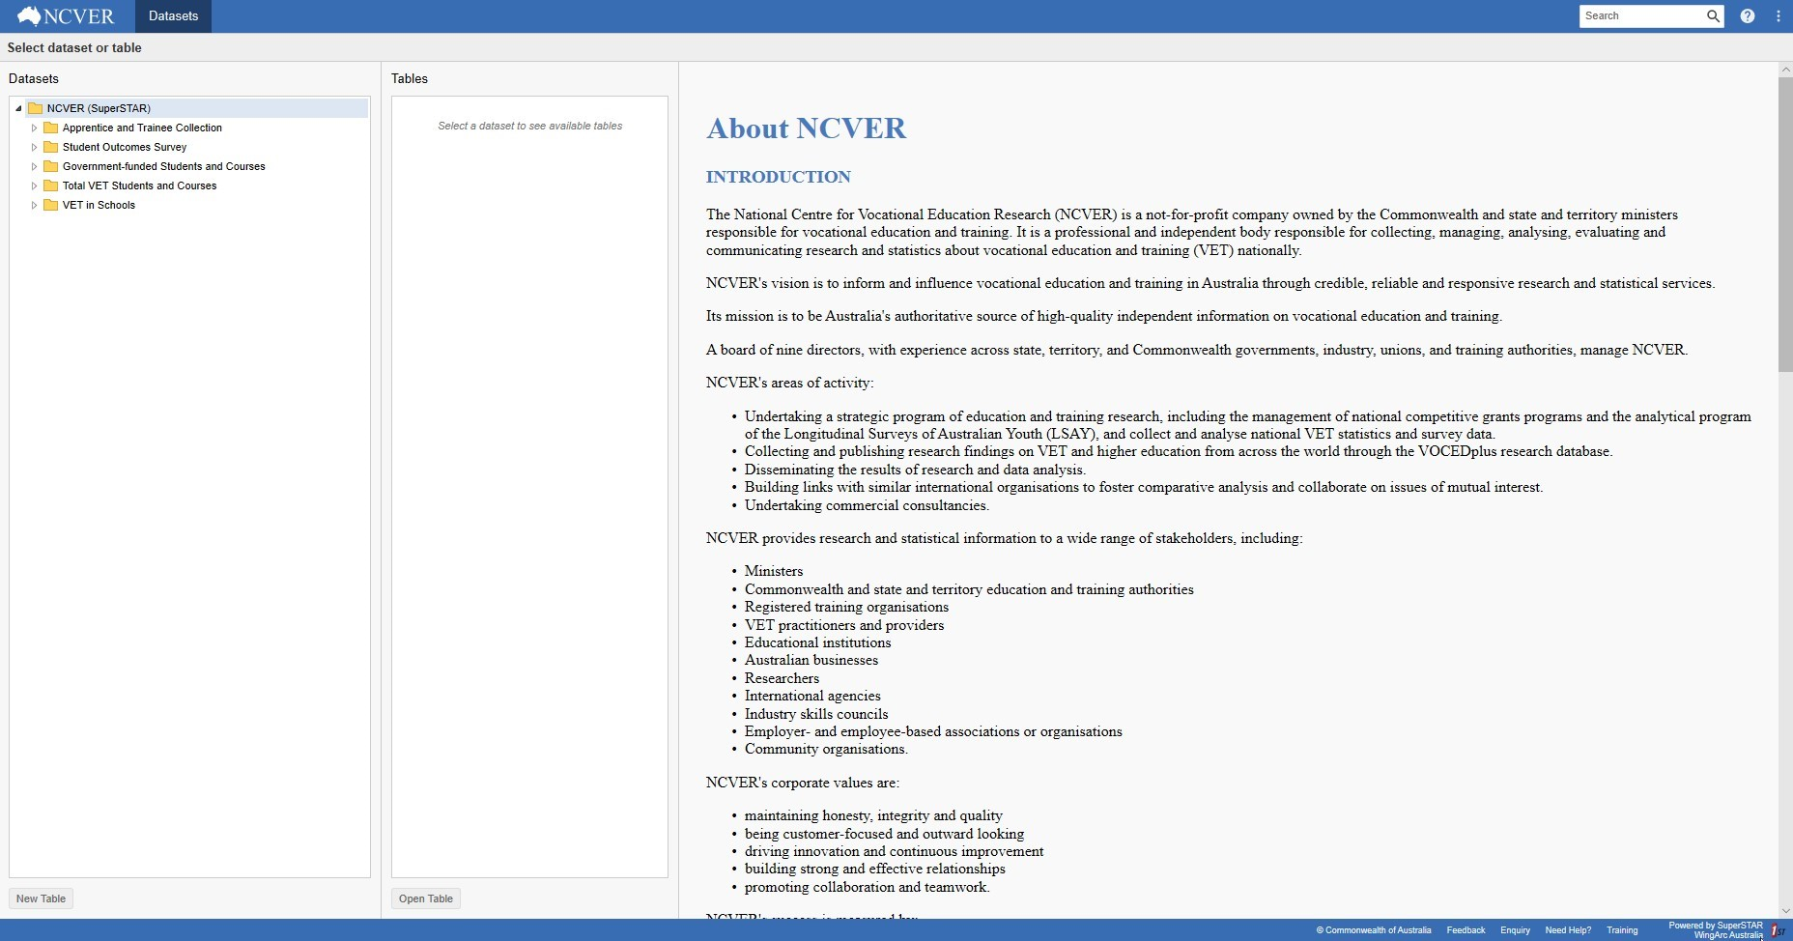
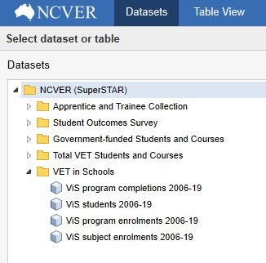
Accessing databases:
To access a database use the following steps:
- Select from the list of databases available to you on the left of the VOCSTATS screen (see screen shot to right),
- Expand on a folder to see the listed databases,
- Double-click the database you would like to open. Alternatively, select the database and then select the New Table button that changes to ‘blue’ in the bottom left-hand corner of the application. The selected database will be opened and all folders will be expanded revealing all fields. These folders can be collapsed by selecting the collapse icon to the left of the folder heading.
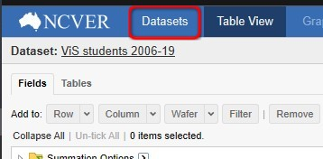
You can return to the Datasets list at any time by selecting the Datasets heading (see right). You can toggle between the database you currently have open and the Datasets list, however, If you open another database you lose any work that was done in the previous database. If you wish to keep previous tables it is recommended you save them.

Adding fields:
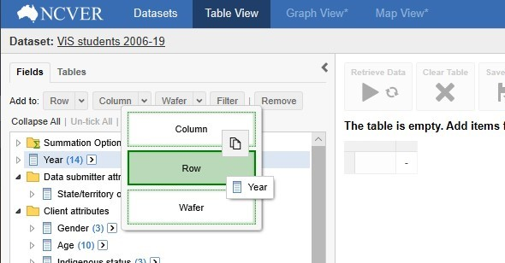
- Add a field to the table area by left mouse clicking and dragging so that the Column, Row or Wafer options become available (see right).
- Release the mouse button to drop the field in the required table area.
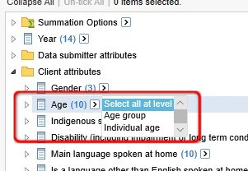
- If the field to be added to the table is a hierarchical field you can you can select a different level of a hierarchy and add all the elements for that particular level (see right). For example, instead of selecting each individual age manually select the Individual age level of the hierarchy and add to the table.
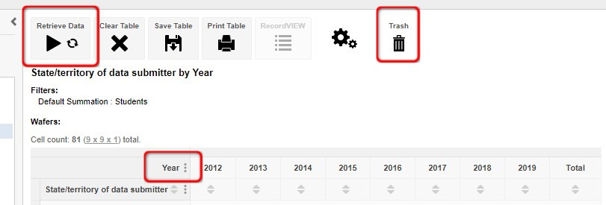
- Once a field is in the table area the Retrieve Data option will become available. Click this to populate the table (See screen shot on next page). You can also drag individual fields to the Trash bin or Clear Table to remove all fields from the table area.

- Totals can be turned on or off using the three vertical dots icon as highlighted above. This is available on both the horizontal and vertical axis of the table.

Removing fields:
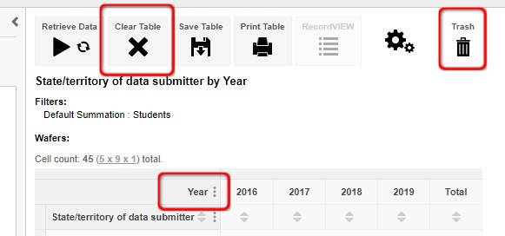
- You can remove fields from the table area by placing the mouse pointer on the field (background will change to a darker shade of grey) to be removed and dragging to the Trash bin. Alternatively you can select Clear Table and all fields will be removed from the table area.
- Fields can also be moved within a table by placing the mouse pointer on the field to be moved and dragging to the desired location. When a field is selected it will be displayed in a darker shade of grey and can be dragged to other areas of the table which will also change to a darker shade of grey when the mouse pointer is over these.
Unselecting fields:
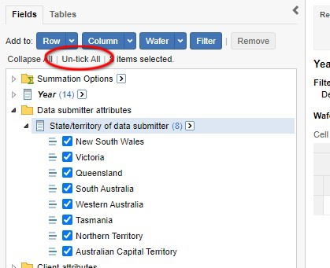
- You can un-select elements of fields if you find you do not need them by selecting Un-tick All as shown to the right.
- To select all elements in a field you can expand a field and use the arrow button to the right of the label instead of selecting each element individually. Using this will also display a box that lists the levels of a hierarchy for the field you are looking at (see below).
- You can select the level of the hierarchy from here or expand or close the hierarchy using the folders to the left of the field label.
PLEASE NOTE: At present mapping is not available in VOCSTATS.

Saving or downloading a table:
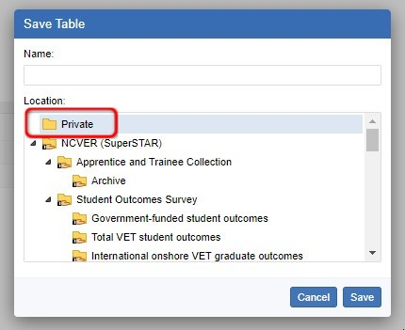
- To save a table within the VOCSTATS application select the Save Table option (see below). A window asking where you would like to save this table will display. You can also download a table in various formats as shown in the screen shot below.
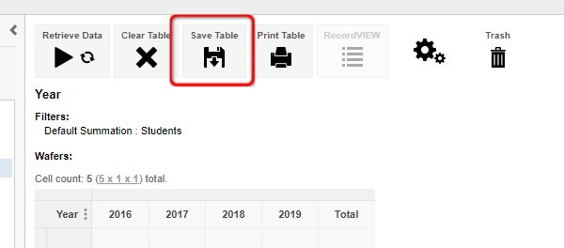
- If you select to save the table to the Private folder this will only be viewable by you. If you save to any of the other folders the table will be viewable by everyone who has access to VOCSTATS. The created table will only be viewable when the source database is highlighted in the Databases list or from the My Tables option in the top right-hand corner of the application (See below). When in the My Tables section you will have access to all tables created.
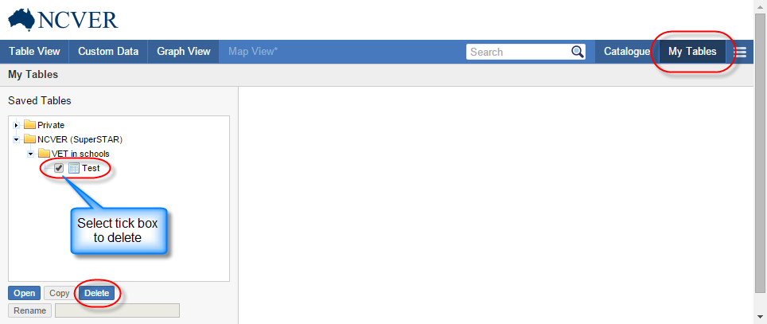
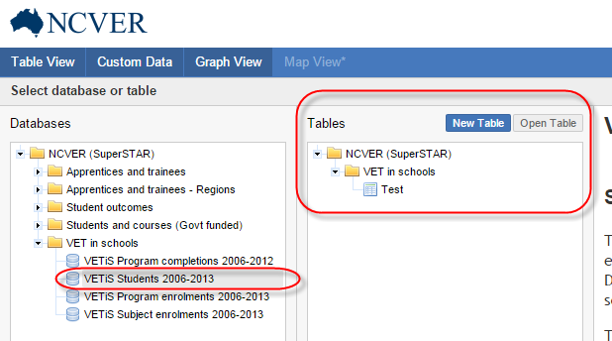
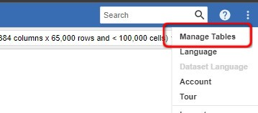
- To delete a table no longer required you need to select Manage Tables from the three vertical dots icon in the top right-hand corner of the VOCSTATS screen.
- From the screen that is then displayed, highlight the table to be deleted in the left panel and select Delete from the options at the bottom of this panel.
- You can then return to the Dataset list or Table View using the appropriate options in the blue bar at the top of the VOCSTATS application.
Further information:
For more detailed information on using VOCSTATS please refer to the SuperWEB documentation or contact the VOCSTATS team at vocstats@ncver.edu.au.

