
TECHNICAL PAPER

A guide to the Apprentices and trainees estimates review dashboard

Nadine Schuil

National Centre for Vocational Education Research




Publisher’s note
The views and opinions expressed in this document are those of NCVER and do not necessarily reflect the views of the Australian Government, or state and territory governments. Any interpretation of data is the responsibility of the author/project team.


© Commonwealth of Australia, 2018

With the exception of the Commonwealth Coat of Arms, the Department’s logo, any material protected by a trade mark and where otherwise noted all material presented in this document is provided under a Creative Commons Attribution 3.0 Australia <http://creativecommons.org/licenses/by/3.0/au> licence.
The details of the relevant licence conditions are available on the Creative Commons website (accessible using the links provided) as is the full legal code for the CC BY 3.0 AU licence <http://creativecommons.org/licenses/by/3.0/legalcode>.
The Creative Commons licence conditions do not apply to all logos, graphic design, artwork and photographs. Requests and enquiries concerning other reproduction and rights should be directed to the National Centre for Vocational Education Research (NCVER).
This document should be attributed as NCVER 2018, A guide to the Apprentices and trainees estimates review dashboard, NCVER, Adelaide.
This work has been produced by NCVER on behalf of the Australian Government and state and territory governments, with funding provided through the Australian Government Department of Education and Training.

ISBN 978 1 925717 11 2
TD/TNC 130.19
Published by NCVER, ABN 87 007 967 311
Level 5, 60 Light Square, Adelaide SA 5000
PO Box 8288 Station Arcade, Adelaide SA 5000, Australia
Phone +61 8 8230 8400 Email ncver@ncver.edu.au
Web <https://www.ncver.edu.au> <https://www.lsay.edu.au>
Follow us: <https://twitter.com/ncver> <https://www.linkedin.com/company/ncver>

Contents
Introduction 4
Overview of estimation methodology 6
Review of estimation methodology 7
Estimates review dashboard 8
Feedback 17
Appendix: glossary and explanatory notes 18

Introduction
This technical paper provides a brief overview of the estimation methodology employed in the National Apprentice and Trainee Collection, background information on the initiative to undertake timely reviews of the estimation methodology and instructions on the operation of the tool developed to best enable efficient reviews.
Apprentice and trainee data (numbers of contracts of training and the time at which these events occur) are reported by the state and territory training authorities (STAs) to NCVER on a quarterly basis. However, it is not unusual for some time to elapse before information about the number of contracts of training appears in the national collection, due to a chain of administrative processes that must be followed. These time gaps are referred to as ‘reporting lags’.
Thus, data about events occurring in a given quarter might require several collections to be completely reported. It takes up to four quarters for commencements and completions and eight quarters for cancellations/withdrawals for complete information about these events to appear in the national collection. As a result, accurate counts take time to accumulate. However, waiting for all the data to be submitted reduces their usefulness. In order to get timely information that can be used for monitoring apprentice/trainee activity and formulating policy, a reliable estimate of the ‘final’ counts is required as soon as possible after the quarter in which the events occur.
For example, consider the lag between estimated and actual collected contract commencements for Australia for the September 2016 quarter:

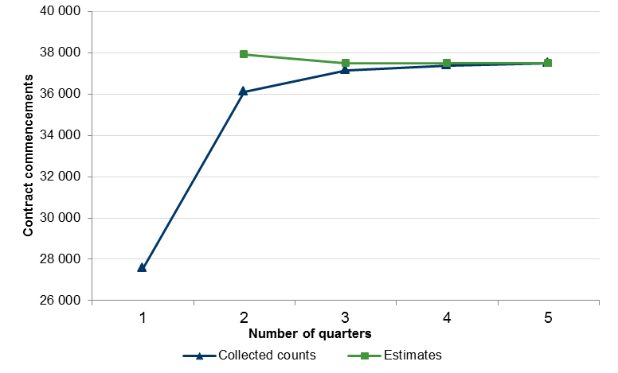
Collected and estimated contract commencements for Australia for September 2016 quarter
Quarter |  | Collected count | Estimate | Type of estimate
1 | September 2016 | 27 567 | - | -
2 | December 2016 | 36 084 | 37 927 | Initial estimate
3 | March 2017 | 37 140 | 37 479 | First revision estimate
4 | June 2017 | 37 384 | 37 493 | Second revision estimate
5 | September 2017 | 37 471 | 37 471 | Final count
The blue line in the figure above, indicating actual collected numbers from the STAs, shows how data for the September 2016 quarter commencements accumulate over time.
The green line shows how the corresponding NCVER estimates are revised over the same time period. The estimates are based on the average ratios of the final reported count to the reported count at quarters two to four as observed for quarters previous to September 2016. As the amount of unknown data reduces across the quarters, the estimates improve and converge toward the actual final count. After four quarters, the actual collected counts are as good as anything NCVER can estimate. For quarter five and onwards, NCVER only reports the actual collected count for September 2016 commencements.
NCVER has committed to reviewing the accuracy and reliability of the methodology employed in the estimation process, as described above, on a quarterly basis. In doing so, stakeholders can be assured on a timely and continuous basis of the robustness and veracity of the estimates that are published by NCVER, based on the counts that are collected from the state training authorities. This is a reflection of NCVER’s continuous commitment to transparency of processes employed and data published.
In order to undertake an efficient and frequent review of the estimation process, NCVER has developed an interactive tool, to allow the user to quickly and effectively assess the accuracy of the estimates published by NCVER. The tool, taking the form of an Excel dashboard, can be accessed at
<https://www.ncver.edu.au/data/collection/apprentices-and-trainees-collection/apprentices-and-trainees-quarterly>.
This paper provides instructions on the Apprentices and trainees estimates review dashboard, which is best used in conjunction with the Excel dashboard, followed in a step-by-step manner, to provide the optimum instruction experience. It should be noted that this technical paper relates to the dashboard as at Collection 93 (June quarter 2017) and will not subsequently be updated.

Overview of estimation methodology
Apprentice and trainee data are reported by the state and territory training authorities (STAs) to NCVER on a quarterly basis. Of particular interest is the number of contracts of training that commence, complete, cancel/withdraw, re-commence, expire or suspend and the time at which these events occur (referred to as the ‘date of effect’). From these events, the number of contracts in training at a given time can be calculated.
Between the occurrence of one of these events and the appearance of the corresponding datum in the national collection, there is a chain of administrative processes that must be followed, which entails the process of apprentice and trainee ‘contracting’, administration, data collection and reporting by the STAs. It is not unusual for some time to elapse before information about events appears in the national collection. These time gaps are referred to as ‘reporting lags’. Thus, data about events occurring in a given quarter might require several collections to be completely reported. As a result, accurate counts take time to accumulate. However, waiting for all the data to be submitted reduces their usefulness. In order to get timely information that can be used for monitoring apprentice/trainee activity and formulating policy, a reliable estimate of the ‘final’ counts is required as soon as possible after the quarter in which the events occur.
The current method of calculating estimates from the National Apprentice and Trainee Collection was endorsed in September 2004 by the National Training Statistics Committee. The detail of the methodology is set out in a technical paper produced by NCVER in July 2010, titled Estimation of apprentice and trainee statistics, and can be found at <http://www.ncver.edu.au/publications/2267.html>.
The estimates produced by the endorsed methodology are subject to review. Estimates that are associated with high relative errors or are unusually high or low are examined and if possible adjusted. Documentation relating to the review for collections can be found in the Adjustment notes for Apprentice and trainee estimates documents, which is provided as a supporting document for each collection.

Review of estimation methodology
The estimates that are reviewed are the initial estimates and first revision estimates. This is because the estimation methodology is best reviewed by considering the estimates published when only two or three quarters of data are available, respectively. From the second revision estimates and onwards, the accuracy of the estimation process is quite certain, since more quarters’ data are available from which to calculate the published estimates.
The reliability and accuracy of the estimates are assessed by comparing the initial and first revision published estimates to the final counts that emerge, and by assessing the final count against the 95% prediction intervals of the published estimates.

Estimates review dashboard

Making sense of the dashboard
The Excel dashboard contains a menu on the left-hand side for parameter selection. The parameters that can be selected are:
- Estimate type (initial or first revision estimate)
- Contract status (commencements, completions, cancellations/withdrawals or in-training)
- State or territory
- Review quarters. Here, select one or all of the review quarters pertaining to a certain contract status.

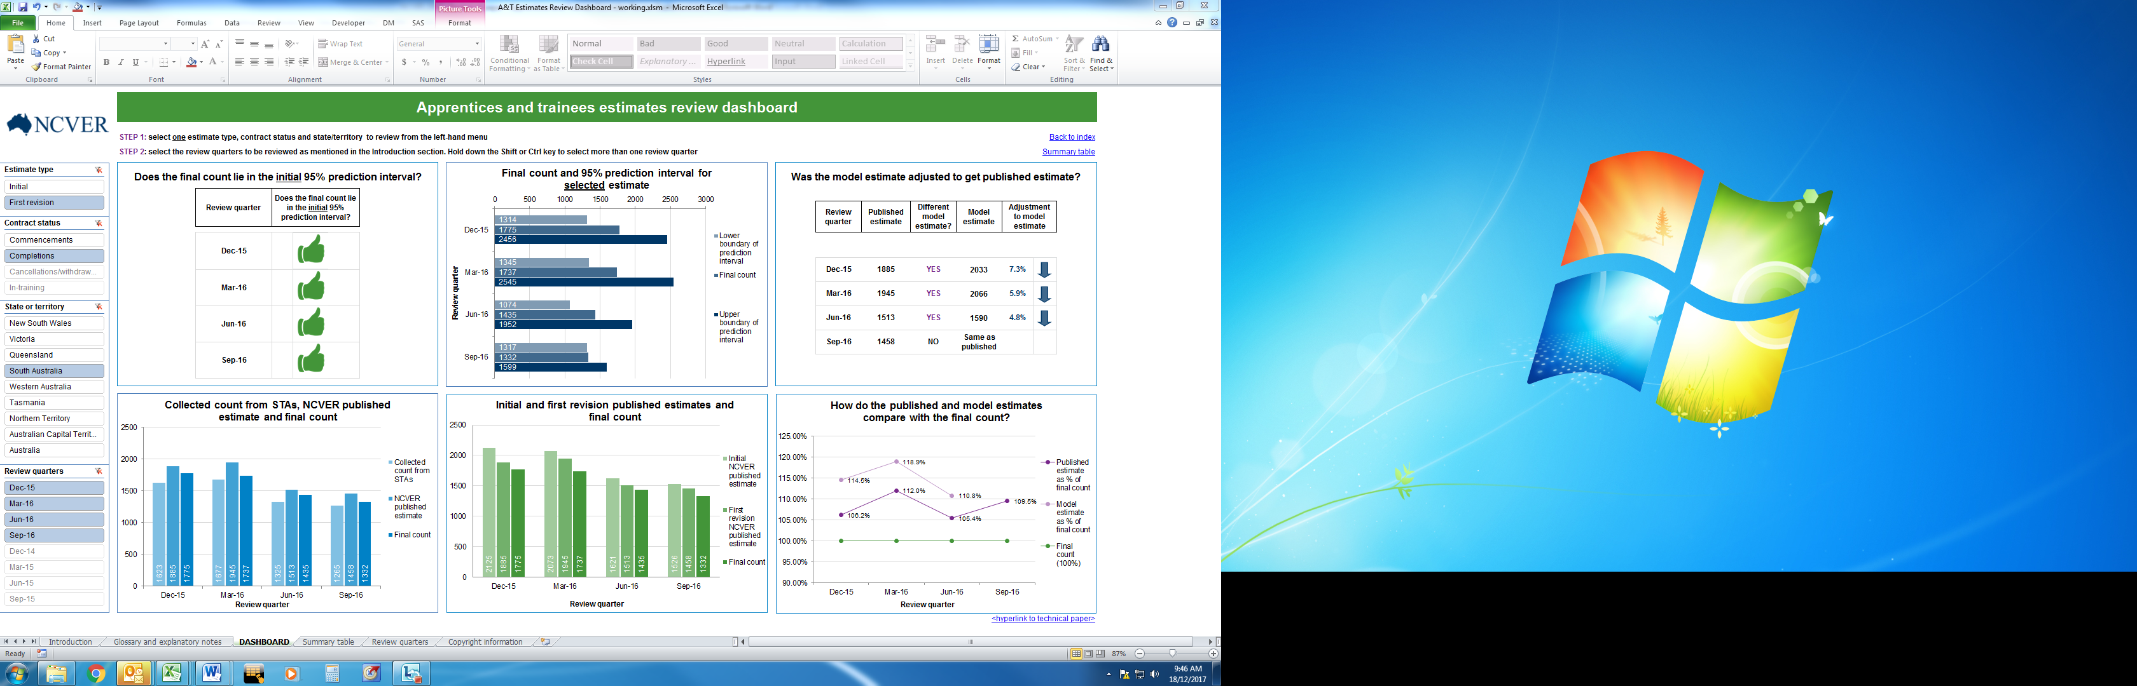
2
4
3
1

The text at the top left of the screen provides the user with instructions:
- Step 1: select one estimate type, contract status and state/territory to review
- Step 2: select the review quarters to be reviewed as mentioned in the Introduction section of the dashboard. Hold down the Shift or Ctrl key to select more than one review quarter.
For example, as shown in the above image, select first revision estimate for completions, for South Australia, from December 2015 to September 2016.
Consequently, various informative metrics and graphs are displayed, which are used to judge the accuracy of the published estimates by comparing them to the eventual final counts that emerge, and by assessing the final count against the 95% prediction intervals for the published estimates.
It should be noted that selections without accompanying data are greyed out in the filters, and if selected, will display no information in the dashboard. Reselecting selections that appear in black text will once again display information in the dashboard. For example, in the screenshot above, it can be seen that December 2014 to September 2015 are greyed out, since those quarters are only reviewed for the cancellations/withdrawals and in-training contract statuses and thus do not have corresponding data for commencements and completions.
To consider each metric in turn, moving clockwise from top left, a comparison is made between the first revision estimate for completions for South Australia from December 2015 to September 2016, with the first revision estimate for completions for Victoria from December 2015 to September 2016.

Does the final count lie in the initial 95% prediction interval?
This metric compares the final count to the initial 95% prediction interval (i.e. the 95 % prediction interval associated with the initial estimate that was published), regardless of the estimate type selected from the filter (initial estimate or first revision). If the final count does lie within the initial 95% prediction interval, a green thumbs up is displayed. If the final count does not lie within the initial 95% prediction interval, a red thumbs down is displayed.
First revision estimate for completions for South First revision estimate for completions for Australia, from December 2015 to September 2016 Victoria, from December 2015 to September 2016
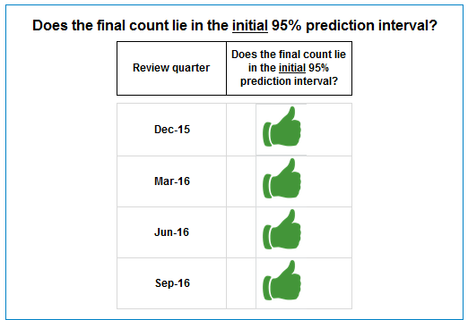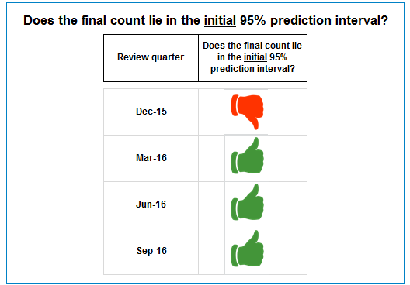
The examples above relate to the first revision estimate for completions for South Australia and Victoria respectively, for the December 2015 to September 2016 quarters. As can be seen, for the December 2015 quarter, the final count that emerged for South Australia does lie within the 95% prediction interval for the initial estimate that was published for that quarter. This is unlike the December 2015 quarter for Victoria, where the final count that emerged does not lie within the 95% prediction interval for the initial estimate that was published for that quarter.

Final count and 95% prediction interval for selected estimate
This graph visually indicates whether the final count that emerged fell within the 95% prediction interval for the estimate type selected from the filter (initial or first revision estimate).
First revision estimate for completions for South First revision estimate for completions for Australia, from December 2015 to September 2016 Victoria, from December 2015 to September 2016
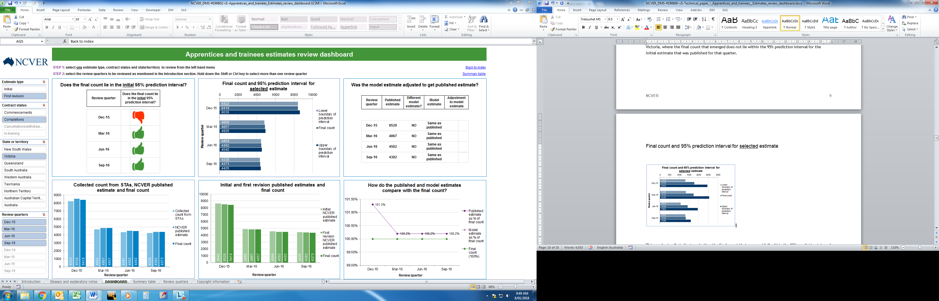
Upper PI
Final count
Lower PI
The final counts for the quarters under review are shown as the middle bar, straddled by the lightest blue and darkest blue bars which indicate the lower and upper boundaries of the 95% prediction interval pertaining to the published estimate selected (initial or first revision) respectively.
The examples above relate to the first revision estimate for completions for South Australia and Victoria respectively, for the December 2015 to September 2016 quarters. As can be seen, for the December 2015 quarter, the final count that emerged for South Australia does lie within the 95% prediction interval for the selected estimate that was published for that quarter. This is unlike the December 2015 quarter for Victoria, where the final count that emerged does not lie within the 95% prediction interval for the selected estimate that was published for that quarter.

Was the model estimate adjusted to get the published estimate?
The model estimate is the estimate produced by the endorsed estimation methodology, and, as mentioned in the previous section, is subject to review. Estimates that are associated with high relative prediction errors or are unusually high or low are examined and, if appropriate and possible, are adjusted. The resulting estimate is the published estimate. Where no adjustment is made to the model estimate, the published estimate is equal to the model estimate.
First revision estimate for completions for South First revision estimate for completions for Australia, from December 2015 to September 2016 Victoria, from December 2015 to September 2016
Therefore, as shown in the image above, the model estimates for completions for South Australia for December 2015 to June 2016 were adjusted to obtain the published estimates. If the model estimate was different from the published estimate, a purple ‘YES’ is shown in the ‘Different model estimate?’ column. The model estimate is then shown, along with the adjustment made to the model estimate (percentage increase or decrease) to arrive at the published estimate. If no adjustment was made to the model estimate, the estimate that is published is equal to the estimate that is produced by the model. This is shown by a black ‘NO’ in the ‘Different model estimate?’ column and ‘Same as published’ in the ‘Model estimate’ column, as for the September 2016 quarter in the image above.
For the model estimates for completions for Victoria for December 2015 to September 2016, no adjustments were made to the model estimates. The estimates that were published were equal to the estimates that were produced by the model. A black ‘NO’ is shown in the ‘Different model estimate?’ column and ‘Same as published’ is indicated in the ‘Model estimate’ column.

How do the published and model estimates compare with the final count?
The first or initial revision published estimate (as selected) and estimate produced by the model, if different from the published estimate, are shown as a percentage of the final count. This enables the assessment to be made of whether the adjustment to model estimates to obtain published estimates process was worthwhile. If the published estimate resulted in a number that is closer to the final count (shown as a percentage of the final count) than the model estimate would have been, the adjustment process can be deemed to have been worthwhile.
If the estimate was more than the final count, a figure greater than 100% will be indicated by the line graph. If the estimate underestimated the final count, a figure less than 100% is indicated by the line graph. The same applies to the model estimate if it is different from the published estimate. The final count that emerged is indicated by the green line.
First revision estimate for completions for South First revision estimate for completions for Australia, from December 2015 to September 2016 Victoria, from December 2015 to September 2016
For example, for South Australia, as can be seen above, the model estimate for completions, shown by the light purple line, for December 2015 was 114.5% of the final count. The published estimate, shown as the dark purple line, was 106.2% of the final count. This indicates that the adjustment made to the model estimate to arrive at a more accurate published estimate (i.e. one that was closer to the final count) was appropriate.
Since the estimates that were published for Victoria were equal to the estimates that were produced by the model, only the published estimate as a percentage of the final count is indicated, as shown by the dark purple line in the above image. For example, for December 2015, the published estimate was 101.3% of the final count. For March 2016 to September 2016, the published estimate was 100.2% of the final count.
There is clearly a difference between the published estimate as a percentage of the final count for South Australia and Victoria, with the published estimates for South Australia being higher percentages of the final counts than Victoria. The reason we observe these differences is because the collected counts from the STAs in Victoria have been stable for many years. South Australia’s data has been subject to more fluctuation, leading to estimates with greater prediction errors and wider prediction intervals.

Initial and first revision published estimates and final count
This graph shows the initial published estimate, first revision published estimate and final count for the review quarters selected. Therefore, this graph does not change when toggling from initial to first revision estimate in the Estimate type filter on the left-hand side.
First revision estimate for completions for South First revision estimate for completions for Australia, from December 2015 to September 2016 Victoria, from December 2015 to September 2016
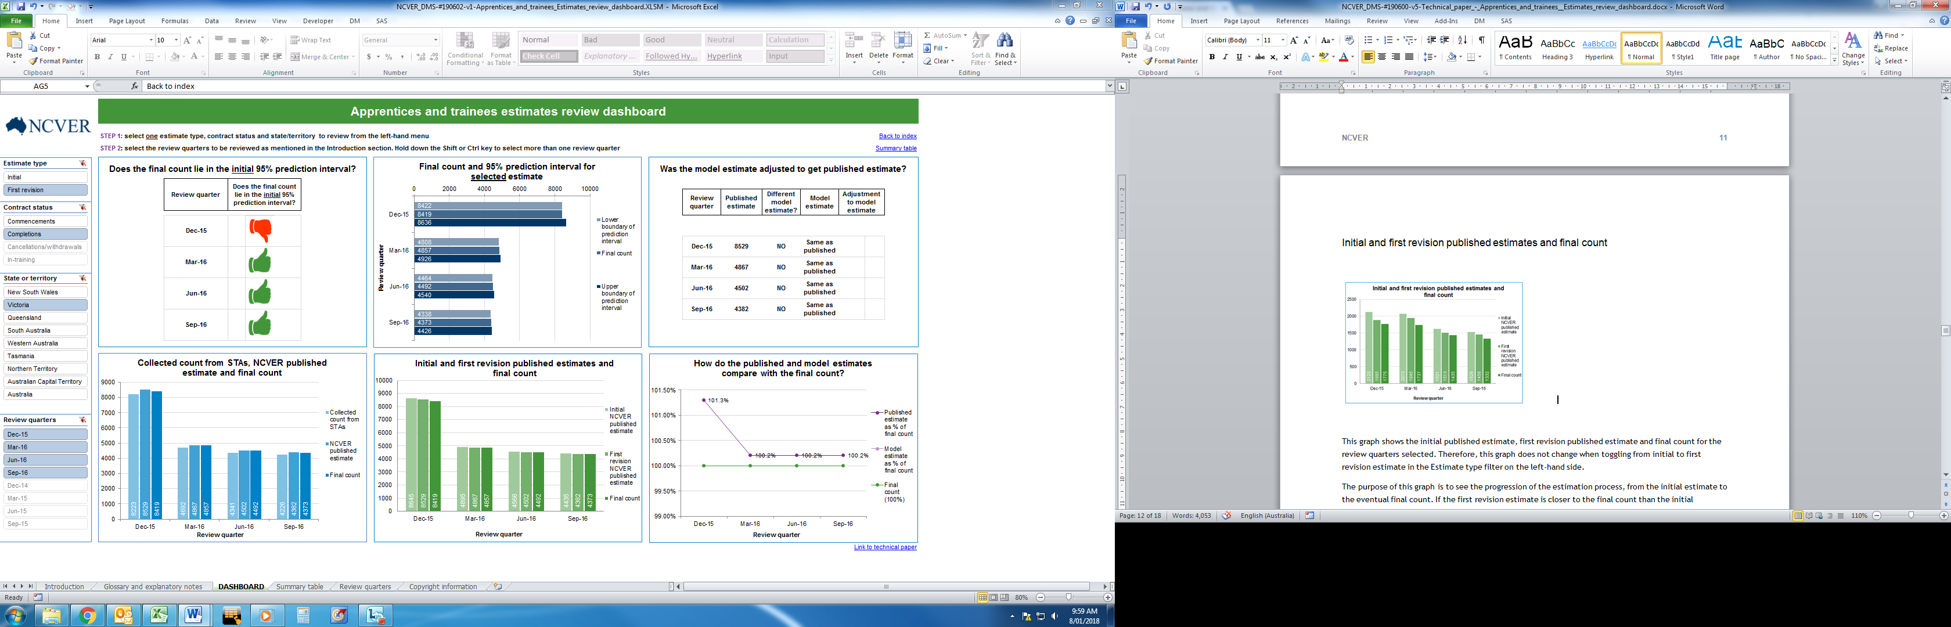
The purpose of this graph is to see the progression of the estimation process, from the initial estimate to the eventual final count. If the first revision estimate is closer to the final count than the initial estimate, it indicates that the current estimation methodology produces estimates that are increasing in accuracy during each iteration of the process (first revision estimate, second revision estimate, etc.).

Collected count from STAs, NCVER published estimate and final count
This graph shows the values submitted by the STAs to and collected by NCVER, the subsequent estimates that NCVER published, and the final counts that emerged for the specific quarters and contract status as selected in the menu.
First revision estimate for completions for South First revision estimate for completions for Australia, from December 2015 to September 2016 Victoria, from December 2015 to September 2016
Users can therefore see the value NCVER adds to and the transformation applied to the submitted values to arrive at the published estimates. In the image above, the collected counts from the STAs can be compared with the published estimates and the final counts.

Summary table
The tab labelled ‘Summary table’ within the dashboard provides a brief overview of the dashboard.

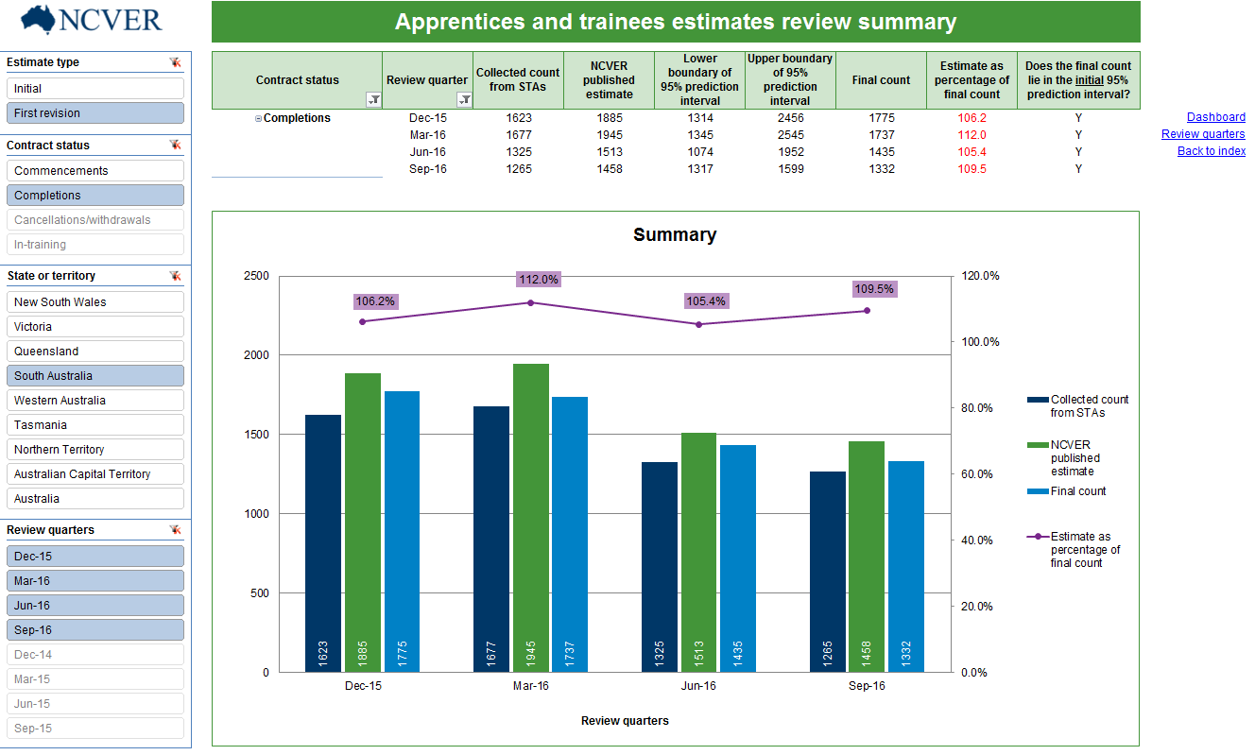
The filters on the left hand side show those applied to the dashboard. Therefore, whatever selections were made in the dashboard tab are mirrored here. The same selections are captured to provide a summary of what the dashboard presented. However, it is possible to change selections (which, in turn, will flow back to the dashboard).
The table shows the values submitted by the STAs to and collected by NCVER, the subsequent estimates that NCVER published (initial or first revision estimate), the lower and upper boundaries of the 95% prediction interval pertaining to the estimate selected (initial or first revision estimate), the final counts that emerged, the estimates as a percentage of the final counts, and whether the final counts are within the 95% prediction interval for the initial estimates.
If the estimate is less than 95% or more than 105% of the final count, the value is displayed in red text; otherwise, in black text. If the final count does not lie in the initial 95% prediction interval, a red ‘N’ is displayed. Otherwise, a black ‘Y’ is displayed.
The graph shows the values submitted by the STAs to and collected by NCVER, the subsequent estimates that NCVER published (initial or first revision estimate), the final counts that emerged, and the estimates as a percentage of the final counts (i.e. whether the estimate over- or underestimated the final count).
An important point to note is the distinction and relationship between ‘Estimate as a percentage of final count’ and ‘Does the final count lie in the initial 95% prediction interval?’. Consider the December 2015 quarter in the summary table above. Even though the initial estimate is 106.2% of the final count, the final count can still lie within the initial 95% prediction interval. This may be due to a wide prediction interval related to the initial estimate and encompassing the final count.

Review quarters
The tab labelled ‘Review quarters’ in the dashboard provides an overview of which quarters are reviewed for different contract statuses (commencements and completions, and cancellations/withdrawals and in-training), and how these are determined.

Quarters to be reviewed for all states and territories, for Collection 93
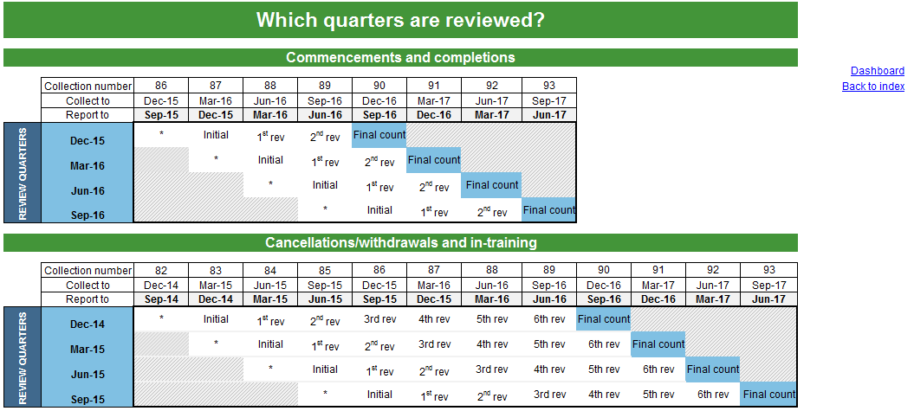

After each collection, the estimates review dashboard will be updated with the latest quarter’s data to enable a review of the most recent quarters possible.
For commencements and completions, we require three collections/quarters of data for a final count to emerge for a certain quarter after an initial estimate was reported. For cancellations/withdrawals and in-training, we require seven collections/quarters of data for a final count to emerge for a certain quarter after an initial estimate was reported.
The commencements and completions example above shows a set of review quarters (December 2015 to September 2016) and which collections NCVER uses to calculate the initial, first revision and second revision estimates, and the quarter in which the subsequent final count emerge. For example, the first time NCVER receives data relating to the December 2015 quarter is in Collection 86, but NCVER does not report on this data. The first time we report on the December 2015 data is in the next quarter, March 2016, after having received the Collection 87 data. An initial estimate is published for the December 2015 quarter. Note that the December 2015 activity is reported in the March 2016 quarter. The initial estimate then gets revised over the next two collections (Collections 88 and 89), before the final count emerges from Collection 90 and gets reported in the December 2016 quarter. Therefore, we can review the initial and first revision estimates from quarters December 2015 to September 2016, since the final counts for these quarters have been published, with Collection 93 containing the final count for September 2016 quarter.
Likewise, for cancellations/withdrawals and in-training, we can review the initial and first revision estimates from quarters December 2014 to September 2015.

Feedback
Feedback on how well this technical paper explains the operation of the Apprentices and trainees estimates review dashboard is welcome. Please send any comments to <ats_req@ncver.edu.au>.

Appendix: glossary and explanatory notes
Initial estimate
Initial estimates are calculated one quarter after the training activity occurred. For example, the initially published estimates for the December quarter contract activities are calculated when NCVER receives the March quarter data. The initial estimates are published in NCVER’s quarterly statistical reports on apprentice and trainee contract activities.

First revision estimate
With each passing quarter, the estimates on contract activities are revised to include the data received during the most recent data submission. For example, for commencements, around 95% of the complete data are captured one quarter after the training activity has occurred and around 99% after two quarters (at the time the first revision estimate is calculated). For completions, approximately 90% are captured one quarter after the training activity occurred and approximately 97% after two quarters. The revised estimates are published in NCVER’s quarterly statistical reports.

Model estimate
The model estimate is the estimate produced by the endorsed estimation methodology, and is subject to review. Estimates that are associated with high relative errors or are unusually high or low are examined and if possible adjusted. The resulting estimate is the published estimate. Where no adjustment is made to the model estimate, the published estimate is equal to the model estimate. Documentation relating to the review for collections can be found in the Adjustment notes for Apprentice and trainee estimates documents <https://www.ncver.edu.au/data/collection/apprentices-and-trainees-collection>, which is provided as a supporting document for each collection.

Estimate as percentage of final count
This metric in the dashboard and corresponding field in the summary table indicates the initial or first revision estimate as a percentage of the final count that eventually emerged. For example, an initial estimate of 2900 for a certain contract status and quarter is 101.8% of a final count of 2850 that emerged.

Does the final count lie in the initial 95% prediction interval?
This metric in the dashboard and corresponding field in the summary table compares the final count that eventually emerges with the 95% prediction interval calculated for the initial estimate. Therefore, for example, even though the initial estimate may be 110% of the final count as described above, the final count can indeed still lie within the initial 95% prediction interval. This may be due to a wide prediction interval related to the initial estimate and encompassing the final count. Conversely, for a narrow prediction interval associated with the initial estimate, the final count may lie outside the initial 95% prediction interval, when the initial estimate is, say, only 102% of the final count.
The width of the prediction interval is determined by the standard error associated with the calculation of the estimate. For detailed information on the calculation methodology of the estimates and subsequent prediction errors and intervals, please see the technical paper, titled Estimation of apprentice and trainee statistics, which can be found at <http://www.ncver.edu.au/publications/2267.html>.

State training authorities (STAs)
State training authorities are government departments in each state or territory responsible for the operation of the vocational education and training (VET) system (including Australian Apprenticeships) within that jurisdiction. Each STA participates in the formulation of national policy, planning and objectives, and promotes and implements the agreed policies and priorities in the state or territory.
Specifically, in the case of apprentices and trainees, the STAs are responsible for the registration and certification of apprenticeships training agreements and employment arrangements surrounding apprentices and trainees.


National Centre for Vocational Education Research
Level 5, 60 Light Square, Adelaide, SA 5000
PO Box 8288 Station Arcade, Adelaide SA 5000, Australia
Phone +61 8 8230 8400 Email ncver@ncver.edu.au
Web <https://www.ncver.edu.au> <https://www.lsay.edu.au>
Follow us: <https://twitter.com/ncver> <https://www.linkedin.com/company/ncver>

