Our Ref: #179134

12 December 2016

Mr Peter Harris AO
Presiding Commissioner
Data Availability and Use
Productivity Commission
Locked Bag 2, Collins St East PO
MELBOURNE VIC 8003

Dear Mr Harris
Submission to the Productivity Commission's Draft Report from the Inquiry into the Data Availability and Use
Thank you for the opportunity to examine and comment on the Productivity Commission’s Draft Report from the Inquiry into data availability and use.
The National Centre for Vocational Education Research (NCVER) is a Ministerial company owned by all Australian Government and states and territories training ministers. NCVER recognises the importance of this inquiry in considering policies aimed at increasing the availability and use of public and private sector data, noting the costs and benefits associated with all options, with a view to boosting innovation and competition.

NCVER is the national custodian of data about Australia’s vocational education and training (VET) system; indeed the Australian Bureau of Statistics recognises NCVER as holding national essential statistical assets. The administrative datasets NCVER manage include the National VET Provider collection, National Apprentice and Trainee Collection, National VET Finance collection, and National VET in Schools collection. Combined these datasets tell the story of training in Australia, providing valuable information on student enrolments, vocational qualifications attained and government expenditure on training.

In 2015, NCVER expanded the data holdings under the National VET Provider Collection to include training activity provided by all registered training organisations; prior to this, NCVER’s data holdings in this collection focused on government funded training activity. This has given rise to new data sets embodied in the Total VET students and courses reports. This expansion is significant as it collects and makes available information about the national VET system regardless of funding source and includes private fee-for-service activity.

Added to these datasets, NCVER manages national surveys on VET outcomes (Student Outcomes Survey), employers’ perceptions of training (Survey of Employer Use and Views of the VET System) and young people’s transition from school to work (Longitudinal Surveys of Australian Youth).

These data and surveys are also used to assess progress in respect of policies and funding agreed by governments in present National Skills and Workforce Development Agreements and VET Reform Partnerships.

In general NCVER releases data and makes information available under the National VET Provider Collection Data Requirements Policy and associated Protocols. It does so also within the requirements of the Australian Privacy Principles.

- 2 -

NCVER is of the view that the value of these data holdings could be enhanced by allowing in particular greater release of training information at an identified registered training provider level (with exceptions as needed).

NCVER has made these proposals in its submission to the present Review of the National VET Provider Collection Data Requirements Policy.

Further NCVER has embarked on data linkage projects that provide valued information that will help expand the evidence base for policymaking, support efficiencies in government funding and regulation, boost innovation and generate community-wide benefits. An example is linkage projects tracking educational and social aspects of Australian youth post schooling.

A final example is the present trials being undertaken cooperatively between the Student Identifiers Registrar and NCVER using the new Unique Student Identifier to produce online transcripts of training outcomes at the request of students, a further use of data held by NCVER.

Based on our work and practical experiences NCVER support in broad principle the general directions of the recommendations within the Draft Report. We would be willing to provide further information if required as the recommendations have significant future implications for NCVER and how we best serve the interests of our ministerial shareholders, the VET sector, students and the public.

In view of NCVER’s national essential data holdings, it would fully support the introduction of the Data Sharing and Release Act. The establishment of a new National Data Custodian and sectoral Accredited Release Authorities would also be of great relevance to NCVER.
If the Productivity Commission requires further information to the above or in relation to NCVER and the Inquiry into data availability and use, please contact me on 08 8230 8400.
Yours sincerely

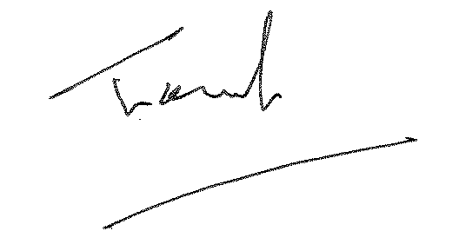
Dr Craig Fowler
Managing Director

