Submission

by the National Centre for Vocational Education Research (NCVER)

To

The Productivity Commission
http://www.pc.gov.au/inquiries/current/education-evidence#draft
May 2016
Public inquiry – Education Evidence Base

Name: National Centre for Vocational Education Research (NCVER)
Category: Ministerial Owned Company
Contact: Dr Mette Creaser, National Manager Statistics and Analytics
Phone: 08 8230 8455
Email: mette.creaser@ncver.edu.au

The National Centre for Vocational Education Research (NCVER) is pleased to provide input into the Productivity Commission’s public inquiry into an Education Evidence Base. We are specifically aiming to discuss the potential use and impact of the Longitudinal Surveys of Australian Youth (LSAY) in helping to establish an evidence base for the impact of school based initiatives and contributing to broader research and public policy debate.
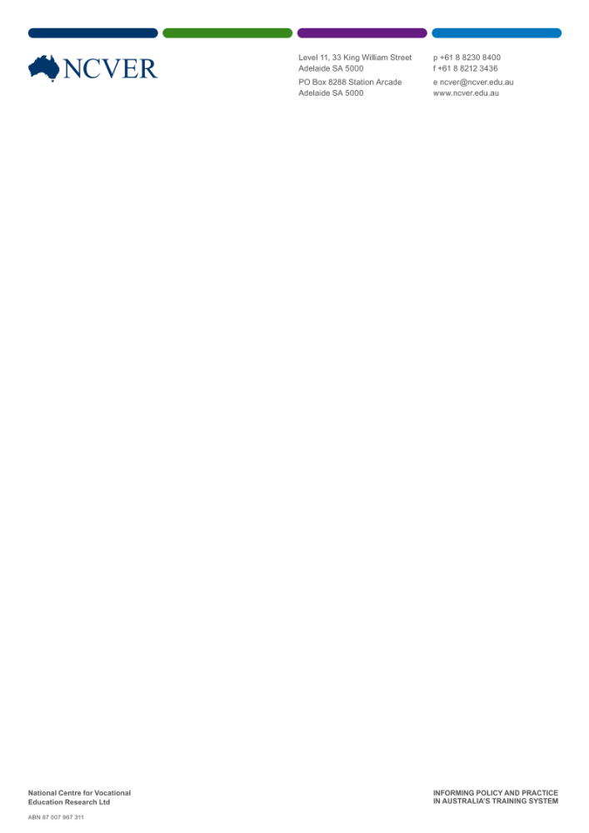
1) What is LSAY?
LSAY is a research program that follows young Australians as they move through secondary school, into further study, work and other destinations. The LSAY program is funded by the Australian Government Department of Education and Training (DET) and is jointly managed by DET and the NCVER. Data preparation and analysis currently lies with NCVER and data collection with Wallis Consulting Group. Through this tool a large, nationally representative sample of students (taken from the Organisation for Economic Cooperation and Development (OECD) Programme for International Student Assessment (PISA)) is tracked from the ages of 15 to 25. This involves interviews on an annual basis using computer-assisted telephone interviewing or online web based surveys. For a discussion of the PISA sampling framework please see Appendix A.
LSAY aims to provide a comprehensive understanding of the key transitions and pathways of young people, in particular, the transition from compulsory schooling to further education, training and employment and allows for examination of factors predicting particular outcomes. The survey has an employment and education focus yet does track various other relevant transition factors, such as living arrangements, and is designed to support government programmes and policies in the area of youth.
The precursors to the LSAY program date back to the late 1970s with the Youth in Transition collection, which sampled groups of young people born in 1961, 1965, 1970 and 1975. This was followed by the Australian Youth Survey in 1989 and the Australian Longitudinal Survey of the mid-1980s. The current LSAY program began in 1995 and refers to samples of participants which began in a particular year as a ‘cohort’. The LSAY began with a cohort of approximately 13 600 Year 9 students in 1995 (Y95 cohort). Further national samples were selected in 1998 (Y98), 2003 (Y03), 2006 (Y06) and 2009 (Y09). Integration with PISA has been a feature of LSAY since 2003, with around 14 000 students starting out in each cohort. PISA data is provided to LSAY and forms the first ‘wave’ of data capture. PISA also incorporates objective achievement scores in the areas of mathematics, science and reading.
A new cohort of participants has commenced in 2015 (Y15) and the survey instrument has undergone sufficient revision, discussed below. The LSAY data sets are stored with the Australian Data Archive (ADA) and are accessible to external researchers (free for institutions that are part of the Australian Consortium for Social and Political Research Incorporated and costed for others).
2) LSAY impact and significance
The key strength of longitudinal studies such as LSAY is their capacity to provide a clear picture of young people’s lives at any point in time and of the pathways taken to get there. The capacity to follow the same young people over time means that factors influencing their pathways and outcomes can be identified, and changes in the education and employment experiences of successive groups can be tracked. As far as we are aware LSAY is the only national survey that tracks the fortunes of young Australians transitioning from school to work.
LSAY has a strong history of research and analysis, facilitated by the data being available through the ADA. Topic areas of research include:
- School effects series (examining the effects of school characteristics relative to those of the individual student in predicting academic success)
- Education and work aspirations of participants
- The prevalence and impact of part-time work
- Identification of educational and work pathways for differing groups of people
- The impact of beginning one’s work career in a low skill occupation
- Time taken to find work post-school and further education.
For more information on LSAY based research activities please refer to www.lsay.edu.au/publications/index.html (Note: this site currently requires registration to access but this is free and simple to establish. NCVER is currently in the process of improving the online resource to make it easier to access and use).
In addition to the impact on academic literature, LSAY has a history of helping inform and shape Australian policy and has been cited as the only source of information available on particular youth transition matters. LSAY has informed the following (Australian Government Department of Education, 2016):
- Council of Australian Governments (COAG) Reform Council reporting on youth transitions (2009-2013)
- The Youth Compact and National Partnership on Youth Attainment and Transition (2009-2013)
- Productivity Commission Impacts of COAG Reforms: Youth Transitions (2012)
- School funding (Gonski) review (2010-2011)
- Review of Australian Higher Education (Bradley review, 2008) and follow-up Senate committee inquiries (2009 to 2011)
- Australia’s contribution to an OECD review of policies facilitating the transition from school to work and improving the career prospects of youth (2008 to 2010).
- House of Representatives Inquiry into Combining school and work: Supporting Successful Youth Transitions (2008-2009)
- Career, Transitions and Partnerships Pilot Strategic Review (2007) informing reforms of Commonwealth youth, career and transition policies and programmes in subsequent years.
- Submission to the Council of Australian Governments on transition pathways from school (2006).
As can be seen LSAY has a clear presence in the research and policy space and this shall only be enhanced with the proposed data linkage work, discussed in section 4.
3) 2015 cohort questionnaire revision
As mentioned above, a new cohort for LSAY launched in 2015 (Y15) has provided NCVER with the opportunity to revise the questionnaire to better reflect current research and policy needs. This revision has been informed by consultation with a wide range of stakeholders as to their needs and emerging issues of concerns as well as attempting to ensure relevance of the data for policy making decisions into the future. NCVER has also performed a scan of available research work to identify question areas which have not been used in any substantial way to remove questions which are not being used.
This revision is still ongoing and is involving extensive client testing for comprehension and usability. This has included additional topic areas such as self-reported soft skills, personality assessment and engagement with education to name a few. A modular structure to the revised LSAY has also been proposed with the possibility of introducing additional modules of questions addressing topical issues in particular years.
4) Data linkage
Data linkage provides an opportunity to dramatically increase the scope and impact of LSAY data whilst maintaining financial feasibility of the project and not introducing additional burden on participants. The NCVER and the Australian Institute of Family Studies Data Linkage and Integration Unit have been working together during 2015 and 2016 to scope potential data linkages for LSAY Y15. At this point the work is focussed on combining LSAY data with National Assessment Program-Literacy and Numeracy (NAPLAN), My Schools, and senior secondary subject databases. Regarding NAPLAN, as this is assessed in grades 3, 5, 7 and 9, the new LSAY cohort would have school performance information from the primary school years. Additionally, these performance measures are in an objective and nationally consistent format. For a more detailed discussion of the benefits of linking LSAY to NAPLAN please refer to Lumsden et al (2015). In addition to these three databases, in the future there is the potential to link LSAY to more varied collections such as the National VET Provider Collection, the Higher Education Statistics Collection and Centrelink data.
The linkage of these data to LSAY, in addition to PISA data (including achievement scores) which is already incorporated, will transform the utility of LSAY. The combination of such administrative data on a cohort of youth will be unparalleled in Australia, and, in conjunction with the existing strengths of LSAY, is likely to be a world leading development in educational research. The competitive advantage to enhance policy development for the Australian Government would be significant and the augmented LSAY would have the capacity to more effectively address a number of longstanding policy concerns about the decline in Australia’s educational performance and the need to enhance the productivity of the workforce to maintain living standards.
5) Relevance for Education Evidence Base
A key component of schooling is preparing students for their working lives and the further education which may be required to achieve their work goals. However, once students leave the secondary school environment there is limited scope to track how well this has been achieved; LSAY can help fill this gap. As typically there is neither the time nor resources to track students in the medium to longer term, the impact of education initiatives on future life benefits to participants may be inferred rather than demonstrated, for example retention in and completion of high school, and potentially enrolment in and graduation from further education as proxy markers of ‘success’. What is typically missing in these analyses is an understanding of the impact differing life circumstances may be having on young people setting and achieving education and work goals; LSAY can explore the genuine impact of policies and educational initiatives. As a nationally representative sample, this will not be possible for initiatives unique at the school level. However, LSAY is a valuable addition in developing a nuanced understanding of initiatives at a regional level.
With proposed data linkage work including NAPLAN, My School and senior secondary subject databases, LSAY’s capacity to contribute to policy decisions and developing research to support evidence based practice can only be enhanced. For example providing more accurate objective data about subject choice at school, participants’ further education choices as well as employment outcomes could feed into policy decisions regarding promotion of Science Technology Engineering and Mathematics (STEM) topics within schools, a focus of the government’s Innovation agenda (Australian Government’s Department of the Prime Minister and Cabinet, 2014). In addition, linking NAPLAN scores from Years 3, 5, 7 and 9 and the PISA achievement scores enables an understanding of how achievement in primary and secondary school influences educational careers and labour force participation. This can be seen as examining how well NAPLAN scores predict future ‘success’, clearly feeding into policy decision making.
6) Key points for consideration and recommendations
6.1) Data linkage
Data linkage provides an opportunity for multiple benefits but also raises numerous challenges around privacy issues and obtaining informed consent from participants and, potentially, their parents. This is further complicated by jurisdictional divides, with differing interpretations of these issues, differing definitions and methods of capturing the data, data sharing protocols and restrictions on the level of aggregation at which data may be analysed or published, for example, state, region or sector comparisons. In addition, for work involving national data involving multiple jurisdictions’ holdings separate approval from each is required, a time consuming and costly endeavour.
NCVER recommends:
- A government working group involving both Commonwealth and the jurisdictions be established to specifically consider the potential of a unified protocol on the point of data linkage for educational research and policy.
- Consider a process for single review and approval for work involving multiple data custodians. This may be similar to the National Health and Medical Research Council’s Human Research Ethics approvals for multi-site work, as discussed in chapter 5.3 of the National Statement on Ethical Conduct in Human Research (2007, updated May 2015 - www.nhmrc.gov.au/guidelines-publications/e72)
- Consider the option of a centralised authority for data linkage oversight and approval perhaps drawing upon the experiences of initiatives such as the Cross Portfolio Data Integration Oversight Board who are responsible for developing a cross government environment for data integration involving Commonwealth data for statistical and research purposes. This board does have a decision making role to the extent that they approve applications to become accredited integrating authorities for Commonwealth data.
6.2) Programme integration
LSAY is based on PISA sampling, however, PISA Australia is a separately managed process. From our experiences we have found the administration of the PISA programme to have limited outside input and collaboration and there have been barriers to accessing information, such as sampling (eg school lists to facilitate awareness of LSAY), or suggesting modifications. To maximise Australia’s return on investment in this OECD initiative there could be greater integration of the varied youth research programmes with PISA and more flexibility in how PISA administration interacts with other research organisations.
- NCVER recommends consideration be given to exploring ways in which PISA, as a feeder survey, could be modified or additions provided to facilitate LSAY and potentially other surveys or research.
7) Future possibilities and enhancements of LSAY

Beyond specific recommendations discussed above, there are a number of opportunities for expanding the potential benefit of LSAY for policy decision makers. Some of this work is currently being undertaken by NCVER whereas other possible extension activities would require additional funding and/or input and assistance. NCVER would welcome discussion on these points.

7.1) Ensuring LSAY data is available and used effectively
For data to have an impact it must be accessible. A clear remit from the Australian Government for the Y15 revision is a focus on improving the accessibility of the data for research purposes and raising the profile of this work more broadly. While this is an ongoing task for NCVER there is scope for discussion with relevant education sector professionals regarding how we could best target dissemination strategies and tailor information for the various education authorities.
An additional aspect of accessibility is the capacity to effectively understand and use the data. We would welcome the opportunity to discuss capacity building activities for organisations in terms of education, training and resources to better facilitate use of the data.

7.2) Further improving the evidence base for critical determinants of educational outcomes
It is acknowledged that there are certain factors which are key determinants of educational outcomes, for example, socioeconomic and Indigenous status as well as whether a child lives in a regional area. On this latter point, there is the possibility of increasing the LSAY sample size to provide more information at a granular level of analysis; potentially enhancing our understanding of the life factors affecting young people’s transitions to further education and employment in both specific jurisdictions and also at the metropolitan, regional and rural areas. This could provide insight into policy implications beyond the national level. The associated costs for this would need to be accommodated for in funding decisions. There is also the possibility that LSAY could work with the Australian PISA team to make some changes in the current sampling scheme to help better address this point whilst maintaining international comparability.
7.3) Is there life beyond 25?
Research suggests that youth transitions are taking longer and follow more complicated pathways than in previous generations. For example, becoming more common for young people to defer undertaking higher education rather than progress to study immediately following post secondary school and for more people to undertake higher level courses which result in longer times taken to complete study. Also, young people are staying in the family home for longer and may be more likely to return at some point after a period of independent living. Consequently, there is a clear argument in favour of extending the LSAY survey beyond 25 years (NCVER, 2016). Extending LSAY up to 30 years of age would offer some real advantages, including:
- better estimation of the returns from education and training, particularly for those young people who pursue higher-level qualifications or who return to education in their 20s
- better modelling of social outcomes, particularly investigating the living arrangements of those who leave home and then return to the parental home
- the transition points of all young people to become more visible (NCVER 2016).
There is the possibility of extending the existing Y06 and Y09 cohort relatively soon which could provide more data on the points mentioned above at both a national level and broken down by gender.

7.4) What about parents?
Parents play a huge role in shaping the aspirations and outcomes of their child. However, information about or from parents may not be included in evaluations of the impact of an educational policy or initiative. Proxy measures such as socio-economic status may be used yet this does not capture a parent’s perception of the value of education or the level of support provided and expectations they have on their child to perform well at school.
LSAY currently captures information on the education and employment of participants’ parents due to the strong impact this may have on aspiration setting and presumed support for educational achievement. However, other information about parental support and attitudes towards education and work is extremely limited. PISA has a module to be completed by participant’s parents but this is not used in Australia. NCVER would be interested in discussing the possible introduction of survey work with parents to truly understand the context in which a young person lives and the impact this may be having on their transition to adulthood. This would obviously be a costed activity and the existing PISA survey would likely need to be modified to reflect Australian circumstances and some modifications to LSAY would be required as well. In addition considering how to sufficiently engage parents in the process to ensure an adequate sample size would be a key challenge.

In conclusion, NCVER would like to thank the Productivity Commission for the opportunity to submit this feedback for consideration in the public inquiry into education evidence base. LSAY offers a rich data source for helping to track the outcomes of educational policy and fill the gaps in understanding the true impacts these may be having on youth transitions into adulthood, future study and working life. We welcome the opportunity to further discuss any of the points raised in this submission.

References
Australian Government Department of the Prime Minister and Cabinet. (2014). A more skilled labour force – improving education and training. Retrieved from: (www.dpmc.gov.au/sites/default/files/publications/IICA_fact_sheet_STEM.pdf)
Australian Government Department of Education. (2016). A Review of the Longitudinal Surveys of Australian Youth. Australian Government Department of Education: Canberra. (http://hdl.voced.edu.au/10707/391875)
Lumsden, M., Semo, R., Blomberg, D., & Lim, P. (2015). Linking NAPLAN scores to the Longitudinal Surveys of Australian Youth. NCVER: Adelaide. (www.lsay.edu.au/publications/2829.html)
National Centre for Vocational Education Research. (2016). Enhancements to the Longitudinal Surveys of Australian Youth. NCVER: Adelaide. (http://hdl.voced.edu.au/10707/391876.)
National Health and Medical Research Council. (2007, updated May 2015). National Statement on Ethical Conduct in Human Research. National Health and Medical Research Council: Canberra. (www.nhmrc.gov.au/guidelines-publications/e72)

Appendix A: PISA and LSAY sampling framework
The LSAY cohort is drawn from PISA participants. PISA Australia is run every three years. This assessment forms part of the National Assessment Program and as such participation is mandatory (under the Australian Education Act, 2013). PISA involves 15 year old students and is a representative sample of 15 year olds in Australia, carefully assessed to ensure it contains the correct ratios of schools in each school sector and geographic area (Metropolitan and non-metropolitan). Smaller states, territories and Indigenous students are oversampled in order for reliable population estimates to be inferred. The PISA has a range of exclusions: part-time students, those undertaking only vocational education and training (VET), students attending foreign schools and those being schooled at home, in the workplace or out of the country. Additional Australian sampling exclusions include those being taught in correctional facilities or in very remote mainland schools and those being taught in a language other than English. Students may also be excluded based on a discrete number of personal characteristics; those with a severe physical, sensory, intellectual or emotional disability or with limited proficiency in English (have received less than one year of teaching instruction in an English language facility).

